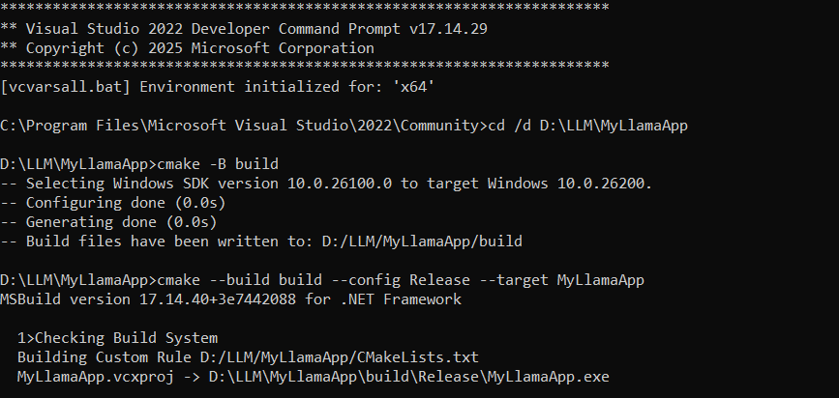

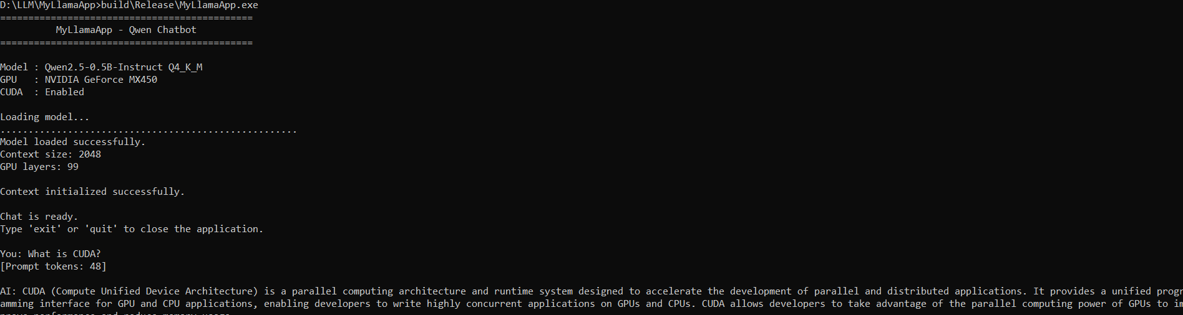

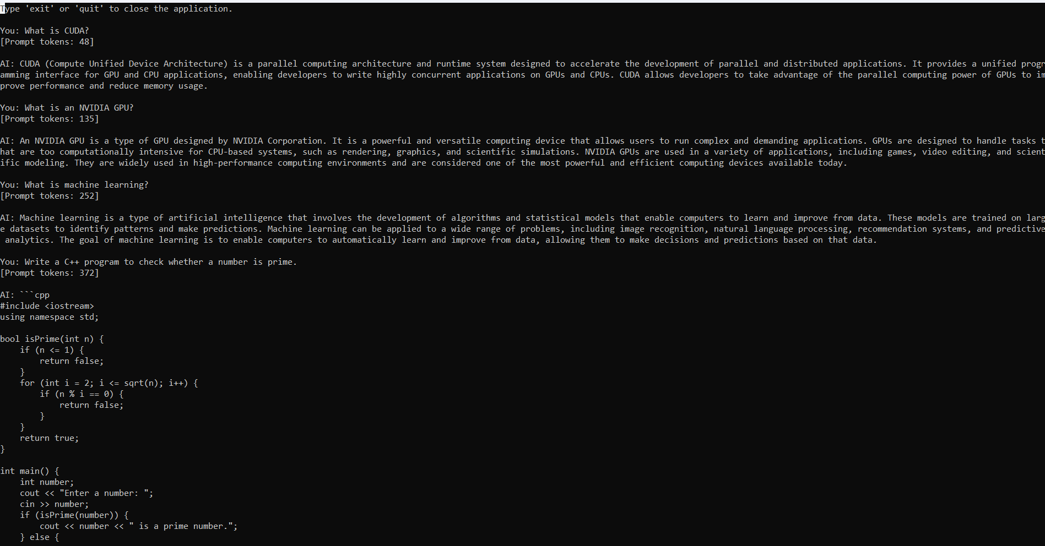

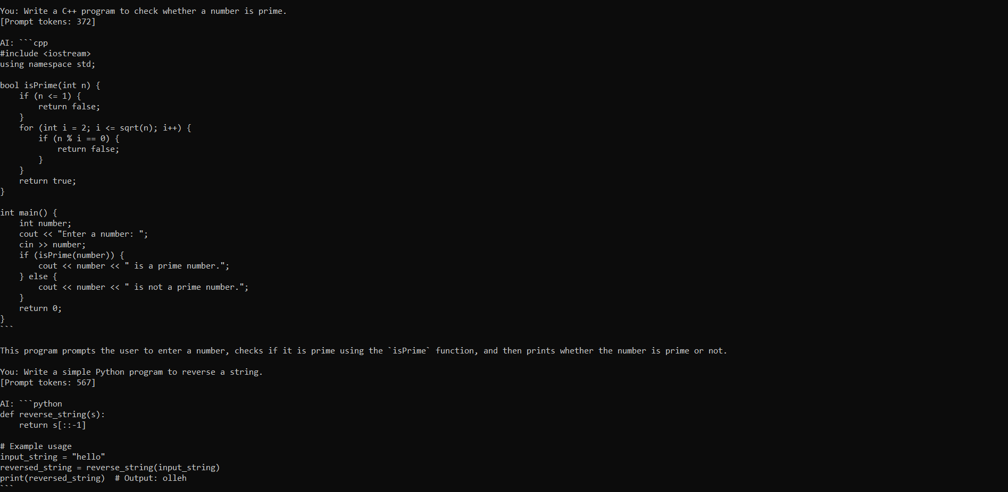

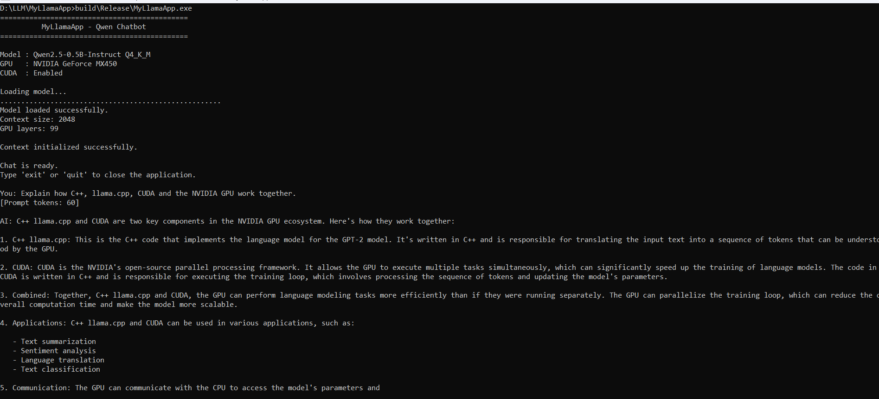

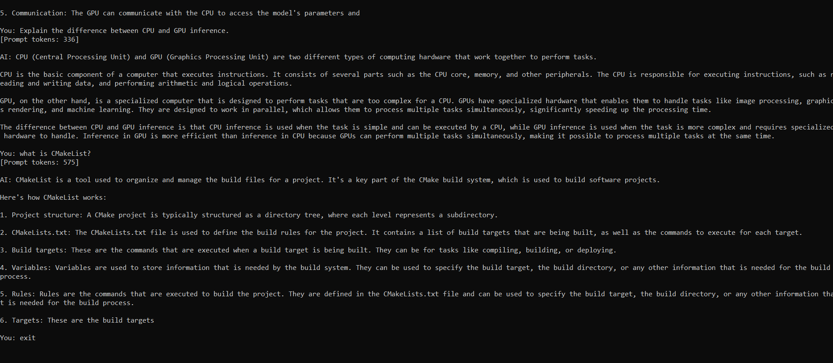

Best 10 queries for your final demonstration
If you need a short test set for your GitHub project/demo, I would use:
# | Query | Feature tested
1 | What is CUDA? | Basic knowledge
2 | What is llama.cpp? | Technical knowledge
3 | Why is CUDA useful for LLMs? | Technical explanation
4 | What is GGUF? | Model format
5 | Write a C++ function to calculate factorial. | Code generation
6 | Explain GPU offloading in simple terms. | Explanation
7 | What did I ask you about CUDA earlier? | Conversation history
8 | Summarize CUDA in 2 sentences. | Summarization
9 | Explain the difference between CPU and GPU inference. | Comparison
10 | Explain how C++, llama.cpp, CUDA and the NVIDIA GPU work together. | End-to-end architecture

