RAG WITH GPT4All Desktop
Technical Documentation, Evaluation & Architecture
RAG_WITH_GPT4All_Desktop
Local Retrieval-Augmented Generation using Gemini Embeddings, ChromaDB and GPT4All Desktop

Documents | 2 PDF documents
Embedding Model | Gemini gemini-embedding-001
Vector Database | ChromaDB
Local LLM | Phi-3 Mini Instruct
LLM Runtime | GPT4All Desktop Local API

1. Overview
This project implements a Retrieval-Augmented Generation (RAG) application that answers questions using a small, controlled knowledge base of two PDF documents. Gemini is used for semantic embeddings, ChromaDB stores and retrieves vectorized document chunks, and GPT4All Desktop runs the local Phi-3 Mini Instruct language model through an OpenAI-compatible local REST API.
The implementation is intentionally split between retrieval and generation. The retrieval layer identifies relevant knowledge from the PDFs, while the generation layer uses the retrieved context to formulate an answer. The system is instructed not to rely on outside knowledge.

2. Objective
- Build a complete local RAG pipeline using two PDF knowledge documents.
- Extract PDF text while preserving filename and page-number metadata.
- Split document text into overlapping chunks suitable for semantic retrieval.
- Generate embeddings using Gemini gemini-embedding-001.
- Persist embeddings, text and metadata in ChromaDB.
- Retrieve semantically relevant chunks for user questions.
- Send retrieved context to Phi-3 Mini Instruct through GPT4All Desktop.
- Generate grounded answers from the retrieved context.
- Provide verified source citations from ChromaDB metadata.
- Evaluate retrieval and generation behavior using multiple test questions.

3. Problem Statement
Traditional keyword search can be insufficient when a user asks a question using wording that differs from the source document. The objective of this project is to demonstrate semantic retrieval: the question and document chunks are represented as vectors, allowing ChromaDB to identify conceptually relevant information. The retrieved information is then supplied to a local language model so that the final response is grounded in the supplied documents.

4. Data – PDF files
The final implementation uses two knowledge documents:
- azure_functions.pdf — information about Azure Functions, triggers, bindings, hosting plans, Durable Functions and common use cases.
- azure_logic_apps.pdf — information about Azure Logic Apps, workflows, triggers, actions, connectors, hosting options and common use cases.
Both PDFs are stored under the project's documents directory. The notebook extracts the text page by page and keeps the source filename and page number with every chunk.

5. Technologies Used
Technology | Purpose / Version
Python | 3.13.15
Jupyter | Local Jupyter Notebook on Windows
PyPDF | PDF text extraction
ReportLab | Creation of the demonstration PDF knowledge documents
Google GenAI SDK | Gemini API client
Gemini Embeddings | gemini-embedding-001
ChromaDB | Persistent vector database
Requests | HTTP communication with GPT4All Desktop
GPT4All Desktop | Local LLM runtime and REST server
Phi-3 Mini Instruct | Local generation model

6. System Architecture
The architecture below shows the complete ingestion, retrieval and generation flow used by the project.
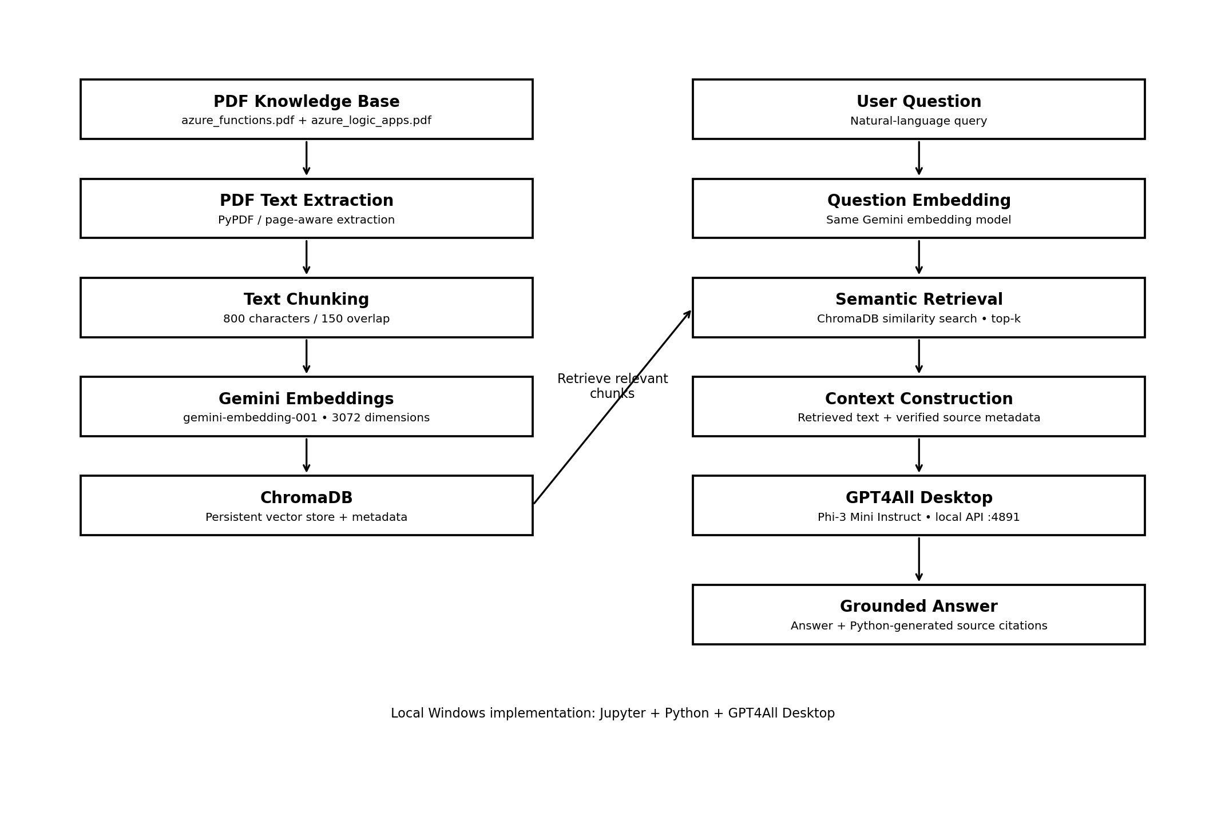

7. Detailed RAG Pipeline

7.1 PDF Ingestion
PyPDF is used to open each PDF and extract text page by page. Each extracted page is stored as a record containing filename, page number and text.
pages.append({
"filename": pdf_path.name,
"page_number": page_number,
"text": text
})

7.2 Text Chunking
The extracted text is normalized and divided into overlapping chunks. The implementation uses an 800-character chunk size and 150-character overlap. Overlap helps retain context at chunk boundaries.
page_chunks = create_chunks(
page["text"],
chunk_size=800,
overlap=150
)

7.3 Gemini Embeddings
Each chunk is converted into a numerical vector using Gemini gemini-embedding-001. During testing, the generated vectors were 3072 dimensions.
response = gemini_client.models.embed_content(
model="gemini-embedding-001",
contents=text
)
embedding = response.embeddings[0].values

7.4 ChromaDB Storage
ChromaDB stores four important pieces of information for every chunk: a unique ID, the chunk text, its embedding vector and source metadata.
collection.upsert(
ids=ids,
documents=documents,
embeddings=embeddings,
metadatas=metadatas
)

7.5 Semantic Retrieval
A user's question is embedded using the same Gemini embedding model. The question vector is submitted to ChromaDB, which returns the most semantically similar chunks. The current demonstration uses top-k retrieval.
results = collection.query(
query_embeddings=[question_embedding],
n_results=top_k,
include=[
"documents",
"metadatas",
"distances"
]
)

7.6 Context Construction
Retrieved chunks are combined into a context block. Each chunk carries its filename and page number so the answer can be traced back to the knowledge base.

7.7 GPT4All Desktop Generation
The context and user question are sent to GPT4All Desktop using its local OpenAI-compatible chat-completions endpoint. The model used in the working environment is Phi-3 Mini Instruct.
payload = {
"model": "Phi-3 Mini Instruct",
"messages": [
{
"role": "user",
"content": prompt
}
],
"max_tokens": 300,
"temperature": 0.2
}
response = requests.post(
"http://127.0.0.1:4891/v1/chat/completions",
json=payload,
timeout=300
)

8. Grounding and Source Citation Strategy
A key improvement in the implementation is separating answer generation from source citation generation. GPT4All is instructed not to invent filenames or page numbers. Python creates the final verified source list directly from the metadata returned by ChromaDB.
This avoids a common RAG problem where an LLM produces a plausible but incorrect page number.
def get_verified_sources(retrieved_documents):
verified_sources = []
seen = set()
for document in retrieved_documents:
filename = document["filename"]
page_number = document["page_number"]
source_key = (filename, page_number)
if source_key not in seen:
verified_sources.append(
f"{filename} - Page {page_number}"
)
seen.add(source_key)
return verified_sources
For example, if ChromaDB returns metadata {'filename': 'azure_functions.pdf', 'page_number': 1}, the application can produce the verified citation "azure_functions.pdf - Page 1" independently of the language model.

9. GPT4All Desktop Integration
- GPT4All Desktop was configured as the local LLM runtime.
- Phi-3 Mini Instruct was downloaded and loaded in GPT4All Desktop.
- The GPT4All local server was enabled.
- The local API was verified through /v1/models.
- The available model reported by the server was Phi-3 Mini Instruct.
- The chat-completions endpoint was successfully tested with an Azure Functions question.
The local server is accessed at 127.0.0.1:4891. The notebook is therefore run locally on the same Windows machine as GPT4All Desktop. A remote Colab runtime cannot use its own 127.0.0.1 address to reach the Windows desktop server.

10. Project Directory Structure
RAG_WITH_GPT4All_Desktop/
│
├── documents/
│ ├── azure_functions.pdf
│ └── azure_logic_apps.pdf
│
├── chroma_db/
│
├── RAG_WITH_GPT4All_Desktop.ipynb
│
└── RAG_WITH_GPT4All_Desktop_Documentation.docx

11. RAG Evaluation
Seven representative test questions were used to evaluate the implementation. The tests cover document-specific questions, a cross-document question and an out-of-scope question.
Test | Question | Expected Source | Retrieved Source | Status | Observation
1 | What is Azure Functions? | azure_functions.pdf | azure_functions.pdf | PASS | Correct source retrieved and grounded answer generated.
2 | What are the triggers supported by Azure Functions? | azure_functions.pdf | azure_functions.pdf, azure_logic_apps.pdf | PASS | Expected source was retrieved; answer addressed Functions triggers.
3 | What are bindings in Azure Functions? | azure_functions.pdf | azure_functions.pdf | PASS | Correct source retrieved; answer described input/output bindings.
4 | What are Azure Logic Apps? | azure_logic_apps.pdf | — | TIMEOUT | GPT4All Desktop generation exceeded the 180-second evaluation timeout.
5 | What are connectors in Azure Logic Apps? | azure_logic_apps.pdf | — | TIMEOUT | GPT4All Desktop generation exceeded the 180-second evaluation timeout.
6 | How can Azure Logic Apps and Azure Functions be used together? | Both documents | azure_logic_apps.pdf | REVIEW | Answer was grounded in the retrieved Logic Apps passage, but the basic evaluator expected both documents.
7 | What is Azure Kubernetes Service? | Not available | azure_functions.pdf | PASS | The system declined to answer from outside knowledge and stated that the information was not found.

Initial basic source-match metric from the notebook: 4 successful matches out of 7 test cases, or 57.14%. This number should not be interpreted as overall RAG accuracy. Tests 4 and 5 failed because of GPT4All Desktop generation timeouts, not because ChromaDB retrieval was proven incorrect. Test 6 was marked REVIEW by the simple evaluator even though the generated answer was grounded in the retrieved Logic Apps content. A production evaluation should separately measure retrieval quality, answer correctness, grounding and latency.

12. Representative RAG Results
Azure Functions question:
Question: What is Azure Functions?
Observed behavior: The system retrieved azure_functions.pdf and generated a context-grounded description of Azure Functions.
Cross-document question:
Question: How can Azure Logic Apps and Azure Functions be used together?
Observed answer: The system explained that Logic Apps can call an Azure Function when custom processing or specialized business logic is required. The answer was supported by the retrieved Logic Apps content.
Out-of-scope question:
Question: What is Azure Kubernetes Service?
Observed behavior: The model responded that it could not find enough information in the provided documents. This demonstrates the intended grounding behavior.

13. Evaluation Methodology and Metrics
- Source Retrieval Match — whether the expected knowledge document appears among retrieved sources.
- Grounded Answer — whether the generated response can be supported by the retrieved context.
- Out-of-Scope Handling — whether the model avoids inventing information absent from the knowledge base.
- Latency — how long GPT4All Desktop requires to generate an answer.
- Citation Correctness — whether filename and page are taken from actual ChromaDB metadata.
The current seven-question evaluation is a demonstration-level evaluation. Because the knowledge base contains only two small PDFs, larger evaluation sets and human-reviewed answer references would be required for stronger conclusions.

14. Advantages
- Uses a controlled document in the form of PDF files.
- Semantic rather than simple keyword retrieval.
- Local LLM generation through GPT4All Desktop.
- No need to send retrieved document text to a hosted generation model.
- Persistent ChromaDB vector store.
- Page-aware source metadata.
- Python-generated citations reduce citation hallucination.
- Supports document-specific and cross-document questions.
- Out-of-scope behavior can be explicitly tested.

15. Limitations
- The demonstration knowledge base contains only two PDFs and seven chunks.
- Gemini embeddings require network/API access and an available API quota.
- GPT4All Desktop generation latency can be significant on local hardware.
- The current chunking strategy is character-based rather than structure-aware.
- The basic retrieval metric does not measure semantic answer correctness.
- Page metadata is limited by the source PDF structure; the current demonstration PDFs are one-page documents.
- A small evaluation set cannot establish production-level performance.

16. Recommended Future Enhancements
- Use more real-world PDFs with multiple pages and larger document collections.
- Introduce structure-aware chunking based on headings, paragraphs and sections.
- Add configurable similarity thresholds to avoid returning weak matches.
- Use reranking for larger knowledge bases.
- Add conversation memory while preserving document grounding.
- Add automated answer evaluation using human-reviewed reference answers.
- Record retrieval latency and generation latency separately.
- Cache embeddings to avoid repeated API calls.
- Add document update and re-indexing workflows.
- Expose the chatbot through Streamlit or a web API.
- Add automated regression tests for retrieval and grounding behavior.

17. Security and Operational Considerations
- Keep the Gemini API key outside the notebook source when possible, such as an environment variable or secure secret store.
- Do not commit API keys, ChromaDB secrets or other credentials to Git.
- GPT4All Desktop's local API should normally remain bound to localhost unless remote access is explicitly required.
- Treat retrieved documents as untrusted content and keep prompts explicit about grounding.
- For enterprise use, add access control, logging, document-level authorization and audit trails.

18. Notebook Cell Flow
- Cells 1–3: Environment setup and imports.
- Cells 4–9: Project folders and creation of the two PDF knowledge documents.
- Cells 10–11: PDF loading and text extraction validation.
- Cells 12–13: Text chunking and chunk inspection.
- Cell 14: Gemini embedding generation.
- Cells 15–16: ChromaDB initialization and data preparation.
- Cells 17–18: ChromaDB insertion and verification.
- Cells 19–21: Semantic retrieval tests.
- Cells 22–24: Complete RAG pipeline and cross-document testing.
- Cell 25: Interactive RAG chatbot.
- Cells 26–29: Evaluation and detailed evaluation results.
- Cells 30–32: Verified source citation implementation and testing.
- Cell 33: Logic Apps retrieval verification.

19. End-to-End Example
- User asks: "What are the triggers supported by Azure Functions?"
- The question is converted into a Gemini embedding.
- ChromaDB compares the question vector with stored document vectors.
- Relevant Azure Functions chunks are returned.
- The retrieved text is placed into the RAG context.
- Phi-3 Mini Instruct receives the context and question through GPT4All Desktop.
- The model produces a grounded answer.
- Python adds verified source citations from ChromaDB metadata.
Verified Sources:
- azure_functions.pdf - Page 1

20. Final Project Summary
RAG_WITH_GPT4All_Desktop demonstrates a complete Retrieval-Augmented Generation workflow in which document knowledge is embedded with Gemini, persisted in ChromaDB, retrieved semantically, and supplied to a local Phi-3 Mini Instruct model running through GPT4All Desktop. The architecture separates retrieval from generation and preserves document metadata for source traceability.
The implementation successfully demonstrated PDF ingestion, chunking, Gemini embedding generation, ChromaDB storage, semantic retrieval, GPT4All Desktop integration, cross-document querying and out-of-scope handling. The evaluation also identified an important operational limitation: local LLM generation can time out on some questions. The documented results therefore distinguish retrieval behavior from generation latency rather than treating the initial 57.14% source-match metric as an overall RAG accuracy score.

21. Conclusion
The project provides a practical demonstration of how RAG can combine a vector database with a local language model. Gemini embeddings provide the semantic representation, ChromaDB provides retrieval, and GPT4All Desktop provides local generation. Verified citations generated from metadata improve traceability, while the evaluation framework provides a foundation for further testing and optimization.

Appendix A — Core Configuration
PROJECT_DIR = Path(r"C:\Users\SEJAL\RAG_WITH_GPT4All_Desktop")
DOCUMENTS_DIR = PROJECT_DIR / "documents"
CHROMA_DIR = PROJECT_DIR / "chroma_db"
GPT4ALL_HOST = "127.0.0.1"
GPT4ALL_PORT = 4891
GPT4ALL_API_URL = (
f"http://{GPT4ALL_HOST}:{GPT4ALL_PORT}"
"/v1/chat/completions"
)
GPT4ALL_MODEL_NAME = "Phi-3 Mini Instruct"
EMBEDDING_MODEL = "gemini-embedding-001"
CHUNK_SIZE = 800
CHUNK_OVERLAP = 150

Appendix B — Key RAG Design Principle
The central design principle is: retrieve first, generate second. The language model should receive the relevant evidence before generating an answer, and the application should derive citations from trusted retrieval metadata rather than asking the model to invent citations.

