Software Requirement Specifications



Submitted by
SEEMAL CHOHDARY (F22BINFT1E02072)
Submitted to
Ms. Sara Farid

Department of Information Technology
Faculty of Computing
The Islamia University of Bahawalpur

Meeting Details
Sr No | Details | Date | Supervisor Signature

Summary
The Smart Online E-Commerce Website (SmartShop) is an integrated web platform built on a robust 3-tier client-server architecture using the WAMP/LAMP stack (HTML, CSS, JavaScript, PHP, and MySQL). The system is bifurcated into a User Panel, which facilitates seamless product discovery, cart management, and secure checkout, and a high-control Admin Panel for comprehensive backend management of inventory, users, and sales analytics. Architecturally, the design emphasizes modularity and security, utilizing PDO prepared statements to prevent SQL injection and Bcrypt hashing for credential protection. The relational database is structured to maintain strict data integrity across seven core tables, ensuring that orders, stock levels, and user feedback remain synchronized. Ultimately, SmartShop provides a scalable, responsive, and user-centric foundation for modern digital commerce, balancing high-performance front-end usability with rigorous administrative oversight.

Key Technical Pillars
- Scalability: Modular PHP logic allows for future additions like payment gateways and AI-driven analytics.
- Responsiveness: A Bootstrap-powered frontend ensures the shopping experience is consistent across mobile and desktop devices.
- Data Integrity: A normalized MySQL schema prevents data redundancy and ensures accurate reporting.

System Design Document (SDD): Smart Shop

1. Introduction

1.1 Design Purpose
This document provides the technical specifications for Smart Shop. It outlines the system's architecture, data models, and interface designs to guide the development and implementation phases.

1.2 System Architecture
Smart Shop utilizes a Client-Server Architecture (specifically a 3-tier model):
- Presentation Tier: HTML5, CSS3, JavaScript, and Bootstrap 5.
- Logic Tier: PHP (Server-side scripting).
- Data Tier: MySQL Database managed via XAMPP.
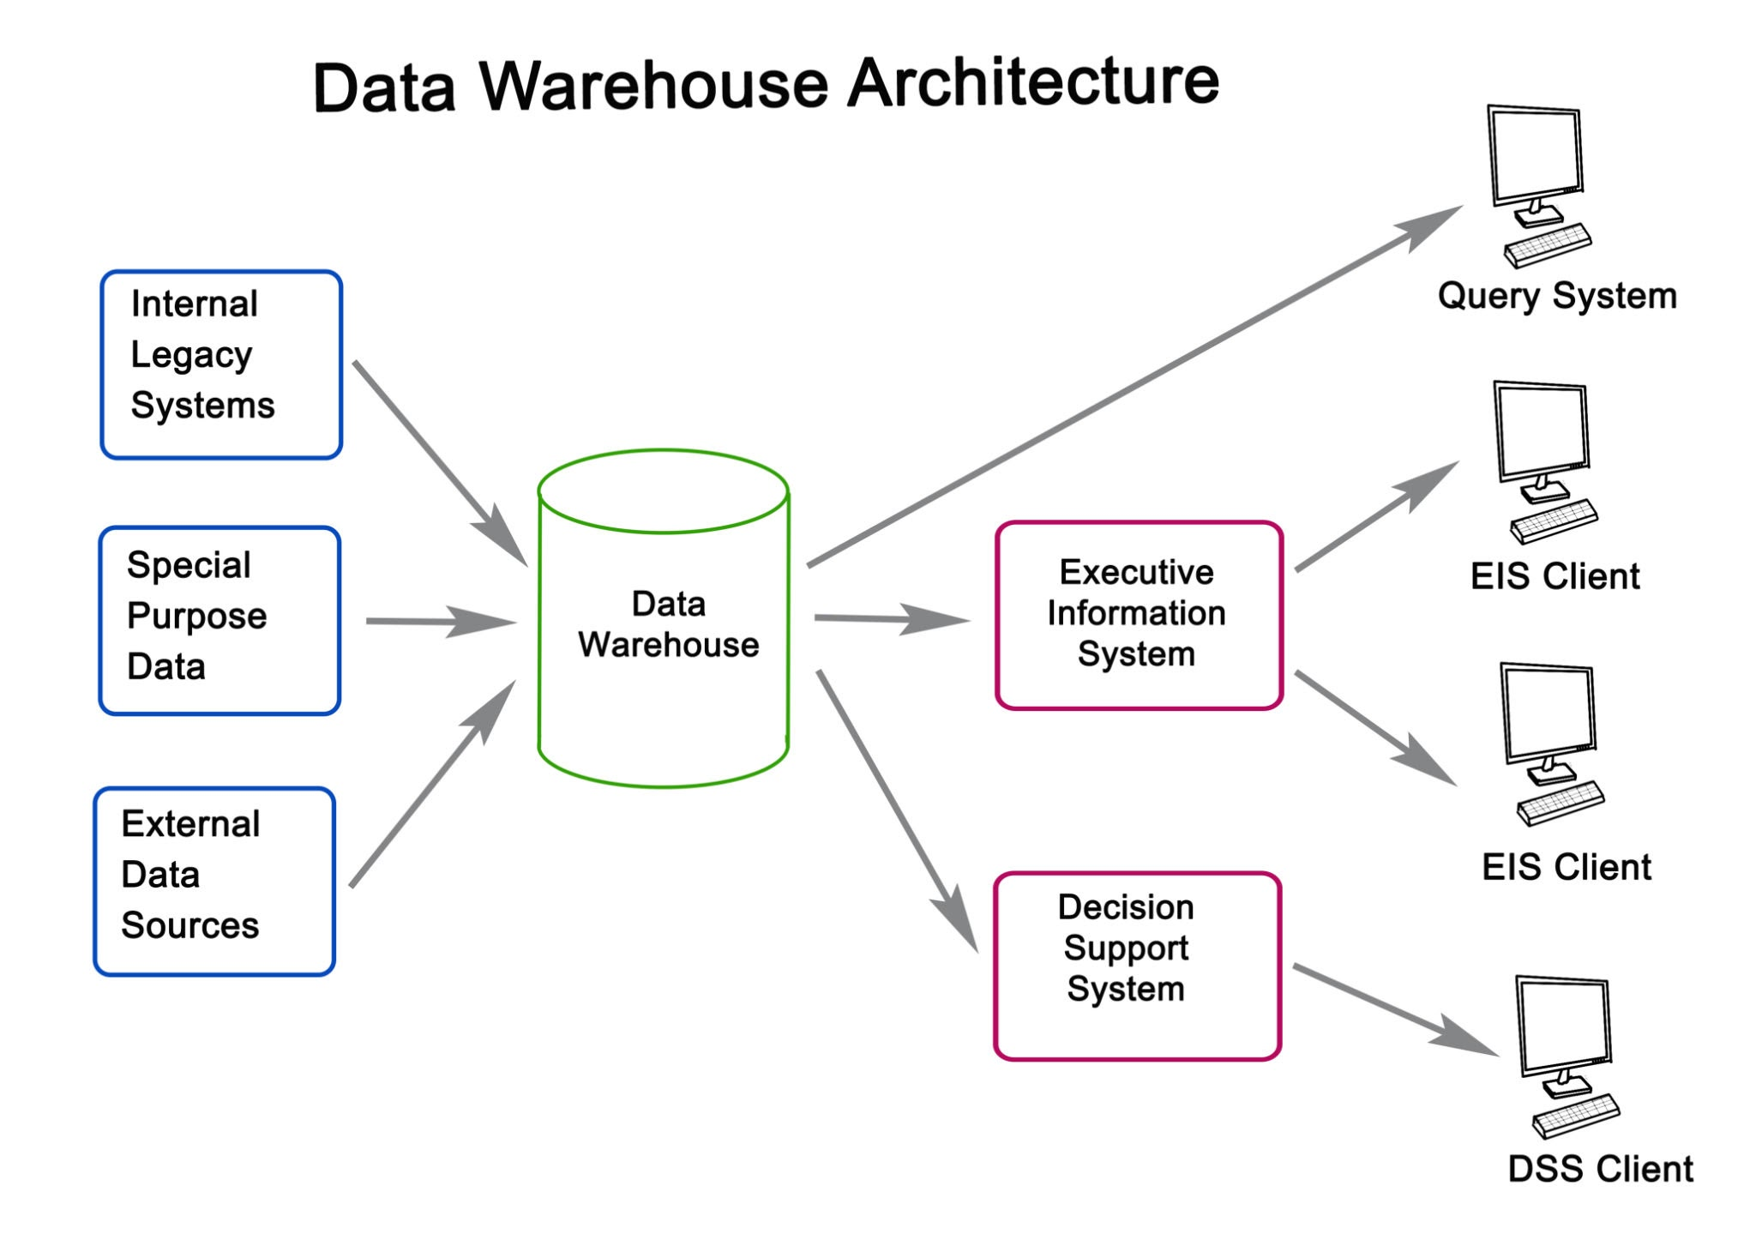
Getty Images

2. System Models and Diagrams

2.1 Use Case Diagram
The system identifies two primary actors: Customer and Admin.
- Customer: Manages profile, browses products, and handles orders.
- Admin: Oversees the inventory, order fulfillment, and user base.

2.2 Data Flow Diagram (DFD) - Level 1
The flow illustrates how data moves from the UI through the PHP logic into the MySQL tables.

3. Database Design

3.1 Entity Relationship Diagram (ERD)
The database is normalized to 3NF (Third Normal Form) to ensure data integrity.

3.2 Detailed Data Dictionary
Table | Column | Data Type | Constraints
users | user_id | INT | PK, AI
 | password_hash | VARCHAR(255) | Hashed
products | price | DECIMAL(10,2) | Not Null
orders | status | ENUM | 'Pending', 'Shipped', 'Delivered'

4. Technical Design Specifications

4.1 Security Implementation
- Authentication: Using PHP $_SESSION variables to maintain user state.
- Data Protection: Use of password_hash() for storage and password_verify() for login.
- SQL Safety: Implementation of PDO (PHP Data Objects) with prepared statements to neutralize SQL Injection risks.

4.2 Component Design
- Cart Module: A session-based or database-linked array that stores product_id and quantity.
- Admin Dashboard: A restricted area using a middleware-style check:
PHP
if($_SESSION['role'] !== 'admin') { header('Location: login.php'); }

5. Interface Design

5.1 User Interface (UI)
- Home Page: Features a dynamic grid of products fetched from the products table.
- Product Detail: Dynamic routing (e.g., product.php?id=101) to display specific item data.

5.2 Admin Interface
- Product CRUD: A table-view with "Edit" and "Delete" icons linked to PHP action scripts.
- Reports: A summary view using SQL SUM() and COUNT() functions to display total sales.

6. Deployment Strategy
- Local Environment: XAMPP (Apache 2.4, MySQL 8.0).
- Database Migration: Exporting .sql schema from localhost and importing to the production server.
- Configuration: Centralized config.php file for database credentials.

7. Summary of Design
SmartShop is designed for modularity. By separating the CSS, PHP logic, and MySQL queries, the system remains maintainable. The use of Bootstrap ensures the site is accessible on mobile devices, meeting the modern standard for e-commerce.

