*Given the following state transition table Which of the test cases below will cover the following series of state transitions? S1 SO S1 S2 SO

Exhibit:
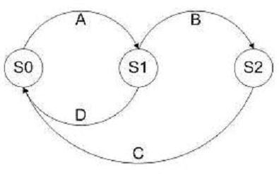

A. D, A, B, C.
B. A, B, C, D.
C. D, A, B.
D. A, B, C.

Q. 13: Given the following state transition diagram Which of the following series of state transitions contains an INVALID transition which may indicate a fault in the system design?

Exhibit:
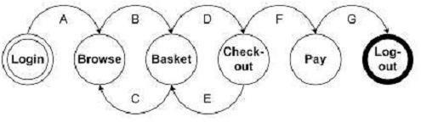

A. Login Browse Basket Checkout Basket Checkout Pay Logout.
B. Login Browse Basket Checkout Pay Logout.
C. Login Browse Basket Checkout Basket Logout.
D. Login Browse Basket Browse Basket Checkout Pay Logout.

Q. 16: Given the following fragment of code, how many tests are required for 100% decision coverage?

if width > length

then
biggest_dimension = width
if height > width
then
biggest_dimension = height
end_if

else
biggest_dimension = length
if height > length
then
biggest_dimension = height
end_if

end_if

- 3
- 4
- 2
- 1

<<<<<< =================== >>>>>>

Q. 17: You have designed test cases to provide 100% statement and 100% decision coverage for the following fragment of code.

if width > length
then

biggest_dimension = width
else
biggest_dimension = length
end_if

The following has been added to the bottom of the code fragment above.

print "Biggest dimension is " & biggest_dimension
print "Width: " & width
print "Length: " & length

How many more test cases are required?

A. One more test case will be required for 100 % decision coverage.

B. Two more test cases will be required for 100 % statement coverage, one of which will be used to provide 100% decision coverage.

C. None, existing test cases can be used.

D. One more test case will be required for 100" statement coverage.

<<<<<< =================== >>>>>>

Q. 18: A thermometer measures temperature in whole degrees only. If the temperature falls below 18 degrees, the heating is switched off. It is switched on again when the temperature reaches 21 degrees. What are the best values in degrees to cover all equivalence partitions?

A. 15,19 and 25.
B. 17,18 and19.
C. 18, 20 and22.
D. 16, 26 and 32.

Q. 21: Given the following decision table: Which of the following test cases and expected results is VALID?

 | Rule 1 | Rule 2 | Rule 3 |  | Rule 4

Conditions
Age | <21 | 21-29 yrs | 30-50yrs |  | > 50yrs
 | yrs
Insurance | A | A or B | B. C or D |  | C or D
Class
Actions
Premium | £100 | £90 | £70 |  | £70
Excess | £2,500 | £2,500 | £500 |  | £1000

A. 23 year old in insurance class A Premium is 0 and excess is,500.
B. 51 year old in insurance class C Premium is 0 and excess is 00.

C. 31 year old in insurance class B Premium is 0 and excess is ,500.
D. 43 year old in insurance class C Premium is 0 and excess is ,000.

Q. 24: A wholesaler sells printer cartridges. The minimum order quantity is 5. There is a 20% discount for orders of 100 or more printer cartridges. You have been asked to prepare test cases using various values for the number of printer cartridges ordered. Which of the following groups contain three test inputs that would be generated using Boundary Value Analysis?

A. 5, 6, 20
B. 4, 5, 80

C. 4, 5, 99

D. 1, 20, 100

Q. 33: Match the following terms and statements.

1.Decision Table Testing
2.Decision Testing
3.State Transition Testing
4.Exploratory Testing

W. Testing carried out w boxes to achieve specific test objectives, possibly to complement structured testing.

X. A test technique used which may be used to verify different system re depending on current conditions or previous history.

Y. A test technique which combines combinations of inputs that might not otherwise have been exercised during testing.

Z. A form of control flow testing based on decision outcomes.

Options:

A. 1Y, 2Z, 3X, 4W.
B. 1X ,2W, 3Z, 4Y.
C. 1Z, 2X, 3W, 4Y.
D. 1Z, 2Y, 3X, 4W.
<<<<<< =================== >>>>>>

Q. 34: Which type of test design techniques does the following statement best describe a procedure to derive test cases based on the specification of a component?

A. Black Box Techniques.
B. White Box Techniques.
C. Glass Box Techniques.

D. Experience Based Techniques.

Q. 36: Which of the following types of defects is use case testing MOST LIKELY to uncover?

- Defects in the process flows during real-world use of the system.
- Defects in the interface parameters in integration testing.
- Integration defects caused by the interaction and interference of different components.

- Defects in the system as it transitions between one state and another.

A. ii, iii.
B. i, iii.
C. iii, iv.
D. i, ii

Q. 39: The above diagram represents the following paths through the code.

- vwy
- vwz
- vxy
- vxz
What is the MINIMUM combination of paths required to provide full statement coverage?
Exhibit:
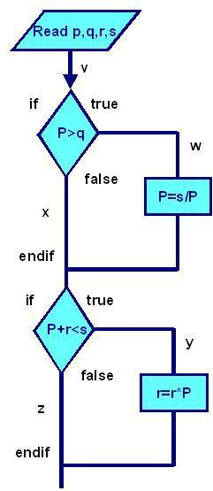

- A
- ABD
- ABCD

- ACD

<<<<<< =================== >>>>>>

Q. 40: Which of the following is MOST characteristic of specification based (black-box) techniques?

A. Test cases can be easily automated.
B. Test cases are independent of each other.

C. Test cases are derived systematically from models of the system .
D. Test cases are derived systematically from the delivered code.
Q. 45: Complete statement and branch coverage means:

A. That you have tested every statement in the program.

B. That you have tested every statement and every branch in the program.

C. That you have tested every IF statement in the program.

D. That you have tested every combination of values of IF statements in the program

Q. 49: We can achieve complete statement coverage but still miss bugs because:

A. The failure occurs only if you reach a statement taking the TRUE branch of an IF statement, and you got to the statement with a test that passed through the FALSE branch.

B. The failure depends on the program's inability to handle specific data values, rather than on the program's flow of control.

C. We are not required to test code that customers are unlikely to execute.

D. All of the above

Q. 61: ‘X’ has given a data on a person age, which should be between 1 to 99. Using BVA which is the appropriate one

- 0,1,2,99
- 1, 99, 100, 98
- 0, 1, 99, 100
- –1, 0, 1, 99

Q. 66: Which is not a black box testing technique

A. Equivalence partition
B. Decision tables
C. Transaction diagrams
D. Decision testing

Q. 69: Purpose of test design technique is

A. Identifying test conditions only, not Identifying test cases

B. Not Identifying test conditions, Identifying test cases only

C. Identifying test conditions and Identifying test cases

D. Identifying test conditions or Identifying test cases

Q. 73: Arc testing is known as

A. Branch testing
B. Agile testing
C. Beta testing

D. Ad-hoc testing

Q. 75: The ___________ technique can be used to achieve input and output coverage

A. Boundary value analysis
B. Equivalence partitioning
C. Decision table testing

D. State transition testing

Q. 83: The principle of Cyclomatic complexity, considering L as edges or links, N as nodes, P as independent paths

- L-N +2P

- N-L +2P
- N-L +P
- N-L +P

Q. 93: White Box Techniques are also called as:

A. Structural Testing
B. Design Based Testin
C. Error Guessing Technique
D. Experience Based Technique

Q. 101: The Switch is switched off once the temperature falls below 18 and then it is turned on when the temperature is more than 21. When the temperature is more than 21. Identify the Equivalance values which belong to the same class.

- 12,16,22
- 24,27,17
- 22,23,24
- 14,15,19

<<<<<< =================== >>>>>>

Q. 102: What is an equivalence partition (also known as an equivalence class)?

A. A set of test cases for testing classes of objects

B. An input or output range of values such that only one value in the range becomes a test case C. An input or output range of values such that each value in the range becomes a test case
D. An input or output range of values such that every tenth value in the range becomes a test case.
Q. 110: The Test Cases Derived from use cases

A. Are most useful in uncovering defects in the process flows during real world use of the system B. Are most useful in uncovering defects in the process flows during the testing use of the system C. Are most useful in covering the defects in the process flows during real world use of the system D. Are most useful in covering the defects at the Integration Level

Q. 111: One of the fields on a form contains a text box which accepts alpha numeric values. Identify the Valid Equivalence class

- BOOK
- Book

- Boo01k
- book

<<<<<< =================== >>>>>>

Q. 112: In a Examination a candidate has to score minimum of 24 marks inorder to clear the exam. The maximum that he can score is 40 marks. Identify the Valid Equivalance values if the student clears the exam.

- 22,23,26
- 21,39,40
- 29,30,31
- 0,15,22

Q. 116: Which of the following techniques is NOT a White box technique?

A. Statement Testing and coverage
B. Decision Testing and coverage

C. Condition Coverage
D. Boundary value analysis

Q. 122: One of the fields on a form contains a text box which accepts numeric values in the range of 18 to 25. Identify the invalid Equivalance class

- 17
- 19

- 24
- 21

Q. 127: What's the disadvantage of Black Box Testing

A. Chances of having repetition of tests that are already done by programmer.
B. The test inputs needs to be from large sample space.

C. It is difficult to identify all possible inputs in limited testing time. So writing test cases is slow and difficult

D. All above

Q. 139: Performs sufficient testing to evaluate every possible path and condition in the application system. The only test method that guarantees the proper functioning of the application system is called as _____________

A. Regression Testing
B. Exhaustive Testing
C. Basic Path Testing
D. Branch Testing

. 148: During testing, a defect was found in which the system crashed when the network got disconnected while receiving data from the server. The defect was fixed by correcting functionality which checks the network availability during data transfer. Existing test cases did cover 100% of the module statements. To verify the fix and ensure more extensive coverage, some tests were designed and added to the test suite. What types of testing are mentioned above?

I. Functional testing
II. Structural testing

- Confirmation testing IV. Performance testing

A. I, III and IV
B. I and III
C. II and IV
D. I, II and III

. 153: The testing technique that requires devising test cases to demonstrate that each program function is operational is called

- Black-box testing
- Glass-box testing
- Grey-box testing
- White-box testing

<<<<<< =================== >>>>>>

Q. 154: A white box testing technique that measures the number of or percentage of decision directions executed by the test case designed is called

A. Condition coverage
B. Decision/Condition coverage

C. Decision Coverage
D. Branch coverage

Q. 168: _______ includes both Black box and White Box Testing features

A. Gray Box Testing
B. Hybrid Testing
C. A. & B.

D. None

<<<<<< ===================
. 178: Incorrect form of Logic coverage is:

A. Statement Coverage
B. Pole Coverage
C. Condition Coverage
D. Path Coverage

<<<<<< =================== >>>>>>

Q. 179: Code Coverage is used as a measure of what?

- Defects
- Trends analysis
- Test Effectiveness

- Time Spent Testing

Q. 183: Statement Coverage will not check for the following.

A. Missing Statements
B. Unused Branches
C. Dead Code
D. Unused Statement

<<<<<< =================== >>>>>>

Q. 184: Given the Following program

IF X <>= Z

THEN Statement 2;
END

McCabe’s Cyclomatic Complexity is :

- 2
- 3
- 4

- 5

Q. 187: Boundary value testing

A. Is the same as equivalence partitioning tests

B. Test boundary conditions on, below and above the edges of input and output equivalence classes

C. Tests combinations of input circumstances
D. Is used in white box testing strategy

<<<<<< =================== >>>>>>

Q. 188: An input field takes the year of birth between 1900 and 2004

The boundary values for testing this field are

- 0,1900,2004,2005
- 1900, 2004
- 1899,1900,2004,2005
- 1899, 1900, 1901,2003,2004,2005

<<<<<< =================== >>>>>>

Q. 189: How many test cases are necessary to cover all the possible sequences of statements (paths) for the following program fragment? Assume that the two conditions are independent of each other:

if (Condition 1)
then statement 1
else statement 2
fi

if (Condition 2)
then statement 3

fi

A. 2 Test Cases
B. 3 Test Cases
C. 4 Test Cases
D. Not achievable

<<<<<< =================== >>>>>>

Q. 190: A common test technique during component test is

A. Statement and branch testing
B. Usability testing

C. Security testing
D. Performance testing

. 208: Equivalence partitioning is:

A. A black box testing technique used only by developers
B. A black box testing technique than can only be used during system testing

C. A black box testing technique appropriate to all levels of testing
D. A white box testing technique appropriate for component testing

Q. 212: Which of these can be successfully tested using Loop Testing methodology?

A. Simple Loops

B. Nested Loops
C. Concatenated Loops
D. All of the above

Q. 213: Cyclomatic Complexity method comes under which testing method.

A. White box
B. Black box

C. Green box
D. Yellow box

Q. 227: Order numbers on a stock control system can range between 10000 and 99999 inclusive. Which of the following inputs might be a result of designing tests for only valid equivalence classes and valid boundaries:

A. 1000, 5000, 99999
B. 9999, 50000, 100000
C. 10000, 50000, 99999
D. 10000, 99999
E. 9999, 10000, 50000, 99999, 10000

Q. 230: Given the following:

Switch PC on
Start "outlook"

IF outlook appears THEN

Send an email
Close outlook

A. 1 test for statement coverage, 1 for branch coverage
B. 1 test for statement coverage, 2 for branch coverage
C. 1 test for statement coverage. 3 for branch coverage
D. 2 tests for statement coverage, 2 for branch coverage
E. 2 tests for statement coverage, 3 for branch coverage

Q. 236: Given the following code, which is true:

IF A > B THEN
C = A – B
ELSE

C = A + B
ENDIF
Read D

IF C = D Then
Print "Error"
ENDIF

A. 1 test for statement coverage, 3 for branch coverage
B. 2 tests for statement coverage, 2 for branch coverage

C. 2 tests for statement coverage. 3 for branch coverage
D. 3 tests for statement coverage, 3 for branch coverage
E. 3 tests for statement coverage, 2 for branch coverage

. 243: Consider the following state transition diagram of a two-speed hair dryer, which is operated by pressing its one button. The first press of the button turns it on to Speed 1, second press to Speed 2 and the third press turns it off.
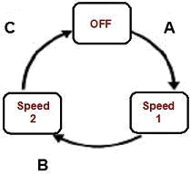

Which of the following series of state transitions below will provide 0-switch coverage?

- A,C,B
- B,C,A

- A,B,C
- C,B,A

<<<<<< ===================

Q. 251: Which of the following is NOT a black box technique:

A. Equivalence partitioning
B. State transition testing
- LCSAJ

- Syntax testing
- Boundary value analysis

. 254: Consider the following:

Pick up and read the newspaper
Look at what is on television

If there is a program that you are interested in watching then switch the the television on and watch the

program
Otherwise

Continue reading the newspaper
If there is a crossword in the newspaper then try and complete the crossword

A. SC = 1 and DC = 1
B. SC = 1 and DC = 2

C. SC = 1 and DC = 3
D. SC = 2 and DC = 2
E. SC = 2 and DC = 3

. 256: Consider the following statements about early test design:

i. Early test design can prevent fault multiplication
- Faults found during early test design are more expensive to fix
- Early test design can find faults

- Early test design can cause changes to the requirements
- Early test design takes more effort

A. i, iii & iv are true. Ii & v are false
B. iii is true, I, ii, iv & v are false
C. iii & iv are true. i, ii & v are false

D. i, iii, iv & v are true, ii us false
E. i & iii are true, ii, iv & v are false

<<<<<< =================== >>>>>>

Q. 257: Given the following code, which is true about the minimum number of test cases required for full statement and branch coverage:

Read P
Read Q
IF P+Q > 100 THEN
Print "Large"

ENDIF

If P > 50 THEN
Print "P Large"
ENDIF

A. 1 test for statement coverage, 3 for branch coverage
B. 1 test for statement coverage, 2 for branch coverage
C. 1 test for statement coverage, 1 for branch coverage
D. 2 tests for statement coverage, 3 for branch coverage

E. 2 tests for statement coverage, 2 for branch coverage

. 259: Error guessing is best used

A. As the first approach to deriving test cases

B. After more formal techniques have been applied
C. By inexperienced testers
D. After the system has gone live
E. Only by end users

Q. 261: One of the fields on a form contains a text box, which accepts alphabets in lower or upper case. Identify the invalid Equivalance class value.

- CLASS
- cLASS
- CLass
- CLa01ss

268: Which of the following is true about White and Black Box Testing Technique:-

A. Equivalence partitioning, Decision Table and Control flow are White box Testing Techniques.

B. Equivalence partitioning, Boundary Value Analysis , Data Flow are Black Box Testing Techniques.

C. Equivalence partitioning , State Transition , Use Case Testing are black box Testing Techniques.

D. Equivalence Partitioning, State Transition, Use Case Testing and Decision Table are White Box Testing Techniques.

270: Features of White Box Testing Technique:
i. We use explicit knowledge of the internal workings of the item being tested to select the test data.

- Uses specific knowledge of programming code to examine outputs and assumes that the tester knows the path of logic in a unit or a program.

- Checking for the performance of the application

- Also checks for functionality.

A. i, ii are true and iii and iv are false
B. iii is true and i,ii, iv are false
C. ii ,iii is true and i,iv is false

D. iii and iv are true and i,ii are false

. 274: Minimum Test Required for Statement Coverage:

Disc = 0
Order-qty = 0
Read Order-qty
If Order-qty >=20 then
Disc = 0.05
If Order-qty >=100 then

Disc =0.1
End if
End if

A. Statement coverage is 4
B. Statement coverage is 1

C. Statement coverage is 3
D. Statement Coverage is 2

Q. 282: What is the expected result for each of the following test cases?

 | Rule1 | Rule2 | Rule3 | Rule4
Conditions
Citibank Card | Yes | Yes | No | No
Member
Type of Room | Silver | Platinum | Silver | Platinum
Actions
Offer upgrade | Yes | No | No | No
To Gold
Luxury
Offer upgrade | N/A | Yes | N/A | No
to Silver

A. Citibank card member, holding a Silver room

B. Non Citibank-member, holding a Platinum room

A. A – Don’t offer any upgrade, B – Don’t offer any upgrade.
B. A – Don’t offer any upgrade, B – Offer upgrade to Gold.
C. A – Offer upgrade to Silver, B – Offer upgrade to Silver.
D. A – Offer upgrade to Gold, B – Don’t offer any upgrade.

Q. 286: Consider the following state transition diagram of a switch. Which of the following represents an invalid state transition?
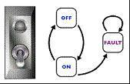

A. OFF to ON
B. ON to OFF

C. FAULT to ON

. 294: Minimum Tests Required for Statement Coverage and Branch Coverage:

Read P
Read Q

If p+q > 100 then
Print "Large"
End if
If p > 50 then

Print "pLarge"
End if

A. Statement coverage is 2, Branch Coverage is 2
B. Statement coverage is 3 and branch coverage is 2
C. Statement coverage is 1 and branch coverage is 2
D. Statement Coverage is 4 and Branch coverage is 2

- If a candidate is given an exam of 40 questions, should get 25 marks to pass (61%) and should get 80% for distinction, what is equivalence class.

A. 23, 24, 25
B. 0, 12, 25
C. 30, 36, 39

D. 32,37,40

- In a system designed to work out the tax to be paid: An employee has $4000 of salary tax free. The next $1500 is taxed at 10% The next $28000 is taxed at 22% Any further amount is taxed at 40%

Which of these groups of numbers would fall into the same equivalence class?
- $5800; $28000; $32000
- $0; $200; $4200
- $5200; $5500; $28000
- $28001; $32000; $35000

. 305: Cyclomatic complexity is used to calculate

A. Number of independent paths in the basis set of a program B. Number of binary decisions + 1

C. Number bound for the number of tests that must be conducted to ensure that all statements have been executed at least once

D. Number of branches and decisions

Q. 310: What is the smallest number of test cases required to Provide 100% branch coverage?

If(x>y) x=x+1;
else y=y+1;
while(x>y)

{
y=x*y; x=x+1;
}

- 1
- 2
- 3
- 4

Q. 329: Error guessing is:

A. An appropriate way of deriving system tests.
B. Only used if good requirements are not available.

C. Only used when good requirements are available.
D. The most appropriate way of deriving system tests.

<<<<<< =================== >>>>>>

Q. 332: In a system designed to work out the tax to be paid: An employee has $4000 of salary tax free. The next $1500 is taxed at 10% The next $28000 is taxed at 22% Any further amount is taxed at 40%

To the nearest $ which of these is a valid Boundary Value Analysis test case?

- $1500
- $32001
- $28000

- $33501

Q. 337: If the pseudo code below were a programming language ,how many tests are required to achieve 100% statement coverage?

- If x=3 then
- Display_messageX;
- If y=2 then
- Display_messageY;
- Else
- Display_messageZ;

- Else
- Display_messageZ;

- 1
- 2

- 3
- 4

- Using the same code example as question 17,how many tests are required to achieve 100% branch/decision coverage?

- 1
- 2
- 3
- 4

<<<<<< =================== >>>>>>

Q. 340: A test design technique is

A. A process for selecting test cases
B. A process for determining expected outputs
C. A way to measure the quality of software
D. A way to measure in a test plan what has to be don

Q. 345: A program validates a numeric field as follows:

Values less than 10 are rejected, values between 10 and 21 are accepted, values greater than or equal to 22 are rejected. Which of the following covers the MOST boundary values?

- 9,10,11,22
- 9,10,21,22

- 10,11,21,22
- 10,11,20,21

. 350: Which of the following is a black box design technique?

A. Statement testing

B. Equivalence partitioning
- Error- guessing
- Usability testing

Q. 353: What is the important criterion in deciding what testing technique to use?

A. How well you know a particular technique
B. The objective of the test

C. How appropriate the technique is for testing the application
D. Whether there is a tool to support the technique
. 355: Coverage measurement

A. Is nothing to do with testing
B. Is a partial measure of test thoroughness
C. Branch coverage should be mandatory for all software
D. Can only be applied at unit or module testing, not at system testing

358: A program validates a numeric field as follows:

Values less than 10 are rejected, values between 10 and 21 are accepted, values greater than or equal to 22 are rejected. Which of the following input values cover all of the equivalence partitions?

- 10,11,21
- 3,20,21

- 3,10,22
- 10,21,22

<<<<<< =================== >>>>>>

- 359: Which is not true-The black box tester

- Should be able to understand a functional specification or requirements document
- Should be able to understand the source code.
- Is highly motivated to find faults
- Is creative to find the system’s weaknesses

- 361: A program with high cyclometic complexity is almost likely to be:

- Large
- Small
- Difficult to write

- Difficult to test

<<<<<< =================== >>>>>>

Q. 362: Which of the following is the odd one out?

A. White box
B. Glass box

- Structural
- Functional

<<<<<< =================== >>>>>>

Q. 363: Which of the following techniques are black box techniques?

A. State transition testing, code testing, agile testing
B. Equivalence partitioning, state transition testing, decision table testing

C. System testing, acceptance testing, equivalence partitioning
D. System integration testing, system testing, decision table testing

. 367: Why does the boundary value analysis provide good test cases?
A. Because it is an industry standard

B. Because errors are frequently made during programming of the different cases near the ‘edges’ of the range of values

C. Because only equivalence classes that are equal from a functional point of view are considered in the test cases

D. Because the test object is tested under maximal load up to its performance limits

<<<<<< =================== >>>>>>

Q. 368: If a program is tested and 100% branch coverage is achieved, which of the following coverage criteria is then guaranteed to be achieved?

A. 100% Equivalence class coverage
B. 100% Condition coverage and 100% Statement coverage
C. 100% Statement coverage
D. 100% Multiple condition coverage

Q. 376: This part of a program is given:

WHILE (condition A) Do B
END WHILE
How many decisions should be tested in this code in order to achieve 100% decision coverage?

- 2
- Indefinite
- 1
- 4

<<<<<< =================== >>>>>>

Q. 377: In a flight reservation system, the number of available seats in each plane model is an input. A plane may have any positive number of available seats, up to the given capacity of the plane. Using Boundary Value analysis, a list of available – seat values were generated. Which of the following lists is correct?

A. 1, 2, capacity -1, capacity, capacity plus 1
B. 0, 1, capacity, capacity plus 1
C. 0, 1, 2, capacity plus 1, a very large number
D. 0, 1, 10, 100, capacity, capacity plus one

<<<<<< =================== >>>>>>

Q. 378: Which of the following is a valid collection of equivalence classes for the following
problem: An integer field shall contain values from and including 1 to and including 15

A. Less than 1, 1 through 15, more than 15
B. Negative numbers, 1 through 15, above 15
C. Less than 1, 1 through 14, more than 15
D. Less than 0, 1 through 14, 15 and more
Q. 385: This part of a program is given:

WHILE (condition A)
Do B
END WHILE

How many paths should be tested in this code in order to achieve 100% path coverage?

- One
- Indefinite
- Two
- Four

. 387:If a program is tested and 100% condition coverage is achieved, which of the following coverage criteria is then guaranteed to be achieved?

A. 100% branch coverage
B. 100% condition coverage and 100% statement coverage

C. Equivalence class and boundary value coverage
D. No other white box coverage criterion is guaranteed to be fulfilled 100%

Q. 402: Branch Coverage

A. Another name for decision coverage
- Another name for all-edges coverage

- Another name for basic path coverage
- All the above

. 405: A test case design technique for a component in which test cases are designed to execute statements is called as?

A. State transition Testing
B. Static Testing
C. Transition testing

D. Statement testing

Q. 411: if (condition1 && (condition2 function1()))
statement1;
else

statement2;

A. Decision coverage
B. Condition coverage
C. Statement coverage

D. Path Coverage

Q. 413: In ________ testing test cases i.e input to the software are created based on the specifications languages

A. State Transition Testing
B. Random Testing
C. Syntax Testing

D. Penetration testing

<<<<<< =================== >>>>>>

Q. 414: White Box Testing

A. Same as glass box testing
B. Same as clear box testing
C. Both A. and B.
D. None of the above.

. 416: Equivalence partitioning consists of various activities:

A. Ensure that test cases test each input and output equivalence class at least once B. Identify all inputs and all outputs
C. Identify equivalence classes for each input
D. All of the above

. 431: Structural Testing

A. Same as black box testing
B. Same as white box testing
C. Same as functional testing
D. None of the above.

Q. 443: Path coverage includes

A. Statement coverage
B. Condition coverage
C. Decision coverage

D. None of these

<<<<<< =================== >>>>>>

Q. 444: Which testing technique do you prefer for the following situations?

- Severe time pressure
- Inadequate specification

A. Decision testing
B. Error guessing

C. Statement testing
D. Exploratory testing

<<<<<< =================== >>>>>>

Q. 445: Recovery testing is a system test that forces the software to fail and verifies that data recovery is properly performed. The following should be checked for correctness

- Re-initialization
- Restart
- Data Recovery
- Check Point Mechanism

A. 1 and 2
B. 1, 2 and 3
C. 1, 2, 3 and 4
D. 2 and 4

<<<<<< =================== >>>>>>

Q. 446: Data flow analysis studies:

A. Possible communications bottlenecks in a program.
B. The rate of change of data values as a program executes.

C. The use of data on paths through the code.
D. The intrinsic complexity of the code.

<<<<<< =================== >>>>>>

Q. 447: Which of the following is NOT a white box technique?

A. Statement testing
B. Path testing
C. Data flow testing
D. State transition testi

459: Which of the following statements is NOT correct?

A. A minimal test set that achieves 100% LCSAJ coverage will also achieve 100% branch coverage.

B. A minimal test set that achieves 100% path coverage will also achieve 100% statement coverage.

C. A minimal test set that achieves 100% path coverage will generally detect more faults than one that achieves 100% statement coverage.

D. A minimal test set that achieves 100% statement coverage will generally detect more faults than one that achieves 100% branch coverage.

Q. 467: Error guessing:

A. Supplements formal test design techniques.

B. Can only be used in component, integration and system testing.
C. Is only performed in user acceptance testing.

D. Is not repeatable and should not be used.

<<<<<< =================== >>>>>>

Q. 468: In a system designed to work out the tax to be paid:

An employee has £4000 of salary tax free. The next £1500 is taxed at 10% The next £28000 is taxed at 22%
Any further amount is taxed at 40%

Which of these groups of numbers would fall into the same equivalence class?

- £4800; £14000; £28000
- £5200; £5500; £28000
- £28001; £32000; £35000
- £5800; £28000; £32000

. 480: In a system designed to work out the tax to be paid:

An employee has £4000 of salary tax free. The next £1500 is taxed at 10% The next £28000 is taxed at 22%

Any further amount is taxed at 40%

To the nearest whole pound, which of these is a valid Boundary Value Analysis test case?

- £1500
- £32001
- £33501
- £28000

Q. 481: Which of the following is NOT true of test coverage criteria?

A. Test coverage criteria can be measured in terms of items exercised by a test suite.
B. A measure of test coverage criteria is the percentage of user requirements covered.

C. A measure of test coverage criteria is the percentage of faults found.
D. Test coverage criteria are often used when specifying test completion criteria.

<<<<<< =================== >>>>>>

Q. 482: Analyze the following highly simplified procedure:

Ask: "What type of ticket do you require, single or return?"
IF the customer wants ‘return’
Ask: "What rate, Standard or Cheap-day?"
IF the customer replies ‘Cheap-day’
Say: "That will be £11:20"
ELSE
Say: "That will be £19:50"

ENDIF
ELSE

Say: "That will be £9:75"
ENDIF

Now decide the minimum number of tests that are needed to ensure that all the questions have been asked, all combinations have occurred and all replies given.

- 3
- 4

- 5
- 6

Q. 490: Given the following specification, which of the following values for age are in the SAME equivalence partition?

If you are less than 18, you are too young to be insured. Between 18 and 30 inclusive, you will receive a 20% discount. Anyone over 30 is not eligible for a discount.

A. 17, 18, 19.
B. 29, 30, 31.

C. 18, 29, 30.
D. 17, 29, 31.

Q. 491: Consider the following statements:

i.100% statement coverage guarantees 100% branch coverage.

ii.100% branch coverage guarantees 100% statement coverage.
iii.100% branch coverage guarantees 100% decision coverage.
iv.100% decision coverage guarantees 100% branch coverage.
v.100% statement coverage guarantees 100% decision coverage.

A. ii is True; i, iii, iv & v are False
B. i & v are True; ii, iii & iv are False
C. ii & iii are True; i, iv & v are False
D. ii, iii & iv are True; i & v are False

Q. 498: In a system designed to work out the tax to be paid:

An employee has £4000 of salary tax free.
The next £1500 is taxed at 10%.

The next £28000 after that is taxed at 22%.
Any further amount is taxed at 40%.

To the nearest whole pound, which of these is a valid Boundary Value Analysis test case?

- £28000.
- £33501.
- £32001.

- £1500.

Q. 503: Considering the following pseudo-code, calculate the MINIMUM number of test cases for statement coverage, and the MINIMUM number of test cases for decision coverage respectively.

READ A

READ B
READ C
IF C>A THEN
IF C>B THEN

PRINT "C must be smaller than at least one number"
ELSE
PRINT "Proceed to next stage"
ENDIF
ELSE
PRINT "B can be smaller than C"

ENDIF
A. 3, 3.

B. 2, 3.
C. 2, 4.
D. 3, 2.

Q. 507: The following statements are used to describe the basis for creating test cases using either black or white box techniques:

i Information about how the software is constructed.
- Models of the system, software or components.
- Analysis of the test basis documentation.
- Analysis of the internal structure of the components.

Which combination of the statements describes the basis for black box techniques?

A. ii and iii.
B. ii and iv.
C. i and iv.

D. i and iii.

Q. 512: Consider the following techniques. Which are static and which are dynamic techniques?

i. Equivalence Partitioning.

- Use Case Testing. iii.Data Flow Analysis. iv.Exploratory Testing.

- Decision Testing.
- Inspections.

- i-iv are static, v-vi are dynamic.
- iii and vi are static, i, ii, iv and v are dynamic.
- ii, iii and vi are static, i, iv and v are dynamic.

- vi is static, i-v are dynamic.

<<<<<< =================== >>>>>>

Q. 513: Given the following code, which statement is true about the minimum number of test cases required for full statement and branch coverage?

Read p
Read q

IF p+q > 100 THEN

Print "Large"
ENDIF
IF p > 50 THEN
Print "p Large"
ENDIF

A. 1 test for statement coverage, 3 for branch coverage
B. 1 test for statement coverage, 2 for branch coverage
C. 1 test for statement coverage, 1 for branch coverage
D. 2 tests for statement coverage, 2 for branch coverage
523: In a system designed to work out the tax to be paid:

An employee has £4000 of salary tax free.
The next £1500 is taxed at 10%.
The next £28000 after that is taxed at 22%.
Any further amount is taxed at 40%.

To the nearest whole pound, which of these groups of numbers fall into three DIFFERENT equivalence classes?

- £4000; £5000; £5500.
- £32001; £34000; £36500.
- £28000; £28001; £32001.

- £4000; £4200; £5600

. 530: Which of the following statements about component testing is FALSE?

A. Black box test design techniques all have an associated test measurement technique
B. White box test design techniques all have an associated test measurement technique
C. Cyclomatic complexity is not a test measurement technique
D. Black box test measurement techniques all have an associated test design technique

Q. 538: When testing a grade calculation system, a tester determines that all scores from 90 to 100 will yield a grade of A, but scores below 90 will not. This analysis is known as:

A. Equivalence partitioning
B. Boundary value analysis

C. Decision table

D. Hybrid analysis

- Which technique can be used to achieve input and output coverage? It can be applied to human input, input via interfaces to a system, or interface parameters in integration testing.

A. Error Guessing
B. Boundary Value Analysis
C. Decision Table testing

D. Equivalence partitioning

. 546: Which of the following statements is true about white-box testing?

A. It includes functional testing
B. It includes loop testing

- It is usually done after black-box testing
- It is usually done during the integration testing phase

. 574: Which test suite will check for an invalid transition using the diagram below?
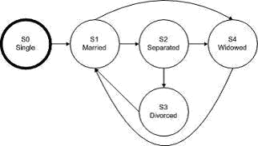

- S0-S1-S2-S3-S1-S4
- S0-S1-S4-S1-S2-S3

- S0-S1-S3-S1-S2-S1
- S0-S1-S2-S3-S1-S2

. 579: In an Examination a candidate has to score minimum of 24 marks in order to clear the exam. The maximum that he can score is 40 marks. Identify the Valid Equivalence values if the student clears the exam.

- 22,23,26
- 21,39,40
- 29,30,31

- 0,15,22

Q. 581: What is the expected result for each of the following test cases?

 | Rule 1 | Rule 2 | Rule 3 | Rule 4
Conditions
Indian Resident? | False | True | True | True
Age between 18-55 | Don’t | False | True | True
 | Care
Married | Don’t | Don’t | False | True
 | Care | Care
Actions
Issue Membership? | False | False | True | True
Offer 10% discount? | False | False | True | False

A.TC1: Anand is a 32 year old married, residing in Kolkatta.
B.TC3: Attapattu is a 65 year old married person, residing in Colombo.

A. A – Issue membership, 10% discount, B–Issue membership, offer no discount.
B. A – Don’t Issue membership, B – Don’t offer discount.

C. A – Issue membership, no discount, B – Don’t Issue membership.
D. A – Issue membership, no discount, B- Issue membership with 10% discount.
Evaluation of different options:

 |  | Rule 1 |  |  |  |  |  | Rule 2 |  |  | Rule 3 |  |  | Rule 4
Conditions
Indian Resident? |  | False |  |  |  |  |  | True |  |  | True |  |  | True
Age between 18-55 |  | Don’t |  |  |  |  |  | False |  |  | True |  |  | True
 |  | Care
Married |  | Don’t |  |  |  |  |  | Don’t |  |  | False |  |  | True
 |  | Care |  |  |  |  |  | Care
Actions
Issue Membership? |  | False |  |  |  |  |  | False |  |  | True |  |  | True
Offer 10% discount? |  | False |  |  |  |  |  | False |  |  | True |  |  | False

Explanation:
For TC1: follow the path in green color

(The person is Indian resident, so select only ‘True’ options. The person is aged between 18-55, so select only ‘True’ The person is a married, so again select only ‘True’

For this person, the actions under ‘Rule 4′ will be applied. That is, issue membership and no discount)

For TC3: follow the path in blue color

(The person is not Indian resident, so select only ‘False’ (under Rule 1)
The person is not aged between 18-55. No need to select any path, as it is written “Don’t care”.
The person is married. No need to select any path, as it is written “Don’t care”.

For this person, the actions under ‘Rule1′ will be applied, That is, Don’t issue membership and no discount.)

<<<<<< =================== >>>>>>

. 588: Which of the following statements about decision tables are TRUE?

I. Decision tables are useful when dealing with multiple inputs that do not interact.

- The strength of a decision table is that it creates combinations of inputs that might not otherwise been evaluated.

III. Decision tables are useful when trying to capture system requirements that contain logical conditions.

IV. Each column of a decision table corresponds to a business rule that defines a unique combination of conditions.

A. II, III and IV
B. I and IV

C. I, II and III
D. I and III

. 594: Which of the following statements is true about white-box testing?

A. It includes functional testing.
B. It includes loop testing.
- It is usually done after black-box testing.
- It is usually done during the integration testing phase.

.598: Which of the following are Black Box test design techniques?

I. Boundary value analysis

- Branch condition testing III. Equivalence partitioning IV. State transition testing.

A. I, II, III and IV
B. I and III
C. III and IV

D. I, III and IV

- Which of the following statements are true for the equivalence partitioning test technique?

I. Divides possible inputs into classes that have the same behavior II. Can be used to create both positive and negative test cases

III. Makes use of only positive test cases for the equivalence partitions

IV. Must always include at least two values from every equivalence partition V. Can be used only for input testing

A. I and II
B. I, II and V
C. I, III and IV
D. I and V

Q. 613: The following code segment contains a potential "divide by 0" error.

J=50
K=1

while (N>= 10) and (N<=10) loop
M [K] = J/N

K = K + 1
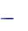
N = N 1
end loop

Which of the following is the most effective way of detecting this error?

A. Boundary testing
B. Condition testing
C. Compilation of the source code
D. Source code inspection

. 619: Which of the following statements about the benefits of deriving test cases from use cases are true?

I. Deriving test cases from use cases is helpful for system and acceptance testing.

- Deriving test cases from use cases is helpful only for automated testing III. Deriving test cases from use cases is helpful for unit testing.

IV. Deriving test cases from use cases is helpful for testing the interaction and interference between different components.

- I
- I and II.
- III
- I and IV

Q. 631: For the following piece of code, how many test cases are needed to get 100% statement coverage?

Procedure X
Read (Color) // Input color from user
IF (Color == “Red”) THEN
Call Roses(Color)
ELSEIF (Color == “Blue”) THEN
Call Violets(Color)
ELSE
PRINT “User is no Shakespeare”
SaveToDatabase(Color)
End Procedure X

- 5
- 3
- 1
- 2

669: Why are both specification-based and structure-based testing techniques useful?

A. They find different types of defect.
B. Using more techniques is always better.

C. Both find the same types of defect.
D. Because specifications tend to be unstructured.

<<<<<< =================== >>>>>>

Q. 670: What is a key characteristic of structure-based testing techniques?

A. They are mainly used to assess the structure of a specification.
B. They are used both to measure coverage and to design tests to increase coverage.
C. They are based on the skills and experience of the tester.

D. They use a formal or informal model of the software or component.

. 671: Which of the following would be an example of decision-table testing for a financial application applied at the system-test level?

A. A table containing rules for combinations of inputs to two fields on a screen.
B. A table containing rules for interfaces between components.
C. A table containing rules for mortgage applications.

D. A table containing rules for chess.

<<<<<< =================== >>>>>>

Q. 672: Which of the following could be a coverage measure for state transition testing?

V. All states have been reached.
W. The response time for each transaction is adequate.
X. Every transition has been exercised.

Y. All boundaries have been exercised.
Z. Specific sequences of transitions have been exercised.

A. X, Y and Z
B. V, X, Y and Z

C. W,X and Y
D. V, X and Z

<<<<<< =================== >>>>>>

Q. 673: Postal rates for 'light letters' are 25p up to 10g, 35p up to 50g plus an extra 10p for each additional 25g up to 100g. Which test inputs (in grams) would be selected using equivalence partitioning?

A. 8, 42, 82, 102
B. 4, 15, 65, 92, 159
C. 10, 50, 75, 100
D. 5, 20, 40, 60, 80

<<<<<< =================== >>>>>>

Q. 674: Which of the following could be used to assess the coverage achieved for specification based (black-box) test techniques?

V. Decision outcomes exercised

W. Partitions exercised
X. Boundaries exercised
Y. State transitions exercised

Z. Statements exercised

A. Y, W, Y, or Z
B. W, X or Y
C. V, X or Z

D. W, X, Y or Z

<<<<<< =================== >>>>>>

Q. 675: Which of the following would structure-based test design techniques be most likely to be applied to?

- Boundaries between mortgage interest rate bands.
- An invalid transition between two different arrears statuses.
- The business process flow for mortgage approval.
- Control flow of the program to calculate repayments.

A. 2, 3 and 4
B. 2 and 4
C. 3 and 4
D. 1,2 and 3

<<<<<< =================== >>>>>>

Q. 676: Use case testing is useful for which of the following?

P. Designing acceptance tests with users or customers.
Q. Making sure that the mainstream business processes are tested.
R. Finding defects in the interaction between components.
S. Identifying the maximum and minimum values for every input field.
T. Identifying the percentage of statements exercised by a sets of tests.

A. P, Q and R
B. Q, S and T
C. P,Q and S
D. R, S and T

<<<<<< =================== >>>>>>

Q. 677: Which of the following statements about the relationship between statement coverage and decision coverage is correct?

A. 100% decision coverage is achieved if statement coverage is greater than 90%.
B. 100% statement coverage is achieved if decision coverage is greater than 90%.
C. 100% decision coverage always means 100% statement coverage.

D. 100% statement coverage always means 100% decision coverage.

<<<<<< =================== >>>>>>

Q. 678: If you are flying with an economy ticket, there is a possibility that you may get upgraded to business class, especially if you hold a gold card in the airline's frequent flier program. If you don't hold a gold card, there is a possibility that you will get 'bumped' off the flight if it is full and you check in late. This is shown in following Figure. Note that each box (i.e. statement) has been numbered.
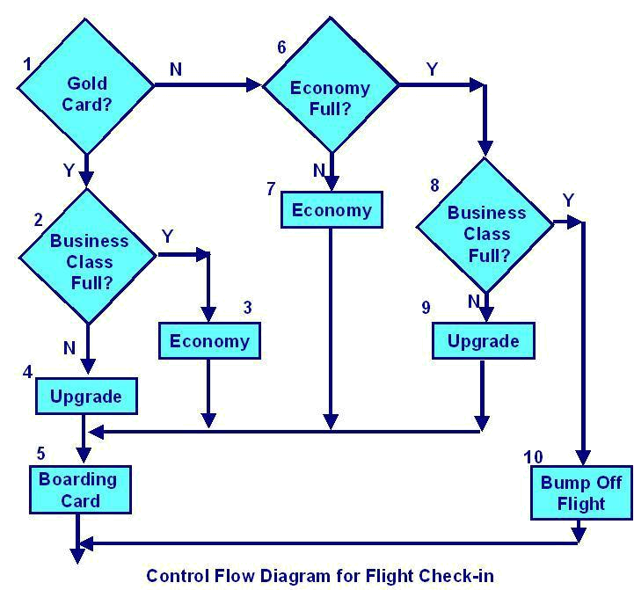

Three tests have been run:

Test 1: Gold card holder who gets upgraded to business class
Test 2: Non-gold card holder who stays in economy

Test 3: A person who is bumped from the flight

What is the statement coverage of these three tests?

- 60%
- 70%
- 80%
- 90%

<<<<<< =================== >>>>>>

Q. 679: Why are error guessing and exploratory testing good to do?

- They can find defects missed by specification-based and structure-based techniques.
- They don't require any training to be as effective as formal techniques.
- They can be used most effectively when there are good specifications.
- They will ensure that all of the code or system is tested.

<<<<<< =================== >>>>>>

Q. 680: How do experience-based techniques differ from specification-based techniques?

A. They depend on the tester's understanding of the way the system is structured rather than on a documented record of what the system should do.

B. They depend on having older testers rather than younger testers.

C. They depend on a documented record of what the system should do rather than on an individual's personal view.

D. They depend on an individual's personal view rather than on a documented record of what the system should do.

. 681: When choosing which technique to use in a given situation, which factors should be taken into account?

V. previous experience of types of defects found in this or similar systems
W. the existing knowledge of the testers

X. regulatory standards that apply

Y. the type of test execution tool that will be used
Z. the documentation available

A. V, W, Y and Z
B. U, V, W and Y
C. U, X and Y
D. V, W and Y

<<<<<< =================== >>>>>>

Q. 682: Given the state diagram in following Figure, which test case is the minimum series of valid transitions to cover every state?
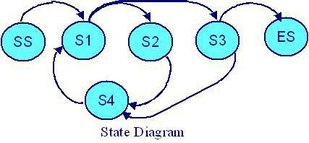

A. SS - S1 - S2 - S4 - S1 - S3 - ES
B. SS - S1 - S2 - S3 - S4 - S3 - S4 - ES
C. SS - S1 - S2 - S4 - S1 - S3 - S4 - S1 - S3 - ES
D. SS - S1 - S4 - S2 - S1 - S3 – ES

. 710: What is a key characteristic of specification-based testing techniques?

A. Tests are derived from information about how the software is constructed.

B. Tests are derived from models (formal or informal) that specify the problem to be solved by the software or its components.

C. Tests are derived based on the skills and experience of the tester.

D. Tests are derived from the extent of the coverage of structural elements of the system or components.

Q. 716: Which of the following could be used to assess the coverage achieved for structure-based (white-box) test techniques?

V. Decision outcomes exercised

W. Partitions exercised
X. Boundaries exercised
Y. Conditions or multiple conditions exercised
Z. Statements exercised

A. V, W or Y
B. W, X or Y
C. V, Y or Z
D. W, X or Z

. 727: If the temperature falls below 18 degrees, the heating is switched on. When the temperature reaches 21 degrees, the heating is switched off. What is the minimum set of test input values to cover all valid equivalence partitions?

A. 15, 19 and 25 degrees
B. 17, 18, 20 and 21 degrees
C. 18, 20 and 22 degrees
D. 16 and 26 degrees

. 734: Assume postal rates for 'light letters' are:

$0.25 up to 10 grams;
$0.35 up to 50 grams;
$0.45 up to 75 grams;
$0.55 up to 100 grams.

Which test inputs (in grams) would be selected using boundary value analysis?

A. 0, 9,19, 49, 50, 74, 75, 99,100
B. 10, 50, 75,100, 250, 1000

C. 0, 1,10,11, 50, 51, 75, 76,100,101
D. 25, 26, 35, 36, 45, 46, 55, 56

<<<<<< =================== >>>>>>

Q. 735: Consider the following decision table for Car rental.
Conditions | Rule 1 | Rule 2 |  | Rule 3 | Rule 4
Over 23? | F | T |  | T | T
Clean driving | Don't | F |  | T | T
record? | care
On business? | Don't | Don't |  | F | T
 | care | care
Actions
Supply rental car? | F | F |  | T | T
Premium charge | F | F |  | F | T

Given this decision table, what is the expected result for the following test cases?

TC1: A 26-year-old on business but with violations or accidents on his driving record

TC2: A 62-year-old tourist with a clean driving record

A. TC1: Don't supply car; TC2: Supply car with premium charge.
B. TC1: Supply car with premium charge; TC2: Supply car with no premium charge.

C. TC1: Don't supply car; TC2: Supply car with no premium charge.
D. TC1: Supply car with premium charge; TC2: Don't supply car.

<<<<<< =================== >>>>>>

Q. 737: What does it mean if a set of tests has achieved 90% statement coverage?

A. 9 out of 10 decision outcomes have been exercised by this set of tests.
B. 9 out of 10 statements have been exercised by this set of tests.

C. 9 out of 10 tests have been run on this set of software.
D. 9 out of 10 requirements statements about the software are correct.

<<<<<< =================== >>>>>>

Q. 746: Which two specification-based testing techniques are most closely related to each other?

A. Decision tables and state transition testing
B. Equivalence partitioning and state transition testing

C. Decision tables and boundary value analysis
D. Equivalence partitioning and boundary value analysis

- 750: Popular specification-based techniques are:

- Equivalence partitioning

B. Boundary value analysis
C. Decision tables

D. All three described above

. 755: A company is going to provide their employees with a bonus which will be based on the employee’s length of service in the company. The bonus calculation will be zero if they have been with the company for less than two years, 10% of their salary for more than two but less than five years, and 25% for five to ten years, 35% for ten years or more. The interface will not allow a negative value to be input, but it will allow a zero to be input.

How many equivalence partitions are needed to test the calculation of the bonus?

A. Two equivalence partitions.

B. Three equivalence partitions.
C. Four equivalence partitions.
D. Five equivalence partitions
. 765: Which of the following statements about test design are TRUE?

I. During test design, the test cases and test data are created and specified.

- If expected results are not defined, a plausible but erroneous result may be accepted as correct.

- The IEEE 829 standard describes the content of test design and test case specifications.

IV. Test design is a formal process in which the conditions to be tested are determined.

A. II, III and IV
B. III and IV
C. I and IV
D. I, II and III

. 769: For the following piece of code, how many test cases are needed to get 100% statement coverage?

Procedure X
Read (Color) // Input color from user
IF (Color == “Red”) THEN
Call Roses(Color)
ELSEIF (Color == “Blue”) THEN
Call Violets(Color)
ELSE
PRINT “User is no Shakespeare”
SaveToDatabase(Color)
End Procedure X

- 5
- 3
- 1
- 2

771: Given the following sample of pseudo code:

01 Input number of male rabbits
02 Input number of female rabbits
03 If male rabbits > 0 and female rabbits > 0 then

- Input Do you want to breed (Yes / No)
- If breed = "No"
- Print "Keep male and female rabbits apart!"
- End if
- End If.

Which of the following test cases will ensure that statement "06" is executed?

A. male rabbits = 1, female rabbits = 1, breed = "yes".
B. male rabbits = 1, female rabbits = 1, breed = "no".
C. male rabbits = 1, female rabbits = 2, breed = "yes".
D. male rabbits = 1, female rabbits = 0, breed = "no".

. 773: A system under development contains complex calculations and decision logic, and it is assessed as high risk because of the relative inexperience of the development team in the application domain. Which of the following would be the MOST appropriate choice of test design technique for component testing?

A. Decision testing.
B. Statement testing
C. State transition testing
D. Equivalence partitioning

<<<<<< =================== >>>>>>

Q. 774: Four testers have each submitted an incident report in which each reported a problem with the User log-on process. User log-on is a critical component of the system. The table below describes the four defect reports submitted.

Tester | Incident | Inputs / Expected & | Business
ID | Description | Actual Results | Priority
 |  |  | (1 High
 |  |  | 2 Medium
 |  |  | 3 Low)
Tester | User Log-on | Entered user ID of | 1
1 | validation | Ram Kumar &

 | error | password ABC123 but
 |  | got an error message
Tester | Log-on does | Inputs: Entered valid | 2
2 | not meet | user ID & password
 | requirements
 |  | Expected result:
 |  | Main menu screen to
 |  | be displayed
 |  | Actual result: Error
 |  | saying incorrect
 |  | password
Tester | Log-on | Inputs: User ID Ram | 2
3 | password | Kumar & password
 | validation | ABC123
 | error
 |  | Expected result:
 |  | Main menu screen
 |  | Actual result: Error
 |  | Message – “Incorrect
 |  | password”
 |  | This test has worked
 |  | many times before
Tester | Password | Inputs: User ID Ram | 1
4 | validation | Kumar & password
 | error | ABC123
 |  | Expected result:
 |  | Main menu screen
 |  | Actual result:
 |  | “Incorrect password”
 |  | N. B: The same inputs
 |  | worked yesterday,
 |  | before code release
 |  | 1.2 was delivered

Which Tester has reported the incident MOST effectively, considering the information and priority they have supplied?

A. Tester 3
B. Tester 1
C. Tester 2
D. Tester 4

Q. 777: Given the following flow chart diagram:

Picture

What is the minimum number of test cases required for 100% statement coverage and 100%decision coverage, respectively?

A. Statement Coverage = 1, Decision Coverage = 3.
B. Statement Coverage = 2, Decision Coverage = 3.
C. Statement Coverage = 2, Decision Coverage = 2.
D. Statement Coverage = 3, Decision Coverage = 3

. 780: Which of the following are structure-based techniques?

a. Decision table testing
b. Boundary value analysis

c. Multiple condition coverage
d. Use case testing
e. Decision testing

A. a and c.
B. b and d.
C. b and e.
D. c and e.

. 782: The following table shows 6 test procedures (P to U) that must now be entered into a test execution schedule.

Test | Business | Dependencies | Other
Proce | Priority | on test | dependencies
-dure | (1 High | procedures
ID | 2 Medium
 | 3 Low)
P | 1 | Can not start
 |  | unless R has
 |  | completed
Q | 1 | None | Regression
 |  |  | testing only
R | 2 | None | None
S | 2 | None | None
T | 3 | None | Delivery of the
 |  |  | code for this
 |  |  | part of system
 |  |  | is running very
 |  |  | late
U | 3 | None | None

Business severity is regarded as the most important element in determining the sequence of the test procedures, but other dependencies must also be taken into consideration. Regression testing can only be run once all other tests have completed.

Which of the following represents the MOST effective sequence for the test execution schedule (where the first entry in the sequence is the first procedure to be run, the second entry is the second to be run and so on)?

A. Q, P, S, R, U, T.
B. R, S, U, P, Q, T.
C. R, P, S, U, T, Q.
D. P, Q, R, S, U, T

Q. 784: Which tasks would USUALLY be performed by a test leader and which by the tester?

a. Adapt planning based on test results.

b. Create test specifications.
c. Plan tests.
d. Write or review a test strategy

A. c and d by the test leader; a and b by the tester
B. a and b by the test leader; c and d by the tester.

C. a and d by the test leader; b and c by the tester
D. a, c and d by the test leader; b by the tester.

<<<<<< =================== >>>>>>

Q. 785: The flow graph below shows the logic of a program for which 100% statement coverage and 100% decision coverage is required on exit from component testing.

Picture

The following test cases have been run:
Test Case 1 covering path A, B, D, G
Test Case 2 covering path A, B, D, E, F, E, F, E, F, E, G
Test Case 3 covering path A, C, D, E, F, E, G

Which of the following statements related to coverage is correct?

A. Statement coverage is 100%; decision coverage is 100%.
B. Statement coverage is less than 100%; decision coverage is 100%.
C. Statement coverage is 100%; decision coverage is less than 100%.
D. Statement coverage and decision coverage are both less than 100%.

- Which of the following statements describe why experience-based test design techniques are useful?

a. They can help derive test cases based on analysis of specification documents.
b. They can identify tests not easily captured by formal techniques.
c. They make good use of tester's knowledge, intuition and experience.
d. They are an effective alternative to formal test design techniques.

A. a and b.
B. b and d
C. c and d
D. b and c.

Q. 789: A system specification states that a particular field should accept alphabetical characters in either upper or lower case. Which of the following test cases is from an INVALID equivalence partition?

- Feeds
- F33ds
- FEEDS
- fEEDs

Q. 793: Which of the following is a specification-based technique?

A. Use Case Testing
B. Error Guessing.
C. Condition coverage
D. Statement Testing.

<<<<<< =================== >>>>>>

Q. 794: Given the following state table:
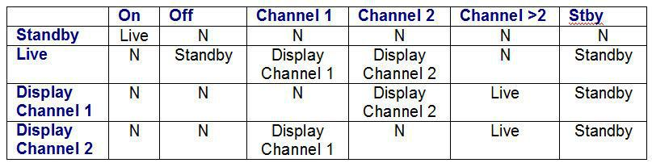

Which of the following represents an INVALID transition (N)?

A. 'Off' from 'Display Channel 1'.
B. 'Channel 2' from 'Display Channel 1'.
C. 'Stby' from 'Live'.
D. 'Channel 2' from 'Live'.

. 796: Pair the correct test design techniques (i to v) with the category of techniques (x, y and z):

i. Exploratory Testing
- Equivalence Partitioning
- Decision Testing
- Use Case Testing
- Condition coverage
- Specification-based
- Structure-based
- Experienced-based

A. x = i and ii; y = iii and v; z = iv.
B. x = i, ii and iv; y = v; z = iii
C. x = ii and iv; y = iii and v; z = i.
D. x = iii and iv; y = v; z = i and ii.

. 801: A bank application determines the creditworthiness of customers. The application uses a set of rules to determine the upper limit of the credit amount. Which of the following black-box test design techniques is best for testing the application?

A. State transition testing
B. Use case testing
C. Equivalence partitioning
D. Decision table testing

Q. 810: Given the following sample of pseudo code:

Read A, B, C;
If A > B then
Print "Primary ratio is" & A / B;
End If
If A > C then
Print "Secondary ration is" & A / C;
End If.

Which of the following test cases would achieve 100% statement coverage?

A. A = 5, B = 10 and C = 2
B. A = 10, B = 10 and C = 10
C. A = 10, B =5 and C = 2

D. A = 2, B= 5 and C = 10

- Which statement is a valid explanation as to why black-box test design techniques can be useful?

A. They can help to derive test data based on analysis of the requirement specification B. They can help derive test cases based on analysis of a component's code structure C. They can help to derive test conditions based on analysis of a system's internal structure

D. They can help to reduce testing costs

. 820: Given the following decision table:
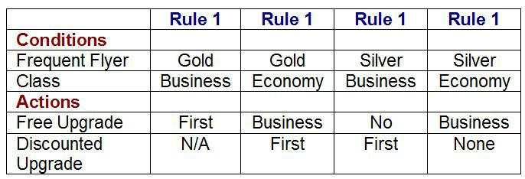

What is the expected result for each of the following test cases?

P. Gold frequent flyer, travelling in Economy class.
Q. Silver frequent flyer, travelling in Business class.

A. P. Offer free upgrade to Business and discounted upgrade to First. Q. Offer discounted upgrade to First

B. P. Offer free upgrade to Business but cannot upgrade to First. Q. Offer discounted upgrade to First

C. P. Offer free upgrade to First. Q. Cannot upgrade to First

D. P. Offer discounted upgrade to First. Q. Offer free upgrade to First

. 824: A wholesaler sells printer cartridges. The minimum order quantity is 5. There is a 20% discount for orders of 100 or more printer cartridges. You have been asked to prepare test cases using various values for the number of printer cartridges ordered. Which of the following groups contain three test inputs that would be generated using Boundary Value Analysis?

A. 5, 6, 20
B. 4, 5, 80
C. 4, 5, 99

D. 1, 20, 100

. 826: Which of the following statements describe why error guessing is a useful test design technique?

a. It can help derive test cases based on analysis of specification documents.
b. It can identify tests not easily captured by formal techniques.
c. It can make good use of tester's experience and available defect data.
d. It is a cheaper alternative to more formal test design techniques.

A. a and b

B. b and c
C. c and d

D. a and c

Q. 828: Consider the following state table:

 | A | B | C | D
S1 | S2/R1 | S3/R2 | S1/N | S4/R6
S2 | S2/N | S2/N | S3/R3 | S4/R4
S3 | S4/R5 | S2/R3 | S2/R6 | S2/N
S4 | S4/N | S4/N | S2/N | S1/R7

Which of the following would result in a change of state to S2 with an action of R6?

A. From state S1, input A
B. From state S2, input B
C. From state S3, input C
D. From state S4, input D

830: Which one of the following provides the BEST description of test design?

A. Identification of the features which should be tested
B. Specification of the test cases required to test a feature
C. Specification of the order in which test cases should be executed

D. Creation of a test suite

. 834: Which of the following are white-box test design techniques?

a. Decision table testing.
b. Decision coverage.

c. Boundary value analysis.
d. Error guessing.

e. Statement testing.

A. a and e

B. b and d
C. b and e
D. e and d

. 839: Which of the following software work products would NOT TYPICALLY be examined using static analysis techniques?

a. Design specification.

b. Component's code.
c. Software model.

d. Test procedure.
e. Non-functional requirements specification.

A. a, c and d
B. a, d and e
C. b, c and d
D. a, b and e

<<<<<< =================== >>>>>>

Q. 840: An automated air-conditioner is programmed to turn its heating unit on when the temperature falls below 17 Deg. C and to turn its refrigeration unit on when the temperature exceeds 26 Deg. C. The air-conditioner is designed to operate at temperatures between -10 Deg. C and +40 Deg. C. Given the above specification, which of the following sets of values shows that the equivalence partition test design technique has been used correctly?

A. –11 Deg. C, -1 Deg. C, 18 Deg. C, 27 Deg. C, 51 Deg. C

B. –11 Deg. C, -1 Deg. C, 12 Deg. C, 18 Deg. C, 27 Deg. C, 51 Deg. C C. -11 Deg. C, 18 Deg. C, 51 Deg. C

D. -1 Deg. C, 12 Deg. C, 18 Deg. C, 27 Deg. C

Q. 842: Given the following decision table:
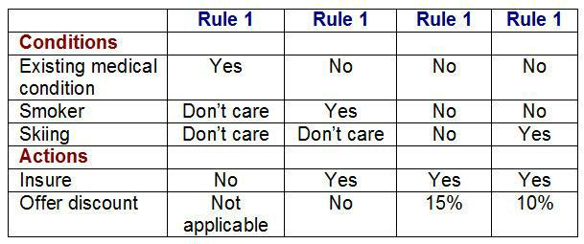

What is the expected action for each of the following test cases?

Joe is a smoker who will be skiing and has an existing medical condition. Sue is a non-smoker who does not ski and does not have an existing medical condition.

A. Insure Joe offering no discount, insure Sue offering no discount

B. Insure Joe, offering a 10% discount and insure Sue offering a 10% discount C. Do not insure Joe and insure Sue offering no discount

D. Do not insure Joe and insure Sue offering a 15% discount

. 845: A simple gaming system has been specified as a set of use cases. It has been tested by the supplier and is now ready for user acceptance testing. The system is assessed as low risk and there is pressure to release the software into the market as soon as possible. Which of the following test techniques would be most appropriate for this testing?

A. State transition testing and decision testing
B. Equivalence partitioning and statement testing
C. Use case testing and exploratory testing

D. Decision table testing and exploratory testing

. 849: Given the following sample of pseudo code:

Input ExamScore
If ExamScore <= 75 then
Print "Candidate has failed"
Else
Print "Candidate has passed"
If ExamScore >= 120 then
Print "Candidate has achieved a distinction"
EndIf
EndIf.

What is the minimum number of test cases required to guarantee 100% decision coverage?

- 2
- 1
- 3
- 4

. 860: Arrive-and-Go airline wants to clarify its baggage handling policy, whilst maximizing revenues, and will introduce the following tariffs for all baggage per individual customer (weights are rounded up to the nearest 0.1Kg):

The first 2Kg will be carried free of charge.

The next 10 Kg will be carried for a flat charge of $10.

An additional 15Kg will be charged a total charge of $17.

Luggage over this amount will be charged at $5 per Kg, up to a maximum of 150Kg per person.

No passenger may take more that 150Kg with them.

Which of the following would constitute boundary values for baggage weights in the price calculation?

A. 0, 5.0, 10.0, 17.0
B. 2.0, 9.9, 15.0, 26.9
C. 1.9, 12.0, 14.9, 150.0
D. 2.0, 12.1, 27.0, 150.1

- Which of the following statements describe why exploratory testing is a useful test design technique?

a. It can help derive test cases based on the internal structure of systems.
b. It is useful when there are limited specification documents available.
c. It is useful when there testing is constrained due to time pressures.
d. It is a cheaper alternative to more formal test design techniques.

A. b and c
B. a and c
C. b and d
D. c and d

<<<<<< =================== >>>>>>

Q. 864: Which two of the following are attributes of structural testing?

a. It is based on testing features described in a functional specification.
b. It can include statement and decision testing.
c. It can be carried out at all levels of testing.
d. It can include debugging.

A. a and b

B. a and d

C. b and d
D. b and c

- Which of the following statements correctly describes the benefit of fault attacks?

A. They are more effective at finding faults than formal test design techniques B. They are useful when there is limited experience in the test team

C. They can evaluate the reliability of a test object by attempting to force specific failures to occur

D. They are less structured than other experience-based techniques

Q. 867: Which of the following is MOST clearly a characteristic of structure based (white-box) techniques?

A. Test cases are independent of each other
B. Test cases can be easily automated
C. Test cases are derived systematically from the delivered code
D. Test cases are derived systematically from specifications

<<<<<< =================== >>>>>>

. 870: Which of the following statements about black box and white box techniques is correct?

A. Decision Testing, Equivalence Partitioning and Condition Coverage are all black box techniques

B. Decision Table Testing, State Transition and Use Case Testing are all black box techniques

C. Decision Testing, Equivalence Partitioning and Statement Testing are all white box techniques

D. Boundary Value Analysis, State Transition and Statement Testing are all white box techniques

Q. 872: A system requires 100% decision coverage at component testing for all modules.

The following module has been tested with a single test case.

The test case follows the path A, B, D, E, F, G.

What level of decision coverage has been achieved?

- 100%
- 50%
- 75%
- 90%

- The Following table shows 6 test procedures (P to U) that must now be entered into a test execution schedule.

Test | Business | Dependencies | Other
Proce | Priority | on other test | dependencies
-dure | (1 High | procedures
ID | 2 Medium

 | 3 Low)
P | 3 | None | Delivery of the
 |  |  | code for this
 |  |  | part of system
 |  |  | is running very
 |  |  | late
Q | 1 | None | Regression
 |  |  | testing only
R | 1 | Requires S to | None
 |  | be run first
S | 2 | None | None
T | 2 | None | Regression
 |  |  | testing only
U | 3 | None | None

Business severity is regarded as the most important element in determining the sequence of the test procedures, but other dependencies must also be taken into consideration. Regression testing can only be run once all other tests have completed.

Which of the following represents the MOST effective sequence for the test execution schedule (where the first entry in the sequence is the first procedure to be run, the second entry is the second to be run and so on)?

A. R, Q, S, T, U, P
B. S, R, P, U, Q, T
C. Q, R, S, T, P, U
D. S, R, U, P, Q, T

. 879: Which of the following statements describe why error guessing is a useful test design technique?

a. It can help derive test cases based on analysis of specification documents.
b. It can identify tests not easily captured by formal techniques.
c. It can make good use of tester's experience and available defect data.
d. It is a cheaper alternative to more formal test design techniques.

A. a and b

B. b and c
C. c and d
D. a and c

<<<<<< =================== >>>>>>

Q. 880: Given the following state transition diagram:
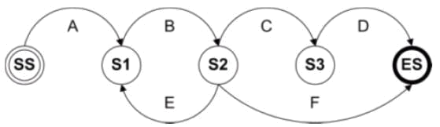

Which of the test cases below will cover the following series of state transitions? SS - S1 - S2 - S1 - S2 - ES

A. A, B, E, B, F
B. A, B, C, D
C. A, B, E, B, C, D
D. A, B, F

Q. 897: One of the test goals for the project is to have 100% decision coverage. The following three tests have been executed for the control flow graph shown below.

Test A covers path: A, B, D, E, G.
Test B covers path: A, B, D, E, F, G.
Test C covers path: A, C, F, C, F, C, F, G.
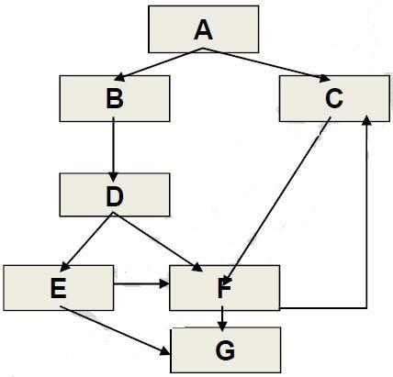

Which of the following statements related to the decision coverage goal is correct?

A. Decision D has not been tested completely.
B. 100% decision coverage has been achieved.
C. Decision E has not been tested completely.
D. Decision F has not been tested completely.
. 899: Which of the following statements about the given state table is TRUE?
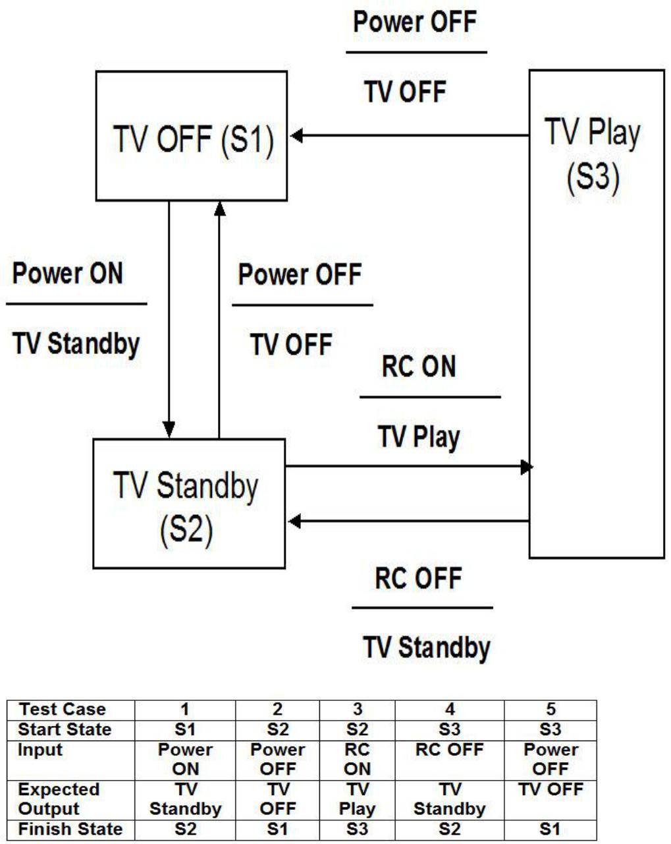

A. The state table can be used to derive both valid and invalid transitions.
B. The state table represents all possible single transitions.

C. The state table represents only some of all possible single transitions.
D. The state table represents sequential pairs of transitions.

<<<<<< =================== >>>>>>

Q. 900: Which TWO of the following solutions below lists techniques that can all be categorized as Black Box design techniques?

Select 2 options.

A. Equivalence Partitioning, decision tables, state transition, and boundary value.
B. Equivalence Partitioning, decision tables, use case.

C. Equivalence Partitioning, decision tables, checklist based, statement coverage, use case.

D. Equivalence Partitioning, cause-effect graph, checklist based, decision coverage, use case.

E. Equivalence Partitioning, cause-effect graph, checklist based, decision coverage and boundary value.

Q. 901: An employee’s bonus is to be calculated. It cannot become negative, but it can be calculated to zero. The bonus is based on the duration of the employment. An employee can be employed for less than or equal to 2 years, more than 2 years but less than 5 years, 5 to 10 years, or longer than 10 years. Depending on this period of employment, an employee will get either onus or a bonus of 10%, 25% or 35%.

How many equivalence partitions are needed to test the calculation of the onus?

- 3.
- 5.
- 2.
- 4.

. 903: Which of the following would be the best test approach when there are poor specifications and time pressures?

A. Use Case Testing.
B. Condition Coverage.
C. Exploratory Testing.
D. Path Testing.

<<<<<< =================== >>>>>>

Q. 904: Which one of the following techniques is structure-based?

A. Decision testing.
B. Boundary value analysis.
C. Equivalence partitioning.
D. State transition testing.

<<<<<< =================== >>>>>>

Q. 905: You have started specification-based testing of a program. It calculates the
greatest common divisor (GCD) of two integers (A and B) greater than zero.

calcGCD (A, B);

TC | A | B
1 | 1 | 1
2 | INT_MAX | INT_MAX
3 | 1 | 0
4 | 0 | 1
5 | INT_MAX+1 | 1
6 | 1 | INT_MAX+1

The following test cases (TC) have been specified.

TC A B
1 1 1
2 INT_MAX INT_MAX
3 1 0
4 0 1
- INT_MAX+1 1
- 1 INT_MAX+1

INT_MAX: largest Integer

Which test technique has been applied in order to determine test cases 1 through 6?

A. Boundary value analysis.
B. State transition testing.
C. Equivalence partitioning.
D. Decision table testing.

<<<<<< =================== >>>>>>

Q. 906: Consider the following state transition diagram and test case table:
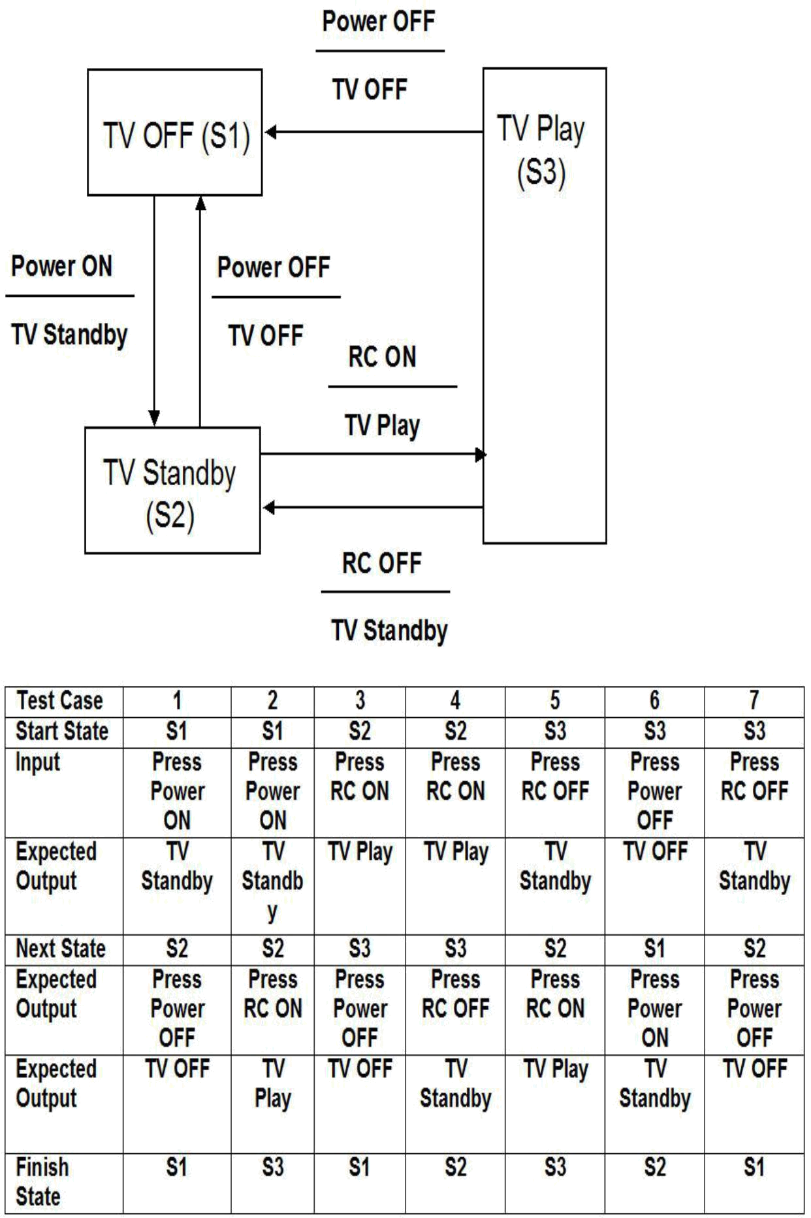
Which of the following statements are TRUE?

A. The test case table exercises the shortest number of transitions.
B. The test case gives only the valid state transitions.
C. The test case gives only the invalid state transitions.
D. The test case exercises the longest number of transitions.

A. Only A is true; B, C and D are false.
B. Only B is true; A, C and D are false.
C. A and D are true; B, C are false.
D. Only C is true; A, B and.

Q. 919: The digital "Rainbow Thermometer" uses 7 colors to show the ambient temperature. Each color spans a range of just 5 Deg. C, with an operating minimum and maximum of minus 5 Deg. C and 30 Deg.C. Which of the following values is LEAST likely to have been identified when applying the boundary value test design technique?

A. 30 Deg. C
B. 0 Deg. C
C. 8 Deg. C
D. 15 Deg.C

.922: Which of the following structure-based test design technique would be most likely to be applied to?

1 Boundaries between mortgage interest rate bands.
2 An invalid transition between two different area’s statuses.
3 The business process flow for mortgage approval.
4 Control flow of the program to calculate repayments.

A. 2, 3 and 4
B. 2 and 4
C. 3 and 4
D. 1, 2 and 3

.928: Consider the following decision table.

Given this decision table on Car Rental, what is the expected result for the following test cases?

Conditions | Rule 1 | Rule 2 | Rule 3 | Rule 4
Over 23? | F | T | T | T
Clean Driving | Don’t | F | T | T

Record | Care
On Business? | Don’t | Don’t | F | T
 | Care | Care
Actions
Supply Rental | F | F | T | T
Car?
Premium | F | F | F | T
Charge?

TCI: A 26-year-old on business but with violations or accidents on his driving record

TC2: A 62-year-old tourist with a clean driving record

A. TCI: Don't supply car; TC2: Supply car with premium charge.
B. TCI: Supply car with premium charge; TC2: Supply car with no premium charge.
- TCI: Don't supply car; TC2: Supply car with no premium charge.
- TCI: Supply car with premium charge; TC2: Don't supply car.

<<<<<< =================== >>>>>>

Q.929: Requirement 24.3. A 'Postage Assistant' will calculate the amount of postage due for letters and small packages up to 1 kilogram in weight. The inputs are: the type of item (letter, book or other package) and the weight in grams. Which of the following conform to the required contents of a test case?

A. Test the three types of item to post and three different weights [Req 24.3]

B. Test 1: letter, 10 grams, postage €0.25. Test 2: book, 500 grams, postage €1.00.
Test 3: package, 999 gram, postage €2.53 [Req 24.3]

- Test 1: letter, 10 grams to Belgium. Test 2: book 500 grams to USA. Test 3: package, 999 grams to South Africa [Req 24.3]

- Test 1: letter 10 grams, Belgium, postage €0.25. Test 2: package 999 grams to South Africa, postage €2.53

