* Viterbi Program is completely working with 83.92 accuracy for POS.train and POS. test data set.
* Baseline Program is completely working with 67.94 accuracy for POS.train set and POS. test data set.

Below are the screenshots:

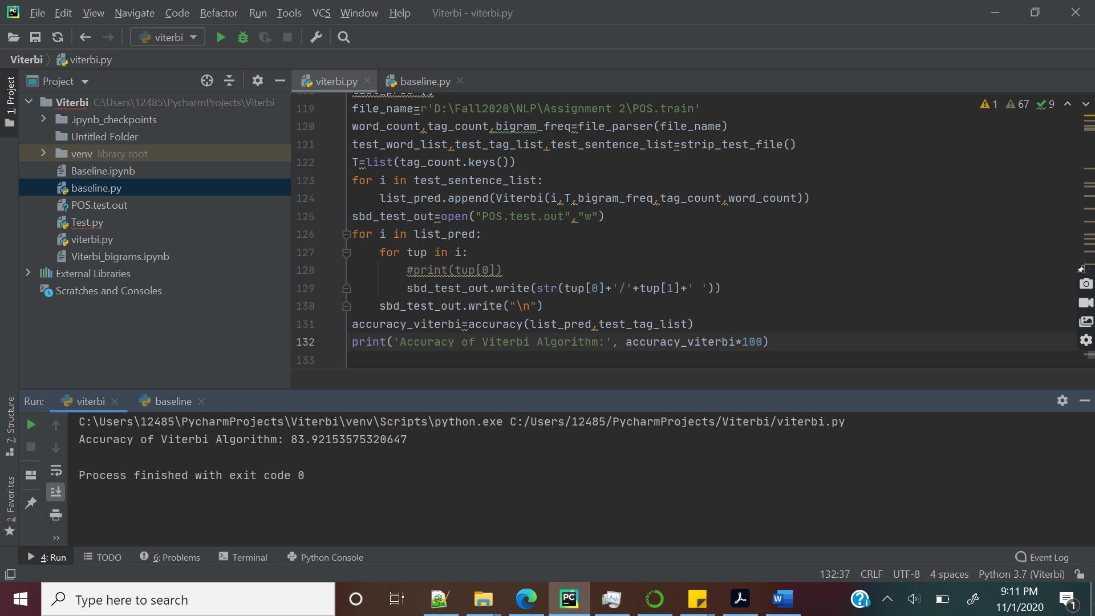

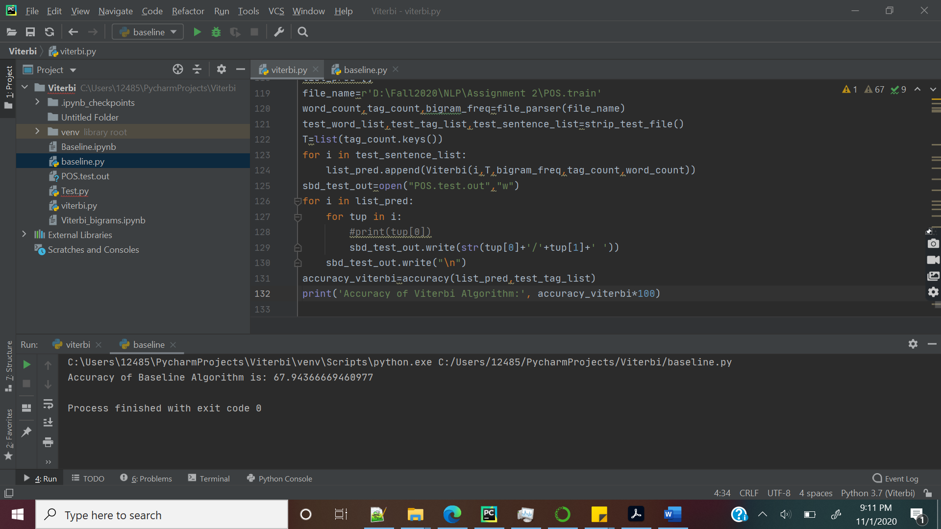

* Actual Tag: cocoa/NN Predicted Tag: cocoa/RP: Cocoa has appeared only once in the train set. To fix this issue we can include train set which has more occurrence of this word with different usages.
* Actual Tag: mainstay/NN Predicted Tag: mainstay/NP: Mainstay has not appeared in the test set. To fix this issue we can include train set which has more occurrence of this word with different usages.
* Actual Tag:Ghana/NP Predicted Tag:Ghana/RP: Ghana has not appeared in the test set. To fix this issue we can include train set which has more occurrence of this word with different usages.