Serverless-Architecture-HeroVired-Assignment
HeroVired Assignment on Serverless Architecture using AWS Lambda and Boto 3

Assignment 2: Automatic EBS Snapshot and Clean up Using AWS Lambda and Boto3
Objective: In this assignment, we will automate the backup process for your EBS volumes and ensure that backups older than a specified retention period are cleaned up to save costs.
Task: Automate the creation of snapshots for specified EBS volumes and clean up snapshots older than 30 days.

Architecture Overview:

Amazon EventBridge (Weekly Schedule)

│

▼

AWS Lambda Function

┌─────────┴─────────┐

│ │

▼ ▼

Create EBS Snapshot Delete Old Snapshots

│ │

└─────────┬─────────┘

▼

Amazon EC2 (EBS)

│

▼

Amazon CloudWatch Logs

Step 1: EBS Setup
1. Navigate to the EC2 dashboard and identify or create an EBS volume you wish to back up.
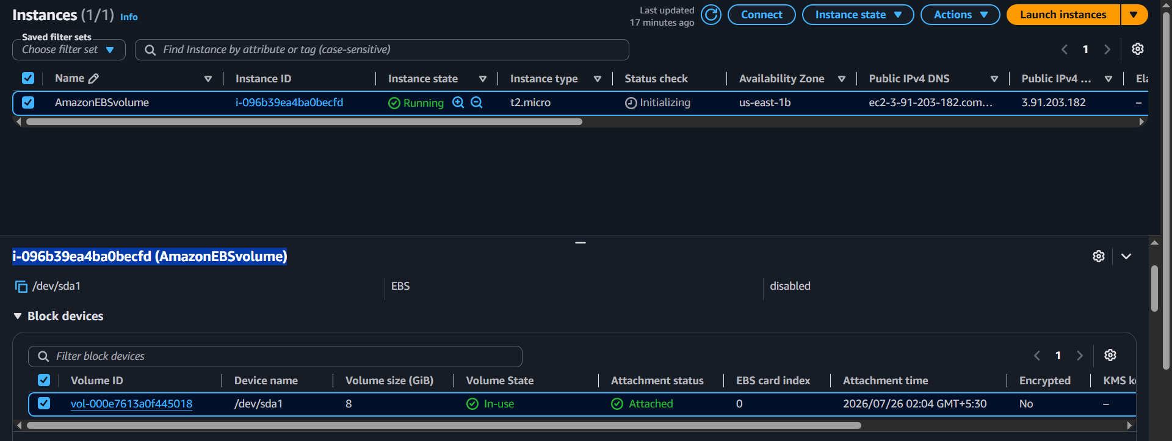
2. Note down the volume ID.000e7613a0f445018
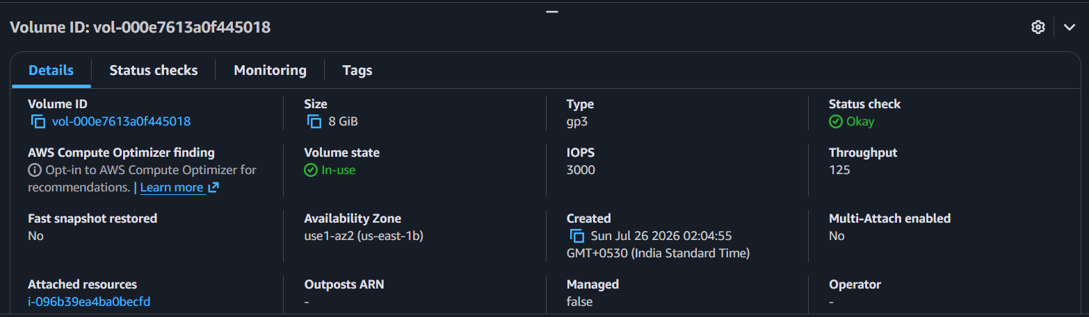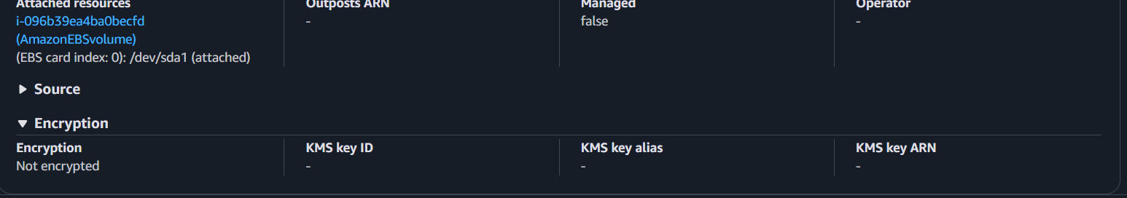

Step 2: Create IAM Role for Lambda
1.In the IAM dashboard, create a new role for Lambda and attach policies that allow Lambda to create EBS snapshots and delete them (AmazonEC2FullAccess AWSLambdaBasicExecutionRole for simplicity, but be more restrictive in real-world scenarios).
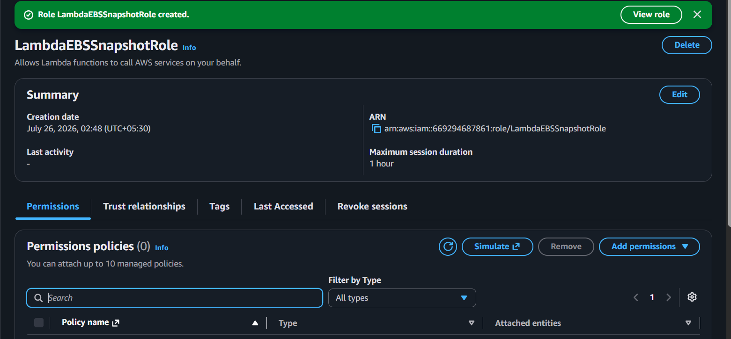
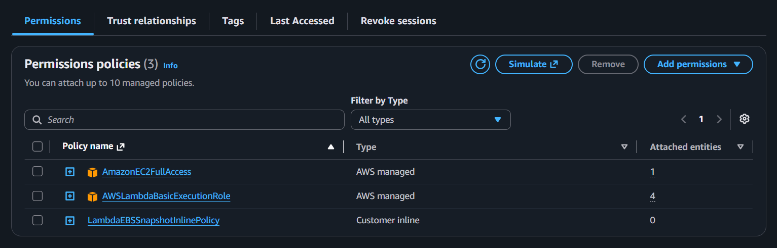
2. Created a inline policy with JSON
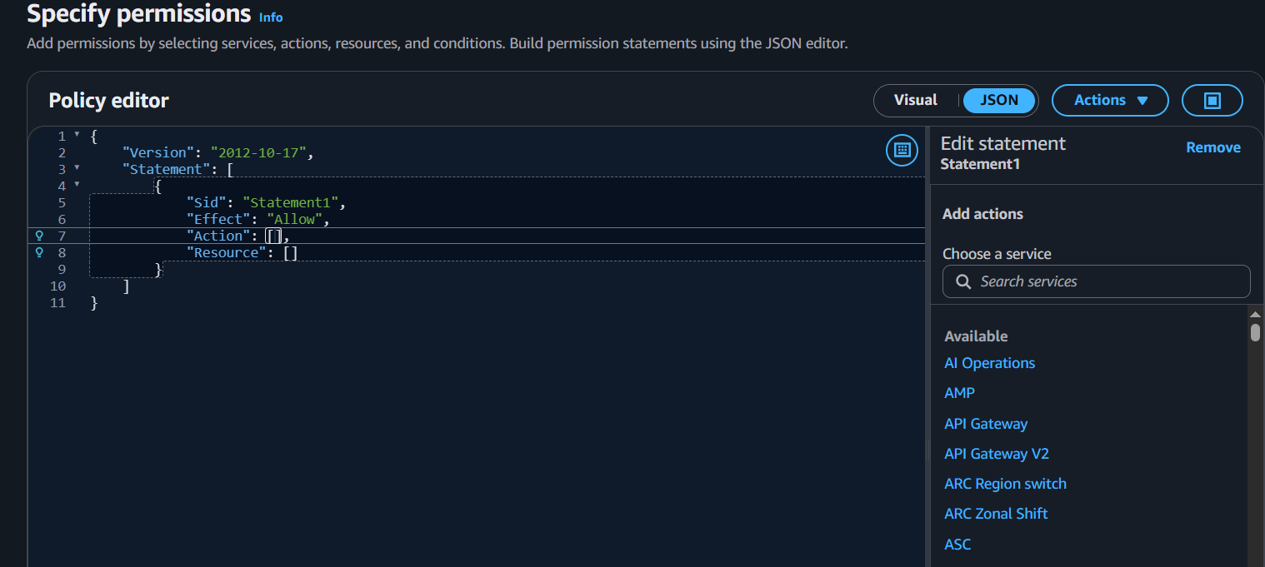

Step 3: Create Lambda Function
1.Navigate to the Lambda dashboard, create a new function by choosing Python 3.14 as the runtime and assign the custom role created in the previous step.
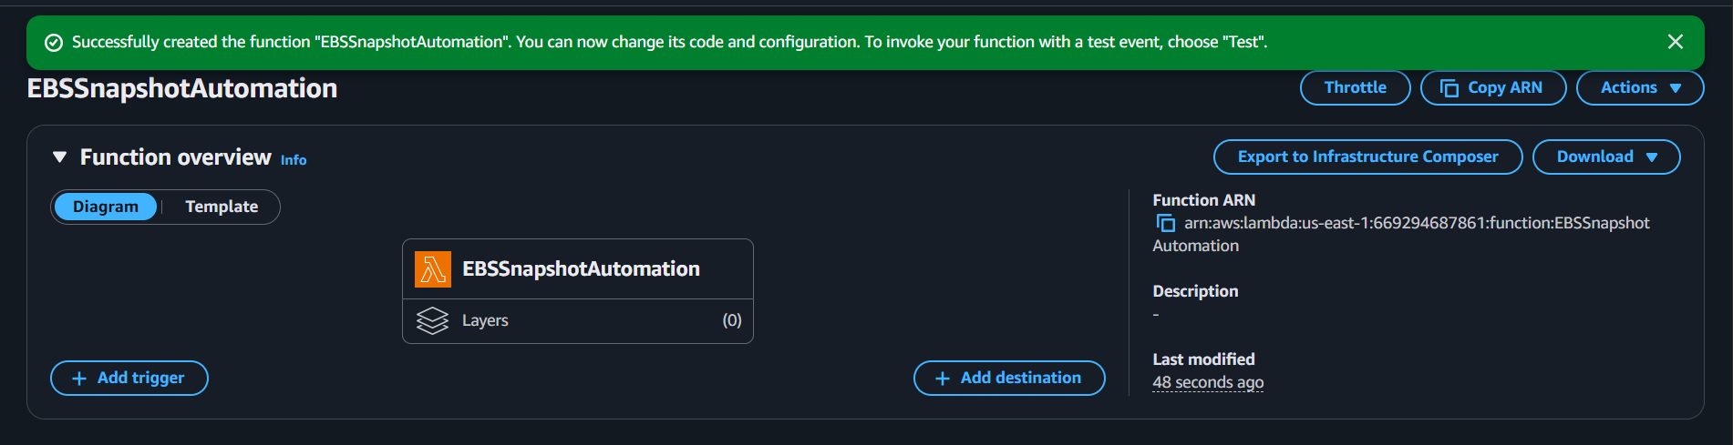

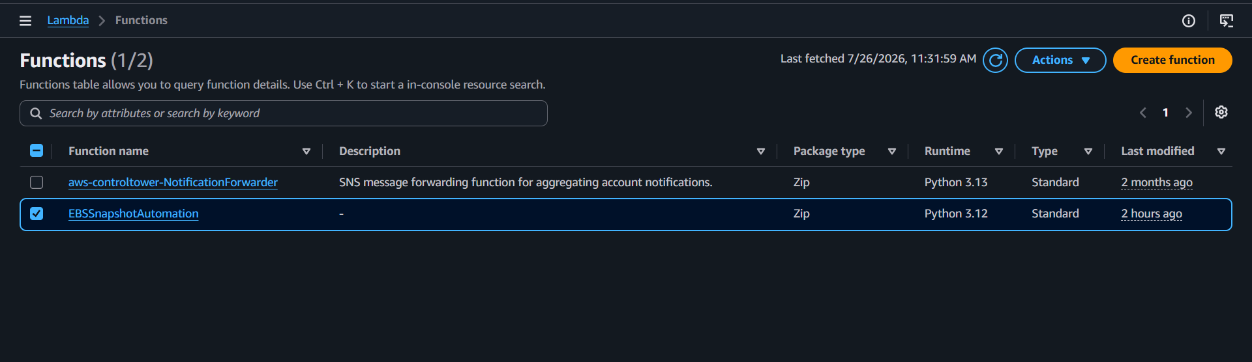

2. Write the Boto3 Python script to:
- Initialize a boto3 EC2 client.
- Create a snapshot for the specified EBS volume.
- List snapshots and delete those older than 30 days.
- Print the IDs of the created and deleted snapshots for logging purposes.

.

Step 4: Manual Invocation
1.After saving your function, either manually trigger it or wait for the scheduled event 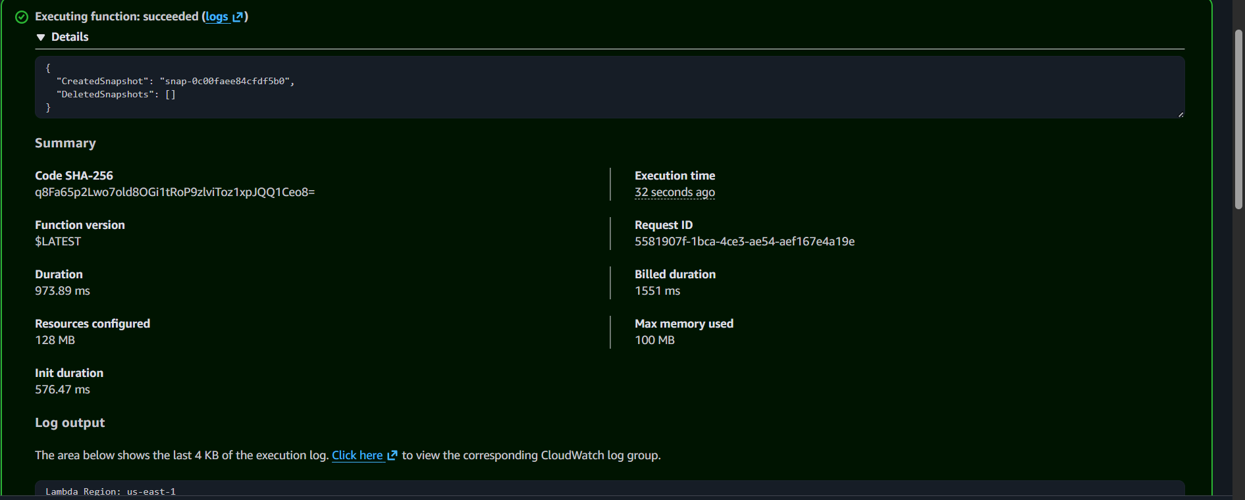
2.Go to the EC2 dashboard and confirm that the snapshot is created and old snapshots are deleted.
i.Created snapshot.
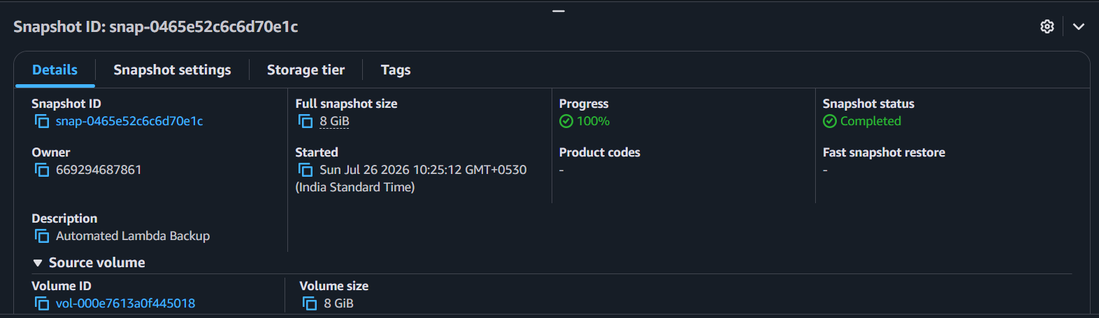
ii. Deleted snapshot.
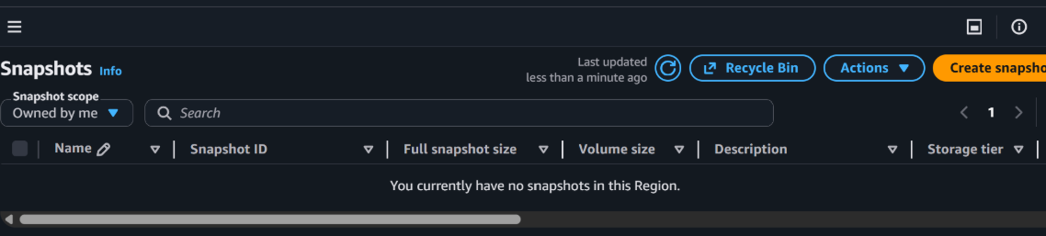

Step 5: Event Source (Bonus)
- Attach an event source, like Amazon CloudWatch Events, to trigger the Lambda function at your desired backup frequency (e.g., every week).
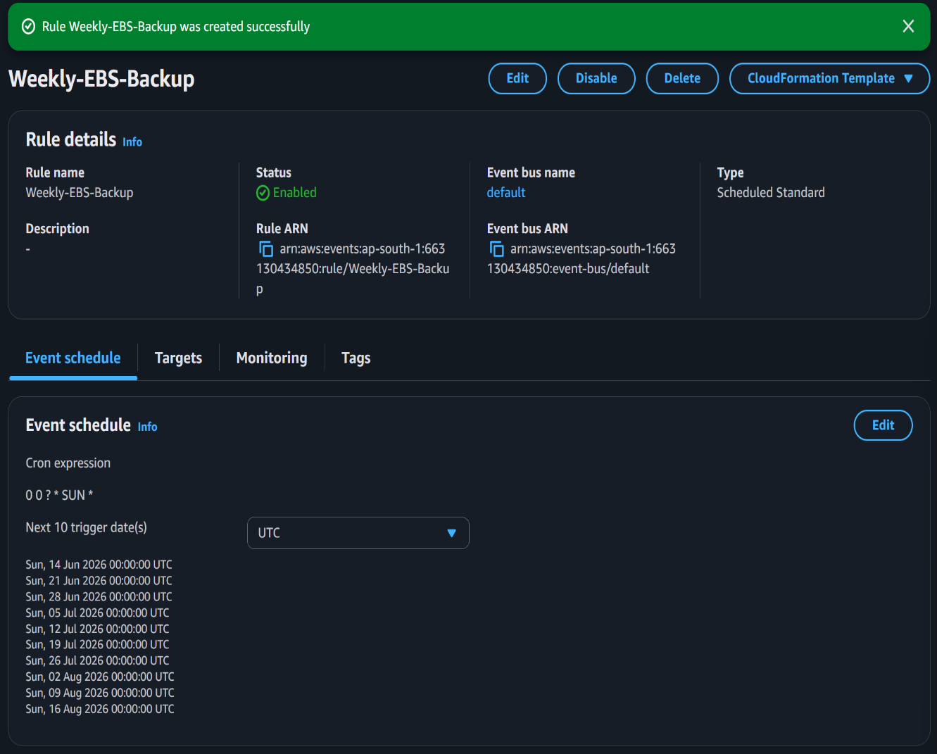
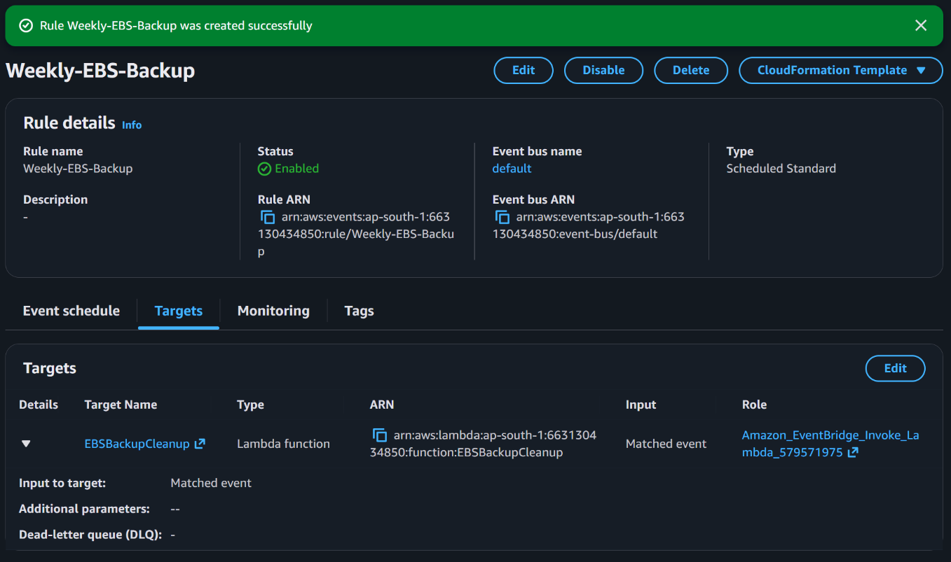
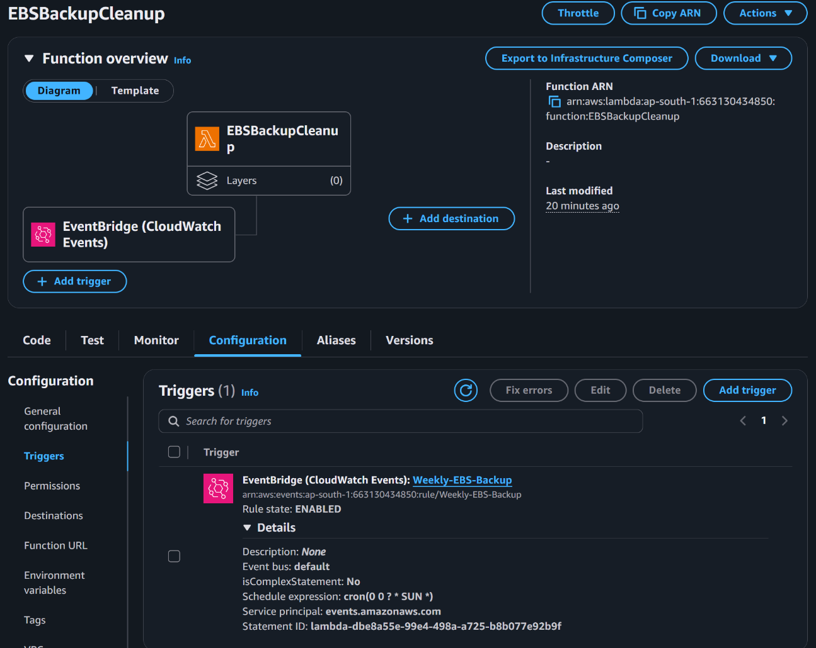
CloudWatch Logs Verification
- Created snapshot logs.
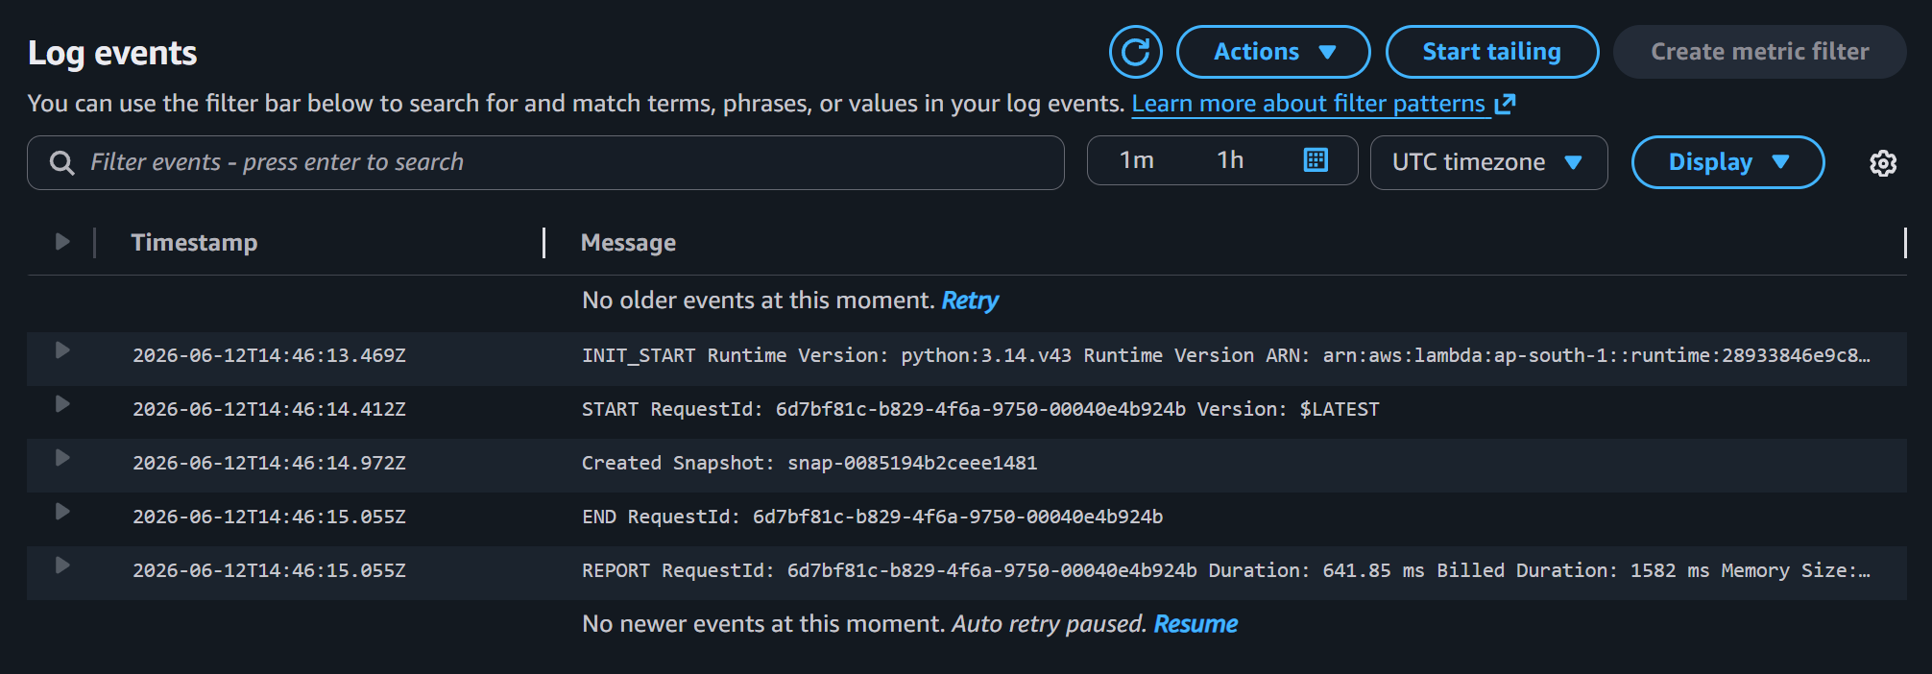

ii.Deleted snapshot logs.
