
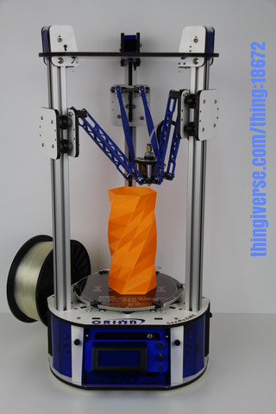

Orion Delta™ 3D Printer Manual
Second Edition – Firmware .91 and Higher
V1.20, March 23rd, 2014
Copyright 2014 By Gene Buckle – geneb@deltasoft.com
Licensed as Creative Commons, Attribution-ShareAlike 3.0
Disclaimer text provided by LulzBot.
This guide will take you through the steps to set up and operate your new 3D printer from SeeMeCNC. You’ll find instructions on calibration, software, maintenance and more all in this manual. As a new SeeMeCNC™ owner, you’ll also find a ton of great resources on the forums at forum.seemecnc.com

Table of Contents
READ ME FIRST! 2
Un-Boxing your new Orion Delta™ 3D Printer 3
Installing the LCD Control Panel, USB Cable and SD Card 6
Installing the Power Cord and Spool Holder 12
Loading Filament 16
Powering Up your new Orion Delta™ 3D Printer for the First Time 19
The LCD Control Panel 20
Setting the Z height 23
Leveling your new Orion Delta™ 3D (The Easy Way!) 25
A Simple Guide to Hot End Priming 31
Printing from the SD Card 33
Changing Filament 36
Printing From Your Computer 39
Advanced Repetier-Host 56

Attention! If your Orion Delta™ has a serial number of 100169 or

less, you may need to download the First Edition of the user

guide here:

http://www.geneb.org/orion/ORIONUserManual.pdf

The First Edition covers the older firmware that originally shipped

with the Orion Delta™ 3D printer.

Before downloading the First Edition, please make sure that you

actually need it. Compare the LCD idle screen (shown on power-on,

after the initialization sequence takes place) on your machine to the

first LCD screen photo shown in the “The LCD Control Panel” chapter.

If they match, you've got the newer firmware and do not need the

second edition. You can follow this edition to reach the power-on

point in order to definitively identify which firmware your machine

was shipped with.

READ ME FIRST!

READ THIS MANUAL COMPLETELY BEFORE UNPACKING AND POWERING UP YOUR
PRINTER!

Hazards and Warnings

The SeeMeCNC Orion Delta 3D printer has motorized and heated parts. When the printer is in

operation always be aware of possible hazards.

Electric Shock Hazard

Never open the electronics bay of the printer while the printer is powered on. Before removing

the access door, always power down the printer and unplug the AC line cord.

Burn Hazard

Never touch the extruder nozzle or heater block without first turning off the hot end and allowing

it to completely cool down. The hot end can take up to twenty minutes to completely cool.

Also, never touch recently extruded plastic. The plastic can stick to your skin and cause burns.

Also before of the heated bed which can reach high temperatures capable of causing burns.

Fire Hazard

Never place flammable materials or liquids on or near the printer when powered on or in

operation. Liquid acetone and vapors are extremely flammable.

Pinch Hazard

When the printer is in operation, take care to never put your fingers in the moving parts,

including the belts, pulleys or gears. Also, tie back long hair or clothing that can get caught in

the moving parts of the printer.

Static Charge

Make sure to ground yourself before touching the printer, especially the electronics.

Electrostatic charges can damage electronic components. To ground yourself, touch a

grounded source.

Age Warning

For users under the age of 18, adult supervision is recommended. Beware of choking hazards

around small children.

Un-Boxing your new Orion Delta™ 3D Printer

With your box standing in the upright position, carefully cut the packing tape along the top edges and across the taped seam in the box.
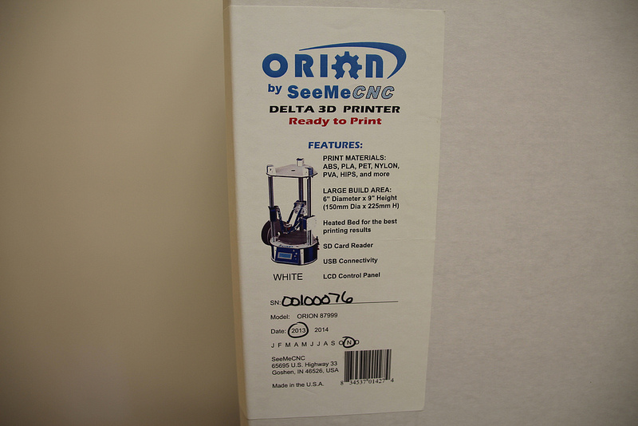
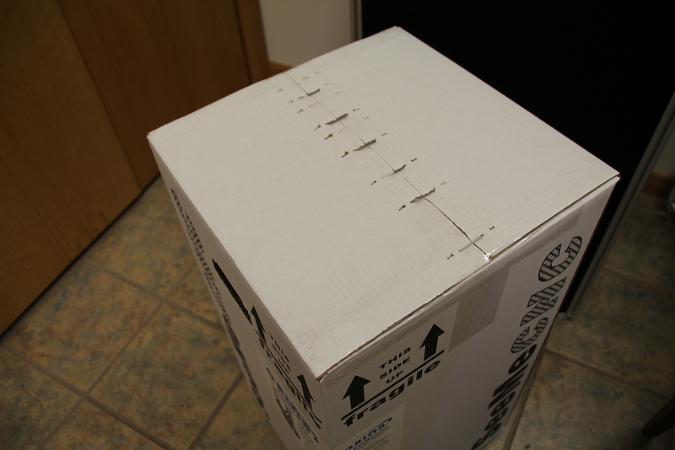

After you’ve cut the tape, open the top of the box being careful of any packaging staples. You’ll find the machine tucked inside and wrapped in a protective expanding foam shell. Remove the machine and foam all as one by pulling straight up out of the box. Be careful not to drop the machine once it’s out of the box and the foam is still around it.

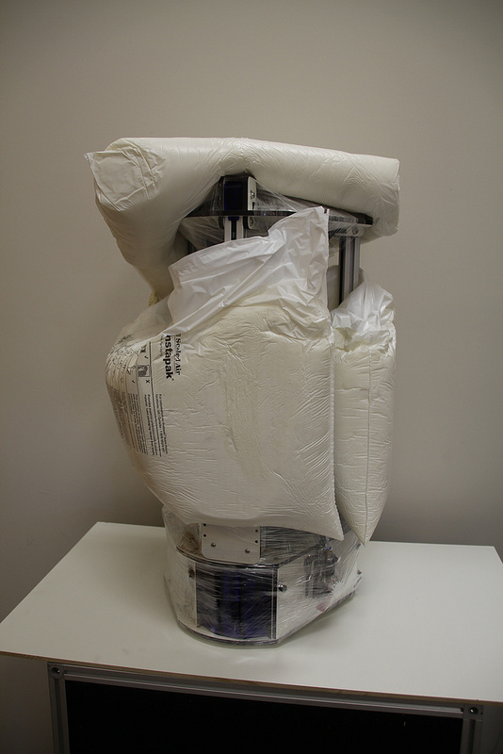
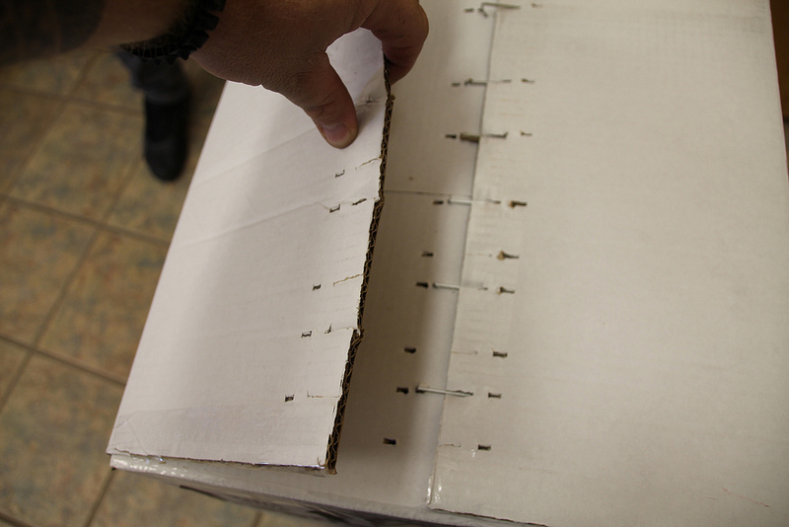

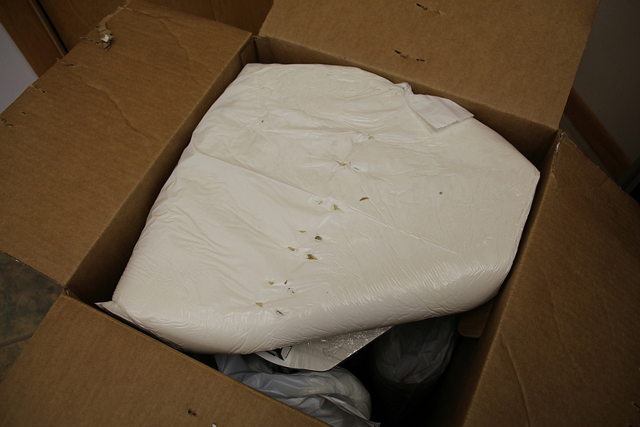

Carefully cut and remove the stretch wrap film that is holding the power/USB cables, Orion control panel and accessories on the top plate, as well as the stretch wrap holding your filament to the table top and glass build surface.
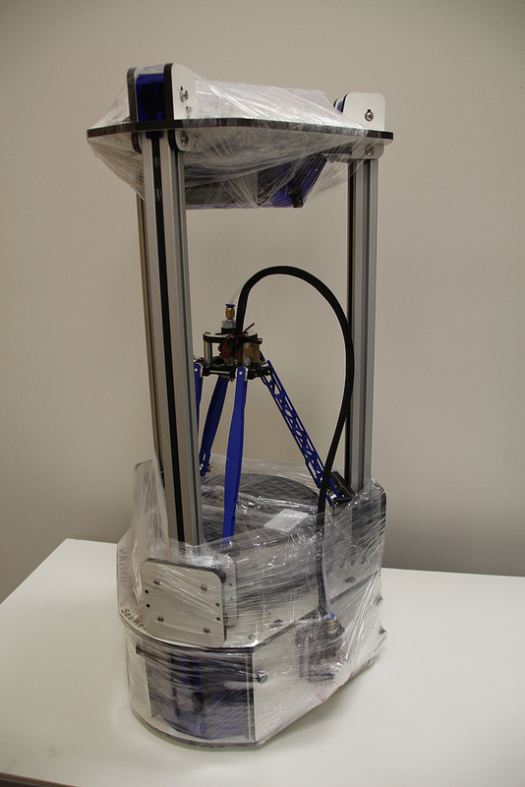
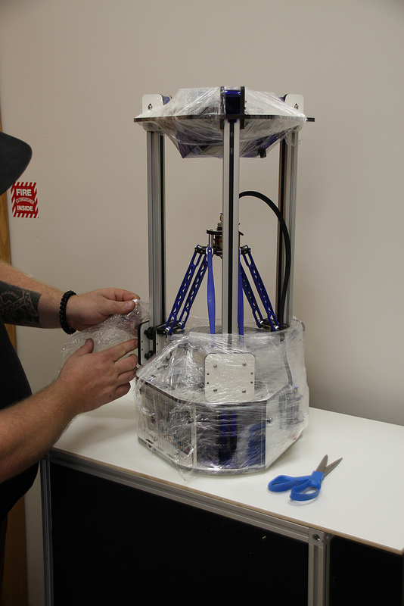

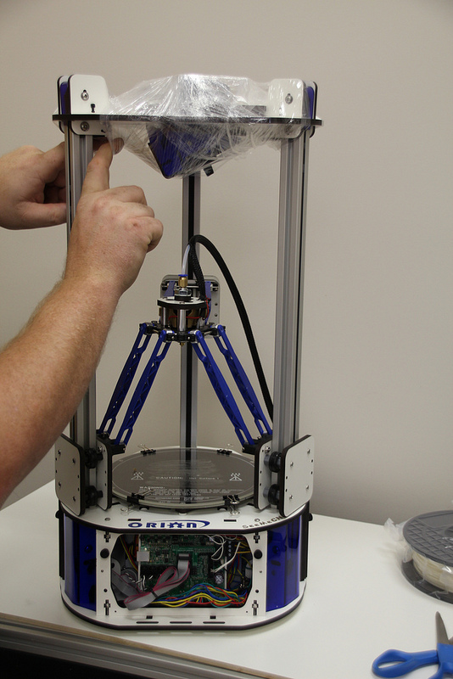

In order to prevent damage during shipping, the hot end on the Orion Delta™ is locked in place over the bed by lowering the delta arms as low as they'll go on each tower. These arms need to be raised in order for the Orion Delta™ to be used.
The process is very simple – just grasp the Cheapskate bearing for each arm and raise them one at a time to the top of the Orion as shown in the photos below.
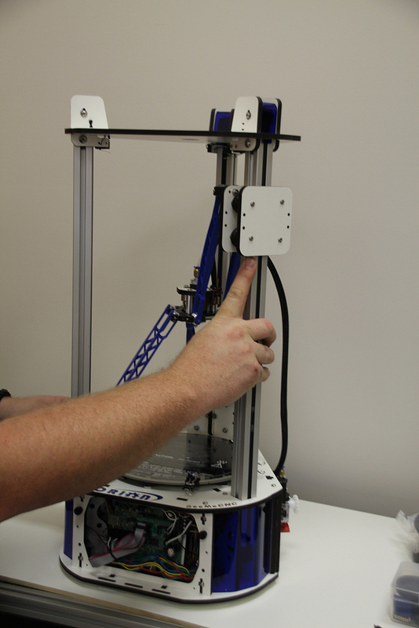
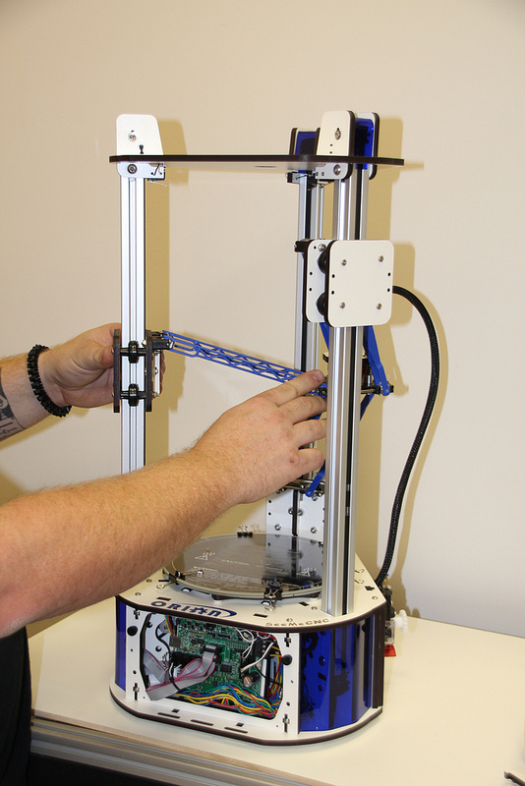
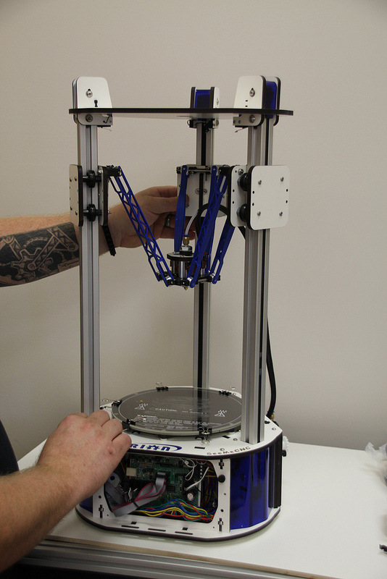

Installing the LCD Control Panel, USB Cable and SD Card

The first step is to install the power switch into the blue acrylic face of the LCD as shown.
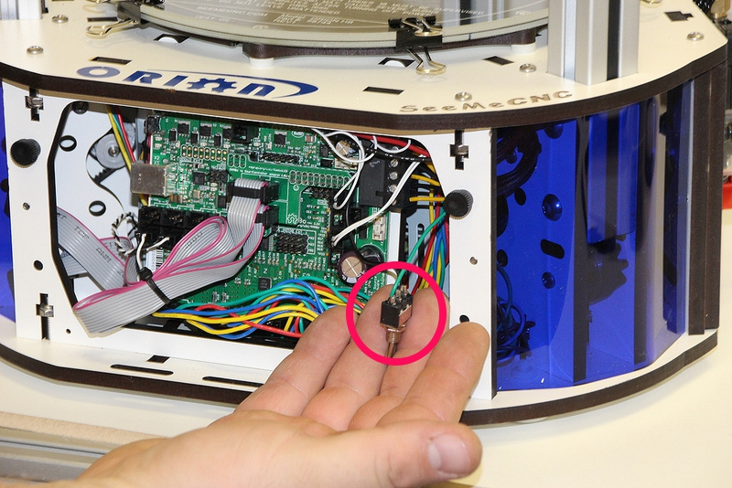

Remove the nut from the switch and insert it into the hole in the blue acrylic LCD control face. Note that the power switch has been shipped in the “Off” position. When you install the switch, make sure that the “bat” or switch handle is pointing to the same “side” that the wires are attached.
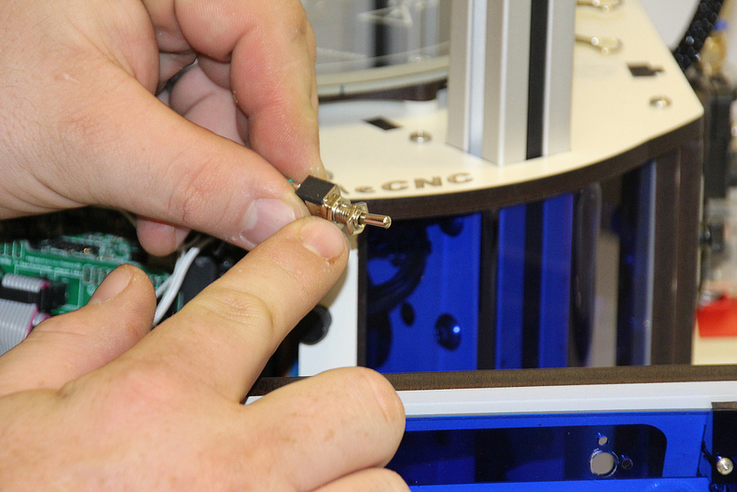

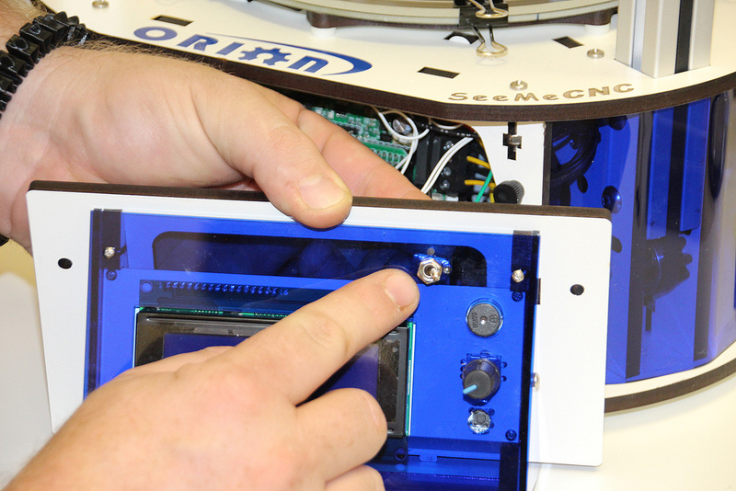

Gently pull the pair of flat ribbon cables out a bit from the Orion Delta™ and install them as shown. The “first” cable is marked by an “X” and has a matching “X” on the back of the LCD controller.
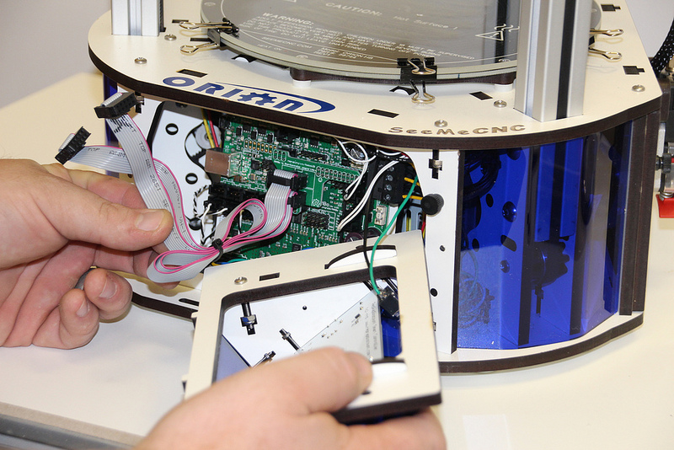

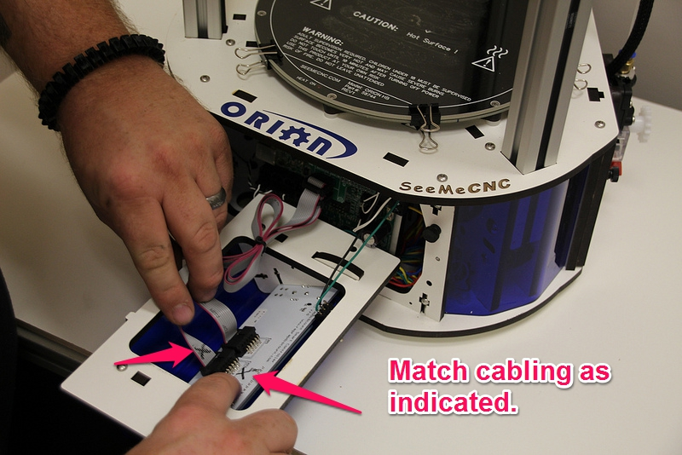
The USB cable only needs to be used if you wish to manually control the machine from the software on your PC. You can print and do most calibration standalone, without the USB cable attached. We recommend hooking it up now, so if you need to connect it to your computer to make changes etc., the cable is already installed.
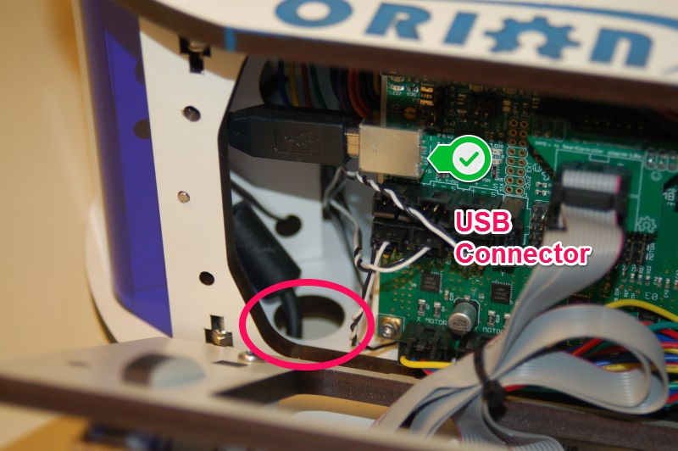
Pass the end of the USB cable up through the hole in the bottom left of the base and plug it into the USB input on the electronics board. Next, replace the front panel by putting the bottom in first, then tilting the top in. Please be careful as it’s a tight fit. Re-install the two black thumb screws and tighten them finger tight.
Remove the two black thumb screws as shown and set them aside.

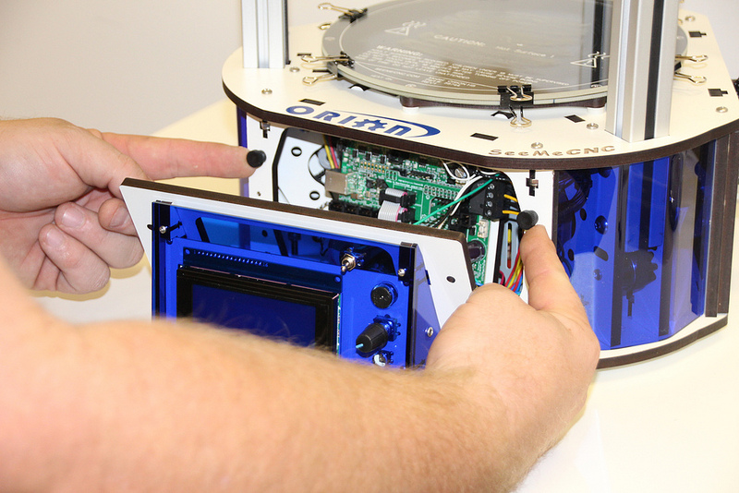

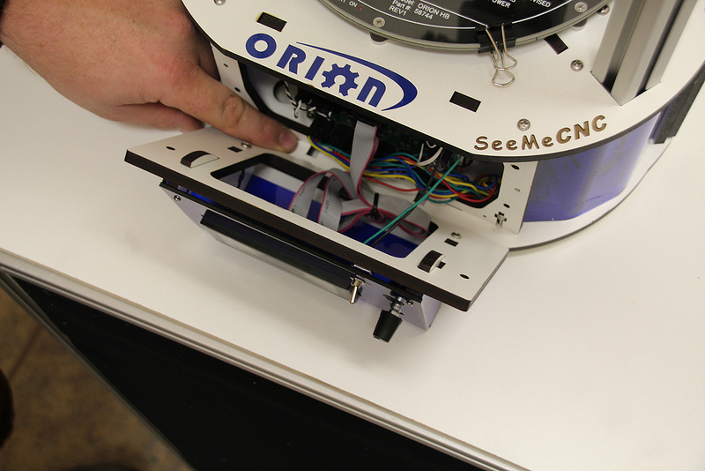
Now you'll install the LCD control panel into the Orion Delta™. Please take care as the parts are a tight fit. Align the LCD mounting plate as shown below – there's small locking tabs that fit into the slots shown.
Carefully raise the panel into place and fit it flush against the mating surface, making sure that not wires get pinched between the two panels – this is a tight fit, so please be careful.
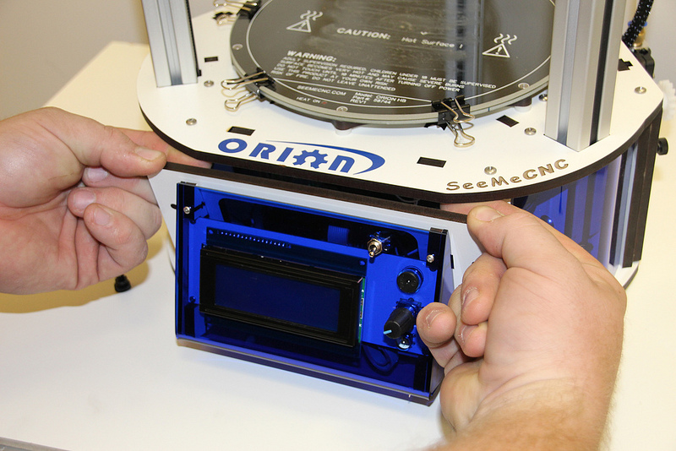
Insert the black thumbscrews you'd removed earlier in the mounting holes and tighten them using only your fingers.

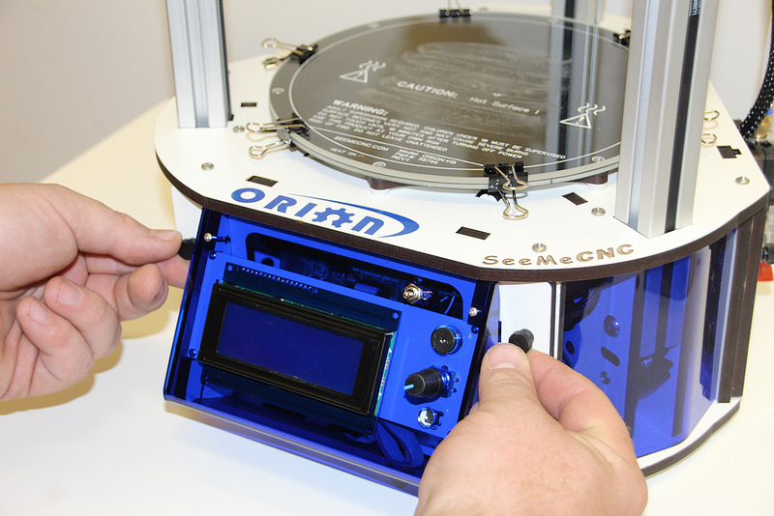
In the accessories box, you should find a small SD card. Insert the SD card into the side of the LCD enclosure as shown below.
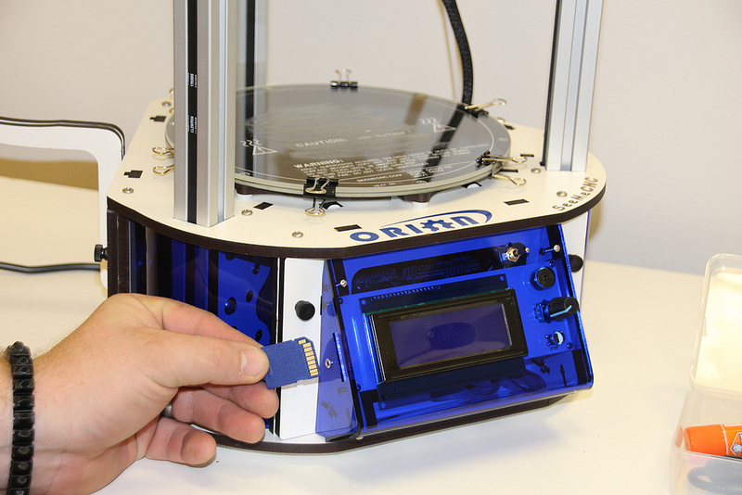
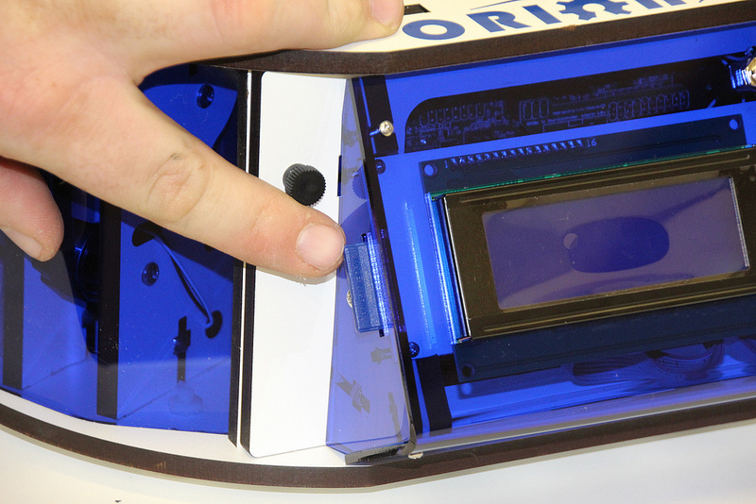

Installing the Power Cord and Spool Holder
In order to reach the power supply, you'll need to remove the panel that covers it.

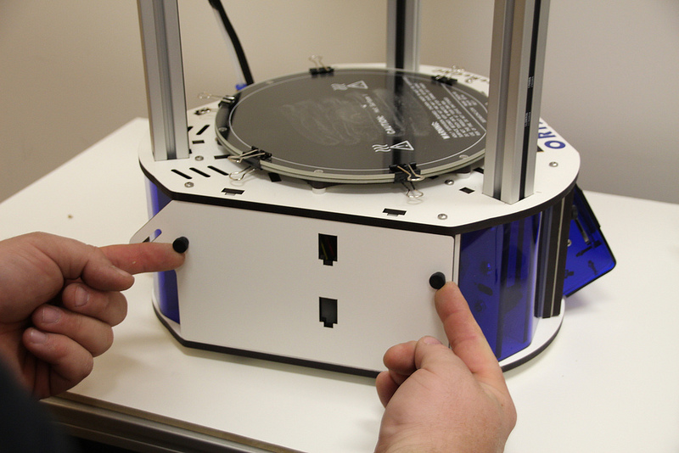

Remove the two black thumb screws and set them and the panel aside. Get the power cable from the box the accessories came in.
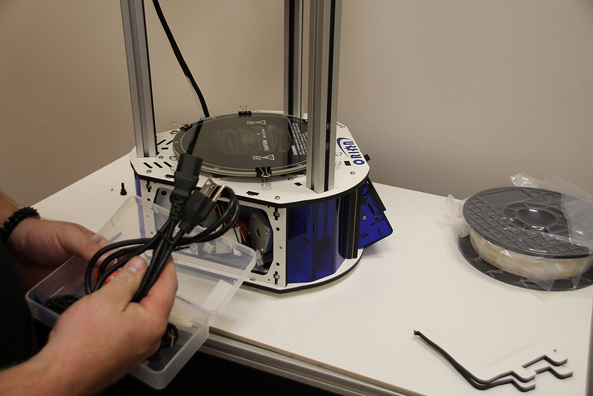

If you're outside the USA and live in a country where the A/C electrical power is 240V, you'll need to flip the switch on the power supply to its 240V setting. This switch is located right below the power socket as shown. You can use a flat tip screwdriver to change its position.
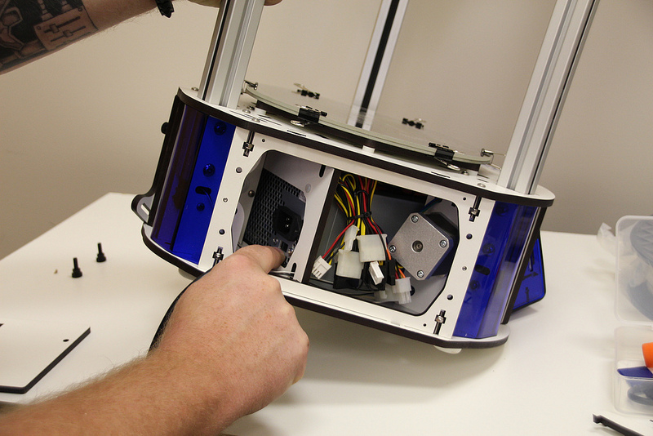
The power cable is installed by routing it through the hole in the base of the Orion Delta™ and plugging it into the socket on the power supply. It's a tight fit, so take your time.
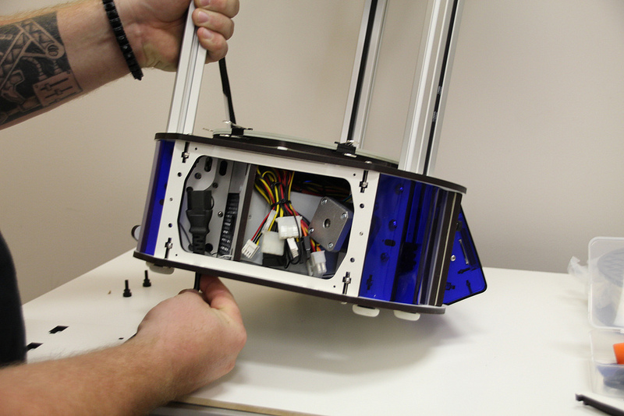
Now replace the door as shown, replacing the black thumbscrews you'd removed previously. As with the others, tighten them only with your fingers.
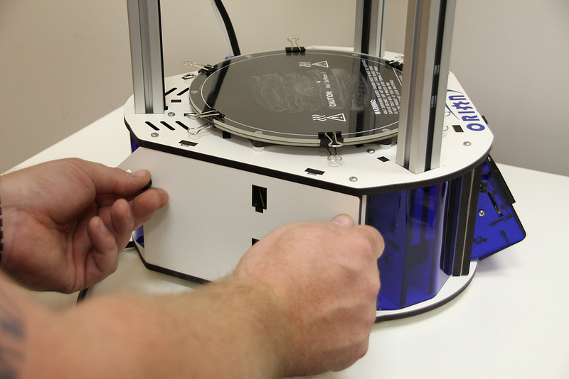
The spool holder is made from two identical laser cut parts.
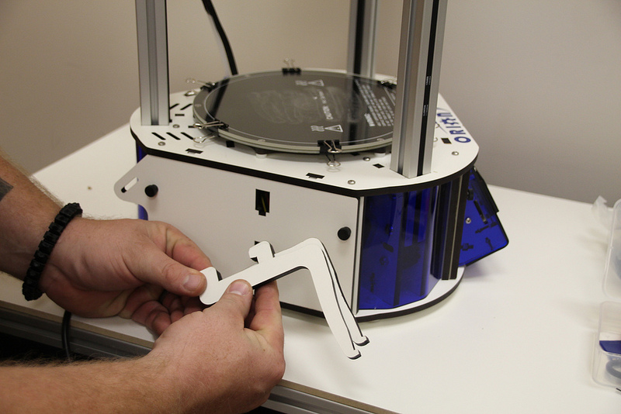

Holding the spool holder parts together, install in the spool holder mount as shown.

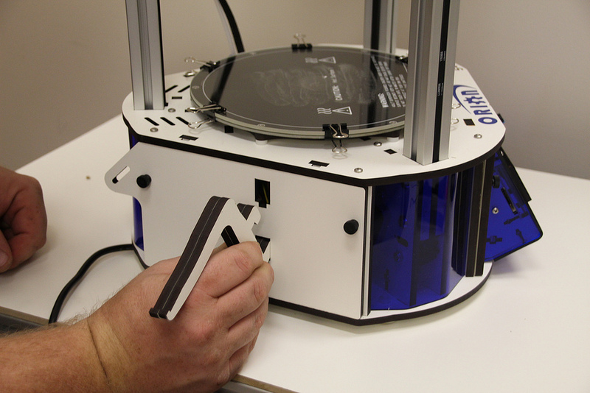

Press down firmly once the hooks on the spool holder are fully inserted into the mounting holes. This will lock the spool holder into place.
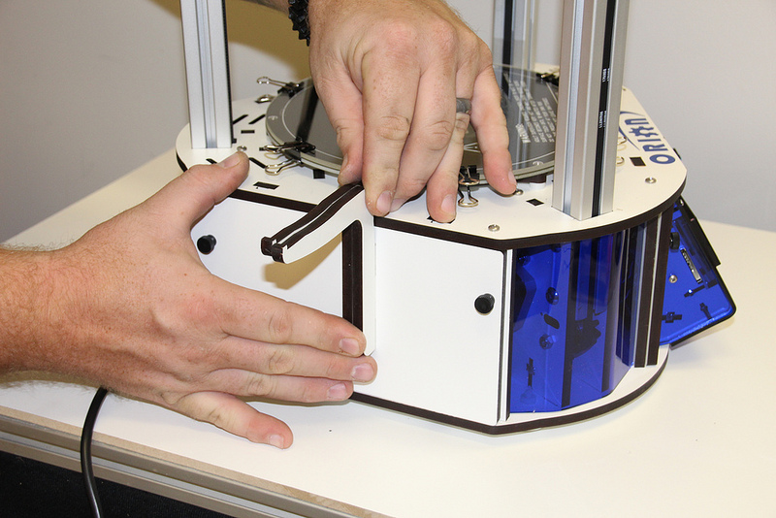

Loading Filament
Hang your filament spool on the hanger as shown – you want to make sure that the filament is oriented such that the filament comes off the top of the spool, not the bottom.
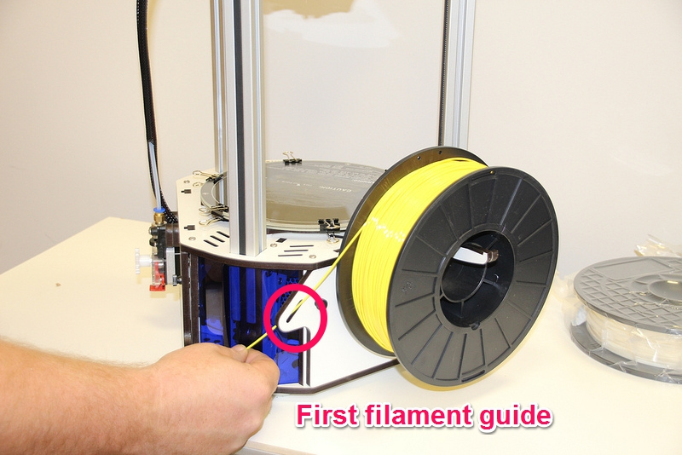
Route the filament through the first filament guide as shown and then route the filament through the second filament guide that's located on the other side of the rear tower.
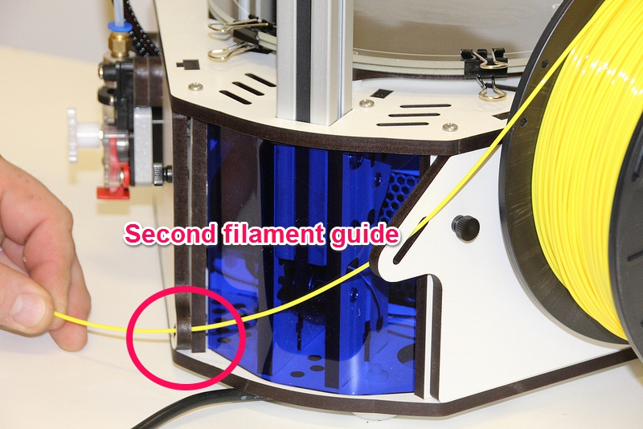

To load the filament through the EZStruder, you'll need to depress the red lever with your thumb (press up) and thread the filament in from the bottom as shown.
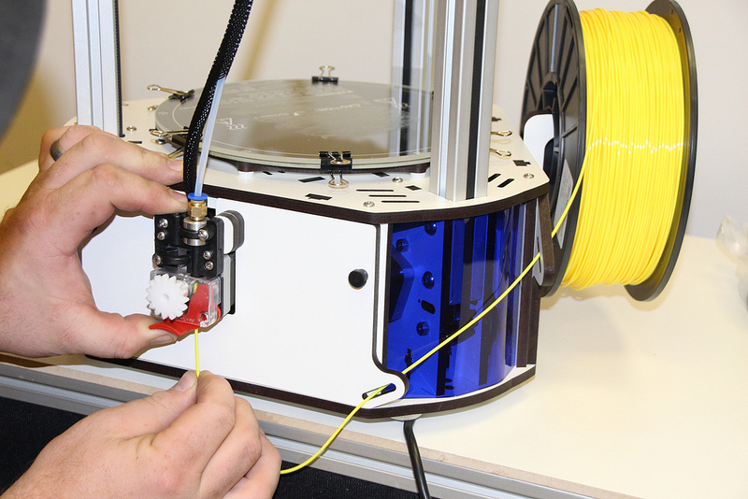
Continue to feed filament until the filament enters the hot end through the bowden tube.
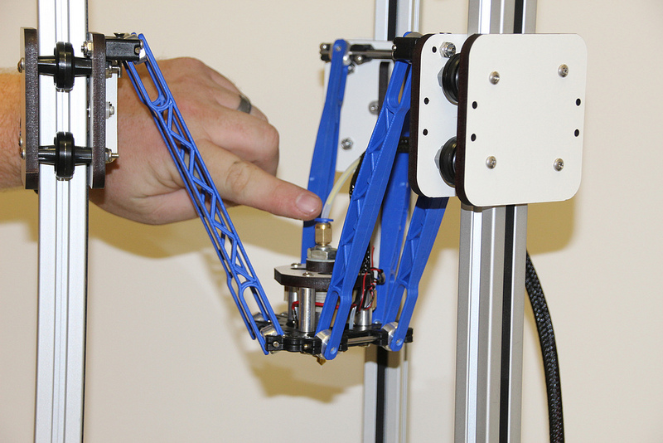

Finally, you'll want to remove the protective plastic sheet that covers the LCD.

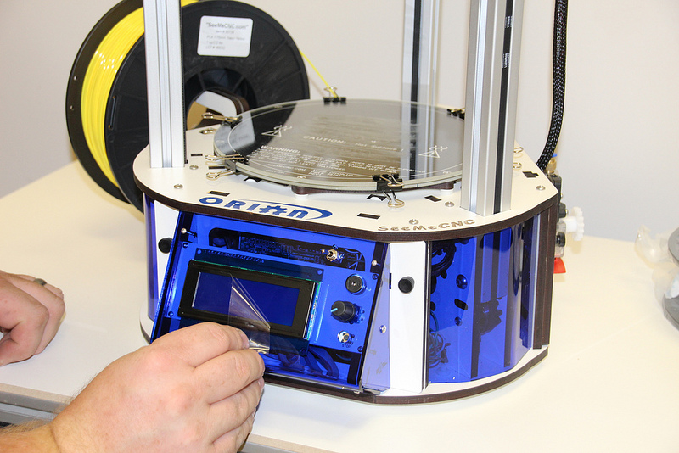

Powering Up your new Orion Delta™ 3D Printer for the First Time

Plug the power cord into a grounded, three prong outlet. Orient the Orion Delta™ to face you and flip the power switch to the right.

You should be briefly greeted by a power on message similar to the one shown below.

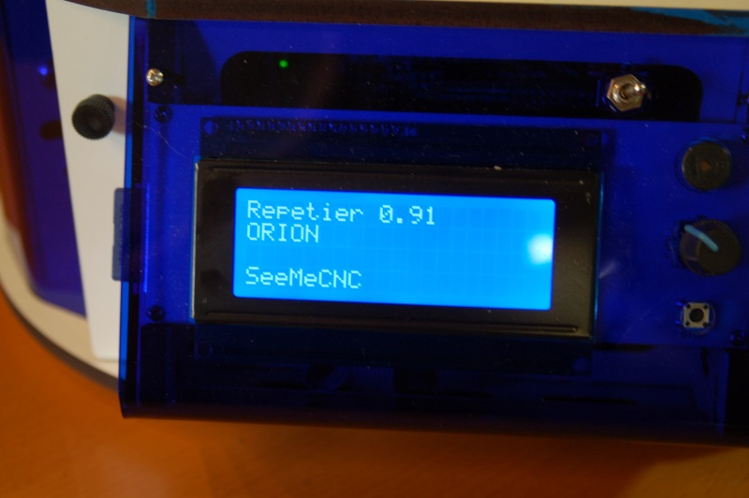

After a short delay, the “front page” of the LCD should be displayed.

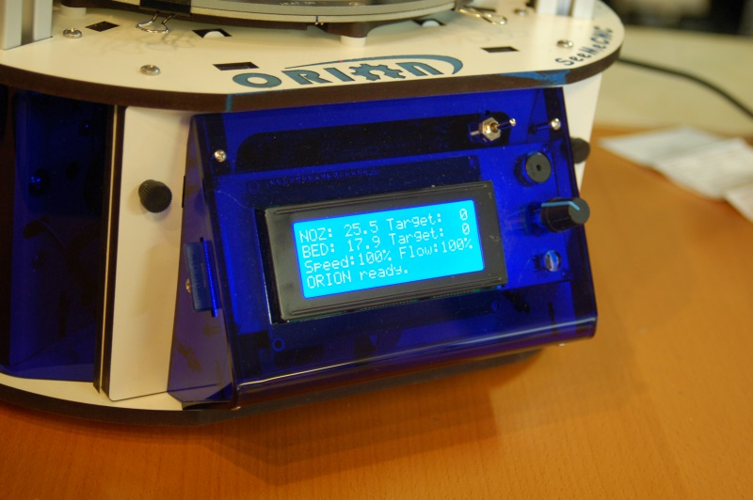

Now that you've got your Orion powered up, let's learn what it's all about!

The LCD Control Panel
Before we get into doing final configuration and printing with your new Orion Delta™ 3D printer, let's take a moment to go over the LCD “home” screen so you'll understand what information is being presented to you.

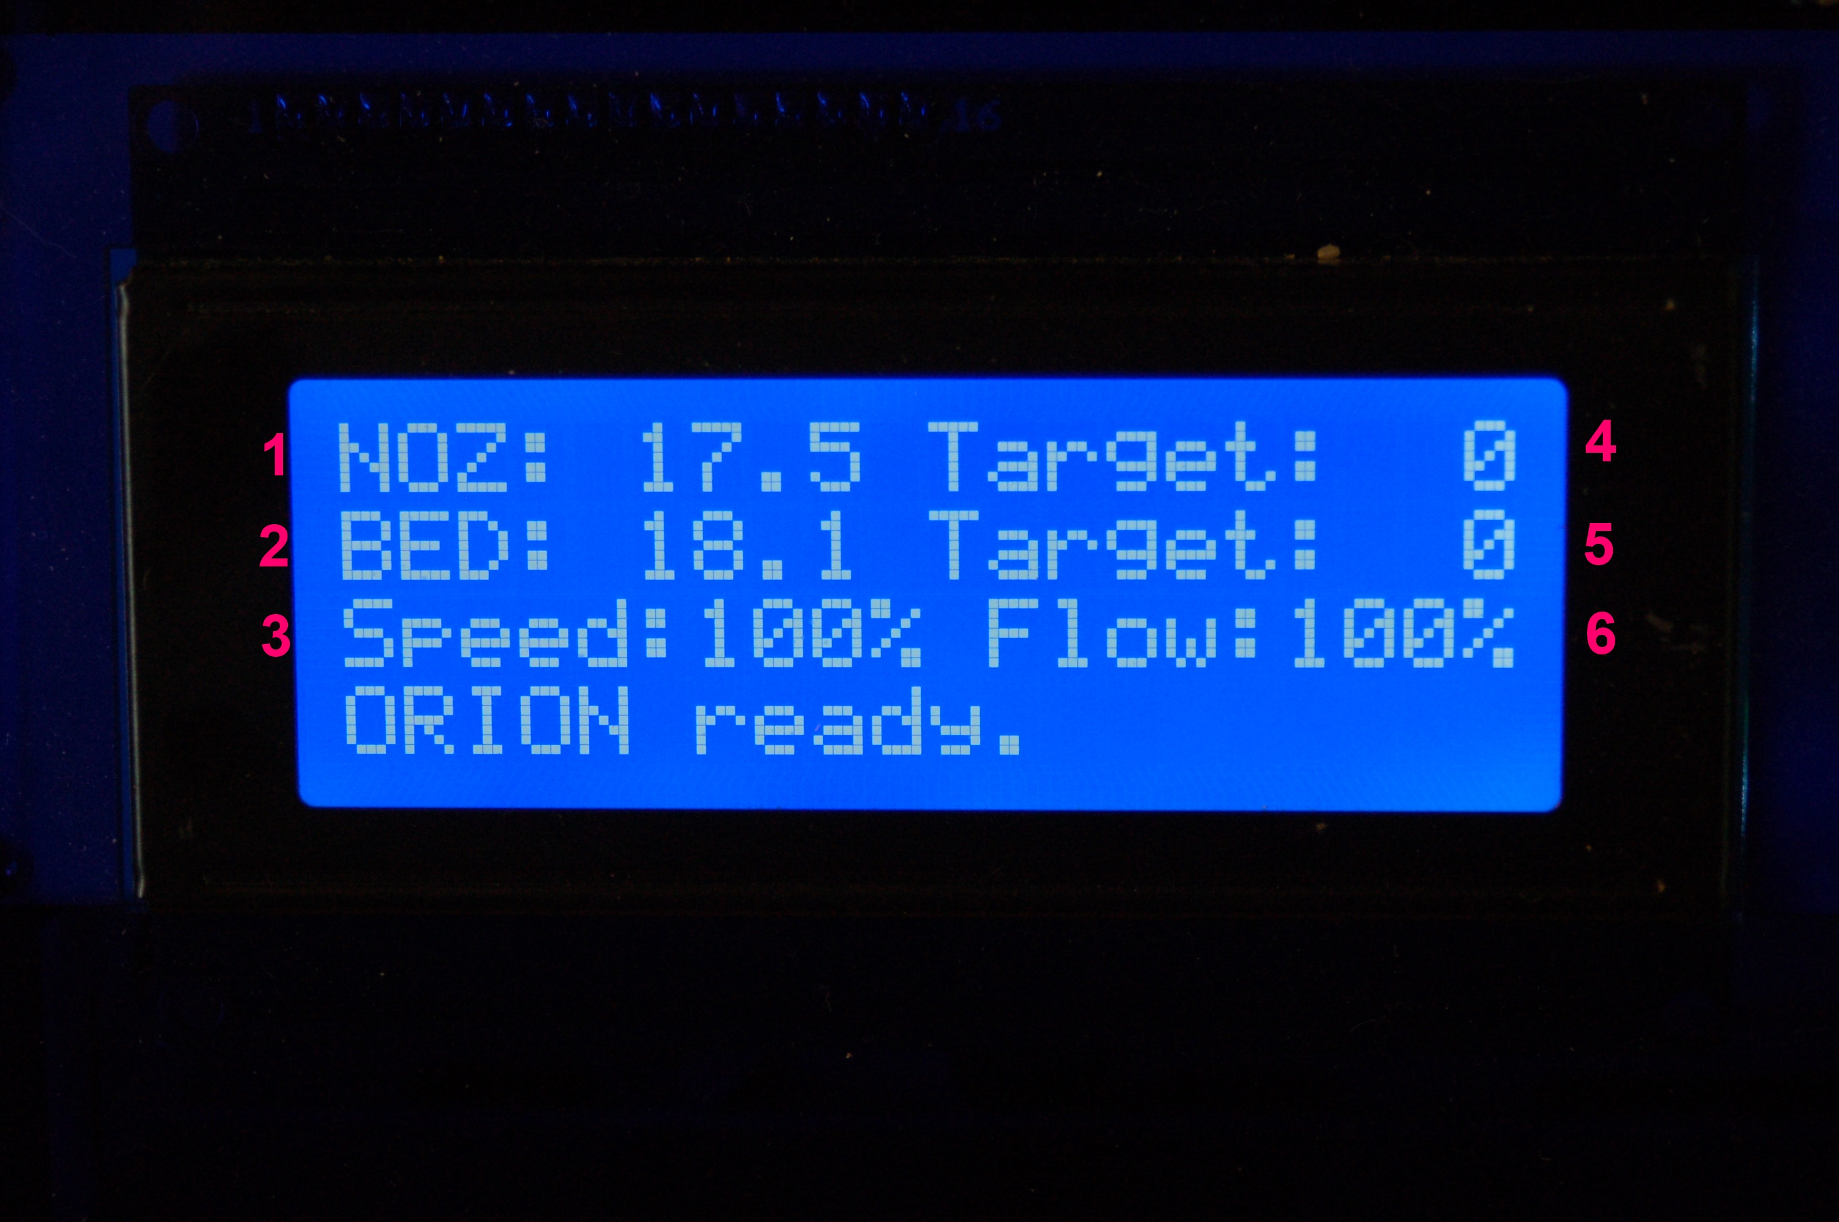

1. Actual Hot End Temperature.
2. Actual Bed Temperature.
3. Speed Multiplier
4. Target Hot End Temperature
5. Target Bed Temperature
6. Extrusion Flow Multiplier.

The current hot end and bed temperatures may differ from what you see above – it's entirely dependent on the temperature of the room that your Orion Delta™ is currently in.
When you specify a hot end and/or bed temperature you'll see those set points reflected in the second portion of each temperature display, like the example below.

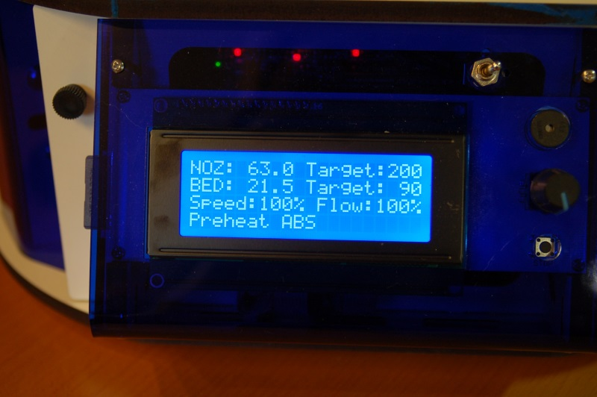

In the image above, the hot end temperature has been set to 200 degrees Celcius and the bed has been set to 90C. Note that just about all aspects of 3D printing is expressed in metric or “SI” units.
You'll notice an additional line at the bottom of the LCD display – this is a “message line” and the firmware in your Orion Delta™ will display information relevant to what it's currently doing on that line.
All control of your Orion Delta™ when not connected to a host computer is done via the LCD panel and the rotary knob to the right of it. The knob will allow you to navigate the various menus and make selections when you press the knob in.
Let's navigate to the “Printer Settings” menu and move the hot end to its home position.

To do this, press the knob in. The interface will beep once and you'll be presented with the following menu:
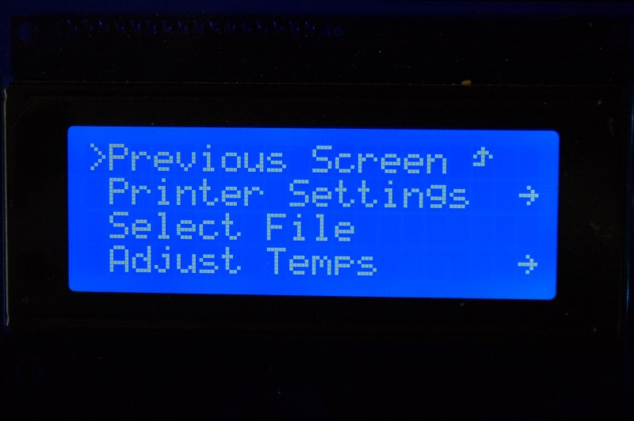

Rotate the knob to the left and move the selection mark to “Printer Settings” as below:

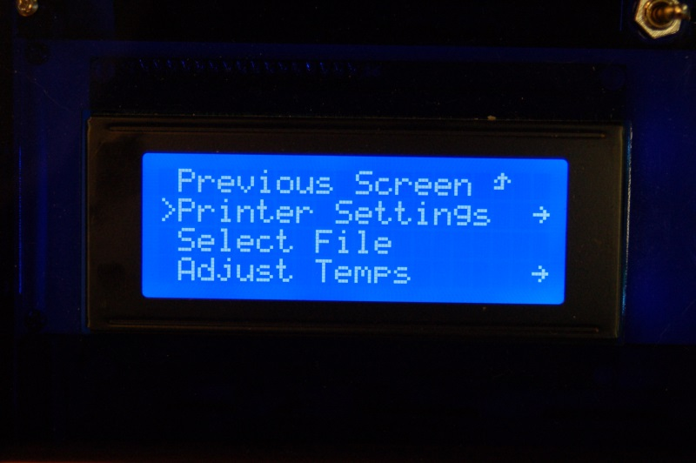

Press the knob in to select the “Printer Settings” menu. Your LCD should now show the following menu:
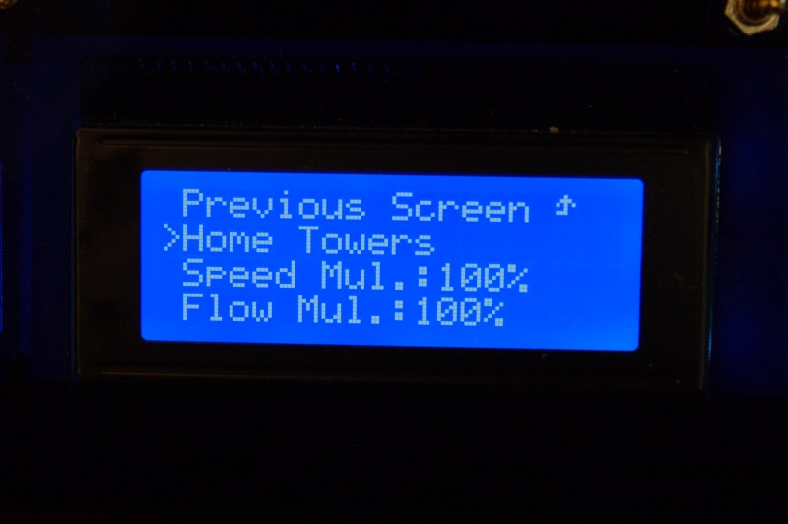

Rotate the knob to the left and select the “Home Towers” option. Pressing the button should result in your Orion Delta™ homing all three axes.
Note that if you leave the LCD in “menu mode” for too long, it will automatically revert to the home screen.

Setting the Z height

Congratulations! Your new Orion Delta™ 3D printer is alive! But before we get to printing lets take a minute to set the Z height of the machine as it could have been bumped during shipping and it needs to be super accurate to get the best first-layer adhesion of your prints.

Using the control panel on the machine to set the Z height is really easy. You’ll find you may need to do this from time to time or after changing to a new build plate or nozzle etc. Pretty much anything that could change the height as measured from the tip of the nozzle to the built plate.

To set the Z height you want to warm the bed and hot end to close to printing temperature to let any heat expansion take place. To do so, click on the knob and scroll to “Printer Settings” then “Preheat ABS” and press the knob. This will set the heated bed to 90c and the hot end to 200c. This is less than the melt temp for ABS, but a good holding temperature that will make sure that any ABS filament doesn’t burn as it sits in the hot end waiting for the bed to heat up. It may take up to 15 minutes to heat the bed to 90c depending on the room temperature, but it’s important to let it heat up before setting the Z height.

Once the bed and hot end are up to the target temperature, click on the knob to reach the menu and scroll down to “Advanced Settings”. Then down to “Calibrate Z Height” and then down to “Home Towers”. Press the knob to home the machine – we're giving it a starting point for the next step.
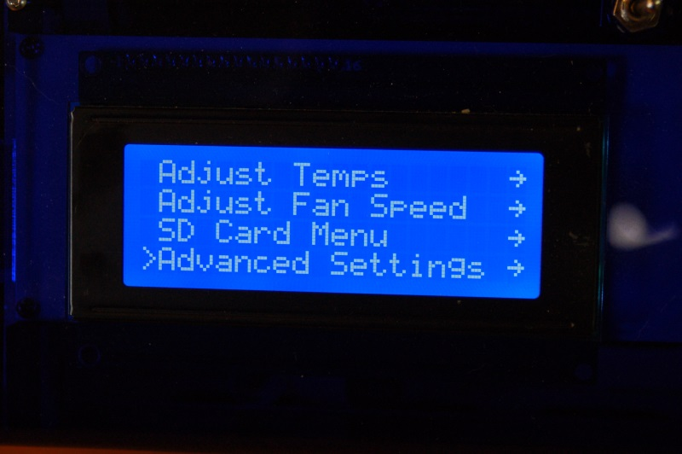
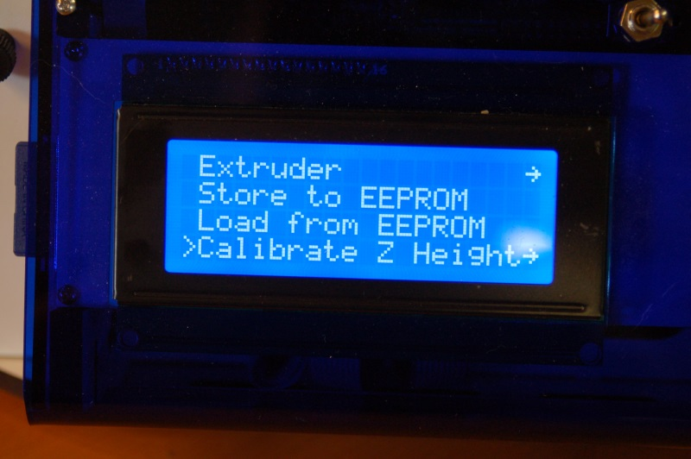

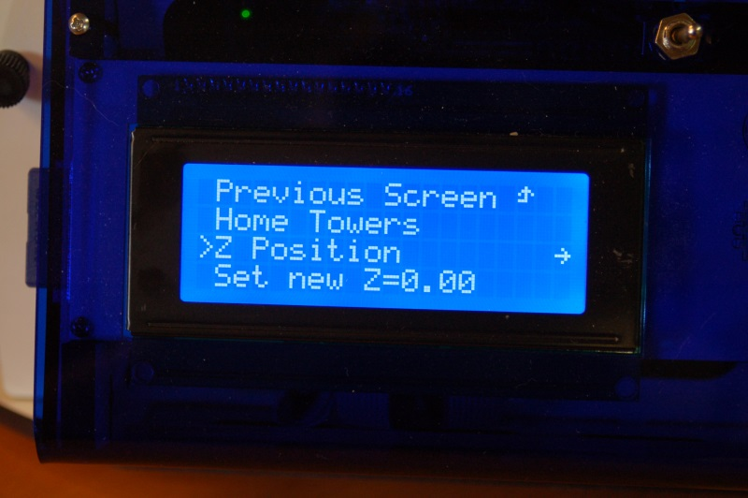

After the machine is homed, scroll to “Z Position” and click.
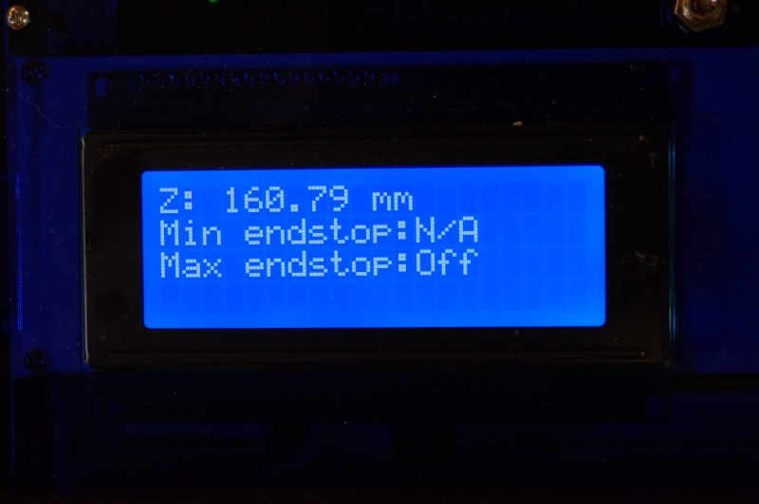

You'll see the display change to what is similar to the photo above. In order to move the platform down, you'll turn the knob counter-clockwise. If you turn it quickly, you'll get large movements and when you turn it very slowly, you'll get a .01mm per-click change.
Use the knob to lower the platform so that the nozzle tip is about 1/2” above the glass build surface.

Make sure the nozzle is clean and there is no filament hanging from the nozzle (Be careful, it’s hot now!). Take a single sheet of notebook paper and place it under the nozzle.
Turn the knob slowly and jog down until the nozzle just begins to “snag” on the paper. Now press the knob to return to the menu and and scroll down to “Set new Z=0.00” to store the new Z height to memory. That’s it! You’ve now set the Z height to the table and you're now ready to prime the hot end and begin your first print!
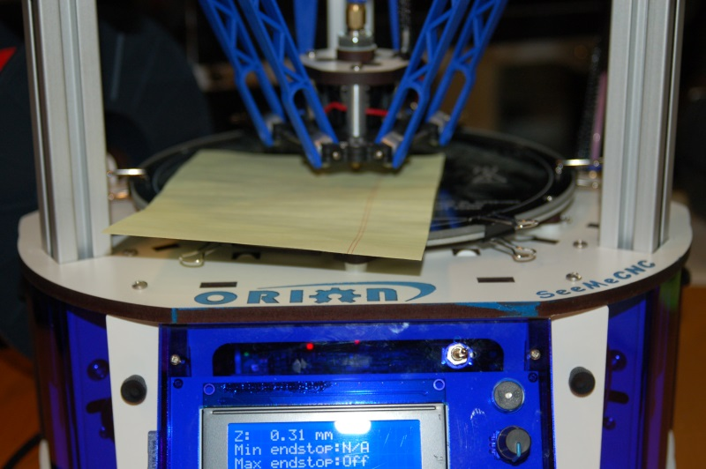
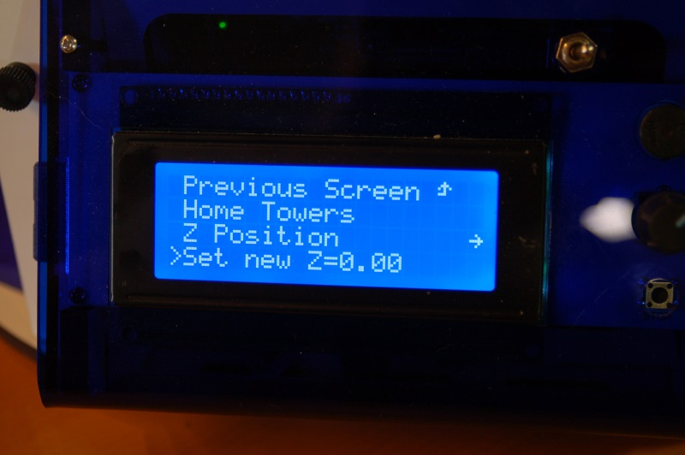

Leveling your new Orion Delta™ 3D (The Easy Way!)

Sometimes the abuse the Orion can experience during shipping can adversely effect the factory calibration. If that's the case with your printer, you can use this easy to follow guide in order to re-calibrate your Orion. This procedure was written by the gentleman that built and calibrated your printer, so there literally is no more authoritative source for the process.

1) Preheat hot-end and bed to the material you use. If you use both, just use the “Preheat ABS” in the printer settings menu on the LCD.

2) Once the hot-end and bed are up to temp, on the LCD, click the knob to bring up the menu, go to Advanced Settings (at the bottom of the list). Click the knob.

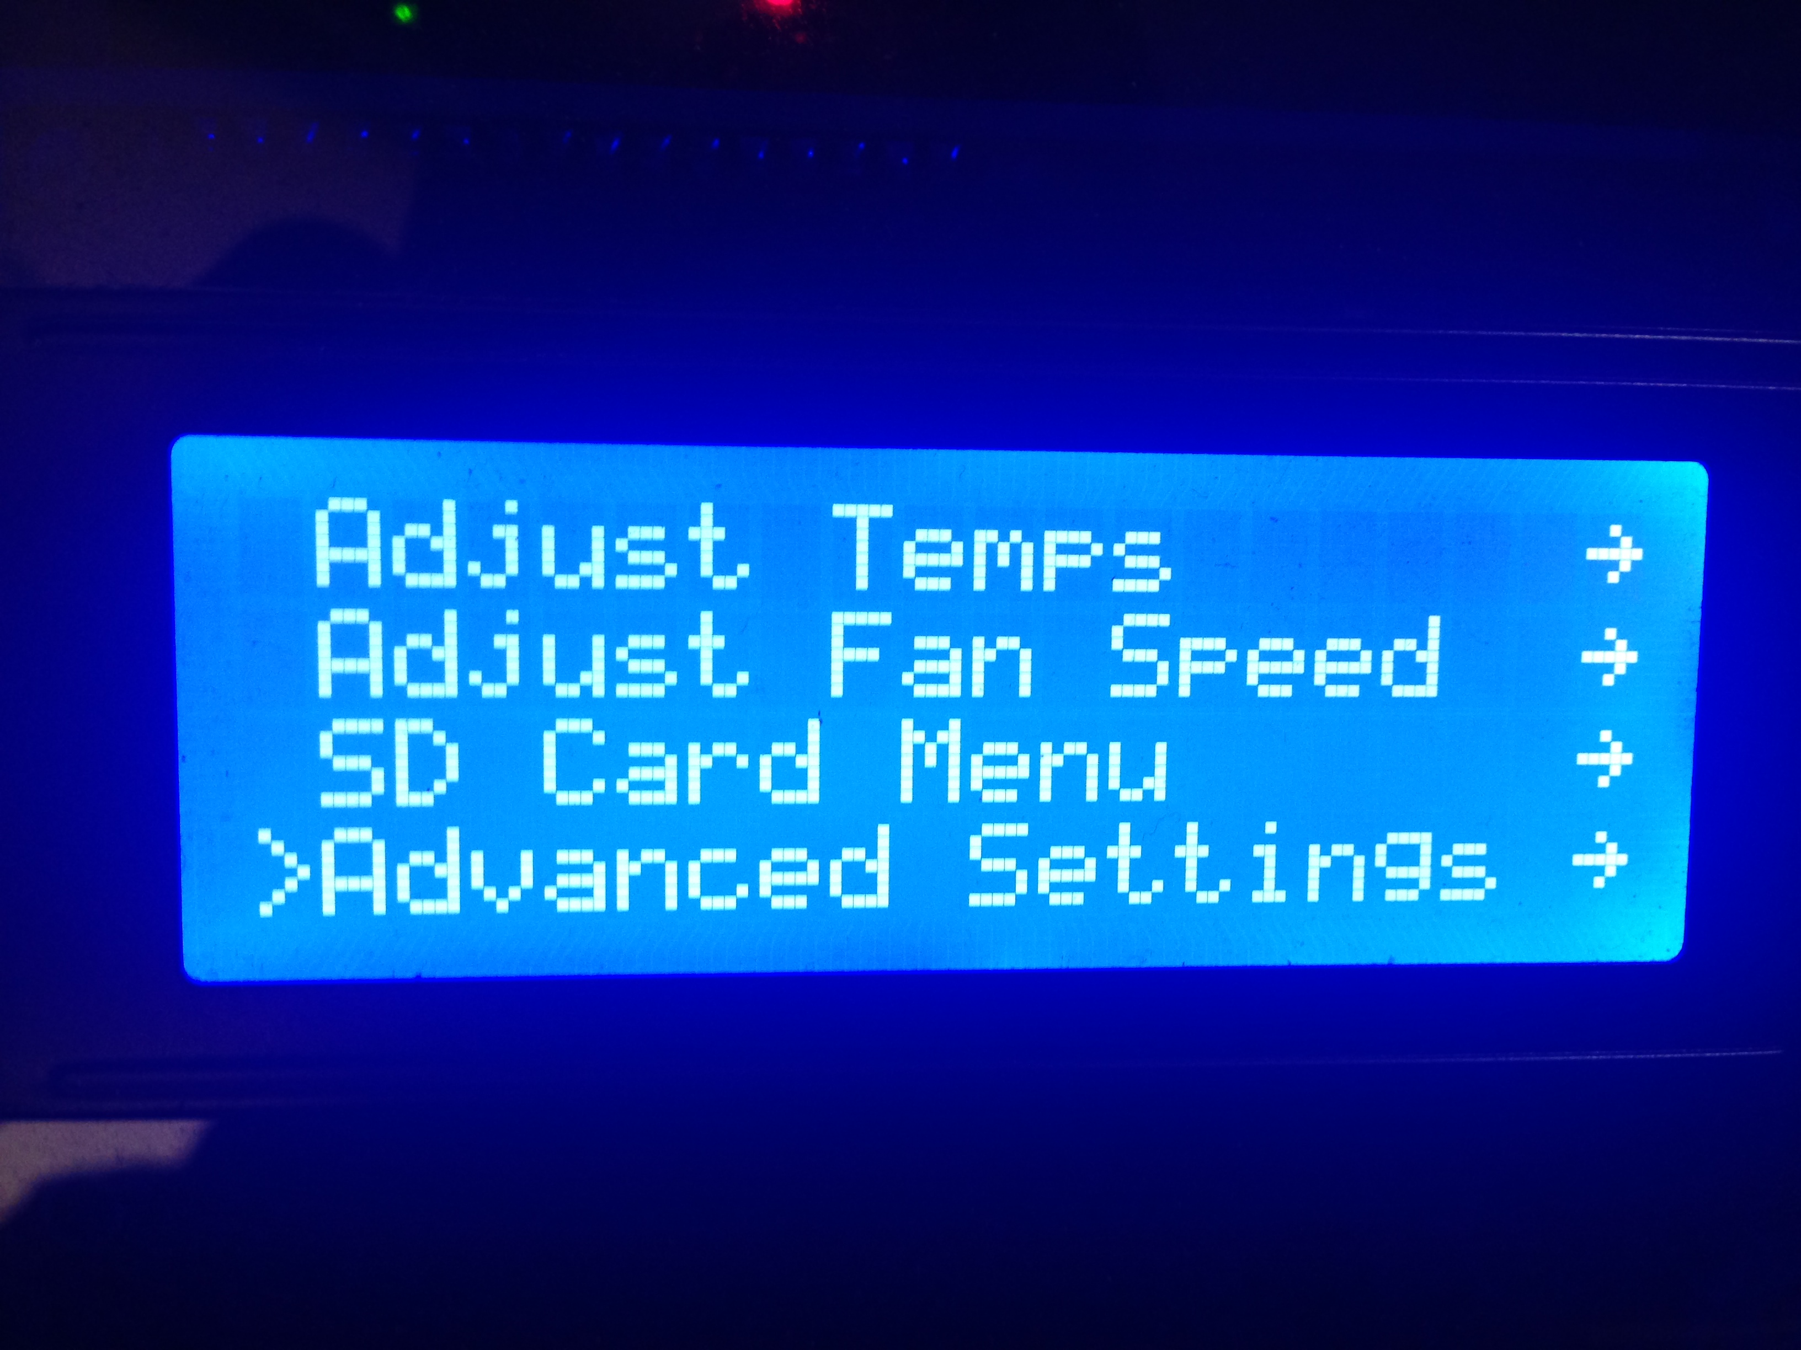

3) Go to the bottom of the next menu to Calibrate Z Height. Click the knob.

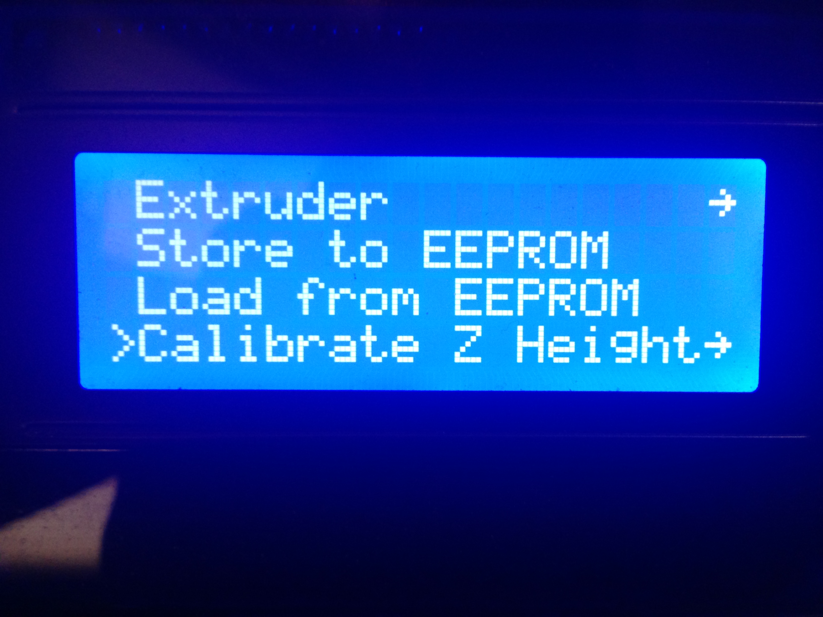

4) Now you are in the calibration menu. Click Home Towers. The machine will go up and hit all the end-stops.

5) Go down to Z Position and click the knob.

6) Turn the knob Counter-Clockwise to lower the nozzle. Bring the nozzle down till its a couple millimeters from the glass like the following pic.

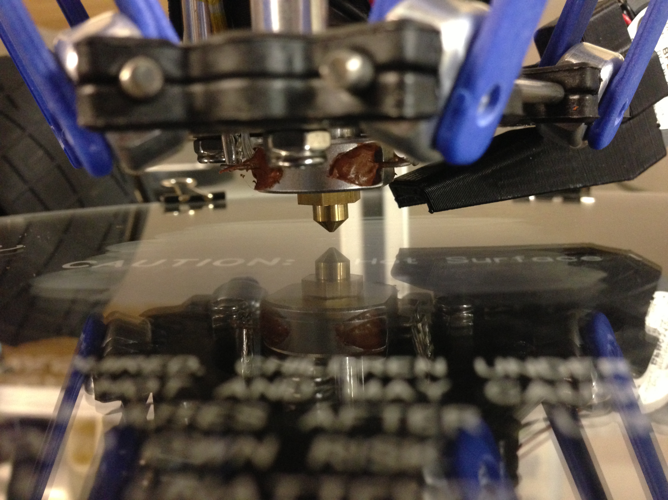
7) Turn the knob counterclockwise SLOWLY and look eye level with the bed, and bring the nozzle down till it just barely meets the glass (this is easiest with a white wall in the background so you can watch the reflection of the nozzle – if you don't have a white background to use, you could tape a sheet of paper between the towers to give you enough contrast). When the nozzle touches the glass, click the knob.

8) Go down to Set New Z=0.00 and then click the knob.

9) Go to Home Towers. Click the knob. You have now set the z height, and now it is time to calibrate the towers.
The next steps can be done through a computer or SD card. I find it is easier on a sd card so you can keep close to the machine to watch the movement.

10) Open notepad or a text editor of your choice.

11) Paste the following into the text editor:

; Tower endstop calibration script
G28
G1 Z.2 F15000
G4 S1 ; pause for 1 second
G1 X-65 Y-37 F2000
G4 S2 ; pause for 2 seconds
G1 X0 Y0
G1 X65 Y-37
G4 S2 ; pause for 2 seconds
G1 X0 Y0
G1 Y65
G4 S2 ; pause for 2 seconds
G1 X0 Y0
12) Save the file as “Towers.gcode” and place it on an SD card, or if you are going to be using a computer, load it into your host software that you use.

13) Again with the bed at eye level and looking close, Run Towers.gcode from either your host software or SD card. Watch closely as the machine will home, then the nozzle will drop to 0.2mm ABOVE the glass.

The gap will look like the following pic.

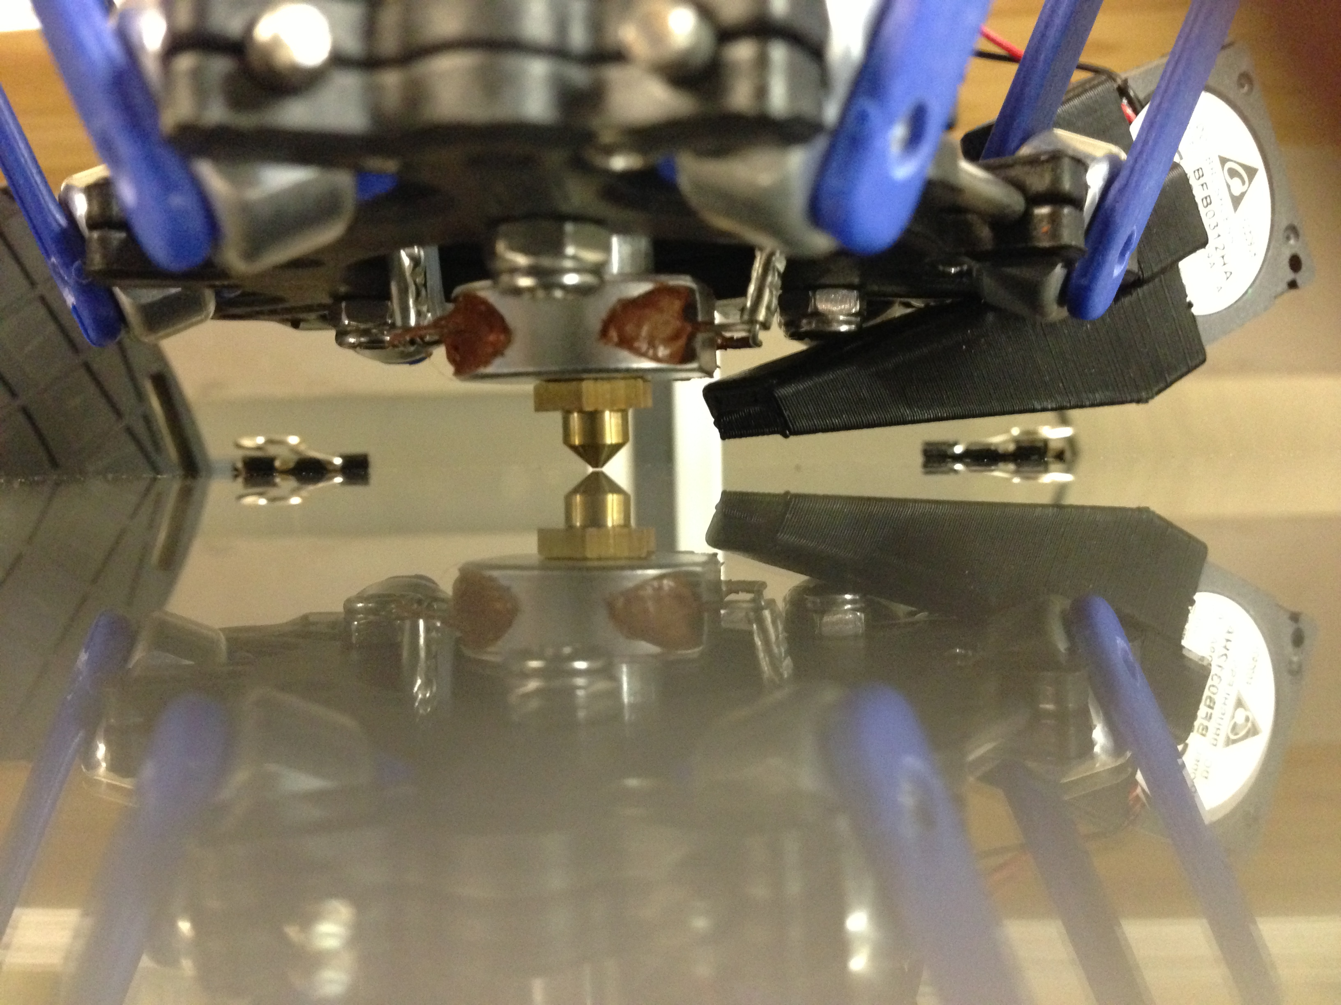

After it drops to the center like that, it will travel to the X tower. DO NOT pay attention to what the nozzle does while traveling, what you must pay attention to is when it pauses.

The nozzle will pause at the X corner, then return to the center, and move to the Y tower and pause. After the pause, it will again move to the center, and move to the Z tower, pause, and return to the center.

14) What you want to remember is the nozzle when it pauses. You want to compare the movement to the gap at the center.

– If the nozzle at the tower RAISES (compared to the CENTER), you want to adjust the screw that hits the end-stop by turning it counterclockwise (moving the screw up).

– If the nozzle at the tower LOWERS (compared to the CENTER), you want to adjust the screw that hits the end-stop by turning it clockwise (moving the screw down).
Pic of screw you will adjust:

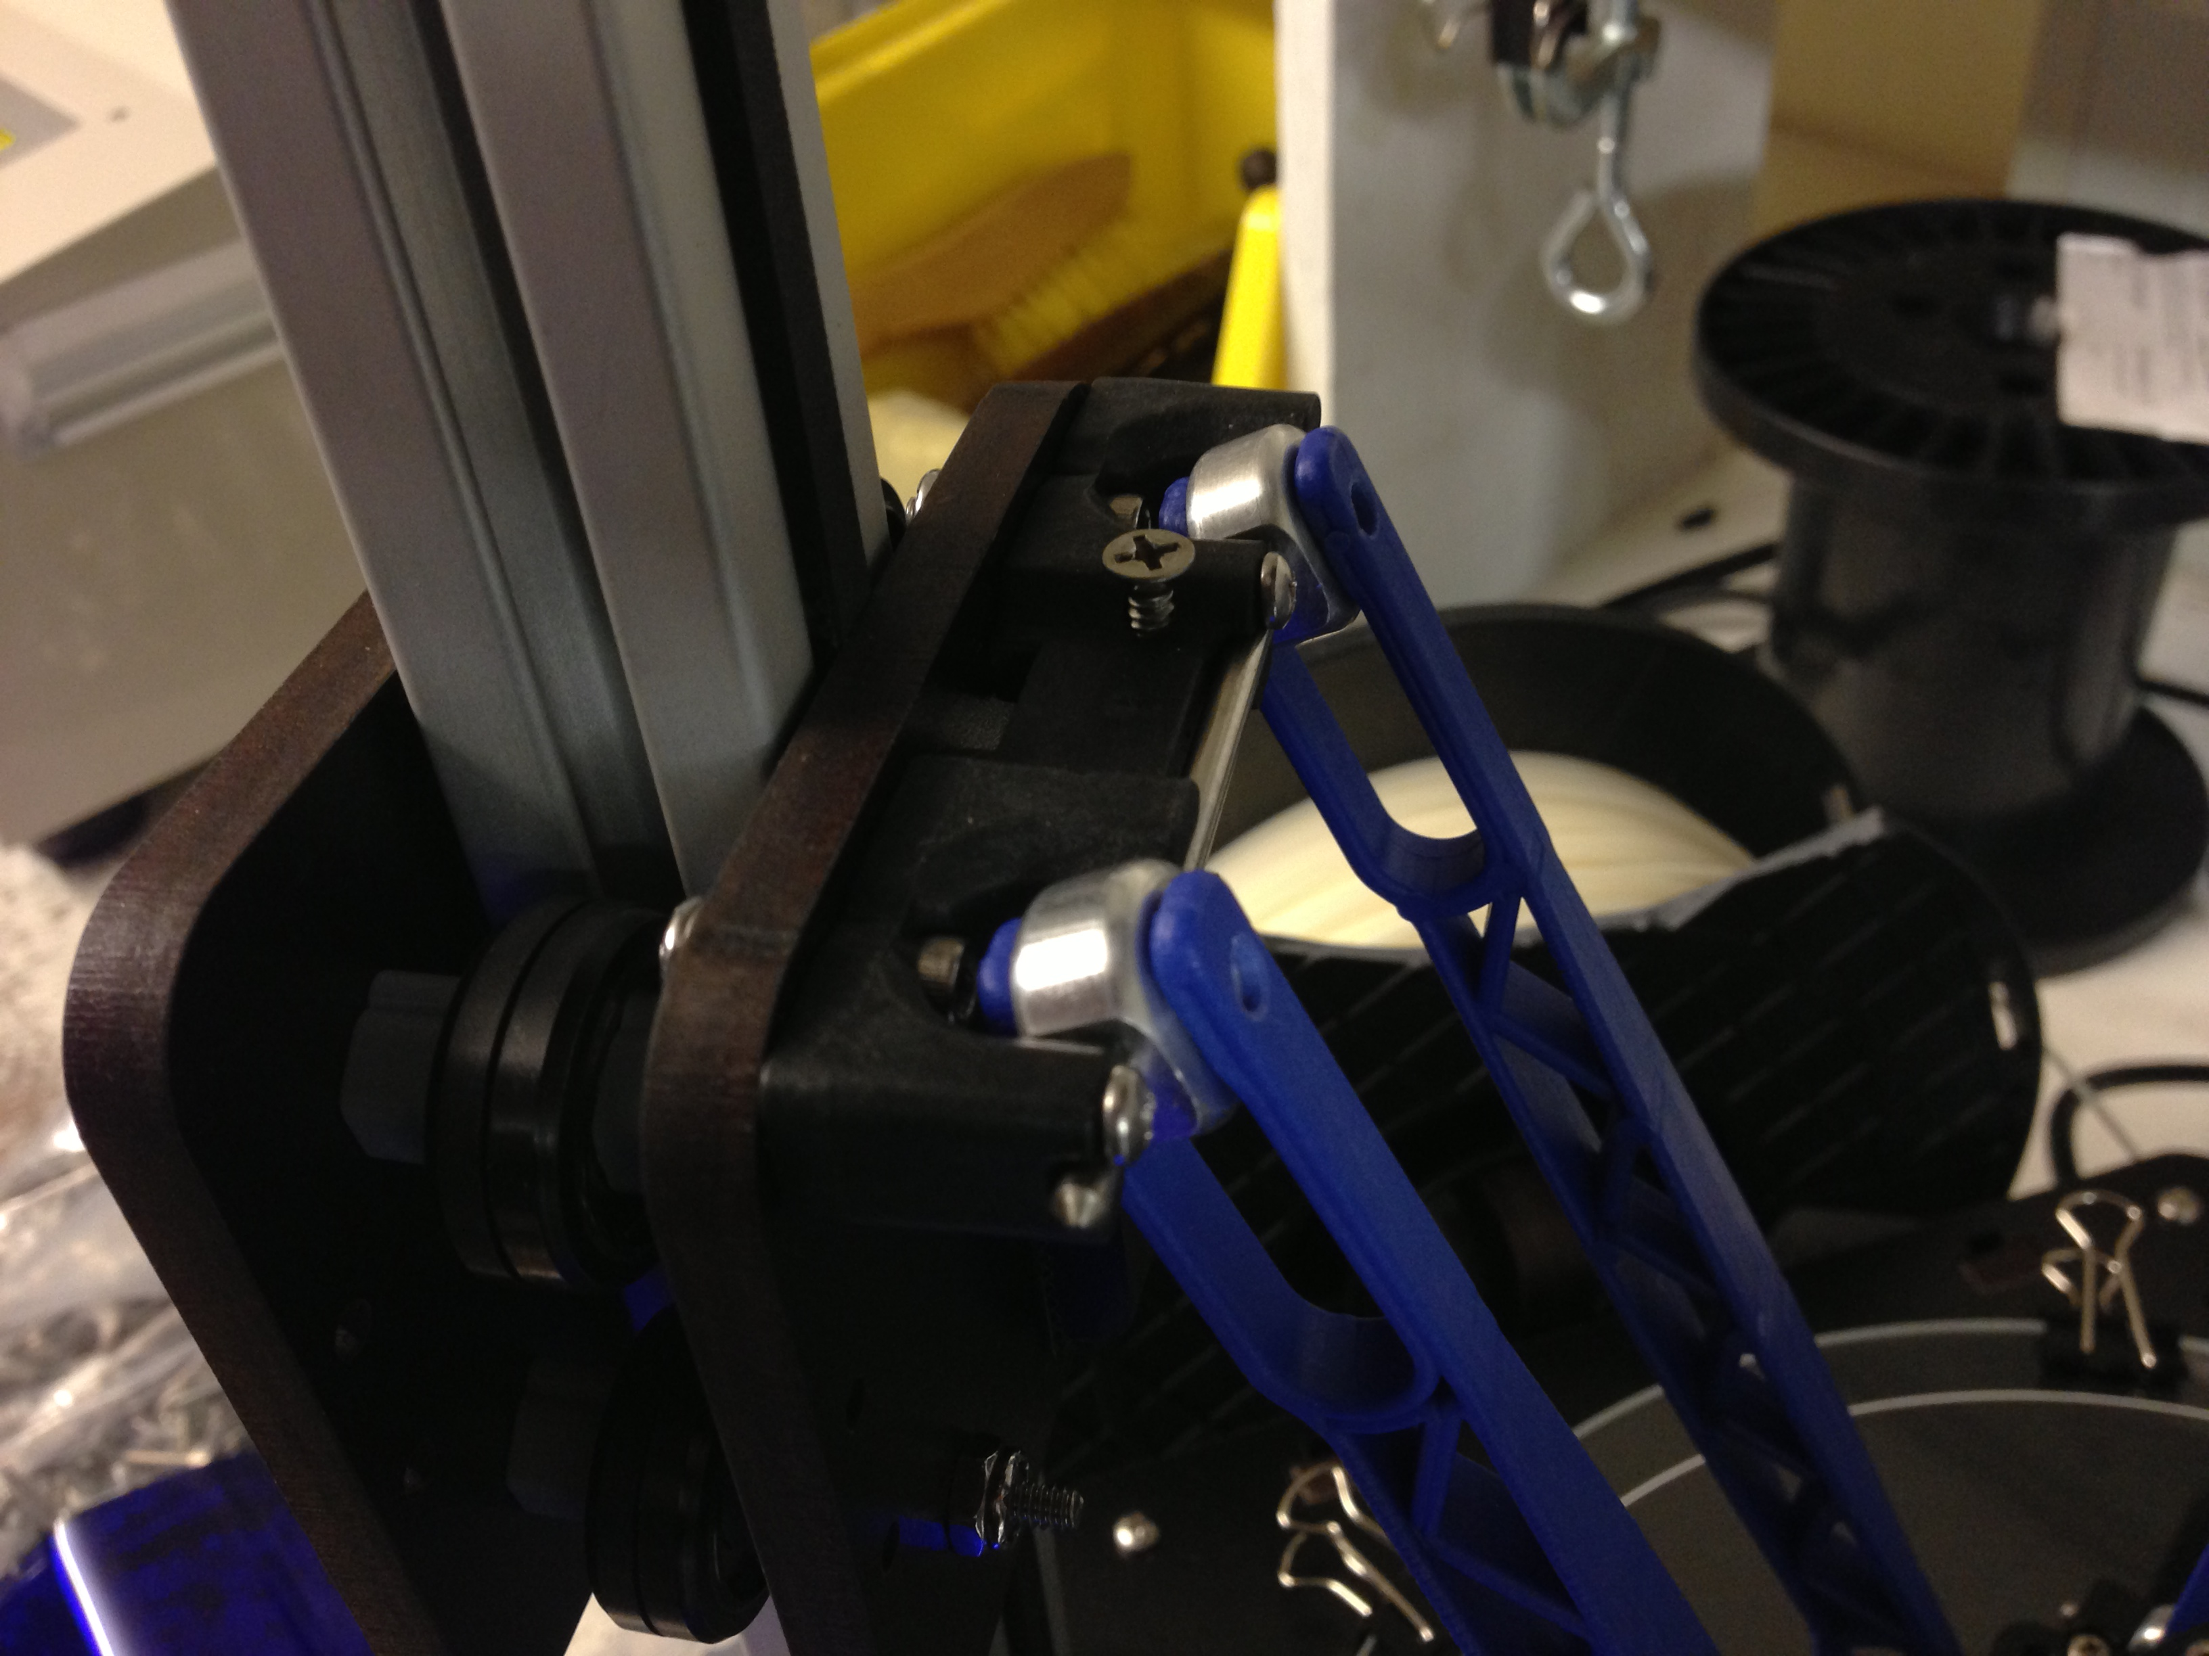
*** Make small changes to the screw about 1/8 – ¼ turn adjustments***

15) After you have adjusted the screws, You have changed the Z height, so you want to go back and re-set the Z height the way you did earlier in this guide.

16) Re-run Towers.gcode and watch as you did before, again noting the changes in the nozzle at each pause. You will run through these steps till the nozzle remains the same height at each tower when compared to the center.

If the nozzle goes the same direction on all 3 towers (such as you have the gap in the center, and at every tower the nozzle lowers. Or you have the gap at the center and at all 3 pauses the nozzle raises), you will adjust the radius in the following way.

17a) If from the center gap, the nozzle goes DOWN toward the glass at ALL 3 TOWERS, load your host software and bring up the EEPROM information. You will look for Horizontal Radius. You want to RAISE that number. I suggest raising it by 0.2 and run towers.gcode to see the change, and keep raising the number till the gap evens out (changing this number will not make you need to re-set your z height, it will just raise the outer edges where the nozzle pauses).

17b) If from the center gap, the nozzle goes UP toward the glass at ALL 3 TOWERS, load your host software and bring up the EEPROM information. You will look for Horizontal Radius. You want to LOWER that number. I suggest raising it by 0.2 and run towers.gcode to see the change, and keep raising the number till the gap evens out (changing this number will not make you need to re-set your z height, it will just lower the outer edges where the nozzle pauses).

After doing this, you will see any changes where one tower may be higher than another, if this is the case, go back to adjusting the end-stop screws as before.

Typically it can take anywhere from 5-10 or so re-runs of the tweaks to get the gap to remain the same at all 3 pauses compared to the center of the machine. Once the gap is the same at each tower compared to the center, your machine is calibrated and ready to print!

A Simple Guide to Hot End Priming
Before you can print with your new Orion Delta™ for the first time (or any time you load new filament), you'll need to prime the hot end with the new material. Fortunately, this is a very simple task!
Now on the LCD screen, click and go to “Printer Settings” and scroll down to “Disable stepper” and click. This will unlock the motors allowing you to turn the extruder by hand in order purge the hot end. Now go to the menu and select “Adjust Temps” then scroll down to “Temp. 0” and click, then set the temp to 215 and click to set the new hot end temperature. You can wait for the screen to go back automatically to the main screen or scroll up and click “Back” and get to the home screen.
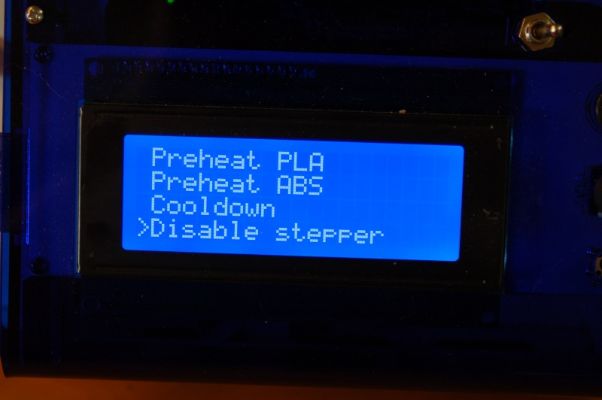
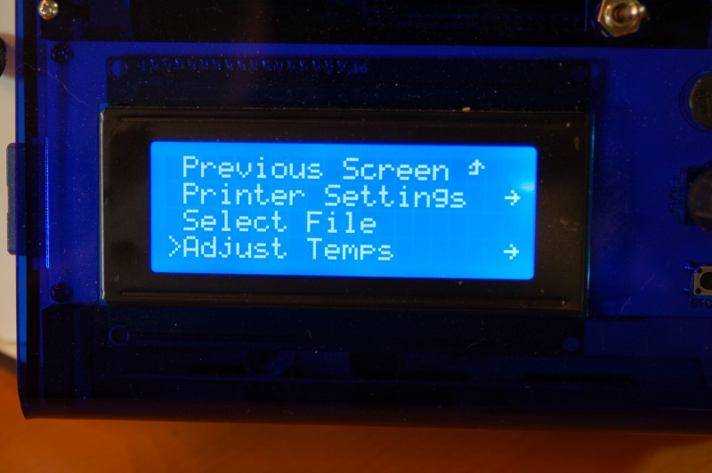

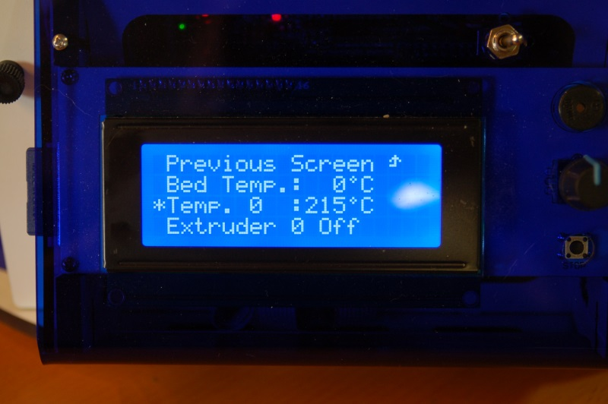

Once the hot end is up to temperature, reach around the right side and rotate the knob on the extruder counter clockwise to feed filament slowly into the hot end and you will see it start to flow out the nozzle. Let it flow out about 4” or so, then stop and remove the hanging filament.

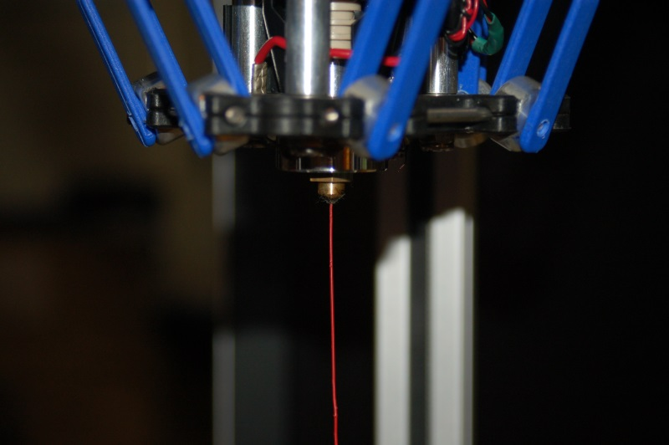

That's all there is to it! You're ready to print!

Printing from the SD Card

The SD card included with your new Orion Delta™ 3D Printer has folders already on it with some sample prints as well as the firmware that was used to calibrate your machine.
The SD card goes in the left side of the control panel, label facing inwards, through a slot in the blue acrylic side panel as shown below.
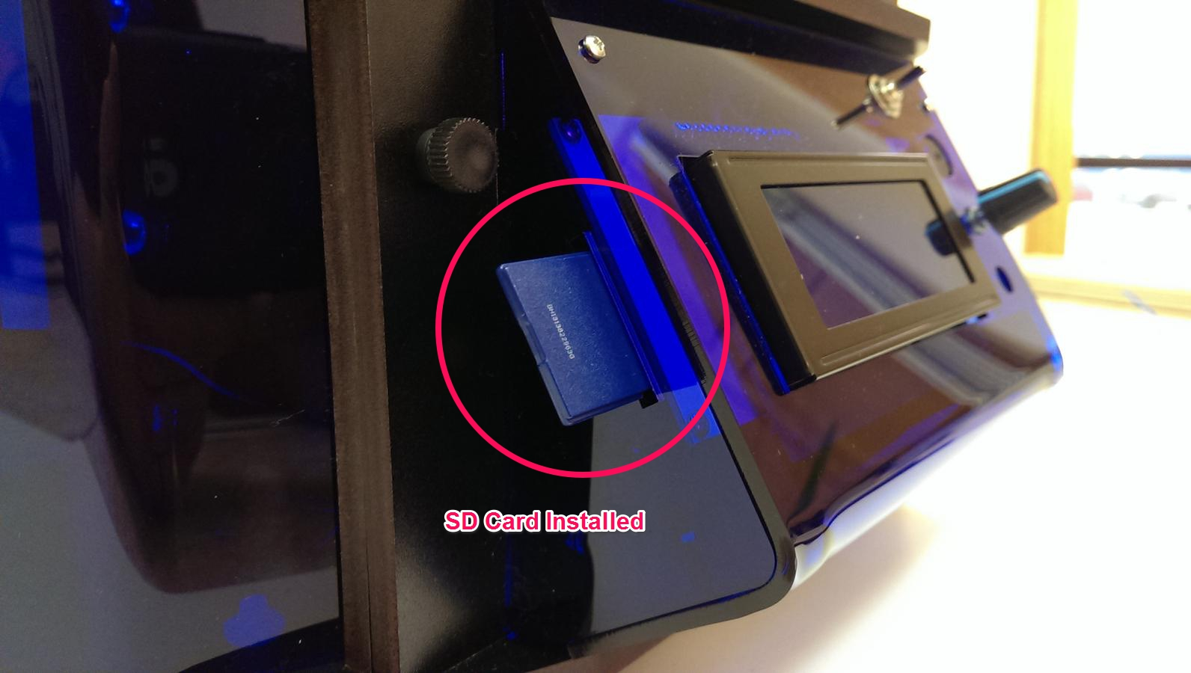
If you've got an SD card reader on your computer, you can easily save files to the SD card in order to print with your Orion Delta™ in “stand-alone” mode. You don't need to connect the printer to your computer in order to print!

Let's take a look at the demo files that were included on the SD card that was shipped with your Orion Delta™.
Click the control knob to enter the LCD menu and scroll down to the entry marked “Select File” and click.
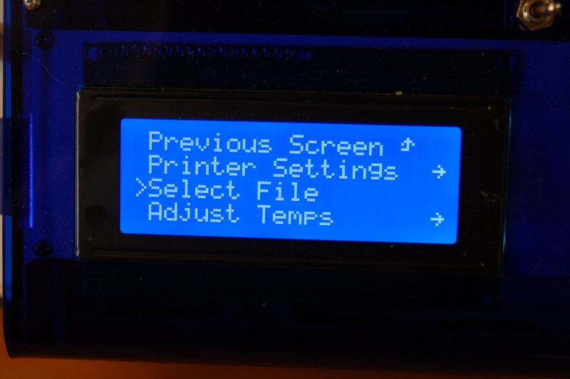

Scroll to the “Print file” menu item and click. This will get you into the top level directory of the SD card.

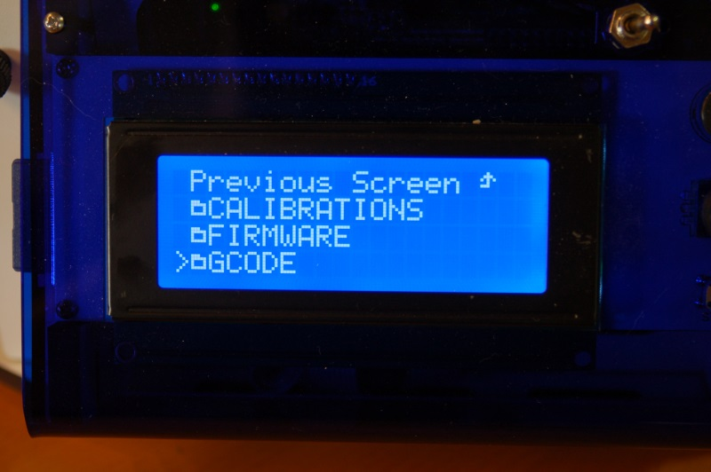

The odd little symbol you see to the left of the directory names are actually little folder icons. This simply helps separate the directories from g-code and other files on the SD card.

Click the “GCODE” directory to see a list of the files included.
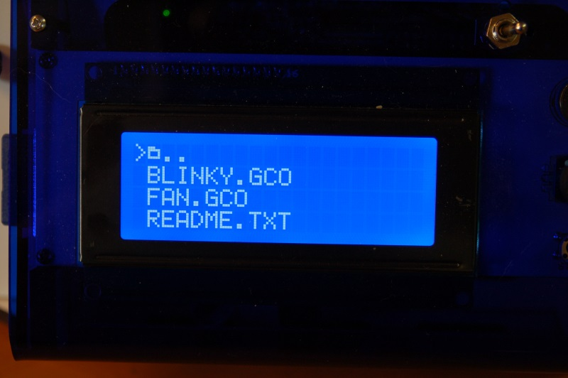

For this first print, go ahead and click on the file, “BLINKY.GCO”.

When you select the file name, the LCD controller will make a “chirping” sound and the heated bed will begin to heat up. Once the bed has reached its target temperature, the printer will home all three axes and then the hot end will begin its heating process. Once that has completed, the printer should begin the print.

Note – before you run a print job on your Orion Delta™, you need to apply a thin layer of adhesive using the included glue stick. This will allow the ABS plastic to stick to the glass. Apply the glue stick in a thin layer of parallel lines. Let it dry and repeat the process, using lines perpendicular to the first layer. Once it dries you can print.

Do NOT apply the glue stick to a hot bed!

If you need to cancel a print job for any reason, simply turn the machine off and use the control panel to re-home the towers.

Changing Filament

Changing the filament on your Orion is a very simple process.
First, you'll want to bring the hot end up to the temperature you normally set it at when you're printing.
Once the hot end is at operating temperature, pop the bowden tube off the hot end as shown in the following steps.

1. Grip the bowden tube with one hand and press down the blue ring and pull up on the bowden tube. You may need to depress the red release lever on the extruder in order to get enough slack to pull the bowden tube free of the hotend fitting.
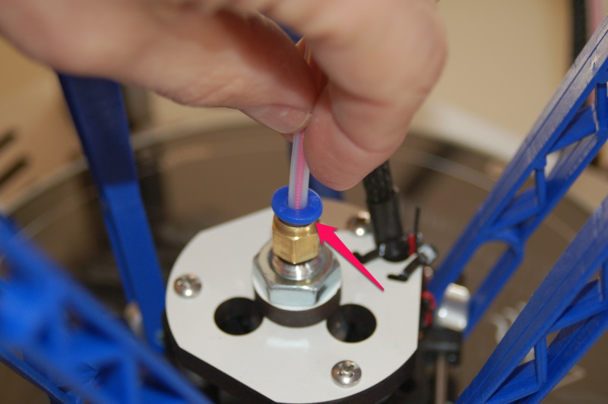

When the filament pulls free, it should look something like the photo below.

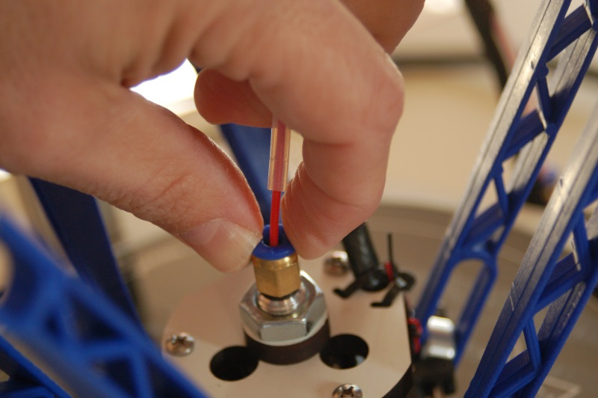

2. Cut off the filament flush with the end of the bowden tube.
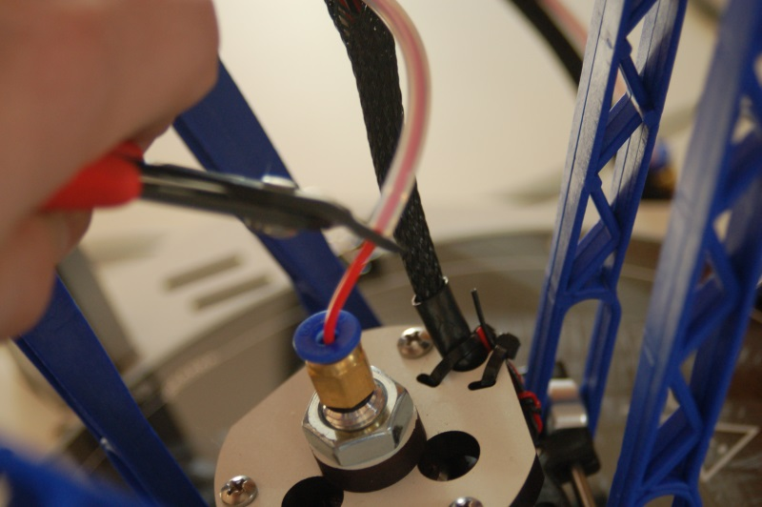

3. Pull the filament stub from the hotend and then re-insert the bowden tube into the hotend, making sure it seats fully.
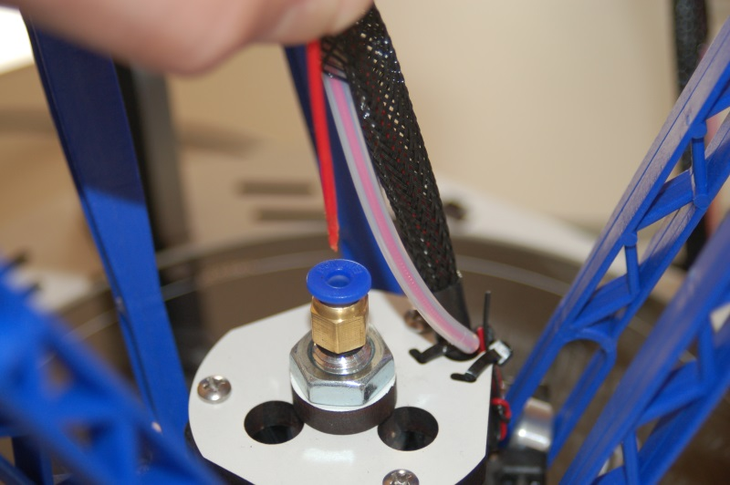

Printing From Your Computer

In order to print from your computer, you'll first need to get the right software installed. Since the machine I use with the Orion is a Windows based PC, these instructions will focus on that platform. If you're using Linux or MacOS, the broad strokes of this section will apply to you since the host software used is available for both Linux and MacOS. The only platform that needs to worry about the driver install is Windows.
In order for Windows to communicate with the Orion, you'll need to download a small driver. This “driver” isn't so much a real piece of code as it is a fancy device description that tells Windows how to talk to a bog standard serial port.
You can download the driver here:
http://download.seemecnc.com/Software/RAMBo_USBdriver.zip
The driver file is signed so it should work without any problems under Windows Vista, 7 and 8.
If you haven't done so already, connect the Orion to your computer using the included USB cable and turn the Orion on.
Unzip the file to a temp directory or other place that you know the location of. For Windows users (and likely XP, Windows 8 and Vista users as well), plug in the RAMBo and let Windows “fail” to find the correct driver for the board.
Open up the device manager by right-clicking on “Computer” or “My Computer” and select “Properties” followed by “Device Manager”. Scroll down to the “Unknown Devices” entry and right-click on the RAMBo entry. Choose “Update Driver” and then “Browse my computer for driver software” (or something similar to this).
Choose “Let me pick from a list of device drivers on my computer”, then click the button for “Have Disk”. Browse to where you unzipped the file you downloaded and then click “OK”. It may complain (depending on OS) that the driver isn’t signed –allow it to install it anyway. That’s all there is to it. The RAMBo will now appear on your computer as a standard serial port.

The software used to send jobs to the printer (among other things!) is called Repetier-Host. From now on, I'll refer to it simply as “the host software”, or some cryptic variant of that.

To get a copy of “the host software”, you'll need to go to http://www.repetier.com and download the version that's appropriate for your platform. Repetier offers it in Windows, Linux and MacOS flavors. On the Repetier site, click the download link and chose the latest release for the platform you're working with. At the time of this revision, the most current version for Windows is 0.90C, Linux is 0.95F and MacOS is 0.56.

Before you start up the host software, you'll need to know what port that the Orion appears as. In order to discover this bit of information, you'll need to open up Device Manager (right click on My Computer, click “Properties” and then click “Device Manager”). You'll get a window that looks something like this:

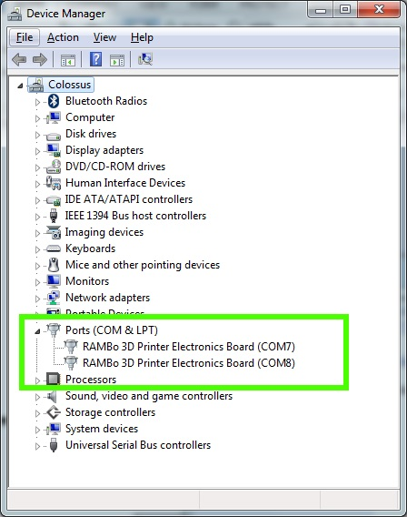
The green box highlights the entries we're interested in. Because I've got two printers currently connected to my machine, there's two entries in there for RAMBo controllers. The data you need is the bit at the end – in this case it's “COM8”. Write this down – we'll need it in order to tell Repetier-Host what port to contact the RAMBo on.

Start Repetier-Host and click on Config->Printer Settings. See below for an example of how that screen looks.
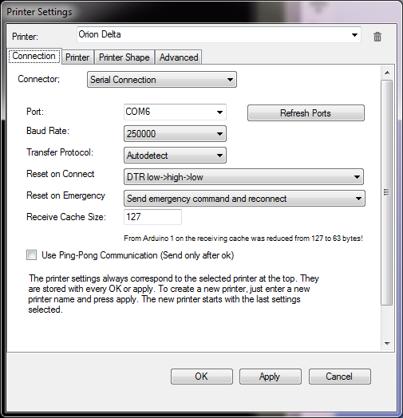
The first thing I want you to do is name the configuration for your printer. You can do this by clicking in the “Printer:” drop-down shown above. It will typically start as “default”, but you can change that to whatever you like. I named this one “Orion Delta”.
You'll want to change the “Port:” selection to match the entry you found previously while exploring the Device Manager. The “Baud Rate:” and remaining fields should be set as they are shown above. Don't forget to click the “Apply” button in order to save the changes you've just made!

Now click on the “Printer” tab:
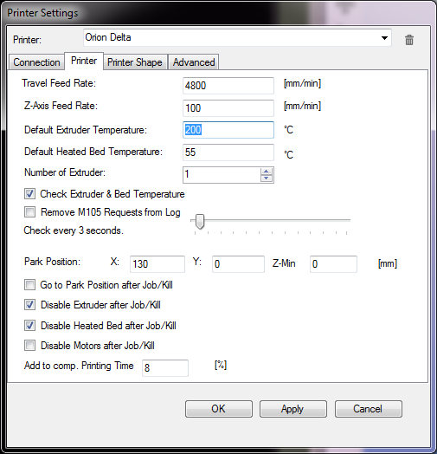
You'll want to change all the fields in your Printer tab to match the values I have set above example. You'll learn over time what each of these different options do, but for now just set them as I have them. Click on the “Apply” button and we'll move on

Now click the Printer Shape tab:
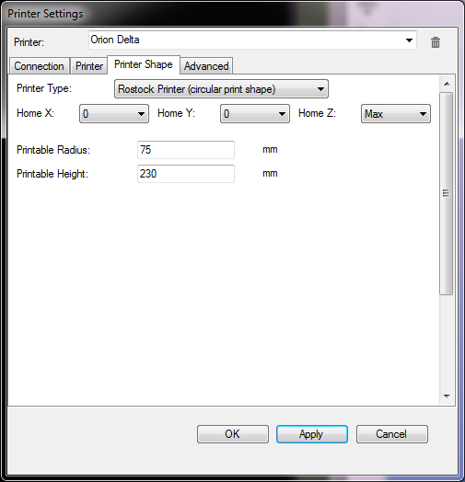
Click on the “Printer Type:” drop-down and select “Rostock Printer (circular print shape)”. That selection should change the Printer Shape configuration screen to look similar to what you see above.
Go ahead and click on the “OK” button to save your changes and dismiss the configuration dialog.
You can now connect to the Orion by clicking the “”Connect” button that's on the left end of the Repeter-Host toolbar. Upon connecting, you should see something similar to this appear in the log window of Repetier-Host.

Below is a more current version of the sign-on banner.
10:48:13.758 : FIRMWARE_NAME:Repetier_0.91 FIRMWARE_URL:https://github.com/seemecnc/Repetier-091-ORION PROTOCOL_VERSION:1.0 MACHINE_TYPE:Orion_Delta EXTRUDER_COUNT:1 REPETIER_PROTOCOL:2
10:48:13.761 : Printed filament:492.65m Printing time:2 days 21 hours 50 min
The firmware “boot” banner basically tells you what the revision of the software is as well as how much filament you've printed (measured in meters) and how much time your Orion has spent printing. As of the .91 release of the firmware, turning the knob either direction will also show you your printing stats. These figures are stored on board the EEPROM in the RAMBo controller.
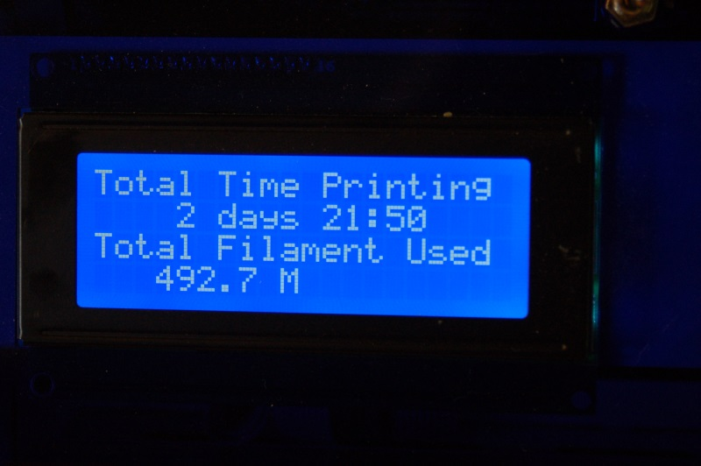

If Repetier-Host is unable to connect, go back into the printer configuration and make sure you've chosen the COM port that matches the RAMBo entry in your Device Manager listing.

Click on the “Manual Control” tab that's located on the right half of the Repetier-Host display: You'll be using this when you need to manually control the Orion.
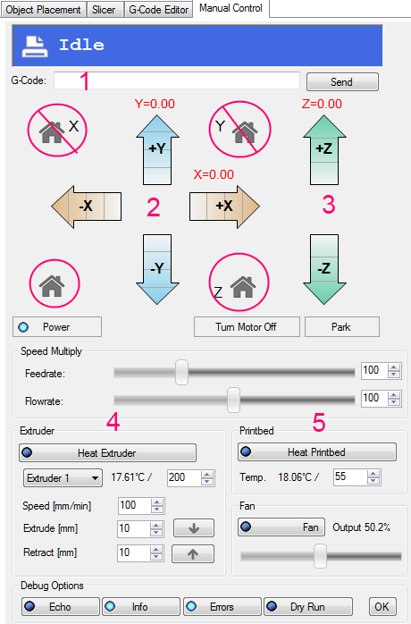
You'll note that there's two icons on the manual control panel that I've “marked out”. These are the X and Y axis home buttons. For the Orion and other delta configuration printers, these shouldn't be used. Adverse effects can occurr, including damage to your bed glass if they're used.
That being said, the other two “house” icons can be used safely. The on on the left homes all axes in the Orion and the one on the right does essentially the same task for the Z axis only. With a delta configuration like the Orion, you really only need to use the “home” button on the left.
Manual Control Tab Features:
1. G-Code input box
2. X & Y movement cursor buttons
3. Z movement cursor buttons
4. Extruder Controls
5. Heated Bed Controls

The G-Code input box will allow you to send G and M codes directly to the Orion. (if you want to learn more about what G and M codes are, please see these links: http://en.wikipedia.org/wiki/G-code and http://reprap.org/wiki/G-code ← this site has details on G and M codes and how they directly relate to 3D printing)
You'll notice that the X, Y and Z position indicators are all red. This tells you that Repetier-Host doesn't know where they currently are. To update the host, go ahead and type “G28” into the G-Code input box and press ENTER. What this will do is tell the Orion to home all axes and figure out where “home” actually is by hitting each end-stop switch located at the top of each tower. (You can perform this same task by clicking the un-labeled Home icon.)

As soon as the G28 command completes, you'll notice that all three red axis labels have turned black. X and Y will be zero and the Z axis will (or at least should) match the Z height you set in the printer configuration dialog when you first started Repetier-Host.
Now that the Orion has been “homed', you can now use the X, Y and Z movement buttons to “jog” the axes around. For the X and Y axes, each arrow is broken up into four segments. Each segment of the arrow defines a movement distance when clicked.

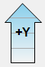
The first segment will “jog” or move the axis 50mm.
The second segment will move the axis 10mm.
The third segment will move the axis 1mm.
The fourth segment will move the axis 0.1mm.
Each click of a segment will move the axis that amount. You don't have to remember these settings though – if you hover your mouse over each segment, a little tip will appear that tells you how much that particular segment will move the chosen axis.
Go ahead and click around on the X and Y axis controls now. You'll see that if you're too close to the end-stops, the movement will be odd or not what you expect. In order to give yourself some room to play, enter this into the G-Code input box and hit ENTER.
G0 Z100 F3500
This will move the effector end of the Orion to 100mm above the print bed. Now you can easily move the X and Y axes around without worrying about hitting the end stops.
The Z movement cursor buttons work the same way as the X and Y axis buttons, but the Z axis cursor only has three segments. The first, or top segment will move the Z axis 10mm, the second 1mm and the third 0.1mm. You'll notice that as you click the Z axis arrows, it moves a lot slower than the X and Y axes do. This is because the Z axis is typically only manually adjusted by small amounts. If you need to manually move it a long distance, you're better off issuing a G-Code command with a feed-rate specifier (the F3500 above) in order to accomplish this.
The Extruder controls are very simple. They allow you you turn the hot end on, set the extrusion temperature and feed or retract filament.
The extruder display shows you what the current hot end temp is in Celcius and next to that is the temperature set point control. Go ahead and click on the “Heat Extruder” button and you'll see that the current temperature display begins to climb in short order.
If you leave it on long enough, the display will eventually match what the set point that's currently set.

Change the set point to the appropriate temperature for your filament by either entering that value into the control or by using the little up arrow next to it. For this demonstration, you can use 185 for PLA and 215 for ABS. If you've turned off the extruder, go ahead and turn it back on, letting it reach the set point. In order to demonstrate the feed controls, the hot end needs to be at the operating temperature of the filament you're using. Notice that while the hot end is heating, the current temperature and set point is also reflected in the Orion's LCD.
Once the hot end has reached the target temperature, click the down arrow that's next to the “Extrude [mm]” control. If your settings match what I have below, the extruder will feed 10mm of filament into the hot end with every click. Click it a few times to see how it works.
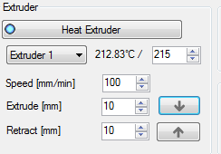
The speed of the manual extrusion is controlled by the “Speed [mm/min]” field. This basically tells Repetier-Host that for every click of the Extrude button, you want to feed filament at so many mm per minute. In the case of this example, that would be 100. Unless you have a specific reason to do so, you don't need to change the feed speed – too high a rate could jam your hot end because it's unable to heat the filament at a sufficent rate to extrude it at the higher feed rate you've specified.
The other control you have available is the “Retract” button. This obviously does the opposite of the Extrude button – for each press, it will pull filament out of the hot end by the amount specified next ot the button. This can be handy when you want to back out filament a bit to prevent a “drooling” problem that can happen with PLA sometimes.
I should also caution you on leaving the hot end at operating temperature with no filament in it – it's not good for the liner of the hot end. If you're not going to use the Orion right away, I would recommend that you leave the hot end cold as it really doesn't take long to reach operating temperature.
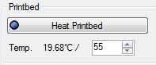
The heated bed control pictured at the left is how you can manually heat the print bed. The example shown has it set for PLA – 55-60C is typically a good bed temp for that material. With ABS I would recommend 80C. That temperature in conjunction with the include glue stick make for good adhesion.
The heated bed takes much longer to bring up to temperature than the hot end does. This is due to both the surface area of the bed as well as its PCB nature. You can shorten heating times by covering the bed with a washcloth or towel – this will prevent the heat from radiating away from the glass surface and extending the required time to reach operating temperature. This isn't so much a factor with the lower bed temperature of PLA, but at ABS temps, it can be an annoying wait some times. You can leave the bed heated for extended periods of time without damage.
I haven't mentioned anything about the Fan control as that is somewhat of an advanced area and it's really not needed for your beginning prints. I'll cover it later however, so don't worry.
Now that you've got a basic understanding of how to manually control your Orion with Repetier-Host, let's find something interesting for you to print as your “introductory” object.
I'd recommend you head over to http://www.repables.com and find something you'd like to print. I'm going to chose the Orion Keychain - http://www.repables.com/r/151/ for my example print. You don't have to make the same choice, but pick something geometrically “simple” in order to make the learning process a bit easier.
Once you've downloaded and unzipped the model you chose, you'll need to load it up in Repetier-Host in order to begin working with it.
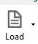
Click the Load icon and browse to where you saved the file you unzipped.
When the model file is loaded, the 3D View in Repetier-Host should look similar to the image below.
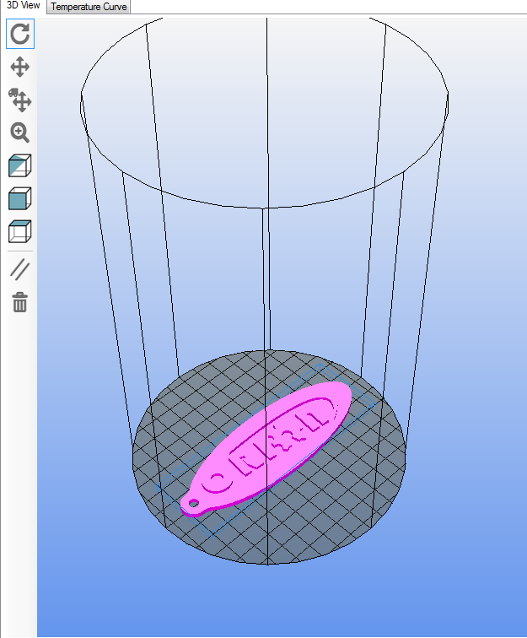
The 3D View will show you your Orion's print volume as well as the current position of the loaded model.
The controls on the left edge of the window allow you to manipulate the view that you see of the model.
You can manipulate the view with your mouse by holding down the left mouse button in the window and moving the mouse around. The position of the drawing space can be moved by holding down the center button and moving the mouse around. The right mouse button will allow you to manually position the model on the build platform, but I don't recommend doing that at this time.
The scroll wheel on your mouse zoom the build volume in and out. This is useful when you're manually arranging parts or you want a closer look at a generated tool path.
The second half of the Repetier-Host display will contain the Object Placement panel after a model has been loaded. You can also change to this tab by clicking on it at any time.
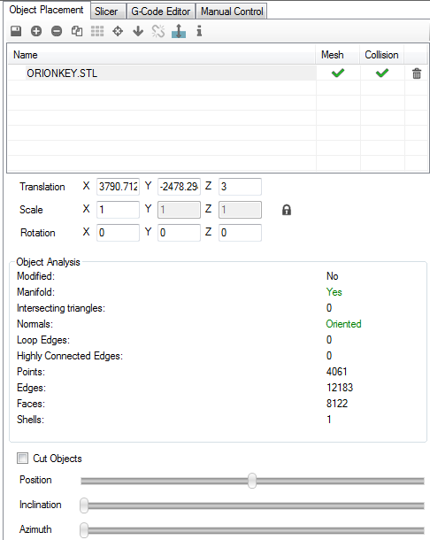
The Object Placement tab will allow you to manipulate the scale, position and quantity of objects currently loaded. If you're going to print the Orion Key fob object, you should change the X scale value to “.75” and then click the “Center Object” icon. This will reduce the size of the object to ¾ size. The Center Object icon is the 6th one in from the left, next to the grid of 9 gray squares. The reason for this is that the key fob is kind of large and will be right at the edges of what the Orion can print when at full size.
We'll get to the other uses of this tab later, so for now just leave the settings as they are.

In order to prepare the object for printing, it first must be “sliced”. This is a term that is used to describe the process of cutting the model into tiny slices the same thickness of your printing height.
The slicing program is what does all the work of turning your model into instructions that the Orion can understand. It take a number of configuration parameters and generates a set of G-Code commands that not only directs the Orion where to move, but how much filament to extrude, where and at what temperature. That's a somewhat simplistic description of the process, but is essentially correct.

The slicing utility that comes with Repetier-Host is called “Slic3r” and is an excellent, open-source utility. In order to make things easier on new users, SeeMeCNC has created two “default” Slic3r profiles for you to use. One is for ABS and one for PLA. You can download them using the links below:
http://download.seemecnc.com/orion/quickstart/ORIONABS.zip
http://download.seemecnc.com/orion/quickstart/ORIONPLA.zip
Unzip the profile you need for your filament and I'll walk you through the process of loading it into Slic3r.
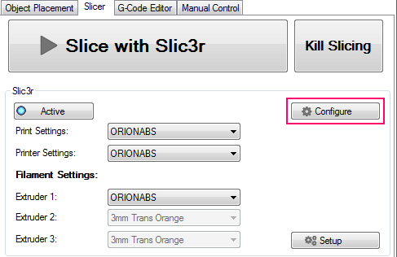
Click on the Configure button – it's highlighted above. It will open the Slic3r configuration utility.
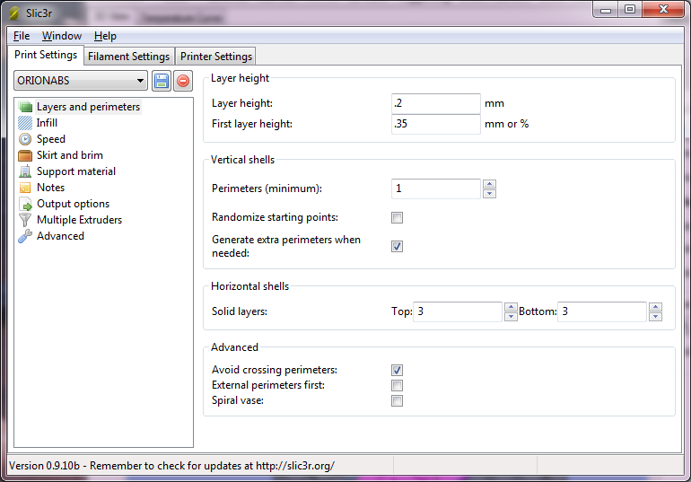

As you can (barely) see on the previous page, I've already gotten the ORIONABS configuration loaded. In order to load it, click on the File menu and choose the “Load Config” item. Browse to the directory where you unpacked your chosen configuration and open it.
Explaining what all the features of Slic3r are is just a bit outside the scope of this manual, so I'm only going to cover a few points. You can find an excellent reference that will cover everything you wanted to know about Slic3r here: http://manual.slic3r.org/.
The part of the configuration you want to work with at the moment is the Filament Settings tab.
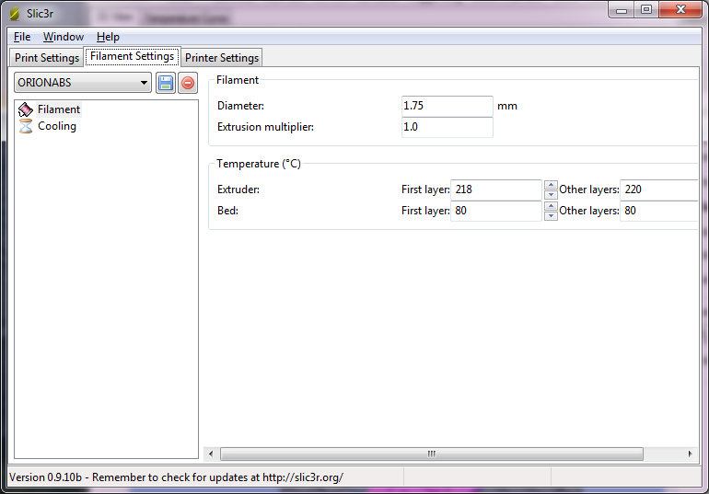
At the top of the tab, you'll see a field marked “Diameter:”. This tells the slicing algorithm what your filament diameter is in order for it to properly calculate the amount of filament it needs to tell the extruder to push. It's very rare that filament is exactly 1.75mm, so in order to make sure you get the best print possible, you need to get your filament diameter as accurate as you can.
This is pretty easily accomplished, but does require that you have a digital caliper handy. If you don't have one, many local hardware stores carry them. If you've got a Harbor Freight local to you, a digital caliper can be had for as little as $12.
Spool off about a meter of filament and take ten measurements along the length, writing each one down as you go. Average those values out and place the result in the Diameter: field.
Once you've done this, click the little disk icon next to the ORIONABS drop down to save your changes. When you click the save icon, you'll be given the choice to name the configuration something new. If you choose to do this, make sure you remember the name you picked. You'll need it for the next step. You can click the close icon in the upper right hand corner to dismiss the Configuration program.
Check the Print Settings, Printer Settings and Extruder 1 settings to make sure they're selected as shown below.
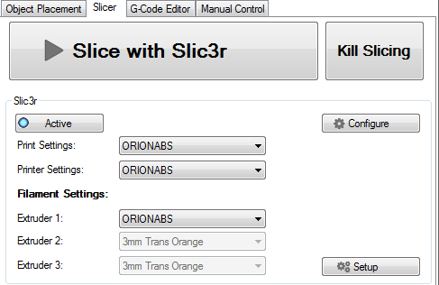
Once you've got your configuration chosen for all three parts, go ahead and click the “Slice with Slic3r” button.
When it's done, the G-Code editor tab will become active and you'll see something like the image on the next page.

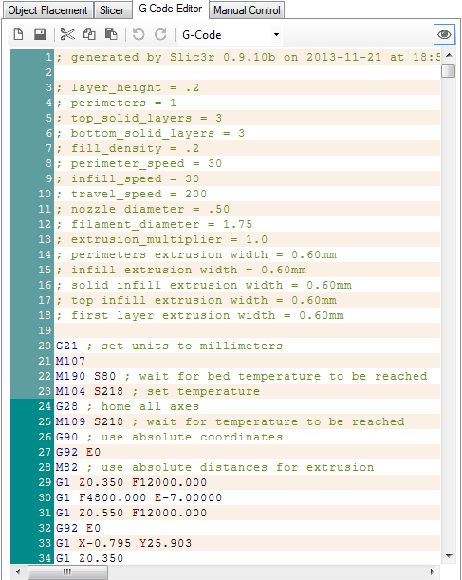
The G-Code editor tab shows the output of the slicing process. It contains all the G and M codes generated by Slic3r.

There's nothing you need to do here, so let's take a peek at the other new thing that appeared after Slic3r was done doing its work.

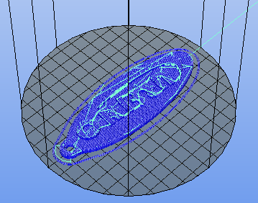

Your output may look different than this if you chose a different part to print from Repables. Above you'll see the new thing that appeared in the 3D View tab. This is a representation of the tool path that the nozzle will follow in order to create the key fob.
The dark blue lines indicate the actual extrusion path, while the lighter blue or cyan lines indicate moves where no filament is extruded.
At this point we're ready to begin printing, so click on the Manual Control tab. Note that this isn't a requirement, just a habit I've gotten into. It shows what the printer is doing and gives me an idea of how long it will take to finish the job once it's started.
Before you begin the print job, you'll want to put a light coat of glue from the glue stick in the area your part will be printing. This will ensure that the part sticks to the build glass.
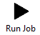
Click the Run Job button and the process will begin!

The first thing you'll notice happen is that the Heat Printbed indicator will come on and the temperature display will slowly begin climbing to its set point.
Once the heated bed reaches temperature, the Orion will home itself and the hot end will begin to heat. Once that is accomplished, your print job will begin.
As the print progresses, you can follow the progress in the 3D View tab. I would recommend that you get a 3” magnifying glass at some point. It makes it easier to see the filament being laid down during the printing process. It's pretty fascinating to watch.
One thing that should be pointed out – with ABS, it just LOVES to curl up off the bed, often times ruining the print. This is caused because when ABS cools asymmetrically, it does really odd things. If you're having curling issues with ABS, please post a message about the issue you're having on the SeeMeCNC Support Forum at http://forum.seemecnc.com/index.php.

There's a lot of really experienced users there that can help you get your ABS prints working properly.
The best way to handle ABS prints is to make sure that the space where the Orion is isn't exposed to drafts. A draft will make any curling issues a lot worse.

Advanced Repetier-Host

Repetier-Host is a pretty advanced piece of software and it can make your life a lot easier when it comes to printing your projects on your new Orion.
I'm going to walk you through most of the more interesting things that Repetier-Host can do. For the printing examples, I'm going to use the Ignite Michiana Keychain that is available on the Repables website (http://www.repables.com/r/146/). Download and unpack the model.

I would like to first cover the Object Placement tab and show you the various functions that it can perform. Go ahead and load the IGNITE.STL file that you downloaded and we'll begin.
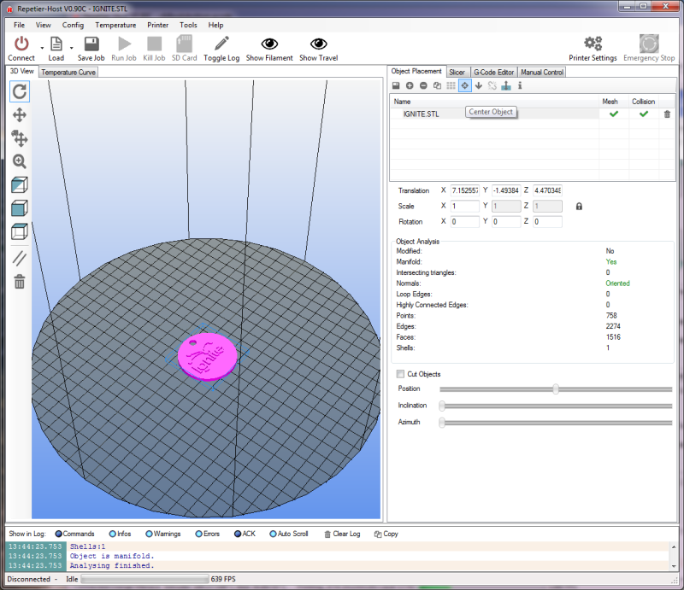

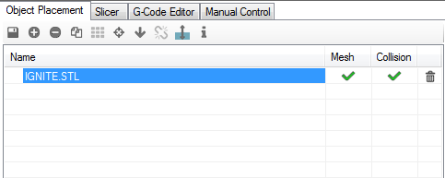
The Object Placement tab allows you to do a number of things with one or more loaded objects. Moving right across from left to right, the functions are:
Export
This allows you to save all the currently loaded (or only the selected ones) parts as a single STL or OBJ file.
Add Object
Clicking this allows you to add another object to the build platform. This can be handy when you've got a few different parts to print and you'd like to print them all during the same print job instead of one at a time. Go ahead and click the Add Object button and pick a new model to load – the Orion Key Fob would be fine for this. You'll notice that when it's loaded, the Ignite object is moved a bit to make room for the new part.
This would is a good time to show you what the Mesh and Collision columns do. Right-click on the Ignite object. Notice that the Ignite object turns purple and the Orion Key Fob turns yellow. The purple color highlights the object you're currently working with. Note that the Object Analysis section of the Object Placement tab is now filled with information related to that selected object. This section will be hidden if you've got more than one object selected.
Hold down your right mouse button and drag around – you can use this technique to manually position parts. Notice that when you move the part so it “overlaps” with another, that both turn a light blue color. This indicates that the models are colliding. The Collision columns will indicate colliding models with a red “X” Now while you CAN slice and print objects that are colliding, don't expect great results unless you've got a specific goal in mind.
Remove Object
This is basically the opposite of Add Object. It will remove whichever object is currently selected.
Copy Objects
This is a neat little feature. Say you'd like to print four of the Ignite key chain tags. Select the Orion Key Fob and click the Remove Object button. Select the Ignite object and then click the Copy Objects button. Set the number of copies to four and make sure the “Auto Position after Adding Objects” box is checked. Click Copy.
You should now have five of the Ignite objects on your build surface.
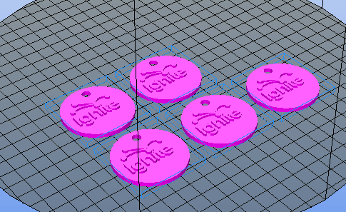
You ended up with five because you made four copies of the one object. If your goal was only four objects total, you'd tell the copier you wanted three copies.
The copy feature is very handy when you have to make a lot of the same thing.
Autoposition
The Autoposition function will allow you to optimally arrange a number of objects with a single mouse click. Go ahead and move your five Ignite objects around manually and then hit the Autoposition icon to see how it re-arranges all the objects.
Center Object
This is handy if you've got a single object and you've accidentally moved it from its default position. Clicking the Center Object icon will automatically move the object to the center of the print volume.
The Drop Object and Split Object buttons are currently undocumented, and experimenting with them hasn't lead me to any new understanding of how they work.
Fix Normals
This function will attempt to correct issues with your model file where there is a surface that should be facing outward, but is actually facing inward. This falls under an advanced modeling topic and won't be covered further here.
Object Information
This will give you some basic details about the currently selected object.

The next section of the Object Placement tab has to do with how objects are sized and oriented in the build volume.
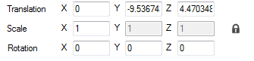

The Translation row controls the object placement on the bed. This is normally something you'll never need to manipulate by hand as you can move the object around with the mouse, or by clicking the Auto-position icon.
The Scale row will allow you to change the size of the object. By default the Scale is locked to the X axis as denoted by the little padlock icon at the far right. Experiment with the scaling by changing the X column number. Think of it as a percentage. At 0.5, the object will be scaled in all axes by half. .75 would be ¾, etc. If you click the padlock, this will “unlock” the scaling for the Y and Z axes so you can change those independently from the X axis. Go ahead and unlock the scale and change them and see how it affects the model. You can easily go back to where you started by setting each axis back to 1 or by simply clicking the padlock icon again.
The Rotation row allows you to change the orientation of the object in the build volume and each field is in degrees. This comes in handy when you've loaded an object that isn't oriented in a way that will allow you to print it. To give you an idea of how this would work, click in the X field and enter “90”. This will flip the Ignite key fob 90 degrees to the build surface. If the Ignite model loaded in this position, you could enter “-90” and it would lay flat on the bed, making it easier to print.
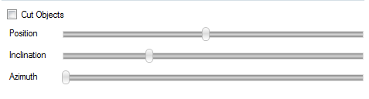
The last section on the Object Placement tab is “Cut Objects”. When you check the Cut Objects box, it will allow you to slice or cut the object in various ways by using the three sliders as shown above. This is strictly a visual inspection tool and doesn't apply to the data fed to Slic3r. Select the Cut Objects box and play around with the sliders to see what they do to the object on the built surface.

The Slicer tab is the basic interface to the primary slicing utility that Repetier-Host uses, Slic3r.
Slic3r is one of the more popular slicing tools for 3D printing. It's open source and community supported.
The Slicer tab also provides access to Skienforge, another free and open source slicing utility. Due to its complexity I won't be covering it here. If you like, you can learn more about it here: http://reprap.org/wiki/Skeinforge.
Slic3r allows you to manage multiple profiles for print settings, the printer itself and different types of filament. The Slic3r interface above allows easy access to any of those three preset categories. As time goes on, you'll collect a number of different configurations for the different models you print and the filaments used to print them. All of those setting can be accessed via the Configure button, located right below the “Kill Slicing” button. The details of the Configuration program for Slic3r is covered in the previously linked Slic3r manual and won't be covered here.
The last thing to note about the Slicer tab is the “Setup” button. This will allow you to tell Repeter-Host to go to a specific place for configuration files and the Slic3r executable. This can be used in the event that you wish to use a version of Slic3r that is different than the version supplied with Repetier-Host. This can come in handy when newer versions are released and you'd like to upgrade without waiting for a new product installer for Repetier-Host.

The last tab I'm going to cover is the G-Code Editor tab.
When you slice a model, the output of the slicer will be automatically loaded here.
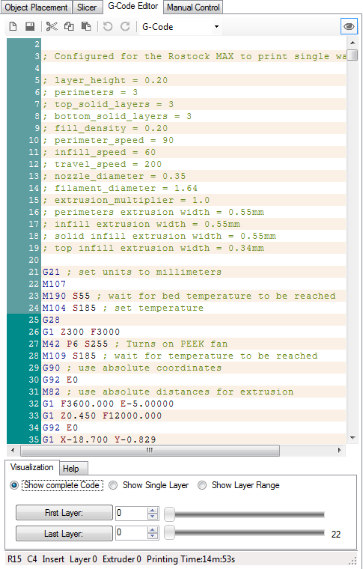
The G-Code Editor is basically just a fancy text editor. It allows you to view the G-Code that the slicer generates for the object(s) you sliced as well as allows you to view the tool path of each layer individually, or all the layers at once.
The G-Code Editor tab has two modes to it. “Visualization” and “Help”. In Visualization mode, you can use one of the three radio buttons to view the whole output, a single layer or a range of layers.
If you want to view a single layer, click the “Show Single Layer” selector and then move the First Layer slider around. You can also use the up/down arrows in the First Layer input box to more precisely go to a specific layer.
You can see an example of this below – it's currently showing layer 6 of the Ignite key fob that I've been using as my example part.

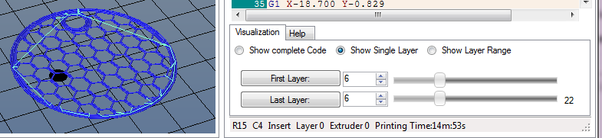
The Help mode (accessed by clicking the “Help” tab next to “Visualization”) is a very handy feature when you'd like to see what all that noise in the G-Code Editor is actually doing.
When you click on a G or M code that Repetier-Host knows about, it'll pull a description out of its database and display the information in the Help window as shown above.
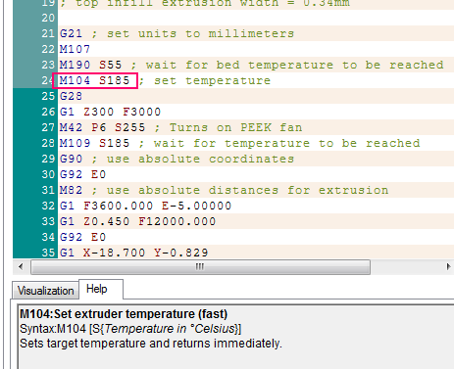

If Repetier-Host doesn't know what a G or M code is, it won't display anything in the Help window at all.

I've covered a number of the basics with Repetier-Host and you should have a pretty good handle on how to use it with your own printed parts. There's one last thing that I'd like to cover and that is the Temperature Curve tab.
This shows some interesting data with regard to both your extruder and heated bed temperatures.

The image below shows a typical “cold” Orion.
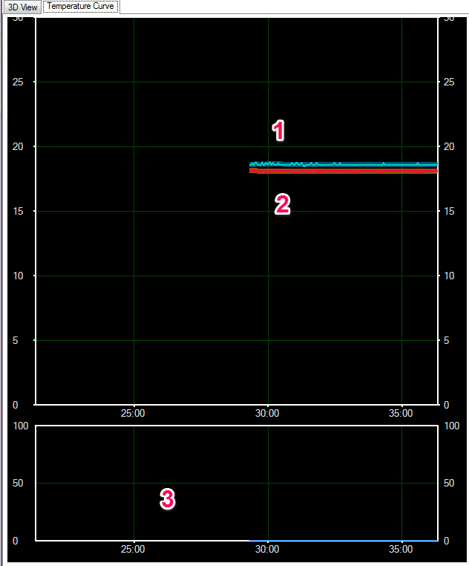
There's four “tracks” worth of data shown on the graph.
Graph #1 shows the bed temperature (the thinner cyan line) and the bed temperature average (thicker, dark blue line)
Graph #2 shows the hot end temperature (the thinner red line) and the hot end average temperature (thicker, brown line).
The graph scale is in time along the bottom (5 minute graduation) and the temperature scale is vertical and uses a 5 degree graduation.
The lower graph (#3) is the “power” graph and that shows how much power is being sent to the hot end.
Go ahead and click the Heat Extruder button on the Manual Control tab and watch what the temperature curve does.

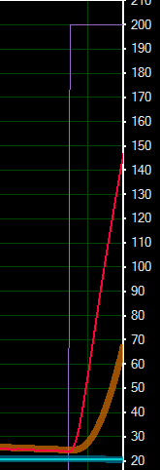
The first thing that will happen is that the scale will jump considerably as it now needs to show your target temperature.
In the figure to the right, you'll see that a new graph line has appeared. The purple line is your target temperature. That is what the system is currently trying to reach. As time goes on, it may exceed that target by a few degrees and then back off on the power in order to get back down to it.
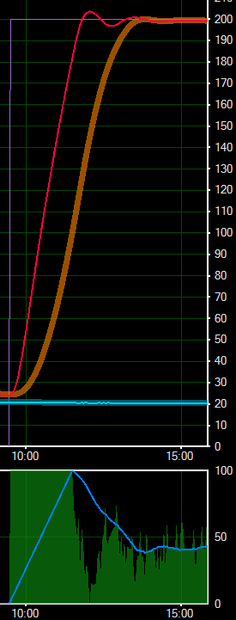
You'll see that the average temperature lags behind the actual by a short period of time. This is okay.

The image to the right shows what the Temperature Curve will show once the hot end has reached the target point. Notice how the power graph on the bottom corresponds to the actual temperature line shown in the top.
As time goes on, the actual temperature line will exist as a little “squggle” that will remain inside the border of the thicker average temperature graph. This is an indication of a properly tuned hot end controlling algorithm.

Now that you've had a good review of Repetier-Host and the Orion Delta 3D printer, go print something cool and have some fun!

