
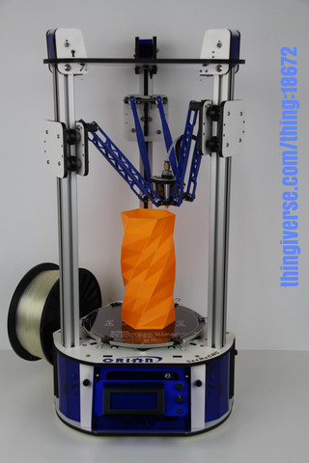

Orion Delta™ 3D Printer Manual
v1.00, November 13th, 2013

This guide will take you through the steps to set up and operate your new 3D printer from SeeMeCNC. You’ll find instructions on calibration, software, maintenance and more all in this manual. As a new SeeMeCNC™ owner, you’ll also find a ton of great resources on the forums at www.forum.seemecnc.com

Table of Contents
Unboxing your new Orion Delta™ 3D Printer 3
Installing the power cord and selecting input voltage 4
Installing the USB cable 6
Getting ready to power up for the first time 8
Setting the Z height 10
Loading Filament and setting up the Spool Holder 11
Changing Filament 14
SD Card 17

Unboxing your new Orion Delta™ 3D Printer

With your box standing in the upright position, carefully cut the packing tape along the top edges and across the taped seam in the box.

After you’ve cut the tape, open the top of the box being careful of any packaging staples. You’ll find the machine tucked inside and wrapped in a protective expanding foam shell. Remove the machine and foam all as one by pulling straight up out of the box. Be careful not to drop the machine once it’s out of the box and the foam is still around it.

Carefully cut and remove the stretch wrap film that is holding the power/USB cables and accessories on the top plate, as well as the stretch wrap holding your filament to the table top and glass build surface. Place the power cable/USB cable and accessories to the side for now, and set the machine on a table or desk close to a grounded power outlet where you will use your new machine.
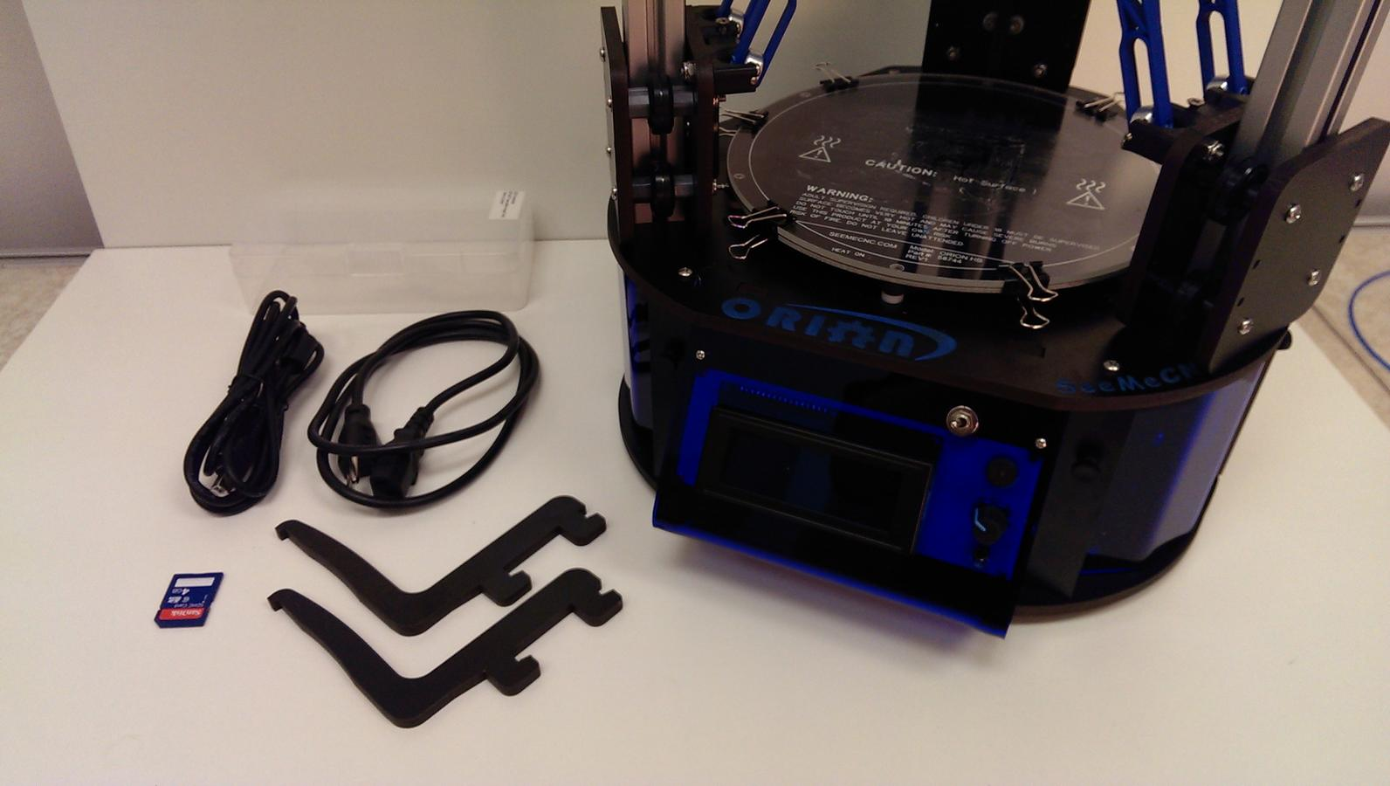

Installing the power cord and selecting input voltage

Locate the two black thumb screws on the left side panel and remove both screws and set them aside.

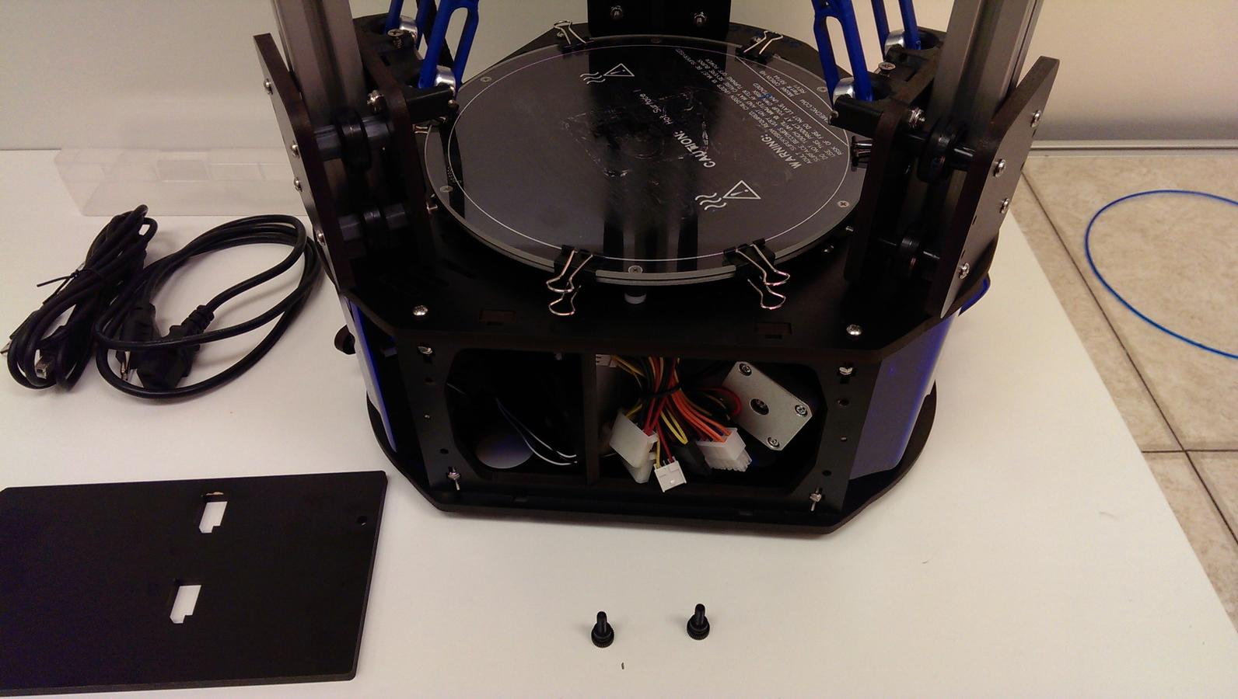

Using a small flat head screwdriver make sure the power supply input voltage switch is set to the correct voltage for your country. Pass the power cord for the power supply through the hole in the bottom of the Orion and plug it into the power supply.

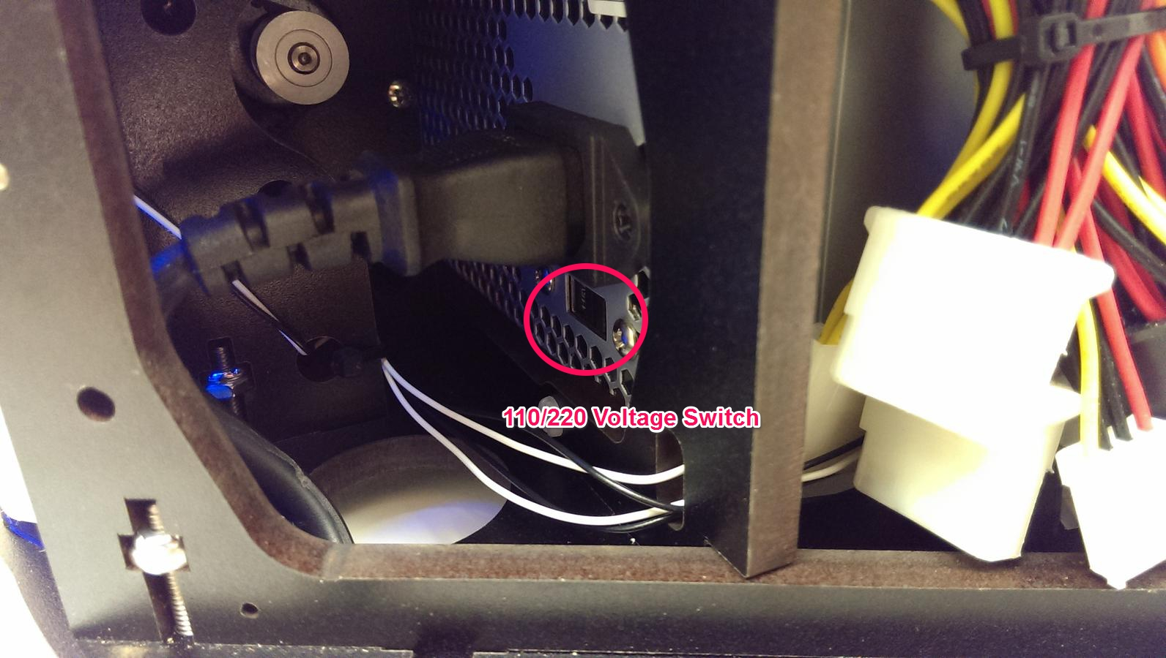

Place the left side cover back on the machine and screw the two thumb screws back in firmly, making sure that the filament routing tab is to the top and rear side of the machine.
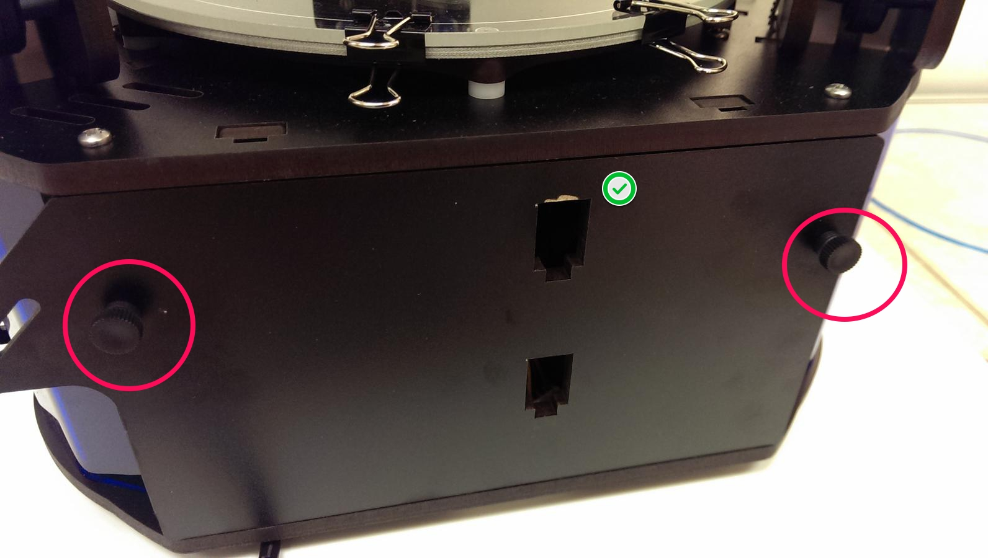

Installing the USB cable

The USB cable only needs to be used if you wish to manually control the machine from the software on your PC. you can print and do most calibration standalone, without the USB cable attached. We recommend hooking it up for starters, so if you need to connect it to your computer to make changes etc… the cable is already installed.

Facing the front of the machine, remove the two black thumb screws on each side of the control panel and set them aside. Carefully pull out on the top of the front panel until it is past the table of the machine, then lift up slightly and set it to the right making sure not to pull on any of the cables connected to the LCD screen.

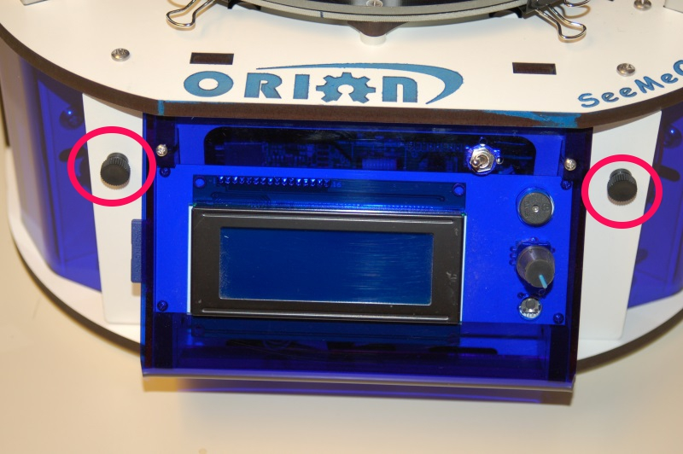

Now pass the end of the USB cable up through the hole in the bottom left of the base and plug it into the USB input on the electronics board. Next, replace the front panel by putting the bottom in first, then tilting the top in. Please be careful as it’s a tight fit. Re-install the two black thumb screws and tighten them finger tight.

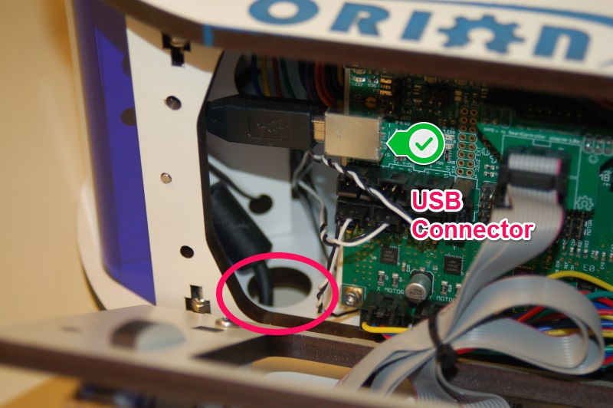

Getting ready to power up for the first time

The machine is shipped with the three arms in the inverted position to help protect the platform and hotend from damage during shipping. To put them into printing position, simply take one arm plate at a time and move it up to the top, then the next and so on.
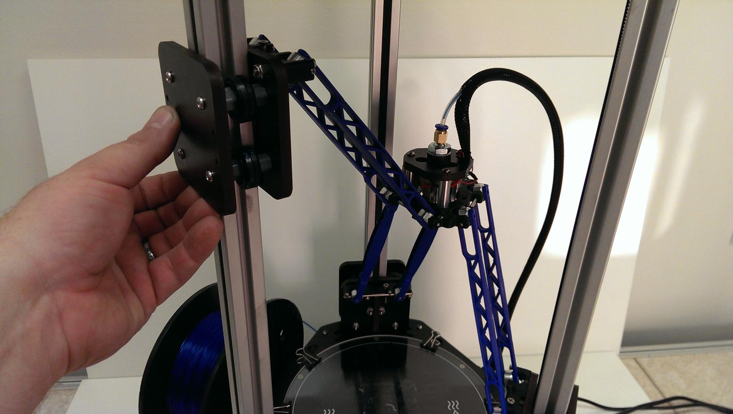

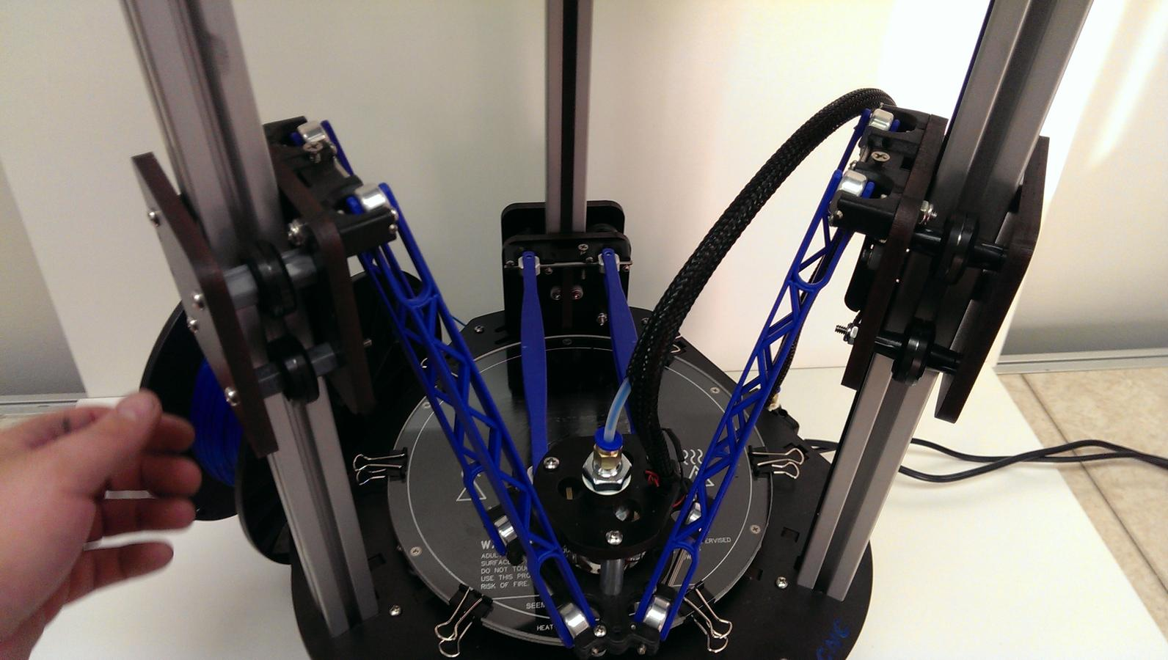

Once you have the arms in the correct position as the photo above shows and you are sure you have the power cord plugged into a grounded outlet, go ahead and turn the power on.

The LCD should light up and display the temperature for the hotend and bed as room temperature (approximately 20-25c).
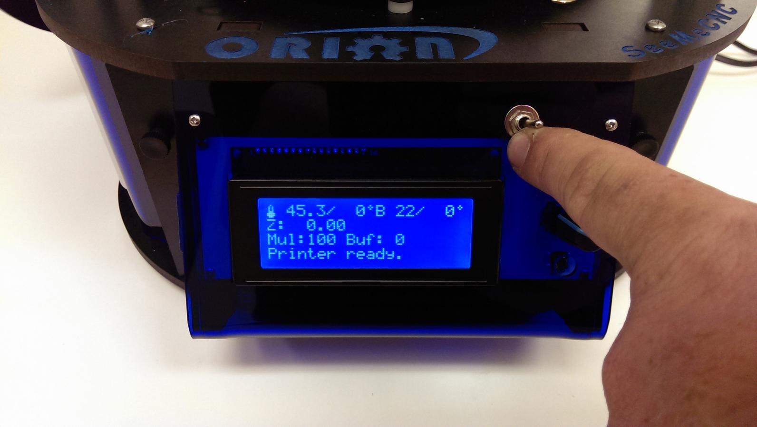
Now, using the knob selector on the control panel, press in on the knob once to access the main menu, and turn the knob to move the cursor to “QUICK SETTINGS” and press again, then select “HOME ALL” and press again. All three arms should move up to the limit switches then back off slightly and go up to the switch again, and this is called “Home Position”.

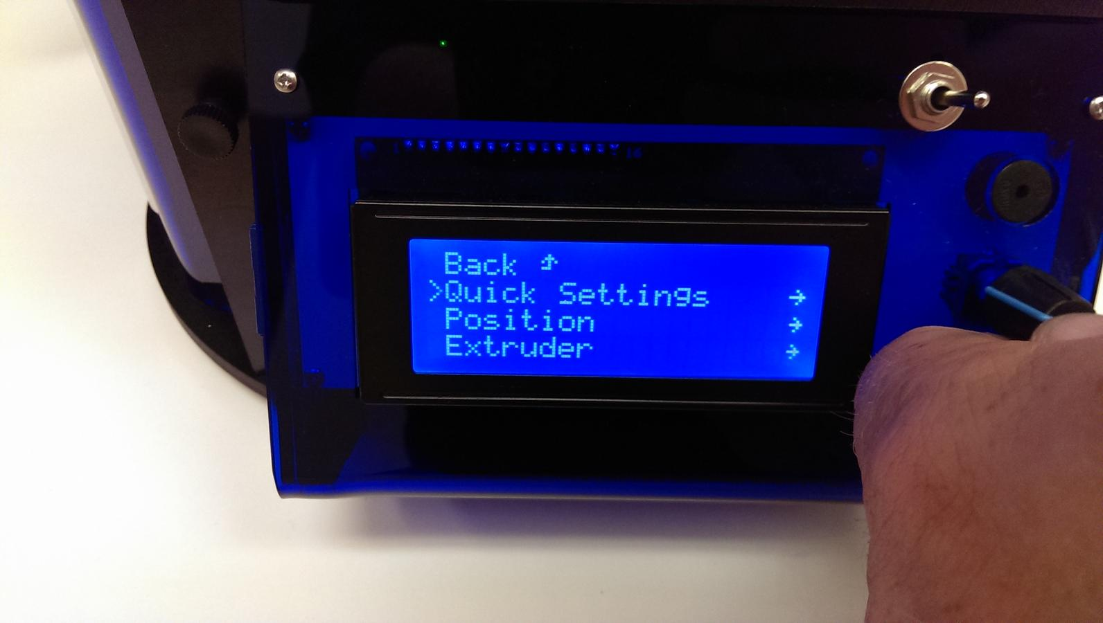

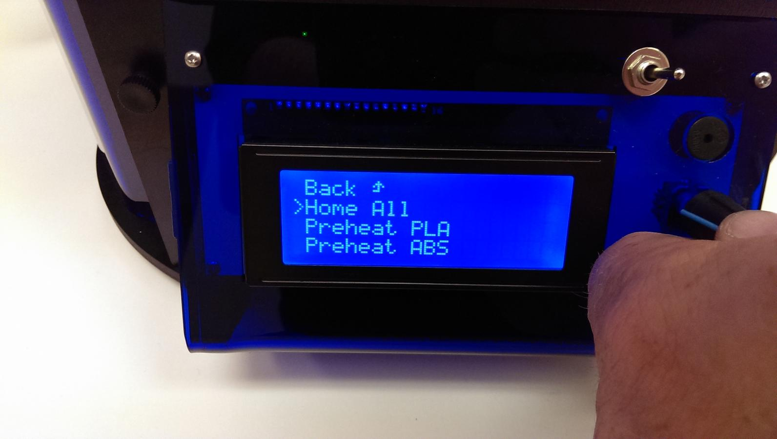

Setting the Z height

Congrats! Your new Orion Delta™ 3D printer is alive! But before we get to printing lets take a minute to set the Z height of the machine as it could have been bumped during shipping and it needs to be super accurate to get the best first-layer adhesion of your prints.

Using the control panel on the machine to set the Z height is really easy. You’ll find you may need to do this from time to time or after changing to a new build plate or nozzle etc…

To set the Z height you want to warm the bed and hotend to close to printing temperature to let any heat expansion take place. To do so, click on the knob and scroll to “QUICK SETTINGS” then “PREHEAT ABS” and click. This will set the heated bed to 90c and the hotend to 175c. This is less than the melt temp for ABS, but a good holding temperature that will make sure that any ABS filament doesn’t burn as it sits in the hotend waiting for the bed to heat up. It may take up to 15 minutes to heat the bed to 90c depending on the room temperature, but it’s important to let it heat up before setting the Z height.

Once the bed and hotend are up to temp, click on the knob and from the main menu scroll down to “CALIBRATION” then down to “DELTA CALIB” then down to “HOME ALL” and press to home the machine first. After the machine is homed, scroll to “Z POS FAST” and click. Now, make sure you turn the knob to the right to lower the head. If you accidentally raise the head into the limit switches, it will stop moving but keep updating the Z position on the display. If that happens, go back to “HOME ALL” and home again first, then move down. Using the “Z POS FAST” screen, jog the hotend down to about a half-inch or so above the table.

Make sure the nozzle is clean and there is no filament hanging from the nozzle (Be careful, it’s hot now!). Take a single sheet of notebook paper and place it under the nozzle.
Click back and choose “Z POS” which puts the jogging into fine mode, and jog down until the nozzle just begins to “snag” on the paper. Now click back and scroll up a few to “SET MEASURED POS” to store the new Z height to memory. That’s it! You’ve now set the Z height to the table and are ready to load up the filament and print!

Loading Filament and setting up the Spool Holder

The spool holders are capable of using spools with the standard size hole as well as spools with a smaller hole like Taulman™. For starting with the included spool of ABS you’ll want to use both spool holders by holding them together and inserting them in the cutouts in the left side panel. Notice how they slip in then down to ‘lock’ onto the side panel. If you were to use a smaller spool, you can use only one of these spool holders and you’ll see there is a tab in the center of the cutouts to hold a single spool holder for those spools.

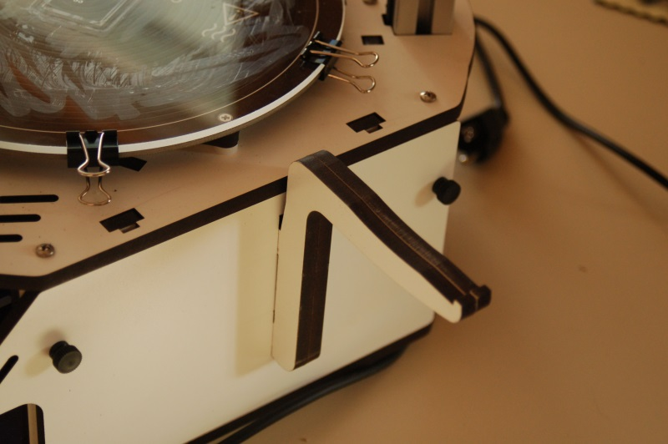

Now take the spool of ABS that came with your machine and open it up. Remove the loose end of the filament and trim the end so it’s a nice and clean end with no kinks. Put the spool on the holder so the filament un-spools OVER the top of the spool, and pass it through the filament guides per the picture below.

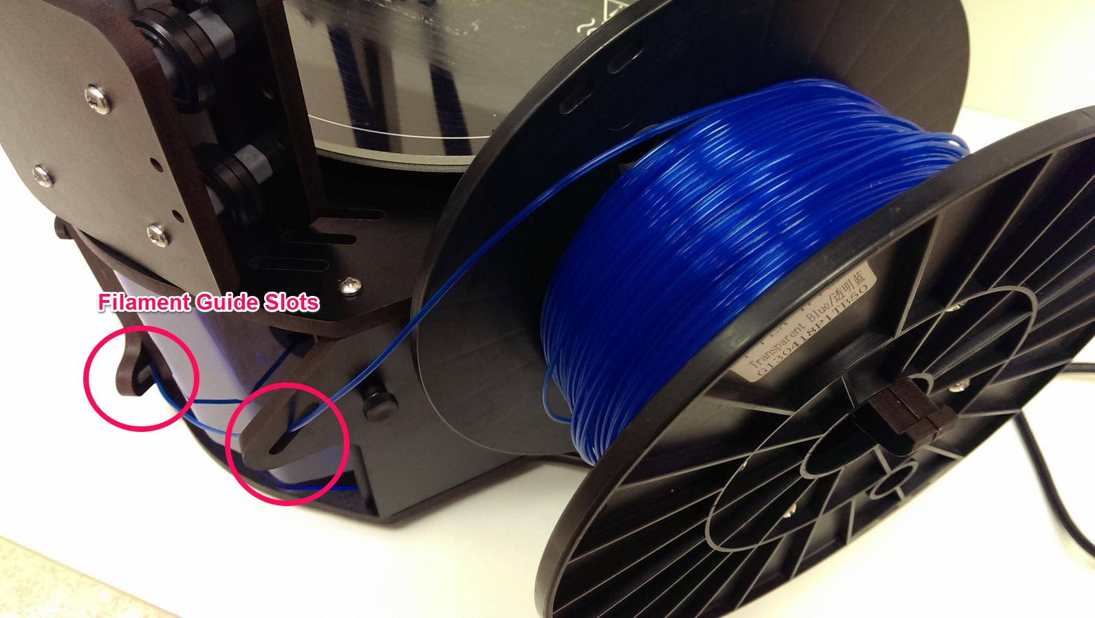

Now take the end of the filament, making sure it is straight and pass it up behind the red lever on the extruder. Squeeze the red lever to release the tensioner and push the filament up and into the extruder body. You should see it in the tube, keep pushing by hand until it is all the way to the hotend. You will feel it get harder to push once it’s inside the hotend itself.
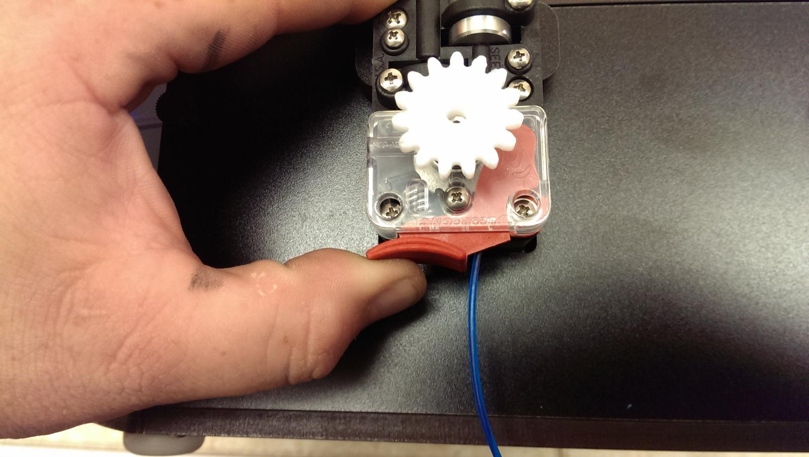
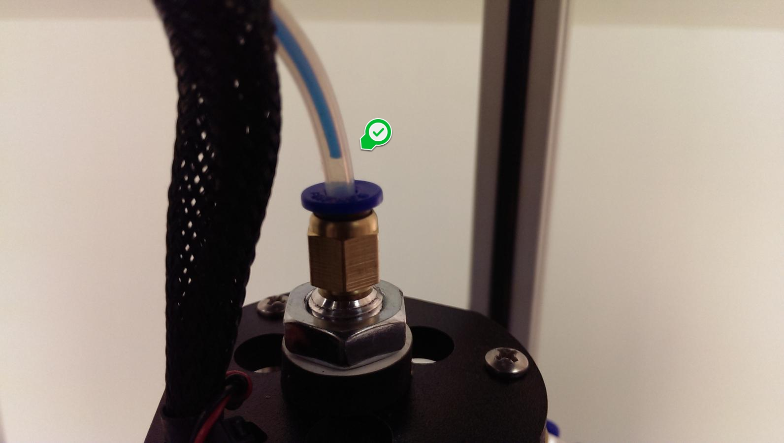

Now on the LCD screen, click and go to “QUICK SETTINGS” and scroll down to “DISABLE STEPPERS” and click. This will unlock the motors allowing you to turn the extruder by hand to purge the hotend. Now go to the main menu and click on “EXTRUDER” then scroll down to “EXTRUDER” and click, then set the temp to 215 and click to set the new temp. You can wait for the screen to go back automagically to the main screen or scroll up and click “BACK” and get to the home screen.

Once the hotend is up to temperature, reach around the right side and rotate the knob on the extruder counter clockwise to feed filament slowly into the hotend and you will see it start to flow out the nozzle. Let it flow out about 4” or so, then stop and remove the hanging filament.

Changing Filament

Changing the filament on your Orion is a very simple process.
First, you'll want to bring the hotend up to the temperature you normally set it at when you're printing.
Once the hotend is at operating temperature, pop the bowden tube off the hot end as shown in the following steps.

1. Grip the bowden tube with one hand and press down the blue ring and pull up on the bowden tube. You may need to depress the red release lever on the extruder in order to get enough slack to pull the bowden tube free of the hotend fitting.
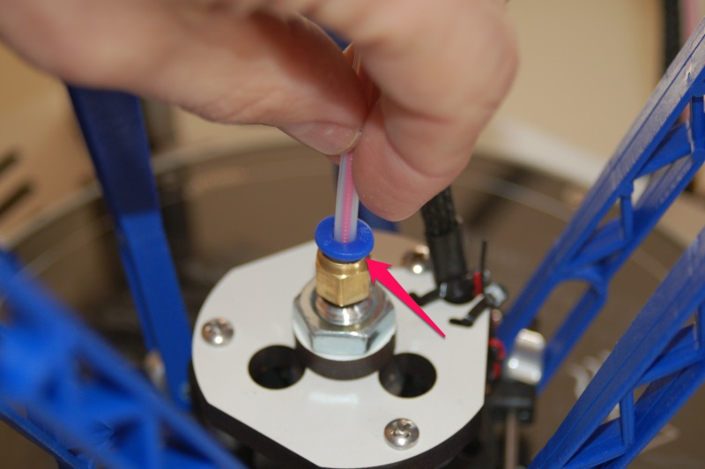

When the filament pulls free, it should look something like the photo below.

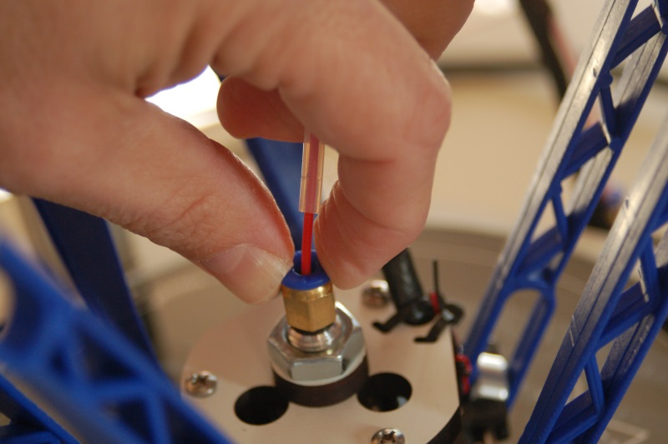

2. Cut off the filament flush with the end of the bowden tube.
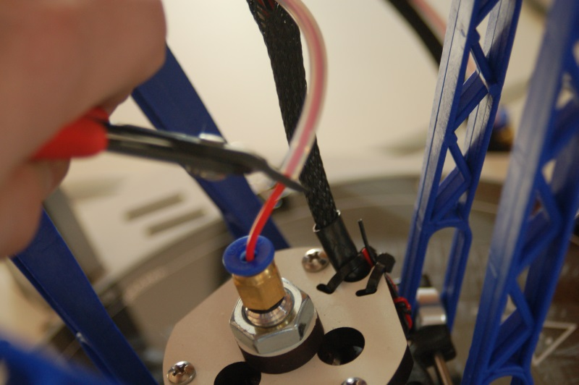

3. Pull the filament stub from the hotend and then re-insert the bowden tube into the hotend, making sure it seats fully.
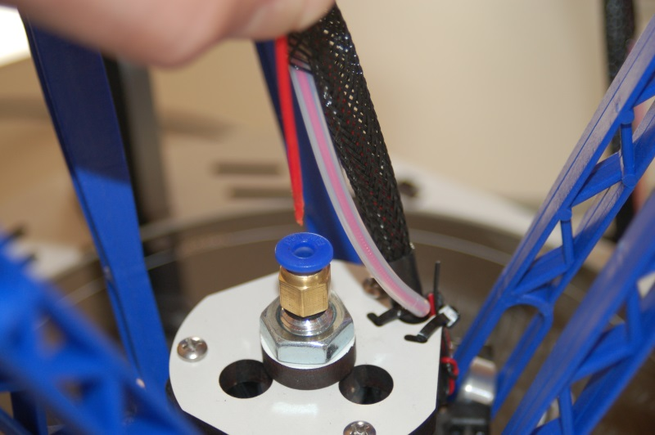

SD Card

The SD card included with your new Orion Delta™ 3D Printer has folders already on it with some sample prints as well as the firmware that was used to calibrate your machine.
The SD card goes in the left side of the control panel, label facing inwards, through a slot in the blue acrylic side panel as shown below.
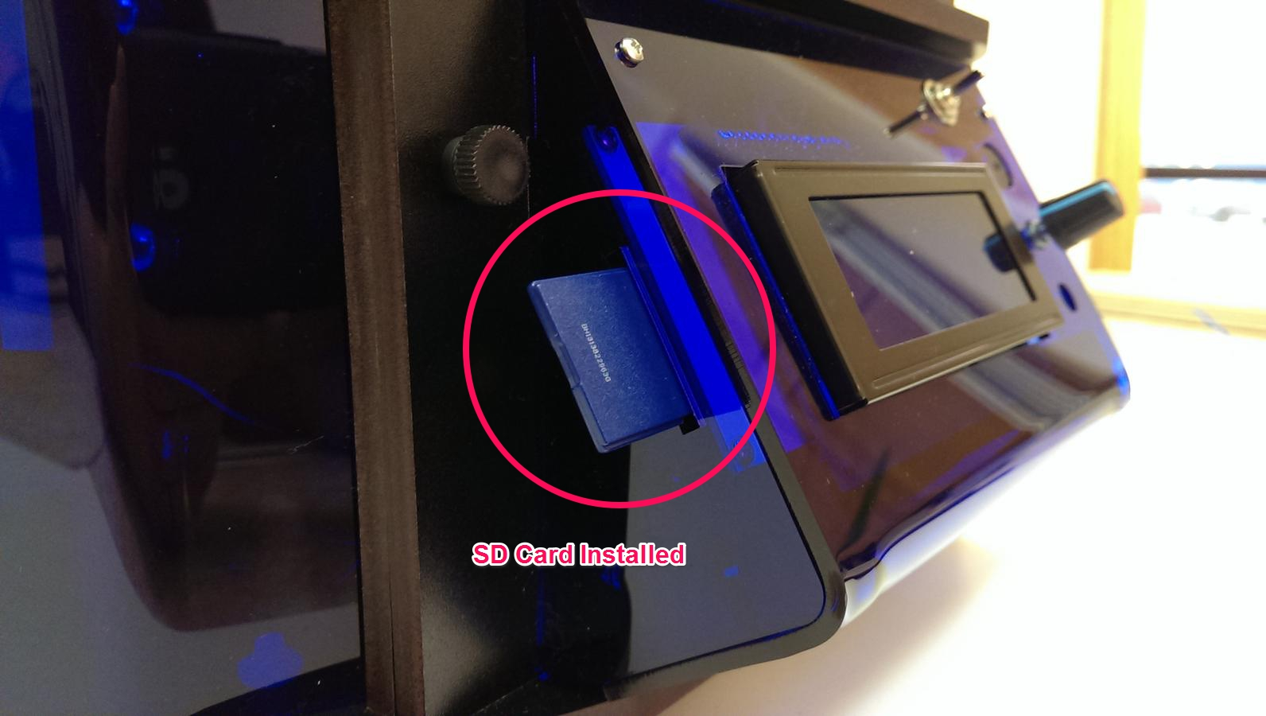

You can save your G Code print files on the card to print directly from it. To do so, with the SD card inserted, click to the main menu and scroll down to “SD CARD” then “PRINT FILE” then select the file you want to print and click to start that print. You can also pause, resume and delete files from the LCD control panel. To cancel a print job when running from the SD card, choose “SD CARD” then “PAUSE PRINT” then go back to “QUICK SETTINGS” and “HOME ALL”
