The Rostock MAX Assembly Guide, 2nd Edition



Welcome to the 2nd Edition Assembly Guide for the Rostock Max 3D printer.
Version 1.45, February 25th, 2014
Copyright 2013 by Gene Buckle
Licensed as Creative Commons Attribution-ShareAlike 3.0
Questions or corrections should be emailed to geneb@deltasoft.com
Disclaimer text provided by LulzBot
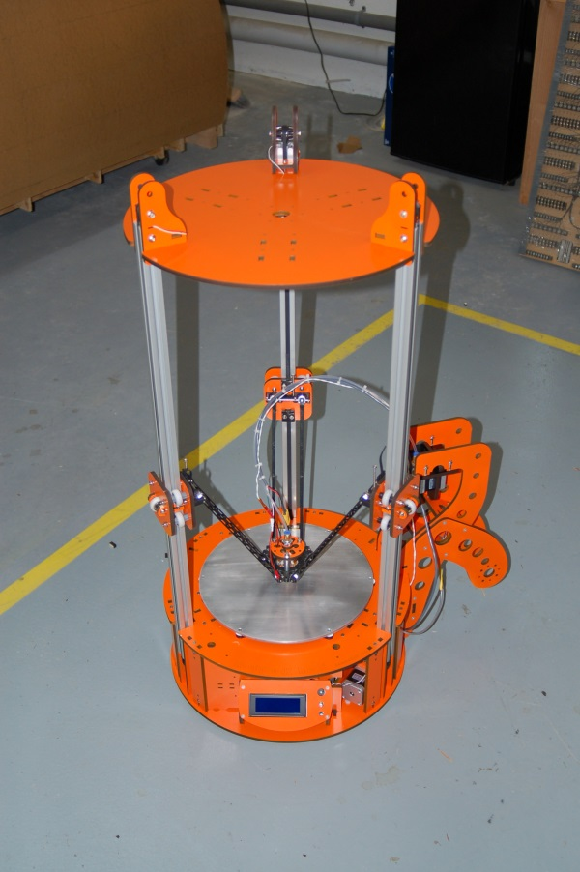

Table of Contents
0 – Introduction and Acknowledgments 3
1 – Required and Optional Tools And Materials, Part Checks 4
2 – Building the Base Assembly 16
3 – Installing and Aligning the Towers 39
4 – Assembling and Installing the Idler Mounts 44
5 – Installing the Top Support Plate 49
6 – Installing the End Stop Wiring, Switches and Idler Bearings 53
7 – Assembling and Installing the Cheapskate Bearings 59
8 – Installing the Belts 75
9 – Assembling the Effector Platform 83
10 – Attaching the Delta Arms 85
11A – Assembling the Side Extruder Mount and Spool Holder 88
11B – Assembling the Top Mounted Extruder and Spool Holder 92
12 – Assembling and Installing the Side Mount Extruder 100
13 – Preparing and Installing the Power Supply & RAMBo 108
14 – Installing the Onyx Heated Bed 114
15 – Assembling and Installing the Hot End 121
16A – Wiring the Effector Platform, Side Mounted Extruder 134
16B – Wiring the Effector Platform, Top Mounted Extruder 141
16C – Completing the Wiring 146
17 – Software Installation and Configuration 154
18 – Calibrating your Rostock MAX 164
19 – Your First Print with the Rostock MAX 177
20 – Maintenance & Troubleshooting 201
21 – Repetier-Host 205
Appendix A – Wire Management 215
Appendix B – Accessories 217
Appendix C – Revised Calibration Instructions 219

READ ME FIRST!

READ THIS MANUAL COMPLETELY BEFORE ASSEMBLING AND POWERING UP
YOUR PRINTER!

Hazards and Warnings

The SeeMeCNC Rostock MAX 3D printer has motorized and heated parts. When the printer is in

operation always be aware of possible hazards.

Electric Shock Hazard

Never open the electronics bay of the printer while the printer is powered on. Before removing

the access door, always power down the printer and unplug the AC line cord.

Burn Hazard

Never touch the extruder nozzle or heater block without first turning off the hot end and

allowing it to completely cool down. The hot end can take up to twenty minutes to completely

cool. Also, never touch recently extruded plastic. The plastic can stick to your skin and cause

burns.

Also before of the heated bed which can reach high temperatures capable of causing burns.

Fire Hazard

Never place flammable materials or liquids on or near the printer when powered on or in

operation. Liquid acetone and vapors are extremely flammable.

Pinch Hazard

When the printer is in operation, take care to never put your fingers in the moving parts,

including the belts, pulleys or gears. Also, tie back long hair or clothing that can get caught in

the moving parts of the printer.

Static Charge

Make sure to ground yourself before touching the printer, especially the electronics.

Electrostatic charges can damage electronic components. To ground yourself, touch a

grounded source.

Age Warning

For users under the age of 18, adult supervision is recommended. Beware of choking hazards

around small children.

0 – Introduction and Acknowledgments
I’d like to welcome you to the second edition of the Rostock MAX assembly guide! This manual is very nearly a complete re-write of the original guide I first published in December of 2012. All the photographs have been re-shot in order to make sure that the parts I show in this guide match what you’ve got in your hands. The original guide was written using the kit I received as part of the original Rostock MAX Indiegogo campaign, and so it differs in a number of areas from the current production model.
Most of the construction steps have been re-ordered. This was done based on direct feedback from builders as well as the fine collection of people at the SeeMeCNC forums.
The biggest change that previous Rostock MAX builders will notice is that the mechanical assembly is completed first and then the electronics are installed. This was done for a number of reasons, but primarily to make the Rostock MAX assembly experience a lot less difficult.
Please read this entire guide before you begin assembly of your new Rostock MAX! It will help you avoid any unpleasant surprises and will ensure that you’ve got everything you need BEFORE you need it!
A quick note on the RAMBo, the controller for your Rostock MAX. The RAMBo is static sensitive, so please don't take it out of the static bag it ships in until you're ready to use it.
The box containing the RAMBo and its wiring should also contain a printed, black & white sheet that looks like this:
http://www.reprap.org/wiki/File:Rambo-conn-all.jpg
Please refer to this sheet when you reach Section 16. This is a valuable guide to wiring the RAMBo up to your Rostock MAX. Note that the connector polarity is clearly marked on the board for the “MOSFET Outputs”.
Acknowledgments
I'd like to thank LulzBot for the use of their images in the Troubleshooting Section as well as the gentleman that runs http://minow.blogspot.com.au/ for his excellent guide on calibrating delta configuration 3D printers.
I'd also like to thank the whole gang over at the SeeMeCNC forums for providing excellent feedback and tips on how they built their machines using the original manual (and sometimes without!). This would be a much lesser creation without their contributions.

1 – Required and Optional Tools And Materials, Part Checks

Before you begin assembly of your Rostock MAX, please make sure you’ve got everything on the following list of tools and additional materials.

- P1 & P2 sized Phillips screwdrivers
- Standard flat head screwdriver
- 3/32” Allen (hex) wrench. A ball-end, T-handled version is a good choice for this and the other sizes of Allen wrenches used
- 5/32” Allen (hex) wrench.
- 7/64” Allen (hex) wrench.
- Needle nose pliers
- Forceps – these will come in handy when routing the belts and reaching for small, hard to reach parts. They can be purchased from Amazon for as little as $3.50 for a set of two.
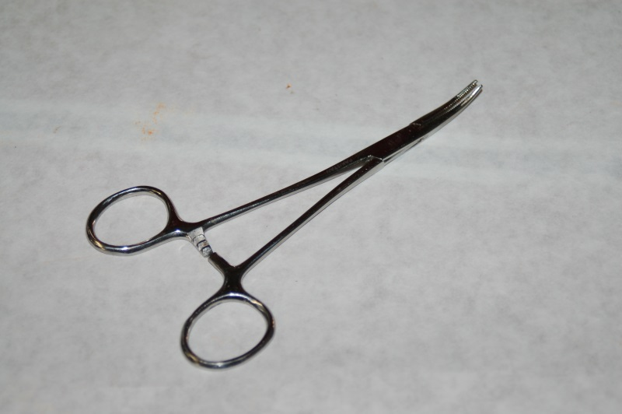

- Wire strippers
- Wire cutters
- Metric tape measure
- A small file. Some of the injection molded parts need to be filed/sanded to fit. A fine “grain” file would be sufficient.
- 100-150 grit sandpaper. Like the file above, this will be used to adjust the fit of some of the injection molded parts.
- 5/16” open-ended wrench (Used if you have a Steve's Extruder)
- 2 7/16” open end wrenches. (used to adjust Cheapskate Bearings)
- 11/16” open-ended wrench (used for hot-end mount)
- PermaTex Ultra Copper High Temp RTV
- 1/2” wide roll of Kapton tape
- Aluminum foil
- High temperature insulating material for the resistor wires. I recommend PTFE tubing from McMaster-Carr, P/N: 5335K13.
- Uninsulated crimp on connectors, sized for 22-18ga wire.
Radio Shack P/N 640-3036 is an excellent choice.
- A digital caliper. These can be purchased from Harbor Freight tools for around $10.
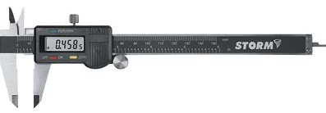

- A small squeeze clamp that can open at least 2”
- A wooden yardstick. This can be purchased at your local home center for less than $1 (typically). This will be cut down in order to be used as a height gauge for the Idler Mounts.
- Thread locking glue. (Loctite, etc – it’s used on the stepper motors)
- Crimping tool (Jameco P/N 159266 is a good choice)
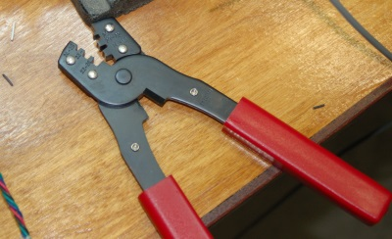

- A Framing or a tall machinists square. (Required for installing the tower extrusions.)
- Battery powered screwdriver.
- Pencil.
- Fishing line (10# is fine).
- Heat shrink tubing suitable for 18-22ga wire.
- 3/16” diameter heat shrink (for the extruder stepper splice)
- Slip-joint pliers
- Drill.
- 1/16” drill bit.
- Countersink. (3/8” diameter is sufficient)
- 300mm diameter Borosilicate glass disc. (Available from the SeeMeCNC Online Store).
This is the heated build plate that goes on top of the Onyx heated bed. [Included in kits produced after August 2013]
- 18-24” of 14ga wire for the Onyx heated bed power.
- 40W Soldering Iron.
- 25ft of 24ga, 4 conductor wire (Jameco P/N: 644383) This is “accessory” wiring and is used to bring power to the PEEK fan, an optional layer fan or an effector-mounted light.

The following is a list of optional things that can make your life easier in the long run.

- Superglue (used instead of scotch tape to hold some T-Nuts in place)
- 25MM, 12V PEEK Fan (if you're going to print PLA). Jameco P/N 2131881 is a good choice, but any 12 volt 25x25x10mm fan will work. [Included in kits produced after August 2013] Note that if you're going to usee the SeeMeCNC fan shroud (recommended!) and your kit does NOT include a fan, you'll want to find a 25x25x10 fan elsewhere. The units that Jameco sells are only 6mm thick and will be a very loose fit in the fan shroud.
- #6-32 Tap. Useful for threading the hole in the plastic component that the end stop adjustment screw fits into.
- Electrician's tape.
- Six small nails to help line up the Onyx heated bed during installation.
- Waxed lacing cord. You can use this in place of wire ties in pretty much any application. You can find it here: http://www.skygeek.com/wht-string.html. While expensive, you'll never really need to buy a wire tie again and it'll likely last you the rest of your life. :)
- .100” (2.54mm) Latching Polarized Male Housing (1x4) and matching crimp pins. This is used to add a connector to the end of the EZStruder extension cable and makes life a lot easier. You can purchase 2 of these connectors and their associated crimp pins from Hansen Hobbies (http://www.hansenhobbies.com/products/connectors/pt1inlpconnectors/pt1in_lp_1x4/) very inexpensively. The link for the pins is shown in the description for the male housing.
I'm going to diverge a bit to discuss connector choices. When doing the wiring for the various things attached to the effector platform (fans, hot end, etc) I like to use quick disconnects. This allows more flexibility for things like light rings, more hot ends, etc.

There's been some discussion on the SeeMeCNC Rostock MAX Forum (http://forum.seemecnc.com) about the kinds of connectors that can be used for these purposes. I personally like using big connectors for the hot end and heated bed, and smaller connectors for the thermistor, fans and other accessories. The hot end itself doesn't really draw that much power so as long as you've got 3” of wire from the hot end resistors to the connector, you should be fine.
Below is a list of connectors that you can use for the hot end, heated bed, fans and other accessories. I would recommend that you stick to the XT60 connector for the heated bed as it's rated for much higher amperage than the JST types and it's a LOT easier to disconnect than the large Deans style.
Remember, you'll need one pair per connection you're going to make.
- Deans or XT60 connectors for the hot-end.
Tower Hobbies Deans: http://www3.towerhobbies.com/cgi-bin/wti0001p?&I=LXKX39&P=ML
Hobby King XT60: http://www.hobbyking.com/hobbyking/store/__9572__Nylon_XT60_Connectors_Male_Female_5_pairs_GENUINE.html
- JST connectors for the hot end thermistor and PEEK fan (if you're installing one)
Female: http://www.hobbyking.com/hobbyking/store/__9631__JST_Female_2_pin_connector_set_10pcs_set_.html
Male: http://www.hobbyking.com/hobbyking/store/__9630__JST_Male_2_pin_connector_set_10pcs_set_.html
- Four pin Deans connectors – useful to place the hot end and thermistor on a single connector.
http://www.amainhobbies.com/product_info.php/cPath/1389_226/products_id/3595/n/Deans-Micro-Plug-4R-Red-Polarized-Connector

- Four pin JST connectors, with leads. Again, this would be a fine choice for a combination hot end and thermistor connection.
http://www.adafruit.com/products/578

The small four pin Deans connectors can also be useful as a quick disconnect for the extruder stepper motor. This would come in handy when trans porting the machine – you wouldn't have to unplug the wiring from the RAMBo and remove it from the base.
Hansen Hobbies has produced an excellent wire crimping tutorial here:
http://www.hansenhobbies.com/products/connectors/Connectors.pdf
I strongly recommend it!
It's been brought to my attention that some builders have routed the three end stop wires down the center of a single tower. This is perfectly acceptable as long as you keep track of which wire pair goes where.
The problem comes when the builder routes the EZStruder stepper motor wires in the same tower as one or more pairs of end stop wires. While the wires may fit, the routing will cause you no end of headaches.
The end stop inputs on the RAMBo controller are very sensitive to “noise”. By running the stepper motor power lines in the same narrow channel that the end stop wires are in, you're going to cause interference with the signal in the end stop wires. This happens because the voltage in the stepper motor wires will induce a voltage in the end stop wires and make the RAMBo think that an end stop switch has been closed when it really hasn't. If you don't know what's going on, it'll make you madder than an epileptic building a Jenga tower. :)
My recommended solution to this issue is to wire the end stop wires as I show in this guide and then add a wire support bar after your assembly is complete.
I've developed an easy to print clip that will allow you to add a 3/8” diameter, 26-1/2” length of dowel as a wiring support structure to the Rostock MAX. The mount requires two of these clips and will support the EZStruder stepper wiring, the hot end wiring and the effector platform accessory wiring.
I recommend that you download the wiring clip from http://www.repables.com/r/131/.
When your printer is calibrated, you'll print two of them. As the comment for the part notes, cut off the single layer thick tabs after printing – they're only there to help hold the small clip tips to the build plate.
I'll cover this in a bit more detail in Section 16B.

There will be a parts inventory included with your kit. Please check the parts you have in the box against this packing list before you begin construction. This will make sure you’re not missing any parts that could delay the assembly of the kit. In the unlikely event that you find you’re missing a part (or more!), please contact SeeMeCNC immediately! They can be reached quickly at support@seemecnc.com.
I've included a parts list of the melamine components below.

This list of materials is current as of 03Jul13. If you get something made from melamine NOT on this list, please let me know!

Here is a list of the hardware included in your kit. It's current as of 15Aug13
Parts Bag #1:

Parts Bag #2:

Parts Bag #3:

Other Parts:

The laser cut parts in the Rostock MAX kit are held in place with masking tape. This tape is in place to make sure that the parts are not damaged in shipping. The simplest way of removing the parts is to cut the tape along the laser cut seam.
All the laser cut parts have a protective film on them that must be removed before you can begin assembly. This film prevents the “flash-over” from the laser cutting process from marring the finish on the Melamine parts. The protective film is easy to remove, but the bits inside the small lettering can be problematic. This material can be easily removed by using a small plastic scraping tool (a credit card or driver’s license works well).
After you’ve got all the laser cut parts removed and the film removed, you’ll want to wipe down the edges of each part with a dry washcloth or shop towel. This will remove the last of the “ash” left over from the laser cutting process.
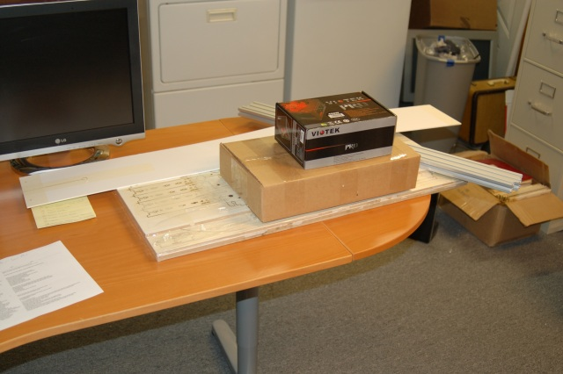Fig 1-1: Kit components

You’ll note that all the parts shown in this guide are a rather painful shade of orange. We’ll skip how I ended up at that color and just note that if you’ve ordered the white melamine kit, painting all the parts to personalize your build is a great idea! [Steve wants me to remind you that you can have any color you want, just as long as it's black or white. Other colors are up to you after you receive the kit.]
Before beginning the assembly process, you’ll want to check some of the parts for consistency and in some cases, symmetry. This is needed because sometimes the laser decides to go off and do its own thing, resulting in parts that pass cursory inspection, but will leave you with a machine that’s impossible to square.

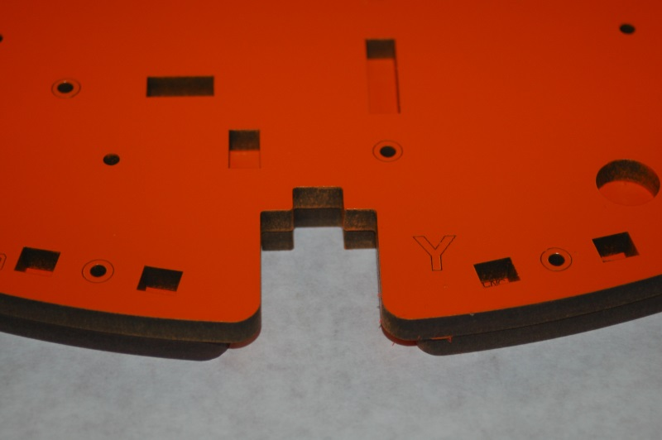Fig 1-2: Symmetry of the base top and machine top.

The first parts you should check are the machine table (P/N: 63851) and the top support (P/N: 68368). These two parts have three notches in them that the tower extrusions fit into. Make sure that the three notches match as show in Fig 1-2 on the right. All three notches need to match. If they don’t, your build will be slightly twisted and you’ll never be able to align the error out.
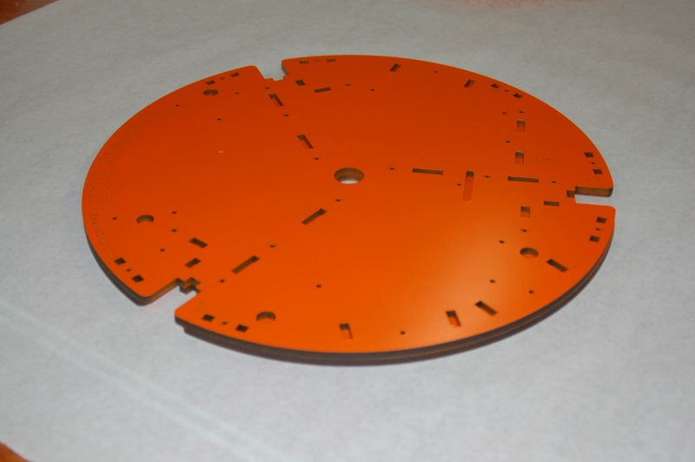Fig 1-3: Table & Top Support aligned.

You can see what the top support (on the bottom) and the Table base (top) look like aligned. (Fig. 1-3) As with all the illustrations in this guide, you can examine large photographs that are stored in the github repository for this document (https://github.com/seemecnc/RostockMAX/tree/master/ASSEMBLY_MANUAL/figures).
Fig 1-4 shows the other parts that need to be checked. The height of each of the parts shown should be exactly the same when measured from the edges below the locking tabs. The exception to this is the two doors. They can be a bit undersized, but cannot be oversized!
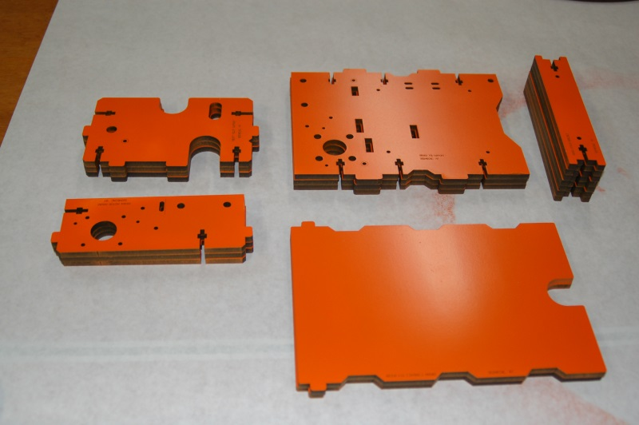Fig 1-4: Vertically oriented parts

If any of these parts don’t meet the uniformity of the others, you’ll need to contact SeeMeCNC support in order to obtain replacements. It’s extremely important that these parts are uniform. If they’re not, you’ll end up with an out of square or warped base. This will make it impossible to align the machine for use. Note that the Tri-Supports have some small variation in the notches – this is ok. The important part is that they're all the same height.
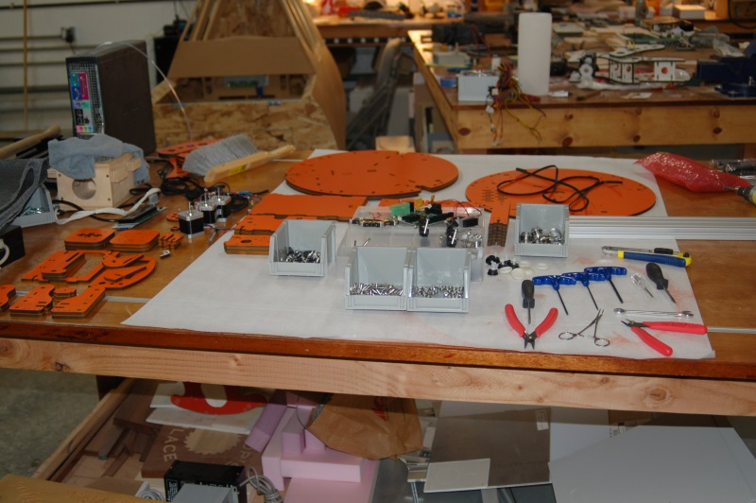Fig 1-5: Ready to build!

2 – Building the Base Assembly
The first thing you’ll need to do is remove the countersink rings from all the base assembly components. (There’s no reason you can’t pop the countersink rings from all the parts right now, not just the base parts).
The countersink rings are small circles that have been laser cut around the mounting holes. When removed, they provide a “soft” space for the beveled head of a flat head screw. When you tighten the screw down, it will be flush with the surface.
I would recommend that you go ahead and remove the countersink rings from all the Rostock MAX components at this time. It’ll save you some work later on.
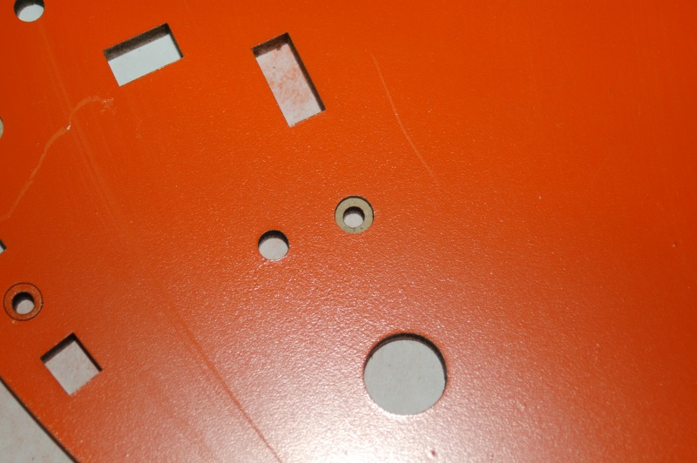Fig 2-1: Countersink rings
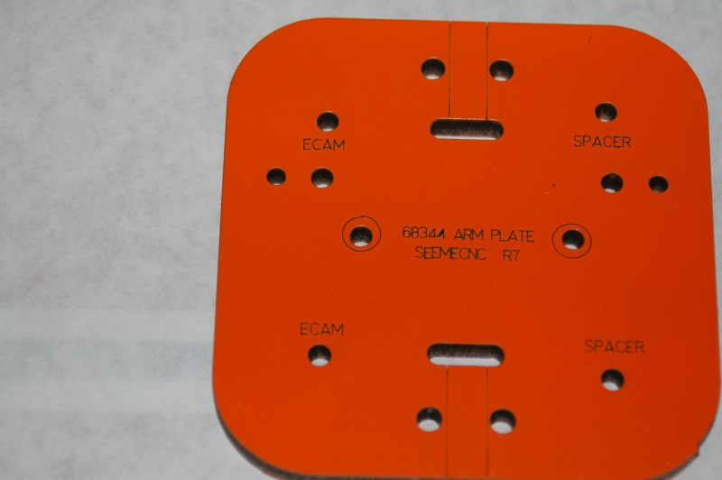Fig 2-2: Countersink rings on the Arm Plate

Locate the bag of parts that contain the feet for the bottom of the Rostock MAX. They’ll look something like what is shown below in Fig. 2-3.
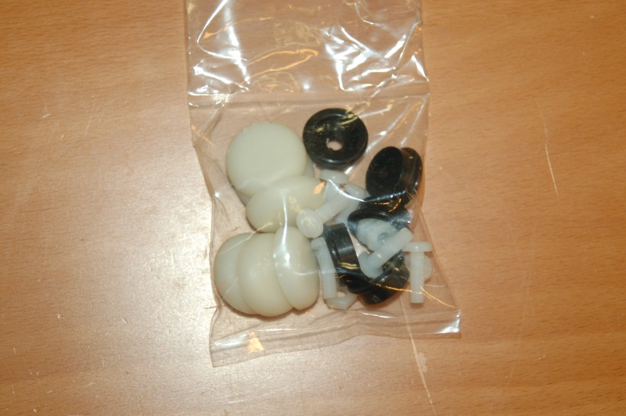Fig. 2-3: Bag of parts for the base feet.

The base is supported by six feet. Each foot is made up of a nylon nut & bolt, a black plastic “foot” and a soft rubber “shoe”.
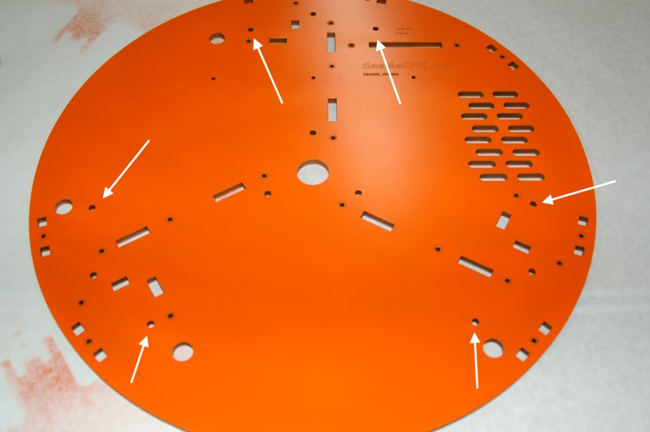Fig. 2-4: Mounting locations for the six feet.

In Fig. 2-4 above, you’ll see the six mounting holes for the base feet. The photo below shows a pair of feet correctly installed, without the rubber “shoes”.
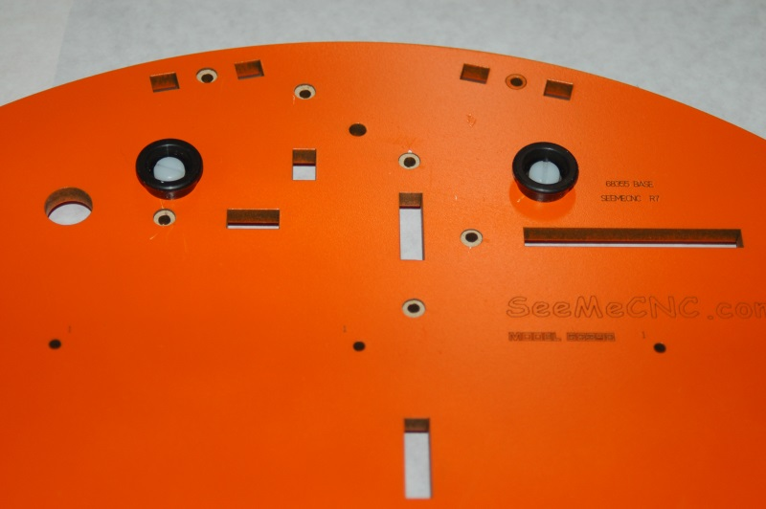Fig. 2-5: Feet installed.

When you’ve got all six feet installed, you should have a bottom base plate that looks like the photo on the next page.
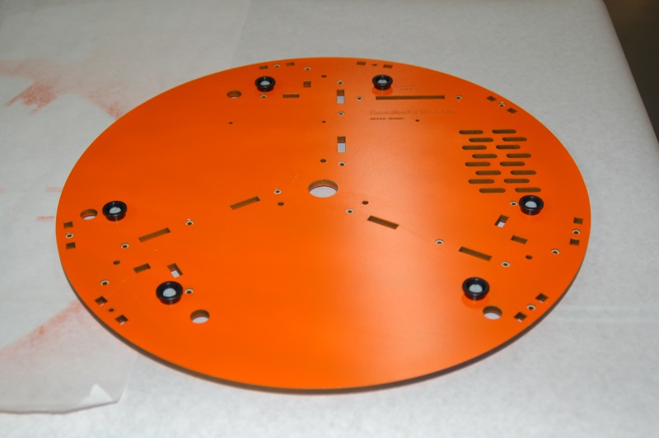Fig. 2-6: Feet Installed

You don’t want to install the “shoes” until the base assembly is complete. The rubber “shoes” are large enough that they’ll block access to the countersunk hole next to three of the feet.
The base of the Rostock MAX is built upon three “tri-support” assemblies. Each tri-support contains a stepper motor, two idler bearings and the hardware required to hold the aluminum tower extrusions in place. The tri-supports consist of a Tri-Support (P/N:68352), a T-Slot Support (P/N:68377) and a Motor Mount (P/N:68364).
In order to make assembly easier, we’re going to treat each of those three parts (four for the tri-support that has the power supply attached) as sub-assemblies. This means that we’ll be not only assembling the components mentioned above, but the stepper motor and idler pulleys as well. This makes assembly a lot easier, especially considering how tight things are once the tri-supports are mounted to the base plate.
The stepper motors don’t ship with connectors attached, so the first thing you’re going need to do is attach the four pin connectors that are included in the RAMBo box. The RAMBo box also has a little packet of crimp on connectors. You’ll need 12 of them to wire up the connectors for the three stepper motors.

DO NOT INSTALL (or remove) A CONNECTOR ON THE FOURTH STEPPER MOTOR! THE WIRING NEEDS TO BE EXTENDED FIRST – THIS IS SHOWN IN SECTION 12.

If you’ve got the “old” model stepper motors, the wires will be colored Red, Black, Green and Blue. If you’ve got the “new” model stepper motors, they’ll be colored Green, Red, Blue and Yellow.
The figures below show the wiring sequence for both models of stepper motor. Fig. 2-7 covers the old style while Fig. 2-8 covers the new.
Note that if you've got a newer edition of the kit, the motors come with the connectors installed on them already, so you can skip the following wiring task.
The white arrow points to pin #1 on the connectors.

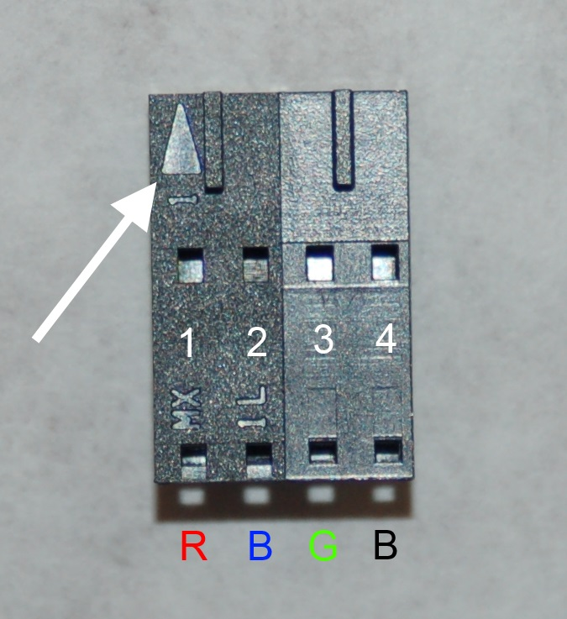Fig. 2-7: Old model stepper motor wiring pin out.

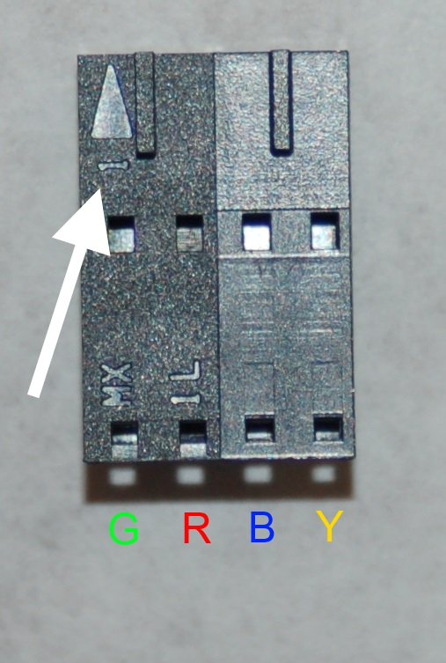Fig. 2-8: Current connector pin out.

Insert each connector such that the little “tab” the top of the connector will face up when inserted into the socket. It will engage in the locking holes in the connector. (These holes are right above each pin # in Figs. 2-7 and 2-8.)
Fig. 2-8A shows what a proper crimp looks like when you use a standard crimping tool. The focus isn’t so hot, but you get the idea.
I would strongly recommend that you “bundle” the wires for each stepper motor by twisting them together and then adding a few small wire ties or use waxed lacing cord to make them more wiring harness-like. They'll be easier to route and their installed appearance will be much neater. My preference is waxed lacing cord as there's no “head” to catch on things like there is with wire ties. Using it is very easy – cut a 7” or so length of it, tie a granny knot tightly around the wire bundle, tie another tight granny knot on top of the first, clip the ends and you're done.
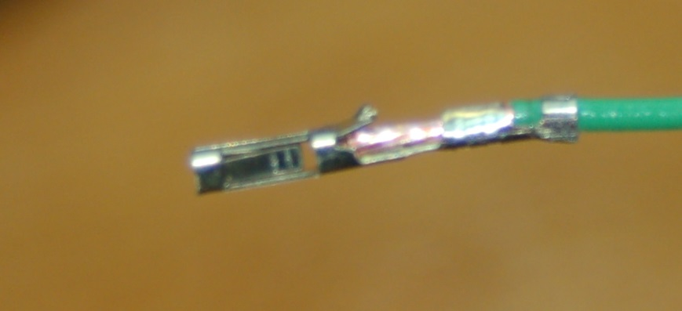Fig. 2-8a: A properly crimped connector.
Once you’ve installed the connectors, locate the parts bag with the three 20 tooth drive gears and their mounting hardware. Newer kits ship with an all-aluminum gear that has the same shape & configuration as those shown below in Fig. 2-9.
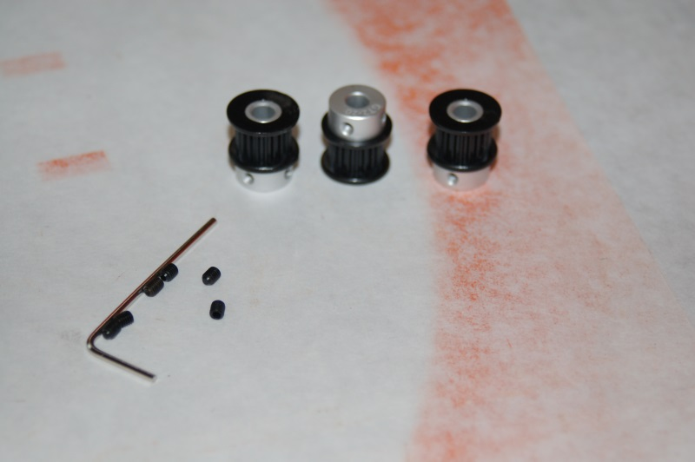 Fig. 2-9: 20 tooth drive gears.

In order to make sure that the tiny grub screws don’t loosen over time, you’ll want to apply a small amount of thread locking compound to each one before you install it. When you slide the gear on to the stepper shaft, stop when the outside face of the inner gear collar is flush with the end of the stepper motor drive shaft as shown below. The blue material around the grub screw is thread locker.
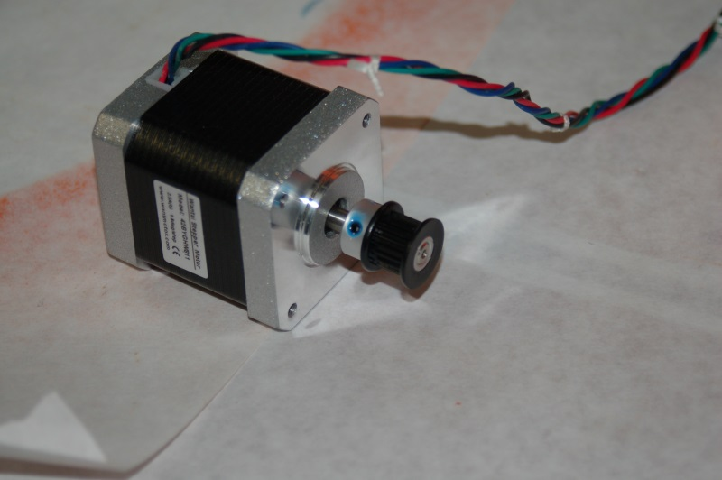Fig. 2-10: Drive gear installed.

Once you’ve got all three stepper motors done, set them aside. We’ll get back to them in a bit. Now you want to start assembling the first of the three tri-supports.
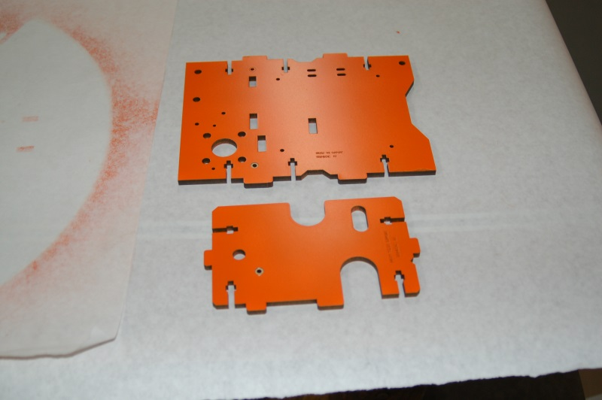Fig. 2-11: Tri-Support and T-Slot Support

Go ahead and test-fit the Tri-Support and T-Slot Support to get an idea of how they go together:
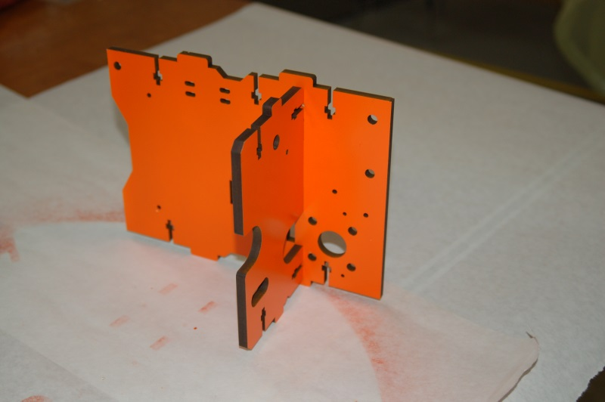Fig. 2-12: Test fitting the Tri-Support and T-Slot Support

In order to assemble these two components, you’ll need two #6-32 nylon lock nuts and two 1” #6-32 flat head machine screws. (All the tab & slot part joins are done with this nut & flat head screw combination.)
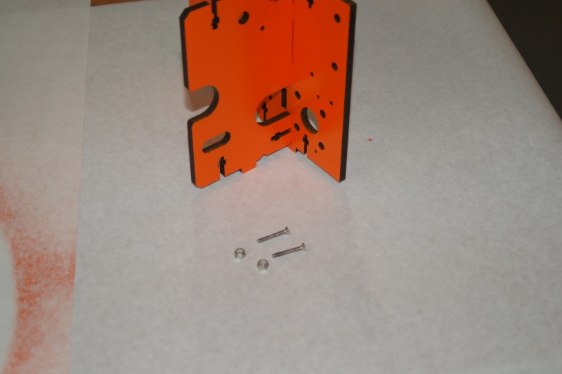Fig. 2-13:Tri-Support & T-Slot mounting hardware.

The nylon lock nuts need to be inserted in the square nut pockets as shown below. Inserting the nuts is easier if you use a pair of needle nose pliers to insert the nut (flat sides parallel with the nut pocket!) from the face that has the laser engraved lettering on it. This allows you to leverage the draft angle that results from laser cutting process in order to make inserting the nylon lock nut much easier.
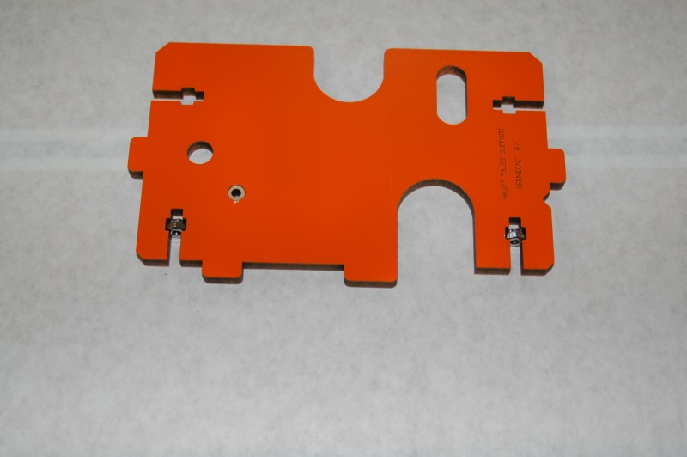Fig. 2-14:Nylon lock nuts installed.

A solid rule to follow when installing the lock nuts is to always position them with the “dome” shape facing the short axis of the slot they’re sitting on. The face of the nut always faces the surface you’re joining to.
Drive the flat head screws in only far enough that the screw begins to engage the nylon ring in the lock nut. It’s important to leave these connections as loose as you can – it be a big help when you’re installing the Tri-Support assemblies into the base and when you install the top plate. Make sure that the countersink rings are facing outward, or toward the bottom of the screw head.

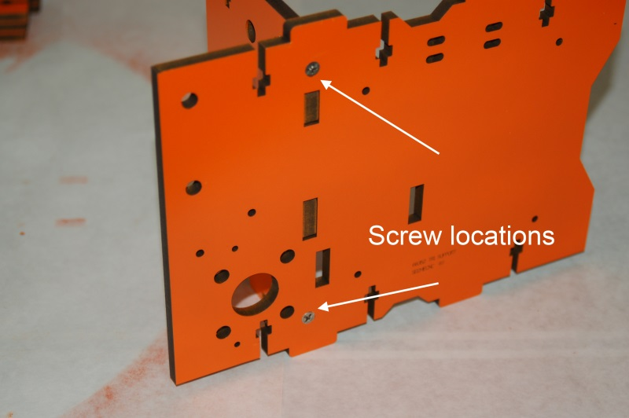Fig. 2-15: T-Slot mounting screw positions.

Now install the stepper motor mount as shown below in Fig. 2-16. It only takes one fastener.
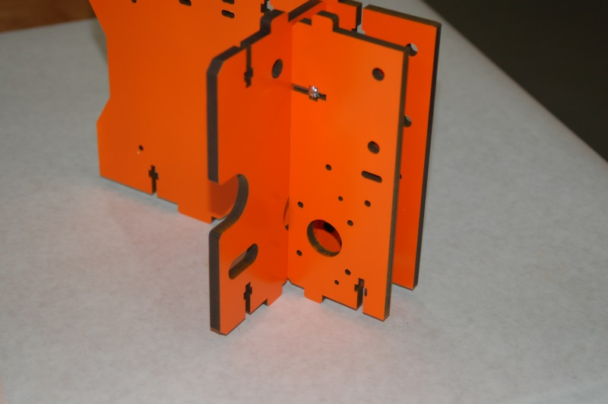Fig. 2-16:Installing the stepper motor mount.

Now it’s time to install one of the stepper motors you were working with earlier on to this Tri-Support assembly.
Route the stepper motor’s wires through the wire pass-through as shown in Fig. 2-17.
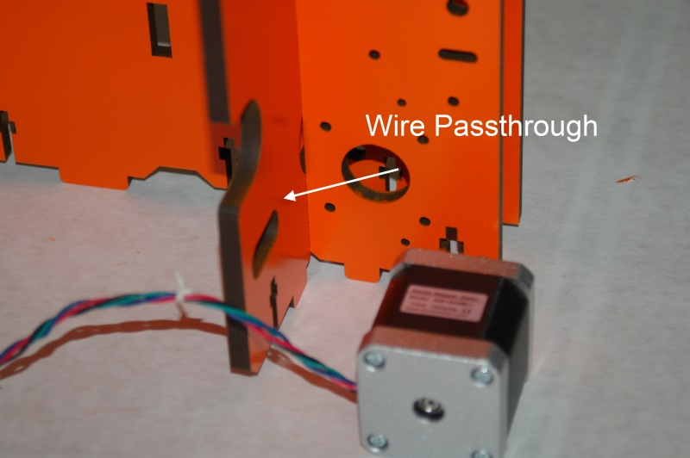Fig. 2-17: Stepper motor wire routing.

The stepper motor mounts to the motor mount using four M3x10mm pan head screws. I would recommend adding thread locker when you perform the installation. Vibration can cause these screws to loosen over time if you don’t take these steps to avoid the problem. A small amount of RTV on the threads will also work as a thread locker if you don't have any.
Please label the stepper motor leads with the name of the axis you're installing them in. It will make final assembly a lot easier.

The motor should be installed as shown below. The Tri-Support has over-sized holes that align with the stepper motor mounting screws, allowing you to reach them from the side. As you can see, the 20 tooth gear is lined up with the center of the channel that’s formed by the motor mount and the Tri-Support.
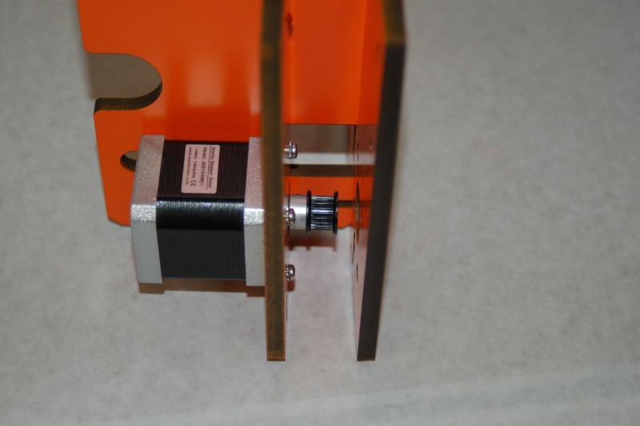Fig. 2-18: Installing the stepper motor.
With the stepper motor installed, it’s now time to move on to the installing the two idler assemblies that each Tri-Support needs. These guide the belt on their way to the drive gear. Each idler assembly is made from two injection molded spacers and a 608 sealed race bearing.
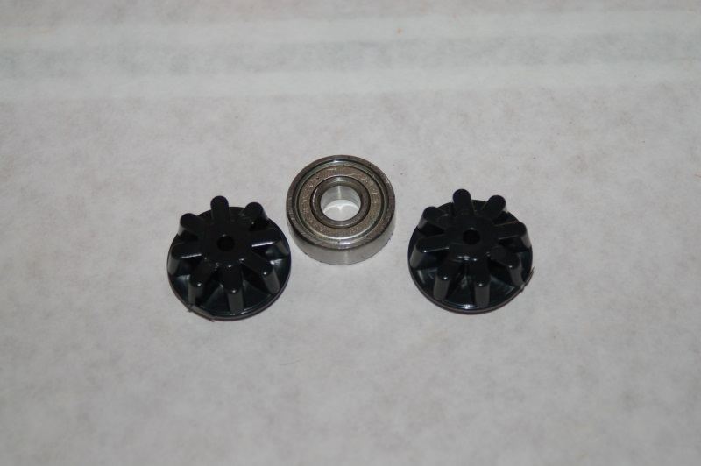Fig. 2-19: Idler bearing components.

The plastic spacers fit into the center bore of the bearing as shown in the photo below.
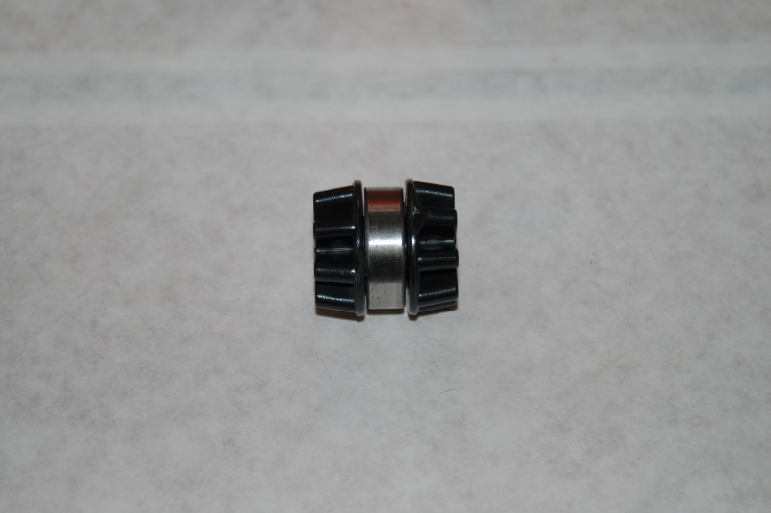Fig. 2-20: Idler bearing assembly ready to install.

Each Tri-Support assembly gets two of these idler bearings. They’re installed using two #6-32, 1.75” long pan head Philips screws, four #6 washers and two #6-32 nylon lock nuts.
Fig. 2-21 below shows the position of the first idler and the hardware required to install it.
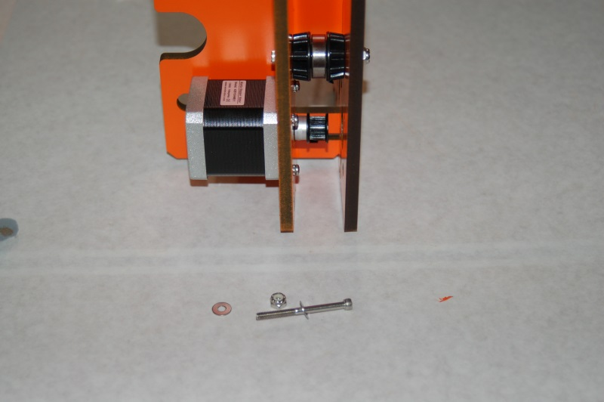Fig. 2-21: Installing the Tri-Support idler bearing assemblies

Fig. 2-22 on the next page shows the correct positioning for the two idler bearing assemblies. When installing them, only tighten the screws enough so they engage the nylon lock nuts – as with the flat head screws, having these loose will help installation into the base and top. I also recommend that you install the screws with the heads to the left. There’s more room to reach them from that side after everything is assembled and it’s time to tighten them down.

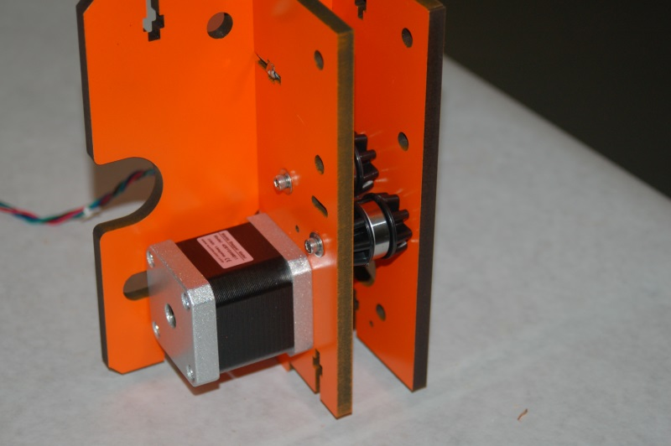Fig. 2-22: Installation position for the two idler bearings.
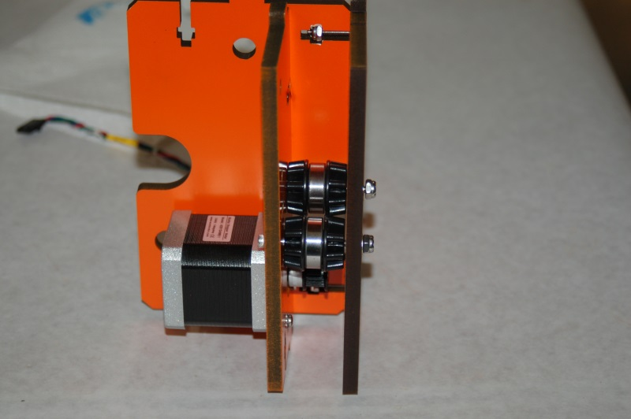Fig. 2-23: Additional view of the idler bearing installation.

The Tri-Support you just finished is going to be installed on the X Axis of the Rostock MAX. This means that this Tri-Support is where the RAMBo circuit board will be installed. The RAMBo board is mounted to the Tri-Support using four T-Nuts, four #4-40 socket head screws, four #4 flat washers and eight nylon spacers. For right now, all we’re going to do is install the four T-Nuts into the X-Axis Tri-Support assembly as shown in Figs. 2-24 and 2-25. You can use the socket head screws and the washers to “draw” the spines of the T-Nut into the melamine. I’d recommend dabbing the outside barrel of the T-Nut with a bit of Superglue before installing them. If they pop out before or during the RAMBo installation, you’re going to have a difficult time re-installing them. A bit of Scotch tape would work just as well. (Do both! Can't hurt!)
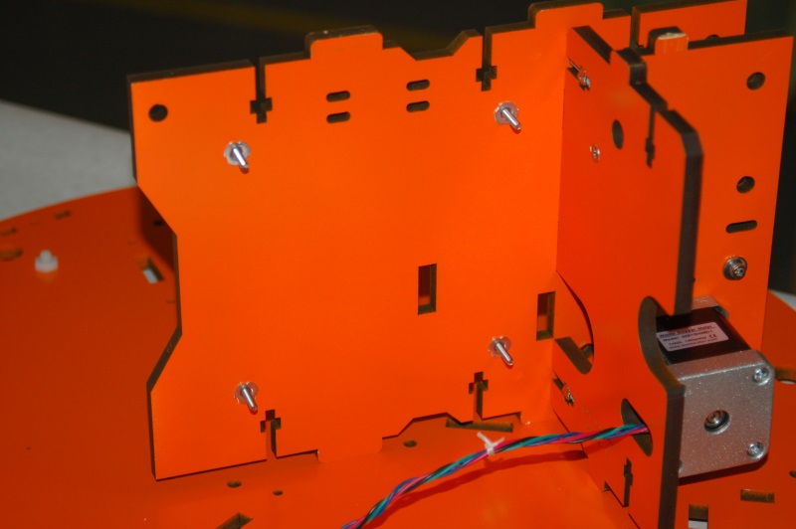Fig. 2-24: T-Nuts installed on the back of the X-Axis Tri-Support

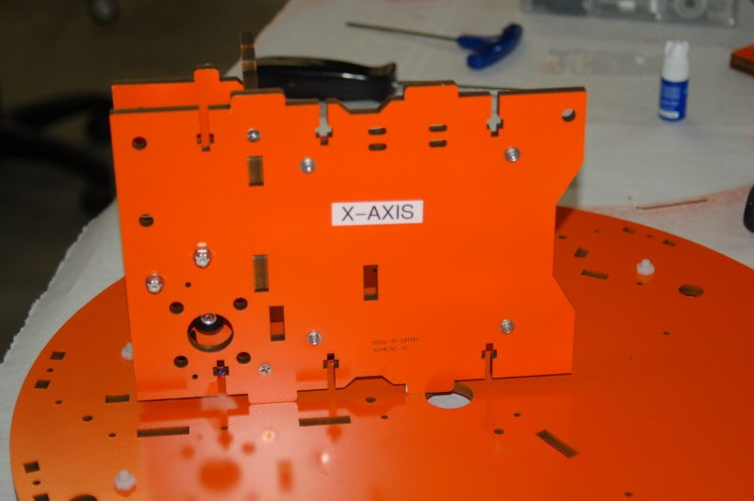Fig. 2-25A: Tri-Support labeled and RAMBo screws installed.
Now would be a good time to start labeling your Tri-Support assemblies as shown on the right.
I would also recommend labeling each stepper motor lead with the axis it’s attached to.
Assemble another Tri-Support and label that one “Y-Axis”. The Z-Axis Tri-Support has one additional component, the power supply mounting bracket, as shown on the next page.

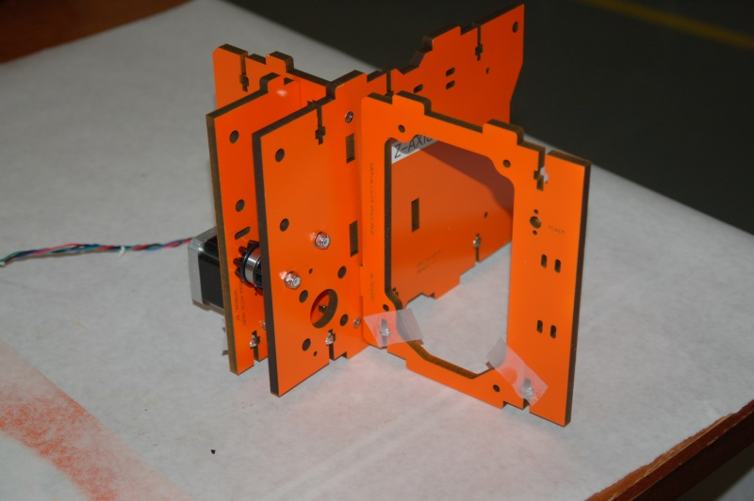Fig. 2-26: Z-Axis Tri-Support with power supply bracket in place.

The power supply bracket (P/N: 68356) fits into a slot in the Z axis Tri-Support as shown above. In my kit, the screw fit was a bit loose, so I used small tabs of Scotch tape to hold them in place until the Tri-Support was installed.
Now it’s time to install the three Tri-Support assemblies you’ve built into the base. Go ahead and install nylon lock nuts in both the top and bottom square nut pockets on all three Tri-Support assemblies. Some are a tight fit, so take your time. If you’re having problems fitting one in, a pair of slip-joint pliers can be used to fit the lock nut. (If you open the slip joint, one jaw will press on the nut corner while the other is flush with the opposite face of the melamine part you’re working on.) DO NOT TIGHEN DOWN THE TRI-SUPPORT SCREWS! Tighten the screws only to the point where they begin to engage the nylon. The Tri-Supports need to be loose in order to give them a bit of “wiggle” room in order to make installing the top of the base a much easier task!
Start with the X axis Tri-Support as shown below:
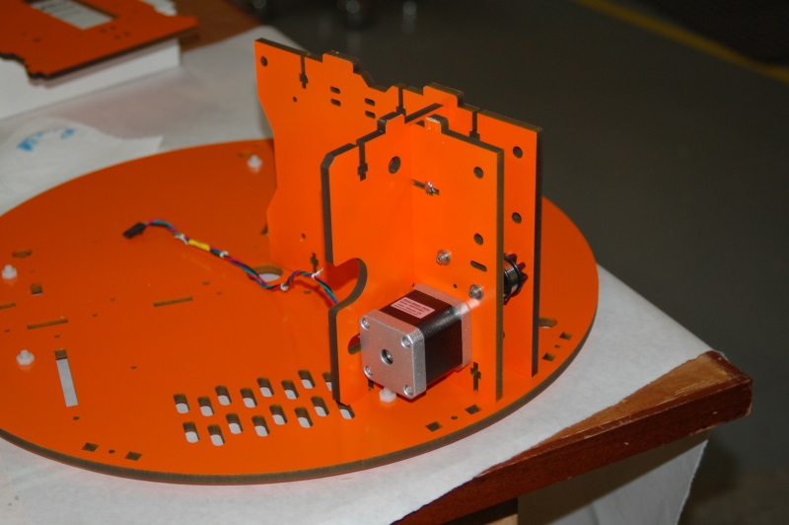Fig. 2-27: Installing the X-Axis Tri-Support.

The next Tri-Support you’ll install is for the Y axis. It’s the next installation position counter-clockwise from the X axis Tri-Support.
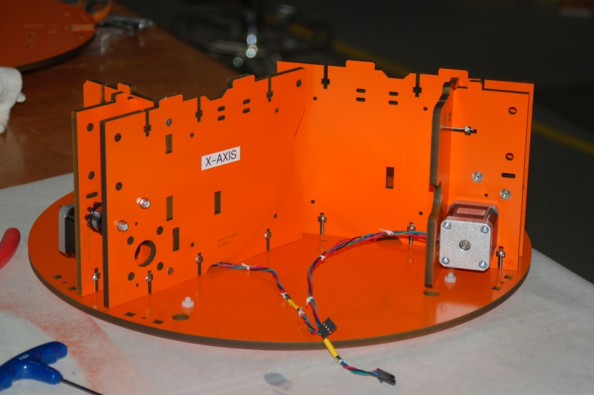Fig. 2-28: Y Axis Tri-Support and X-Axis stepper wire routing.

After installing the Y axis, you should pass the X axis stepper motor wires under the X axis Tri-Support as shown above.
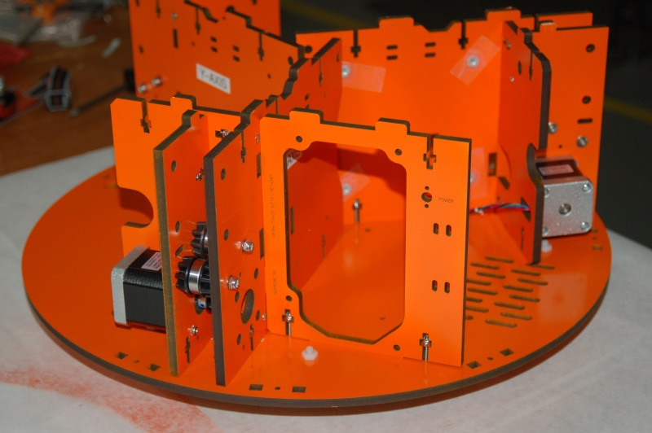Fig. 2-29: Z axis Tri-Support in place.

The last thing you’ll need to do is make sure all three stepper motor wiring harnesses end up in what I call the “electronics bay” - the space between the X and Y axis Tri-Supports. With this done, the Tri-Support assembly installation is complete.
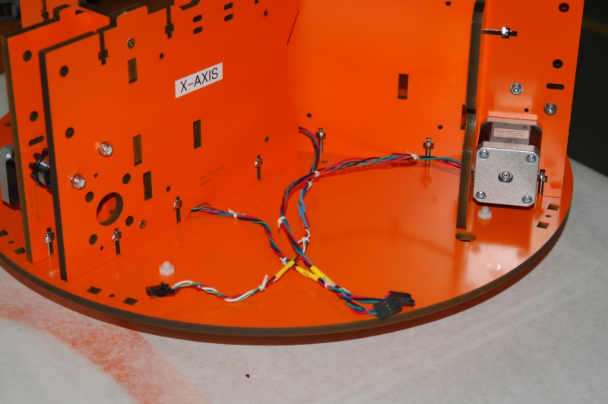Fig. 2-30: Stepper motor wire routing.

The last structural part that needs to be installed in the base is the Cover Brackets (P/N: 68361). There are seven of them. These parts were originally used to help hold a plastic cover in place, but they’re now relegated to simple structural items. Like all the other base components, the Cover Brackets use #6-32 nylon lock nuts and 1” #6-32 flat head screws.
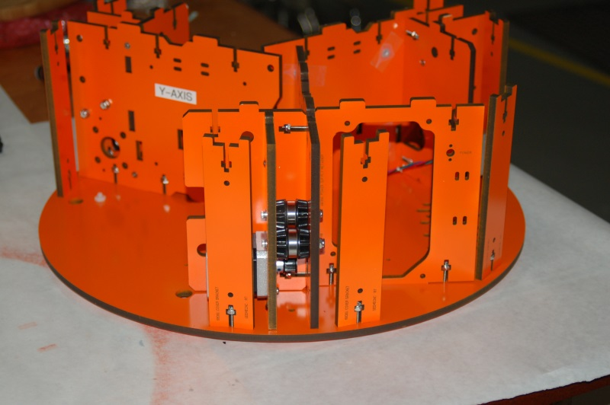Fig. 2-31: Installing the Cover Brackets.

Next, you’ll need to position the two doors on the base plate. The first door is positioned between the X and Y axes and is where the LCD brackets will mount. It’s P/N 68357 and is labeled “Support Panel”.
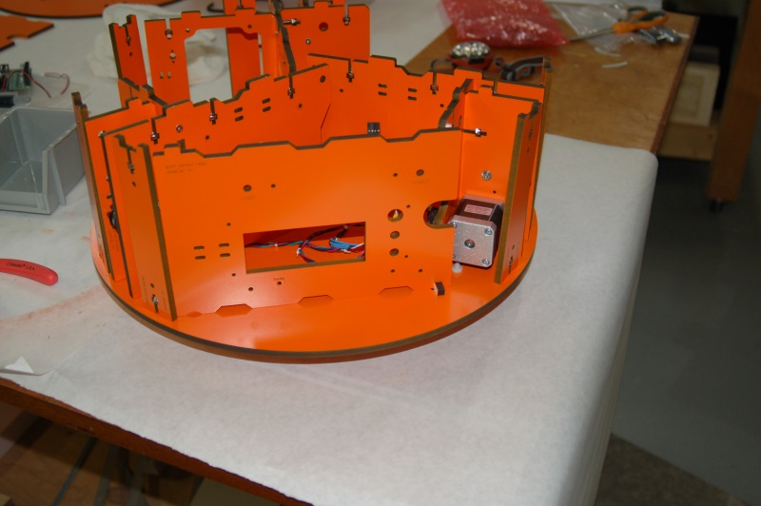Fig. 2-32: Installation of the Support Panel

The door has a “pin” that will fit into the hole located right behind the Cover Bracket as seen above. There’s another hole next to the stepper motor that is for the “door keeper”. This is just a tiny little part that helps keep the door shut.
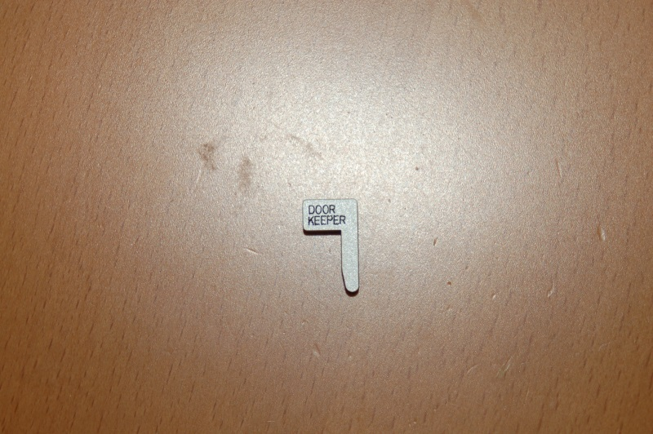Fig. 2-33: Door Keeper.

Install the door keeper and tape it into place so the door doesn’t swing out when you’re working with the base.
The other door to install is P/N 68358 and is marked “Electronics Door”. This door is positioned between the Y and Z axes and is simply used for a storage area. Like you did on the previous door, drop the door keeper in the hole and tape it in place.

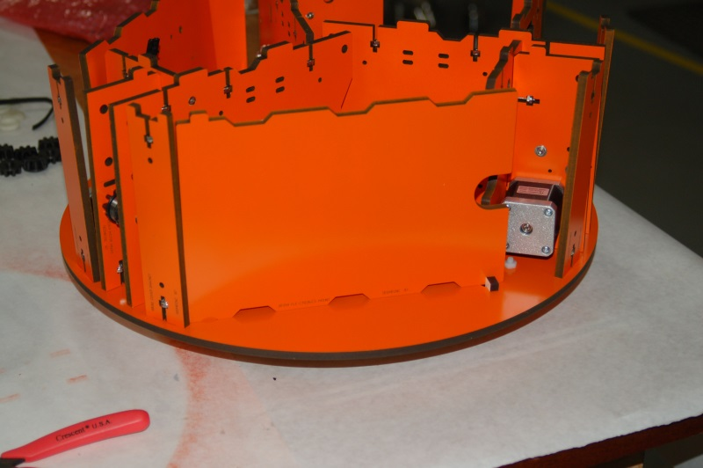Fig. 2-34: Installation of the "Electronics Mount" door.

The next task is to insert the T-Nuts for the Onyx heated bed into the back face of the top plate. The figure below was taken of my original Rostock MAX top plate, so it’s not painted the same as the other parts. The arrows highlight the six T-Nut locations.
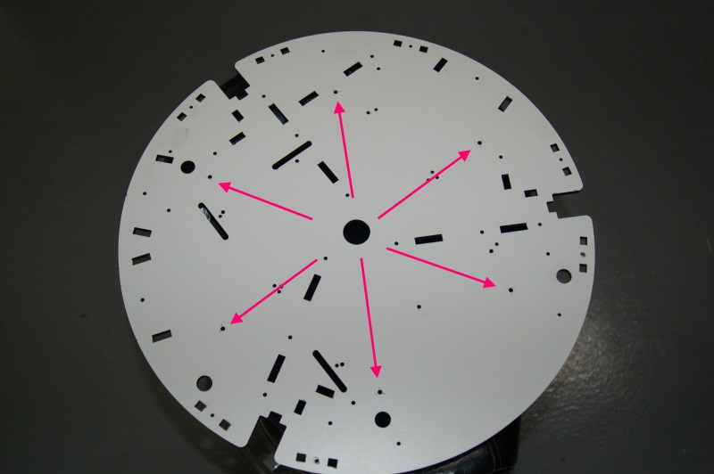Fig. 2-35: Locations for the heated bed T-Nuts.

You can use the heated bed spacer plate as a guide if you’re unsure where the holes are. Just make sure that you’re inserting the T-Nuts on the bottom of the top plate. The bottom is the face that does not have any text engraved on it.
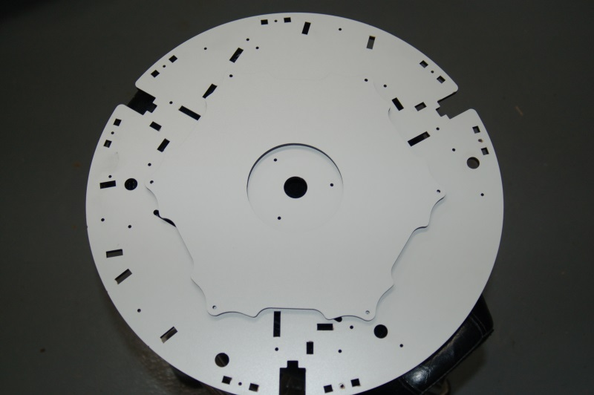Fig. 2-36: Using the heated bed support plate as a hole locator.
I would recommend that you either put a dab of Superglue on the T-Nuts as you install them, or cover them with a small patch of Scotch tape after they’re in (or both!). This will ensure that you don’t accidentally knock one out when it comes time to install the Onyx heated bed.
Now carefully insert nylon lock nuts in all the square nut pockets on all the Tri-Supports and Cover Brackets (if you’ve not done so already as I know some of you like to race ahead of the class!) :)
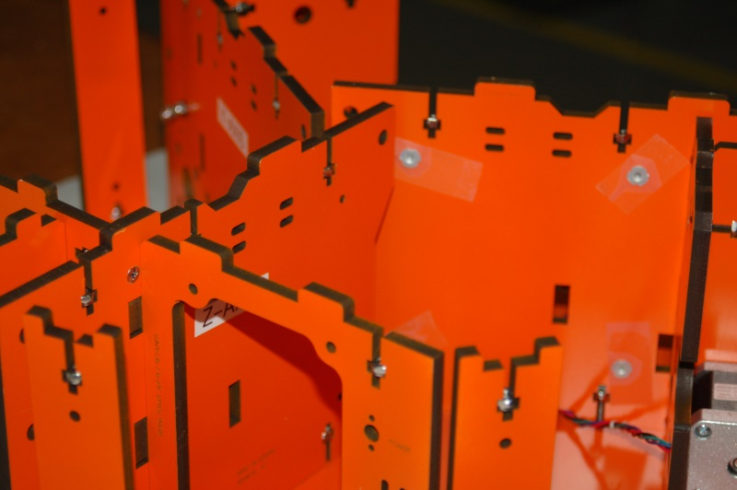Fig. 2-37: The remaining nylon lock nuts are installed.

Now you can finally install the table top! This task isn’t difficult, but it does take care to do it right and not damage the tabs on the Tri-Supports and Cover Brackets. The trick here is to start small and work your way around the table top. We’ll start this process at the Y axis as shown below.
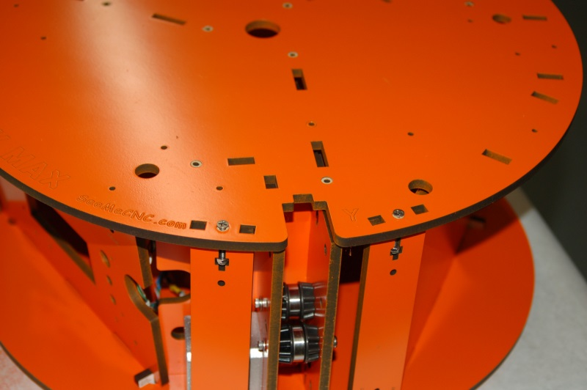Fig. 2-38: Starting the table top installation.
In Fig. 2-38, you can see that we’ve really only started two parts – the Cover Brackets located to either side of the channel for the Y axis tower. Because we didn’t tighten anything down, the parts can move a bit to help them fit into the slots. Install two #6-32 1” flat head screws as shown above (this same screw is used throughout the table top installation). Tighten it only enough that it begins to engage the nylon portion of the lock nut. By doing this, we’ve established a starting point that won’t pop free as we’re working to get the other parts fit. Don’t forget that you also have to make sure that the door “pins” fit as well. Having the doors taped shut will help keep them from tilting over too much.
Please take your time with this step and try not to force tabs into place. The tolerances are very tight, but they will fit! As you progress through the process, install screws in the Cover Brackets as you go – this will help quite a bit by preventing spots you've got fitted from popping out as you work your way around the top.

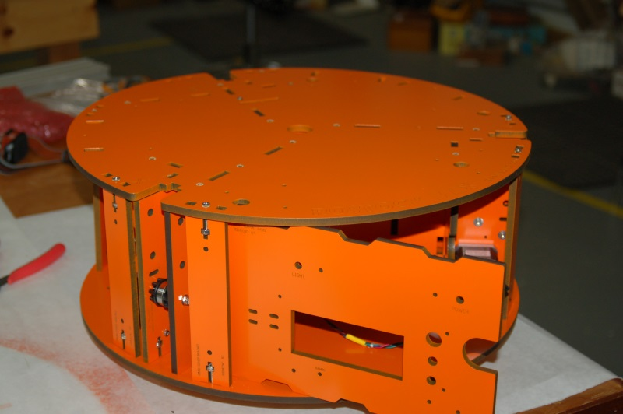Fig. 2-39: Top is firmly in place!

Now that you’ve got the table top fitted down and you’re done teaching your children some fascinating new words, go ahead and install the remaining #6-32 1” flat head screws, but don’t tighten them down quite yet.
Flip the base assembly upside down and begin tightening down the mounting screws. If you use a power screwdriver, be VERY careful that you don’t over drive the screw and pull it below the surface of the melamine. You should tighten it enough that it’s flush, but no more. You don’t want to do damage to the screw holes. When you start tightening the screws, start in the center and work your way out in a spiral pattern, tapping as you go to make sure everything is seated properly. When you’re finished, install the “shoes” on the feet as shown in Fig. 2-40 below.
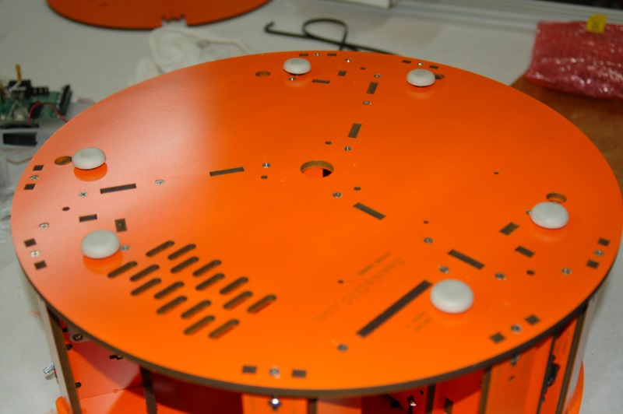Fig. 2-40: Screws tightened and shoes installed.

Now flip the base over and get all the screws in the top tightened down.
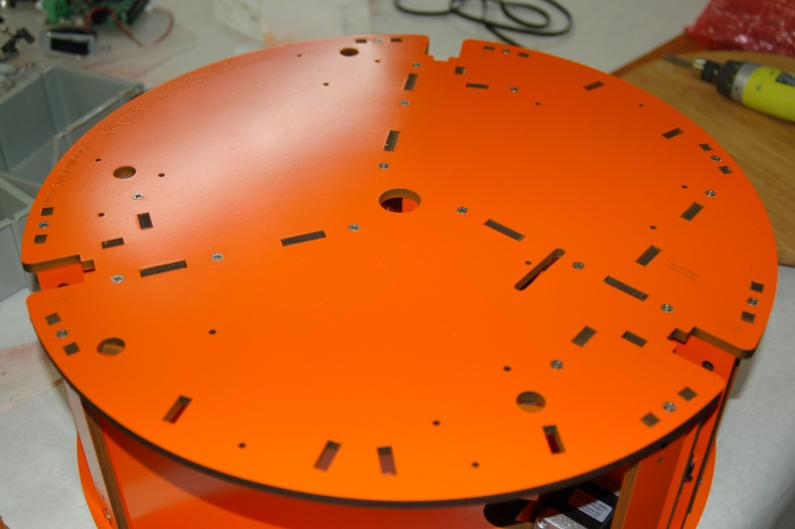Fig. 2-41: Screws tightened down in the top of the table base.

After the top screws are tightened down, go through and tighten the screws that hold the Tri-Supports together. It can be tricky to reach a few of them, but not impossible.

3 – Installing and Aligning the Towers
Now that the base is completed, it’s time to install the three aluminum towers into the base plate. Start off by locating the 1/4-20 x 1/2” button head cap screws and the 1/4-20 T-Slot nuts. There are 12 of each required for this step.
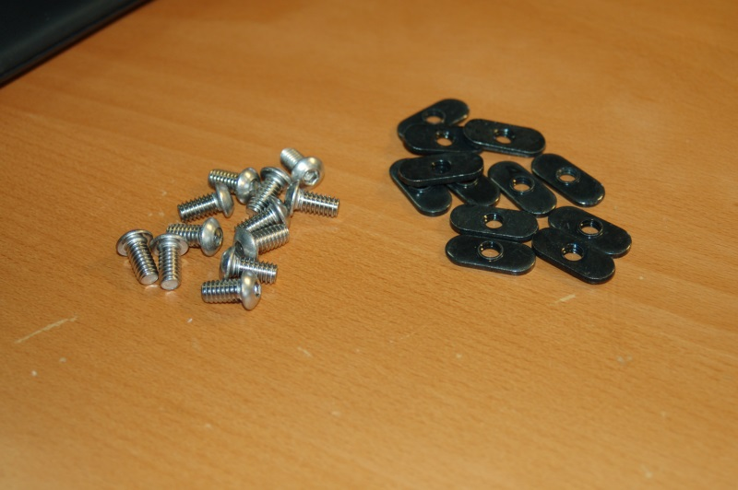Fig. 3-1: Screws and T-Slot nuts required for the tower installation.

You need to pay special attention to the orientation of the “boss” or protrusion on the T-Slot nuts. See Fig. 3-2 below for the correct orientation.
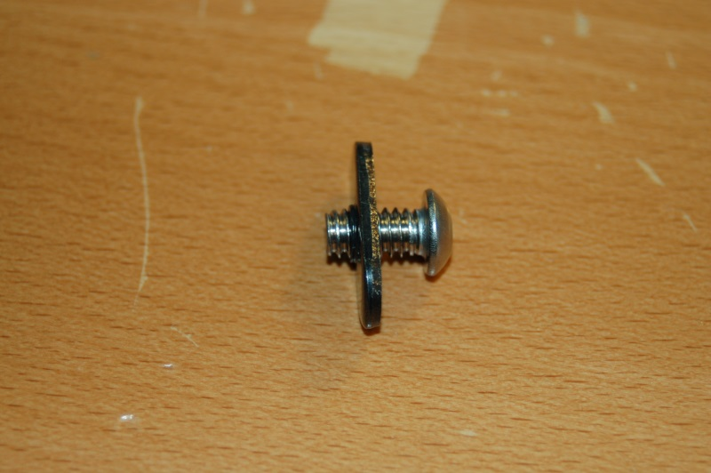Fig. 3-2: T-Nut boss orientation.

The orientation is important because the flat surface of the T-Nut must be flush against the face of the Tri-Support in order for it to hold properly.

Now you want to install four t-slot nuts and four screws in each of the three tower locations as shown below. The image focus isn’t the best, so I’ve included an additional photo from the first edition of the manual to more clearly show what you need to do.
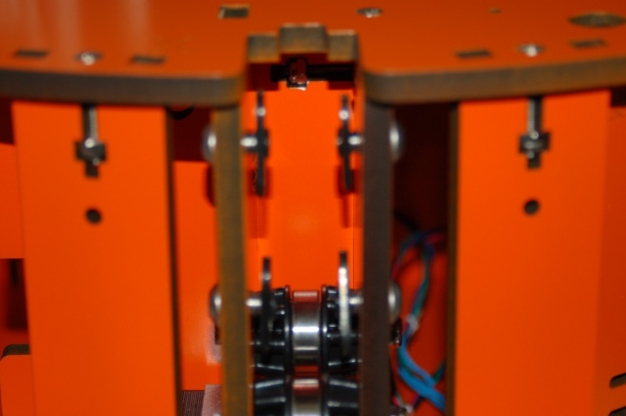Fig. 3-3: Installing the tower mounting hardware.

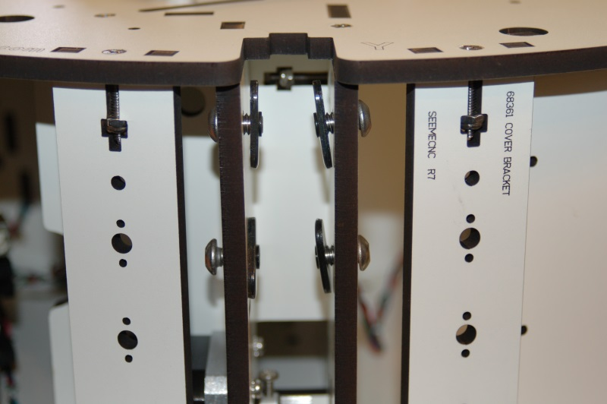Fig. 3-3a: Installation of the tower hardware, clarification.

You’ll note that the T-Nuts are only a few threads deep on the screws. This is needed in order for them to fit easily into the slots in the tower extrusions.

Now you can start installing the tower extrusions. It doesn't matter which one you start with, but I usually start from the Z axis and work my way around. Carefully slide the extrusion into the slot formed by the Tri-Support. Make sure that the T-Nuts are oriented in parallel to the extrusion slots so they'll fit properly.
Slide the extrusion down to the alignment mark that’s been laser engraved to the inside face of the Tri-Support
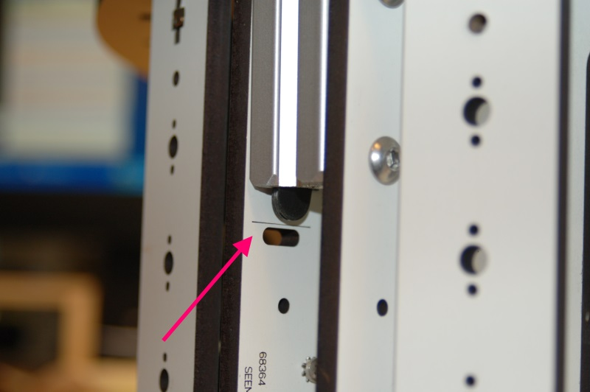Fig. 3-4: Tower alignment mark.

You want to make sure that the bottom of the extrusion is perfectly even with the alignment mark. Once you have done that, tighten down the bottom screws (only!) a small amount. The idea is to keep the extrusion from slipping lower while you’re squaring it up.
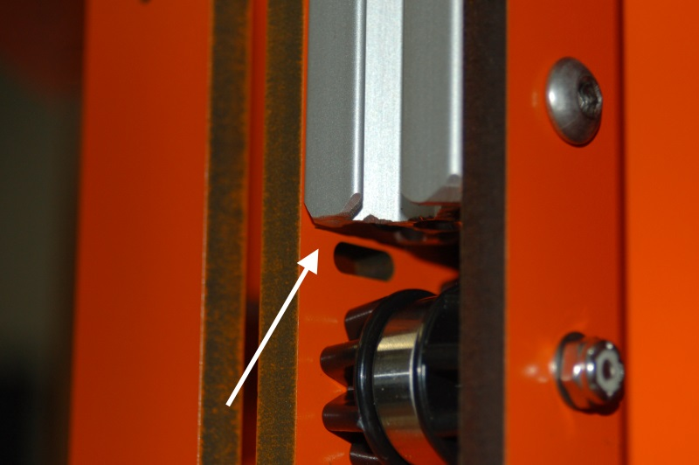 Fig. 3-5: Extrusion even with the alignment mark.

Now grab the your framing square because here’s where we make sure that the tower is perfectly square to the Rostock MAX’s base.
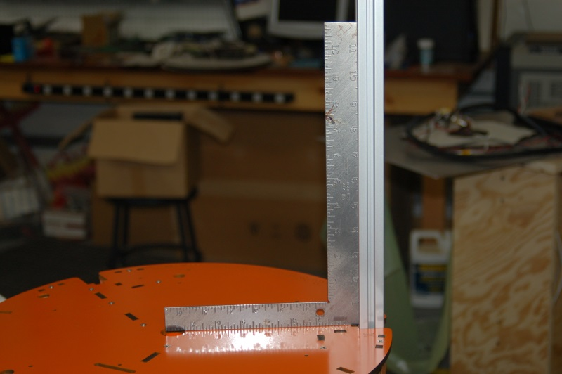Fig. 3-6: Squaring the tower extrusion to the base.

Adjust the tower back and forth until you’re confident that it’s square. If you’ve never used a square before, you’re trying to make the “L” of the square fit such that it’s in full contact with the extrusion vertically and in full contact with the table base horizontally. It shouldn’t rock back and forth at all. Think of it as an upside down shelf brace.
Once you’re confident that the tower is square, carefully finish tightening down the two lower screws in the tower base and fully tighten the two upper screws as well. Double check the tower to make sure it didn’t come out of square while you were tightening down the mounting screws.
After the tower is tightened down, go ahead and tighten down the two idler bearings in the base.
Repeat this process for the other two towers.
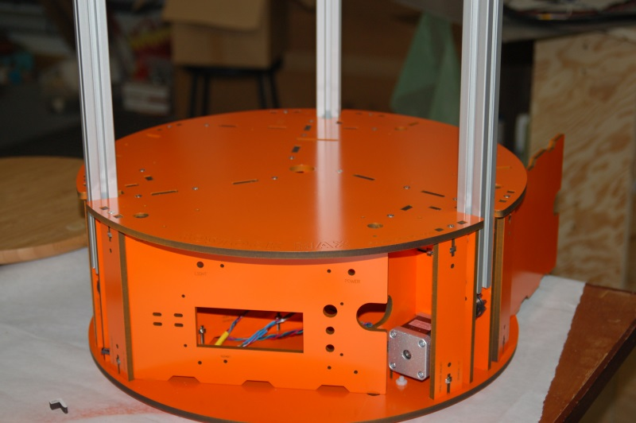Fig. 3-7: Towers installed!

A final note on the towers – make sure that while the towers are square, that each one has the same distance between the inside face of the tower and the outside face of the tower pocket on the table top. While it’s important that each tower be square, it’s also very important that they’re equidistant from one another around the circle defined by the base. If they’re not, you’ll have problems calibrating the Rostock MAX (if you can do it at all!).

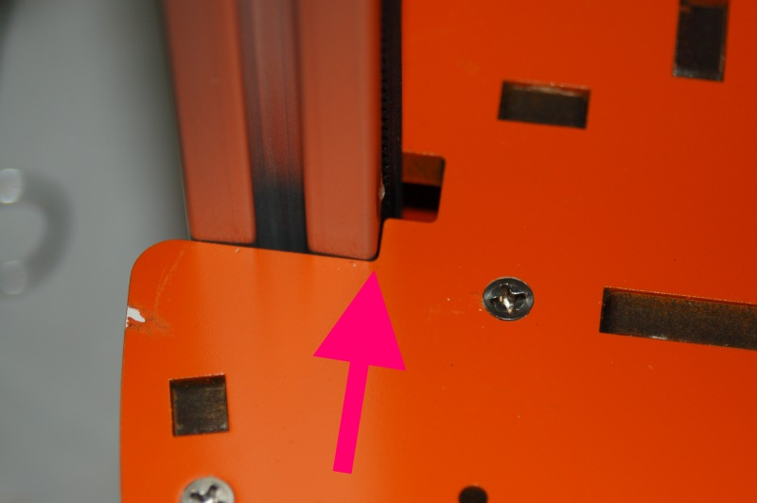Fig. 3-8: Mind the gap! Make sure the gap is the same for each tower!

4 – Assembling and Installing the Idler Mounts
For this step, you’ll need the six Idler Mount parts (P/N: 68369) and the three Top Clamps (P/N: 68370). You’ll insert the remaining 1/4-20 button head screws and their associated T-Nuts as shown in Fig. 4-1.
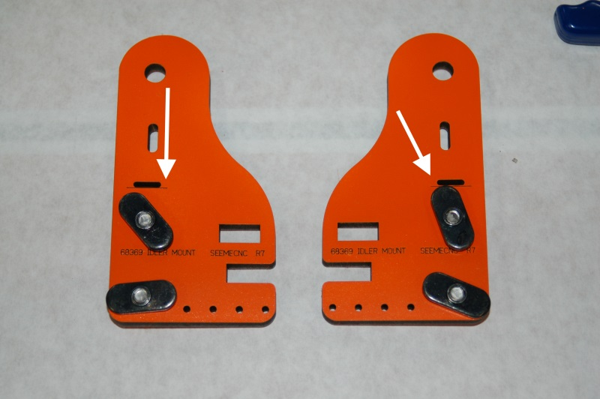Fig. 4-1: Idler Mount parts.

Make sure you orient the parts as shown in order to have the alignment marks visible (the white arrows indicate those marks – the marks are a thin, laser cut line below the wire slot)
Take one of the Idler Mounts and install it at the top of the tower extrusion. Position it such that the alignment mark is perfectly even with the top of the extrusion. Tighten one of the bolts a bit and make a pencil mark on the extrusion, even with the bottom of the Idler Mount as shown below.
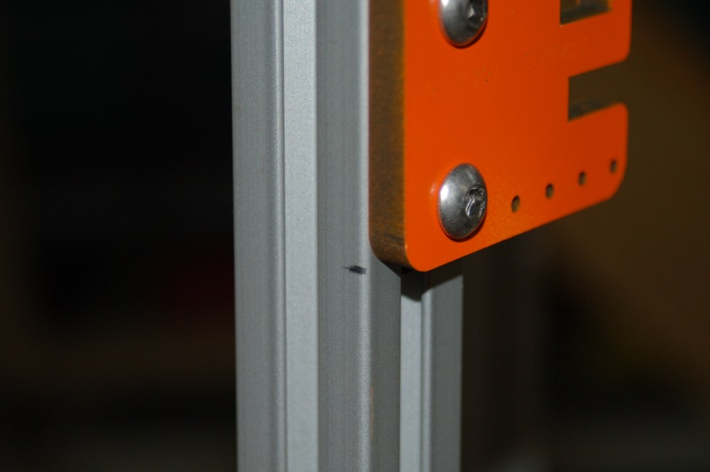Fig. 4-2: Marking the bottom of the Idler Mount.

The pencil mark is going to be your guide for how much you’ll need to cut off the yardstick you bought. (I bet you were wondering about that!)
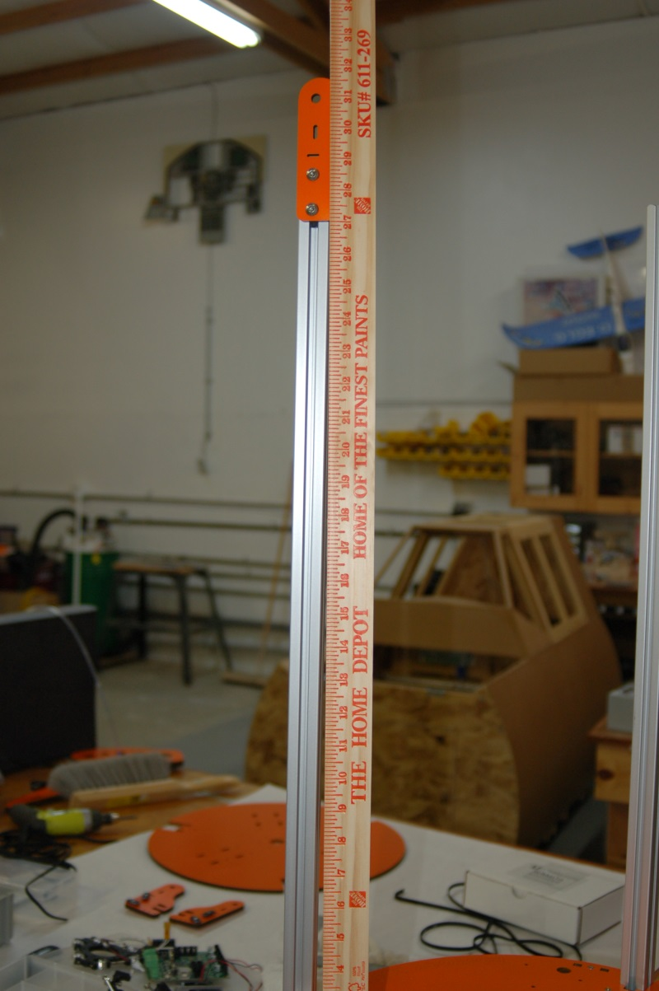Fig. 4-3: Idler Mount spacing gauge.

The idea here is to cut the yardstick off at the mark and then when it’s time to install the top assembly, you’ll be able to guarantee that each idler mount is at the exact same height as all the rest of them.
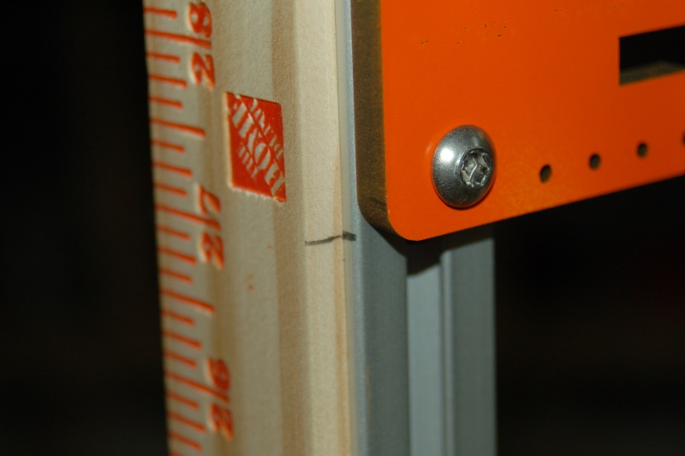Fig. 4-4: Marking the yardstick.

Make sure that when you cut the yardstick that the cut is perfectly square! If it’s not, using the yardstick as a good gauge will be problematic at best.
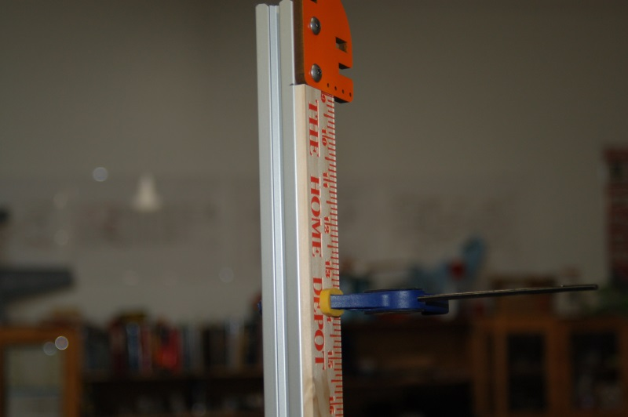Fig. 4-5: Test fitting the gauge.

After you’ve got the yardstick cut down, clamp it in place and verify that when the idler mount is installed, the alignment mark remains even with the top of the tower extrusion, then remove it.

Loosely assemble each Idler Mount as shown below. (Like “loosely” is a choice at this stage!)
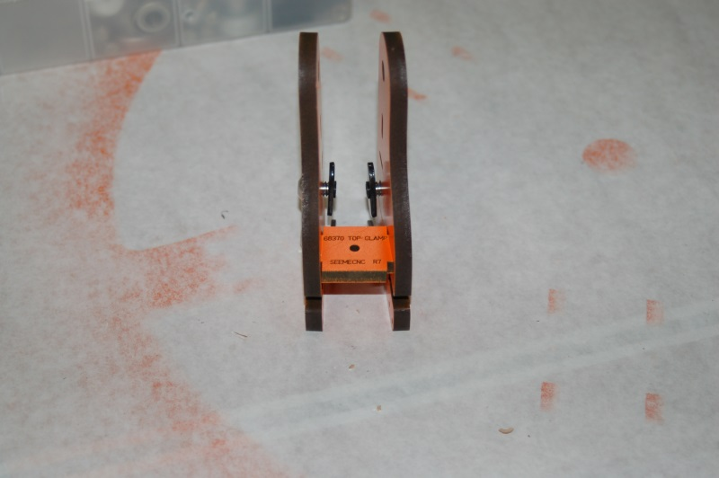Fig. 4-6: Idler Mount assembly.

Install a #4-40 T-Nut on the bottom of each Idler Mount location in the Top Support Plate (P/N: 68368) as shown:
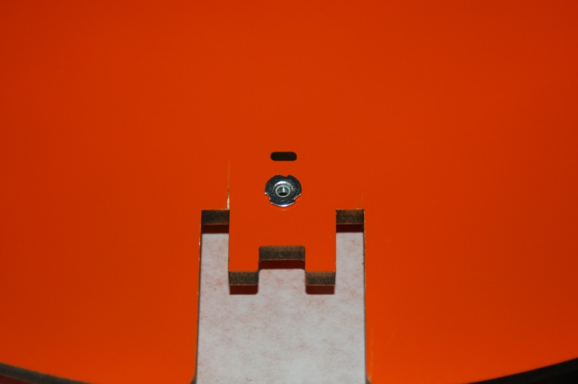Fig. 4-7: T-Nut installed in the Top Support Plate

Install each Idler Mount assembly using a 1-1/4”, #4-40 pan head machine screw and a #4 washer.
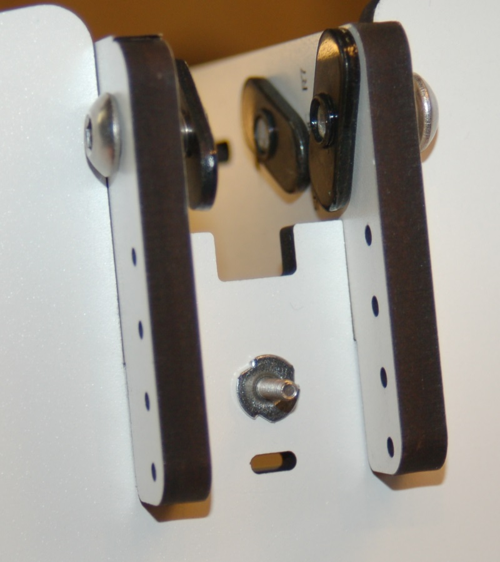Fig. 4-8: Bottom view of the Idler Mount installed in the Top Support Plate.

The Top Support Plate should now look like what is shown below in Fig. 4-9.
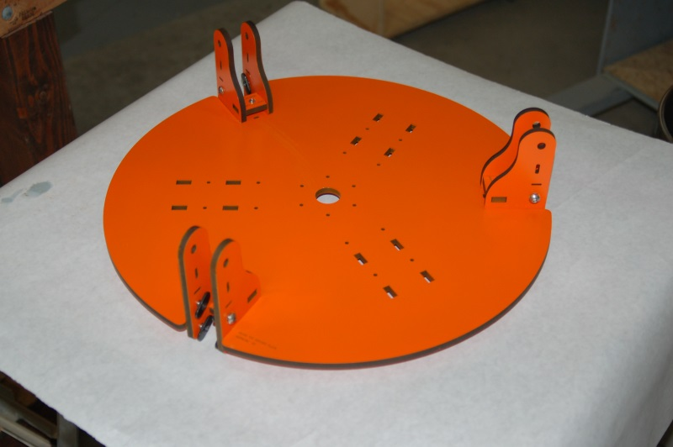Fig. 4-9: Assembled Idler Mounts and Top Support Plate.

5 – Installing the Top Support Plate
Now it’s time to install the Top Support Plate on to the three extrusion towers. It’s not difficult, but you will need to take your time. Start by getting one Idler Mount set in the extrusion tower as shown:
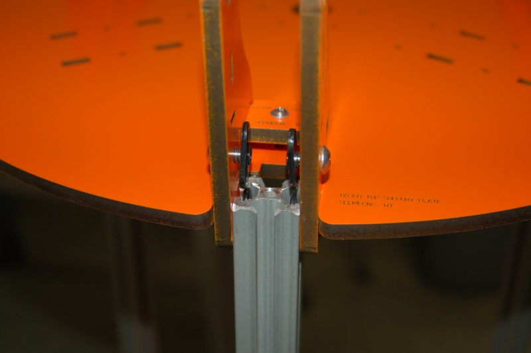Fig. 5-1: Setting the Idler Mount into the tower extrusion.

When you set the Idler Mounts in, just do the bottom two T-Slot nuts for each tower. This makes all three easier to install without the Top Support Plate tilting and making installation more difficult than it needs to be. After you get the base T-Nut pairs done, repeat the process and insert the top two pair:
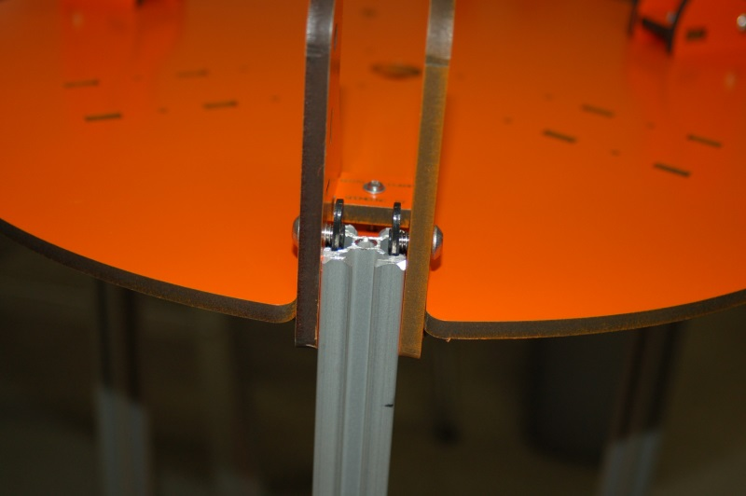Fig. 5-2: Setting the top pairs of T-Nuts into the tower extrusion.

Now grab your fancy Idler Mount Height Gauge and let’s get the top completed!
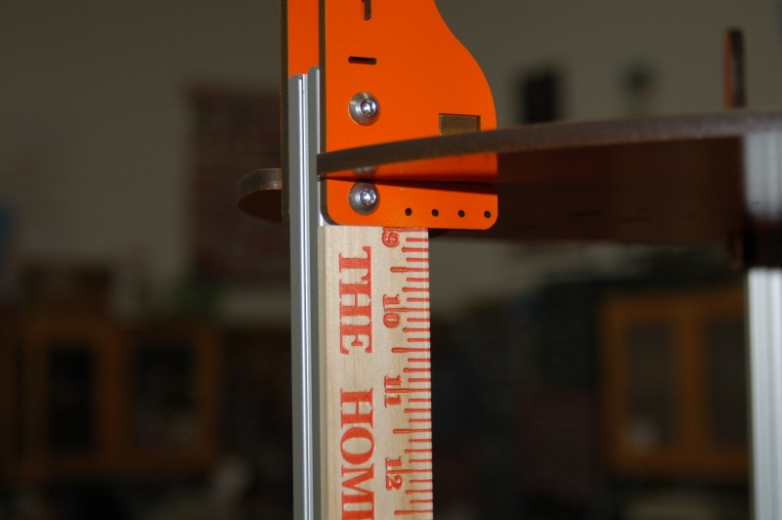Fig. 5-3: Adjusting the Idler Mount height using the height gauge.

As you get each side positioned to the right height, tighten the lower cap screw to hold the Idler Mount in place. You’ll perform this task for all six Idler Mounts.
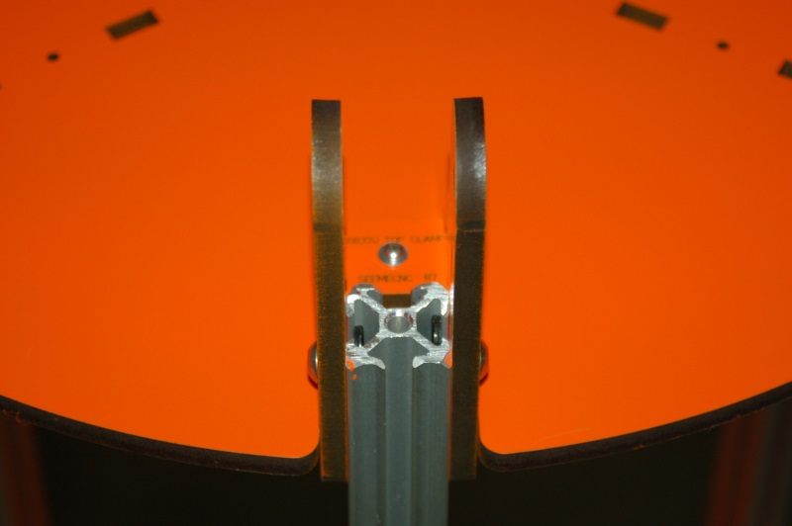Fig 5-4: Idler Mounts at correct height.

When you’ve got all six brackets at the correct height, tighten down all the cap head screws as well as the Top Clamp screw on each Idler Mount assembly.

At this stage, your Rostock MAX should look like the one shown in Fig. 5-5. (Or not, if you’ve got better taste in paint colors than I do!)
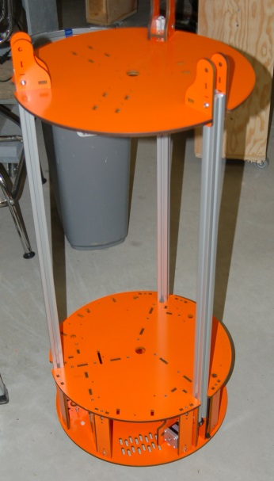Fig. 5-5: Assembly progress so far.

In order to ensure that the machine is properly aligned and squared up, you’ll need to flip it upside down and check each tower extrusion with your framing or machinists square to ensure that the towers are square to the top as well as the bottom of the machine.
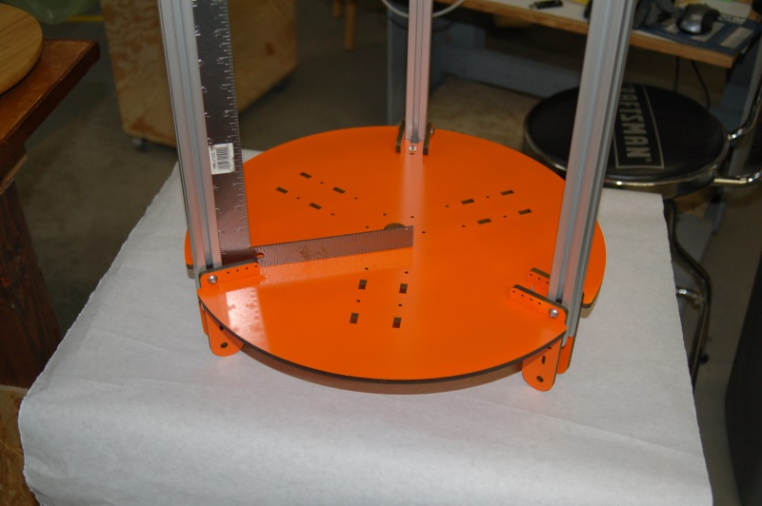Fig. 5-6: Checking the top for square alignment.

If you find one that’s not square, you can use your height gauge to ensure that the Idler Mount doesn’t slide “up” while you’re adjusting the tower extrusion. Also note that just as with the base, you need to ensure that the gap between the inside face of the extrusion and the outside face of the tower notch in the Top Support Plate is the same for each tower location. The gap on the top should match the gap on the bottom – this kind of happens by default when the towers are perfectly square to both the base and top.

6 – Installing the End Stop Wiring, Switches and Idler Bearings
In the box for the RAMBo controller, you’ll find the end stop wiring harnesses. There’s three of them and they consist of a pair of wires (black & white) with crimp-on spade connectors on one end and small crimp-sockets on the other. Note: Under no circumstances should you route the wires for the extruder down the same channel as any of the end-stop switch wires. Do. Not. EVER. The power flowing through the stepper motor wires will cause false triggering of the end-stop electronics and cause erratic printing.
To begin, route the first end stop wires through the bottom of the Top Support Plate at the top of the tower as shown below.
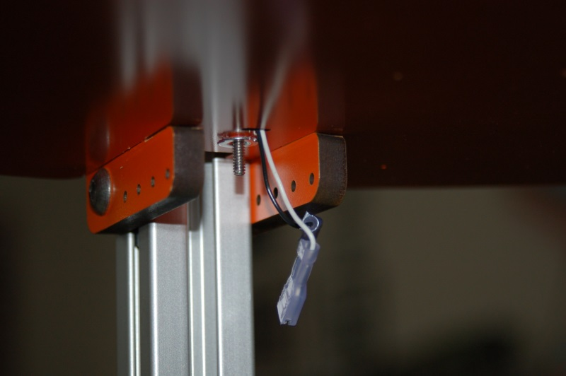Fig. 6-1: Routing the end stop wires, step #1.

Next, route the wire through the side of the Idler Mount:
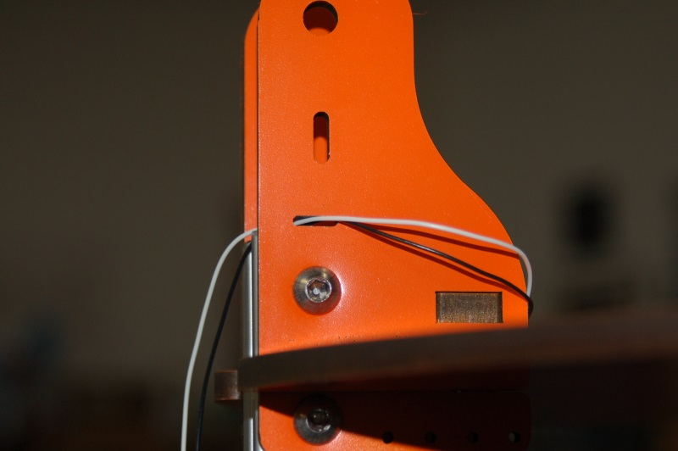Fig. 6-2: Routing the end stop wires, step #2.

Now here comes the tricky part – the end stop wires need to be run down the center channel in the tower extrusion. The simplest method is to take a length of fishing line and use it to “fish” the wires through. You’ll start by tying a simple granny knot around the crimped pins of the end stop wiring:
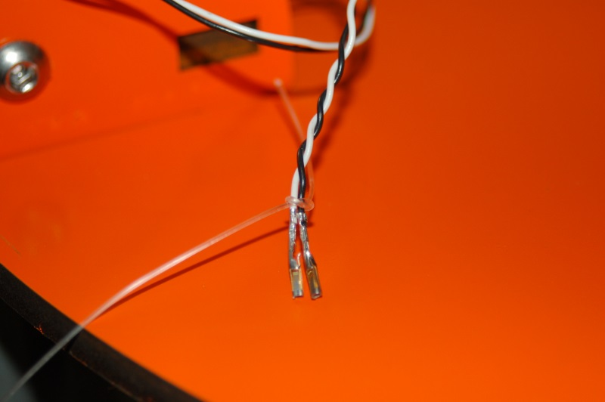Fig. 6-3: Fishing the end stop wires.

Thread the fishing line through the center of the extrusion and make sure it exits to the outside of the idler pulleys. Carefully pull the wires through, and you’ll end up with this view from the top:
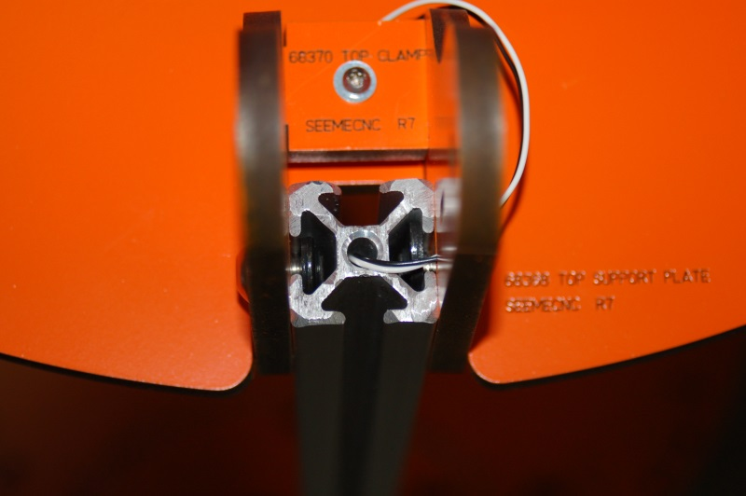Fig. 6-4: End stop wires routed through the tower extrusion. (Step #3)

Now carefully route the end stop wires through the left side of the Tri-Support as shown in Fig. 6-5.
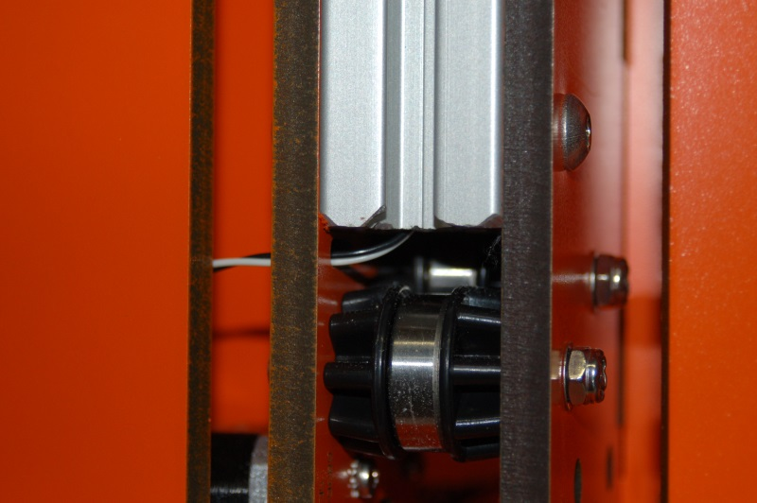Fig. 6-5: Routing the end stop wires through the Tri-Support. (Step #4)

After routing the wiring through the Tri-Support, install the crimped socket connectors in one of the 3 pin connector shells that were included with the RAMBo package.
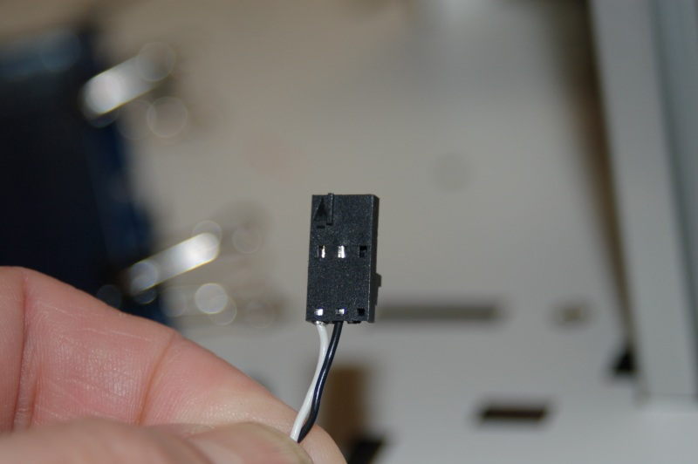Fig. 6-6: End stop wiring connector.

Please pay careful attention to how you assemble the end stop connector. The wires must go in positions #1 and #2 (pin 1 is indicated by the arrow mark that’s in-line with the pin exit). If you put a wire in pin #3, you’ll short out the input on the RAMBo. Note that it doesn't matter which pin uses which color – just make sure you're consistent across all three connectors.
After installing the connector, label the wire for which axis it belongs to and then route it along the same path as the stepper motor wiring so it ends up in the “electronics bay” where you’ll be installing the RAMBo later on.
Now install the end stop wiring for the other two axes.
In order to install the end stop micro switches, you’ll need two #2-56, 5/8” long machine screws and two #2-56 nuts for each switch.
Since the switches are wired as “Normally Closed”, we’ll remove the center, “Normally Open” terminal as it’s just in the way.
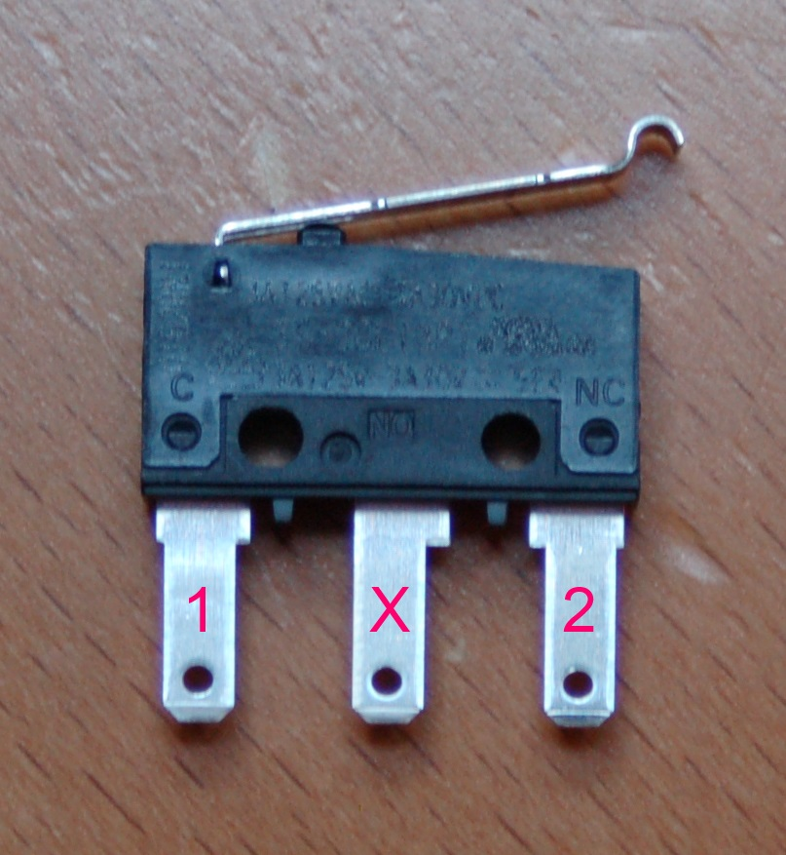Fig. 6-7: End stop switch terminals.

Pin 1 in the photograph above is the “common” terminal, while pin 2 is the “normally closed” terminal. The terminal labeled “X” can be carefully cut free from the switch using a pair of wire cutters.

In order to mount the switch properly, you’re going to have to bend over the two terminals on the switch itself. If you hold the switch flat and then “roll” it upright, you can bend both terminals at the same time and the same amount.
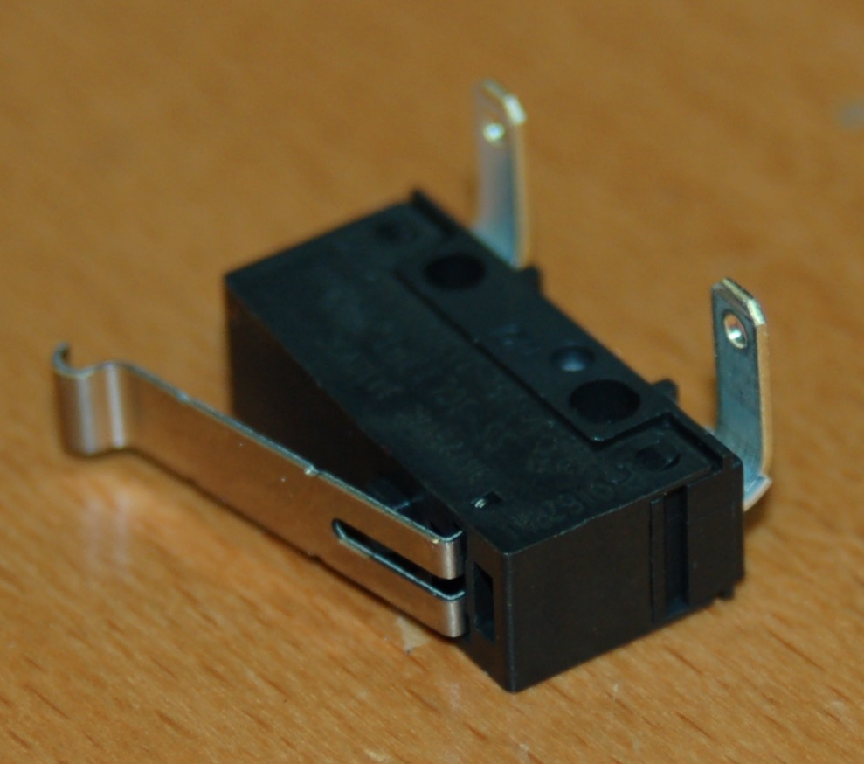Fig. 6-8: End stop switch with the leads bent properly.

Install an end stop switch at each axis as shown below. This is where the forceps come in really handy!
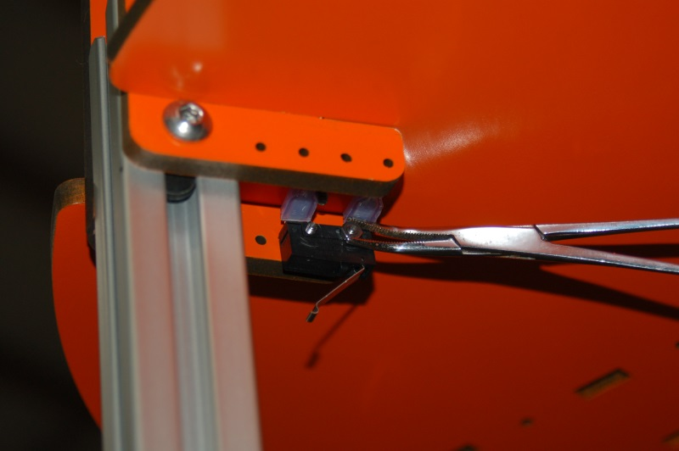Fig. 6-9: Installing the end stop switches.

Take care not to over-tighten the screws. Too much pressure will destroy the switch body. Install the end stop switches on the other two axes. Don’t forget to hook them up! :)
Now that the end stop wiring and switches are handled, it’s time to install the upper idler bearings in the Idler Mounts. For this task, you’ll need three 1.75” long #6-32 pan head screws, six washers, three nylon lock nuts. The bearings require the last six injection molded bearing spacers and three 608 sealed bearings. Just as you built the bearings for the lower idlers, you’ll do the same here.
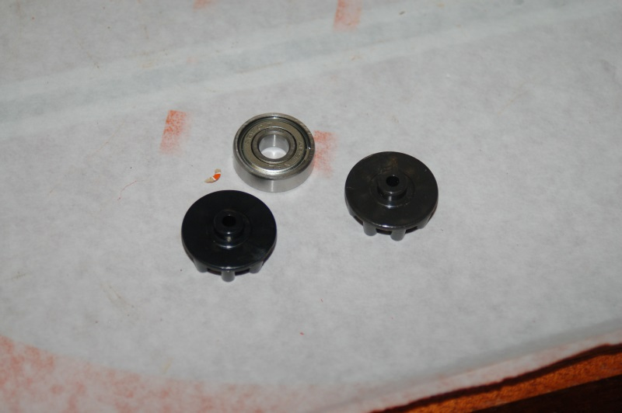Fig. 6-10: Idler bearing parts
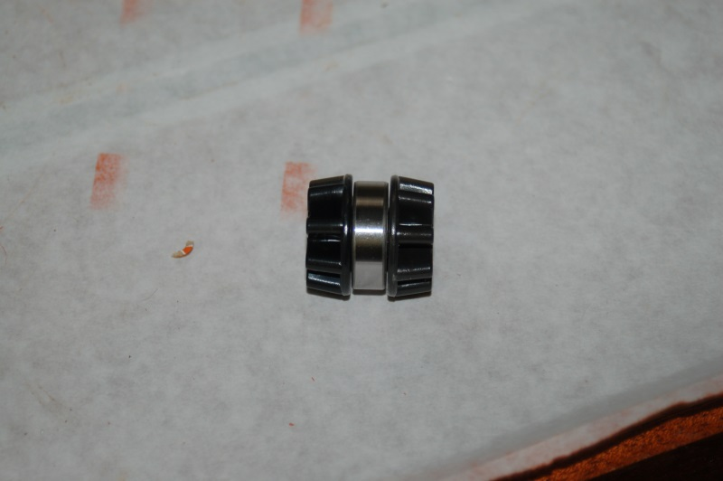Fig. 6-11: Idler bearing assembled.
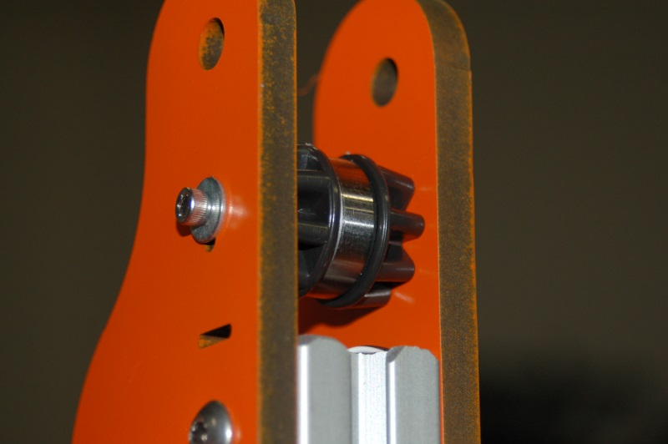Fig. 6-12: Upper idler bearing installed.

When you install the idler bearing, you don’t need to tighten it down just yet. Press the bearing down until the 1.75” screw is resting in the bottom of the tensioner slot on both sides of the Idler Mount. I would strongly recommend you go take a break. The Cheapskate bearing assemblies are next! (Drink a beer, chase the significant other around the living room, etc)

7 – Assembling and Installing the Cheapskate Bearings
Each Cheapskate bearing assembly consists of these melamine parts:
Carriage Plate (P/N: 68343) 1ea.
Arm Plate (P/N: 68344) 1ea.
Axle Support (P/N: 68381) 2ea.
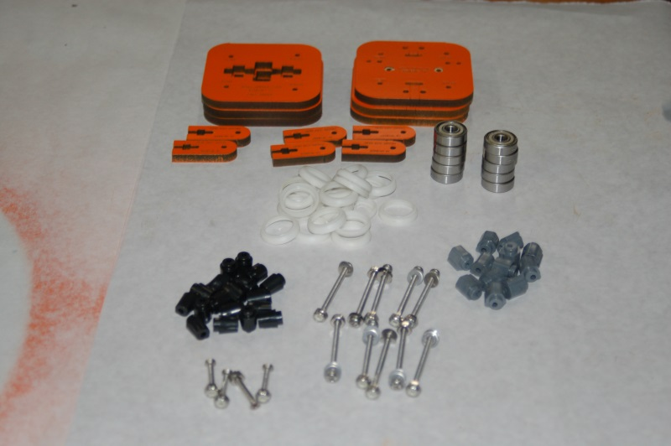Fig. 7-1: Some of the Cheapskate bearing assembly components.

The first thing you need to do is attach the bearing covers to each one of the 608 bearings. In my photos, the bearing covers are white, but chances are pretty good that you’ll get the updated ones made from a black material. The covers just snap over the bearing as shown below.
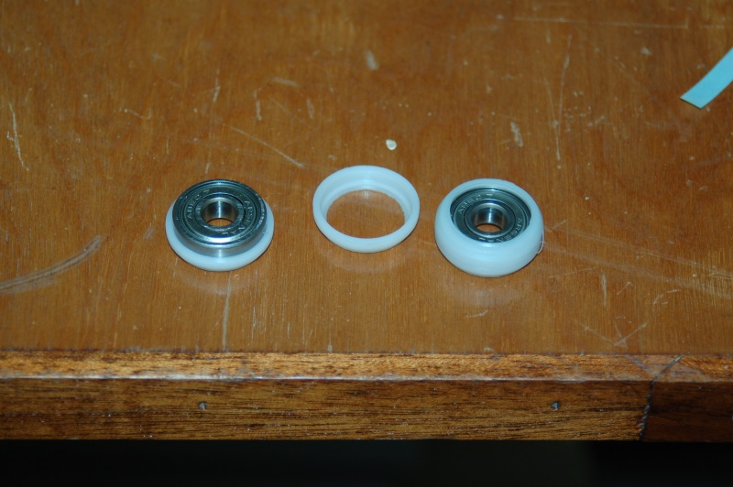Fig. 7-2: Assembling the bearing covers

Once you’ve got the bearing covers taken care of, you’ll now need to prepare the three Carriage U-Joint mounts and u-joints for installation. The screws shown below are from a package of #4 3/8” sheet metal screws. You’ll need six of them to install the u-joint axles in the Carriage U-Joint mount.
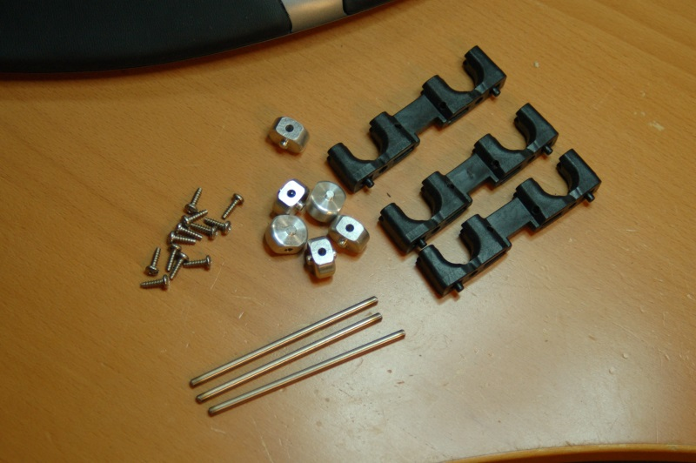 Fig. 7-3: Carriage U-Joint mount parts.

Next comes one of the parts of the Rostock MAX assembly that is frankly, a pain in the ass. The Carriage U-Joint mounts need some sanding in order for the machined aluminum u-joint to fit.
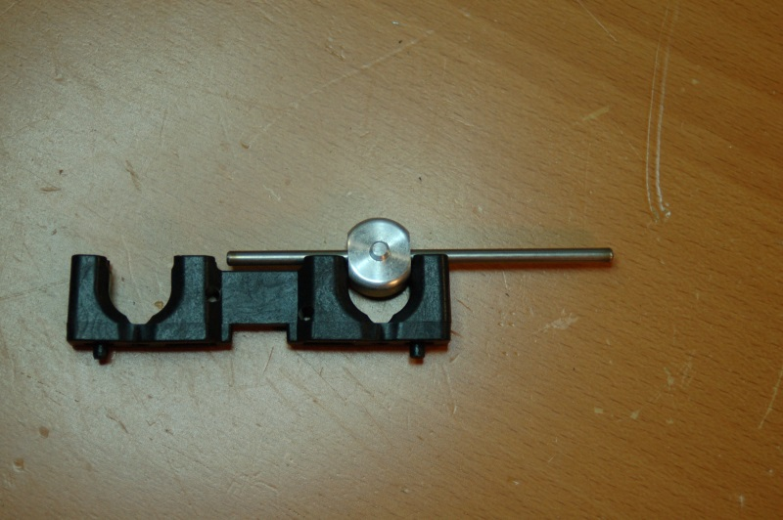Fig. 7-4: Test fitting a u-joint in the Carriage U-Joint mount.

The reason for this is that it’s apparently very difficult to produce injection molded glass-filled nylon parts in the kind of tolerances required for this application. This enjoyable task will be repeated when it comes time to assemble the effector end. Fortunately SeeMeCNC is now shipping the Delta Arms in a machined state, so they should require little if any sanding.

You want to sand the sides of the U-joint mount just enough that the u-joint will spin freely on the axle when in place, but has no side-to-side play. If you over-sand and get side-to-side play, you’ll need to install shims to remove that, otherwise your prints will have tiny, uncorrectable errors in them.
The u-joint needs to pass the “flick test” - where you “flick” the u-joint with your finger, and it’ll spin on the axle for a short period of time. If they stick at all, you’ll need to fix it, otherwise you’ll experience a phenomenon unique to the Rostock MAX, the dreaded Delta Arm Blues! The DAB was coined by the fine folks on the SeeMeCNC forum as a slick way to describe the effects caused by any mechanical friction in the delta arm interconnect system. I’ll cover this in more detail when I discuss calibration and tuning later on.
After you’ve got all three Carriage U-Joint mounts sanded properly, you can install one in each of the Arm Plates (P/N: 68344). Each mount requires 2 #6-32 nylon lock nuts and two #6-32 5/8” socket head screws as shown below.
You may want to add a #6 washer to the back of these when you assemble them. Your choice.
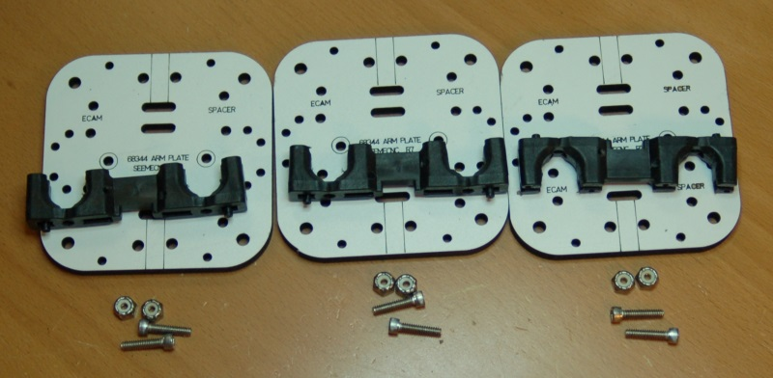Fig. 7-5: Carriage U-Joint mounts and mounting hardware ready to go.
I would recommend that before you install the Carriage U-Joint mount that you install the end stop adjustment screws into each of the Carriage U-Joint mounts. These screws are 2” long #6-32 pan head screws and are threaded into the mounts as shown on the next page.

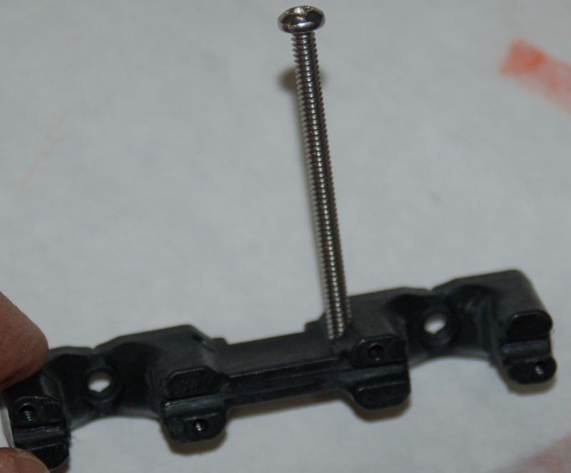Fig. 7-6: End stop adjustment screw installed in the u-joint mount.

The mounts are not threaded, so you’ll need to carefully thread the holes with a #6-32 tap. Take special care that the tap remains square to the hole! You don't want to cut the threads at an angle.
If you don't have a tap, you can drive the screw in to form threads in the glass-filled nylon mount. Drive the screw such that about 1/16” of the end of it sticks out through the other side. Pay careful attention to what hole you insert the screw into. Some mounts may have two holes – you want to install it exactly as shown in Fig. 7-6 in order for it to properly engage the arm on the end stop switch that’s mounted on the Idler Mount.
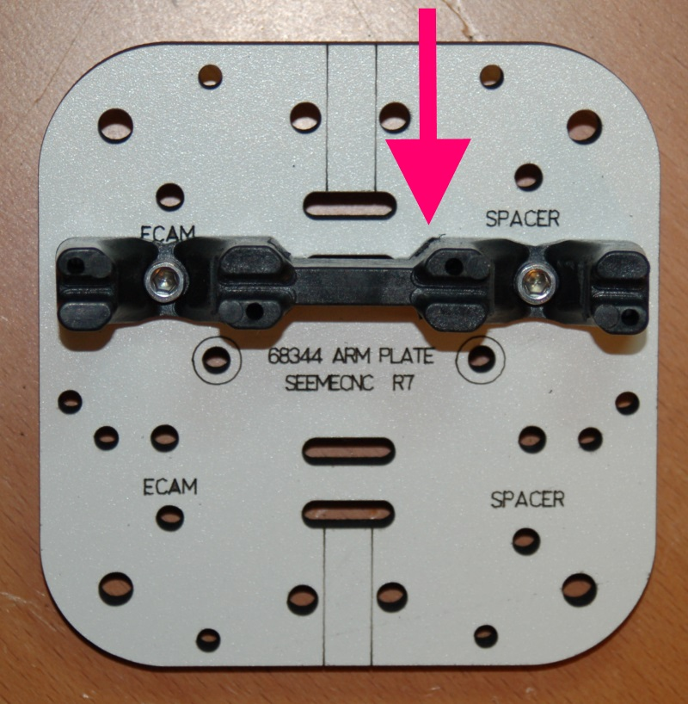Fig. 7-7: Carriage U-Joint mount installed in the arm plate.

In Fig. 7-7 above, you’ll see the mount installed in the correct position. The arrow indicates the location of the end stop adjustment screw.
Next, you’ll install the two u-joints using four 5/8” long, #4 sheet metal screws. After installing the u-joints and the screws are in tight, ensure they still pass the “flick” test. If they don’t, it means that the screws have slightly deformed the notches that the u-joints are installed in. Identify where the contact is happening and lightly sand it until all six of the u-joints can pass the flick test with no side-to-side motion.

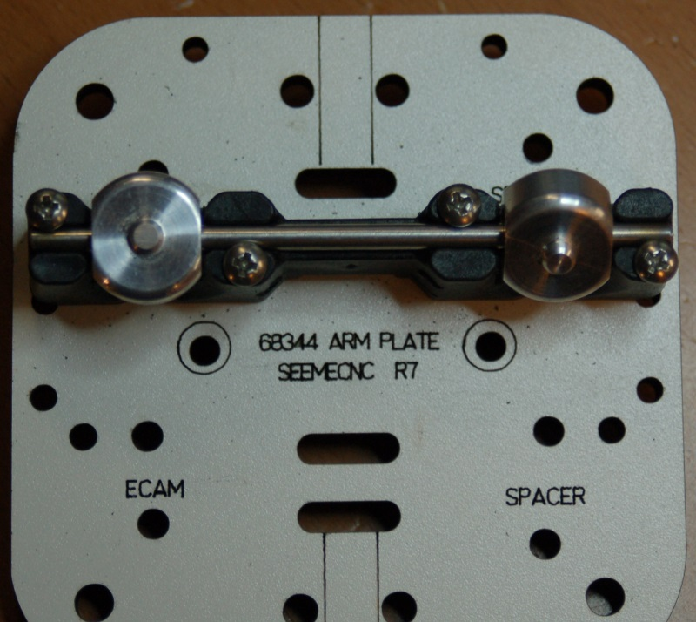Fig. 7-8: U-joints installed in the carriage mount.

Now we’ll go ahead and get the Cheapskates assembled. For this task you’ll need the following materials:
- Four 2” long, #6-32 cap head screws
- Eight #6 washers
- Four #6-32 nylon lock nuts
- Four bearings with covers attached
- Four bearing spacers (black, cone shaped spacers)
- Four eccentric cams (gray, six sided spacers)
- Four #4-40 T-Nuts

First up, we need to install the four #4-40 t-nuts. These parts will hold the belt brackets in place. I highly recommend that you use Superglue to hold them into place. You don’t want to chase them around when it comes time to install the belts.
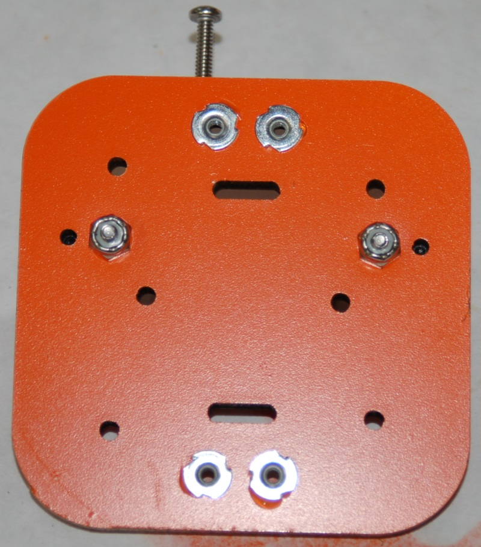Fig. 7-9: Installing the t-nuts for the belt clamps.

Next, we’ll build the spacer “stacks”. You’ll see on the Arm Plates that the holes are marked for the type of “stack” that belongs there.
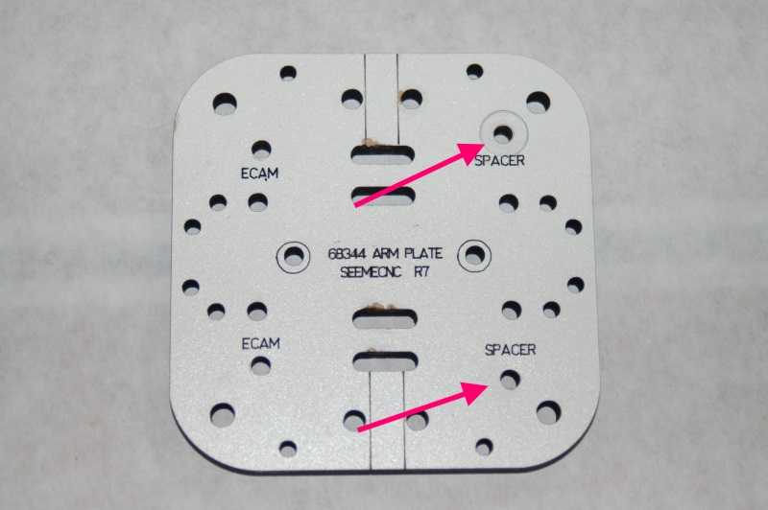Fig. 7-10: Spacer "stack" locations.

I refer to them as “stacks” because they consist of a stack of parts. One spacer, a bearing assembly and another spacer. The next figures will illustrate how the spacer stacks are assembled.
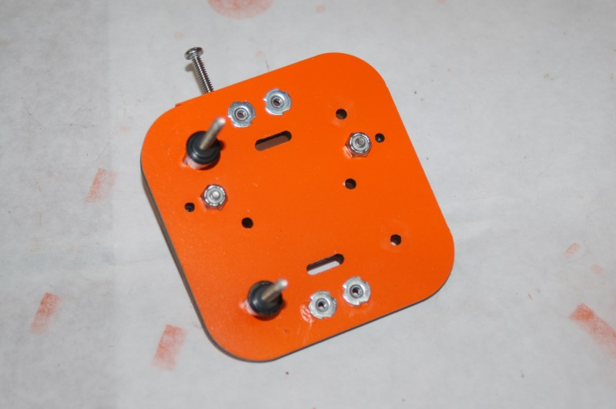Fig. 7-11: The spacer stack begins with a black, conical spacer.

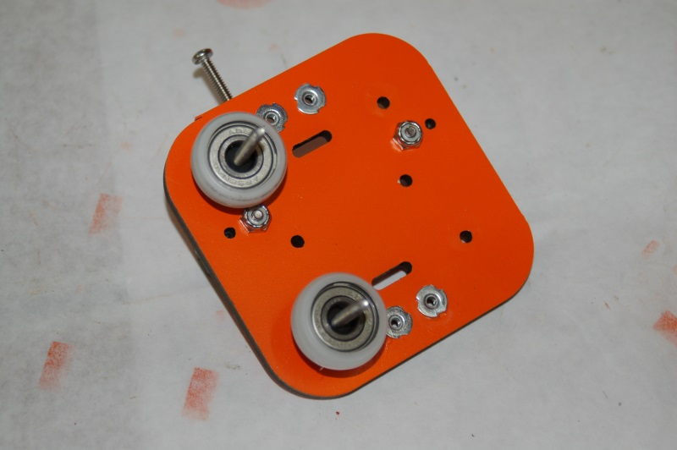Fig. 7-12: Next are the bearing assemblies.

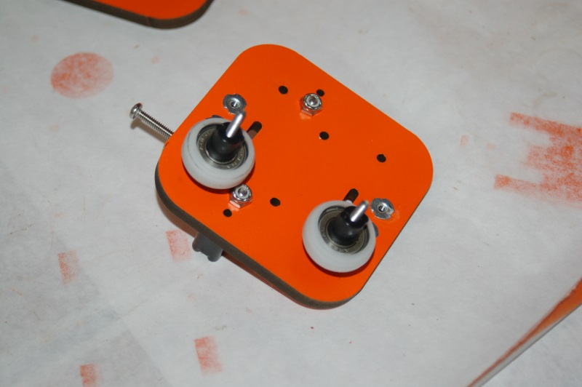Fig. 7-13: Finally, add two more conic shaped spacers as shown.

Now you’ll want to add one of the Carriage Plates to this – take care to ensure that you’re aligning the holes marked “SPACER” in the Carriage Plate with the screws you’ve built the spacer stacks on.
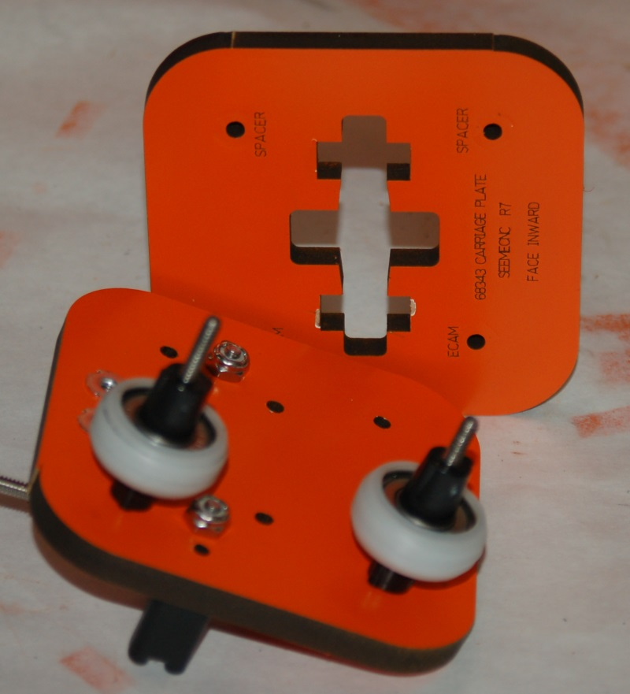Fig. 7-14: Carriage Plate showing the spacer mounting holes.
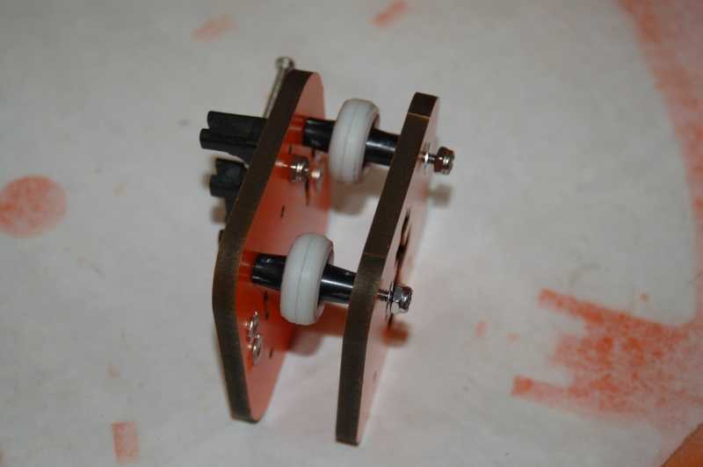Fig. 7-15: Carriage Plate attached.

You’ll note that they’re attached loosely – this is done in order to allow the Cheapskate assembly to be set on the tower extrusion without striking the nylon lock nuts that are holding the u-joint mount in place.
Now you’ll need to position the Cheapskate on the tower extrusion as shown below. You’ll be installing the bearings with the gray plastic eccentric cams next.
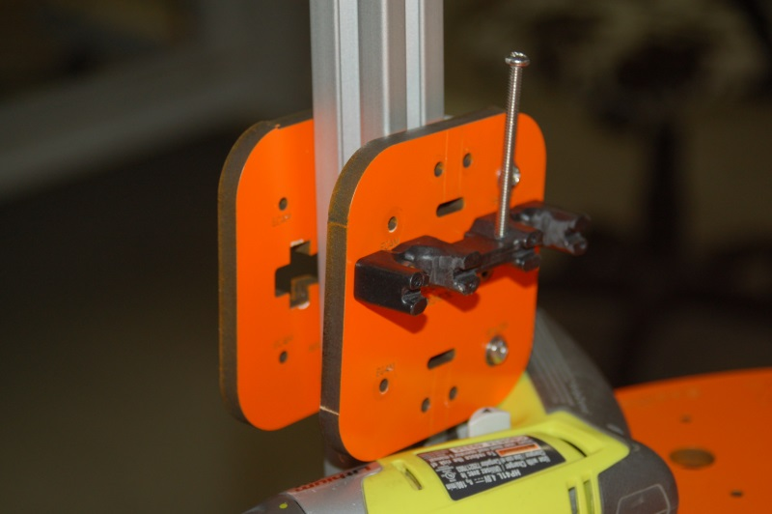Fig. 7-16: Cheapskate resting on the tower extrusion.

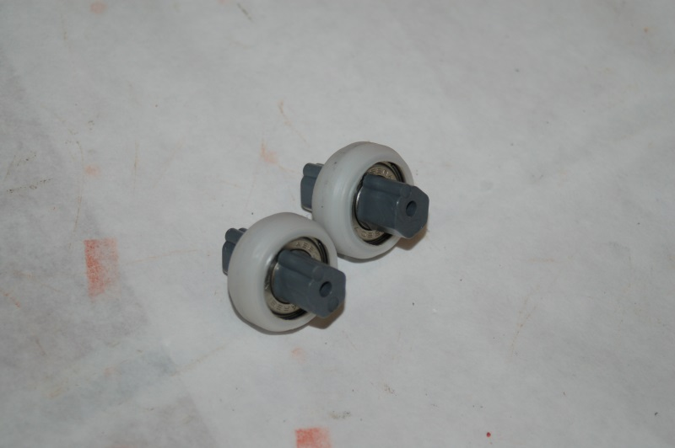Fig. 7-17: Bearing assemblies with eccentric cams in place

The eccentric cams are used to tighten the “grip” of the bearings on the tower extrusion. This allows you to adjust the completed Cheapskate to fit the tower precisely and with no “slop”.
The eccentric cam has a ridge that indicates the “narrow” point of the cam shape. When you install the eccentric cams into the bearings, make sure you line the ridges up as shown above.

When installing the eccentric cam & bearings into the Cheapskate, make sure that the ridge is facing the tower extrusion as illustrated below.
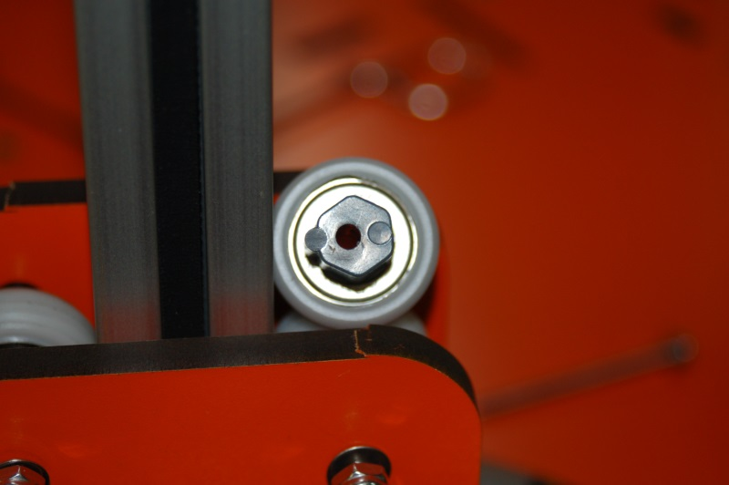Fig. 7-18: Correct orientation of the eccentric cam prior to installation.

Install the two bearing assemblies as shown below. Make sure that you tighten the screws that hold the bearings in place BEFORE you start your adjustment procedure!
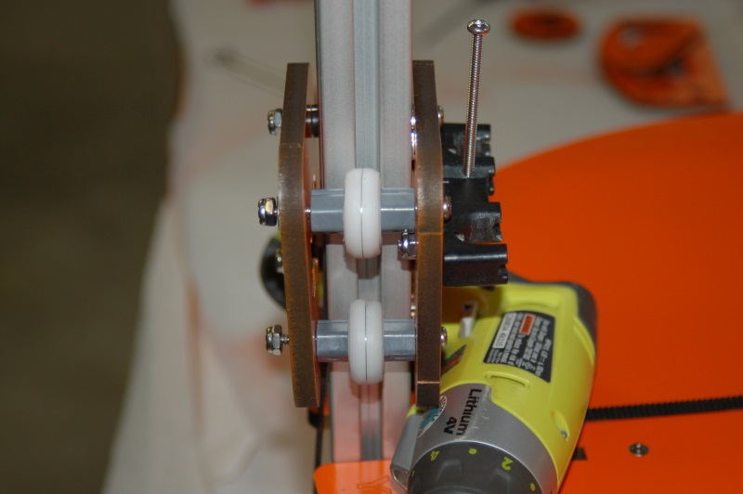Fig. 7-19: Eccentric bearings installed.

With the eccentric bearings installed, use a 7/16” open end wrench to adjust the distance of the bearings to the tower extrusion. When you adjust the cam on one side, they should both move the same amount. If they don’t, you should use two wrenches to keep the eccentric cams “in sync”.
This short video illustrates how the Cheapskates should operate when correctly adjusted.
http://www.youtube.com/watch?v=5LCHGMivJeE
Now you need to install the Axle Supports (P/N: 68381). You’ll need two melamine Axle Supports, one 2” long, #6-32 screw, two #6 washers, one #6-32 nylon lock nut, two conical spacers, and one bearing assembly for each of the three required Axle Support assemblies. You’ll also need two #6-32 nylon lock nuts and two 1” long #6-32 flat head screws to install each Axle Support into the Cheapskate bearing assembly.
Please check each melamine part to ensure that it fits properly in the mounting notches in the Cheapskate Carriage Plate (P/N: 68343). I’ve found that while most of them fit properly, one or two are just a tiny bit too large to fit without a lot of friction. Sand them down evenly on each contact side until they fit properly. You want a fit that is snug, but not one that’s so tight that you have to break out the hammer to make it fit. Please check the fit of each Axle Support to make sure that it won't bind when you finish assembling them.
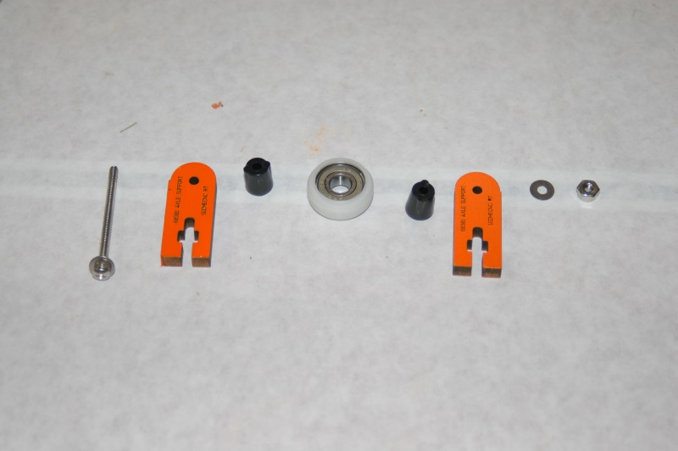Fig. 7-20: Required parts for the Axle Support assemblies.

The next set of figures illustrates the assembly order for each Axle Support.
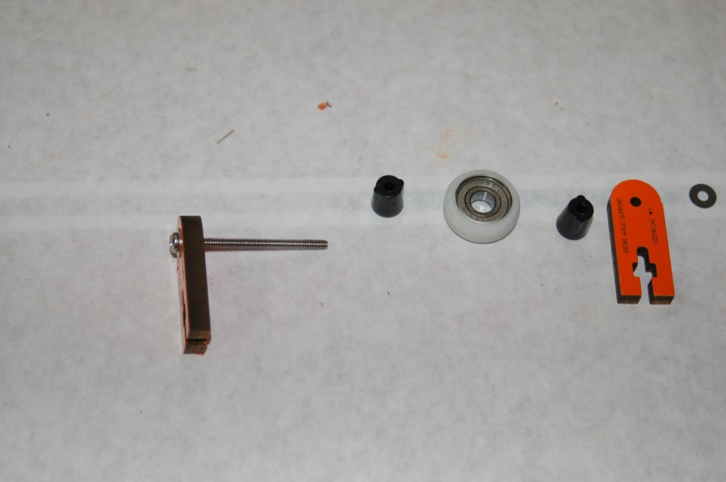Fig. 7-21: Insert screw with a washer into the melamine Axle Support

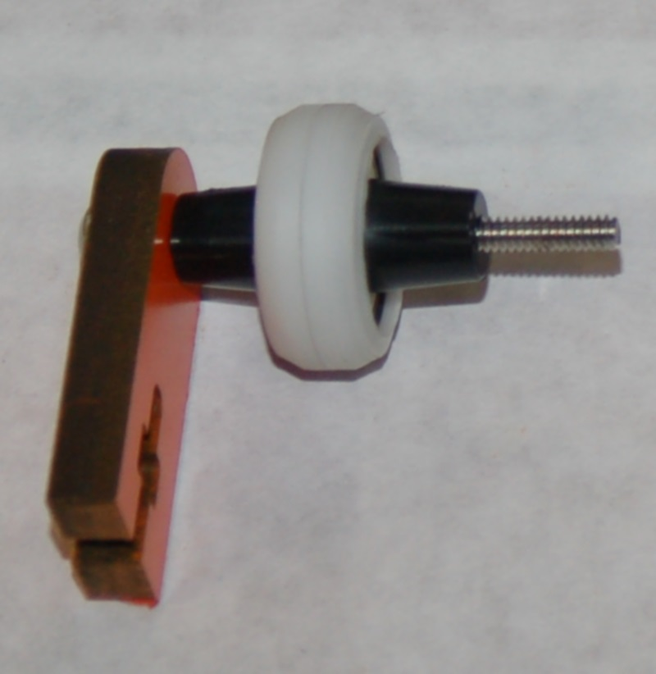Fig. 7-22: Install two conical spacers and a bearing assembly.

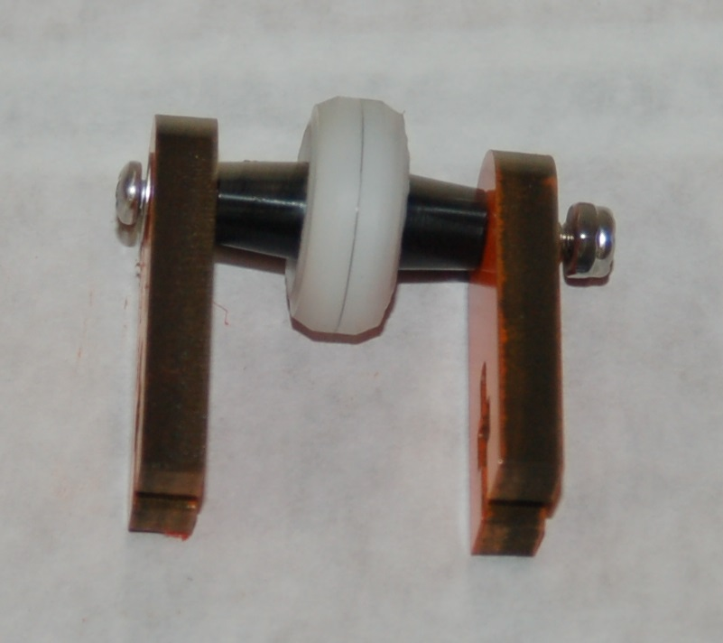Fig. 7-23: Next, install the remaining Axle Support, a washer and a #6-32 nylon lock nut.

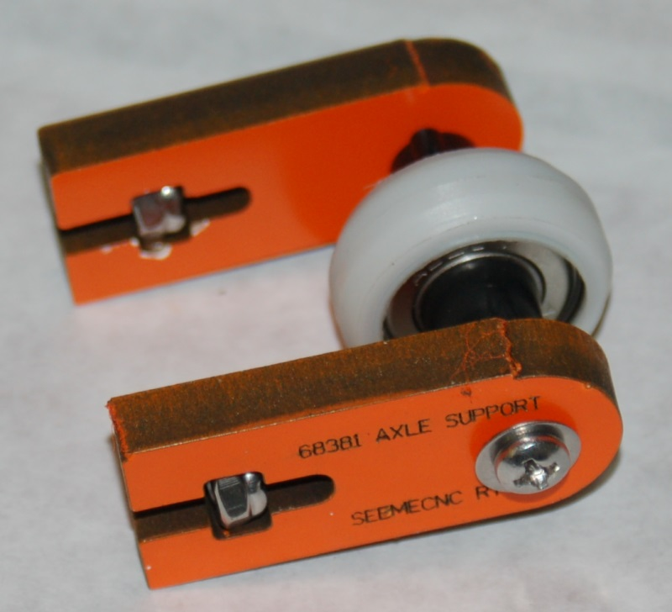Fig. 7-24: Completed Axle Support assembly.

Finally, insert the #6-32 nylon lock nuts into the square nut capture pockets as shown above.
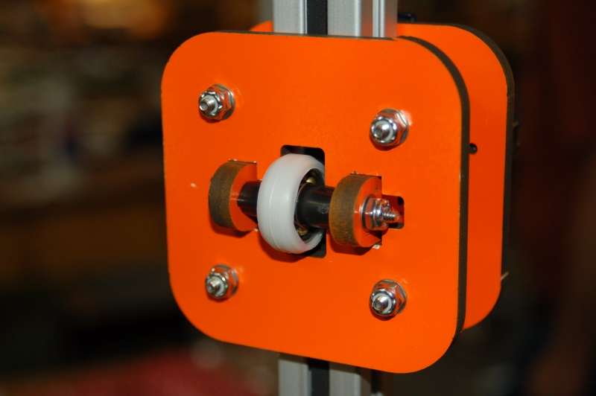Fig. 7-25: Axle Support installed in the Cheapskate bearing assembly.

The Axle Support assembly is fitted into the back of the Cheapskate bearing as shown in Fig. 7-25. You may want to loosen the axle screw a bit in order to give yourself a bit more “wiggle” room when installing it.

The retaining screws for the Axle Support fit through the face of the Arm Plate as shown below.
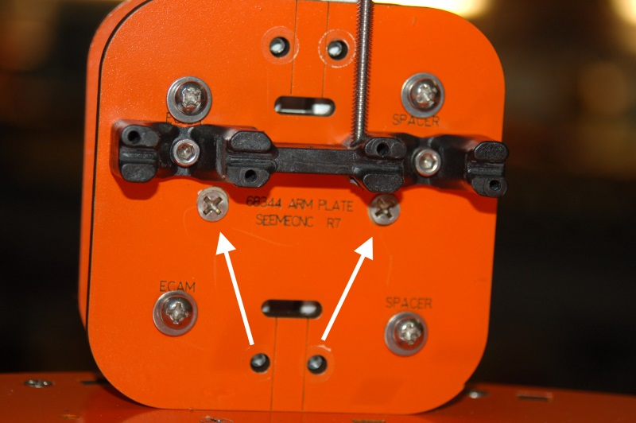Fig. 2-26: Axle Support retaining screws.

When tightening the retaining screws, make sure you tighten them evenly in order to avoid “canting” the Axle Support. Only tighten them enough to cause the bearing to get good contact with the back of the tower extrusion. You don’t want it so tight that it interferes with the smooth motion of the Cheapskate assembly.
When the upper and lower bearings are adjusted properly, the Cheapskate should slide freely along the tower extrusion and should not bind at any point in its travel. Attempt to “rotate” the Cheapskate by gripping the back of the Cheapskate as shown in Fig. 2-27 and attempt to turn it.
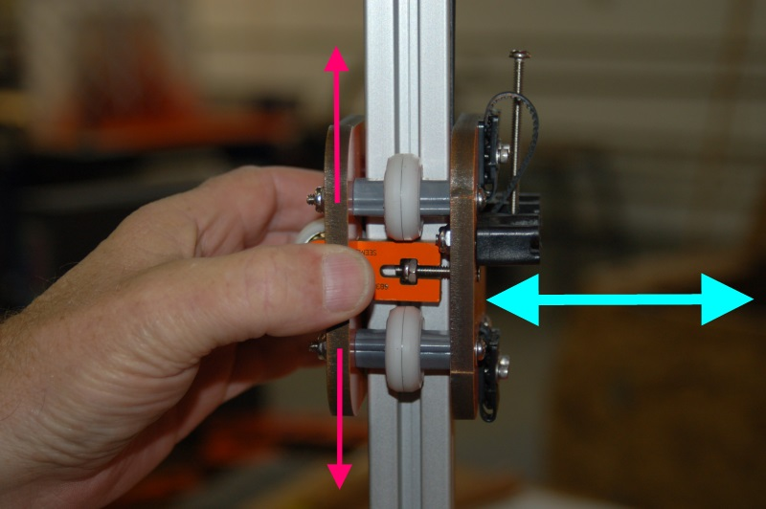Fig. 7-27: Testing the Cheapskate for proper bearing tension.

The pink arrows indicate a rotation motion that results in your thumb moving up and down. The cyan colored arrow indicates a rotation motion that results in your thumb turning away from you and toward you. If the Cheapskate has any motion along the cyan arrow, the Axle Support can be adjusted to remove this motion. Correct adjustment will have been achieved when the only motion the Cheapskate has is purely up and down along the tower extrusion. It should have no motion along any other axis.
It is important to note that you want the Cheapskate assembly gripping the extrusion only tight enough to keep it from moving improperly. It shouldn't be loose enough to move laterally or rotationally as shown previously. Correct tension has been achieved when lateral and rotational movement have been adjusted out AND the Cheapskate falls quickly and smoothly when raised to the top of the tower and dropped. Do NOT let it strike the machine base – catch the stupid thing so it doesn't do any damage. [It annoys me that I have to put an explicit warning about that, but I just know someone will let it hit and then squall about me not telling them not to let it happen...]

Complete these steps for the remaining two Cheapskate bearing assemblies.

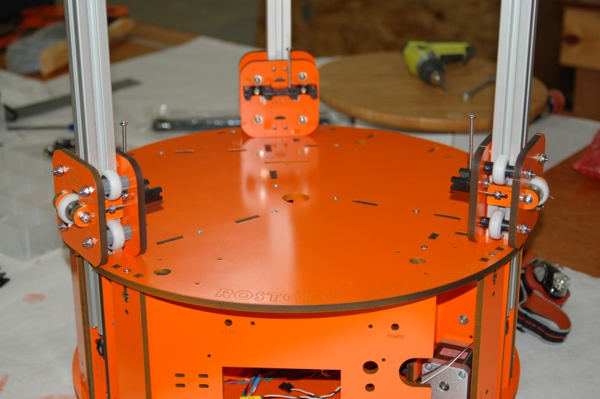Fig. 7-28: Cheapskate bearings installed!

8 – Installing the Belts
For this step, you’ll need one of the three drive belts and a pair of forceps. You’ll also need two belt clamps and four 1/2” #4-40 socket head machine screws in order to attach the belt ends to the Cheapskate.
The figures 8-2 and 8-3 below show the belt path at the top and at the bottom of the Rostock MAX. Each tower gets a single belt with the teeth of the belt facing the center of the tower extrusion.
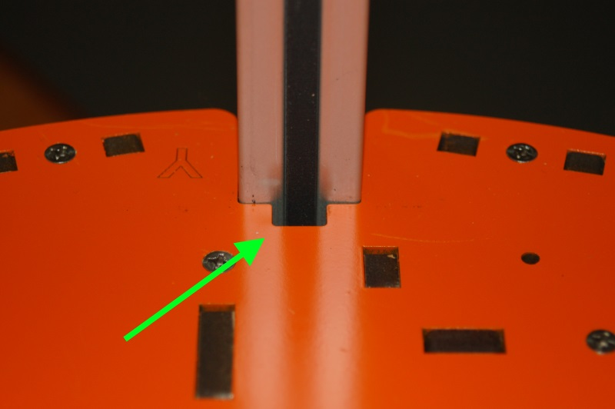Fig. 8-1: Entry point for the belt routing task.

.

Insert the belt through the notch at the base of the tower as shown above. Please ensure that the belt teeth are facing the center of the tower extrusion or the gear on the stepper motor will not be able to engage the belt. Tape the end of the belt about mid-way up the tower until you’re ready to attach it to the bottom of the Cheapskate.
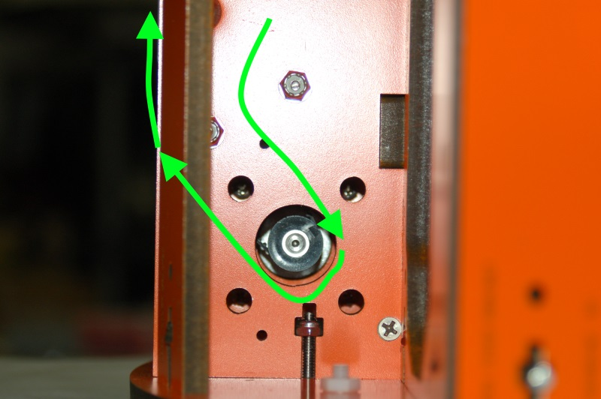Fig. 8-2: Routing the belt around the stepper motor gear.

Route the belt around the gear as shown in Fig. 8-2. Note that the belt path takes the belt between the two idler pulleys on the way down towards the gear, and on the outside of the outer idler bearing as it travels up the tower toward the Idler Mount at the top of the Rostock MAX.
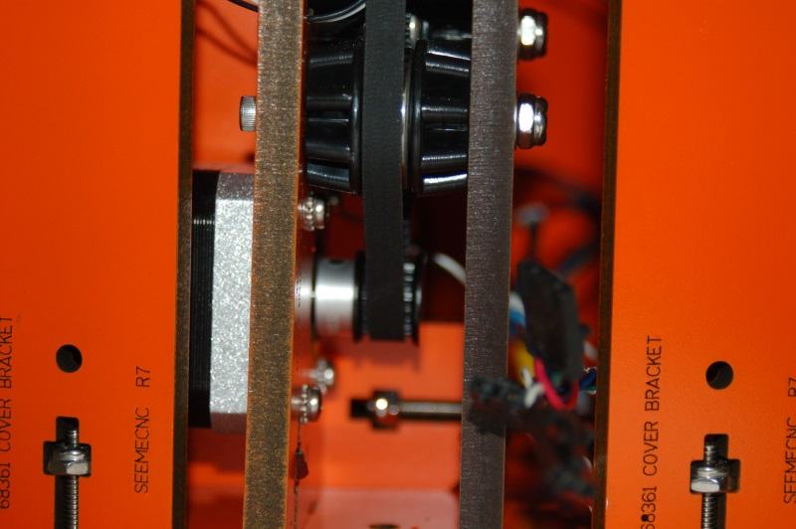Fig. 8-2.1: Lower belt path.

The figure above shows the belt as it passes over the drive gear and up over the outer idler bearing.
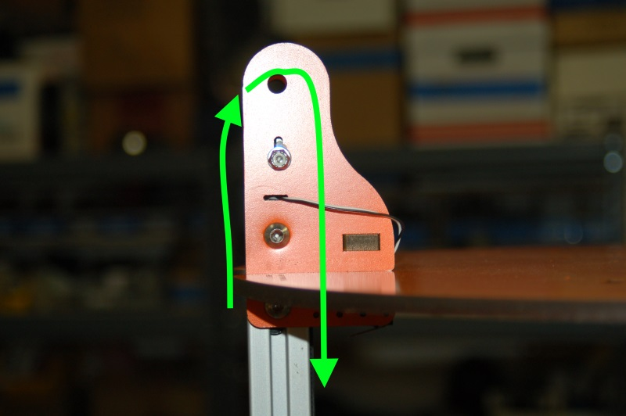Fig. 8-3: Belt path as it goes over the upper idler pulley.

Now that you’ve got the belt routed, let’s get it attached to the Cheapskate!
Before I outline the “traditional” method of getting the belts installed, I wanted to show you a slick method that Dan Barrans over at the SeeMeCNC Forum came up with.

Dan’s process goes like this:
1) Cut a strip of flat plastic narrow enough to fit in the slot in the rail.
2) Push the strip into the belt slot far enough to stick out above the carriage.
3) Grab the top end of the plastic. You'll need to use a toothpick or something else sharp enough to get behind it.
4) Thread the belt between the plastic strip and the back of the carriage.
5) Hold the belt and strip together with your thumb and finger, pushing them both down a bit to open up enough space in the slot for the belt to fit through.
6) Push the belt and strip through the slot enough so you can grab the belt from the front.

Here’s a picture of how this works:
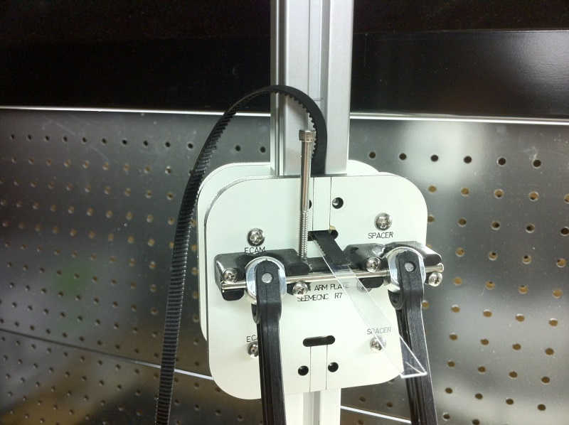Routing the belt on a plastic "ramp".

As you can see, this is a pretty slick method of getting the belts installed Dan says that it takes very little time and is easy to accomplish. Many thanks to Dan for allowing me to include his tip in this assembly guide!

If you’re interested, the link that contains the discussion about his mounting method is here:
http://forum.seemecnc.com/viewtopic.php?f=42&t=1590

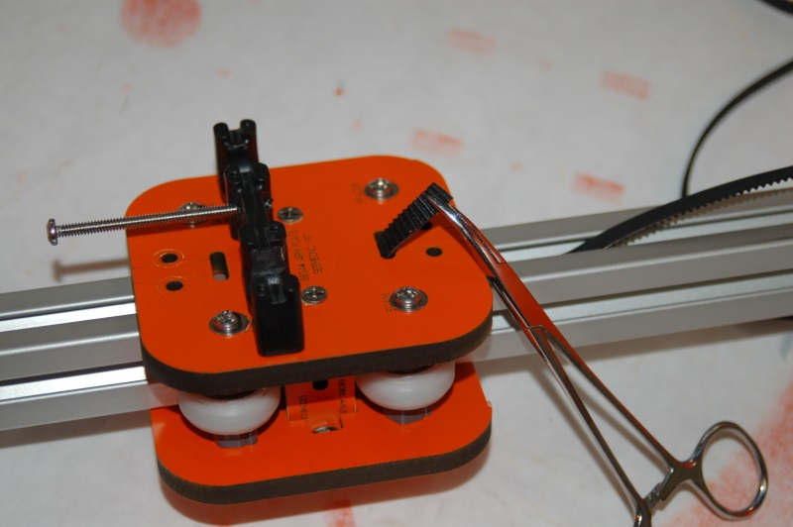Fig. 8-4: Pulling the belt through with forceps.

This task is deceptively simple. If you slide the belt end under the Cheapskate with it oriented vertically, you can reach through the slot with small forceps and easily grab the belt end and pull it through.
Now grab one of the belt clamps and fold it in half as shown below.
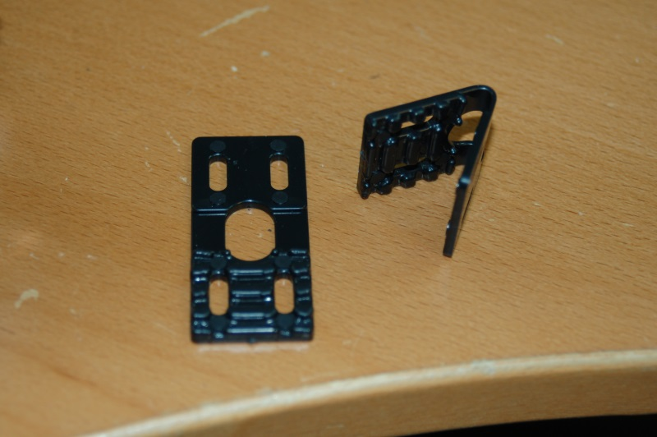Fig. 8-5: Belt clamp.

Hold the clamp in your right hand with the “teeth” of the clamp facing down and the oval “mouth” of the clamp pointing to the left. Slide the belt end through the oval with the teeth facing up – they’ll lock into the teeth in the clamp. Push the belt through until it’s even with the outside edge of the clamp and using two 1/2”, #4-40 socket head screws, install it as shown in Fig. 8-6.
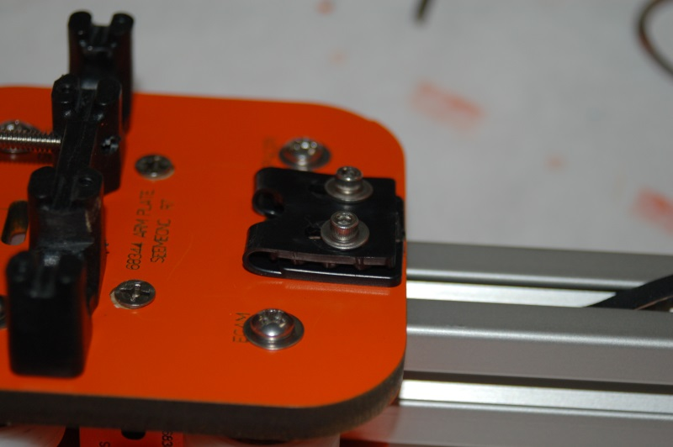Fig. 8-6: Lower belt clamp installed.

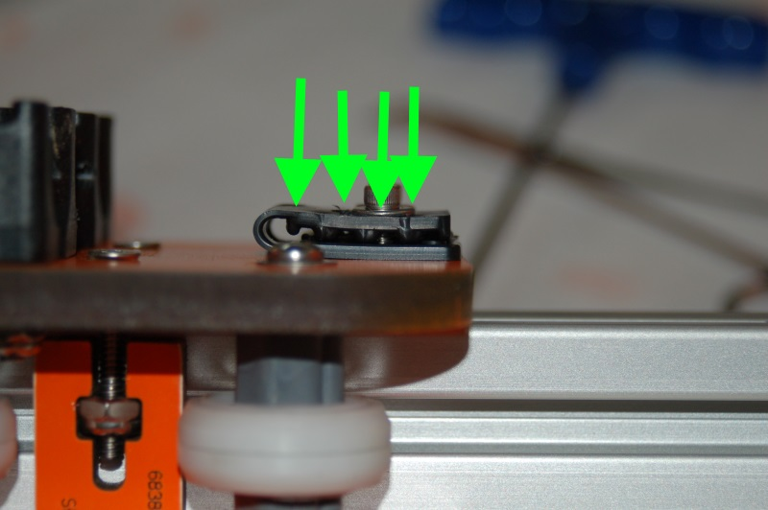Fig. 8-7: Belt clamp installed. Arrows indicate direction of teeth in the clamp.

Perform the same procedure on the upper belt clamp as shown below – if you’ve got enough “extra” belt, just loop it down under the u-joint carriage to get it out of the way. If there’s not enough to do this, fold the tail of the belt in half and tape it together. You don’t want the belt interfering with the end stop switch. Try to take out as much slack as you can when you attach the upper belt clip. It’ll give you more “room” to work with when it comes time to adjust the tension in the belts.
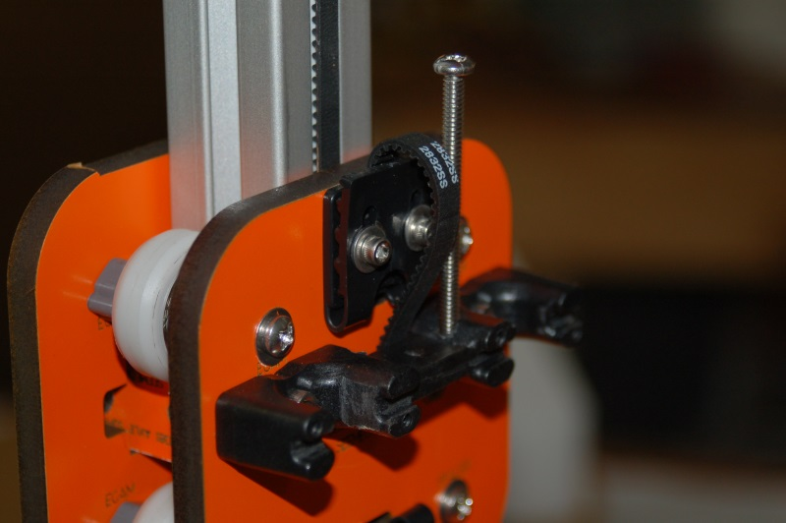Fig. 8-8: Upper belt clamp installed.

Repeat this process for the other two Cheapskates.
Once you’ve got all three belts installed, you’ll need to get them tensioned. The mounting screw for the idler pulley on the Idler Mount is in a slot for a reason. This slot is used to adjust the belt tension to ensure smooth operation of each axis.
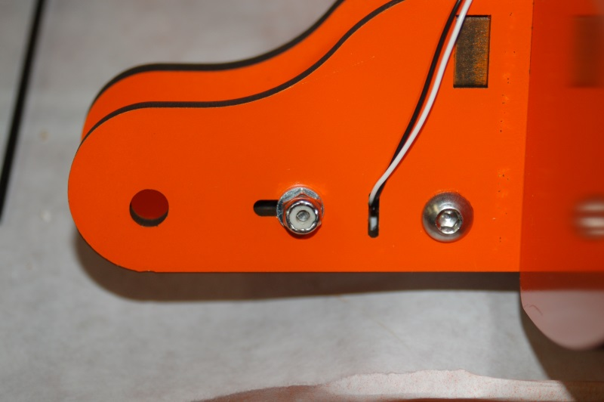Fig. 8-9: The belt tension adjustment.

In order to adjust the tension on the belt, you need to move the idler pulley such that it’s farther away from the base – higher in the slot as it were. This task can be done easily, if a bit awkwardly by a single person.
Place the Rostock MAX on a table that allows your eye level to be above the top plate of the machine. Insert a screwdriver diagonally under the idler bearing as shown below:
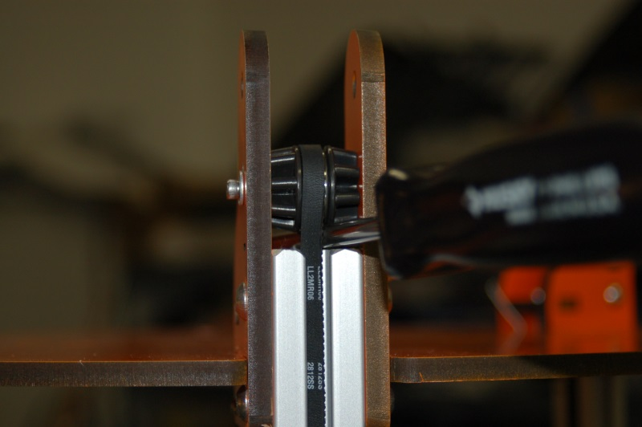Fig. 8-10: Using a screwdriver as a lever.

Tighten the idler pulley screw just enough so that it begins to grip the side of the Idler Mount. Press down on the end of the screwdriver until the center line of the idler pulley screw is in the center of the travel allowed by the slot it passes through. Once you’ve reached that point, tighten the screw down to lock it in place. Do NOT tighten it down too much! The small area of the washer can compress the melamine in such a way that it begins to collapse and form a “cup” as the washer is drawn through it. Keep a careful eye on how “level” the idler pulley screw is. If it tilts to either side of the Idler Mount, the belt will rub against the “high” side.
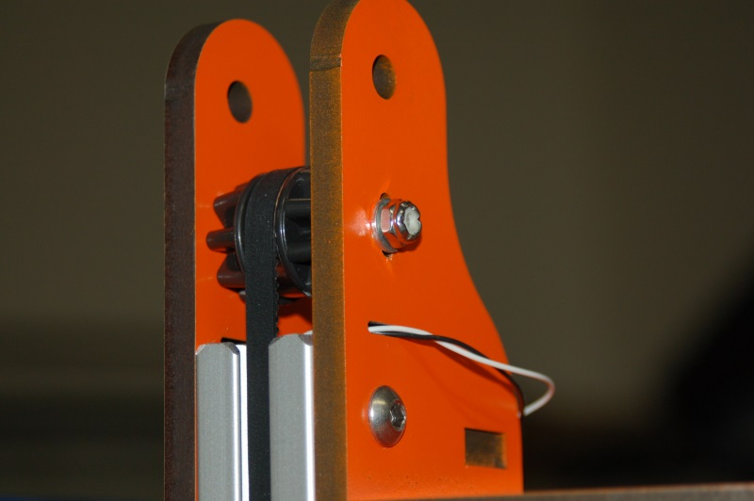Fig. 8-11: Screw at center point of adjustment travel.

There is no measurable “ideal” belt tension that I’m aware of. The rule of thumb to go by is to adjust the belts such that they’re tight enough to not skip on the drive gear and not have any “slack”, but not so tight that it creates a bunch of drag on the stepper motor. Play with it a bit and go with your instinct on it. I wish I had a better way of doing this, but until some guy with a LOT more brain power than I have comes along, this is what we’ve got to work with.

9 – Assembling the Effector Platform
For this step, you’ll need the three remaining short steel rods, the two Effector Platform halves (P/N: 68304) and six u-joints (P/N: 68309). You’ll also need 12 1/4” long #4 sheet metal screws in order to complete the assembly.
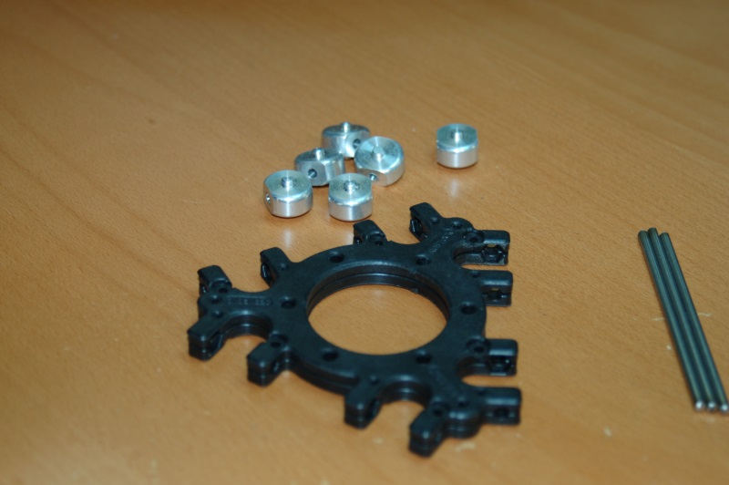Fig. 9-1: Effector Platform Components.

Assemble the platform and start test fitting the u-joints. Make sure you have the u-joint aligned by holding it in place with the steel rod.
The u-joint mounts in platform are made slightly under-sized in order to guarantee a precise fit. Unfortunately, this means that in order for the u-joints to move freely, you’ll need to perform the same sanding/filing task that you did to the u-joint mounts that are mounted to the Cheapskate bearings.
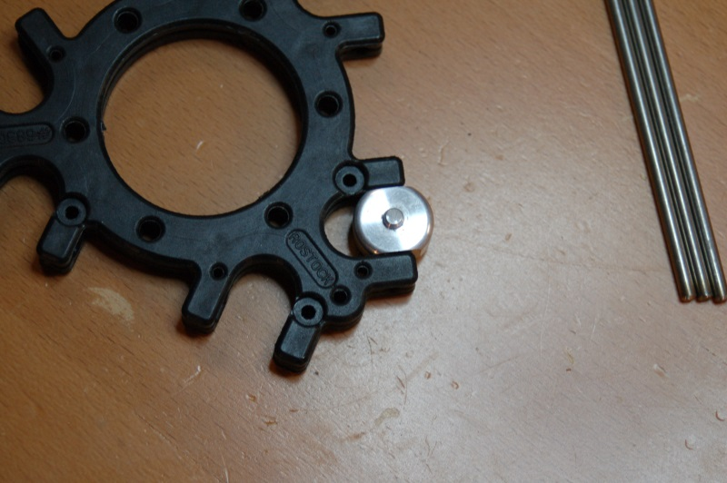Fig. 9-2: Test fitting a u-joint.
As with the carriage mount, you want to ensure that the u-joint has no side-to-side play along the steel shaft when it’s installed in the Effector Platform. Note that when you put the 1/4” #4 screws into the platform, the contact area around the screw will bulge a tiny amount. This will cause the platform to grip the sides of the u-joint near where the screws are. To avoid this issue, assemble the platform using the screws as a final check of each u-joint “pocket” and file or sand in order to be able to pass the same “flick test” you performed on the Cheapskate u-joints.

Please take your time with this sanding process. If you take off too much material, you’ll need to make shims to prevent any lateral play in the u-joint. Lateral motion along the steel support rod will cause your prints to be inaccurate and it will drive you madder than a box of frogs.
When installing the screws, take care to not over-tighten them. The thread on the screw is pretty coarse, but the platform material is soft and won’t take much abuse. You want to avoid a stripped screw hole!
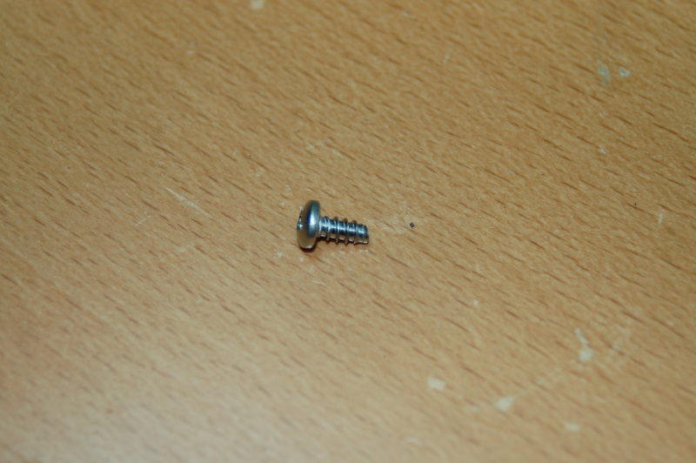Fig. 9-3: 1/4" #4 Sheet Metal Screw.

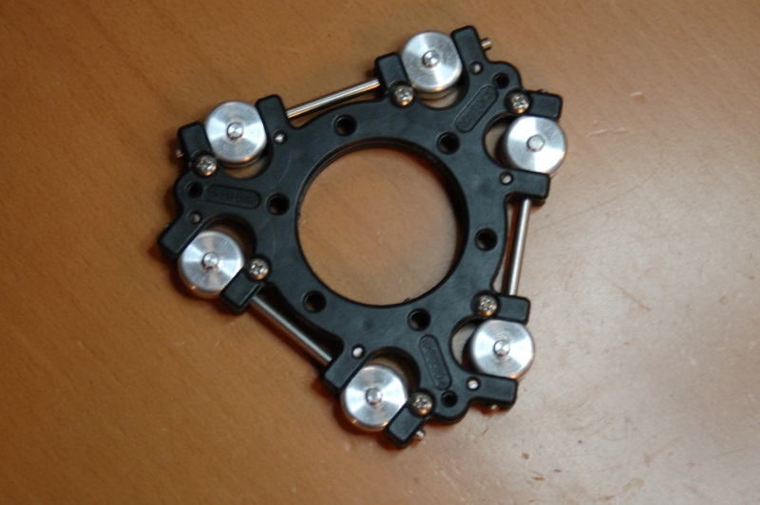Fig. 9-4: Assembled Effector Platform

10 – Attaching the Delta Arms
For this step, you’ll need the six Parallel Delta Arms (P/N: 68303).
In the original release of the Rostock MAX kit, the delta arms needed a lot of work before you could install them. Like the carriage and effector u-joint mounts, they grip the u-joints way too much. This friction causes no end of really odd print issues. In order to help reduced the work required to fit the arms, SeeMeCNC has begun to perform these post-production sanding steps for you. However, even though the arms come machined to a better fit, they’re still going to grip the u-joints too tightly. The good news is that they require very little sanding or filing in order to make them fit properly!
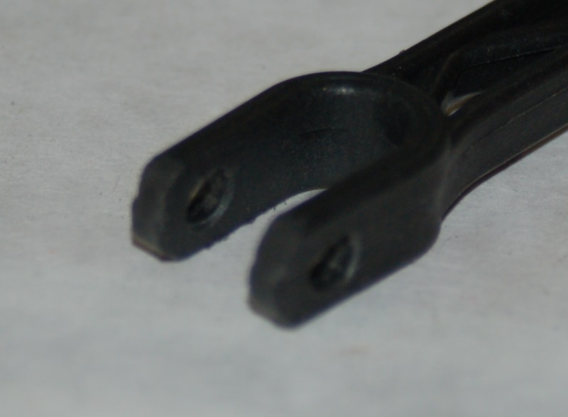Fig. 10-1: Pre-processed Delta Arm end.

I recommend using the Effector Platform assembly as the test fixture for testing the u-joint fit for all six arms. As you get the both ends of one adjusted, just leave it in place and move on to the next u-joint for testing. Installing the delta arms is very easy – they just “twist” on to the u-joint. Note that getting them off again can be problematic. Use a thin flat bladed screwdriver or your thumbnail to pry one side of the arm off the u-joint as you twist the arm. It should come off easily. You CAN break them, but it’s pretty hard to do. [Yes, I broke one.]

If you've gotten a Rostock MAX kit produced after September 9th, 2013, you'll have the updated delta arms:
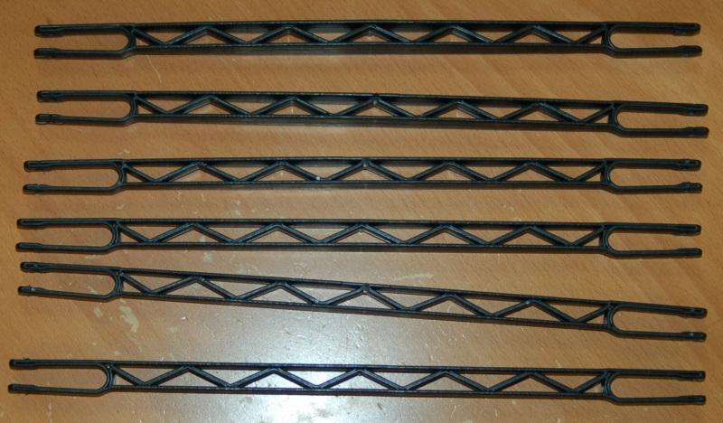Fig: 10-1a: Updated Delta Arm Design

This new delta arm design is much more rigid than the original design and they require NO sanding at all! They're also very easy to install and remove, with no danger of breaking them. The new design for the ends means that they inherently have the correct grip on the u-joints. It may seem a tiny bit stiff, but they're ok. If they appear to grip the u-joint too tightly, make sure that there's no mold flashing that could cause binding. If you feel they're still too tight after removing any problematic flashing, please contact SeeMeCNC support and let them know what you're experiencing and ask their advice.
You want the arm to grip the u-joint loosely enough that it will fall under its own weight when you lift it up. Just like the u-joint mounts, you want to make sure that you don’t remove so much material that you get lateral motion of the u-joint when it’s installed in the delta arm.
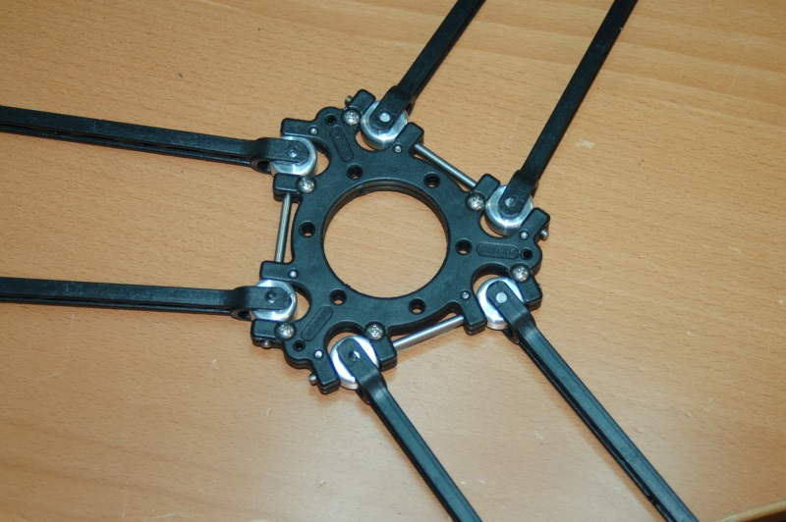Fig. 10-2: Delta arms installed on the effector platform.

Once you’re satisfied that the arms are moving freely and you’ve got them installed on the platform, go ahead and mount them to the Cheapskates as shown below:
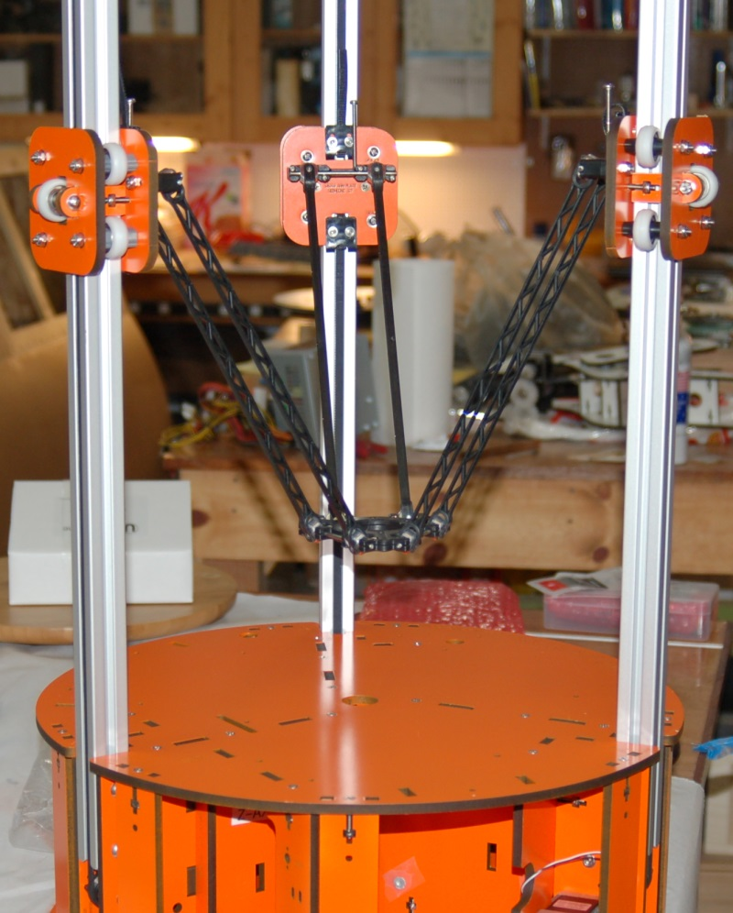Fig. 10-3: Delta arms attached to effector platform and the Cheapskates.

The arms should install just as easily as they did on the platform. Since you’ve sanded both ends, you shouldn’t have any friction issues when they’re installed on the Cheapskates.

11A – Assembling the Side Extruder Mount and Spool Holder
For this step, you’ll need two Filament Spool Brackets (P/N: 68392), two Extruder Brackets (P/N: 68387), three Extruder Support Spacers (P/N: 68388) and one Extruder Clamp (P/N: 68389).
If you don't have the parts listed above, you've most likely got a kit that includes the top mounted extruder and not the side mounted version. You can easily tell which you got by the sheet count for the melamine parts. If your kit had four sheets, you've got the side mounted extruder and if your kit had three sheets, you have the top mounted extruder. If you have the top mounted extruder, please skip to section 11B – Assembling the Top Mounted Extruder and Spool Holder.
For the side-mounted extruder you’ll also need 12 #6-32 nylon lock nuts and 12 1” #6-32 flat head screws to complete the assembly.
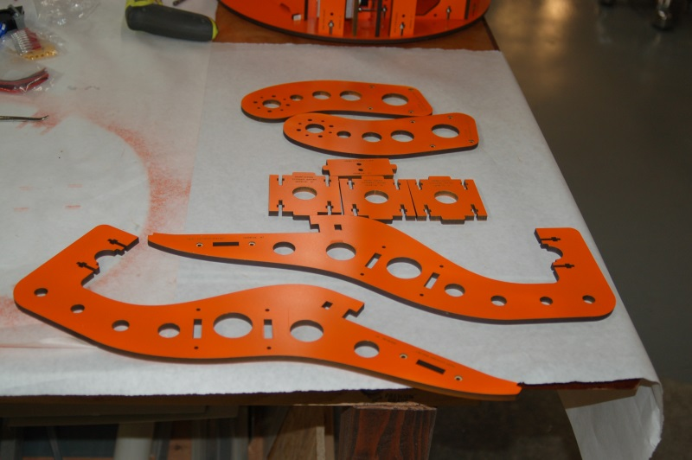Fig. 11-1: Extruder mount parts.

If you haven’t done so already, please pop out the countersink rings on both filament spool brackets.
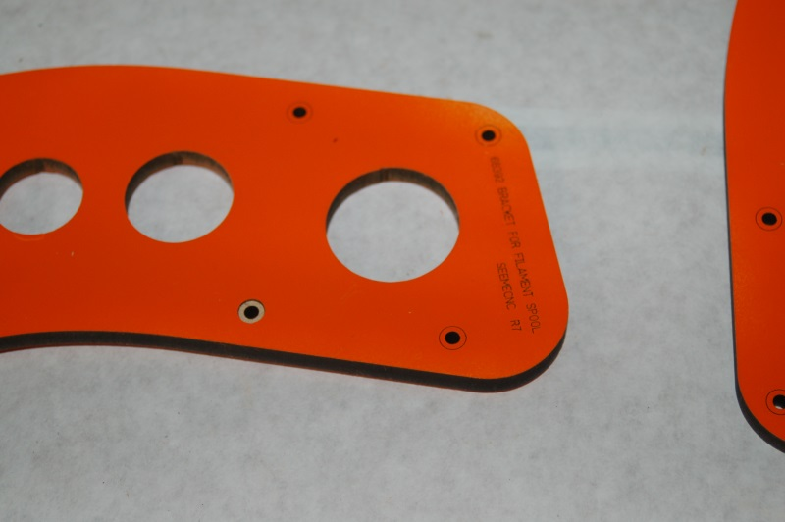Fig. 11-2: Extruder bracket with one of the countersinks popped out.

Insert 12 #6-32 nylon lock nuts into the three Extruder Support parts as shown below:
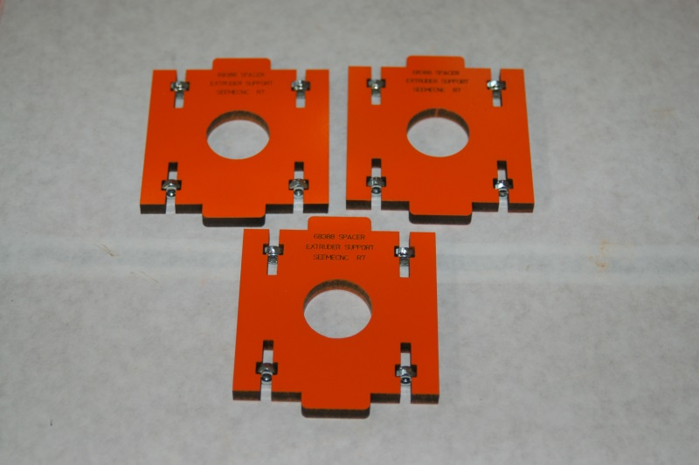Fig. 11-3: Nuts installed in the extruder supports.

Start the assembly by mounting an extruder support in the bottom slot in the extruder bracket as shown in Fig. 11-4.
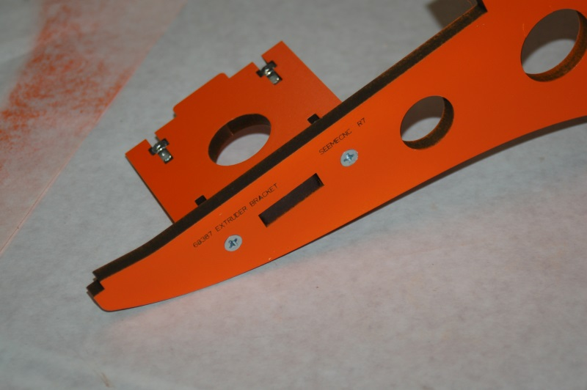Fig. 11-4: Installing the first extruder support.

Now set the other two extruder supports into the other two slots and rest the extruder bracket on them. Place the spool holder as shown and install it with four #6-32 1” flat head screws. Take care to tighten it enough that there is no visible gap between the inside face of the extruder bracket and the outside edge of the extruder supports. If they’re not tight, the extruder bracket spacing will be too wide to allow it to properly fit into the slots on the Rostock MAX machine base.
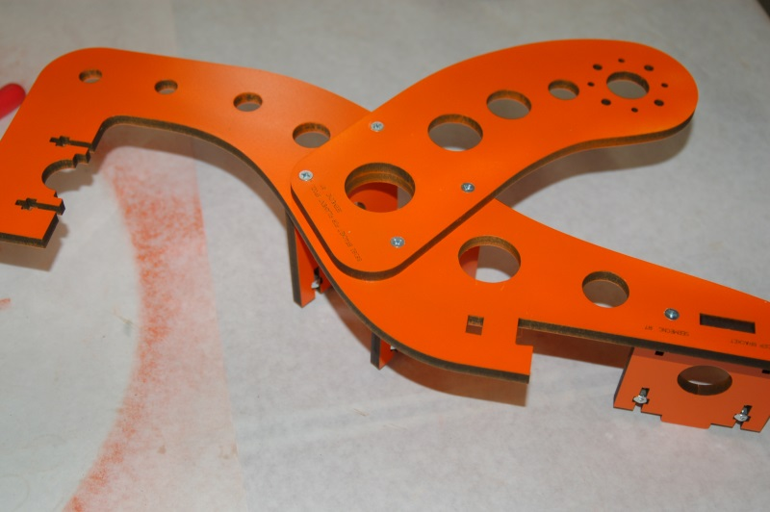Fig. 11-5: Spool holder installed on extruder bracket.

Flip the extruder over and install the extruder clamp as shown below in Fig. 11-6.
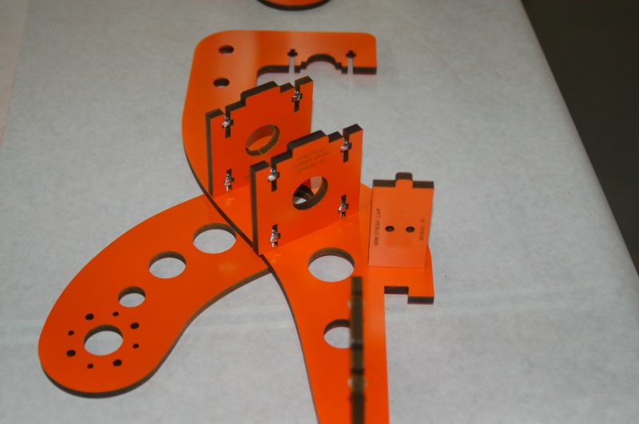Fig. 11-6: Adding the extruder clamp to the extruder bracket.

Flip the bracket back over and install the bracket and spool holder on the other side – make sure all the tabs are aligned as you go so there is no damage to the brackets.
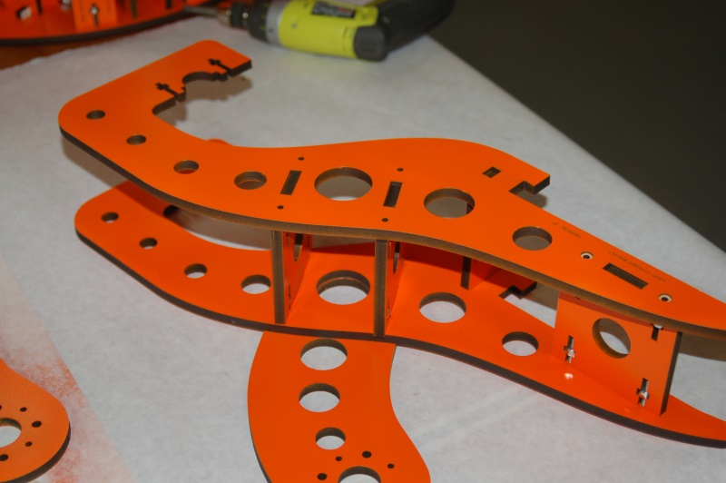Fig. 11-7: Completing assembly. (Spool holder omitted for clarity)

When you’re done, test fit it to the Rostock MAX platform as shown below. The tabs on the extruder support should fit the base snugly, but not bind. Take care when installing and removing the extruder support as it can cosmetically damage the slots.
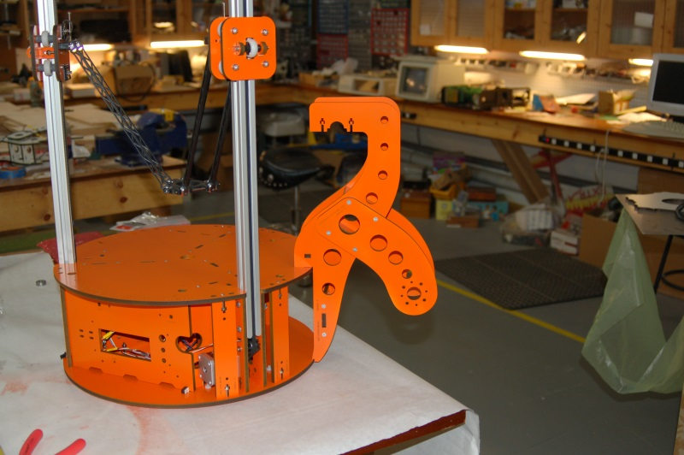Fig. 11-8: Extruder bracket installed.

11B – Assembling the Top Mounted Extruder and Spool Holder
Parts list for the top mounted extruder:
7 ea. #6-32 x 1" Phillips Flat Head, Stainless
9 ea. #6-32 nylon lock nut, Stainless
1 ea. #6-32 x 2" Phillips Pan Head
1 ea. #6-32 x 1-3/4" Phillips Pan Head
3 Spacers (P/N: 70769)
1 Brace (P/N: 70770)
1 “Part A” (P/N: 70771)
1 “Part B” (P/N: 70772)
1 “Part C” (P/N: 70774)
2 Arms (P/N: 70773)
1 Motor Support (P/N: 70777)
I'll cover the assembly of the EZStruder here because it's part of assembling and installing the top mounted extruder & spool holder.
You’ll start with these parts:
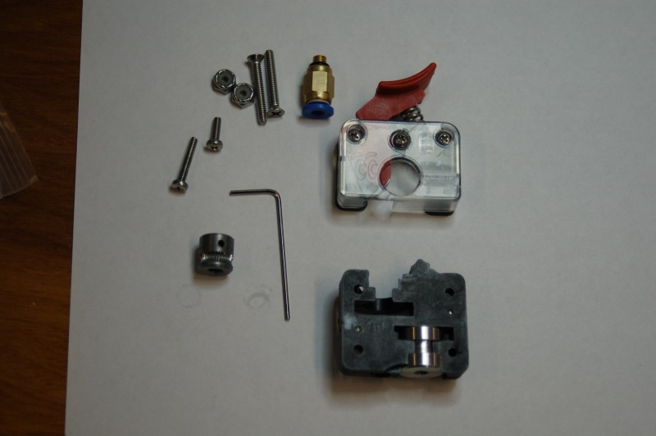Fig. 11B-1: Stepper motor mounted EZStruder parts.

First, thread the push-fit connector into the metal guide boss as shown:
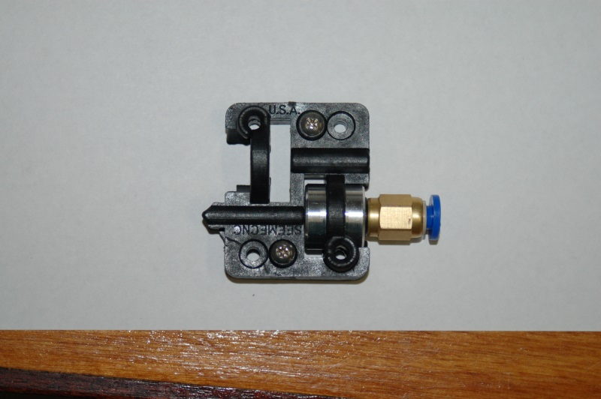Fig. 11B-2: Push-fit connector installed.

Next, you want to temporarily install the filament release mechanism on to the stepper motor so you can properly position the hobbed gear. The release mechanism should have two short screws already present.
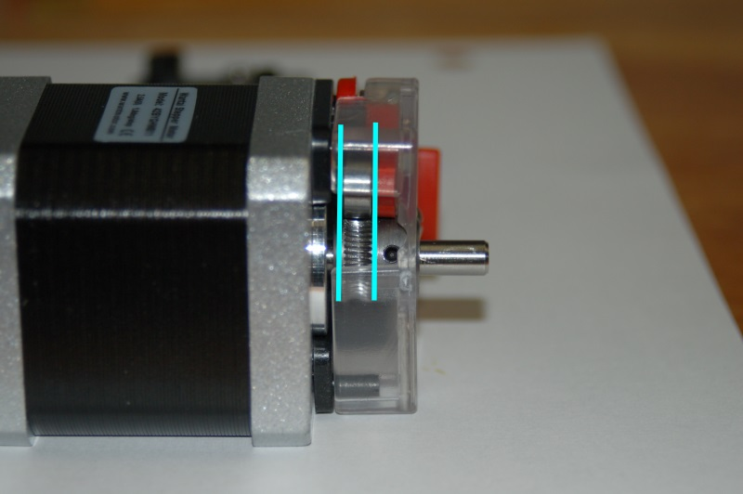Fig. 11B-3: Aligning the hobbed gear.

You want to align the hobbed portion of the gear with the small bearing that is attached to the filament release lever. This bearing squeezes the filament against the hobbed gear in order to allow the stepper motor to feed filament to the hot end.

Once you’ve got the hobbed gear positioned properly, carefully remove the filament release mechanism from the stepper motor. Apply some thread locking compound to the grub screw and install the hobbed gear on to the stepper motor shaft as shown.
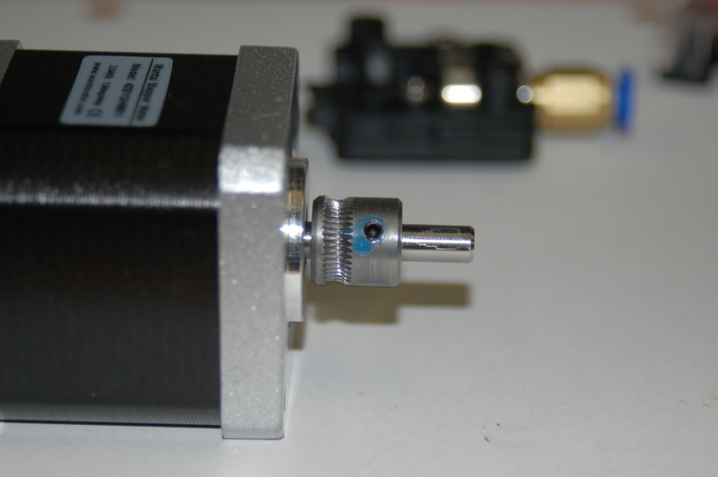Fig. 11B-4: Hobbed gear installed on the stepper motor.

Now re-install the filament release mechanism back on to the stepper motor like so:
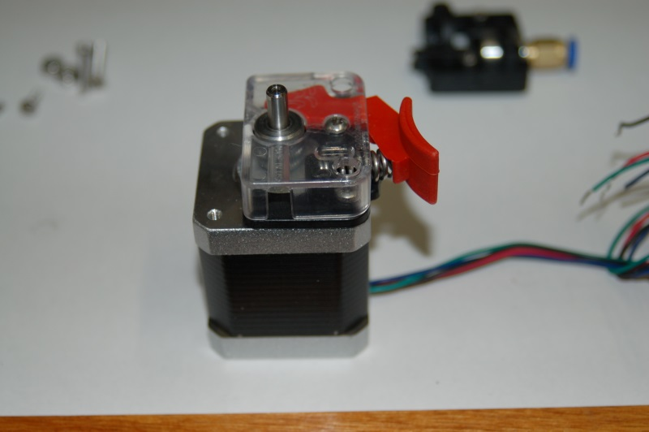Fig. 11B-5: Filament release installed.

The filament feed block that you installed the push-fit connector on is mounted to the stepper motor using one short and one long screw. The mounting holes in the filament feed block are a bit under-sized. You can thread the mounting screws into the holes easily, but it's not a “slip” fit.
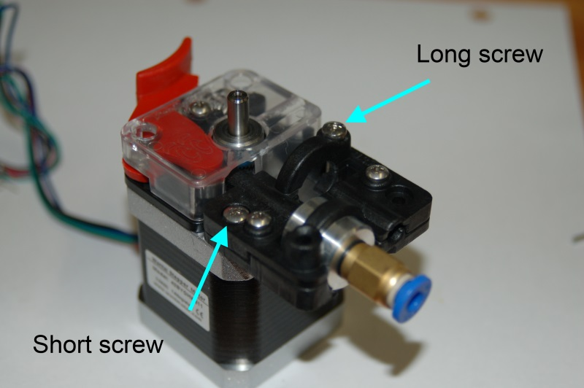Fig. 11B-6: Completed EZStruder

When you’ve attached the feed block the assembling of the EZStruder is complete. It’s VERY easy to do, isn’t it? For those with experience assembling the Steve’s Extruder, this should be almost disappointing in its ease of construction. :)
In order to connect the extruder to the RAMBo, you’re going to need to extend the stepper leads in order to reach the board on the interior of the base.
Included in your kit should be a length of four conductor, 22ga wire for this purpose If it’s like the material I have, the wires will be Red, Black, White and Green. Match these colors to your stepper motor wires as closely as you can – write up a little “translation” table if you need to. It will help when you add the crimp on connectors and the 4 pin connector shell. You’ll want to make your extension between 18 and 24” long. You’re much better off making it too long than too short. :) You can always loop up any extra. If your stepper motors came with the four pin connector pre-installed, and you want to make the lead extension permanent, you can clip off the connector with a few inches of lead and then splice in the extension. I would advise that you get the male crimp connector as listed in the “stuff to get” section – You'll be better off in the long run with an EZStruder you can disconnect if you need to.
In order to ensure you've got enough wire cut for the extension, I would tape one end to the top of the Rostock MAX, next to the X axis idler bracket and route it across to the Z axis, down the tower and then back over to the electronics bay with about 6” of extra. This will give you plenty of wire to attach to the wire routing rod that will be described later.
If you solder up the extension, I’d recommend using heat shrink tubing and not electrical tape. You’ll get a much nicer looking splice and it will better sealed against outside contaminates.

Next, let's build the spool holder. You'll need parts marked “Part A”, “Part B”, “Part C” and the two parts marked “Arm”.
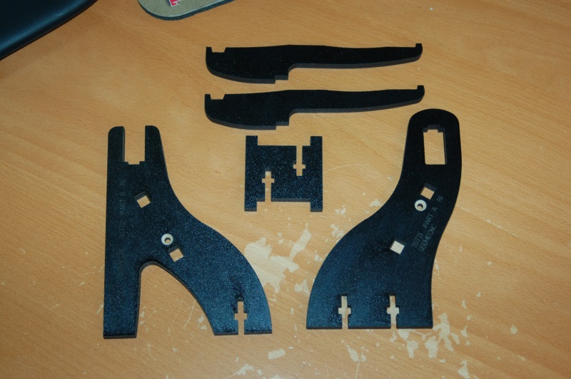Fig. 11B-7: Top mounted spool holder.

You'll want to pop the countersink rings in the outside faces of Part A and Part B and then insert two #6-32 nylon lock nuts into Part C. Assemble the spool holder frame as shown in the figures below.
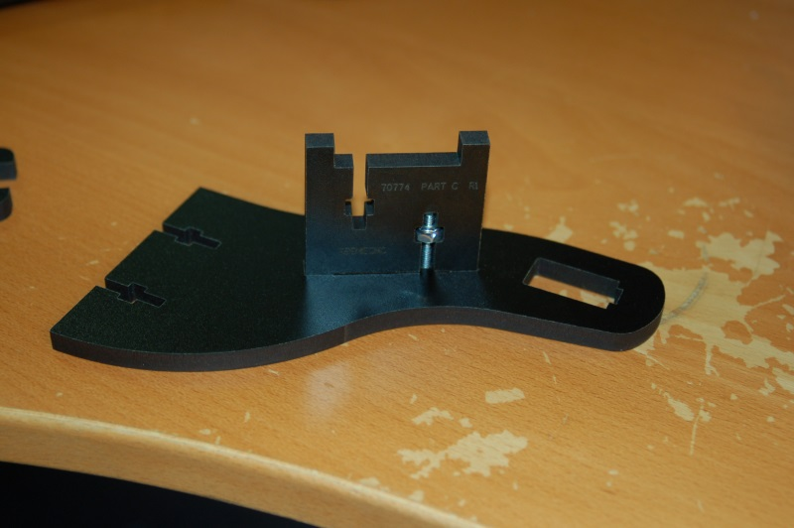Fig. 11B-8: Installing Part C into Part A.

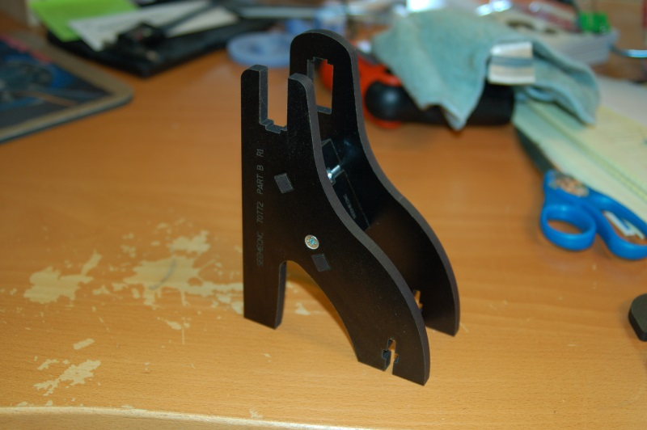Fig. 11B-9: Attaching Part B to Part C.

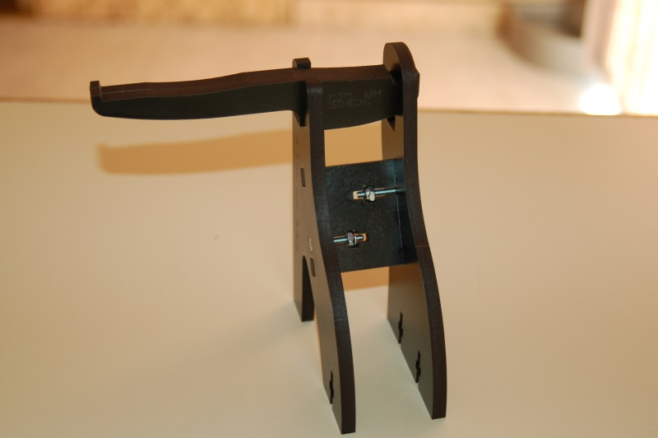Fig. 11B-10: Attaching the support arms to the spool holder.

This completes this assembly for the moment. Set it aside and grab the Motor Mount and the three identical spacer parts. The three spacers will support the lower face of the EZStruder drive.
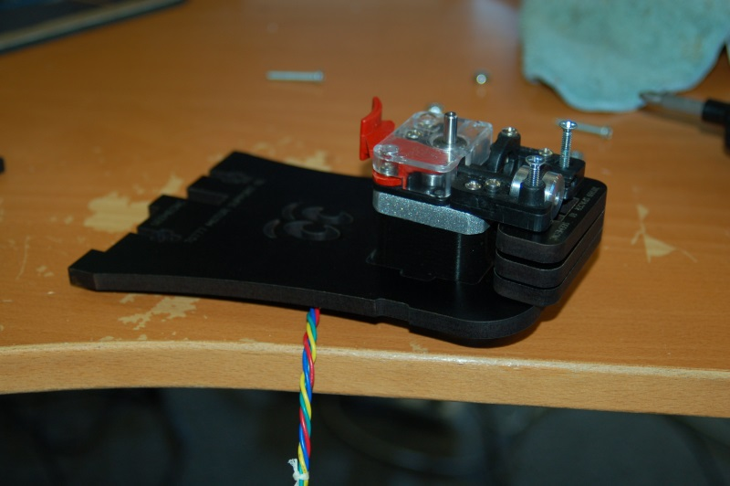Fig. 11B-11: Attaching the EZStruder to its mount.

As you can see in Fig. 11B-11, you'll stack the three identical spacers under the “output” side of the EZStruder. Use two #6-32 nylon lock nuts and a 2” #6-32 pan head screw and a 1.75” #6-32 pan head screw to attach the EZStruder to the Motor Mount.
Insert two #6-32 nylon lock nuts into the nut capture cutouts and install the curved brace as shown below. Using 2 #6-32 1” flat head screws, install the motor mount in the top of the Rostock MAX. I recommend that you install it between the X and Y towers.
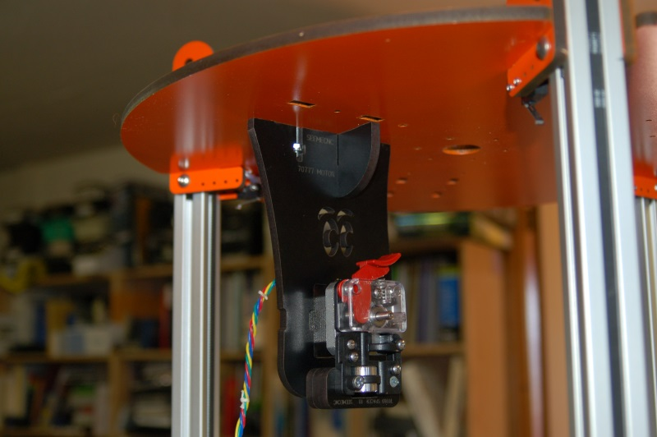Fig. 11B-12: Installing the EZStruder Mount.

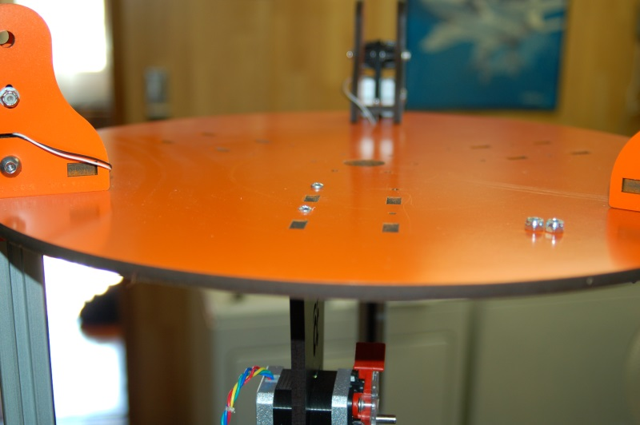Fig. 11B-13: Top view of the installation location.

Once that's done, you can now install the top mounted spool holder as shown below. You'll need to install three #6-32 nylon lock nuts and use three #6-32 1” flat head screws to install it.
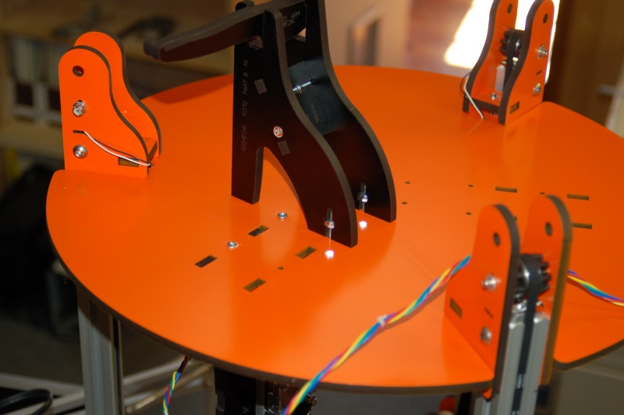Fig. 11B-14: Spool holder installed.

That completes the installation of the top mounted extruder mount and spool holder.

12 – Assembling and Installing the Side Mount Extruder
If you’ve got an older Rostock MAX kit that features the original “Steve’s Extruder”, SeeMeCNC produced a YouTube video that does an excellent job in illustrating how that device is assembled. The video can be seen here: https://www.youtube.com/watch?v=mua3i_wP32I.
When I assembled my Steve’s Extruder, I used a vise with soft jaw covers to install the bearings in the gears as well as the drive gear on the stepper motor. The video covers this, but I figured a clear shot of what goes on would help.
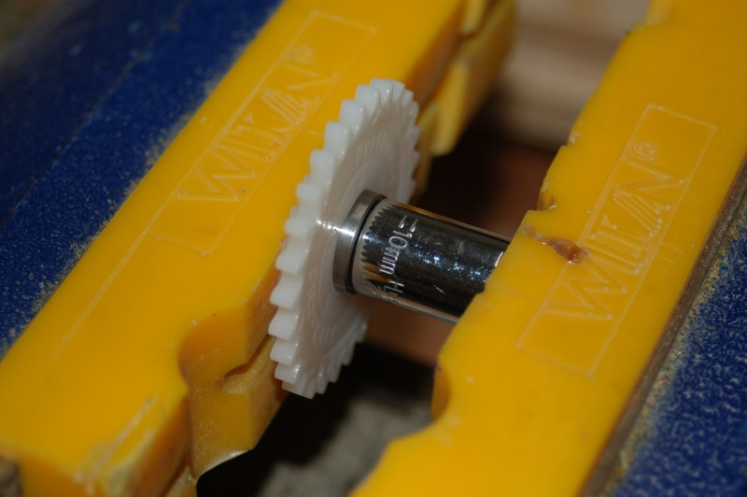Fig. 12-1: Installing the bearing in a Steve's Extruder gear.

In the photo above, I’m using a 10mm socket with the back of the socket pressed against the bearing. It’s being pressed in place with a vice. The socket is just large enough to press on the outside ring of the bearing without coming into contact with the gear itself. If you were to press on the middle or inner portion of the bearing, you’d ruin it.
Make sure that the bearing is fully seated – the face of the bearing should be a bit below the face of the gear.
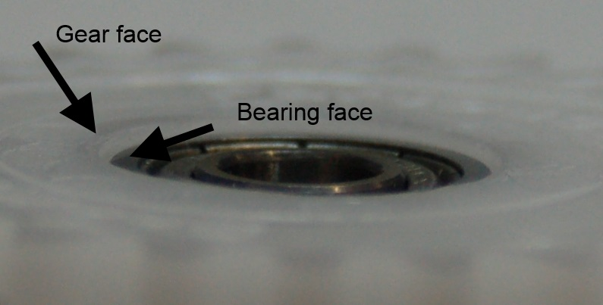Fig. 12-2: Proper fitting of the bearing to the gear.

I created a short video that describes some of the less clear elements of assembling the Steve’s Extruder. You can find that here: http://youtu.be/rAVlvRuHuE8 .
If you’ve got the EZStruder, you’ll have a package of parts that looks like the figure below. The hobbed gear and push-fit connector for the bowden tube are not shown.
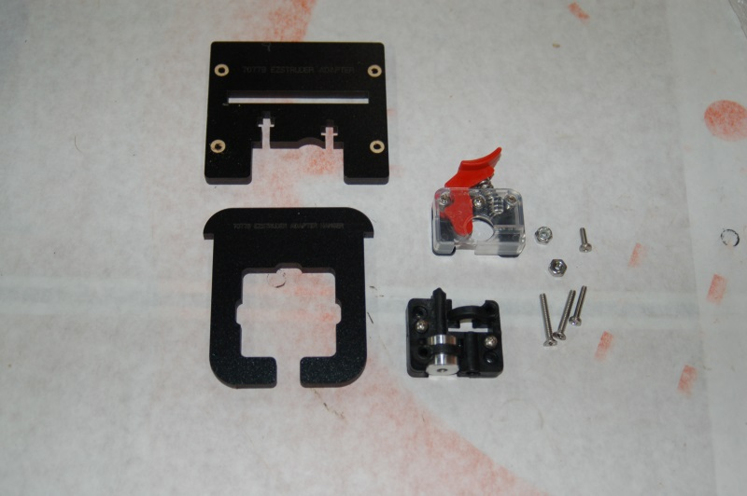Fig. 12-3: Components for the EZStruder

The melamine parts are used in order to mount the assembled EZStruder to the side mount Extruder Bracket that you completed a short time ago. Let’s get the EZStruder mounted to the extruder stepper motor.
You’ll start with these parts:
Fig. 12-4: Stepper motor mounted EZStruder parts.

First, thread the push-fit connector into the metal guide boss as shown:
Fig. 12-5: Push-fit connector installed.

Next, you want to temporarily install the filament release mechanism on to the stepper motor so you can properly position the hobbed gear. The release mechanism should have two short screws already present.
Fig. 12-6: Aligning the hobbed gear.

You want to align the hobbed portion of the gear with the small bearing that is attached to the filament release lever. This bearing squeezes the filament against the hobbed gear in order to allow the stepper motor to feed filament to the hot end.

Once you’ve got the hobbed gear positioned properly, carefully remove the filament release mechanism from the stepper motor. Apply some thread locking compound to the grub screw and install the hobbed gear on to the stepper motor shaft as shown.
Fig. 12-7: Hobbed gear installed on the stepper motor.

Now re-install the filament release mechanism back on to the stepper motor like so:
Fig. 12-8: Filament release installed.

The filament feed block that you installed the push-fit connector on is mounted to the stepper motor using one short and one long screw. The mounting holes in the filament feed block are a bit under-sized. You can thread the mounting screws into the holes easily, but it's not a “slip” fit.
Fig. 12-9: Completed EZStruder

When you’ve attached the feed block the assembly of the EZStruder is complete. It’s VERY easy to do, isn’t it? For those with experience assembly the Steve’s Extruder, this should be almost disappointing in its ease of construction. :)
In order to connect the extruder to the RAMBo, you’re going to need to extend the servo leads in order to reach the board on the interior of the base.
Included in your kit should be a length of four conductor, 22ga wire for this purpose If it’s like the material I have, the wires will be Red, Black, White and Green. Match these colors to your stepper motor wires as closely as you can – write up a little “translation” table if you need to. It will help when you add the crimp on connectors and the 4 pin connector shell. You’ll want to make your extension between 18 and 24” long. You’re much better off making it too long than too short. :) You can always loop up any extra.
When you solder up the extension, I’d recommend using heat shrink tubing and not electrical tape. You’ll get a much nicer looking splice and it will better sealed against outside contaminates.
If you've never spliced two wires together before, I'd suggest you check out the Wikipedia article on the “Western Union” splice, shown here: http://en.wikipedia.org/wiki/Western_union_splice.
Your goal is the splice shown in Fig. D on the Wikipedia page.

In order to mount the EZStruder to the side Extruder Mount you assembled in the previous section, you’ll need to attach it to the EZStruder adapter. This consists of an EZStruder Adapter Hanger (P/N: 70778) and an EZStruder Adapter (P/N: 70779).
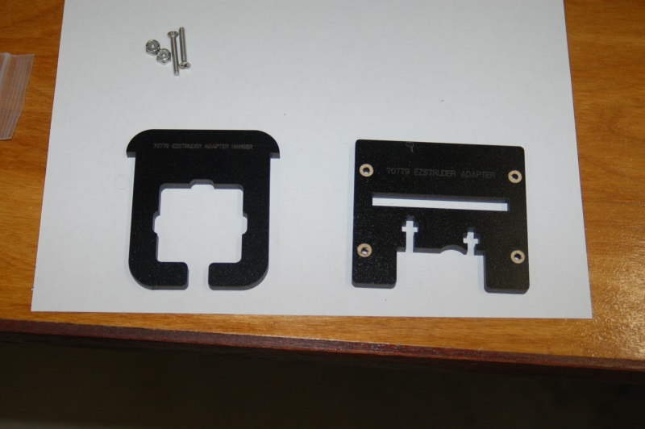Fig. 12-10: EZStruder adapter components.

Remove the countersink rings from the adapter plate as shown above and insert the hangar part into it.
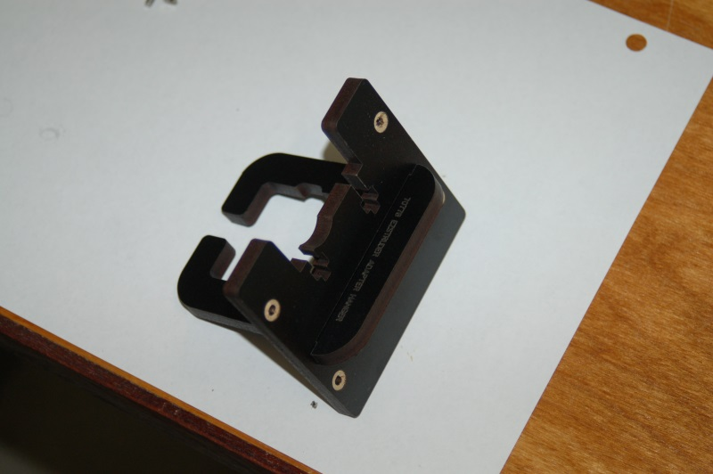Fig. 12-11: Assembled EZStruder adapter.

Now insert two #6-32 nylon lock nuts into the laser cut nut capture pockets located on the adapter. You may need to temporarily tape the nuts in place if they’re too loose in the capture pockets.
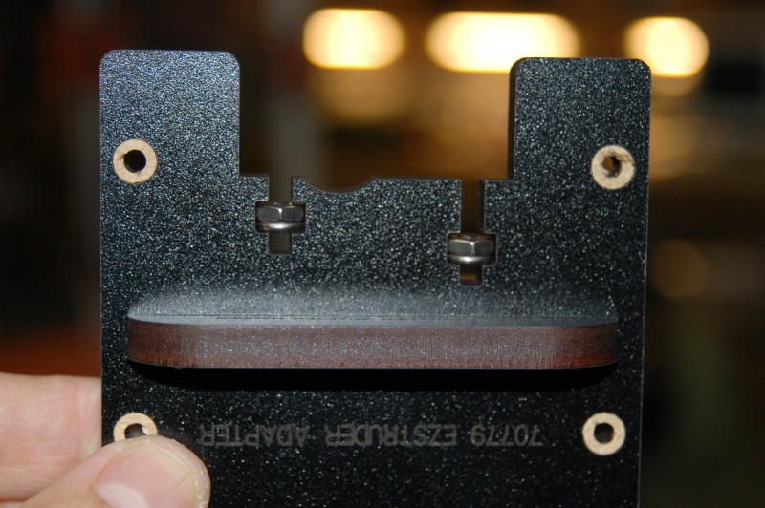Fig. 12-12: Nylon lock nuts in place.

Using two 1” #6-32 flat head screws, attach the EZStruder to the adapter plate as shown below.
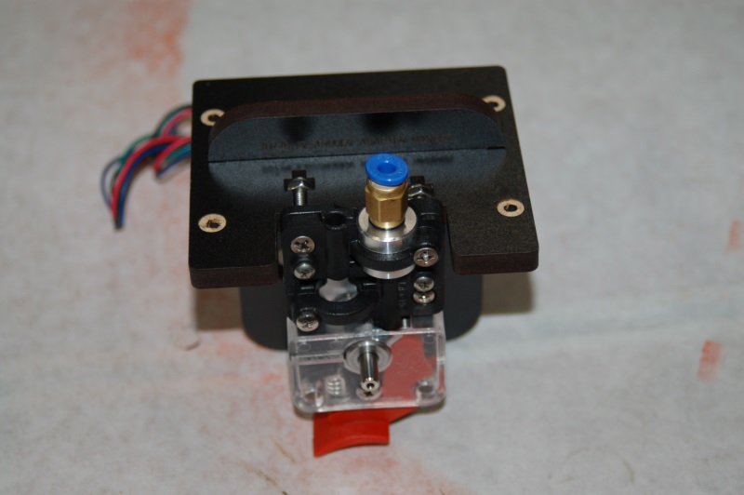Fig. 12-13: EZStruder mounted to the adapter plate.

All that remains is to mount the EZStruder to the side Extruder Mount we finished in the last section.

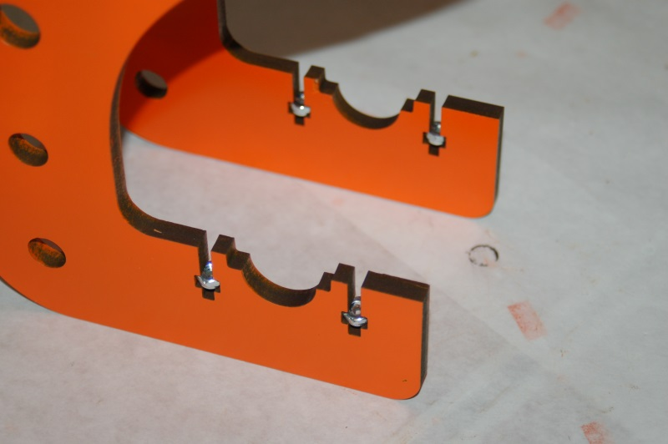Fig. 12-14: Nylon lock nuts installed in the side extruder mount.

Insert four #6-32 nylon lock nuts into the side extruder mount as shown above. Using four 1”, #6-32 flat head screws, mount the EZStruder to the side extruder mount.
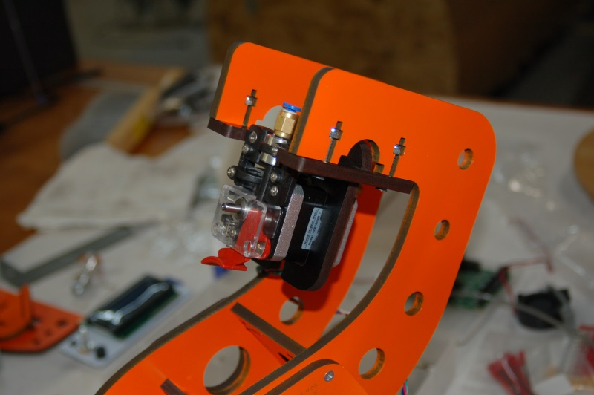Fig. 12-15: EZStruder mounted to the side extruder mount.

Now that this is complete, we can move on to the next task!

13 – Preparing and Installing the Power Supply & RAMBo
The Rostock MAX uses a standard ATX computer power supply to provide power to the RAMBo controller, the Onyx heated bed and the hot-end. All of these components require 12V DC. The 12V wires on an ATX power supply are yellow. You’ll need four of these for the heated bed power, and one each for the hot-end and motors.
Start by locating the six longest yellow wires in the power supply. You want the most reach possible. Clip them and the six longest black wires from the connectors they’re attached to and bundle them up into two sets. [Note, Fig. 13-1 shows four, but you want six.]
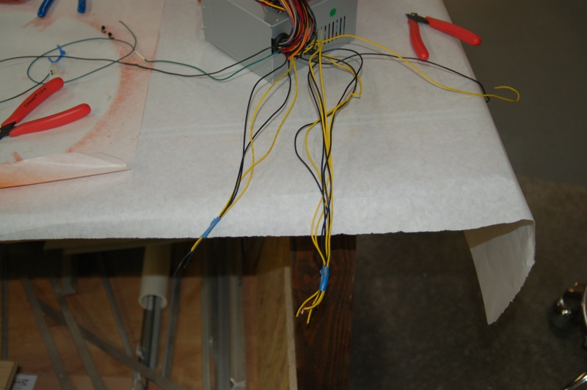Fig. 13-1: Isolating the power wires for the Rostock MAX.

Next, locate the green wire that goes to the large ATX connector and cut it flush with the connector. The green wire and one black wire will be attached to a toggle switch in order for you to power up the supply. You’ll need to extend the green and black wires as they’re too short to reach the required distance. I would recommend an 18” extension to them – you’ll be cutting it down later, but you’ll appreciate the extra length when it comes time to add the switch and mount it.
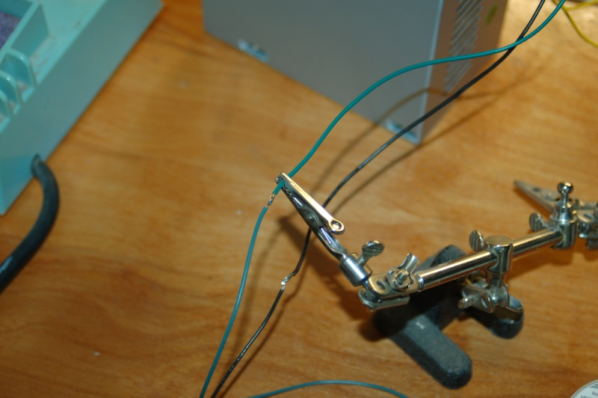Fig. 13-2: Extending the power-on wires.

Now fold up and bundle the unused wires – you don’t want to cut them all off as you may have some use for them later when adding lighting or other “upgrades” to the printer.
Install the power supply in the power supply bay by facing the wire exit towards the center of the printer and the power cord connector facing out. You’ll want to thread the power and switch wires through the center and into the electronics bay. Some builders have found it simpler to add the RAMBo power connector to the wiring and THEN install the power supply.
The power supply can be mounted using three of the 1/2” long #6-32 nylon screws that you’ll find in the parts kit. The fourth screw can be problematic to install once three have been placed, so you can just skip the fourth.
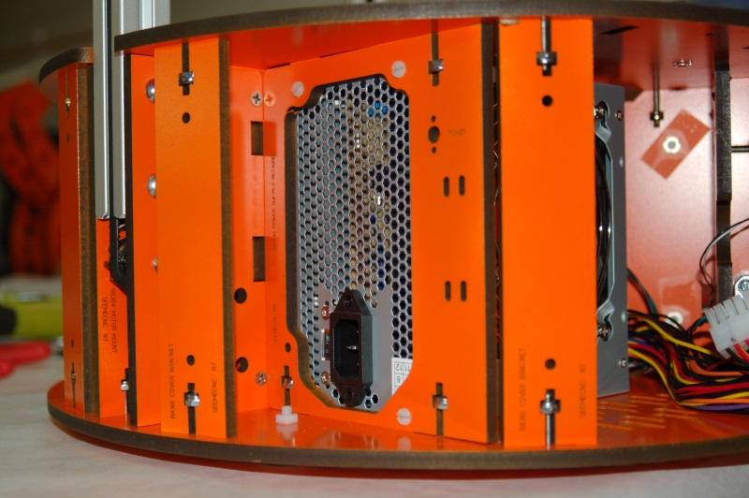Fig. 13-3: Power supply mounted.
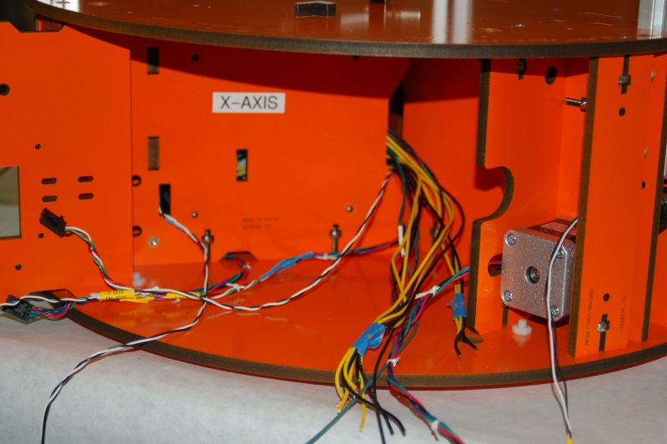Fig. 13-4: Power wires routed to the electronics bay.

Now take the four long black wires from the bundle and strip about 3/4” of insulation from each. Tightly twist them together as shown below. Do the same for the four long yellow wires.
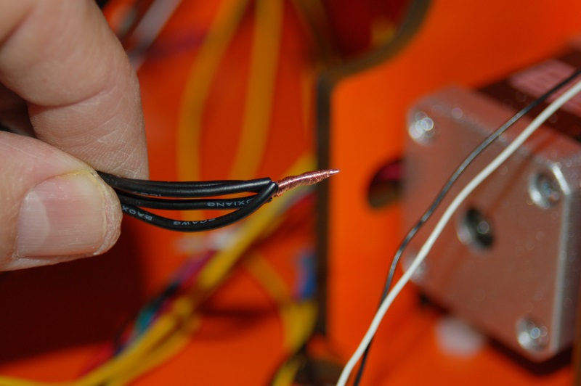Fig. 13-5: Twisting the ground wires together for the heated bed supply.

The reason you’re doing this is because the Onyx heated bed requires a significant amount of power to heat up. A single wire can’t carry enough current to do the job. The reason is that you can only draw so much power through a wire of a given gauge. Think of it like a small water hose. No matter how much you try to draw water through that little hose, you’re only going to get as much as it has room for. However, if you use four small hoses, you effectively get the same volume as if you had one hose with the same volume capacity as the four smaller ones combined.
Once you have the wires twisted together, insert them into the large black terminal block connector as shown below:
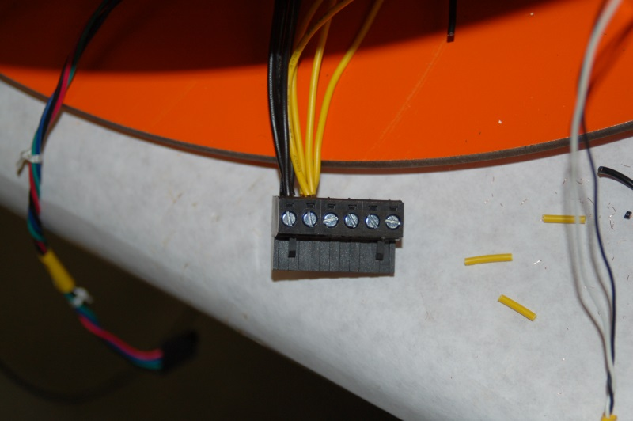Fig. 13-6: Installing the heated bed power wires into the terminal block connector.

DO NOT, UNDER ANY CIRCUMSTANCES, SOLDER THE WIRES TOGETHER!
Soldering the power wires together can prevent the terminal clamp from getting good contact with the wires. A poor connection will result in a lot of heat due to resistance and you run the risk of damaging the terminal block connector, the RAMBo, or both. A fire could also result!
Please take care to install the wires exactly as shown! If you reverse the polarity (yellow is positive, black is negative (or ground)), you’ll blow up the RAMBo board and make yourself very sad.
Now strip about 1/2” of insulation from the other yellow and black wires and install them as shown:
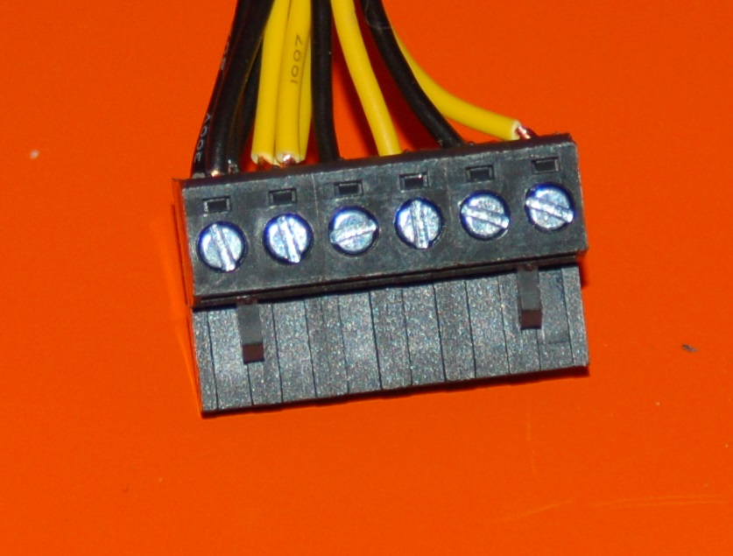Fig. 13-7a: RAMBo power terminal wiring completed.

The next task is to assemble the RAMBo to SmartController adapter board. I've created a short video that does an excellent job of illustrating how this small board is soldered together. You can view the video here: http://www.youtube.com/watch?v=fzdWk5BtttA.

Before you install the RAMBo board, you should change the power supply jumper on the board.
After you change this jumper, the RAMBo will only be turned on when the power switch is turned on. As it's shipped, the RAMBo will be active any time the USB cable is connected to the computer.
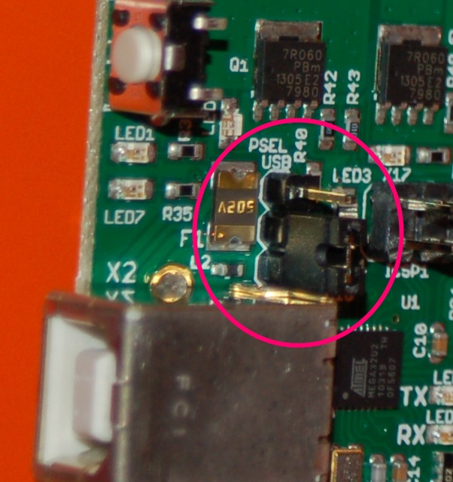Fig. 13-7b: Setting the Power Supply Select Jumper
The “PSEL” jumper should be set as shown in Fig. 13-7b.
Note, if you received your Rostock MAX kit after November 2013, you may have a RAMBo v1.2 board.
The v1.2 board does not have the PSEL jumper mentioned here. The board is powered externally by default.

Now you can install the RAMBo controller. Please take special care when handling the RAMBo! It’s extremely static sensitive! It’s best to handle it while you’re wearing a ground strap, but if you can touch a nearby metal water faucet, you should be OK. (that’ll drain away any static charge you’re carrying)
The RAMBo board is installed on the X-axis Tri-Support as shown on the right.
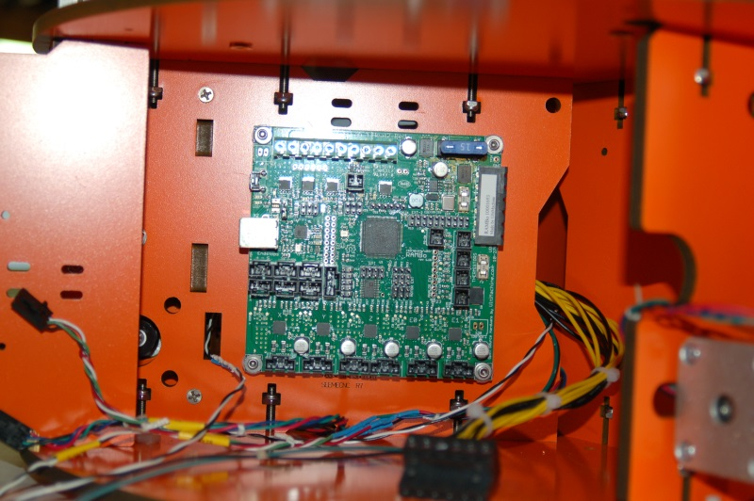Fig. 13-8: RAMBo Installed
You’ll need four 1/2” #4-40 socket head screws, four #4 flat washers and eight small round plastic spacers.
You should have installed the four t-nuts into the back of the X-axis Tri-Support all the way back in Section 2. If you didn’t, you’re in a world of hurt because you’re going to have to pull the power supply to easily reach the t-nut locations on the back of the Tri-Support.

See Fig. 13-9 for details on how the spacers are used.
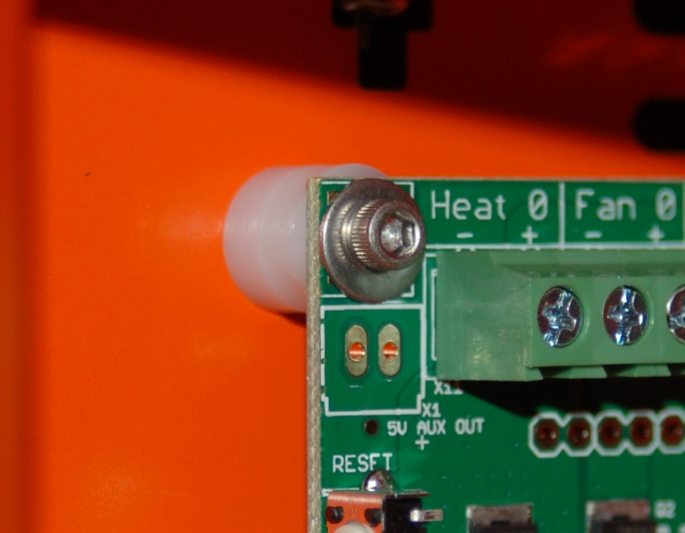Fig. 13-9: RAMBo mounting point detail.

As you can see above, the RAMBo uses a pair of spacers at each corner. This gives an air gap between the RAMBo and the surface it’s mounted to. This is important as the stepper driver chips use the board itself as a heat sink and need good airflow behind the board in order to help prevent them from overheating.
Note that if you're a European user, make sure you've got the voltage selection switch set to 220v. The power supply will ship with the switch (located next to the power plug socket) set to 115v.

14 – Installing the Onyx Heated Bed
Installing the Onyx heated bed is pretty simple. Get your soldering iron heating up and make sure you’ve got the following bits handy:
- 6 nylon stand-offs
- 6 #4-40 flat head mounting screws
- Melamine heated bed mounting plate (it’s a “star” shaped melamine plate)
- Onyx heated bed
- Thermistor
- 1 short length of PTFE tubing – this is used to insulate the thermistor leads.
- 1 4.7K Ohm Resistor (used to drive the LED with 12vdc)
- 1 LED
- 14ga power wires. Two leads, one black and one white, 18” long.
- RTV

You should have installed the six #4 t-nuts that the heated bed requires when you were doing the steps in Section 2. If you didn’t...well let’s just say I’m glad I’m not you right now. :)
The first thing you should do is tin (apply solder to) the two square power pads on the bottom of the Onyx. See below.
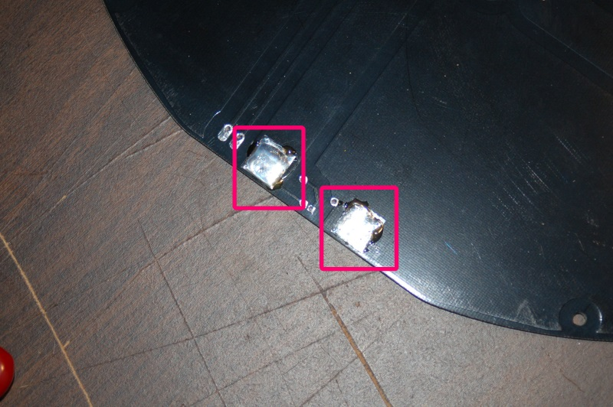Fig. 14-1: Preparing the power pads for wiring.

Grab your 14ga power wires and strip about 1/2” of insulation of one end of each wire. Flatten the wire and tin it as shown below.
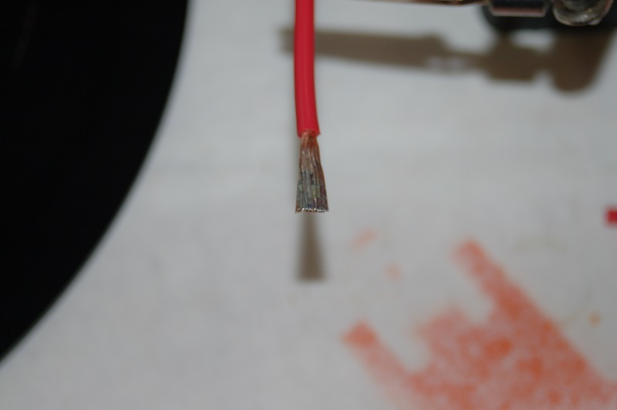Fig. 14-2: Tinned power lead.

By flattening and tinning the wire as shown, it’ll make it a lot easier to install on the bottom of the Onyx. Set the power wires aside and grab the Onyx bed and your roll of Kapton tape.
On the front side of the Onyx, place a small bit of Kapton tape over the hole in the center. This will keep the RTV you’ll be filling the hole with from leaking out while it cures.
Examine both the top and bottom of the board for vias. These are tiny little gold plated holes that pass electrical current from one side of the board to the other. When you find these, cover them with a tiny bit of Kapton tape. This will ensure that if you decide to install an aluminum heat spreader (covered in detail later), you won’t worry about the metal shorting out the vias. The Kapton tape won’t interfere with your glass build plate.
Now cut two 1/4” (or so) lengths of the tiny PTFE tubing and slip them over the thermistor leads, one for each lead. Bend the wires at the thermistor head at a 90 degree angle, making sure the exposed portion of the wires don’t touch. Set it aside and flip the Onyx upside down. Fill the center hole with RTV and then press the thermistor into the center of the hole. Take special care to make sure that the thermistor is in the hole center so that you don’t need to worry about the thermistor leads touching the metal edges of the center hole. If they do, you could short the thermistor against the heated bed. Much screaming and throwing of things would likely occur. :) Making sure the PTFE tubing is up as far as it will go along the wire thermistor leads will help prevent this.

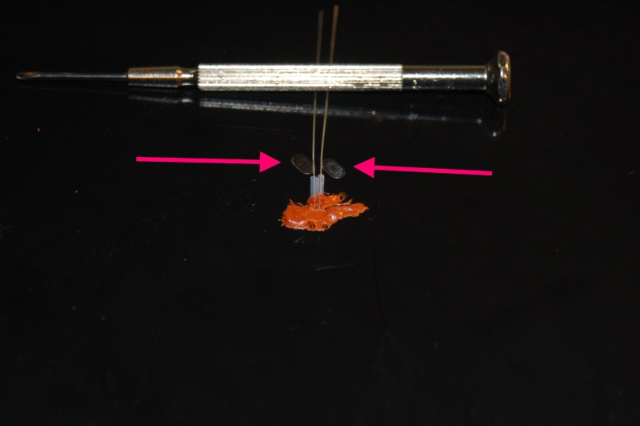Fig. 14-3: Installing the heated bed thermistor.

You’ll want to set the Onyx aside until the RTV has a chance to cure. After the RTV has cured, spread the wires a bit so each crosses the solder pads as shown above and solder the leads to the pads and trim off the excess wire. Placing a strip of Kapton tape over the thermistor after the RTV cures will help prevent it from being accidentally dislodged from the hole over time. (Theoretically this could happen across a number of heating/cooling cycles. Better safe than sorry!)
Now we can wire up the thermistor leads, power LED, resistor and the two power wires to the Onyx. All of these parts are mounted on the bottom of the Onyx in order to prevent them from interfering with the glass build plate that rests atop the Onyx.

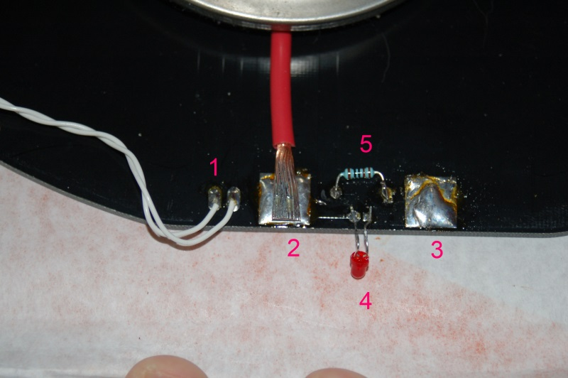Fig. 14-4: Wiring up the heated bed.
The RAMBo comes with two thermistor wiring harnesses. They’re a long pair of white wires with a locking connector attached to one end. Grab one and attach it to the thermistor pads located at position #1 shown above. You can solder them in place by just tacking them to the solder pad – you don’t need to push the wire through the hole first. If you DO, please make sure you trim it flush on the other side so it won’t interfere with the glass build plate.
Soldering the power leads is pretty easy, but does take a little time due to the thermal mass of all that wire & solder. You want to install the lead as shown in #2 with the wire oriented as shown. This orientation makes it a bit easier for the wire to route through the slot in the top of the Rostock MAX base. Red goes to #2, black goes to #3. You’ll see them both in place in the next photo.
Install the resistor by laying the leads across the mounting holes and soldering it in place. Do the same for the power-on LED. The LED must be installed with the proper polarity in order for it to operate. The negative wire of the LED is closest to the “side” of the LED that has a flat spot ground in it (this is called the Cathode). Looking at the bottom of the heated bed, the negative lead is near the negative power input lead. (#3 in Fig. 14-4, above.) You'll want to bend the LED up at a 90 degree angle such that it's easily visible once the heated bed is installed on the Rostock MAX.

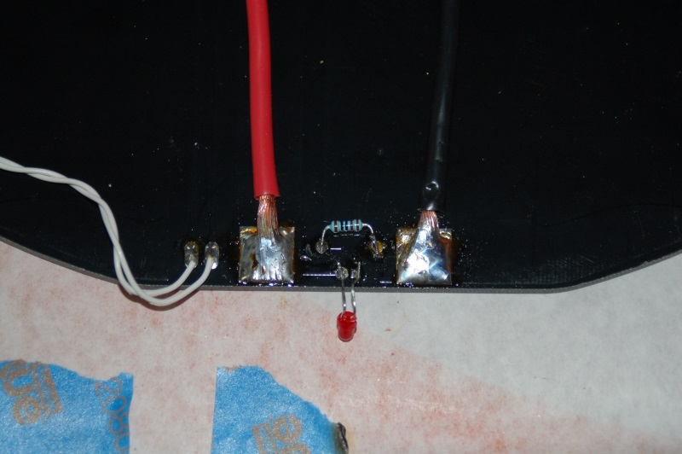Fig. 14-5: Completed Onyx heated bed wiring.
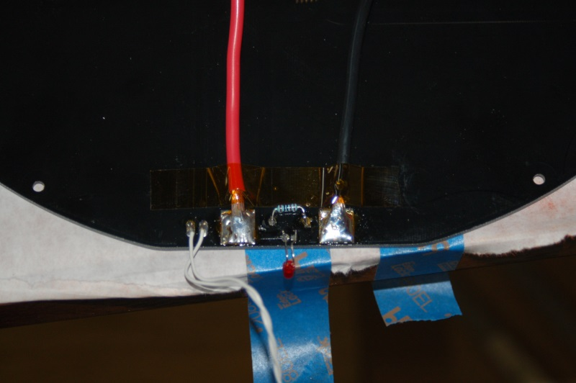Fig. 14-6: Taping the power wires down with Kapton tape.

Now we can get the Onyx heated bed installed! Take six of the white spacers and arrange them around the base over their mounting holes as shown below. The wiring slot for the thermistor and power wires is at the base of the Z axis tower and is indicated by the green arrow.
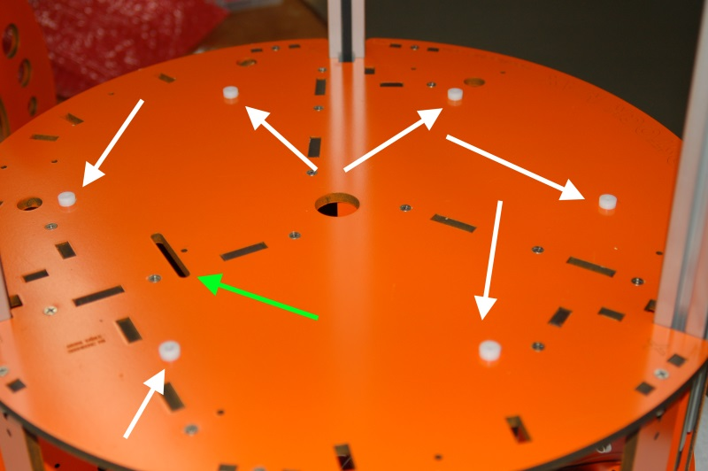Fig. 14-7: Mounting spacers and wiring slot.

Carefully route the Onyx bed wiring through the slot as shown. After the installation is complete, you can route the wires through the Tri-Supports and into the electronics bay.
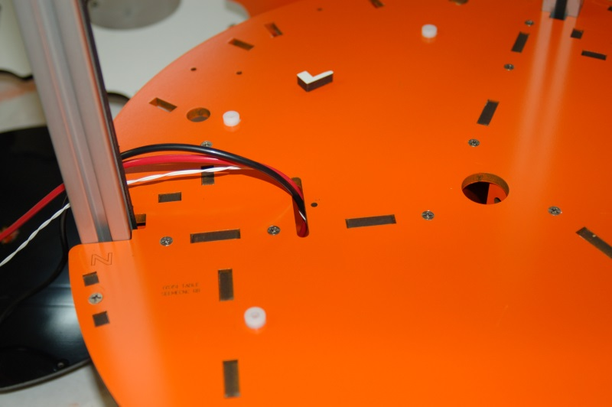Fig. 14-8: Running the Onyx wiring into the base.

Carefully set the star shaped heated bed platform on the plastic spacers and then set the Onyx on top of the platform. It’ll be tricky because you’ve got to feed the Onyx wiring through the slot at the same time. I’d suggest finding some small nails that you can use to drop into the mounting holes in the Onyx in order to use them as alignment pins.

You could also use the #4-40 flat head mounting screws for this, but take care that you don’t accidentally punch out the t-nuts on the bottom of the base. If you do, some are difficult to put back into place easily.
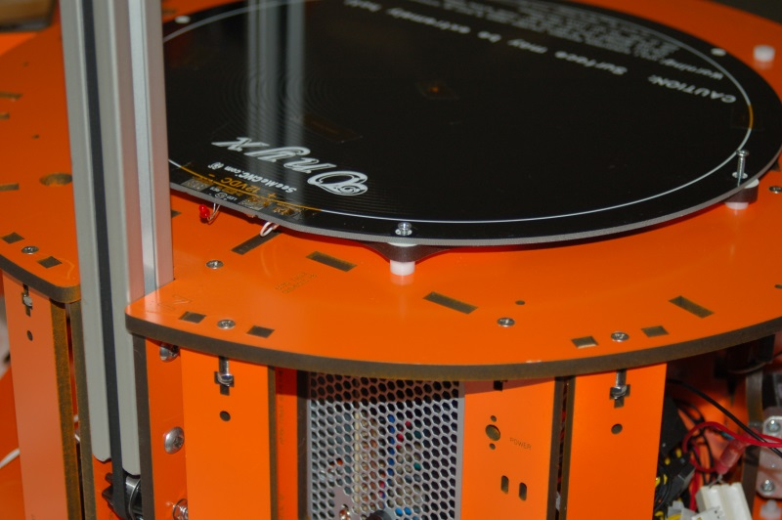Fig. 14-9: Aligning the Onyx.

Insert the six #4-40 flat head screws screws into the Onyx and tighten them in a “star” pattern. See the figure below for a suggested tightening order.
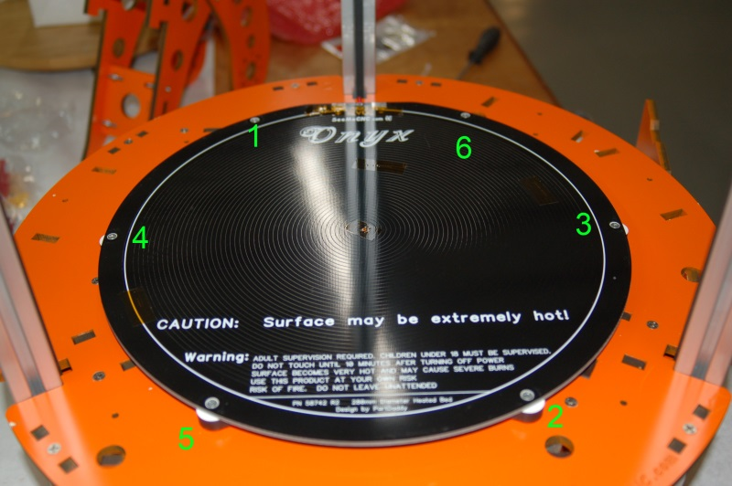Fig. 14-10: Suggested fastener tightening pattern.

Take care to not over-tighten the screws, you don’t want to damage the Onyx.

15 – Assembling and Installing the Hot End
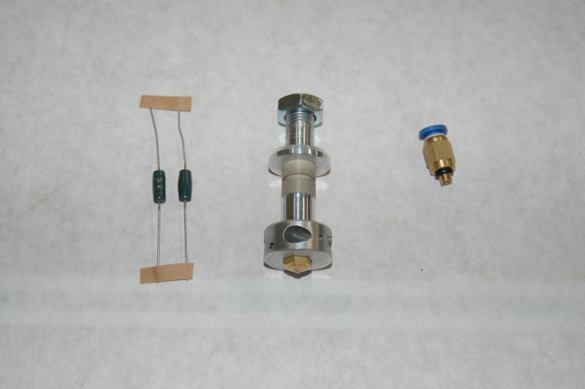Fig. 15-1: Hot end components.

The hot end for the Rostock MAX is mostly pre-assembled for you. The only tasks you need to complete involve installing the heating resistors, the thermistor and the push-fit connector.
The resistors included with the hot end (the green objects in Fig. 15-1) are too small to fit snugly into the bore holes to either side of the hot end. In order to make them bigger, you’ll need to cut a strip of aluminum foil and wrap the resistor. You want the width of the foil strip to be about 1/16” shorter than the length of the resistor body so that it can’t come into contact with the leads on either end of the resistor.
Note that in order to shield the resistor leads from accidental shorts, you should have purchased some PFTE tubing as listed in Section 1. You can get by without it by wrapping the leads in Kapton tape, but the PFTE is a much better looking and simpler to install solution.
Once you've got the resistors installed in the hot end with a snug fit, cover each end with RTV to glue them into place. We use RTV here because if you have a resistor failure, it can be removed easily, but is very resistant to high temperatures.
Note that Rostock MAX kits that shipped from September 9th, 2013 will include hot ends equipped with a new nozzle design. The new nozzle design is shown below in Fig. 15-1A.

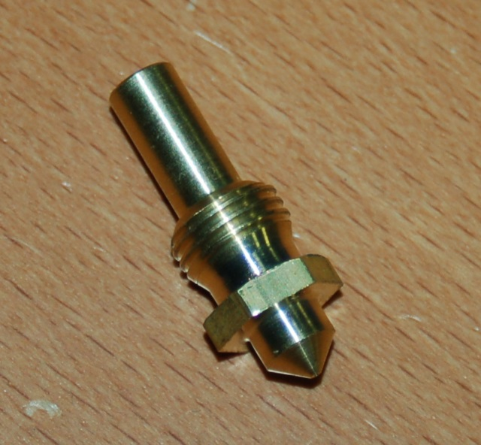Fig. 15-1A: New nozzle design.

Before the RTV cures, install a 3/4” length of PTFE tubing on each of the resistor leads as shown below.
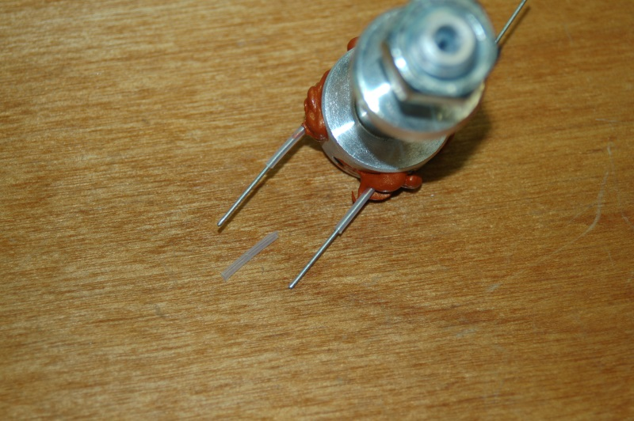Fig. 15-2: Insulating the hot end resistor leads.

Once the RTV cures, carefully twist the resistor leads together as shown below. Use a pair of needle nose pliers to help you get a good, tight twist.
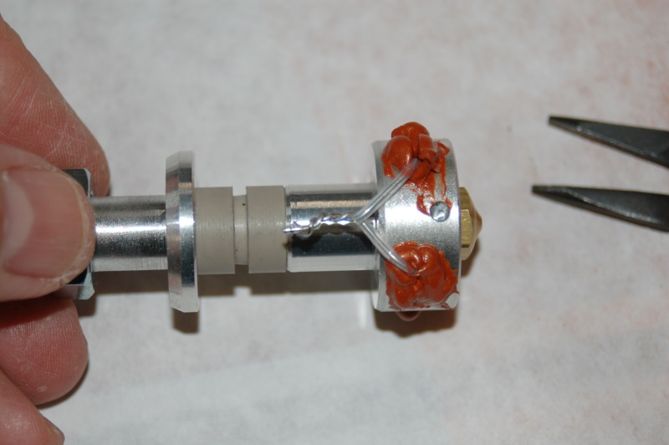Fig. 15-3: Resistor leads twisted together.

When you're done twisting the leads together, clip about 1/16” to 1/8” off each end to clean up the ends a bit. A crimp connector will go on them and you want the best fit you can get.

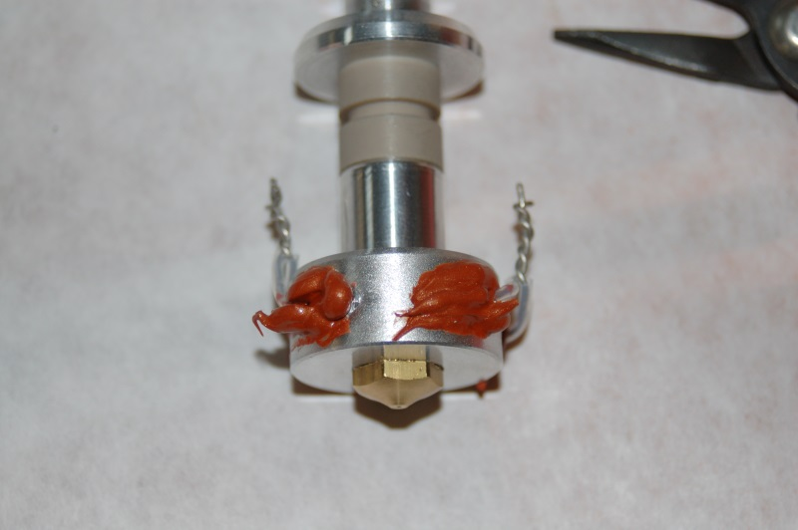Fig. 15-4: Resistor leads ready to crimp.

Because of the temperatures reached by the hot end, we can't use solder to attach the power wires to the resistors. We'll use uninsulated crimp on connectors – if you purchased the recommended ones, you'll use the ones marked “22-16”.

Crimp one connector to each twisted pair of resistor leads as shown below.
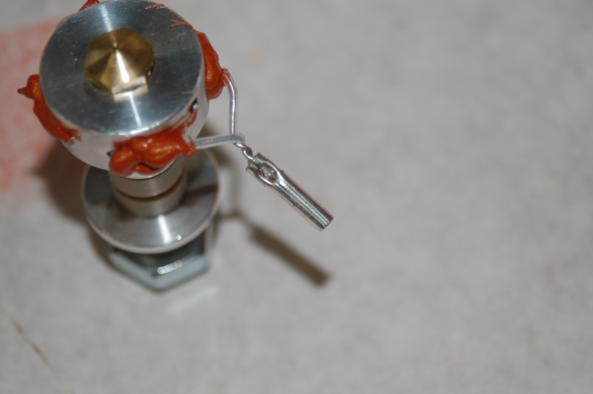Fig. 15-5: Crimp on connector in place.

Note that you only want to crimp it in one place.
The lower portion of the hot end is threaded on to a PEEK barrel that acts like a thermal break. In order to keep repeated heating and cooling cycles from loosening the hot end from the PEEK, wrap the seam with a short length of Kapton tape as shown below.
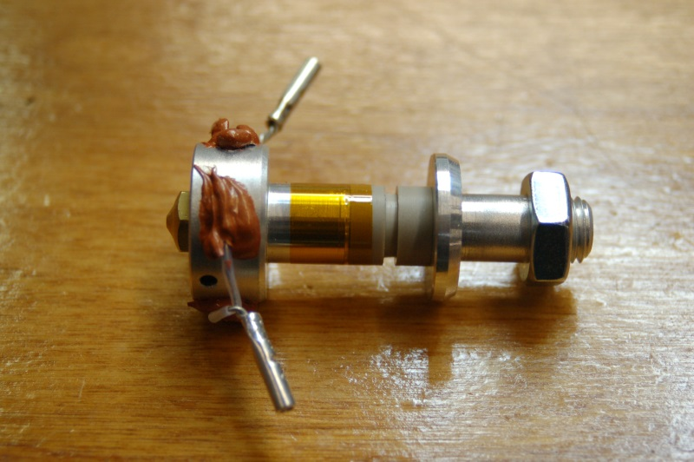Fig. 15-6: Kapton wrap on the PEEK barrel.

I prefer to use a quick disconnect connector on my hot-end and I strongly suggest you do the same. In Section 1 I list two different types – the Deans and XT-60 connectors. My preference is the XT-60, but if you've got Deans on hand, they're well suited to the task. I won't show how to attach them – it should be pretty obvious and if not, there's always Google. :) I'm going with the assumption that you like to be able to change out hot-ends and have installed the connectors of your choice.

Attach a 3” or so length of 16ga wire (one black, one red) to the crimped connectors, and wrap them in Kapton tape to insulate them.
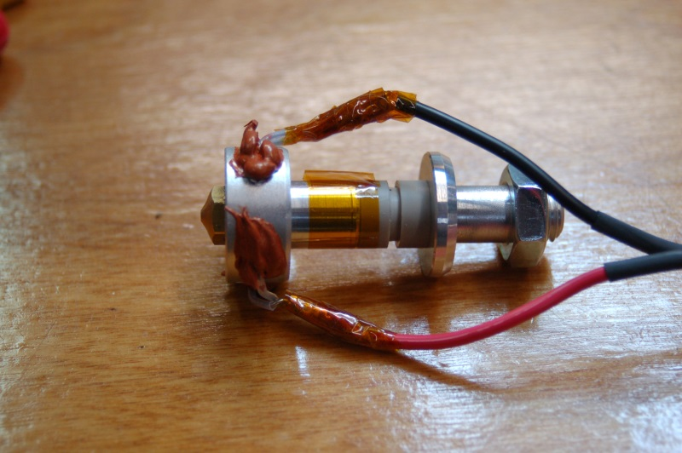Fig. 15-7: Attaching the power leads to the hot end.

Now you need to install the thermistor into the hot end. A thermistor is a tiny temperature sensing device that changes resistance as the temperature around it changes. I cannot stress this enough it's a very delicate component! Please handle it very carefully! The glass bead is fragile and the wire can be brittle if soldered and moved too much.
First, cut two 1” lengths of the included PTFE tubing and slide them over the thermistor leads as shown:
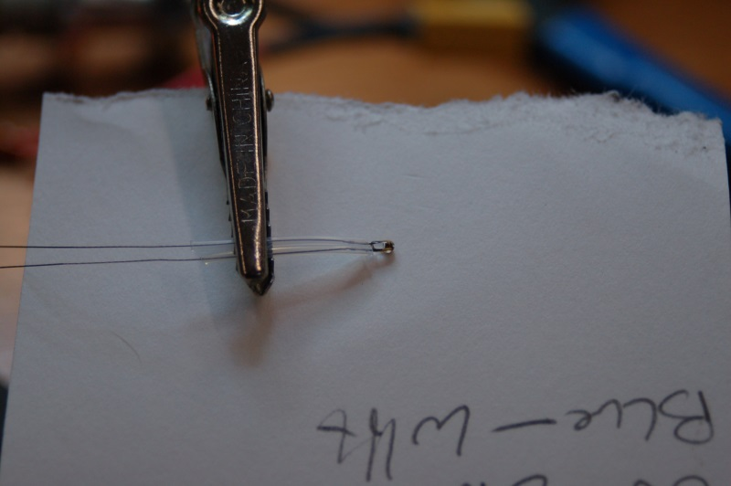Fig. 15-8: Insulating the thermistor leads.

Just like the resistor wiring, I recommend you use a quick disconnect connector. For the thermistor, I recommend using a JST connector like the ones listed in Section 1. You can cut a 2” long section from the wiring supplied for doing the stepper motor extension for this purpose. Thermistors have no polarity, so it doesn't matter how you attach the JST connectors.
Now you can solder your leads to the thermistor. I recommend covering the solder joint with heat shrink tubing. The thermistor wires won't get hot enough to affect it. You'll also see that I taped the leads together with Kapton tape. This is done to give it a bit more protection.
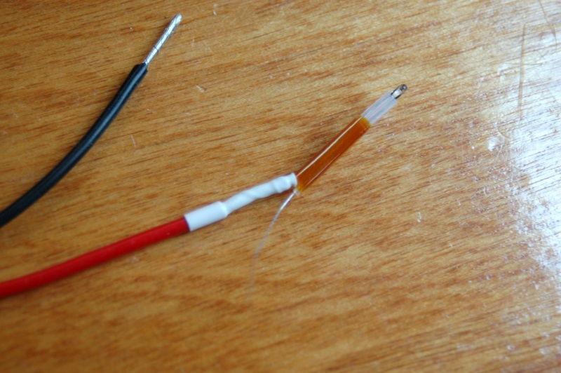Fig. 15-9: Attaching leads to the thermistor.
Be careful when you're soldering this up. The thermistor leads are very brittle and can break easily once soldered.

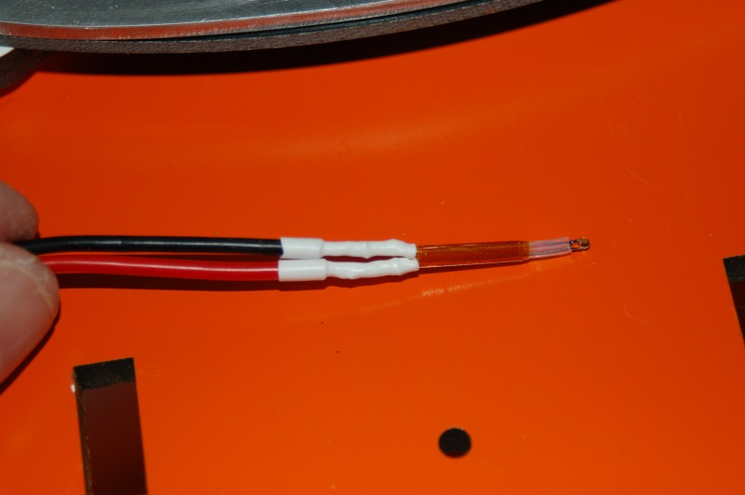Fig. 15-10: Thermistor ready to install.

Once you've got the leads added, I strongly suggest that you use Kapton tape or more heat shrink to bind the two leads together at the joint – this will help prevent flex that could cause the thermistor lead solder joint to fail.

The thermistor is installed in the hot end at the location shown in Fig. 15-11.
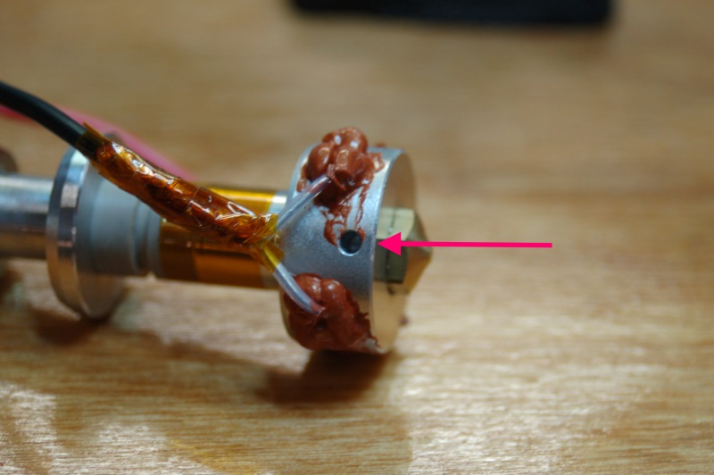Fig. 15-11: Thermistor installation location.

In order to “glue” the thermistor into place, you'll need to coat the sides of the thermistor bead with a small amount of RTV as shown in Fig. 15-12.
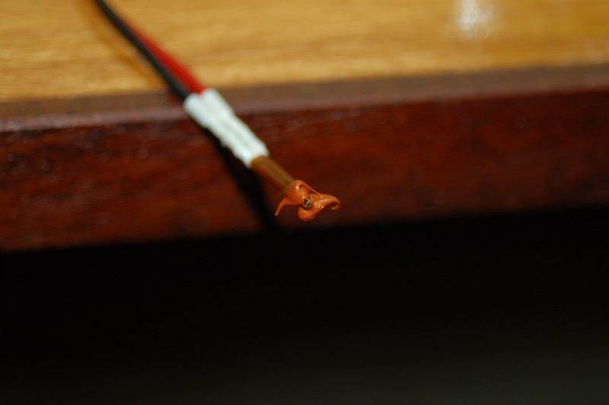Fig. 15-12: RTV applied to the thermistor sides.

The idea here is to leave the tip of the glass bead exposed. This will allow it to come into unobstructed contact with the thermistor port on the hot end.
Wait, you just broke the wires on your thermistor, didn't you? Oh. You didn't? Well I just did.
Fig. 15-12a: D'OH!

So instead of doing the technical writing equivalent of sweeping the bits of broken ceramic under the couch with your foot while smiling and telling your mother you have no idea where her prize vase is, I'm going to show you photos of the thermistor as I actually installed it.
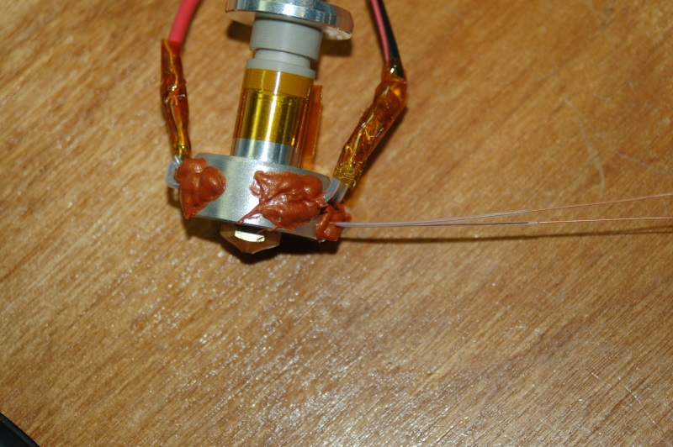Fig. 15-13: Magically repaired (and slightly different) thermistor installed in the hot end.

Please give the RTV time to fully cure before you move on to the next steps.

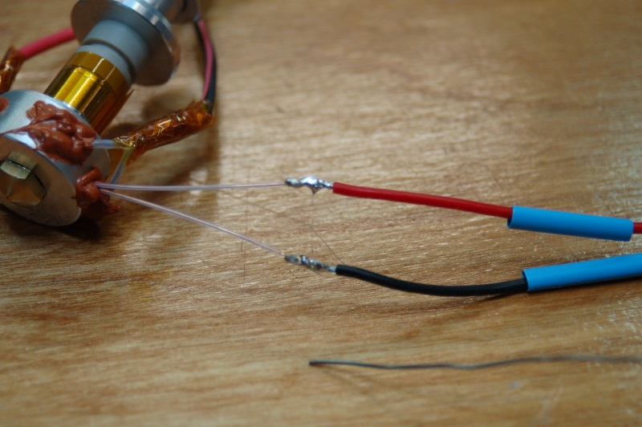Fig. 15-14: Magic thermistor getting JST connector.
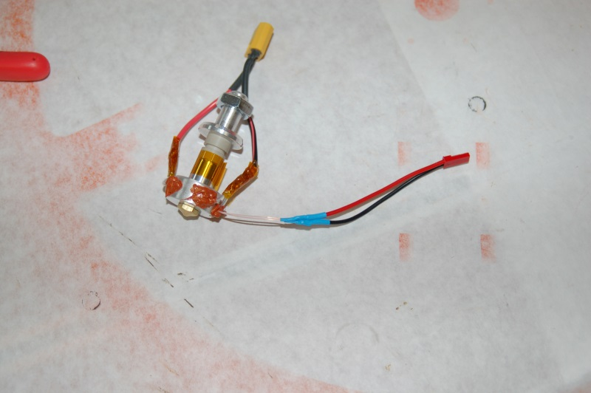Fig. 15-15: Magic thermistor with JST connector in place.

In order to install the hot end, you'll need the Hot End Spacer (P/N: 68324), Hot End Adapter Plate (P/N: 68328), Bowden Hot End PTC Adapter (P/N: 68316), three 2” #6-32 machine screws, three #6 washers, three #6-32 nylon lock nuts and three #6 aluminum spacers.
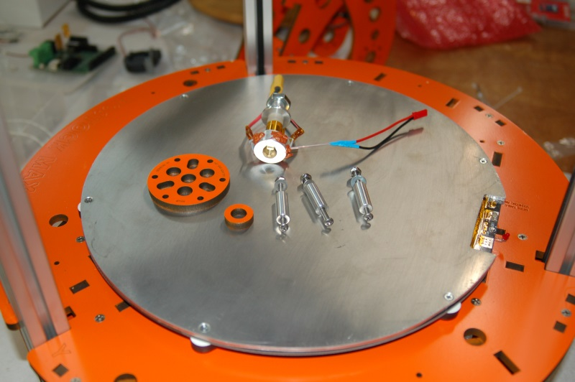Fig. 15-16: Mounting the hot end!

The first step is to mount the hot end adapter plate to the plastic effector platform.
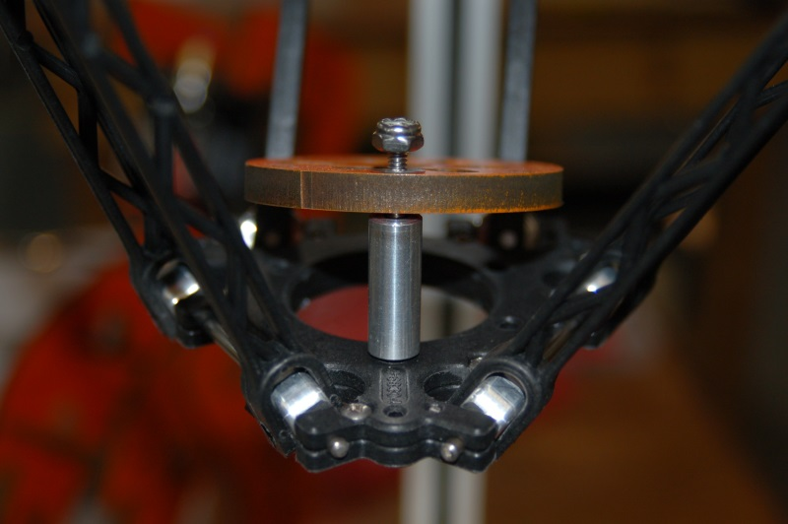Fig. 15-17: Hot end adapter plate.

Insert a 2” #6-32 machine screw from the bottom of the effector plate and then slide on a #6 spacer, followed by the adapter plate, a #6 washer and then a #6-32 nylon lock nut.

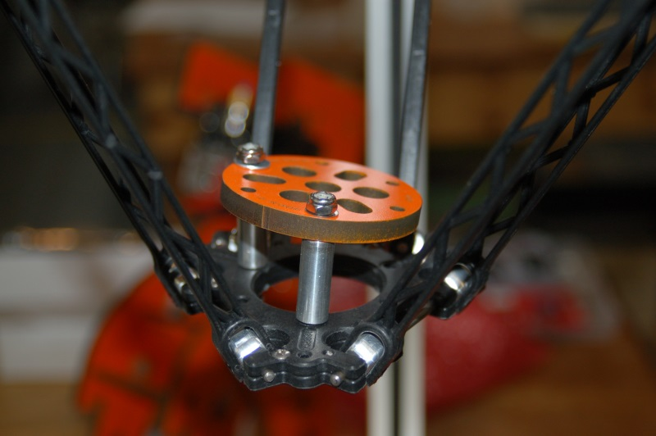Fig. 15-18: Two of the three mounting screws in place.

You'll perform the same process for all three mounting screws.
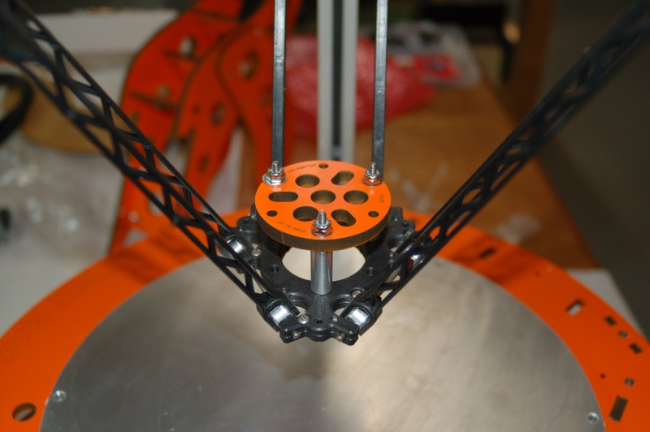Fig. 15-19: Hot end adapter plate installation complete.

Now the hot end needs to be mounted to the hot end adapter plate as shown below.
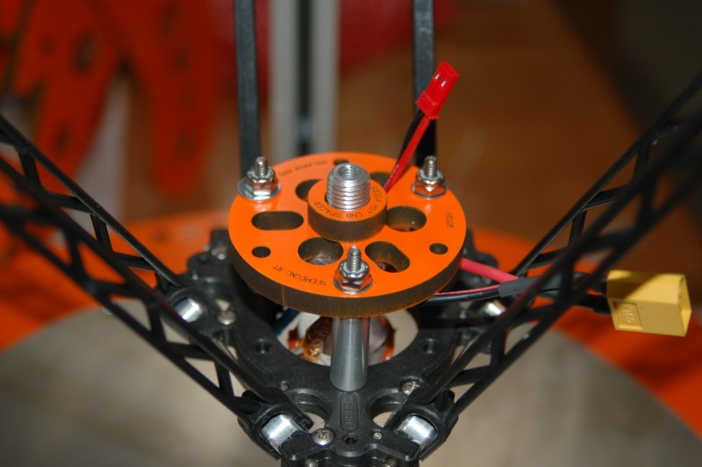Fig. 15-20: Mounting the hot end.

Make sure you also install the small Hot End Spacer as shown above. Route the thermistor wiring through one of the holes in the adapter plate. The power leads for the hot end should be routed outside the adapter.
You'll need an 11/16” open end wrench and a set of large slip-joint pliers. You'll need the pliers to carefully grip the PEEK section of the hot end while you tighten the 11/16” mounting nut on top.
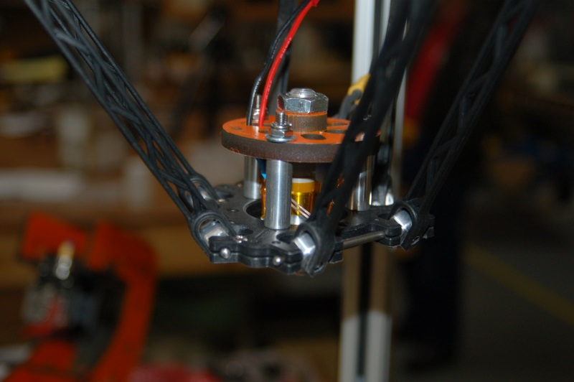Fig. 15-21: Hot end installation completed!

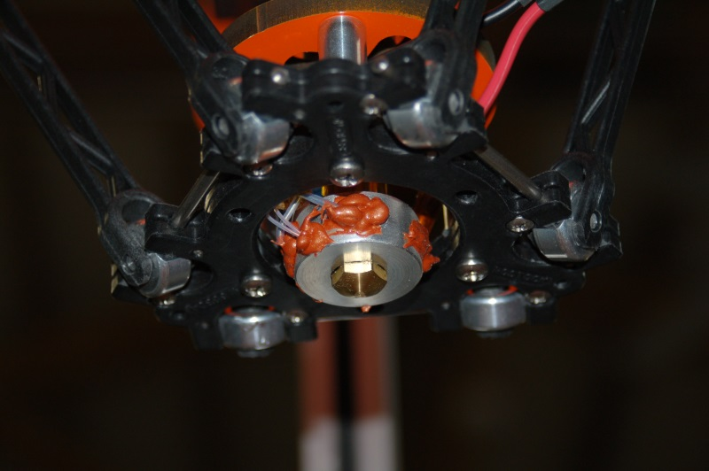Fig. 15-22: Underside view of the installed hot end.

Don't forget to install the push-fit connector for the Bowden tube on to the hot end. Thread it on just finger tight – just enough to compress the O ring a bit. The O ring will prevent the connector from backing out.

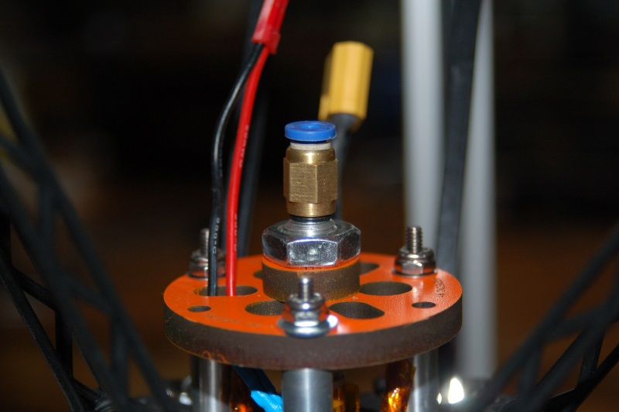Fig. 15-23: Push-fit connector installed.

Now you need to install the bowden tube. The Bowden tube is a long length (roughly 18” or so) of 2.0mm PTFE tubing. This tubing guides the filament from the top of the extruder and into the hot end.
The tube fits into the push-fit connection at the top of the extruder and the one located on the top of the hot end. They're circled below in Fig. 15-24.
Shove the end of the tube into the fitting until it bottoms out. You can remove it by pressing the blue ring at the top of the connector.
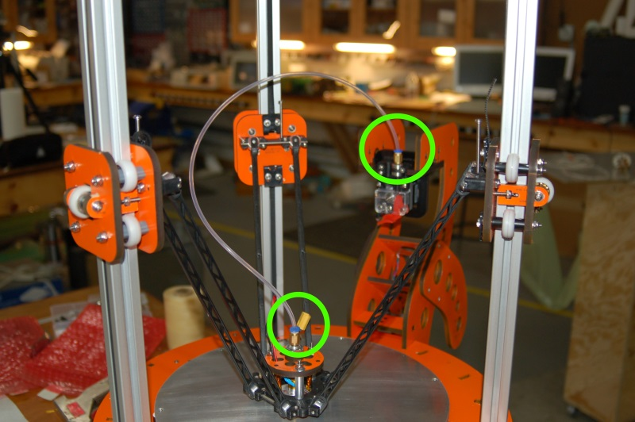Fig. 15-24: Attaching the Bowden tube.

16A – Wiring the Effector Platform, Side Mounted Extruder
Well, you've come a long way and it's finally time to start dealing with the rat's nest of wiring we've created so far in the build. This section is broken into a few parts. Which part pertains to you is dependent on which extruder mount your kit included. The beginning of this section covers items that remain common between the two mounting methods.
The first task I want you to do is attach the power switch to the green & black wires we worked with in Section 13.
Open the electronics door and route the green & black wires along the bottom of the RAMBo, up the inside face of the door and over to the mounting hole in the door marked “Power”. You're trying to get an idea of how much wire you'll need in order to reach this spot when the door is fully opened.
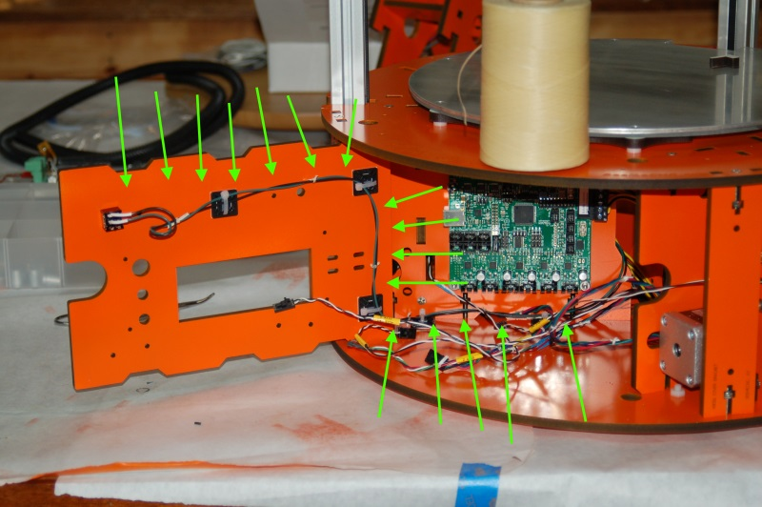Fig. 16-1: Routing the power switch wiring.

Take look at the path highlighted by the arrows in Fig. 16-1. If it helps, take a look at the fig16-1.jpg image in the github repository, or on your local disk if you downloaded this manual as part of an archive file. I recommend using adhesive-backed tie-downs and wire ties in order to manage how the wire moves along the indicated path. It keeps the wiring neat and prevents it from interfering with the door. (https://github.com/seemecnc/RostockMAX/tree/master/ASSEMBLY_MANUAL/figures)
When you've got the right length of wire, solder the wires to the switch as shown in Fig. 16-2. Please use heat shrink tubing in order to prevent accidental shorts.
Note the orientation of the switch bat. It's currently in the “off” position. You can tell when a toggle switch is “on” when you picture an imaginary line drawn along the center of the bat handle intersects with the wire to the outside of the switch.
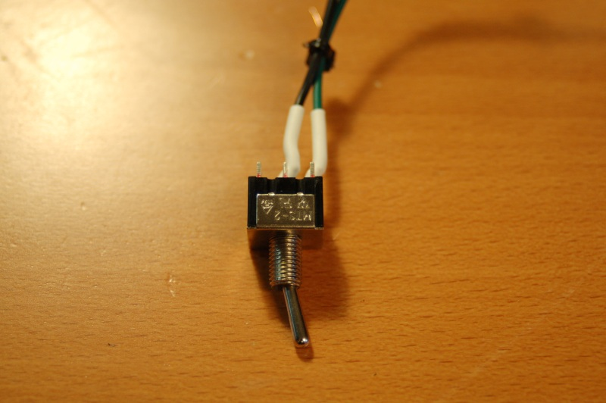Fig. 16-2: Wiring the power switch.

Now you're going to attach the thermistor from the heated bed to position T2 on the RAMBo board. See Fig. 16-3 for the correct position.
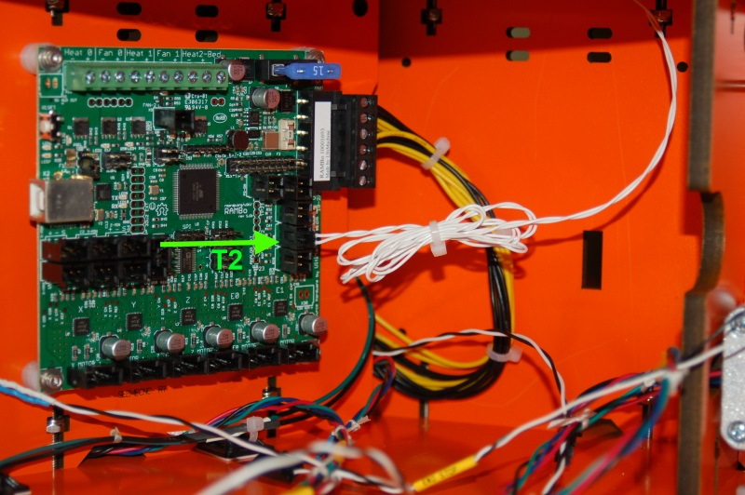Fig. 16-3: Heated bed thermistor connection.

Use a wire tie to clean up the extra wire and go ahead and connect the big power connector to the terminal block in the upper right corner of the RAMBo as shown above.
The heated bed power wires enter the base in what I refer to as the “Y-Axis Bay”. Clean up the wiring by adding wire ties as shown below. (Note that I prefer using waxed lacing cord – it's a better choice for making wiring harnesses than wire ties and a spool of lacing cord can last you YEARS.)
[OPTIONAL]You'll want to install either an XT60 or Deans connector to the heated bed power wires at this time. Space is a premium where the RAMBo is installed and using a quick disconnect connector on the RAMBo power wires will make maintenance and upgrades simpler.
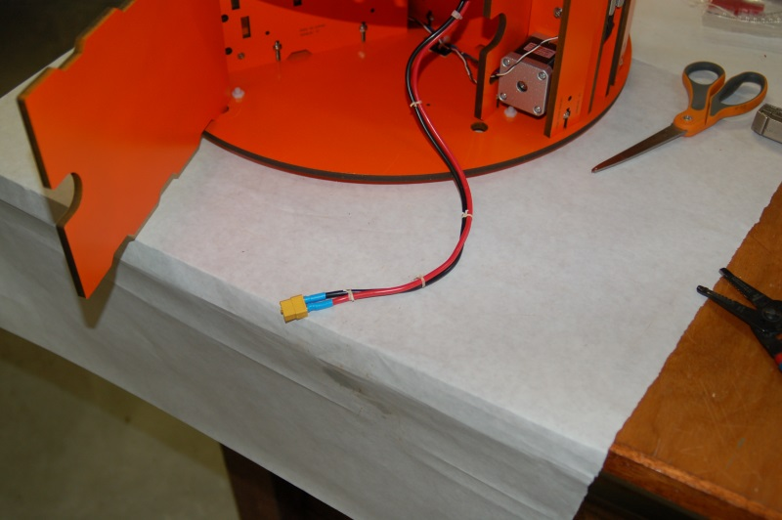Fig. 16-4: Heated bed wiring with quick disconnect installed.

[OPTIONAL] Now you'll need to create a short pigtail with the other mating XT60 or Deans connector and attach it to the terminal block on the RAMBo. Take special care to make sure you're observing the polarity printed on the connector. You don't want to get them backwards!
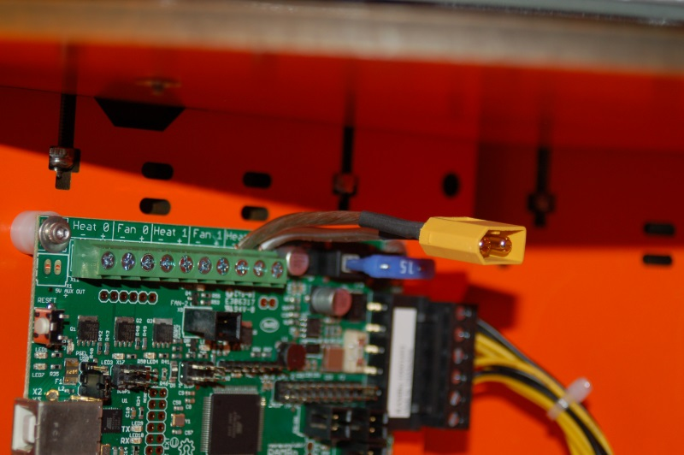Fig. 16-5: Heated bed quick disconnect attached to the RAMBo.

Now route the heated bed power wires through the center of the base as shown below. We'll connect it up later.
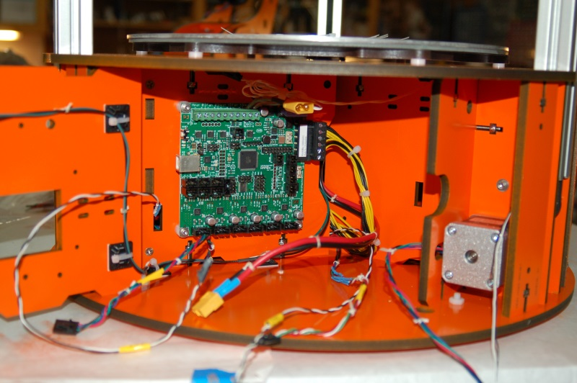Fig. 16-6: Headed bed wires routed to the electronics bay.

If you've got a Rostock MAX with the top mounted extruder, go to Section 16B.

Now it's time to get the hot end and a PEEK fan (if you're installing one) wired up.
You should have some four conductor, 18ga wire included with your kit. This wire is for powering the hot end and one “accessory”. In this case, the accessory is going to be a PEEK fan. (If you plan to print in PLA, you MUST HAVE ONE. It will prevent the PLA from jamming in the hot end due to thermal creep.)
In order to find the optimal length of wire for your installation, clip the wire to the bowden tube using the binder clips included in the kit – you'll want to follow the path shown by the arrows in Fig. 16-7. Route the wire from the hot end to the extruder mount and then down to and through the notch in the Y Axis Bay door, through the center of the base and into the electronics bay. You want to have a few inches of extra wire in order to provide enough to reach the terminal block on the RAMBo and have some extra to allow the wire to flex without binding.
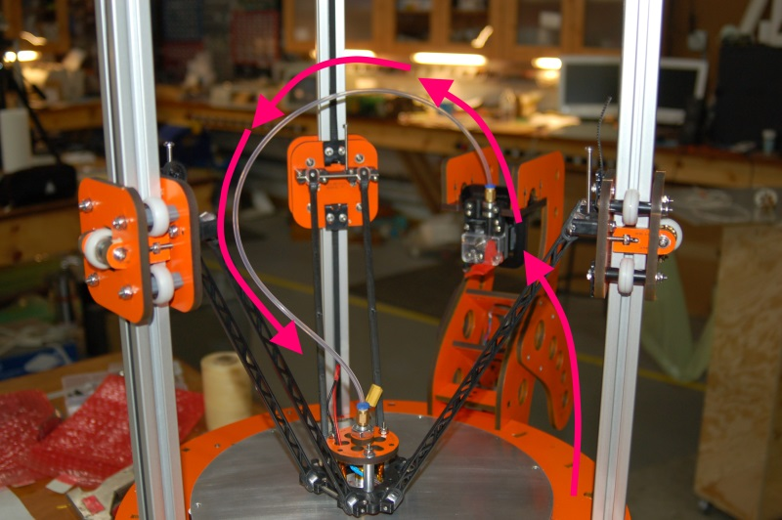Fig. 16-7: Hot end wiring path.

After you've cut the wire to length, cut back about 3” of the gray outer jacket and install the XT60 or Deans quick disconnect connector that mates to the one you used on the hot end heater wiring. Use the red & black wires for this. If you're installing a PEEK fan, attach the appropriate connector to the green and white wires. In my installation, I used white for “+” and green for “-”. Make sure you follow this wiring convention when attaching the connector to your PEEK fan. (Typically, red is “+” and black is “-” on most fans.)
When you've got the connectors added, remove 3” or so of the outer jacket on the other end and route it from the hot end to the electronics bay. Use wire ties to hold it in place. (We'll be adding the hot end thermistor wire to this route in a second.)

Now attach the wire you just ran to the terminal block on the RAMBo as shown below.
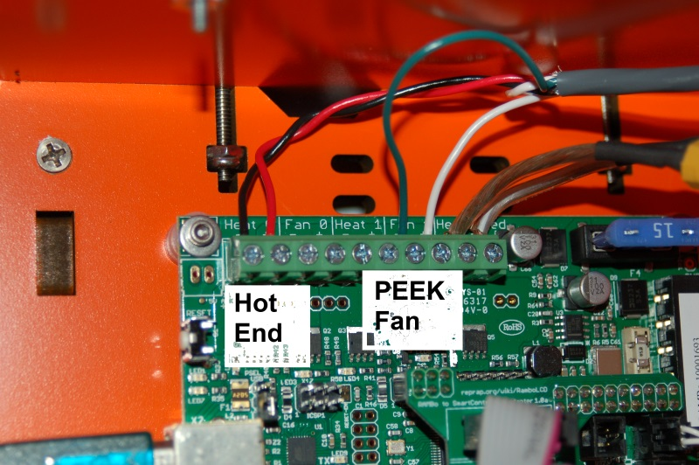Fig. 16-8: Hot end & PEEK fan wiring.

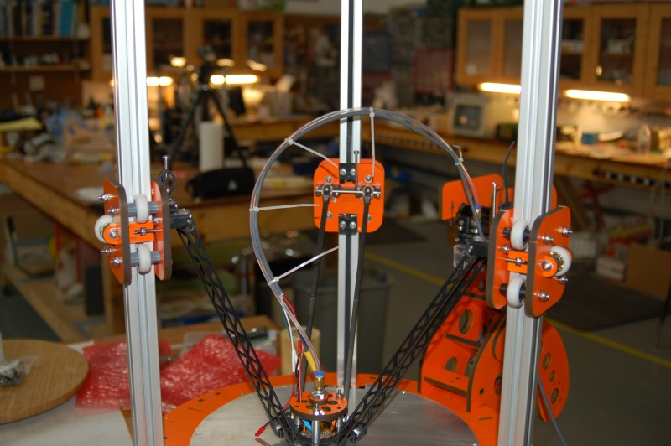Fig. 16-9: Hot end wiring attached.

If you haven't done so already, attach the mating connector to the wiring harness for the hot end thermistor. (If you're not sure what that is, it's identical to the wire you used to connect the heated bed thermistor to the RAMBo – a two wire (both white) harness with a 2 pin locking connector on one end.) Connect the thermistor harness to the thermistor and route the wire along the same path as the hot end and fan power lines.

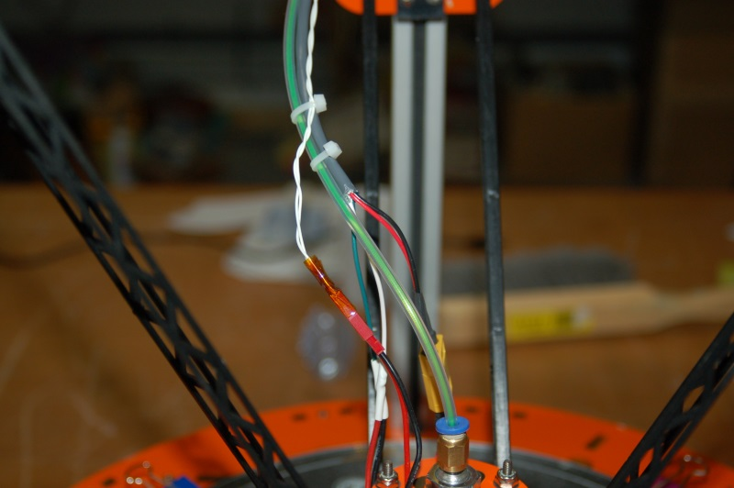Fig. 16-10: Thermistor wiring plugged in.

Now bind up any extra wire to neaten up the bundle and plug the hot end thermistor connector into the top thermistor connector, marked T0 as shown below.
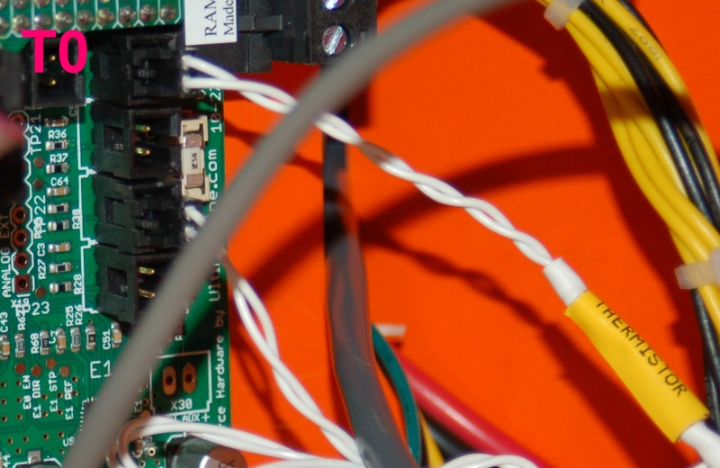Fig. 16-11: Hot end thermistor wiring plugged in.
If you're installing a PEEK fan, mount it as shown in Fig. 16-12. It's just a friction fit, so if it's a bit loose, wrap the fan chassis in a couple of layers of blue tape or Kapton until you get a snug fit.
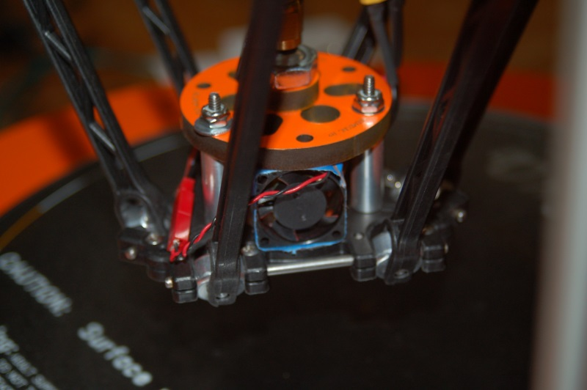Fig. 16-12: PEEK Fan installation.

16B – Wiring the Effector Platform, Top Mounted Extruder
The wiring for the top mounted extruder is different in that the wire path is much longer. The hot end and accessory wiring travels from the RAMBo, across to the base of the Z axis, up the Z-axis tower to the top and then hangs down to the center of the bed. The easiest way to get the right length of wire goes like this;
- Push the effector platform to the bottom of it's travel, leaving it centered in the bed. You may want to put a washcloth under the nozzle to keep it from scratching the Onyx.
- Unroll the 18ga, 4 conductor wire and clip one end to the effector platform.
- String the wire up to the EZStruder and then over to the top of the Z axis tower, then down the tower to the desk and straight across to where the RAMBo is mounted.
This should give you enough wire to do the job. To give you an idea of what the end wire path will look like, see the photo below:
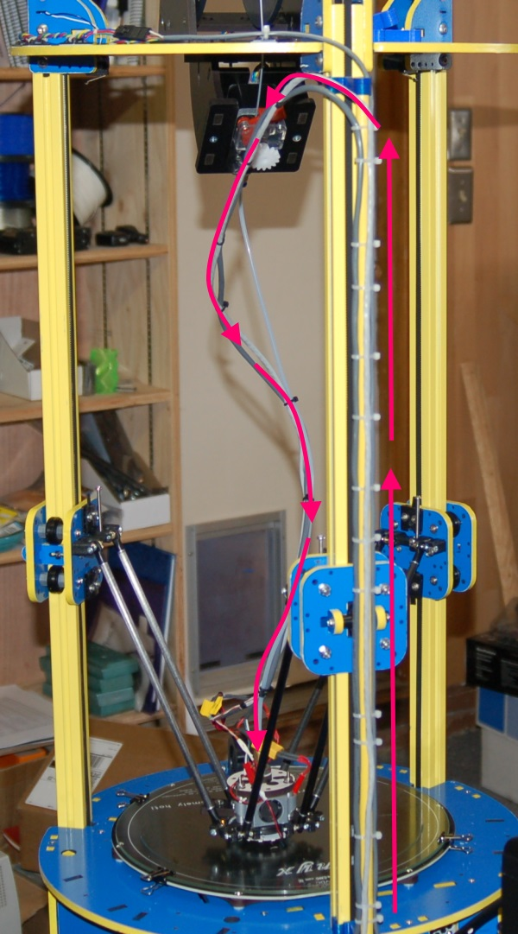Fig. 16B-1: Completed wiring path.

You'll want to cut a length of the 24ga four conductor wire you purchased to match the length of 18ga you just cut. The 24ga wire will be used to connect the thermistor as well as provide power for a layer fan if you wish to install one. The supplied thermistor wires are too short to follow the new wiring path, so we must supply our own.
After you've cut the wire to length, cut back about 3” of the gray outer jacket and install the XT60 or Deans quick disconnect connector that mates to the one you used on the hot end heater wiring. Use the red & black wires for this. If you're installing a PEEK fan, attach the appropriate connector to the green and white wires. In my installation, I used white for “+” and green for “-”. Make sure you follow this wiring convention when attaching the connector to your PEEK fan. (Typically, red is “+” and black is “-” on most fans.)
When you've got the connectors added, remove 3” or so of the outer jacket on the other end and route it from the hot end, to the top of the Z axis, down to the Y axis door and into the electronics bay. Use wire ties to hold it in place. (We'll be adding the hot end thermistor wire to this route in a second.)
In order to wire up the thermistor to the RAMBo using the new wire, you're going to need to add the 2 pin connector from the supplied thermistor wire to the new 24ga wire you're using now.
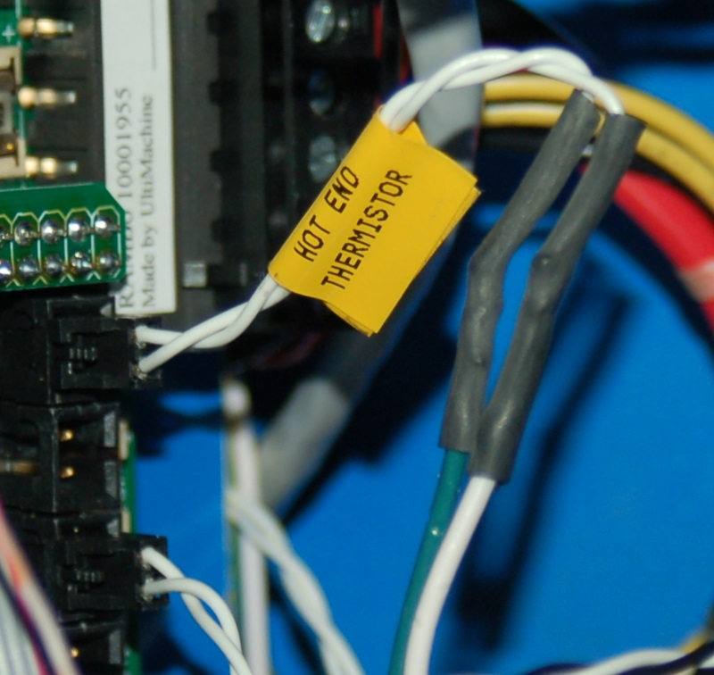Fig. 16B-2: Thermistor connector spliced into new cable.

Just clip off the connector, leaving yourself a few inches of wire to work with. Solder it to thew new wire and you're done. It doesn't matter the polarity or which color you use, just as long as you're consistent on the other end of the wire. A thermistor is basically a temperature controlled resistor and as such as no “polarity” anyway. On the other end of the wire, crimp on the mating connector to the one you'd installed on the thermistor itself. Ignore the thermistor wire colors you see here – they won't match what you're doing as mine is wired slightly differently.
Now go ahead and connect up the hot end and PEEK fan wires as shown:
Fig. 16B-4: Hot end and PEEK Fan wired.
Route the 24ga thermistor wire just like the hot end wire and insert the 2 pin connector into the T0 location as shown in Fig. 16B-5:
Fig. 16B-5: Connecting the Thermistor to the RAMBo
If you're installing a PEEK fan, mount it as shown in Fig. 16B-6. It's just a friction fit, so if it's a bit loose, wrap the fan chassis in a couple of layers of blue tape or Kapton until you get a snug fit.
Fig. 16B-6: Installing the PEEK fan.
Note that once you have your printer calibrated, I recommend printing the SeeMeCNC Fan Shroud, which can be found on the SeeMeCNC Git repository: https://github.com/seemecnc/RostockMAX/tree/master/PRINTED_ADDONS

The hot end and thermistor cables should be wire tied to the bowden tube that runs from the hot end to the extruder. This will support them until you've got the wire management parts printed and installed. The extension wire for the EZStruder stepper should follow the same path along the Z axis tower that the hot end and thermistor cables do. Route it through the access door on the Y axis and into the RAMBo bay.

16C – Completing the Wiring

Now you need to connect the three end stop leads and the four stepper motor connections.
Each position is clearly marked in Fig. 16C-1. Each wire should reach its respective connection point without having to be stretched tight. If this is the case for any of them, please splice in an extension or re-route the wire to provide enough slack for the wire to be connected without straining it. Note that “E” is the location for the extruder stepper motor.
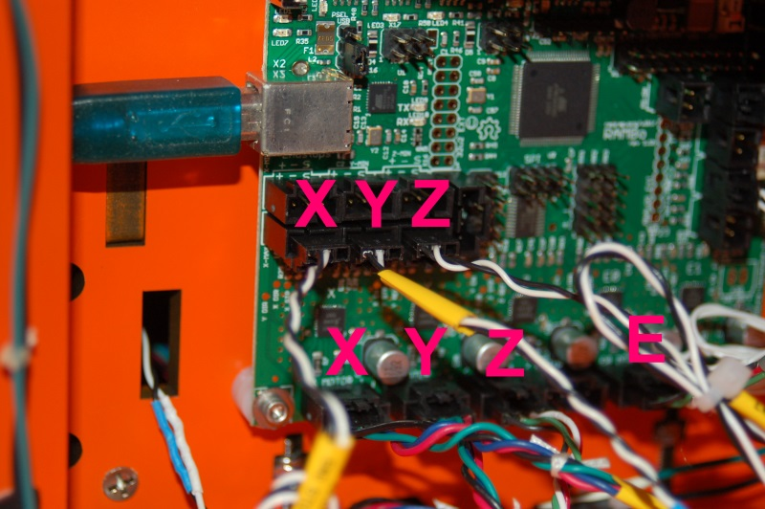Fig. 16C-1:End stop and stepper motor connections.
Now the last thing we've got to do is install the LCD panel!
Because of a few design issues, this can be a little bit tricky, but it's very straightforward. To mount the LCD and it's faceplate, you'll need four #4 5/8” flat head wood screws.
Alternately, you can friction fit the LCD into place and use a bit of hot glue or rubber cement to affix the LCD faceplate in place. This is a good alternative to using the screws as shown below.

First, slide the right side mounting plate on to the right edge of the LCD panel. You want to make sure that the outside edge of the circuit board is flush with the outside face of the mounting plate. Draw two pencil lines that match where the mounting holes in the LCD panel are located.
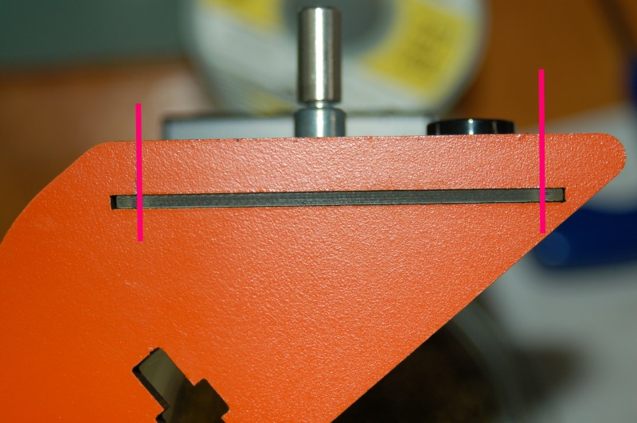Fig. 16C-2: Mounting hole alignment marks.

Transfer the two lines to the top of the mounting plate and then transfer the marks to the left side mounting plate. Then drill two 7/64” holes in each, about 1/4” past the bottom of the circuit board slot. It was recently pointed out that a 7/64” hole is small enough to allow the screws to grip, but has a much smaller chance of splitting the melamine.
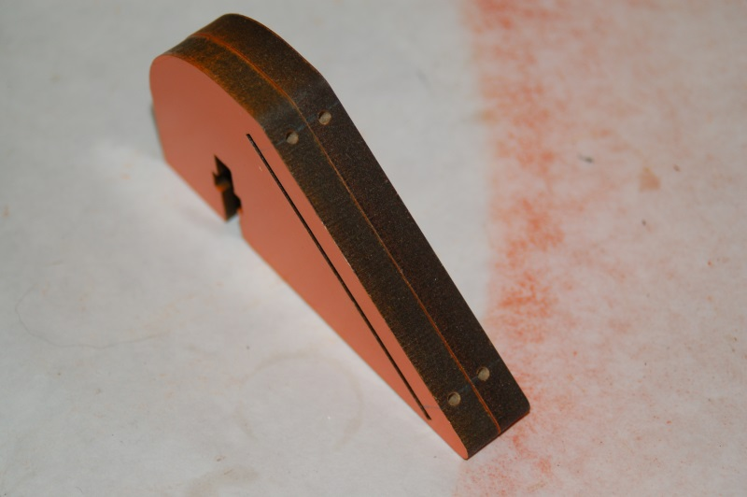Fig. 16C-3:Pilot holes for mounting the LCD panel.

I'll warn you right now – the melamine will split when you insert the screw. That's just the nature of the material. If you install the screws carefully, you can minimize the splitting problem.
Now you want to countersink the four mounting holes in the LCD face plate as shown below:
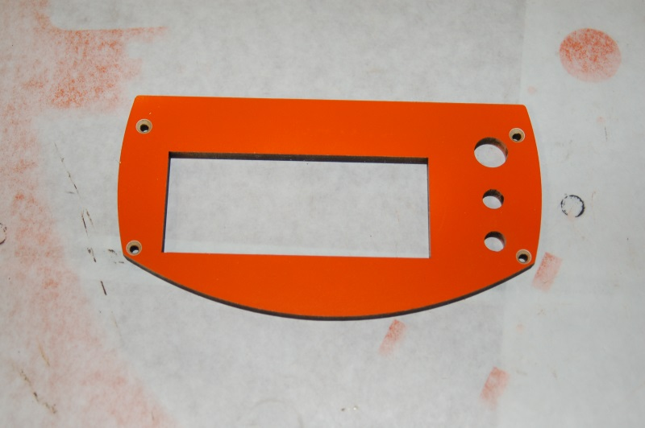Fig. 16C-4: Countersunk mounting holes.

If you don't have a countersink, you can use #4 pan head screws instead of the flat head, but I recommend getting a countersink.
Insert the LCD panel into the right hand mount and install the two screws for that side.
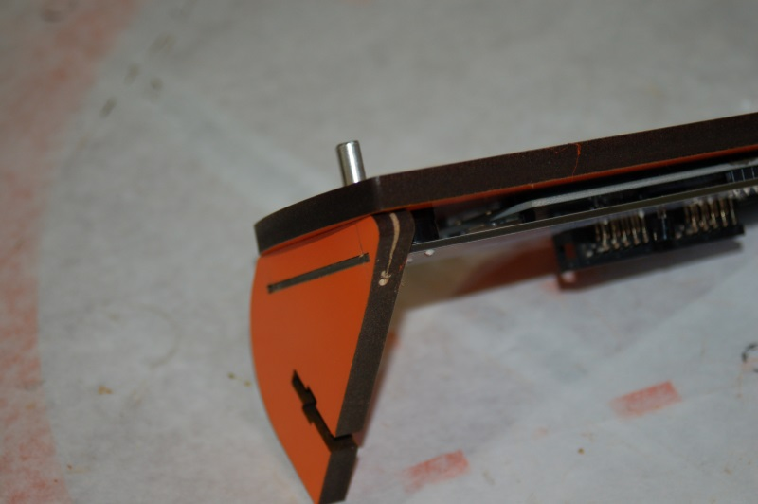Fig. 16C-5: Right side installed.

You'll notice that the material is split on the upper screw. This is unfortunate, but there just isn't enough material there to take the screws intrusion into the material, even with a pilot hole.
The left side is a bit odd. The SD card slot is wide enough for the connector on the circuit board, but it's not wide enough to clear the two solder tabs that hold the connector in place. This results in a rather...odd mounting of the left side.
As you can see below, the two screws don't actually hit the left side mount. This isn't a fatal issue, it's just annoying. :)
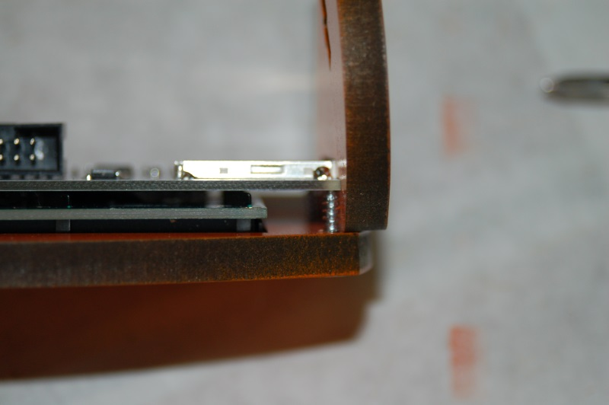Fig. 16C-6: Mounting the left side.

This becomes less of a problem once the LCD is attached to the electronics bay door. The LCD panel mounts using two #6-32 nylon lock nuts and two #6, 1” long flat head screws. The nut capture pockets are a bit loose, so use a bit of tape to hold them in place until you've got the whole assembly installed on the door.
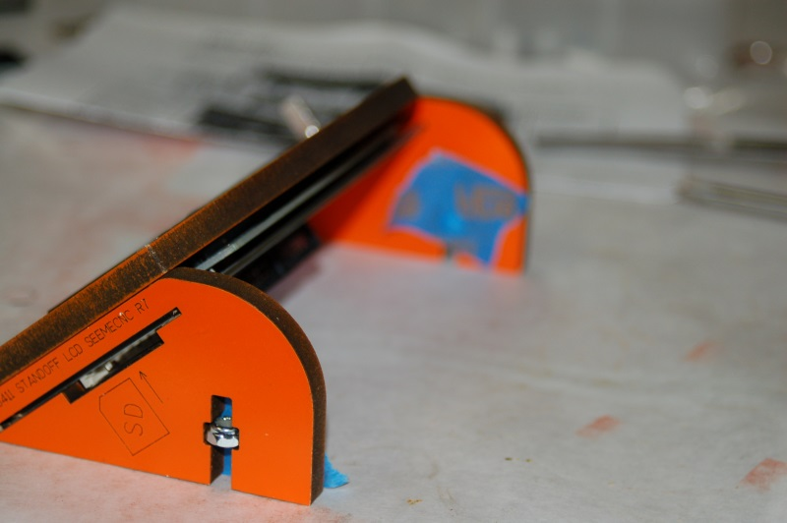Fig. 16C-7: Attaching the nylon lock nuts.

On the back of the LCD panel, label the connectors “A” and “B” and then attach the two ribbon cables. Mark the cables “A” and “B” to match the position they're connected to.
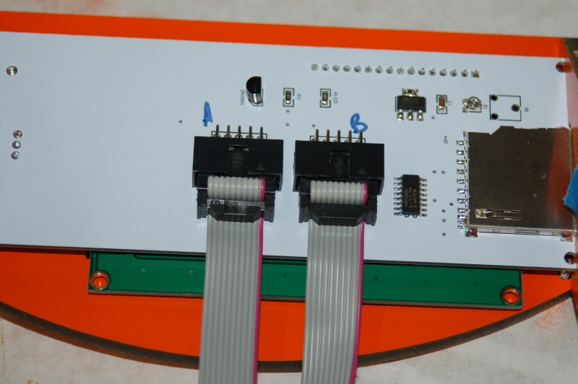Fig. 16C-8: Marking the ribbon cable locations.

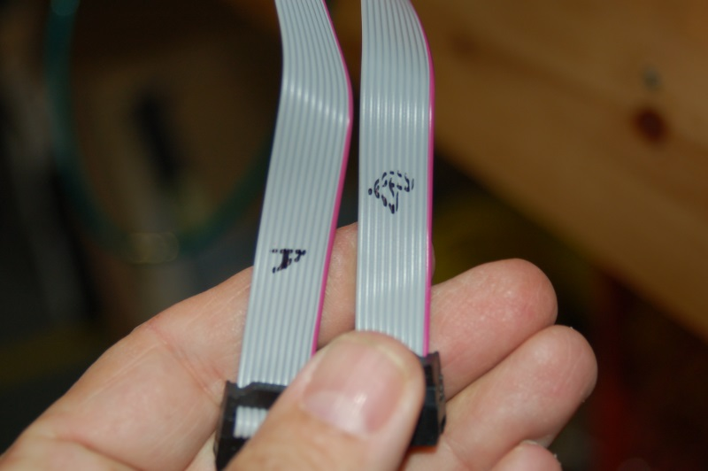Fig. 16C-9: Marked cables.

Now thread the ribbon cables through the door and mount the LCD assembly with the two #6-32 flat head screws as shown below.
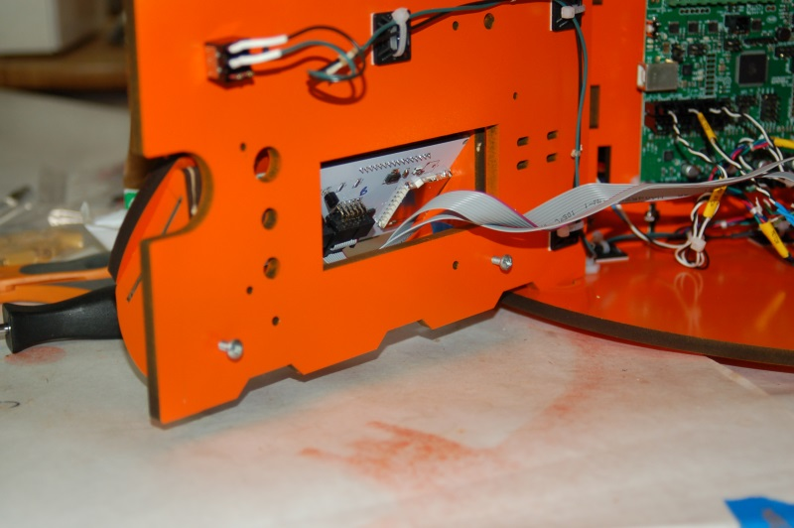Fig. 16C-10: Attaching the LCD panel to the electronics door.

Take the RAMBo to SmartController adapter you assembled in Section 13 and mark the connections as “A” and “B” as shown below.
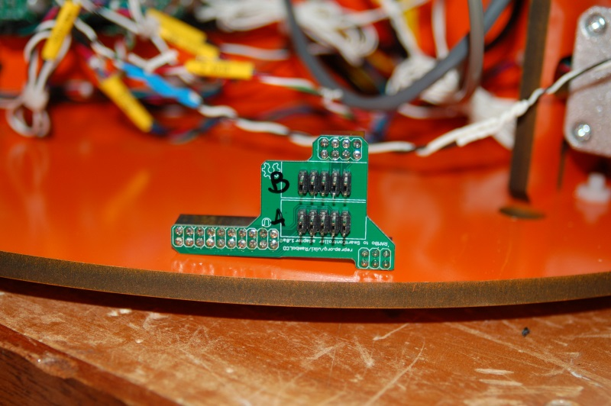Fig. 16C-11: Adapter board assembled & marked.

Let's start by adding the “B” cable to the adapter first.
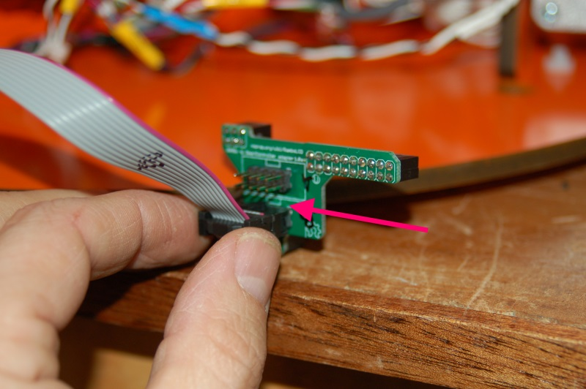Fig. 16C-12: Installing the "B" cable.

There is a small graphic or “silk screen” on the circuit board that shows the orientation of the cable. The ribbon cable connector has a plastic “key” on one side – this key should face the little rectangular drawing on the circuit board as shown above.
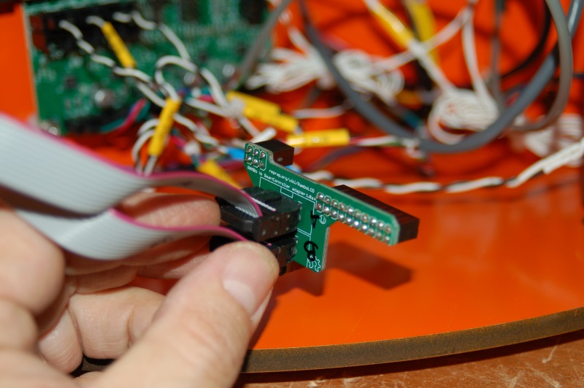Fig. 16C-13: Installing the "A" cable.

Install the adapter on the RAMBo in the same location as the one you were shown in the assembly video and close the door.

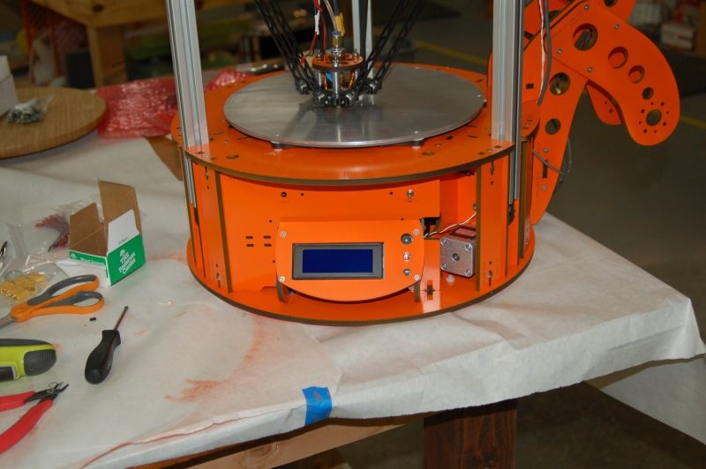Fig. 16C-14: DONE!
Congratulations! You're now the proud owner of a completed Rostock MAX 3D printer! Take a load off, get a beer, a Coke or whatever. Grab your significant other and take them out for dinner in appreciation of them putting up with you throwing things and saying lots of bad words during the construction process.
Next up, we'll get the required software installed and get your beautiful new machine calibrated so you can happily join the exalted ranks of crazy, grinning people that print inexplicable plastic objects. (Why? Because we can!)

17 – Software Installation and Configuration
Okay, you’ve managed to get this far, so it’s time to get this old beastie printing little green squirrels (or whatever other “legitimate” use you have for this fancy thing). The instructions provided in this guide are centered on the Windows operating system – that’s because it is what I have. Details for Linux & MacOS should be on the Rostock MAX Wiki page.
In order to communicate with the RAMBo, you’ll need to download the driver for the board.
This driver is essentially just an INF file that Windows needs to figure out what’s going on with the new peripheral you’ve just hooked up.
Download the USB Driver zip file from this location:
http://www.reprap.org/wiki/File:RAMBo_USBdriver.zip
The driver is now “signed”. This means that when you install it, you should get no security warnings due to having an un-signed driver package.
If you haven't done so already, connect the Rostock MAX to your computer using the included USB cable and turn the Rostock MAX on using the power switch you installed previously.
Unzip the file to a temp directory or other place that you know the location of. For Windows users (and likely XP, Windows 8 and Vista users as well), plug in the RAMBo and let Windows “fail” to find the correct driver for the board. Open up the device manager by right-clicking on “Computer” or “My Computer” and select “Properties” followed by “Device Manager”. Scroll down to the “Unknown Devices” entry and right-click on the RAMBo entry. Choose “Update Driver” and then “Browse my computer for driver software” (or something similar to this). Choose “Let me pick from a list of device drivers on my computer”, then click the button for “Have Disk”. Browse to where you unzipped the file you downloaded and then click “OK”. It may complain (depending on OS) that the driver isn’t signed –allow it to install it anyway. That’s all there is to it. The RAMBo will now appear on your computer as a standard serial port. On my computer it appeared as COM6 – it will most likely be different on yours.
There are some simple changes you'll need to make to the RAMBo's firmware as part of the calibration and configuration process. In order to send your changes to the RAMBo, you'll need to download and install the Arduino IDE. The firmware on the RAMBo is called Repetier and requires the version of the Arduino IDE to be at least 1.0. You can download the current release of the Arduino IDE from this location: http://arduino.cc/en/Main/Software. At the time of this writing, version 1.0.5 was the current stable release.
The firmware for the Rostock MAX can be downloaded from this location:
https://github.com/seemecnc/RostockMAX/tree/master/FIRMWARE.
If you click on the “Zip” button on that page, it will create a zip file of the current code and you can download it all in one go instead of picking each file. I would recommend you download the firmware and unzip it so you can tweak it if need be.

The “host” software of choice for the Rostock MAX is called Repetier-Host.
Repetier-Host is a full featured and multi-platform host interface for 3D printers. There are other host interfaces out there such as Octoprint and Pronterface, but this guide will only cover Repetier-Host.
Repetier-Host can be downloaded from http://repetier.com. Click on the “Download” link.
The Repetier-Host installer for Windows also includes the latest stable release of Slic3r, which is the tool we'll be using to “slice” 3D models into a form that the Rostock MAX can print.
The RAMBo controller in your Rostock MAX comes with a “default” installation of the Repetier firmware (the controller side “companion” to Repetier-Host).
Before we can run Repetier-Host for the first time, we need to know what communications port the RAMBo has appeared as. In order to discover this bit of information, you'll need to open up Device Manager (right click on My Computer, click “Properties” and then click “Device Manager”). You'll get a window that looks something like this:
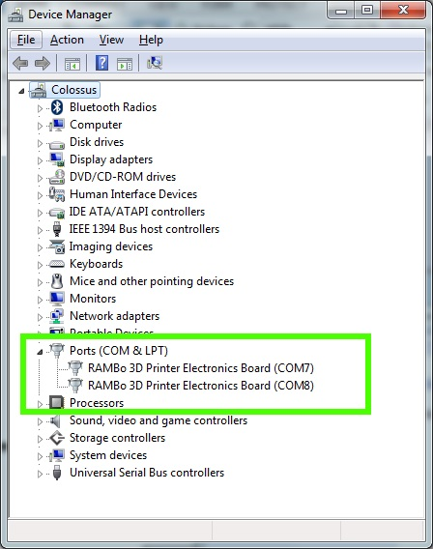Fig. 17-1:Locating RAMBo in the Device Manager.

The green box highlights the entries we're interested in. Because I've got two printers currently connected to my machine, there's two entries in there for RAMBo controllers. The data you need is the bit at the end – in this case it's “COM8”. Write this down – we'll need it in order to tell Repetier-Host what port to contact the RAMBo on.
Start Repetier-Host and click on Config->Printer Settings. See Fig. 17-2 for an example of how that screen looks.
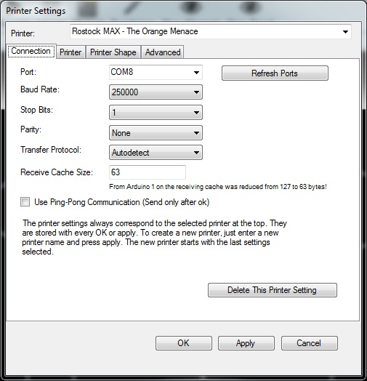

The first thing I want you to do is name the configuration for your printer. You can do this by clicking in the “Printer:” drop-down shown above. It will typically start as “default”, but you can change that to whatever you like. As you can see, I named this configuration “Rostock MAX – The Orange Menace” (for obvious reasons).
You'll want to change the “Port:” selection to match the entry you found previously while exploring the Device Manager. The “Baud Rate:” and remaining fields should be set as they are shown above. Don't forget to click the “Apply” button in order to save the changes you've just made!
Now click on the “Printer” tab:
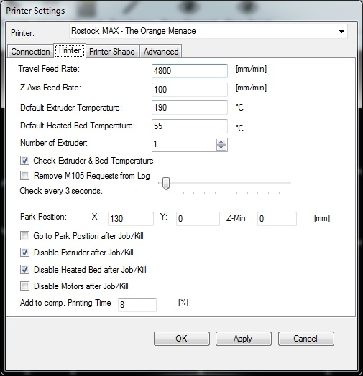Fig. 17-3:Configuring the basics.

You'll want to change all the fields in your Printer tab to match the values I have set above in Fig. 17-3. You'll learn over time what each of these different options do, but for now just set them as I have them. Click on the “Apply” button and we'll move on

Now click on the “Printer Shape” tab:
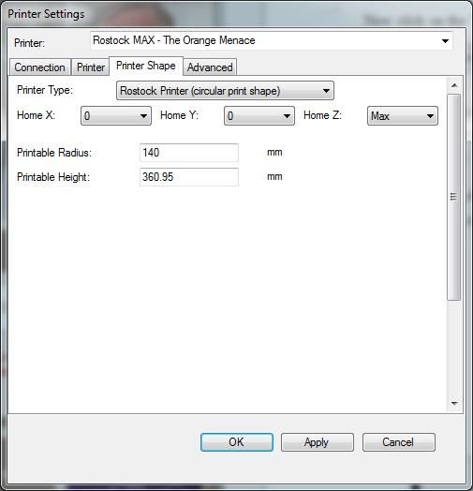Fig. 17-4: Printer Shape.

Click on the “Printer Type:” drop-down and select “Rostock Printer (circular print shape)”. That selection should change the Printer Shape tab to look similar to Fig. 17-4 above. The “Printable Height” field is one we'll be coming back to later on.
Go ahead and click on the “OK” button to save your changes and dismiss the configuration dialog.

Now it's time to test the machine! Click on the “Connect” button in Repetier-Host – it's located in the upper left corner of the window, right under the “File” menu bar item.
When you connect successfully, you should see something very similar to Fig. 17-5 in the Repetier-Host log window.
Fig. 17-5: Connecting to the printer for the first time.
The text is a bit hard to read, so I've included the raw information below.
08:50:21.420 : start
08:50:21.592 : External Reset
08:50:21.643 : FIRMWARE_NAME:RepetierMAX0.80 FIRMWARE_URL:https://github.com/seemecnc/RepetierMAX PROTOCOL_VERSION:1.0 MACHINE_TYPE:RostockMAX EXTRUDER_COUNT:1 REPETIER_PROTOCOL:2
08:50:21.643 : Printed filament:43.60 m
08:50:21.643 : Printing time:0 days 7 hours 11 min
When you connect to the Rostock MAX, the Repetier firmware will tell you what version it is, the link to where you can find the code, how much filament you've consumed so far and how long the printer has been printing. The last two values are stored in the RAMBo's EEPROM (non-volatile storage) so you can clear them if you want to.
If Repetier-Host is unable to connect, go back into the printer configuration and make sure you've chose the COM port that matches the RAMBo entry in your Device Manager listing.
Next, we're going to do a few tests to ensure that the Rostock MAX is ready to start printing!

Click on the “Manual Control” tab that's located in the right half of the Repetier-Host display window:
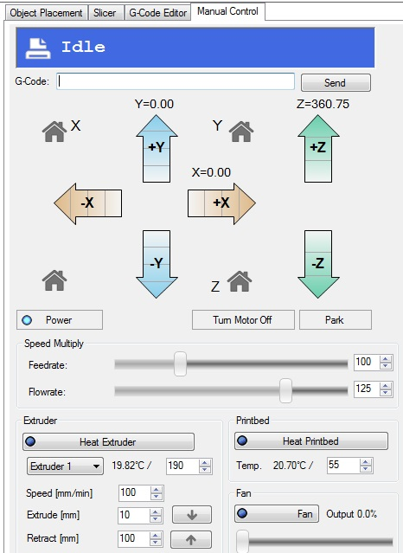Fig. 17-6: Manual Control Panel.

This is the Manual Control Panel and is the interface you'll use most often while working with the Rostock MAX. From here you can home the machine, move it around the work area, heat the hot end or heated bed, turn on fans, etc.

The next tests you're going to run make frequent use of the “G-Code:” input area on the Manual Control Panel. This is how you send commands directly to the RAMBo. Any time you see me write “Send the …. command”, I'm referring to you typing out the command exactly as written in the G-Code input box and press the ENTER key to send the command to the RAMBo.
The first test that you need to perform is on the end stop (or “limit”) switches that you installed on each Idler Bracket.
In order to test them, click your mouse in the “G-Code:” box and type: M119 and then press ENTER. Make sure that the end stop adjustment screws are not in contact with the switches. If they are, move the platform down by hand a little bit to get them to disengage the switches.
In the log window, you should see the following text appear:
x_max:L y_max:L z_max:L
This would indicate that all three end-stop switches have not been pressed. If you see anything different, please check your wiring! Now I want you to hold down the switch lever for the X axis and re-run the M119 command. You should see the x_max value change to “H”. Do this for the Y and Z axes. This will ensure the end stop switches are functioning – this is very important for the next step.
The next test involves checking the correct wiring of the stepper motors. You're going to issue a “G28” command which tells the machine to move all three axes up until the end stop adjustment screws engage the end stop switches. BEFORE you run this command, I want you to have one hand on the power switch! If the axes begin to travel down when you send G28, turn off the power IMMEDIATELY! You don't want to damage the belts or the heated bed by ramming the hot end into it.
If the steppers are going the wrong direction, there's two simple ways to fix the problem. The first method involves changing the wiring on the stepper motor. Swapping the positions of the first two (pins 1 and 2) wires on each stepper motor connector will change their direction of travel. The sockets can be removed by pressing on the release tab that's accessible via a tiny square hole located over every socket. Gently press down on the tab with a sharp pin or tiny jeweler's screwdriver and carefully withdraw the socket by pulling on its wire. Don't pull too hard or you'll pull the wire out of the socket. Much yelling and cursing will then occur.
If you don't feel up to that, you can change how the firmware talks to the stepper motors.
In order to make the firmware changes, you'll need to start up the Arduino IDE and then open up the “repetier.ino” file from where you unpacked the zip file you downloaded.
Use the tabs across the edit window to bring up “Configuration.h”. You'll want to search the file for the following section text:
#define INVERT_X_DIR true
#define INVERT_Y_DIR true
#define INVERT_Z_DIR true
Your INVERT values may not match what you see above, but what you want to do is make them the opposite of whatever they currently are. If they're true, make them false, and vice-verse.
I should mention that you should only change the INVERT options for those axes that are actually traveling in the wrong direction!
Save your changes.
Now we need to tell the Arduino IDE how to talk to the RAMBo. Before you we do this however, you'll need to click the “Disconnect” button in Repetier-Host. The Arduino IDE cannot talk to the RAMBo board if Repetier-Host is connected to it.
In the Arduino IDE, click Tools->Board and pick the entry marked “Arduino Mega 2560 or Mega ADK”. This tells the IDE what chip it needs to generate code for.
Next, pick the correct serial port – do this by clicking Tools->Serial Port and then choose the COM port that your RAMBo is connected as.
To compile and upload the new changes to the RAMBo, just click the “Upload” button – it's the second icon to the right in the Arduino IDE toolbar (it's an arrow pointing to the right).
After a short period of time, you should see the message “Done uploading.” in the blue bar that's right above the log window in the Arduino IDE. If you see an error, please post a message describing the error on the SeeMeCNC forum and we'll get you straightened out as quick as possible.
The next test involves moving the axes around to make sure they're free and clear and there's no “bad” noises going on.
Issue a G28 command – the axes should travel all the way up and “bounce” off the limit switches.
Send “G0 Z300 F3500”. This will move the effector platform down a few centimeters. The idea is to get them off the end stops so we can move things around a bit.
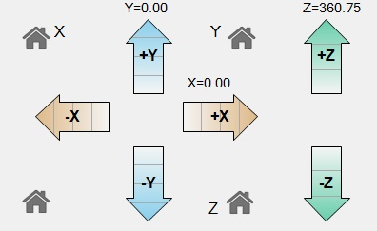Fig. 17-7: The axis controls.

Fig. 17-7 shows the manual controls you have for moving the machine around. Each movement arrow is broken up into four sections. Each section represents a unit of motion. Hover your mouse over one of the arrows and the center will display the amount of motion it will cause when clicked.

The manual panel also has four “house” icons that are used to “home” the axes.
UNDER NO CIRCUMSTANCES SHOULD YOU CLICK ON THE “HOME X” OR “HOME Y” ICONS! THERE IS A BUG IN THE REPETIER-HOST SOFTWARE THAT WILL DRIVE THE HOT END INTO THE BUILD PLATFORM AS SOON AS ANY OF THE MOVEMENT ARROWS ARE CLICKED IF AN X OR Y HOME BUTTON IS CLICKED FIRST!
Experiment with how the machine moves by clicking around the various arrows. Be careful not to drive the hot end outside the boundaries. The host software is pretty smart, but it will allow you to somewhat overdrive the axes. A good rule of thumb with the Rostock MAX is to not move the X or Y axis plus or minus 140mm. Even so, 140mm is at the extreme operational envelope of the machine.
While learning how the motion controls work, please keep the Z height (the distance from the tip of the hot end to the build surface) a few inches above the build platform. We haven't set the Rostock MAX's true Z height yet and you don't want to smash the hot end into the bed by accident.
The last test involves checking the basic function of both the hot end heating resistors and the heated bed. For this test, you're only going to turn them on long enough to verify that they're indeed heating up as they should.

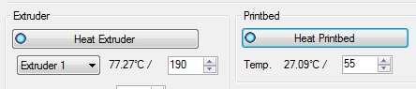Fig. 17-8: Validating the operation of the hot end and heated bed.

Once you're sure they're heating up, please turn them off. The PID loops need to be calibrated before they can be used for printing. (See: http://en.wikipedia.org/wiki/PID_controller for more information on the system the Repetier firmware uses to control the hot end and heated bed temperatures.)

18 – Calibrating your Rostock MAX
Okay, now that you've spent the last 5 minutes (Who am I kidding? You've been poking at it for at least an hour, giggling like a little kid. Your dignity is the first casualty of having your own 3D printer. Don't worry, you're in good company.) moving the hot end around and seeing how it works, now it's time to get it calibrated so you can begin printing your army of squirrels and Yoda heads.
In order for the mechanical calibration to be accurate, we need to do the steps with the Rostock MAX at operating temperature. This means that both the hot end and heated bed must be at the temperature they'd normally be at while printing.
It's very important that the temperature controlling algorithm in the RAMBo (the PID loop) be as accurate as possible. To do this, we need to run what is called the “PID Auto tune” routine. This is a firmware function that you run in order to determine the best values for the P(roportional), I(ntegral) and D(erivative) values used by the PID loop.
First, let's start the auto tune routine for the hot end:
Send the command “M303 S200”. This begins the auto tune process and when it starts, it begins to add data to the log window at the bottom of the Repetier-Host display. The target temperature for this process is 200C (that's what the “S200” is for).
It will begin with the entry, “PID Autotune start”. You'll notice that the temperature in the hot end will begin to climb. A few minutes later, you'll start to see more information appear in the log window.
While it's working, click on the “Temperature Curve” tab in the main Repetier-Host window:
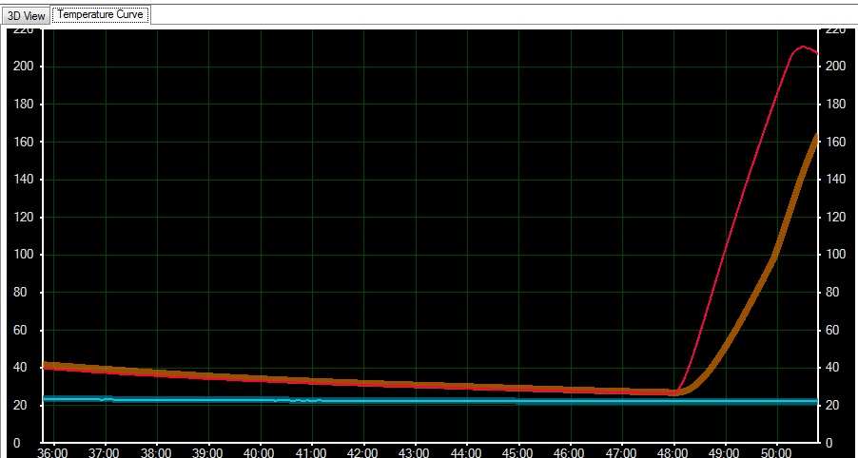Fig. 18-1: Hot end temperature graph during PID auto tune process.
Fig. 18-1 shows how well the controller manages temperature over time. The display we're interested in right now are the red and brown lines. The thin red line represents the actual hot end temperature and the brown line shows an average of the recorded temperature. After a short time, the display will look something like this:
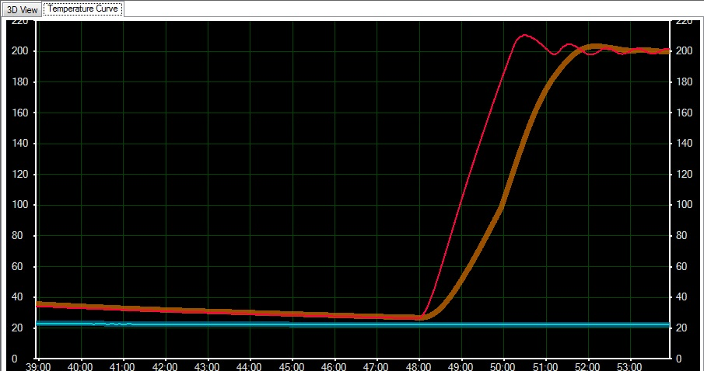Fig. 18-2:Reaching and holding a target temperature.
You can see the PID auto tune function is “learning” how to better manage the temperature in the hot end. As time goes on, the actual temperature begins to hold to the center of the average target temperature.
In a few minutes, the routine will complete, and you'll get output similar to the below example:
12:51:52.455 : bias: 76 d: 76 min: 198.18 max: 204.63
12:52:38.513 : bias: 74 d: 74 min: 197.88 max: 202.22
12:53:21.112 : bias: 72 d: 72 min: 198.18 max: 202.04
12:53:21.112 : Ku: 23.78 Tu: 42.60
12:53:21.116 : Classic PID
12:53:21.116 : Kp: 14.27
12:53:21.116 : Ki: 0.67
12:53:21.116 : Kd: 75.97
12:54:02.565 : bias: 71 d: 71 min: 198.33 max: 201.67
12:54:02.569 : Ku: 27.12 Tu: 41.45
12:54:02.569 : Classic PID
12:54:02.569 : Kp: 16.27
12:54:02.569 : Ki: 0.79
12:54:02.569 : Kd: 84.31
12:54:45.247 : bias: 71 d: 71 min: 198.33 max: 201.67
12:54:45.251 : Ku: 27.12 Tu: 42.68
12:54:45.251 : Classic PID
12:54:45.252 : Kp: 16.27
12:54:45.252 : Ki: 0.76
12:54:45.252 : Kd: 86.81
12:54:45.255 : PID Autotune finished ! Place the Kp, Ki and Kd constants in the configuration.h
The values that you're interested in are the “Kp”, “Ki” and “Kd” values. There are three blocks of these values, each under the heading “Classic PID”. Create an average of all the values (add up all the Kp values, divide by three. Do the same with the Ki and Kd values) and we'll get them added to the proper spot in the EEPROM table.

In order to store your new set of PID values, we need to open up the EEPROM table in Repetier-Host. Click on Config->Firmware EEPROM Configuration. This will bring up the EEPROM table editor.
Scroll down until you see the fields highlighted in green as above in Fig. 18-3. Change the P-gain field to the value you calculated for the average of Kp. Do the same for the I-Gain (Ki) and D-Gain (Kd) values and then click OK.
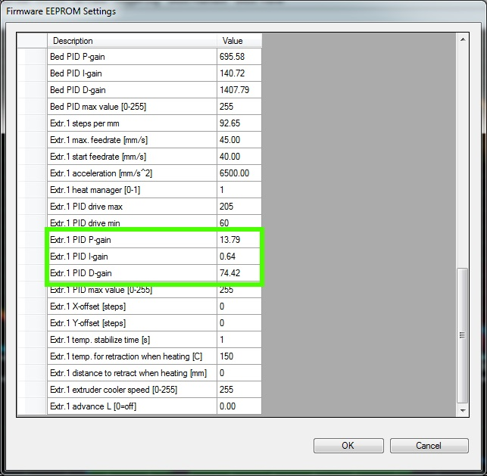Fig. 18-3: EEPROM Table Editor.

A properly tuned PID loop will look like the following graph:
The thin purple line is the actual set point for the hot end (190C). You can see over time how the actual temperature (thin red line) eventually merges with the center-line of the average temperature line (brown line). This is a good representation of a well tune PID loop.
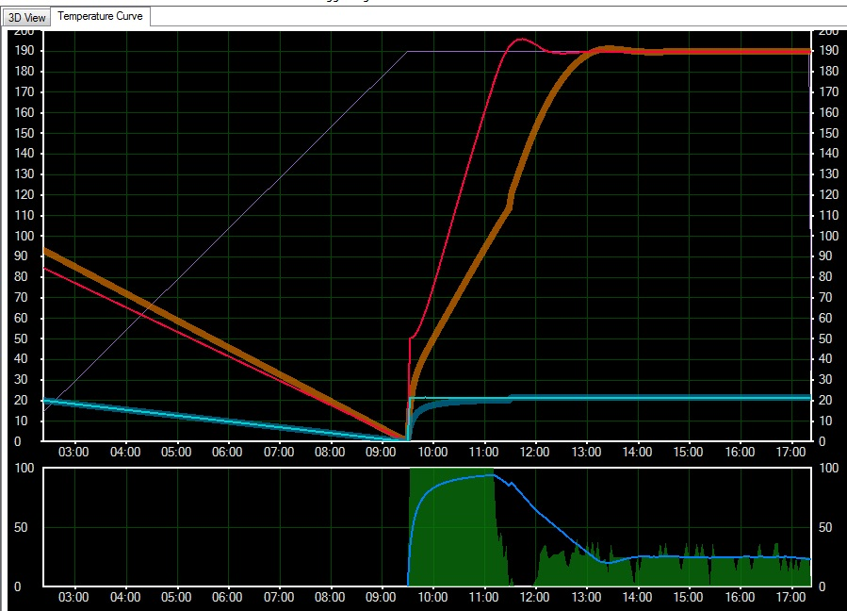Fig. 18-4: Accurate temperature management.
The graph at the bottom measures how much power in percent that is being fed to the hot end resistors. You can see how it applies 100% until it overshoots the target temperature. It then falls to zero and then slowly ramps back up as the target temperature is maintained.
Okay, now it's time to perform the same task, but this time we're going to tune the PID loop for the heated bed.
Send the command “M303 P1 S60”. This will start the auto tune process for the heated bed with a 60C target temperature.

The graph for the heated bed auto tune process will look something like Fig. 18-5.
When the auto tune process finishes, you'll have a similar list of figures as what you got for the hot end PID loop auto tune process. Obtain the average values for Kp, Ki and Kd as before. Go into the EEPROM table editor and look for the fields marked in green below:
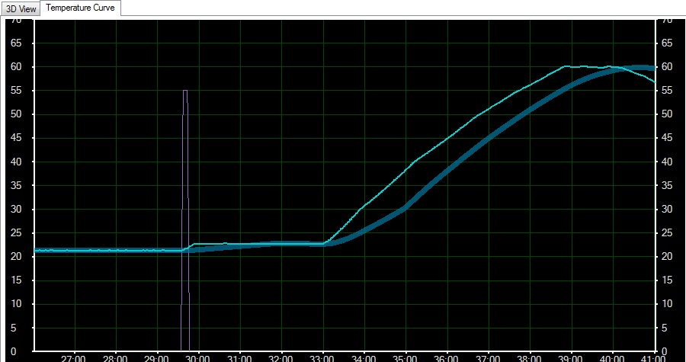Fig. 18-5: PID Auto tune for the heated bed.
Just like you did for the hot end PID values, enter the ones you got from the heated bed here. Click save and we're ready to go on to the next step!
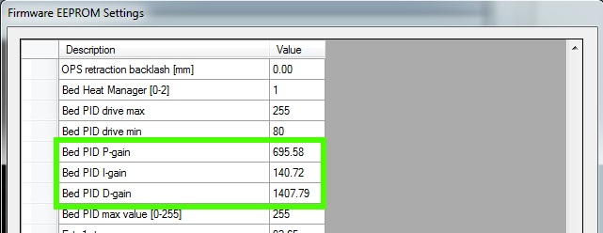Fig. 18-6: Heated bed PID parameters.

The following calibration process has changed if your Rostock MAX was shipped with Repetier-Firmware v0.91 or greater. If you ordered your Rostock MAX kit after February 19th, 2014, you more than likely have this new firmware version. The simplest way to know for sure is to look at the idle screen for your printer. If it looks like the image below, please jump to Appendix C: “Revised Calibration Instructions”. When you're done with the calibration, you can resume this guide at Chapter 19, “Your First Print with the Rostock MAX”!
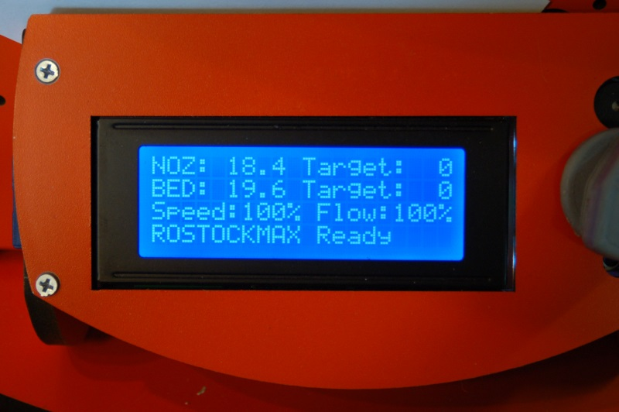Updated Idle Screen

Okay, now we need to find out what the actual Z height on your machine is. Send the G28 command to the Rostock MAX. If you haven't done so already, install the 300mm Borosilicate glass build surface on top of the Onyx. You can fix it in place using the included document clips.
Bring your hot end and heated bed up to operating temperature. Set the hot end temp to 190C and the heated bed to 55C. We want the hot end and bed to expand to “normal” so we can get a fairly accurate measurement here.
Once the hot end and bed have reached the target temperatures, measure the distance from the tip of the brass nozzle on the hot end to the surface of your build plate. Add 2mm to this figure and write it down. Open up the EEPROM table editor. Take care to not burn yourself on the hot end!
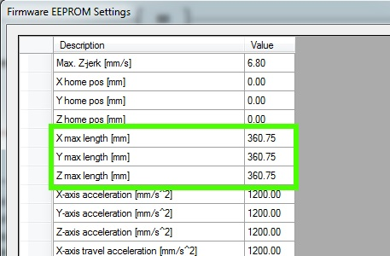Fig. 18-7: Updating X, Y and Z axis lengths.

Take the number you just wrote down and fill the three parameters shown in green above with it. We'll come back and tweak it again in a moment. Save the EEPROM editor and open up the Printer Shape tab on the Printer Settings dialog.
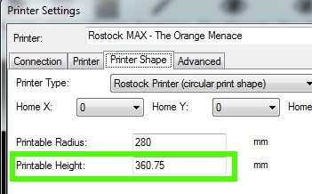Fig. 18-8: Updating the Printable Height.

Enter the number you entered in the Printable Height field as shown in Fig. 18-8.
Now comes the task of making that figure as accurate as we can.
Send the command “G0 Z10 F3500” to the Rostock MAX. It should send the hot end to a spot roughly 10mm above the build surface. We added 2mm in the measurement step in order to give us a bit of wiggle room here.
Lay a sheet of notebook paper on the heated bed and begin to bring the Z height down 1mm at a time. Click on the “down” Z arrow in the 1mm segment (it's the center segment of the arrow). If the last time you click pins the paper down hard, start clicking the “up” Z arrow using the 0.1mm (bottom segment of the arrow) until the hot end is only dragging on the paper a small amount. You should be able to move the paper around but still hear it rubbing on the tip of the nozzle when the paper is pressed flat. Take care not to burn yourself on the hot end or build plate!
When you reach the point where the paper is just dragging on the tip of the nozzle, write down the “Z” height. See Fig. 18-9 below for the location of the Z height.
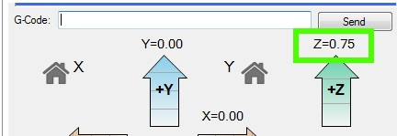Fig. 18-9: Current Z height.

Now subtract this number from the number you entered into both the EEPROM and the printer configuration areas. Edit the EEPROM table and replace your previous figure with this new one. Do the same for the Printable Height parameter in the Printer Shape dialog.
Send a G28 command to re-home the Rostock MAX and then send the command “G0 Z5 F3500”. This should send the hot end to a spot 5mm above the surface of the build platform. Make sure your sheet of paper is still in place and send the command, “G0 Z0 F3500”. It should stop in the same place as before – just barely snagging the paper. The reason I had you stop 5mm short the first time is just in case there was a problem, the hot end wasn't going to smash into the build plate. You can test again by sending a G28 followed by G0 Z0 F3500. It should stop right where it did last time. If it didn't, start over and make sure you enter the figures carefully!
Now we need to calibrate the end stops. This ensures that your Rostock MAX achieves an accurate hot end height no matter where on the bed it is.
To make this process easier, we're going to set up three “scripts” within Repetier-Host.
To edit these scripts, you'll need to click on the G-Code Editor tab and then select “Script 1” from the drop down indicated by the arrow in Fig. 18-10, below.
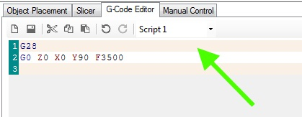Fig. 18-10: Creating scripts.

Enter the g-code just as you see it above. After you've entered the two lines, click the Save icon and choose the next script, “Script 2” from the drop down. Enter “G28” on line #1 and “G0 Z0 X77.94 Y-45 F3500” on line #2. Save this script and pick “Script 3” from the drop down. As before, enter “G28” on line #1, and on line #2, enter “G0 Z0 X-77.94 Y-45 F3500”, then save it.
Last, enter the following code for Script 4.
G28
G0 Z0 F3500
And save it.
In order to make sure that each axis is higher than the three points listed above, I want you to position the machine using these commands:
G28
G0 Z5 X0 Y90 F3500

As before, stick a sheet of paper under the hot end. Approach the zero point 1mm at a time by clicking on the down arrow for the Z axis. If you pinch the sheet of paper really hard before you hit the zero height point, use a #2 Philips screwdriver to turn the end stop adjustment screw two full turns to the right. Perform the same check on the other axes by issuing G28 followed by G0 Z5 X77.94 Y-45 F3500 and G0 Z5 X-77.94 Y-45 F3500. You're not after accuracy at this point, you just want to get the nozzle from pressing into the build plate.
Once you're confident you can go to the heated bed without striking it, you can begin to precisely adjust the end stop screws.
Click the “Printer” menu option at the top of the Repetier-Host window and select “Send Script 1”. This will send the g-code you entered previously to the Rostock MAX. Make sure you've got your sheet of paper under where the hot end will “land”. Script #1 covers the Z tower, #2 covers the Y tower and #3 covers the X tower. Having these in script form makes the repeating task of setting the end stops much easier.
You adjust the height of each axis by turning the end stop adjustment screw to the right to raise the platform and to the left to lower the platform. Each time you make an adjustment, re-issue the Send Script 1 command. Repeat this process until you're getting the same amount of “grab” on the paper as you did when setting the initial Z height. When you're satisfied, move on to the #2 and #3 scripts.
Lay your sheet of notebook paper on the center of the build platform and execute Script 4.
The nozzle tip is going to end up in one of three positions. It's going to be above your paper by a visible amount, it's going to pin the paper firmly to the bed, or if you're incredibly lucky, it will be “gripping” the paper the same amount as the tower base calibration steps. If it IS, I strongly recommend you go buy a lottery ticket. Your luck is just that good.
If you're merely mortal like the rest of us poor suckers, you're going to have to make an additional adjustment. Delta configuration printers like the Rostock MAX have a very interesting geometry that will result in the hot end traveling in a non-flat path if it's not perfectly calibrated. This tiny error will express itself as a “virtual” convexity or concavity in what it thinks the bed shape is. If your hot end is pinning the paper to the build surface, the error is expressing itself as a concavity – the firmware thinks that it is moving flat, but the path of the hot end is actually concave and that's why it pins the paper to the build surface – the center is actually lower than it should be. The reverse is also true – if the hot end is not touching the paper at all, it thinks that the bed is dome shaped (convex).
In order to adjust this out, you'll need to crank up the Arduino IDE and edit your firmware – we're going to be making changes to Configuration.h again.
It was recently discovered that there is an issue with the Repetier firmware that can sometimes cause problems when you're adjusting the PRINTER_RADIUS parameter. In order to avoid this issue, you should turn off the EEPROM feature during the next calibration step. You can do this by locating the line in Configuration.h that reads “#define EEPROM_MODE” You'll change the value that's listed to “0” in order to turn off the EEPROM feature. Once your PRINTER_RADIUS configuration is completed, change it back to “1” to re-enable the EEPROM.
Note that because the firmware will not be referencing the EEPROM settings, you'll need to manually configure the X, Y and Z max length figures that you previously set in the EEPROM.
Look in Configuration.h for the following values:
#define X_MAX_LENGTH 365.0
#define Y_MAX_LENGTH 365.0
#define Z_MAX_LENGTH 365.0
Set these equal to the data you placed in the EEPROM table. This will ensure that the firmware knows the correct height of the machine while you're calibrating the PRINTER_RADIUS value.

The concave/convex shape of the bed is controlled by the DELTA_RADIUS parameter in the Repetier firmware. Because DELTA_RADIUS is a calculated value, we don't change it directly. All our changes will be made to the value called PRINTER_RADIUS.
Search Configuration.h for a field that looks something like this:
#define PRINTER_RADIUS 198.40
What you're going to do is bump that figure by.5 (you'll see this figure mentioned in the comment right above the #define in Configuration.h) until the nozzle is touching the paper just the same as it was when you calibrated at the base of each tower.
In order to lower the nozzle, you'll need to increase the value in PRINTER_RADIUS.
In order to raise the nozzle, you'll need to decrease the value in PRINTER_RADIUS.
Each time you change PRINTER_RADIUS, you'll need to save your changes and upload the new firmware to the RAMBo. Note that the Arduino IDE won't be able to perform the upload if you're still connected to the Rostock MAX with Repetier-Host. Click the “Disconnect” icon in the upper left corner of the Repetier-Host window before you try to upload your changed firmware.
Once you've uploaded the new firmware, you'll have to re-calibrate the base of each tower as you did in the previous steps using Scripts 1 through 4. It may take a number of iterations to get the center nozzle height nailed down, but it IS worth the hassle. Your first layer quality and plastic adhesion require that the nozzle track across the entire bed as perfectly flat as it can.
I've added a flowchart below that outlines this calibration process more clearly.
With the completion of this task, you should have yourself a perfectly[1] calibrated Rostock MAX 3D printer!
At this point, you should return the EEPROM_MODE setting back to “1” to re-enable the EEPROM.

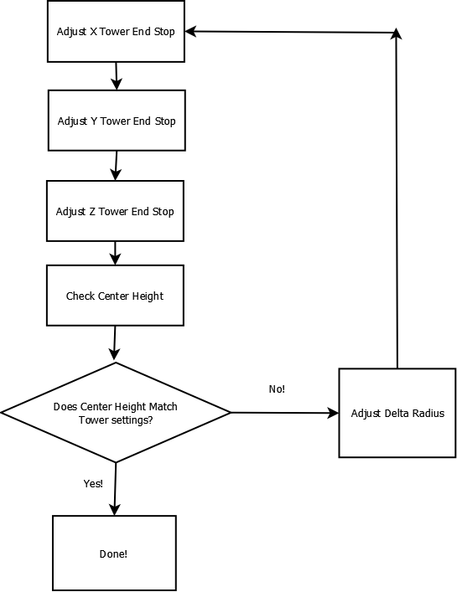Delta Radius Calibration Flowchart

The last task you'll need to perform before you can load plastic in to the machine is to correctly set the steps per mm (“E-Steps”) for the extruder. Open up the EEPROM configuration editor and look for the label highlighted below:
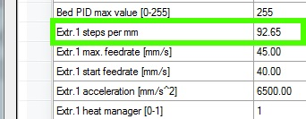Fig. 18-11: Setting the steps per mm.

The value should be set to 92.65. If you're using the older Steve's Extruder, this value should be set to 584.
This value dictates the number of steps that the stepper motor must rotate in order to feed 1mm worth of filament to the hot end. The figures supplied will get your e-steps very close to ideal, but extra fine tuning can't hurt. I highly recommend that you check out the “E Steps Fine Tuning” section of Triffid_Hunter's excellent calibration guide. It can be found here:
http://reprap.org/wiki/Triffid_Hunter%27s_Calibration_Guide
The other portions of his calibration guide doesn't really apply to the Rostock MAX, so it's not necessary to read unless you're simply curious.

19 – Your First Print with the Rostock MAX
Here's where the rubber meets the road! The whole point of the previous 174 pages to get to this point. This section will introduce you to Slic3r, the tool that you'll use to turn solid models into printable objects. The version used here is v0.9.9, which is the version included with Repetier-Host v0.85b.
The first object you're going to print will be the Skeinforge Bridge Calibration Cube. This object is commonly used to calibrate a large number of different printers. Download the STL file for the cube from here: www.thingiverse.com/download:15293 – I recommend creating a “STL Files” folder to store files like this – you'll be getting a lot of them as time goes on!
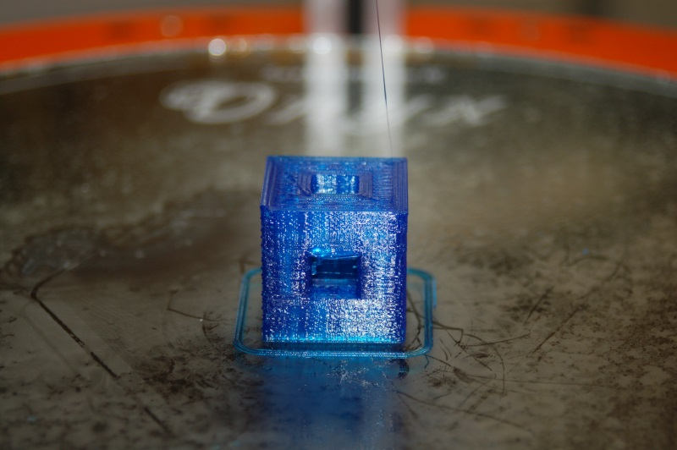Fig. 19-0: Printed test cube.

In order to print your first object, we're going to have to feed the model to a “slicing” program. Slicers basically “slice” the solid model into dozens or hundreds of layers, each layer being the height of the print layer. Each trip around the model is one print layer. Repetier-Host includes the latest release of Slic3r. There are a number of other good slicing utilities, but for simplicities sake, we'll focus on Slic3r.

Start up Repetier-Host and click on the Slicer tab and then click the Configure button as highlighted below.

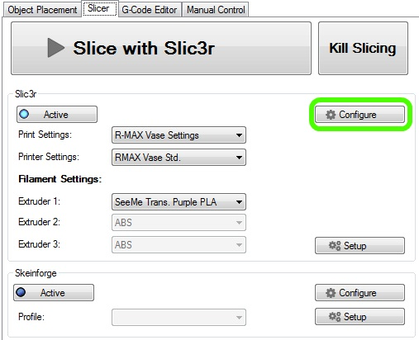Fig. 19-1: The Slicer tab.

The Slic3r configuration window should appear similar to the figure below.
The first section, Layers and perimeters dictate how thick the print layers are and some other features.
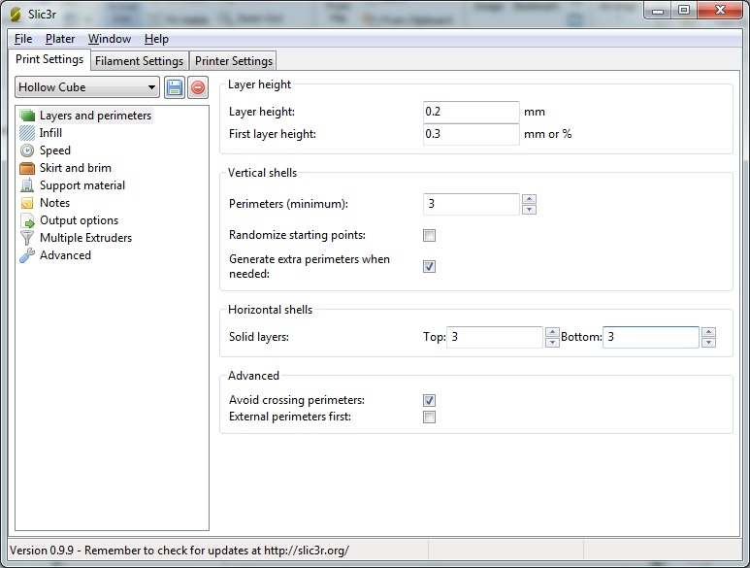Fig. 19-2: Print Settings – Layers and Perimeters.
Layer height is how thick each print layer will be. The smaller the thickness, the smoother your model will be. 0.2mm is a good first setting. Experiment with this and the other settings when printing other models. It’s the best way to learn how the various printing settings affect your print.
First layer height allows you to specify a starting layer that is thicker or thinner than the rest of the print. Please click in the input box and allow the Hint to be displayed – it will give you more information on this setting. All the other fields have this feature as well. Use it! The information is very good to have. For printing the calibration cube, set First layer height to 0.3.
Perimeters (minimum), specifies the minimum number of outlines on an object for every layer.
For this first print, make sure it’s set to 3.
Randomize Starting Points if checked will make the print head move to a random location on each layer in order to prevent odd plastic buildup on one specific spot. For the calibration cube, leave this unchecked. This is another parameter that you’ll want to experiment with.
Generate extra perimeters when needed will add additional perimeter prints to each layer if they’re required. Leave this checked.
Solid Layers determines the number of solid or 100% fill layers that should be done on the top and the bottom of the print. For the calibration cube, set this value to 3. Higher values may give better print results on the top.
Click the floppy disk icon next to the drop-down and name the print settings “Calibration Cube”
and then click on Infill. (..and don't misspell it like I did!)
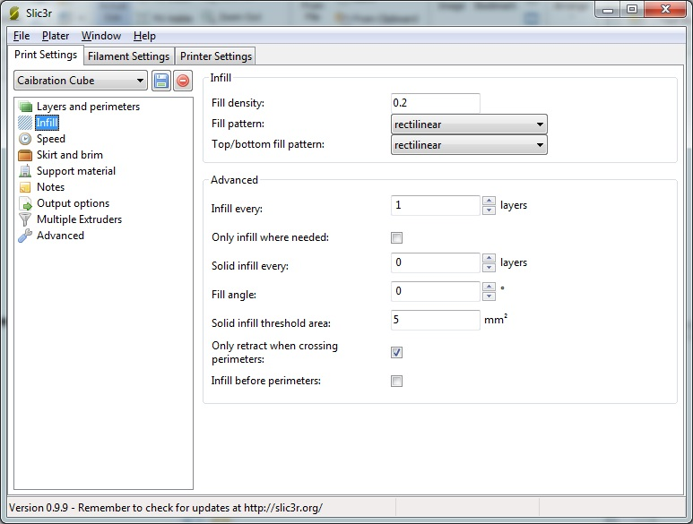Fig. 19-3: Print Settings - Infill

The Infill configuration page controls how the interior, solid areas of your model are filled up with plastic.
Fill density controls how much plastic is used to fill the “solid” areas of your model. This is a percentage value, so 0.2 shown above will be a 20% infill.
Fill pattern determines HOW the fill is added to the solid areas of your model. It provides for a number of different fill patterns, but for this first print make sure it’s set to rectilinear.
Top/Bottom fill pattern is essentially the same as Fill pattern, but the fill density is 100%. For this first print, make sure it’s set to rectilinear.
Infill every allows you to change how the infill works if you don’t want it to infill plastic on the solid areas for every layer. For the test cube, set this to 1.
Solid infill every allows you to force a 100% infill every so many layers. For the test cube, set this to 0.
Solid infill threshold area will force a 100% infill for sections that have a size less than or equal to the size specified. Note that the value is expressed in square millimeters. For our test cube, set this to 5.
Only retract when crossing perimeters means that the filament will only be retracted from the print head when you’re crossing perimeters of the part and you don’t want to risk any “extra” plastic accumulating outside the print volume. The infill areas really don’t matter and not retracting while crossing these areas will improve your print speed. For the test print, check this option.
Click the save icon (don’t change the name!) and let’s move on to Speed!

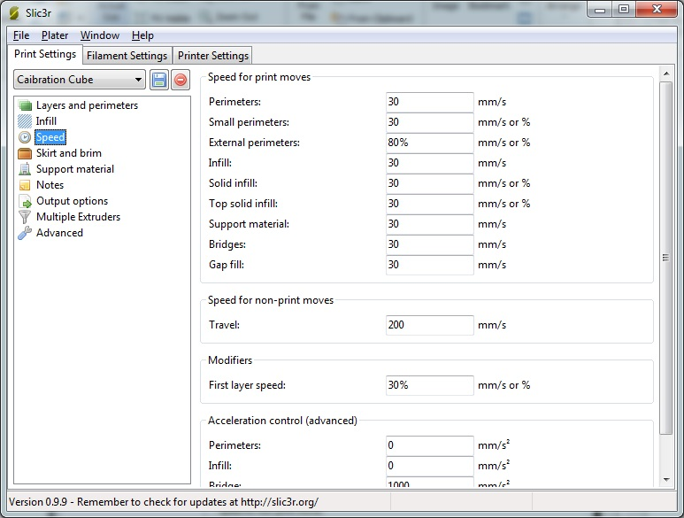Fig. 19-4: Print Settings - Speed
Each option above controls the speed in which the print head will move during the various stages of the print process. For your first print, make sure your settings match all those above. If you’re curious about what each one effects, hover your mouse pointer over the field you’re interested in. A helpful hint will be displayed with a short description of the field.
When you’re done, click the save button and let’s move on to the next section, Skirt and Brim.

The Skirt page has some very useful options on it that are useful for starting the printing process.
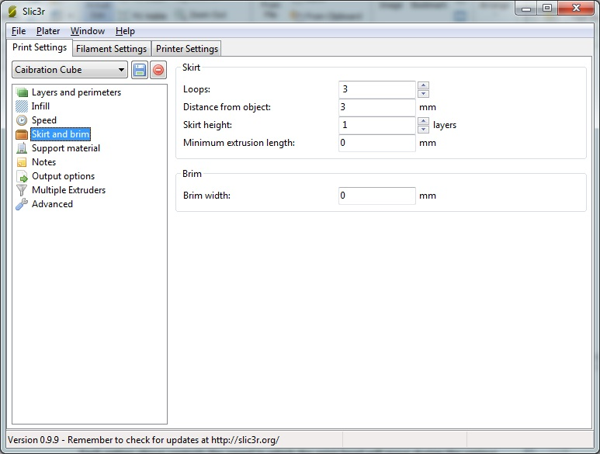Fig. 19-5: Printer Settings - Skirt and Brim
Loops does exactly that. Before your part starts to print, the printer will print a number of loops around where your part will print. This is very handy when you’d like to make sure that the hot-end is primed with enough plastic to begin the printing process. For the calibration cube, set this to 3.
Distance from object dictates how far away from where your part will be that the loop will print. Set this to 3mm for the cube print.
Skirt height will tell the looping routine in Slic3r how high to build a “skirt” around your part. This is especially useful if you want to use the looping feature to build a “draft dam” around your part to prevent air drafts from causing adhesion or other problems. Specify a high number here (20?) to build a skirt around your part. For now, set this to 0. This is really only a useful feature if you’ve got issues with cold air movement or you’re using a Cartesian printer than moves the build platform around quickly.

Brim width tells Slic3r to print what essentially amounts to a hat brim around your part for the distance specified. This can be helpful for prints that have problems with curling edges. Let’s leave this value set to zero – we’re more interested in getting a good overall print than worrying about curling issues right now.
The Support Material page covers options that are specific to parts that have large overhangs that could make printing problematic. These settings would craft little support structures as part of the printing process that you would cut away after printing finishes. Their purpose is to support extruded plastic that sticks out in “open” air at angles greater than 45 degrees and wouldn’t stand up well during printing. For our calibration cube, there’s nothing to set here, so leave “Generate support material” unchecked.
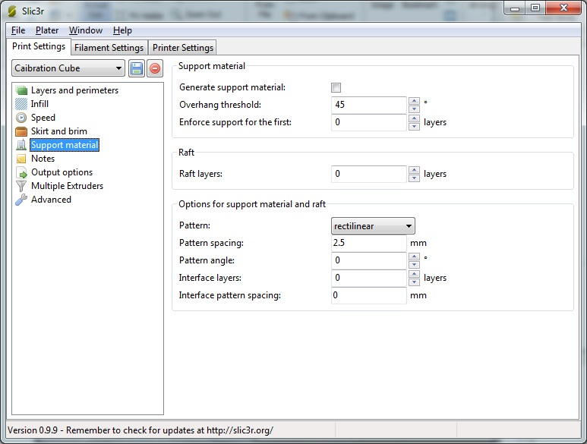Fig. 19-6: Print Settings - Support Material.

The Notes page is very straightforward. If you have any comments you’d like to include special comments with the output that Slic3r generates, put it here!
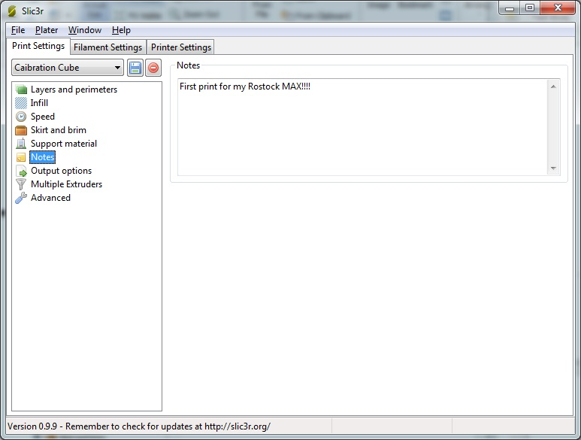Fig. 19-7: Print Settings - Notes.

The Output Options page covers three main items that handle some details on how the G-Code is generated for your part.
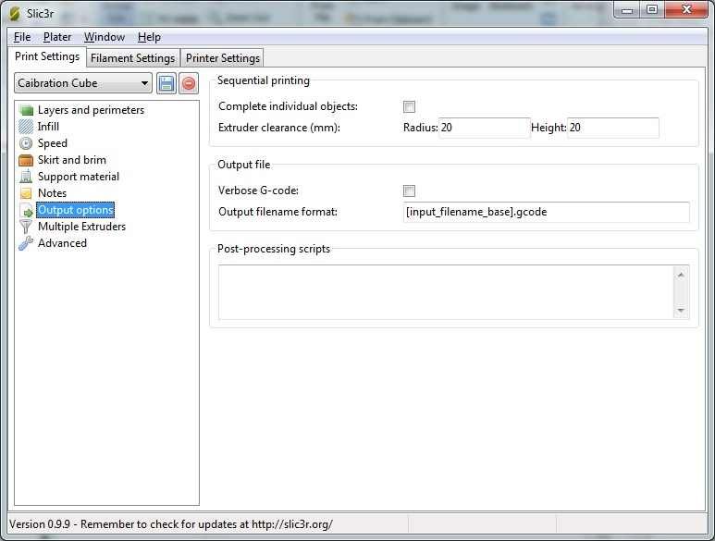Fig. 19-8: Printer Settings - Output Options.
Complete individual objects will tell Slic3r that if you’re printing multiple parts during one job that you want each part to print before Slic3r begins printing the next part. For the calibration cube we’ll leave this unchecked.
Extruder clearance (mm) tells Slic3r the amount of free space it needs to leave around each of the objects in order to avoid striking a previously printed object with the extruder.
Verbose G-Code indicates that you want Slic3r to put descriptive text on each line in the G-Code file. This can be a good educational tool to see what each G-Code statement does, but will create pretty large files – if you’re printing from an SD card, you may want to leave this unchecked. For your first print, you can check this or not. It’s entirely up to you. When it’s time to print, I’ll show you where you can view the code that Slic3r generated and you can see (or not!) the comments it put in.

Output file name format allows you to change how the file name is created for your print job. For now, just leave it at the default shown.
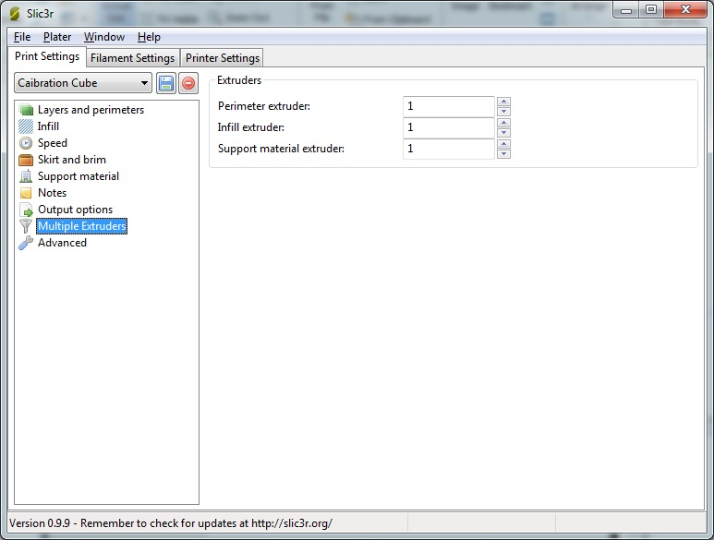Fig. 19-9: Print Settings - Multiple Extruders.
The Multiple Extruders page allows you to specify a specific extruder for each of the tasks listed. For now, leave them all set to 1. Note that unless your Rostock MAX has more than one extruder mounted on the carriage, you’ll never need to revisit this configuration page.

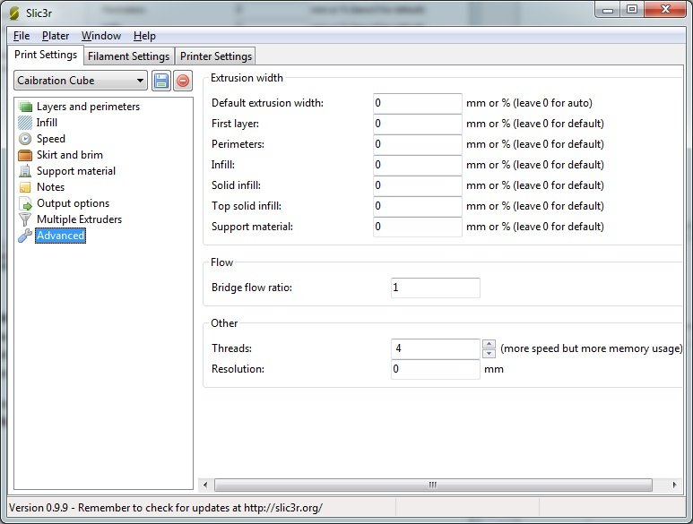Fig. 19-10: Print Settings - Advanced.
The Advanced page only has one setting we may need to adjust at this time. The Threads field tells Slic3r how many simultaneous tasks to undertake during the processing of your model. I would recommend setting this number to the number of CPU cores that your computer has. If you’re not sure what that count is, you can safely leave it set to the default of 2.
Click on the Save icon one more time to ensure that your changes have been saved and then click on the Filament Settings tab.

The Filament Settings tab is for setting options that are relevant to the filament that you’re going to use on your test print.
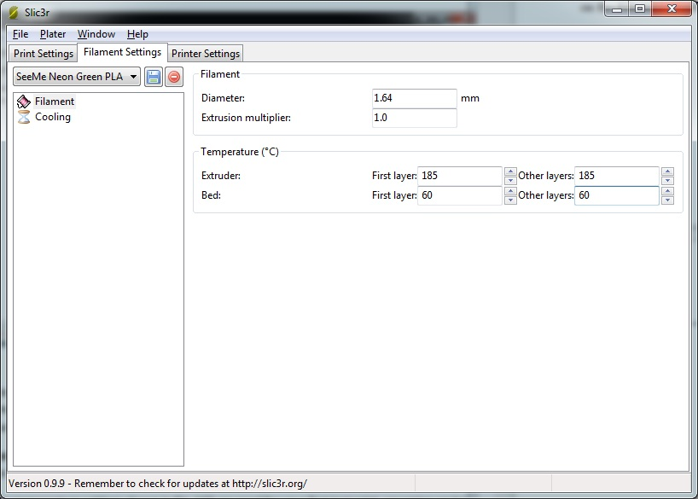Fig. 19-11: Filament Settings - Filament.
For the Diameter setting, you’ll want to use your digital calipers to take a few test measurements along a couple of meters of filament to get an idea of its actual diameter. Put an average of the measurements you took into the Diameter field. This helps the slicing algorithm determine the optimal amount of filament to feed at any one time.
Extrusion Multiplier proportionally changes the flow rate of the extruder. For your test print, make sure this is set to 1 as shown.
The temperature settings shown in Fig. 19-11 are good for your first test print, assuming you’re using PLA plastic. If you’re using ABS or another material, you should consult your filament vendor for appropriate extruder and heated bed settings.
Click the save icon at this point and name the configuration something that makes sense to you.

I use the vendor name, the color, type and filament diameter. You really want a configuration file for every color, vendor and type of filament you print as not all filament is created the same, even from the same vendor.
The last filament page is Cooling. This is primarily used by people extruding PLA. Make sure Enable Cooling is checked. PLA can do odd things if it's not cooled properly as it prints. Don't worry if you don't have a fan, just set the configuration in your Cooling tab as shown below and save your changes one more time, then we’ll move on to Printer Settings.
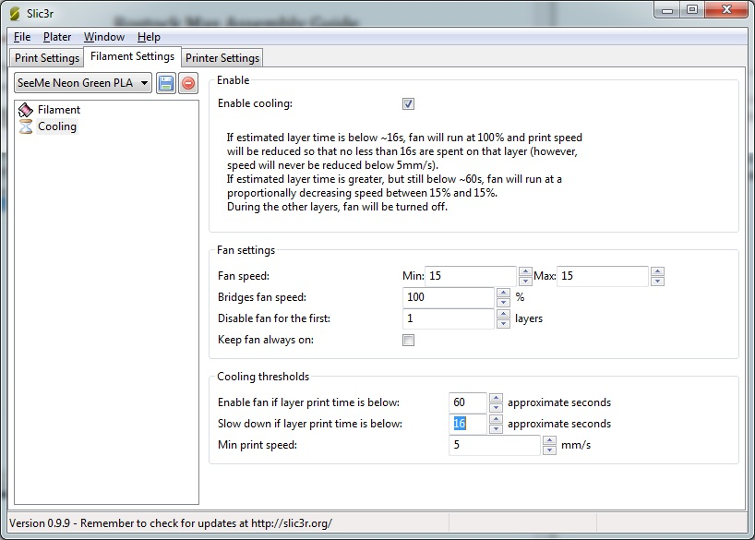Fig. 19-12: Filament Settings - Cooling

On the Printer Settings tab in the General page you’ll see how you specify the physical attributes of your Rostock MAX 3D printer. Make sure your Slic3r settings match those in Fig. 19-13 and then click the save icon. Name it “Rostock MAX” and then click on the Custom G-Code page.
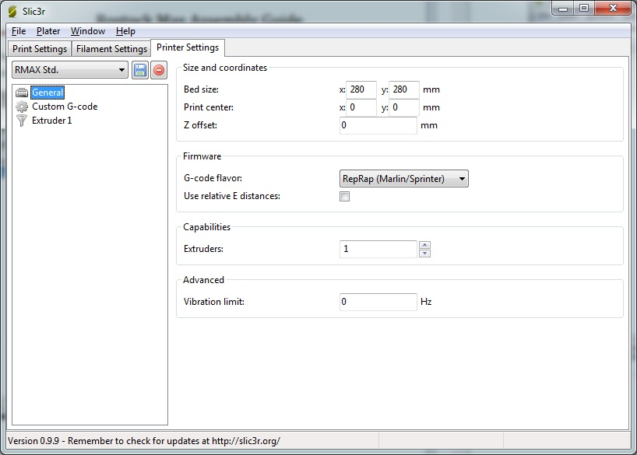Fig. 19-13: Printer Settings - General.

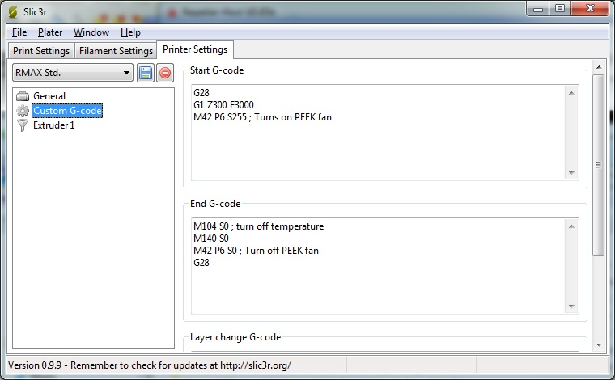Fig. 19-14: Printer Settings - Custom G-Code.
The Custom G-Code page allows you to tell your Rostock MAX to do some specific chores before and after a print job is run.
Start G-Code is run before the print job is run. In this case, we send G28 which re-homes the Rostock MAX, followed by G1 Z300 F3000 which rapidly moves the carriage to 300mm above the print surface. This just gets the Cheapskates off the end stop switches gives you a chance to see things are moving smoothly. The last line, M42 P6 S255 is what turns on the PEEK fan.
Note, if you're using the firmware supplied by SeeMeCNC, it has been modified to turn on the HEAT1 output any time the hot end is hot. If you choose to connect a PEEK fan to the HEAT1 output, you do NOT need to add the M42 prefix/suffix code as shown here. If you want manual control of the PEEK fan, connect the PEEK fan to the FAN1 output and use the M42 codes as shown.
End G-Code is executed right after the print job is finished. M104 S0 turns off the heat to the extruder and M140 S0 turns off the heat to the heated bed. M42 P6 S0 turns off the PEEK fan and G28 re-homes the machine.
Layer Change G-Code would insert any special code you need between each layer that’s printed. For your first test print, make sure your Slic3R configuration matches what’s shown above in Fig. 19-14. Click save and let’s move on to the Extruder 1 page.
Tool change G-Code (not shown above) are g-code instructions issued to the controller each time you switch to a different extruder when using two or more filament extruders.
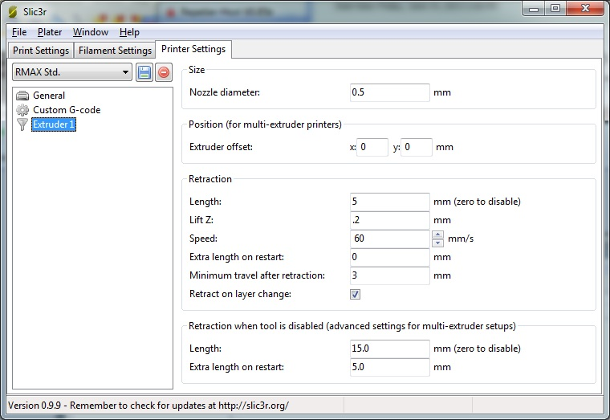Fig. 19-15: Printer Settings - Extruder 1
Size describes the diameter of the hole in your extruder nozzle. For a typical Rostock MAX, this should be 0.5mm. This helps Slic3r know how much plastic is extruded for a given extrusion speed.
Extruder Offset is only used if you’ve got multiple extruder nozzles. For now, leave both X and Y set to 0.
Retraction Length tells Slic3r how much filament should be “backed out” of the hot end when making rapid moves. This helps ensure that no plastic is accidentally extruded while the hot end is moving to a new position to begin printing again.
Lift Z will tell the machine to rapidly move the Z axis up this amount during retractions. For the calibration cube, leave this set to 0.2. (This is a good general setting).
Speed will tell Slic3r how fast the plastic should be fed to the hot end. For this and most other prints, you’ll want to set it to 60.
Extra length on restart will extrude an extra amount of filament once a rapid move & retraction has occurred. This is seldom used. Set it to 0.
Minimum travel after retraction will tell Slic3r that you have to move at least as far as specified here for a retraction to take place during a rapid move. Set this to 3 for the calibration (and most other) cube prints.
You can leave the Retraction when tool is disabled advanced settings at their defaults as they really only pertain to multiple-extruder jobs.
Now make sure you click save and then close the Slic3r configuration window.
In order to give Slic3r something to work with, we need to load a model into Repetier-Host. Click the Load button and navigate to where you saved the hollow_cube.stl file. When you open the file, you should see a rendering of the cube sitting in the center of your build volume as shown below..
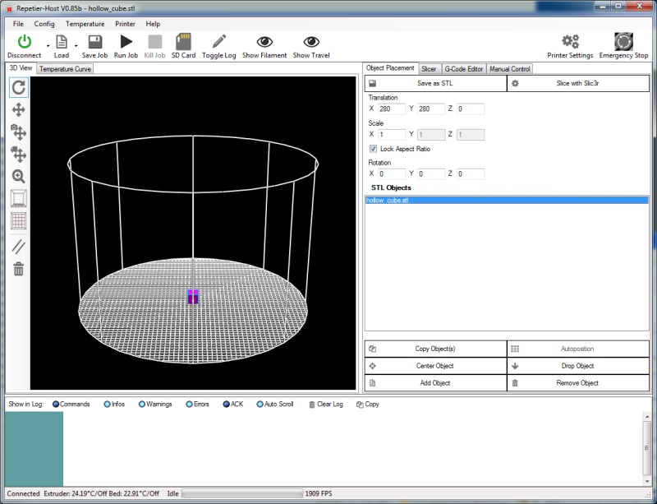Fig. 19-16: Hollow cube loaded!

In order to make sure that Slic3r is using the configuration you just created, you'll need to make sure that you've selected the proper Print, Printer and Filament settings.
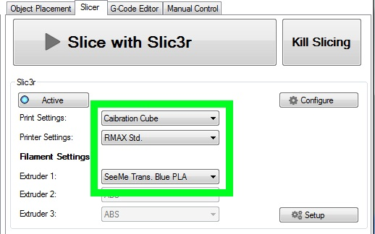Fig. 19-17: Choosing the Slicing configuration parameters.
Make sure you've chosen the settings by name that we just entered into the Slic3r configuration tool. When you've chosen those settings, click “Slice with Slic3r”.
After a few seconds the Repetier-Host display should change to look something like this:
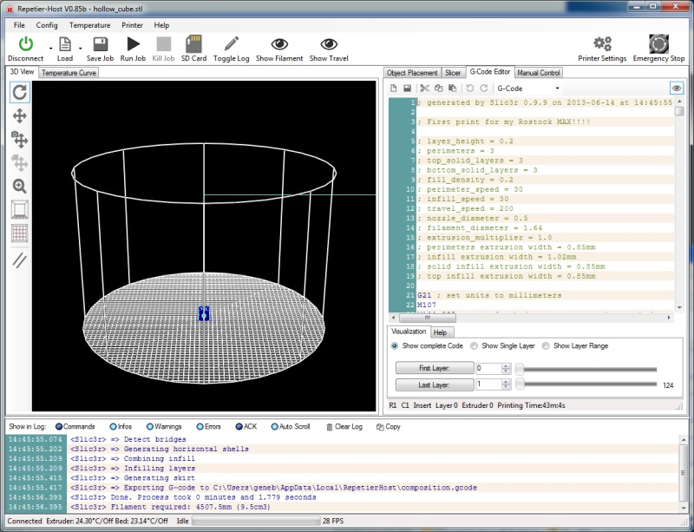Fig. 19-18: Hollow cube sliced and ready to go!

The cyan colored lines you see is the path that the extruder head will take as it moves and the dark blue represents the extruded plastic. You can click in that window and using your mouse, pan, zoom and rotate the model. In fact, why don’t you zoom in on the calibration cube so you can see what it will look like:
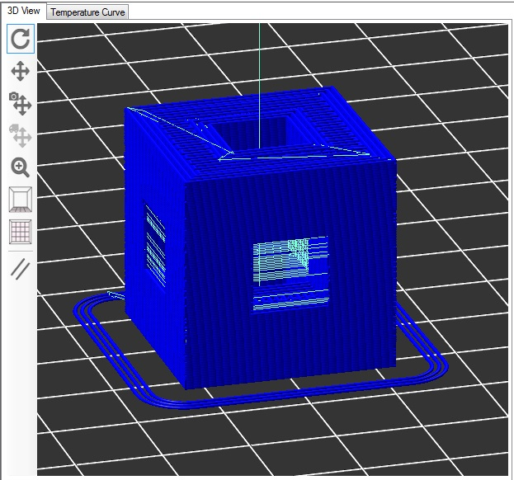Fig. 19-19: The sliced hollow cube showing the extrusion path.
The rendering in Fig. 150 is a pretty accurate rendition of what will happen on your print bed. Notice the three rings around the part? When you set Loops to 3, it caused that to be generated as part of the tool path. (“tool path” is a term used to describe the path that the tool takes during the entire printing process)

Back when I was walking you through the Slic3r configuration, I mentioned we’d be viewing the G-Code that Slic3r generates. Fig. 19-20 below shows the code that Slic3r generated.
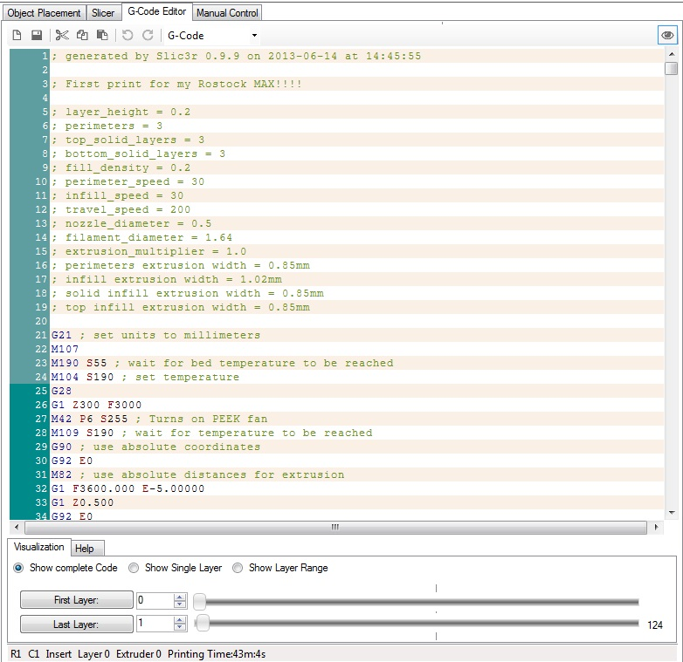Fig. 19-20: The G-Code editing pane.
All that text is what controls the Rostock MAX through the RAMBo. Repetier-Host sends each line of that file to the RAMBo board and the software on the board interprets each line in order to tell the Rostock MAX to move to a specific place, extrude plastic, etc. Lines that start with “;” are comments.
They’re ignored by the G-Code processor on the RAMBo board and you’ll notice that the start of the file contains all the settings that you set up in Slic3r. This is a great way to track prior configurations.
If you want to know what a specific program code does, you can click on the Help tab under the editor and each time you click on a line of code, Repetier-Host will display a little bit about what it does if it knows about it. There are very few codes that Repetier-Host doesn’t know about.
I highly recommend learning more about how G-Code works – that knowledge will help you get the most out of your Rostock MAX in the long run. Send G28 to the Rostock MAX so it's in its home position before we start working with the filament.
Before you can print the model you just sliced, you're going to have to load filament into the printer. I'm only going to cover the new EZStruder for this, so if you have the older Steve's extruder, please consult the first edition manual. If you can't find it online, email me and I'll provide a place where you can download it from.
The first step is going to be pre-heating the hot end.
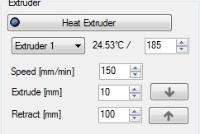Fig. 19-21: Pre-heating the hot end

If you're using ABS and not PLA, you'll want to make sure that your temperature is set to 230-240 instead of the 185 that I show above. Click the “Heat Extruder” button in order to bring the hot end up to operating temperature.
Load a spool of filament into the spool holder – you want the spool to unwind in a clockwise direction. The idea is to have the filament coming off the bottom of the roll, up toward the EZStruder.

It's extremely simple to load filament into the EZStruder. Just place your index finger on the top of the extruder and your thumb on the tension lever (marked by the white arrow below). Squeeze the tension lever up and feed the filament by hand along the path marked by the green arrow. There is a small opening behind the tension lever that the filament will enter into the extruder through.
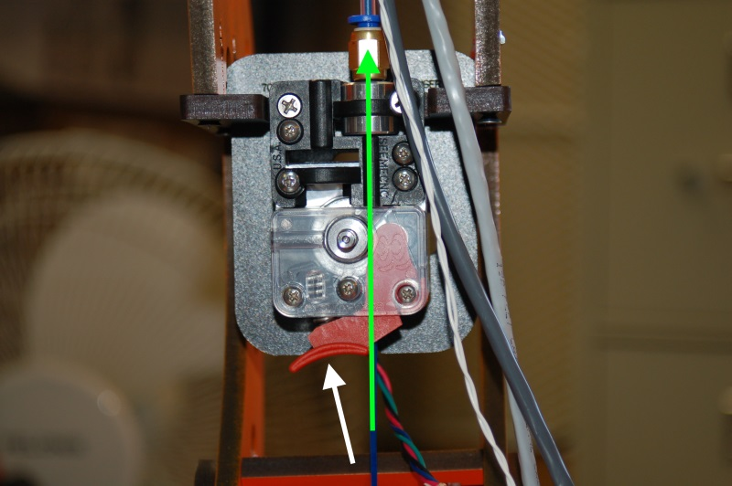Fig. 19-22: Loading filament into the EZStruder.

Continue to manually feed the filament until it passes through the other push-fit connector on the hot end.
Once the hot end reaches the target temperature, I want you to start using the manual Extrusion button to feed filament into the hot end.
In the figure to the right, you'll see the control panel for the extruder. In order to safely feed the hot end, make sure that your settings match those in Fig. 19-23. The arrows on the panel control the feed – they indicate the actual filament direction. Click the down arrow to feed the first 10mm of filament into the hot end. You may have to click the down arrow a number of times to get filament coming out of the hot end, but you'll want to wait for the extruder to stop moving before you click it again.
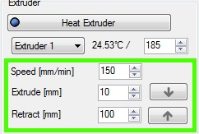Fig. 19-23: Feeding filament
Once it does begin to feed, go ahead and click the down arrow a few more times just to get the extruder all nice and primed.
I recommend that you extrude 20-30mm of filament each time you start up the printer for the day. This ensures that the hot end is primed and you have no jamming issues.

Before you begin printing you'll need to make sure you're using a good printing surface. In the case of the Rostock MAX and ABS or PLA plastic, you'll want to have the 300mm borosilicate glass disc attached to the Onyx with the included binder clips. For your first print I would recommend using blue painter's tape on top of the glass if you're using PLA. PLA sticks very well to the tape. If you're using ABS, I recommend using an unscented hairspray such as Aquanet Extra Super Hold. Spray it on the glass and let it dry before starting your print. There's a number of different methods you can use for both plastics, but I'll leave those up to you to research. See the SeeMeCNC forums for more information on this kind of thing.
Ok, I give up. I can’t keep you waiting any longer. Reach up with your mouse cursor and whack the Run Job button!
When you start the job, Repetier-Host will start sending the G-Code in the editor to the RAMBo over the USB cable. The first thing it will do is begin to heat the bed. When the bed has reached its operating temperature, it will then begin heating the hot-end. Once the hot end has come up to temperature, the Rostock MAX will begin printing the calibration cube you just sliced.
Before the printer begins, I want you to move the Feed rate slider that’s in the Speed Multiply box back to about 50.
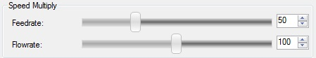Fig. 19-24: Reducing the print speed.

The reason for this is to help make sure that the print is going to adhere to the bed properly and to ensure that the flow rate will be sufficient for the printing speed. If you go too fast, you can easily over-run the ability of the hot end to melt the plastic. You'll soon learn how to tweak speeds and feeds as part of your learning experience with the Rostock MAX and 3D printers in general.
That being said, there's no reason you can't bump the speed up a bit after you're sure it's doing ok. You'll soon discover the limitations imposed by the slicer settings or the machine itself. Have fun with it!
I’ll shut up now so you can watch your Rostock MAX in peace. It’s absolutely the most fascinating thing you’ll watch in a long time. I would highly recommend getting a 3 diopter or better magnifying glass so you can really watch that sucker lay down plastic. It's simply amazing.

20 – Maintenance & Troubleshooting
Like any machine, your Rostock MAX 3D printer needs preventative maintenance to continue to function as good as the day you built it. Vibration and heating/cooling cycles can take their toll and you want to stay ahead of any issues before they begin to adversely affect your prints.

- Check the condition of your drive belts to insure they’re not getting worn out or rubbing on any of the Rostock MAX structure. Check to make sure that a print too close to the bed hasn’t caused the drive gear to chew up the belt in one spot. This would be a good item to add to your start-up checklist.
- Check all bolted connections to ensure that vibration hasn’t begun to loosen them. This should be part of your start-up checklist.
- Check the Cheapskate bearings to ensure that they still have a good hold on the rails. If you leave your Rostock MAX idle for an extended period of time could cause “flat” spots to form on the Acetal bearing covers. You’ll know this has happened if you begin to hear “ticks” as the flat spot comes into contact with the rail. The good news is that the flat spot isn’t permanent as the Acetal will relax a bit with continued use and the flat spot will disappear.
- Make sure that the fan in the power supply remains dust-free. Vacuum it out periodically to prevent the buildup of too much dust. Dust traps heat and isn’t any good for power supplies.
- Keep the RAMBo free of dust. Clean it periodically with either canned air or a dry paintbrush. Do NOT use a vacuum cleaner on it! The tip of a vacuum cleaner accumulates static electricity and will kill the RAMBo dead as a post.
- Keep the heated bed free of scratches and debris. If your bed gets too scratched up to be usable, you can either order a new one from SeeMeCNC or go to your local glass shop and order a 300mm diameter disc of glass, 1/8” to 3mm thick. Compare the thickness of the glass and your original build surface. If the glass isn’t the same, you may need to re-adjust your Z axis height.

The problem with troubleshooting is sometimes trouble shoots back. :)
Your Rostock MAX 3D printer is a pretty complex piece of machinery even though it looks pretty simple. As with any complex device sometimes things can go wrong in really weird ways. This won’t be a comprehensive troubleshooting guide, but will touch on a few of the problems I’ve run into with my printer. As others offer tips, they’ll be added to this section.

Print Layer Issues
When you first start a print, you should get a very even and consistent layer height. By properly adjusting the machine, you should get this automatically if you’ve got all three towers adjusted exactly the same. Unfortunately, that’s really difficult to do. The larger the object you print, the more obvious first layer thickness inconsistencies will be, especially when using loops.
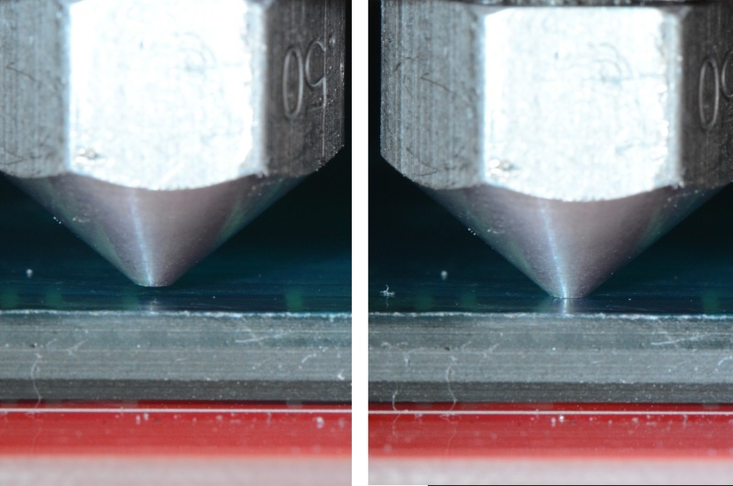Fig. 20-1: Nozzle height examples. (Image Courtesy of LulzBot)
Above is an example of correct and incorrect nozzle height. The nozzle on the right is right at the surface of the print bed. This means that there’s no room for the plastic to go – the bed is effectively plugging the nozzle and will eventually cause the extruder to start skipping, or it'll grind a notch in the filament as it tries to feed it.
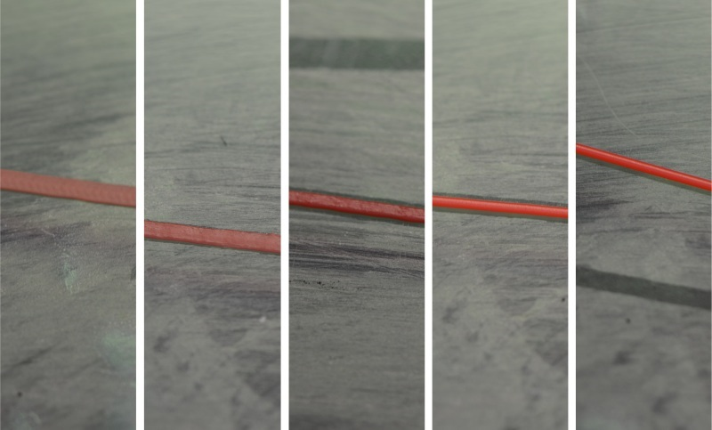Fig. 20-2: First print layer examples. (Image Courtesy of LulzBot)
In the figure above, you’ll see five different print examples. On the far left you see the result of the nozzle being too close to the print bed, while at the far right you see the result of the nozzle being too far away. The result you’re looking for is shown in the center. That’s what a good first layer should look like. If you set the Z height such that you can just begin to feel a sheet of note paper begin to drag between the nozzle and machine bed, you’re pretty close to the ideal Z height when at zero.

Machine Won't Move!
You’ve sent G28 and the machine still won’t move using the jog arrows. Take a look at the log output. You may be seeing an error go by that looks like this:
Extruder switched off. MINTEMP triggered!
What is most likely happening is that you haven’t yet plugged the hot-end thermistor in. The firmware is preventing the machine from moving because of this – it’s a safety measure of sorts. A cold thermistor will read ambient room temperature, but a failed one may not – it could read zero or some very high number. The firmware is will prevent the Rostock MAX from operating if the thermistor readings are below 3 degrees Celsius for the hot end and heated bed, or if the hot end temp is above 275 or the heated bed is above 140. (These are defaults and shouldn’t be messed with unless you know exactly what you’re doing)
Belt Damage or “The Delta Arm Blues”
So you're printing along and you start to notice things like this:
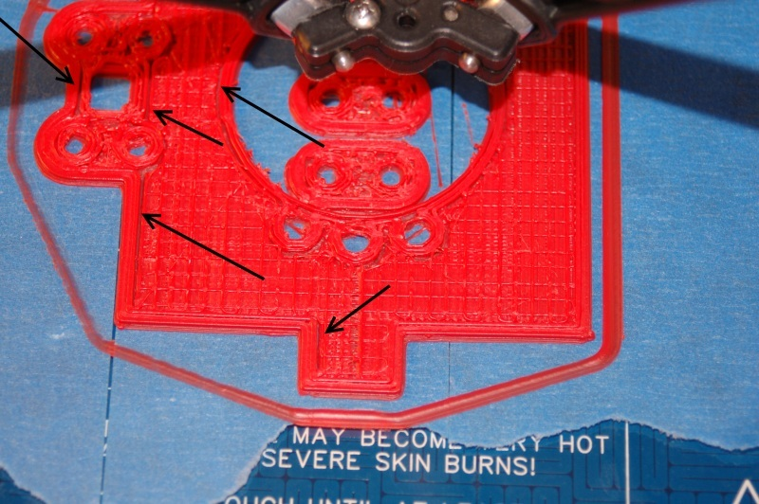Fig. 20-3: Infill not meeting the perimeter.
The arrows are pointing to a gap between the infill and the perimeter of the part. This was caused by a number of factors, eventually resulting in a sharp drive gear devouring all the teeth from a short section of the drive belt. Vigilant belt inspection and more care in setting the Z height would have helped to prevent this from happening.
A sign to watch for is the accumulation of tiny black “crumbs” in the area where the drive pulley is located.
Another issue that will cause the problems shown above is known as “The Delta Arm Blues”. What happens is that one or more of the delta arm joints have a little bit of extra friction to them. When the delta platform changes direction, this tiny amount of drag will cause a positioning error resulting in the infill not completely meeting the perimeter. If you're seeing this kind of issue and your belts are in good shape, it's time to test each delta arm and u-joint for fit. There is a thread on the SeeMeCNC forum called “Don't get those Delta Arm Blues!” and it covers the why of it as well as great suggestions and techniques for getting the issue solved. Here's the link: http://forum.seemecnc.com/viewtopic.php?f=54&t=1434

21 – Repetier-Host
Repetier-Host is a pretty advanced piece of software and it can make your life a lot easier when it comes to printing your projects on your Rostock MAX.
I'm going to walk you through most of the more interesting things that Repetier-Host can do. For the printing examples, I'm going to use the Ignite Michiana Keychain that is available on the Repables website (http://www.repables.com/r/146/). Download and unpack the model.

I would like to first cover the Object Placement tab and show you the various functions that it can perform. Go ahead and load the IGNITE.STL file that you downloaded and we'll begin.
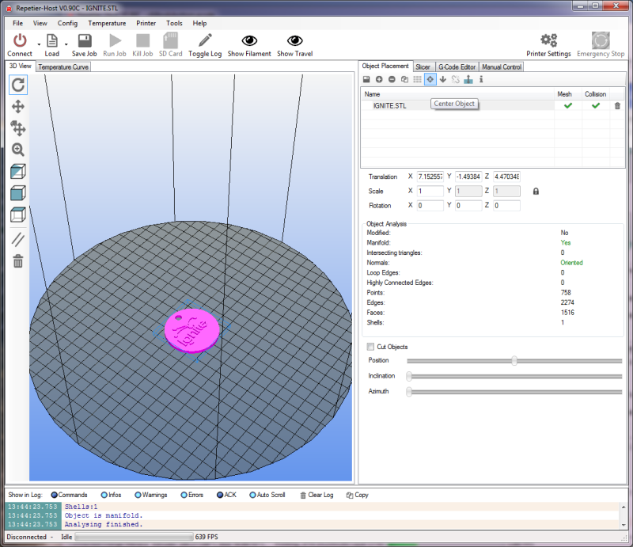

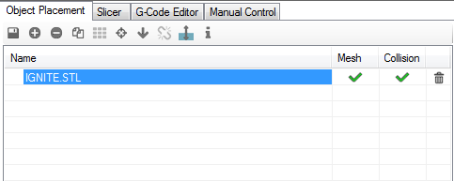
The Object Placement tab allows you to do a number of things with one or more loaded objects. Moving right across from left to right, the functions are:

Export
This allows you to save all the currently loaded (or only the selected ones) parts as a single STL or OBJ file.
Add Object
Clicking this allows you to add another object to the build platform. This can be handy when you've got a few different parts to print and you'd like to print them all during the same print job instead of one at a time. Go ahead and click the Add Object button and pick a new model to load – the Orion Key Fob would be fine for this. You'll notice that when it's loaded, the Ignite object is moved a bit to make room for the new part.
This would is a good time to show you what the Mesh and Collision columns do. Right-click on the Ignite object. Notice that the Ignite object turns purple and the Orion Key Fob turns yellow. The purple color highlights the object you're currently working with. Note that the Object Analysis section of the Object Placement tab is now filled with information related to that selected object. This section will be hidden if you've got more than one object selected.
Hold down your right mouse button and drag around – you can use this technique to manually position parts. Notice that when you move the part so it “overlaps” with another, that both turn a light blue color. This indicates that the models are colliding. The Collision columns will indicate colliding models with a red “X” Now while you CAN slice and print objects that are colliding, don't expect great results unless you've got a specific goal in mind.
Remove Object
This is basically the opposite of Add Object. It will remove whichever object is currently selected.

Copy Objects
This is a neat little feature. Say you'd like to print four of the Ignite key chain tags. Select the Orion Key Fob and click the Remove Object button. Select the Ignite object and then click the Copy Objects button. Set the number of copies to four and make sure the “Auto Position after Adding Objects” box is checked. Click Copy.
You should now have five of the Ignite objects on your build surface.
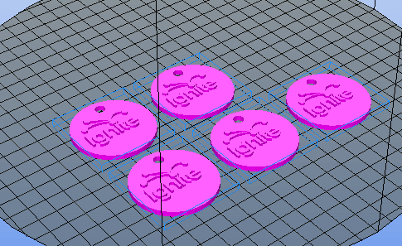
You ended up with five because you made four copies of the one object. If your goal was only four objects total, you'd tell the copier you wanted three copies.
The copy feature is very handy when you have to make a lot of the same thing.

Autoposition
The Autoposition function will allow you to optimally arrange a number of objects with a single mouse click. Go ahead and move your five Ignite objects around manually and then hit the Autoposition icon to see how it re-arranges all the objects.
Center Object
This is handy if you've got a single object and you've accidentally moved it from its default position. Clicking the Center Object icon will automatically move the object to the center of the print volume.
The Drop Object and Split Object buttons are currently undocumented, and experimenting with them hasn't lead me to any new understanding of how they work.
Fix Normals
This function will attempt to correct issues with your model file where there is a surface that should be facing outward, but is actually facing inward. This falls under an advanced modeling topic and won't be covered further here.

Object Information
This will give you some basic details about the currently selected object.
The next section of the Object Placement tab has to do with how objects are sized and oriented in the build volume.
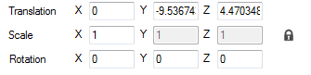

The Translation row controls the object placement on the bed. This is normally something you'll never need to manipulate by hand as you can move the object around with the mouse, or by clicking the Autoposition icon.
The Scale row will allow you to change the size of the object. By default the Scale is locked to the X axis as denoted by the little padlock icon at the far right. Experiment with the scaling by changing the X column number. Think of it as a percentage. At 0.5, the object will be scaled in all axes by half. .75 would be ¾, etc. If you click the padlock, this will “unlock” the scaling for the Y and Z axes so you can change those independently from the X axis. Go ahead and unlock the scale and change them and see how it affects the model. You can easily go back to where you started by setting each axis back to 1 or by simply clicking the padlock icon again.
The Rotation row allows you to change the orientation of the object in the build volume and each field is in degrees. This comes in handy when you've loaded an object that isn't oriented in a way that will allow you to print it. To give you an idea of how this would work, click in the X field and enter “90”. This will flip the Ignite key fob 90 degrees to the build surface. If the Ignite model loaded in this position, you could enter “-90” and it would lay flat on the bed, making it easier to print.

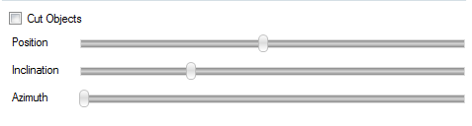

The last section on the Object Placement tab is “Cut Objects”. When you check the Cut Objects box, it will allow you to slice or cut the object in various ways by using the three sliders as shown above. This is strictly a visual inspection tool and doesn't apply to the data fed to Slic3r. Select the Cut Objects box and play around with the sliders to see what they do to the object on the built surface.
The Slicer tab is the basic interface to the primary slicing utility that Repetier-Host uses, Slic3r.
Slic3r is one of the more popular slicing tools for 3D printing. It's open source and community supported.
The Slicer tab also provides access to Skeinforge, another free and open source slicing utility. Due to its complexity I won't be covering it here. If you like, you can learn more about it here: http://reprap.org/wiki/Skeinforge.

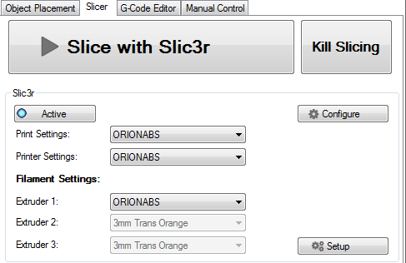

Slic3r allows you to manage multiple profiles for print settings, the printer itself and different types of filament. The Slic3r interface above allows easy access to any of those three preset categories. As time goes on, you'll collect a number of different configurations for the different models you print and the filaments used to print them. All of those setting can be accessed via the Configure button, located right below the “Kill Slicing” button. The details of the Configuration program for Slic3r is covered in the previously linked Slic3r manual and won't be covered here.
The last thing to note about the Slicer tab is the “Setup” button. This will allow you to tell Repetier-Host to go to a specific place for configuration files and the Slic3r executable. This can be used in the event that you wish to use a version of Slic3r that is different than the version supplied with Repetier-Host. This can come in handy when newer versions are released and you'd like to upgrade without waiting for a new product installer for Repetier-Host.

The last tab I'm going to cover is the G-Code Editor tab.
When you slice a model, the output of the slicer will be automatically loaded here.
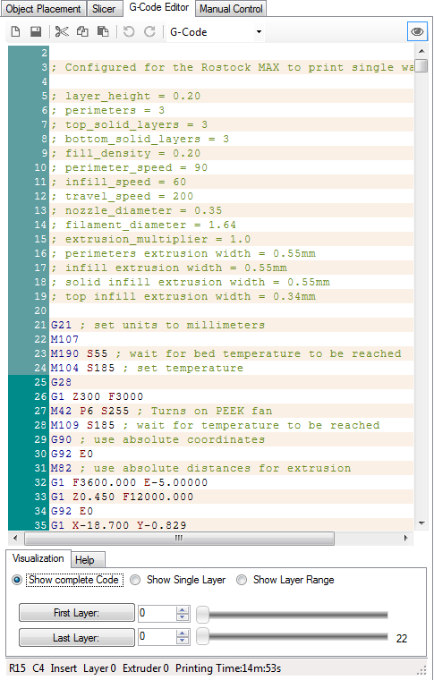
The G-Code Editor is basically just a fancy text editor. It allows you to view the G-Code that the slicer generates for the object(s) you sliced as well as allows you to view the tool path of each layer individually, or all the layers at once.
The G-Code Editor tab has two modes to it. “Visualization” and “Help”. In Visualization mode, you can use one of the three radio buttons to view the whole output, a single layer or a range of layers.
If you want to view a single layer, click the “Show Single Layer” selector and then move the First Layer slider around. You can also use the up/down arrows in the First Layer input box to more precisely go to a specific layer.

You can see an example of this below – it's currently showing layer 6 of the Ignite key fob that I've been using as my example part.
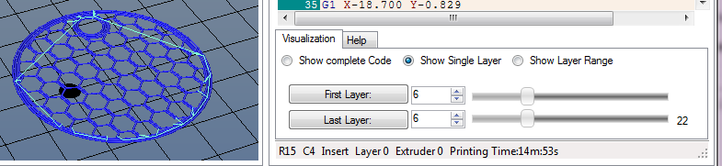
The Help mode (accessed by clicking the “Help” tab next to “Visualization”) is a very handy feature when you'd like to see what all that noise in the G-Code Editor is actually doing.
When you click on a G or M code that Repetier-Host knows about, it'll pull a description out of its database and display the information in the Help window as shown above.
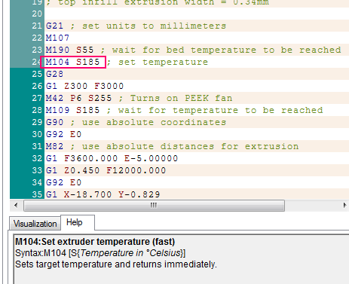

If Repetier-Host doesn't know what a G or M code is, it won't display anything in the Help window at all.

I've covered a number of the basics with Repetier-Host and you should have a pretty good handle on how to use it with your own printed parts. There's one last thing that I'd like to cover and that is the Temperature Curve tab.
This shows some interesting data with regard to both your extruder and heated bed temperatures.
The image below shows a typical “cold” Rostock MAX.
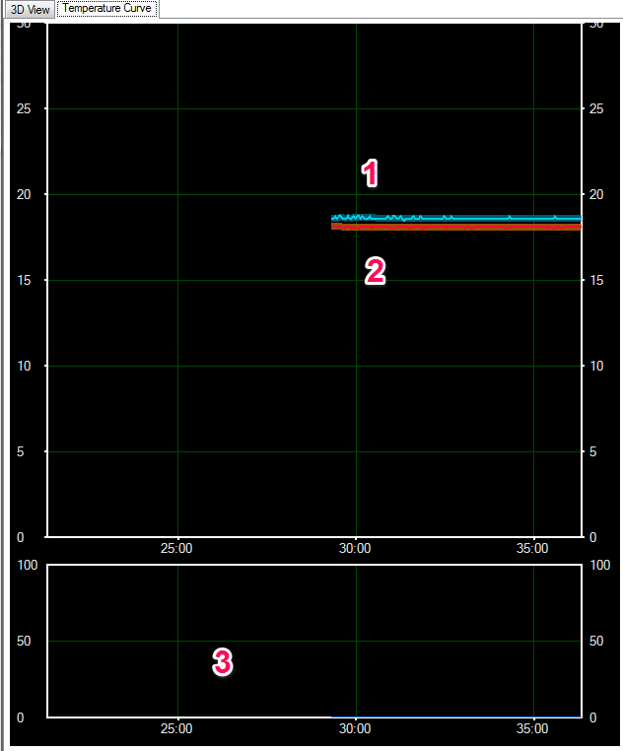
There's four “tracks” worth of data shown on the graph.
Graph #1 shows the bed temperature (the thinner cyan line) and the bed temperature average (thicker, dark blue line)
Graph #2 shows the hot end temperature (the thinner red line) and the hot end average temperature (thicker, brown line).
The graph scale is in time along the bottom (5 minute graduation) and the temperature scale is vertical and uses a 5 degree graduation.
The lower graph (#3) is the “power” graph and that shows how much power is being sent to the hot end.
Go ahead and click the Heat Extruder button on the Manual Control tab and watch what the temperature curve does.

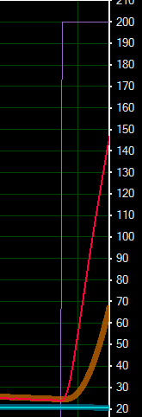
The first thing that will happen is that the scale will jump considerably as it now needs to show your target temperature.
In the figure to the right, you'll see that a new graph line has appeared. The purple line is your target temperature. That is what the system is currently trying to reach. As time goes on, it may exceed that target by a few degrees and then back off on the power in order to get back down to it.
You'll see that the average temperature lags behind the actual by a short period of time. This is okay.

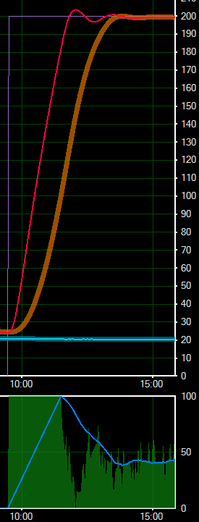
The image to the right shows what the Temperature Curve will show once the hot end has reached the target point. Notice how the power graph on the bottom corresponds to the actual temperature line shown in the top.
As time goes on, the actual temperature line will exist as a little “squggle” that will remain inside the border of the thicker average temperature graph. This is an indication of a properly tuned hot end controlling algorithm.

Appendix A – Wire Management
With the advent of the top mounted extruder, it became necessary to find a new way to route the effector and stepper motor wiring. In order to solve this issue, I designed a simple, easy to print clip that will allow you to fit a 3/8” dowel to the back of the Z axis tower in order to support the wiring.
Download and print two of the brackets from Repables: http://www.repables.com/r/131/
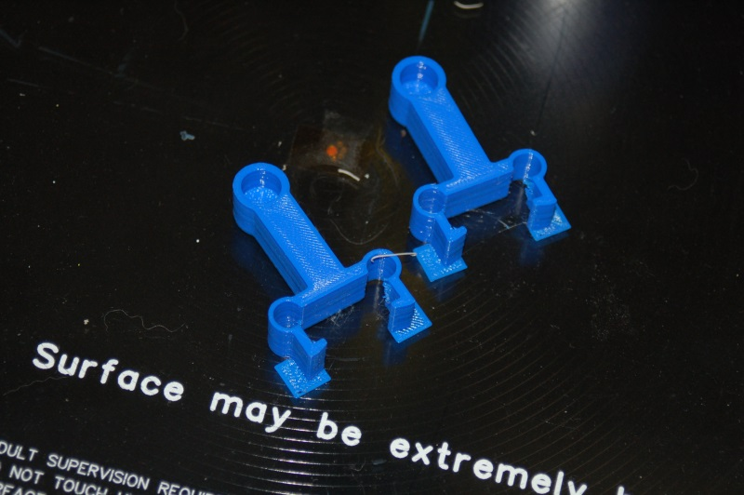Fig. A-1: Wire Management Clips.

These were printed using a .25 layer height out of PLA. When they're done, clip off the single layer squares that surround the ends of the clips. Those are only there to ensure the tips of the clips will adhere to the bed properly – basically gives them more surface area to stick with.
Cut a 26-1/2” length of 3/8” dowel – this will be the rod that the wiring is attached to. Fit a clip to each end and attach them to the base & top of the Z axis tower.
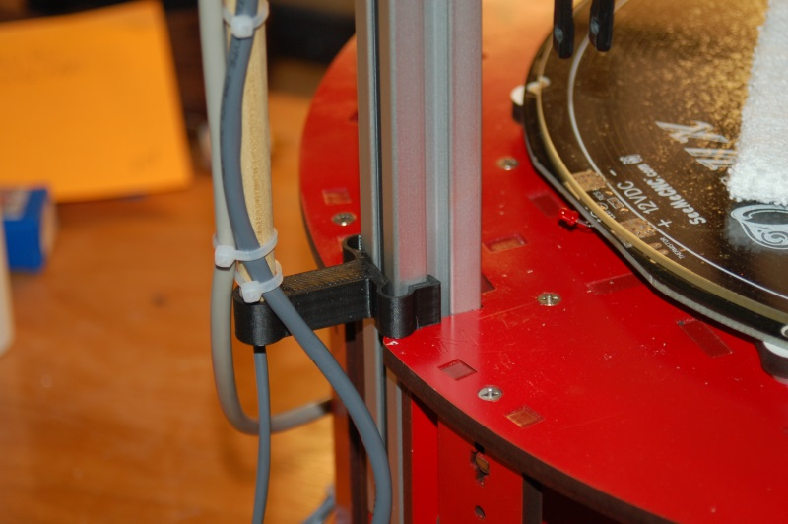Fig. A-3: Base wire clip.
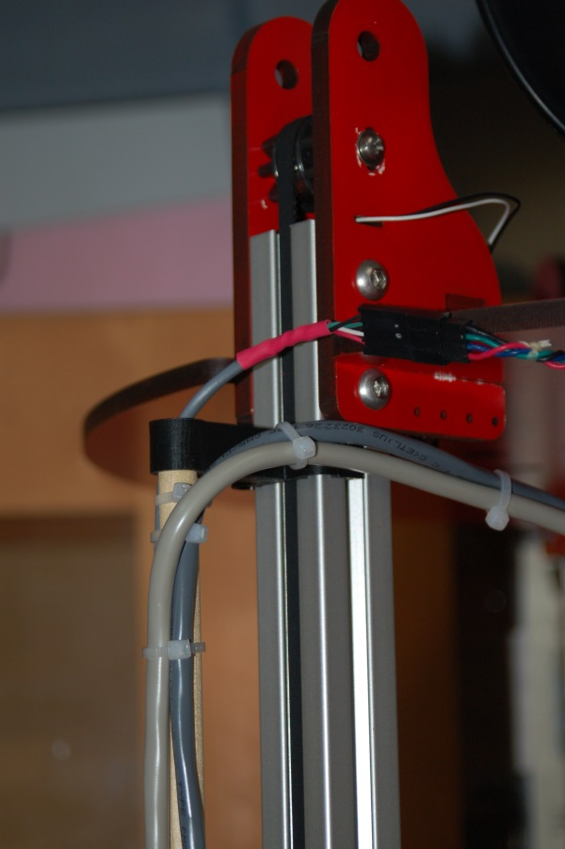Fig. A-4: Top wire clip

Attach the hot end, accessory and stepper motor wiring to the dowel rod using either lacing cord or wire ties, whichever you prefer. Attach from the bottom to the top to ensure that you've got enough slack on the hot end and accessory wiring to allow the effector platform to move throughout its range without putting stress on the wire.
See the following figures for examples of routing the wiring.

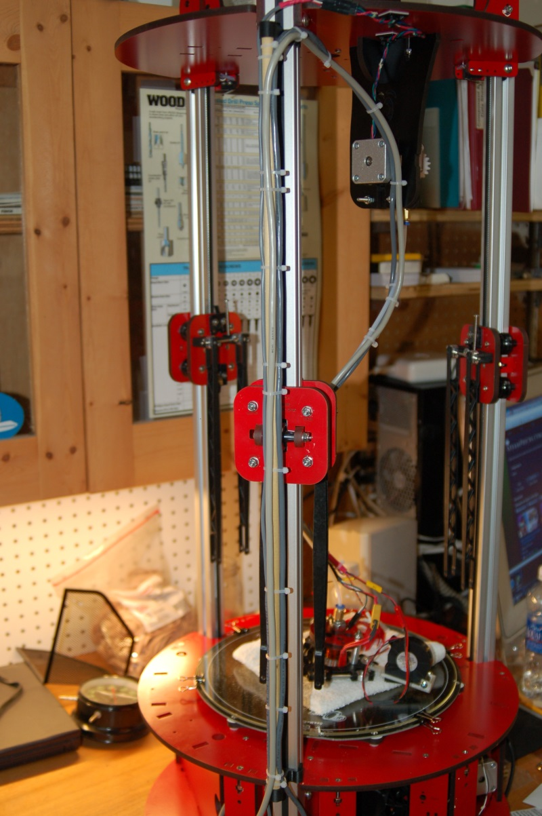Fig. A-4: Wire routing on Red Sonja.
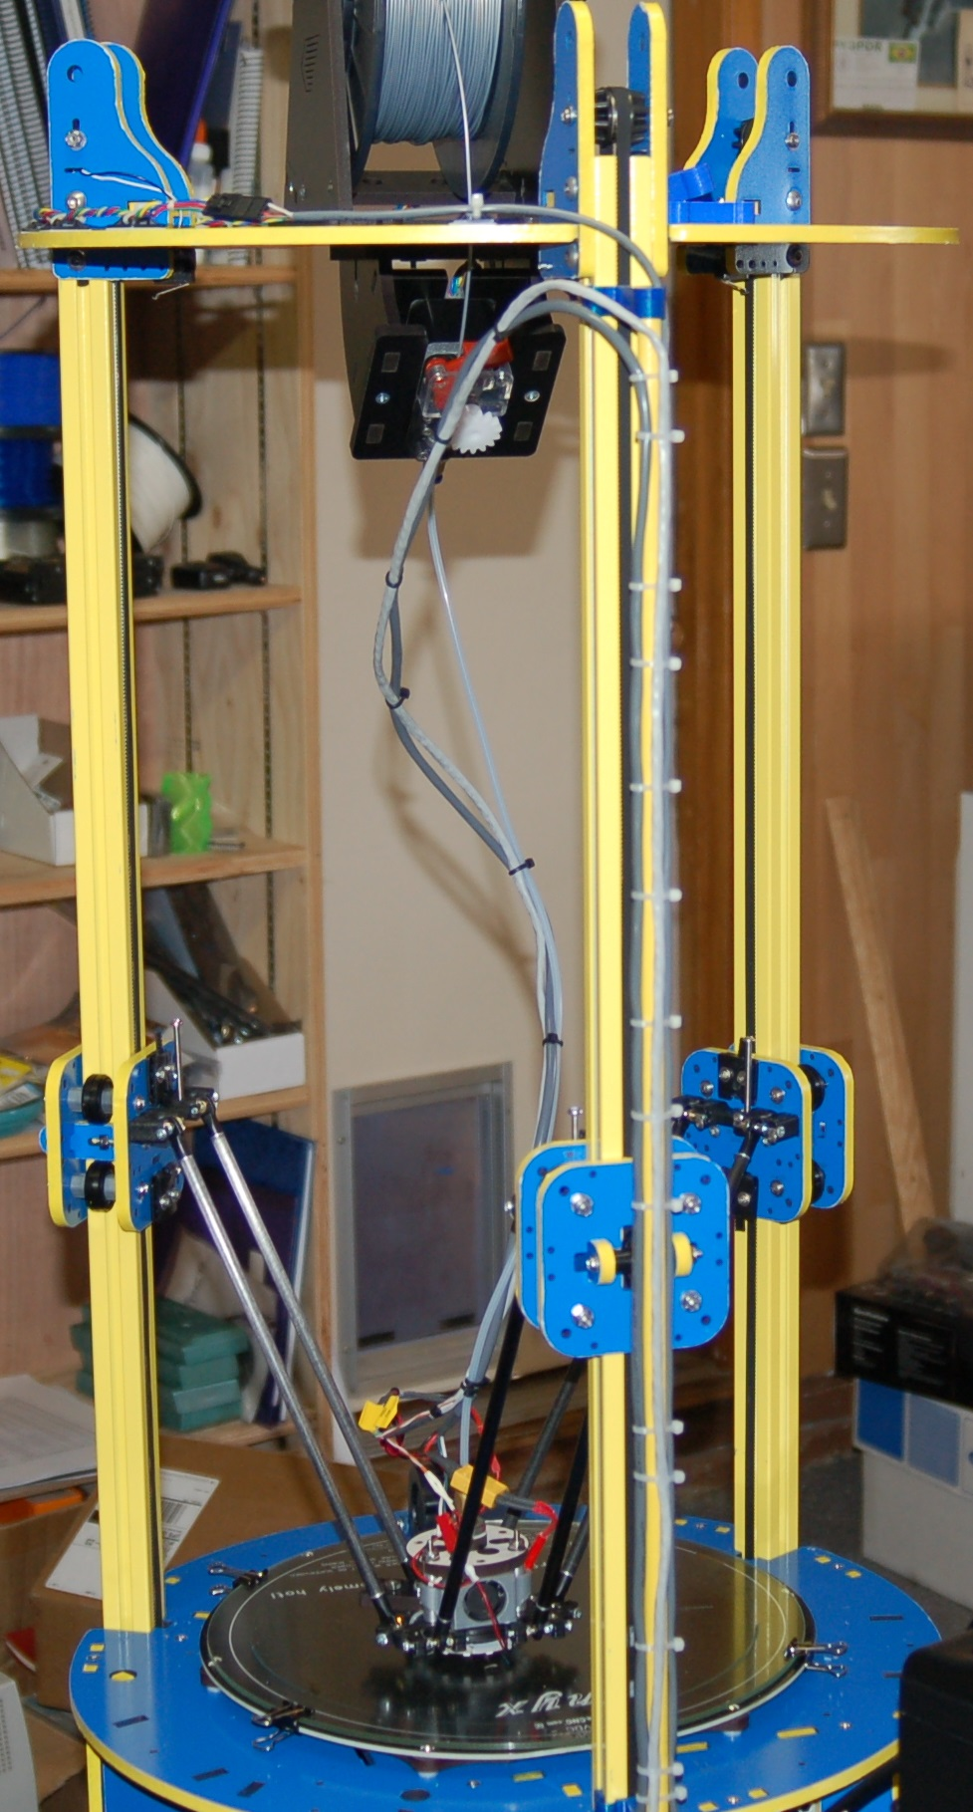Fig. A-5: Wire routing on Blue Max.

That's really all there is to it!

Appendix B – Accessories

PEEK Fan Shroud
One of the first accessories that you should print for your new Rostock MAX 3D printer is a fan shroud for the PEEK fan.
The PEEK fan is very important, especially when printing with PLA. The fan keeps the PEEK section cool in order to prevent “heat creep” from jamming the hot end.
The Repables site has a SeeMeCNC-designed fan shroud here:
http://www.repables.com/r/140/
You should print it out of ABS. The shroud is in close proximity to the hot end and will melt if you print it from PLA. The fan shroud requires a 25x25x10mm 12VDC fan. If you don't have one, you can purchase one from the SeeMeCNC online store, or any number of resellers on eBay.
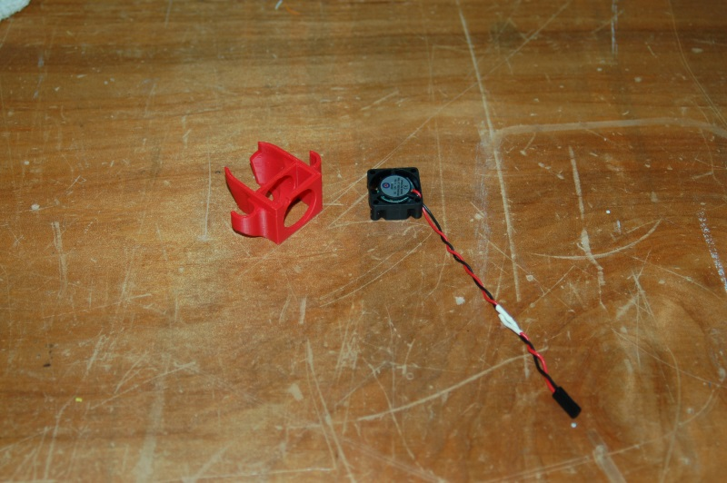Fig. B-1: Fan shroud and fan.

In order to ensure maximum cooling to the PEEK barrel, you'll need to make sure you insert the fan into the fan pocket such that it's blowing IN towards the PEEK barrel.
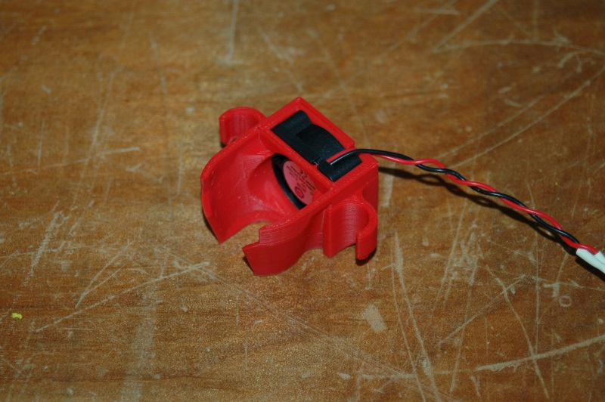Fig. B-2: Fan installed, top view.
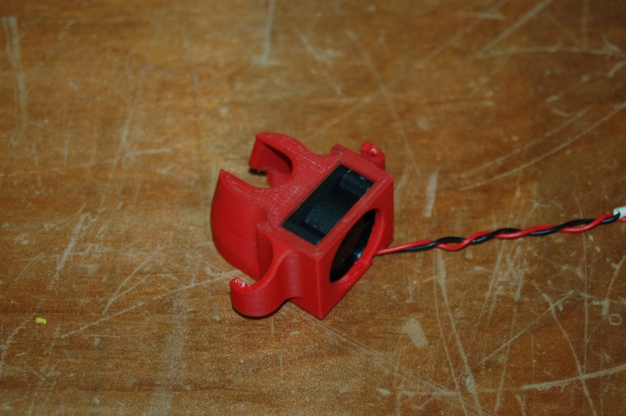Fig. B-3: Fan installed, bottom view.

If you're using the Repetier firmware supplied by SeeMeCNC, you can connect the PEEK fan to the HEAT1 terminal on the RAMBo board. This output is set to turn on any time the extruder is on and it will drive the fan 100%, which is what you want.
If you're using your own firmware, or an older version of the Repetier firmware by SeeMeCNC that does NOT have this feature added, you can wire it in to the FAN1 output and turn the fan on by sending “M42 P6 S255” to turn the fan on and “M42 P6 S0” to turn the fan off.
Install the fan shroud on the effector platform is very simple. Just slide it between any pair of aluminum spacers and you're done. You may need to loosen the platform screws a small amount if the fit is too tight for the fan shroud to fit.
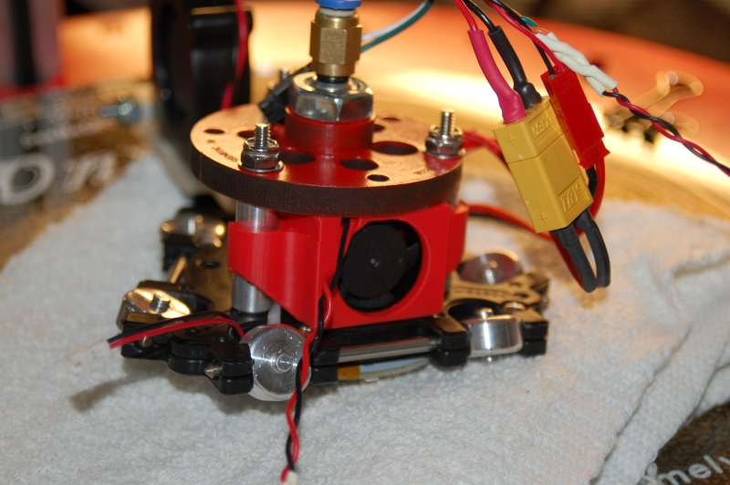Fig. B-4: PEEK Fan shroud installed!

Appendix C – Revised Calibration Instructions
The 0.91 version of the firmware has really made calibrating your Rostock MAX a very easy task! In order to calibrate the Rostock MAX, we'll need to first set what the “true” Z-Height of the machine is. In order to do that, send a G28 command to the Rostock MAX. If you haven't done so already, install the 300mm Borosilicate glass build surface on top of the Onyx. You can fix it in place using the included document clips.
Bring your hot end and heated bed up to operating temperature. Set the hot end temp to 190C and the heated bed to 55C. We want the hot end and bed to expand to “normal” so we can get a fairly accurate measurement here.
Once the hot end and bed have reached their target temperatures, “click” the rotary shaft on the LCD controller by pressing it in. This will take you to the LCD menu. Turn the shaft counter-clockwise until you reach the “Advanced Settings” entry and then click the button to select that option.
Rotate the shaft counter-clockwise until you reach the “Calibrate Z Height” option and click the button.
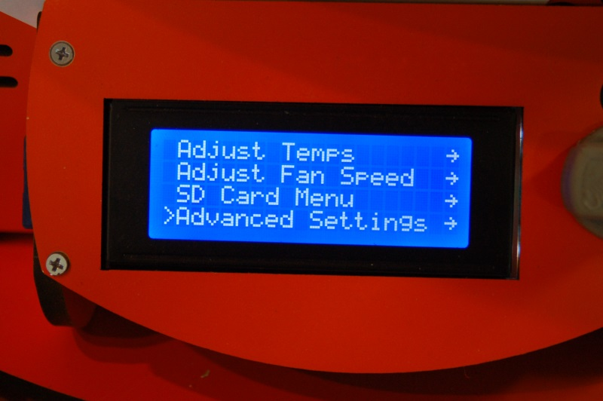Fig. C-1: Advanced Settings.
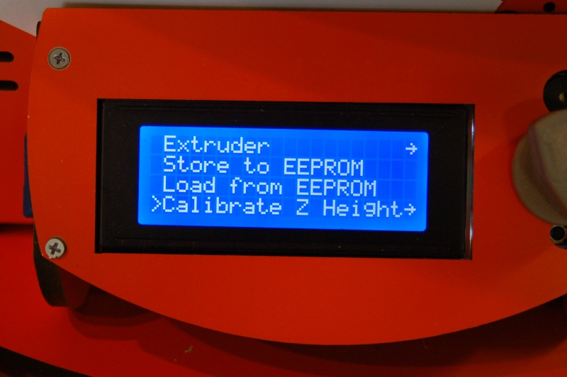Fig. C-2: Calibrate Z-Height

Rotate the knob counter-clockwise again and choose the “Home Towers” menu option and click. This will send the Rostock MAX to the home position. This is the same as sending G28 to the printer. After the homing process finishes, select the “Z-Position” option and click.
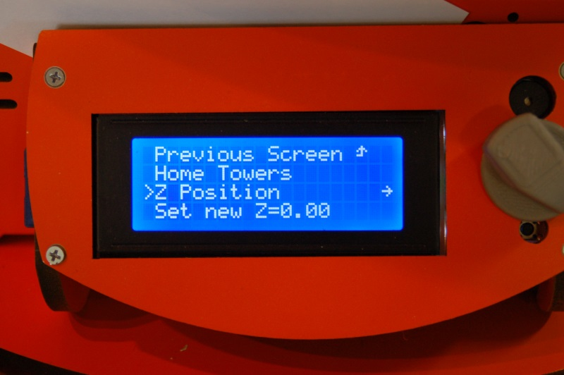Fig. C-3: Z Position

When you click on the Z-Position option, you'll see a display similar to that shown in Fig. C-4.
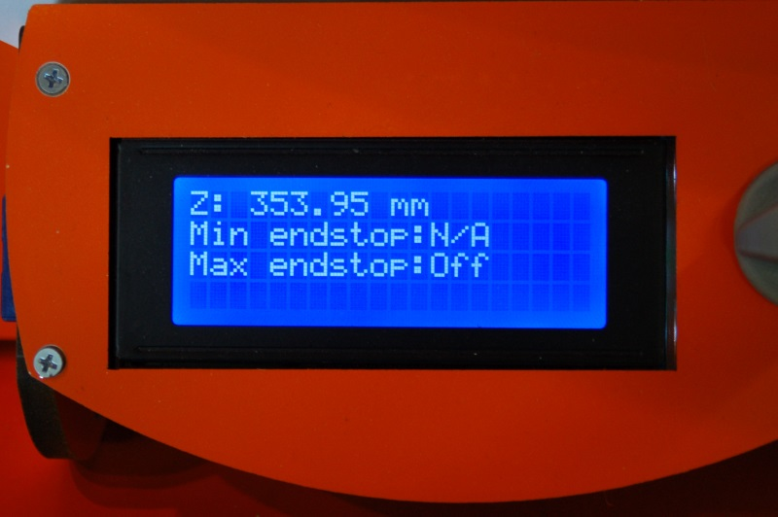Fig. C-4: Adjusting the Z-Height.

You control the height of the effector platform by turning the shaft on the LCD panel. Turning it counter-clockwise will lower the nozzle, and turning it clockwise will raise it.
If you turn the shaft quickly, you'll get large changes and if you turn it slowly, one step at a time, the change will only be 0.01mm per click. Please be careful not to accidentally burn yourself on the heated bed or the nozzle!
Turn the shaft counter-clockwise until you're about 1/2” from the bed surface. Place a sheet of paper on the bed, under the nozzle. Lower the nozzle slowly until moving the paper around causes it to drag a little bit on the nozzle tip. You want it close enough that you can push the paper under the nozzle, such that it almost prevents you from pushing the paper under the nozzle.
When you've reached that point, click the shaft and choose the “Set new Z=0.00” option and this will set the correct Z-Height for your Rostock MAX. Now that you know what the correct max Z height is, you'll need to update Repetier-Host with that information. Click on the EEPROM table by clicking on Config and then “Firmware EEPROM Configuration” in Repetier-Host.
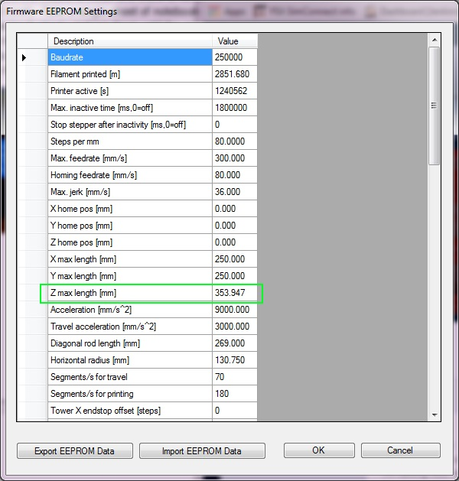Fig. C-5: Z Max Length.
You'll see a parameter in the table called “Z max length [mm]”. This is the actual maximum Z height that we just discovered using the LCD interface. Write that number down and dismiss the EEPROM table dialog box by clicking the “Cancel” button.

In order to tell Repetier-Host what your printer Z height is, you'll need to disconnect from the Rostock MAX to enable the “Printer Settings” option. Click the Disconnect icon and then open the Printer Settings dialog via the Config menu.
Click on the Printer Shape tab and make your change to the Printable Height field – populate it with the figure you noted from the EEPROM table's “Z max length [mm]” field.
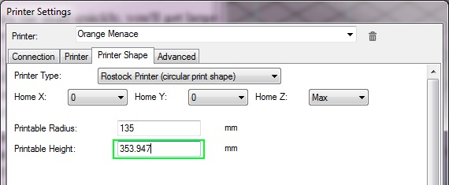Fig. C-6: Setting the Printable Height in Repetier-Host.
Once you're done, click the “Apply” and then “Ok” buttons to save your changes. Click the Connect icon to connect back up to the Rostock MAX.
Now we need to calibrate the end stops. This ensures that the effector platform your Rostock MAX achieves an accurate nozzle height and parallel travel across the entire bed surface.
To make this process easier, we're going to set up three “scripts” within Repetier-Host.
To edit these scripts, you'll need to click on the G-Code Editor tab and then select “Script 1” from the drop down indicated by the arrow in Fig. C-7, below.
Fig. C-7: Creating scripts.

Enter the g-code just as you see it on the previous page. After you've entered the two lines, click the Save icon and choose the next script, “Script 2” from the drop down. Enter “G28” on line #1 and “G0 Z0 X77.94 Y-45 F3500” on line #2. Save this script and pick “Script 3” from the drop down. As before, enter “G28” on line #1, and on line #2, enter “G0 Z0 X-77.94 Y-45 F3500”, then save it.
Last, enter the following code for Script 4.
G28
G0 Z0 F3500
And save it.
In order to make sure that each axis is higher than the three points listed above, I want you to position the machine using these commands:
G28
G0 Z5 X0 Y90 F3500
Click the “Home All” icon on the manual control panel and then stick a sheet of paper under the nozzle, just like you did when setting the Z height. Approach the zero point 1mm at a time by clicking on the down arrow for the Z axis. If you pinch the sheet of paper really hard before you hit the zero height point, use a #2 Philips screwdriver to turn the end stop adjustment screw two full turns to the right. Perform the same check on the other axes by issuing G28 followed by G0 Z5 X77.94 Y-45 F3500 and G0 Z5 X-77.94 Y-45 F3500. You're not after accuracy at this point, you just want to get the nozzle from pressing into the build plate.
Once you're confident you can go to the heated bed without striking it, you can begin to precisely adjust the end stop screws.
Click the “Printer” menu option at the top of the Repetier-Host window and select “Send Script 1”. This will send the g-code you entered previously to the Rostock MAX. Make sure you've got your sheet of paper under where the hot end will “land”. Script #1 covers the Z tower, #2 covers the Y tower and #3 covers the X tower. Having these in script form makes the repeating task of setting the end stops much easier. The shortcut key sequences for these are Ctrl-Alt-1, Ctrl-Alt-2, and Ctrl-Alt-3.
You adjust the height of each axis by turning the end stop adjustment screw to the right to raise the platform and to the left to lower the platform. Each time you make an adjustment, re-issue the Send Script 1 command. Repeat this process until you're getting the same amount of “grab” on the paper as you did when setting the initial Z height. When you're satisfied, move on to the #2 and #3 scripts.
Lay your sheet of notebook paper on the center of the build platform and execute Script 4. ( Ctrl-Alt-4)
The nozzle tip is going to end up in one of three positions. It's going to be above your paper by a visible amount, it's going to pin the paper firmly to the bed, or if you're incredibly lucky, it will be “gripping” the paper the same amount as the tower base calibration steps. If it IS, I strongly recommend you go buy a lottery ticket. Your luck is just that good.

If you're merely mortal like the rest of us poor suckers, you're going to have to make an additional adjustment. Delta configuration printers like the Rostock MAX have a very interesting geometry that will result in the hot end traveling in a non-flat path if it's not perfectly calibrated. This tiny error will express itself as a “virtual” convexity or concavity in what it thinks the bed shape is. If your hot end is pinning the paper to the build surface, the error is expressing itself as a concavity – the firmware thinks that it is moving flat, but the path of the hot end is actually concave and that's why it pins the paper to the build surface – the center is actually lower than it should be. The reverse is also true – if the hot end is not touching the paper at all, it thinks that the bed is dome shaped (convex).
The concave/convex shape of the bed is controlled by the EEPROM table entry labeled “Horizontal radius [mm]”.
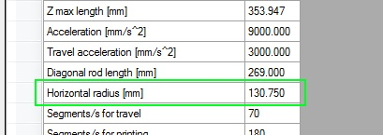Fig. C-8: Horizontal Radius Setting.

What you're going to do is bump that figure by 0.5 until the nozzle is touching the paper just the same as it was when you calibrated at the base of each tower.
In order to lower the nozzle, you'll need to increase the Horizontal Radius value.
In order to raise the nozzle, you'll need to decrease the Horizontal Radius value.
Each time you change the Horizontal Radius, you must re-calibrate the base of each tower as you did in the previous steps using Scripts 1 through 4. It may take a number of iterations to get the center nozzle height nailed down, but it IS worth the hassle. Your first layer quality and plastic adhesion require that the nozzle track across the entire bed as perfectly flat as it can.

Here's a flowchart that will hopefully clarify the process.
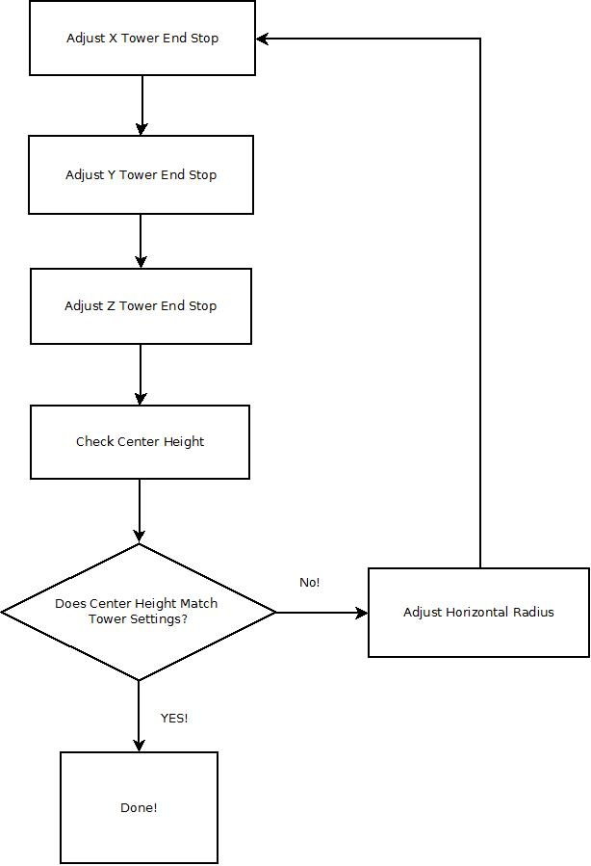Fig. C-9: Calibrating the Effector Platform.

The last task you'll need to perform before you can load plastic in to the machine is to correctly set the steps per mm (“E-Steps”) for the extruder. Open up the EEPROM configuration editor and look for the label highlighted below:
Fig. C-10: Setting the E-steps per mm.

The value should be set to 92.65. If you're using the older Steve's Extruder, this value should be set to 584.
This value dictates the number of steps that the stepper motor must rotate in order to feed 1mm worth of filament to the hot end. The figures supplied will get your e-steps very close to ideal, but extra fine tuning can't hurt. I highly recommend that you check out the “E Steps Fine Tuning” section of Triffid_Hunter's excellent calibration guide. It can be found here:
http://reprap.org/wiki/Triffid_Hunter%27s_Calibration_Guide
The other portions of his calibration guide doesn't really apply to the Rostock MAX, so it's not necessary to read unless you're simply curious.

