Visual Bill of Materials
Your Rostock MAX v2 kit should contain three large laser cut Melamine sheets, a large box containing hardware, injection molded parts, the RAMBo controller and the required wiring. The box will also contain a 450W ATX style power supply.
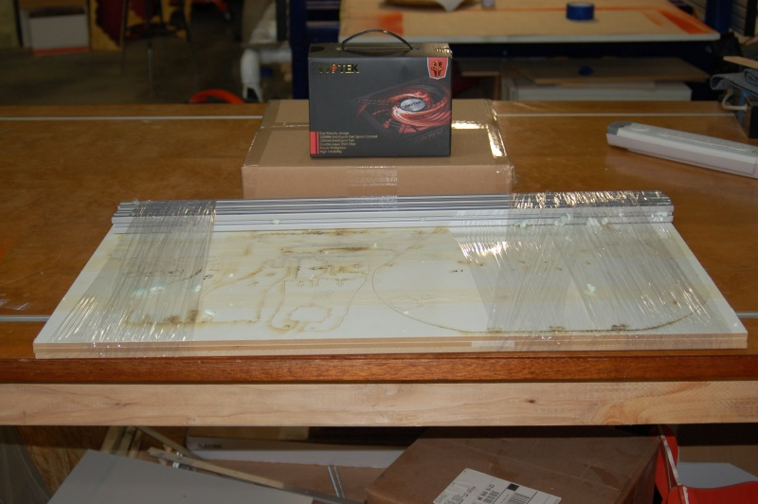Fig. 1-1: Shipping box contents.

The Melamine parts are held in place with masking tape in order to protect them during shipping. The parts are also covered with a special cutting mask that prevents the laser cutting operation from depositing cutting residue on the Melamine surface. You'll need to remove all of this material before beginning construction.
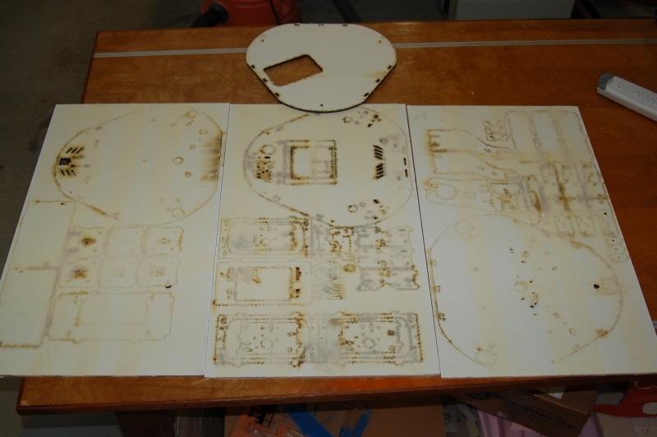Fig. 1-2: Laser cut parts.
Included in the three laser cut sheets is an additional component that's part of the printer's upper section, as seen in Fig. 1-2.

Take special care when removing the laser cut parts from the sheets. Sometimes the laser doesn't quite cut all the way through. If you find a part like this, you'll want to gently score the back side of the sheet along the faint cut line and then press the part out from the front of the sheet. The front and back of the sheet is easily identifiable – the front of the sheet will have very dark laser cut lines with “flash” deposits to either side of the laser cut line. The back of the sheet will have much fainter marks.
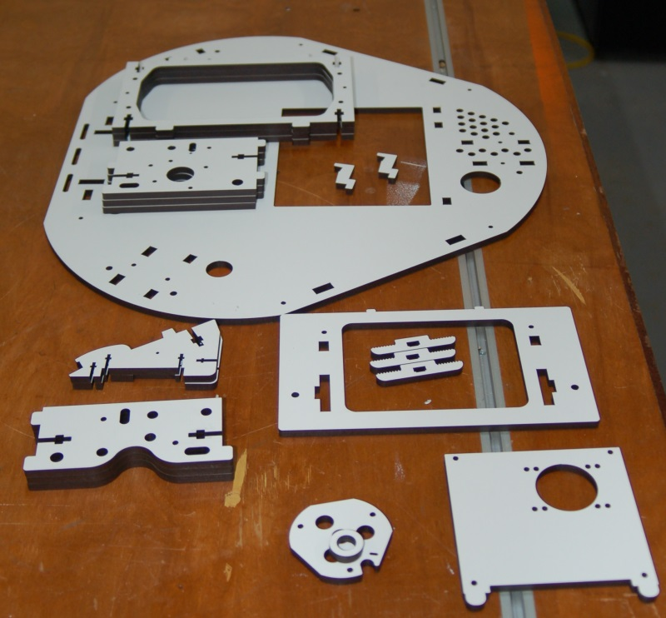Fig. 1-3: Sheet #1 parts.
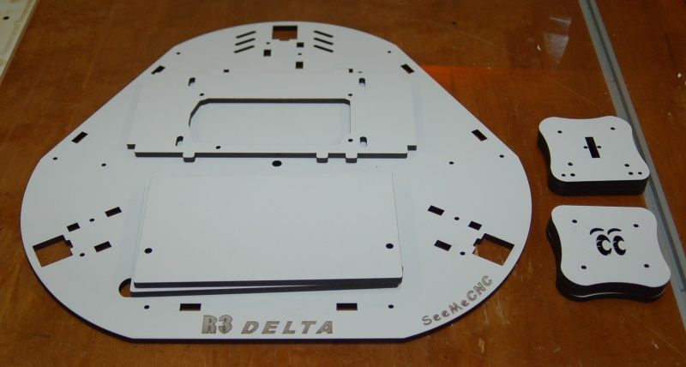Fig. 1-4: Sheet #2 parts.
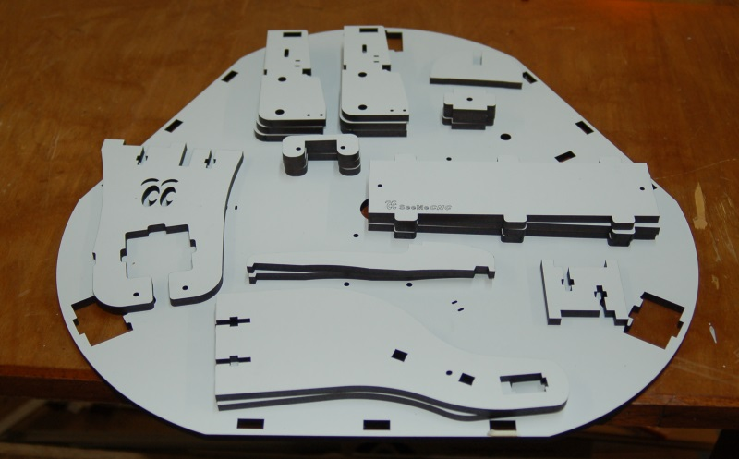Fig. 1-5: Sheet #3 parts.

The cardboard box contains all the non-melamine components required to build the Rostock MAX v2. Many are in individual baggies, some are in heat-sealed bag “packs”. As you go through the following Bill of Materials, please count and check off each item. This is important as you don't want to be short a vital part during the build. It's better to find out before hand than being forced to stop the assembly process due to a missing part. If you are missing any parts, please contact support@seemecnc.com with the subject line of “Missing Parts!”. Note that the quantities shown in the photographs may not necessarily match the quantity listed to the right. When it doubt, follow the quantities listed in the text!
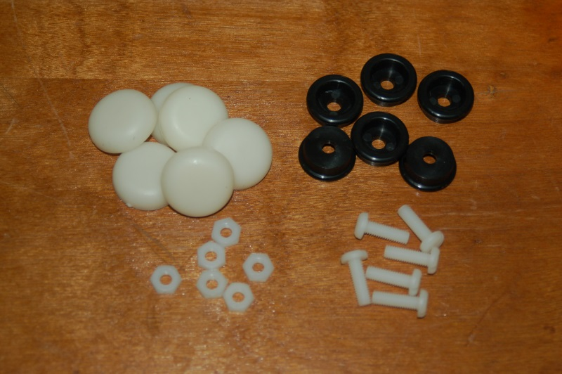
Rubber foot pack. Contains 6 each of the following components:
#10-32 x 5/8” Nylon Pan Head Screws
#10-32 Nylon Finish Nuts
Injection molded legs (black)
Soft rubber feet
9 each, #10-32 x 3/4” Knurled Nylon Thumb Screws.
These are for the right & left base covers as well as the LCD panel.

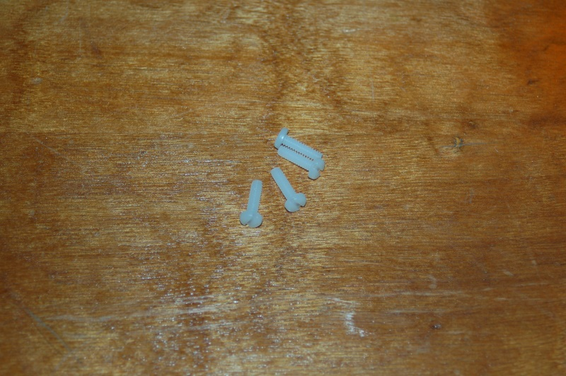
4 each, #6-32 x 1/2” Slotted Pan Head Screws (Nylon).
These are used to mount the 450W ATX power supply
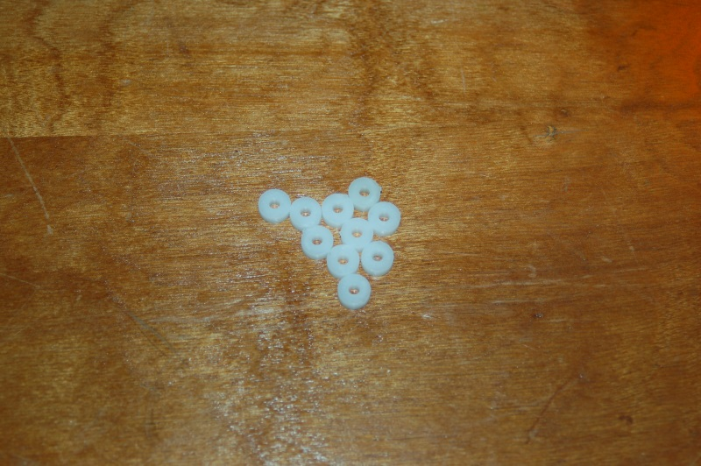

10 each, Plastic Bearing Rollers. 4 are used for mounting the RAMBo and six are used for the belt clamps.

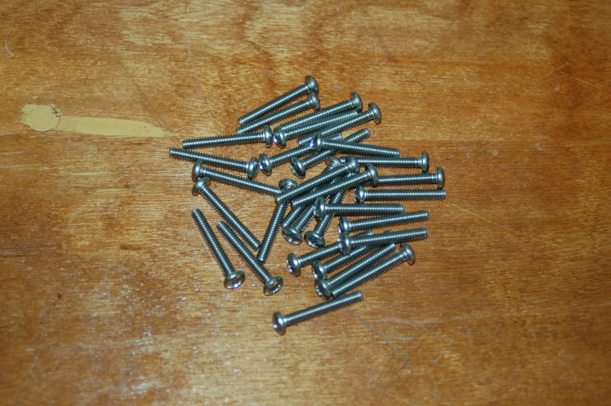
31 each, #6-32 x 1” Phillips Pan Head Screws. Used for general assembly.

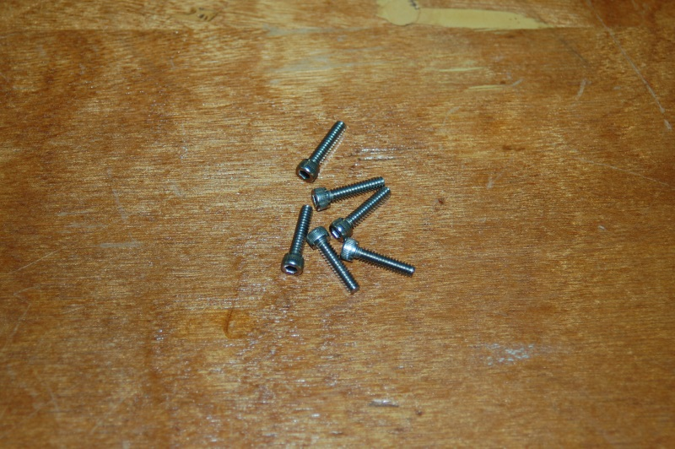
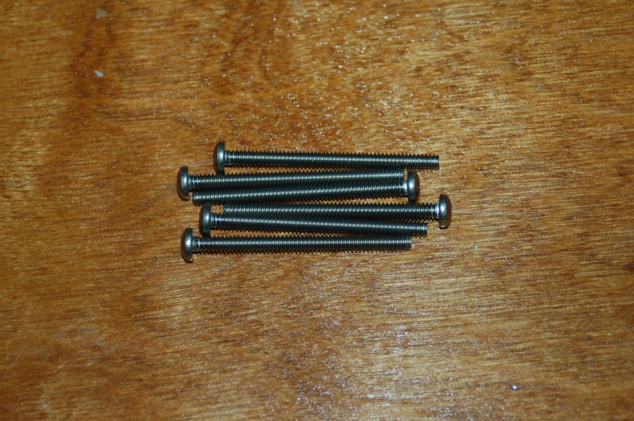
6 each, #6-32 x 5/8” Socket Head Cap Screws. Used for mounting the U- Joint plates to the Cheapskate plates.

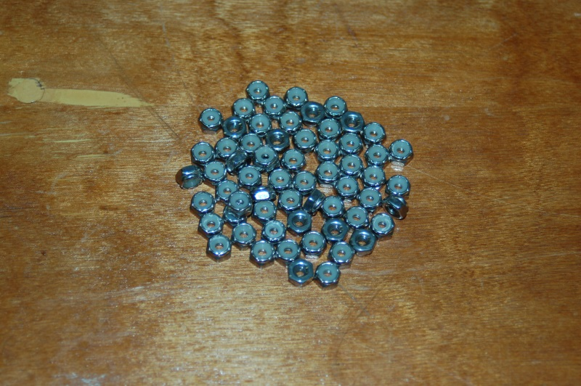
12 each, #6-32 x 1-3/4” Phillips Pan Head Stainless Steel screws. Used for 608 idlers in the motor mounts as well as the hot end standoffs.

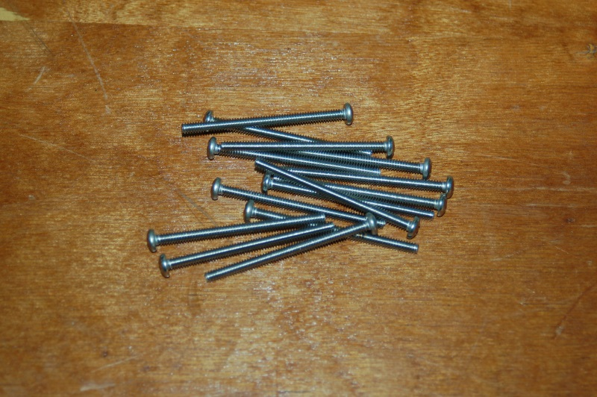
63 each, #6-32 Stainless Steel Nylon Lock Nut – covers all #6-32 screws.

14 each, #6-12 x 1” Phillips Pan Head Stainless Steel screws. Used for Cheapskate plates and EZStruder mount.

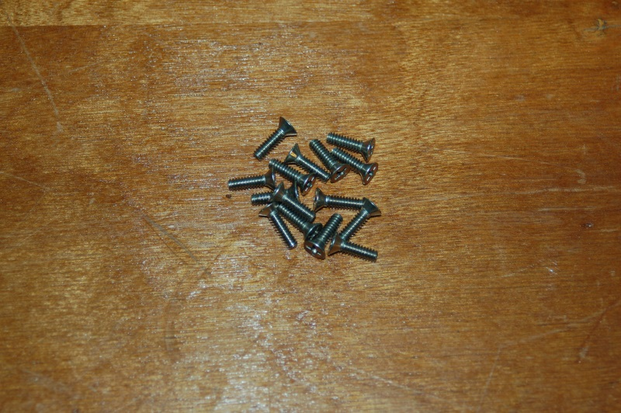
15 each, #6-32 x 1/2” 18-8 Stainless Steel Flathead screw. Used inside of base and top side plates, to retain acrylic panels and the three end-stop triggering screws installed in the Cheapskate U-Joint mounts.

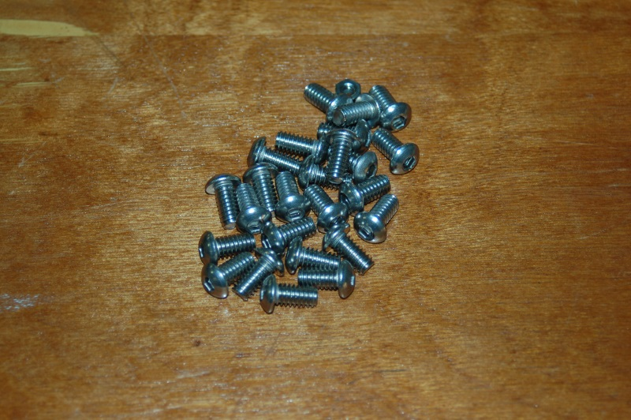
25 each, #¼-20 x 1/2” Stainless Steel Button Head Cap Screws. Used for T-Slot mounting.

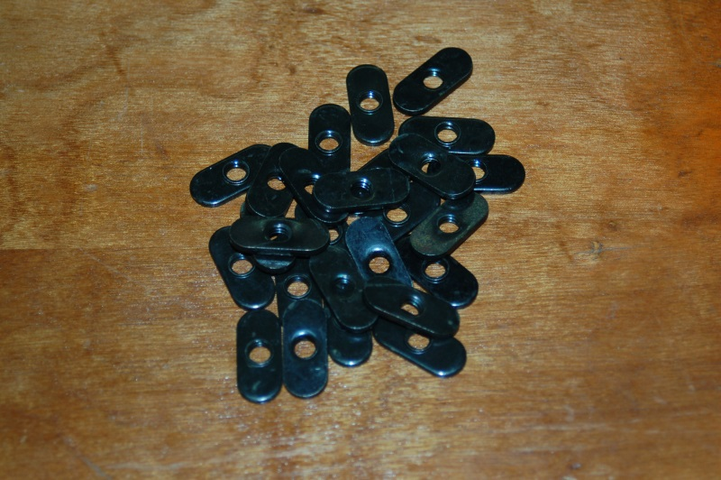
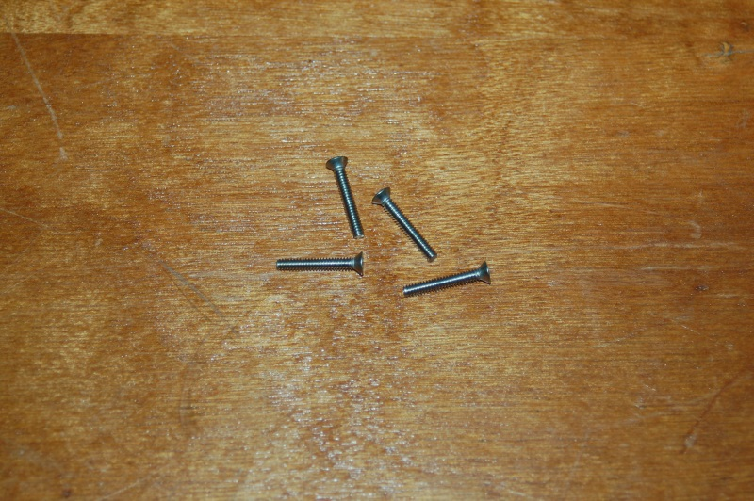
25 each, #¼-20 nut plates. Used for T-Slot mounting.

4 each, #4-40 x 3/4” Phillips Flat Head Machine screws. Used for mounting the RAMBo Controller.

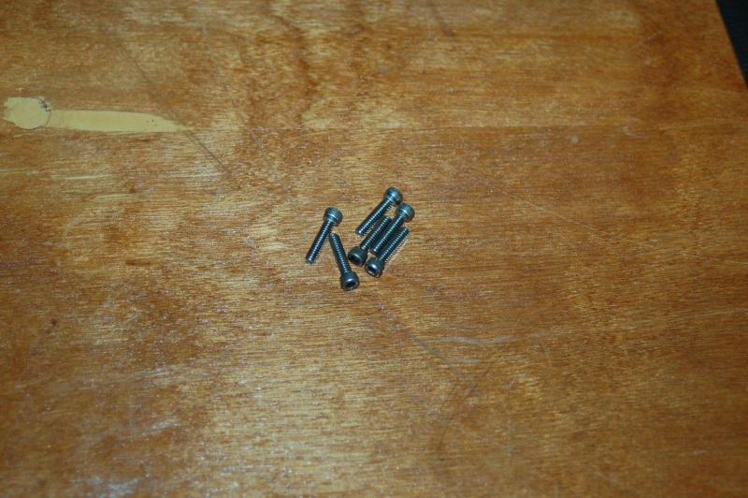
6 each, #4-40 x 1/2” Stainless Steel Socket Head Cap screws. Used for the belt clamps.

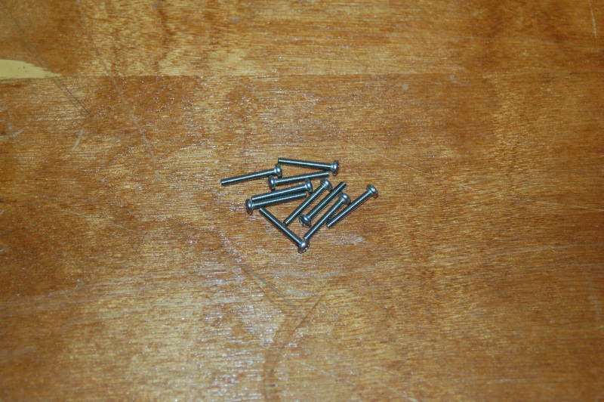
10 each, #2-56 x 5/8” Pan Head Phillips Machine screws. Used for LCD mounting and end-stop switch mounting.

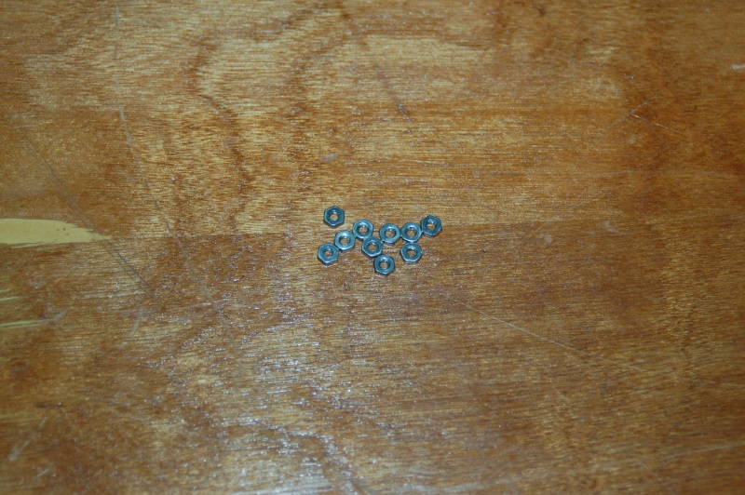
10 each, 2-56 Finish Nuts. Used for LCD mounting and end-stop switch mounting.

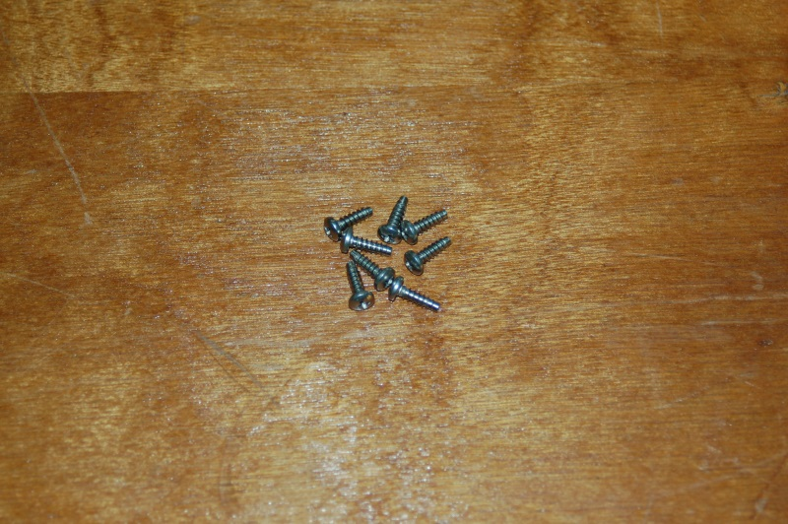
8 each, #4 x 3/8” Phillips Pan Head Sheet Metal screws. Used for LCD sides and tower alignment guides.

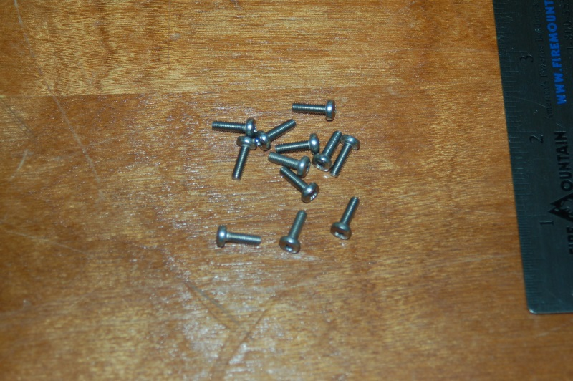
12 each, M3x.5 x 10mm Pan Head Machine screws. Used for mounting the stepper motors.

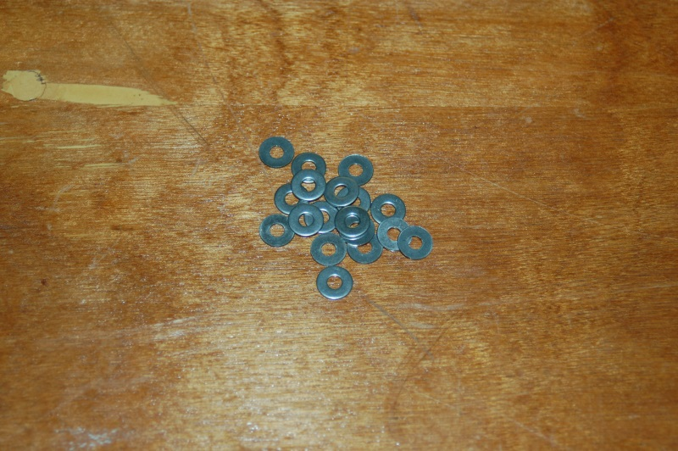
18 each, #6 Stainless Steel Flat washers. Used on the 608 bearings that go in the top & bottom t-slot rails.

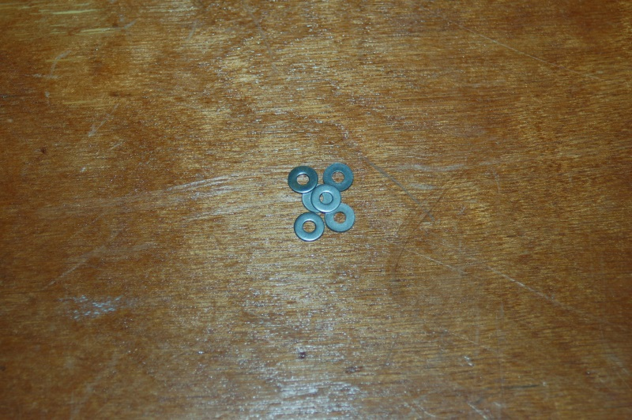
6 each, #4 Stainless Steel Flat washers. Used with the belt clamp screws.

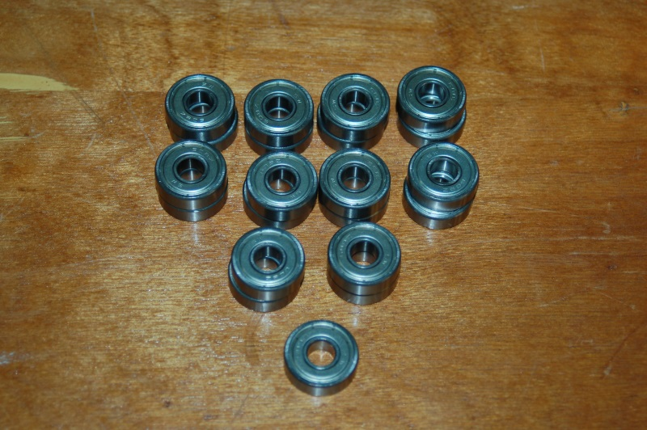
21 each, 608ZZ Ball Bearings. Used in the Cheapskates and belt idlers.

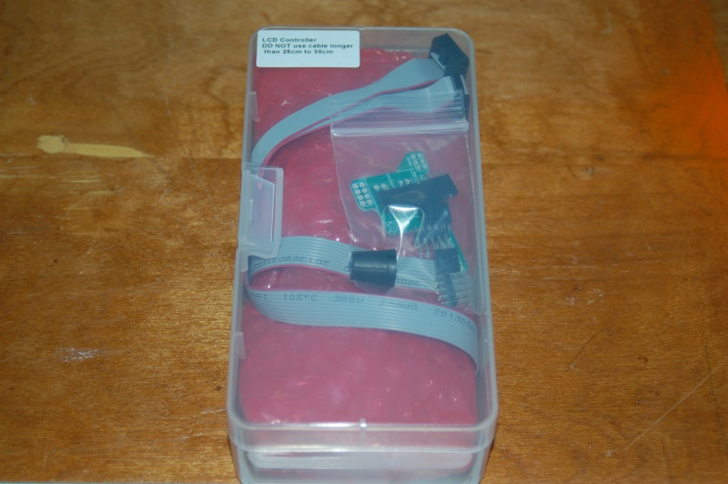
1 each, RAMBo Electronic Control Board with screw terminals and end stop wires [REPLACE WITH CORRECT PHOTO]
1 each, USB Cable.

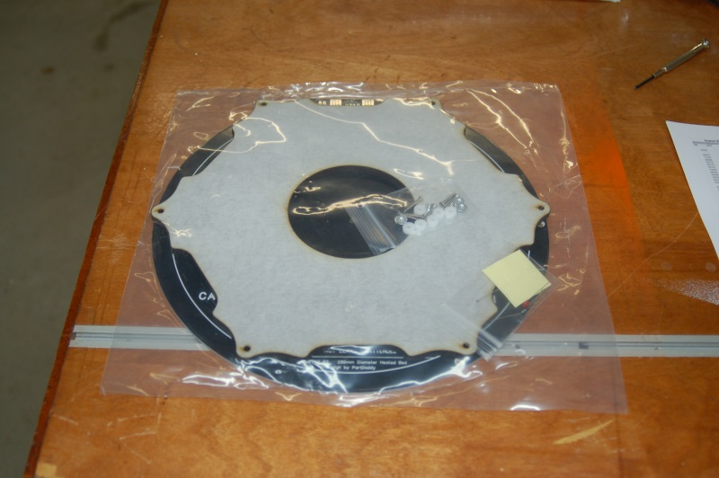
1 each, Onyx Heated Bed Kit.

1 each, 300mm x 3mm Borosilicate Glass Build Plate. Used with Onyx Heated Bed.
[REPLACE WITH CORRECT PHOTO]

1 each, LCD Smart Controller with SD card, LCD to RAMBo Adapter Kit and 1 Soft Touch 5mm knob.

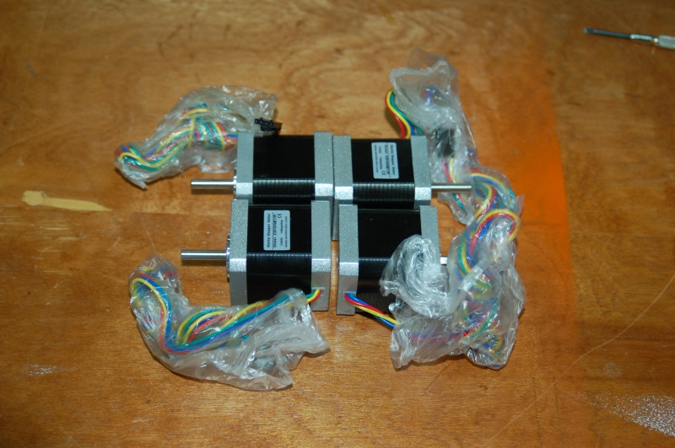
4 each, NEMA 17 Stepper Motors (4800cgm holding torque). Used for three motion axes and extruder drive.

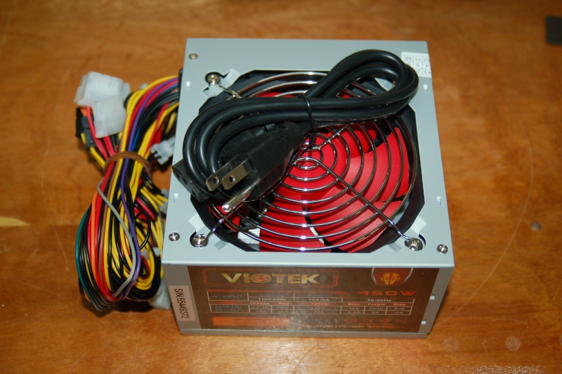
1 each, 450W Power Supply.

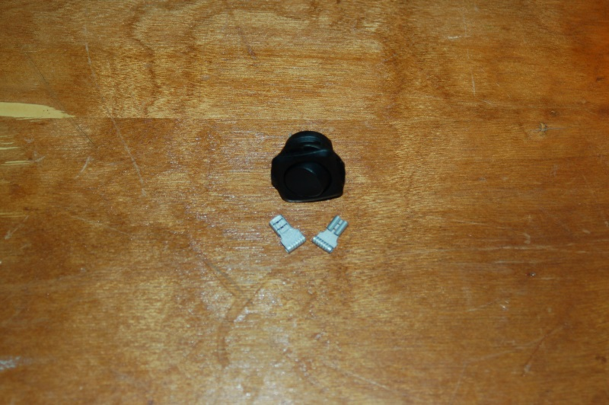
1 each, Rocker switch, including spade lug crimp terminals.

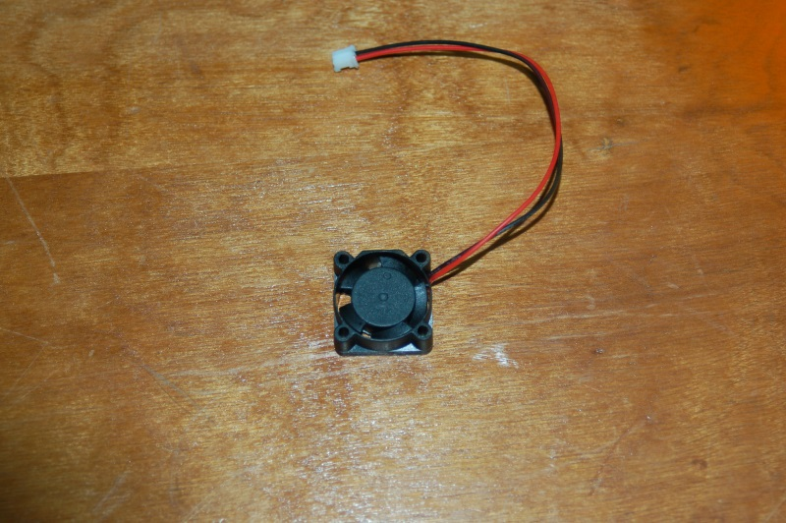
1 each, 25x25x10mm 12VDC fan. Used to cool the PEEK section on the hot end.

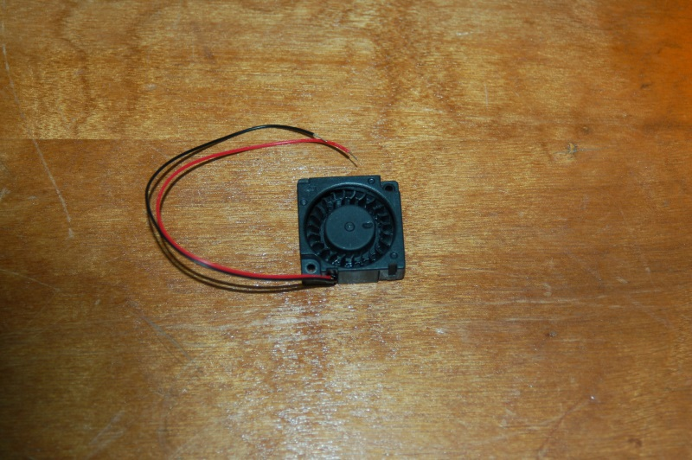
1 each, 30x30x10mm 12VDC fan. Used for part cooling.

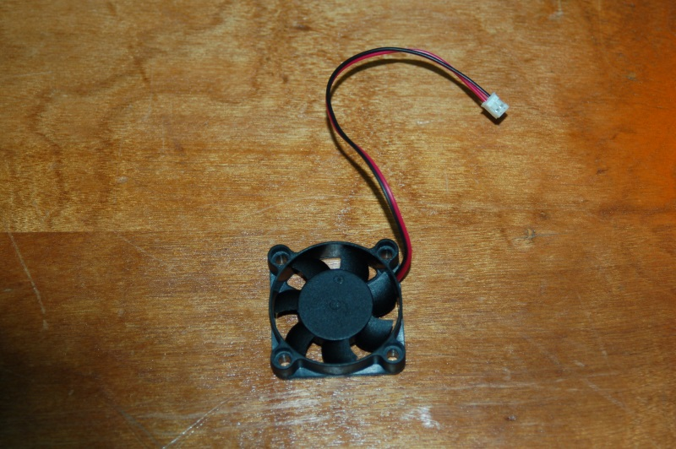
1 each, 40x40x10mm 12VDC fan. RAMBo cooling fan.

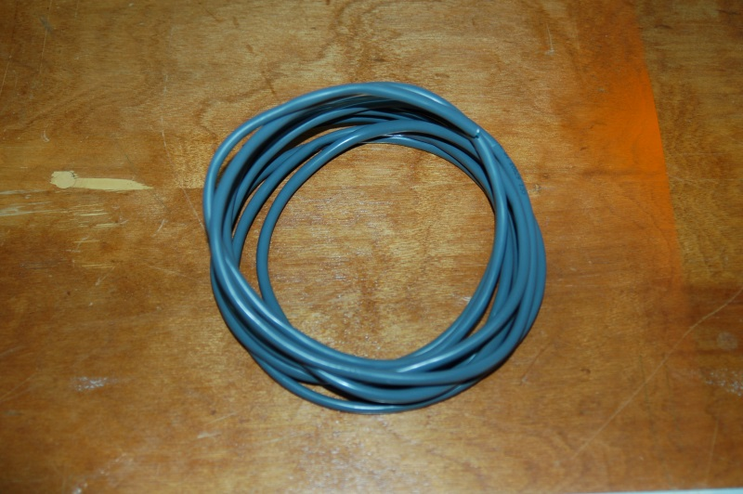
10 feet, 18ga, 4 conductor wire. Used for the hot end power and thermistor.

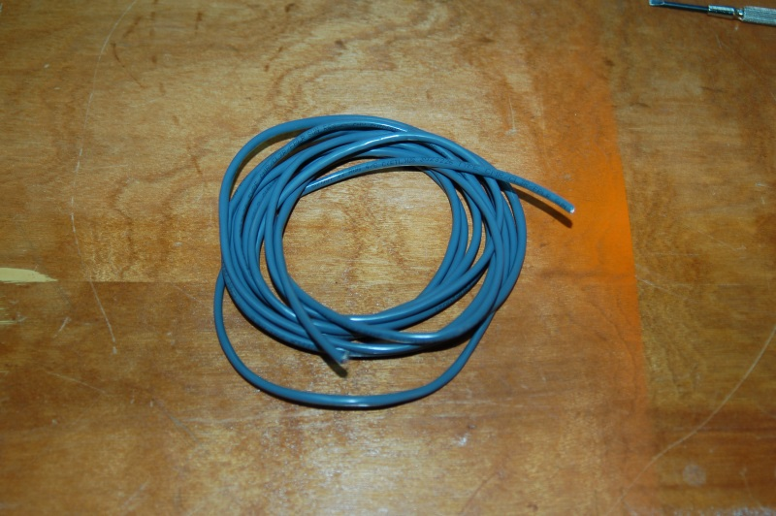
10 feet, 22ga, 4 conductor wire. Used to extend wiring for extruder motor.

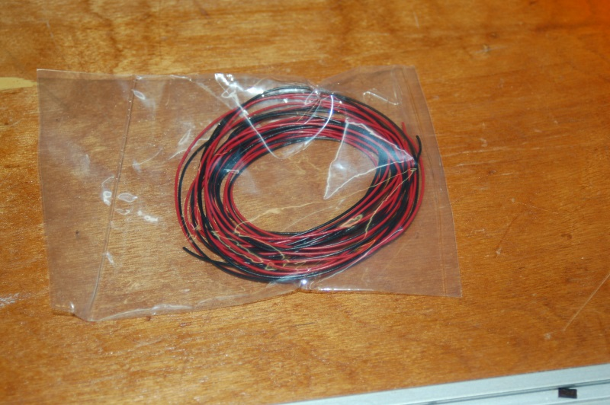
15 feet, 26ga, Black & Red wire. Used for hot end PEEK and part fans.

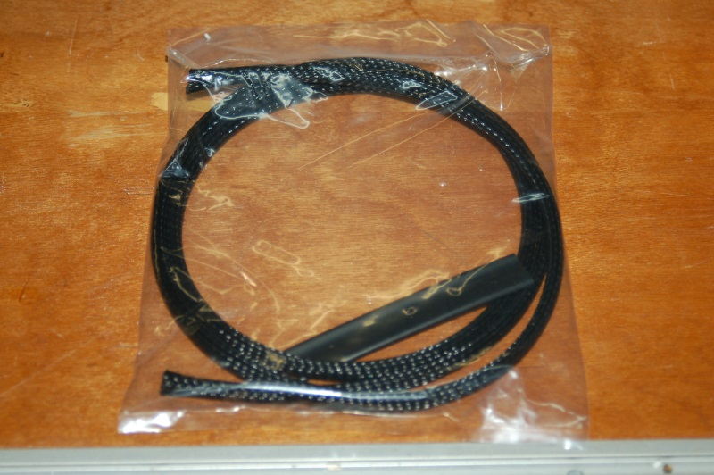
4 feet, 3/8” diameter Expandable Mesh Wire Loom (black). Used to cover wiring & bowden tube from the top to the hot end platform.
Includes 3” of 5/16” heat shrink tubing.

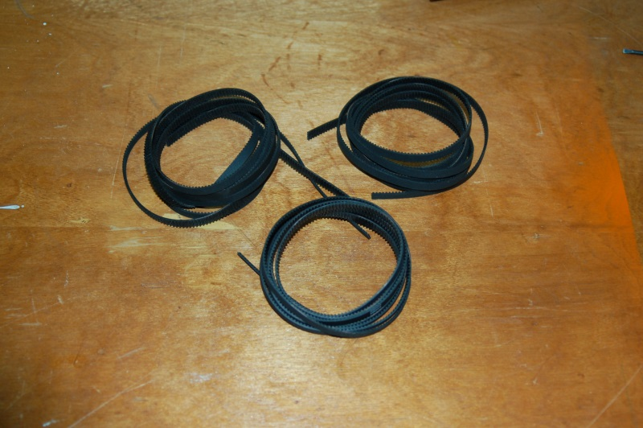
3 each, 76” GT2 Timing Belts.

3 each, T-Slot rails, 32” long. [REPLACE WITH CORRECT PHOTO]

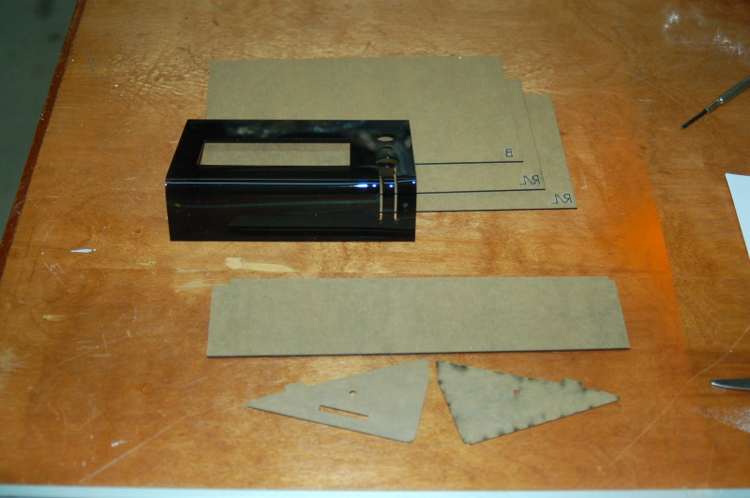
1 each, Smoked Acrylic parts pack. Includes, LCD face, LCD sides (left & right), base and top covers.

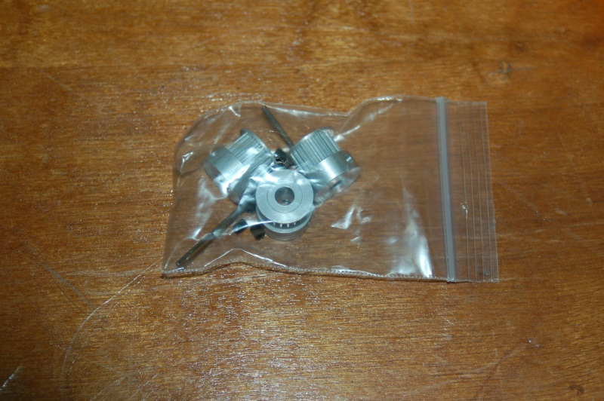
1 each, GT2 2mm pitch belt pulley pack. Includes six grub screws and allen wrench.

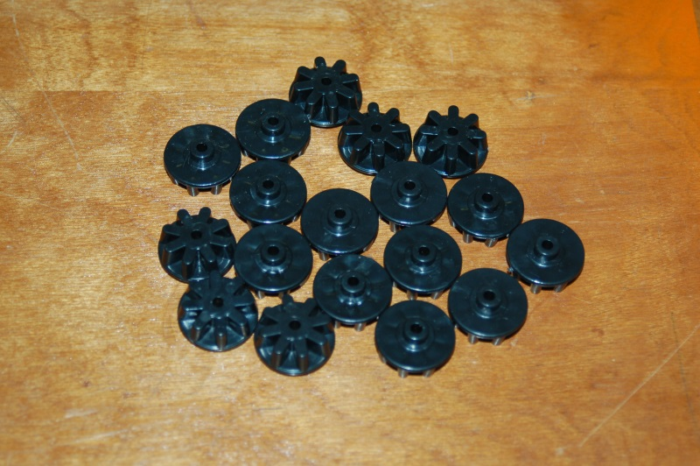
18 each, 608 Cheapskate Idler Bearing Spacer. Used for belt idlers.

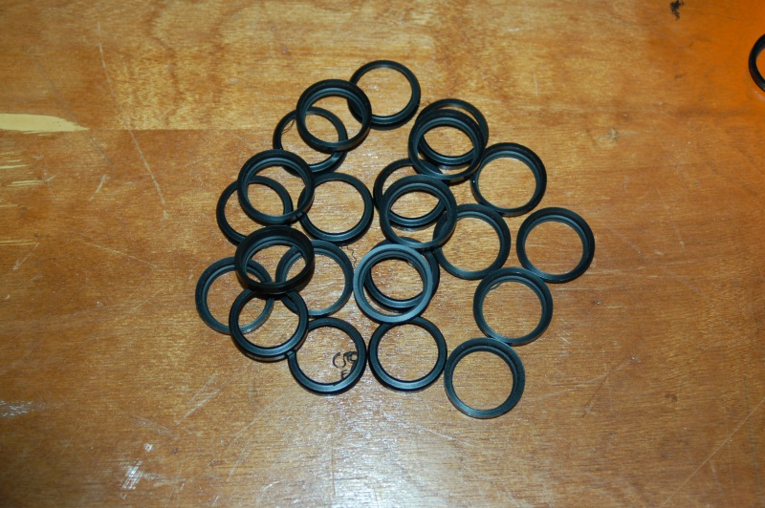
24 each, Bearing Sleeves. Used to cover 608ZZ bearings.

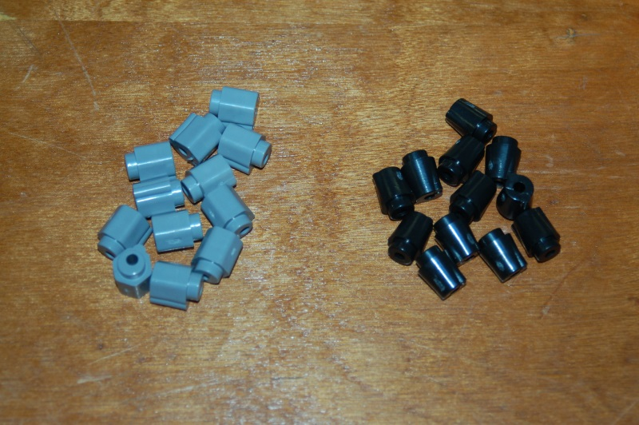
12 each, 608 Cheapskate Carriage Bearing Spacers (black).
12 each, 608 Cheapskate Eccentric Bearing Spacers (gray).

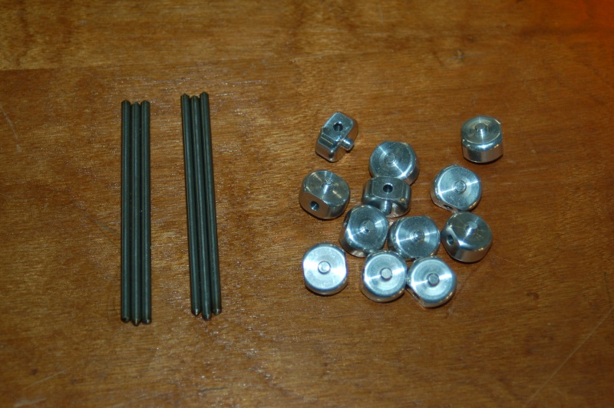
12 each, Universal Joints (machined aluminum).
6 each, 3-1/8” Steel Universal Joint axle shafts.

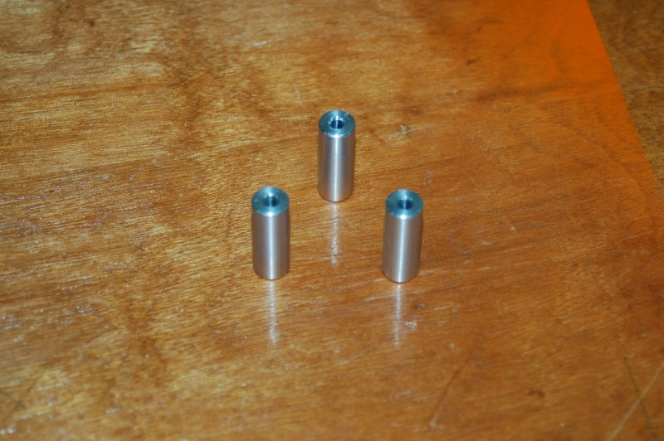
3 each, 1” long machined aluminum hot end platform spacers.

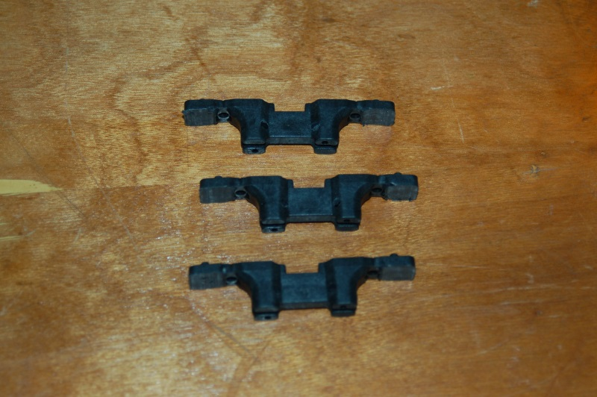
3 each, Cheapskate U-Joint mounts. Outer tabs have been removed to allow for spring clips.

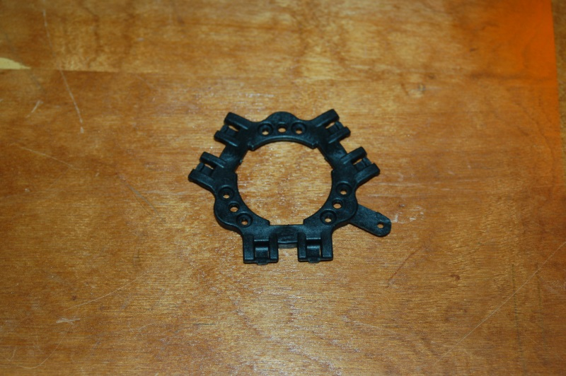
1 each, Effector Platform (spring clip style).

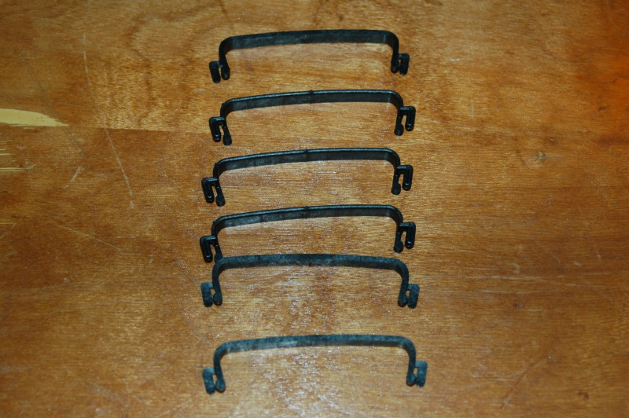
6 each, U-Joint Spring Clips.

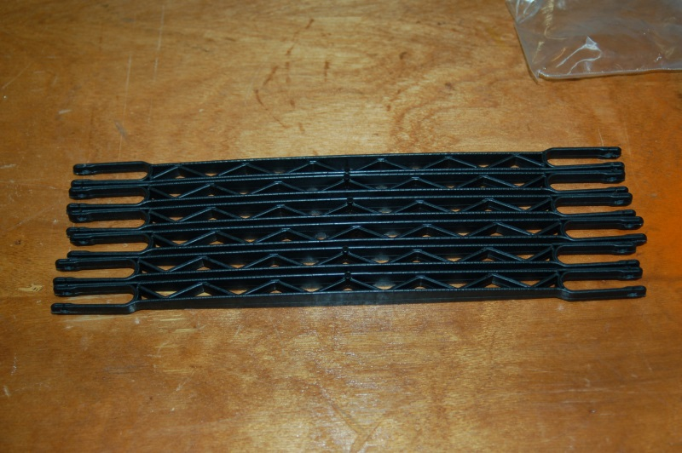
6 each, Rostock MAX Delta Arms.

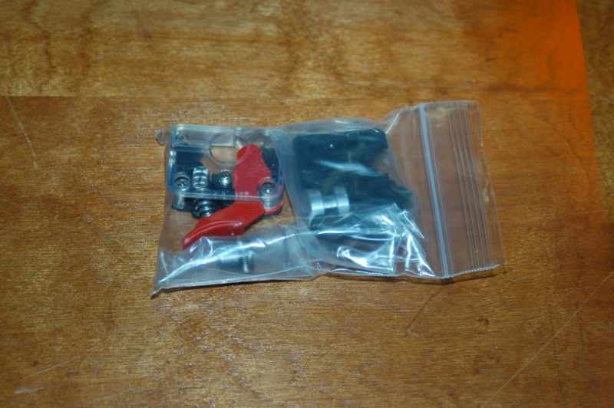
1 each, EZStruder Cold End Kit. Includes stepper motor mounting hardware.

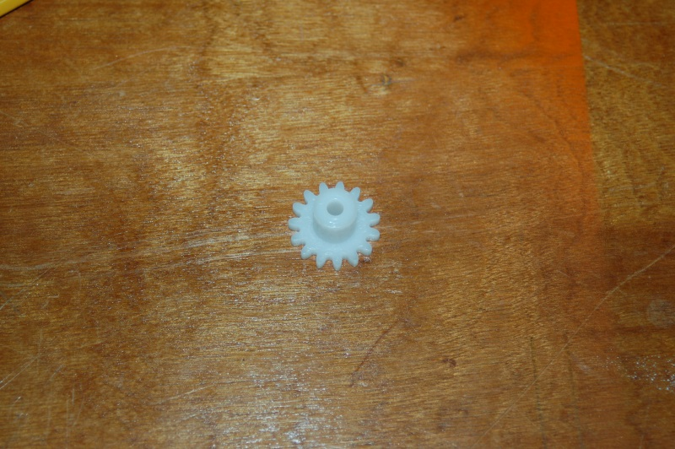
1 each, 15 Tooth Gear. Used for manually operating extruder motor.

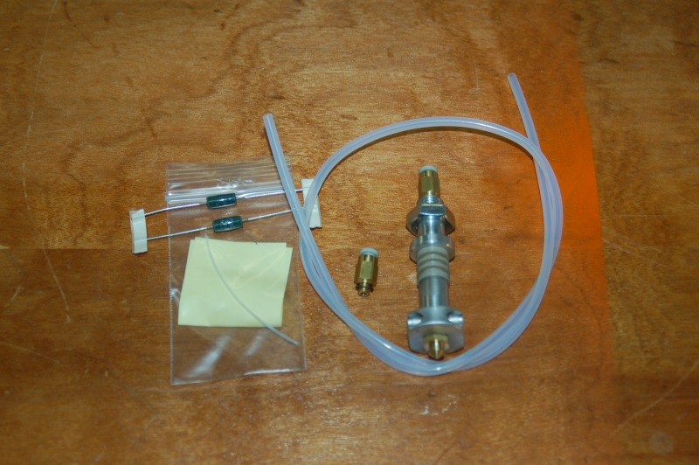
1 each, Hot End Kit. Includes hot end, heating resistors, thermistor, PTFE sleeve for thermistor, PTC fittings and PTFE bowden tube.

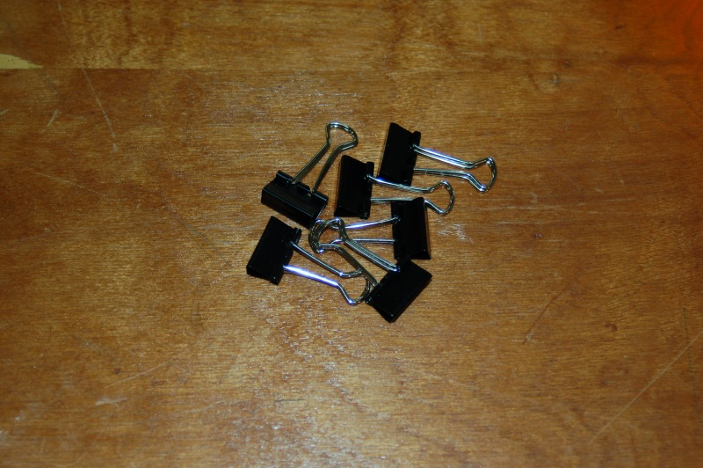
6 each, Binder Clips. Used to hold the Borosilicate glass build plate to the Onyx heated bed.

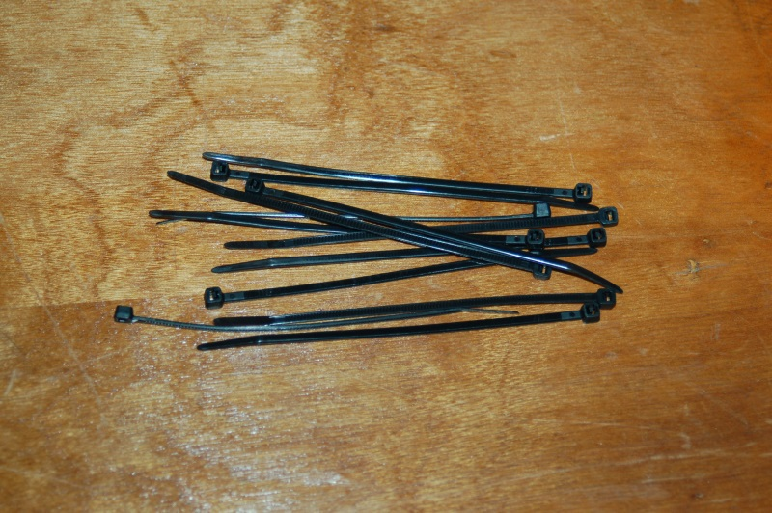
12 each, Wire ties. Used for wire management or Barbie Handcuffs. Your call.


2.2 each, Metric Tons of RTFM. Used for rapid mitigation of Insufficient User Headspace Errors.

