常州维仕千秋电子有限公司
Changzhou Weishi Qianqiu Electronics Co. Ltd.
产品规格书  Products Specification |  |  |  |  | 日期：
 |  |  |  |  | Date:
客户:  Customer: | 型号:  Part No: | 客户型号：  Customer No:
客户:  Customer: | 型号:  Part No: | 维仕千秋型号：  Weishi No: WS-A1640H12
编号  No. | 项目：  Items |  |  | 规格  Specifications
1 | 中心频率Fo  Center Frequency |  |  | 40KHz
2 | 自由电容  Free Capacitance |  |  | 2000±20%pF at 1KHz
3 | 声压  Min. Sound Pressure level |  |  | ≥110dB
4 | 灵敏度  Sensitivity |  |  | ≥-60dB
5 | 使用温度  Operating Temperature |  |  | -30 to 85 ℃
6 | 材料  Meterial |  |  | 铝  Aluminium
7 | 尺寸  Dimension |  |  | 见下图  As Per Figure 1.
备注  Note: | 底部黑点处为正极 单收单发 收发分开
设计  Designed By | Daisy | 审核  Checked | Sandy |  |  | 承认  Approved By |  | John
Dimension UNIT:mm Tolerance:±0.5 mm 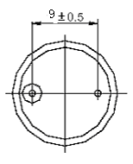 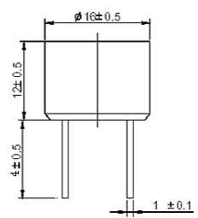 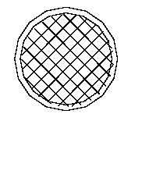
ADD: 常州市青洋路1号新动力创业中心23幢B4楼
Tel: 0086-519-88867199 Fax: 0086-519-88869029

SPECIFICATION FOR APPOVAL
承 认 书

Description: ULTRASONIC SENSOR
Weishiqianqiu Part No.: WS-A1640H12T/R
Customer’s Model No.:
Number of the Edition: 1.1

CUSTOMER’S APPROVED SIGNATURE

常州维仕千秋电子有限公司
CHANGZHOU WEISHIQIANQIU ELECTRONICS CO., LTD.
ADD: No.1 Qingyang Road 213000 Changzhou ,Jiangsu,China
Tel: 0086 519 88867199 Fax: 0086 519 88869029
E-mail: sales@ws-buzzer.com Website: www.ws-buzzer.com

Approved by | Checked by | Issued by

