MED2026
User's Guide and Tutorial
Moore Electrical Design for AutoCAD

Moore Design
© Copyright 2026 Moore Design
DRAFT FOR REVIEW – October 2026. Items marked [VERIFY] must be checked in AutoCAD before release.

Contents
General Information 6
Introduction 6
How to use this guide 6
What's new in MED2026 6
Installing and Starting MED 7
Drawing Setup 8
Setup 8
MED Main Toolbar and Settings 10
Main Toolbar 10
MED Settings 11
Plan Drawings 13
Conduit 13
The Conduit Toolbar 13
Size Menu 14
Bends on or off 14
Route Conduit 14
Turn Conduit Up / Down 15
Editing conduit with MEDCHG 16
Using CHGSIZE to change conduits 18
Placing conduit fittings 18
Identifying conduits and fittings with MEDLIST and MEDPROPERTIES 22
Tagging 22
Cable Tray 24
The Cable Tray Toolbar 24
Size Menus 25
Two point placement method 26
The center line and its importance 29
Placing a Cable tray fitting 29
Offsets 34
Side view cable tray 38
Stripping data from entities 40
Editing cable tray 41
Identifying cable trays and fittings with MEDLIST and MEDPROPERTIES 43
3D cable tray extraction 43
Cables 44
The Cable palette 44
The Cables toolbar 45
Routing cable 45
Cables turned up or down 47
Editing cables with MEDCHG 48
Equipment 48
What is a detail entity 48
The Details Toolbar 48
Place a lighting detail 49
Using the tray detail sets and placing tray related details 52
Tagging details 52
Updating detail tags in a drawing 52
Material Data 55
Where MED keeps its data 56
The MED catalog (MEDTYPE) 56
Material Extraction 57
Browsing the BOM (MEDSHOWBOM) 57
Editing multiple records (MEDRECORDS) 58
Adding Materials 59
Other MED data tools 59
Details 61
Detail Conduit 61
The Detail Conduit Toolbar 61
Size Menu 61
Bends on or off 62
Route Two Line Conduit 62
Conduit Away, Toward, and Break 63
Placing conduit fittings 65
Block Size Invalid or Not Found 67
Wiring Diagrams 69
The Oneline Toolbar 69
Oneline Sample Drawing 69
Placing a typical branch 74
The Elementary Toolbar 76
3D Modeling 78
The 3D commands 78
Preparing the plan 78
Building the model with MEDMAKE3D 79
Reading the summary 79
Running it again 80
Conduit fittings in 3D (conduit bodies) 80
Flags and mirrored fittings 80
Single-purpose 3D commands 81
MAKE3DTRAY 81
MAKE3DCONDUIT, MAKE3DCABLE, M3D and C3D 82
Inserting conduit bodies by hand (MEDCBINS) 82
Conduit body test and data commands 83
When the data changes 83
Using the model in Navisworks 83
3D Block Library 84
Opening the library 84
The palette at a glance 84
Finding a block 85
List, Tiles and Grid views 85
Inserting a block 85
Opening a block DWG 85
Editing block information 86
Bulk editing with Excel 86
Keeping the library up to date 87
Library categories 87
Utilities 88
Attributes and Text 88
Miscellaneous Utility and Edit commands 88
Balloons and Tagging commands 89
ACAD.PGP Shortcut command Keys 90
Appendix A: Command Reference 91
Commands by category 91
Setup and Configuration 91
Conduit and Conduit Fittings 91
Cable Tray and Channel 91
Cables and Wiring 92
One-Lines and Elementary Diagrams 92
Details and Equipment 92
Lists, Reports and MED Data 92
Tagging and Balloons 92
Text and Attributes 93
Layers, Editing and View Utilities 93
3D Modeling and Conduit Bodies 93
3D Block Library 94
Developer and Test 94
Commands A to Z 94
Removed commands and menu items 103
Index 105

General Information

Introduction
This guide is intended to help you understand the philosophy behind MED and to use it as a system that improves productivity and produces electrical drawings that are data driven. MED covers three areas of electrical drawings: Plan (layout) drawings, Detail (assembly) drawings, and Wiring diagrams. MED2026 adds a fourth: 3D models built from your 2D plans.
The primary focus of MED is on plan drawings and material takeoff. MED lets you place the elements of your design into an AutoCAD drawing while recording valid material and tagging information on each element. Detail drawings show how the design is to be constructed; accurate details are critical to field success and are where the bulk material information comes from. Wiring diagrams are usually unique to each project; MED helps by placing standard symbols quickly, but wiring diagrams are not data driven.
Each section of this guide can be read on its own. References to other sections point you to more information. If you are new to MED, work through General Information, Plan Drawings and Material Data first, then skip to the sections you need.
Important notice: 3D models are approximations for layout and coordination only and are not reproductions of manufacturer specifications. Verify all dimensions against manufacturer data.

How to use this guide
- Commands are shown in capitals, for example CONDUIT. Type the command at the AutoCAD command line, or pick the matching button or menu item.
- Command-line prompts are shown in a fixed-width font. Your input follows in square brackets, for example Pick point: [Pick Point A]. [Enter] means press the Enter key.
- Task steps are numbered. Do them in order.
- [Screenshot: ...] marks a picture that still has to be captured for MED2026.
- [VERIFY] marks a statement that could not be confirmed from the MED2026 program files and must be checked in AutoCAD before this guide is released.
- Pictures of drawings and toolbar buttons are carried over from the 2012 guide where MED still works the same way. The MED2026 toolbars contain the same buttons as 2012 (with a few additions noted in the text), but the icons may look slightly different. [VERIFY: compare the toolbar pictures with med.cuix]

What's new in MED2026
- Runs on AutoCAD 2020 through 2024 (64-bit Windows). The catalog and bill of materials live in a SQLite database (or SQL Server, optional) instead of Access/FoxPro .dbf files.
- New palettes and dialogs replace the old DCL dialogs: MEDSETTINGS (MED Settings palette), MEDCHG (MED Properties palette), MEDRECORDS (multi-record grid), MEDTYPE (catalog grid), MEDCABLE (Cable palette) and MEDSHOWBOM (BOM browser).
- 3D modeling: MEDMAKE3D builds tray, tray fittings, conduit, 3D conduit bodies and cable from the 2D plan in one step. See the chapter 3D Modeling.
- 3D Block Library: MED3DLIB opens a dockable palette of 385 categorized 3D blocks with search, previews and insert. See the chapter 3D Block Library.
- Duct Bank System (new in 2026.0.1013a): DUCTBANK builds a complete encased ductbank from one conduit or 3D polyline route; DBEDIT, DBLIST, DBDELETE and DBSEED manage it. See Duct Bank in the Plan Drawings chapter.
- Removed: the MED 1.53 training icon, the Access front end and MEDPACK, and the old SHOW BOM browser (use MEDSHOWBOM).

Installing and Starting MED
MED2026 replaces the MED 1.53 "Training Mode" icon of earlier versions. There is no separate training mode; you start MED from its own AutoCAD profile.
To install MED2026:
1. Make sure AutoCAD 2020, 2022 or 2024 is installed and has been started at least once.
2. Log in to Windows as the person who will use MED, then run MED2026-Setup.exe. Click Yes when Windows asks for permission. The default install folder is C:\MED2026.
3. Setup copies the Support files, the database (Data\MED.db) and the block library, creates an AutoCAD profile named MED2026, and places a MED2026 AutoCAD shortcut on the desktop.
To start MED the first time:
1. Double-click MED2026 AutoCAD on the desktop.
2. Type APPLOAD, load C:\MED2026\Support\MED2026-ProfileSetup.lsp, then type MED2026SETUP. This adds MED to the support and trusted paths and loads the MED menu (med.cuix). You only need to do this once; it is safe to run again if the MED menus go missing.
3. Close and restart AutoCAD from the MED2026 AutoCAD shortcut. The MED pull-down menus (MED Main, Plan Conduit, Cable Tray, Details and others) appear on the menu bar, and the MED .NET tools (MED-DotNet) load automatically.
To show a MED toolbar:
1. Right-click in an empty toolbar area (or type -TOOLBAR).
2. Pick the MED menu group and turn on the toolbar you need, for example Main Tool Bar, Conduit, Cable Tray, Cables, Details, MED Data Tools or Tagging.
Tip: Do not install MED2026 over a PC that already runs MED against a production SQL Server database. See Material Data > Where MED keeps its data.

Drawing Setup
Drawing setup is essential for any drawing. Setup needs several pieces of information before it is complete: scale, title block, text heights, layers, pen weights and more. MED's SETUP command handles these for you.

Setup
Just before running setup, set one AutoCAD variable. ATTDIA controls whether attributes are entered in a dialog box. Setting it to 1 avoids a long list of attribute prompts at the command line.
Command: ATTDIA [Enter]
New value for ATTDIA <0>: 1 [Enter]
To set up a new drawing:
1. Pick the Drawing Setup button on the Main Tool Bar, pick MED Main > Title Block Setup, or type SETUP.
2. In the Drawing Setup dialog pick the drawing scale type: Full Size 1=1, Architectural, Engineering or Metric. Then pick the scale. The examples in this guide use 1/4" = 1'-0", Architectural.
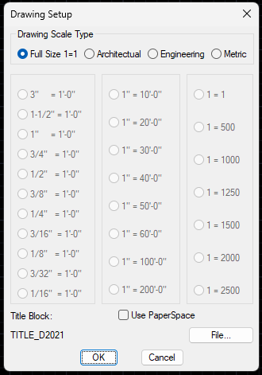
3. Check the Title Block name (default TITLE_D2021, set in med.spc) or pick File... to choose another title block drawing. Turn on Use PaperSpace to place the title block on Layout1 instead of model space.
4. Pick OK.
5. Answer the prompts for the title block insertion point and rotation (see below).
6. When the attribute dialog for the title block appears, fill in the fields or simply pick OK.
Insertion point for Title block: 0,0 [Enter]
Rotation Angle <0>: [Enter]
To change the title block information later, use the DD command (pick the title block) or AutoCAD's ATTEDIT. Or simply double click any Attribute to use standard AutoCAD Attribute Editing.

Changing the Drawing Scale
SETUP sets the drawing scale when you start a drawing. To change it later, use the Scale list on the MED Settings palette. MED uses the scale factor to size the text, tags and symbols it places, so set the scale before you draw.
To set the drawing scale:
1. Type MEDSETTINGS (or MEDSET), pick MED Main > MED Settings, or pick the MED Settings button on the MED Data Tools toolbar or ribbon panel.
2. In the General group of the palette, open the Scale list.
3. Pick the scale. It takes effect as soon as you pick it; there is no OK button.
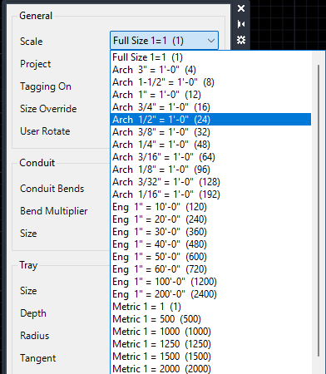
The Scale list on the MED Settings palette.
The list starts with Full Size 1=1, followed by the Arch, Eng and Metric scales. The number in parentheses is the scale factor; for example, Arch 1/4" = 1'-0" is 48. MED writes the factor to DIMSCALE and USERR1, which are saved with the drawing. If the drawing uses a scale that is not on the list, it shows at the top as Custom. Unlike SETUP, the palette does not insert a title block or reset LTSCALE, units, grid and snap.
Tip: Changing the scale does not resize text, tags or symbols already in the drawing. Run LOADTXT (Load Text Styles on the Text Styles toolbar) to reset the MED text styles to the new scale. Then use XT (Change Text Styles) to give existing single-line text a style and its new height and width, or use AutoCAD's SCALE command.

MED Main Toolbar and Settings

Main Toolbar
The Main Tool Bar provides easy access to settings, utilities, text, tags and various other symbols.
The MED Main Tool Bar.
The Main Tool Bar buttons, from left to right:
- Moore Design Home Page and MED Docs open the Moore Design web site and the MED documentation (new in MED2026).
The Text Styles flyout starts text at the standard MED sizes (T1, T2 and T3 for body, medium and large text; B1, B2 and B3 for the same sizes on the bold layer) and provides text editing utilities.
The Attribute Tools flyout provides tools for editing attributes.
The Tagging flyout provides various tags for drawing notation.
The MED Data Tools flyout provides the same buttons as the MED Data Tools toolbar: MED Change (MEDCHG), MED Records, MED 3D Library, MED Change Classic, MED Settings, BOM, BOM SS, Browse BOM, Detail Tag Update, MED Find, MED Copy, MED Data Strip and Change Size. See Material Data > Other MED data tools.
The Lisp Tools flyout provides many useful tools for everyday drafting (polyline box, bubble leaders, clouds, line breaks, File Date and more).
The Drawing Setup button launches the drawing setup command. It can also be used to change the current scale of a drawing.
Revision Triangle inserts a revision triangle.
The Layer Tools flyout provides useful layer tools.
The Fillets flyout provides typical fillet radius settings.
The Misc Symbols flyout provides typical symbols (north arrow, break, connect dots and others).
The Power Lines flyout lets you draw power linetypes (continuous, hidden, dashed).
The Control Lines flyout lets you draw control linetypes.
The Instrument Lines flyout lets you draw instrumentation linetypes.
2LINE draws two lines at once.
3LINE draws three lines at once.
Note: The 2012 Main Toolbar had a separate DD button. In MED2026, type DD or use the Text & Attributes menu (Dialog Edit).

MED Settings
Various settings control the way conduits, fittings and cable tray are drawn. In MED2026 these settings are on the MED Settings palette. Type MEDSETTINGS (or MEDSET), or pick MED Settings on the MED Data Tools toolbar. The palette can stay docked while you work.
The MED Settings button on the MED Data Tools toolbar.
[Screenshot: MED Settings palette (General, Conduit and Tray sections, Scale list)]
Changes made on the palette apply to the current drawing session only. When you open another drawing the settings go back to the defaults in the med.spc file (the drawing scale is the exception: it is stored in the drawing).
We will see how each setting affects drawing as we go. For now, here is what each one does.

Scale
The same scale sets used by SETUP: Full Size, Architectural (3" to 1/16" = 1'-0"), Engineering (1" = 10' to 200') and Metric (1 = 1 to 2500). Changing the scale here updates the drawing scale factors just as SETUP does.

Project
The project name stamped on bill of materials records when you run BOM. MEDSHOWBOM can filter by it.

Conduit Bends
When checked, every conduit you draw is automatically filleted with the bend radius set by the Bend Multiplier. Turn it off to get square corners where you want L fittings or pull points.

Size Override
Occasionally a designer uses a larger fitting than the raceway requires (for example to make room for splices). With Size Override on, MED places the fitting at the current size setting. With it off, MED sizes the fitting to the largest conduit or cable tray it finds at the insertion point.

User Rotate
Automatic rotation is a great tool, but sometimes it rotates the wrong way. With User Rotate on, you supply the rotation for every MED insert. With it off, MED rotates automatically where it can.

Tagging
MED can tag material references. If tagging is not needed, turn Tagging off and you will no longer be prompted for a tag; the tag is stored as NONE.

Vertical Tray
Normally off. When on, all tray is drawn as a side view. If every tray you draw comes out as wide as the tray depth, this setting is probably on by mistake; turn it off here or reopen the drawing.

Bend Multiplier
Used to calculate the radius of conduit bends. The default is 5 times the conduit size: a 1" conduit gets 5" bends. For long-radius bends, increase the multiplier.

Conduit Size
The current conduit size used by the conduit and fitting commands. You can also set it with the Conduit Size toolbar flyout.

Tray Size, Depth, Radius, Tangent and Flange
Size is the tray width (default 24"). Depth is the rail height (default 6"). Radius is the fitting radius (default 24"). Tangent is the straight length at each end of a fitting before it begins to arc; it is needed to connect tray to the fitting. MED cannot draw a true zero-tangent fitting, but a tangent of 0.0000001 gives practically the same result. Flange is stored with the tray data.

Plan Drawings
Plan drawing tools are on the Plan pull-down menus (Plan Conduit, Fittings, Cable Tray, Plan Fittings, Cables, Details) and on the Conduit, Cable Tray, Cables and Details toolbars. You can always type the command instead.
Note: In 2012 the MEDPLAN command switched the pull-down menus to the Plan set. The command still exists (MED Main > Plan Drawings) and does the same thing. [VERIFY: MEDPLAN / MEDDETAIL / MEDWIRING menu switching with med.cuix in AutoCAD 2020-2024]

Conduit
Conduit is an essential raceway for any electrical design. MED lets you route any type or size of conduit and place any type of fitting. The flexibility comes from being able to add any material item to the MED catalog (see Material Data).

The Conduit Toolbar
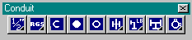
The Conduit toolbar.
The Conduit toolbar gives you access to the most common parts of MED's conduit drafting system:
Conduit Size flyout. Sets the active conduit size (1/2" to 6").
Conduit Types flyout. Picks a conduit type (Rigid Steel, EMT, IMC, PVC Coated Rigid Steel, PVC) and starts routing.
Conduit Down places the down symbol and prompts for the distance traveled.
Conduit Up Solid places a solid conduit-up symbol and prompts for the distance traveled.
Conduit Up Open places an open conduit-up symbol and prompts for the distance traveled.
The Conduit Fittings flyout places union, cee, BUB, seal, seal with drain, recessed plug, square head plug, hub and reducer fittings.
The L Fittings flyout places LB, LL, LR, LB down/up, LBD and LBY fittings.
The Tees and Cross flyout places tee, tee down, tee up and cross fittings.
The GUA Fittings flyout places GUAL, GUAT and GUAX fittings.

Size Menu
Set the conduit size before you pick a conduit type to route. Use the Conduit Size flyout, the Plan Conduit > Set Size menu, the Size list on the MED Settings palette, or type CONSIZE for the size dialog.

Bends on or off
The Conduit Bends setting on the MED Settings palette controls whether bends are placed automatically. It is on by default, which is normally what you want, except when you need L fittings at tight corners or pull points.

Bend Multiplier
The default multiplier is 5 times the conduit size. If you need larger bends, increase the Bend Multiplier on the MED Settings palette.

Route Conduit
To draw a conduit run:
1. Set the conduit size (for this example, 1").
2. Pick a conduit type from the Conduit Types flyout or the Plan Conduit menu (for this example, Rigid Steel), or type CONDUIT to use the current type.
3. Pick the start point and each corner. Press [Enter] to finish.
4. Type a tag at the tag prompt, or press [Enter] for NONE. (No tag prompt appears when Tagging is off.)
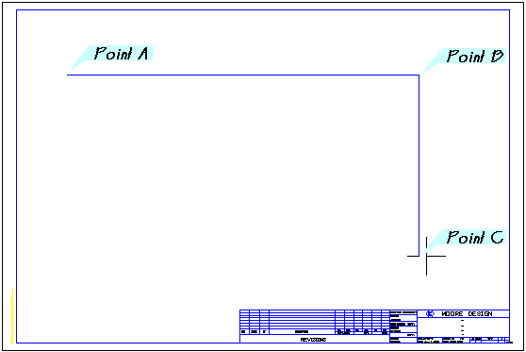
Conduit route points A, B and C.
Pick start point of 1" Rigid Steel Conduit: [Pick Point A]
Pick point: [Pick Point B]
Pick point: [Pick Point C]
Pick point: [Enter]
Conduit Tag number <NONE>: P-101 [Enter]
Notice that the conduit is filleted to a 5" radius at point B. The bend radius is controlled by the Bend Multiplier on the MED Settings palette.
Tip: To turn a polyline you have already drawn into a conduit, use DEFINE. It attaches the current conduit type and size to existing geometry: select the run, then all the entities of the run, then enter the tag.

Turn Conduit Up / Down
Conduits do not stay on one elevation. The Conduit Up and Conduit Down symbols show the conduit turning up or down.
To show a conduit turning up or down:
1. Pick Conduit Up Open (or Up Solid, or Down) on the Conduit toolbar.
2. Use the ENDpoint osnap and pick the end of the conduit.
3. Enter the length of conduit traveling up or down, or press [Enter] for the default (10').
Place an Open Turn Up symbol at Point A and a Conduit Turn Down symbol at Point C. Use the ENDpoint osnap for each one.
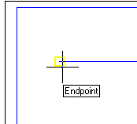
Conduit Up placed with the Endpoint osnap.
Select Insertion Point for 1" Rigid Steel Conduit: ENDP [Enter]
of [Pick Point A]
Length of Conduit traveling Up<10'>: [Enter]
You are prompted for a vertical distance because the symbol is a block and cannot be measured; the distance is stored with the symbol. Repeat for the other end using the Down symbol.

Editing conduit with MEDCHG
One thing guaranteed to happen in design is change. Suppose the 1" conduit P-101 we routed for a 10 HP pump must now feed a 25 HP pump with added control cables, so it grows to 1-1/2". The client has also changed the tagging convention: the new tag is PC240.
To change the size and tag of a conduit:
1. Pick MED Change on the MED Data Tools toolbar (or MED Main > MED Change), or type MEDCHG. The MED Properties palette opens.
2. Select the main conduit line (not the up or down symbols). The palette shows the conduit's MED data.
3. Change Tag to PC240 and Size/Count to 1.5. Press [Enter] or click out of each field; the change is written immediately.
The MED Change button.
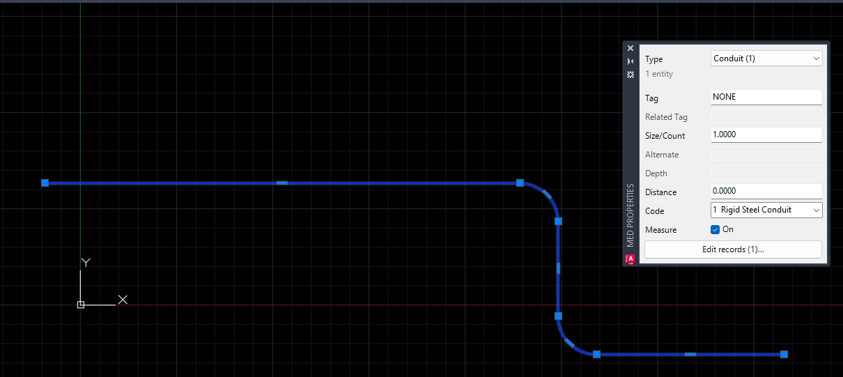
The MED Properties palette with a conduit selected.
The palette works like AutoCAD's Properties palette. It follows the current selection; with several items selected, fields that differ show *VARIES* and an edit is applied to every selected item of the type shown in the Type list. The fields depend on the material type: conduit has Tag, Size/Count, Code, Distance and Measure; cable adds Related Tag; tray adds Depth and Flange; fittings have Alternate (second size) and Depth; equipment has Tag and Code.
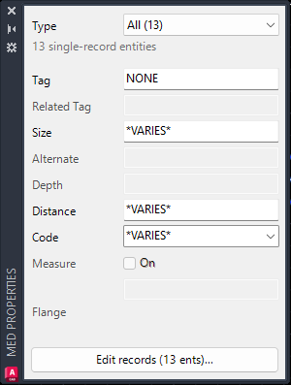
With several entities selected, fields that differ show *VARIES*.
Measure tells the bill of materials to use the measured length of the entity. Blocks such as conduit up/down symbols cannot be measured, so Measure stays off and the Distance value is used instead. Select the Conduit Up symbol and you will see this.
When an entity holds more than one MED record, or you need to add a record, click Edit records... on the palette to open the MEDRECORDS grid (see Material Data).
Note that the up and down symbols inherited the type, size and tag of the conduit when they were placed, but changing the main conduit did not update them. MEDCHG does not update associated entities. Change the tag of the up and down symbols to PC240 now; we will change their size with another tool.
Tip: The old DCL MED Change dialog is still available as MEDCHG-CLASSIC (MED Change Classic on the MED Data Tools toolbar). MED and MC are shortcuts for MEDCHG.

Using CHGSIZE to change conduits
CHGSIZE changes the size of several conduits or fittings at once. Pick Change Conduit or Fitting Size on the MED Data Tools toolbar, or type CHGSIZE.
Select Entities to change Size:
Select objects: [Pick the Up Symbol]
Select objects: [Pick the Down Symbol]
Select objects: [Enter]
Change COnduit or Fitting <CO>: [Enter]
New Size for Selected Entities: 1.5 [Enter]
Both symbols now have a size of 1-1/2". Enter sizes as decimal inches (1.5, not 1-1/2).

Placing conduit fittings
Conduit fittings are an integral part of any conduit raceway system. Placing fittings with MED is a simple pick-and-place. To practice, route some conduits with bends turned off.
To set up the fitting exercise:
1. On the MED Settings palette, clear Conduit Bends.
2. Pick the Rigid Steel button on the Conduit Types flyout and pick the points in order as shown. Make the distance between Point C and Point D at least 20'.
3. Pick the Rigid Steel button again and draw a branch from A to B. Use the NEArest osnap when you pick the point on the conduit.
4. Use AutoCAD's OFFSET command with a distance of 10' to offset the branch up twice. If the main conduit is too short to meet all three branches, stretch it with grips or STRETCH.
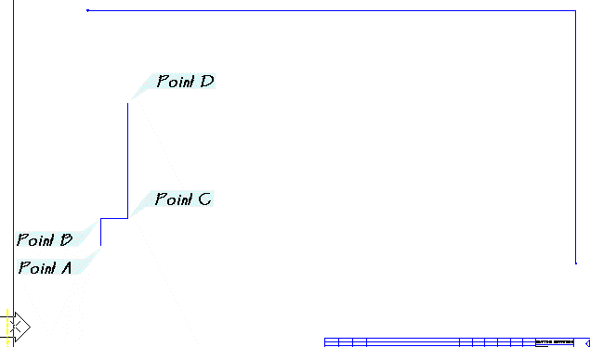
Conduit with bends off, points A to D.
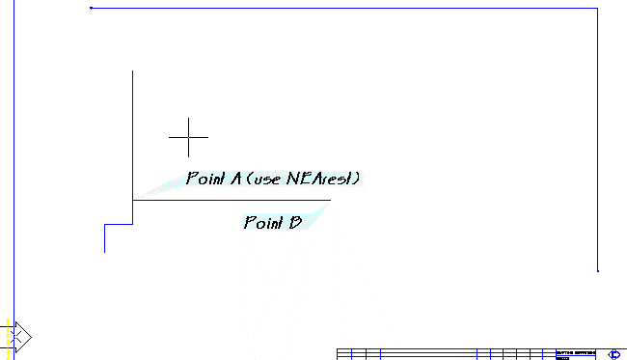
Branch conduit from A (NEArest) to B.
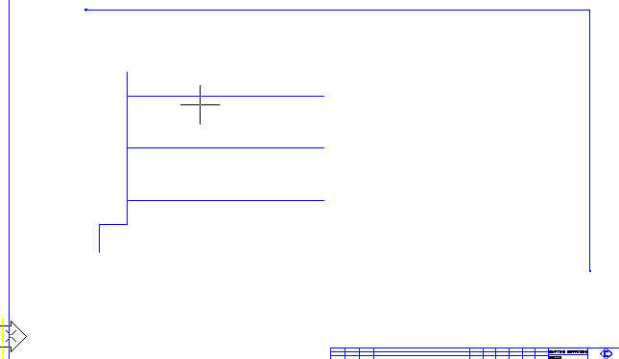
Three branch conduits.

Using osnaps to place fittings
Always use osnaps when placing fittings. They ensure proper placement and give MED real points to calculate automatic rotation. MED does not preset osnaps for you. To try it, pick the cap fitting from the Fittings flyout and place one on the right end of each branch using the ENDpoint osnap.
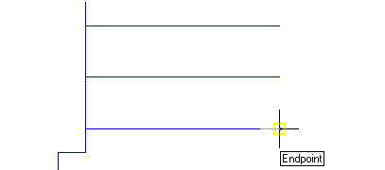
Placing a cap with the Endpoint osnap.
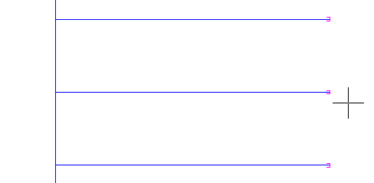
Branch conduits with caps.

Size override setting
An oversize tee is often used to provide room for splices. MED normally sizes a fitting to the largest conduit at the insertion point: if a 3/4" conduit tees into a 1-1/2" conduit, MED uses 1-1/2" regardless of the current size. Size Override lets you place a larger fitting than the conduits require.
To place an oversized tee:
1. On the MED Settings palette, check Size Override.
2. Set the conduit size to 1-1/2" with the Conduit Size flyout.
3. Pick the Tee fitting from the Tees and Cross flyout and use the INTersection osnap to place it where the bottom branch meets the main conduit. The size is 1-1/2" and the tag is taken from the conduits; rotation and scale are automatic.
4. Repeat for the middle branch.
5. Clear Size Override again.
6. Place a tee at the top branch. MED prompts for a 1-1/2" tee (the current size) but places a 1" fitting, because it found two 1" conduits at the insertion point.
The 1-1/2" button on the Conduit Size flyout.
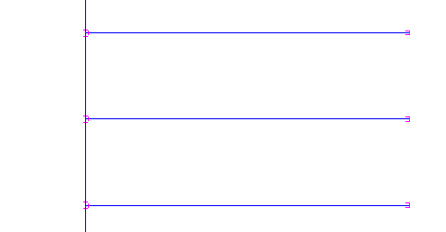
Branches with tees.

User Rotate setting
If MED's automatic rotation picks the wrong direction, check User Rotate on the MED Settings palette. You will then be asked for the rotation of each fitting you place.

Identifying conduits and fittings with MEDLIST and MEDPROPERTIES
Conduits are lines and fittings are blocks; how do you tell them apart? MEDLIST and MEDPROPERTIES show the MED data that is not visible in the drawing.
To check the size of the tees:
1. Pick MED Change on the MED Data Tools toolbar, or type MEDPROPERTIES (or MEDCHG) to open the MED Properties palette.
2. Select the bottom tee. The palette shows its MED data (Tag, Size, Code).
3. Select the middle tee to see its data. With several entities selected, differing values show *VARIES*; Edit records... opens the MEDRECORDS grid for several records or entities.
4. Repeat for the top tee to confirm it is 1".
The MED Records button (MEDRECORDS) on the MED Data Tools toolbar opens the same records in a grid. See Material Data > Editing multiple records.
MEDLIST lists the same information at the command line: Select Entity to list:, including the catalog description of each record.

Tagging
Conduit tagging is simple: the conduit already knows its size and tag, so you only place the tag and pick the conduit.
To tag a conduit:
1. Pick Conduit Tag on the Tagging toolbar (or Tagging > Conduit Tag), or type CTAG.
2. Select conduit to tag: [Pick the PC240 conduit]
3. Pick an insertion point for the tag below the conduit. [VERIFY: tag insertion prompt text]
The Conduit Tag button.
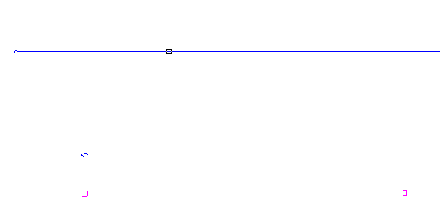
Selecting the conduit to tag.
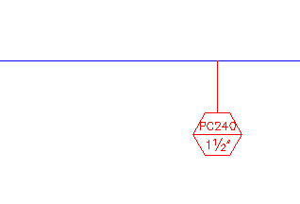
The finished conduit tag.
That wraps up the conduit tutorial. For extra practice, complete the drawing with the MED tools to match the final drawing below.
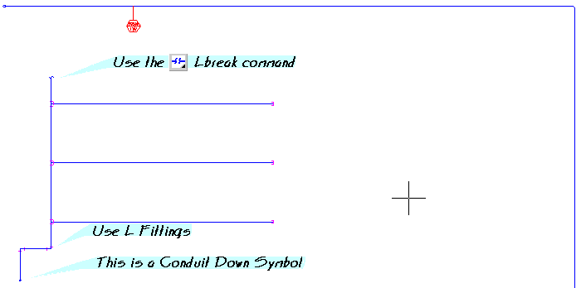
Final conduit exercise.
Note: The 2012 tutorial drawings (Conduit2, Conduit3, TRAY START, CABLE START, Oneline) are not shipped with MED2026; start from a new drawing set up with SETUP. [VERIFY: ship the tutorial drawings or drop the references]

Duct Bank
DUCTBANK turns one routed MED conduit, or a plain 3D polyline route, into a complete concrete-encased ductbank: a plan conduit for every position, plan and stub-up elbows, risers, Carlon Snap-N-Stac spacer stations, the concrete envelope with its stub-up turn-ups, sections 1-1 and 2-2, and BOM records for all of it. It can also build 3D envelope and spacer solids for MEDMAKE3D.

Building a ductbank
- Draw the route as a normal MED conduit (CONDUIT) or as a plain 3DPOLY. Vertical legs at either end become stub-ups; give 3D polyline vertices elevations for route rises.
- Run DUCTBANK and pick the route. For a plain polyline, set the reference conduit size and type.
- In the Ductbank dialog, click each position card and set its Tag, Size and Type. Size to all and Type to all copy the current values to every position; Auto tags re-applies the {BANK}-{POS} pattern.
- Click Check to re-run the solver and refresh the preview and checks, then OK to generate. OK is refused while any check shows an error.

Defaults
The defaults cover most banks: Snap-N-Stac spacers at 2" separation every 8 ft, 3" top and bottom cover and 2" side cover (sized off the primary conduit OD), 5.5" stub-up pitch, PVC-coated RGS stub-ups (plain RGS optional), 90 degree stub-ups at both ends (45 degree optional, open riser tops), concrete chamfered at bends, and the turn-up cut level at least 4" below the riser ends. Encasement Auto runs to the top of the elbow sweep at 90 degree ends and to the Top limit at 45 degree ends. All defaults are _DBK settings in med.spc.

Editing and managing a ductbank
- DBEDIT: pick any part of a bank to reopen the dialog with its stored settings; Rebuild regenerates it in place with the same bank ID.
- DBLIST: lists a bank's positions, tags, sizes, lengths, elbows, stations, stub-ups and encasement.
- DBDELETE: erases a bank, including its 3D solids, and restores the reference route.
- DBSEED: adds the ductbank catalog codes to MEDType (run once per database).
- -DUCTBANK and -DBEDIT: the same at the command line, without the dialog.
3D solids go on layer 3DMEDModel-Ductbank (75% transparent); MEDMAKE3D pulls in the bank elbows and every 3DMEDModel- layer. Full details: docs\ductbank.md.
Note: 3D models are approximations for layout and coordination only and are not reproductions of manufacturer specifications. Verify all dimensions against manufacturer data.

Cable Tray
Cable tray is another raceway used frequently in electrical design. Tray is generally large enough to be included in 3D models for interference checking and clearance. MED offers a large variety of tray options to fit your design.

The Cable Tray Toolbar
[Screenshot: MED2026 Cable Tray toolbar]
The Cable Tray toolbar is your main interface to the MED tray system:
Export Tray to 3D Model (MAKE3DTRAY). See the chapter 3D Modeling.
Tray Size flyout. Sets the current tray width.
Tray Depth flyout. Sets the current depth.
Tray Radius flyout. Sets the fitting radius.
Tray Types flyout. Starts the TRAY command with the selected tray type (Heavy, Medium or Light Duty).
Fix Tray Outline (TRAYFIX).
Tray Offset (TRAYOFF), horizontal offsets.
Vertical Tray Offset (PTRAYOFF), vertical offsets from a plan view.
Tray Elbows flyout (90, 60, 45, 30 degree horizontal elbows and the 90 degree vertical elbow).
Tray Fittings flyout (cross, tee, straight, left-hand and right-hand reducers).
Vertical Tray Down (TRAYDN).
Vertical Tray Up (TRAYUP).
Note: The 2012 toolbar had a Side View Tray button. In MED2026 type VTRAY, or use the Tray Side View and Fittings image menu on the Cable Tray menu.

Size Menus
The size flyouts set the values that control cable tray: Width, the primary size; Depth, the height of the tray rails; and Radius, the radius used to draw fittings. The same values are on the MED Settings palette and in the TRAYSIZE dialog.

Width
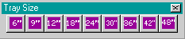
Tray Size flyout.
The last width selected is used for new tray and fittings. If a smaller fitting is placed on a larger tray, MED adjusts the fitting to the tray width. The default (24") is set by _TRSIZE in med.spc.

Depth
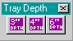
Tray Depth flyout.
Depth is usually part of the project specification: set it once and leave it. The default (6") is set by _TRDEPTH in med.spc.

Radius
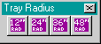
Tray Radius flyout.
The fitting radius. The default (24") is set by _TRRAD in med.spc.

Two point placement method
MED draws cable tray the way it is installed: from point to point. Use AutoCAD osnaps when placing tray.
To draw a tray run:
1. Pick Heavy Duty Tray from the Tray Types flyout (or Cable Tray > Heavy Duty Cable Tray), or type TRAY for the current type.
2. Pick the start point and the end point.
3. Type a tag at the tag prompt, or press [Enter]. Always finish the command at the tag prompt.
The Heavy Duty Tray button.
Startpoint of 24" Cable Tray Heavy Duty: [Pick Point A]
To Point: [Pick Point B]
CableTray Tag number <NONE>: [Enter]
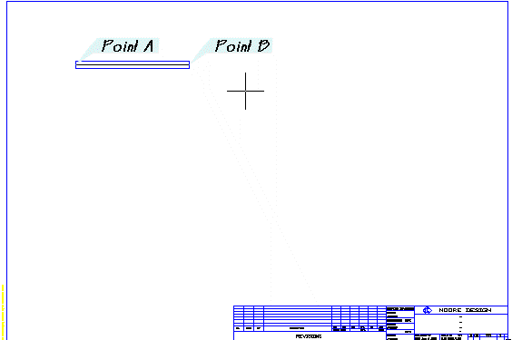
First tray segment, A to B.
Place a few more pieces of tray to set up the fitting exercises. Use the INTersection or ENDpoint osnap to pick Point B.
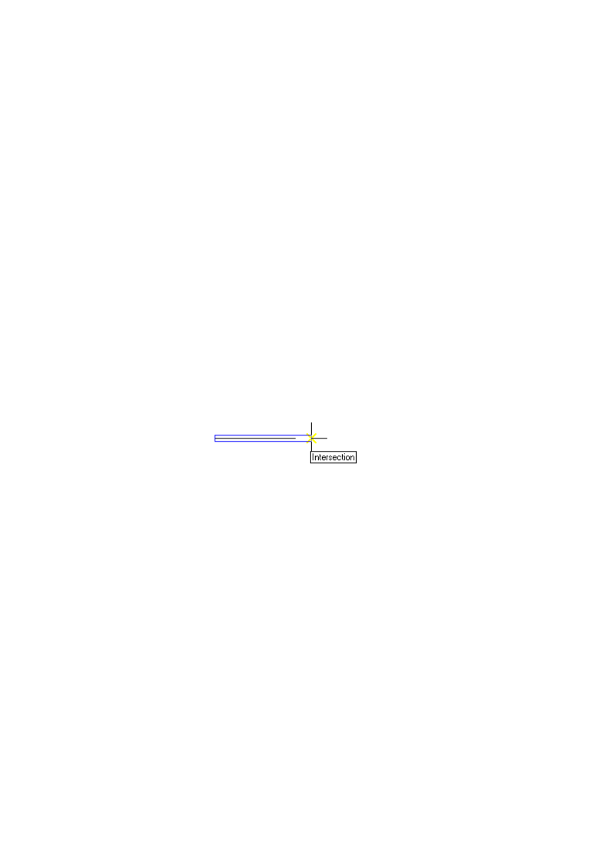
Tray points for the second segment.
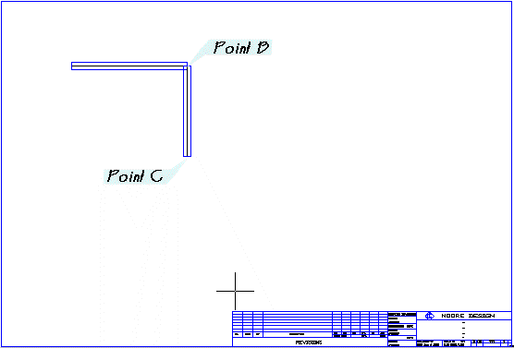
Second tray segment.
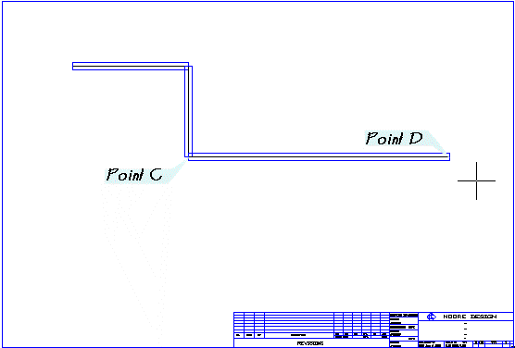
Third tray segment.

Tagging
The tag prompt at the end of TRAY is important: either enter a tag or press [Enter] to complete the command. If a tray entity later gives errors, it may be from an incomplete TRAY command; replace it with a new tray. To stop being asked for tags, turn Tagging off on the MED Settings palette (or set _TAGOFF to T in med.spc).
To display a tray tag:
1. Pick Tray Tag on the Tagging toolbar, or type TTAG.
2. Select Tray to tag: [Pick the tray centerline]
3. Pick the leader start (Point A) and the next point (Point B, with Ortho on), then press [Enter]. [VERIFY: leader prompt text in MED2026]
4. Elevation: <current>: Enter an elevation or press [Enter] to use the tray elevation. The tag reads B.O.T. EL. followed by the value.
5. TraySystem: Enter a tray system name, or press [Enter] to leave it blank (new in MED2026).
The Tray Tag button.
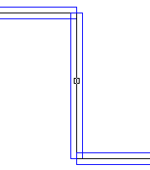
Selecting the tray centerline.
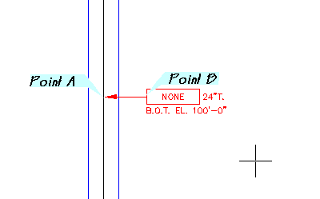
Tray tag with tag, size and elevation.

The center line and its importance
The centerline of the tray holds the data that makes up the tray. When a command asks you to pick the tray, pick the centerline.
- Type CF to turn the centerline layer off (for plotting) and CN to turn it back on.
- Do not erase the centerline. That deletes the tray's data and it will not appear in the bill of materials.

Placing a Cable tray fitting
Pick the fitting button and pick an insertion point. Remember to use osnaps.
To place two 90 degree elbows:
1. Pick the 90 Degree Horizontal Elbow on the Tray Elbows flyout (or Plan Fittings > 90 Elbow), or type TRAY90.
2. Use the INTersection osnap to pick the corner where two trays meet.
3. Press [Enter] to repeat TRAY90 and pick the second corner (Point A).
The 90 degree elbow button.
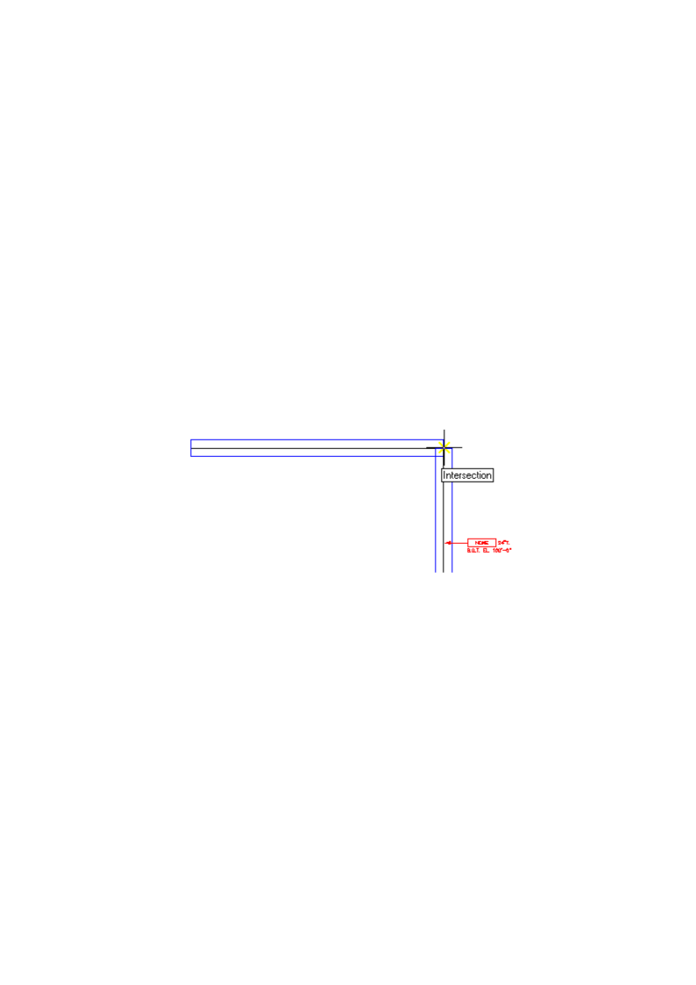
Pick the intersection.
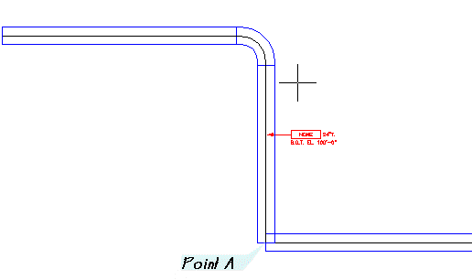
Result after the first elbow.

Using osnaps to place fittings
It is very important to use AutoCAD osnaps when drawing tray and placing fittings. MED does not preset osnaps for you; this gives you more flexibility.

Tee Fittings
A tee is placed where one tray ends against another, perpendicular tray. Rotation is automatic. If MED finds only one tray, it chooses a rotation for you.
To add a branch tray and tee:
1. Set the tray width to 18" with the Tray Size flyout.
2. Pick the tray button and route the branch as shown, using the NEArest osnap on the existing tray (Point A).
3. Pick Tee Fitting on the Tray Fittings flyout (or type TRAYTEE) and pick Point A with the INTersection osnap.
The Tee Fitting button.
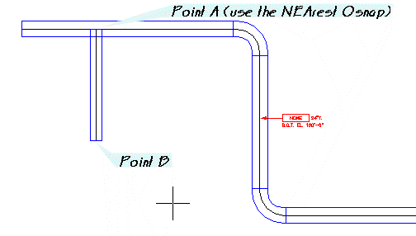
Branch tray, A (NEArest) to B.
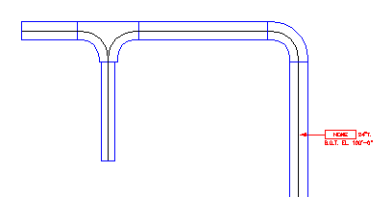
Tee placed.

The User Rotate setting
If MED rotates a fitting incorrectly, check User Rotate on the MED Settings palette and pick the rotation yourself. Placing the branch tray before the tee helps MED rotate the tee correctly.

Cross Fittings
The cross (TRAYCROSS) works the same way as the tee. Place it where two trays completely cross each other.

Reducers
The tee we placed is too large for the 18" tray: MED read both trays and used the larger size. Now place a reducer.
To place a reducer:
1. Pick Straight Reducer Fitting on the Tray Fittings flyout (or Plan Fittings > Str RE), or type TRAYRE.
2. Pick Point A with the INTersection osnap.
3. At the rotation prompt, drag down the path of the tray or type 270.
4. At Size to Reduce to: enter the smaller width if asked.
The Straight Reducer button.
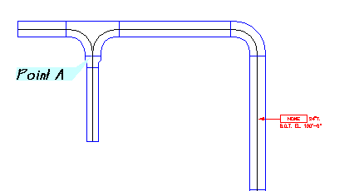
Reducer placed at Point A.
Left-hand and right-hand reducers (TRAYREL, TRAYRER) and the reducing tee (TRAYTEERE) work the same way.

30, 45, and 60 degree fittings
These elbows (TRAY30, TRAY45, TRAY60) do not rotate automatically. Place them on the endpoints of a tray centerline. They are mostly used for offsets, which TRAYOFF automates.

Placing vertical fittings and tray in plan view
Cable tray often travels up or down. MED can place real vertical fittings.
To place a vertical elbow and a tray drop:
1. Pick 90 Degree Vertical Elbow on the Tray Elbows flyout (or Cable Tray > Plan Vert 90), or type TRAYV90.
2. Answer Inside or <Outside>:. Inside means up, Outside means down. Press [Enter] for a down elbow.
3. Use the INTersection osnap to pick Point A.
4. At Angle of generation: drag left or type 180.
5. At Tag <NONE>: press [Enter].
6. Pick Vertical Tray Down (or type TRAYDN). At Select Tray item pick near the end of the centerline closest to the end with the box.
7. At Length of 24" Cable Tray Heavy Duty traveling Down <10'>: press [Enter] to accept 10'.
The 90 Degree Vertical Elbow button.
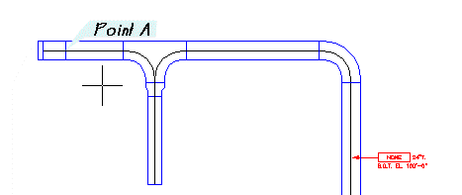
Vertical elbow.
The Vertical Tray Down button.
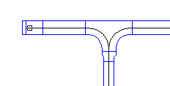
Pick near the end with the box.
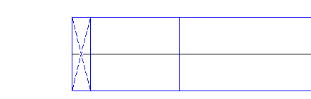
Tray down: a hidden X. Tray up is a continuous X.
Tip: TRAYDN sets the current linetype to HIDDEN2 while it runs. If you cancel in the middle of the command and your new lines come out hidden, set the current linetype back to BYLAYER with the LINETYPE command, and use CHANGE (or Properties) to set any affected entities to BYLAYER.

Offsets
Offsets are common in raceways. MED automates them with TRAYOFF (horizontal) and PTRAYOFF (vertical, from a plan view). Offset distances are measured center to center.
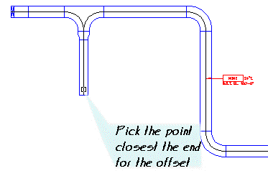
Pick the point closest to the end for the offset.

Horizontal offsets
To make a horizontal offset:
1. Set the tray width to 18".
2. Pick Tray Offset on the Cable Tray toolbar (or Cable Tray > Horizontal Offset), or type TRAYOFF.
3. Select First Entity: pick the tray centerline near the end you want to offset from.
4. Distance of Offset: enter the center-to-center offset, for example @16'<0, or pick a point.
5. Offset with 30 / 45 / 60 / 90 degree angle: type the fitting angle. The plan offset does not ask for a direction; PTRAYOFF (below) is the command that prompts Up/Down.
The Tray Offset button.
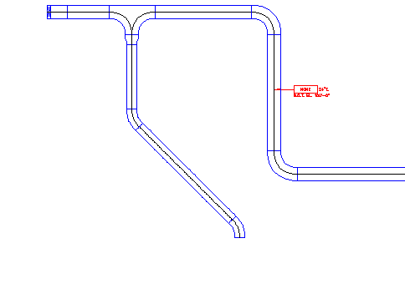
Result of the horizontal offset.
You can now continue the tray from the end of the fitting.

Vertical offsets from a plan view
Vertical offsets let you change elevation for grade, pipe racks, or anything else in the way. To set up an example, route another 24" branch and place a tee at Point A with the INTersection osnap.
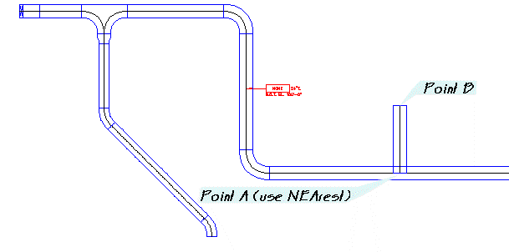
New 24" branch.
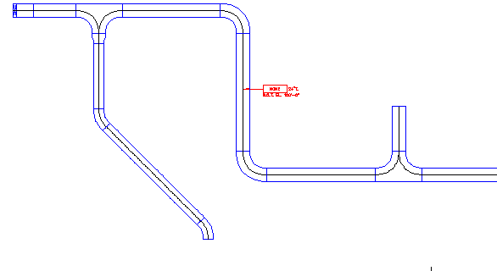
Tee at Point A.
To make a vertical offset:
1. Pick Vertical Tray Offset on the Cable Tray toolbar (or Cable Tray > Vertical Offset), or type PTRAYOFF.
2. Select First Entity: pick the centerline near the end to offset from.
3. Distance of Offset: 20'.
4. Offset with 30 / 45 / 60 / 90 degree angle: 90.
5. Direction Up/Down <Down>: press [Enter] for Down.
The Vertical Tray Offset button.
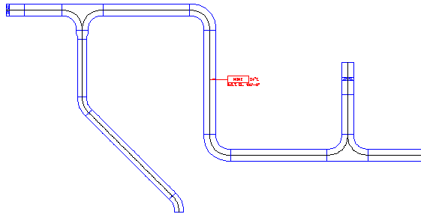
Result of the vertical offset.

Side view cable tray
Elevations or sections of cable tray are often needed to complete a design. First place a section mark with SECT (Section Callouts on the Tagging toolbar).
Pick first section point [Pick Point A]
Pick second section point [Pick Point B]
Enter section letter <A>: [Enter]
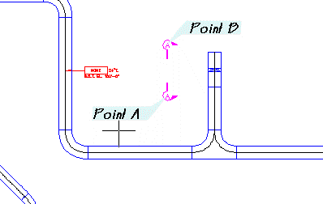
Section mark points.

Side view tray uses the same two point method as regular tray
Type VTRAY (or use the Tray Side View and Fittings image menu) and route the side view tray as shown. Tray is routed on its centerline. Finish the command at the tag prompt.
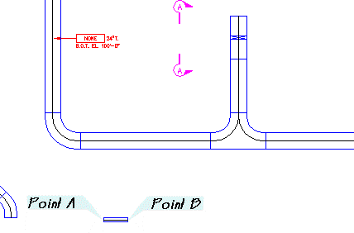
Side view tray, A to B.

Placing vertical fittings in side view
Placing fittings in side view is as simple as in plan, except that you use the vertical fittings (VTRAY30, VTRAY45, VTRAY60, VTRAY90). Most of the time you will use VTRAYOFF.

Elevation offset
To make an offset in a side view:
1. Zoom in on the side view tray.
2. Type VTRAYOFF.
3. Select First Entity: pick the end of the side view tray to use.
4. Distance of Offset: 20' [Enter].
5. Offset with 30 / 45 / 60 / 90 degree angle: 90 [Enter].
6. Direction Up/Down <Down>: [Enter] for Down.
Note: VTRAYOFF has no toolbar button; type it at the command prompt. It is kept for older side-view drawings, since the 3D model (see 3D Modeling) mostly replaces side views of tray.
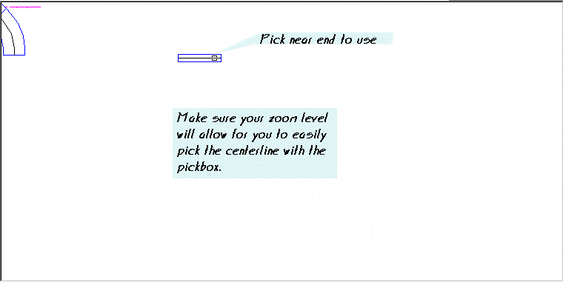
Pick near the end to use. Zoom in so you can pick the centerline easily.
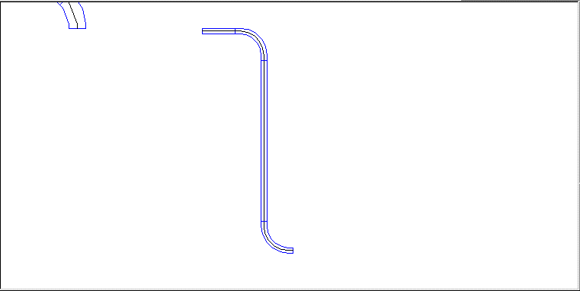
The side view offset.

Stripping data from entities
The offset now appears twice: in plan and in the elevation. The material should be counted only once, so strip the data from the elevation.
To strip MED data:
1. Pick MED Data Strip on the MED Data Tools toolbar, or type MEDSTRIP.
2. MEDSTRIP Select Entities to strip XDATA from: pick the centerlines in the elevation and press [Enter].
The MED Data Strip button.
The data is removed and will not be counted twice in the bill of materials. (Erasing the elevation centerlines does the same thing.)

Editing cable tray

Changing cable trays with MEDCHG
MEDCHG (MED Properties palette) changes any MED entity, including tray: size, tag, type (code), depth, flange and measure/distance. MED does not redraw the tray outline when you change the size; use TRAYFIX afterwards (see Fixing cable trays).

Trimming cable trays
Use AutoCAD's TRIM command to trim tray linework, with one exception: do not trim the centerline. The centerline holds the tray's data.
To show one tray passing over another:
1. Route two tray segments and place a 90 degree elbow at their intersection, using osnaps so the elevations are read correctly.
2. Start TRIM. Pick the tray outline shown at left as the cutting edge and press [Enter].
3. Pick the outline lines to trim as shown at right.
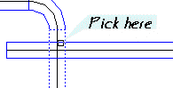
Pick the cutting edge here.
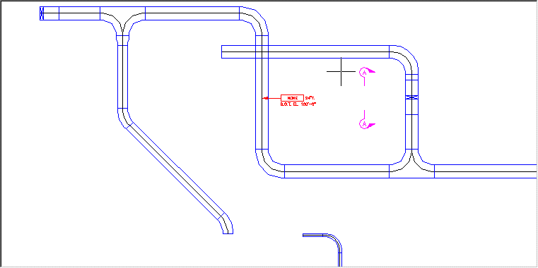
Trays before trimming.
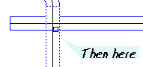
Then pick here.
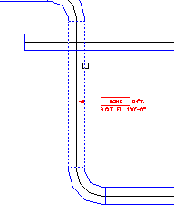
Result. The centerline is still intact; turn it off with CF before plotting.

Fixing cable trays
Sometimes you modify the lines MED draws and later want the standard representation back.
To restore a tray outline:
1. Erase all parts of the tray except the centerline.
2. Pick Fix Tray Outline on the Cable Tray toolbar, or type TRAYFIX.
3. Select Tray to fix: pick the centerline.
The Fix Tray Outline button.
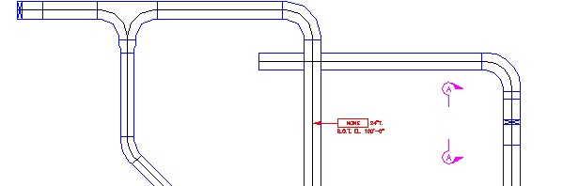
Tray outline restored with TRAYFIX.
Note: TRAYFIX redraws the outlines of both tray and tray fittings. (In 2012 it handled tray only.)

Copying cable trays
To copy a tray, copy only the centerline, then use TRAYFIX to draw the tray linework.

Identifying cable trays and fittings with MEDLIST and MEDPROPERTIES
It can be hard to tell cable trays apart on screen. MEDLIST lists the data of one selected entity. MEDPROPERTIES shows the data of the selected entities on the MED Properties palette and lets you edit it; MEDRECORDS lists every MED record in a grid.

3D cable tray extraction
Cable tray is often large enough to use for interference checking. MAKE3DTRAY (Export Tray to 3D Model) extracts solids for every tray and tray fitting. In MED2026, MEDMAKE3D builds tray, conduit, conduit bodies and cable together. Both are described in the chapter 3D Modeling.
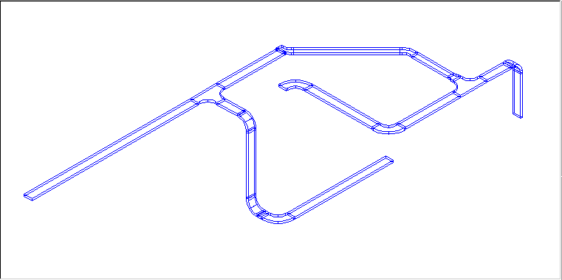
3D tray in wireframe.

Cables
Cables are drawn with the CABLE command. Cables differ from conduit and tray in that they have an extra tag field: the related tag (RTAG). If you route a cable that belongs to a raceway, say P-10001, enter P-10001 as the related tag whether that raceway is a conduit or a tray. The relationship is stored in the database only; nothing in the drawing updates automatically. In practice cables are mostly used to draw grounding systems.

The Cable palette
New in MED2026, the Cable palette is where you pick the cable to draw. Type MEDCABLE (or CABLEPALETTE or CABLESET).
[Screenshot: Cable palette (Cable Type list, Cable list, Route Cable button)]
To pick a cable:
1. Type MEDCABLE to open the Cable palette.
2. Pick the Cable Type: Building Wire, Tray Cable, Ground Cable, Instrument Cable or Residential Cable.
3. Pick the Cable (code and description from the catalog).
Picking a cable sets the current cable and the current layer. Each cable type has its own layer (for example MEDCable-GroundCable), created automatically if it does not exist.

The Cables toolbar
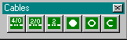
The Cables toolbar.
The Cables toolbar has a few standard grounding cable sizes and cable up/down symbols:
Sets the cable to #4/0 ground cable and starts CABLE.
Sets the cable to #2/0 ground cable and starts CABLE.
Sets the cable to #2 ground cable and starts CABLE.
Places a cable up symbol (solid).
Places a cable up symbol (open).
Places a cable down symbol. [VERIFY: the three symbol buttons are all named 'Ground Cable Up' in med.cuix; confirm which is up solid / up open / down]

Routing cable
Routing cable is simple, because it is essentially the PLINE command.
To route a ground cable:
1. Pick the #4/0 button on the Cables toolbar, or pick the cable on the Cable palette and click Route Cable (or type CABLE).
2. Pick the start point and each point along the route. Press [Enter] to finish.
3. At the tag prompt type a tag or press [Enter].
4. At the related tag prompt type the raceway tag or press [Enter].
The #4/0 ground cable button.
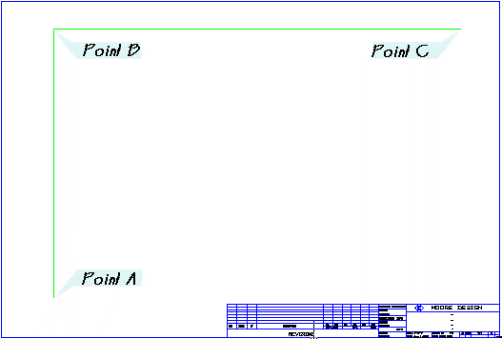
Cable route points A, B and C.
Pick start point of 1 TYPE THW CU GROUND CABLE 4/0 BARE: [Pick Point A]
Pick point: [Pick Point B]
Pick point: [Pick Point C]
Pick point: [Enter]
Cable Tag number <NONE>: [Enter]
Cable Relate Tag <NONE>: [Enter]
The description in the first prompt comes from the catalog and may read differently in your database. Next add some #2/0 cables with the #2/0 button. Press [Enter] at the tag prompts, and use osnaps when connecting to other cables.
The #2/0 ground cable button.
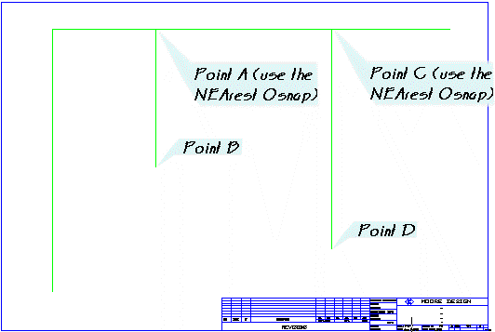
#2/0 cables (use the NEArest osnap at A and C).
Tip: RUN3DCABLE draws a cable as a 3D polyline with the same prompts, for cable that must change elevation.

Cables turned up or down
As with conduit, a cable going up or down is a block with a distance stored in its cable data. Place an up symbol on the end of a cable using the ENDpoint osnap and accept the 10' default length.
The cable up button.
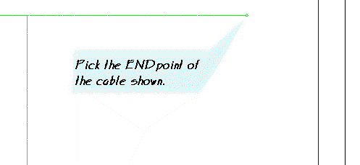
Pick the ENDpoint of the cable shown.
Notice that MED placed a #2/0 cable instead of #4/0: it read the cable type from the cable you placed the symbol on.

Editing cables with MEDCHG
With MEDCHG you can change a cable's tag, related tag, number of cables and type (code). Select the cable up symbol with the MED Properties palette open and check its code. Size/Count is 1 because the symbol represents one cable; increase it to represent several cables with one symbol.
The MED Change button.
[Screenshot: MED Properties palette showing a cable record (Tag, Related Tag, Size/Count, Code, Distance, Measure)]

Equipment
Equipment entities are a very important feature of MED. They are assemblies, or detail references; this guide calls them details. A detail reference is just that: a reference to a detail. Material extraction writes one record for each detail reference in the drawing. By linking those records to your detail material lists, you get a complete material takeoff for the drawing.

What is a detail entity
A detail entity can be any AutoCAD entity type; the difference is that it carries MED extended entity data (xdata). Usually it is a block insertion. The block definition does not hold the xdata, only the insertion. For example, if you insert the block "light" with AutoCAD's INSERT command, it has no MED data. If you insert it from the MED toolbar, menu or Details dialog, the data is attached, and any copies made afterwards carry it too. MEDSTRIP removes the data from selected entities.

The Details Toolbar
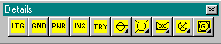
The Details toolbar.
The first buttons open the detail insert list for a group: Lighting (LTG), Grounding (GND), Power (PWR) and Tray (TRY). Each command looks up all details of that group in the MED catalog and presents a list to pick from. For Instrument details type INS. The remaining buttons are flyouts of symbols: receptacles and switches, lighting, fluorescent lighting, grounding, and detectors and alarms.
LTG opens the detail list for Lighting details in the catalog.
GND opens the detail list for Grounding details.
PWR opens the detail list for Power details.
INS opens the detail list for Instrument details. Type INS at the command line.
TRY opens the detail list for Tray details.
Receptacles and Switches flyout.
Lighting flyout.
Fluorescent Lighting flyout.
Grounding flyout.
Detectors and Alarms flyout.
DETAIL (Details > Details...) opens one dialog with all the groups: Lighting, Grounding, Power, Instrument, Cable Tray, Communication, Junction Box and Pole Line. COM (communication), JBX (junction box) and MSC (miscellaneous) open their groups directly.

Place a lighting detail
To place pendant lights at conduit intersections:
1. In a drawing with a lighting conduit run, offset the main conduit 10' several times to make a grid of construction lines.
2. Set the running osnap to INTersection (OSNAP command or the status bar).
3. Pick the Ceiling or Pendant Light symbol from the Lighting flyout and place one at each intersection.
4. Erase the construction lines.
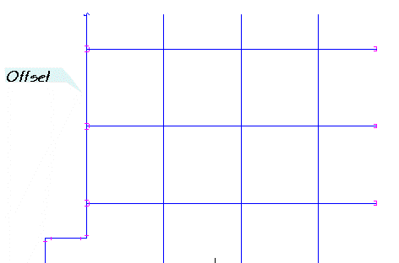
Offset construction lines.
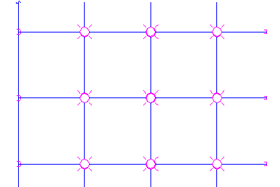
Lights placed at each intersection.
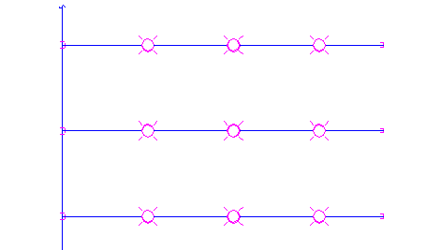
Construction lines erased.
Now show how to construct the pendant fixture by referencing a detail on another drawing.
To tag a detail:
1. Pick Detail Tag on the Tagging toolbar, or type DETAG.
2. From point: and To point: pick the leader points.
3. Select Entity with Detail info: pick a light fixture.
The Detail Tag button.
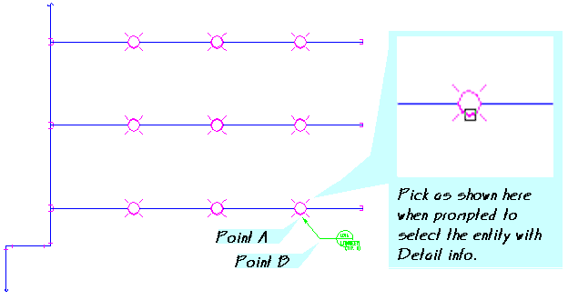
Pick as shown when prompted to select the entity with detail info.
DETAG fills in the detail bubble with the detail number, the drawing number where the detail is found, and the typical count. All of this comes from the MED catalog (see Material Data). If you change the bubble block (DETAG is in QKEY.lsp), adjust the matching variables in med.spc.

Using the tray detail sets and placing tray related details
Tray details are represented differently. Tray comes in many sizes, so the details must adapt. MED places a block on each side of the tray outline with a visible or invisible line between them. The data is in the connecting line, not in the two blocks; otherwise each use of the detail would be counted twice in the bill of materials.
Tray hardware commands: TRAYEP (expansion plate), TRAYEG, TRAYHD (hold-down), TRAYHANG (hanger), TRAYDROP (dropout), TRAYBLIND (blind end), TRAYHINGE and TRAYCON.
Tip: If you use the detail line as a construction line and offset it, you create extra detail occurrences. MEDSTRIP the extra entities.

Tagging details
Sometimes you need only the bubble and want to fill in the data yourself. Run DETAG and press [Enter] instead of picking a detail entity; you are then prompted for Detail Number:, Drawing Number: and Typical:. DETAG2 uses an alternate bubble block.

Updating detail tags in a drawing
As drawings change, the number of detail references changes too. DETAGUPD compares the typical count on each detail bubble with the actual count in the drawing and updates the bubbles you select.
Variable | Description | Default value
_DETTYP | List of the typical attribute tag name and the prefix length (for "(TYP. ") | (list "TYP" 6)
_DETNUM | Detail number attribute tag | "DETNUM"
_DETNUM1 | Secondary detail number (detail entities that use concatenated detailing) | "TAGINFO1"
_DETNUM1A | Secondary detail suffix | "TYPE"
_DETBLK | Name of the detail tag block | "DETBUB2"

You only need to change these med.spc variables if you change the block used by DETAG.
To update detail tags after a change:
1. Starting from the lighting drawing above, erase three light fixtures and three conduits with a crossing selection as shown.
2. With no command active, select the conduits shown with a crossing selection (right to left) to show their grips.
3. Hold Shift and pick each grip box on the right end, then release Shift and pick the top right grip as the base point. Stretch the conduits to the left quadrant of the light fixture (QUAdrant osnap).
4. Pick Detail Tag Update on the MED Data Tools toolbar, or type DETAGUPD.
5. In the Detail Tag Update dialog, pick the detail (it shows the current and actual typical counts) and click Update. The bubble now reads (TYP. 6) instead of (TYP. 9).
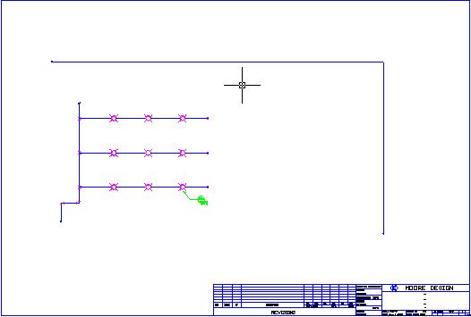
The lighting drawing before the change.
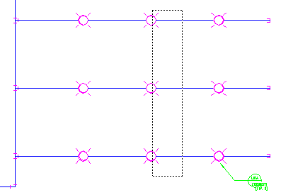
Erase with a crossing selection.
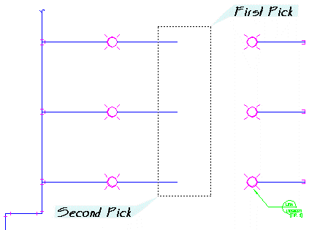
Select the conduits: first pick, second pick.
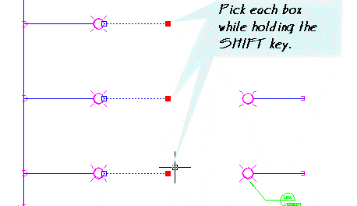
Pick each box while holding the Shift key.
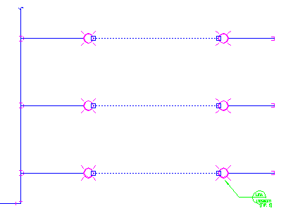
Conduits stretched to the fixtures.
The Detail Tag Update button.
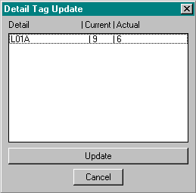
Detail Tag Update dialog.
You could change 9 to 6 by hand, but DETAGUPD saves time when there are many detail references in the drawing.

Material Data
Material data is the key to MED use and success. To use MED to its full potential you need to understand how it stores material information about the various entity types.
There are five entity types. Each is listed below with the data stored in the drawing. The code is the minimum value stored in the drawing; the material description is kept in the MED catalog (the MEDType table). This keeps MED from growing the drawing more than needed.
Type | Data stored in the drawing | Notes
Conduit (MED_CONDUIT) | Tag, Size, Code, Dist, Measure | Tag of the conduit; trade size; catalog code; distance (used when the entity is not measured, e.g. up/down symbols); Measure = use the measured length.
Cable (MED_CABLE) | Tag, Num, Code, Rtag, Dist, Measure | Num is the number of cables; Rtag is the related raceway tag.
Cable tray (MED_TRAY) | Tag, Size, Code, Dist, Depth, Measure, Flange | Size is the tray width; Depth is the rail height.
Fitting (MED_FITTING) | Tag, Size, Code, Alt, Depth, Flange | Alt is the second size of a reducer; Depth applies to tray fittings.
Equipment / Detail (MED_EQUIP) | Tag, Code | Code points to the detail record in the catalog.

Where MED keeps its data
MED2026 keeps the catalog and the extracted bill of materials in a database, by default the SQLite file Data\MED.db in the MED folder. A shop that already runs SQL Server can point MED at it instead; the connection is set by the installer in Support\MEDDataBaseSettings.dat.
- MEDType is the catalog: your warehouse of materials.
- MEDProject is the extraction: the materials you have used, written by the BOM command.
Note: The 2012 dBase/Access files (MEDTYPE.dbf, PROJECT.dbf) and the MEDPACK command are no longer used. Do not open or edit the database with Access or another desktop tool; use MEDTYPE.

The MED catalog (MEDTYPE)
The catalog holds every material item. Do not confuse it with the extraction (MEDProject). The catalog fields are:
Field | Use
Type (ITEMTYPE) | CONDUIT, CABLE, TRAY, FITTING or EQUIP.
Code (ITEMCODE) | The material code referenced by the drawing. Unique per type.
Description (ITEMDESC) | Description of the material item.
Group (ITEM_GRP) | Details: the group (Lighting, Grounding, ...). Cables: the Cable Type shown on the Cable palette. A detail with no group does not appear in the detail lists.
Key1 (ITEMKEY1) | Details: detail number.
Key2 (ITEMKEY2) | Details: drawing number of the detail. Fittings: the conduit body key used by MEDMAKE3D (for example RGD|F7|LB).
Key3 (ITEMKEY3) | Details: block (and slide) to insert.
Key4 (ITEMKEY4) | Details: layer set from med.spc.
User1 | Details: value for a DETNUM attribute if the block has one. Tray: section length in feet (reporting only).
User2 | Details: insert function (usually opt_eq_ins).
User3 | Cable: outside diameter in inches (used for 3D cable). Equipment: original code kept by the project remap.
User4 | Details: sort order in the detail list.

Material Extraction
Material extraction is not dynamic. When you want a material takeoff, run BOM and the materials are extracted for the current drawing at that moment.
To extract the bill of materials:
1. Save the drawing (the drawing name identifies its records).
2. Pick BOM on the MED Data Tools toolbar (or MED Main > MED Data to BOM), or type BOM.
3. Wait for the command to finish. MED deletes all records for this drawing name from MEDProject, then cycles through the drawing and writes a new record for each material item.
Each extracted record holds: type, tag, related tag, quantity (measured length of conduit, cable and tray, or the stored distance; 1 for fittings and equipment), size, alternate size, depth, code, description (from the catalog), entity handle, entity type, drawing name and the measure flag.
Tip: If the same tray appears in a plan and in a section, strip the data from the section with MEDSTRIP before running BOM, or it will be counted twice.

Browsing the BOM (MEDSHOWBOM)
MEDSHOWBOM replaces the 2012 SHOW browse dialog. It shows the extraction for the current drawing, with filters and a summary.
To browse the bill of materials:
1. Run BOM first (the grid is empty until you do).
2. Type MEDSHOWBOM (or MEDSHOW). MEDSHOWSUM opens it with Summarize already checked.
3. Pick a Type filter: All, Conduit, Cable, Tray, Fitting or Equipment.
4. Check This project only to limit the list to the current project, or Summarize (by type, code, size) to roll all tags into one line per item.
5. Click Copy to put the grid on the clipboard, or Export CSV to save it to a file. Refresh reloads after another BOM.
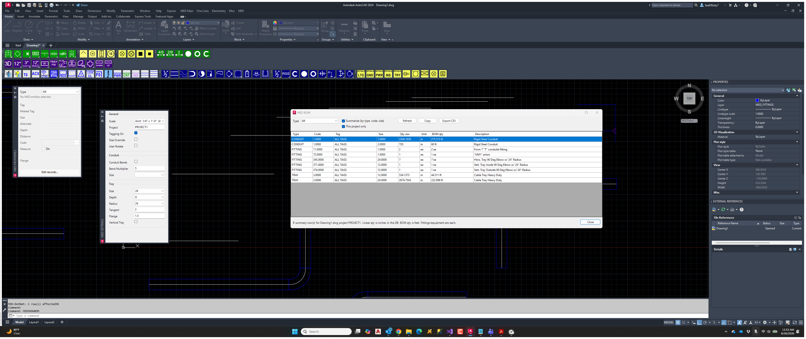
MEDSHOWBOM dialog.
In the grid, conduit, cable and tray quantities are shown in inches; the BOM quantity is in feet. Fittings and equipment are counted each.
Note: The Browse BOM button on the MED Data Tools toolbar runs MEDSHOWBOM. BOM SS (BOMSS) runs BOM on a selection set you pick instead of the whole drawing.

Editing multiple records (MEDRECORDS)
An entity can hold more than one MED record, for example a symbol that carries two fittings. MEDRECORDS (or Edit records... on the MED Properties palette) shows every record of the selected entities in a grid.
To edit the records of an entity:
1. Select the entity, then type MEDRECORDS (or click Edit records... on the MED Properties palette).
2. Edit Type, Tag, Related Tag, Size/Count, Alt, Depth, Dist, Code, Measure or Flange in the grid. Ctrl+C / Ctrl+V copy and paste, Ctrl+D fills down.
3. To add a record to a single entity, fill in the blank row at the bottom.
4. Click Show entity to zoom to the entity of the current row (it is highlighted with a yellow halo).
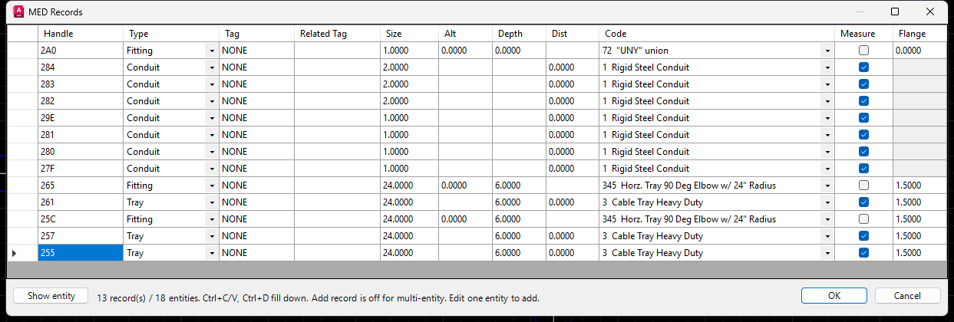
MEDRECORDS grid.

Adding Materials
Adding materials is not a day-to-day task. The best method is to set up the project catalog fully before you start drawing. Details are the usual exception; they are added and deleted throughout a project. MEDTYPE is purposely left off the toolbars because it requires a working knowledge of the data.
To add a detail to the catalog:
1. Type MEDTYPE at the command prompt. The MED catalog grid opens.
2. Set the Type filter to Equipment (or type in the Find box to locate similar items).
3. In the blank row at the bottom enter the Type (EQUIP) and a Code. The code must be unique for the type; you cannot have two EQUIP records with code 999.
4. Enter the Group (required for the detail to appear in the Details lists), the Description, Key1 (detail number), Key2 (drawing number), Key3 (block to insert) and Key4 (layer set from med.spc).
5. Enter User1 (value for the DETNUM attribute, if the block has one), User2 (insert function, usually opt_eq_ins) and User4 (sort order).
6. Press Ctrl+S or click Save. If you close with unsaved changes you are asked whether to save.
[Screenshot: MEDTYPE catalog grid with the Type filter set to Equipment]
Other grid tools: Ctrl+C / Ctrl+V copy and paste cells, Ctrl+D fills down, Export CSV writes the rows in the current filter, and Import CSV adds or updates rows by Type and Code (the CSV must have ITEMTYPE and ITEMCODE columns).
Tip: No MEDPACK is needed after editing the catalog. To keep a copy of the catalog, type MEDDBBACKUP (writes MEDTYPE-DB-Backup.csv in the MED folder). MEDDBRESTORE restores it; it asks Project Name To Restore [ALL for All Projects]: and DeleteRecords prior to restore [Yes/No]:.

Other MED data tools
The MED data commands are on the MED Data Tools toolbar. The same buttons are on the MED Data Tools flyout of the Main Tool Bar.
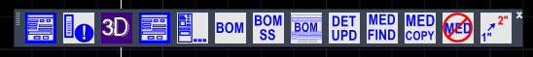
The MED Data Tools toolbar.
The buttons, from left to right:
- MED Change (MEDCHG) opens the MED Properties palette. See Editing conduit with MEDCHG.
- MED Records (MEDRECORDS) opens the records grid for the selected entities. See Editing multiple records.
- MED 3D Library (MED3DLIB) opens the 3D Block Library palette.
- MED Change Classic (MEDCHG-CLASSIC) opens the old MED Change dialog.
- MED Settings (MEDSET) opens the MED Settings palette.
- BOM extracts the bill of materials for the drawing.
- BOM SS (BOMSS) runs BOM on a selection set you pick instead of the whole drawing.
- Browse BOM runs MEDSHOWBOM to browse the bill of materials. See Browsing the BOM.
- DET UPD (DETAGUPD) updates the typical counts on detail tags.
- MED FIND (MEDFIND) selects MED entities by type and code.
- MED COPY (MEDCOPY) copies the MED data of one entity to others.
- MED Data Strip (MEDSTRIP) removes MED data from entities.
- 1" to 2" (CHGSIZE) changes the size of conduits or fittings.
More about some of these commands, and other MED data tools:
Command | What it does
MEDFIND | Selects and highlights MED entities of a type and optional code. Prompt: Select COnduit/Cable/Tray/Fitting/Equipment <Tray>:
MEDCOPY | Copies the MED data of one entity onto other entities (Select Entity to with Xdata to Copy: then Select Entities to copy data to:).
MEDSTRIP | Removes MED data from selected entities.
CHGTAG | Changes the tag of several entities at once.
ISOLATE / UNISOLATE | Hides everything except the equipment with the same code as a picked entity; UNISOLATE shows everything again.

Details
Detail drawings use the Detail Conduit toolbar and the Detail Conduit, J-Boxes and Details pull-down menus. The MEDDETAIL command (MED Main > Detail Drawings) switches the pull-down menus to the Detail set. [VERIFY: MEDDETAIL menu switching with med.cuix]

Detail Conduit
Detail conduit is drawn as two lines: a centerline that carries the MED data, plus an outline on each side at the rigid conduit outside diameter. You can route any type or size, and place two-line fittings, hubs, lights and hardware.

The Detail Conduit Toolbar
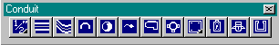
The Detail Conduit toolbar (2012). The MED2026 toolbar adds a Devices button. [VERIFY: toolbar picture]
Conduit Size flyout. Sets the active size.
2LCON routes two-line conduit.
2LFLEX routes two-line flex.
2AWAY places an away symbol on the end of two-line conduit or flex.
2TOWARD places a toward symbol on the end of two-line conduit or flex.
2BREAK places a break symbol on the end of two-line conduit or flex.
The Fitting button opens an image menu of two-line fittings.
The GUAT Fitting button opens an image menu of two-line GUA fittings.
The Hubs flyout places RS junction boxes and hubs (HUBS).
The Lighting button opens an image menu of two-line light fixtures.
The Hardware button opens an image menu of hardware.

Size Menu
Set the size before routing, with the Conduit Size flyout or the MED Settings palette.

Bends on or off
The Conduit Bends setting on the MED Settings palette controls automatic bends, exactly as for plan conduit. The Bend Multiplier (default 5 times the conduit size) sets the bend radius.

Route Two Line Conduit
To draw two-line conduit:
1. Set the size (for this example 1").
2. Pick 2LCON on the Detail Conduit toolbar, or type 2LCON.
3. Pick the start point and each corner along the centerline. Press [Enter] to finish.
4. Answer the tag prompt (or press [Enter]).
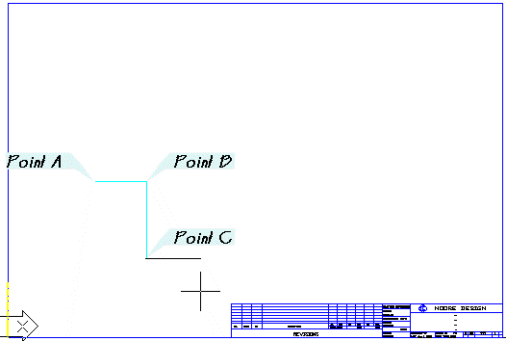
Two-line conduit route.
Pick start point of 1" Rigid Steel Conduit: [Pick Point A]
Pick point: [Pick Point B]
Pick point: [Pick Point C]
Pick point: [Enter]
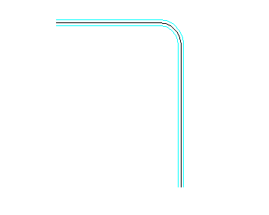
Two-line conduit, zoomed in at the bend.
The conduit is filleted to a 5" radius at point B (Bend Multiplier). The points you pick are the centerline; MED offsets the outlines to the rigid conduit outside diameter. The outlines are on layer MEDDETCON. If you edit the outlines and want them back, use CONFIX on the centerline.

Conduit Away, Toward, and Break
Conduit does not always stay in the plane of the sheet. Use away, toward and break symbols to show it turning away from you, toward you, or continuing.
To place an away symbol:
1. Pick 2AWAY (or 2TOWARD or 2BREAK) on the Detail Conduit toolbar.
2. Pick one of the outer lines of the conduit near its end.
3. Pick the second outer line.
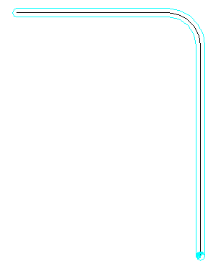
Where to place the away and toward symbols.
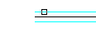
Pick here first for the away symbol.
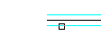
Pick here second for the away symbol.
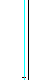
Away symbol placed.
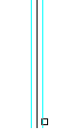
Toward symbol placed.

Placing conduit fittings
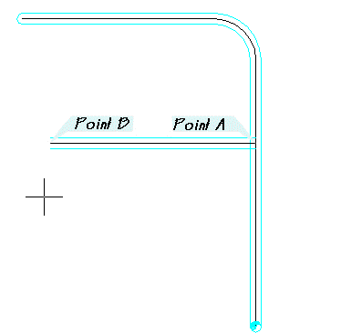
Fitting exercise.
To place a two-line tee:
1. Use 2LCON to add a branch conduit as shown. Use the NEArest osnap at Point A.
2. Pick the Fitting button on the Detail Conduit toolbar. In the image menu pick the Tee fitting and click OK.
3. Use the INTersection osnap to place the fitting at Point A.
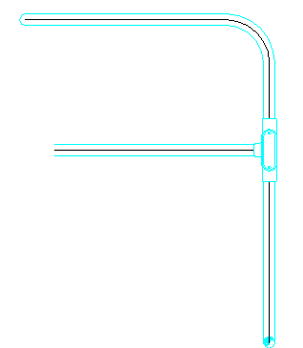
Pick the Tee in the image menu.
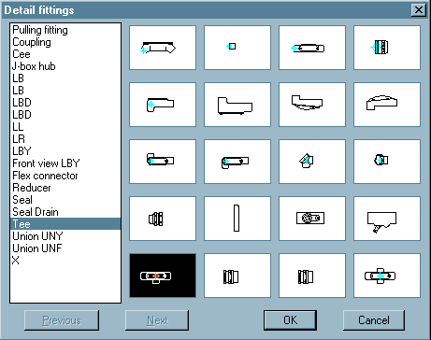
The tee placed.

Size override setting
As with plan fittings, MED sizes a fitting to the largest conduit at the insertion point. To place a larger fitting (for example a 1-1/2" tee on 1" conduit), check Size Override on the MED Settings palette and set the size to 1-1/2" first.

User Rotate setting
If automatic rotation is wrong, check User Rotate on the MED Settings palette and pick the rotation yourself.

Block Size Invalid or Not Found
This message means there is no block for the size you are placing. Light fixtures are often size specific.
To place a stanchion light:
1. Set the conduit size to 1-1/2" and use 2LCON to draw the riser as shown.
2. Pick the Lighting button on the Detail Conduit toolbar and pick the stanchion fixture.
3. Place the fixture at Point A on the centerline, then drag down to set the rotation.
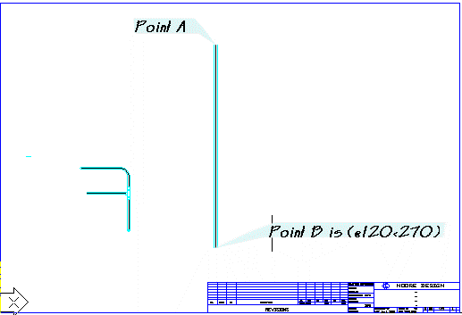
Stanchion riser.
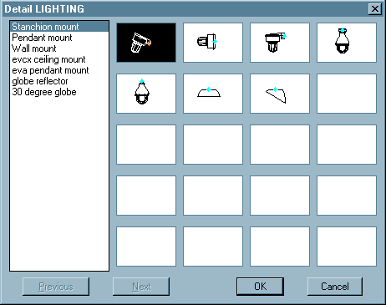
Pick the stanchion fixture.
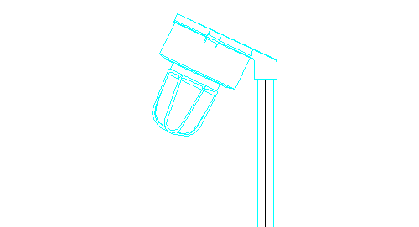
The finished stanchion light.
This fixture is only available in 1-1/2". With 1-1/4" set you would see the Block size invalid message.

Wiring Diagrams
Wiring diagrams use the Oneline and Elementary toolbars and the One Lines, Typical Starters and Elementary pull-down menus. The MEDWIRING command (MED Main > Wiring Diagrams) switches the pull-down menus to the Wiring set. [VERIFY: MEDWIRING menu switching with med.cuix]

The Oneline Toolbar
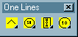
The Oneline toolbar.
The Components flyout places common oneline components.
The Relays and Meters flyout places common meter and relay symbols.
The Controls flyout places common oneline control symbols.
The Loads flyout places common oneline load symbols.

Oneline Sample Drawing
To see how MED builds a oneline, draw a simple branch. Start a new drawing and set it up with SETUP. (The 2012 Oneline tutorial drawing is not shipped with MED2026.)
To draw the bus and branch:
1. Pick the PWR continuous line from the Power Lines flyout on the MED Main toolbar and pick two points for the main bus.
2. Pick the PWR line again and draw a branch down from the bus. Use the NEArest osnap on the bus.
The PWR continuous line button.
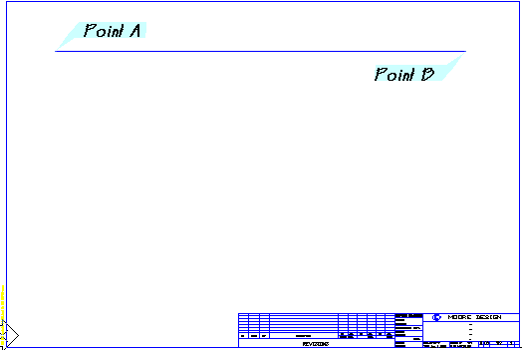
The main bus.
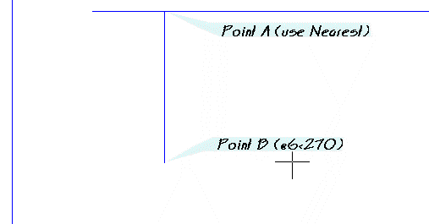
The branch.
To add the branch components:
1. Zoom in to a workable view.
2. Pick the Solid Connection symbol from the Misc Symbols flyout on the MED Main toolbar and place it at the intersection of the bus and the branch.
3. Pick the Stab symbol from the Components flyout on the Oneline toolbar and place it on the branch (NEArest osnap).
4. Pick the Circuit Breaker from the Components flyout and place it below the stab (NEArest osnap).
5. Place the remaining components shown to complete the branch.
The Solid Connection symbol.

Solid dot at the bus.
Stab symbol.
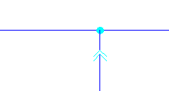
Stab placed.
Circuit breaker placed.
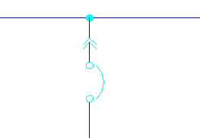
Remaining components.
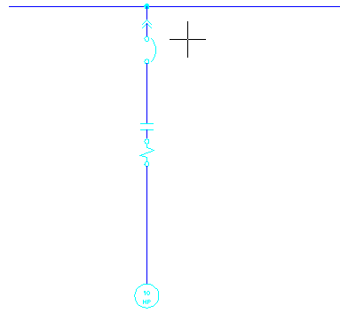
The completed power branch.
To add the controls:
1. Pick the Solid Control line from the Control Lines flyout on the MED Main toolbar and route the control line as shown. Use osnaps where it meets other linework.
2. Place a solid connection where the control line meets the power line, then place a Fuse.
3. Place the Control Transformer followed by another Fuse.
4. Pick the Coil from the Components flyout and place it as shown.
5. Pick the Hidden Control line and draw from the left QUAdrant of the coil to the contact to show that the coil controls the contacts.
6. Pick the HOA control from the Controls flyout and insert it at the endpoint.
The Solid Control line button.
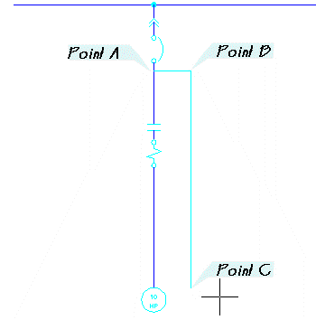
Control line routed.
Connection and fuse.
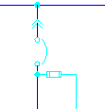
Fuse placed.
Control transformer.
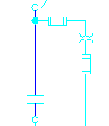
Second fuse.
Main coil placed.
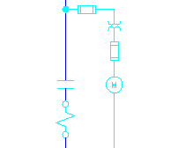
Hidden control line to the contact.
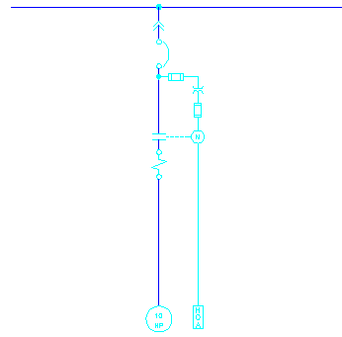
The completed branch with the HOA.

Placing a typical branch
Onelines are built from typical branches. MED has a few built-in typicals, and you can add your own with standard AutoCAD customization and the functions provided with MED.
To place a typical starter branch:
1. Open the Typical Starters pull-down menu (or One Lines) and pick the typical starter image menu.
2. Pick the first selection in the image menu and click OK.
3. Pick a point on the main bus away from the existing branch.
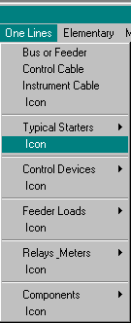
One Lines menu (2012). [VERIFY: menu name and item in med.cuix]
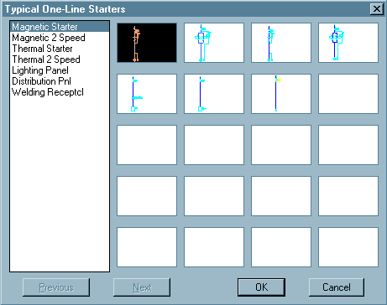
Typical starter image menu. [VERIFY: image menu still current]
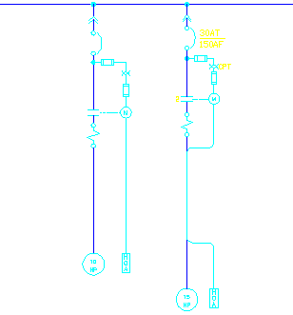
The typical branch placed.
The typical looks much like the branch you built by hand, but it was a lot faster to place. Take advantage of typical circuits and expand MED to suit your needs.

The Elementary Toolbar
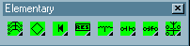
The Elementary toolbar.
The Overcurrent Protection flyout places typical overcurrent symbols.
The Components flyout places typical component symbols.
The Diodes flyout places typical diode symbols.
The Semiconductor flyout places semiconductor symbols.
The Transformer and Inductor flyout places transformer and inductor symbols.
The Normally Open flyout places contacts and switches in the open position.
The Normally Closed flyout places contacts and switches in the closed position.
The Miscellaneous Switches flyout places other switches.
Placing symbols from the Elementary toolbar works the same as from the Oneline toolbar. See the Oneline sample above.

3D Modeling
MED2026 can build a 3D model straight from your 2D plan. Tray, tray fittings, conduit, conduit bodies (Condulets) and cable are turned into 3D solids using the sizes, elevations and up/down distances already stored in the MED data. You do not draw anything in 3D yourself. The model can be used for interference checking, clearances and coordination (for example in Navisworks).
Important: 3D models are approximations for layout and coordination only and are not reproductions of manufacturer specifications. Verify all dimensions against manufacturer data.
[Screenshot: MEDMAKE3D result: tray, conduit and conduit bodies in an isometric view]

The 3D commands
Command | Use
MEDMAKE3D | Builds everything in one pass: tray, tray fittings, conduit, conduit bodies and cable. One prompt, one summary. This is the command to use.
MAKE3DTRAY | Tray and tray fittings only (Export Tray to 3D Model button on the Cable Tray toolbar).
MAKE3DCONDUIT / MAKE3DCABLE | Every conduit run / every cable run (no conduit bodies).
M3D / C3D | Only the conduit / cable runs you select.
MEDCBINS | Inserts one 3D conduit body by hand.
MEDCBTEST / MEDCBALL / MEDCBGRID | Draw test rows and galleries of conduit bodies.
MEDCBDATA | Reloads the conduit body dimension data and lists the sizes available.
MED3DVER / MEDCBVER | Show the version of the 3D modules and where their data comes from.
ESOLID | Erases ALL 3D solids in the drawing.

Note: MEDMAKE3D and the other 3D commands are not on a toolbar or menu in MED2026 (except MAKE3DTRAY). Type them at the command prompt. [VERIFY: add MEDMAKE3D and MED3DLIB to med.cuix?]

Preparing the plan
MEDMAKE3D reads the plan exactly as you drew it, so a clean plan gives a clean model.
- Draw tray with TRAY and the tray fittings, conduit with CONDUIT, and cable with CABLE or RUN3DCABLE.
- Place conduit fittings from the MED fitting menus and toolbars (so they carry MED data) and use osnaps, so each fitting sits on the conduit centerlines.
- Show conduit going up or down with the Conduit Up / Down symbols; the distance you entered becomes the vertical run.
- Check the drawing scale (SETUP). MED uses it to find the conduits that belong to each fitting.
- Never MIRROR a conduit fitting symbol. Insert the other-handed symbol instead (for example an LBR instead of a mirrored LBL). Mirrored fittings are not built (see Flags).
- Save the drawing first if you want the property file (.medprops.json) with the Layer option.

Building the model with MEDMAKE3D
To build the 3D model:
1. Open the plan drawing and save it.
2. Type MEDMAKE3D.
3. At MEDMAKE3D output to [Dwg/Layer] <Dwg>: choose an output:
4. Dwg (default): name the output file in the file dialog. All the solids made by this run are written to that one DWG, with a <name>.medprops.json property file beside it, and removed from the current drawing. If you cancel the file dialog, the solids stay in the drawing.
5. Layer: the solids stay in the current drawing on layers MED_3DTRAY-*, MED_3DCONDUIT and MED_3DCABLE, and the view changes to an isometric viewpoint (1,1,1). Type PLAN to return to the plan view.
6. Read the summary at the command line (see below), fix anything that was flagged or skipped, and run the command again.
MEDMAKE3D works in stages: tray and tray fittings; then it finds the conduit bodies; then it builds the conduit, cutting each run back to the hub faces of its bodies; then it inserts the conduit body blocks; then it builds the cable. If one stage has an error it is reported in the summary and the next stage still runs. Press Esc to stop the whole command.

Reading the summary
MEDMAKE3D summary:
Tray : 2 solid(s)
Tray fittings : 1 solid(s)
Conduit : 1 solid(s) from 1 of 2 run(s)
Conduit bodies: 3 block(s), 1 placeholder(s), 2 fitting(s) not modelled
Cable : 1 solid(s) from 1 of 1 run(s)
Flagged : 1 (markers on MED_3DFLAG)
Skipped : 3
2A4 conduit: no OD for this conduit type/size
3B1 fitting: RGD|F8|TB: no 3D data for TB 3 in - placeholder on MED_3DFLAG
Output : C:\...\combined.dwg (+ .medprops.json)
Line | Meaning
Tray / Tray fittings | Number of tray solids built.
Conduit / Cable | Solids built and how many runs were converted.
Conduit bodies | 3D body blocks inserted, placeholders (no dimension data), and fittings that are not modelled (couplings, connectors, straps; these get no solid and no message).
Flagged | Problems marked on layer MED_3DFLAG (see Flags).
Mirrored fittings | Only shown when there are any: fittings that were mirrored and therefore not built.
Skipped | Each run or fitting with no solid, with its handle and the reason.
Output | The DWG written (Dwg option).

Running it again
- With the Layer option, erase the old solids before running again, or the new ones are stacked on top. ESOLID erases every 3D solid in the drawing; do not use it if you keep other solids in the drawing.
- Clear the MED_3DFLAG layer after fixing problems (MAKE3DCONDUIT and MAKE3DCABLE clear it for you).

Conduit fittings in 3D (conduit bodies)
MEDMAKE3D replaces each 2D conduit fitting symbol with a 3D conduit body block of the right form, shape and trade size: LB, LL, LR, T, TB, C, X, LBD, LBY, Mogul bodies, GUA fittings, unions, seals (EYS/EYD), plugs, hubs and reducers. The conduit is trimmed back to the hub faces so the model connects properly.
- Bodies are named MED_CB_RGD_<form>_<shape>_<size>, for example MED_CB_RGD_F7_LB_1-00, and placed on layer MED_3DCONDUIT.
- Which body a fitting gets is set by the fitting's catalog record: Key2 on the FITTING row in MEDTYPE (for example RGD|F7|LB). If Key2 is blank MED works it out from the description. You can type your own key in MEDTYPE.
- Forms: F7, F8, M9 (Condulet Form 7, Form 8, Mark 9), CH (Crouse-Hinds: LBD, LBY, UNY, EYS, EYD, HUB, plugs, RE), MOG (Mogul), XP (GUA), MYR (Myers hub).
- If there is no dimension data for a form or size, a placeholder box is inserted on MED_3DFLAG and listed under Skipped.
- Not modelled: couplings, connectors, straps, REC, EYS elbows, EZS/EZD.
[Screenshot: Conduit run with LB and T conduit bodies after MEDMAKE3D]

Flags and mirrored fittings
Anything MEDMAKE3D could not build cleanly is marked on the red layer MED_3DFLAG, and listed at the command line.
Flag | What to do
Sharp corner (sphere at the corner) | The bend would not fit between the neighbouring corners. Lengthen the straight runs or reduce the bend, then run again.
Conduit leg with no hub | A conduit meets a body where no hub lines up with it (within 30 degrees). Check the fitting type and rotation.
Placeholder box | No dimension data for that body and size. Check the size, or add the data.
MIRRORED FITTING - re-insert, do not mirror | The 2D fitting symbol was mirrored. Erase it and insert the other-handed symbol (for example 1lbr instead of a mirrored 1lbl). The conduit next to it is left as drawn until you do.

To review the flags:
1. Run MEDMAKE3D with the Layer option.
2. Turn on layer MED_3DFLAG and look for the red markers (or use the handles listed under Skipped).
3. Fix the 2D plan, erase the old solids and run MEDMAKE3D again.

Single-purpose 3D commands

MAKE3DTRAY
To extract only the cable tray:
1. Pick Export Tray to 3D Model on the Cable Tray toolbar, or type MAKE3DTRAY.
2. At Output to 3DS Layer <Dwg>: choose Dwg (export to a drawing you name) or Layer (solids stay in the drawing on the 3D tray layer, other layers are turned off and the view goes isometric; type PLAN to return).
3D tray in wireframe.
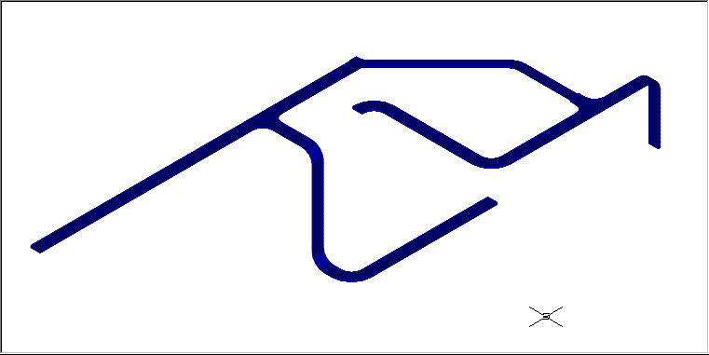
3D tray shaded.
Note: The 3DS option is still offered but AutoCAD 2024 has no 3DSOUT command. [VERIFY: 3DS option in current AutoCAD] MAKE3DTRAY exports every 3D solid in the drawing, not only the tray.

MAKE3DCONDUIT, MAKE3DCABLE, M3D and C3D
MAKE3DCONDUIT and MAKE3DCABLE convert every conduit or cable run, with the prompt [Dwg/Layer] <Dwg>. M3D and C3D convert only the runs you select. These commands do not place conduit bodies; use MEDMAKE3D for a complete model.

Inserting conduit bodies by hand (MEDCBINS)
To insert a 3D conduit body:
1. Type MEDCBINS.
2. At Fitting type [LB/LR/LL/T/TB/C/X/LBD/BLB/LBY/BT/BC/BUB/GUAL/GUAT/GUAX/UNY/EYS/EYD/PLGR/PLGS/HUB/RE] type the shape.
3. At Form (F7 = Form 7, F8 = Form 8, M9 = Mark 9 aluminum, CH = Crouse-Hinds, MOG = Mogul, XP = GUA, MYR = Myers) choose the form (only asked when more than one form exists for that shape).
4. At Trade size (1/2, 3/4, 1, 1-1/4, 1-1/2, 2 ... 4) type the size. For RE you are also asked Reduce to size.
5. At Insertion point (conduit centerline intersection) for <block> <done>: pick where the conduit centerlines meet.
6. At Rotation about Z <0>: enter the rotation. The cover faces up (+Z) and the run hub points along +X.
7. Keep picking points to insert more of the same body, or press [Enter] when done.

Conduit body test and data commands
Command | What it does
MEDCBTEST | Asks for a form and trade size, then Base point for the row <0,0,0>:, and draws a labelled row of the classic bodies (LB, LL, LR, T, TB, C, ...) of that form.
MEDCBALL | Asks for a trade size and Base point <0,0,0>:, and draws every body at that size, one row per form, labelled. Missing sizes come in as placeholders.
MEDCBGRID | Draws the whole fitting test matrix in a test drawing. Load it first with APPLOAD (tests\autocad\MEDCBGrid.lsp). Prompts: MEDCBGRID base point (top-left cell) <0,0>: and Rotation of every cell (degrees) <0>:. [VERIFY: MEDCBGrid.lsp is not installed with MED]
MEDCBDATA | Reloads the conduit body dimensions from the database and lists the sizes available. Run it after editing the data.
MEDCBVER / MED3DVER | Show the version of the conduit body and 3D path modules and where their data comes from.

When the data changes
- A body block is built once per drawing and never redefined. To rebuild a body from new data, erase its inserts and PURGE the MED_CB_RGD_... block, then run MEDMAKE3D again.
- When MED updates a body design, older blocks in a drawing are renamed with _PRE_ (for example _PRE_R6) and new ones are built. Run PURGE (Blocks) afterwards to remove the unused _PRE_ definitions.
- Dimension data is in the database tables MEDConduitBody and MEDConduitOD. Editing them is an administrator task; see docs\3d-guide.md.

Using the model in Navisworks
With the Dwg option, MEDMAKE3D writes <name>.medprops.json beside the 3D DWG. Each solid also carries MED identification data (object type, size, description, tag, length, weight). The MEDPropertiesPlugin for Navisworks Manage / Simulate 2024 shows these fields for the selected objects. With the Layer option the property file of the current drawing is rebuilt if the drawing has been saved. [VERIFY: how the Navisworks plug-in is installed for end users]

3D Block Library
The 3D Block Library (MED3DLIB) is a dockable palette for finding and inserting 3D blocks: equipment, lighting, fittings, strut, tray, enclosures and more. It shows every DWG in the MED Dwg3D folder (385 blocks in 22 categories) with a preview, a description, a category and a note, and lets you insert a block by double-clicking it or dragging it into the drawing.
Important: 3D models are approximations for layout and coordination only and are not reproductions of manufacturer specifications. Verify all dimensions against manufacturer data.

Opening the library
To open the 3D Block Library:
1. Type MED3DLIB. The MED 3D Library palette opens with the 3D Blocks tab.
2. Dock it on the left or right of the AutoCAD window, or leave it floating. It reopens where you left it.
[Screenshot: MED3DLIB palette in List view, docked on the right]
The library reads the Dwg3D folder next to the MED Support folder (for example C:\MED2026\Dwg3D) unless you have picked another folder with Folder.... The descriptions, categories and notes are kept in a small catalog file, Dwg3DCatalog.db, in the same folder. The first time a folder is opened, MED scans it and builds the previews. [VERIFY: the MED2026 installer ships the Dwg3D folder and Dwg3DCatalog.db]

The palette at a glance
Area | What it does
Search box | Type words to filter the list. A block is shown when every word is found in its file name, description, note, category or source path.
Category filter | (All categories), one category, or the special filters (Uncategorized), (Missing files) and (No preview).
View | List, Tiles or Grid. MED remembers your choice.
Block list | The blocks that match. Missing files are shown in red.
Details panel | Large preview, file information (size, date, source), and the Description, Category and Note fields.
Insert / Save / Open DWG | Insert the selected block; save your edits (Ctrl+S); open the block's DWG read-only.
Rescan / Folder... / Excel | Refresh from the folder; choose another folder; export to and import from Excel.
Status line | How many blocks are shown and the result of the last action.

Finding a block
To find a block:
1. Pick a category in the category filter, for example Lighting (or leave (All categories)).
2. Type one or more words in the search box, for example flood 400. The list updates as you type.
3. Click a block to see its preview and details.

List, Tiles and Grid views
- List: File, Category and Description columns. Click a column header to sort.
- Tiles: thumbnails, good for picking by eye.
- Grid: a spreadsheet-style view with thumbnail, File, Category, Description, Note and Source. You can edit Category, Description and Note directly in the grid (see Editing block information).
[Screenshot: MED3DLIB palette in Tiles view]
[Screenshot: MED3DLIB palette in Grid view]

Inserting a block
To insert a block from the library:
1. Select the block in the list.
2. Double-click it, press [Enter], or click Insert. (MED runs MED3DLIBINSERT for you.)
3. At Insertion point for <name>: pick the insertion point. The block follows the cursor.
4. At Rotation angle <0>: enter or pick the rotation.
To insert by dragging:
1. Drag the block from the list, or drag the preview picture, into the drawing.
2. Release the mouse where you want the block. It is inserted at the drop point.
3. At Rotation angle <0>: enter or pick the rotation.
- The block is named after its DWG file. If the drawing already has a block of that name, the existing definition is used.
- Attributes in the block are filled with their default values.
- You cannot insert a drawing into itself.
- To insert by name without the palette, type MED3DLIBINSERT. At DWG file (full path or name in the 3D library): type the file name (or a full path), then pick the point and rotation.

Opening a block DWG
Select a block and click Open DWG to open its drawing read-only, for example to check the model. If it is already open, AutoCAD switches to it. Open DWG is the only way to open a block's drawing file from the palette; double-clicking or dragging a block always inserts it.

Editing block information
Each block has a Description, a Category and a Note. They are stored in the library catalog, not in the DWG files.
To edit one block in the details panel:
1. Select the block.
2. Type in Description, Category (pick an existing category from the drop-down list as you type, or type a new one) and Note.
3. Click Save or press Ctrl+S. Changes are also saved when you select another block.
To edit in the Grid view:
1. Switch the view to Grid.
2. Click a Category, Description or Note cell and type (or press F2). The change is saved when you leave the cell.
3. Double-click any other cell, or press [Enter], to insert the block.

Bulk editing with Excel
To edit many blocks at once, export the catalog to Excel, edit it there and import it back.
To export the catalog:
1. Click Excel and choose Export to Excel....
2. Choose the file name (default Dwg3DCatalog_BulkEdit.xlsx) and click Save. MED offers to open the workbook.
The workbook has a Blocks sheet (Preview, File, Category, Description, Note, Source, Modified) and a Categories sheet. Only Category, Description and Note can be edited; the other columns are protected. The Category column has a drop-down list of categories.
To import your edits:
1. Edit Category, Description or Note in the Blocks sheet. To empty a field, type (clear) in the cell. Blank cells are left unchanged.
2. Save and close the workbook.
3. Click Excel and choose Import from Excel..., then pick the workbook.
4. Review the summary MED shows before applying: the number of changes, and any rows whose file was not found in the library.
5. Confirm to apply. Only non-blank cells that differ from the catalog are applied. MED backs up the catalog first (Dwg3DCatalog.db.bak-<date>-<time>).
[Screenshot: Dwg3DCatalog_BulkEdit.xlsx Blocks sheet with category drop-down]

Keeping the library up to date
To add new blocks:
1. Copy the new DWG files into the Dwg3D folder (sub-folders are fine).
2. Click Rescan. New files are added, missing files are flagged (filter: (Missing files)), and previews of changed files are refreshed. Hold Shift while clicking Rescan to rebuild every preview.
3. Give the new blocks a category and description (filter: (Uncategorized)).
To use a different library folder, for example a shared folder on the network, click Folder... and pick the folder. MED remembers it for your Windows login.

Library categories
The library ships with these categories (number of blocks in brackets):
Category | Blocks
Lighting | 47
Power Equipment | 47
Conduit Fittings | 44
Strut | 40
Cable Tray | 29
Junction Boxes/Enclosures | 23
Structural | 23
Grounding/Lightning | 18
Receptacles/Switches | 17
Panels/Racks | 16
Detectors/Gas/Flame | 14
Letters/Text | 13
Stations/Push Buttons | 13
Horns/PA/Antennas | 10
Cable Gland | 8
Cameras | 6
People/Misc | 6
HVAC | 3
Heat Trace | 3
Instrument | 3
Detail | 1
Instrumentation | 1
Total | 385

Tip: Use a consistent set of categories so the filter stays useful. The Categories sheet of the Excel export lists the categories in use.

Utilities
Certain drawing utilities you may be used to are already built into MED: utilities for modifying text, entity properties such as layers, colors and linetypes, tagging, material bubbles, and shortcut keys such as Z for Zoom. They range from simple ACAD.PGP aliases to full AutoLISP routines.

Attributes and Text
AutoCAD has many ways to modify text and attribute values. MED offers a few more that are often quicker. These are also on the Text & Attributes menu and the Attribute Tools flyout.
Command | Description
AC | Attribute Change changes the value of the selected attribute to a new value you provide.
ACX | Attribute Change Exchange changes only part of the selected attribute, based on an old value and a new value.
CT | Change Text changes text strings to new values. Select several strings in the order you want to change them.
CTEDIT | Change Text Edit adds or edits prefixes and suffixes on a selection of text. Prefixes and suffixes can be added one by one, auto-stepped, or as typical. Simple editing can also be done with CTEDIT.
CX | Change Exchange replaces every occurrence of an old string with a new string in the selected text.
DD | Opens the right editor (text edit or attribute edit) for the selected entity.
IL | Isolate Layer freezes all layers except the layer of the selected entity, which becomes current. Use AutoCAD's LAYTHW to thaw all layers again.
RT | Replace Text replaces several text entities with a new value, typed or picked.
TJ | Text Justification changes the justification of the selected text and aligns it to one X coordinate.
UPCASE | Changes the selected text to upper case.
UT | Underline Text underlines the selected text.
XT | Change Text Style converts the selected text to a style. If the heights differ it offers to adjust the spacing from a base point.

Miscellaneous Utility and Edit commands
Productivity improves when time-consuming drafting tasks are automated. These commands help when creating and editing drawings.
Command | Description
ALEAD | Arrow Leader asks for a few points and then the text to place on the leader.
BF | Break First lets you select an entity and then pick the two break points.
BN | Block Name shows the name of a selected block.
CD | Coordinate text: pick a line to read the coordinate from, then the text location and rotation. Uses the current text style and layer.
CL | Change Layer changes a selection to the layer of a picked entity.
CLOUD | Pick one point and drag the cursor around in a cloud-like path, then press Enter. The cloud is closed and drawn as a polyline.
CUT | Conduit section cut marks: two points and a section letter.
EM | Extend Multiple extends a selection of entities to a selection of boundaries.
FD | FileDate places or updates the file name, scale, date and user initials (the FILEINFO block).
FL | Freeze Layer freezes the layer of a picked entity.
GR | Inserts a hook (grab) symbol at the end of a line and breaks the line.
GRAB | Like ALEAD, but with a hook around the line picked as the first point.
LB | LineBreak breaks several lines at once away from a priority line. Useful in terminal strip drawings.
LBREAK | Breaks a line at two points and inserts a break symbol at each.
LISP | Loads a LISP file by name (Name of lisp file to load:) from the AutoCAD support path.
LT | LineType changes a selection to the linetype of a picked entity (offers BYLAYER when the base entity is BYLAYER).
PBOX | Polyline Box draws a closed polyline rectangle from two corners.
PLMAKE | Polyline Make converts selected lines to polylines.
PW | Polyline Width sets the width of selected polylines to a picked or typed width.
QC | Quick Circle draws several circles of different radii from one center.
SECT | Inserts section marks for sections or elevations on plan drawings.
SL | Set Layer makes the layer of a picked entity current.
ST | Starts STRETCH with a crossing selection.
TM | Trim Multiple trims several lines to a selection of boundaries.
VR / VA | View Restore restores a named view; VA restores the view named ALL (save it first).
ZD, ZE, ZP, ZV, ZW | Zoom Dynamic, Extents, Previous, VMAX and Window.

Balloons and Tagging commands
Material tags and other balloon-type tags can be placed and edited with these commands (Tagging menu and toolbar).
Command | Description
ABL | Adds a leader line to a selected balloon or bubble.
HDTAG | Hot Dog Tag: asks for the tag text (up to 15 characters) and sizes the tag to fit.
IT | Instrument Tag: asks for the instrument type and number.
MB | Material Bubbles: place one or a string of material bubbles by entering several material ID numbers.
MBL | Move Bubble Leader moves a bubble or its leader and adjusts the other to suit.
WIRES | Places the dashes and squiggles on conduits that show the circuits and wires inside (mainly lighting plans). Ground is a longer dash with a small G.
CTAG / TTAG / DETAG | Conduit, tray and detail tags (see the Plan Drawings chapter).

ACAD.PGP Shortcut command Keys
Most users already use shortcut keys from the ACAD.PGP file. These are the shortcuts in the ACAD.PGP shipped with MED. You are encouraged to change the file to suit you; see the AutoCAD help on editing ACAD.PGP.
Key | Command | Key | Command
A | Array | ME | Measure
AE | Attedit | MI | Mirror
AR | Arc | MS | Mspace
B | Break | MV | Mview
BL | Block | O | Offset
C | Copy | P | Pan
CH | Change | PD | Pedit
CK | Circle | PG | Polygon
D | Dist | PL | Pline
DE | Ddatte | PS | Pspace
DH | Donut | PT | Point
DI | Divide | R | Redraw
DT | Dtext | RG | Regen
DV | Dview | RO | Rotate
DWG | Dwgname (shows the current drawing name) | SC | Scale
E | Erase | T | Text
EL | Ellipse | TR | Trim
EX | Extend | WB | Wblock
F | Fillet | X | Explode
H | Hatch | XR | Xref
I | Insert | Z | Zoom
L | Line | 3DLINE | Line
LA | Layer | RR | DLDCLEAN
LL | List | SERIAL | _PKSER
M | Move

If you are unfamiliar with any of these commands, see the AutoCAD help.

Appendix A: Command Reference
This appendix lists every command MED2026 defines: 283 commands, 262 from the LISP files and 21 from MED-DotNet.dll. Commands by category groups them by task; Commands A to Z gives a one-line description and the file that defines each one. For the prompts, options and menu or toolbar location of each command, see the developer reference in the MED2026 repository:
- docs\command-reference.md: every MED command, grouped by topic.
- docs\3d-guide.md and docs\3d.md: 3D modeling details, tuning and data files.
- docs\lisp-reference.md: LISP functions for customizing MED.

Commands by category
Each command is listed once, under the task it is used for. Aliases (for example MEDPROPS for MEDCHG) are listed with the command they run.

Setup and Configuration
Drawing setup, scale and limits, menus, layers, text and dimension setup, the MED Settings palette and the debug log. (15)
BLDIST | MED2026SETUP | MEDDIMSETUP | MEDSET | SETLIM
IOD | MEDDEBUG | MEDMENU | MEDSETTINGS | SETPLOT
LOADLAYERS | MEDDETAIL | MEDPLAN | MEDWIRING | SETUP

Conduit and Conduit Fittings
Single-line and two-line conduit, flex, conduit fittings, hubs, sizes and conduit repair. (16)
2AWAY | 2TOWARD | CONSIZE | FLEX
2BREAK | ADDRE | DEFINE | HUBS
2LCON | CONDUIT | F0 | OFF2CON
2LFLEX | CONFIX | FC | UNJ

Duct Bank
DBDELETE | DBEDIT / -DBEDIT | DBLIST | DBSEED | DUCTBANK / -DUCTBANK

Cable Tray and Channel
Cable tray and channel runs, horizontal and vertical fittings, offsets, reducers, tray hardware and the tray centerline. (48)
CF | CHANUP | TRAY60 | TRAYHANG | TRAYUP
CHAN30 | CHANV90 | TRAY90 | TRAYHD | TRAYV90
CHAN45 | CN | TRAYBLIND | TRAYHINGE | VTRAY
CHAN60 | PTRAYOFF | TRAYCON | TRAYOFF | VTRAY30
CHAN90 | STRUT | TRAYCROSS | TRAYRE | VTRAY45
CHANCROSS | STRUT1 | TRAYDN | TRAYREL | VTRAY60
CHANDN | TELEV | TRAYDROP | TRAYRER | VTRAY90
CHANNEL | TRAY | TRAYEG | TRAYSIZE | VTRAYOFF
CHANOFF | TRAY30 | TRAYEP | TRAYTEE
CHANTEE | TRAY45 | TRAYFIX | TRAYTEERE

Cables and Wiring
Cable runs, the Cable palette and wire markers. (6)
CABLE | CABLESET | RUN3DCABLE
CABLEPALETTE | MEDCABLE | WIRES

One-Lines and Elementary Diagrams
Wiring diagram lines and terminal strips. (4)
2LINE | 3LINE | MEDLINE | TSTRIP

Details and Equipment
Detail symbols (lighting, power, grounding, instruments, communication, tray) and equipment blocks. (11)
COM | INS | MEDBLOCKINSERT | PWR
DETAIL | JBX | MSC | TRY
GND | LTG | PLANMOTOR

Lists, Reports and MED Data
MED entity data (xdata), the MED Properties palette, records, the MEDType catalog, bills of material and database backup. (34)
ATLSC | MCABLE | MEDDBBACKUP | MEDRECORDS | MEDXDEDIT
ATRSC | MCON | MEDDBRESTORE | MEDSHOW | MEQUIP
BOM | MED | MEDFIND | MEDSHOWBOM | MFIT
CHGSIZE | MED-REBUILDMEDPROPERTIESJSON | MEDLIST | MEDSHOWSUM | MTRAY
CHGTAG | MEDCHG | MEDPROPERTIES | MEDSTRIP | TAKEOFF
ISOLATE | MEDCHG-CLASSIC | MEDPROPS | MEDTYPE | UNISOLATE
MC | MEDCOPY | MEDREBUILDMEDPROPSJSON | MEDTYPES

Tagging and Balloons
Conduit, tray and detail tags, balloons, leaders, revision clouds and section marks. (34)
ABL | CTAG | GR | ITAGT | QTR
AL | CUT | GRAB | LOOPIT | QTT
ALEAD | DETAG | HDTAG | MB | SECT
BC | DETAG2 | HDTAGOLD | MB1 | SECTD
BOXCLOUD | DETAGUPD | IT | MBL | TTAG
BRACKET | GL | ITAGA | QTA | TTAGS
CLOUD | GLEAD | ITAGE | QTE

Text and Attributes
Text, text styles, attribute editing and field links. (36)
AC | B1 | DD | RT | TJ
ACX | B2 | FD | SETLINK | UPCASE
APP | B3 | LINKPREFIX | SETLINKSUM | UT
ATADD | BLDSTL | LINKPREFIXATT | SHOWFIELDCODE | XT
ATC | CD | LINKVALUE | T1
ATTCOPY | CT | LOADTXT | T1THIN
ATTLAY | CTEDIT | MT | T2
ATTROT | CX | PAR | T3

Layers, Editing and View Utilities
Layer, editing, polyline, block and zoom shortcuts. (41)
BF | EW | PB | RW | ZD
BLK2BYL | FL | PBOX | SL | ZE
BLKREINS | HAND | PLMAKE | SORT | ZP
BN | IL | PLWIDE | ST | ZV
CC | LB | PW | TM | ZW
CL | LBREAK | QC | UIL
CW | LISP | QE | VA
EC | LT | RC | VR
EM | MW | REFDWG | WBL

3D Modeling and Conduit Bodies
Building the 3D model from the plan (MEDMAKE3D and the single-purpose 3D commands) and 3D conduit bodies. (17)
3DJBOX | M3DOLD | MAKE3DTRAY | MEDCBDATA | MEDMAKE3D
C3D | MAKE3DCABLE | MED3DPLAN | MEDCBINS
ESOLID | MAKE3DCONDUIT | MED3DVER | MEDCBTEST
M3D | MAKE3DCONDUITOLD | MEDCBALL | MEDCBVER

3D Block Library
The 3D block library palette and command-line insert. (2)
MED3DLIB | MED3DLIBINSERT

Developer and Test
Test and developer commands. They are not needed for normal drafting; some are in files MEDCore does not load. (11)
MED3DLIBTEST | MYTEST | TRAYFITTEST | TRAYTEETEST
MED3DPATHTEST | QVTEST | TRAYLRRETEST | TRAYTEST
MEDCBGRID | TEST | TRAYRETEST
Note: T1, T2 and T3 are quick commands that start text (DTEXT) in the default MED text styles at body, medium and large sizes. B1, B2 and B3 do the same at the same sizes on the bold text layer (MED_TEXT-BOLD), for emphasis. They are not text styles themselves. Separately, BLDSTL makes one command for each text style in the drawing when it runs (for example T937THIN), so you can type a style name to start DTEXT in that style. Those commands are created at run time and are not listed here.

Commands A to Z
Source is the file that defines the command. LISP files are in Support\ unless a folder is shown; MED-DotNet\ files are the C# sources in src\MED-DotNet (MED-DotNet.dll). Where a command is defined in two files, the first file listed is the definition that loads last and is the one AutoCAD runs.
Command | Description | Category | Source
2AWAY | Inserts the conduit-away symbol on a two-line conduit. | Conduit | medcon.lsp
2BREAK | Inserts a break symbol on a two-line conduit. | Conduit | medcon.lsp
2LCON | Two-line (detail) conduit run. | Conduit | medcon.lsp
2LFLEX | Two-line flexible conduit run. | Conduit | medcon.lsp
2LINE | Double / triple line: offsets a polyline by _2LINOFF / _3LINOFF. | One-Line / Elem. | medwire.lsp
2TOWARD | Inserts the conduit-toward symbol on a two-line conduit. | Conduit | medcon.lsp
3DJBOX | 3D junction box from corner, angle, height, width, depth. | 3D Modeling | MED3DMisc.lsp
3LINE | Double / triple line: offsets a polyline by _2LINOFF / _3LINOFF. | One-Line / Elem. | medwire.lsp
ABL | Adds a leader to a selected bubble. | Tagging | medtag.lsp
AC | Changes a selected attribute to a new value. | Text | medtext.lsp
ACX | Replaces part of attribute values (old string -> new string). | Text | medtext.lsp
ADDRE | Adds a given number of reducing fittings (RE) to an entity's MED_FITTING xdata. | Conduit | QKEY.lsp
AL | Arrow leader. | Tagging | MEDCommands.lsp
ALEAD | Arrow leader. | Tagging | MEDCommands.lsp
APP | Appends a string to selected text. | Text | QKEY.lsp
ATADD | Adds an attribute to a block insert. | Text | medtext.lsp
ATC | Alias for ATTCOPY. | Text | QKEY.lsp
ATLSC | Adds schedule data (material 67 / 68) to a picked entity's xdata (legacy lighting/receptacle schedule). | MED Data | QKEY.lsp
ATRSC | Adds schedule data (material 67 / 68) to a picked entity's xdata (legacy lighting/receptacle schedule). | MED Data | QKEY.lsp
ATTCOPY | Copies one attribute value to another attribute. | Text | medtext.lsp
ATTLAY | Moves the attributes of selected blocks to the MED text layer. | Text | QKEY.lsp
ATTROT | Rotates the attributes of selected blocks to 0 degrees. | Text | QKEY.lsp
B1 | Same as T1 (body text) but on the bold text layer MED_TEXT-BOLD, for emphasis. | Text | MEDCommands.lsp
B2 | Same as T2 (medium text) but on the bold text layer MED_TEXT-BOLD, for emphasis. | Text | MEDCommands.lsp
B3 | Same as T3 (large text) but on the bold text layer MED_TEXT-BOLD, for emphasis. | Text | MEDCommands.lsp
BC | Alias for BOXCLOUD. | Tagging | QKEY.lsp
BF | BREAK at two points. | Utilities | QKEY.lsp
BLDIST | Builds break/rotation distances for a block (0/90/180/270 points) for medblck.dat. | Setup | medsetup.lsp
BLDSTL | Builds temporary commands named after each text style (MEDlsp.tmp) to set that style. | Text | medutil.lsp
BLK2BYL | Loads blk2byl.lsp and runs its BLK2BYL (block layers to 0/ByLayer). blk2byl.lsp is not in Support. | Utilities | QKEY.lsp
BLKREINS | Re-inserts blocks by name. | Utilities | medutil.lsp
BN | Shows the block name of a picked insert. | Utilities | medutil.lsp
BOM | Extracts all MED xdata in the drawing to MEDProject (deletes this drawing's old rows first). Not live. | MED Data | MEDCommands.lsp
BOMSS | BOM on a selection set: pick MED entities instead of the whole drawing (same write path as BOM). | MED Data | MEDCommands.lsp
BOXCLOUD | Rectangular revision cloud from two corners with X/Y arc spacing. | Tagging | medtag.lsp
BRACKET | Bracket mark from two points and a direction. | Tagging | medtag.lsp
C3D | Selected cable runs to 3D solids on MED_3DCABLE. | 3D Modeling | MED3DPath.lsp
CABLE | Draws a cable run (MED_CABLE xdata, tag + related tag). Palette "Route Cable" runs this. | Cables | medcable.lsp
CABLEPALETTE | Shows the MED Cable palette (type, then cable). | Cables | MED-DotNet\MedCablePalette.cs
CABLESET | Alias: shows the Cable palette. | Cables | MED-DotNet\MedCablePalette.cs
CC | Erase / copy / move / rotate with window or crossing preselected. | Utilities | QKEY.lsp
CD | Coordinate text from a grid line or two points. | Text | MEDCommands.lsp
CF | Centerline layer off / on. | Cable Tray | QKEY.lsp
CHAN30 | Cable channel elbow of that angle. | Cable Tray | medtray.lsp
CHAN45 | Cable channel elbow of that angle. | Cable Tray | medtray.lsp
CHAN60 | Cable channel elbow of that angle. | Cable Tray | medtray.lsp
CHAN90 | Cable channel elbow of that angle. | Cable Tray | medtray.lsp
CHANCROSS | Cable channel tee / cross. | Cable Tray | medtray.lsp
CHANDN | Cable channel up / down / plan vertical 90. | Cable Tray | MEDCableTray.lsp
CHANNEL | Cable channel run (4" default). | Cable Tray | medtray.lsp
CHANOFF | Cable channel offset. | Cable Tray | medtray.lsp
CHANTEE | Cable channel tee / cross. | Cable Tray | medtray.lsp
CHANUP | Cable channel up / down / plan vertical 90. | Cable Tray | MEDCableTray.lsp
CHANV90 | Cable channel up / down / plan vertical 90. | Cable Tray | medtray.lsp
CHGSIZE | Changes the size in the MED xdata of a selection of conduits or fittings. | MED Data | MEDCommands.lsp
CHGTAG | Changes the tag in the MED xdata of a selection. (Prompt text still says "New Size".) | MED Data | MEDCommands.lsp
CL | Moves a selection to the layer of a picked entity. | Utilities | medutil.lsp
CLOUD | Revision cloud: pick-and-drag closed polyline cloud. | Tagging | medtag.lsp
CN | Centerline layer off / on. | Cable Tray | QKEY.lsp
COM | Detail insert from that MEDType group (lighting, ground, power, instrument, tray, comm, j-box, misc). | Details | meddetl.lsp
CONDUIT | Draws a conduit polyline run with MED_CONDUIT xdata; optional bend fillet; tag prompt. | Conduit | medcon.lsp
CONFIX | Rebuilds a two-line conduit from its centerline. | Conduit | medcon.lsp
CONSIZE | DCL conduit size picker (sets _CSIZE/_ACSIZE/_CLETT). | Conduit | medcon.lsp
CT | Changes text strings; pick several in the order to change. | Text | medtext.lsp
CTAG | Conduit tag (block contag) from xdata size/tag. | Tagging | QKEY.lsp
CTEDIT | Edits a text set: change / prefix / suffix, autostep or typical. | Text | medtext.lsp
CUT | Cut marks plus a section letter. | Tagging | medtag.lsp
CW | Erase / copy / move / rotate with window or crossing preselected. | Utilities | QKEY.lsp
CX | Find and replace a substring across selected text. | Text | medtext.lsp
DBDELETE | Erases a ductbank (2D, 3D solids, BOM) and restores its reference route. | Duct Bank | MEDDuctbank.lsp
DBEDIT | Reopens a ductbank in the dialog with its stored settings and rebuilds it in place (same bank ID). | Duct Bank | MEDDuctbank.lsp
-DBEDIT | DBEDIT at the command line. | Duct Bank | MEDDuctbank.lsp
DBLIST | Lists a ductbank: positions, tags, sizes, lengths, elbows, stations, stub-ups, encasement. | Duct Bank | MEDDuctbank.lsp
DBSEED | Adds the ductbank catalog codes to MEDType (only missing codes). | Duct Bank | MEDDuctbank.lsp
DD | DDEDIT for TEXT/ATTDEF/MTEXT, DDATTE for INSERT. | Text | QKEY.lsp
DEFINE | Attaches the current conduit settings (xdata) to existing geometry of a run. | Conduit | medcon.lsp
DETAG | Detail bubble detbub2 from catalog keys. | Tagging | QKEY.lsp
DETAG2 | Alternate detail bubble dtlhd1. | Tagging | QKEY.lsp
DETAGUPD | Refreshes typical counts on existing detail bubbles. | Tagging | MEDCommands.lsp
DETAIL | DCL detail picker by MEDType group; inserts the block with MED_EQUIP xdata. | Details | meddetl.lsp
DUCTBANK | Encased ductbank from a MED conduit or 3D polyline route: conduits, elbows, stub-ups, spacers, envelope, sections, BOM, optional 3D. | Duct Bank | MEDDuctbank.lsp
-DUCTBANK | DUCTBANK at the command line (no dialog). | Duct Bank | MEDDuctbank.lsp
EC | Erase / copy / move / rotate with window or crossing preselected. | Utilities | QKEY.lsp
EM | Extend multiple to a boundary set. | Utilities | medutil.lsp
ESOLID | Erases ALL 3DSOLIDs in the drawing (loaded version). | 3D Modeling | medtray.lsp; also in MED3DCON.lsp
EW | Erase / copy / move / rotate with window or crossing preselected. | Utilities | QKEY.lsp
F0 | FILLET with radius 0 (restores FILLETRAD after). | Conduit | QKEY.lsp
FC | Fillet at the bend radius for a conduit size (asks the size). | Conduit | medcon.lsp
FD | Inserts/updates the FILEINFO block (name, scale, date, user). | Text | medtext.lsp
FL | Freezes the layers of picked entities. | Utilities | medutil.lsp
FLEX | Draws a flexible conduit (4-point spline-like run) with connectors. | Conduit | medcon.lsp
GL | Hook ("grab") leader / add a hoop at a line end. | Tagging | MEDCommands.lsp
GLEAD | Hook ("grab") leader / add a hoop at a line end. | Tagging | MEDCommands.lsp
GND | Detail insert from that MEDType group (lighting, ground, power, instrument, tray, comm, j-box, misc). | Details | meddetl.lsp
GR | Hook ("grab") leader / add a hoop at a line end. | Tagging | medtag.lsp
GRAB | Hook ("grab") leader / add a hoop at a line end. | Tagging | MEDCommands.lsp
HAND | Copies the entity with a typed handle. | Utilities | QKEY.lsp
HDTAG | "Hot dog" conduit tag sized to the text. | Tagging | medtag.lsp
HDTAGOLD | Previous hot dog tag version. | Tagging | medtag.lsp
HUBS | Adds hubs to an RS junction box at picked locations. | Conduit | MEDCommands.lsp
IL | Isolate layer: makes the picked entity's layer current and turns all other layers off (remembered in _LAYLIST). | Utilities | medutil.lsp
INS | Detail insert from that MEDType group (lighting, ground, power, instrument, tray, comm, j-box, misc). | Details | meddetl.lsp
IOD | Finds dimensions with a text override and moves them to layer "_Faked Dimensions" so overridden (faked) dimensions stand out. | Setup | MEDDim.lsp
ISOLATE | Hides everything except entities whose detail/equipment code matches a picked entity or typed code. | MED Data | MEDCommands.lsp
IT | Instrument bubble (tag + number). | Tagging | QKEY.lsp
ITAGA | Instrument tag series with prefix A / E / T along a line. | Tagging | QKEY.lsp
ITAGE | Instrument tag series with prefix A / E / T along a line. | Tagging | QKEY.lsp
ITAGT | Instrument tag series with prefix A / E / T along a line. | Tagging | QKEY.lsp
JBX | Detail insert from that MEDType group (lighting, ground, power, instrument, tray, comm, j-box, misc). | Details | meddetl.lsp
LB | Priority break: break entities around one that stays whole. | Utilities | medutil.lsp
LBREAK | Line break symbol between two points. | Utilities | medutil.lsp
LINKPREFIX | Links a prefix text to other text / attributes (field-based). | Text | medutil.lsp
LINKPREFIXATT | Links a prefix text to other text / attributes (field-based). | Text | medutil.lsp
LINKVALUE | Links target text/attributes to a source value (field). | Text | medutil.lsp
LISP | Loads a lisp file by name. | Utilities | medutil.lsp
LOADLAYERS | Creates the MED layers from the Layers1 table (colour, linetype, lineweight). | Setup | MEDCommands.lsp
LOADTXT | Creates the older style set B250 B187 B125 T125 T125THIN T187 T937THIN T937 at _SC, then BLDSTL. MEDCore loads med.spc last, so this is the LOADTXT that runs. | Text | med.spc; also in medtext.lsp
LOOPIT | Loop leader: draws a loop mark between two points on the text layer. | Tagging | QKEY.lsp
LT | Changes linetype of a selection to a picked entity's. | Utilities | medutil.lsp
LTG | Detail insert from that MEDType group (lighting, ground, power, instrument, tray, comm, j-box, misc). | Details | meddetl.lsp
M3D | Selected conduit runs to 3D solids on MED_3DCONDUIT. | 3D Modeling | MED3DPath.lsp
M3DOLD | 2012 single-run conduit to 3D (MED3DCON.lsp, not loaded). | 3D Modeling | MED3DCON.lsp (not loaded by MEDCore)
MAKE3DCABLE | Every cable run to 3D; Dwg or Layer. | 3D Modeling | MED3DPath.lsp
MAKE3DCONDUIT | Every conduit run to 3D; Dwg (WBLOCK + .medprops.json) or Layer. | 3D Modeling | MED3DPath.lsp
MAKE3DCONDUITOLD | 2012 all-conduit to 3D/3DS export (MED3DCON.lsp, not loaded). | 3D Modeling | MED3DCON.lsp (not loaded by MEDCore)
MAKE3DTRAY | 3D solids from all cable tray and tray fittings (Dwg / Layer / 3DS). | 3D Modeling | MED3DTrayFunctions.lsp
MB | Material bubble(s) with leader. | Tagging | medtag.lsp
MB1 | Material bubble(s) with leader. | Tagging | medtag.lsp
MBL | Moves a bubble or its leader point. | Tagging | medtag.lsp
MC | Alias: runs the .NET MEDCHG properties palette (replaces the earlier move-crossing MC). | MED Data | QKEY.lsp
MCABLE | Adds a MED_CABLE record (current _CABCODE, tag NONE) to a picked polyline. | MED Data | QKEY.lsp
MCON | Adds a MED_CONDUIT record (current _CODE/_CSIZE, tag NONE) to a picked polyline. | MED Data | QKEY.lsp
MED | Alias: runs the .NET MEDCHG properties palette. | MED Data | medchg.lsp
MED-REBUILDMEDPROPERTIESJSON | Same as MEDREBUILDMEDPROPSJSON (alternate command name). | MED Data | MED-DotNet\MedPropertiesLisp.cs
MED2026SETUP | One-time profile setup: support + trusted paths, CUILOAD med.cuix, MENUBAR=1, clears an old enterprise-menu entry. | Setup | MED2026-ProfileSetup.lsp
MED3DLIB | Dockable 3D block library palette over Dwg3D\ and Dwg3D\Dwg3DCatalog.db (search, categories, thumbnails, List/Tiles/Grid, Excel bulk edit, insert). | 3D Library | MED-DotNet\Dwg3DLib\Dwg3DLibCommands.cs
MED3DLIBINSERT | Inserts a library DWG from the command line (full path or file name in the library folder). | 3D Library | MED-DotNet\Dwg3DLib\Dwg3DLibCommands.cs
MED3DLIBTEST | Self-test for the 3D Block Library (works in accoreconsole): reports the DLL, library folder and catalog database it finds. | Developer / Test | MED-DotNet\Dwg3DLib\Dwg3DLibCommands.cs
MED3DPATHTEST | Draws sample runs in a scratch drawing and converts them (tests\autocad\MED3DPathTest.lsp; APPLOAD first). | Developer / Test | tests\MED3DPathTest.lsp (not loaded by MEDCore)
MED3DPLAN | Prints the corner/bend table of one run; draws nothing. | 3D Modeling | MED3DPath.lsp
MED3DVER | Prints the MED3DPath version, command ownership, tray worker, debug and file paths. | 3D Modeling | MED3DPath.lsp
MEDBLOCKINSERT | Block insert used by the fitting/detail menu pipeline (setblkins data, break + rotation). | Details | medinser.lsp
MEDCABLE | Shows the Cable palette; Route Cable on the palette runs CABLE. | Cables | MED-DotNet\MedCablePalette.cs
MEDCBALL | Gallery of every body type of every form at one trade size. | 3D Modeling | MED3DFittings.lsp
MEDCBDATA | Reloads conduit-body dimension data and lists sizes per form/shape. | 3D Modeling | MED3DFittings.lsp
MEDCBGRID | Draws every 2D fitting-symbol matrix row (fitting_matrix.csv) as a MEDMAKE3D check. | Developer / Test | tests\MEDCBGrid.lsp (not loaded by MEDCore)
MEDCBINS | Inserts one 3D conduit body (type, form, trade size) at picked points. | 3D Modeling | MED3DFittings.lsp
MEDCBTEST | Row of LB LR LL T TB C X for one form and size, labelled. | 3D Modeling | MED3DFittings.lsp
MEDCBVER | Prints MED3DFittings version, row count and CSV path. | 3D Modeling | MED3DFittings.lsp
MEDCHG | MED Properties palette (entity xdata); UsePickSet. | MED Data | MED-DotNet\MedPropertiesPalette.cs
MEDCHG-CLASSIC | Old DCL MED xdata editor (medchg.lsp). | MED Data | medchg.lsp
MEDCOPY | Copies the MED xdata of one entity onto other selected entities. | MED Data | QKEY.lsp
MEDDBBACKUP | Writes a CSV snapshot of MEDType (MEDTYPE-DB-Backup.csv) under the MED directory. | MED Data | MEDCommands.lsp
MEDDBRESTORE | Restores MEDType rows from the CSV snapshot; asks project name (ALL) and whether to delete first. | MED Data | MEDCommands.lsp
MEDDEBUG | Sets MED debug Off / On / Verbose (MED log, MED-DEBUG). | Setup | MED-DotNet\MedDebug.cs
MEDDETAIL | Swaps the MED pull-down menus to the Detail set. | Setup | med.mnl
MEDDIMSETUP | Makes the "Standard" dimension style current and applies the UEI_DIMSETTINGS variables (loads text styles first if needed). | Setup | MEDDim.lsp
MEDFIND | Selects/highlights MED entities of a type (Conduit/Cable/Tray/Fitting/Equipment) and optional code. | MED Data | QKEY.lsp
MEDLINE | Plain polyline on the current MED linetype/layer (wiring diagrams). | One-Line / Elem. | medwire.lsp
MEDLIST | Command-line listing of an entity's MED xdata with catalog descriptions. | MED Data | MEDCommands.lsp
MEDMAKE3D | Tray, tray fittings, conduit, conduit bodies and cable to 3D in one go (Dwg / Layer). | 3D Modeling | MED3DPath.lsp
MEDMENU | Reloads the AutoCAD menu then MENULOADs med and shows the Plan pull-downs (legacy .mnu workflow). | Setup | med.mnl
MEDPLAN | Swaps the MED pull-down menus to the Plan set (med.mnl menucmd switcher). | Setup | med.mnl
MEDPROPERTIES | Alias of MEDCHG. | MED Data | MED-DotNet\MedPropertiesPalette.cs
MEDPROPS | Alias of MEDCHG. | MED Data | MED-DotNet\MedPropertiesPalette.cs
MEDREBUILDMEDPROPSJSON | Command: rebuilds {dwg}.medprops.json for the current drawing. | MED Data | MED-DotNet\MedPropertiesLisp.cs
MEDRECORDS | Handle-based multi-record xdata grid for the selected entity. | MED Data | MED-DotNet\MedPropertiesPalette.cs
MEDSET | Alias of MEDSETTINGS. | Setup | MED-DotNet\MedSettingsPalette.cs
MEDSETTINGS | MED Settings palette (conduit, tray and scale defaults). | Setup | MED-DotNet\MedSettingsPalette.cs
MEDSHOW | Alias of MEDSHOWBOM. | MED Data | MED-DotNet\MedShowBomForm.cs
MEDSHOWBOM | Browse MEDProject rows for this drawing (filters, summary, CSV). | MED Data | MED-DotNet\MedShowBomForm.cs
MEDSHOWSUM | MEDSHOWBOM opened in summary mode. | MED Data | MED-DotNet\MedShowBomForm.cs
MEDSTRIP | Removes all MED xdata from the selected entities. | MED Data | MEDCommands.lsp
MEDTYPE | Catalog grid for the MEDType table (edit, CSV export / import). | MED Data | MED-DotNet\MedTypeForm.cs
MEDTYPES | Alias of MEDTYPE. | MED Data | MED-DotNet\MedTypeForm.cs
MEDWIRING | Swaps the MED pull-down menus to the Wiring Diagram set. | Setup | med.mnl
MEDXDEDIT | Alias of MEDRECORDS. | MED Data | MED-DotNet\MedPropertiesPalette.cs
MEQUIP | Adds a MED_EQUIP record (current _EQCODE) to a picked entity. | MED Data | QKEY.lsp
MFIT | Adds a MED_FITTING record (current _FITTCODE and _CSIZE) to a picked entity. | MED Data | QKEY.lsp
MSC | Detail insert from that MEDType group (lighting, ground, power, instrument, tray, comm, j-box, misc). | Details | meddetl.lsp
MT | Matches text properties from a master text entity. | Text | medtext.lsp
MTRAY | Adds a MED_TRAY record (current tray code/size/depth, tag NONE) to a picked polyline. | MED Data | QKEY.lsp
MW | Erase / copy / move / rotate with window or crossing preselected. | Utilities | QKEY.lsp
MYTEST | Developer test: picks a polyline arc (MED3DCON.lsp, not loaded). | Developer / Test | MED3DCON.lsp (not loaded by MEDCore)
OFF2CON | Offsets a picked entity by a distance and turns the copy into a conduit run. | Conduit | QKEY.lsp
PAR | Wraps each selected TEXT string in parentheses. | Text | QKEY.lsp
PB | Break an entity at one point. | Utilities | QKEY.lsp
PBOX | Closed polyline box from two corners. | Utilities | medutil.lsp
PLANMOTOR | Plan motor symbol sized from MOTOR.DAT (horizontal/vertical). | Details | QKEY.lsp
PLMAKE | Converts lines to polylines. | Utilities | medutil.lsp
PLWIDE | Polyline width change (match or type). | Utilities | medutil.lsp
PTRAYOFF | Plan vertical tray offset at 30/45/60/90 degrees (up/down). | Cable Tray | MEDCableTray.lsp
PW | Polyline width change (match or type). | Utilities | medutil.lsp
PWR | Detail insert from that MEDType group (lighting, ground, power, instrument, tray, comm, j-box, misc). | Details | meddetl.lsp
QC | Circles of several radii from one center. | Utilities | QKEY.lsp
QE | Erases a fixed-size crossing window from a picked point (legacy sheet helper). | Utilities | QKEY.lsp
QTA | Quick cable-tag text with prefix A / E / R / T on selected text. | Tagging | QKEY.lsp
QTE | Quick cable-tag text with prefix A / E / R / T on selected text. | Tagging | QKEY.lsp
QTR | Quick cable-tag text with prefix A / E / R / T on selected text. | Tagging | QKEY.lsp
QTT | Quick cable-tag text with prefix A / E / R / T on selected text. | Tagging | QKEY.lsp
QVTEST | Developer test for the 3D tray builders (MED3DTrayFunctions.lsp). Not a user command. | Developer / Test | MED3DTrayFunctions.lsp
RC | Erase / copy / move / rotate with window or crossing preselected. | Utilities | QKEY.lsp
REFDWG | Reference drawing list next to the title block (from the drawing list). | Utilities | QKEY.lsp
RT | Replaces several text entities with one value (pick or type). | Text | medtext.lsp
RUN3DCABLE | Cable on a 3DPOLY using the current _CABCODE and cable-type layer. | Cables | medcable.lsp
RW | Erase / copy / move / rotate with window or crossing preselected. | Utilities | QKEY.lsp
SECT | Section marks in plan (two points + letter). This definition wins (loads after MEDCommands.lsp). | Tagging | medtag.lsp; also in MEDCommands.lsp
SECTD | Inserts the dynamic section-mark block sect-dyn on the MED text layer. | Tagging | MEDCommands.lsp
SETLIM | Sets drawing limits from the title block size and current MED scale. | Setup | medsetup.lsp
SETLINK | Builds a linked (field) string / sum from several sources into a target. | Text | medutil.lsp
SETLINKSUM | Builds a linked (field) string / sum from several sources into a target. | Text | medutil.lsp
SETPLOT | Sets or turns off the plot correction factor used by MED text/symbol scaling. | Setup | medsetup.lsp
SETUP | Drawing setup: DCL for scale set, title block (model or paper space), text styles; sets _SC, DIMSCALE, USERR1. | Setup | medsetup.lsp
SHOWFIELDCODE | Shows the field code of a picked entity. | Text | medutil.lsp
SL | Sets the current layer from a picked entity. | Utilities | medutil.lsp
SORT | Sorts and rewrites the existing reference drawing list text. | Utilities | QKEY.lsp
ST | STRETCH with crossing already chosen. | Utilities | QKEY.lsp
STRUT | Framing channel (strut) run between two points. | Cable Tray | MEDCableTray.lsp
STRUT1 | Strut on the centerline layer with MED xdata (QKEY variant). | Cable Tray | QKEY.lsp
T1 | Starts text (DTEXT) in the default MED body text style (0.125 plotted). A quick command, not a text style. | Text | MEDCommands.lsp
T1THIN | Sets the T1Thin MED text style. | Text | QKEY.lsp
T2 | Starts text (DTEXT) in the default MED medium text style (0.15625 plotted). A quick command, not a text style. | Text | MEDCommands.lsp
T3 | Starts text (DTEXT) in the default MED large text style (0.1875 plotted). A quick command, not a text style. | Text | MEDCommands.lsp
TAKEOFF | Turns HANDLES on and runs BOM (legacy take-off wrapper). | MED Data | QKEY.lsp
TELEV | Labels tray elevations with a leader tag. | Cable Tray | QKEY.lsp
TEST | Developer test in medtray.lsp. Not a user command. | Developer / Test | medtray.lsp
TJ | Sets text justification and aligns text to a picked point. | Text | medtext.lsp
TM | Trim multiple to a boundary set. | Utilities | medutil.lsp
TRAY | Two-point cable tray (outline + centerline + MED_TRAY xdata). | Cable Tray | MEDCableTray.lsp
TRAY30 | Horizontal tray elbow of that angle at a tray end. | Cable Tray | medtray.lsp
TRAY45 | Horizontal tray elbow of that angle at a tray end. | Cable Tray | medtray.lsp
TRAY60 | Horizontal tray elbow of that angle at a tray end. | Cable Tray | medtray.lsp
TRAY90 | Horizontal tray elbow of that angle at a tray end. | Cable Tray | MEDCableTray.lsp
TRAYBLIND | Adds a drop-out / blind-end fitting record to a picked tray. | Cable Tray | QKEY.lsp
TRAYCON | Tray-to-conduit connector (side or end entry) by conduit size. | Cable Tray | QKEY.lsp
TRAYCROSS | Horizontal tray cross. | Cable Tray | MEDCableTray.lsp
TRAYDN | Tray turning up / down in plan (vertical fitting symbol + elevation). | Cable Tray | MEDCableTray.lsp
TRAYDROP | Adds a drop-out / blind-end fitting record to a picked tray. | Cable Tray | QKEY.lsp
TRAYEG | Tray hardware detail insert: expansion plate / expansion guide / hold-down / trapeze hanger / hinge. | Cable Tray | QKEY.lsp
TRAYEP | Tray hardware detail insert: expansion plate / expansion guide / hold-down / trapeze hanger / hinge. | Cable Tray | QKEY.lsp
TRAYFITTEST | Developer test for the 3D tray builders (MED3DTrayFunctions.lsp). Not a user command. | Developer / Test | MED3DTrayFunctions.lsp
TRAYFIX | Rebuilds a tray or tray fitting outline from its centerline. | Cable Tray | MEDCableTray.lsp
TRAYHANG | Tray hardware detail insert: expansion plate / expansion guide / hold-down / trapeze hanger / hinge. | Cable Tray | QKEY.lsp
TRAYHD | Tray hardware detail insert: expansion plate / expansion guide / hold-down / trapeze hanger / hinge. | Cable Tray | QKEY.lsp
TRAYHINGE | Tray hardware detail insert: expansion plate / expansion guide / hold-down / trapeze hanger / hinge. | Cable Tray | QKEY.lsp
TRAYLRRETEST | Developer test for the 3D tray builders (MED3DTrayFunctions.lsp). Not a user command. | Developer / Test | MED3DTrayFunctions.lsp
TRAYOFF | Plan horizontal tray offset at 30/45/60/90 degrees. | Cable Tray | MEDCableTray.lsp
TRAYRE | Straight tray reducer (asks reduce-to size). | Cable Tray | MEDCableTray.lsp
TRAYREL | Left-hand tray reducer. | Cable Tray | medtray.lsp
TRAYRER | Right-hand tray reducer. | Cable Tray | medtray.lsp
TRAYRETEST | Developer test for the 3D tray builders (MED3DTrayFunctions.lsp). Not a user command. | Developer / Test | MED3DTrayFunctions.lsp
TRAYSIZE | DCL for tray size, depth, type and radius. | Cable Tray | medtray.lsp
TRAYTEE | Horizontal tray tee. | Cable Tray | MEDCableTray.lsp
TRAYTEERE | Reducing tray tee. | Cable Tray | MEDCableTray.lsp
TRAYTEETEST | Developer test for the 3D tray builders (MED3DTrayFunctions.lsp). Not a user command. | Developer / Test | MED3DTrayFunctions.lsp
TRAYTEST | Developer test for the 3D tray builders (MED3DTrayFunctions.lsp). Not a user command. | Developer / Test | MED3DTrayFunctions.lsp
TRAYUP | Tray turning up / down in plan (vertical fitting symbol + elevation). | Cable Tray | MEDCableTray.lsp
TRAYV90 | Plan vertical 90 degree tray elbow (inside/outside). | Cable Tray | MEDCableTray.lsp
TRY | Detail insert from that MEDType group (lighting, ground, power, instrument, tray, comm, j-box, misc). | Details | meddetl.lsp
TSTRIP | Terminal strip generator; can chain into CTEDIT for numbering. | One-Line / Elem. | medwire.lsp
TTAG | Tray tag on the centerline with leader. | Tagging | QKEY.lsp
TTAGS | Tray tag variant (T1 style). | Tagging | QKEY.lsp
UIL | Turns back on layers switched off by IL (_LAYLIST). | Utilities | medutil.lsp
UNISOLATE | Restores entities hidden by ISOLATE. | MED Data | MEDCommands.lsp
UNJ | Inserts a UNJ / UNJC fitting at a point, aligned to a reference entity. | Conduit | MEDCommands.lsp
UPCASE | Converts selected text to upper case. | Text | medtext.lsp
UT | Underlines selected text. | Text | medtext.lsp
VA | Restore view ALL / named view. | Utilities | QKEY.lsp
VR | Restore view ALL / named view. | Utilities | QKEY.lsp
VTRAY | Side-view (vertical) tray run. | Cable Tray | medtray.lsp
VTRAY30 | Side-view tray elbow of that angle (inside/outside). | Cable Tray | medtray.lsp
VTRAY45 | Side-view tray elbow of that angle (inside/outside). | Cable Tray | medtray.lsp
VTRAY60 | Side-view tray elbow of that angle (inside/outside). | Cable Tray | medtray.lsp
VTRAY90 | Side-view tray elbow of that angle (inside/outside). | Cable Tray | MEDCableTray.lsp
VTRAYOFF | Side-view tray offset (no toolbar button; type it). Kept for older side-view drawings. | Cable Tray | medtray.lsp
WBL | Defines a block from a selection (BLOCK with redefine). | Utilities | QKEY.lsp
WIRES | Wire markers (hot/neutral/ground dashes) on conduit. | Cables | QKEY.lsp
XT | Converts selected text to another style (spacing adjust if heights differ). | Text | medtext.lsp
ZD | Zoom window / dynamic / previous / vmax / extents. | Utilities | QKEY.lsp
ZE | Zoom window / dynamic / previous / vmax / extents. | Utilities | QKEY.lsp
ZP | Zoom window / dynamic / previous / vmax / extents. | Utilities | QKEY.lsp
ZV | Zoom window / dynamic / previous / vmax / extents. | Utilities | QKEY.lsp
ZW | Zoom window / dynamic / previous / vmax / extents. | Utilities | QKEY.lsp

Removed commands and menu items
These 2012 commands and menu items are not part of MED2026. Some menu buttons still call them and do nothing:
2012 item | Use instead
SHOW (2012 browse dialog) | MEDSHOWBOM
INST (Instrument Details button) | INS
MOTOR (menu item) | PLANMOTOR
VCHAN90 (Plan Vertical Fit image menu) | CHANV90
ADDATRIB (menu item) | ATADD
T0 (text style menu item) | T1, T2, T3
MEDPACK | Not needed (SQLite database)
BLK20 | Not available in MED2026
Training mode (MEDTRAIN icon) | Not available
DDMEDLIST (MED List toolbar / ribbon button, Dynamic MEDList dialog) | MEDLIST (command line), MEDPROPERTIES or MEDRECORDS

Note: [VERIFY: remove or remap the dead menu items above in med.cuix]

Index

2
2AWAY, 61, 63, 94
2BREAK, 61, 63, 94
2LCON, 61, 62, 65, 67, 94
2LFLEX, 61, 94
2LINE, 11, 94
2TOWARD, 61, 63, 94
3
3D Block Library, 7, 78, 84
3D flags, 57, 79, 80
3D modeling, 7, 24, 78, 79, 93
3DJBOX, 94
3LINE, 11, 94
A
ABL, 89, 94
AC, 88, 94
ACAD.PGP, 88, 90
ACX, 88, 94
ADDRE, 95
AL, 95
ALEAD, 88, 95
APP, 95
ATADD, 95
ATC, 95
ATLSC, 95
ATRSC, 95
ATTCOPY, 95
ATTLAY, 95
Attributes, 8, 52, 85, 88, 93
ATTROT, 95
B
B1, 95
B2, 95
B3, 95
Balloons, 89, 92
BC, 95
Bends, 11, 12, 14, 62, 80
BF, 88, 95
Bill of materials, 6, 18, 57
BLDIST, 95
BLDSTL, 95
BLK2BYL, 95
BLKREINS, 95
BN, 88, 95
BOM, 11, 56, 57, 95
BOXCLOUD, 95
BRACKET, 95
C
C3D, 95
CABLE, 24, 44, 45, 56, 78, 95
Cable tray, 12, 24, 29, 33, 38, 41, 42, 43, 52, 91
CABLEPALETTE, 44, 95
Cables, 44, 45, 47, 48, 92
CABLESET, 44, 95
CC, 95
CD, 88, 95
Centerline, 28, 29, 61, 82
CF, 29, 95
CHAN30, 95
CHAN45, 95
CHAN60, 95
CHAN90, 95
CHANCROSS, 96
CHANDN, 96
CHANNEL, 96
CHANOFF, 96
CHANTEE, 96
CHANUP, 96
CHANV90, 96
CHGSIZE, 18, 96
CHGTAG, 60, 96
CL, 89, 96
CLOUD, 89, 96
CN, 96
COM, 49, 96
CONDUIT, 6, 14, 56, 78, 96
Conduit bodies, 7, 43, 78, 80, 82, 83, 93
Conduit fittings, 13, 18, 78, 80, 87, 91
Conduit runs, 11, 12, 13, 14, 15, 16, 18, 22, 61, 62, 63, 80, 82, 83, 91, 93
CONFIX, 63, 96
CONSIZE, 14, 96
CT, 88, 96
CTAG, 22, 89, 96
CTEDIT, 88, 96
CUT, 89, 96
CW, 96
CX, 88, 96
D
Database, 6, 44, 83
DD, 9, 11, 88, 96
DEFINE, 15, 96
DETAG, 51, 52, 89, 96
DETAG2, 52, 96
DETAGUPD, 52, 96
DETAIL, 49, 96
Detail tags, 51, 52, 89
Details, 48, 49, 52, 61, 92
Disclaimer, 3D models, 6, 78, 84
Drawing setup, 7, 8, 24, 69, 78, 91
E
EC, 96
Elbows, 25, 80
Elementary diagrams, 69, 76, 92
EM, 89, 96
Equipment, 48, 92
ESOLID, 78, 80, 96
EW, 96
Excel, 84, 86
F
F0, 96
FC, 96
FD, 89, 96
FL, 89, 96
FLEX, 97
Flexible conduit, 61
G
GL, 97
GLEAD, 97
GND, 48, 97
GR, 89, 97
GRAB, 89, 97
Grounding, 44, 87, 89
H
HAND, 97
HDTAG, 89, 97
HDTAGOLD, 97
HUBS, 61, 97
I
IL, 88, 97
INS, 48, 97
Installing MED, 7
IOD, 97
ISOLATE, 60, 97
IT, 89, 97
ITAGA, 97
ITAGE, 97
ITAGT, 97
J
JBX, 49, 97
L
Layers, 93
LB, 89, 97
LBREAK, 89, 97
Leaders, 10, 28, 88
Lighting, 49
LINKPREFIX, 97
LINKPREFIXATT, 97
LINKVALUE, 97
LISP, 89, 97
LOADLAYERS, 97
LOADTXT, 9, 97
LOOPIT, 97
LT, 89, 97
LTG, 48, 98
M
M3D, 78, 98
M3DOLD, 98
MAKE3DCABLE, 78, 80, 82, 98
MAKE3DCONDUIT, 78, 80, 82, 98
MAKE3DCONDUITOLD, 98
MAKE3DTRAY, 24, 43, 78, 81, 98
Material extraction, 43, 48, 57, 81
MB, 89, 98
MB1, 98
MBL, 89, 98
MC, 98
MCABLE, 98
MCON, 98
MED, 98
MED Data Tools toolbar, 59
MED Properties palette, 7, 16, 22, 41, 43, 48
MED Settings palette, 7, 9, 11, 14, 61
MED2026SETUP, 7, 98
MED3DLIB, 7, 78, 84, 85, 98
MED3DLIBINSERT, 85, 98
MED3DLIBTEST, 98
MED3DPATHTEST, 98
MED3DPLAN, 98
MED3DVER, 78, 83, 98
MEDBLOCKINSERT, 98
MEDCABLE, 7, 44, 98
MEDCBALL, 78, 83, 98
MEDCBDATA, 78, 83, 98
MEDCBGRID, 78, 83, 98
MEDCBINS, 78, 82, 99
MEDCBTEST, 78, 83, 99
MEDCBVER, 78, 83, 99
MEDCHG, 7, 16, 22, 41, 48, 99
MEDCHG-CLASSIC, 18, 99
MEDCOPY, 60, 99
MEDDBBACKUP, 59, 99
MEDDBRESTORE, 59, 99
MEDDEBUG, 99
MEDDETAIL, 13, 61, 99
MEDDIMSETUP, 99
MEDFIND, 60, 99
MEDLINE, 99
MEDLIST, 22, 43, 99
MEDMAKE3D, 7, 43, 56, 78, 79, 80, 82, 83, 99
MEDMENU, 99
MEDPLAN, 13, 99
MEDPROPERTIES, 22, 43, 99
MEDPROPS, 99
medprops.json, 79
MED-REBUILDMEDPROPERTIESJSON, 98
MEDREBUILDMEDPROPSJSON, 99
MEDRECORDS, 7, 18, 22, 43, 58, 99
MEDSET, 9, 11, 99
MEDSETTINGS, 7, 9, 11, 99
MEDSHOW, 57, 99
MEDSHOWBOM, 7, 11, 57, 100
MEDSHOWSUM, 57, 100
MEDSTRIP, 40, 48, 52, 57, 60, 100
MEDTYPE, 7, 56, 59, 80, 100
MEDType catalog, 6, 13, 56, 80, 84
MEDTYPES, 100
MEDWIRING, 13, 69, 100
MEDXDEDIT, 100
MEQUIP, 100
MFIT, 100
Mirrored fittings, 79, 80
MSC, 49, 100
MT, 100
MTRAY, 100
MW, 100
MYTEST, 100
N
Navisworks, 78, 83
O
OFF2CON, 100
Offsets, 18, 34, 35, 36, 39, 63
One-line diagrams, 24, 69
Osnaps, 15, 20, 65, 69, 78
P
PAR, 100
PB, 100
PBOX, 89, 100
PLANMOTOR, 100
PLMAKE, 89, 100
PLWIDE, 100
PTRAYOFF, 25, 34, 100
PW, 89, 100
PWR, 48, 100
Q
QC, 89, 100
QE, 100
QTA, 100
QTE, 100
QTR, 100
QTT, 100
QVTEST, 101
R
RC, 101
Reducers, 13, 32, 80
REFDWG, 101
Revision clouds, 10, 89
RT, 88, 101
RUN3DCABLE, 47, 78, 101
RW, 101
S
Scale, 9, 11
SECT, 38, 89, 101
SECTD, 101
Section marks, 38, 89
SETLIM, 101
SETLINK, 101
SETLINKSUM, 101
SETPLOT, 101
SETUP, 8, 78, 101
SHOWFIELDCODE, 101
Side view tray, 12, 25, 38, 39
Size override setting, 11, 21, 67
SL, 89, 101
SORT, 101
SQL Server, 6, 56
ST, 89, 101
Stripping MED data, 40
STRUT, 101
STRUT1, 101
T
T1, 101
T1THIN, 101
T2, 101
T3, 101
Tagging, 12, 52, 89, 92
TAKEOFF, 101
Tees, 13, 31, 65
TELEV, 101
TEST, 101
Text styles, 9, 88
Title block, 8, 89
TJ, 88, 101
TM, 89, 101
Toolbars, 10, 13, 24, 45, 48, 61, 69, 76
TRAY, 24, 26, 56, 78, 101
Tray fittings, 7, 25, 29, 78
TRAY30, 33, 102
TRAY45, 33, 102
TRAY60, 33, 102
TRAY90, 29, 102
TRAYBLIND, 52, 102
TRAYCON, 52, 102
TRAYCROSS, 32, 102
TRAYDN, 25, 33, 102
TRAYDROP, 52, 102
TRAYEG, 52, 102
TRAYEP, 52, 102
TRAYFITTEST, 102
TRAYFIX, 24, 41, 102
TRAYHANG, 52, 102
TRAYHD, 52, 102
TRAYHINGE, 52, 102
TRAYLRRETEST, 102
TRAYOFF, 24, 33, 34, 102
TRAYRE, 32, 102
TRAYREL, 33, 102
TRAYRER, 33, 102
TRAYRETEST, 102
TRAYSIZE, 25, 102
TRAYTEE, 31, 102
TRAYTEERE, 33, 102
TRAYTEETEST, 102
TRAYTEST, 102
TRAYUP, 25, 102
TRAYV90, 33, 102
TRY, 48, 102
TSTRIP, 103
TTAG, 28, 89, 103
TTAGS, 103
Two-line conduit, 61
U
UIL, 103
UNISOLATE, 60, 103
UNJ, 103
UPCASE, 88, 103
User Rotate setting, 12, 22, 32, 67
UT, 88, 103
V
VA, 103
Vertical tray and fittings, 12, 25, 33, 36, 39
VR, 89, 103
VTRAY, 25, 38, 103
VTRAY30, 39, 103
VTRAY45, 39, 103
VTRAY60, 39, 103
VTRAY90, 39, 103
VTRAYOFF, 39, 103
W
WBL, 103
WIRES, 89, 103
Wiring diagrams, 6, 69
X
Xdata, 40
XT, 9, 88, 103
Z
ZD, 89, 103
ZE, 103
ZP, 103
ZV, 103
ZW, 103

