Cloud-Based University Portal
- Overview
The Cloud-Based University Portal is a web application developed to simplify student module registration and academic management processes. The system enables students to register, browse modules, and manage academic activities through a secure cloud-hosted platform.
- Access the deployed application here:
🔗 Home - University Module Registration System
The project was developed using Django and deployed using Microsoft Azure services to provide scalability, reliability, and secure data management.
Login Page
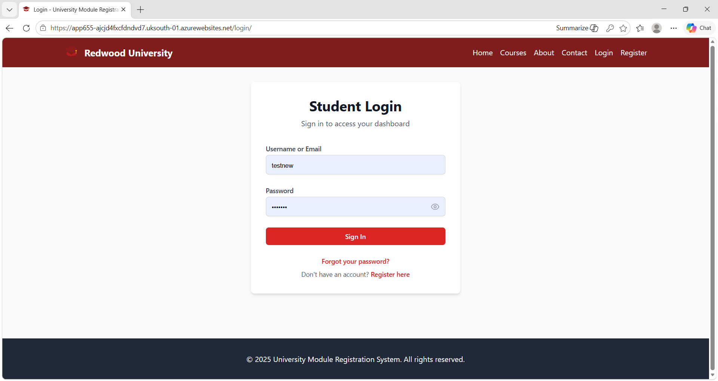
Home Page
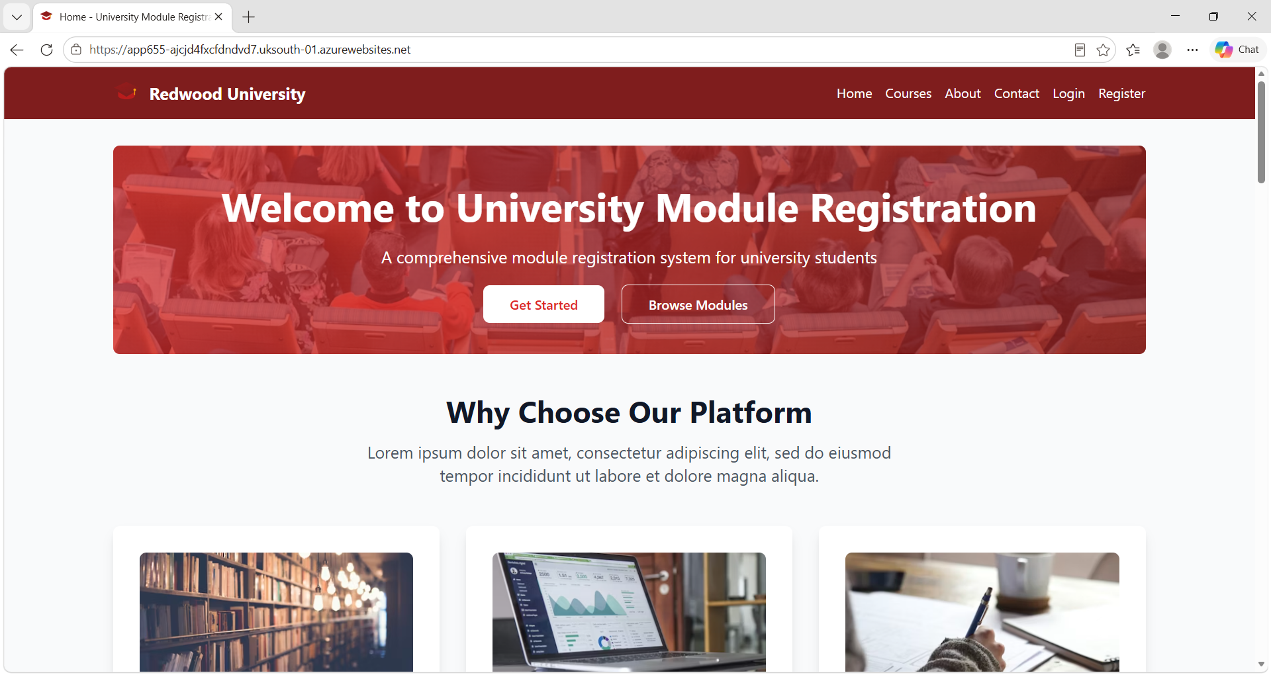
Register Page
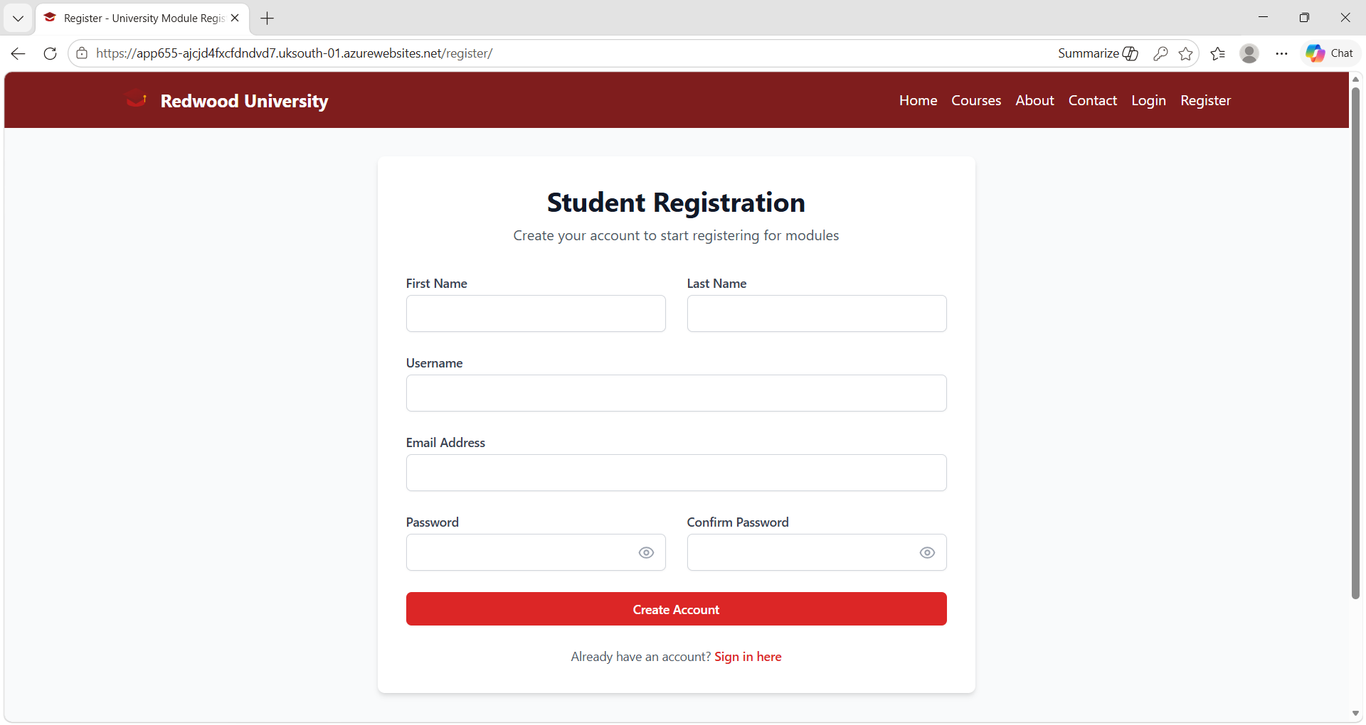
Student Dashboard
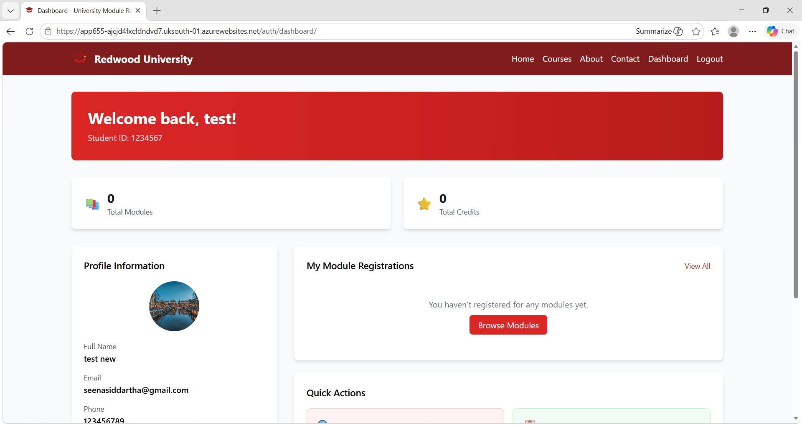
Modules Page
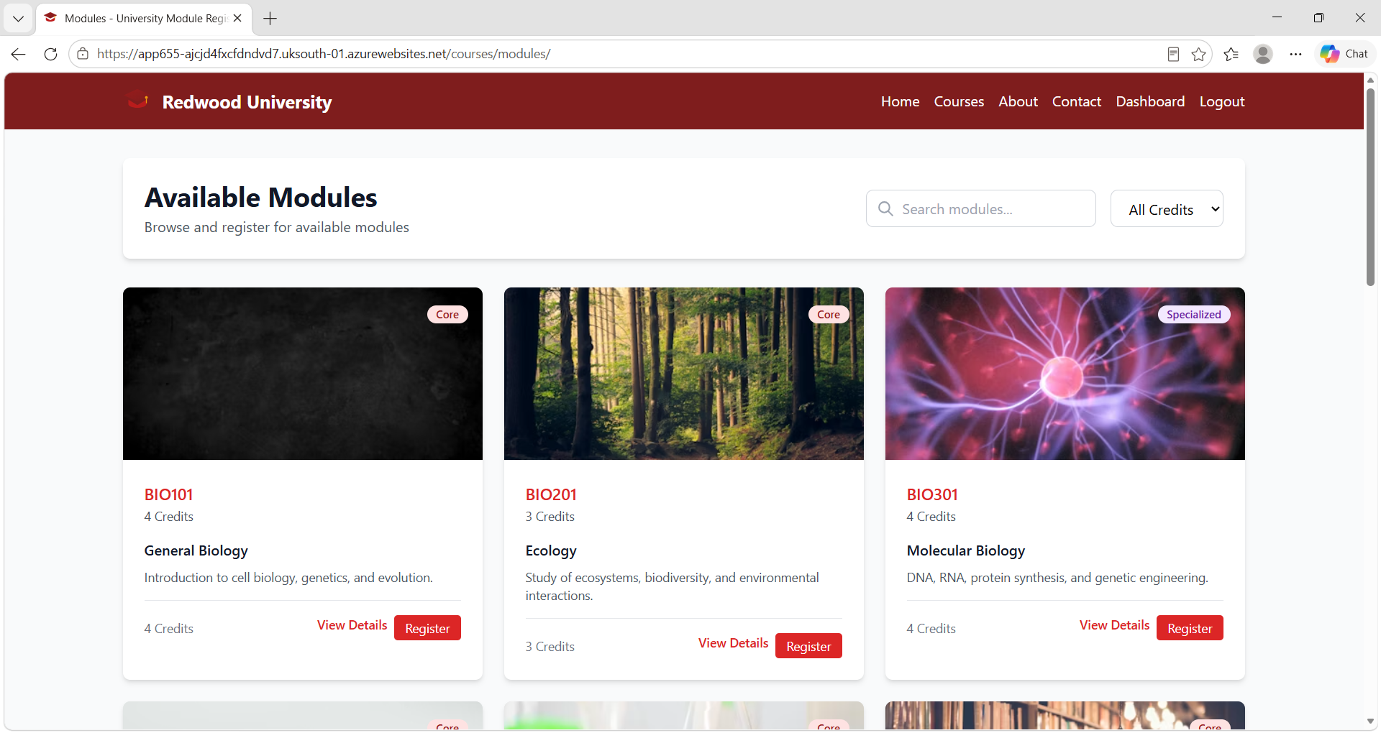
News & YouTube Link
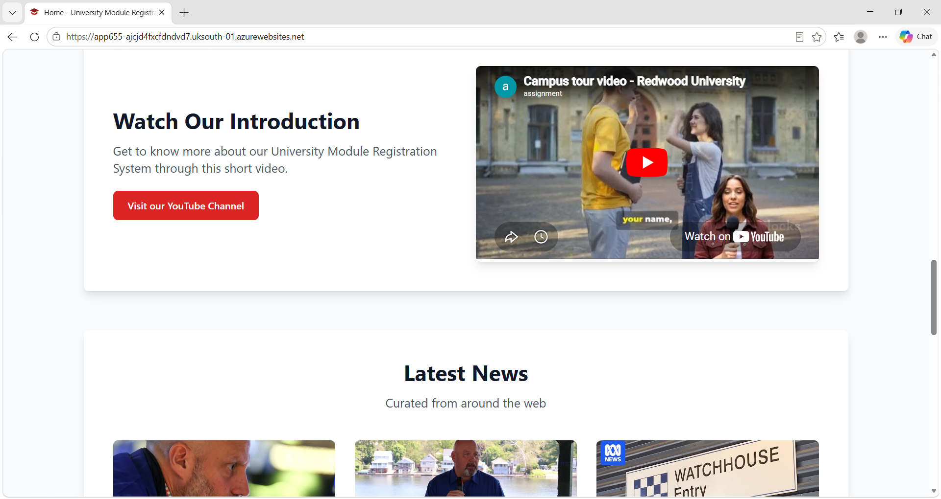
- Functionalities Implemented
- User Registration & OTP Confirmation
  - New users must register with their email address.
  - An OTP (One-Time Password) is sent to confirm registration.
- Password Reset
  - Users can reset their password securely via email confirmation.
- Django REST API Integration – News API
  - The portal consumes and displays real-time university-related news using REST API.
- Google Maps Integration
  - Embedded Google Maps feature to display university location.
- University Video Resource
  - Integrated YouTube video relevant to university life and portal demonstration.
- Website Favicon & Logo
  - A custom favicon and university logo have been added to the site for branding.
- Contact form with email confirmation
  - Users can contact the university through a form.
  - Email confirmation is sent automatically upon form submission.
- Pagination and Search facility
  - Application implements pagination or search facility

- Technologies Used
a. Backend
- Python
- Django
- Django REST Framework
b. Cloud Services
- Microsoft Azure Web App
- Azure SQL Database
- Azure Storage Account
c. APIs & Integrations
- News API
- Google Maps API
- SMTP Email Services
d. Tools & Technologies
- Git & GitHub
- REST APIs
5. System Architecture
1. Users interact with the portal through a web interface.
2. Django handles backend logic and authentication.
3. Azure SQL stores application data.
4. Azure Storage stores media and static files.
5. External APIs provide dynamic content and integrations.
6. Azure Web App hosts the deployed application.
6. Future Enhancements
- Docker containerization
- CI/CD pipeline implementation
- Role-based access control
- Monitoring and logging integration
- Performance optimization
7. Learning Outcomes
This project improved my practical knowledge in:
- Cloud application deployment
- Django web development
- Azure cloud services
- Database integration
- REST API implementation
- Authentication and email systems

