**KERNEL PANIC ERROR ( Initramfs Error ) Troubleshooting**

**DAY – 7 14-12-2024**

**Main Directory - /boot/**

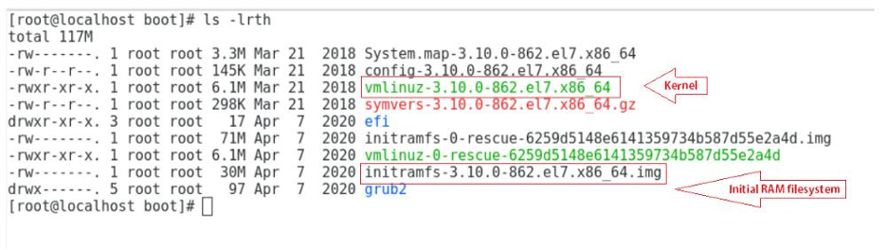

**Why do kernel panics occur?**

**Kernel panics occur:**

1. If the initramfs file gets corrupted.
2. If initramfs is not created properly for the specified kernel. Every kernel version has its own corresponding initramfs.
3. If the installed kernel is not supported or not installed correctly.
4. If recent patches have some flaws.
5. If a module has been installed from online or another source, but the initrd image is not created with the latest installed module.

For Testing purpose removing **initramfs** -kernel file in server ( Directory /boot/ )

# rm initramfs-kernel_version.img ( Removing the initramfs in /boot directory )

Example 1 -

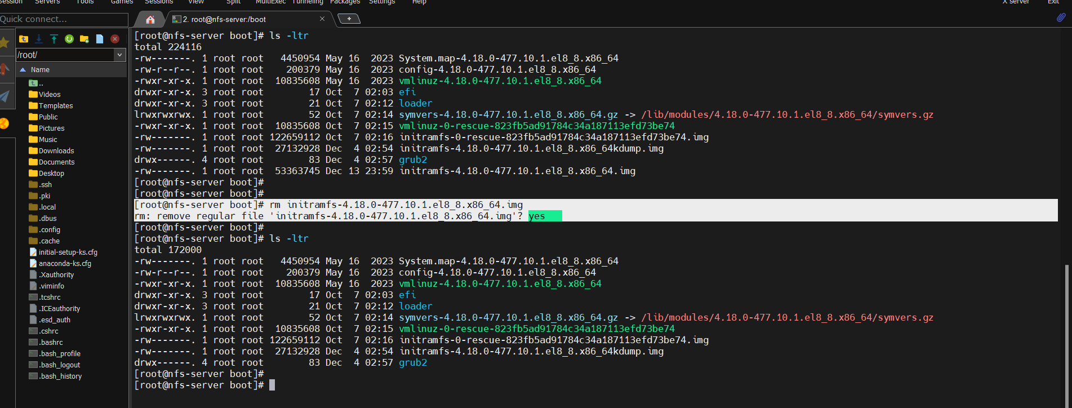

**Example - 2**

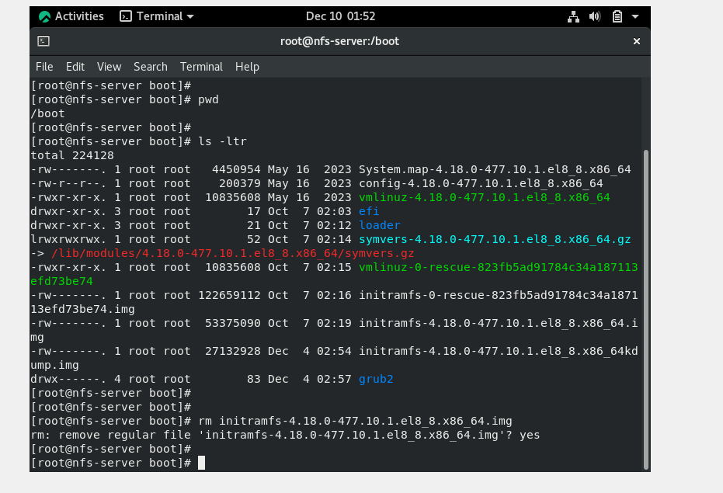

**Then Reboot the system to see the error.**

**# reboot**

**How to troubleshoot?**

The first thing to do after seeing a kernel panic error is not to panic , because now you are aware of the image file related to the error.

Step 1: Boot the system normally with your given kernel version.

**Then enter -**

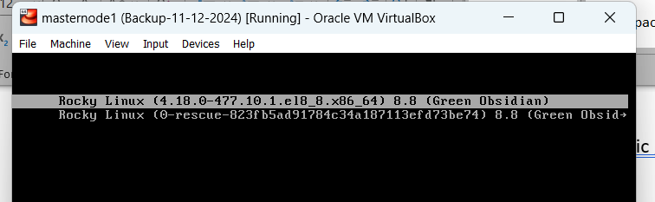

**Error appear then ENTER**

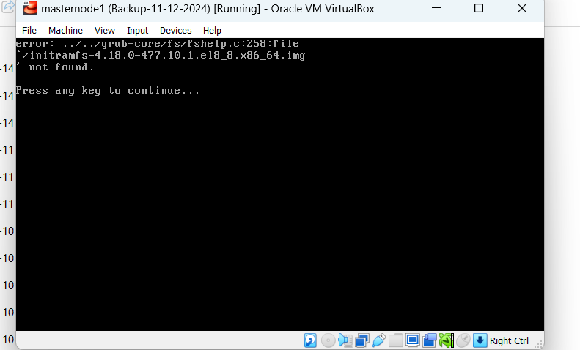

Then **ENTER** – Its will appear the error

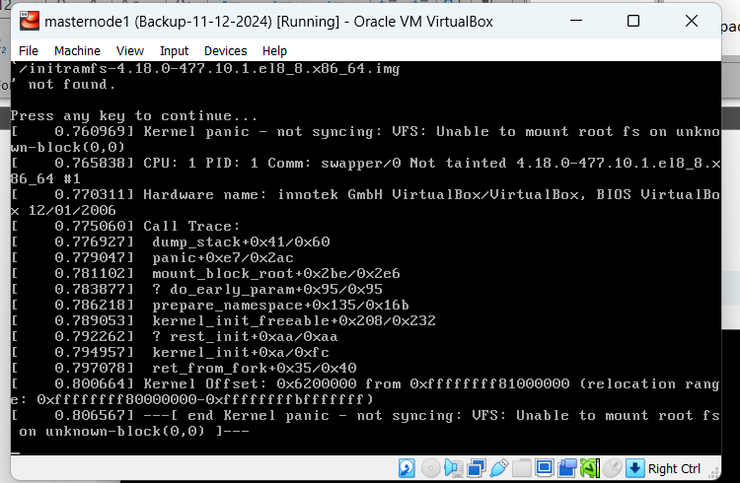

**Solution –**

**Step 1 – Attached the Boot DVD/ISO image in VM Server, Or physical means pen drive**

**# reset or reboot the server**

Then click Troubleshooting option >> Rescue option >> Enter 1 to continue >> Enter

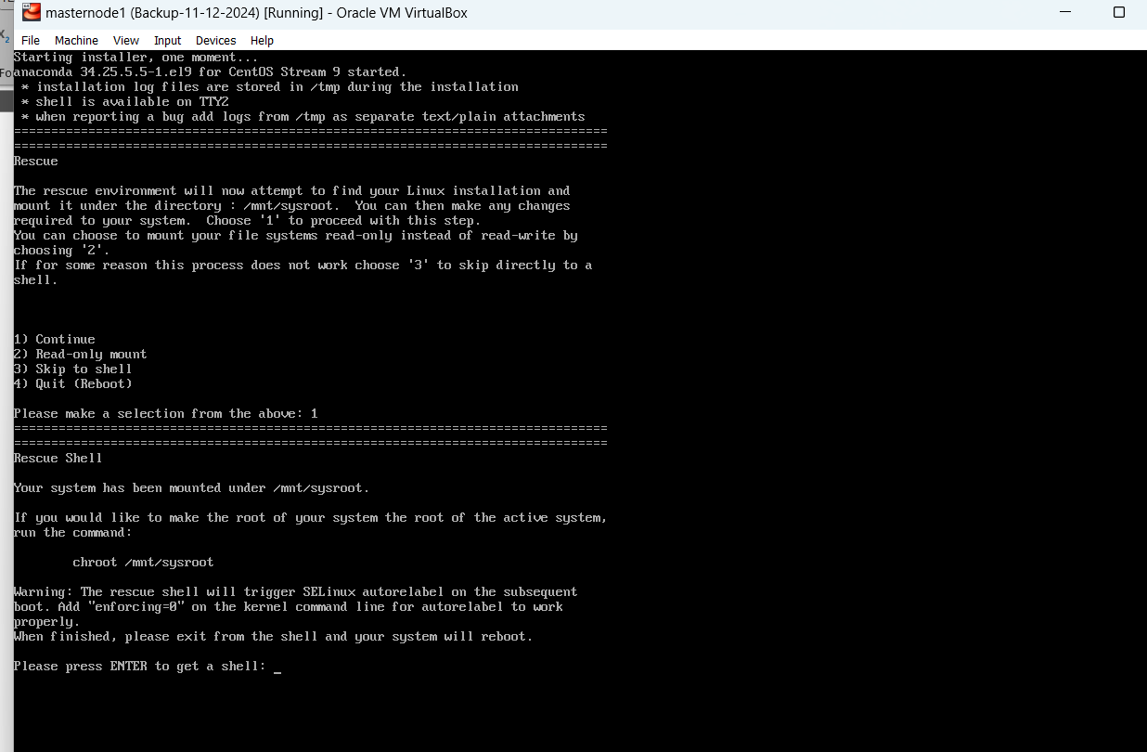

Step 2 - Mounting Chroot **RESCUE ENVIORMENT ROOT USER** into **LOCAL SYSTEM ROOT USER in directory**

**Reason for step is without mount filesystem we cannot access the sysroot directory**

# Chroot /mnt/sysroot



Now we entire in system shell, Then

# cd /boot

# ls -ltr /boot

To list and verify the initramfs image (.img) with kernel version

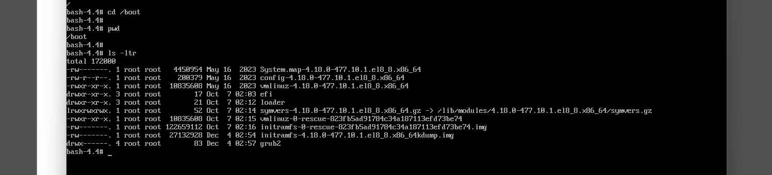

**Step 3 - Important - Two Method can use to create the new initramfs image file**

**Method 1 - # dracut command**

**Method 2 - # mkinitrd command**

**Already file is existing and corrupted in /boot directory means we can use the –force command in both methods**

**Example - # dracut --force initramfs-<kernel_ver>.img <kernel_ver>**

**# dracut /boot/initramfs-<kernel-version>.img <kernel-version> OR**

**Present working dir means # dracut initramfs-<kernel-version>.img <kernelversion>**

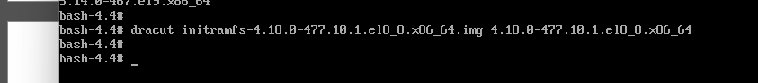

**# ls -ltr cmd will display the created initramfs.image file**

**Initramfs-4.18.0-477.10.1.el8_8.x86_64.img**

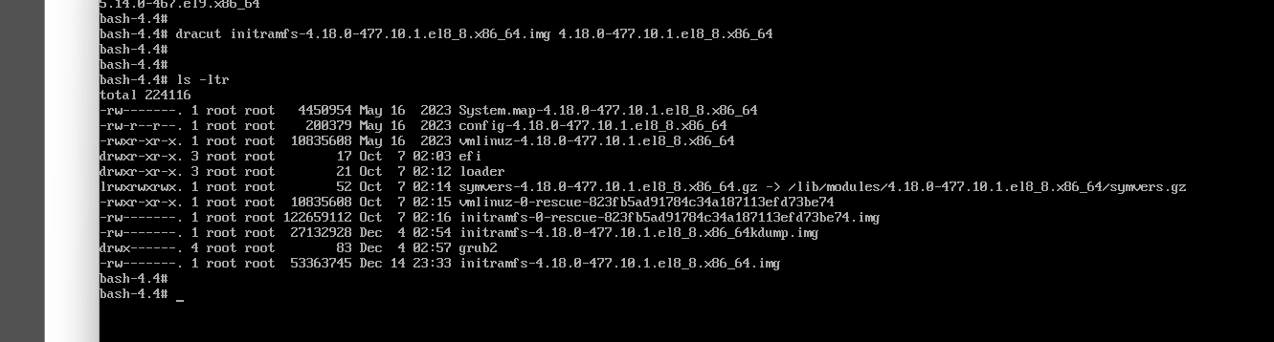

**#exit**

**#reboot**

**Output – Its load the initramfs.img file then appear user interface to access the system**

**Booting process – Kernel panic troubleshooting done**

