**ROOT PASSWORD RESET**

1. **Reboot the System**: Start by rebooting the RHEL 8 system.
2. **Access GRUB Menu**: During the boot process, when the GRUB menu appears, press any key to interrupt the normal boot process and enter the GRUB menu.

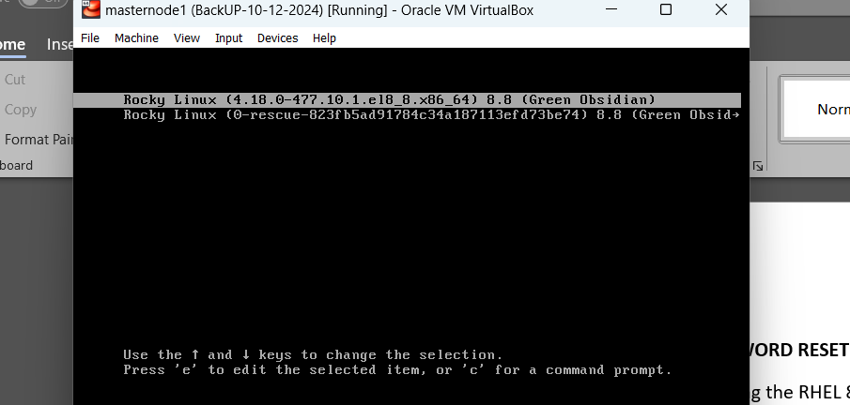

1. **Select Kernel Entry**: Select the kernel entry that you normally boot into (usually the first entry) and press the e key to edit it.
2. **Edit Kernel Parameters**: In the editing mode, navigate to the line starting with linux  which specifies the kernel parameters. Append **rd.break enforcing=0** to the end of this line. This instructs the system to enter a special mode with a root shell before the system fully boots.

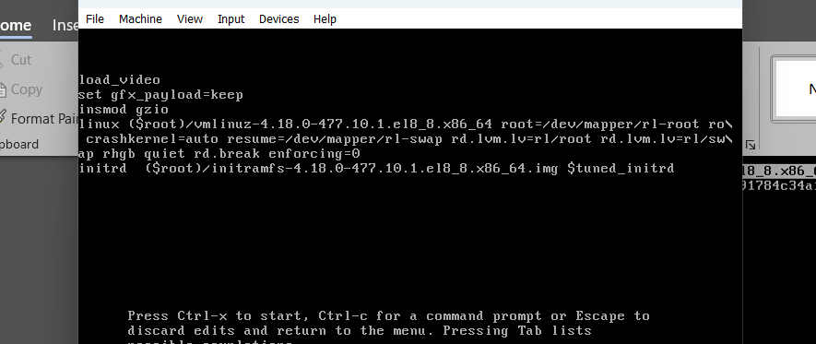

1. **Boot with Changes**: Press Ctrl + x or F10 to boot with the modified kernel parameters.
2. **Remount the File System**: After the system boots into emergency mode with a root shell, the root file system is mounted as read-only. Remount it with read-write permissions using the following command:

#mount -o remount,rw /sysroot

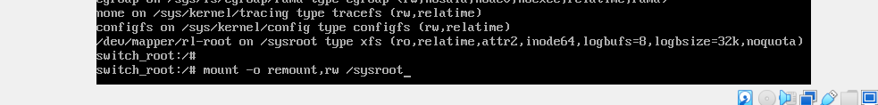

1. **Change Root**: Change the root to the mounted file system:

#chroot /sysroot



1. **Change Root Password**: Now, you can reset the root password using the passwd command. Enter your new root password when prompted:

# passwd



1. **Update SELinux Contexts**: It's necessary to update the SELinux contexts after changing the password. Run the following command:

**#touch /.autorelabel**



1. **Exit and Reboot**: Exit the chroot environment and reboot the system:
2. exit

reboot

After rebooting, you can log in with the new root password.