RAJALAKSHMI ENGINEERING COLLEGE
RAJALAKSHMI NAGAR, THANDALAM 602 105



Laboratory Record Note Book
CS23331 - DESIGN AND ANALYSIS OF ALGORITHMS

.
Academic Year :
.
Semester :
.
College Roll No. :
..
University Register No. :
.
..
Year / Branch / Section :
...
.
Name :

SEENIVASAN S

IInd YEAR – CSD A

2116251701051

251701051

III SEM

2025-2029

INDEX PAGE

Exp.No | Name of the Experiment | Date of Completion
1 | Finding Complexity using Counter Method | 09-08-2026
2 | Finding Complexity using Counter method | 09-08-2026
3 | Finding Complexity using Counter Method | 09-08-2026
4 | Finding Complexity using Counter Method | 26-08-2026
5 | Finding Complexity using counter method | 26-08-2026
6 | 1-G-Coin Problem | 09-09-2026
7 | 2-G-Cookies Problem | 09-09-2026
8 | 3-G-Burger Problem | 28-09-2026
9 | 4-G-Array Sum max problem | 09-09-2026
10 | 5-G-Product of Array elements-Minimum | 09-09-2026
11 | Number of Zeros in a Given Array | 30-09-2026
12 | Majority Element | 30-09-2026
13 | Finding Floor Value | 30-09-2026
14 | Two Elements sum to x | 30-09-2026
15 | Implementation of Quick Sort | 30-09-2026
16 | DP-Playing with Numbers | 07-10-2026
17 | DP-Playing with chessboard | 07-10-2026
18 | DP-Longest Common Subsequence | 07-10-2026
19 | DP-Longest non-decreasing Subsequence | 07-10-2026
20 | Finding Duplicates-O(n^2) Time Complexity, O(1) Space Complexity | 07-10-2026
21 | Finding Duplicates-O(n) Time Complexity, O(1) Space Complexity | 07-10-2026
22 | Print Intersection of 2 sorted arrays-O(m*n) Time Complexity, O(1) Space Complexity | 07-10-2026
23 | Print Intersection of 2 sorted arrays-O(m+n) Time Complexity, O(1) Space Complexity | 08-10-2026
24 | Print Intersection of 2 sorted arrays-O(m+n) Time Complexity, O(1) Space Complexity | 08-10-2026
25 | Pair with Difference-O(n^2) Time Complexity, O(1) Space Complexity | 08-10-2026
26 | Pair with Difference-O(n) Time Complexity, O(1) Space Complexity | 08-10-2026

EXPERIMENT 1 — FINDING COMPLEXITY USING COUNTER METHOD
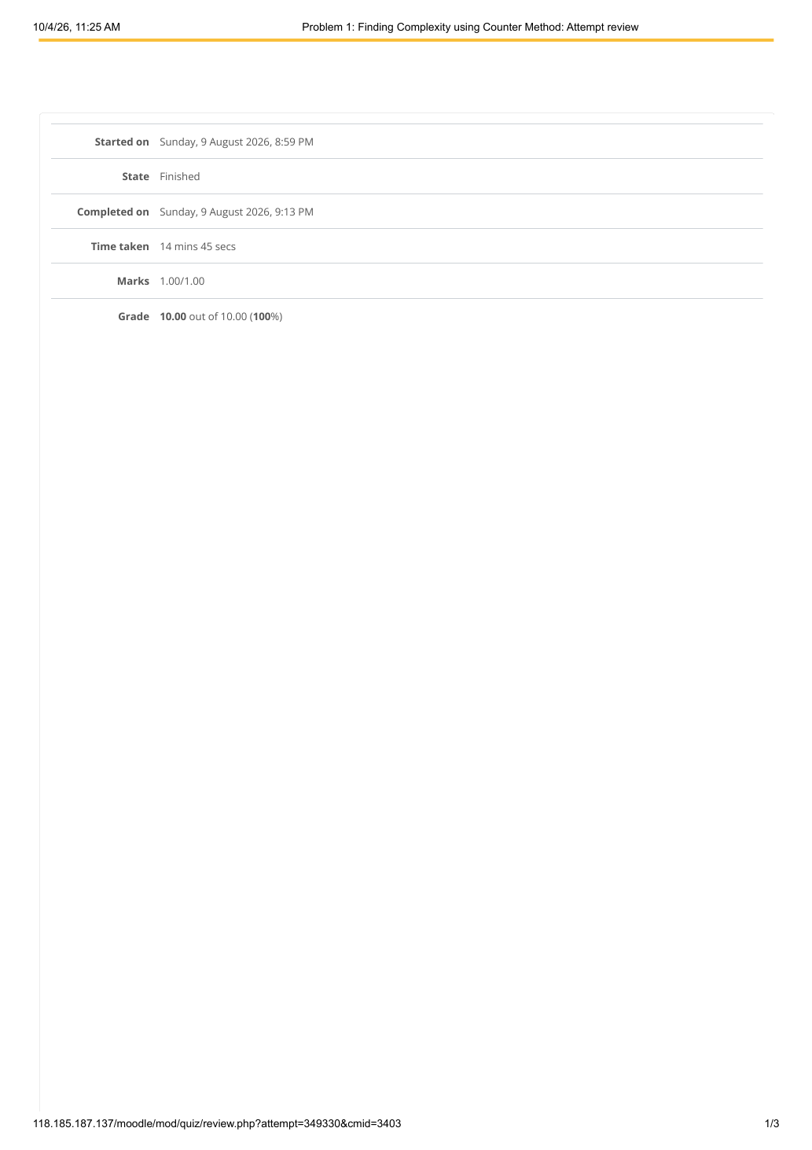

EXPERIMENT 1 — FINDING COMPLEXITY USING COUNTER METHOD
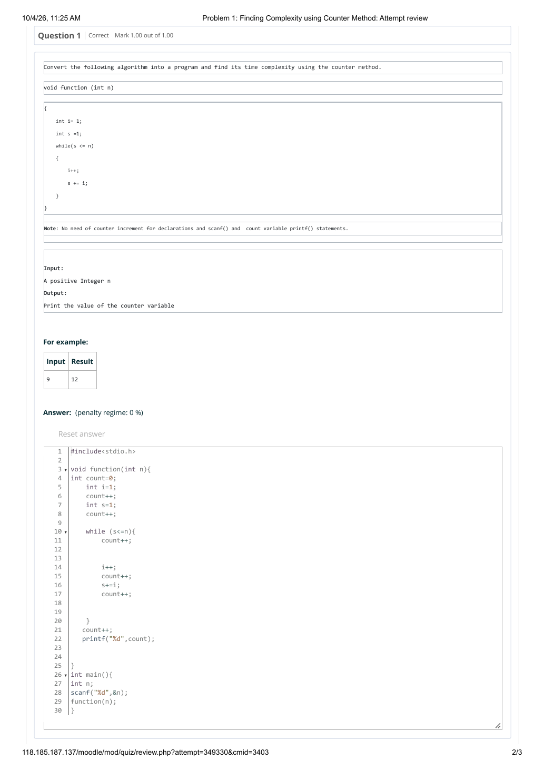

EXPERIMENT 1 — FINDING COMPLEXITY USING COUNTER METHOD
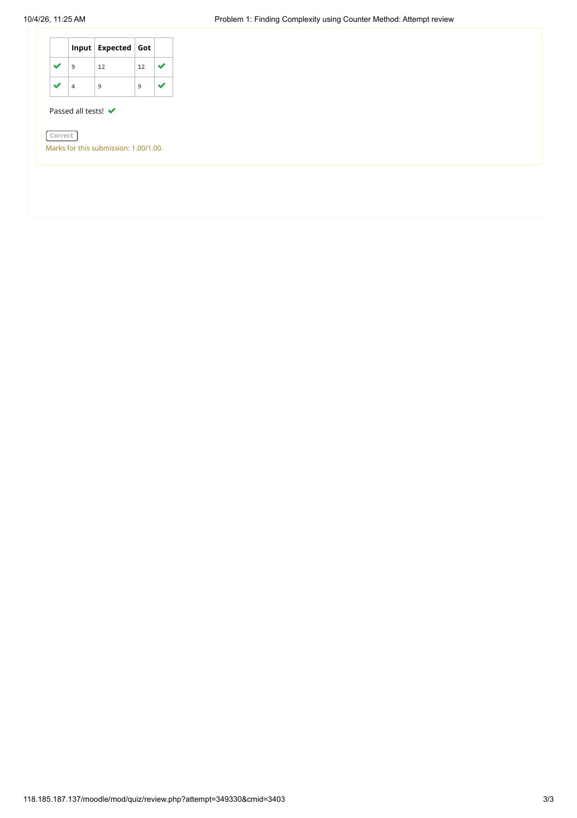

EXPERIMENT 2 — FINDING COMPLEXITY USING COUNTER METHOD
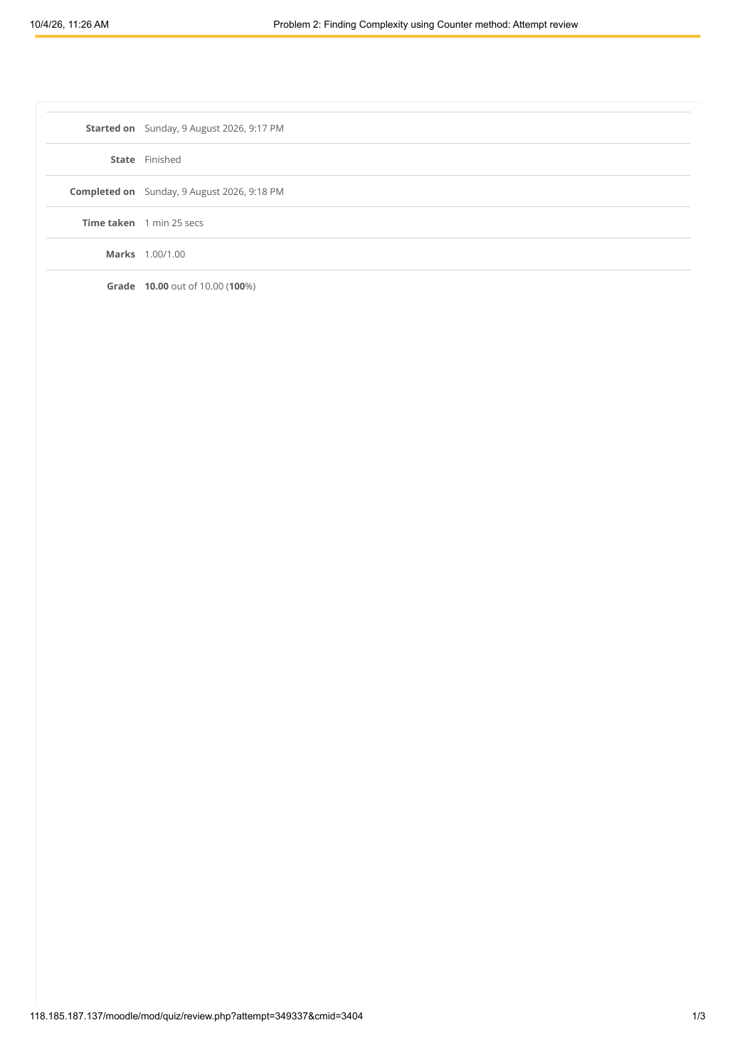

EXPERIMENT 2 — FINDING COMPLEXITY USING COUNTER METHOD
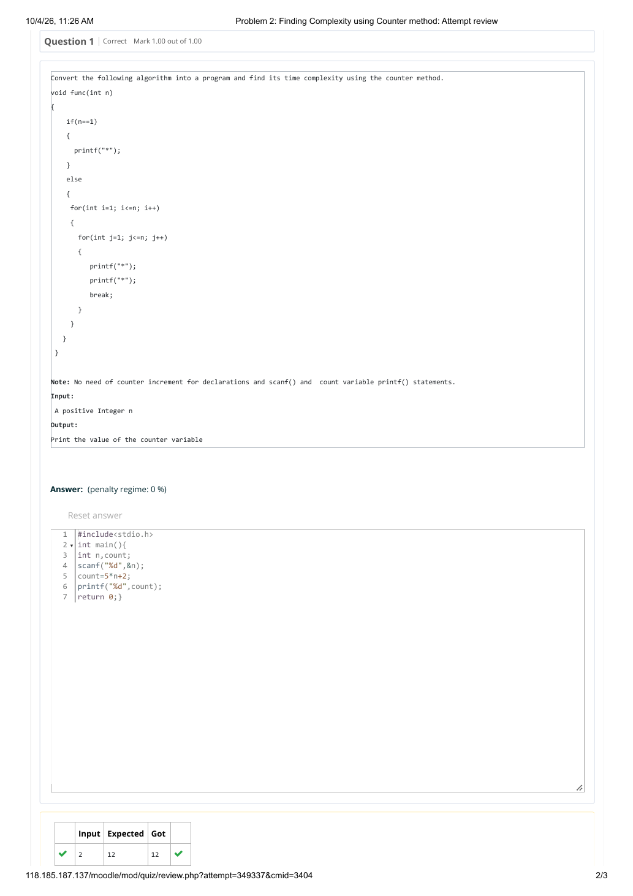

EXPERIMENT 2 — FINDING COMPLEXITY USING COUNTER METHOD
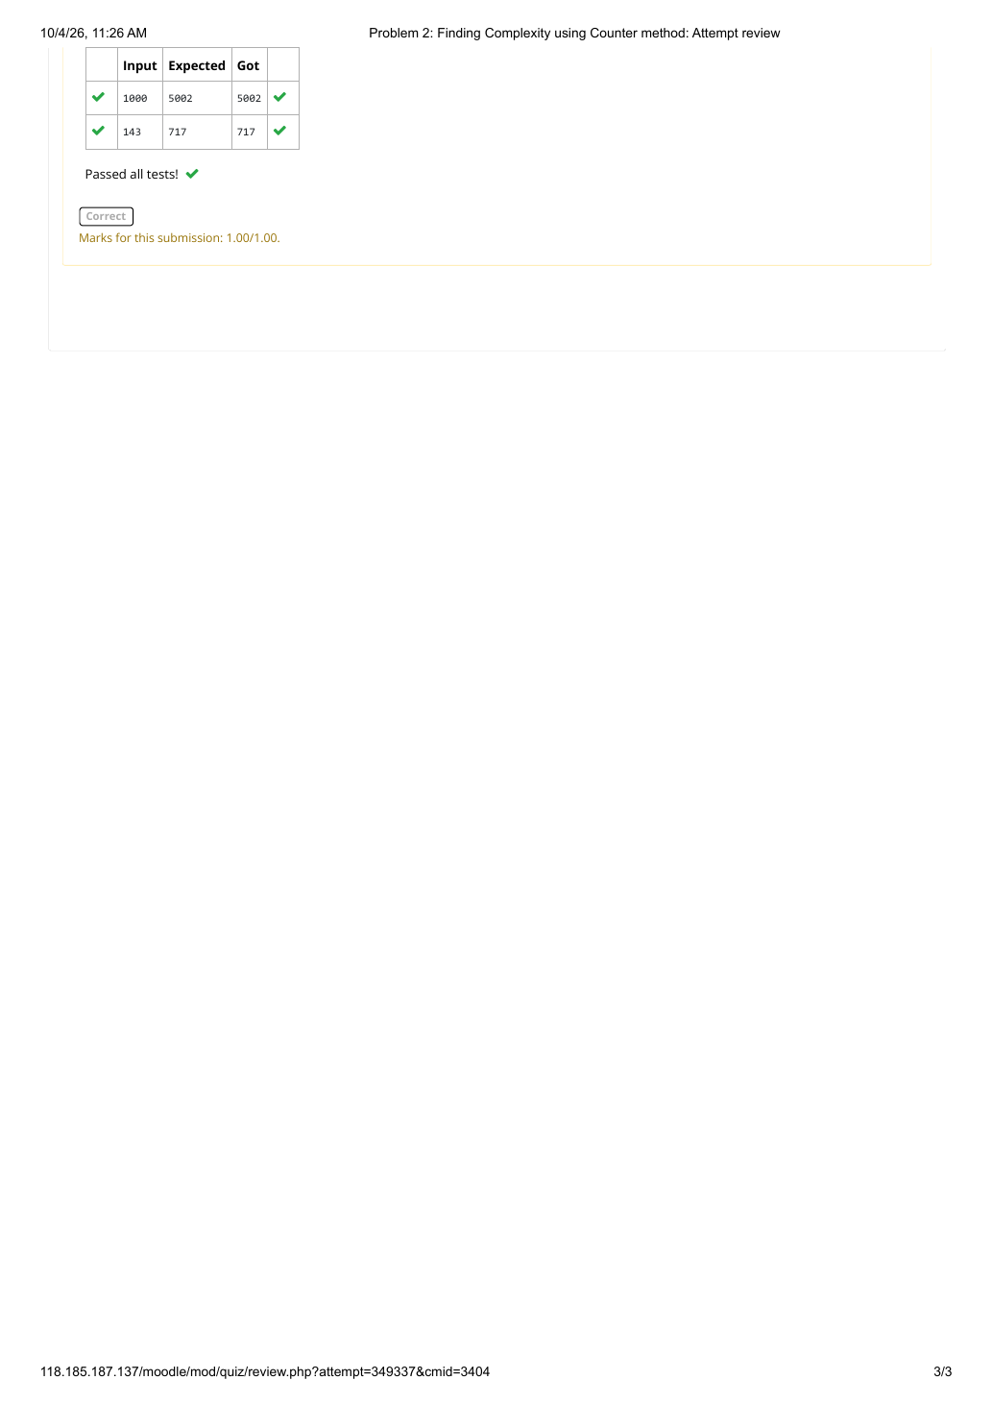

EXPERIMENT 3 — FINDING COMPLEXITY USING COUNTER METHOD
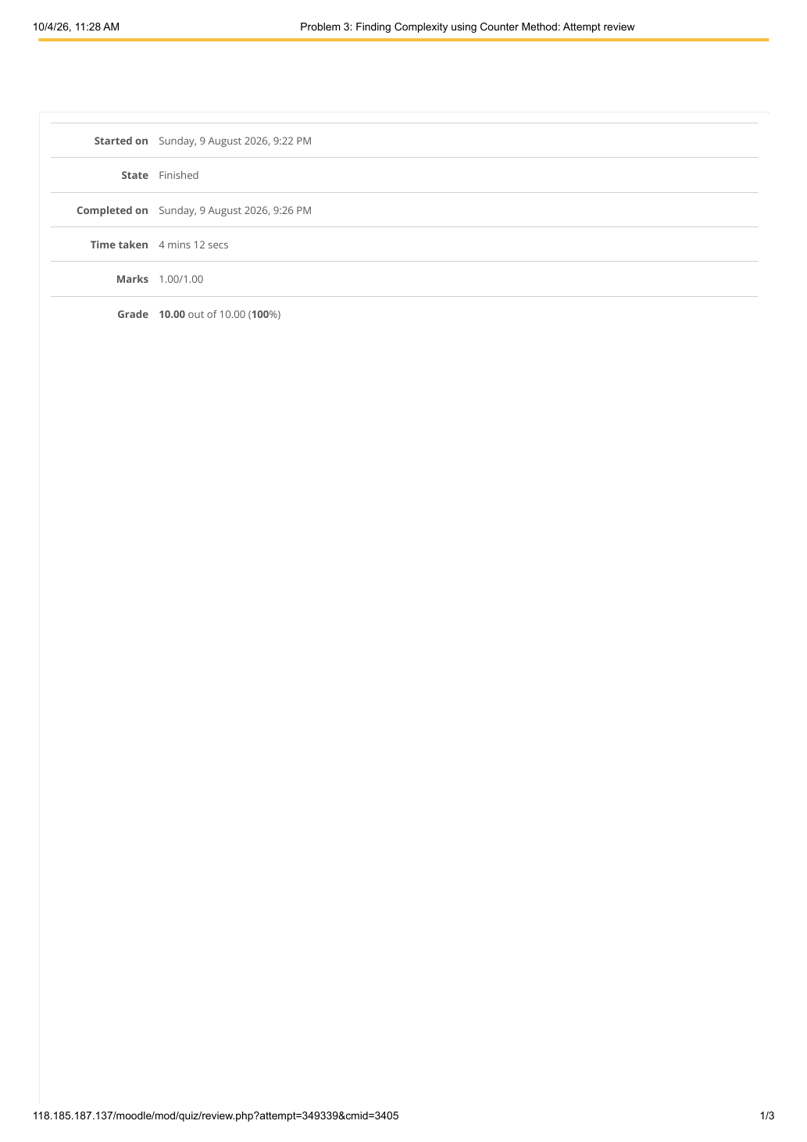

EXPERIMENT 3 — FINDING COMPLEXITY USING COUNTER METHOD
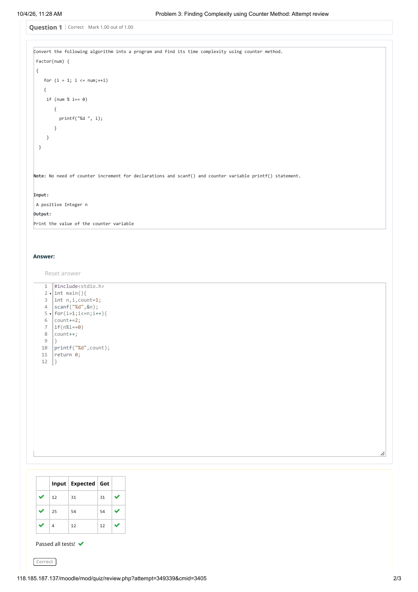

EXPERIMENT 3 — FINDING COMPLEXITY USING COUNTER METHOD


EXPERIMENT 4 — FINDING COMPLEXITY USING COUNTER METHOD
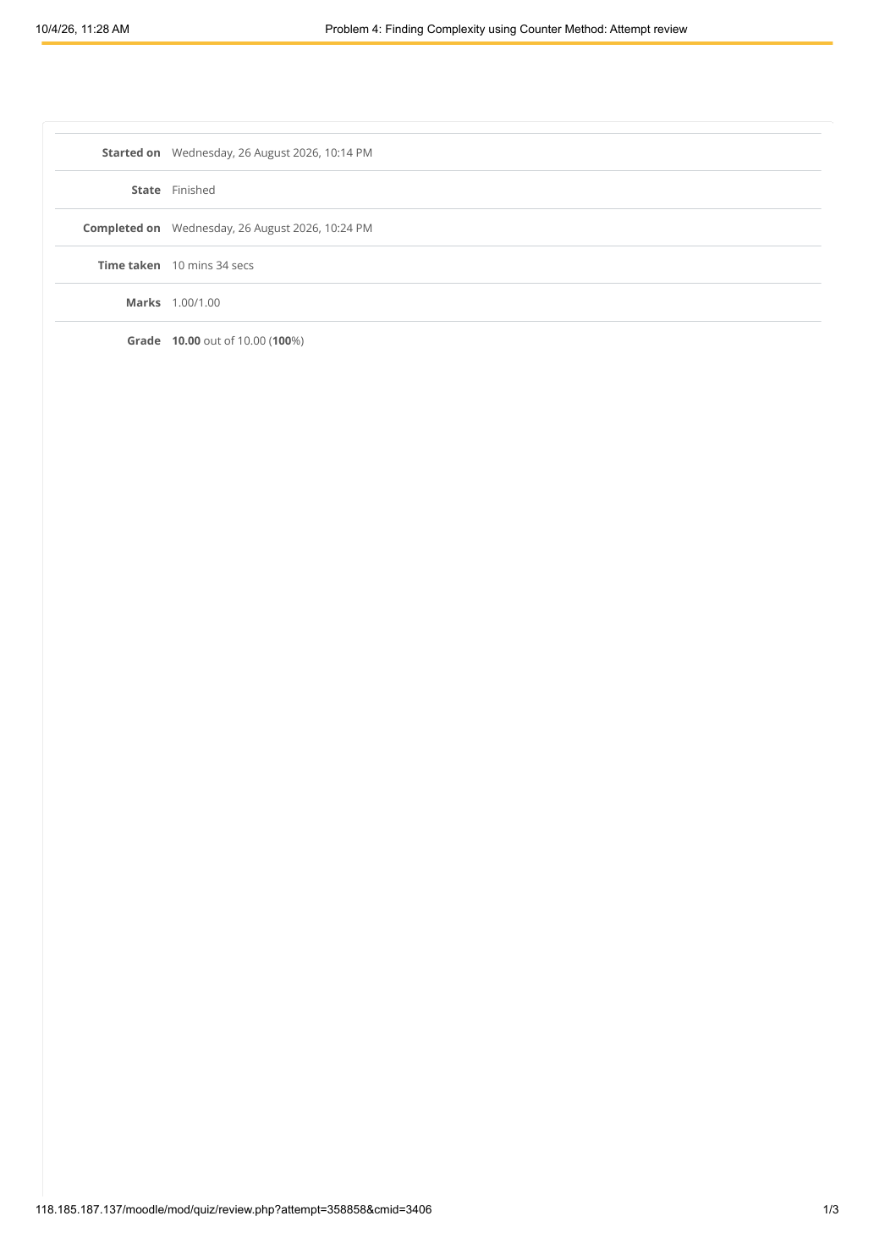

EXPERIMENT 4 — FINDING COMPLEXITY USING COUNTER METHOD
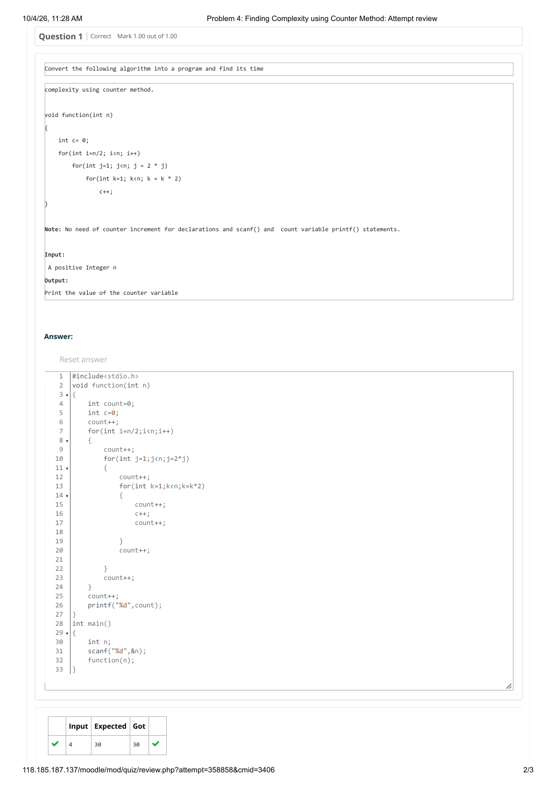

EXPERIMENT 4 — FINDING COMPLEXITY USING COUNTER METHOD
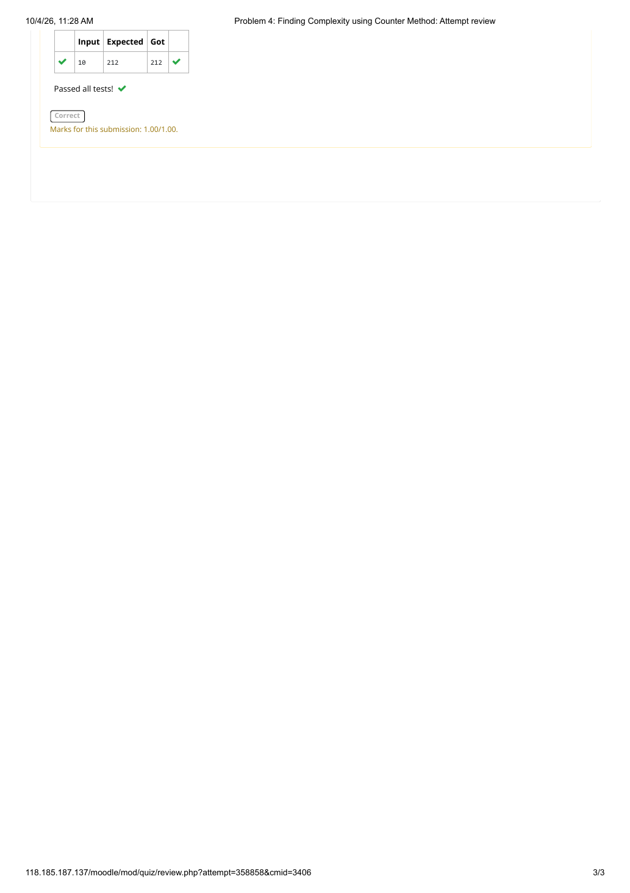

EXPERIMENT 5 — FINDING COMPLEXITY USING COUNTER METHOD
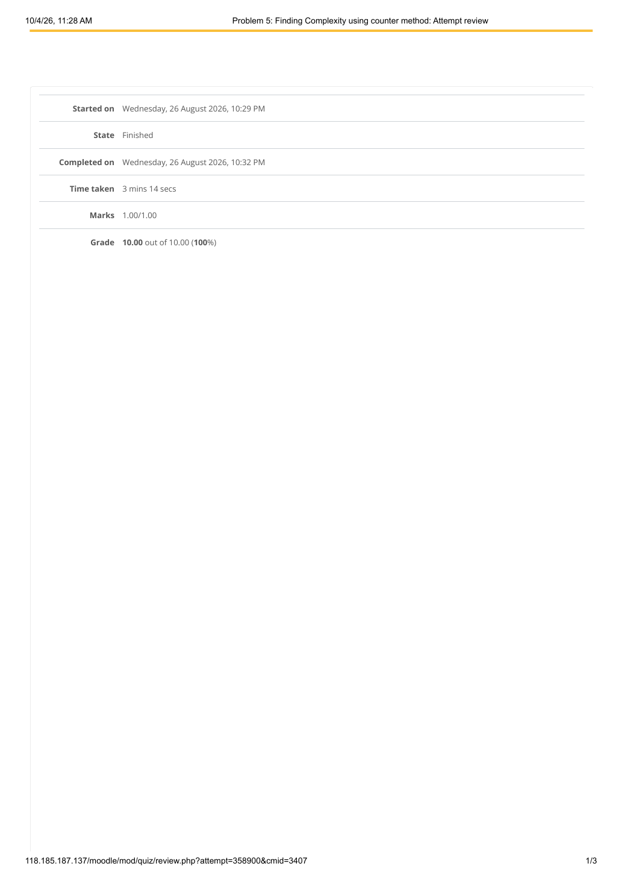

EXPERIMENT 5 — FINDING COMPLEXITY USING COUNTER METHOD
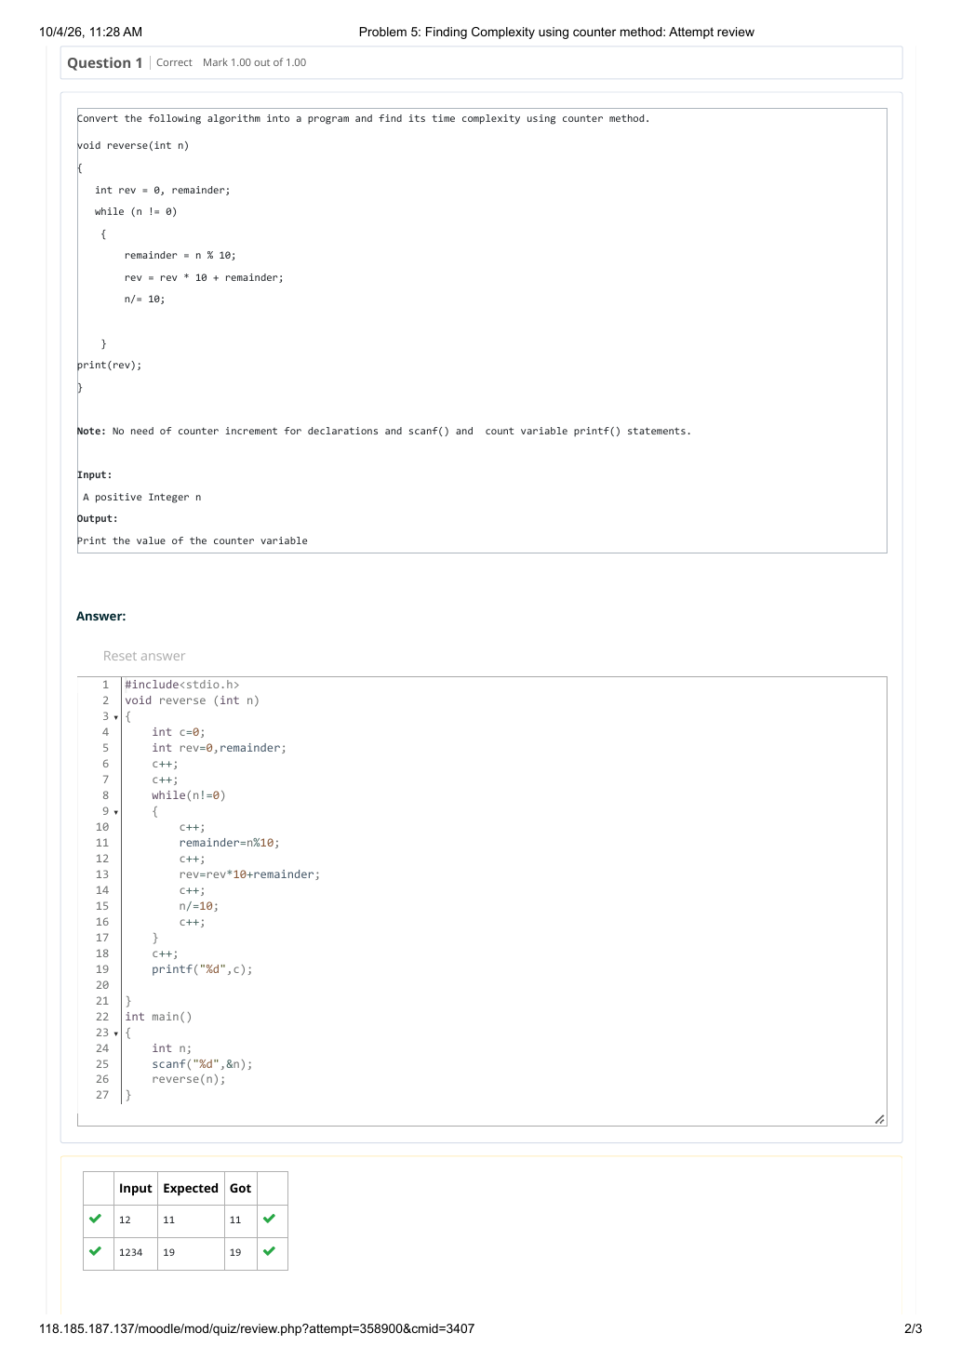

EXPERIMENT 5 — FINDING COMPLEXITY USING COUNTER METHOD
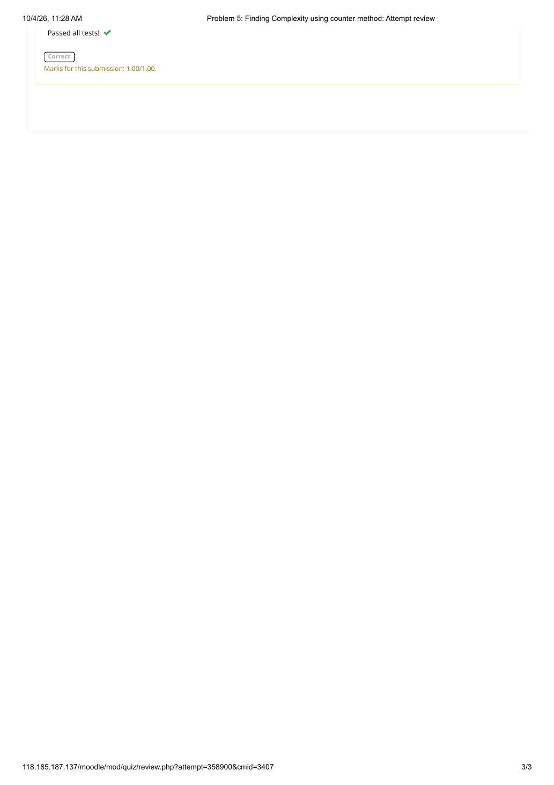

EXPERIMENT 6 — 1-G-COIN PROBLEM
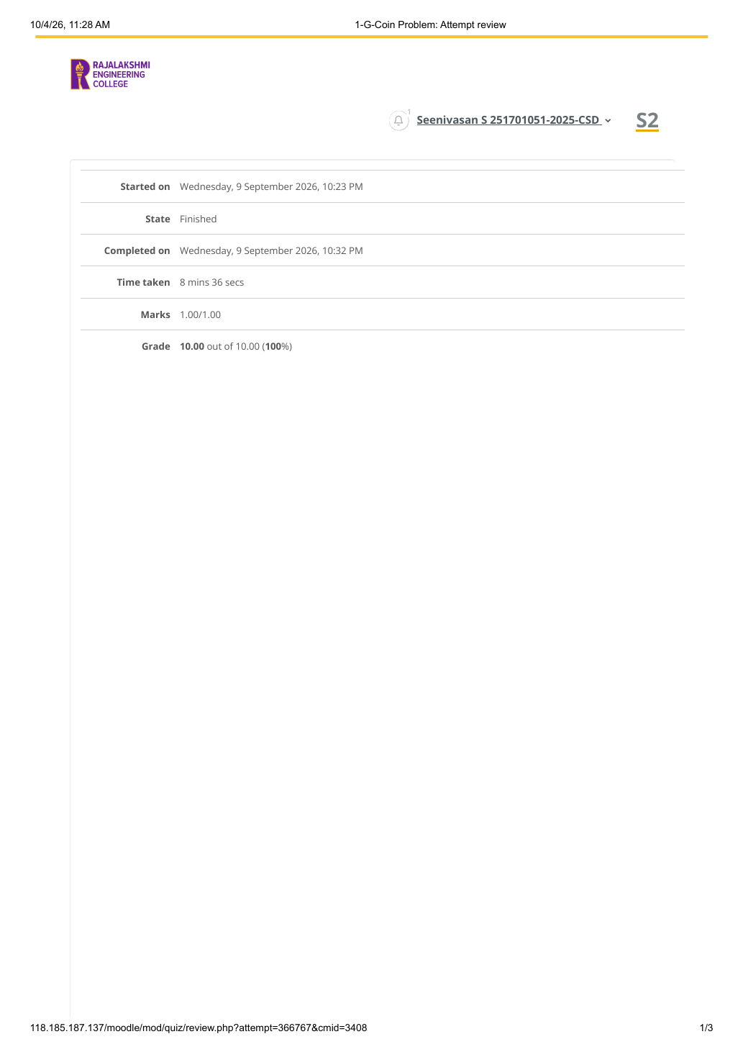

EXPERIMENT 6 — 1-G-COIN PROBLEM
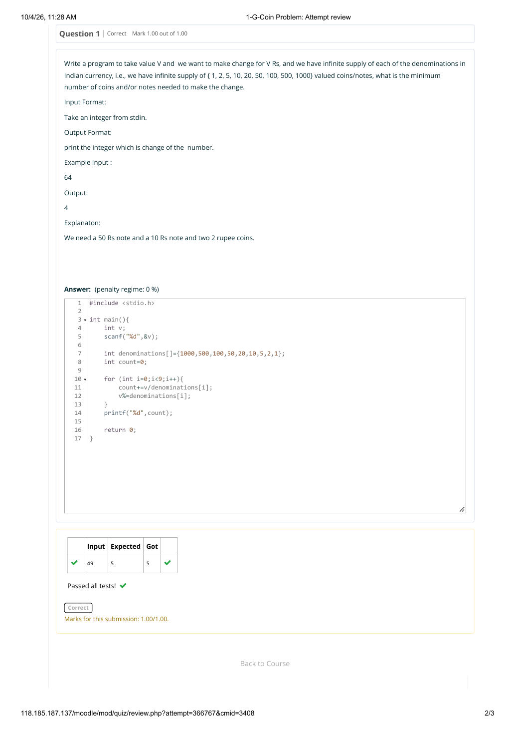

EXPERIMENT 6 — 1-G-COIN PROBLEM


EXPERIMENT 7 — 2-G-COOKIES PROBLEM
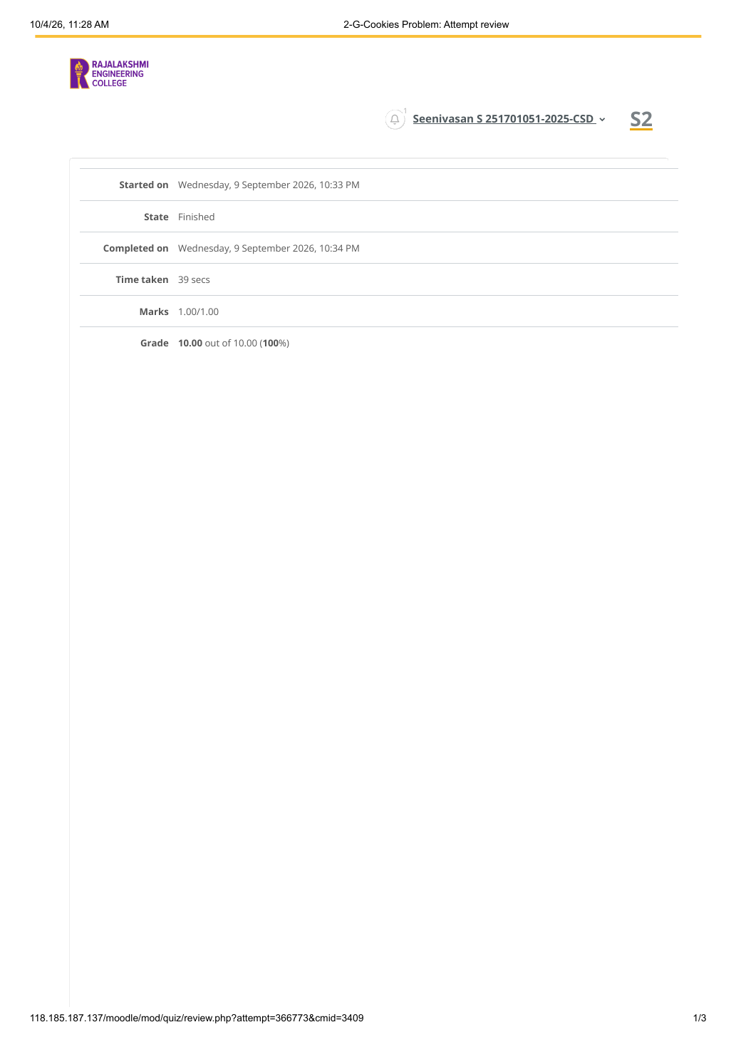

EXPERIMENT 7 — 2-G-COOKIES PROBLEM
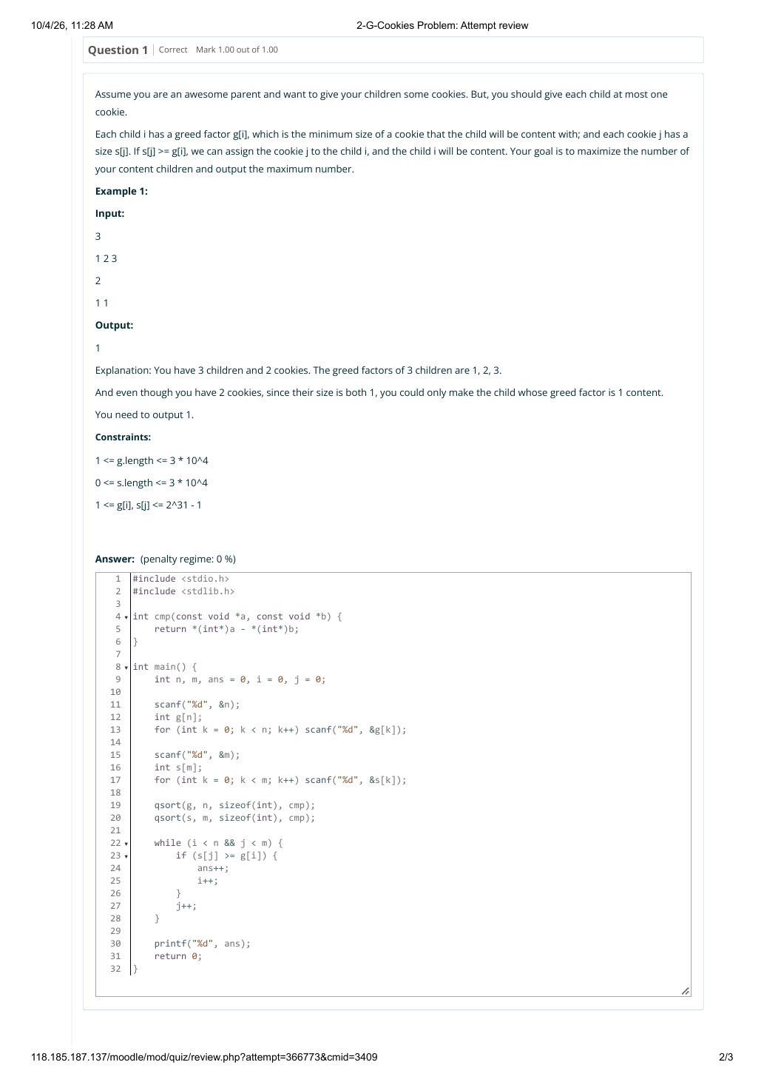

EXPERIMENT 7 — 2-G-COOKIES PROBLEM
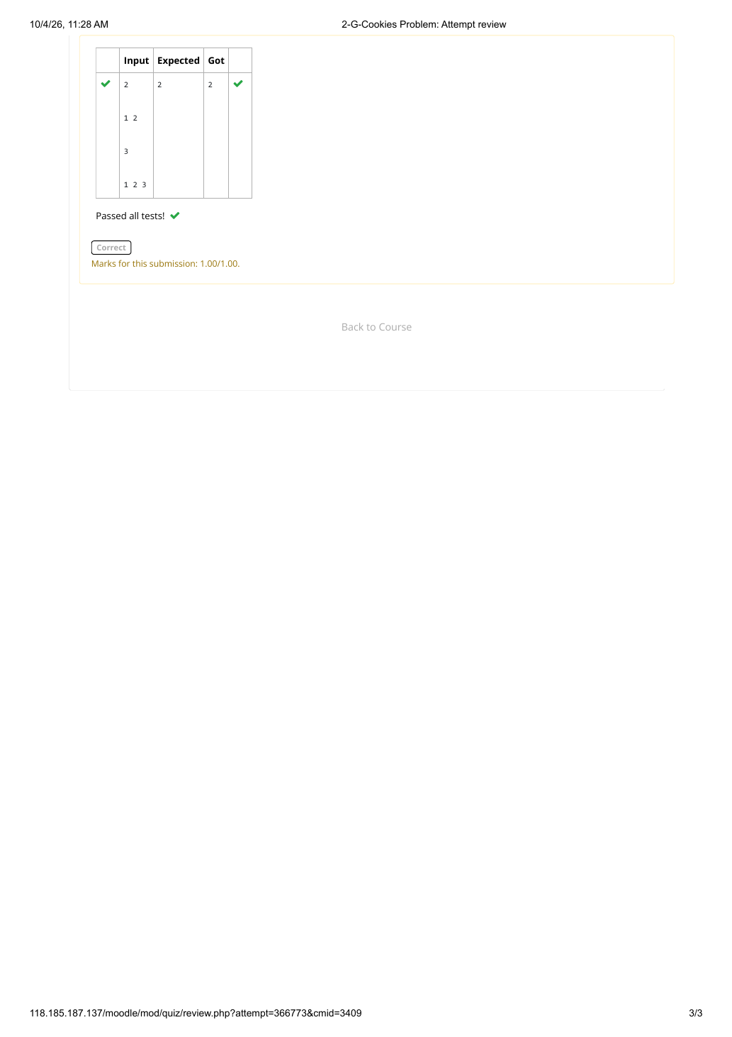

EXPERIMENT 8 — 3-G-BURGER PROBLEM
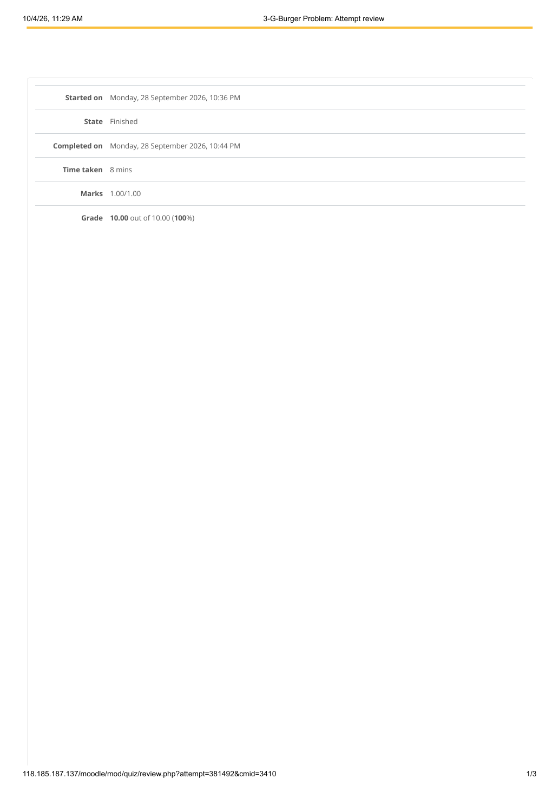

EXPERIMENT 8 — 3-G-BURGER PROBLEM
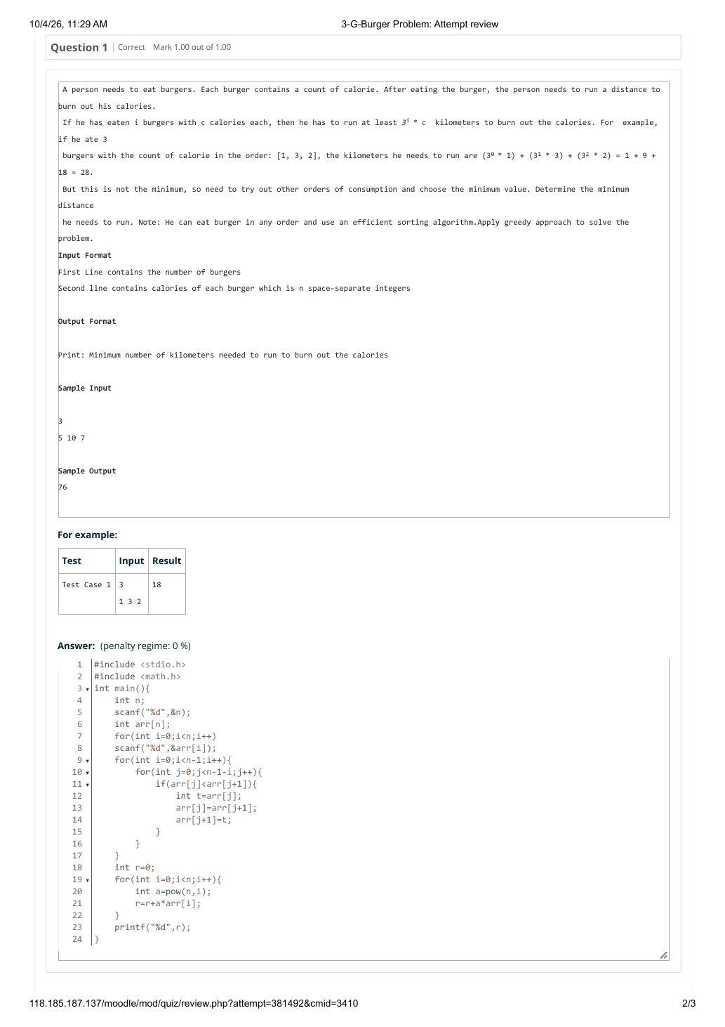

EXPERIMENT 8 — 3-G-BURGER PROBLEM
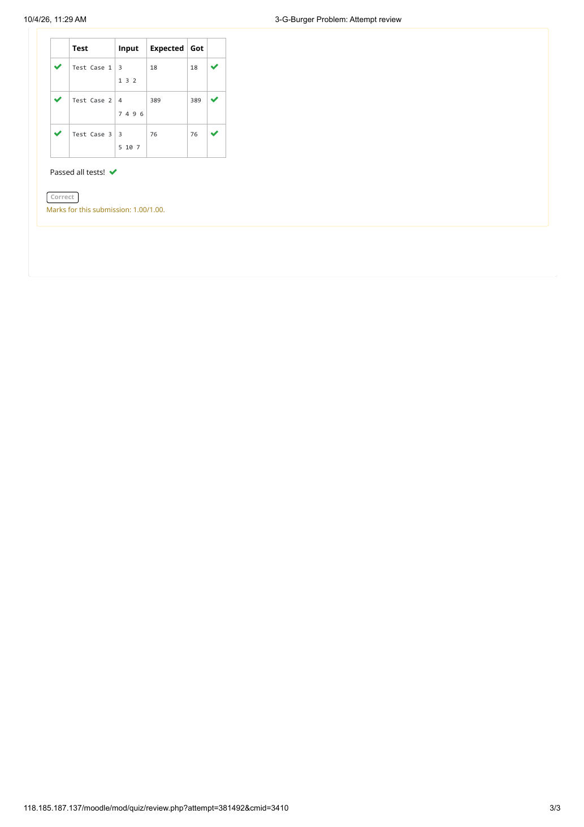

EXPERIMENT 9 — 4-G-ARRAY SUM MAX PROBLEM
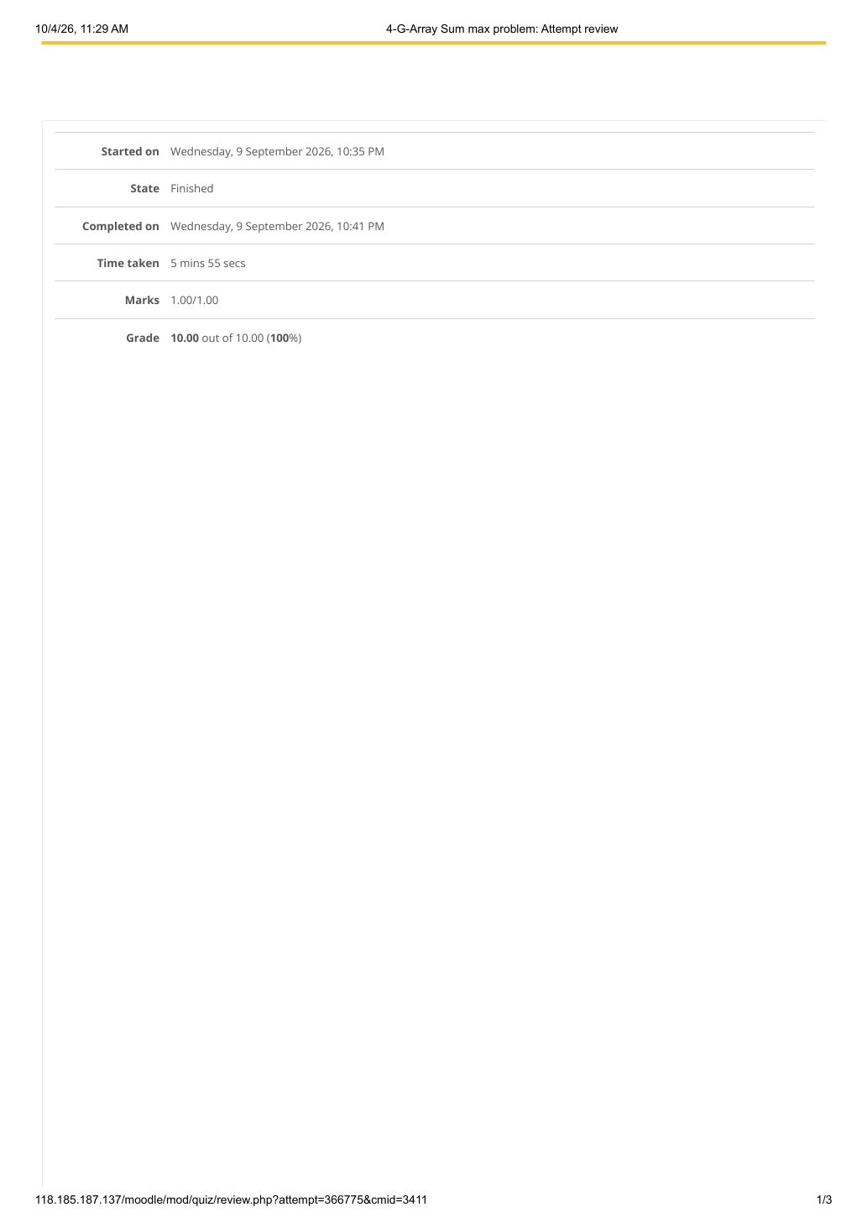

EXPERIMENT 9 — 4-G-ARRAY SUM MAX PROBLEM
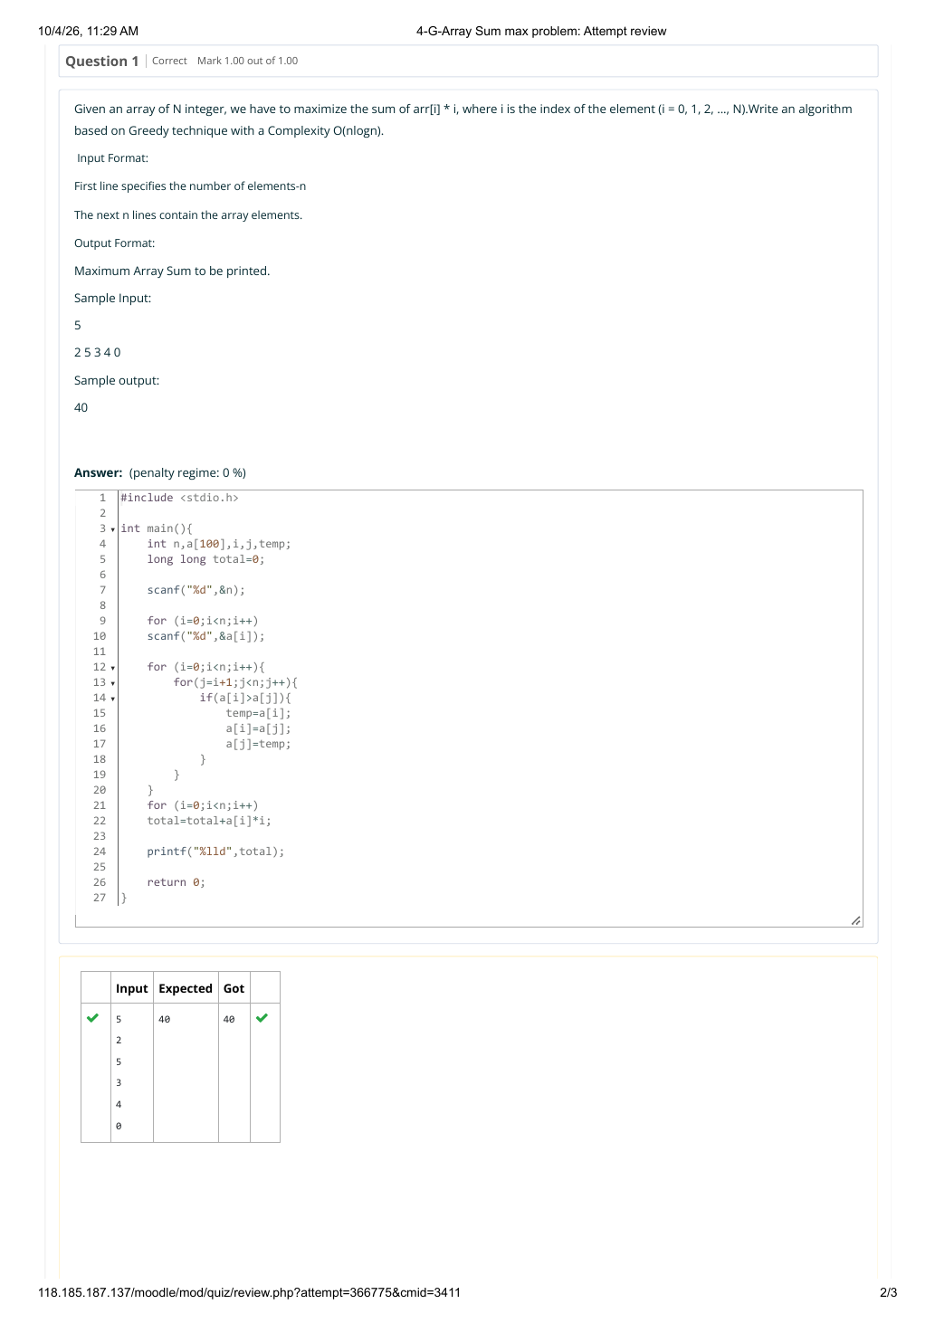

EXPERIMENT 9 — 4-G-ARRAY SUM MAX PROBLEM
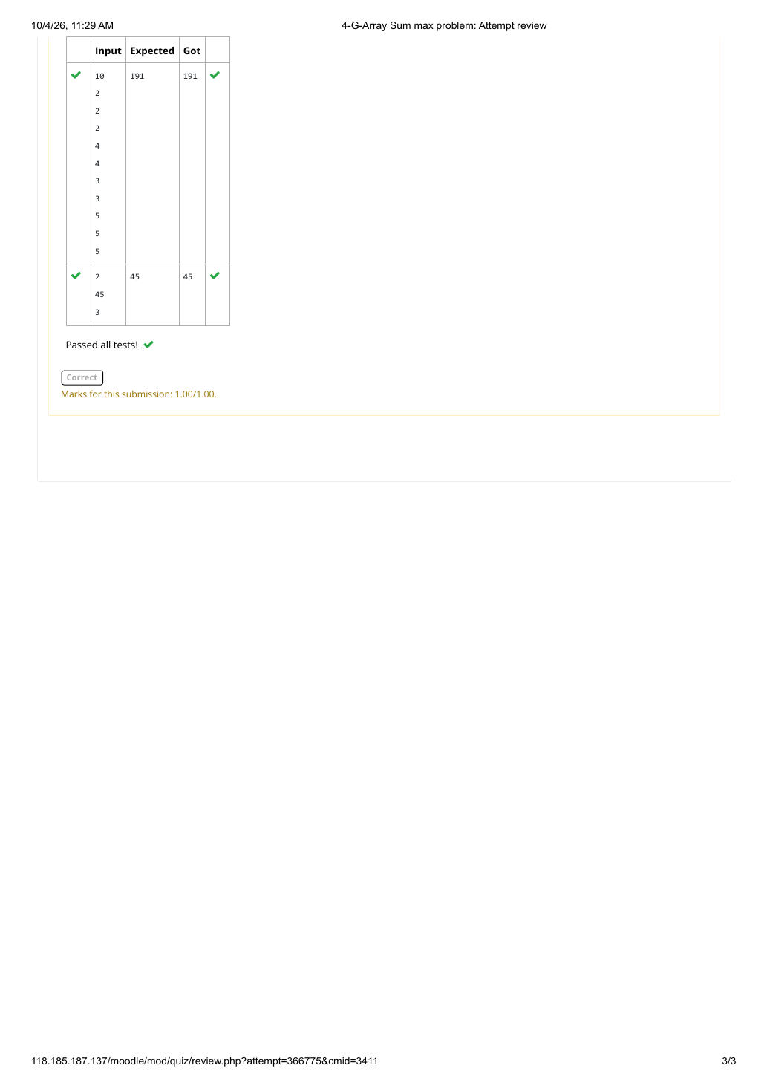

EXPERIMENT 10 — 5-G-PRODUCT OF ARRAY ELEMENTS – MINIMUM
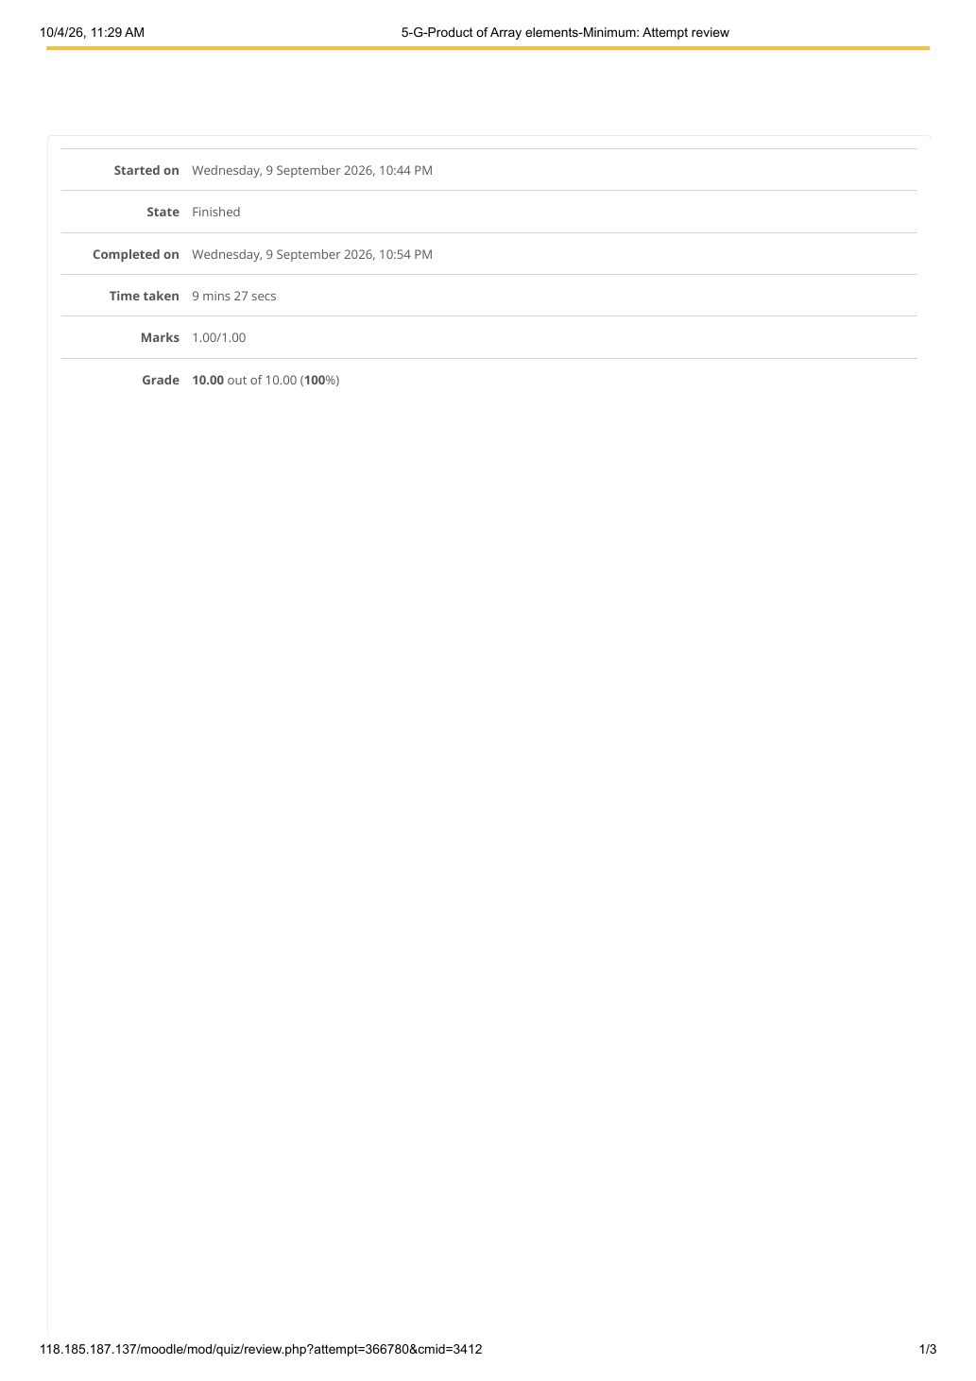

EXPERIMENT 10 — 5-G-PRODUCT OF ARRAY ELEMENTS – MINIMUM
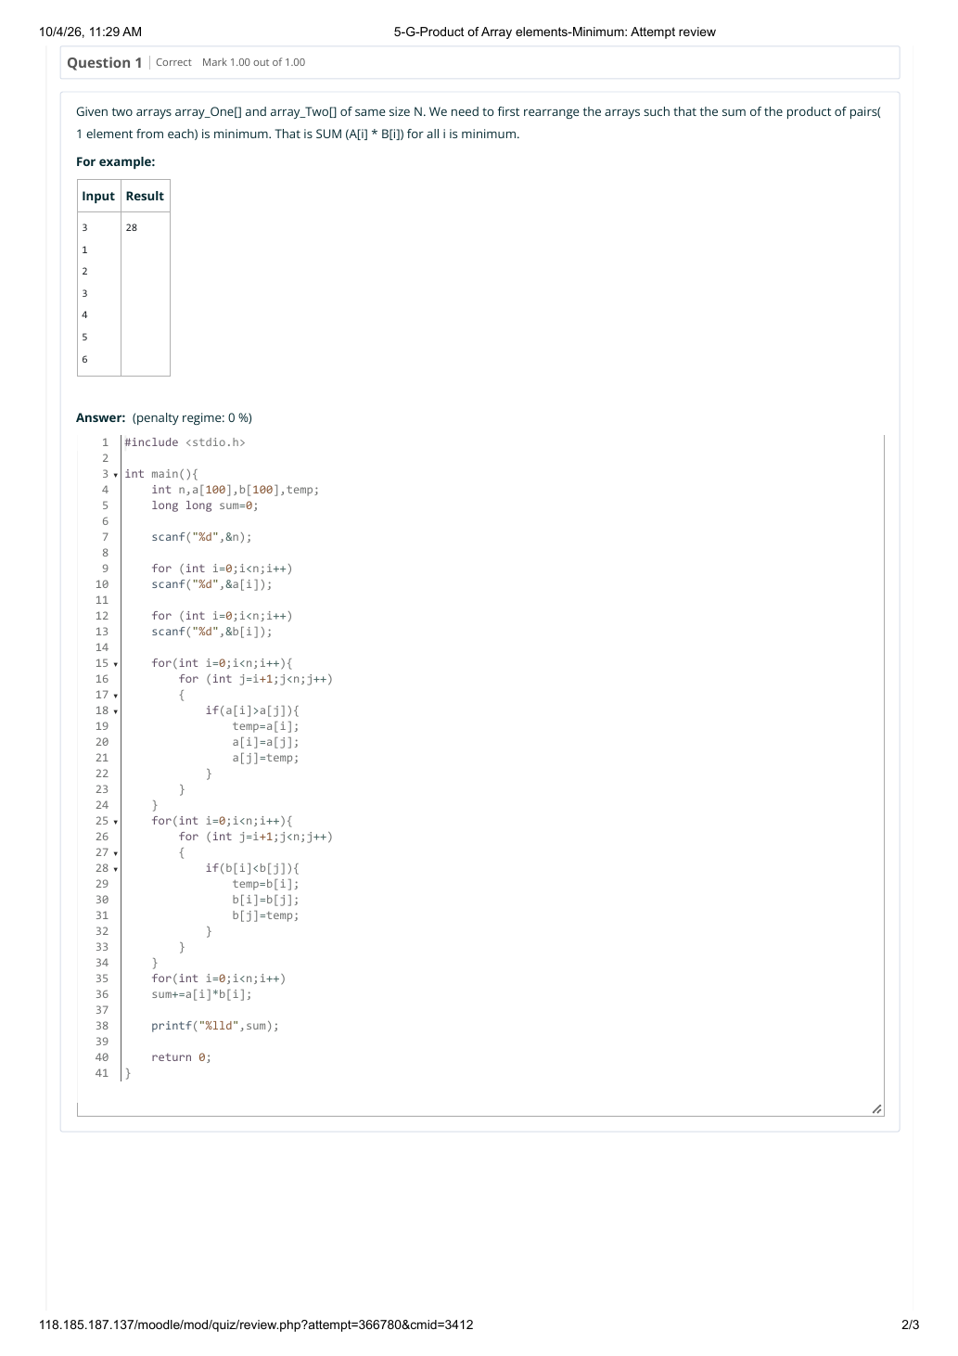

EXPERIMENT 10 — 5-G-PRODUCT OF ARRAY ELEMENTS – MINIMUM
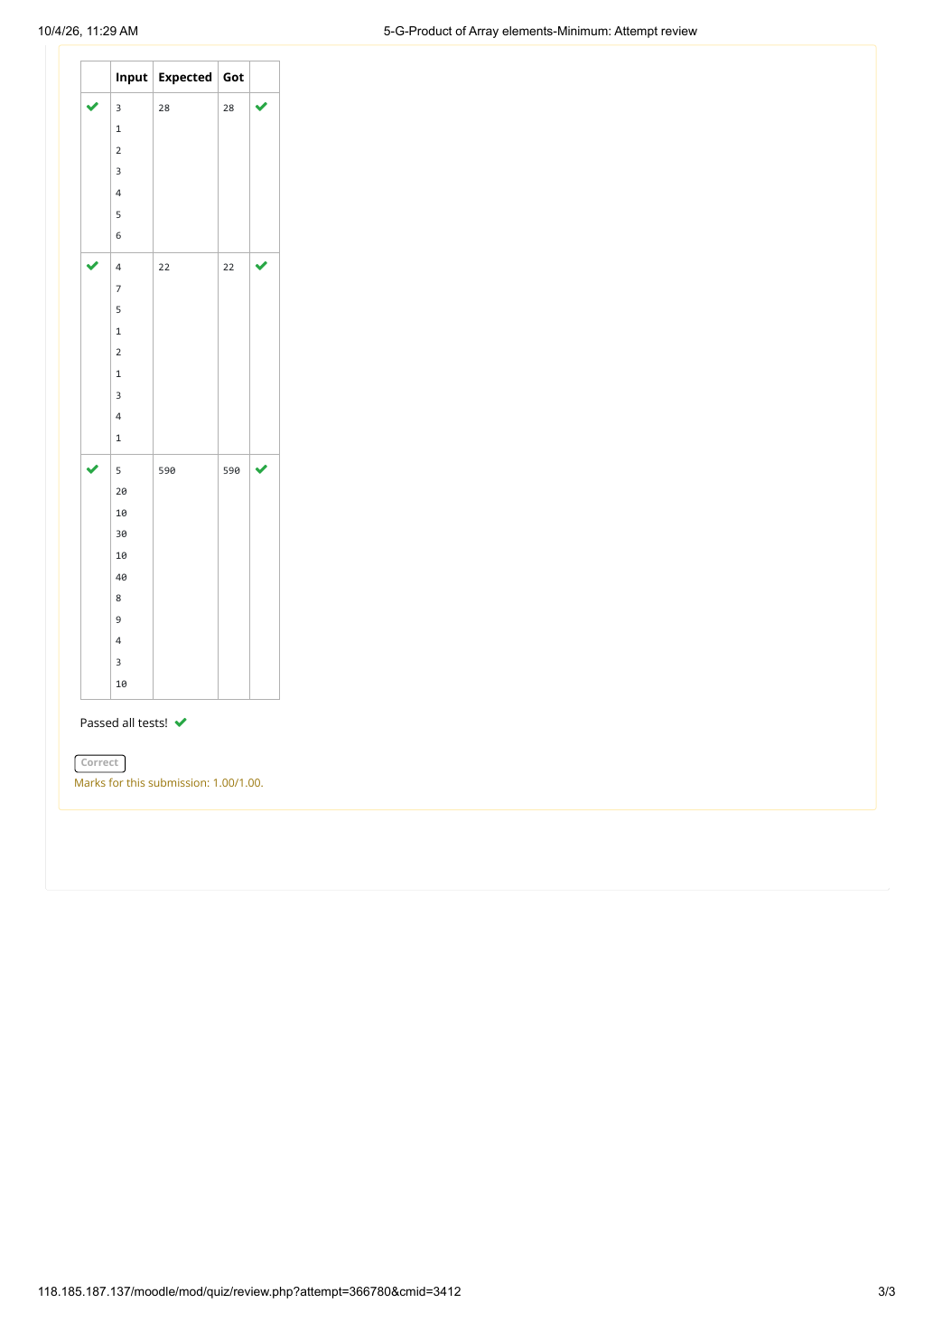

EXPERIMENT 11 — NUMBER OF ZEROS IN A GIVEN ARRAY
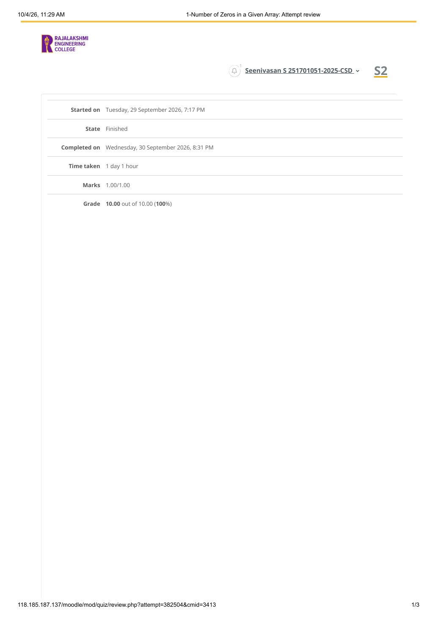

EXPERIMENT 11 — NUMBER OF ZEROS IN A GIVEN ARRAY
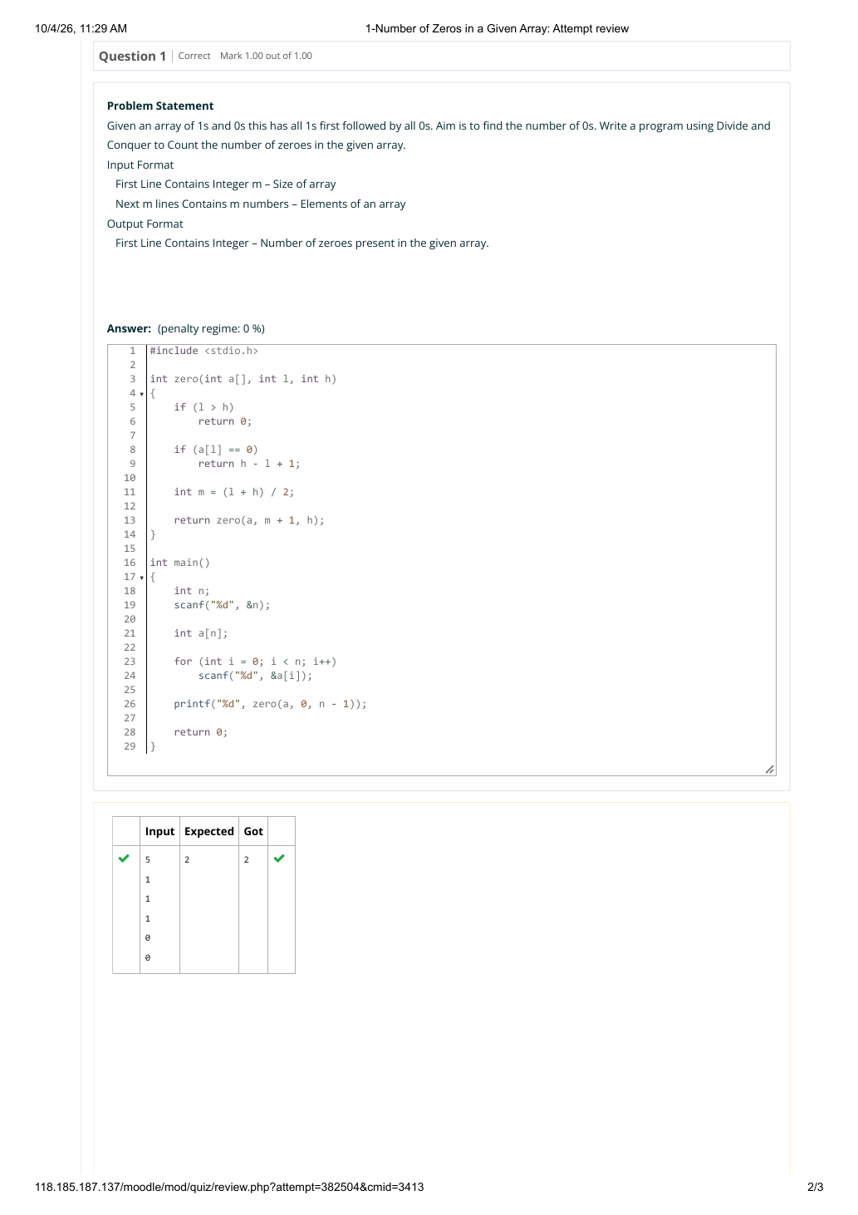

EXPERIMENT 11 — NUMBER OF ZEROS IN A GIVEN ARRAY
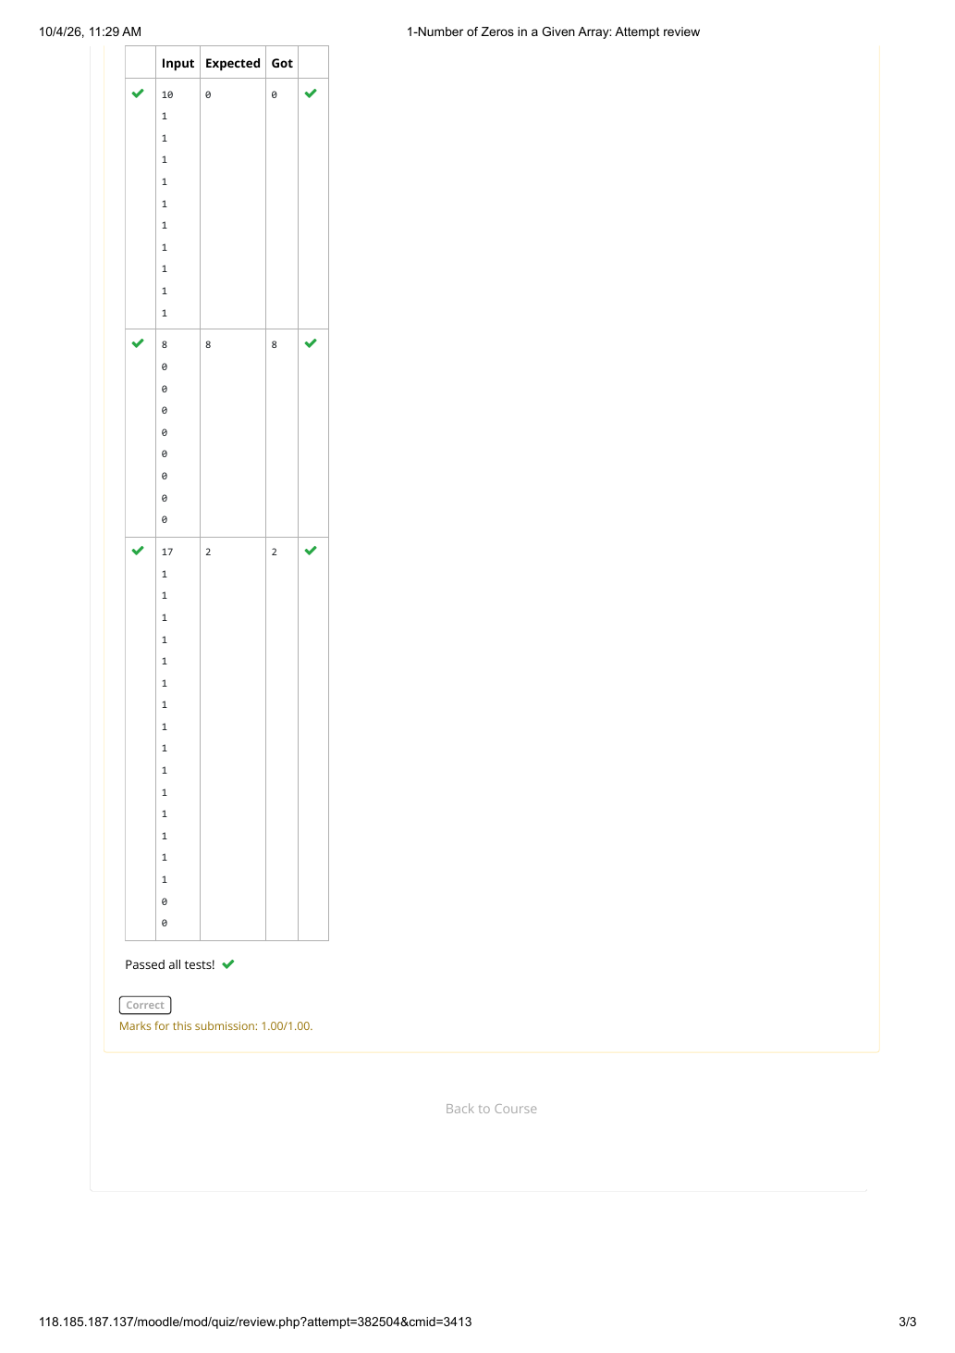

EXPERIMENT 12 — MAJORITY ELEMENT
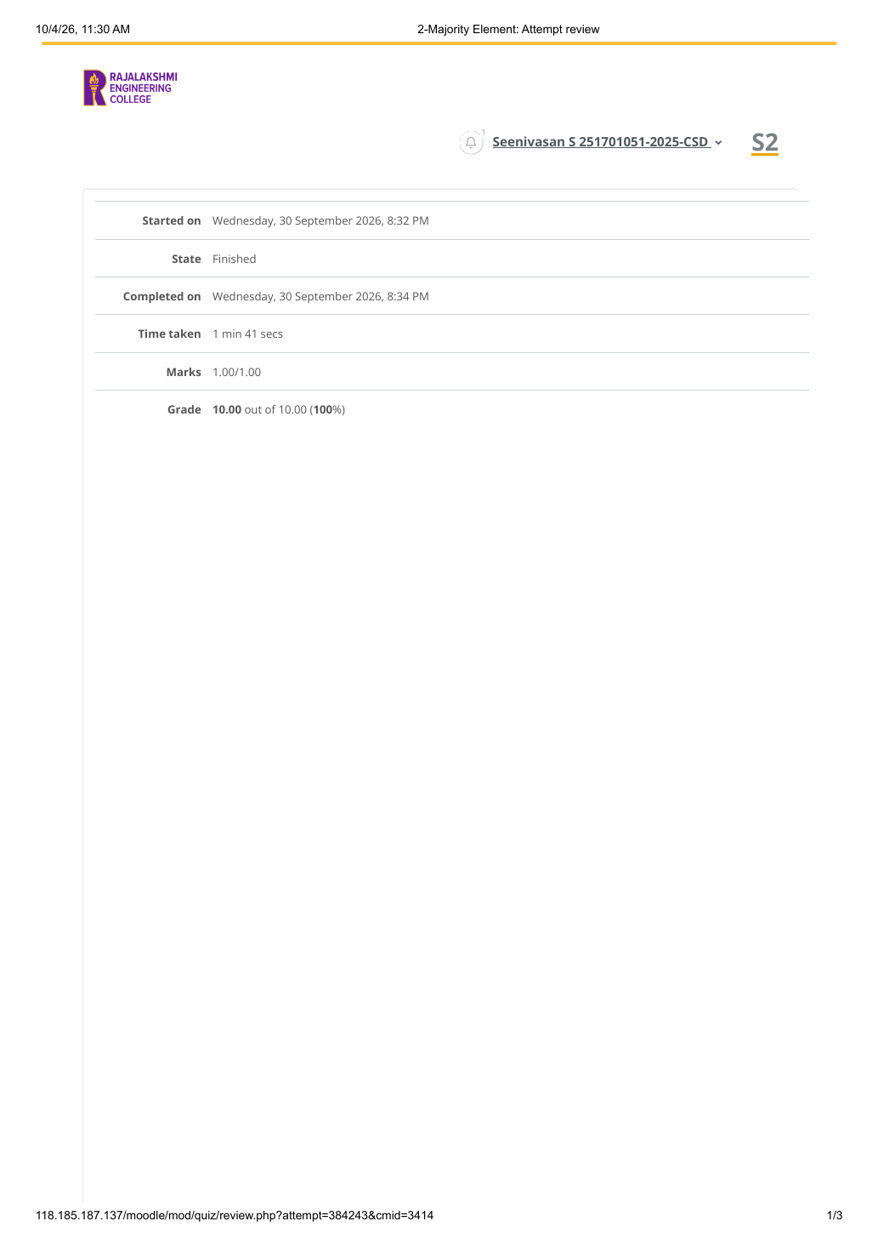

EXPERIMENT 12 — MAJORITY ELEMENT
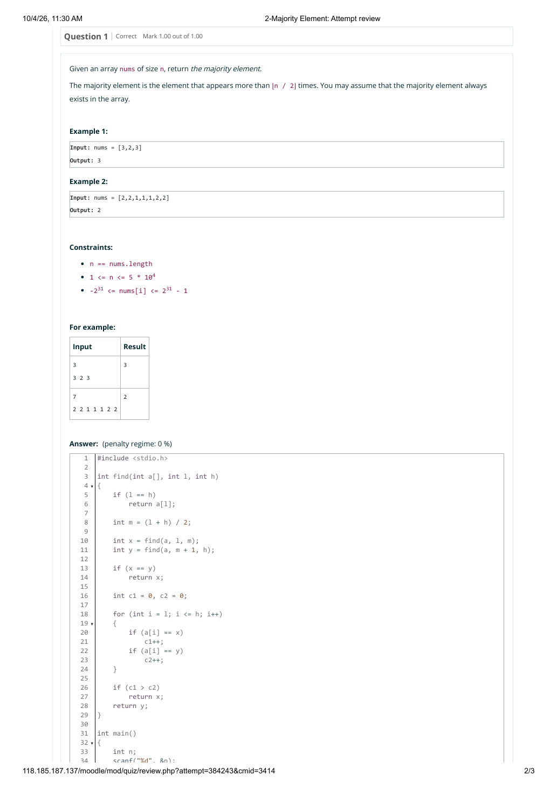

EXPERIMENT 12 — MAJORITY ELEMENT
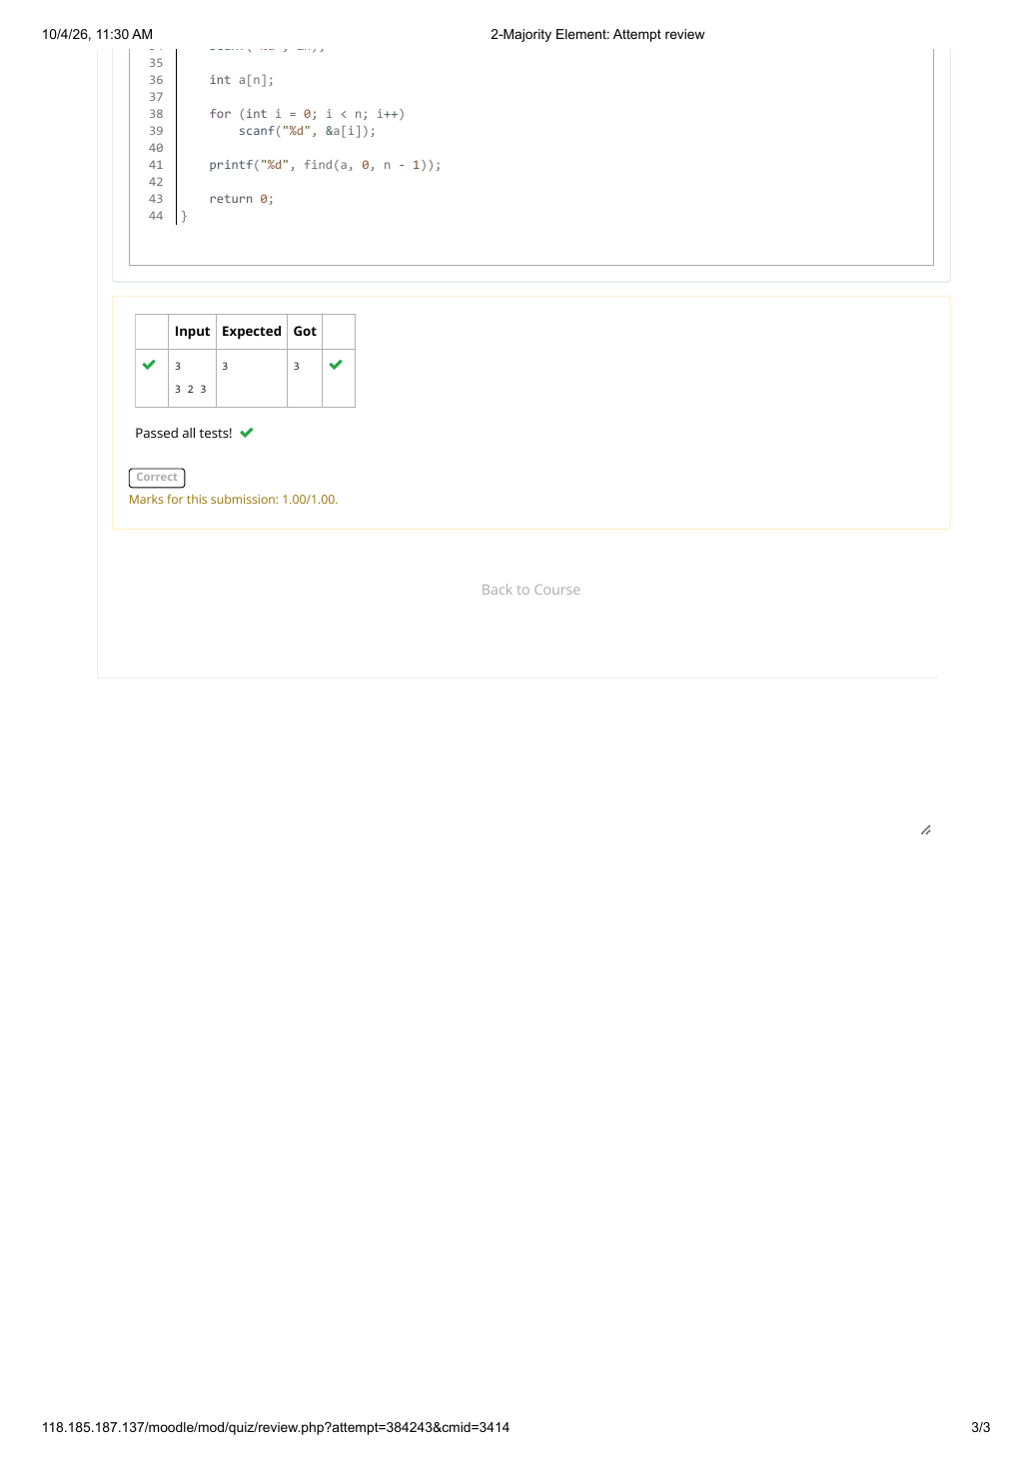

EXPERIMENT 13 — FINDING FLOOR VALUE
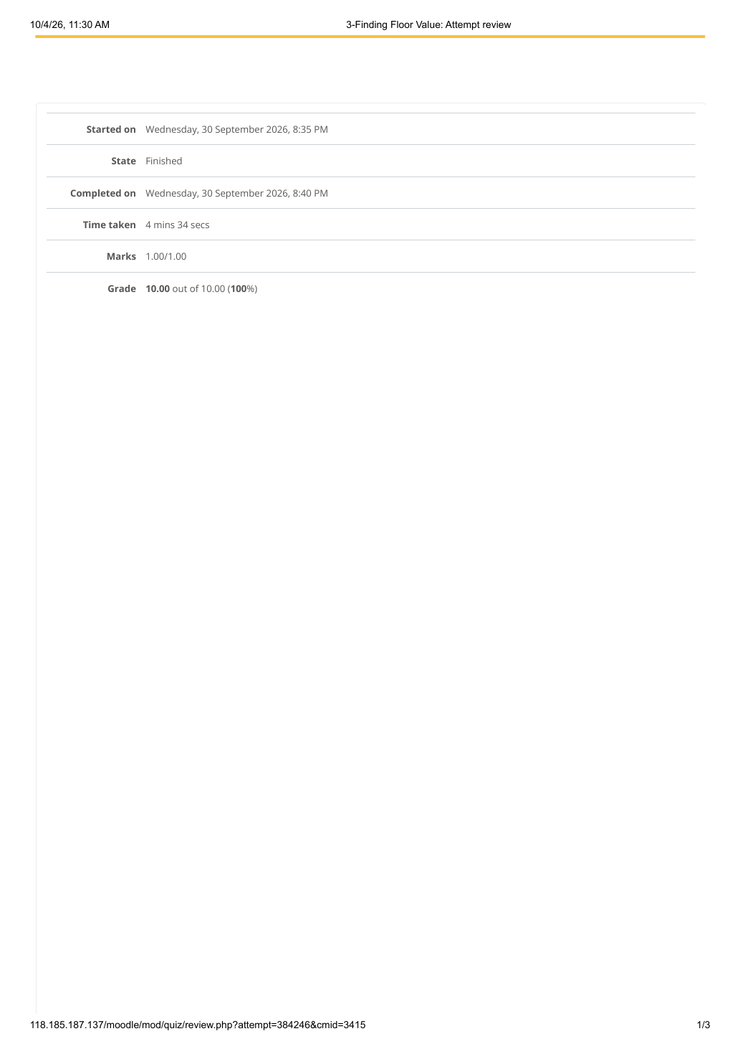

EXPERIMENT 13 — FINDING FLOOR VALUE
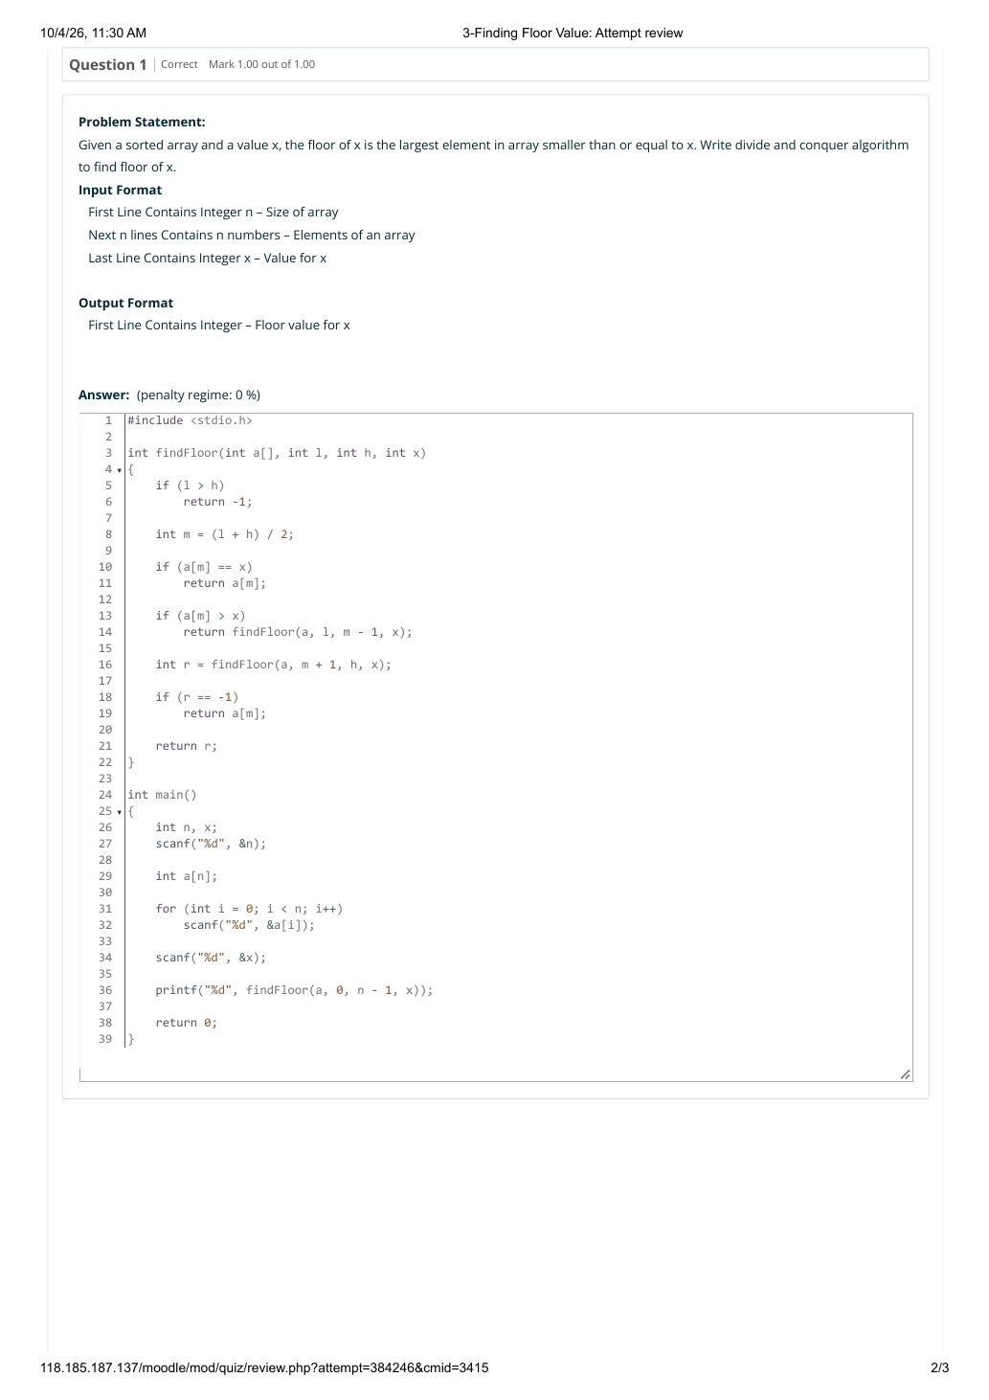

EXPERIMENT 13 — FINDING FLOOR VALUE
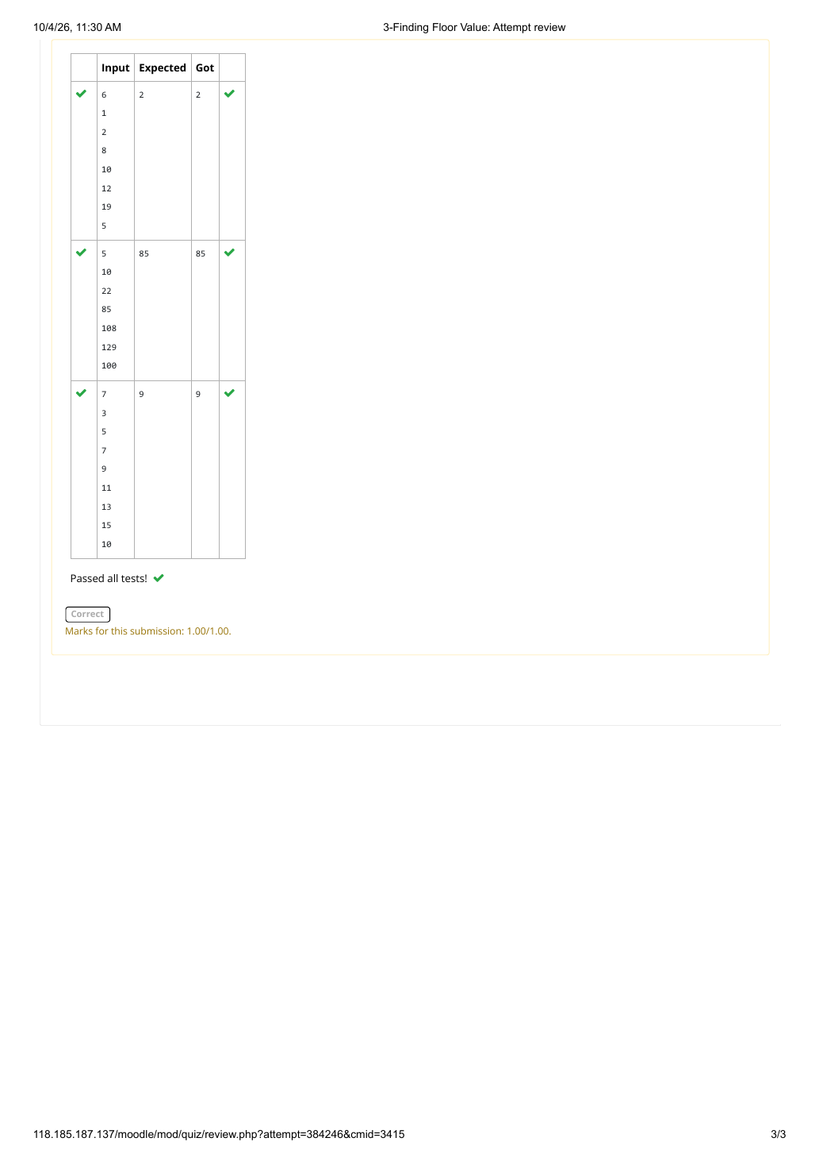

EXPERIMENT 14 — TWO ELEMENTS SUM TO X
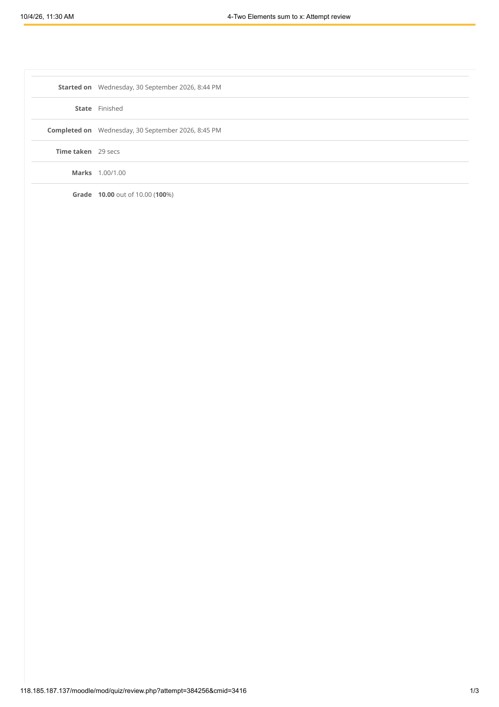

EXPERIMENT 14 — TWO ELEMENTS SUM TO X
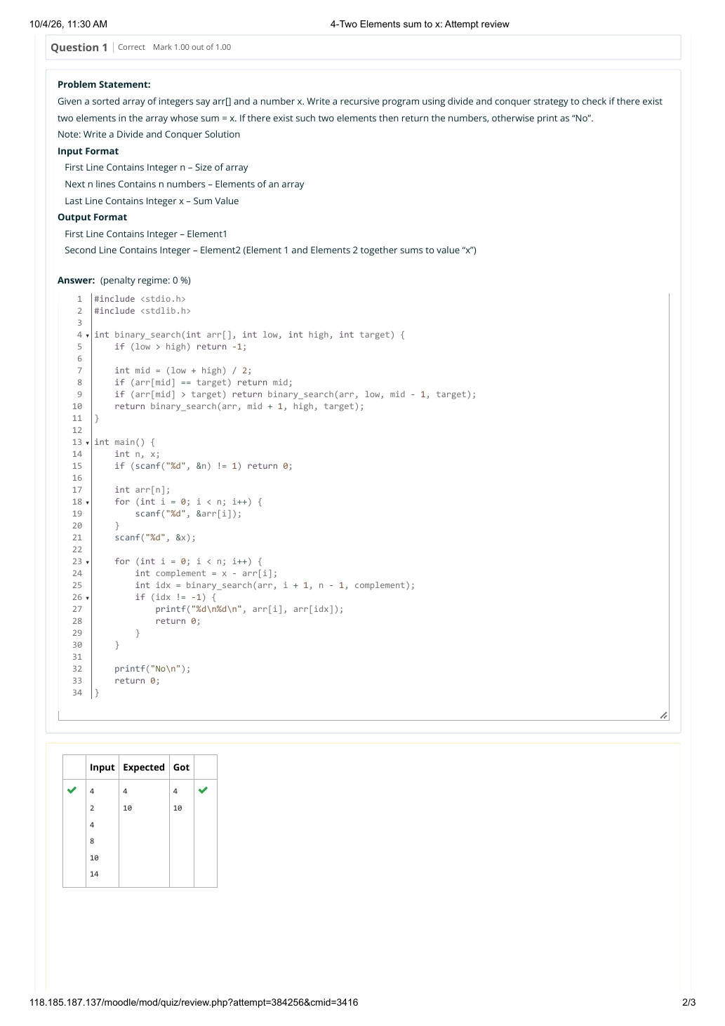

EXPERIMENT 14 — TWO ELEMENTS SUM TO X
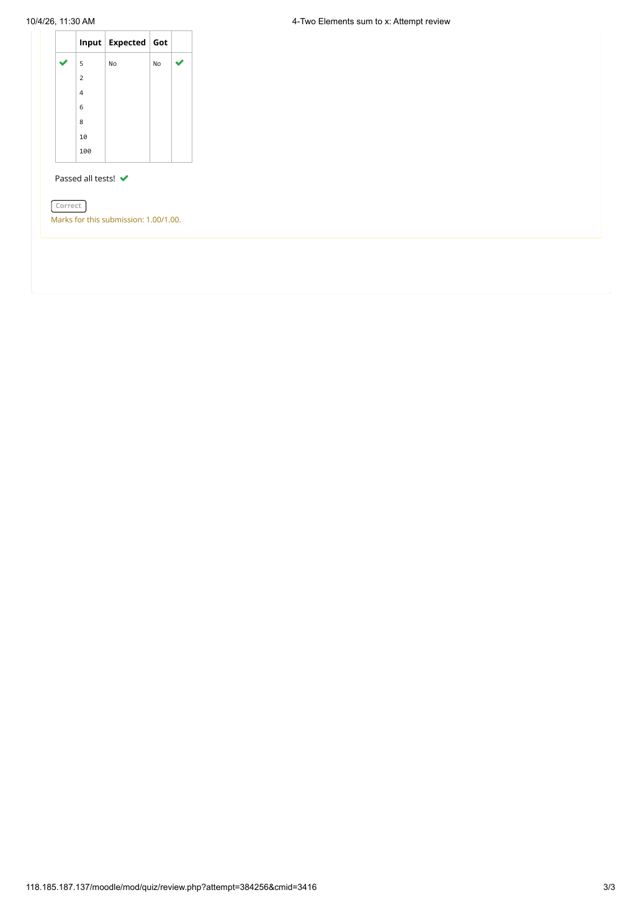

EXPERIMENT 15 — IMPLEMENTATION OF QUICK SORT
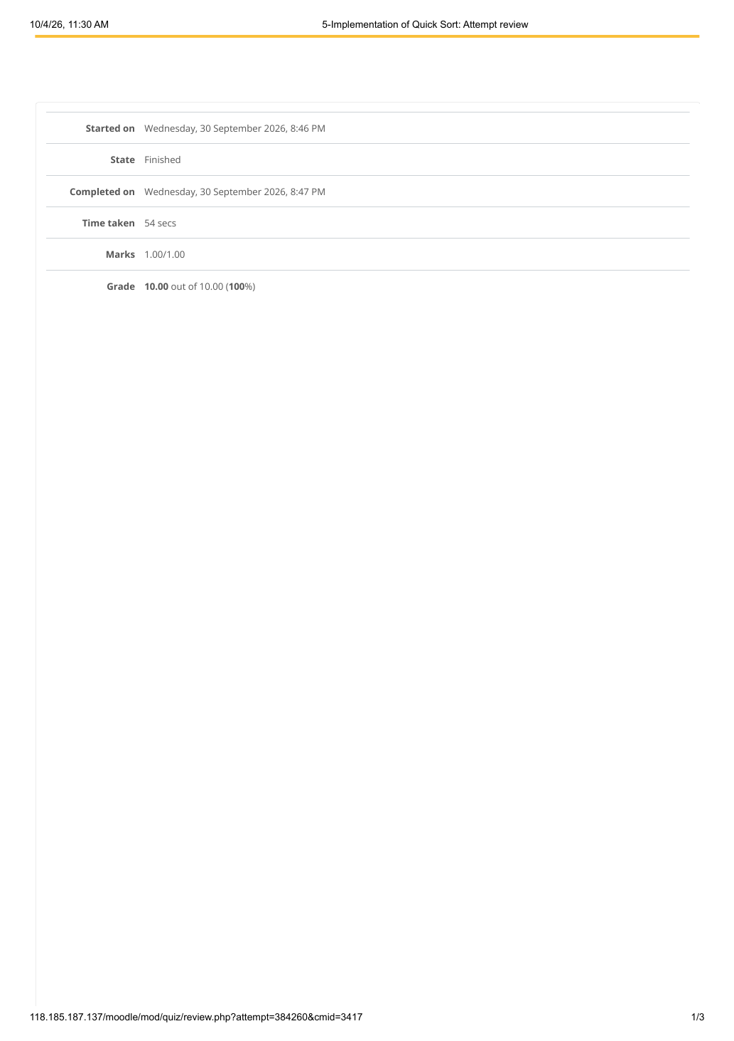

EXPERIMENT 15 — IMPLEMENTATION OF QUICK SORT
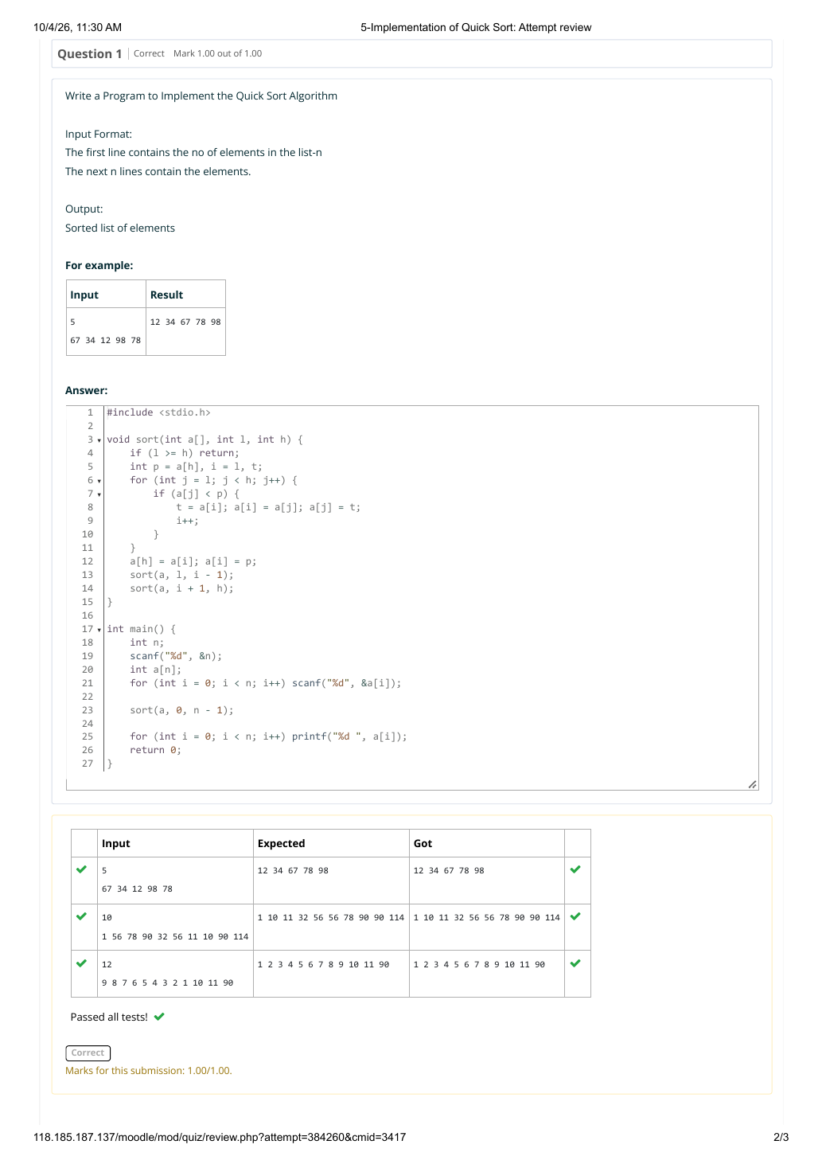

EXPERIMENT 15 — IMPLEMENTATION OF QUICK SORT
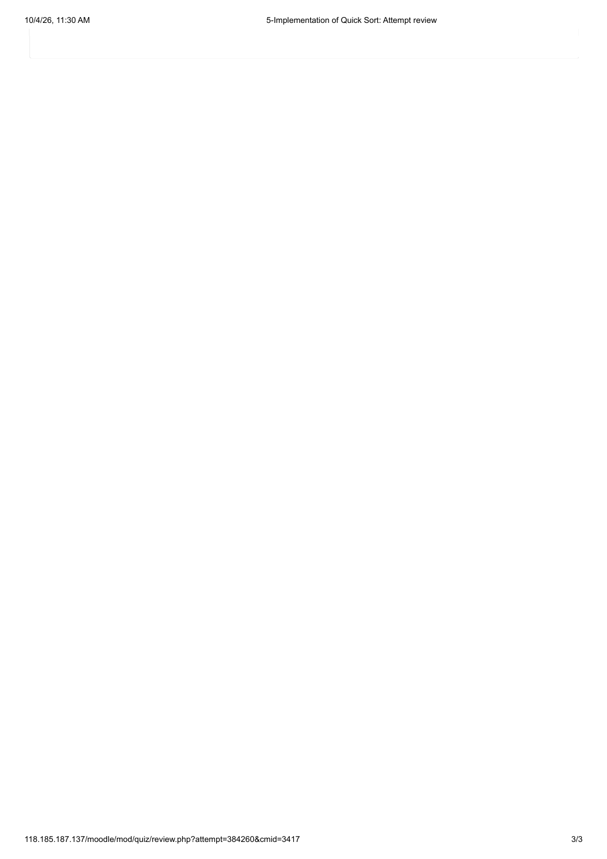

EXPERIMENT 16 — DP — PLAYING WITH NUMBERS
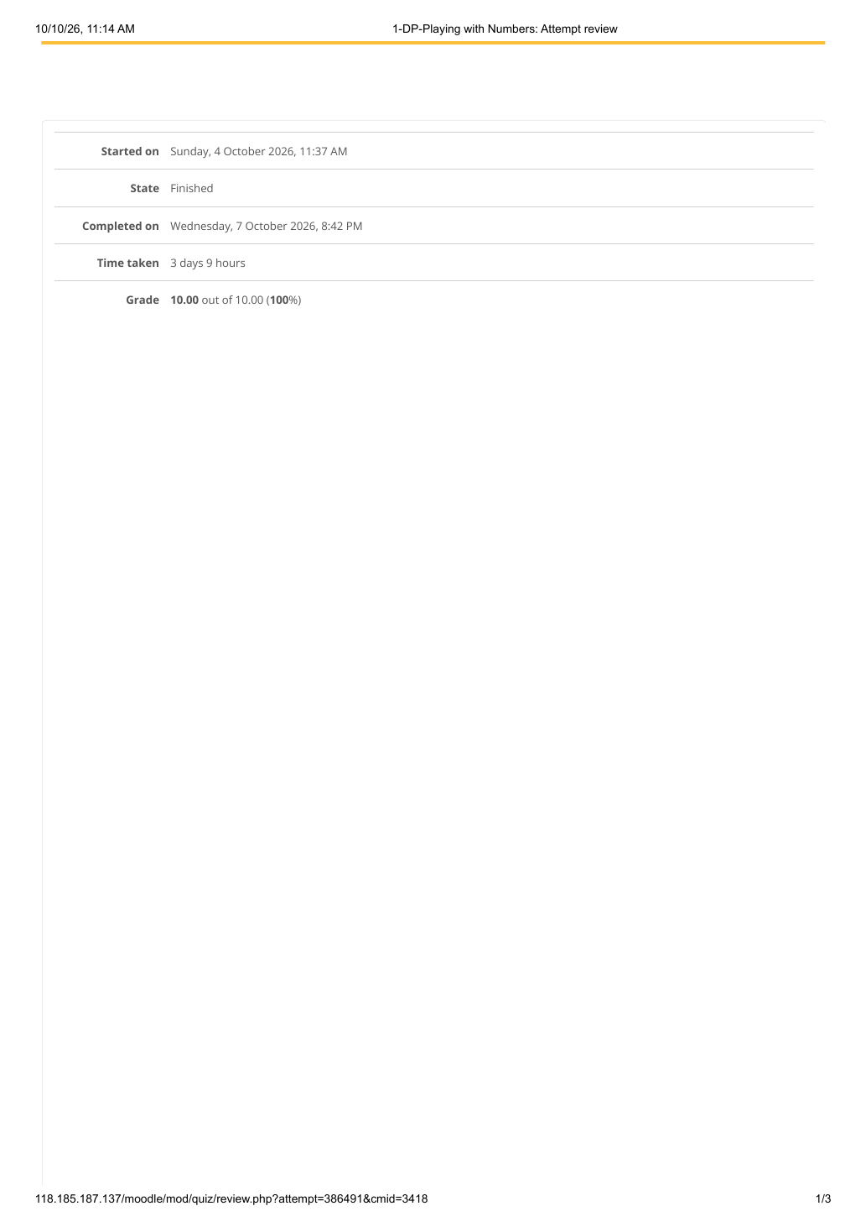

EXPERIMENT 16 — DP — PLAYING WITH NUMBERS
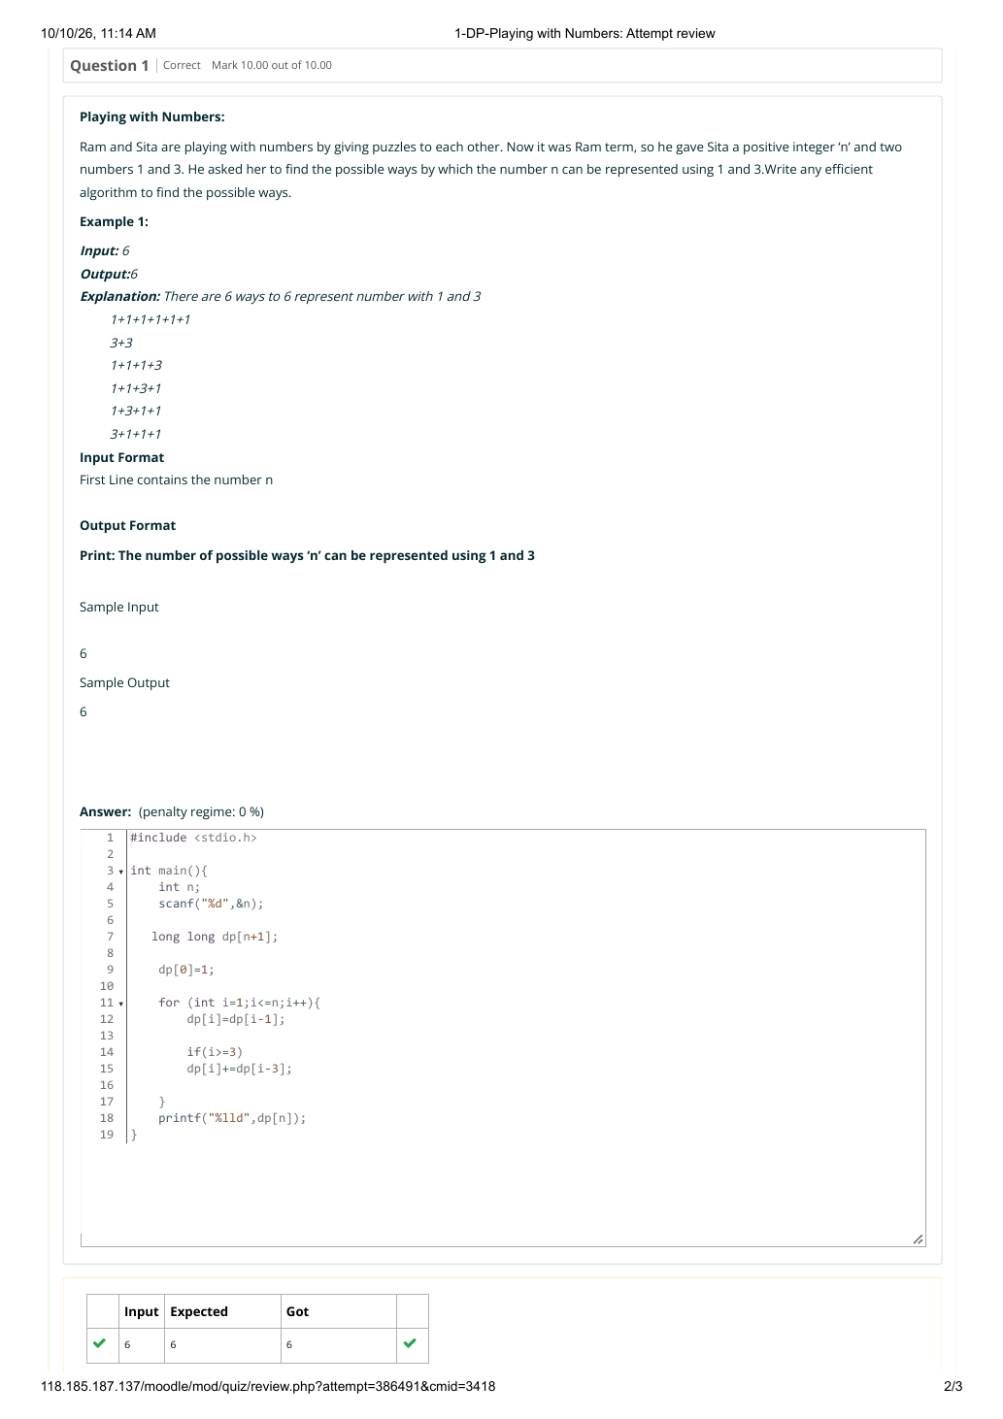

EXPERIMENT 16 — DP — PLAYING WITH NUMBERS
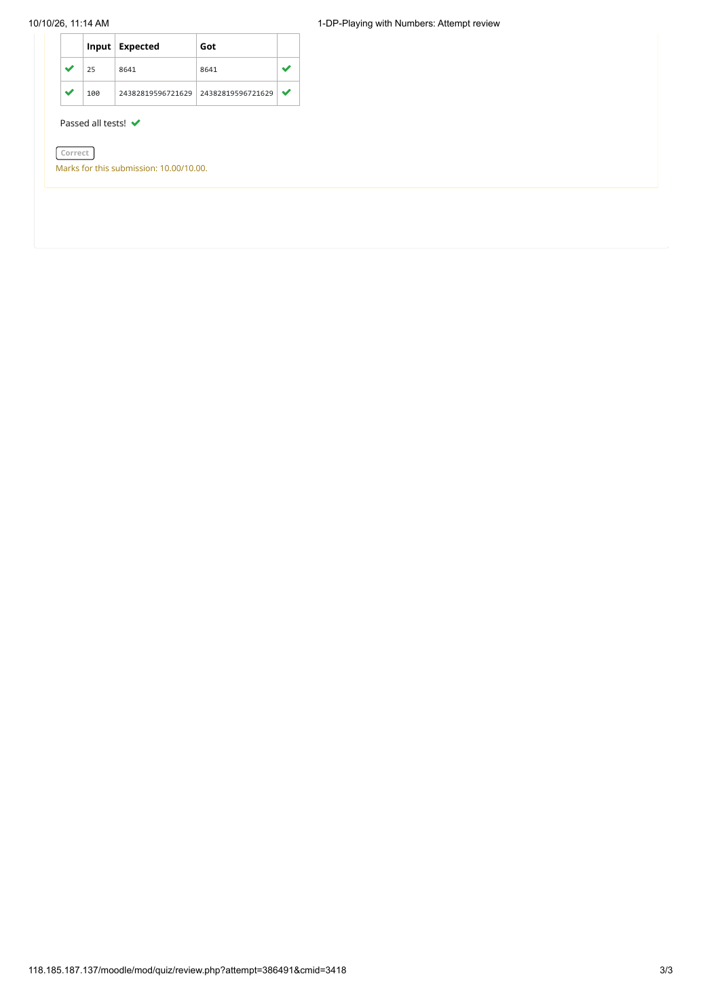

EXPERIMENT 17 — DP — PLAYING WITH CHESSBOARD
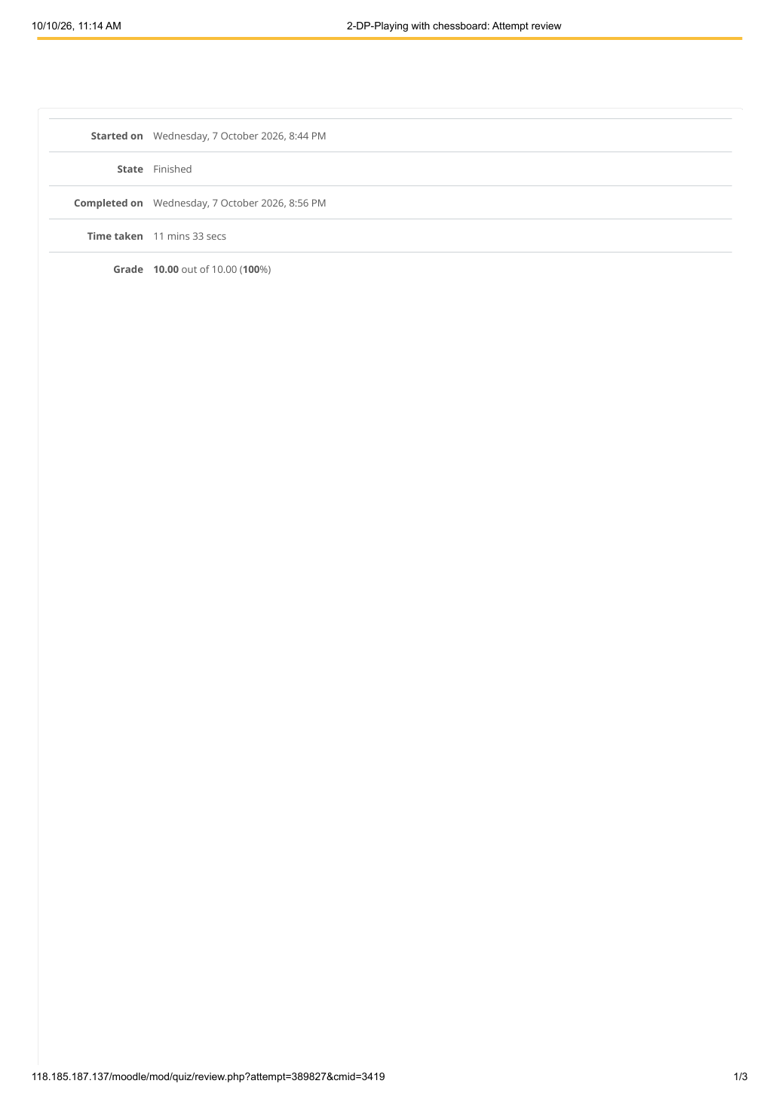

EXPERIMENT 17 — DP — PLAYING WITH CHESSBOARD
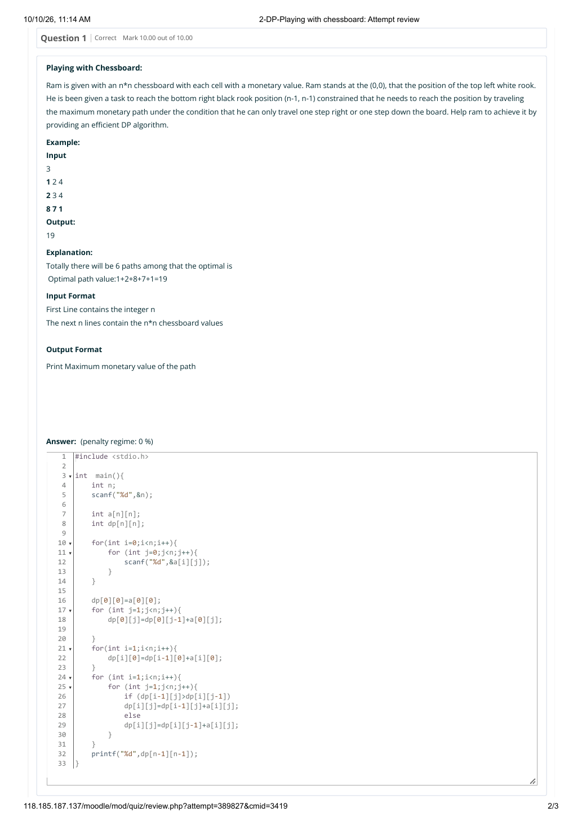

EXPERIMENT 17 — DP — PLAYING WITH CHESSBOARD
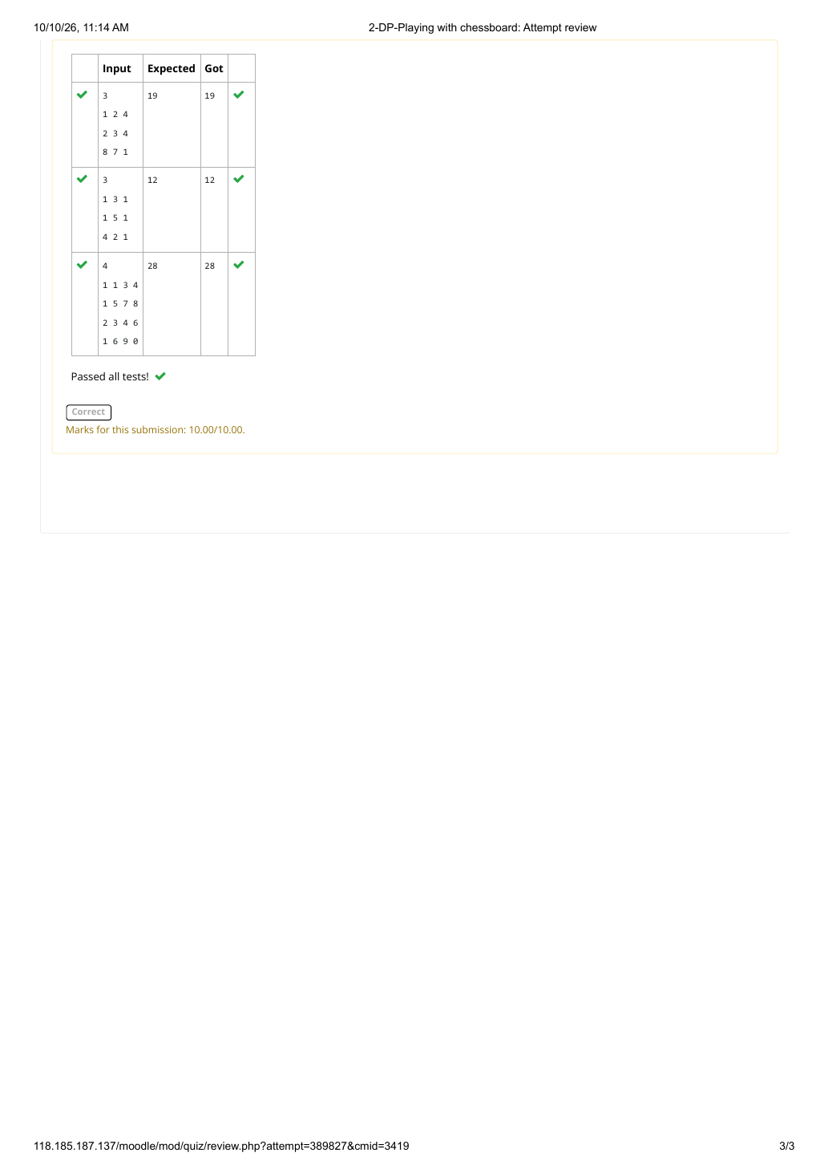

EXPERIMENT 18 — DP — LONGEST COMMON SUBSEQUENCE
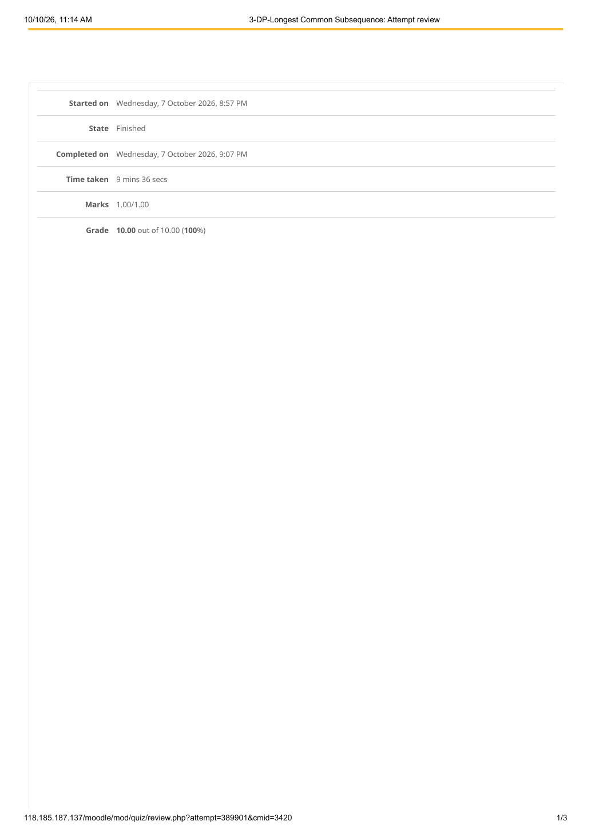

EXPERIMENT 18 — DP — LONGEST COMMON SUBSEQUENCE
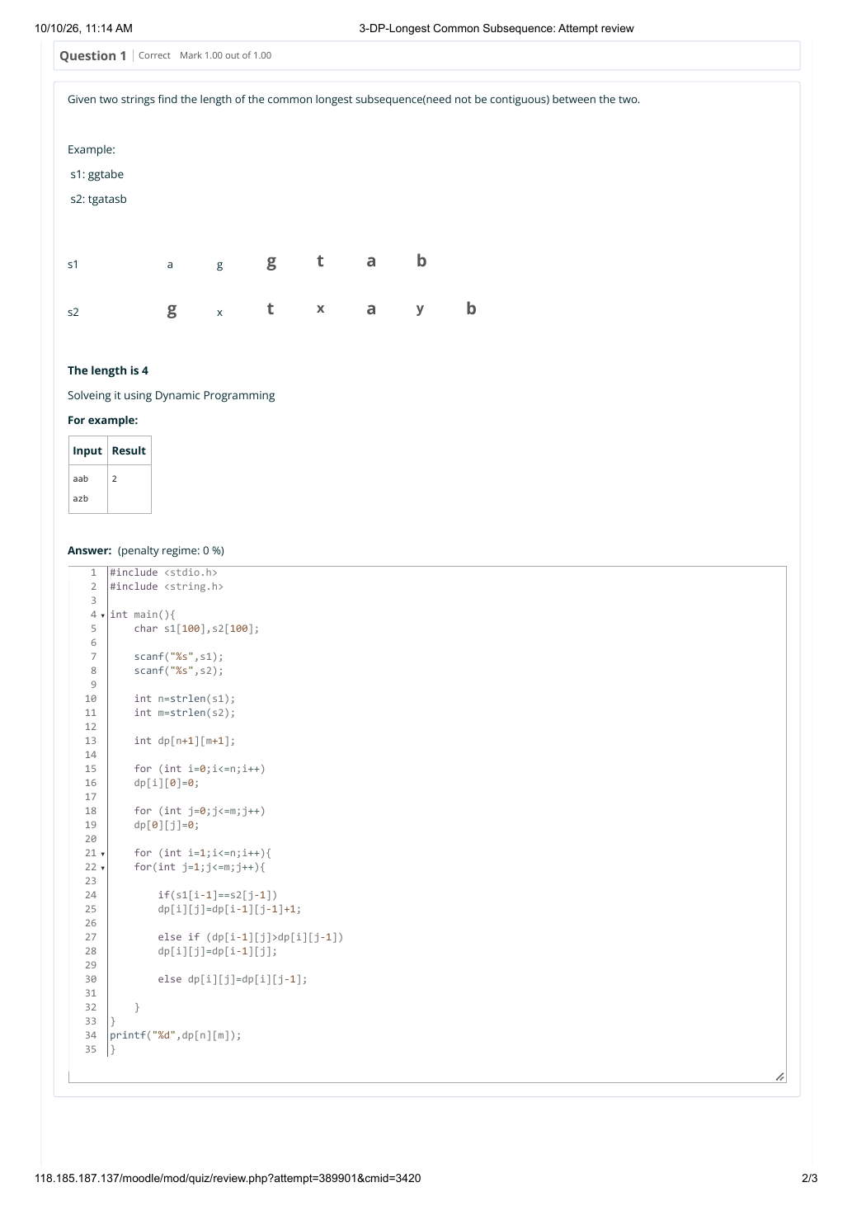

EXPERIMENT 18 — DP — LONGEST COMMON SUBSEQUENCE
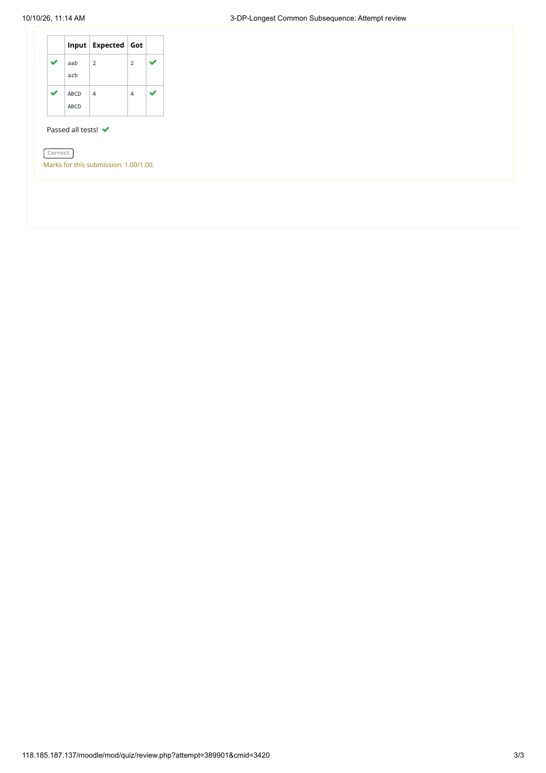

EXPERIMENT 19 — DP — LONGEST NON-DECREASING SUBSEQUENCE
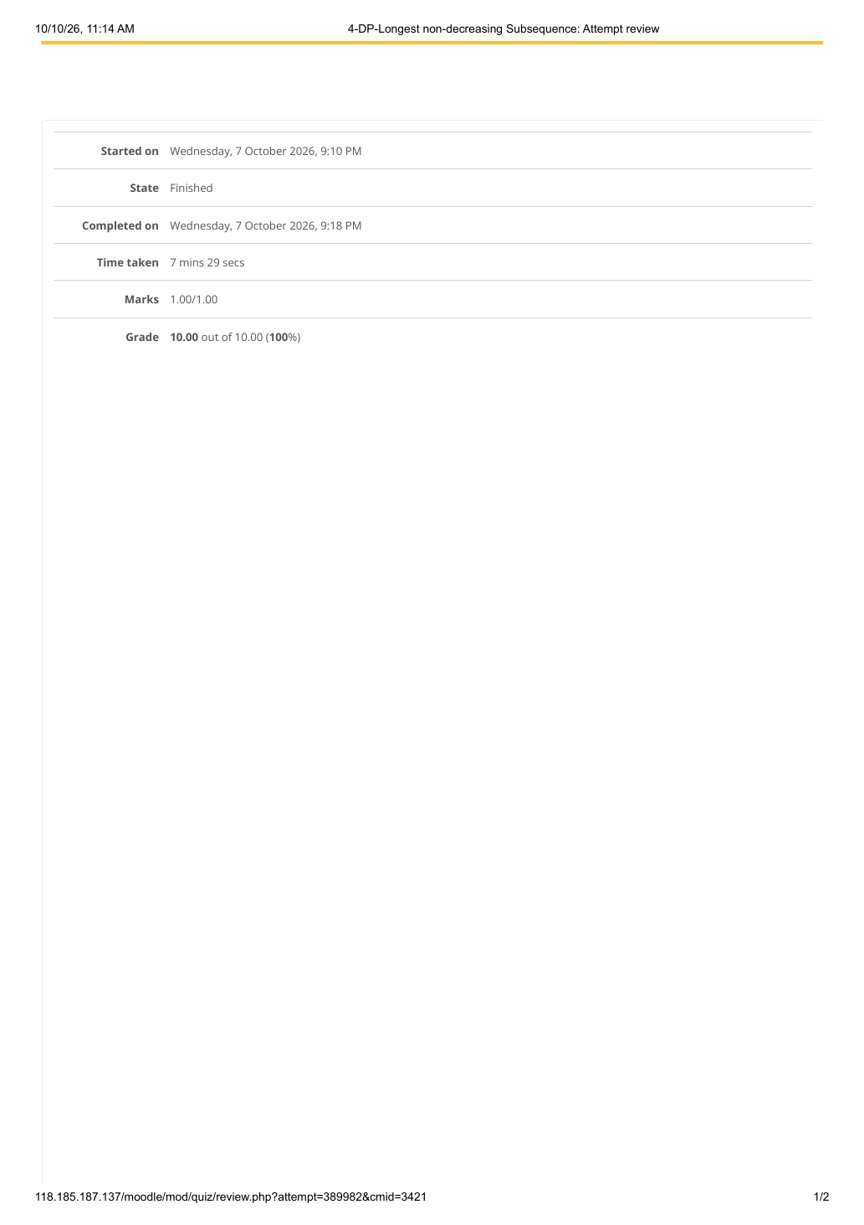

EXPERIMENT 19 — DP — LONGEST NON-DECREASING SUBSEQUENCE
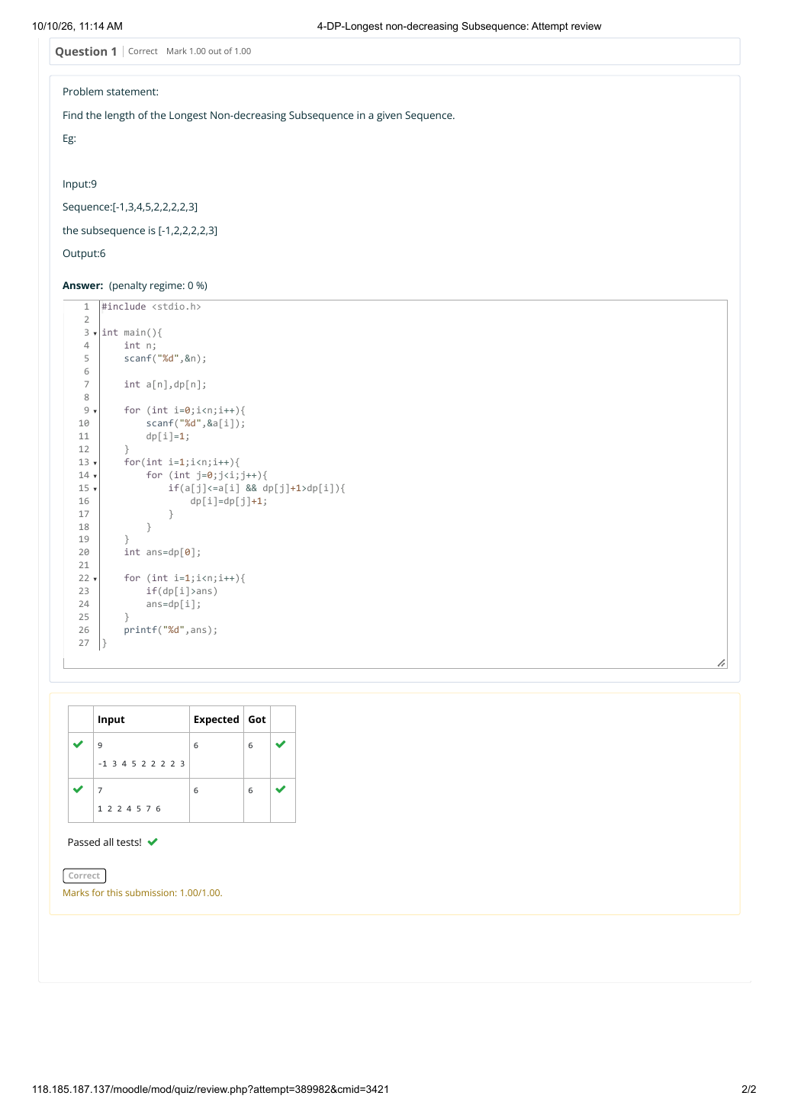

EXPERIMENT 20 — FINDING DUPLICATES — O(n²) TIME, O(1) SPACE
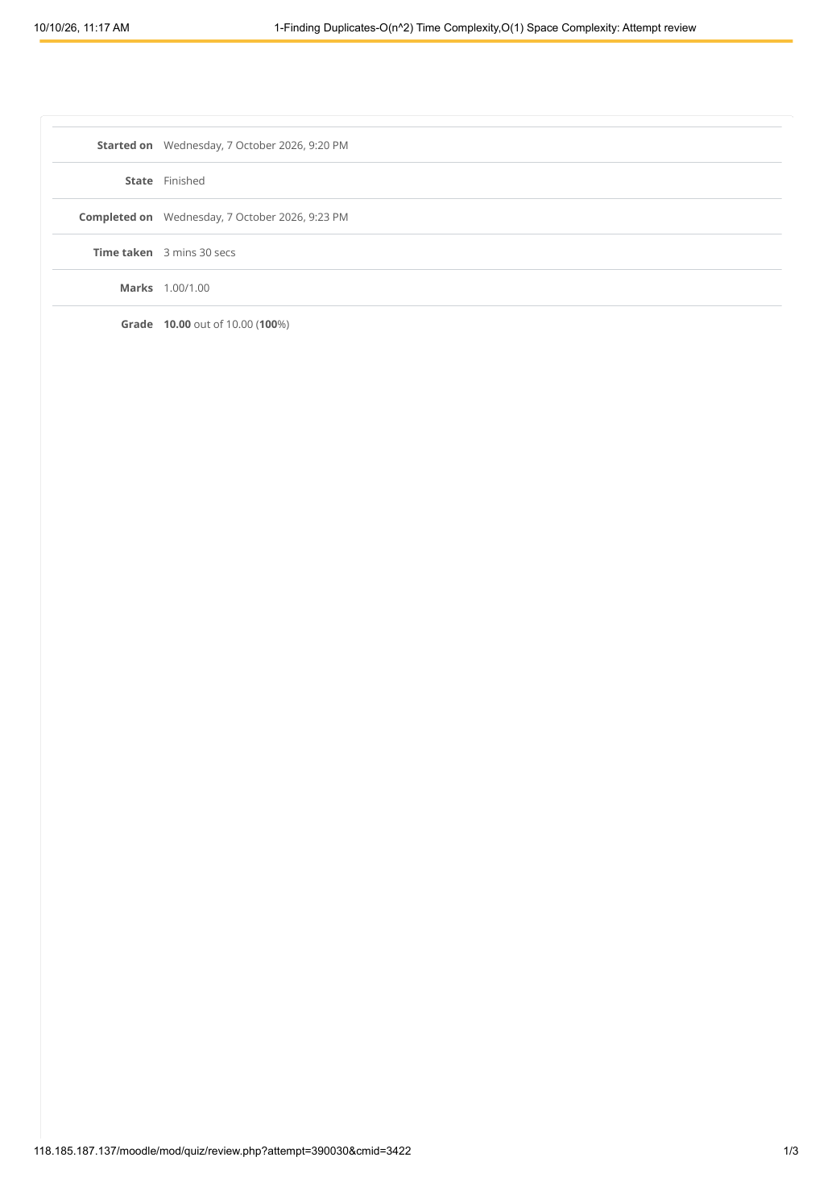

EXPERIMENT 20 — FINDING DUPLICATES — O(n²) TIME, O(1) SPACE
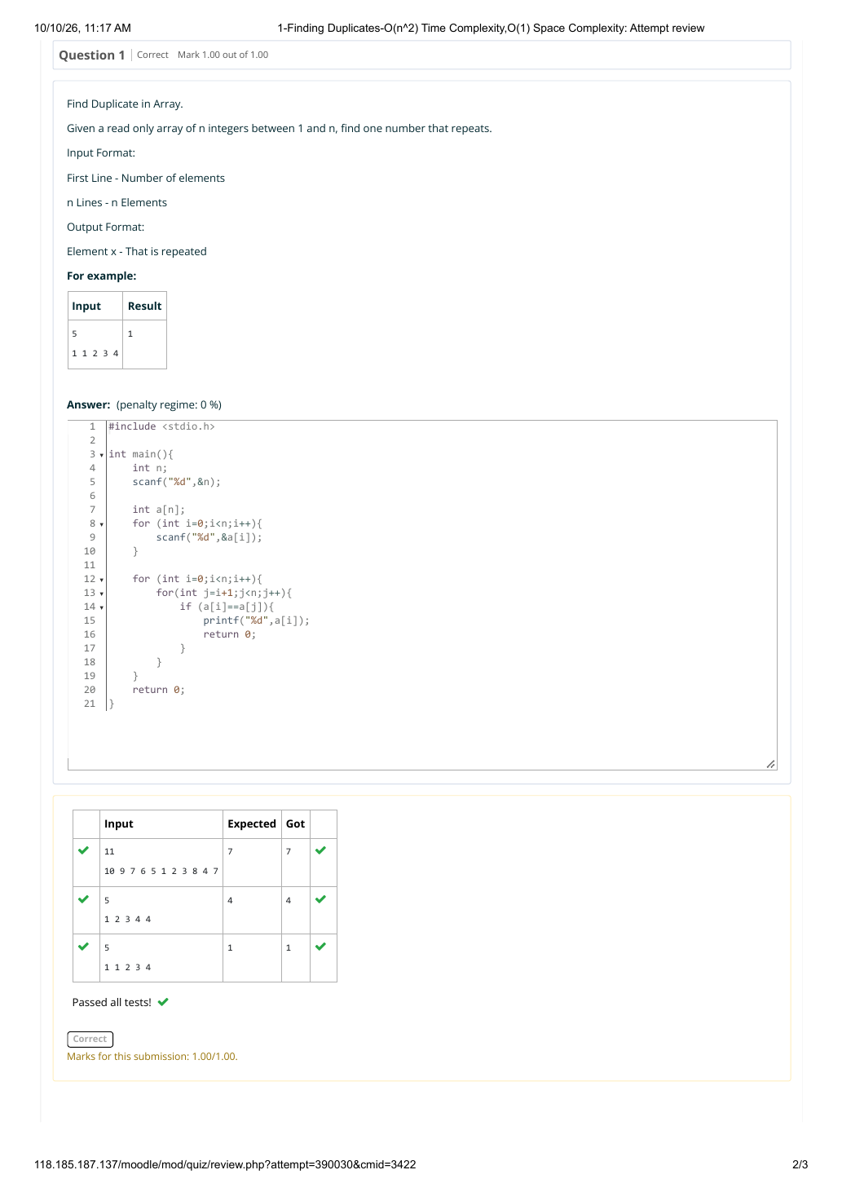

EXPERIMENT 20 — FINDING DUPLICATES — O(n²) TIME, O(1) SPACE
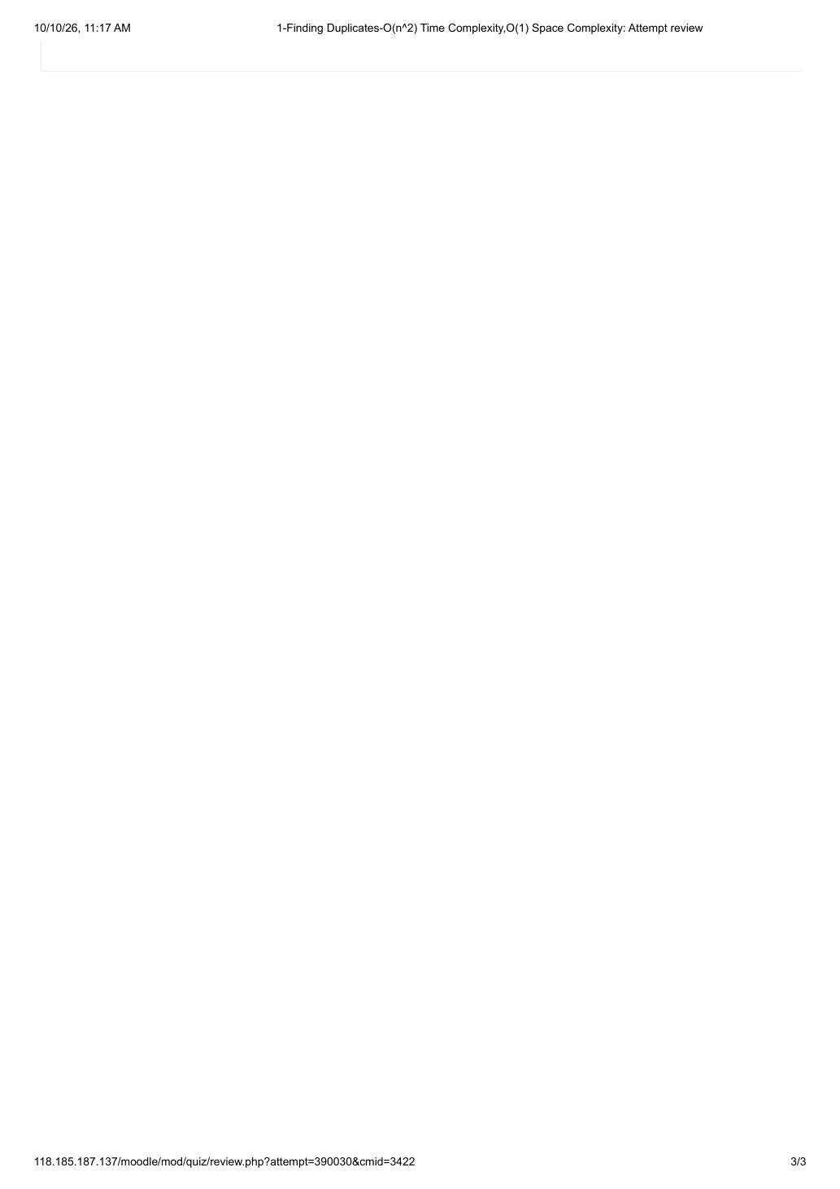

EXPERIMENT 21 — FINDING DUPLICATES — O(n) TIME, O(1) SPACE
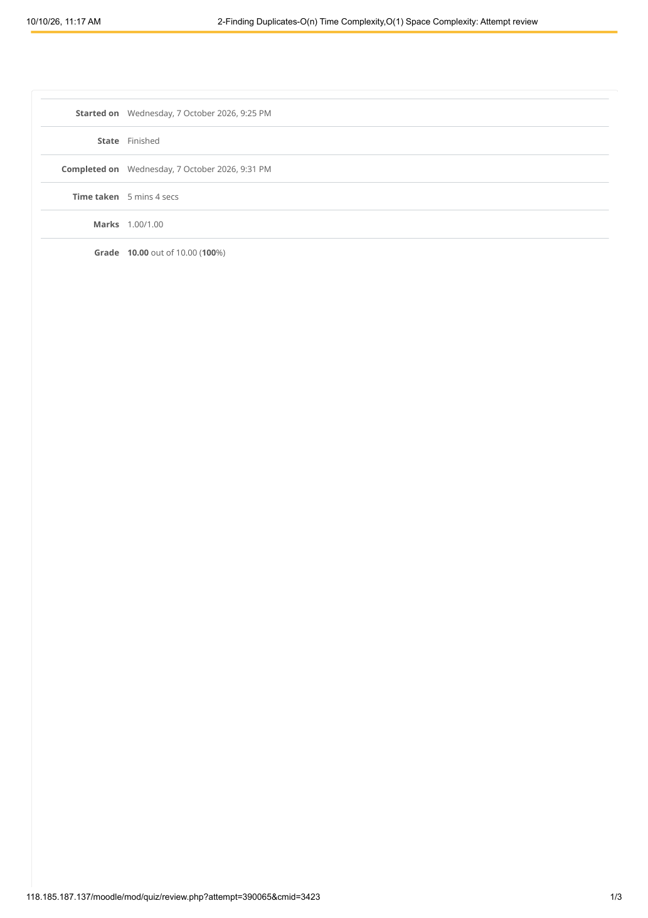

EXPERIMENT 21 — FINDING DUPLICATES — O(n) TIME, O(1) SPACE
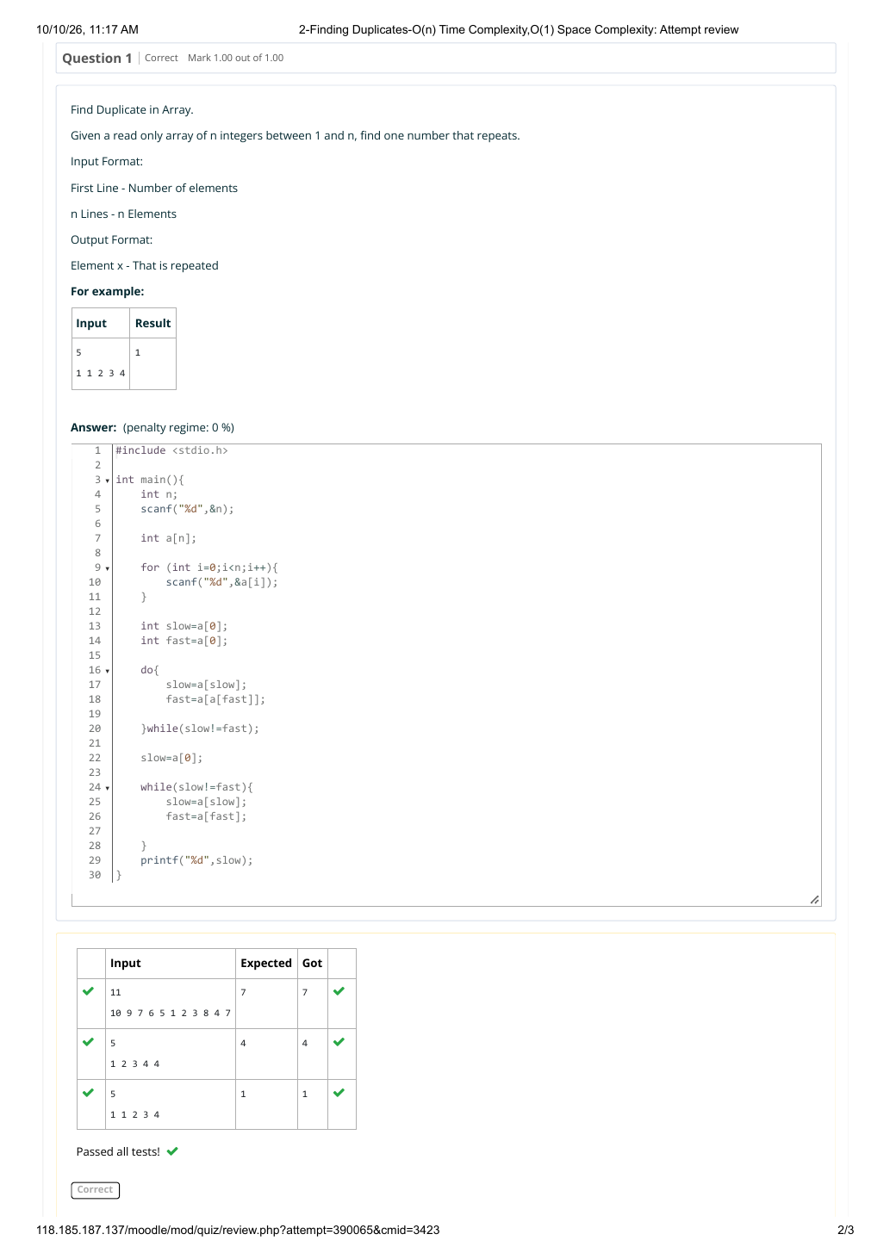

EXPERIMENT 21 — FINDING DUPLICATES — O(n) TIME, O(1) SPACE
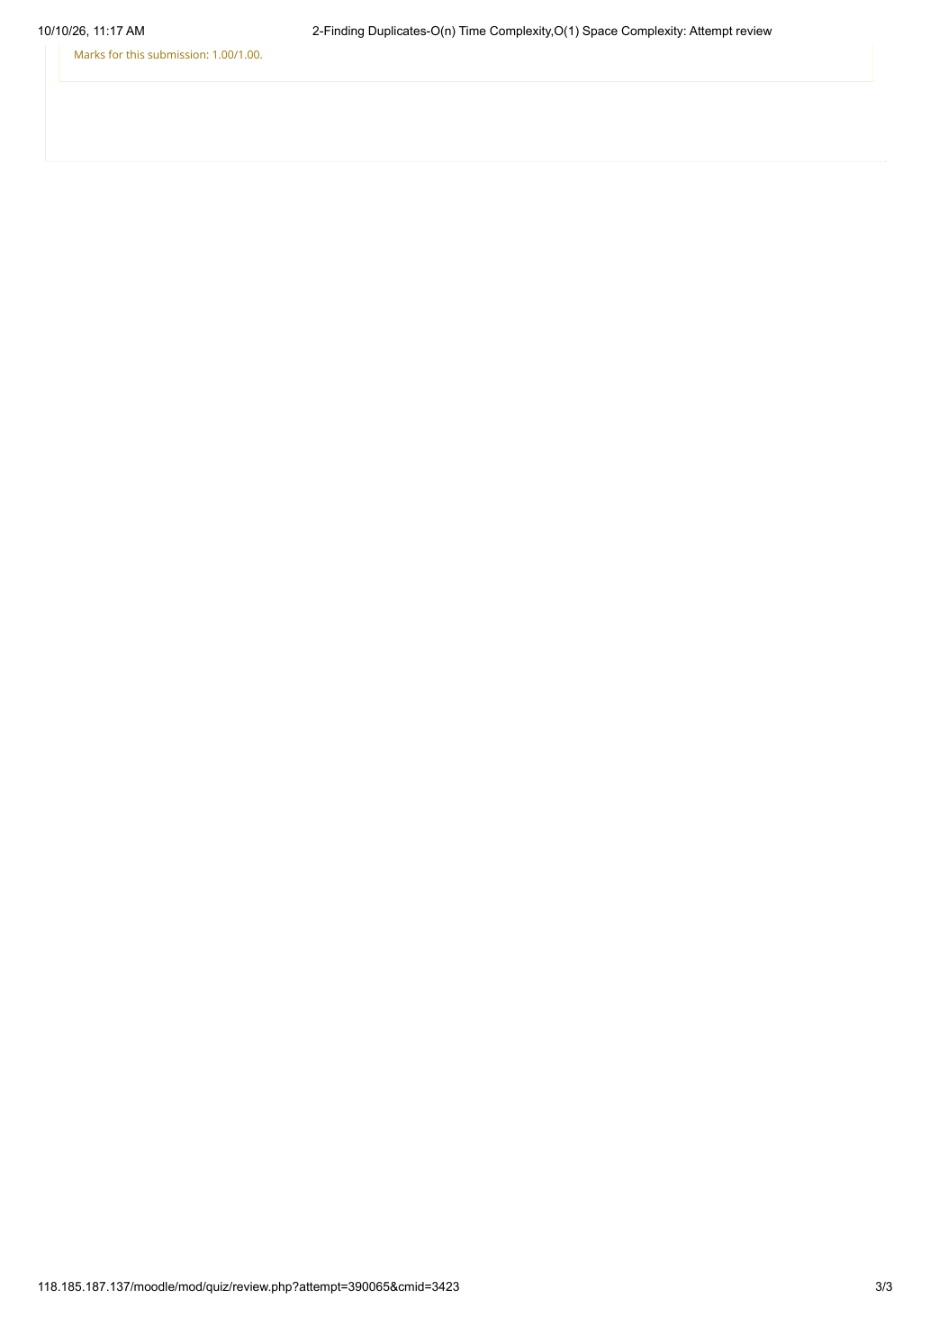

EXPERIMENT 22 — INTERSECTION OF 2 SORTED ARRAYS — O(m*n) TIME, O(1) SPACE
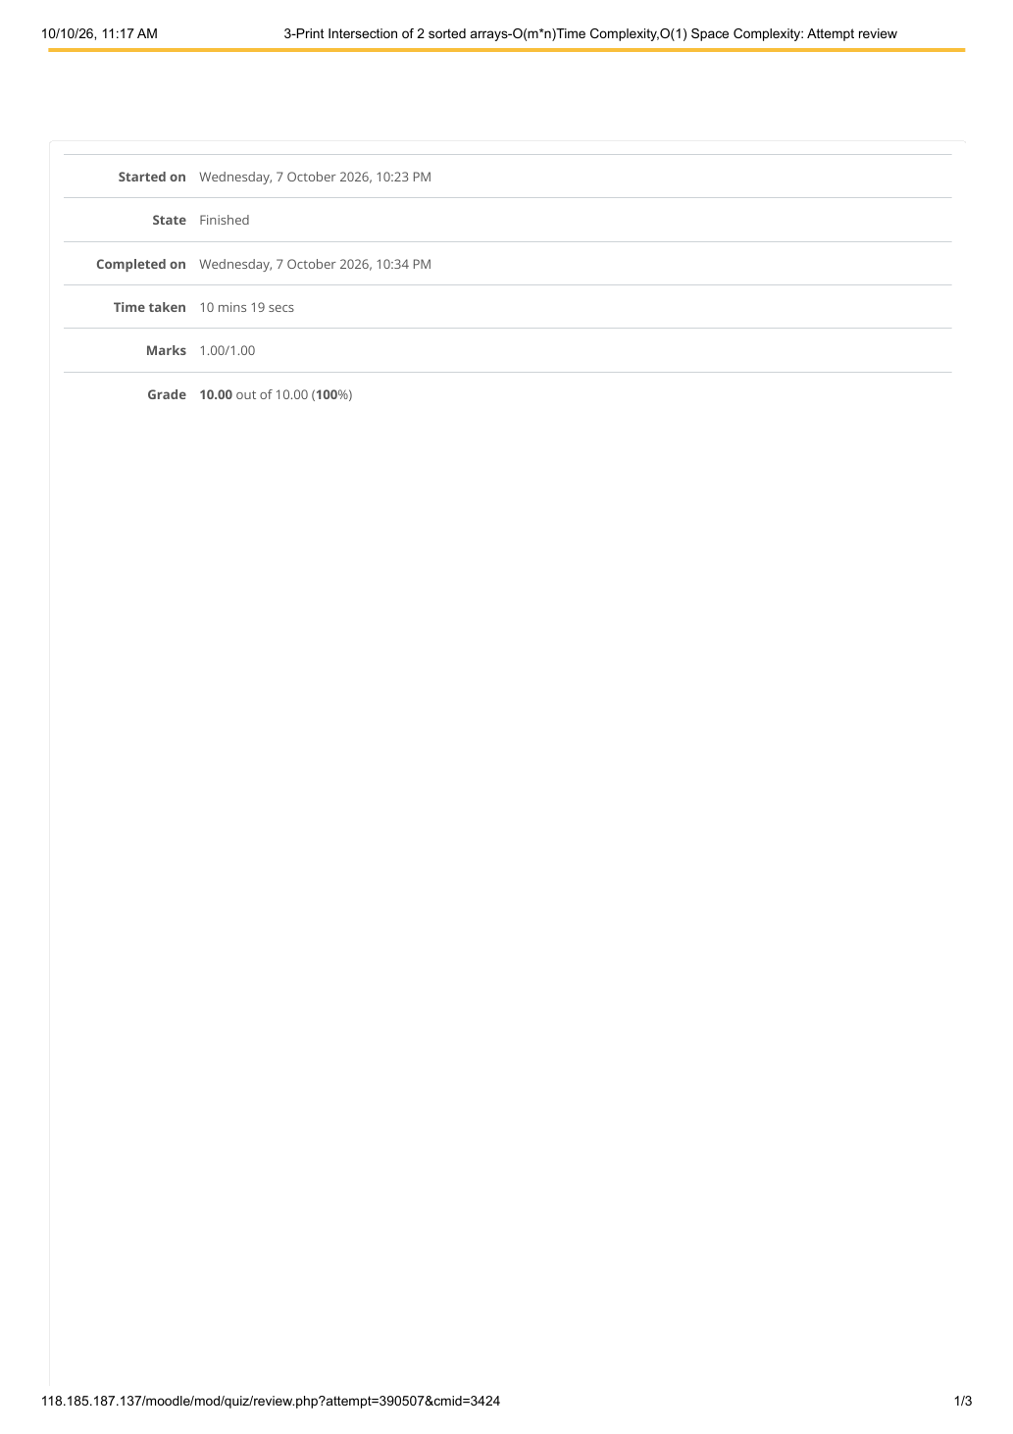

EXPERIMENT 22 — INTERSECTION OF 2 SORTED ARRAYS — O(m*n) TIME, O(1) SPACE
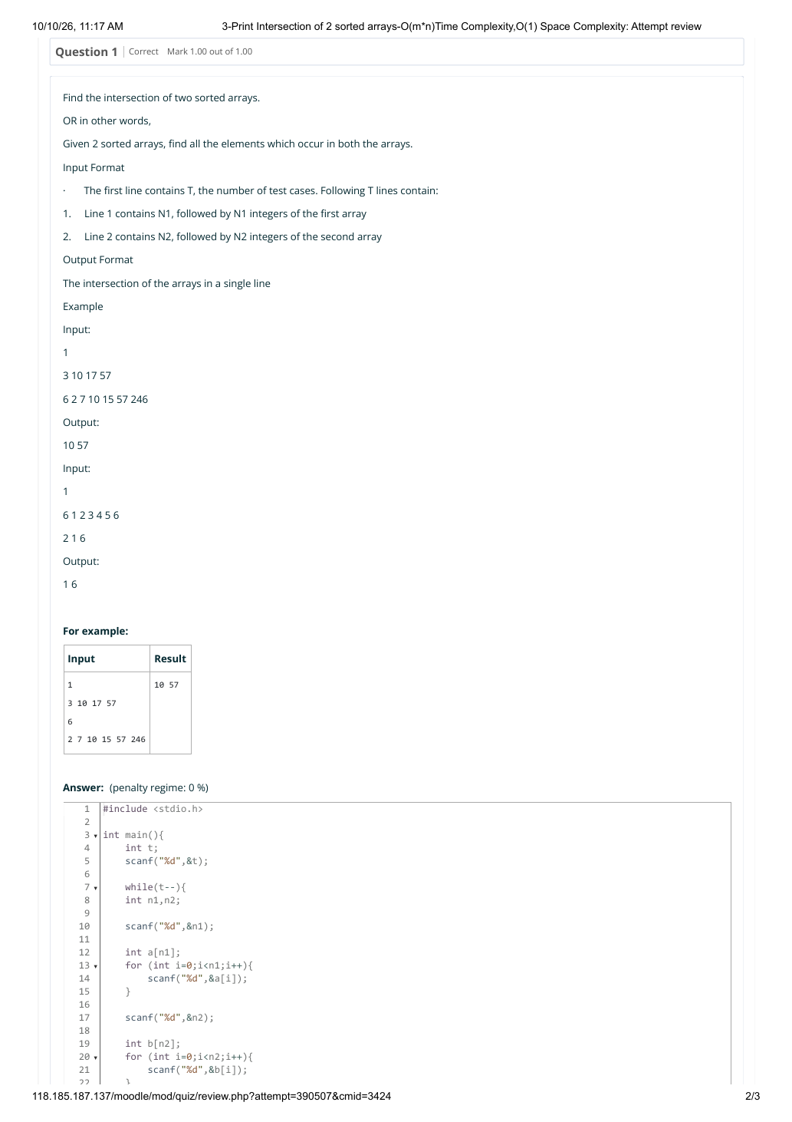

EXPERIMENT 22 — INTERSECTION OF 2 SORTED ARRAYS — O(m*n) TIME, O(1) SPACE
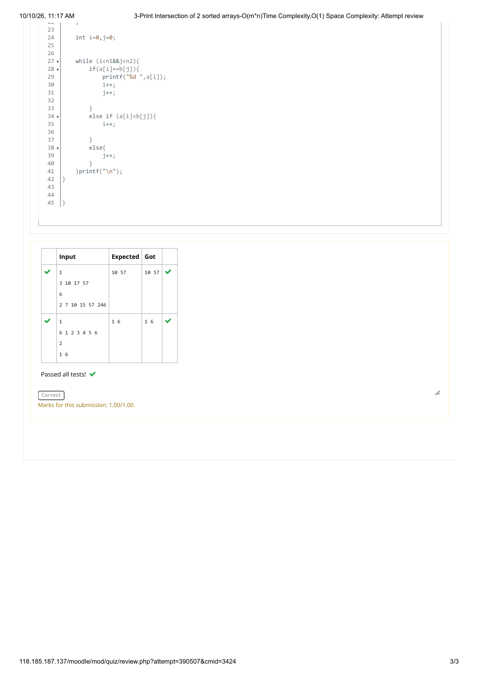

EXPERIMENT 23 — INTERSECTION OF 2 SORTED ARRAYS — O(m+n) TIME, O(1) SPACE
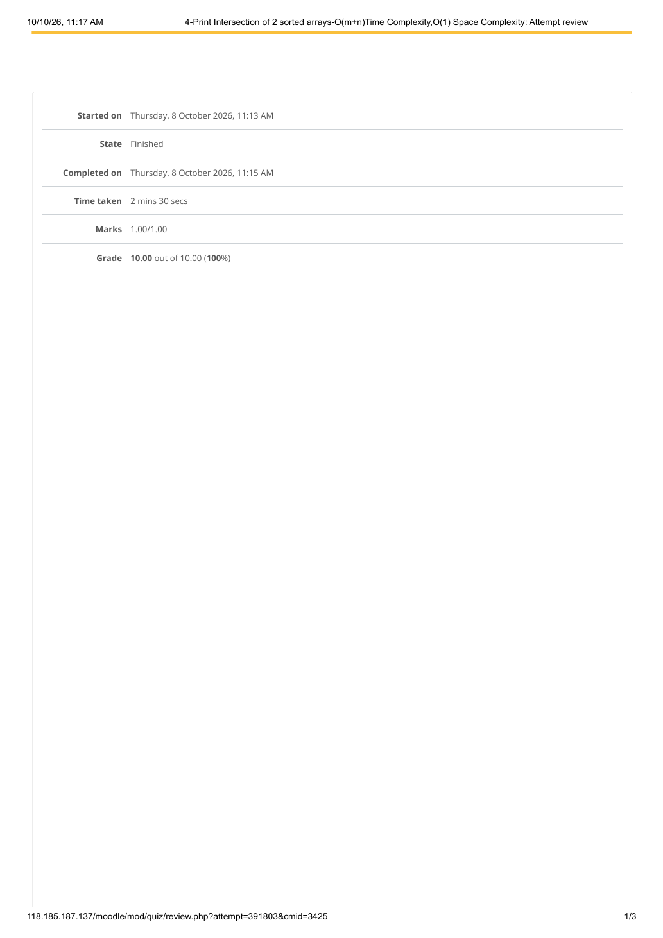

EXPERIMENT 23 — INTERSECTION OF 2 SORTED ARRAYS — O(m+n) TIME, O(1) SPACE
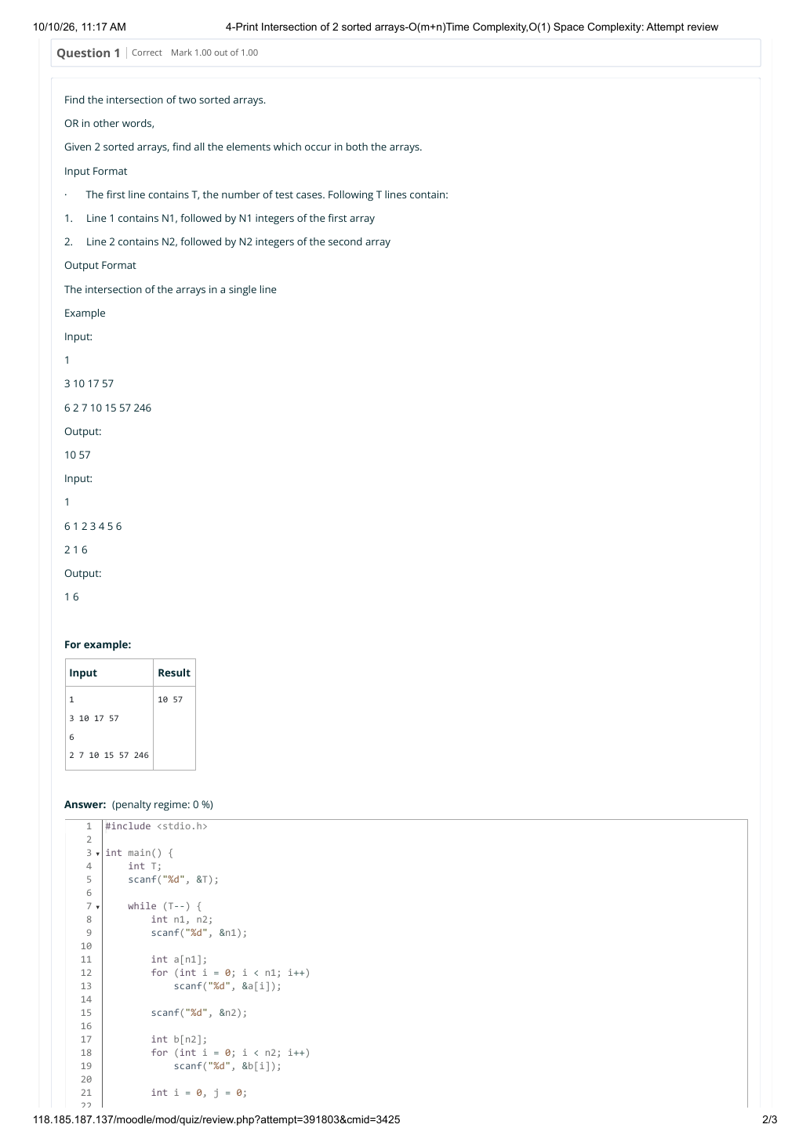

EXPERIMENT 23 — INTERSECTION OF 2 SORTED ARRAYS — O(m+n) TIME, O(1) SPACE
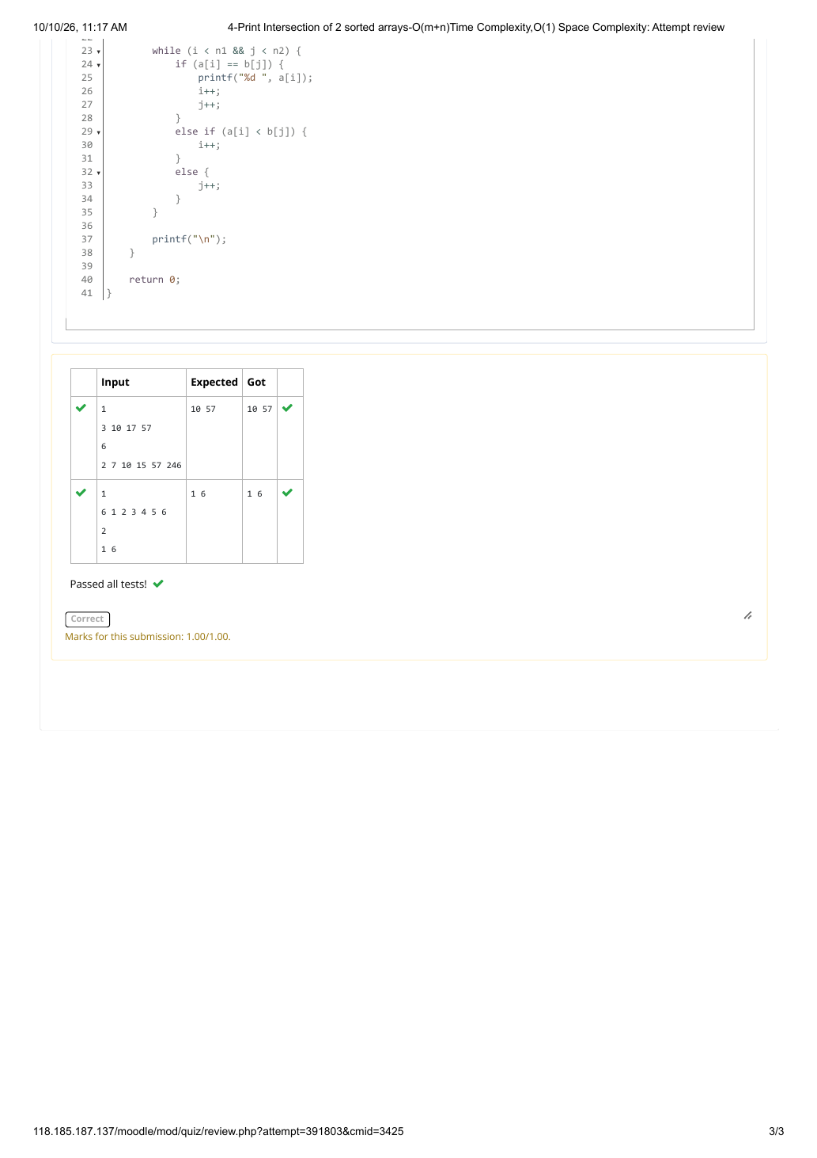

EXPERIMENT 24 — INTERSECTION OF 2 SORTED ARRAYS — O(m+n) TIME, O(1) SPACE

EXPERIMENT 24 — INTERSECTION OF 2 SORTED ARRAYS — O(m+n) TIME, O(1) SPACE

EXPERIMENT 24 — INTERSECTION OF 2 SORTED ARRAYS — O(m+n) TIME, O(1) SPACE

EXPERIMENT 25 — PAIR WITH DIFFERENCE — O(n²) TIME, O(1) SPACE
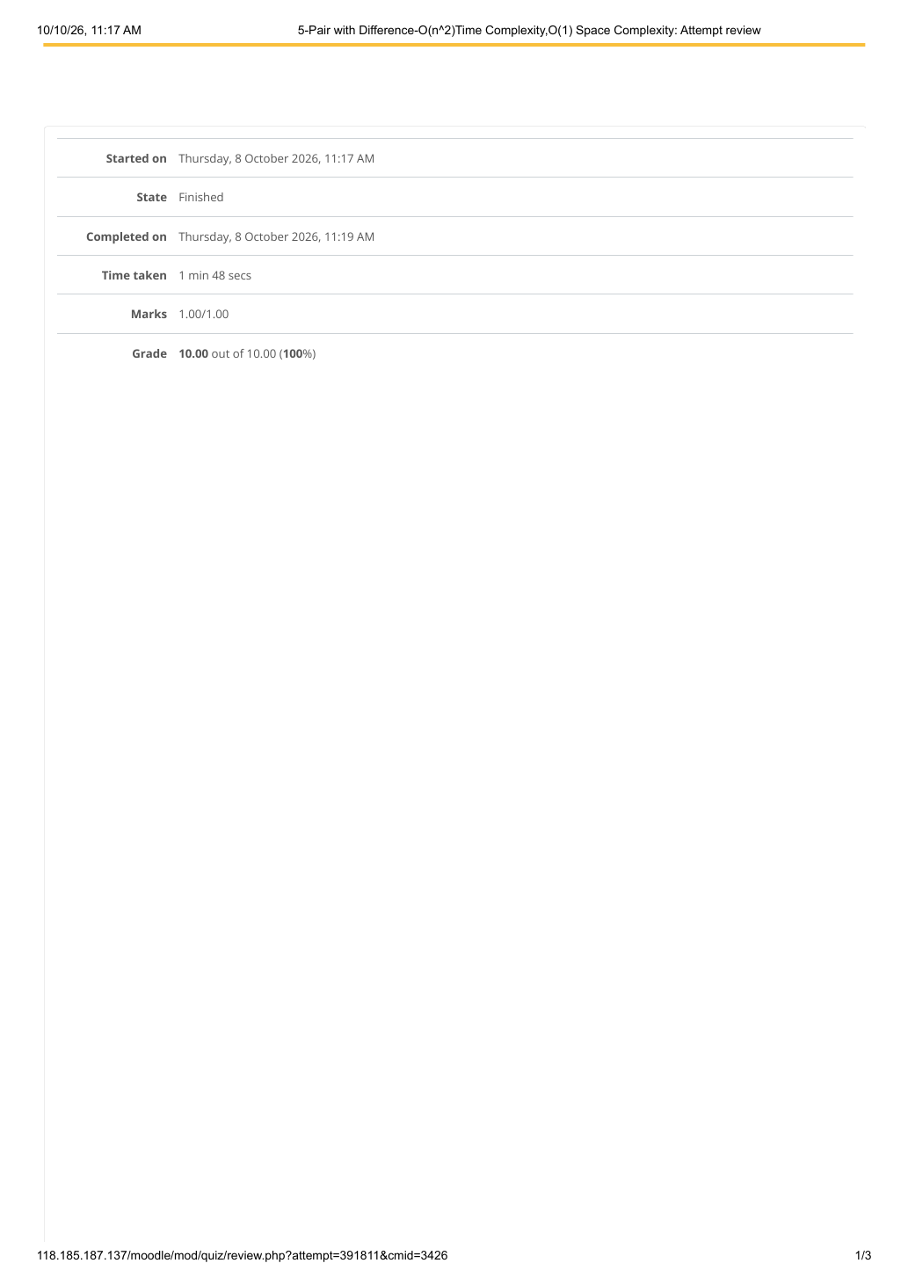

EXPERIMENT 25 — PAIR WITH DIFFERENCE — O(n²) TIME, O(1) SPACE
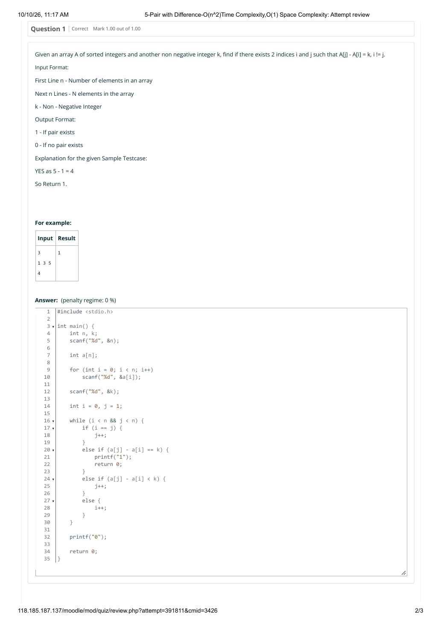

EXPERIMENT 25 — PAIR WITH DIFFERENCE — O(n²) TIME, O(1) SPACE
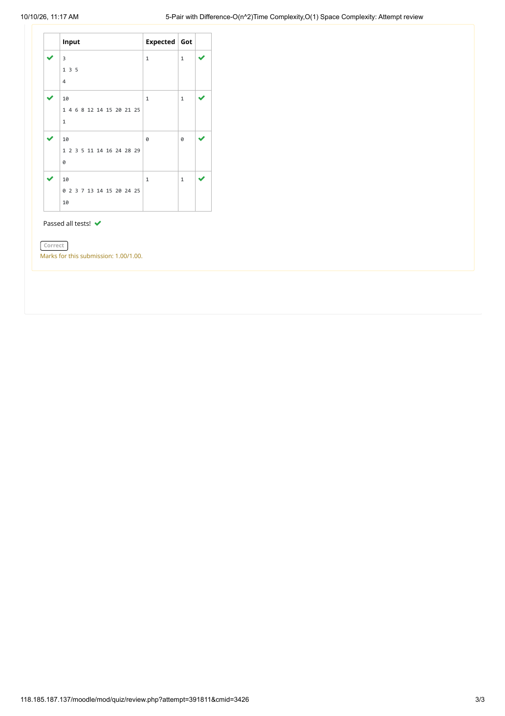

EXPERIMENT 26 — PAIR WITH DIFFERENCE — O(n) TIME, O(1) SPACE
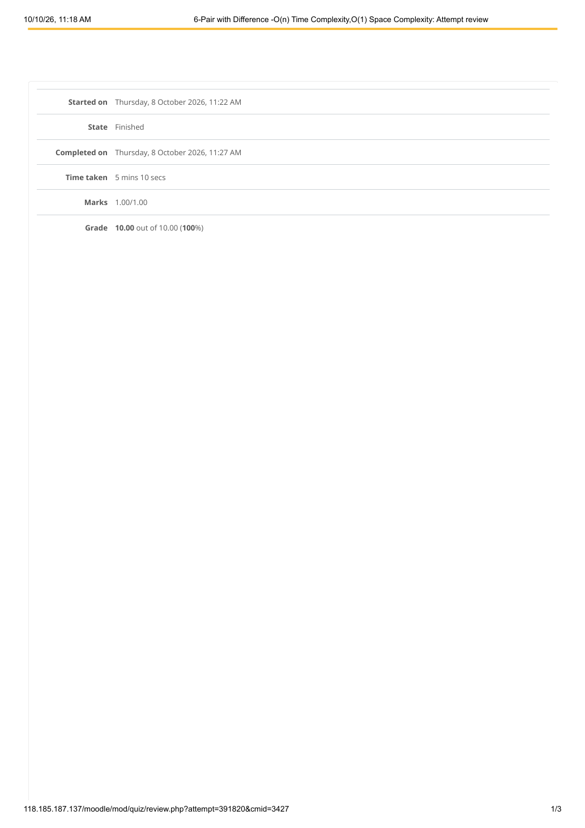

EXPERIMENT 26 — PAIR WITH DIFFERENCE — O(n) TIME, O(1) SPACE
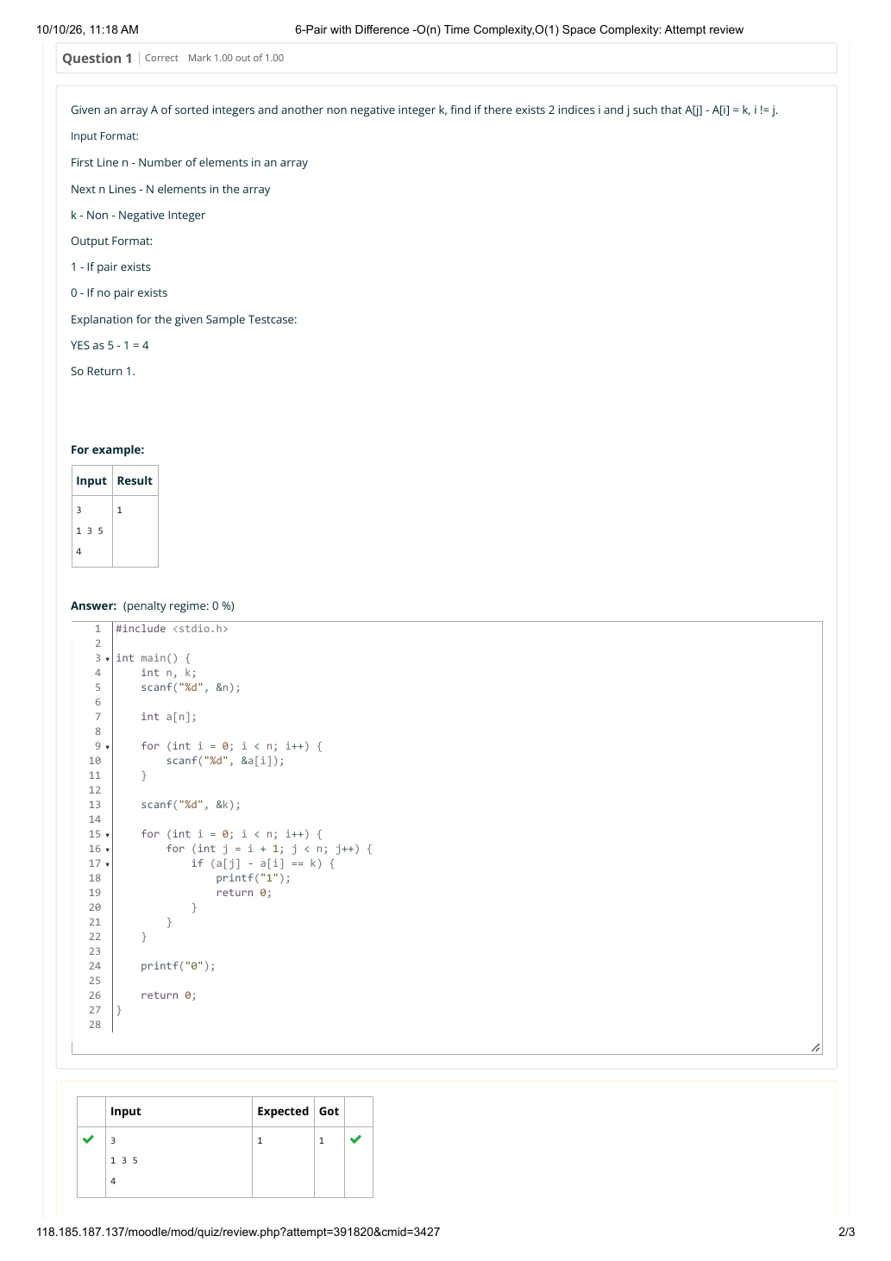

EXPERIMENT 26 — PAIR WITH DIFFERENCE — O(n) TIME, O(1) SPACE
