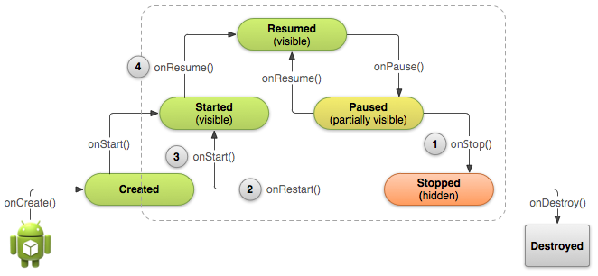

So

Caution: Your activity will be destroyed and recreated each time the user rotates the screen. When the screen changes orientation, the system destroys and recreates the foreground activity because the screen configuration has changed and your activity might need to load alternative resources (such as the layout).

So on every screen rotation time onStop and onResume will be called?
To check the flow by adding logs in source code… ☺

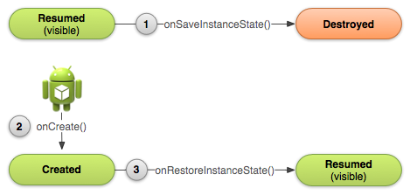

Caution: Always call the superclass implementation of onSaveInstanceState() so the default implementation can save the state of the view hierarchy.

onSaveInstanceState is called end of the method.
Can I call first it self or last only we have to call, any difference?
To check ☺

There are a few scenarios in which your activity is destroyed due to normal app behavior, such as when the user presses theBack button or your activity signals its own destruction by calling finish().

Write an application with activity that will signals its own destruction.
Just to understand how alarm screen will close the screen after some time.
Basically want to know how to kill activity without user interaction.
May use timer?
How to use timer in app?

Need to understand services more.
To check in websites
To compare camera service and audio service for better understanding.
How to create a new service and use it?

String support:
New Language support: needs to add a folder inside res/values folder with country code (like es, fr), and keep the updated “strings.xml” inside for corresponding country. (refer below)
MyProject/
res/
values/
strings.xml
values-es/
strings.xml
values-fr/
strings.xml

New string support: For new string refer below. New string should be updated in all the “strings.xml” to support in all the languages.
<?xml version="1.0" encoding="utf-8"?>
<resources>
<string name="title">My Application</string>
<string name="hello_world">Hello World!</string>
</resources>

To use the string resource:
In source code (java files):

// Get a string resource from your app's Resources
String hello = getResources().getString(R.string.hello_world);

// Or supply a string resource to a method that requires a string
TextView textView = new TextView(this);
textView.setText(R.string.hello_world);
In xml file:
<TextView
android:layout_width="wrap_content"
android:layout_height="wrap_content"
android:text="@string/hello_world" />

Supporting diff screens:

* Four generalized sizes: small, normal, large, xlarge
* Four generalized densities: low (ldpi), medium (mdpi), high (hdpi), extra high (xhdpi).

Also screen orientation is considered a variation of screen size, so app should revise the layout to optimize the user experience in each orientation.

To create diff layout: for each size and orientation combination one “main.xml” file should be there. "main.xml” file is should be kept in corresponding folder…

MyProject/
res/
layout/ # default (portrait)
main.xml
layout-land/ # landscape
main.xml
layout-large/ # large (portrait)
main.xml
layout-large-land/ # large landscape
main.xml

To create diff bitmap:

Create a folder for each density and keep images.
MyProject/
res/
drawable-xhdpi/
awesomeimage.png
drawable-hdpi/
awesomeimage.png
drawable-mdpi/
awesomeimage.png
drawable-ldpi/
awesomeimage.png
to use : @drawable/awesomeimage

SDK version:

android:minSdkVersion is to set the lowest level api, app support.
android:targetSdkVersion is to set the latest Android version available
* To allow your app to take advantage of the latest changes in android and ensure that your app fits the style of each user's device, you should set the targetSdkVersion value to match the latest Android version available.
<manifest xmlns:android="http://schemas.android.com/apk/res/android" ... >
<uses-sdk android:minSdkVersion="4" android:targetSdkVersion="15" />
...
</manifest>
To check system version on runtime:
Use “Build.VERSION.SDK_INT”
private void setUpActionBar() {
// Make sure we're running on Honeycomb or higher to use ActionBar APIs
if (Build.VERSION.SDK_INT >= Build.VERSION_CODES.HONEYCOMB) {
ActionBar actionBar = getActionBar();
actionBar.setDisplayHomeAsUpEnabled(true);
}
}
When parsing XML resources, Android ignores XML attributes that aren’t supported by the current device. So you can safely use XML attributes that are only supported by newer versions without worrying about older versions breaking when they encounter that code.

Platform style and themes:
Themes can be applied to your app within the manifest file
Ex: <activity android:theme="@android:style/Theme.Dialog">

sas

