Uploading Continue.dev Logs
Instruction for a Mac:
1. Press Cmd + Space bar and search for “Finder” or look for Finder in your dock and open it
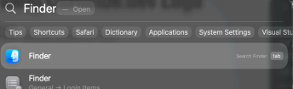
2. Once inside Finder, Press Cmd + Shift + G and type ~/.continue and press Return: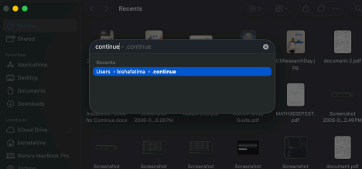
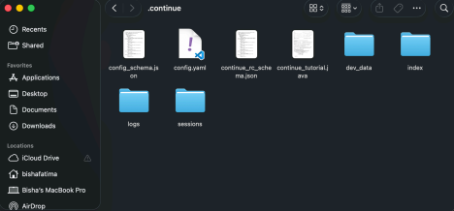This is should open when Enter is pressed:
3. Click on Sessions and upload the log file from there
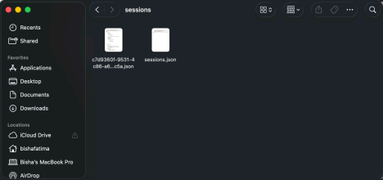Upload this file
Note: If Finder is not able to locate the .continue directory, go to your username and look for the .continue directory
Instructions for a Windows:
1. Click on This PC in the left sidebar.
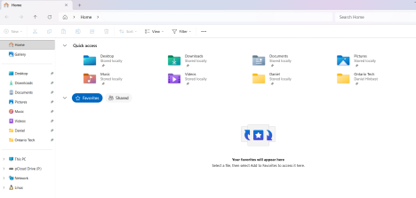2. Open your Local Disk (C:).
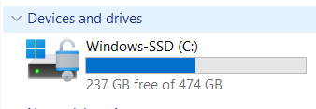
3. Open the Users folder.
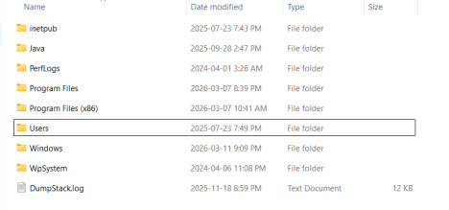
4. Open the folder with your username (e.g., JohnDoe).
5. Look for a folder named .continue (Notice the dot at the beginning).
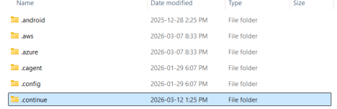6. Open the sessions folder.
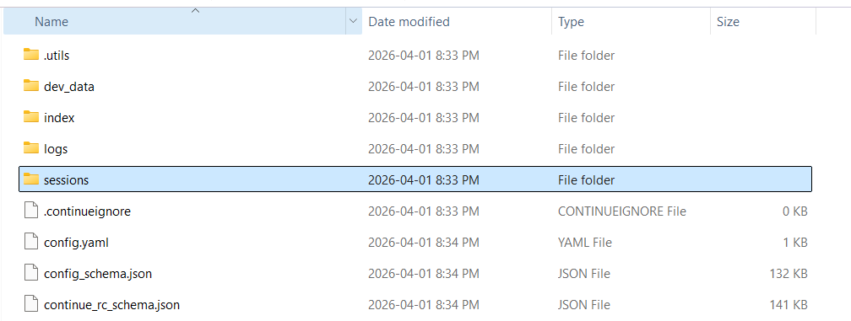
7. Upload the json file with multiple characters.
