Installation Guide for Continue.dev
1. Open up IntelliJ on your laptop
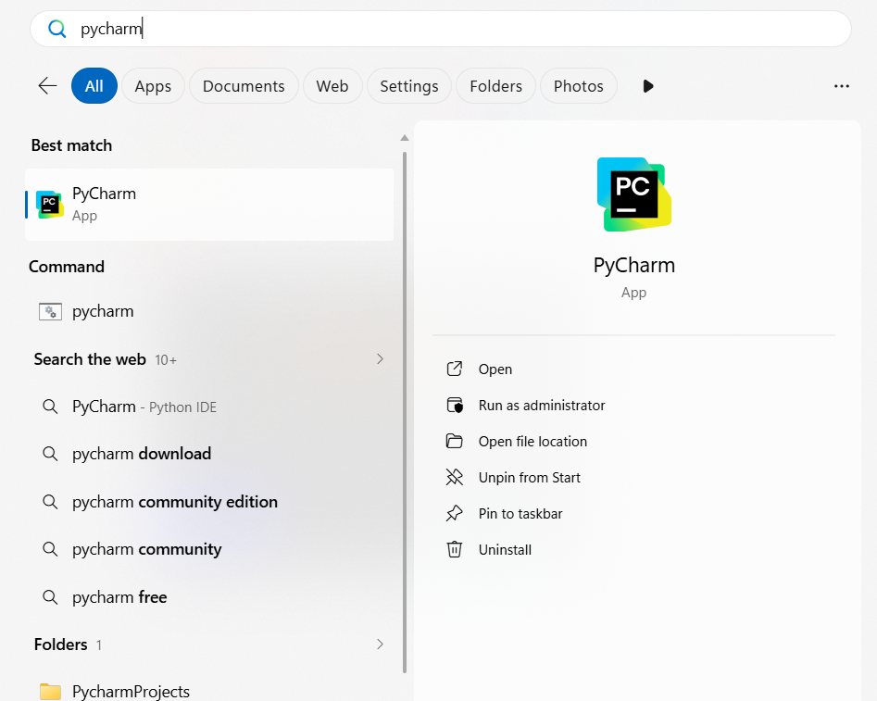2.
Click the gear icon to open the ‘Plugins’ menu in PyCharm
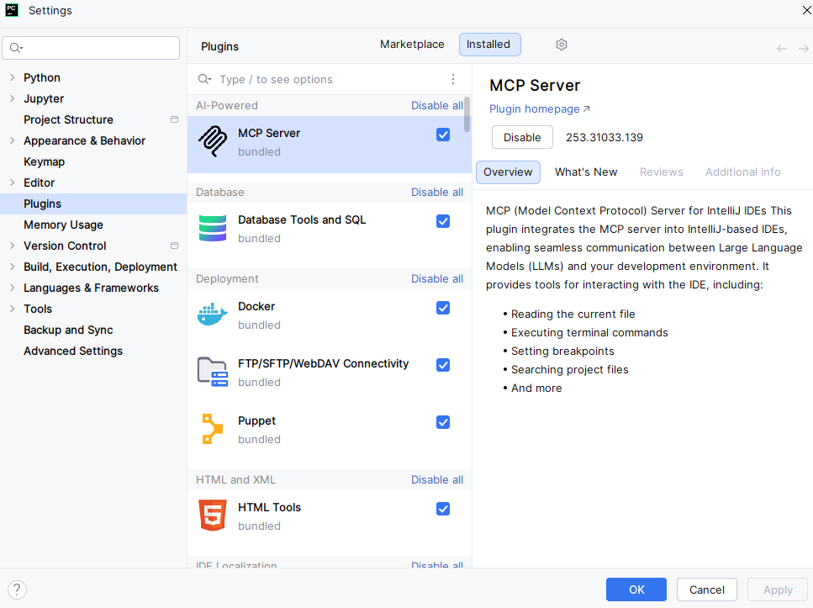
Switch to ‘Marketplace’ and search for ‘Continue’ in the search bar
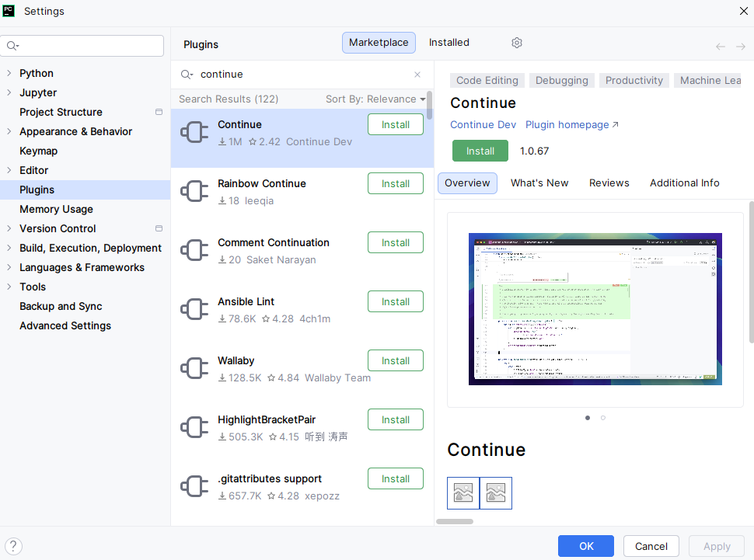5. Click ‘Install’ to add the plugin
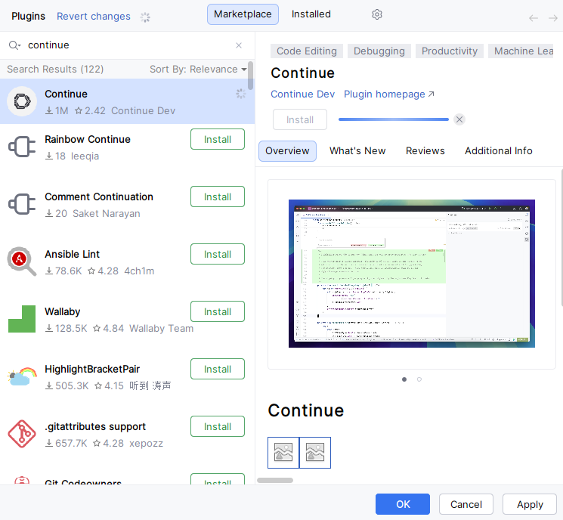
6. After Installation, click ‘OK’. The Plugins menu will close and Continue will appear on the sidebar on the right

8. Click on the ‘Continue.dev’ Plugin to set it up, something similar to the image below should open up
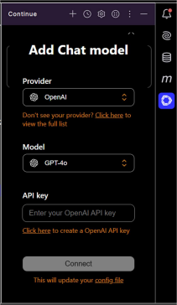
An API key will be provided to you, select OpenAI and GPT-4o and enter the API key provided to begin using the in-IDE AI coding assistant.
You are encouraged to use the context reference for files (using ‘@’ ) and reference previous prompts (using ‘/’). More information on how to optimally use Continue.dev can be found at : How to Use Continue.dev AI IDE
