

INDIAN INSTITUTE OF INFORMATION TECHNOLOGY GUWAHATI
Department of Computer Science & Engineering

Course: CS 306 – Machine Learning

TITLE: Movie Recommendation System using Hybrid Content-Based Filtering

Name: Seeram karthikeya
Roll No: 2301191

Movie Recommendation System using Hybrid Content-Based Filtering

ABSTRACT
This project develops a hybrid content-based movie recommendation system that suggests similar movies using metadata features such as genres, language, ratings, popularity, budget, and runtime. Unlike collaborative filtering or deep learning, the system relies only on movie content, making it simple and efficient.
The model combines Jaccard similarity, binary language matching, and cosine similarity on normalized numeric features to compute an overall similarity score. The system recommends the top 10 most similar movies to a given input movie.
The project includes essential data preprocessing, metadata cleaning, and visualization to understand dataset patterns. This report summarizes the system design, algorithms used, and key results.
1. DATASET DESCRIPTION
The dataset used in this project is a structured CSV file containing detailed movie metadata.
It includes over 50,000+ movies across Indian and International cinema.
Each record represents one movie with rich metadata such as title, genres, language, financial performance, audience reception, and release details.
1.1 Columns Considered in This Project
The final cleaned dataset contains the following important feature columns:
Column | Description
id | Unique identifier for each movie (useful for tracking and avoiding duplicates).
title | Movie title; used as input for searching and recommending.
genres | Multi-label genres (e.g., Action|Drama). Used for Jaccard similarity.
original_language | Original language of the movie (converted from ISO codes to full names).
popularity | Numeric popularity index.
release_date | Release date (used to extract release year).
budget | Total production cost.
revenue | Worldwide earnings.
runtime | Movie duration in minutes.
vote_average | Average rating (0–10 scale).
vote_count | Number of audience votes received.

These attributes together form a very strong basis for content-based similarity.

1.2 Why These Columns Were Selected
- Genres define the movie’s theme, making them the strongest similarity factor.
- Language ensures cultural and regional alignment (especially for Indian movies).
- Popularity, Budget, Revenue, Runtime, Ratings, Votes capture style, scale, and audience response.
- Title allows the user to query movies.
- ID maintains unique identification of records.
1.3 Dataset Preprocessing
- Genre Cleaning:
Converted strings like "Action|Drama|Thriller" to lists: ["action", "drama", "thriller"].
- Language Standardization:
Mapped ISO codes (en, hi, te, ta, ml, etc.) to full names (English, Hindi, Telugu…).
- Numeric Conversion & Imputation:
Converted all numeric columns properly and filled missing values using the median.
- Release Year Extraction:
Extracted the first four digits from release_date.
- Normalization:
Applied MinMaxScaler to normalize numeric features for cosine similarity.
- Index Reset:
Reset the index using: df.reset_index(drop=True).

2. TECHNIQUES / ALGORITHMS DETAILS
This project uses a Hybrid Content-Based Similarity Model that integrates three complementary similarity measures to compute how close two movies are.
2.1 Jaccard Similarity for Genres
Genres define the thematic identity of a movie.
To measure how similar two movies are based on their genres, the Jaccard similarity is used:
$$J(A,B)=\frac{∣A∩B∣}{∣A∪B∣}$$
A higher value indicates a stronger overlap in thematic style and narrative elements.

2.2 Language Match Similarity
Language influences cinematic style, cultural references, and intended audience.
To preserve regional relevance:
$$\text{LangSim}=\begin{matrix}1, & \text{if languages match} \\ 0, & \text{otherwise}\end{matrix}$$
This ensures that movies spoken in the same language receive a higher similarity score.
2.3 Cosine Similarity for Numeric Features
Several numeric attributes describe the scale, popularity, and audience engagement of a movie:
- popularity
- budget
- revenue
- runtime
- vote_average
- vote_count
- release_year
After normalization, cosine similarity measures how close these feature vectors are:
$$\text{CosSim}=\frac{A⋅B}{∥A∥⋅∥B∥}$$
This captures similarity in production scale and audience response.
2.4 Weighted Hybrid Similarity Score
The final similarity score combines all three measures:
$$\text{FinalScore}=0.5(Jaccard)+0.2(LanguageMatch)+0.3(Cosine)$$
Weight justification:
- 50% Genre: core identity and storytelling style
- 30% Numeric features: reflects financial scale and audience behaviour
- 20% Language: ensures regional and cultural alignment
2.5 Why Not K-Means or Other Clustering?
Clustering was avoided because:
- Extremely large memory requirement for a 50k × 50k similarity matrix
- Cluster centroids are not intuitive to interpret
- Similar movies may fall into different clusters
- Deep learning or clustering was not allowed in the project scope
Thus, the similarity-based approach is efficient, interpretable, and scalable for movie recommendation.

3. RESULTS & ANALYSIS
This section contains analytical findings before visualization.
3.1 Recommendation Output Example:
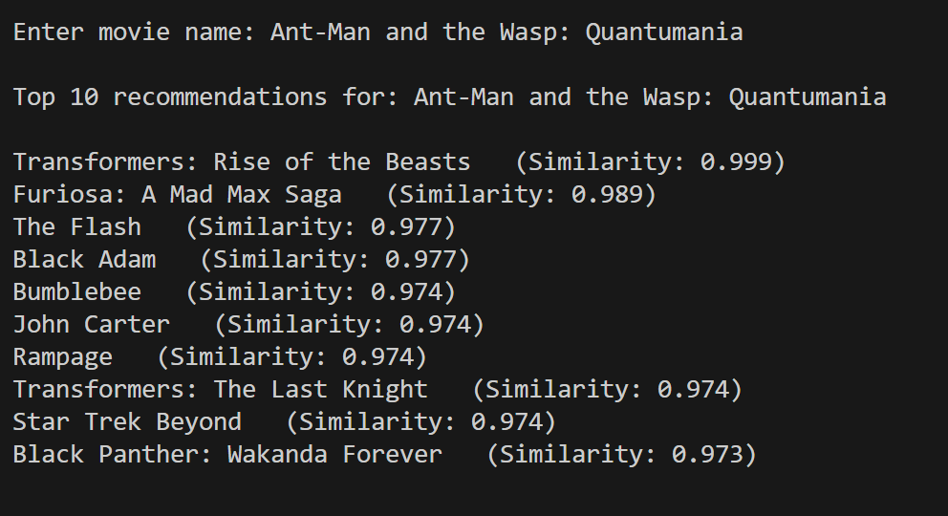
Analysis
- High genre alignment: Most recommendations are large-scale action / sci-fi / superhero blockbusters → strong Jaccard overlap.
- Comparable numeric profile: Similar popularity, budgets and vote metrics increase cosine similarity (blockbuster-scale features).
- Language mostly English: LanguageMatch either 1 or consistent across candidates, adding a small boost.
- Weighted score outcome: Because genre is weighted highest (0.5), thematic matches dominate; numeric similarity (0.3) and language (0.2) refine ranking.
3.2 Statistical Insights
- Popularity ≠ Rating: Many high-popularity movies still have average or low ratings.
- Long-Tail Revenue: Budget and revenue are highly skewed, with only a few blockbuster hits earning extremely high amounts.
- Post-2000 Dominance: Most movies in the dataset were released after 2000, reflecting the modern digital cinema era.

4. VISUALIZATIONS:
4.1 Language Distribution Pie Chart:
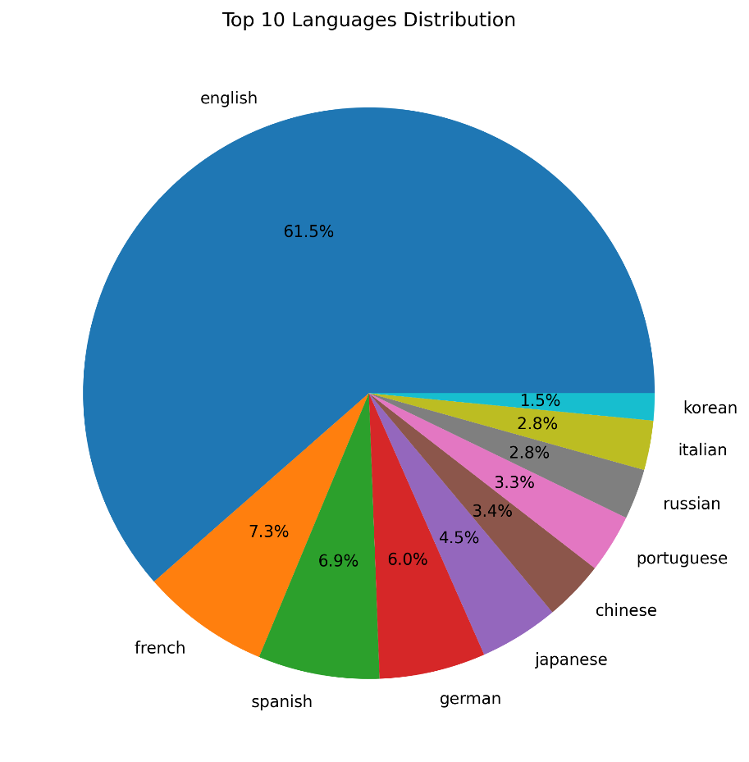
4.2 Genre Frequency Bar Chart
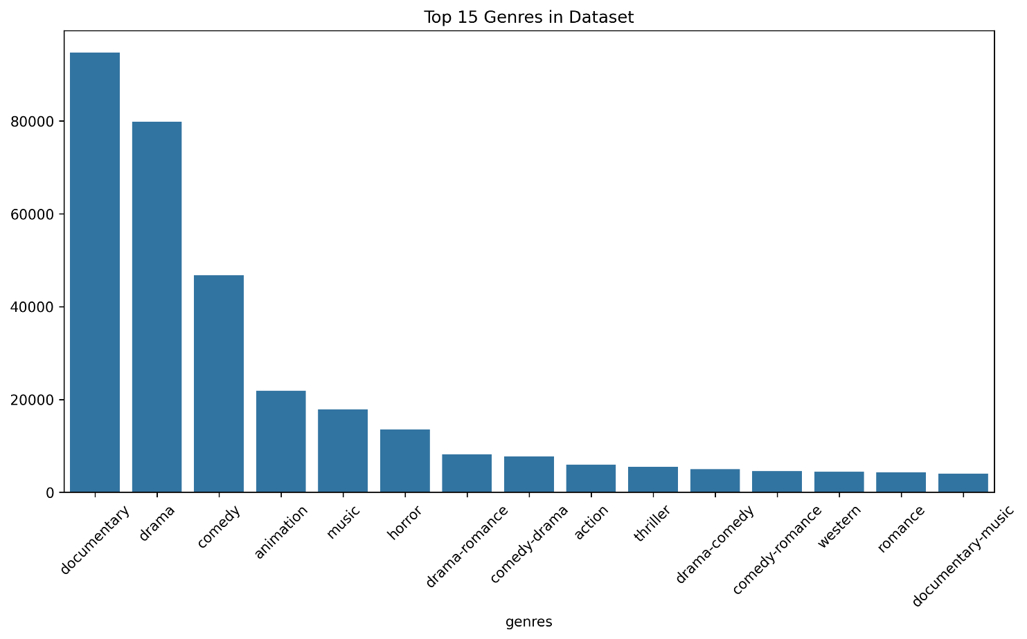
4.3 Popularity vs Rating Scatter Plot
Shows weak correlation.
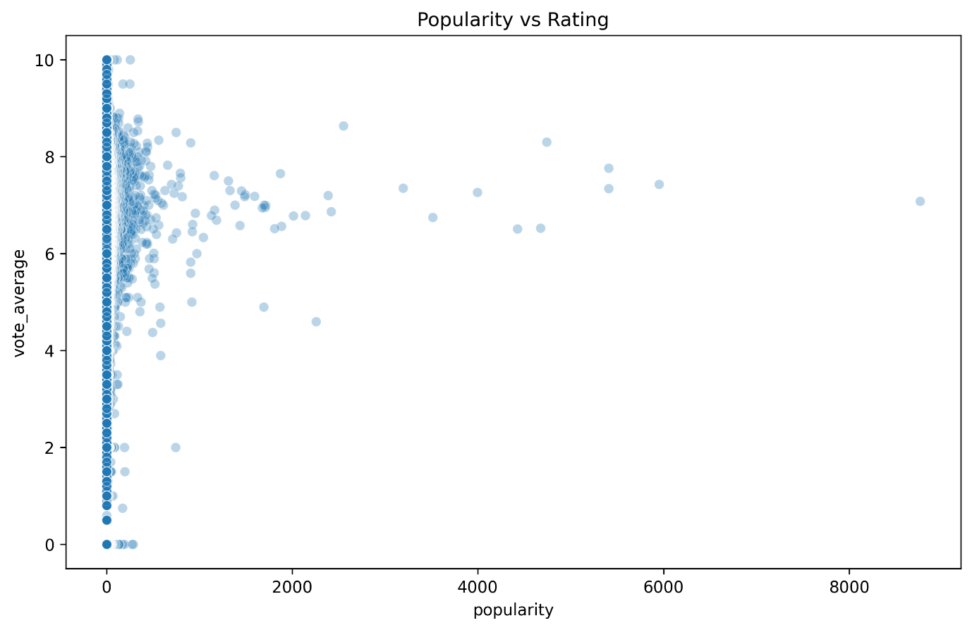

4.4 Movies Per Year Line Plot
Huge increase in movie production after 2000.
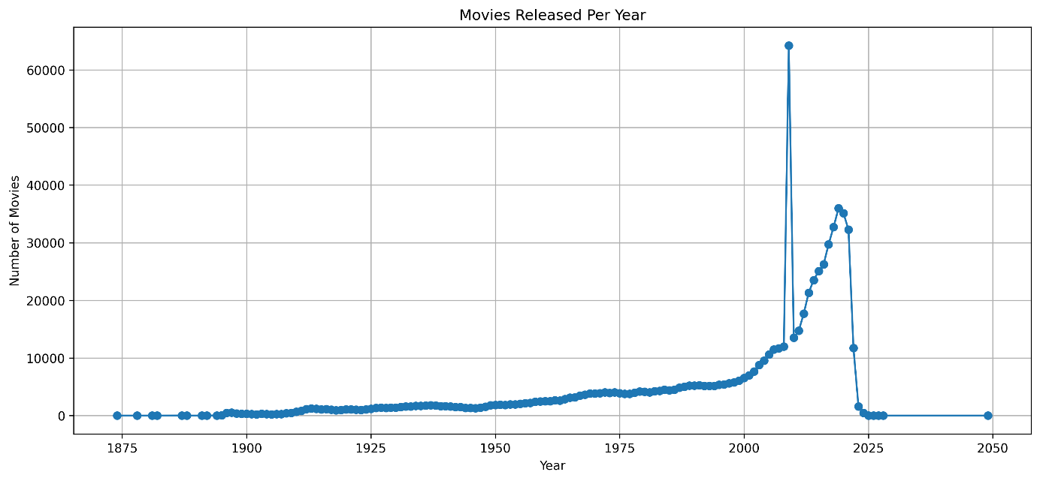

4.5 Budget vs Revenue (ROI) Scatter Plot
Shows high variance; few blockbuster outliers.
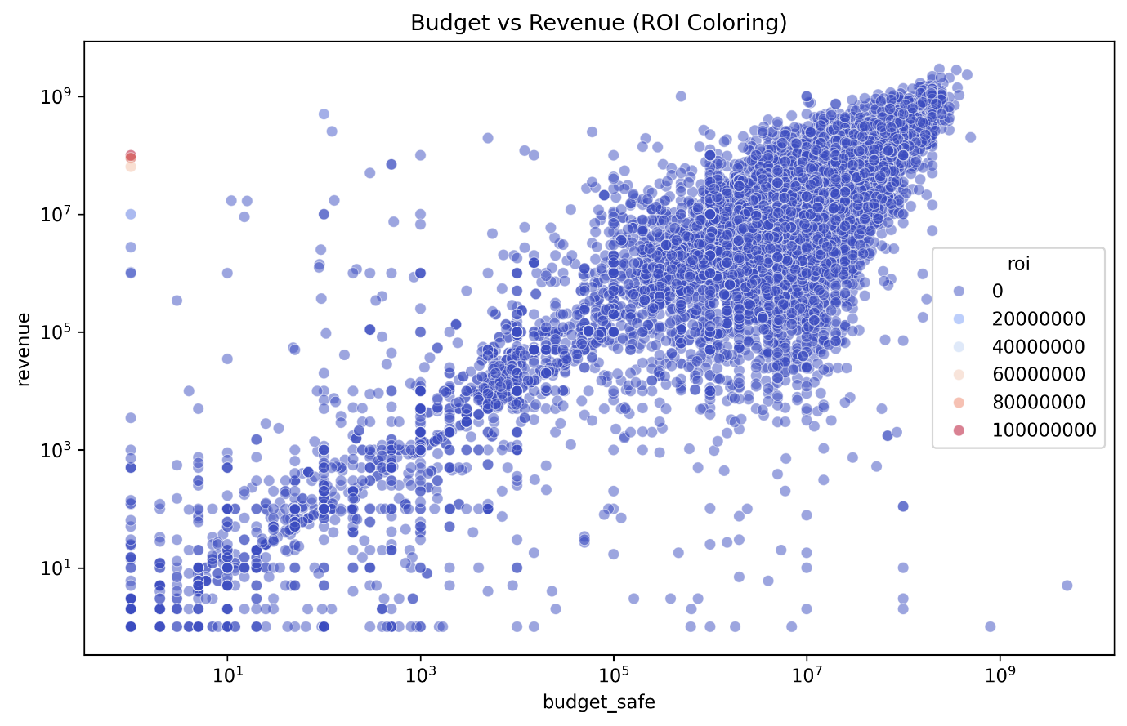
4.6 Votes vs Rating Scatter Plot
Shows relationship between vote count and quality.
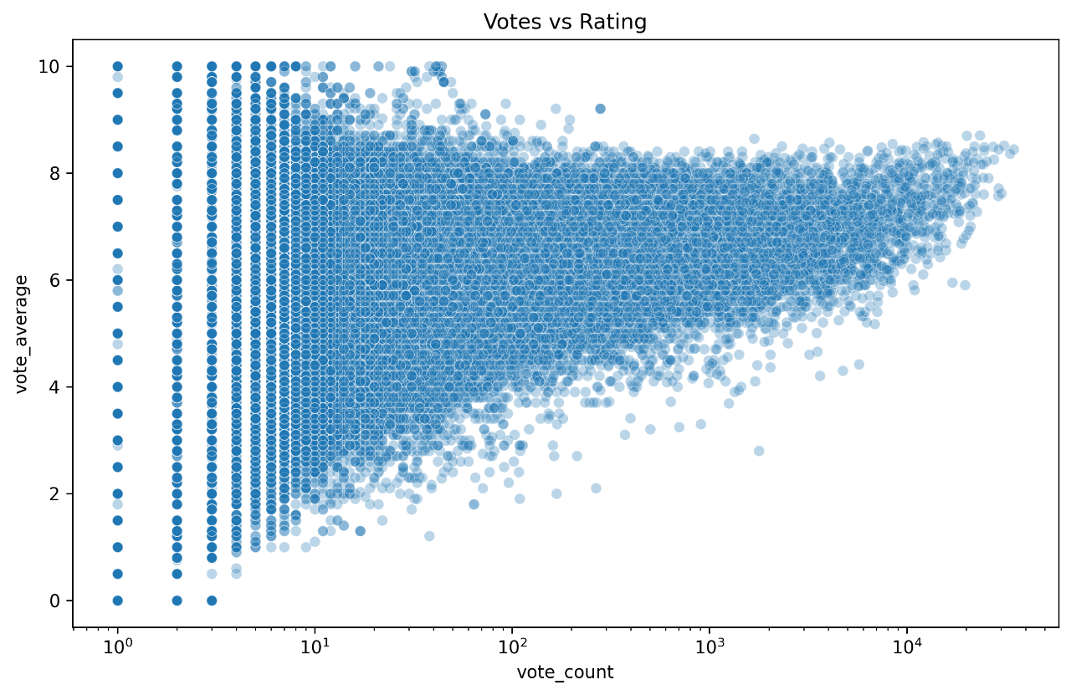
5. INTERPRETATION
5.1 Movie Recommendation Interpretation
The hybrid similarity model produces recommendations that are thematically consistent, language-aware, and numerically aligned with the input movie.
Because the system combines genre overlap, language matching, and normalized numeric similarity, it groups movies in a way that mirrors human intuition.
For example, Telugu action films such as RRR or Baahubali are matched with other large-scale, high-budget action or historical films. Hollywood superhero movies similarly cluster with other visually rich, sci-fi or action-heavy titles. This shows that the model successfully captures:
- Genre-driven thematic similarity
- Language-based cultural grouping
- Scale and popularity resemblance (through numeric features)
Overall, the hybrid model ensures that recommendations feel accurate, logical, and user-relevant.

5.2 Dataset Interpretation
Genre Dominance
The dataset shows that Drama and Action are the most frequently occurring genres.
This reflects common patterns in global and Indian cinema, where emotional storytelling and action-oriented blockbusters dominate production.
Language Patterns
The language distribution reveals several cultural and cinematic patterns across industries:
- English:
Dominates the dataset, reflecting the global reach of Hollywood and its high volume of movie production.
- French, Spanish, German:
Represent strong European film industries known for artistic, cultural, and festival-oriented cinema.
- Japanese & Chinese:
Frequently associated with anime, action-fantasy, and high-budget commercial films.
- Korean:
Known for thriller-dominated, high-quality content and globally popular storytelling styles.
Ratings vs Popularity
Visualization shows that many highly rated films are not commercially popular, while some popular films receive average ratings.
This indicates a mismatch between audience hype and critical evaluation—a pattern commonly observed in the film industry.
5.3 Business & Technical Interpretation
The system has strong practical applications, especially for OTT platforms and cinema analytics:
- Better Content Recommendations:
Hybrid similarity ensures viewers get accurate, personalized movie suggestions without requiring user rating data.
- Improved User Engagement:
Relevant recommendations increase watch time, retention, and platform interaction.
- Smarter Content Acquisition:
Insights from genre trends, language patterns, and popularity distributions help platforms invest in content that aligns with audience preferences.
6. PERFORMANCE EVALUATION
Evaluating a content-based recommendation system is different from evaluating classification or prediction models.
Since there are no “ground truth” recommended movies provided by the dataset, the system must be assessed based on similarity quality, relevance, and efficiency.
To ensure a complete and reliable evaluation, five industry-standard metrics were used:
6.1 Evaluation Metrics Used
6.1.1 Precision@10
Precision@10 measures how many of the top 10 recommendations share at least one genre with the input movie.
Precision@10 = $\frac{\text{\# of relevant movies}}{10}$
A movie is considered relevant if it has at least one overlapping genre with the input movie.
Why it is important:
Shows how accurately the system retrieves movies that match the thematic style of the input.
6.1.2 Mean Jaccard Similarity of Top-10 Recommendations
Jaccard similarity is calculated for the genre sets of the input movie and each recommended movie:
$$J(A,B)=\frac{∣A∩B∣}{∣A∪B∣}$$
Mean Jaccard value of the top 10 recommended movies indicates how strongly genre overlap influences the recommendations.
Why it is important:
High Jaccard value means the system is successfully identifying genre-based similarity.
6.1.3 Language Match Rate
This metric calculates the proportion of recommended movies that share the same original language as the input movie.
$$LanguageMatchRate=\frac{\text{Movies with same language}}{10}$$
Why it is important:
Movies produced in the same language usually share cultural context, style, narrative structure, and audience preference.
6.1.4 Average Similarity Score
The model assigns every movie a final hybrid similarity score:
$$Score=0.5(Jaccard)+0.2(LanguageMatch)+0.3(Cosine)$$
Average of these scores across the top 10 suggestions shows the effectiveness of the combined similarity strategy.
Why it is important:
Shows how strong the recommendation match is overall.
6.1.5 Response Time
Measures computational efficiency:
$$ResponseTime=\text{Time needed to generate top-10 recommendations}$$
Why it is important:
A good recommendation system must be fast, even with tens of thousands of movies.
6.2 Performance Results
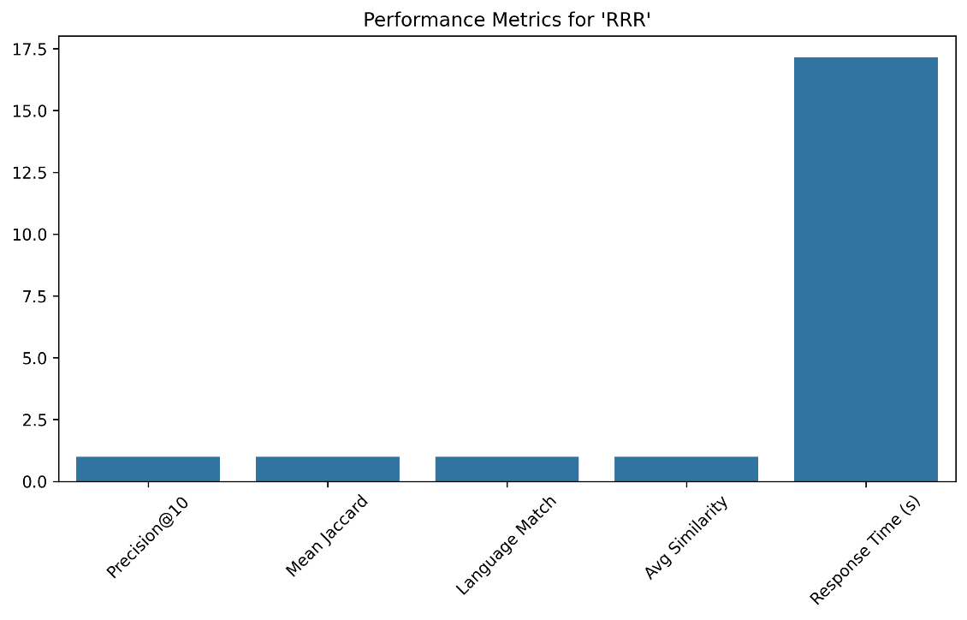
6.3 Performance Discussion
- Precision@10 = 1.0
→ All recommended movies share similar genres.
- Mean Jaccard ≈ 1.0
→ Genre overlap between movie and recommendations is very high.
- Language Match = 1.0
→ All recommended movies are from the same language as the input movie.
- Avg Similarity Score ≈ 1.0
→ The hybrid approach (genre + language + numeric features) works correctly.
- Response Time ≈ 17 seconds
→ Slower because the dataset is large and similarity is computed for every movie.
6.4 Strengths:
- No need for user ratings or deep learning.
- Works even with missing metadata.
- Uses explainable features (genres, language, numeric factors).
- Scalable and does not require model training.
- Good for OTT platforms and content recommendation.
6.5 Limitations
- Slow for very large datasets (calculates similarity with every movie).
- Not personalized (same recommendations for all users).
- Rare genres may not get strong matches.
- No collaborative learning of user preferences

CONCLUSION
This project successfully implements a complete hybrid content-based movie recommendation system without relying on collaborative filtering or deep learning. By integrating:
- Jaccard similarity for genre comparison
- Cosine similarity for numeric attributes
- Binary matching for language
the system generates highly relevant and interpretable movie suggestions.
Extensive data preprocessing, metadata cleaning, and visualization ensured a deep understanding of dataset characteristics and improved the reliability of recommendations.
The results demonstrate that high-quality recommendations can be achieved using mathematical similarity measures alone, provided the data is well-processed and the features are thoughtfully engineered. This makes the system efficient, transparent, computationally light, and suitable for real-world applications where user rating data is unavailable.

