1. “Name of employee  work in deptno   with the job_Id”  use last_name  coloum



1. Employees who joined in the  year  2000

select concat(first_name,last_name),hire_date from employees where date_format(hire_date,"%Y") = 2000;

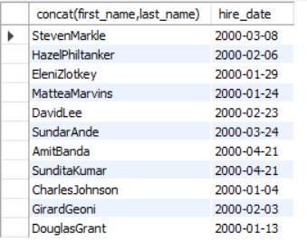

1. Emploees who joined in  after jan_1996

select concat(first_name,last_name),hire_date from employees where date_format(hire_date,"%m") > 01 and date_format(hire_date,"%Y") > 1996;

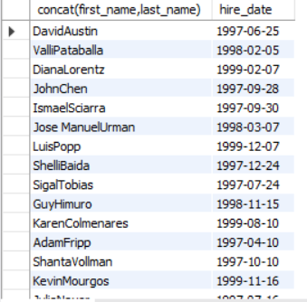

1. Employess  whose name starts between  ‘S’ to ‘R’ staring with s or r

select first_name from employees where first_name LIKE "s%" OR first_name LIKE "r%";

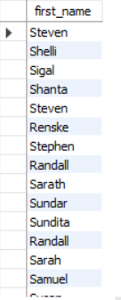

1. Employees who works under manger_id (200,201)

select concat(first_name,last_name),manager_id from employees where manager_id in (200,201);

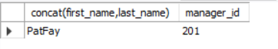

1. Employees who are “REP”(representatives) or “MAN”(salesmans) and who are paid more than 6000

select concat(first_name,last_name),job_id,salary from employees where job_id LIKE "SA_REP" or job_id LIKE "SA_MAN" and salary > 6000;

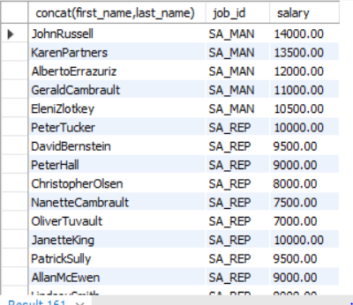

1. Calculate annual salary of each employee and print them in descending order

select last_name,salary*12 from employees order by salary desc;

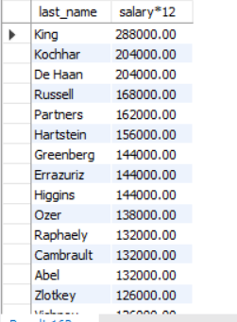

1. Replace the  last_name  of “Landry”  to “JOE” in the employee table

select replace(last_name,"landry","Joey") as replaced from employees where last_name="landry";



1. Find the position of first occurance of the character ‘o’  in the last_name  of all employees who have ‘o’  in their last_name.

select last_name,instr(last_name,'o') as position from employees where last_name like '%o%';

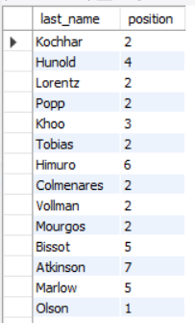

1. Prefix “2020_B84” for employee last_names who works in department 90.

Select concat(“2020_B84 ”last-name) “concated from employees where department_id=90;



1. Find the current date with local  date and time

select current_timestamp();



1. Find the average commission paid for all  the employees (ignoring the null entries)

select avg(commission_pct) from employees where commission_pct is not null;



1. Find the average  and highest salary paid for department 80,90,100.

select avg(salary),max(salary),department_id from employees group by department_id having department_id>=80 and department_id<=100 order by department_id;

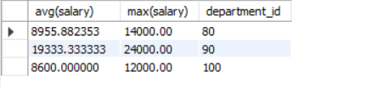

1. Find the department id    where  the highest paid employee salary is more than 1000.

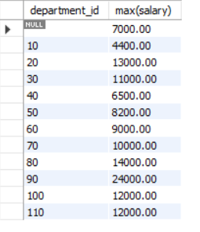

1. Find the  department id  who is paid the  maximum average salary in the organization: use subqueries.

select max(sal) from (select department_id,avg(salary) sal from employees group by department_id) as tbl;

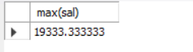

1. Find the departmentname and loacation_id in which ‘Ernst’ work.

select department_id , location_id from departments where department_id = (select department_id from employees where last_name ='Ernst');



1. Find all the employee names who work in “Tokyo” city  ( use subqueries  , table used : employees, departments, locations )

select concat(first_name,last_name) as Name from employees

where department_id =(select department_id from departments

where location_id =(select location_id from locations where city = 'Tokyo'));

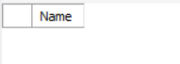

1. Find the employee names who are the maximum paid salary in the organization

select max(salary),last_name from employees;



1. Find the employees who are drawing minimum salary in their respective departments

(Use the jobs table for getting the min salary and use subquries )

select last_name,job_id from employees where job_id = (select job_id from jobs where min_salary = (select min(min_salary) from jobs));

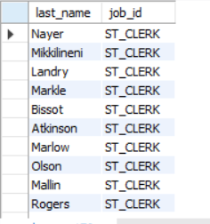

1. Find the employee names and their job_id and job_titles by joining employee and jobs table

select employees.last_name,jobs.job_id,jobs.job_title from employees

INNER JOIN jobs on employees.job_id = jobs.job_id;

