select max(sal) from (select avg(salary) as sal from employees group by department_id) as result;



select job_id from employees where last_name like 'Ernst';



select employee_id,last_name,salary,job_id from employees

where job_id = (select job_id from employees where last_name like 'Ernst')

and salary>(select salary from employees where last_name = 'Austin');



select employee_id,last_name,salary,job_id from employees

where salary = (select min(salary) from employees);



select employee_id,last_name,salary,job_id from employees

where salary in (select min(salary) from employees group by department_id);

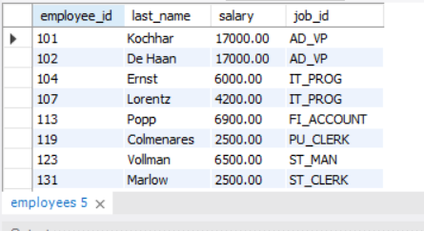

select employee_id,last_name,salary,job_id from employees

where salary > ALL (select salary from employees where job_id = 'IT_PROG');



select * from employees;

select * from departments;

select employees.first_name,employees.salary,employees.last_name,departments.department_name,departments.department_name from employees

right join departments on employees.department_id = departments.department_id

