Pakistan Street Child Football Team **Media Engagement**

**MORNING SHOW / TV CHANNEL / SM Followers**

**Geo Pakistan** (Geo News) 2 **560,045 Followers**

**Dunya Bol Ha** (Bol News) 2 **5,069,406 Followers**

**Subah Say Agay** (Hum News) 2 **1 Million Followers**

**Aaj Pakistan** (Aaj Tv) 1 **7,089,222 Followers**

**Expresso Morning** (Express News) 2 **17,949,858 Followers**

**Ak or Subha** (Aur Tv) 1 **72k Followers**

**Subha e Pakistan** (PTV News) 2 **3,074,089 Followers**

**Suno Pakistan**  (Suno Tv) 2 **769,273 Followers**

**SPORTS PROGRAME**

**Replay** (Dawn News) 1 **5,772,962 Followers**

**Game Set Match** (Samaa Tv) 1 **13,150,405 Followers**

**Sports Lounge** (Geo Super) 1 **8,216,293 Followers**

**Play Field** (Such Tv) 1 [**28K followers**](https://www.facebook.com/suchtvurdu/followers/)

**INTERNATIONAL MEDIA ENGAGEMENT**

**Independent Urdu**

(Stories were made before going to the World Cup and after getting the runner-up position(

**Arab News**

)Created a story on the team before going to the World Cup and is constantly giving updates on the Pakistan team on digital media platforms.(

**China Radio International**

)A special interview of Tufail Shinwari was aired after securing the runner-up position in the World Cup(

**Al Jazeera**

)Before going to the World Cup and during the World Cup will make a special report on the Pakistan team(

**NEWS BULLETIN UPDATE**

**Geo News** 12PM – 12AM

**Ary News** 12PM – 12AM

**Bol News**  12PM – 12AM

**PTV News** 12PM – 12AM

**Hum News** 12PM – 12AM

**Aaj Tv** 12PM – 12AM

**Express News** 12PM – 12AM

**Suno Tv**  12PM – 12AM

**Such Tv**  12PM – 12AM

**Dawn News** 12PM – 12AM

**Samaa News** 12PM – 12AM

**GTV News 12PM – 12AM**

**Capital News 12PM – 12AM**

**PTV World 12PM – 12AM**

(Note: The news has been circulating at various times between the timings given above)

**COVERAGE LEADING NEWSPAPER**

**Daily Tribune**

**Daily The Nation**

**Daily Dawn**

**Daily Daily Times**

**Daily Pakistan Today**

**Daily Pak Observer**

**Daily Express**

**Daily Dunya**

**Daily Ausaf**

**Daily Tufan Mail**

**Daily Al Akbar**

**Daily News Mart**

**Daily Ak Awaz**

**Daily Orient Express**

**Daily Islamabad**

**Associated Press**

**Daily F.I.R**

**Daily Sama**

**SPORTS / JOURNALIST TWEET**

**Arfa Feroz Zake** (Geo News)

**Farhad Jarral** (Arab News)

**Sudrish Khan**

**Faizan Lakhani** (Geo News)

**Hassan Ayub Khan** (Ary News)

**Anas Mallick** (WIONews)

**Arsalan Shahzad** (The News)

**Aaliyan Mahmood** (Cricket)

**Saddam HUSSAIN** (National Football Team)

**Muhammad Ibrahim** (Arab News)

**Zeeshan Qayyum** (Ptv News)

**Akber Ali** (Ajj Tv)

**Shahrukh Sohail** (Uni of East London)

**NeelumArshad** (Bol News)

**Adil Nabi** (Professional footballer)

**Huzaifa khan** (Samaa Tv)

**Javaria Hina** (indyurdu)

**Abdul Ghaffar** (Dawn News)

**Osama Bin Javaid** (Al Jazeera English)

**Haider Azhar** (Geo Super)

**Rehan Ulhaq** (Analyst)

**Imran Munawar** (Geo News)

**Muneeb Farrukh** (Samaa Tv)

**Syed Arslan Abbas** (Ptv World)

**Bahria Town Official** (Realstate)

**National Assembly of Pakistan** (Govt of Pakistan)

**Shaza Fatima Khawaja** (SAPM Youth)

**Omar r Quraishi** (Bilawal Bhutto Media Adv)

**Qurrat ul Ain Shirazi** (indyurdu)

**Javaria Hina** (indyurdu)

**DIGITAL MEDIA NEWS PLATFORM**

**Tag It 593,619 Followers**

**Trending Pakistan** [**68K followers**](https://www.facebook.com/ItsTrendingPakistan/followers/)

**Economy.pk 1,336,365 Followers**

**FootballPakistan 282,182 Followers**

**Startup Pakistan 2,726,439 Followers**

# **News Curators** [**71K followers**](https://www.facebook.com/NewsCuratorsNC/followers/)

**Jaanlo 141,611 Followers**

**MAIDAAN FACEBOOK PAGE INSIGHTS**

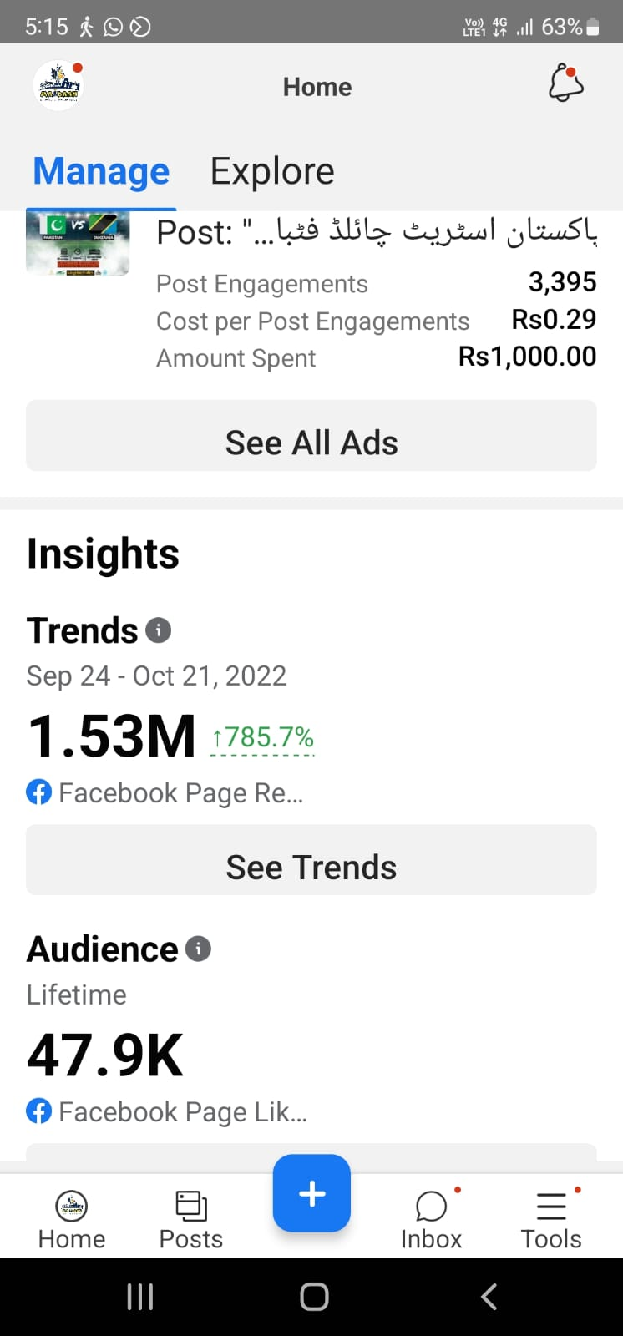

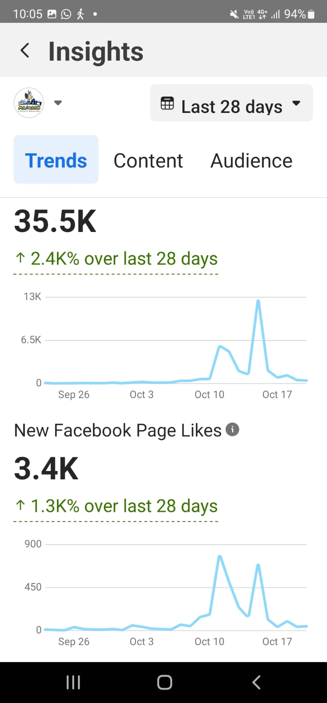

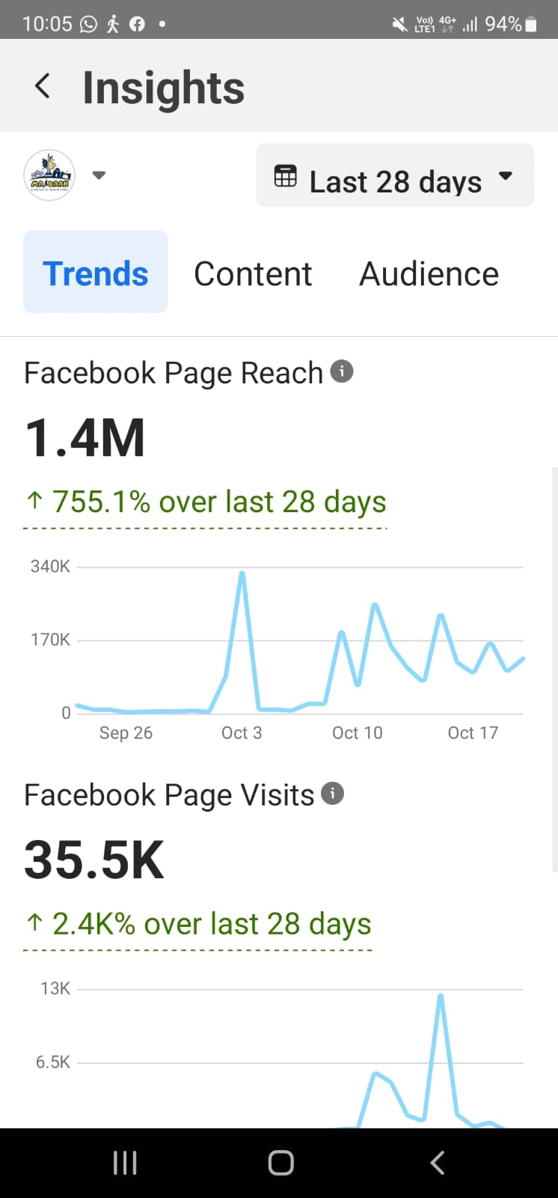

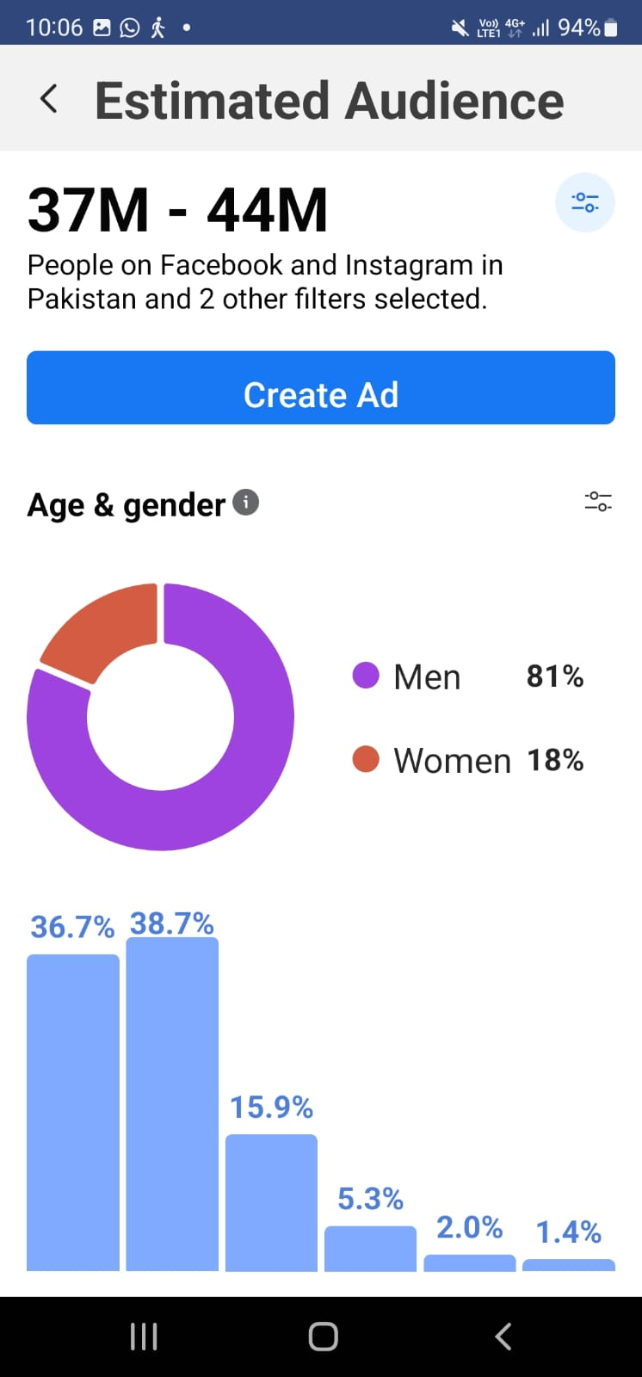

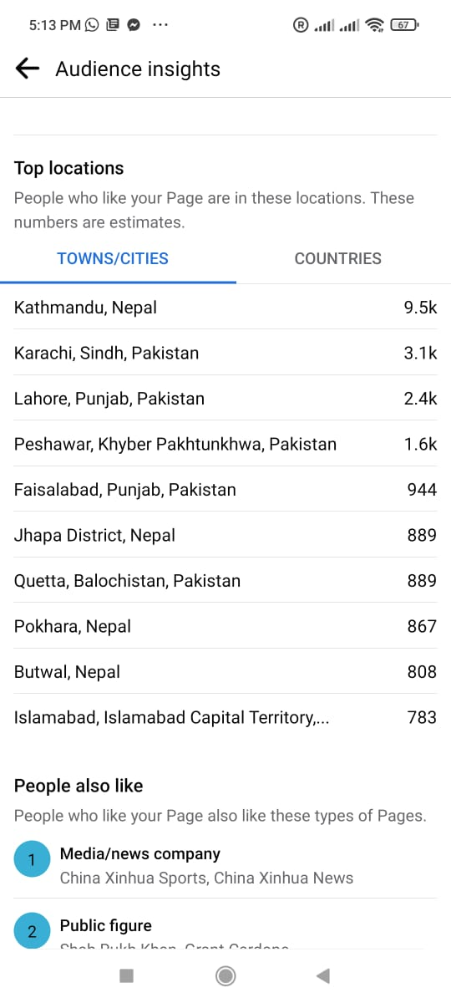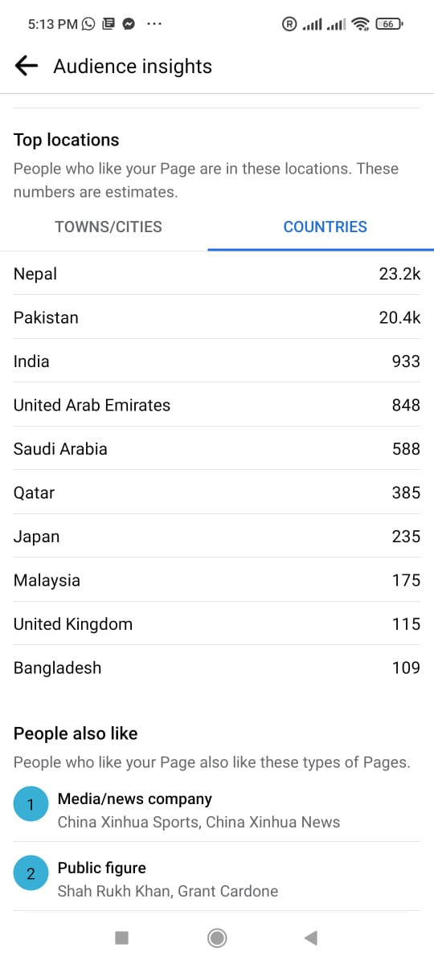

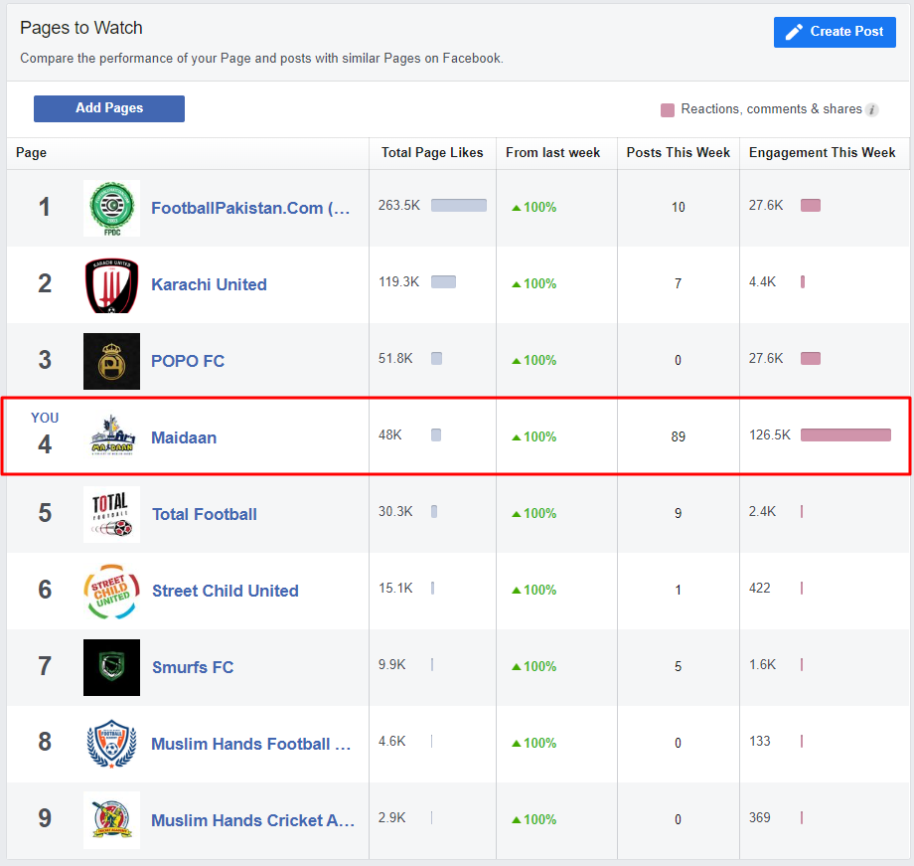

**MAIDAAN TWITTER ACCOUNT INSIGHTS**

