

ANALYSING gOOGLE APP STORE



Done By: SEERAT FATEMA

**Analysing Google Apps Store HLD Author: Seerat Fatema**

**Analysing Google Apps Store**

(High Level Design)

Author: SEERAT FATEMA

**Analysing Google Apps Store HLD Author: Seerat Fatema**

Contents

1.Project Details.............................................................................................02

2.Problem Statement....................................................................................03

3. Data Description....................................................................................... 05

5.Architecture................................................................................................06

6.Visuals........................................................................................................... 07

7.Data Analysis ............................................................................................. 09

**Analysing Google Apps Store HLD Author: Seerat Fatema**

**Project Details**

|  |  |
| --- | --- |
| **Project Title** | Analysing Google Apps Store dataset in terms of App downloads and Rating |
| **Technologies** | Business Intelligence |
| **Domain** | Technology |
| **Project Difficulties level** | Advanced |
| **Project Title** | Analysing Google Apps Store dataset in terms of App downloads and Rating |

**Analysing Google Apps Store HLD Author: Seerat Fatema**

**Problem Statement**

Technology is the increasing need nowadays and used everywhere. One of the features of Technology is android. Which we all use in our daily life. Android is a mobile operating system based on a modified version of the Linux kernel and other open source software, designed primarily for touchscreen mobile devices such as smartphones and tablets.

**Analysing Google Apps Store HLD Author: Seerat Fatema**

**Data Description**

* Data was given in single excel file named as googleplaystore.csv
* googleplaystore.csv includes App, Category, Rating, Reviews, Size, Installs , Type ,Price, Content Rating, Genres, Last Updated, Current Version, Android Version.

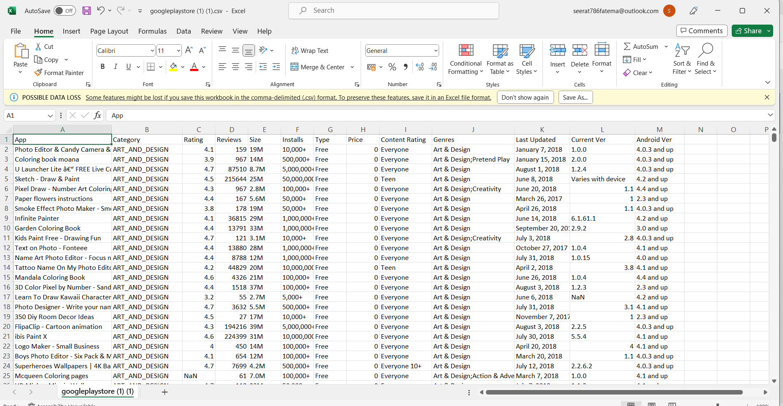

* This datasets includes total 10841 rows.
* A new column has also been added to given dataset , named it as sentiments( whether reviews are positive, negative ,neutral)

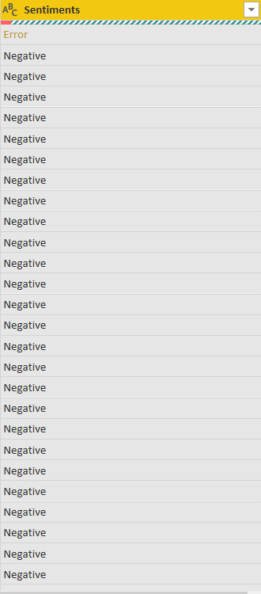

**Analysing Google Apps Store HLD Author: Seerat Fatema**

**Architecture**



Overall architecture of the project which was build to the dashboard.

**Analysing Google Apps Store HLD Author: Seerat Fatema**

**Visuals**

1. **HOME PAGE**

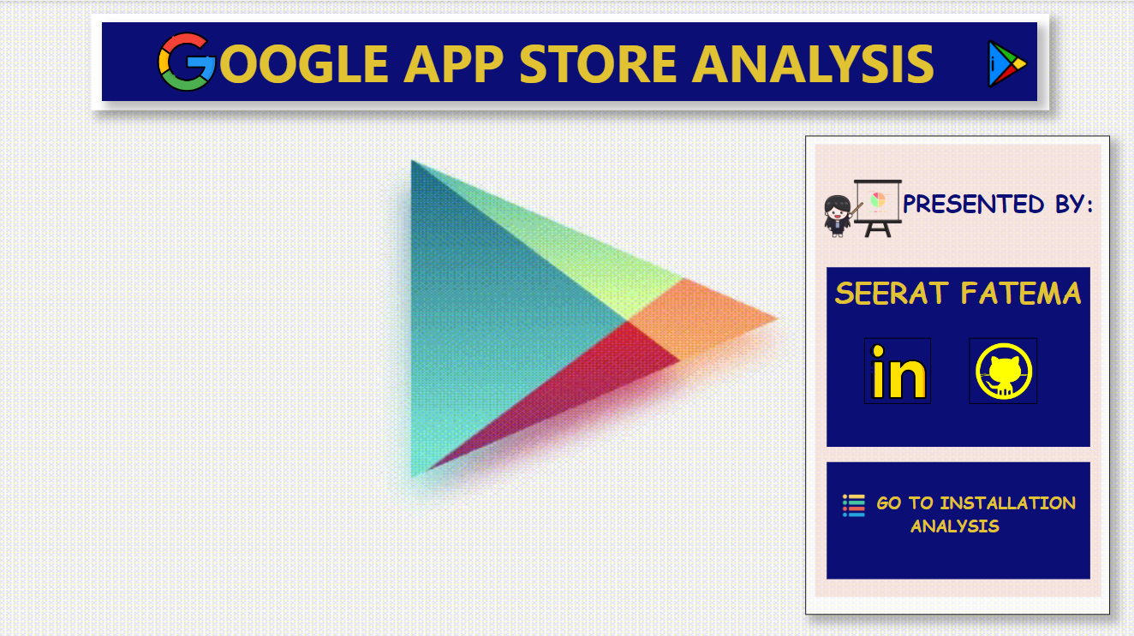

1. **INSTALLATION ANALYSIS**

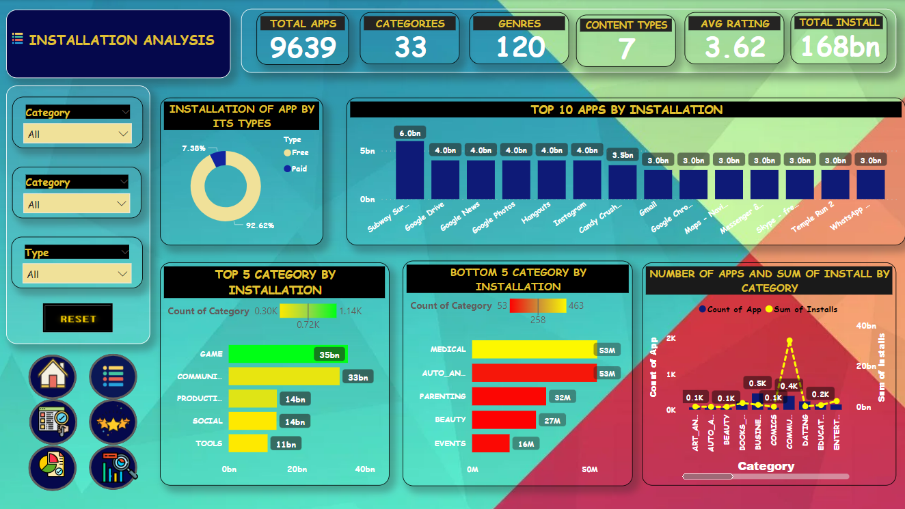

**Analysing Google Apps Store HLD Author: Seerat Fatema**

1. **REVIEW ANALYSIS**

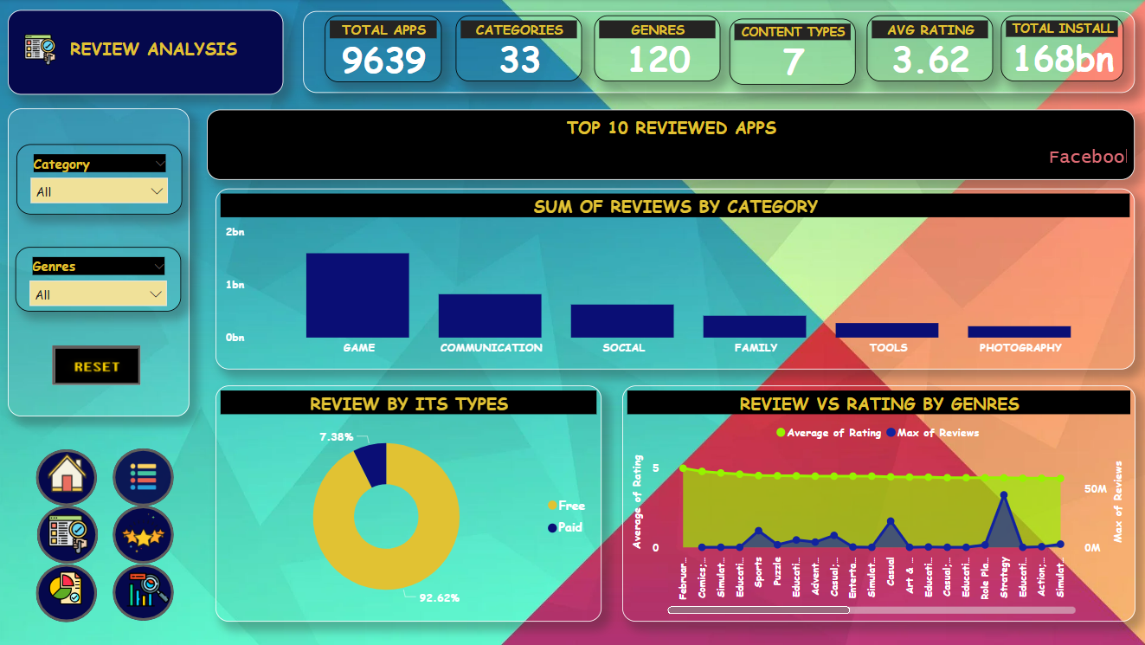

1. **RATING ANALYSIS**

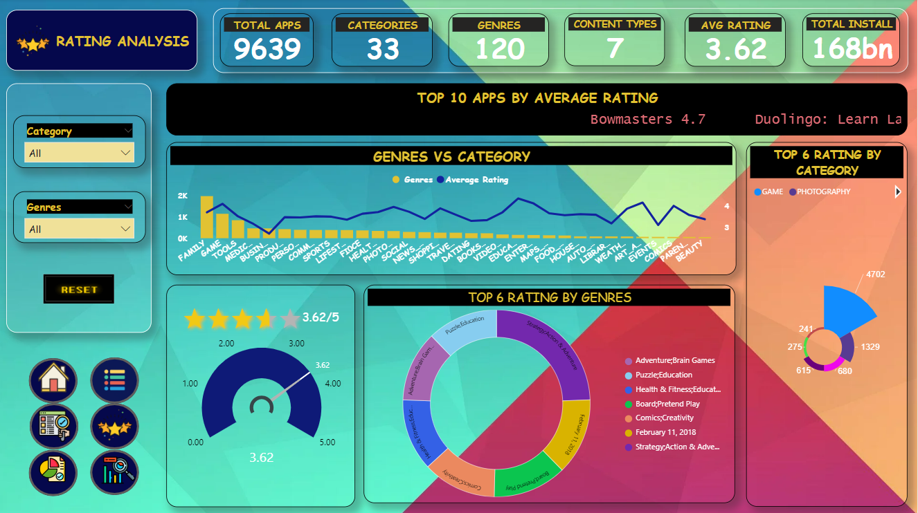

**Analysing Google Apps Store HLD Author: Seerat Fatema**

1. **OTHER ANALYSIS**

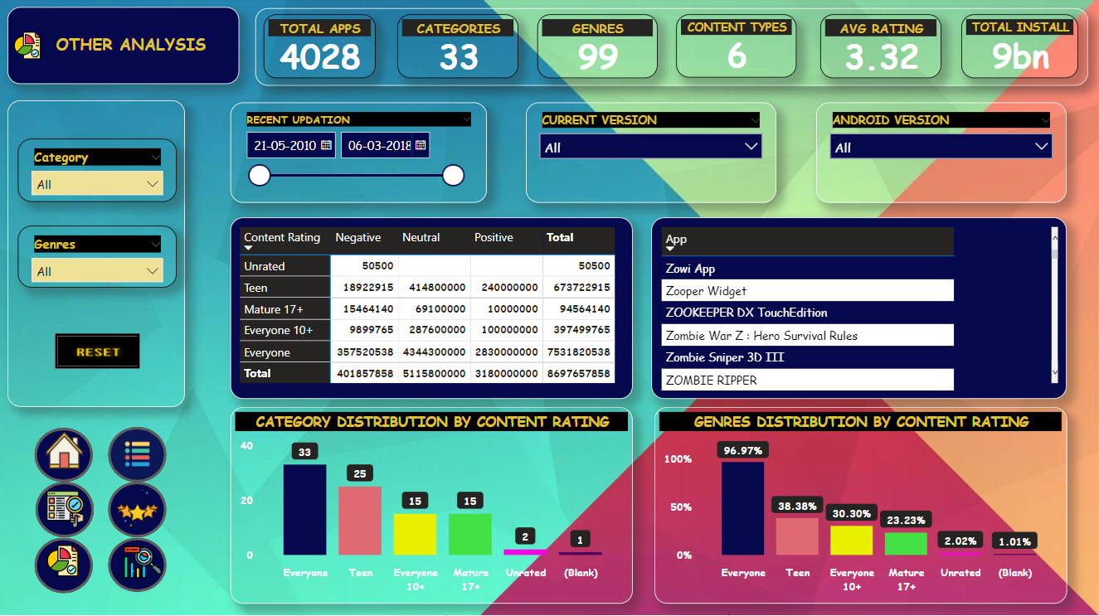

1. **SENTIMENTS(TOOLTIPS)**

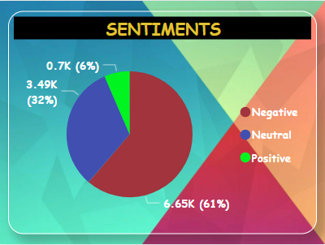

**Analysing Google Apps Store HLD Author: Seerat Fatema**

**Data Analysis**

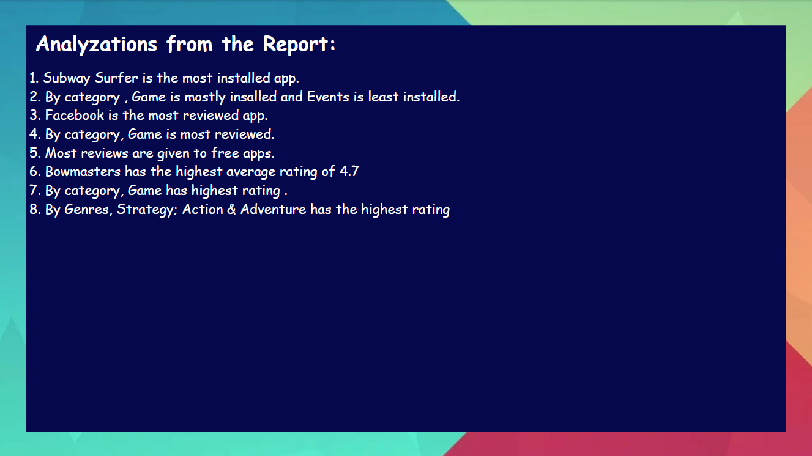

**Analysing Google Apps Store HLD Author: Seerat Fatema**

