**Analysing Google Apps Store LLD Author: Seerat Fatema**

**Analysing Google Apps Store**

(Low Level Design)

Author: SEERAT FATEMA

**Analysing Google Apps Store LLD Author: Seerat Fatema**

Contents

1.Problem Statement....................................................................................03

3.Aim.................................................................................................................04

4.Architecture...............................................................................................05

5. Data Description................................................................................ 06-07

6. Connect Data with Powerbi....................................................................08

**Analysing Google Apps Store LLD Author: Seerat Fatema**

**Problem Statement**

Technology is the increasing need nowadays and used everywhere. One of the features of Technology is android. Which we all use in our daily life. Android is a mobile operating system based on a modified version of the Linux kernel and other open source software, designed primarily for touchscreen mobile devices such as smartphones and tablets.

**Analysing Google Apps Store LLD Author: Seerat Fatema**

**Aim**

* Main aim to find out the number of apps and its rating.
* The reports also shows the current version of respective apps, its android version and recent updation.
* This report also focuses on reviews by respective age category of people.

**Analysing Google Apps Store LLD Author: Seerat Fatema**

**Architecture**

The Dataset contains Number of Awards and Nominations of Entertainers.

1. Total Apps: Total Number of Apps in given dataset.

2. Categories: Count of total number of categories in given dataset.

3. Genres: Total Number of Genres.

4. Content Types: Review given by people of different age.

5. Avg Rating : Average Rating to different apps.

6.Total Install: Total number of Install.

**Analysing Google Apps Store LLD Author: Seerat Fatema**

**Data Description**

* Data was given in single excel file named as googleplaystore.csv
* googleplaystore.csv includes App, Category, Rating, Reviews, Size, Installs , Type ,Price, Content Rating, Genres, Last Updated, Current Version, Android Version.

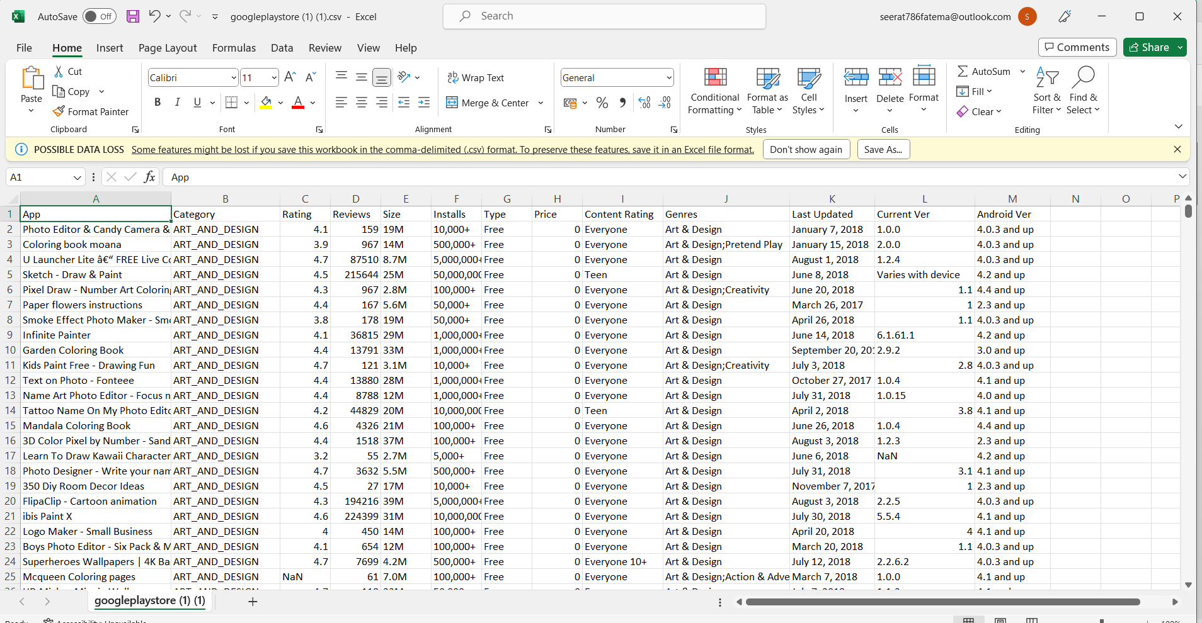

* This datasets includes total 10841 rows.
* A new column has also been added to given dataset , named it as sentiments( whether reviews are positive, negative ,neutral)

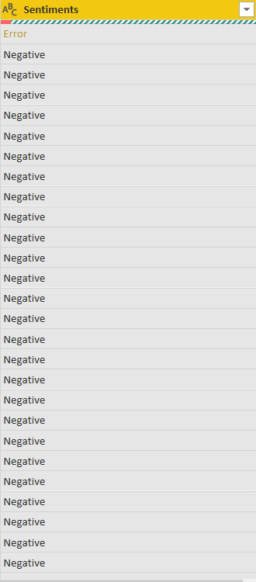

**Analysing Google Apps Store LLD Author: Seerat Fatema**

**Connect Dataset With Powerbi**

* Open Power Bi desktop.
* Connect it with the Excel files
* Import and Load these files.
* Make sure there is good internet connection for better experience.