Fatima Jinnah Women University, Rawalpindi



CC Assignment_1
Git, Gitea, GitHub, Git LFS, and GitHub Pages

Submitted By | Seerat Fatima
Reg. No | fa24b1-se-020
Subject | Cloud Computing
Course Code | -
Git Hub username | seeratfatima97
Session | 2024-2028
Section | B
Submitted To | Sir Waqas Saleem

Department of Software Engineering
(Semester V)

Task 1

This task sets up a self-hosted local Git service using Gitea and PostgreSQL via Docker Compose. The container environment and network parameters are verified through standard terminal commands. A local Git repository is initialized, configured with student credentials, and staged with a README file. Finally, the initial commit is pushed to the Gitea server and verified through the Gitea web dashboard.

Sub-step 1.1: Docker Compose Service Deployment
Executes docker compose up -d to launch Gitea and PostgreSQL containers in detached mode, followed by container status and IP network verification.

Screenshot
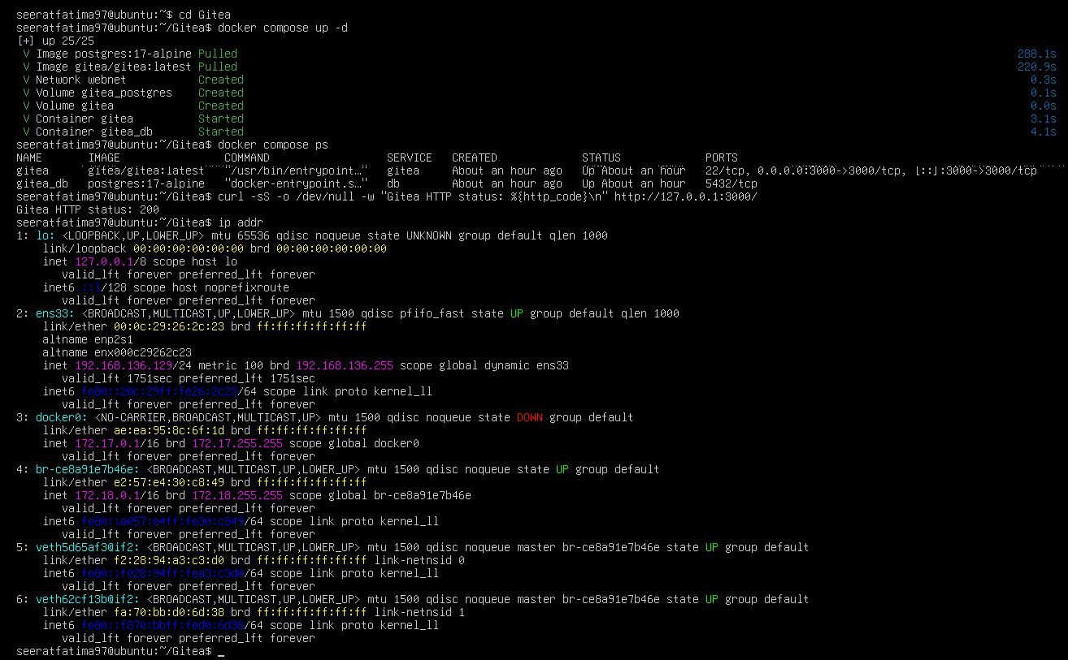
Figure 1.1: Docker Compose Service Deployment and Network Verification for Gitea.

Sub-step 1.2: Repository Initialization and Initial Push
Configures global Git user credentials, links the local Gitea remote URL, creates README.md, and pushes the initial commit to the main branch.
Screenshot
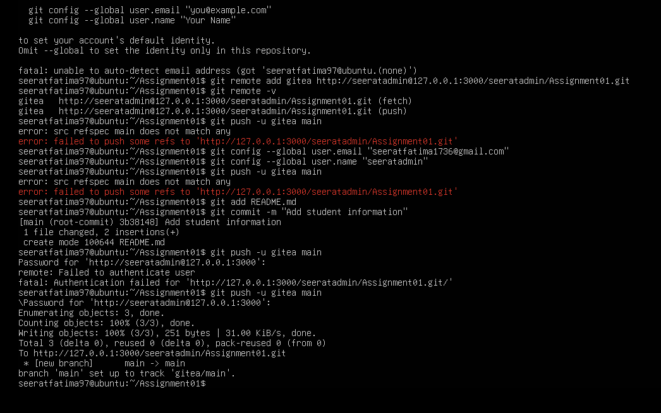
Figure 1.2: Git Repository Initialization and Initial Push to Local Gitea Server.

Sub-step 1.3: Gitea Web Interface Verification
Displays the Gitea web dashboard showing the uploaded README.md file and commit history for the Assignment01 repository.

Screenshot
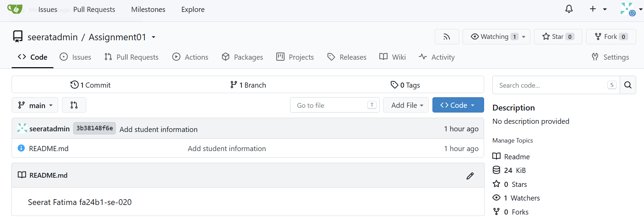
Figure 1.3: Verification of Repository Contents on Local Gitea Web Interface.
Task 2

Task 2
This task demonstrates configuring multi-remote synchronization between local Gitea and remote GitHub repositories. A secondary remote endpoint pointing to GitHub is added to the local Git repository alongside Gitea. The codebase and commit history are pushed to GitHub using Personal Access Token authentication. The successful synchronization is then confirmed directly on the public GitHub repository dashboard.

Sub-step 2.1: Adding Secondary GitHub Remote
Adds GitHub as a secondary remote target using git remote add and verifies configured fetch/push URLs with git remote -v.

Screenshot
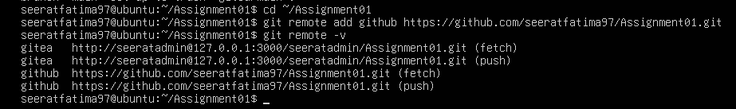
Figure 2.1: Configuring Dual Remotes for Gitea and GitHub.

Sub-step 2.2: Pushing Codebase to GitHub
Executes git push -u github main with GitHub user credentials to upload the main branch commit history to the remote platform.

Screenshot
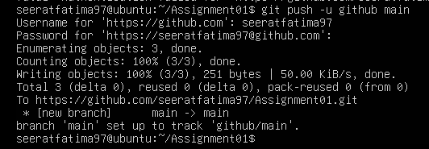
Figure 2.2: Pushing Repository Code Base to Remote GitHub Repository.

Sub-step 2.3: GitHub Dashboard Verification
Displays the seeratfatima97/Assignment01 GitHub repository interface, verifying that README.md and commit details match the local repository.

Screenshot

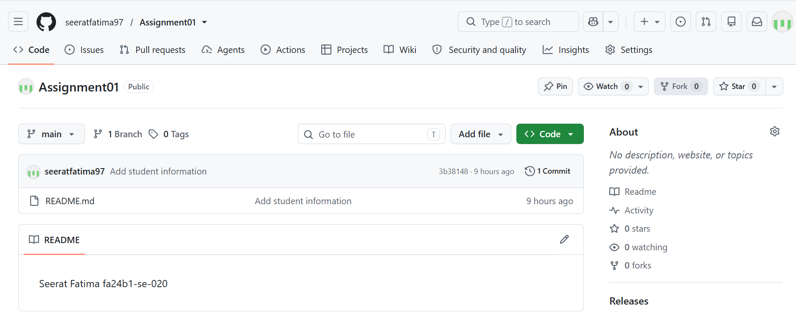
Figure 2.3: GitHub Repository Dashboard Confirming Multi-Remote Sync.

Task 3

This task covers tracking and managing large binary files in Git using Git Large File Storage (LFS). Git LFS is initialized locally to automatically track binary files matching the *.bin pattern. Three dummy binary files of ~100MB each are created using terminal commands and staged alongside .gitattributes. Finally, the LFS pointer objects and binary payloads are pushed successfully to the GitHub remote repository.

Sub-step 3.1: Initializing Git LFS and File Tracking

Runs git lfs install to initialize the extension and configures automatic tracking for *.bin files inside .gitattributes.

Screenshot

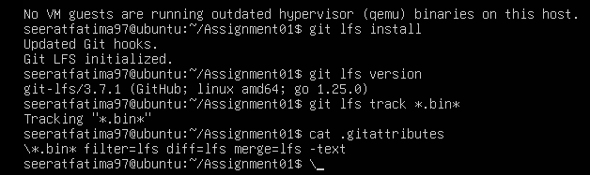
Figure 3.1: Initializing Git LFS and Setting Up File Tracking.

Sub-step 3.2: Binary File Generation and LFS Staging
Generates three large binary files using the truncate command and lists tracked LFS files using git lfs ls-files --size.

Screenshot

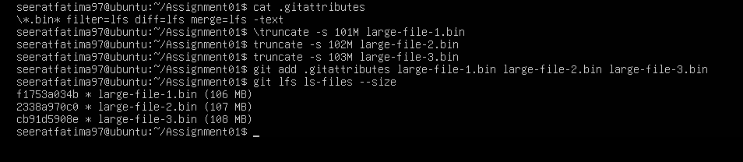
Figure 3.2: Generating Dummy Binary Files and Inspecting LFS Tracking.

Sub-step 3.3: Pushing LFS Objects to Remote Repository
Commits the large binary files and uploads the pointer references and payload data to GitHub using git push github main.

Screenshot
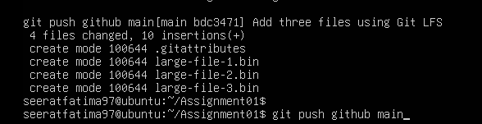
Figure 3.3: Committing and Pushing Git LFS Pointer Objects to GitHub.

Task 4

This task involves building and deploying a custom personal portfolio website hosted live on GitHub Pages. The HTML layout, CSS styling, media assets, and CV file are pushed to the <username>.github.io repository. GitHub Pages build settings are enabled under repository settings targeting the main branch root folder. The live website deployment is then verified directly in the browser via the public github.io URL.
Sub-step 4.1: Repository Structure and Source Uploads
Displays the root directory of seeratfatima97.github.io on GitHub, confirming the presence of required source files (index.html, style.css), image assets, and CV PDF.
Screenshot
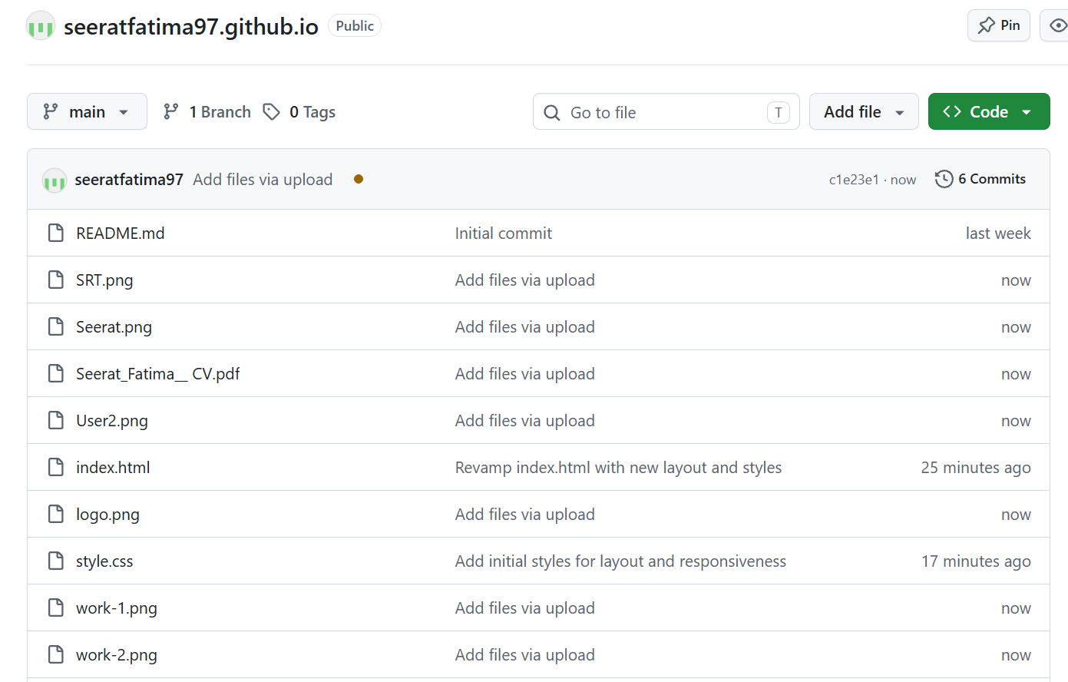
Figure 4.1: GitHub Portfolio Repository File Structure Overview.

Sub-step 4.2: GitHub Pages Build Configuration

Configures GitHub Pages settings to deploy from the main branch root directory and verifies the successful live build banner.

Screenshot

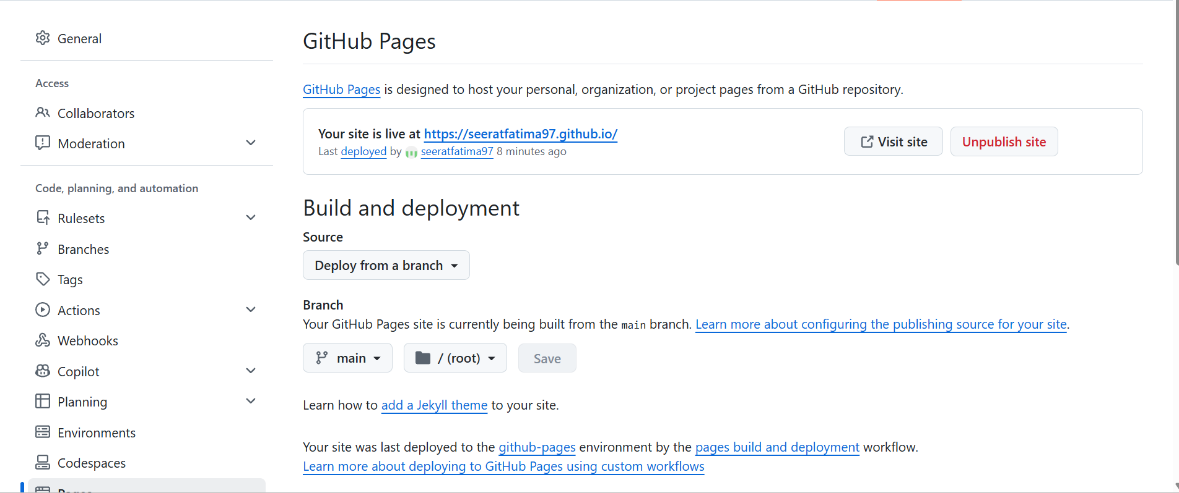
Figure 4.2: GitHub Pages Build Configuration and Deployment Status.

Sub-step 4.3: Verification of Live Portfolio Site

Confirms the fully rendered live portfolio website in the browser at [https://seeratfatima97.github.io/](https://seeratfatima97.github.io/), displaying navigation links, hero section, personal profile photo, and responsive UI layout.

Screenshot


Figure 4.3: Verification of Live Portfolio Web Page on Browser.

----------THE END----------

