**1) Install Power BI Desktop and share the final screenshot of the report view page which appears when power desktop starts.**

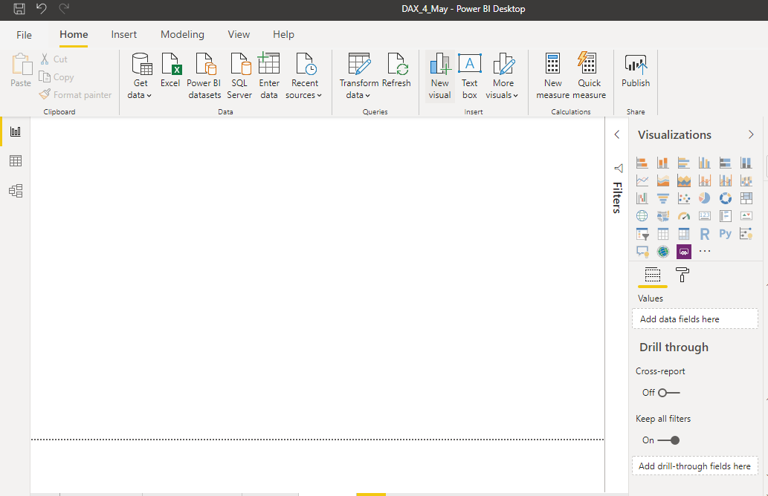

**2) Prepare a document and with the following screenshot**

− Report View 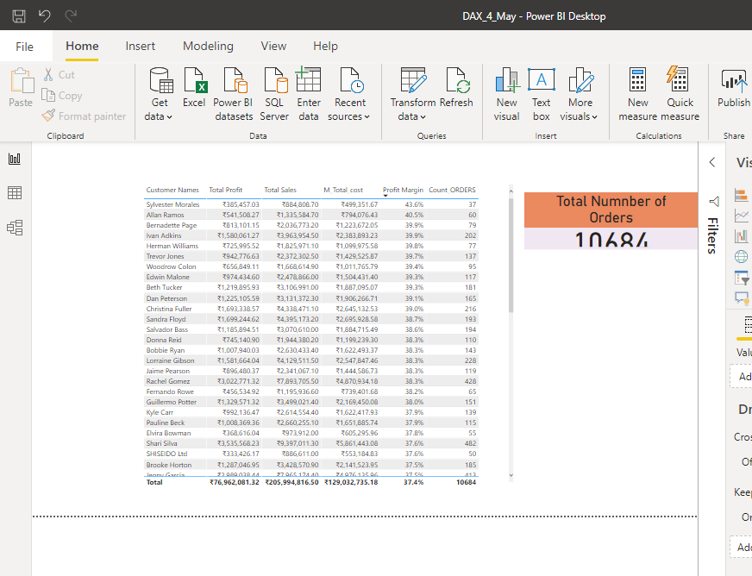

− Data View

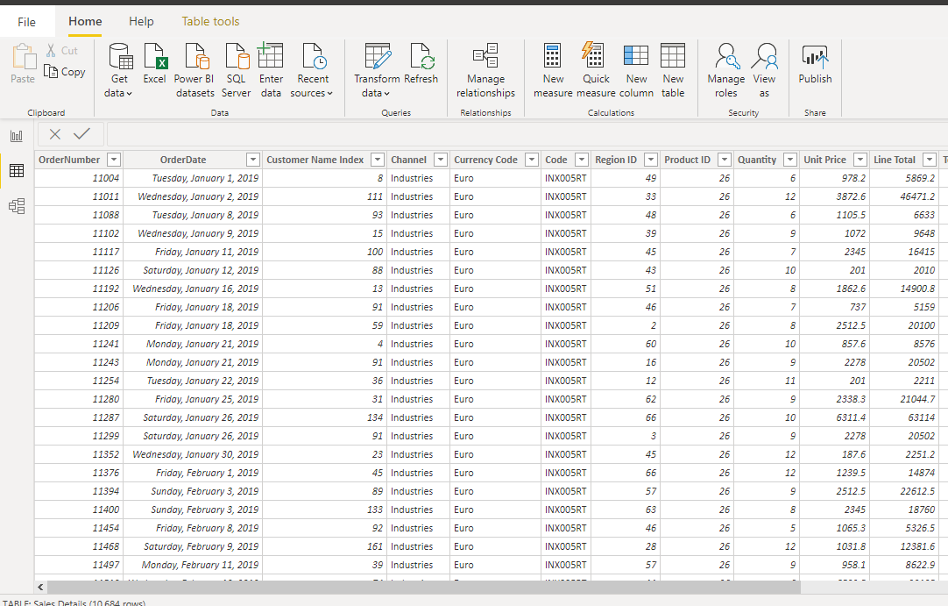

− Model View 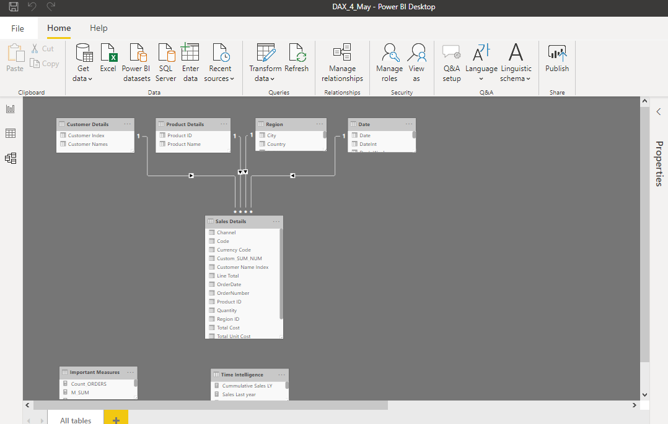

− Power Query Editor

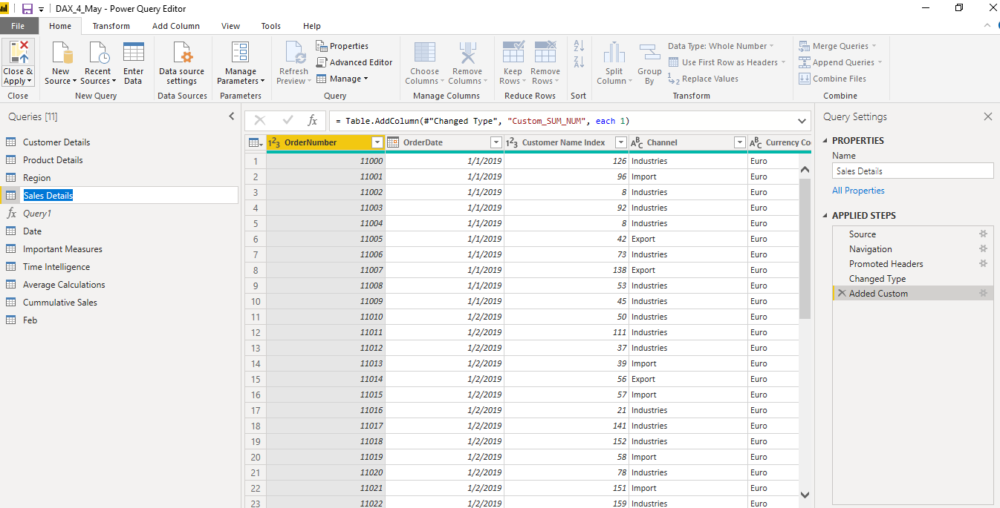

− Advance Editor

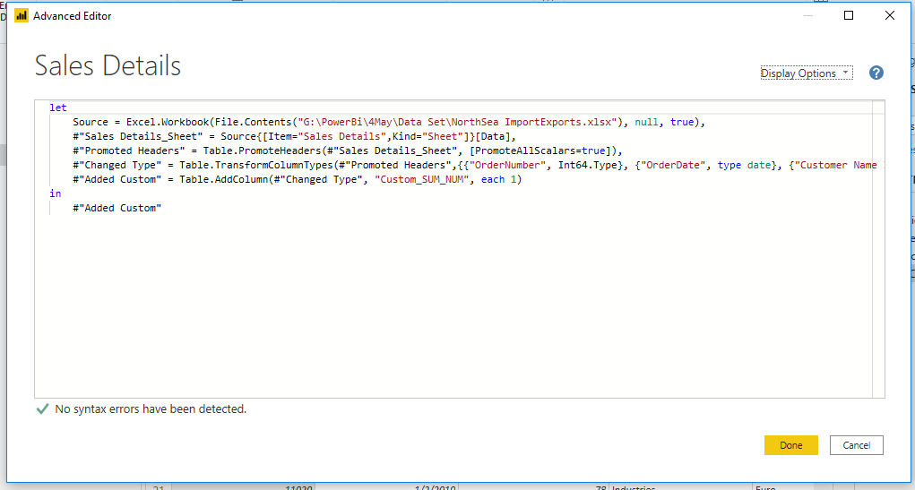

**3) Prepare a document with details of the following along with their price**

**Power BI desktop: Free for Author**

