## Task: fetch_apple_files

Log:

*** Reading local file: /opt/airflow/logs/analyzelogs/fetch_apple_files/2022-08-19T21:59:05.341883+00:00/1.log

[2022-08-19 21:59:07,720] {taskinstance.py:851} INFO - Dependencies all met for <TaskInstance: analyzelogs.fetch_apple_files 2022-08-19T21:59:05.341883+00:00 [queued]>

[2022-08-19 21:59:07,727] {taskinstance.py:851} INFO - Dependencies all met for <TaskInstance: analyzelogs.fetch_apple_files 2022-08-19T21:59:05.341883+00:00 [queued]>

[2022-08-19 21:59:07,727] {taskinstance.py:1042} INFO -

--------------------------------------------------------------------------------

[2022-08-19 21:59:07,727] {taskinstance.py:1043} INFO - Starting attempt 1 of 3

[2022-08-19 21:59:07,727] {taskinstance.py:1044} INFO -

--------------------------------------------------------------------------------

[2022-08-19 21:59:07,737] {taskinstance.py:1063} INFO - Executing <Task(PythonOperator): fetch_apple_files> on 2022-08-19T21:59:05.341883+00:00

[2022-08-19 21:59:07,739] {standard_task_runner.py:52} INFO - Started process 771 to run task

[2022-08-19 21:59:07,744] {standard_task_runner.py:76} INFO - Running: ['airflow', 'tasks', 'run', 'analyzelogs', 'fetch_apple_files', '2022-08-19T21:59:05.341883+00:00', '--job-id', '34', '--pool', 'default_pool', '--raw', '--subdir', 'DAGS_FOLDER/analyze_log.py', '--cfg-path', '/tmp/tmp_xrx7erw', '--error-file', '/tmp/tmpxb8riya4']

[2022-08-19 21:59:07,744] {standard_task_runner.py:77} INFO - Job 34: Subtask fetch_apple_files

[2022-08-19 21:59:07,769] {logging_mixin.py:104} INFO - Running <TaskInstance: analyzelogs.fetch_apple_files 2022-08-19T21:59:05.341883+00:00 [running]> on host c089c6e12222

[2022-08-19 21:59:07,793] {taskinstance.py:1255} INFO - Exporting the following env vars:

AIRFLOW_CTX_DAG_OWNER=airflow

AIRFLOW_CTX_DAG_ID=analyzelogs

AIRFLOW_CTX_TASK_ID=fetch_apple_files

AIRFLOW_CTX_EXECUTION_DATE=2022-08-19T21:59:05.341883+00:00

AIRFLOW_CTX_DAG_RUN_ID=manual__2022-08-19T21:59:05.341883+00:00

[2022-08-19 21:59:07,807] {python.py:118} INFO - Done. Returned value was: None

[2022-08-19 21:59:07,810] {taskinstance.py:1159} INFO - Marking task as SUCCESS. dag_id=analyzelogs, task_id=fetch_apple_files, execution_date=20220819T215905, start_date=20220819T215907, end_date=20220819T215907

[2022-08-19 21:59:07,852] {taskinstance.py:1220} INFO - 1 downstream tasks scheduled from follow-on schedule check

[2022-08-19 21:59:07,876] {local_task_job.py:146} INFO - Task exited with return code 0

Xcom value:

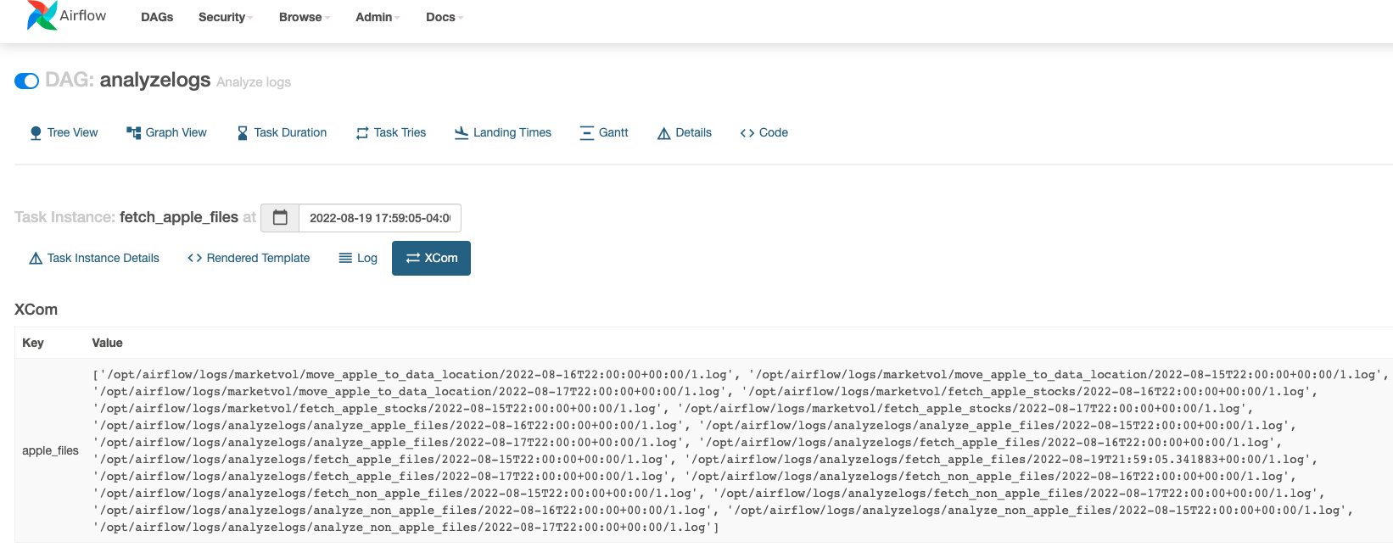

## Task: analyze_apple_files

Log:

*** Reading local file: /opt/airflow/logs/analyzelogs/analyze_apple_files/2022-08-19T21:59:05.341883+00:00/1.log

[2022-08-19 21:59:10,377] {taskinstance.py:851} INFO - Dependencies all met for <TaskInstance: analyzelogs.analyze_apple_files 2022-08-19T21:59:05.341883+00:00 [queued]>

[2022-08-19 21:59:10,384] {taskinstance.py:851} INFO - Dependencies all met for <TaskInstance: analyzelogs.analyze_apple_files 2022-08-19T21:59:05.341883+00:00 [queued]>

[2022-08-19 21:59:10,384] {taskinstance.py:1042} INFO -

--------------------------------------------------------------------------------

[2022-08-19 21:59:10,384] {taskinstance.py:1043} INFO - Starting attempt 1 of 3

[2022-08-19 21:59:10,384] {taskinstance.py:1044} INFO -

--------------------------------------------------------------------------------

[2022-08-19 21:59:10,393] {taskinstance.py:1063} INFO - Executing <Task(PythonOperator): analyze_apple_files> on 2022-08-19T21:59:05.341883+00:00

[2022-08-19 21:59:10,395] {standard_task_runner.py:52} INFO - Started process 778 to run task

[2022-08-19 21:59:10,399] {standard_task_runner.py:76} INFO - Running: ['airflow', 'tasks', 'run', 'analyzelogs', 'analyze_apple_files', '2022-08-19T21:59:05.341883+00:00', '--job-id', '36', '--pool', 'default_pool', '--raw', '--subdir', 'DAGS_FOLDER/analyze_log.py', '--cfg-path', '/tmp/tmpgvpjwr4_', '--error-file', '/tmp/tmp84p9c9xl']

[2022-08-19 21:59:10,400] {standard_task_runner.py:77} INFO - Job 36: Subtask analyze_apple_files

[2022-08-19 21:59:10,427] {logging_mixin.py:104} INFO - Running <TaskInstance: analyzelogs.analyze_apple_files 2022-08-19T21:59:05.341883+00:00 [running]> on host c089c6e12222

[2022-08-19 21:59:10,451] {taskinstance.py:1255} INFO - Exporting the following env vars:

AIRFLOW_CTX_DAG_OWNER=airflow

AIRFLOW_CTX_DAG_ID=analyzelogs

AIRFLOW_CTX_TASK_ID=analyze_apple_files

AIRFLOW_CTX_EXECUTION_DATE=2022-08-19T21:59:05.341883+00:00

AIRFLOW_CTX_DAG_RUN_ID=manual__2022-08-19T21:59:05.341883+00:00

[2022-08-19 21:59:10,469] {python.py:118} INFO - Done. Returned value was: None

[2022-08-19 21:59:10,472] {taskinstance.py:1159} INFO - Marking task as SUCCESS. dag_id=analyzelogs, task_id=analyze_apple_files, execution_date=20220819T215905, start_date=20220819T215910, end_date=20220819T215910

[2022-08-19 21:59:10,507] {taskinstance.py:1220} INFO - 0 downstream tasks scheduled from follow-on schedule check

[2022-08-19 21:59:10,535] {local_task_job.py:146} INFO - Task exited with return code 0

Xcom value:

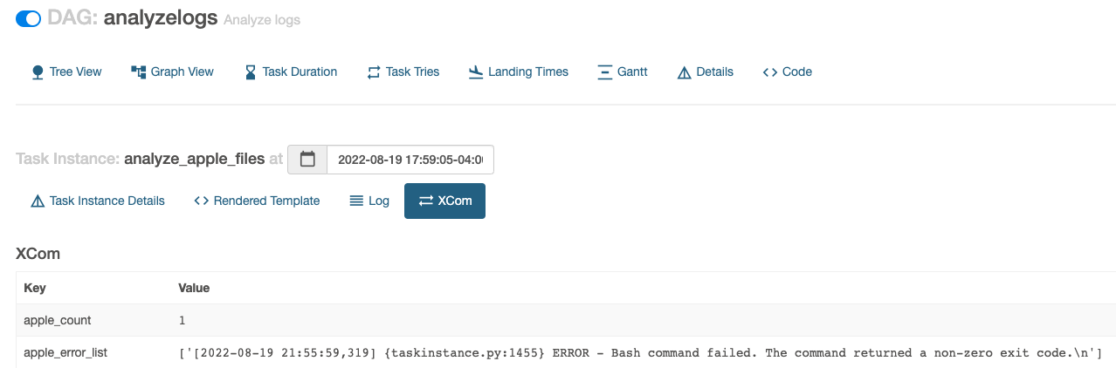

## Task: fetch_non_apple_files

Log:

*** Reading local file: /opt/airflow/logs/analyzelogs/fetch_non_apple_files/2022-08-19T21:59:05.341883+00:00/1.log

[2022-08-19 21:59:08,931] {taskinstance.py:851} INFO - Dependencies all met for <TaskInstance: analyzelogs.fetch_non_apple_files 2022-08-19T21:59:05.341883+00:00 [queued]>

[2022-08-19 21:59:08,936] {taskinstance.py:851} INFO - Dependencies all met for <TaskInstance: analyzelogs.fetch_non_apple_files 2022-08-19T21:59:05.341883+00:00 [queued]>

[2022-08-19 21:59:08,936] {taskinstance.py:1042} INFO -

--------------------------------------------------------------------------------

[2022-08-19 21:59:08,936] {taskinstance.py:1043} INFO - Starting attempt 1 of 3

[2022-08-19 21:59:08,936] {taskinstance.py:1044} INFO -

--------------------------------------------------------------------------------

[2022-08-19 21:59:08,944] {taskinstance.py:1063} INFO - Executing <Task(PythonOperator): fetch_non_apple_files> on 2022-08-19T21:59:05.341883+00:00

[2022-08-19 21:59:08,946] {standard_task_runner.py:52} INFO - Started process 774 to run task

[2022-08-19 21:59:08,950] {standard_task_runner.py:76} INFO - Running: ['airflow', 'tasks', 'run', 'analyzelogs', 'fetch_non_apple_files', '2022-08-19T21:59:05.341883+00:00', '--job-id', '35', '--pool', 'default_pool', '--raw', '--subdir', 'DAGS_FOLDER/analyze_log.py', '--cfg-path', '/tmp/tmplxcv4r0b', '--error-file', '/tmp/tmpm6_rvflj']

[2022-08-19 21:59:08,950] {standard_task_runner.py:77} INFO - Job 35: Subtask fetch_non_apple_files

[2022-08-19 21:59:08,976] {logging_mixin.py:104} INFO - Running <TaskInstance: analyzelogs.fetch_non_apple_files 2022-08-19T21:59:05.341883+00:00 [running]> on host c089c6e12222

[2022-08-19 21:59:09,006] {taskinstance.py:1255} INFO - Exporting the following env vars:

AIRFLOW_CTX_DAG_OWNER=airflow

AIRFLOW_CTX_DAG_ID=analyzelogs

AIRFLOW_CTX_TASK_ID=fetch_non_apple_files

AIRFLOW_CTX_EXECUTION_DATE=2022-08-19T21:59:05.341883+00:00

AIRFLOW_CTX_DAG_RUN_ID=manual__2022-08-19T21:59:05.341883+00:00

[2022-08-19 21:59:09,018] {python.py:118} INFO - Done. Returned value was: None

[2022-08-19 21:59:09,021] {taskinstance.py:1159} INFO - Marking task as SUCCESS. dag_id=analyzelogs, task_id=fetch_non_apple_files, execution_date=20220819T215905, start_date=20220819T215908, end_date=20220819T215909

[2022-08-19 21:59:09,061] {taskinstance.py:1220} INFO - 1 downstream tasks scheduled from follow-on schedule check

[2022-08-19 21:59:09,083] {local_task_job.py:146} INFO - Task exited with return code 0

Xcom value:

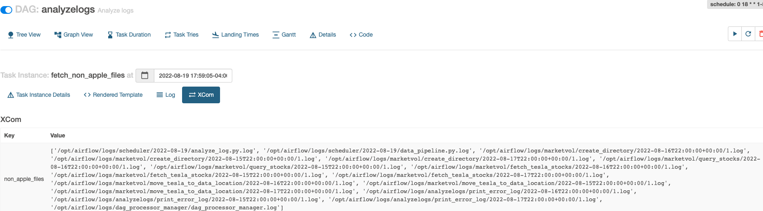

## Task: analyze_non_apple_files

Log:

*** Reading local file: /opt/airflow/logs/analyzelogs/analyze_non_apple_files/2022-08-19T21:59:05.341883+00:00/1.log

[2022-08-19 21:59:11,538] {taskinstance.py:851} INFO - Dependencies all met for <TaskInstance: analyzelogs.analyze_non_apple_files 2022-08-19T21:59:05.341883+00:00 [queued]>

[2022-08-19 21:59:11,542] {taskinstance.py:851} INFO - Dependencies all met for <TaskInstance: analyzelogs.analyze_non_apple_files 2022-08-19T21:59:05.341883+00:00 [queued]>

[2022-08-19 21:59:11,543] {taskinstance.py:1042} INFO -

--------------------------------------------------------------------------------

[2022-08-19 21:59:11,543] {taskinstance.py:1043} INFO - Starting attempt 1 of 3

[2022-08-19 21:59:11,543] {taskinstance.py:1044} INFO -

--------------------------------------------------------------------------------

[2022-08-19 21:59:11,551] {taskinstance.py:1063} INFO - Executing <Task(PythonOperator): analyze_non_apple_files> on 2022-08-19T21:59:05.341883+00:00

[2022-08-19 21:59:11,553] {standard_task_runner.py:52} INFO - Started process 781 to run task

[2022-08-19 21:59:11,558] {standard_task_runner.py:76} INFO - Running: ['airflow', 'tasks', 'run', 'analyzelogs', 'analyze_non_apple_files', '2022-08-19T21:59:05.341883+00:00', '--job-id', '37', '--pool', 'default_pool', '--raw', '--subdir', 'DAGS_FOLDER/analyze_log.py', '--cfg-path', '/tmp/tmp688obzmg', '--error-file', '/tmp/tmpmq62nkt8']

[2022-08-19 21:59:11,558] {standard_task_runner.py:77} INFO - Job 37: Subtask analyze_non_apple_files

[2022-08-19 21:59:11,584] {logging_mixin.py:104} INFO - Running <TaskInstance: analyzelogs.analyze_non_apple_files 2022-08-19T21:59:05.341883+00:00 [running]> on host c089c6e12222

[2022-08-19 21:59:11,605] {taskinstance.py:1255} INFO - Exporting the following env vars:

AIRFLOW_CTX_DAG_OWNER=airflow

AIRFLOW_CTX_DAG_ID=analyzelogs

AIRFLOW_CTX_TASK_ID=analyze_non_apple_files

AIRFLOW_CTX_EXECUTION_DATE=2022-08-19T21:59:05.341883+00:00

AIRFLOW_CTX_DAG_RUN_ID=manual__2022-08-19T21:59:05.341883+00:00

[2022-08-19 21:59:11,623] {python.py:118} INFO - Done. Returned value was: None

[2022-08-19 21:59:11,626] {taskinstance.py:1159} INFO - Marking task as SUCCESS. dag_id=analyzelogs, task_id=analyze_non_apple_files, execution_date=20220819T215905, start_date=20220819T215911, end_date=20220819T215911

[2022-08-19 21:59:11,662] {taskinstance.py:1220} INFO - 1 downstream tasks scheduled from follow-on schedule check

[2022-08-19 21:59:11,691] {local_task_job.py:146} INFO - Task exited with return code 0

Xcom value:

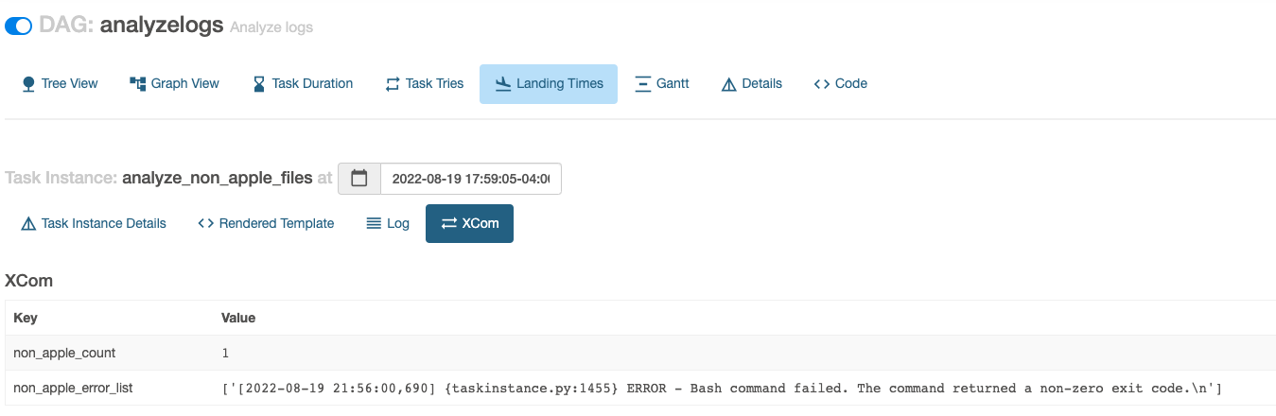

## Task: print_error_log

Log (Highlighted output in yellow):

*** Reading local file: /opt/airflow/logs/analyzelogs/print_error_log/2022-08-19T21:59:05.341883+00:00/1.log

[2022-08-19 21:59:13,394] {taskinstance.py:851} INFO - Dependencies all met for <TaskInstance: analyzelogs.print_error_log 2022-08-19T21:59:05.341883+00:00 [queued]>

[2022-08-19 21:59:13,402] {taskinstance.py:851} INFO - Dependencies all met for <TaskInstance: analyzelogs.print_error_log 2022-08-19T21:59:05.341883+00:00 [queued]>

[2022-08-19 21:59:13,402] {taskinstance.py:1042} INFO -

--------------------------------------------------------------------------------

[2022-08-19 21:59:13,402] {taskinstance.py:1043} INFO - Starting attempt 1 of 3

[2022-08-19 21:59:13,402] {taskinstance.py:1044} INFO -

--------------------------------------------------------------------------------

[2022-08-19 21:59:13,411] {taskinstance.py:1063} INFO - Executing <Task(PythonOperator): print_error_log> on 2022-08-19T21:59:05.341883+00:00

[2022-08-19 21:59:13,413] {standard_task_runner.py:52} INFO - Started process 799 to run task

[2022-08-19 21:59:13,418] {standard_task_runner.py:76} INFO - Running: ['airflow', 'tasks', 'run', 'analyzelogs', 'print_error_log', '2022-08-19T21:59:05.341883+00:00', '--job-id', '38', '--pool', 'default_pool', '--raw', '--subdir', 'DAGS_FOLDER/analyze_log.py', '--cfg-path', '/tmp/tmpj2std1l1', '--error-file', '/tmp/tmpbot7zyi2']

[2022-08-19 21:59:13,418] {standard_task_runner.py:77} INFO - Job 38: Subtask print_error_log

[2022-08-19 21:59:13,447] {logging_mixin.py:104} INFO - Running <TaskInstance: analyzelogs.print_error_log 2022-08-19T21:59:05.341883+00:00 [running]> on host c089c6e12222

[2022-08-19 21:59:13,469] {taskinstance.py:1255} INFO - Exporting the following env vars:

AIRFLOW_CTX_DAG_OWNER=airflow

AIRFLOW_CTX_DAG_ID=analyzelogs

AIRFLOW_CTX_TASK_ID=print_error_log

AIRFLOW_CTX_EXECUTION_DATE=2022-08-19T21:59:05.341883+00:00

AIRFLOW_CTX_DAG_RUN_ID=manual__2022-08-19T21:59:05.341883+00:00

[2022-08-19 21:59:13,479] {logging_mixin.py:104} INFO - Total number of errors: 2

[2022-08-19 21:59:13,479] {logging_mixin.py:104} INFO - Here are all the errors:

[2022-08-19 21:59:13,479] {logging_mixin.py:104} INFO - [2022-08-19 21:55:59,319] {taskinstance.py:1455} ERROR - Bash command failed. The command returned a non-zero exit code.

[2022-08-19 21:59:13,479] {logging_mixin.py:104} INFO -

[2022-08-19 21:59:13,479] {logging_mixin.py:104} INFO - [2022-08-19 21:56:00,690] {taskinstance.py:1455} ERROR - Bash command failed. The command returned a non-zero exit code.

[2022-08-19 21:59:13,479] {logging_mixin.py:104} INFO -

[2022-08-19 21:59:13,480] {python.py:118} INFO - Done. Returned value was: None

[2022-08-19 21:59:13,484] {taskinstance.py:1159} INFO - Marking task as SUCCESS. dag_id=analyzelogs, task_id=print_error_log, execution_date=20220819T215905, start_date=20220819T215913, end_date=20220819T215913

[2022-08-19 21:59:13,521] {taskinstance.py:1220} INFO - 0 downstream tasks scheduled from follow-on schedule check

[2022-08-19 21:59:13,550] {local_task_job.py:146} INFO - Task exited with return code 0