FUTURE log
Rough diary/logbook to keep track of work. Most work/thoughts are written in the notebook, or saved in the GitHub repo. (Dates indicate the week of work)
Week of October 9, 2025
Read about Traumatic Brain Injuries (TBIs), its one of the leading causes of long-term disability and death, disproportionately hits low-income, rural, and off-grid populations who have absolutely zero access to post-acute follow-up care. If we can track these patients after they leave the regional hospital, we can monitor fluctuating symptoms, prevent secondary injuries, and gather long-term recovery data.
Huge infrastructure gap in rural Global South. Rural health clinics do not have stable power, low smartphone usage or data/network connectivity. Charging occurs in towns and cities where they work but not in the villages where they live. Standard telemedicine apps are completely classist and exclusionary here. FUTURE project want to use basic, cheap SMS-based follow-up surveys to collect patient-generated health data, but SMS is vulnerable to impersonation, ie. Fake numbers or short-codes, spoofing. Also can’t easily tell who the doctor is, they may use personal phones not hospital or work phones. Patients also swap SIM cards often or share their devices with other people.
The idea is to create a cheaper version of an OTP keyfob (these cost around £25). Need to check if this is the right approach or best approach, if there are other ways of getting the same outcome.
Could potentially link into wider decentralised or offline health data transmission. Ie EyeVu planning to deploy low-resource ophthalmoscope. Either AI is edge-deployed or image is transmitted over 2G to somewhere (ie. Where the AI model is running), potential for authentication here as biometric data is involved.
Started searching Web of Science and PubMed for related papers or wider reading to understand the context/problem and any existing solutions. Also need to fill in risk assessment and submit to department.
October 16, 2025
Filled Laboratory Hazard Assessment Form. Need to get signed off by Tom.
Planned initial project to guide this term’s work.
Dyson Bursary application is due next week. Need to define the project to be able to write up a grant application. Ideas for student workshops:
- Electronics
- Programming
- OTP game – teach some cryptography
- 3D printing/CAD to teach about design, iteration etc.
Plan for spending: PCB, displays probably will take up most of it. If surveys will be conducted for stakeholder research, could pay for participation prizes/payment.
Started academic literature on cryptographic authentication protocols. Google Authenticator and others use a TOTP standard defined in RFC-6238, SHA-256 hash used. SHA-1 is easier to implement on low-memory devices so will need to look into both.
Brainstormed trust solutions, explore phase of problem space. Other authentication methods are harder to deploy offline ie. Passkeys. Most require memorisation which adds a burden to a vulnerable population (ie. TBI sufferers, memory or cognitive loss etc.) so not the best idea to memorise passwords or even personal information. Data governance too, rural or low-resource health clinics would have to store this information. Also its static, if confidential info is found out then its easy to impersonate. Codes are harder to find out about.
October 23, 2025
Finished and submitted the Dyson Bursary application, justified spending oncustom PCBs, bare microcontrollers, surveys. Maybe Raspberry Pi too.
Summary of auth/cryptography findings: For an offline, low-cost token, asymmetric public-key cryptography (like RSA-2048 or even ECC Curve25519) hard to implement. RSA signature verification takes hundreds of milliseconds even on fast 32-bit chips, could drain battery quickly. Symmetric cryptography (HMAC) uses a pre-shared secret key, which only requires lightweight hash operations, making it computationally efficient and perfect for our tiny power budget.
Technical research findings: ATECC6 has ability to store keys and run crypto? Ordered ATtiny85 for prototoyping, easy to use Arduino IDE so can test immediately a crypto library or implementation on Arduino whilst waiting for microcontroller to arrive.
Should probably do some design-thinking self-reflection as im currently focused on physical keyfob's hardware details and completely ignoring how the clinical integration actually works.
October 30, 2025
Decided to try and solve technical implementation this term then focus on ‘design’ next term. Want to try and get technical architecture sorted in time for Christmas break just in case lead times are long for PCBs or final prototypes, need to have time for testing in lent.
Started scoping cryptographic token hardware like Google Authenticator (requires a smartphone, which is exclusionary), YubiKey (requires a host connection via USB/NFC and lacks a screen), and RSA SecurID (expensive, proprietary, and lacks simple, decentralized re-provisioning). There is a massive gap for a cheap, offline, open visual-verification token. Table of results would be useful in report.
November 6, 2025
Started converging on TOTP. Will try and implement on ATtiny85. Basic code works on Arduino, able to generate 6-digit codes (Every 5 seconds for now) and print them in the SerialMonitor.
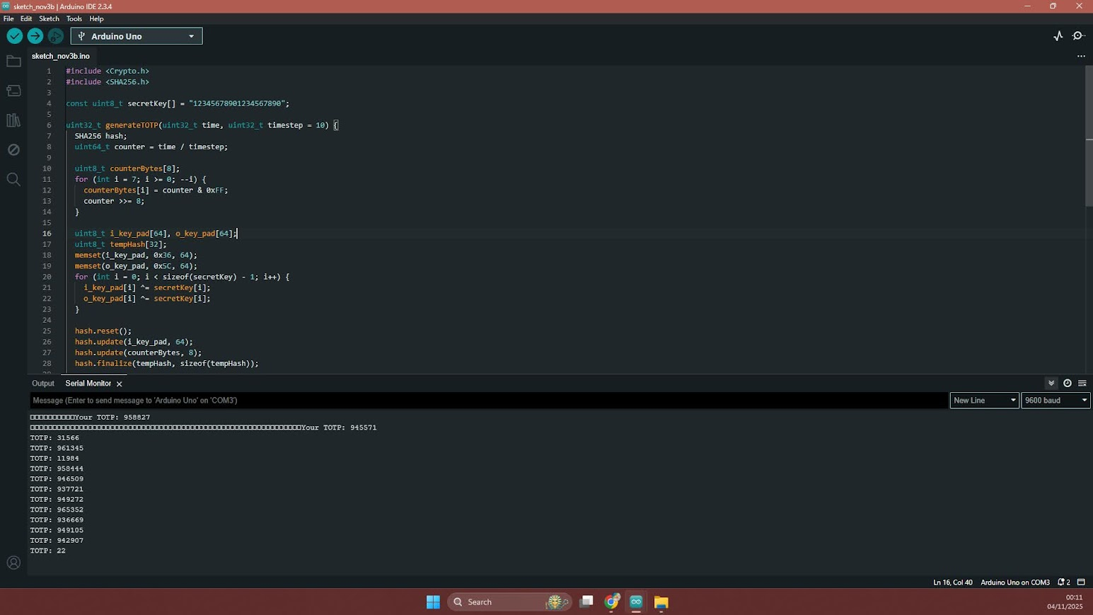
Research feasibility of power generation ie. Solar panels, vibrations, piezoelectric
Clinical integration ideas:
Should be distribution agnostic, consider an open-source API or SDK to allow people to integrate it with existing systems or digital infrastructure. Could be cloud based or maybe local computer that a clinic can just run – need to consider power intermittency so may need battery backup.
Internet connectivity can be assumed for clinics. Look at software implementation or RPi (hardware).
Need to research accessibility standards, ie. Font sizes or character heights, WCA, Inclusive Design Group at the EDC to inform design of UI of both device and clinical backend if software will be developed.
November 13, 2025
Started playing around with ATtiny1616 dev board instead of ATtiny85 as I am moving onto displays. Ordered an e-ink, OLED, and LCD is on the way. OLED was easy to wire up, included a dev board so could just plug in jumper wires. Uses SPI which is easy to interface with.

November 17, 2025
Programming stalling with raw ATtiny1616 (raw ones ordered and soldered onto SOIC adapter, want to avoid the LED and random other unnecessary stff on the dev board that drink up current and not representative of final circuit design). Unable to use Arduino Uno as a controller as software/packages that I can find online that people used are all deprecataed. Might need to buy the dedicated adafruit UPDI programmer.
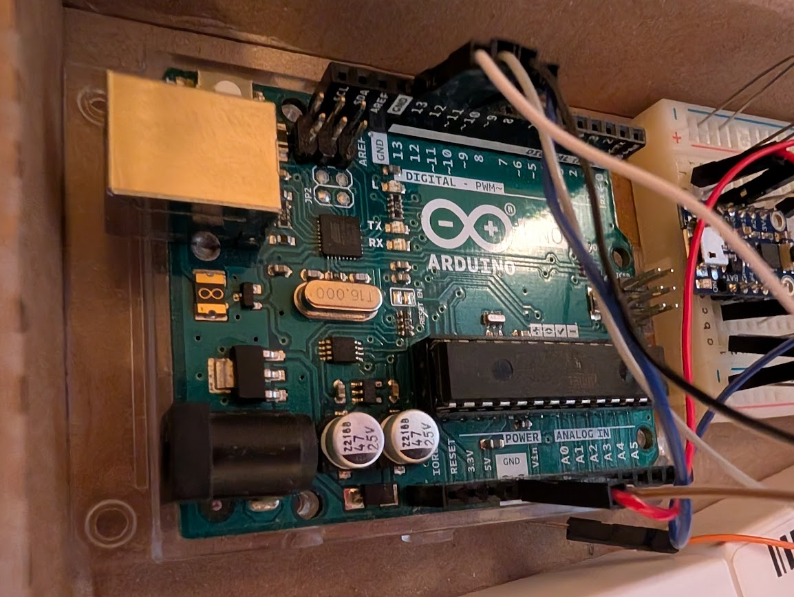
November 20, 2025
Will just use dev board for presentation. Started modelling an indicative housing for the interface for the presentation to 3D print and have something to show – definitely not the final version as no research has been done yet into what this should look like.
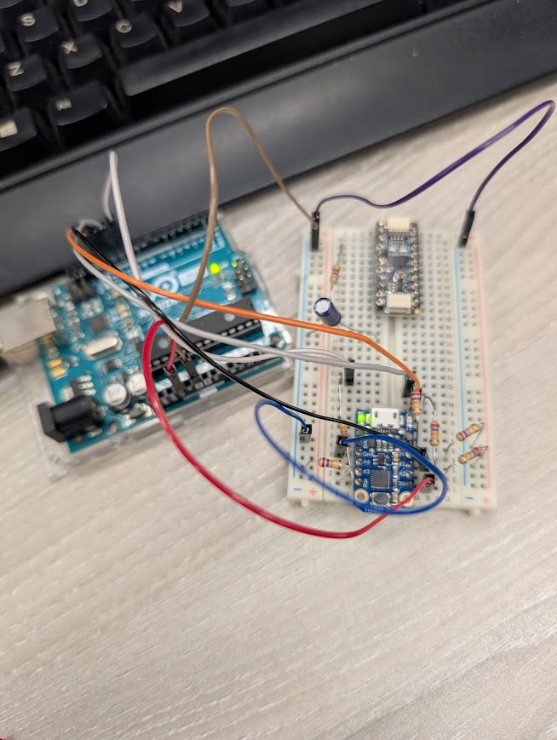
Arduino here used to read codes via UART, no display integrated yet

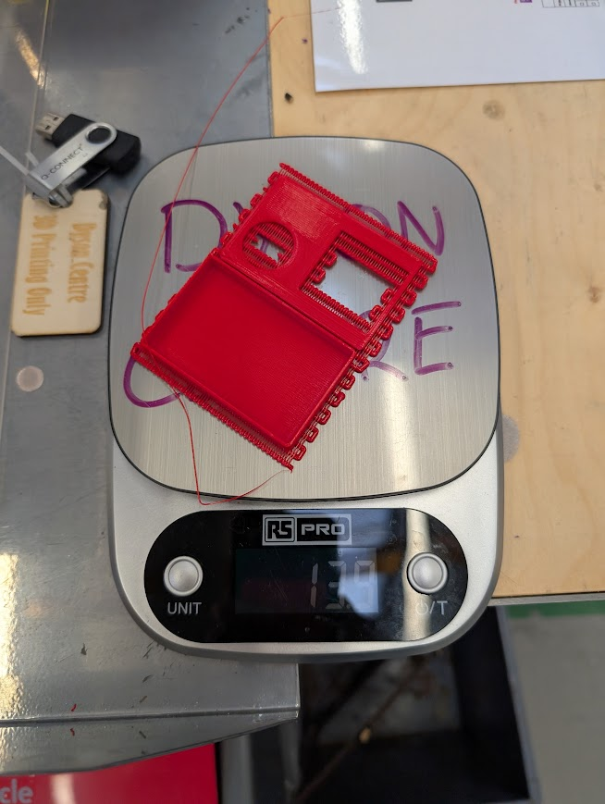

November 27, 2025
Solved issue of Arduino Uno unable to program (discovered that its impossible, not really sovled it). First, the older megaTinyCore v1.0.5 under the Arduino 1.8.x IDE erroneously maps the jtag2updi upload command line to jtagmkII in avrdude, causing a baud rate mismap and handshaking freeze. Second, the Uno's five-volt logic was triggering the ATtiny1616's internal ESD protection which was interfering somehow (it uses 3V logic, not able to get a voltage thing to step it down so this approach was abandoned and the UPDI programmer was ordered). uninstalled all old megaTinyCore versions, installed the stable v2.5.11, selected the SerialUPDI programmer option o use with the programmer. The flash succeeded instantly, was able to upload a simple blink sketch and verify the chip actually works.
Notes on CR2032 lithium coin-cell batteries: Standard coin cells have a nominal capacity of around 220mAh. If our system draws high pulse currents like the 15mA needed roughly for display then voltage can drop.
This voltage drop can easily pull the supply rail below the microcontroller's brown-out reset (BOR) threshold, causing the keyfob to constantly reboo. To prevent this, we must ensure our peak active current remains in the low microamp or single-digit milliamp range. Need to use capacitor to buffer the voltage drop.
Currently SHA-1 is running but next I will try and see if SHA-256 is small enough to fit on the ATtiny.
Winter break
LCD arrived. Much more complicated than the OLED, datasheet doesn’t really make much sense. Will spend the Christmas break trying to get the LCD working. Also the crpyto is fully implemented on the ATtiny1616 now, SHA-256 is possible. Need to consider counting, the RTC has a maximum memory of around 66k seconds (18 hours or so?) so need to program to periodically wake the device to increment a counter (in ISR?) to handle this overflow.
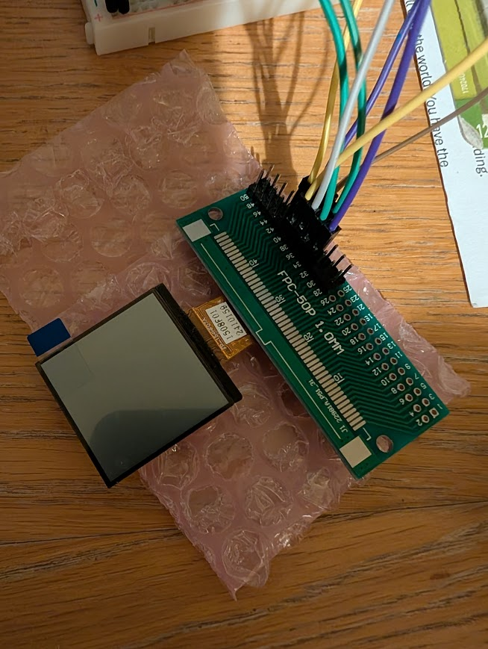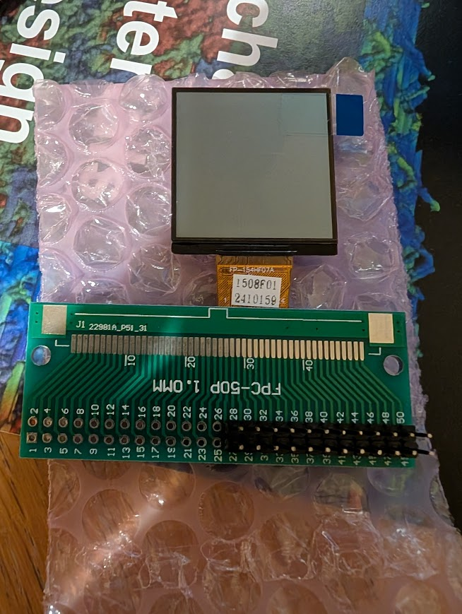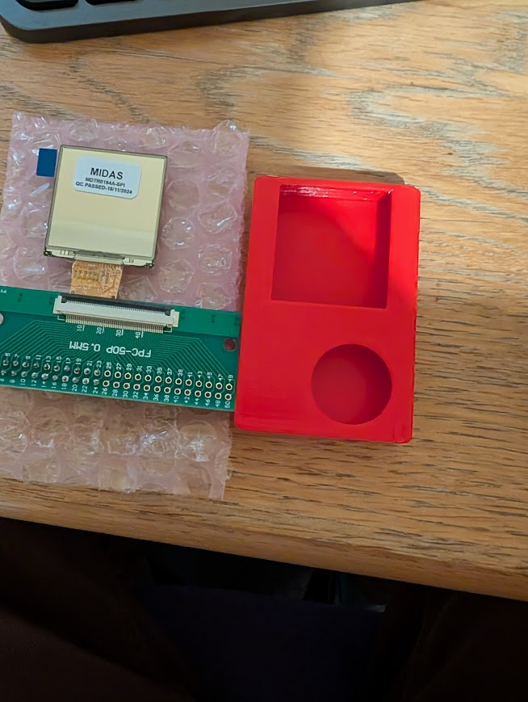
Tried to save power by setting clock prescaler of the microcontroller's internal RC oscillator to drop the system clock from 20MHz to 3MHz but not really working right. Maybe this is wrong approach, could just sacrifice clock speed and try and find power saving elsewhere. The compiled cryptographic code takes up 2.8 KB of Flash and 250 bytes of SRAM using size-optimization flags so there is space to upgrade to SHA-256 since NIST officially retired SHA-1 in 2022 due to mounting collision vulnerabilities
OLED from presentation drained battery very quickly. Definitely need to eliminate that. LCD from Midas still not working. Tried different wiring because maybe I interpreted datasheet wrong. Can’t tell if its that or if its firmware. Tried looking for some packages or libraries comptabile with the display’s driver but they’re all too big for the ATtiny1616. Might need to downgrade back to SHA-1. Tried bypassing a library/driver and directly control the bits but that’s been proving too difficult.
January
Still struggling with the ST7305 reflective LCD wiring issues. Finally realised that the polarity was wrong and screen is able to be powered and not just static. But still not able to control shapes or graphics. Ug82 library was found and this now does seem to work, but finding out that flash space is limited so we can only load in small numeric only fonts.
Should finally look at design of overall system and get the electronics finalised for PCB manufacturing during lent, want to try and get it delivered by week 6-8 so testing can occur in second half of term.
Created test files for UART provisioning to eventually enable repgoramming of the future token after manufacturer, by being controlled by Ardino currently but in future it could be a Raspberry Pi with a USB cable which is something everyone ideally has. Researched single-wire UART which is possible apparently, useful when pins are in short supply for the ATtiny and in case I want to add extra functionality or need extra peripherals for anything else, minimising this aspect of the design to 1 wire instead of 2 is useful (usually you need read and write but with half-duplexing you can read then write on the same wire by alternating it)
Was able to read the device information in SerialMonitor via Arduino: 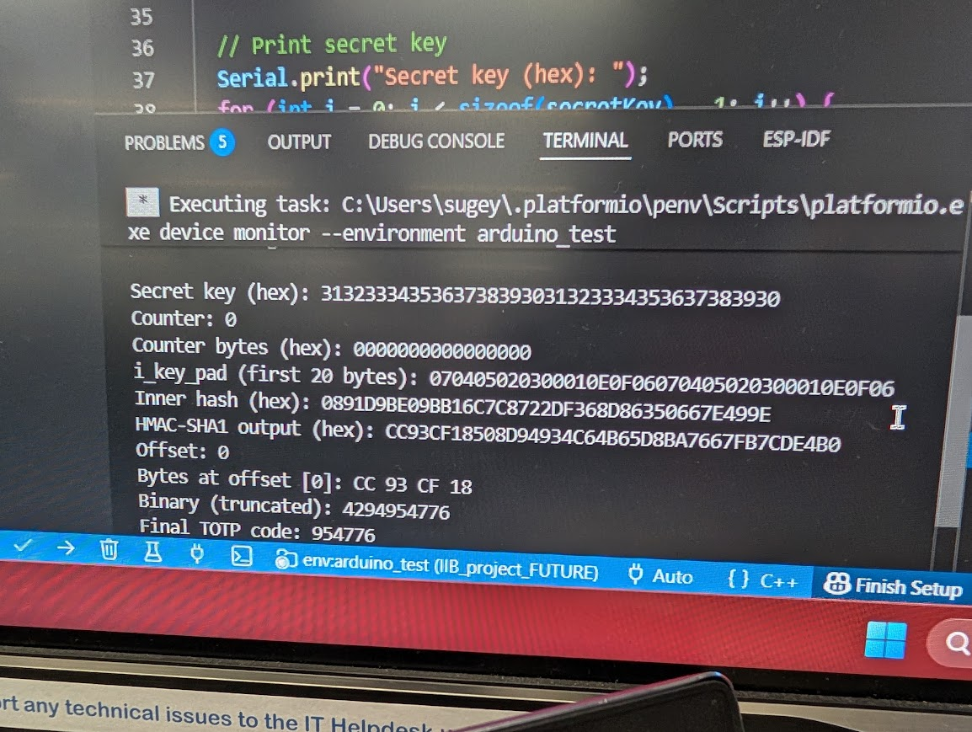
(on Arduino end it still has the separate read and write wires on pins 10 and 11)
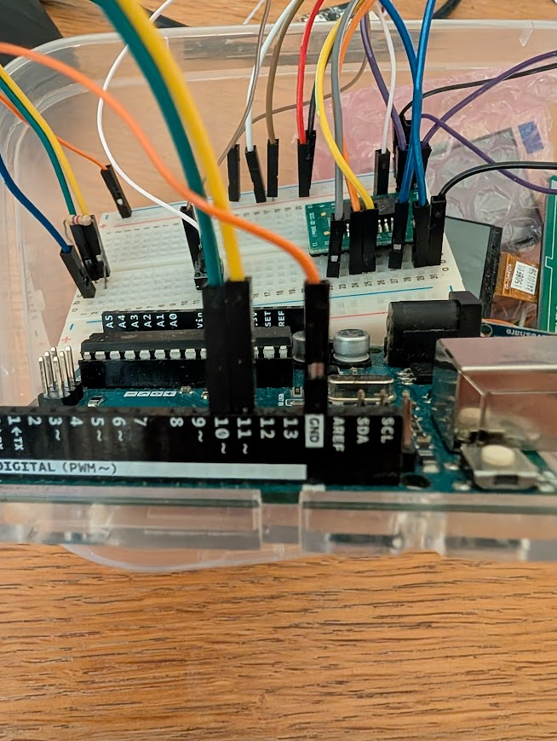

February 5, 2026
Finalised design objectives and requirements using objectives tree. Also began translating breadboard circuit into PCB software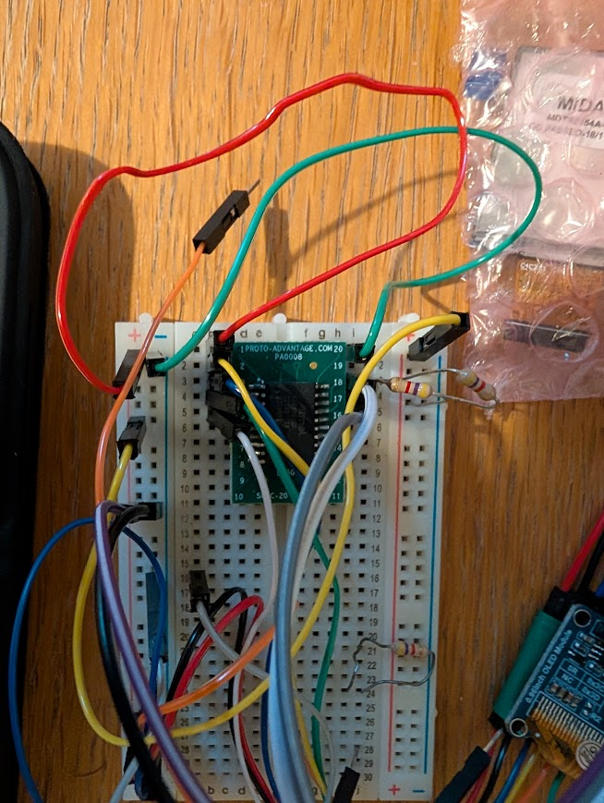
February 12 2026
Set up a morphological chart in my notebook to brainstorm alternative hardware layouts for our functional objectives. I mapped out four options for each main blockand then did a Weighted Objectives Method (design methods taken from one of the books) to rate and score these configurations so I can select our final physical design path.
Ran our Weighted Objectives evaluation in my notebook, scoring our design concepts across five key metrics: power efficiency, circuit footprint, cost, reliability, and routing complexity. Concept A (Reflective TFT Display + pogo pin UART/UPDI + ATtiny1616) received best weighted score .
February 19, 2026
Settled on pogo-pin reprogramming (4 pins, UART, UPDI, GND, and 3V). Designed our dual-rail power isolation circuit. To prevent backcharging our non-rechargeable CR2032 lithium battery when USB-C power is connected, theres a P-Channel MOSFET (AO3401A) ideal-diode switch.
This positive voltage turns the P-MOSFET fully off, completely isolating the battery, so USB charging can’t backcharge the battery.
I also mapped out the Key Security Architecture. The secret key is stored directly in the ATtiny1616's secure internal EEPROM which is writeable via UART (for provisioning).
Clock synchronisation tests have begun using Raspberry Pi and breadboard prototype. I simply just run it and see the difference in time after a set time has passed to get the % error. Have been doing multiple runs. And testing with and without DS3231 chips (external RTCs, battery powered, uses crystal oscillator)
February 26, 2019
Clock synchronisation tests yielding some results: basically internal clock is quite bad. Would only be synchronised for a few months even with daily codes. PCB design has been edited to have the crystal and AN2468 design note used to specify the capacitors needed to get the crystal working correctly at right frequency.
PCB design has been emailed to Tom and Brandon and order is placed, should arrive within 2 weeks.

A co-creation user survey was drafted if I wanted to get stakeholder feedback on housing design. Light-touch ethics form needed. Use Qualtrics, data-secure and has the uni’s branding. Problem is might be difficult to get in touch with this demographic within a reasonable timeframe and I have a bit of literature information anyway to make an informed guess. Might likely leave this as future work and focus on the technical implementation. Was interesting making the survey anyway and learning about how to not bias answers to a specific solution, how to frame questions, also some javascript involved to try and calibrate the screen size to test for readability of different fonts, also tried to design survey to test readability of different contrasts but might be hard to formally do this given differing brightnesses or displays or lighting conditions that the survey-user is in when answering.
March 5, 2026
Started modelling the housing on Solidworks. Concepts developed and can be included in the draft survey are the pendant, the keycard, and a watch.
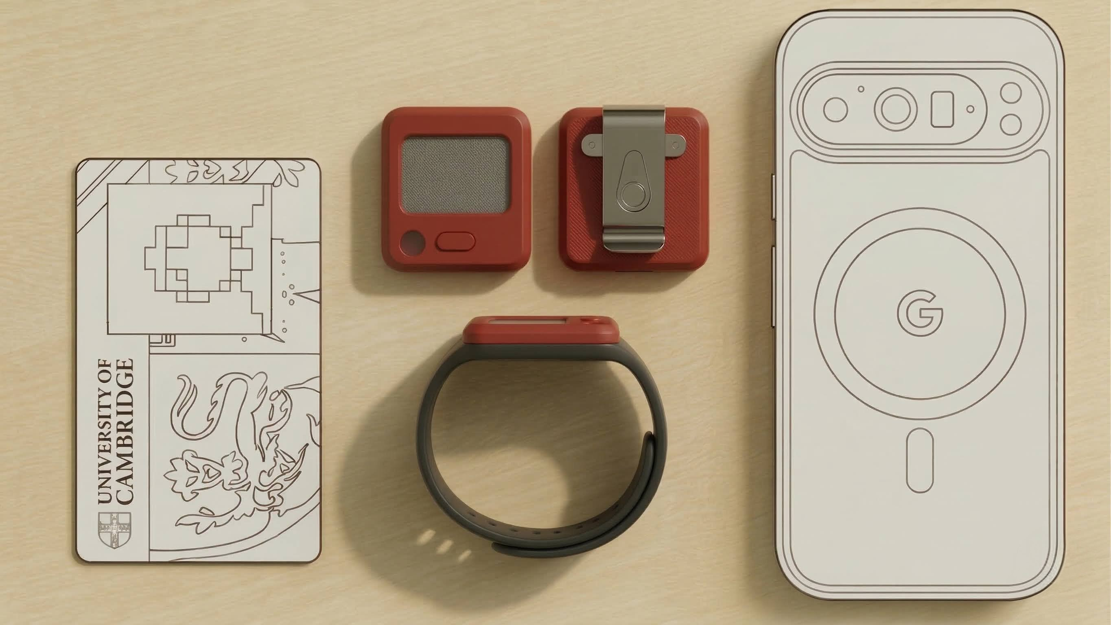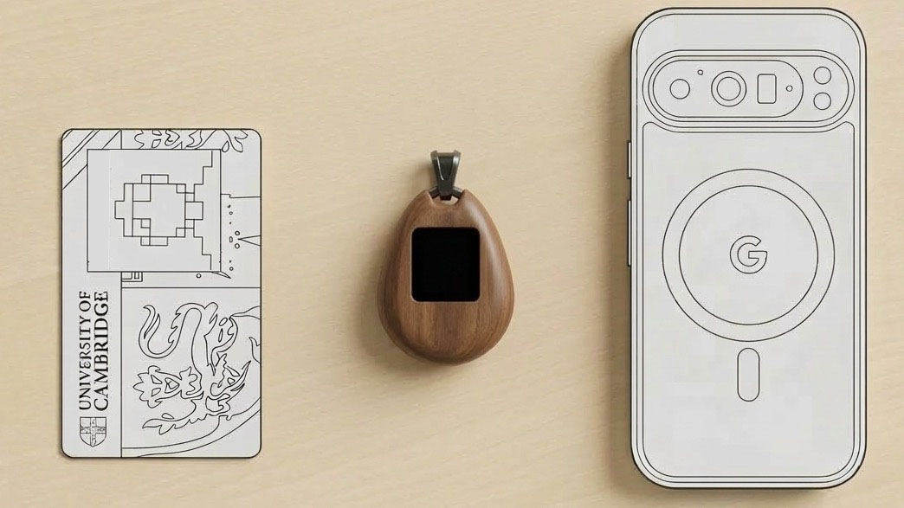
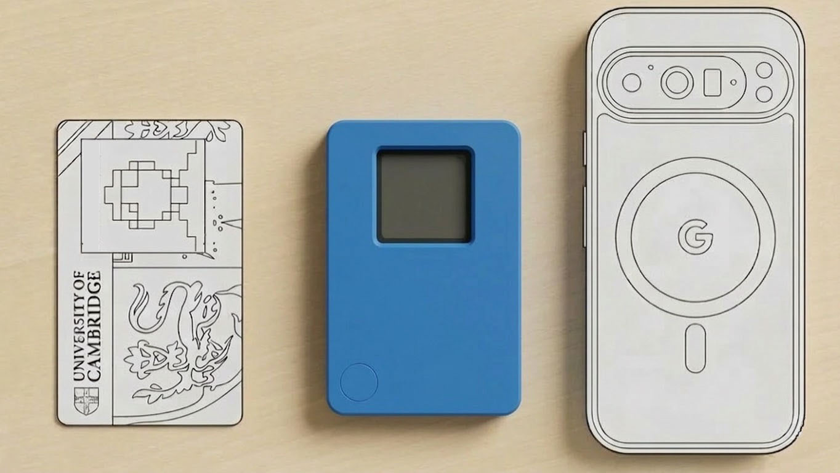
Re-rendered it with a phone and keycard for scale so people can grasp the scale and also how it looks in real life, rather than a cad model.
From research, cards and wallets are less prominent in rural populations and women also have less financial freedom so may not carry this item as commonly. Want a form factor that is culturally carried, but western-assumptions of keys/phone/card/wallet need to be reconsidered. Pendants/jewelry/clothing is quite universal, especially if you can involve local designers. Started designing an indicative pendant, but in real life this thing could be artistically designed. Goal was something as small as possible, roughly the right size and shape.
Also came up with acronym PENDANT to formally describe the FUTURE token. PENDANT = Personal Encrypted Number-generating Device for Auth. in Network-limited Teleheatlh.
March 12, 2026
Started printing these using the Bambu printers in the lab. Trial and error to get right settings and make sure the fits are tight but not too tight. A few issues with tolerances, was hard to assemble and LCD broke in process when I tried to assemble it for first time.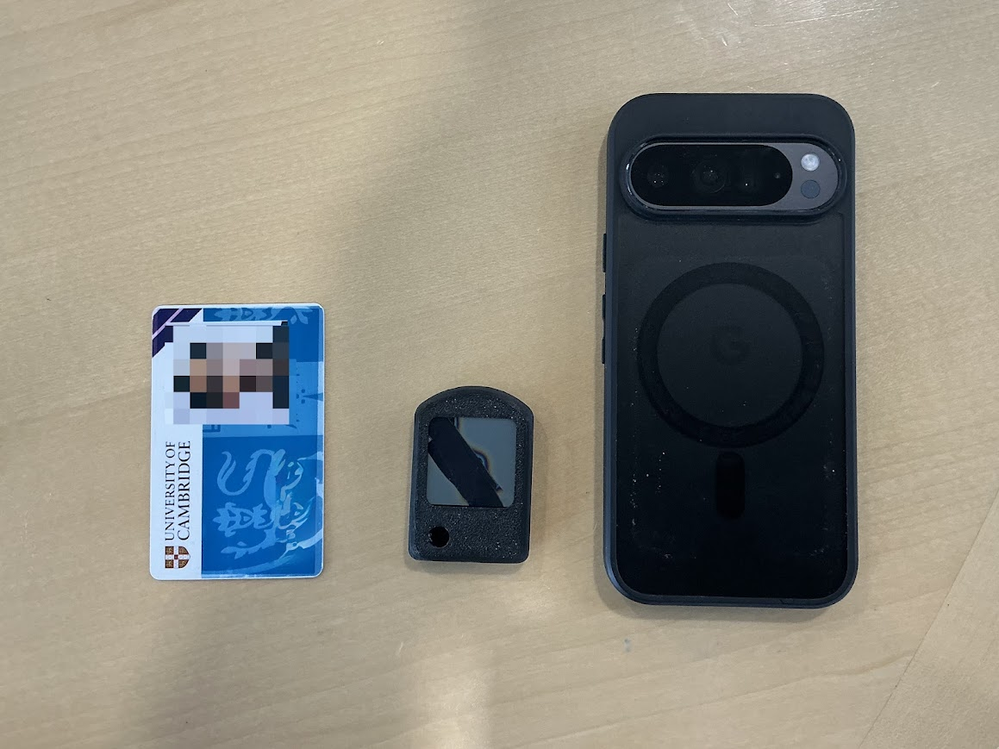
USB programmer housing was also modelled and printed. Also did this iteratively and changed design from symmetric to asymmetric to avoid need for orientating magnets or ugly lock/key shapes. 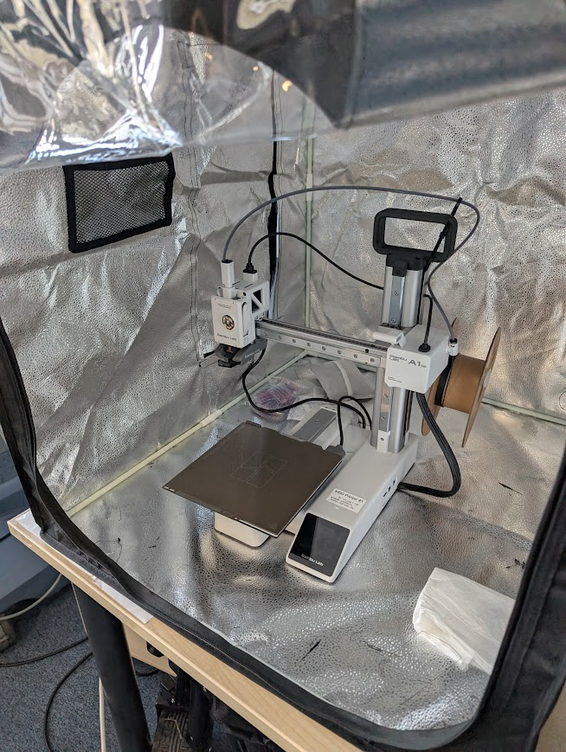
March 22, 2026
Went to Cambridge Health Futures Conference at Emma, not directly related to the project but quite insightful about health tech in general.
March 23, 2026
PCBs arrived last week but now I am finally testing them. Coded up some dataloggers to take VirtualBench digital multimeter output (can measure up to 5 decimal places so I can measure as small as 10nA resolution). 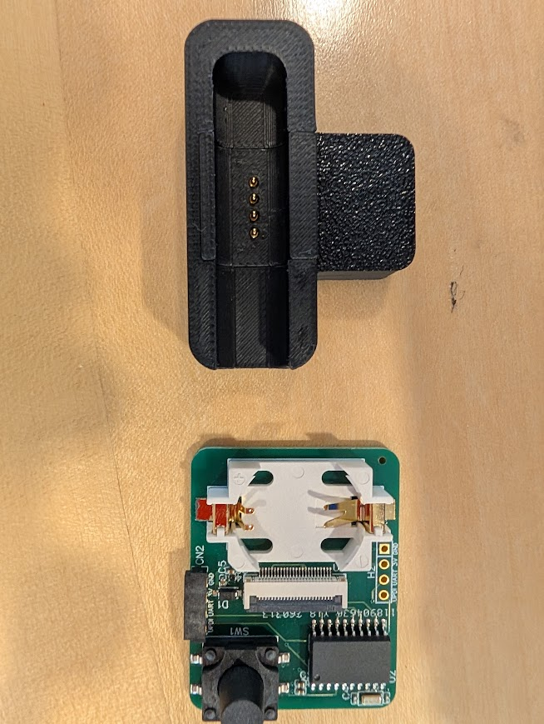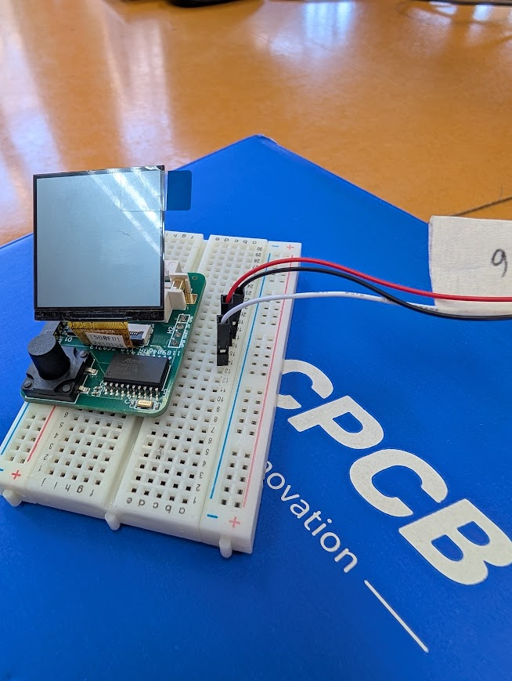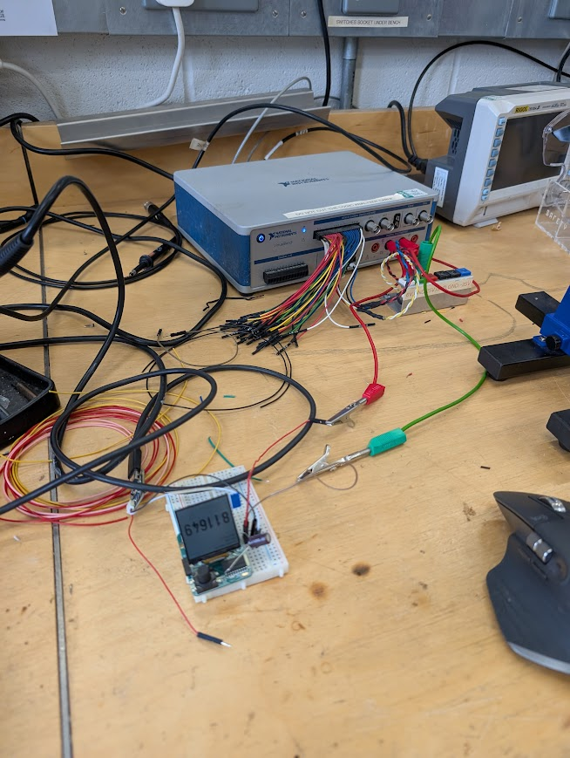
Plots are on github.
Current is quite large, discovered its due to LCD being plugged in. Was unable to fix with firmware. Need to fix with a switch or MOSFET to physically disconnect the LCD from the power source when the pendant is set to sleep.
March 26, 2026
Uploaded the final firmware onto the PCB prototype to test clock synchronisation. Managed to do a 12 hour test run, no observed clock drift (still counting the same second). Room temp was 20 degrees.
April 9, 2026
Started writing up the report and doing the data analysis of the .csv files obtained from the current measuring tests. Plots are on the github.
May 8, 2026
Second PCB iteration arrived just after exams. Spent the next week running the same tests as before. Data and plots on the github. Battery life calculated to be 6.4 years thanks to new firmware (main2.cpp) that controls power-gating of the LCD. 
May 15, 2026
Started building the clinic-side system that would actually manage it on a Raspberry Pi or clinic laptop. Set up a Flask backend with a SQLite database for registered pendants, Python-side TOTP generation, and routes for listing devices, registering pendants, generating codes, resetting clocks, and deleting records.
Turned the web app into an actual hardware control panel. Added the serial communication layer so the Flask server can list COM/USB ports and talk to the pendant over UART. Defined the backend-to-token protocol around simple text commands: HELLO, STATUS, READ_RTC, CHALLENGE, RESET_ARM, RESET_TIME, PROVISION, RESET_ALL, and UNREGISTER. The backend parses these replies and exposes them through API endpoints, while the frontend now has port selectors, UART testing, RTC readout, reset controls, and live logging.
Also finalised the CAD, making improvements to fit and trying to make assembly easier to avoid breaking the LCD.
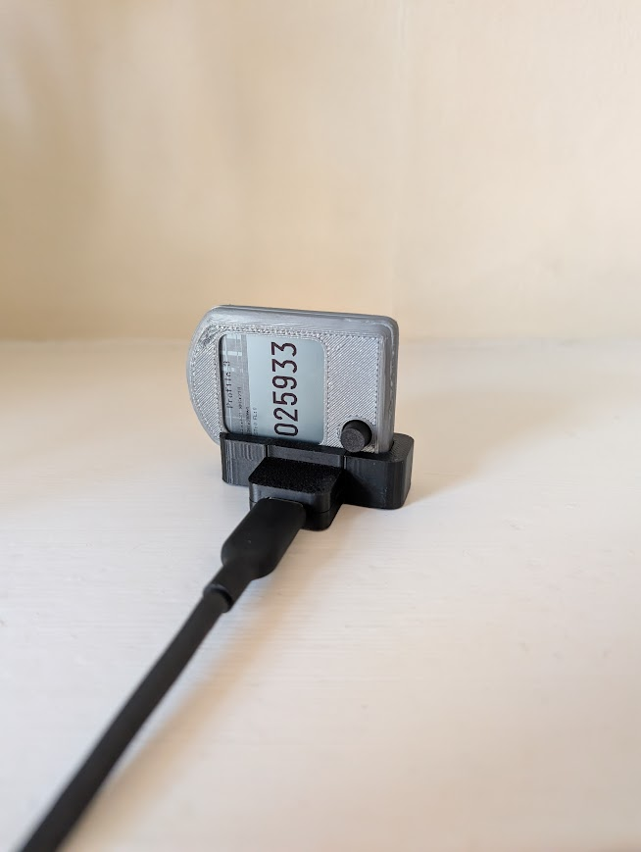
May 22, 2026
added challenge-response verification so the clinic-side software can check that the connected pendant matches the saved database record before doing destructive operations like resetting or unregistering. This uses a random nonce and HMAC-SHA1 with the stored secret, so the server does not just trust that the plugged-in device is the right one.
Finalised main3.cpp as the more complete pendant firmware. Moved to the ATtiny3216 version with three selectable profiles, each storing its own 20-byte secret, timestep, elapsed-time offset, and provisioned marker in EEPROM. Added button-based profile cycling, a “Not Set” display for blank profiles, and a reset/admin mode so provisioning and reset commands only work after the device has deliberately been armed.

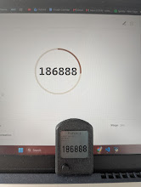
Pendant and back-end in-sync.
Printed the final housings for the rest of the PCBs.
