RFID BASED ATTENDANCE SYSTEM

Project Report Submitted in Partial Fulfilment of the Requirements for the Degree of

Bachelor of Technology
in
Electronics and Communication Engineering

by

D. Seethend Reddy (13241A0434)


DEPARTMENT OF ELECTRONICS AND COMMUNICATION ENGINEERING

GOKARAJU RANGARAJU INSTITUTE OF ENGINEERING AND TECHNOLOGY

(Affiliated to Jawaharlal Nehru Technological University)

HYDERABAD 500 090

2016
Abstract

In recent years, there have been rise in the number of applications based on Radio Frequency Identification (RFID) systems and have been successfully applied to different areas as diverse as transportation, health-care, agriculture, and hospitality industry to name a few. RFID technology facilitates automatic wireless identification using electronic passive and active tags with suitable readers. In this paper, an attempt is made to solve recurrent attendance monitoring problem using RFID technology.
The application of RFID to attendance monitoring as developed and deployed in this study is capable of eliminating time wasted during manual collection of attendance for allocation of appropriate attendance scores.

Contents
1. Introduction 1
2. Hardware Components 2
2.1. RFID Reader 2
2.2. RFID Tags 3
2.3. Bluetooth Module 4
2.4. UDC Board 5
3. Software Components 8
3.1. MIT App Inventor 2 8
3.1.1. Designer 8
3.1.2. Blocks 9
3.2 Atmel Boot loader 14
3.3 Arduino IDE 15
4. Source Code 15
5. Functionality 18

1. Introduction
We will use RFID hardware to take the attendance of an employee. Each employee will be given an individual RFID tags and its record will be maintained in a database. When he will place the tag for first time in a day, time will be fetched and will be stored as in time. When he leaves he has to place the tag again and this time it will be noted as out time. Thus maintaining the record when the employee enters and leave the premises.

The cost of implementation of the system is only one time as the RFID chips are light and cheap containing information up to a few binary digits. The chip is rewritable and so is the information that is stored in the database corresponding to the chip code.

2. Hardware Components

2.1. RFID Reader

RFID systems can be classified by the type of tag and reader. A Passive Reader Active Tag (PRAT) system has a passive reader which only receives radio signals from active tags (battery operated, transmit only). The reception range of a PRAT system reader can be adjusted from 1–2,000 feet (0–600 m)[citation needed], allowing flexibility in applications such as asset protection and supervision.
An Active Reader Passive Tag (ARPT) system has an active reader, which transmits interrogator signals and also receives authentication replies from passive tags.
An Active Reader Active Tag (ARAT) system uses active tags awoken with an interrogator signal from the active reader. A variation of this system could also use a Battery-Assisted Passive (BAP) tag which acts like a passive tag but has a small battery to power the tag's return reporting signal.
RFID module used is ID-12 from “ID Innovations”. This is a very simple to use RFID reader module. With a built in antenna, the only holdup is the 2mm pin spacing). Power the module, hold up a card, and get a serial string output containing the unique ID of the card. It support ASCII, Wiegand26 and Magnetic ABA Track2 data formats.

Its specifications are:
- Range: 12+ cm.
- Frequency: 125 kHz.
- Card Format: EM 4001 or compatible
- Encoding: Manchester 64 bit
- Power: 5V DC @ 30mA nominal
- Voltage Supply Range: +4.6V through +5.4V
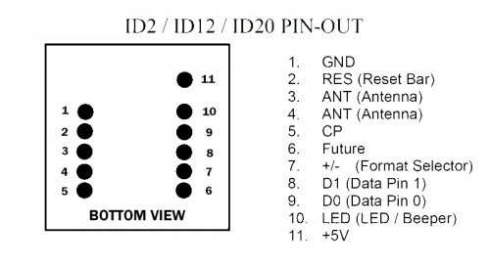
FIG. 2.1.1. ID 12 Pin out Diagram
Pin |  |  | Description |  |  |  | ASCII |  |  |  | Magnet Emulation |  |  |  |  |  |  | Wiegand26
No. |  |  | Description |  |  |  | ASCII
Pin 1 |  |  | Zero Volts and Tuning Capacitor |  |  |  | GND 0V |  |  |  |  |  | GND 0V |  |  |  |  | GND 0V
 |  |  | Ground
Pin 2 |  | Strap to +5V |  |  |  | Reset Bar |  |  |  |  |  | Reset Bar |  |  |  |  | Reset Bar
Pin 3 |  |  | To External Antenna and Tuning |  |  |  | Antenna |  |  |  |  |  | Antenna |  |  |  | Antenna
 |  |  | Capacitor
Pin 4 |  |  | To External Antenna |  |  | Antenna |  |  |  |  |  | Antenna |  |  |  |  | Antenna
Pin 5 |  |  | Card Present |  |  |  | No function |  |  |  |  |  | Card Present * |  |  |  |  | No function
Pin 6 | Future |  |  |  | Future |  |  |  | Future |  |  |  |  |  | Future
Pin 7 | Format Selector (+/-) |  |  |  | Strap to GND |  |  |  | Strap to Pin 10 |  |  |  |  |  | Strap to +5V
Pin 8 | Data 1 |  |  |  | CMOS |  |  |  | Clock * |  |  |  |  |  | One Output *
Pin 9 | Data 0 |  |  |  | TTL Data (inverted) |  |  |  | Data * |  |  |  |  |  | Zero Output *
Pin 10 | 3.1 kHz Logic |  |  |  | Beeper / LED |  |  |  | Beeper / LED |  |  |  |  |  | Beeper / LED
Pin 11 | DC Voltage Supply |  |  |  | +5V |  |  |  | +5V |  |  |  |  |  | +5V
Table 2.1.1. ID 12 Pin Description

Out of these pins, only the Power supply of +5V, Ground (GND) and Data1 pins are used to connect with the UDC board. The data1 pin is used for the read card data or unique code to be transmitted to the microprocessor.

2.2. RFID Tags
RFID tags (Figs 2.2.1 and 2.2.2) can be either passive, active or battery-assisted passive. An active tag has an on-board battery and periodically transmits its ID signal. A battery-assisted passive (BAP) has a small battery on board and is activated when in the presence of an RFID reader. A passive tag is cheaper and smaller because it has no battery; instead, the tag uses the radio energy transmitted by the reader. However, to operate a passive tag, it must be illuminated with a power level roughly a thousand times stronger than for signal transmission. That makes a difference in interference and in exposure to radiation.
RFID tags contain at least two parts: an integrated circuit for storing and processing information, modulating and demodulating a radio-frequency (RF) signal, collecting DC power from the incident reader signal, and other specialized functions; and an antenna for receiving and transmitting the signal. The tag information is stored in a non-volatile memory. The RFID tag includes either fixed or programmable logic for processing the transmission and sensor data, respectively.
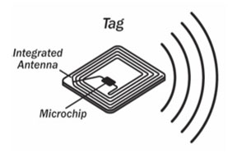
Fig.2.2.1. RFID tag layout

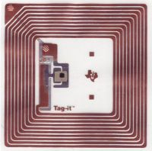
Fig 2.2.2 RFID tag

2.3. Bluetooth Module
Bluetooth component used is RN-42 module from Roving Networks, a powerful, small, and very easy to use. This Bluetooth module is designed to replace serial cables. The Bluetooth stack is completely encapsulated.
The RN42 is a small form factor, low power, highly economic Bluetooth radio for OEM’s adding wireless capability to their products. The RN42 supports multiple interface protocols, is simple to design in and fully certified, making it a complete embedded Bluetooth solution.
Features:
- Fully qualified Bluetooth 2.1/2.0/1.2/1.1 module

- Bluetooth v2.0+EDR support

- Available with on board chip antenna (RN-42) and without antenna (RN-42-N)

- Postage stamp sized form factor, 13.4mm x 25.8 mm x 2mm (RN-42) and 13.4mm x 20 mm x 2 mm (RN-42-N)

- Low power (26uA sleep, 3mA connected, 30mA transmit)

- UART (SPP or HCI) and USB (HCI only) data connection interfaces.

- Sustained SPP data rates - 240Kbps (slave), 300Kbps (master)

- HCI data rates - 1.5Mbps sustained, 3.0Mbps burst in HCI mode

- Embedded Bluetooth stack profiles included

  - (Requires no host stack): GAP, SDP, RFCOMM and L2CAP protocols, with SPP and DUN profile support.

- Bluetooth SIG certified

- Castellated SMT pads for easy and reliable PCB mounting

- Certifications: FCC, ICS, CE
- Environmentally friendly,
- RoHS compliant
- Baud rate speeds: 1200bps up to 921Kbps, non-standard baud rates can be programmed.

- Class 2 radio, 60 feet (20meters) distance, 4dBm output transmitter, -80dBm typical receive sensitivity

- Frequency 2402 ~ 2480MHz,

- FHSS/GFSK modulation, 79 channels at 1MHz intervals

- Secure communications, 128 bit encryption

- Error correction for guaranteed packet delivery

- UART local and over-the-air RF configuration

- Auto-discovery/pairing requires no software configuration (instant cable replacement).

- Auto-connect master, IO pin (DTR) and character based trigger modes.

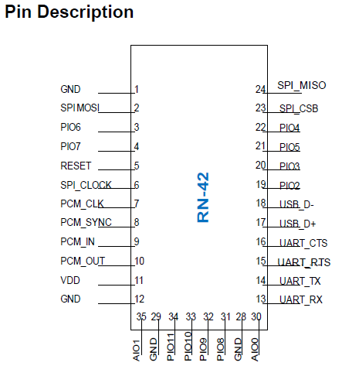
Fig. 2.2.1. Pin out for RN-42
The Bluetooth module (Fig.2.1.1) fits into the UDC board in the given port. The 3.3V supply is given from the microcontroller through a voltage stabilizer circuit. The data pins of the RN 42 are connected to the RX and TX pins of the Atmega 328P which are PD0 and PD1.

2.4. UDC Board
Universal Device Control (UDC) board (Fig.2.4.1) is a customized printed circuit board (PCB) designed by the college. It deploys Atmega 328 Microprocessor booted with Arduino UNO files.

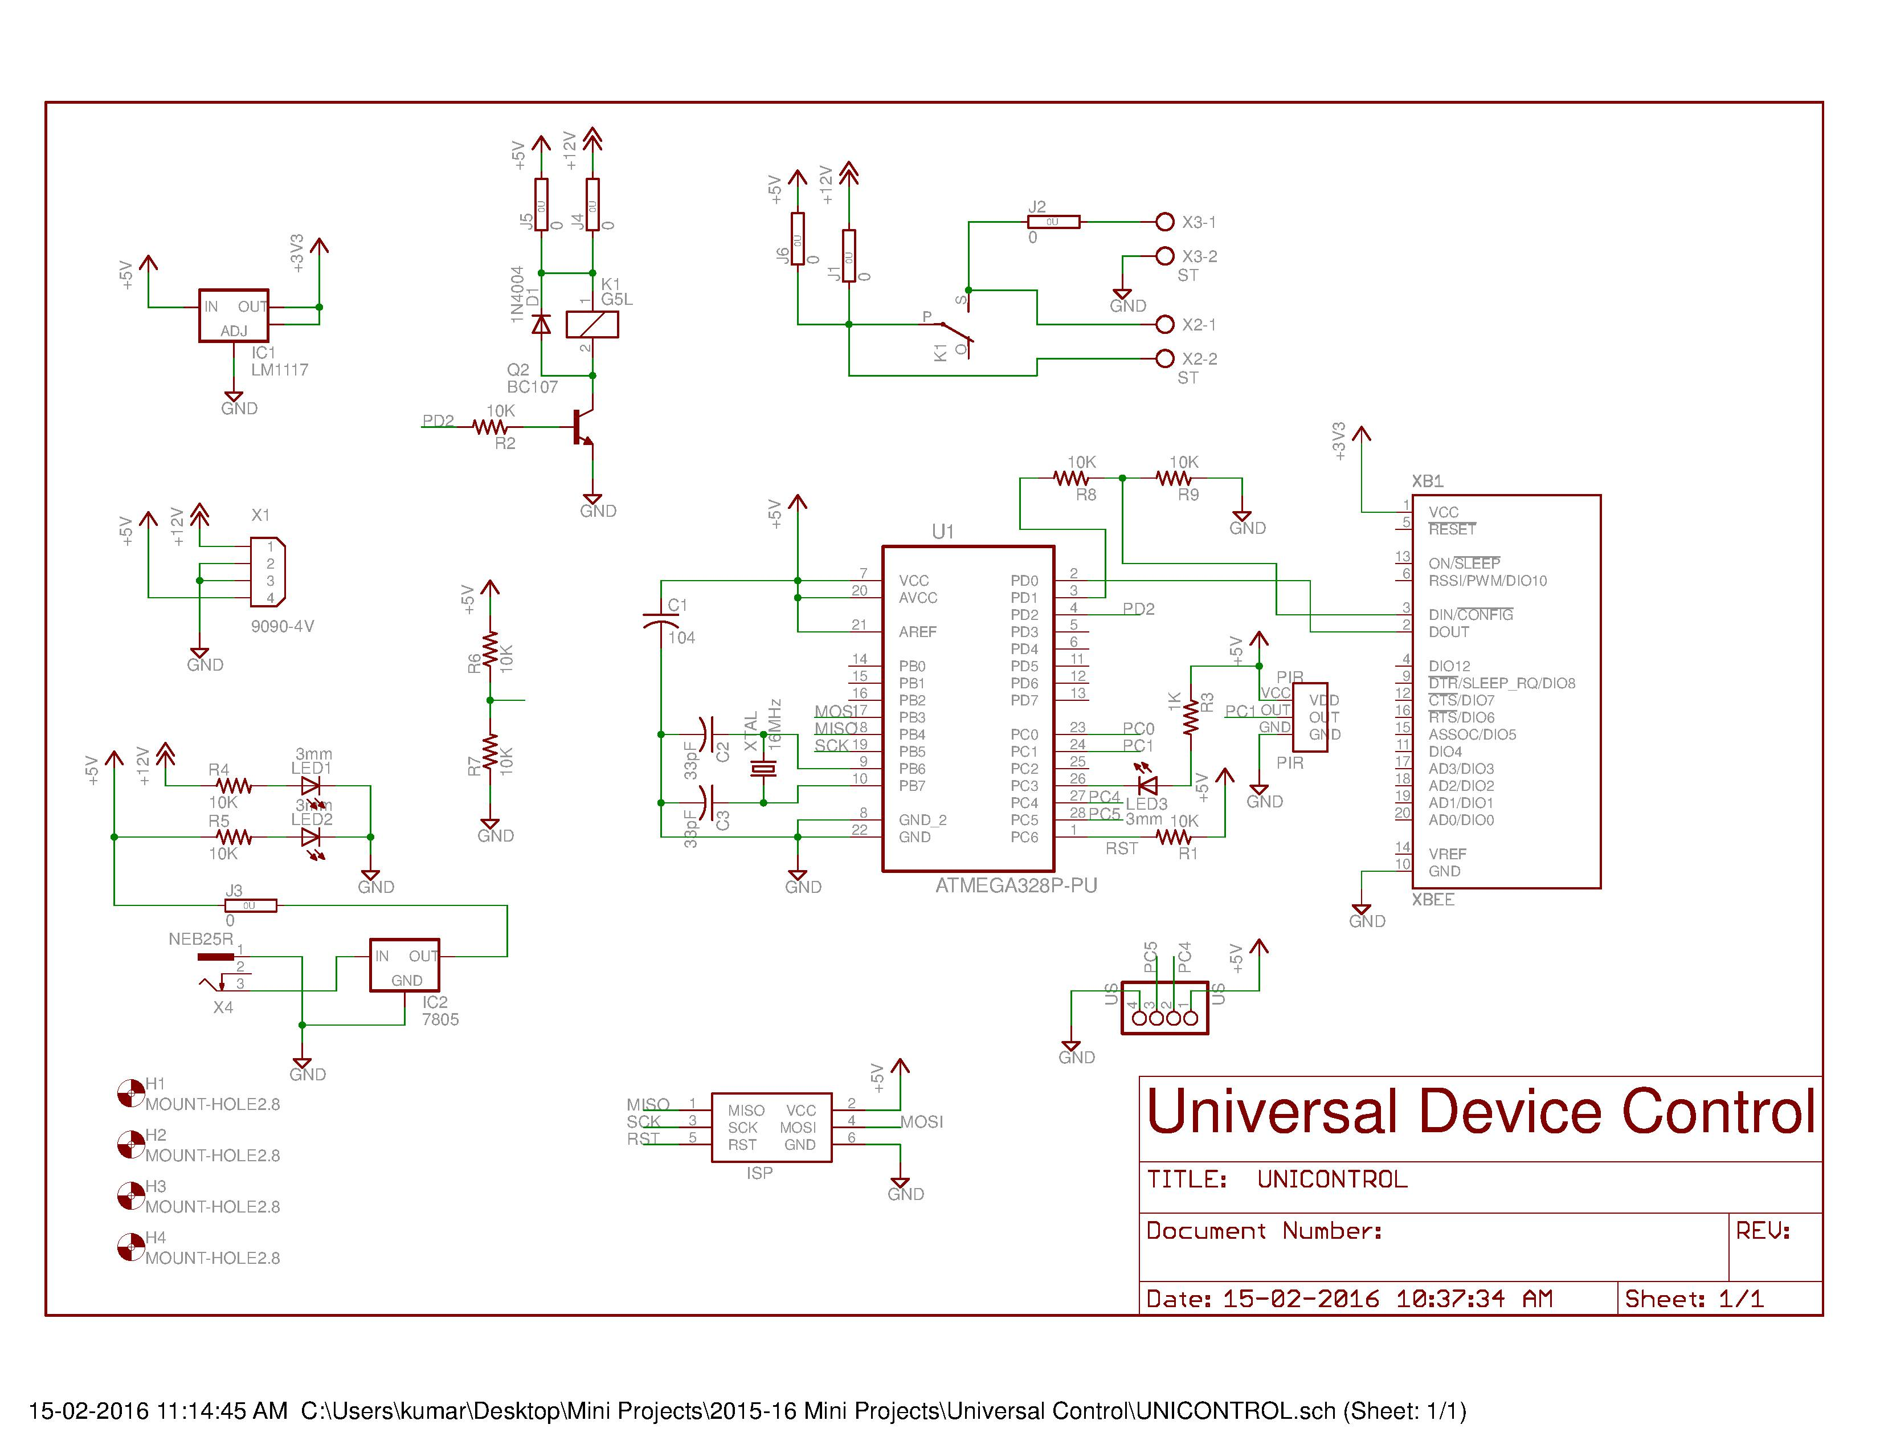
Fig.2.4.1. UDC Layout
The ATmega328 (Fig.2.4.2) is a single chip micro-controller created by Atmel and belongs to the megaAVR series. Its parameters are:
- Flash:32kBytes
- EEPROM:1024 Bytes
- SRAM:2 Kbytes
- Pin Count:32
- Max. Operating Frequency:20 MHz
- CPU: 8-bit AVR
- Max I/O pins:23
- External Interrupts:24
- SPI:2
- UART:1

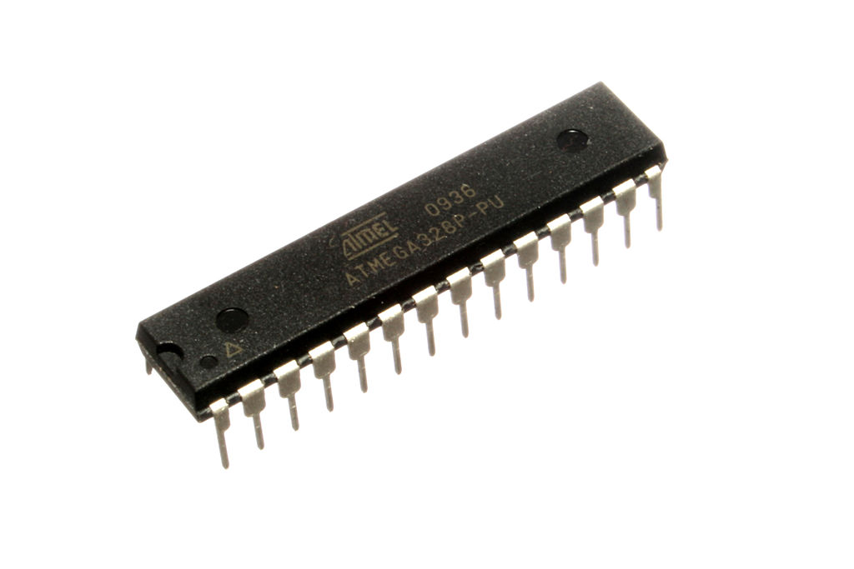
Fig.2.4.2.Atmega 328

The pin out diagram for the microprocessor is given in Fig.2.4.3, giving the mapping between the Arduino Uno and the IC.
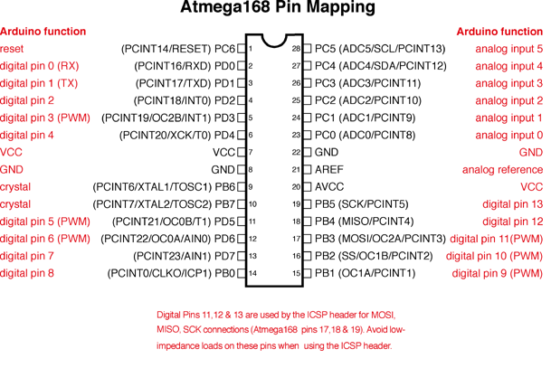
Fig.2.4.3.Atmega 328 Mapping
To provide a steady +3.3V supply to the Bluetooth module, a voltage regulator LM1117 is used (shown in top right corner of Fig.2.4.1). Manufactured by “Texas Instruments”, the LM1117 is a low drop out voltage regulator providing a current of 800mA. It also offers current limiting and thermal shutdown. Its circuit includes a Zener trimmed band gap reference to assure output voltage accuracy to within 1%.
The UDC board has an LED integrated into it at the pin PC3. It runs on a power supply of +5V drawn through an adapter stepping down the voltage from +240V to +5V. The power connector used is 9090-4V from “Thomas & Betts Corporation’. It is a 4 contact, rectangular male power connector with a Solder type terminal.

3. Software Components

3.1. MIT App Inventor 2
App Inventor for Android is an open-source web application originally provided by Google, and now maintained by the Massachusetts Institute of Technology (MIT). It allows newcomers to computer programming to create software applications for the Android operating system (OS). It uses a graphical interface, which allows users to drag-and-drop visual objects to create an application that can run on Android devices.

3.1.1. Designer
Fig.3.1.1 is screen1 in the android app. This Screen appears on the initialization on Android app. This screen consist of names of the employees working in the company whose attendance is monitored by the administration.
Here, we used horizontal and vertical arrangements for perfect alignment of the buttons and checkboxes. We used buttons to display the employee names and when pressed they lead to screen2 where employee details are already registered. Checkboxes are used to check when they enter and when they leave. Button “next day” is used to increment the day and Button “Bluetooth” is used to connect to the addresses of the Bluetooth module.
We also use a textbox to display the data received from Bluetooth and there are many Non-Visible Components like TinyDB for storing the data, Bluetooth Client for connecting, Clock is used to monitor the data from Bluetooth and notifiers are used to notify when back is pressed.
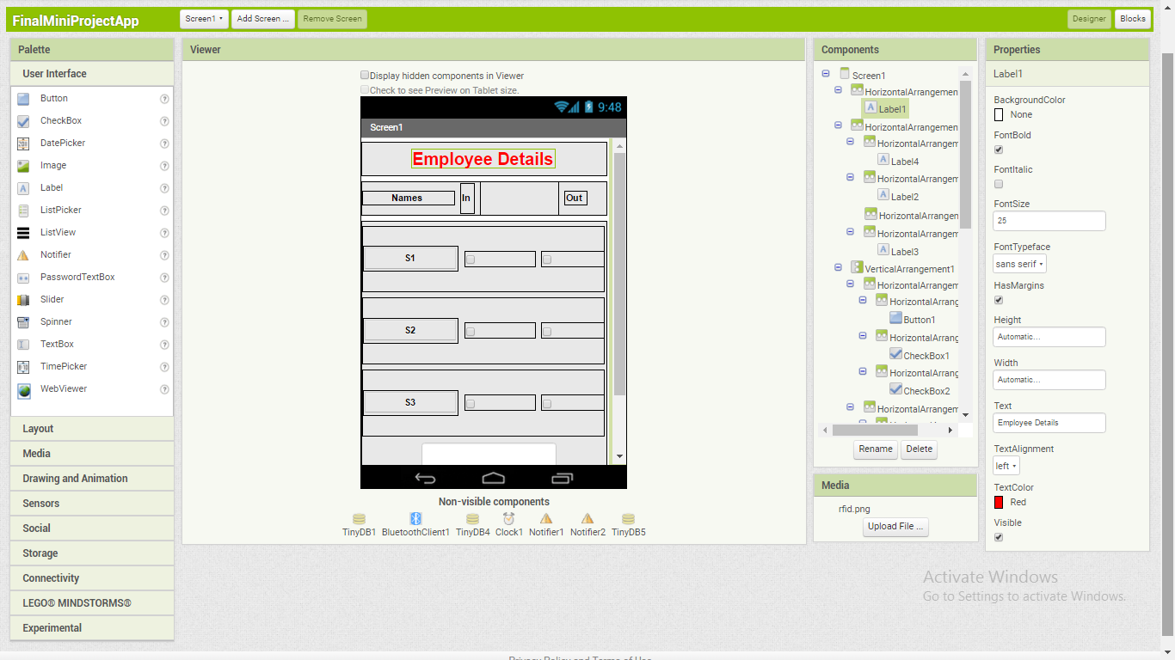
Fig.3.1.1 Designer Screenshot1
Fig.3.1.2 is Screen2 in which details of the employees are displayed according to the button pressed. Horizontal and Vertical arrangements are used to perfectly align the labels and display the details accordingly.
There are many Non-Visible Components like TinyDB for storing the data, Bluetooth Client for connecting, Clock is used to monitor the data from Bluetooth and notifiers are used to notify when back is pressed.
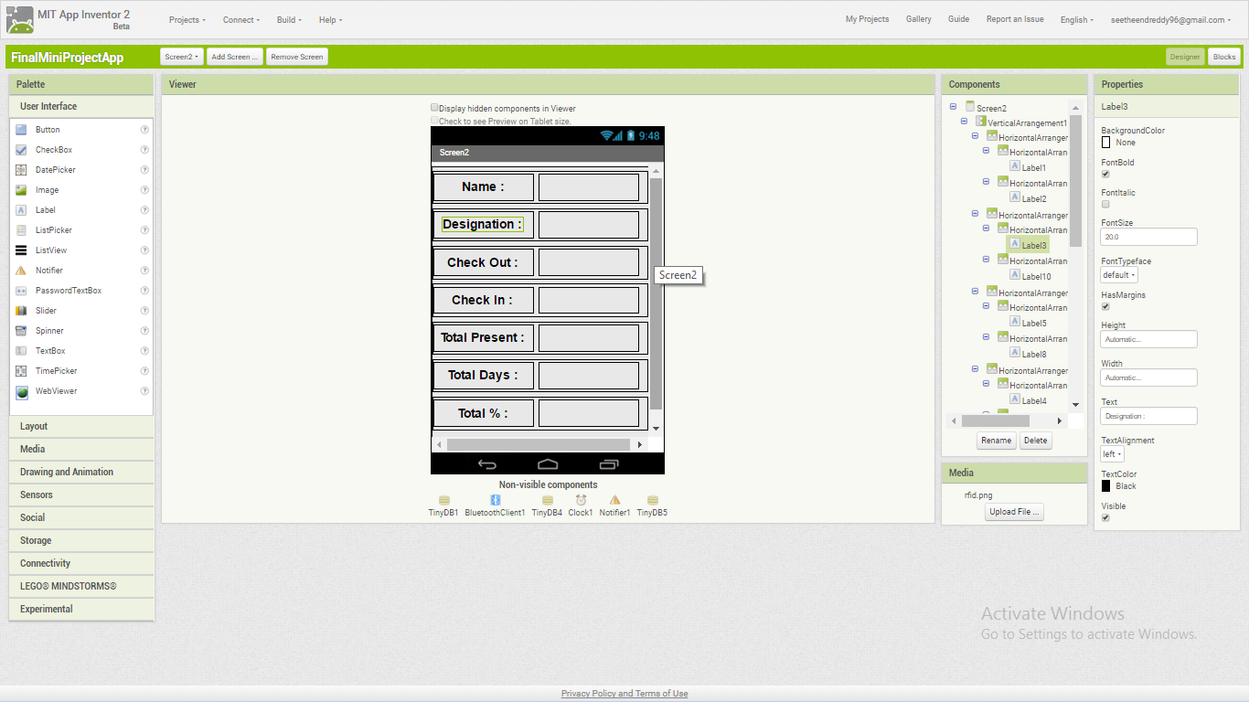
Fig.3.1.2 Designer Screenshot2

3.1.2. Blocks
Built-in blocks are available regardless of which components are in a project. In addition to these language blocks, each component has its own set of blocks specific to its own events, methods, and properties.
Fig.3.1.2.1 consists of a non-visible component that provides the instant in time using the internal clock on the phone. It can fire a timer at regularly set intervals and perform time calculations, manipulations, and conversions.
Here, we take two variables ‘BytesAvailable’ and ‘Commandbyte’ to check the number of ‘BytesAvailableToReceive’ and to receive the bytes from ‘Bluetooth’ respectively. When we receive bytes from ‘Bluetooth’ we display it in textbox and compare it with the already defined values and check the checkboxes if the values are matched. In this we define different values for different employees and compare the value in textbox and check the corresponding check boxes otherwise set the value to zero.
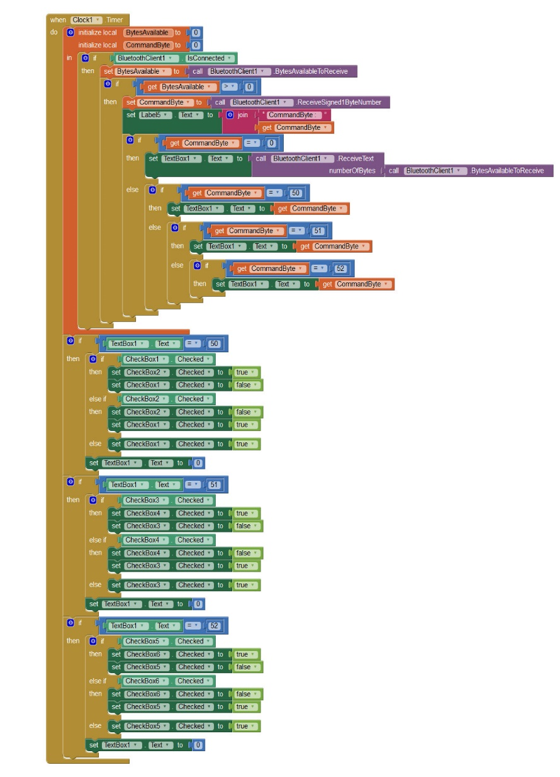
Fig.3.1.2.1 Blocks Screenshot1
As we used the values from Bluetooth to change the state of check boxes and now we store the instant of time in another database at which the check box is changed its state using another timer sensor and use the stored value in the Screen2 while displaying the employee details. Now, we need to show the employees attendance so we used another database to store the checkbox state changes and days changed when we press a button.
We used four variables to store the total days and individual employee present days and these value are used to display in employee details screen and their individual percentage. This is shown in Fig.3.1.2.2
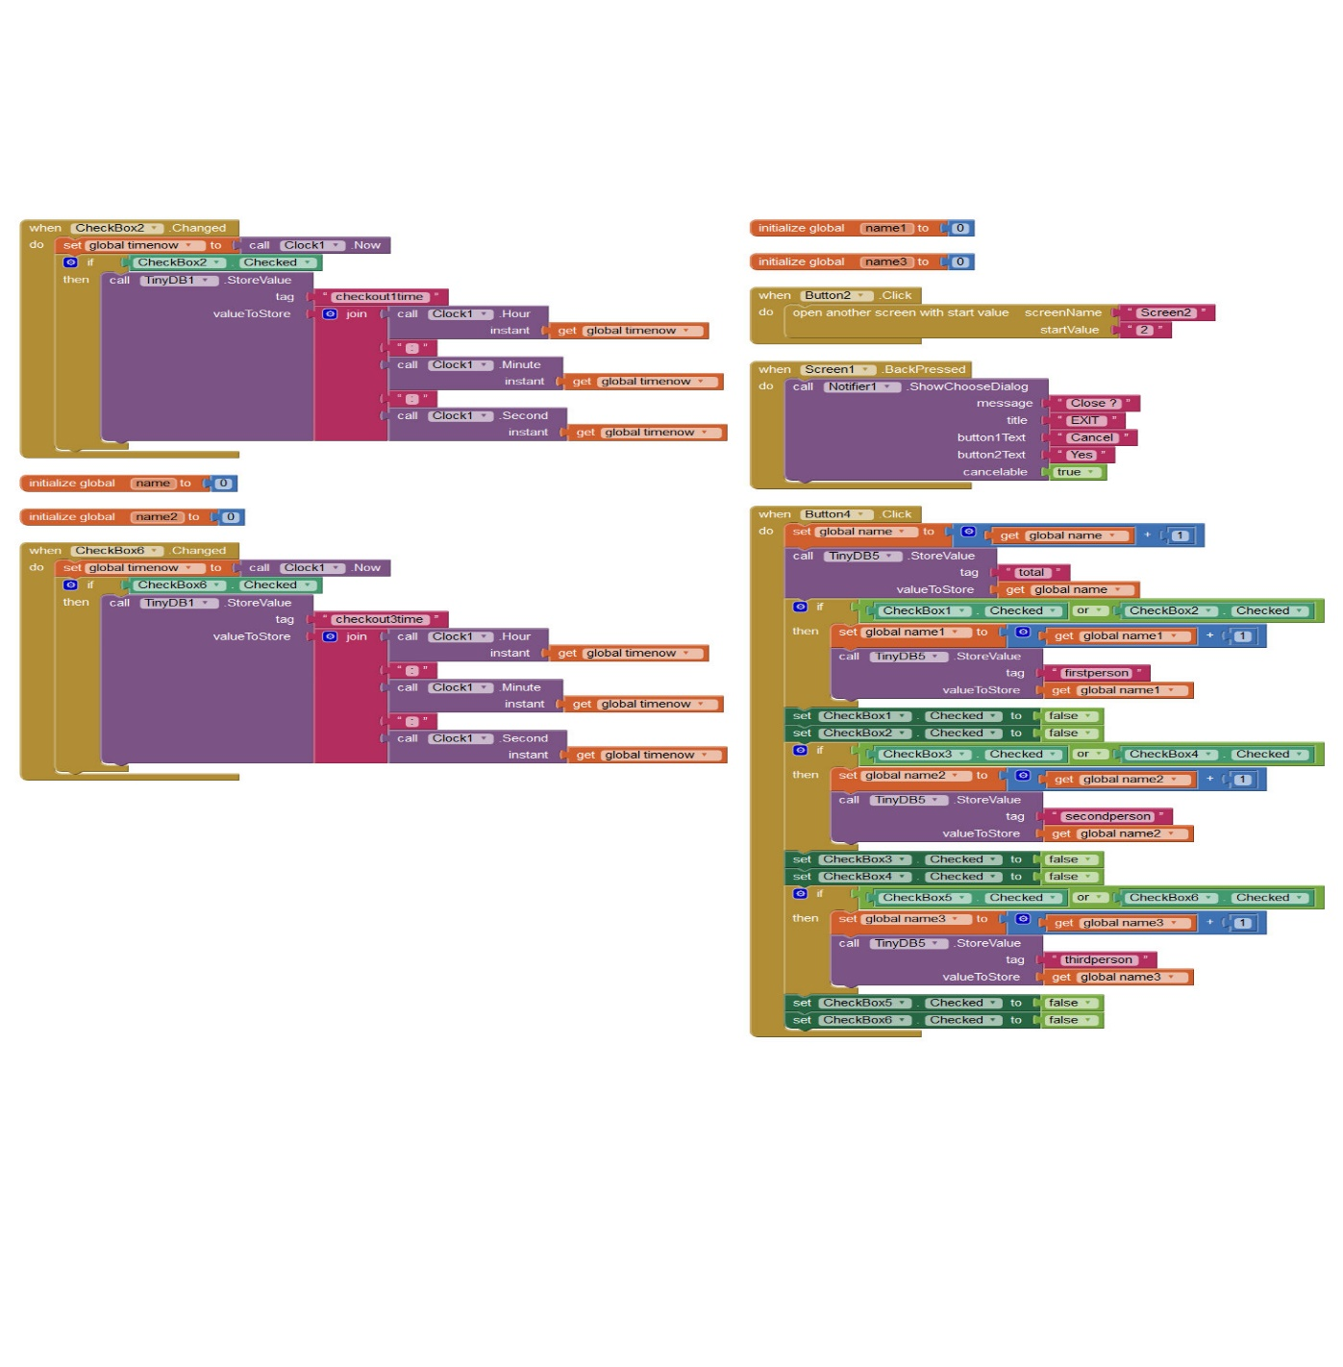
Fig.3.1.2.2 Blocks Screenshot2

In the Fig.3.1.2.3 , also we used same variable which is used to store the instant of time and get the time instant when the state of check boxes are changed and store them in another database with different tags and use them to display in another screen below the respective employee. Here, a list picker is used to display the Bluetooth addresses and the Bluetooth module address and connect to it.
Now, to show the particular employee details when his/her button is pressed we use open the same page with different values so that we can compare in another screen and display the corresponding employee detail when matched.

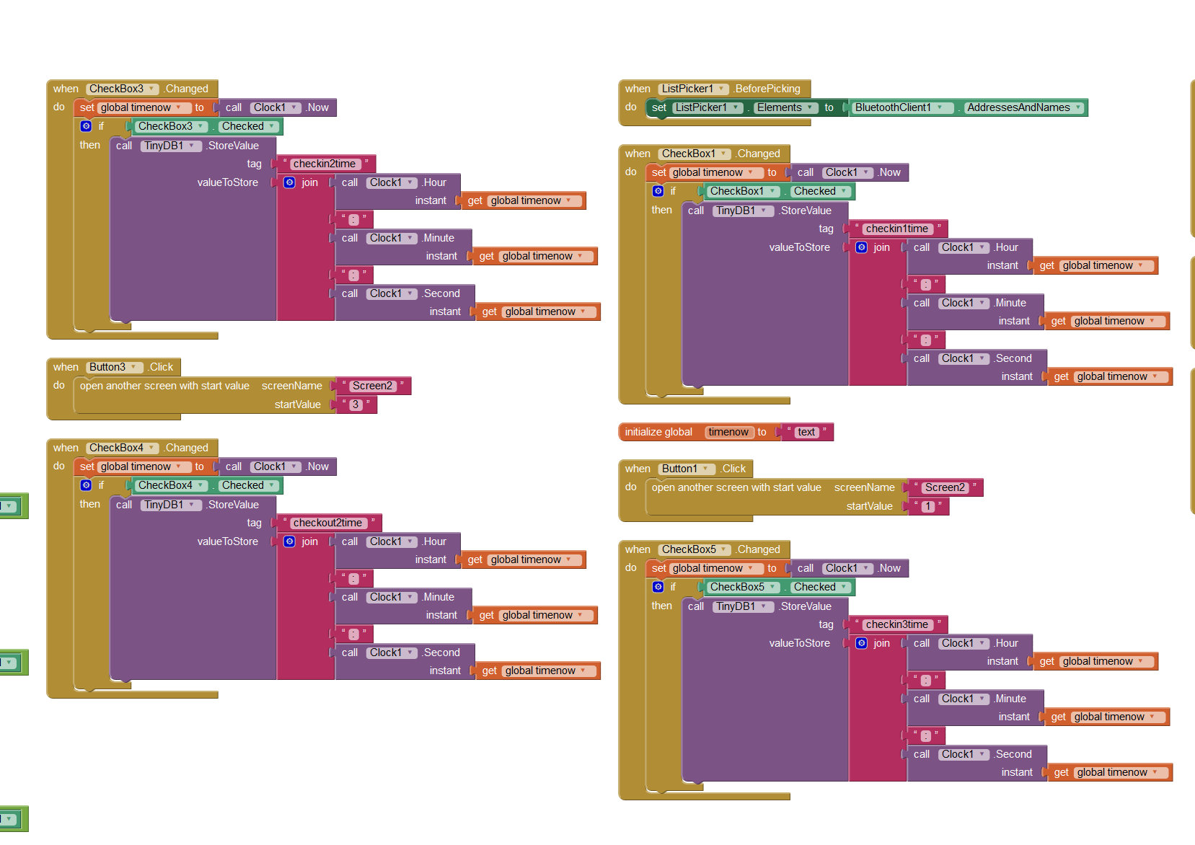
Fig.3.1.2.3 Blocks Screenshot3
In the Fig.3.1.2.4 screen we mostly check the connection of Android Phone to the Bluetooth module and if it is not correctly connected it shows a notifier to notify that it is not connected. Here, we used Bluetooth client and connect to attribute to connect to the picked Bluetooth address and check whether it is connected or not.
During every initialization of the main screen the app checks whether the Bluetooth is ON and ready to connect to Bluetooth server. There is also a notifier which pops up when you press back button on the phone with a message “Do you want to exit?” and three options “yes” , “cancel” , “back” .

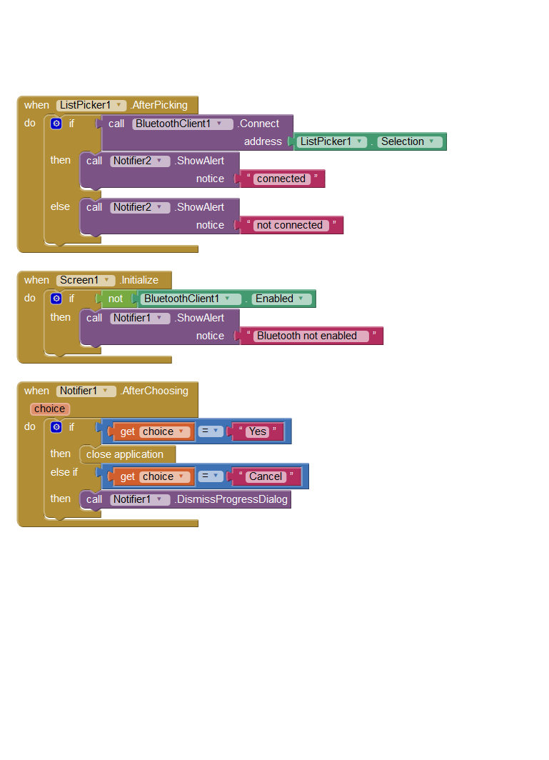
Fig.3.2.1.4 Blocks Screenshot4
This is screen2 where you display the employee’s details when his/her button with their name on is pressed. It is shown in Fig.3.2.1.5. When back button is pressed it gets back to the main page. When the screen2 is initialized it compares the start value of the page and displays the respective employee details from the data stored in databases. Here, we perform some mathematical calculations to display their attendance percentage.
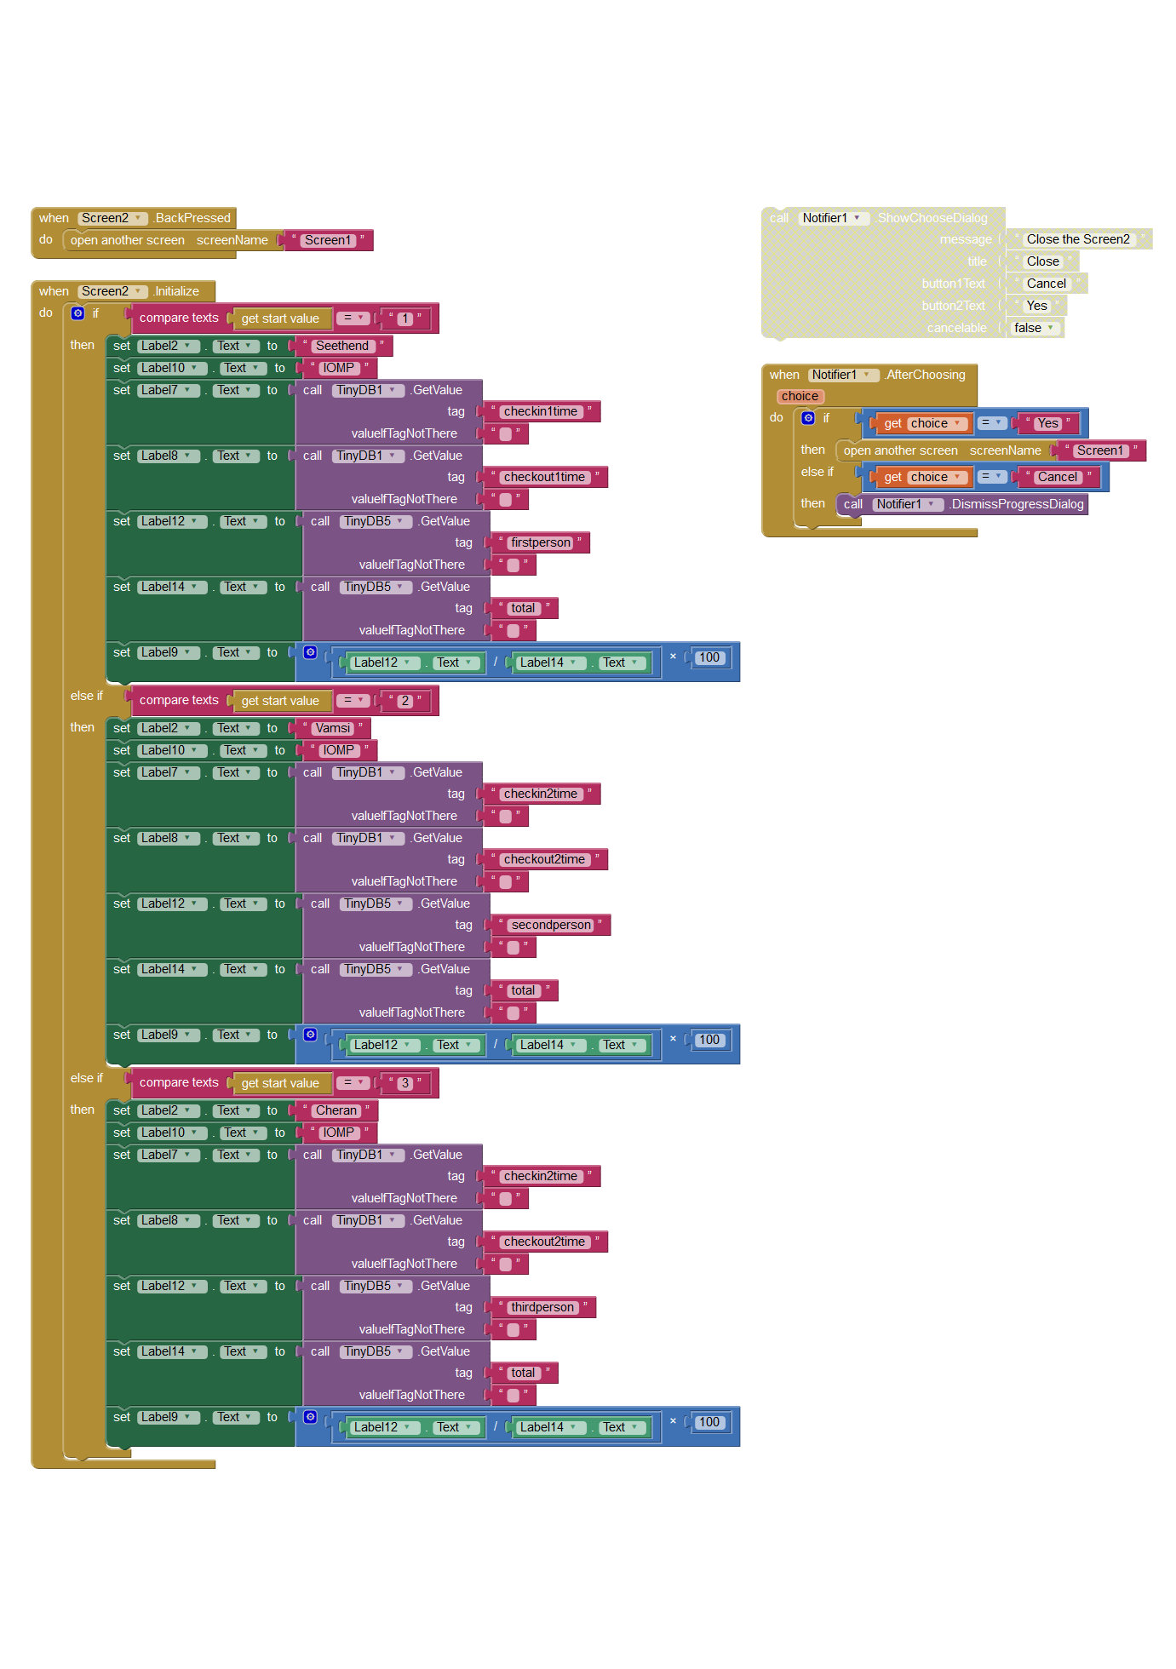
Fig.3.1.2.5. Blocks Screenshot 5

3.2 Atmel Boot loader
Atmel Studio with Visual Micro enables ANY Arduino project (with code completion) to be developed, compiled and then uploaded to any Arduino micro-processor. By default, the plugin shares the sources and tools of the Arduino IDE which means we use the same code. Thus,code is written and uploaded to the Atmega 328 using Atmel Studio 7.
Procedure:
1) Interface the AVR programmer to Arduino board through ISP.
2) Click on Atmel Studio 7.0 icon and make sure that the AVR programmer light stops flickering before you move on to device programming.
3) Select Device Programming option from the Tools menu in Atmel Studio 7.0.
4) A new Window opens as shown below for programming your device.
In this Window the following options should be selected:
➢ Tool: AVRISP
➢ Device: ATMEGA328P
➢ Interface: ISP
Finally click on APPLY.
5) To change the fuse bits click on FUSES and make the following changes:
Fuse Register Value
EXTENDED 0XFD
HIGH 0xD6
LOW 0xFF
Click on PROGRAM to change the fuse bits
6) Click on MEMORY and select the following path in Flash (32 KB):
C:\Program Files (x86)\Arduino\hardware\arduino\avr\bootloaders\optiboot\optiboot_atmega328.hex
7) Click on PROGRAM

3.3 Arduino IDE
The Arduino project provides the Arduino integrated development environment (IDE), which is a cross-platform application written in the programming language Java. It includes a code editor with features such as syntax highlighting, brace matching, and automatic indentation, and provides simple one-click mechanism to compile and load programs to an Arduino board. A program written with the IDE for Arduino is called a "sketch".
After compiling and linking with the GNU tool chain, also included with the IDE distribution, the Arduino IDE employs the program avrdude to convert the executable code into a text file in hexadecimal coding that is loaded into the Arduino board by a loader program in the board's firmware.

4. Source Code
#include<SoftwareSerial.h>
SoftwareSerial rfid = SoftwareSerial(4, 5);
char* allowedTags[] = { "3100DE3BDB0F","2900940E95", "ABC123DE45"};
int numberOfTags = sizeof(allowedTags);
int incomingByte = 0;
void setup()
{
Serial.begin(9600);
rfid.begin(9600);
}
void loop()
{
byte i = 0;
byte val = 0;
byte checksum = 0;
byte bytesRead = 0;
byte tempByte = 0;
byte tagBytes[6];
char tagValue[10];
if ((val = rfid.read()) == 2)
{
bytesRead = 0;
while (bytesRead < 12) {
val = rfid.read();
if (bytesRead < 10)
{
tagValue[bytesRead] = val;
}
if ((val == 0x0D) || (val == 0x0A) || (val == 0x03) || (val == 0x02))
{
break;
}
if ((val >= '0') && (val <= '9'))
{
val = val - '0';
}
else if ((val >= 'A') && (val <= 'F'))
{
val = 10 + val - 'A';
}
if (bytesRead & 1 == 1)
{
tagBytes[bytesRead >> 1] = (val | (tempByte << 4));
if (bytesRead >> 1 != 5)
{
checksum ^= tagBytes[bytesRead >> 1];
};
}
else
{
tempByte = val;
};
bytesRead++;
}
if (bytesRead == 12)
{
tagValue[10] = '\0';
int tagId = findTag( tagValue );
if ( tagId > 0 )
{
Serial.print(tagId);
}
}
bytesRead = 0;
}
}
int findTag( char tagValue[10] ) {
for (int thisCard = 0; thisCard < numberOfTags; thisCard++) {
if (strcmp(tagValue, allowedTags[thisCard]) == 0)
{
return (thisCard + 1);
}
}
return (0);
}

5. Functionality
The main component of the system is the RFID reader which transmits a 12-byte ASCII string via the TTL-level SOUT pin. This helps to identify a student from the rest, as each TAG generates a unique ASCII string. This String is then fed to the AVR’s RX line which processes it for marking his/her attendance.
The start byte and stop byte are used to easily identify that a correct string has been received from the reader (they correspond to a line feed and carriage return characters, respectively). The middle ten bytes are the actual tag's unique ID. This ID is then matched with the ID stored on MCU’s memory to get the details. Once a match has been found it is then sent to the Android app via the Bluetooth Module.
The No. of the swiped card identified is matched to the details stored in the Android app developed using MIT AppInventor2. The attendance is recorded along with the time of access, which can be viewed from the app itself.

