VIVID
Product Requirements Document
A General-Purpose Creative Coding Platform with Audio-Visual Parity
Jeff Crouse / See-through Lab
February 2026

1. Vision
In the entire creative coding ecosystem, audio is structurally second-class. TouchDesigner’s CHOPs exist, but nobody calls it an audio authoring environment. openFrameworks’ ofSoundPlayer is a thin wrapper. Unity and Unreal treat audio as playback, not a creative medium. The result: in practice, the visual team builds the installation and then someone drops in a soundtrack. The audio doesn’t respond to the same data the visuals respond to.
Meanwhile, in music production, Bitwig Studio has shown what happens when audio is treated as a medium you sculpt in real time rather than a timeline you arrange. Its modulation system — where any signal can modulate any parameter with visible feedback directly on the control — demonstrates that cross-domain routing can be immediate, visual, and explorable. Vivid takes this philosophy and extends it across the audio-visual boundary.
Vivid is the first general-purpose creative coding platform where audio and visuals are equal peers — authored in the same graph, driven by the same data, with the same level of expressive control. It combines the inspect-anywhere philosophy of TouchDesigner, the extensibility of openFrameworks, the modulation routing of Bitwig, the inline output of Jupyter notebooks, and the immediacy of Strudel — but with plain C++ that LLMs can read and write.
Vivid’s core innovation: an LLM that populates exploration spaces, not just writes code. The user never stares at a blank canvas. They describe a direction, the LLM generates a field of possibilities, and the user navigates that field through direct manipulation.

1.1 What Vivid Is For
- Live audiovisual performances
- Museum and gallery installations
- Branded interactive experiences
- Interactive art and generative art
- Creative prototyping and experimentation

1.2 What Vivid Is Not For
- Game engines (use Unity, Unreal, Godot)
- Traditional desktop applications
- Web applications
- Film/video post-production (linear composition tools)
The scope boundary: Vivid is for real-time, interactive audiovisual experiences. If the output is a window (or multiple windows, or a projector, or an LED wall) showing real-time graphics with real-time audio, and the system is reactive to some input (performer, sensor, data, time), Vivid is the right tool.

2. Core Principles
These are ordered by importance. Principles 1–4 define what Vivid is. Principles 5–8 define how it works. Principles 9–11 define how it’s built.

2.1 Audio-Visual Parity
The thesis. Why Vivid exists. Audio-visual parity means three things simultaneously:
- Equal ease of creation: a drum machine should be as easy to create as a particle system. The interface, documentation, and operator library treat both domains as first-class.
- Equal breadth of options: for any visual technique the creator wants to explore (feedback, particle systems, shaders, compositing), there should be an equally rich set of audio tools (synthesis, sequencing, effects, analysis) available in the same environment.
- Easy cross-domain interaction: this is the one existing tools miss entirely. When you create an interactive installation that responds to a camera tracking people, the audio and visual responses should be authored in the same graph, driven by the same data, with connections between domains as easy to make as connections within a single domain.
The cross-domain interaction point is critical. TouchDesigner has CHOPs and TOPs, but connecting audio analysis to visual parameters requires manual bridging between separate operator families in separate editor panes. Max/MSP separates audio (MSP) from video (Jitter) into different namespaces. In Vivid, audio, visual, and control operators coexist in a single unified graph. A wire from an FFT analysis node to a particle system’s size parameter is the same gesture as a wire between two visual effects.

2.2 Temporal Plurality
Vivid has no master timeline. It has clocks. Clocks are temporal contexts that can be driven by anything — wall time, musical tempo, sensor data, spectral energy, walking speed, each other. Patterns, state machines, and animations all bind to clocks, not to “the” time.
A single master timeline implies an experience has a beginning, a duration, and an end. An installation running 12 hours a day in a museum lobby has no beginning. It has states, cycles, reactions, and rhythms, but no timeline. Forcing it onto one is like putting a river on a ruler.
This is the architectural foundation that makes Vivid equally suited for performances (where one clock happens to be musical tempo) and installations (where there’s no privileged clock and everything is reactive or cyclical).

2.3 General-Purpose Positioning
Vivid is a general-purpose creative coding platform — not just a performance tool. The A/V parity thesis isn’t about live AV artists alone; it’s about the entire creative coding ecosystem where audio is structurally second-class across installations, branded experiences, museum exhibits, and any context where visuals and sound should respond to the same data.

2.4 Experimentation First
Most creative coding time is spent trying things — not performing and not installing. Vivid’s interface treats experimentation as the primary mode of use, not a stepping stone to a finished piece. The distance between an idea and seeing/hearing its result should be as short as possible. The framework’s interface is designed around the experimental loop of tweak → perceive → tweak, with both audio and visual feedback simultaneous and immediate.

2.5 Text Is the Source of Truth
The canonical representation of a Vivid project is text — diffable, versionable, LLM-readable. The visual graph is a view of that text, not a replacement for it.

2.6 See Every Step
Every point in the processing chain is inspectable. A creator debugging an installation in the studio sees the same chain-health information as anyone working with the system in real time. The LLM and developer get structured data (JSON) for the same state.

2.7 Hot Reload Everything
Changes to parameters and routing propagate within the same frame. Changes to operator implementations recompile and hot-swap within 1–3 seconds. The system never requires a restart. Non-negotiable.

2.8 LLM-Native Workflow
Every layer of Vivid’s architecture is designed for LLM interaction: the routing graph is serializable JSON the LLM can read and write, the operator API is constrained enough for confident generation, and the experimentation interfaces are designed to be populated by the LLM, not just built by the user.

2.9 Keep the Core Minimal
The Vivid runtime is small. Complexity lives in addons and operator libraries. The core handles graph execution, domain bridging, and the operator plugin interface.

2.10 Creator Tools vs Developer Tools
Built-in UI handles what external tools can’t: real-time GPU/audio feedback, parameter manipulation, connection routing, live preview. External tools handle what Vivid shouldn’t rebuild: code editing, file management, version control. Decision framework: “Would a creator need it during a live session, while prototyping in the studio, or while running an installation?”
Operator code editing happens in the user’s native IDE (VS Code, CLion, etc.), not inside Vivid. Vivid provides scaffolding — right-click in the graph to create a new operator, and Vivid generates the boilerplate C++ file with the correct base class and opens it in the external editor. On save, Vivid detects the change and hot-reloads the operator into the palette.

2.11 Don’t Reinvent the Wheel
Use existing, well-maintained libraries for solved problems. Build custom only when the existing solution doesn’t meet real-time constraints or integration requirements.

3. Experimentation & Interface Design

3.1 What Experimentation Actually Requires
Studying how creative people actually explore in existing tools reveals five invariants. If any of them break, the exploration feeling dies.

The Perception-Action Loop Must Be Under 50ms
When a user turns a knob, moves a slider, or connects two things, the audiovisual result must be perceptible within a single frame (ideally 16ms for visual, immediately for audio). Any latency above 50ms turns the interaction into a request-response cycle. This is why TouchDesigner and Ableton feel like instruments and most code-based tools don’t. Anything the user directly manipulates cannot require compilation.

Combinatorial Discovery Requires a Palette
The most productive experimentation comes from combining pre-existing units in unexpected ways. The user doesn’t design these combinations from first principles; they see a menu of available pieces and try them. The type system should be permissive at the experimentation stage (any number can drive any parameter) even if the underlying execution is strictly typed.
The palette must be easy to populate. Creating a new operator — scaffolded by Vivid, written with LLM assistance in the user’s IDE, and hot-reloaded into the running graph — should be a lightweight act, not a project. The richer the palette, the more combinatorial possibilities exist.

Happy Accidents Require Branching
“I found two interesting variations — let me keep both and compare.” Vivid should store full state at each meaningful change point. The user should be able to name, compare, and recall states. This is not undo history; it’s version control for the creative state.

Visible Options Produce More Exploration
When all parameters and connection points are physically visible and labeled, users explore more. When they’re hidden behind menus, users only use what they already know. The experimentation interface should show the parameter space and the connection space at all times.

Randomization and Mutation Are Legitimate
Many creative discoveries come from randomizing parameters within a structured space. The user’s role becomes curation: evaluate, keep or discard, refine. The LLM becomes a variation generator: “give me five different mappings of this audio analysis to these visual parameters.”

3.2 The Six Experimentation Interfaces
These interfaces are composable — different lenses on the same underlying representation, not competing paradigms. The patchbay handles cross-domain mapping. The parameter explorer handles within-patch tuning. The pattern algebra handles temporal behavior. The session grid handles variation management. The state machine handles macro structure.
A note on the node graph: Nodes-and-wires is the assumed primary paradigm for representing the processing topology, but it’s worth acknowledging that existing node-based tools (TouchDesigner, Max/MSP, Reaktor) were designed with a single domain dominant. Vivid’s A/V parity thesis — where audio, visual, and control operators coexist in a single unified graph — may surface interaction patterns that existing single-domain node editors don’t address well. The interface should be designed to accommodate paradigm evolution if better representations emerge during prototyping.

The Patchbay / Connection Matrix
A visible grid showing all available audio analysis outputs on one axis and all visual/audio synthesis parameters on the other. Each intersection is a potential mapping. Click to connect, drag to set intensity. Every possible connection is visible at all times. The matrix representation supports multi-mapping without wire clutter.
The interaction model takes inspiration from Bitwig Studio’s modulation routing, where any modulator can be dragged onto any parameter and the modulation range is displayed as a visual overlay directly on the target control. In Vivid, this principle extends across the audio-visual boundary: when a patchbay intersection is active, the target parameter’s control should show the modulation range and current value in real time, making the mapping relationship immediately legible.
The patchbay is an auditioning and mixing interface, not a creation interface. It operates on operators that already exist in the graph, letting the user rapidly explore how they interact. The LLM populates the matrix with interesting configurations or generates variations. Trivially serializable as a sparse 2D array.
Discovery potential: very high. Latency: instant. Surprisingly rare in audiovisual tools despite being the most natural interface for cross-domain mapping.

The Session / Variation Grid
Borrowed from Ableton’s Session View. Columns represent components (audio voice, visual layer, mapping configuration) and rows represent variations. Each cell is a snapshot. The user triggers cells to mix and match. 4 visual presets × 4 audio presets = 16 combinations, most unplanned. The LLM is the ultimate variation generator: “fill this column with 8 variations of this particle behavior, ranging from subtle to chaotic.” This reverses the usual creative coding workflow — the LLM builds many things and the user selects and combines.
Discovery potential: very high. Latency: instant for parameter snapshots, 50–200ms for kernel swaps.

The Live REPL
A command input that executes graph mutations against the running state. Each command modifies the live output: adding nodes, changing connections, setting parameter values. Previous commands are visible as toggleable history. The TidalCycles and Hydra communities demonstrate deeply exploratory text-based live coding. The LLM can suggest next commands based on REPL history. The REPL operates on the same JSON graph representation that everything else uses.
Discovery potential: high. Latency: instant for parameter changes, 50–200ms for structural changes.

The Parameter Space Explorer
Every exposed parameter as a manipulable control (slider, knob, XY pad, color picker). Parameters can be grouped, MIDI-mapped, randomized, and interpolated between saved presets. Once a structure exists, this finds the sweet spot. The LLM annotates parameters with semantic meaning and suggests values based on intent (“make it feel tense and dark”). The innovation: controls span both audio and visual domains simultaneously.
Discovery potential: moderate (high for refinement). Latency: instant.

The Pattern Algebra
Time-varying behavior through composable pattern expressions (TidalCycles model). Patterns are first-class: nested, combined, transformed, and applied to any parameter. Combining two simple patterns often produces complex, musically interesting polyrhythms. Pattern expressions are extremely LLM-friendly: short, text-based, compositional. No existing tool applies pattern algebra to audiovisual parameter mapping.
Discovery potential: very high. Latency: instant (interpreted scheduling instructions).

The State Machine
Macro-level structure as named states (intro, build, drop, ambient, climax) with transition conditions. Each state has its own parameter configuration, active modules, and pattern set. Transitions can be crossfades, hard cuts, or morphs. State machines are among the most LLM-friendly structures — small, discrete, easy to reason about.
Discovery potential: moderate (high for composition). Latency: 50–200ms for kernel swaps.

3.3 The Audio/Visual Exploration Asymmetry
A critical design constraint: the preceding interfaces implicitly treat audio and visual exploration as if they have the same feedback characteristics. They do not.
Visual exploration is spatial and instantaneous — you can glance at a grid of 8 visual variations and evaluate all of them in under a second. Audio exploration is temporal and sequential — you cannot “glance” at a sound. You have to listen to it unfold over at least a bar or two. The evaluation bandwidth asymmetry is roughly 65×: visual permits ~8 options per second; audio permits ~0.12 options per second (~8 seconds per variation).
When exploring audio and visual together, the audio’s temporal constraint dominates. Visual exploration gets slowed to audio speed, wasting the spatial advantage that makes visual experimentation so productive.

3.4 The Tiered Exploration Model
The resolution is not to treat audio and visual exploration identically, but to design for their different speeds. Crucially, the interface does not impose an order. A creator might start with audio and explore visuals against it, start with visuals and add audio later, or iterate on both from rough drafts. The tiers below are strategies the interface supports, not steps it enforces.
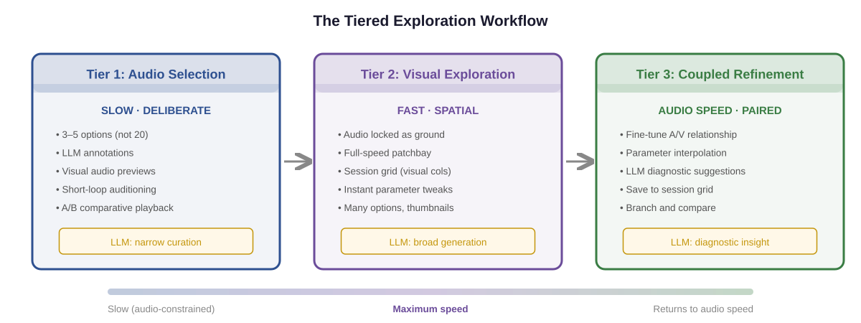
Figure 1. Three exploration strategies the interface supports. The creator chooses based on their workflow, not a prescribed sequence.

Strategy: Anchor One Domain, Explore the Other
The most productive cross-domain exploration comes from holding one domain stable while freely exploring the other. Which domain to anchor is the creator’s choice:
- Audio-first: select or compose an audio element, then rapidly explore visual responses against it. The audio loops; visual changes are instant. The patchbay and session grid are at their most powerful here.
- Visual-first: build a visual scene, then explore how different audio elements interact with it. This is common for installations where the visual identity is primary and audio is a reactive layer.
The interface assists whichever domain is being explored: when exploring audio, it offers rich metadata, short-loop auditioning, and A/B comparison to compensate for audio’s slower evaluation. When exploring visuals, it offers spatial grids, instant switching, and LLM-generated mapping variations.

Strategy: Coupled Refinement
Fine-tuning the relationship between audio and visual once both are roughly in place. This operates at audio speed (evaluation per bar/phrase) and is the most LLM-assisted phase: the LLM observes the current state and suggests adjustments, the user saves successful coupled configurations to the session grid as complete A/V states.

Audio Exploration Aids
Because audio evaluates slower than visual, the interface provides tools to narrow the gap:
- LLM annotations: each audio variation tagged with semantic descriptions (“more syncopated,” “darker harmonic quality”). The user scans descriptions first, auditions only promising ones.
- Visual audio previews: spectrograms, rhythm grids, harmonic maps — giving audio some of visual’s spatial evaluation quality.
- Short-loop auditioning: 2-beat excerpts rather than full 4-bar phrases. Cuts audition time by 75%.
- Comparative playback: A/B toggle switching between variations on the beat boundary.

3.5 LLM Role by Exploration Strategy
Strategy | LLM Role | Example
Audio Exploration | Annotator + pre-filter | "Variation B has a deeper swing feel with a Neapolitan chord in bar 3."
Visual Exploration | Variation generator | "Here are 6 mapping configurations ranging from minimal to heavy audio-reactivity."
Coupled Refinement | Critic + advisor | "Particle density peaks are lagging the beat by ~100ms. Try routing onset detection with 0 smoothing."

4. The LLM Execution Bridge

4.1 The Representation Problem
Vivid’s canonical representation must simultaneously serve three masters: human readability (understand the flow, find the parameter to change), LLM readability and writability (parse, understand, generate valid modifications without hallucinating), and execution efficiency (compile to real-time frame rates with GPU-scale element counts).

4.2 The Two-Layer Architecture
The routing layer (what connects to what, parameter values) is interpreted and hot. Changes propagate within the same frame. It’s a lightweight data structure: a graph of nodes with typed ports, connection lists, and parameter values. Serializable to JSON. An LLM reads and writes it trivially. This is what the user directly manipulates during experimentation.
The computation layer (per-element logic, GPU kernels, audio DSP) is compiled and fast. When the user or LLM modifies per-element behavior, this triggers a scoped compilation step. Only the changed kernel recompiles. The routing layer keeps running while the kernel compiles; the new kernel swaps in atomically when ready.
This is what Max/MSP’s Gen~ does for audio, what TouchDesigner’s GLSL TOPs do for visuals, and what Faust does for audio DSP. The graph is interpreted and instant; the inner computations are compiled and fast.
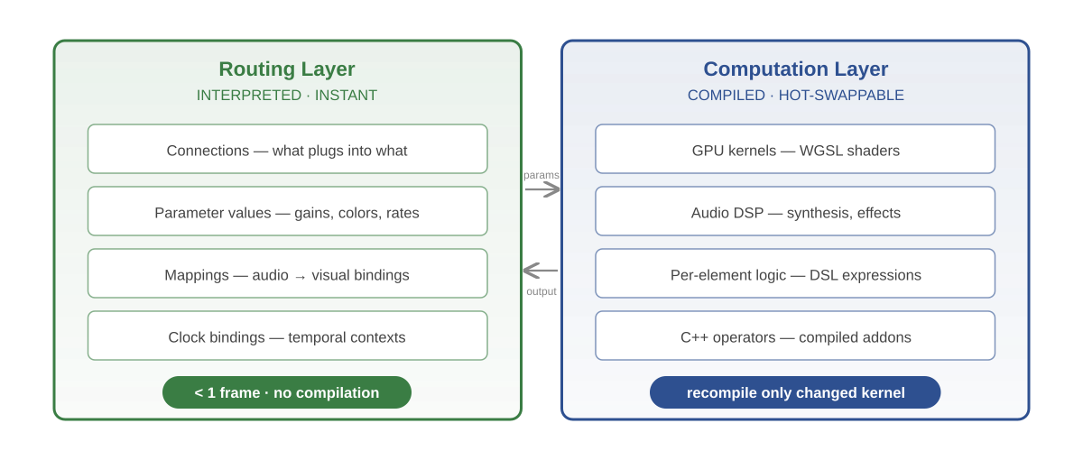
Figure 2. The two-layer architecture: instant routing (left) backed by compiled computation (right).

4.3 The Orchestration Layer
The routing graph is JSON, and JSON is the complete description. All automation, timing, and logic are handled by visible Control operators in the graph (LFO, Clock, Sequencer, Pattern, Envelope, Math, Logic, Gate, Smooth). There is no separate scripting or DSL layer. The answer to “how does this work?” is always “look at the graph.”
This is the most LLM-friendly design: the LLM reads JSON, writes JSON. No code generation for the orchestration layer. Parameter transitions, pattern-driven modulation, and conditional logic are all visible as nodes rather than hidden in scripts.
External integration via WebSocket: Vivid’s internal model is always JSON graph + control operators. A WebSocket API accepts graph mutations from external processes — a Python script, a JS orchestrator, a Max patch, or any other tool can generate JSON and feed it to Vivid. This provides scripting-level power for users who want it, without introducing a language dependency into the core.
Build toward visual graph equivalence on top of the same JSON representation. Every graph has a canonical visual representation and a canonical JSON representation. They are isomorphic. The LLM generates JSON (its strength); the visual graph exists for direct manipulation. The escape hatch to raw WGSL/C++ exists for power users writing operator internals.

4.4 The Four LLM Roles
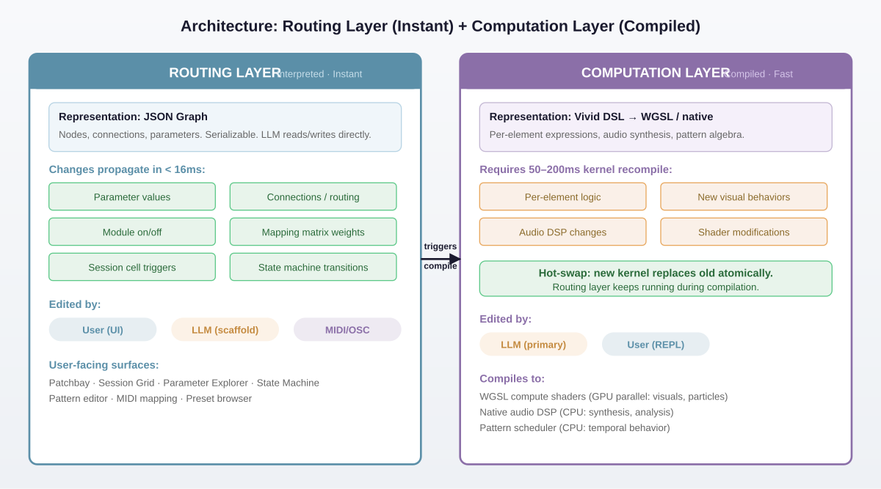
Figure 3. The architecture stack showing each layer, who edits it, latency, and the LLM’s role. JSON is the single source of truth.
Experimentation layer — LLM as variation generator. “Generate 8 different connection matrix configurations.” “Fill this session column with particle behavior variations.” The user evaluates and selects. The LLM produces breadth; the user provides taste.
Routing layer — LLM as architect. “Build me a patch with 3 audio analysis bands driving 3 visual layers with independent particle systems.” The LLM generates graph structure as JSON that the user then explores. This is the scaffolding role.
Operator layer — LLM as programmer. When the user creates a new operator via the IDE scaffolding workflow, the LLM in their IDE assists with writing the C++ implementation. “Write a GPU operator that makes particles orbit a central point with velocity proportional to their FFT bin value.”
Reflective layer — LLM as critic and analyst. “What’s happening harmonically in the audio right now?” “The visual rhythm isn’t syncing with the beat — what’s wrong?” The LLM observes the current state and helps the user understand and refine.

4.5 LLM Integration Architecture
The LLM connects to Vivid through two complementary paths, both built on a shared Runtime API.
The Runtime API is an internal interface exposing all LLM-relevant operations: inspect graph structure, read and write parameters, capture frames and audio, run analysis tools, evaluate assertions, scaffold operators, and modify graph topology. This is the single source of truth for what the LLM can do. Both integration paths below call into the same API.
Path 1: Built-in chat. A collapsible chat panel inside Vivid’s interface (§6.4) calls the Anthropic API directly and invokes the Runtime API in-process. This is the primary workflow for creative exploration: “make the particles react more to the bass,” “generate 5 variations of this feedback loop,” “why is the output so dark?” Zero latency between the LLM’s intent and its effect on the graph. The user stays in Vivid.
Path 2: MCP server. Vivid runs an MCP (Model Context Protocol) server that exposes the same Runtime API as MCP tools. Claude Code, Claude.ai, or any MCP-capable LLM connects to it externally. This is the power-user workflow for operator development: scaffolding C++ operators, debugging compilation errors, running test assertions from the terminal, and automating batch operations. It also enables non-interactive use cases: CI pipelines running assertions, scripts generating patch variations, installation monitors watching for drift.
Both paths are Phase 1. The built-in chat handles creative workflows where immediacy matters. MCP handles development workflows where the user is already in their IDE or terminal. The underlying Runtime API is implemented once; the chat panel and MCP server are thin layers on top.
Future path: WebSocket API (Phase 3) exposes the same Runtime API over WebSocket for non-LLM external processes — Python scripts, Max/MSP, show control systems. The MCP server and WebSocket API may share transport infrastructure but serve different audiences.

5. System Architecture

5.1 Two-Tier Interaction Model
Fast path — parameter adjustments and connection routing are instantaneous. No compilation, just reconfiguring the live graph. This layer is entirely declarative (parameters, topology), making it inherently LLM-friendly.
Slow path — editing an operator’s C++ implementation. The user right-clicks a node and selects “Edit in IDE,” which opens the operator’s source file in their configured external editor (VS Code, CLion, etc.). On save, Vivid detects the file change, builds just that operator’s shared library via the bundled compiler, and hot-swaps it into the running graph. Expected latency: 1–3 seconds. For new operators, Vivid scaffolds the boilerplate C++ with the correct base class and port declarations before opening the file.

5.2 Language and Toolchain
Decision: C++ throughout. The runtime, interface, and operators are all C++. This eliminates any ABI translation layer between the runtime and operators — they share types, headers, and conventions directly. The only boundary is the extern “C” interface used for dlopen-based hot-reload during development.
C++ was chosen over Zig and Rust for one overriding reason: library integration. Vivid is a creative technology tool that will integrate specialized libraries on client timelines — OpenCV, ONNX Runtime, NDI, Syphon, libtorch, CEF, and others. All of these are C or C++ libraries. In C++, integration is just “link and include.” In Zig or Rust, every library requires FFI bindings, wrappers, and ongoing maintenance — friction that compounds over time.
Build system: CMake. The standard for C++ projects. Every library Vivid might depend on supports CMake. Dependencies are managed via git submodules or CMake FetchContent — no package manager.
Compiler: System clang on macOS (Xcode Command Line Tools). This is a one-time install (xcode-select –install) that virtually every developer on macOS already has. Cross-platform builds will use the platform’s native compiler (MSVC on Windows, GCC or Clang on Linux).
Operator compilation for hot-reload: during development, operators are compiled by invoking the system C++ compiler as a subprocess. Vivid detects which compiler is available and invokes it directly. For future zero-friction onboarding (no system compiler required), a bundled compiler option can be added later — Zig’s zig c++ command is a single-binary C++ compiler that could serve this role without requiring Vivid’s runtime to be written in Zig.

5.3 Three Domains
Control — event-driven and low-rate continuous data. MIDI, OSC, DMX, serial input, keyboard input, API responses, LLM output, timers, clocks. The nervous system of the graph. Runs push-based: events propagate forward immediately.
GPU — renders frames on the graphics card. Textures and buffers. Runs pull-based, driven by vsync / the render loop.
Audio — renders sample blocks in a real-time audio thread. Buffers at 44.1/48kHz. Runs pull-based, driven by the audio callback. Never allocates, locks, or blocks.
MIDI, OSC, DMX, and similar protocols are all forms of control data. Under the Control umbrella, a MIDI CC can drive a shader parameter and a synth filter cutoff simultaneously with no special treatment.

5.4 Execution Model: Hybrid Push/Pull
Control is push-based — events propagate forward immediately. Audio and GPU are pull-based — driven by their respective hardware clocks. When a Control change reaches the boundary of an Audio or GPU subgraph, it updates the parameter store. The next pull cycle picks it up. No domain ever waits on another.

5.5 Domain Bridges: Control as Hub
Decision: Control sits at the center of a star topology. Audio and GPU never communicate directly — everything routes through Control. This simplifies the architecture from six specialized bridges to two bidirectional mechanisms:
[Diagram: Control-as-hub star topology — to be regenerated]
Figure 4. Control-as-hub star topology. Audio and GPU communicate through Control; the only real domain boundary is CPU ↔ GPU.

Control ↔ Audio
- Control → Audio: lock-free ring buffer or atomic. Audio callback reads at next block boundary. Latency: ~5ms at 256 samples / 48kHz.
- Audio → Control: audio analysis operators write results into a lock-free queue. Control nodes poll at whatever rate they like.

Control ↔ GPU
- Control → GPU: atomics or double-buffered parameter store. GPU render loop picks up changes next frame. Latency: ~16ms at 60fps.
- GPU → Control: async readback from GPU staging buffers. Control emits events when data lands. Latency: 1–2 frames.
Why not direct Audio ↔ GPU? Audio and Control both live on the CPU. The “hop” through Control is just a CPU-side buffer copy (nanoseconds), followed by the same CPU→GPU upload that would happen regardless. The only real domain boundary is CPU↔GPU, and that crossing happens exactly once no matter how the data is routed.
Backup approach: If six explicit per-pair bridges prove to share enough machinery during implementation, a unified port abstraction may emerge naturally from the bottom up.

5.6 Port Type System
The type system serves three consumers: the graph runtime (bridge selection), the UI (valid connection enforcement), and the LLM (compatibility reasoning).

Control Port Types
Control::Float, Control::Int, Control::Bool, Control::String, Control::Event (discrete trigger with optional payload), Control::Buffer (arbitrary blobs — JSON, point clouds, FFT spectra). These update at no fixed rate.

Audio Port Types
Audio::Mono, Audio::Stereo, Audio::Multichannel(n). Implicitly carry sample rate and block size. Always continuous — producing a buffer every callback, even if silence.

GPU Port Types
GPU::Texture2D, GPU::Texture3D, GPU::Buffer, GPU::Mesh. Each carries format metadata: resolution, pixel format, color space for textures; vertex layout, index count for meshes. Meshes are GPU domain data — their purpose and consumption is GPU rendering, even when vertex generation happens on the CPU (procedural geometry). CPU-side construction is an implementation detail of the operator, not a domain classification. If mesh properties need to feed back into the graph (vertex count, bounding box), they use the same GPU→Control async readback bridge that texture analysis uses.

Semantic Tags (Advisory)
Port types can carry optional semantic tags: normalized (0–1), bipolar (-1 to 1), frequency_hz, decibels, midi_note, etc. Tags are advisory hints, not enforced by the runtime. When connecting ports with mismatched ranges, the graph editor suggests inserting a visible Remap node with the mapping pre-configured. No silent auto-mapping.

5.7 Operator API Contract
Each operator is a self-contained compilation unit — a shared library with a known C ABI interface. The graph runtime introspects inputs, outputs, and parameter declarations:
#include "vivid/operator.h"
struct MyFilter : vivid::ImageOp {
Param<float> intensity{"intensity", 0.5, 0.0, 1.0};
void process(const Image& in, Image& out) override { ... }
};
VIVID_REGISTER(MyFilter)
The simpler this contract, the better everything downstream works: auto-generated UI knobs, confident LLM generation, and fast compilation of small self-contained units.

5.8 Hot-Reload Behavior
Decision: Parameters survive, internal state resets. Since parameters live outside the operator in the graph’s Control-layer parameter store, they are untouched by a reload. The operator’s private internal state reinitializes fresh. This avoids serialize/deserialize complexity and matches creative workflows where the user is iterating on behavior.

5.9 Spreads: Implicit Vectorization
Decision: Every wire in the graph implicitly carries a Spread — an ordered collection of values. A single number is a Spread of length 1. An FFT output is a Spread of length 512. When a Spread-producing output connects to a single-value input, the operation automatically vectorizes across all elements. No explicit loop nodes are needed for the common case.
This is the single most impactful design decision for Vivid’s data model. It resolves the instantiation problem that plagues every visual programming environment for creative work: “how do I make 500 particles?” In Vivid, the answer is “connect a Spread of 500 positions to a rendering operator.” Where that Spread came from — a grid generator, an FFT, a MIDI controller, a Spread literal — doesn’t matter. The operator processes all elements.
Precedent: vvvv’s Spreads, Houdini’s per-point attribute operations, and Blender Geometry Nodes’ Fields all validate this pattern. The systems that handle instantiation best all converge on the same insight: the right primitive for creative work is not an object with methods but an element with attributes, operated on in parallel.

Key properties
- Broadcasting: when two Spreads of different lengths connect to the same operator, the shorter one repeats (wraps) to match the longer. A Spread of 3 colors applied to a Spread of 512 particles cycles through the 3 colors.
- Cross-domain: a Spread of Control values (e.g., 512 FFT bins) can connect directly to a GPU operator’s parameter, producing 512 visual elements driven by audio. No explicit bridging required — the existing Control→GPU bridge handles the data; Spreads handle the cardinality.
- LLM-friendly: describing Spread-based operations in natural language is natural. “Create 512 particles in a circle, sized by the FFT, colored by frequency” maps directly to a chain of operations on Spreads.
- Port types: Spread<Control::Float>, Spread<GPU::Texture2D>, Spread<Audio::Mono> are all valid. The Spread is orthogonal to the domain type system.

5.10 Simulation Zones: Frame-to-Frame State
Decision: Simulation Zones provide explicit, visible frame-to-frame feedback. A Simulation Zone is a marked region of the graph whose output at frame N becomes an additional input at frame N+1. This is the mechanism for all persistent, evolving state: particle motion, video feedback, envelope followers, accumulators, counters.
In a normal dataflow graph, everything is stateless — each frame computes from scratch. But creative behaviors need memory: a particle’s position at frame 42 depends on its position at frame 41 plus its velocity. Video feedback takes the previous frame’s output, transforms it, and composites it with new input. An envelope follower smooths a signal by blending with its previous value.
The Simulation Zone makes this feedback explicit and visible in the graph, unlike TouchDesigner’s implicit Feedback TOP where the feedback path is invisible. Inside the zone, a special “Previous State” input carries whatever the zone output last frame. The user wires up transformations — apply forces, decay opacity, blend with new input — and the output both leaves the zone for downstream use and loops back to become next frame’s Previous State.

Domain applications
- GPU — video feedback: previous frame’s texture → Blur → Displace → Composite with new input. The classic generative feedback loop, now debuggable because every step is visible.
- GPU — particle state: the Previous State is a Spread of particle positions/velocities/colors. Inside: apply forces, update positions, kill dead particles, spawn new ones. The Spread output is both renderable data and state for next frame.
- Audio — envelope follower: previous smoothed value blended with new raw value by a coefficient. Output is the smoothed value.
- Control — accumulators: previous count incremented on each beat event. Running totals, state machines, event counters.
Spread-compatible: the state inside a Simulation Zone can be a Spread. “500 particles each with their own evolving state” is a Simulation Zone operating on a Spread of 500 elements. Each element carries its own position, velocity, color, and lifetime — updated in parallel every frame.
JSON representation: a Simulation Zone is a node with a feedback connection from its output to a designated state input. The runtime knows to buffer the previous frame’s output and provide it as input on the next frame. The exact visual representation — whether a visible bounding box around grouped nodes or a single Feedback operator with an internal graph — is a UX question to be resolved during prototyping.

5.11 JSON Graph Schema
The JSON graph is the single source of truth for the entire system. Every operator, connection, parameter value, and structural relationship is captured in this format. The LLM reads and writes it directly. Below is a representative example:
{
"version": "0.1.0",
"name": "audio_reactive_particles",
"nodes": {
"clock1": {
"type": "Clock",
"domain": "control"
},
"fft1": {
"type": "FFTAnalysis",
"domain": "audio",
"params": { "bins": 512 }
},
"particles1": {
"type": "Particles",
"domain": "gpu",
"params": { "count": 5000, "size": 2.4 }
}
},
"connections": [
{ "from": "clock1/beat", "to": "fft1/trigger" },
{ "from": "fft1/spectrum", "to": "particles1/scale" }
]
}

Design principles
- Node IDs as object keys: fast lookup, prevents duplicates. IDs are user-readable strings ("fft1", "particles1"), not UUIDs.
- Params carry current values only: parameter metadata (min, max, default, semantic tags) is declared in the operator’s C++ code and introspected at load time. The JSON stores only the user’s current values. This keeps the JSON compact and avoids dual source-of-truth.
- Connections are source/target pairs: "from": "node/port" and "to": "node/port". The operator declares its ports; the JSON just names them.
- Spread-aware: a connection from fft1/spectrum (Spread<float> of 512) to particles1/scale (float) implicitly fans out. The JSON doesn’t need to represent this — the runtime infers cardinality from port types.
- Domain is metadata: the "domain" field is informational for the UI (accent colors, preview treatment) and the runtime (thread scheduling). It does not affect how connections are expressed.

5.12 Platform Target
Decision: macOS first. Phase 1 targets macOS exclusively. This eliminates cross-platform build/test complexity and matches the primary development environment. The architecture does not paint into a corner — Dawn, GLFW, and miniaudio all support Linux and Windows, so cross-platform is a matter of build configuration, not redesign.

5.13 Windowing: GLFW
Decision: GLFW 3.4 for window creation and input. GLFW creates the OS window, provides the Metal surface for Dawn, and handles keyboard/mouse input events. It is minimal (~200KB source), mature, and has proven WebGPU integration.
Alternatives considered: SDL3 provides file dialogs, pen/tablet pressure, touch input, and a structured event queue, but adds ~2MB of surface area and capabilities that are not needed for Phase 1. Raw Cocoa (NSWindow + CAMetalLayer) provides maximum control but is macOS-only with no migration path.
GLFW does not provide file open/save dialogs or pen/tablet pressure. File dialogs will be added via tinyfiledialogs (single-header C library) or a small Cocoa shim when save/load is implemented. Tablet pressure support is a Phase 2+ concern and can be added via platform-specific input handling without replacing the windowing library.

5.14 Dependency Manifest
Decision: Seven dependencies, most of which are small C libraries. CMake manages the build. No external package manager required.
- Dawn (latest stable): GPU abstraction (WebGPU over Metal/Vulkan/DX12). Google’s C++ WebGPU implementation. Provides the rendering backend for both the creative output and the interface. ~17MB pre-built.
- GLFW (3.4): window creation, input events, Metal surface. ~200KB source, compiled by CMake.
- miniaudio (0.11.x): audio device I/O. Single-header C library. Handles device enumeration, playback, and capture. Vivid’s audio operators provide all DSP; miniaudio only manages the hardware interface.
- stb_truetype: font rasterization for UI text rendering. Single-header C library.
- yyjson: JSON parsing for graph files, project files, and WebSocket messages. ~40KB, fast, C API. Chosen over cJSON for performance on large graph files.
- stb_image: image loading for textures and assets (PNG, JPEG, BMP). Single-header C library.
Not included in Phase 1: WebSocket library (Phase 3), HTTP client (for Anthropic API — use libcurl or curl subprocess), tinyfiledialogs (added when save/load is implemented).
Compiler requirement: Xcode Command Line Tools on macOS (xcode-select –install). Provides clang, libc++, and Metal framework headers.

5.15 Project Directory Structure
Decision: Single C++ codebase with a four-level operator search path. The runtime and operators are all C++. Operators compile as individual shared libraries for hot-reload during development.

Source tree
vivid/
├─ CMakeLists.txt # Top-level build
├─ deps/ # Third-party (submodules or FetchContent)
│ ├─ dawn/ ├─ glfw/ ├─ miniaudio/ ├─ stb/ └─ yyjson/
├─ src/
│ ├─ runtime/ # Core engine (C++)
│ │ ├─ main.cpp # Entry point, window, main loop
│ │ ├─ graph.cpp/.h # JSON graph loading, node management
│ │ ├─ scheduler.cpp/.h # Frame scheduling, domain threads
│ │ ├─ spreads.cpp/.h # Spread type, broadcasting
│ │ ├─ simulation.cpp/.h # Simulation Zone state
│ │ ├─ bridges.cpp/.h # Control↔GPU, Control↔Audio
│ │ ├─ params.cpp/.h # Parameter store
│ │ ├─ gpu_context.cpp/.h # Dawn device, queue, surface
│ │ ├─ audio_context.cpp/.h # miniaudio device, buffers
│ │ ├─ hot_reload.cpp/.h # File watch, compile, swap
│ │ └─ export.cpp/.h # Standalone build logic
│ ├─ interface/ # UI layer (C++)
│ │ ├─ widgets/ # Panel, Button, Slider, Knob, etc.
│ │ ├─ layout.cpp/.h # Application layout
│ │ ├─ input.cpp/.h # GLFW event → widget events
│ │ ├─ renderer.cpp/.h # Widget → Dawn/WebGPU draw calls
│ │ ├─ theme.cpp/.h # Visual style (§6.6)
│ │ └─ text.cpp/.h # Text rendering (stb_truetype)
│ └─ operator_api/ # Shared headers for operator contract
│ ├─ operator.h # Base classes, Param, VIVID_REGISTER
│ ├─ spread.h # Spread types
│ └─ types.h # Shared type definitions
├─ operators/ # Built-in operators (each a directory)
│ ├─ gpu/
│ │ ├─ noise/ { noise.cpp, noise.wgsl }
│ │ ├─ blur/ { blur.cpp, blur.wgsl }
│ │ └─ ...
│ ├─ audio/
│ │ ├─ oscillator/ { oscillator.cpp }
│ │ └─ ...
│ └─ control/
│ ├─ lfo/ { lfo.cpp }
│ └─ ...
├─ projects/ # Example projects
│ └─ demo_reactive/
│ ├─ graph.json # The patch
│ ├─ assertions.json # Quality gates
│ └─ operators/ # Project-local operators
└─ docs/
Each operator is a directory containing its .cpp source and, for GPU operators, its .wgsl shader(s). This structure supports hot-reload (watch one directory per operator), scaffolding (create a directory with boilerplate), and the library system (§5.17).

Operator search path (priority order)
- 1. Project-local — my_project/operators/ — operators specific to this patch
- 2. User global — ~/.vivid/operators/ — personal operators shared across projects
- 3. Installed libraries — ~/.vivid/libraries/*/operators/ — third-party packages (§5.17)
- 4. Built-in — vivid/operators/ — ships with Vivid
When two operators share the same name, earlier in the path wins. This lets users fork a library operator into their project to customize it.

5.16 Export: Standalone Builds
Decision: Export compiles the graph and its operators into a single standalone binary. During development, operators are separate .dylib files loaded via dlopen so they can hot-reload independently. For export, those same C++ source files are compiled as static .o files and linked into one binary.
CMake handles this with a separate build target that compiles operators as static libraries instead of shared libraries and links everything together. The extern “C” functions from VIVID_REGISTER are resolved at link time instead of via dlopen. The graph JSON is embedded as a compile-time resource.
Tree-shaking: exported builds compile only the operators the graph actually references. The build system reads the graph JSON, resolves operator types to source directories via the search path, and compiles only those. A graph using three operators produces a binary containing three operators, not the entire built-in set.
The exported binary includes: the runtime, Dawn, miniaudio, the referenced operators, and the embedded graph. It does not include: the editor interface, GLFW, hot-reload machinery, or the LLM perception system. For windowed output (e.g., a projection application), a minimal GLFW window is included; for headless output (e.g., an LED wall media server), no window is needed.

5.17 Operator Libraries
Decision: Third-party operator libraries are GitHub repositories installed from source and compiled locally. No pre-built binaries, no CI pipeline required, no platform-specific distribution.
A library is a repository with a manifest and operator directories:
awesome-particles/
├─ vivid-library.json # Manifest
├─ operators/
│ ├─ gpu/
│ │ ├─ fluid_sim/ { fluid_sim.cpp, fluid_sim.wgsl }
│ │ └─ voronoi/ { voronoi.cpp, voronoi.wgsl }
│ └─ audio/
│ └─ granular/ { granular.cpp }
└─ README.md
The manifest is minimal:
{ "name": "awesome-particles", "version": "0.2.0",
"vivid": ">=0.1.0",
"operators": ["gpu/fluid_sim", "gpu/voronoi", "audio/granular"] }
Install flow: vivid install github.com/user/awesome-particles → clones to ~/.vivid/libraries/awesome-particles/ → compiles all operators → they appear in the operator palette. Compilation is fast (single operators compile in under a second with clang).
Library template: a template GitHub repository provides the directory structure, a starter operator with boilerplate, and the vivid-library.json manifest. No GitHub Actions needed for CI builds — operators compile from source on the user’s machine.
For export: the build system follows the same search path to find operator source files. If a graph uses fluid_sim from an installed library, the export compiles that library’s source directly into the standalone binary.
Constraints: libraries may only depend on the Vivid operator API and standard C/C++. External C library dependencies (OpenCV, FFTW) are not managed by the library system — users who need them are responsible for making them available to the build. This keeps the package manager from becoming a general-purpose build system.

6. Interface Architecture
Section 3 describes what the experimentation interfaces are. This section describes how they are built — the technology, rendering model, toolkit, layout, and thumbnail strategy.

6.1 GUI Technology: Native Rendering
Decision: The interface runs natively in the same GPU context as the Vivid runtime. This is constrained by a single non-negotiable requirement: the “See Every Step” principle demands live GPU texture thumbnails for every node in the chain, potentially 20+ simultaneously at frame rate.
A web-based interface (React/Svelte + WebSocket) was eliminated because GPU→CPU readback, encoding, and transport don’t scale to 20+ thumbnails at 30fps. A hybrid approach using Chromium Embedded Framework was eliminated after direct implementation experience — texture sharing between Dawn’s GPU context and Chromium’s compositor proved unworkable, and the module added ~200MB of dependency for a fragile integration.
Native rendering gives zero-copy texture thumbnails (every intermediate texture is a handle that can be blitted directly), no process boundary, no IPC overhead, and sub-frame latency for parameter changes. The tradeoff is slower UI iteration compared to web technologies.

6.2 Rendering Mode: Retained
Decision: Retained-mode UI, not immediate mode. In immediate mode (Dear ImGui), the application redraws the entire UI every frame with no persistent widget objects. In retained mode, widgets are objects that persist between frames and manage their own state: a slider knows it’s being dragged, a panel knows which child has focus, a list knows its scroll position.
Vivid’s experimentation interfaces are inherently stateful — a patchbay intersection remembers its mapping curve, a session grid cell knows its variation and playback state, a parameter knob tracks its MIDI mapping and drag state. Retained mode handles this naturally. Immediate mode would require maintaining all interaction state in parallel data structures, manually synchronized with draw calls every frame.

6.3 Toolkit: Custom Purpose-Built Widgets
Decision: Build a purpose-built retained-mode widget set directly on the existing Dawn/WebGPU rendering context. Not a general-purpose UI framework — just the 10–15 widget types Vivid’s experimentation interfaces actually need.
Alternatives evaluated and rejected: Dear ImGui (already in the repo, good for prototyping, but immediate-mode and limited aesthetic ceiling), Qt Quick/QML (mature but ~100MB+ dependency, GPL licensing complexity, two GPU contexts to coordinate), Slint (modern but young ecosystem with unproven custom texture integration).
The custom approach gives zero-copy texture thumbnails trivially (same GPU context), total control over look and interaction, no external dependencies, and purpose-built widgets the LLM can generate. The scope is bounded: rows, columns, fixed/flex sizing, scroll containers, and absolute positioning for the node graph. The required widget set:
- Core: Panel, Button, Slider, Knob, Dropdown, TextInput, Toggle
- Specialized: NodeGraph, PatchbayMatrix, SessionGrid, TexturePreview, Waveform/Meter

6.4 Application Layout
Decision: Output preview pinned right, tabbed workspace center-left, context-sensitive inspector below, transport strip at bottom, collapsible chat/REPL. This is the default fixed layout; the output preview can undock to a separate window for multi-monitor setups.
The visibility hierarchy driving this layout:
- Always visible: output preview (the perception-action loop), active parameters (context-sensitive to selection), transport/clock.
- Primary workspace (one at a time, instant switching): node graph, patchbay matrix, session grid. These are different lenses on the same patch. Switching feels like changing a view, not navigating to a different screen.
- On-demand (collapsible): LLM chat, live REPL, pattern editor, state machine editor. Brought up when needed, don’t consume space during direct manipulation.
- External: operator code editing happens in the user’s IDE, not inside Vivid.
The main workspace tabs are the key interaction pattern: the node graph builds structure (add nodes, connect, see topology), the patchbay maps cross-domain relationships, and the session grid manages variations. Three primary lenses on the same underlying data.

6.5 Node Thumbnails
Decision: Always-on small thumbnails, with on-hover fallback for large graphs. Every node in the graph displays a live texture thumbnail at all times, matching the existing Vivid chain visualizer and TouchDesigner’s behavior. This directly serves the “See Every Step” principle — maximum inspectability. If GPU cost becomes a problem at high node counts (20+), a user toggle switches to on-hover mode where nodes are compact by default and expand on selection.

6.6 Visual Style
Aesthetic: dark steel with colored accents. Vivid’s interface is a professional tool, not a consumer application. The visual language draws from hardware audio equipment and HUD displays — dark, high-contrast, precise, content-forward. Sharp geometry, monospace type, thin borders. More Elektron Digitakt than Apple Human Interface Guidelines.

Core principles
- Content is the star. The interface chrome recedes; the live previews, waveforms, and values dominate. Node containers are minimal dark steel rectangles — as invisible as possible so the preview content takes focus.
- Identity lives in the preview, not the container. Operators across all three domains share the same container shape (sharp-cornered rectangles, uniform size). A thin accent-color bar at the top and small domain badge are the only container-level indicators. The preview content inside is where domain identity becomes unmistakable.
- Three-color domain system. GPU operators use cyan (#4ECDC4) for accent color. Audio operators use amber (#F0A030). Control operators use light gray (#C0C8D0). These colors appear in accent bars, port indicators, wire colors, and inspector highlights. Background and chrome use dark steel grays (#16191D background, #1A1D21 panels, #22262B containers, #2A2E33 borders).
- Monospace type throughout. Reinforces the tool aesthetic and ensures values, labels, and code all align cleanly. Sans-serif body text would feel like a website.

Domain preview treatments
- GPU nodes: the texture IS the preview. A full-bleed live thumbnail fills the node body. This is the dominant visual element — you see the output of every processing step.
- Audio nodes: waveform display (time domain), spectrum analyzer (frequency domain), and a thin level meter strip. You “see the sound” through its visual signatures. Waveform and spectrum update in real time.
- Control nodes: compact data display. Current value in large type, sparkline showing recent history, small metadata (frequency, channel, etc.). Intentionally smaller than GPU/Audio nodes — control data is compact by nature.
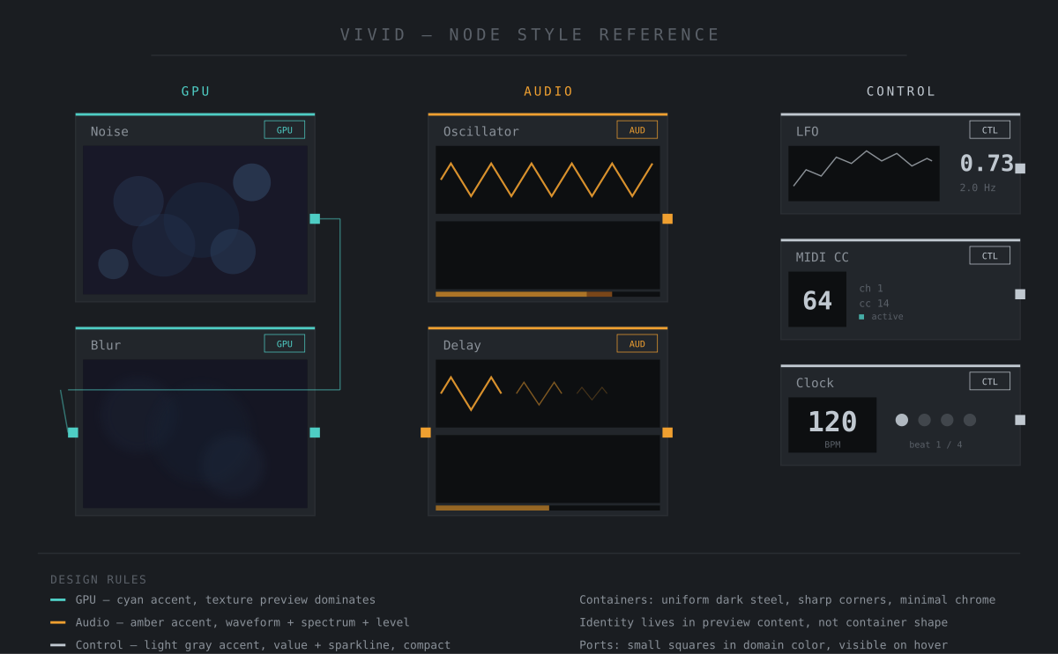
Figure 5. Node style reference: uniform containers with domain identity expressed through preview content and accent color.

Interface chrome
- Workspace grid. A subtle grid underlays the node graph — very low opacity, in the GPU accent color. Provides structure and snap targets without visual noise.
- Wires. Thin (1px), in the domain color of the source port, low opacity (40%). Cross-domain wires (Control→GPU, Control→Audio) are dashed to indicate the bridge crossing. Wires should never visually compete with node content.
- Inspector. Dark background, parameters as horizontal rows. Slider tracks are dark with a domain-colored fill. Modulation range overlays (Bitwig-inspired) appear as subtle highlights showing the modulated range. Modulation source is indicated by a small tag next to the parameter.
- Transport bar. Minimal. Beat position as filled/unfilled dots. BPM as a number. Current state name. No unnecessary decoration.
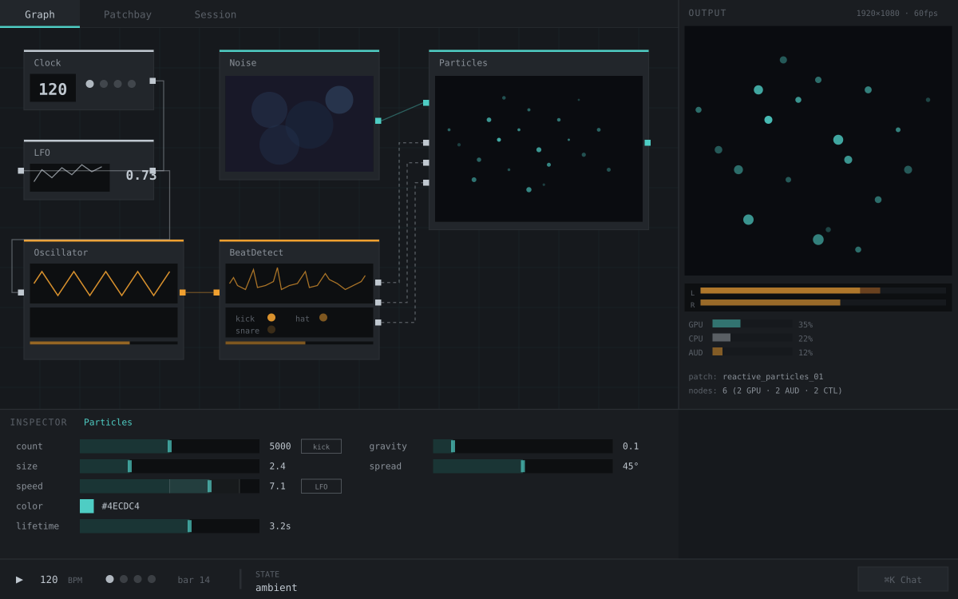
Figure 6. Interface mockup showing the visual style in context: dark steel background, domain-colored accents, content-forward node previews, minimal chrome.

What this is NOT
- Not soft or rounded — sharp corners, no border-radius, no blur effects on chrome
- Not colorful — the three domain colors are the only chromatic accents against neutral gray
- Not decorative — every visual element serves a functional purpose
- Not MaxMSP — not esoteric or diagrammatic, the live content dominates over the wiring
- Not Notch — no irregular node shapes, no visual complexity in the containers themselves

7. Phased Roadmap
Each phase is independently useful and shippable.
The roadmap has 22 phases across 6 tiers. Each phase ends with a binary verification: it works or it doesn’t. Phases are small enough to complete in days to a couple weeks, not months.

Tier 1: Can It Run? (Phases 1–3)
Phase 1 — Window: CMake + Dawn + GLFW. Verify: window opens cleared to #16191D. Phase 2 — First Operator: Operator contract (operator.h). Build LFO as .dylib, load via dlopen. Phase 3 — Graph + Data Flow: Graph loader (yyjson), parameter store, synchronous scheduler. Values flow through connections.

Tier 2: Can You See and Hear It? (Phases 4–7)
Phase 4 — GPU Rendering: GPU operator pipeline via Dawn. First operator: Noise with WGSL shader. Phase 5 — Control Drives Visuals: Control→GPU bridge. LFO drives Noise scale. First cross-domain data flow. Phase 6 — Audio Output: miniaudio device, audio scheduling, Oscillator + Delay operators. Phase 7 — Audio Drives Visuals: Audio→Control bridge. Audio RMS drives visual brightness. The thesis moment: audio → control → GPU round-trip.

Tier 3: Can You Use It? (Phases 8–11)
Phase 8 — Hot-Reload: File watching, recompile via system clang, dlclose/dlopen swap. Parameters survive. Phase 9 — REPL: Text input, Runtime API, graph manipulation commands. Phase 10 — Minimal UI: Retained-mode renderer, node graph viewer + inspector with sliders. No draggable editing. Phase 11 — Live Thumbnails: Zero-copy GPU thumbnails on GPU nodes, waveforms on audio nodes, values on control nodes.

Tier 4: Can It Do the Thing? (Phases 12–14)
Phase 12 — Spreads + FFT: Spread type, FFT analysis, bar visualization. The canonical demo: audio-reactive visuals. Phase 13 — MCP Server: stdio JSON-RPC exposing Runtime API. Claude Code can inspect and modify running instance. Phase 14 — Built-in Chat: Anthropic API integration. Natural language graph manipulation inside Vivid.

Tier 5: Experimentation Interfaces (Phases 15–18)
Phase 15 — Patchbay: Cross-domain connection matrix. Phase 16 — Session Grid: Parameter snapshot navigation. Phase 17 — Pattern Algebra: Composable temporal operators. Phase 18 — State Machines: Named states with transitions.

Tier 6: Production Readiness (Phases 19–22)
Phase 19 — Export/Standalone Builds. Phase 20 — Operator Library System. Phase 21 — LLM Perception System. Phase 22 — WebSocket API.
Explicitly Deferred: Subpatches, Simulation Zones, draggable graph editing, multi-window, accessibility, library version pinning, project file format, bundled compiler.
The guiding principle: the LLM populates the exploration space; the user navigates it. Every architectural decision should be evaluated against this principle. If a decision makes it harder for the LLM to generate options, or harder for the user to evaluate and combine them in real-time, it’s the wrong decision.

8. Open Questions

Cross-Domain Connection UX
When a user drags a wire between nodes in different domains, should the system block and offer to insert a bridge node (explicit), auto-insert a visually distinct bridge node (semi-explicit), or silently handle bridging (implicit)? To be resolved during prototyping.

Semantic Tag Depth
How many semantic tags to define initially, and whether to formalize a standard set or let it grow organically as operators are built.

GPU Operator Model
Whether GPU operators are primarily C++ host code dispatching compute shaders / WGSL, or C++ all the way down. Affects the operator API and what the build system compiles.

Graph Serialization Format
The declarative graph representation enabling LLM-driven patching. Needs to capture node types, connections, parameter values, and semantic tags. This is the single source of truth for the entire system.

Control Operator Sufficiency
The decision to handle all automation and logic as visible Control operators (no scripting layer) requires a rich enough set of built-in control operators. What is the minimum viable set? LFO, Clock, Sequencer, Pattern, Envelope, Math, Logic, Gate, Random, Smooth/Lerp. Are there common automation patterns that are awkward to express as node graphs?

WebSocket API Scope
What mutations should the WebSocket API support? Parameter changes only, or full graph topology changes (adding/removing nodes, connections)? How to handle conflicts between WebSocket mutations and direct UI manipulation?

Audio/Visual Session Grid Interaction
The exact UX for the exploration strategies — how audio columns, visual columns, and mapping columns behave differently within the same grid widget.

9. LLM Perception System
The LLM cannot see the screen. When it generates a graph, adjusts parameters, or scaffolds operators, it works blind unless it has structured instruments that turn pixels and waveforms into numbers it can reason about. The perception system is what closes the loop between LLM generation and creative quality.

9.1 The Perception Loop
LLM-assisted development in Vivid follows a feedback cycle: capture the current output (frame, audio buffer, or both), extract structured metrics, evaluate whether the result matches intent, modify the graph or parameters, and capture again to verify. This loop is the runtime equivalent of a human watching the screen while turning knobs. Without it, the LLM’s role collapses from “collaborator” to “one-shot generator.”

9.2 Three Perception Layers

Layer 1: Introspection
The LLM’s eyes. Structured readout of what the graph is actually producing at every point in the processing chain.
- Per-node output analysis: for every GPU node, extract texture metrics (brightness, contrast, entropy, edge density, color temperature, clipping). For every Audio node, extract signal metrics (RMS, spectrum, crest factor, onset density, LUFS). For Control nodes, current values and recent history.
- Chain tracing: when the final output has a problem (too dark, clipping, frozen), the LLM inspects metrics at each node in the upstream chain to find where the problem originates. If brightness is healthy at node 3 and gone at node 4, node 4 is the culprit.
- Solo mode: isolate any node’s output, bypassing everything downstream. In a graph (not a chain), this means rendering the selected node and its upstream dependencies only.
- Performance metrics: per-node timing, GPU memory, audio thread load. Identifies bottlenecks.

Layer 2: Analysis
The LLM’s judgment. Higher-level evaluation that goes beyond raw metrics to assess perceptual and aesthetic quality.
- Visual analysis: color harmony scoring (complementary, analogous, triadic), bilateral and rotational symmetry measurement, spatial balance (rule of thirds, center of mass, quadrant distribution).
- Audio analysis: loudness standards compliance (EBU R128), spectral character (brightness, flatness, rolloff), dynamic range, pitch detection, stereo imaging.
- Audio-visual reactivity: this is core to Vivid’s thesis. Measures how well visuals respond to audio: correlation between audio energy and visual brightness/motion, onset response rate (what fraction of beats produce visual change), reactivity latency (how many milliseconds between an audio event and the visual response), per-band correlation (does bass drive one thing and treble drive another).
- Comparison tools: A/B frame comparison (semantic diffs: brightness change, contrast change, sharpness change), A/B audio comparison (spectral diff, loudness diff), parameter sweeps (capture output across a parameter range to find optimal values).

Layer 3: Assertions
The LLM’s memory of intent. Codified quality gates that persist across sessions and can be checked automatically.
Assertions are JSON declarations that bind a metric path to a comparison: “output brightness must be between 0.2 and 0.8,” “audio RMS must be above 0.01,” “AV onset response rate must exceed 0.5.” They serve multiple purposes:
- CI/CD: run the graph headlessly and validate that all assertions pass. Prevents regressions when operators are modified.
- Intent preservation: when the user says “make it brighter,” the LLM can add an assertion that brightness stays above a threshold. Future changes that violate this assertion are flagged.
- Installation monitoring: for long-running installations, assertions detect drift (frozen output, silence, loss of audio reactivity) and alert or trigger recovery.
- Conditional assertions: guards allow assertions to apply only when relevant. “Bass energy should be high, but only when the kick operator is active.”

9.3 Temporal and Cross-Domain Metrics
Single-frame analysis is insufficient for a real-time system. The perception system must also measure temporal behavior (is the animation frozen? is there unwanted flicker? has a feedback loop converged or diverged? is the output looping?) and cross-domain relationships (does visual motion correlate with audio energy? how much latency exists between an audio onset and the visual response?).
These temporal and cross-domain metrics require multi-sample capture: the system records output over a time window (typically 1–3 seconds) and computes statistics across the sample set. This is more expensive than single-frame analysis and is triggered on demand rather than running continuously.

9.4 Design Principle
The perception system is not a debugger bolted onto the side. It is a core architectural component — the mechanism through which the LLM iterates on creative output. Every operator should expose metrics. Every domain bridge should be measurable. The JSON graph format should support assertion definitions alongside node and connection definitions. When the perception system works well, the LLM becomes a genuine collaborator: it can see what it built, evaluate whether it’s good, and fix what’s wrong.

10. To Be Determined
The following topics are acknowledged as important but are not yet designed. They will be addressed as the project progresses, most during or after Phase 1 implementation.

Subpatches
Equivalent to TouchDesigner’s Bases or Max/MSP’s subpatchers. A subpatch collapses a group of operators into a single node with defined inputs and outputs. Essential for managing graph complexity, enabling operator reuse, and supporting LLM scaffolding (the LLM generates a subpatch, not a flat graph). The design depends on how Spreads and Simulation Zones interact with encapsulation boundaries. A subpatch may also serve as the unit of session grid variation — swapping a cell swaps a subpatch.

Project File Format
Is a Vivid project a single .json file, or a directory containing the graph JSON, operator source files, assets (textures, audio samples), and assertion definitions? How does save/load work? How are assets referenced — absolute paths, relative paths, or embedded?

Performance Targets
60fps at what node count? Audio at what buffer size / sample rate? Maximum acceptable hot-reload time? GPU memory budget? These become acceptance criteria for Phase 1.

Error Handling and Recovery
What happens when an operator’s hot-reload fails to compile? When an operator segfaults? When an audio operator misses its deadline? When a GPU shader fails validation? The graph must keep running. Strategies: per-operator error isolation, fallback to last-known-good, visual error indicators on failed nodes, audio silence on missed deadlines.

Spread Visual Representation
How do Spreads appear in the graph? Wire thickness proportional to cardinality? A small badge showing count? Color intensity? How does the user know they’re looking at a Spread of 512 vs. a Spread of 1? This is a UX design problem to be resolved through prototyping.

Simulation Zone Visual Representation
Whether Simulation Zones are a visible bounding box around grouped nodes (like Blender) or a single Feedback operator with an internal graph (like a subpatch). The former is more explicit and inspectable; the latter is simpler for the JSON schema.

Accessibility
Keyboard navigation, screen reader support, high-contrast mode. Important but not blocking Phase 1.

Multi-Window / Multi-Monitor
Output preview undocking to a separate window for projector/LED wall output. Multiple graph views. Phase 2 concern.

Library Version Pinning
Should the project record which library versions were used? A lockfile (vivid-lock.json) that pins awesome-particles@0.2.0 would ensure reproducibility, especially for installations that need to rebuild months later. Alternatively, the project could simply vendor library source into its own directory. The tradeoff is reproducibility vs. simplicity.
End of Document

