Analysis on the Dynamical System of Numbers
Youngjong Oh
dmqcka@gmail.comg

Abstract:
Irrational numbers are real numbers which cannot be expressed as a ratio of integers. Other than that, here I present a simple but previously unknown way to see the hidden nature of irrational numbers. To find out the hidden structure, I propose the definition of the dynamical system of numbers. In fact, the digital expansion of numbers can be thought of as a dynamical system for numbers. Statistical analysis of the dynamical system helps us to view a new and surprising true nature of irrational numbers.

One-Sentence Summary: A statistical analysis on the dynamical system derived from the digital expansion of numbers helps us to see the hidden structure of irrational numbers.

Main Text:
Introduction
The discovery of irrational numbers in ancient Greece posed a big problem to Pythagorean mathematics because it broke the strong belief that numbers existing in the world should be integers or numbers that can be expressed as fractions. In fact, irrational numbers which are incommensurable cannot be determined precisely and without error because they never terminate or repeat. Today we all know that real numbers include not only integers and fractional numbers but also irrational numbers which cannot be expressed as a simple fraction, and all real numbers are a scalar value which does not change regardless of time or place.

For a real number, the number symbol and digital expansion are two manifestations of the same thing. The former represents ideality and the latter means the reality because the symbol is a sort of name for the unknown entity and digital expansion is a physical quantity which can be comparable to knowing the difference with other numbers. It should be noted that with a number symbol such as and π only, there is no way to compare any two numbers and thus we need realized forms such as digital expansion or a point on a line for numbers.

The digital expansion of rational numbers has a very simple pattern because digits are either terminated or repeat but not for irrational numbers. The best description for the expansion of irrational numbers is usually that digits are neither terminated nor repeated, or there is simply no pattern at all. The fact that irrational numbers are also a scalar value makes me suspect that something—such as an unknown pattern hidden in the digital expansion showing random behavior—prevents us from knowing what digit will appear at any location in advance without calculating first. In this paper, I propose a new way to extract something static in the digital expansion of irrational numbers.
A dynamical system of numbers

A dynamical system usually has a fixed rule to describe precisely the evolution of states over time. The concept for a dynamical system is so flexible it can be extended to the digital expansion of numbers. The digital expansion, which is in fact a realized form, of any irrational number is a never-repeating endless list. One remarkable observation here is that it is almost impossible for humans to get an error-free realized form of irrational numbers because that would require an infinite amount of time and storage to fully calculate the endless list.

If we consider the calculation time for 1 digit as a unit of time, then generating 10 digits will take 10 units of time. With this concept, we can treat the digital expansion of irrational numbers as a dynamical system in which digits are evolving deterministically over time.

Let a real number A have the following decimal digital expansion:
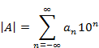 | (1)
, where n is an integer and is a (digital) state at a digital distance n from the decimal point.

If we switch n as time and as a state, one of the decimal set

, then the digits of a number A can be thought as a unique trajectory in the decimal digital space evolving over time n. For the example of π=3.14149, the state of this number dynamical system at time t=3 and t=5 would be and , respectively.

Various types for the dynamical system of numbers

Once the definition of a dynamical system of numbers is ready, we notice that there are three types in the periodicity of a dynamical system from the periodical point of view.

The first one is the fixed type which repeats the same digit forever. This type includes every integer and some rational numbers. For example, every integer has a single repeating digit 0 and some rational numbers such as 1/3=0.33333…. belong to this type too. The second type is for every other rational number with a series of forever-repeating digits of which the length is greater than 1. For example, 1/7 (=0.14285714285….) has a digital list, 142857, of which the length is 6 greater than 1 and repeats forever. These two types have one thing in common—both can be found in rational numbers. The third type is for irrational numbers which have no periodic digits at all or are aperiodic.

For irrational numbers such as π and e, it is self-evident that the numbers themselves are deterministic. But when we look at the digital expansion of irrational numbers, it seems to be non-periodic. To sum up, irrational numbers show a characteristic feature of the deterministic non-periodic dynamical system providing us a clue that there may be a strong analogy between irrational numbers and a Chaos system. The relational details between irrational numbers and a Chaos system are beyond the scope of this paper, so I will not address them.

Returning to the main point, I would like to tackle this naive belief that we merely have to understand that the digital expansion of irrational number is non-periodic. Again, it is obvious that Number Dynamical System (NDS) is implicitly a deterministic dynamic. When we consider that especially for irrational numbers like π, the sum of probabilities to be in (digital) states at any time index n should be 1, we can check to see whether it is not only deterministic but also stochastic dynamics. At least it is true when only digital expansion is given with no information about the number mapping to the digital expansion.

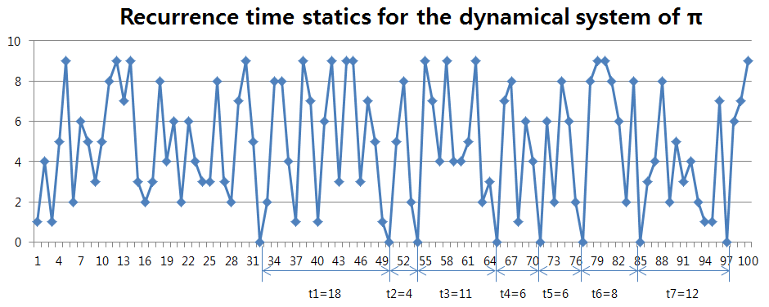
Figure 1. Given N=100 digits of π, histograms of intervals for ‘0’. There are 8 ‘0’s within 100 digits and the count for interval 6 is 2.

Recurrence time statics for NDS

The probability density of a digital return map for NDS can show the hidden nature of numbers. The return map of NDS can be defined as the histogram of intervals for a fixed state. In this paper, to get a histogram of intervals or the probability distribution of a digital return map, the following simple algorithm is used:

- Pick any digit in which 10-based digital expansion is used.
- In the digital expansion, seek the first position of x and mark it as t₀.
- Then seek the position next to the first returning digit and mark it as t₁.
- Get a time interval i=t1-t2 and increase the count for the interval by 1
- Repeat steps 3 and 4 as long as there are unsearched digits available.
- Then a return map H over interval n is ready.
, where h(x) is the count with the interval x and n is a maximal interval.
- Histogram can be normalized to show the probability distribution P.

Let us apply the above algorithm to the famous irrational number π.
π=3.1415926535897932384626433832795028841971693993751058209749445923078164062862089986280348253421170679……

To construct a histogram of intervals for a number, we need to first make a choice as to which digit will be searched for getting intervals using the above algorithm. Figure 1 shows that there are 8 ‘0’s and 12 ‘2’s. Normally given a digit length N, a histogram of each digit state has a “bin” size different from each other. With N=1,000, two histograms for ‘0’ and ‘2’ look different as can be seen in Figure 2-(a). But if N increases to 1,000,000, then those two histograms are getting very similar to each other.
To compare how two probability densities of histograms are close to each other, histograms need to be normalized first and the Root Mean Square Error (RMSE) is calculated as below:
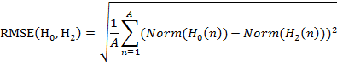 | (2)
, where A is the max of total intervals between H₀ and H₂.

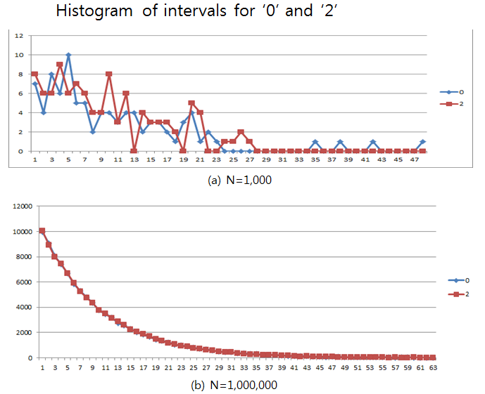
Figure 2. Histogram of intervals for ‘0’ and ‘2’ with (a) N=1,000 and (b) N=1,000,000.

The calculated SMSE with H0 and H2 in Figure 3 shows a consistently decreasing tendency as N goes to 1,000,000,000. This tendency seems to continue to infinity, and eventually both histograms are expected to converge into a single one. Table 1 shows the coefficients of the probability density to each interval up to N=1,000,000,000. For example, if a digital state is repeated 100 times in a given decimal digit, then the recurring interval 1 and 23 would be roughly 10 and 1, respectively.

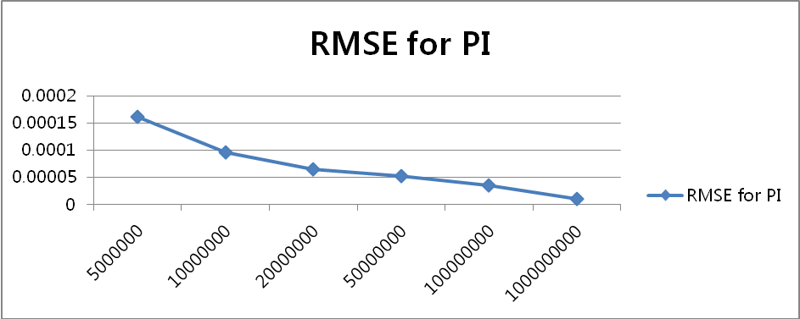
Figure 3. RMSE of H₀ and H₂ for π. As N increases, it decreases gradually and almost to 0 as N goes to infinity.

Interval | Probability  density | Interval | Probability  density | Interval | Probability  density | Interval | Probability  density
1 | 0.100012366 | 16 | 0.02059723 | 31 | 0.004240757 | 46 | 0.00087199
2 | 0.089997454 | 17 | 0.018543247 | 32 | 0.003808793 | 47 | 0.00078816
3 | 0.080983904 | 18 | 0.016688526 | 33 | 0.003428058 | 48 | 0.00071271
4 | 0.072894794 | 19 | 0.015010198 | 34 | 0.003083544 | 49 | 0.00063249
5 | 0.065621382 | 20 | 0.013513211 | 35 | 0.002783641 | 50 | 0.00057152
6 | 0.059061529 | 21 | 0.012158906 | 36 | 0.002496778 | 51 | 0.00051789
7 | 0.053104693 | 22 | 0.010924852 | 37 | 0.002252415 | 52 | 0.00045888
8 | 0.047830724 | 23 | 0.00984364 | 38 | 0.002028163 | 53 | 0.00041918
9 | 0.04302177 | 24 | 0.008849469 | 39 | 0.00182854 | 54 | 0.00037358
10 | 0.038739302 | 25 | 0.007980399 | 40 | 0.001647168 | 55 | 0.00034041
11 | 0.034877079 | 26 | 0.00717747 | 41 | 0.001475926 | 56 | 0.00030452
12 | 0.03137484 | 27 | 0.006461552 | 42 | 0.001329985 | 57 | 0.00027132
13 | 0.028244535 | 28 | 0.005809155 | 43 | 0.001200433 | 58 | 0.00024778
14 | 0.025458754 | 29 | 0.005245759 | 44 | 0.001079382 | 59 | 0.00022126
15 | 0.022876855 | 30 | 0.004717903 | 45 | 0.000967861 | 60 | 0.0001993
Table 1. The probability distribution of intervals ranging from 1 to 60 for π at N=1,000,000,000. The probability density is almost constant f7or any digit.

Concerning the probability density of intervals, one interesting feature is that not only the histograms of ‘0’ and ‘2’ but also those of other digits would eventually have the same interval probability density. It means that two histograms for any different digit will become asymptotically close to the ideal curve which will be shaped as.

From the study so far, I conjecture that all the probability distributions of intervals for any digit in the digital expansion of any irrational number will be the same as N going to infinity. Given that there is no known pattern or rule on how digits are arranged in the digital expansion of π so far and no way to store the endless list of digits, it is my view that proving this conjecture is hardly likely in the near future. Also, a huge gap seems to lie between Ideal and Reality which cannot be overcome due to the mismatch or non-zero error between π, the symbol itself which we can imagine only in our mind without any physical form, and the digital expansion which represents reality.

Conjecture 1: For π, given any i and j, the interval probability density P has a property as follows:

The three types of number dynamical systems in view point of periodicity
In the previous paragraph, the definition of a dynamical system of numbers was presented. If we treat the decimal places after the decimal point as time in the increasing order, every state which is a decimal digit of NDS at any instance of time is determined. The time evolution graph in Figure 1 can be converted into the digital circle diagram as in the upper row of Figure 3, which makes it easy to discern some sort of periodicity. By looking at the trajectory pattern of NDS in Figure 3, we can notice that there are three different types of NDS.

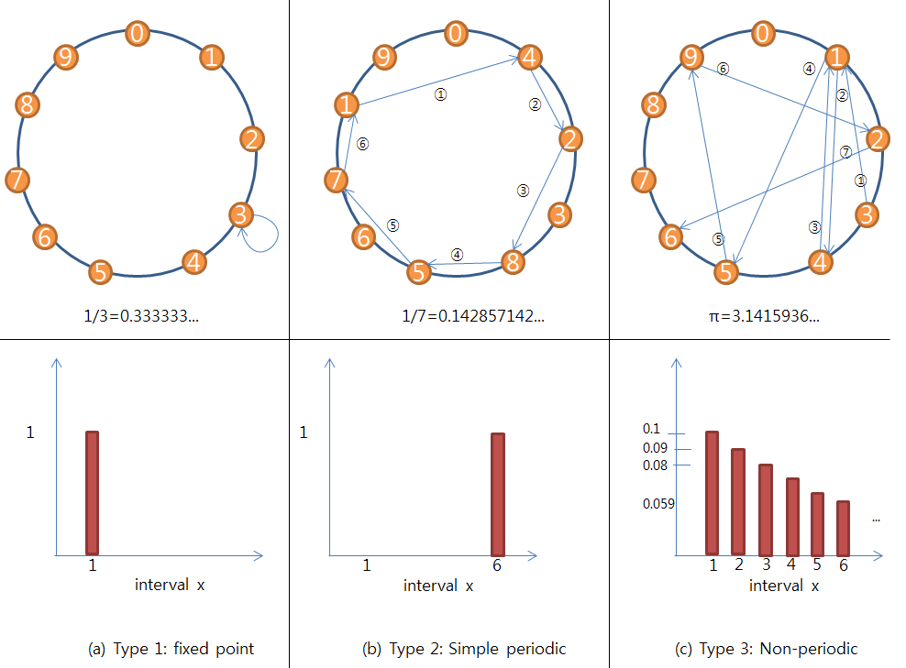
Figure 3. Three different types of dynamical systems of real numbers from the view point of periodicity. From left to right, each column has a different periodic type. The first two types have a loop that repeats forever, and the third one has many temporal loops but no loop that repeats forever. The top and bottom lines represent the view of time domain and frequency domain, respectively.

The first type shown in Figure 3-(a) is called a singularity type which stands for any rational number with no change in the state in its equilibrium such as 1.0, 1/3, 1/9 and so on. This type usually has the interval length 1, and its interval probability density has a single peak with value 1 at interval 1 and zeros at every other interval.

The type 2 in Figure 3-(b) represents any rational number with a repeated digit whose size is greater than 1 at equilibrium. This type has a simple loop connecting multiple digits. For example, 1/7 has a repeating digit list “142857” in the digital expansion, and its interval is 6 such that the interval probability density has a single peak with value 1 only at interval 6. If we sum two rational numbers whose decimals have different repeating lengths, then the sum result will also have a repeating digit. It can be calculated that “(1/353) + (1/911) + (1/997)” has a repeating decimal with interval 1,208,480 using a computing tool supported in [1]. Types 1 and 2 show that every rational number will have a repeating decimal with a fixed interval x, and its probability density will have 1 only at interval x. What distinguish type 1 and 2 is that type 1 has a single digit or state repeated such that it has no change in state. On the other hand, type 2 has a periodic change across many states.

Type III stands for an irrational number of which the dynamical system shows a non-periodic trajectory in the decimal digital diagram view. It is hard to see any pattern in this time domain view, but we can notice a pattern in the frequency domain as in the bottom row of Figure 3-(c). The probability density shows that there should be an infinite number of non-zero peaks in the interval or period axis as can be seen in the previous case study for π NDS.

All types of NDS share a common feature wherein the probability density does not change depending on the choice of the initial time or decimal place. This means that, in order to calculate the probability density for a digit, no matter where the decimal place is after the decimal point we choose to begin with, the results will be the same. It can be conceptually thought of as time translational symmetry, meaning that the probability density is conserved.

Another important thing is that usually each valid state of a number shares the same probability density. For example, 1/7 has a repeating decimal 142857 and all valid states have the same interval of 6. But it should be noted that not all irrational numbers have this feature. Let us look at the below irrational number generated by a fixed rule such that a digit will have an infinite number of non-zero periods:
The Ni above is an irrational number because there is no repeating decimal, and the valid states are 0 and 1 out of 10 decimal digits. If we compare two interval probability densities for ‘0’ and ‘1’, I notice they are different from each other. The period count of ‘1’ is 1 at every period but the probability density for ‘0’ has only two peaks at intervals 1 and 2 and zeros elsewhere From this case, I can think of the possibility of further categorizing the irrational number but it is beyond the scope of the present paper.

Is the NDS of irrational numbers aperiodic?
From the above study, it is obvious to me that types 1 and 2 represent a rational number which has a simple period but there must be more to it than simply saying that it is aperiodic for irrational numbers since we can see a fixed pattern in the interval probability density which can be thought of as a frequency domain view. To offer an insight on this question, I would like to restate it as follows:
“Do you ever imagine what the periodic trajectory with a period of an irrational number looks like?”
Recalling that rational numbers and irrational numbers are incommensurable with each other, the above observations lead to the conclusion that the trajectory of an irrationally numbered period should differ from a simple repeating loop. As can be seen in Figure 3, it should have the converging probability density of periods as time goes to infinity.

Analogy between NDS and quantum mechanics

I hope those who are not familiar with quantum mechanics will forgive me for briefly describing the relation between NDS and quantum mechanics; it is a hidden but true reason why I wrote this paper. I believe that NDS has a strong analogy or sort of symmetry with the dynamics of subatomic-scale particles.

Reference
[1] http://www.wolframalpha.com/

