Model selection and visualization:

The main models of infectious diseases are SI, SIS, SIR, and SEIR. Each of them fits different infectious diseases. The capital letters inside these words stand for:

**·S (Susceptible):** the number of individuals that can get infected.

**·I (Infectious):** the number of individuals who are infected and can transmit the disease

**·R (Removed or Recovered):** the number of individuals who are immune.

**·E (Exposed):** the number of individuals who have touched the infected but are temporarily unable to infect others.

From the previous medical report, we can know that the COVID-19 most likely fits the SEIR model (the most complex one). SEIR model is a general model. If the infectious diseases studied have a certain incubation period, the healthy people who have contact with the patients do not get sick immediately but become the carriers of pathogens, which are classified as class E.

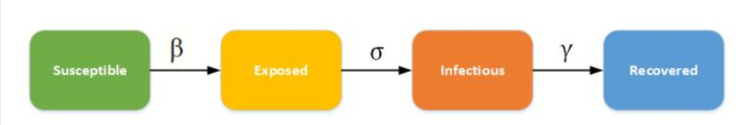

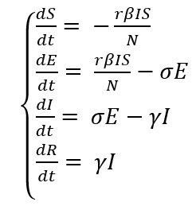

S: susceptible

E: exposed

I: infectious

R: recovered

t: time

β: Infection rate

N: total number

$γ$: recover rate

$α:$ rate of the E change to the Infectious.

Besides, researchers not only found that the exposed people can also be infected susceptible and be recovered but also the recovered can become susceptible again. These features of COVID-19 make the model more complex than normal SEIR. Then, we have to use the equation below to fit our model.

Let me quickly introduce the equations set. The Susceptible can change to the Exposed and come from the Recovered. The Exposed comes from the Susceptible and can change to the Recovered or the Infectious. The infectious come from the Exposed and can change to Recovered. The recovered can change to the Susceptible and come from the Exposed or the Infectious.

$\left\{\begin{aligned}&\frac{dS}{dt}= -\frac{βIS}{N} \\ &\frac{dE}{dt}= \frac{βIS}{N}-aE{-γ}_{1}E-μ_{1}E \\ &\frac{dI}{dt}= aE-γ_{2}I-μ_{2}I \\ &\frac{dR}{dt}= γ_{1}E+γ_{2}I \\ &\end{aligned}\right.$

S: Susceptible

E: Exposed

I: Infectious

R: Recovered

t: time

β­: infection rate for Susceptible

N: total number

$α$: rate of the Exposed change to the Infectious.

$γ_{1}$: recovery rate for the Exposed

$γ_{2}$: recovery rate for the Infectious

$μ_{1}$: death rate for the Exposed

$μ_{2}$: death rate for the Infectious

The sample graph is shown below. The paraments are N = 10000, r = 100, S0 = N-I0, E0 = 0, I0 = 1, R0 = 0, β = .03,  = .05,  = .2, 1 = .1, 2 = .001, = .03 .03.

