UYG414 Project Report: Intelligent Microservice Architecture

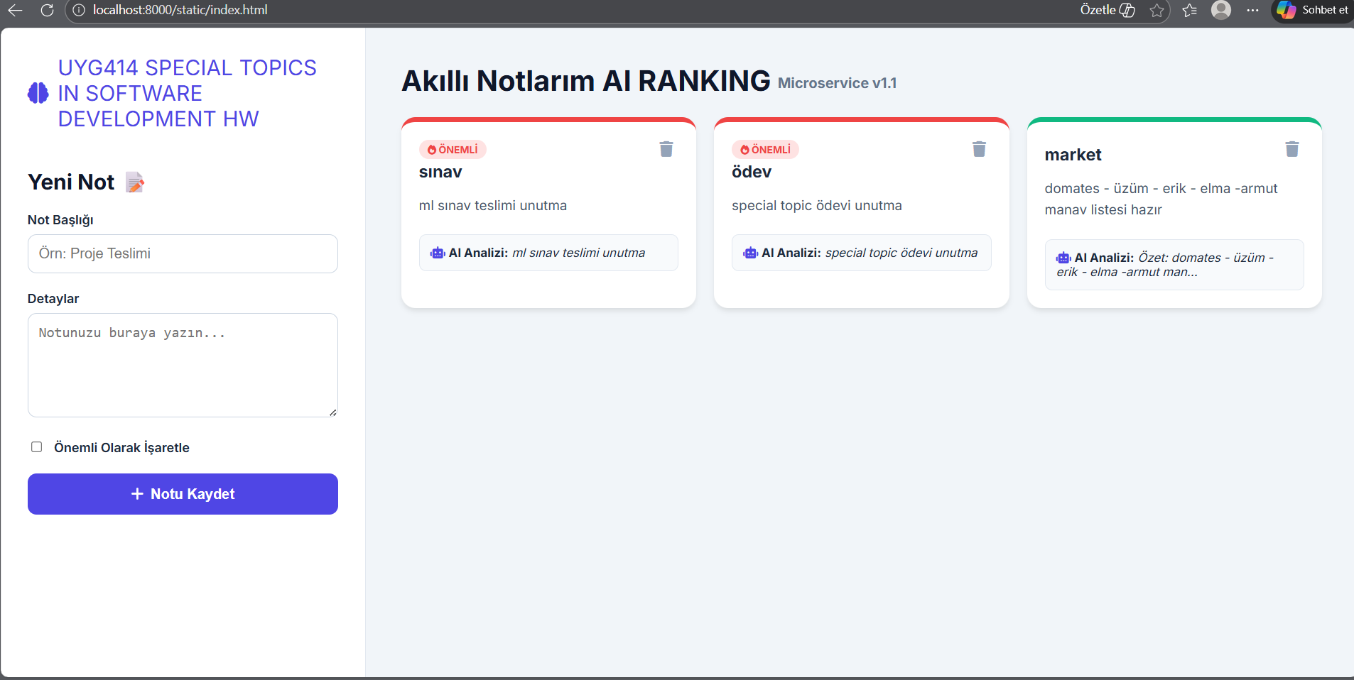
1. Executive Summary

Before starting this project, we conducted brief research to determine which scenario would best satisfy the course requirements (Clean Architecture, Containerization, CI/CD, etc.). As a result of our research, we realized that although a Note Management System may seem simple at first glance, it is highly suitable for building a complex microservice architecture in the background, managing database relationships, and adding “Smart Analysis” layers on top of .Our design idea came from our research project, but the entire code and design belong to us. For the design part, we used HTML to design our interface. For the container part, we used Docker to design our container structure. For the backend part, we used Visual Studio Code to design a clean backend structure using Python. For the database part, we used SQLite to design the database tables that were specified in the project. Our system also enables users to make notes and set urgency levels for their notes. Furthermore, we designed a smart sorting system using AI that could sort the important notes and show them first.

2. Product Description and Vision
2.1 Problem Domain
In day-to-day academic and professional life, it is very common to face problems in organizing and maintaining tasks and notes. Many times, critical information is stored in random places in the form of paper-based notes, plain text files, or simple application-based notes without any facility of prioritization. This may result in missing deadlines and urgent tasks, leading to poor time management.With the conventional method of note taking, users do not have the facility of structured information storage, urgency levels, and smart prioritization. As the information increases, users may find it difficult to focus on what is critical and what is not.

2.2 Solution: Smart Notes Application
Our project provides a simple and effective solution to this critical issue with the development of a smart notes application. This application provides a centralized solution for users to store and manage their notes in a structured manner.. This application provides users with the facility of assigning an urgency level to each note. Additionally, this application provides an artificial intelligence-based smart sort facility to users to get their critical notes at the top of the list.This application uses Python for backend programming and SQLite for storing information. Docker is used for containerization to ensure portability and consistency in the application. This application aims to provide a lightweight and scalable microservice-based solution with good architecture and REST API principles.

2.3 Target Audience
University students and their assignments and deadlines
Professionals and their day-to-day tasks and responsibilities
Small teams and their task-tracking requirements
Users and their structured and smart note-taking requirements

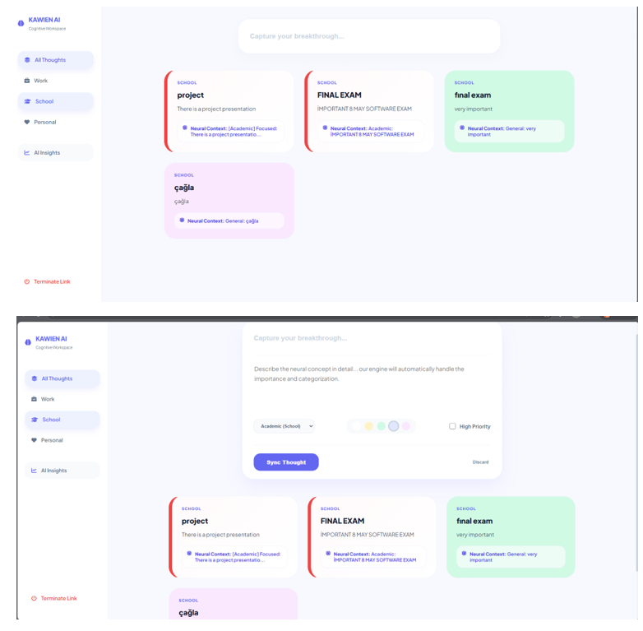

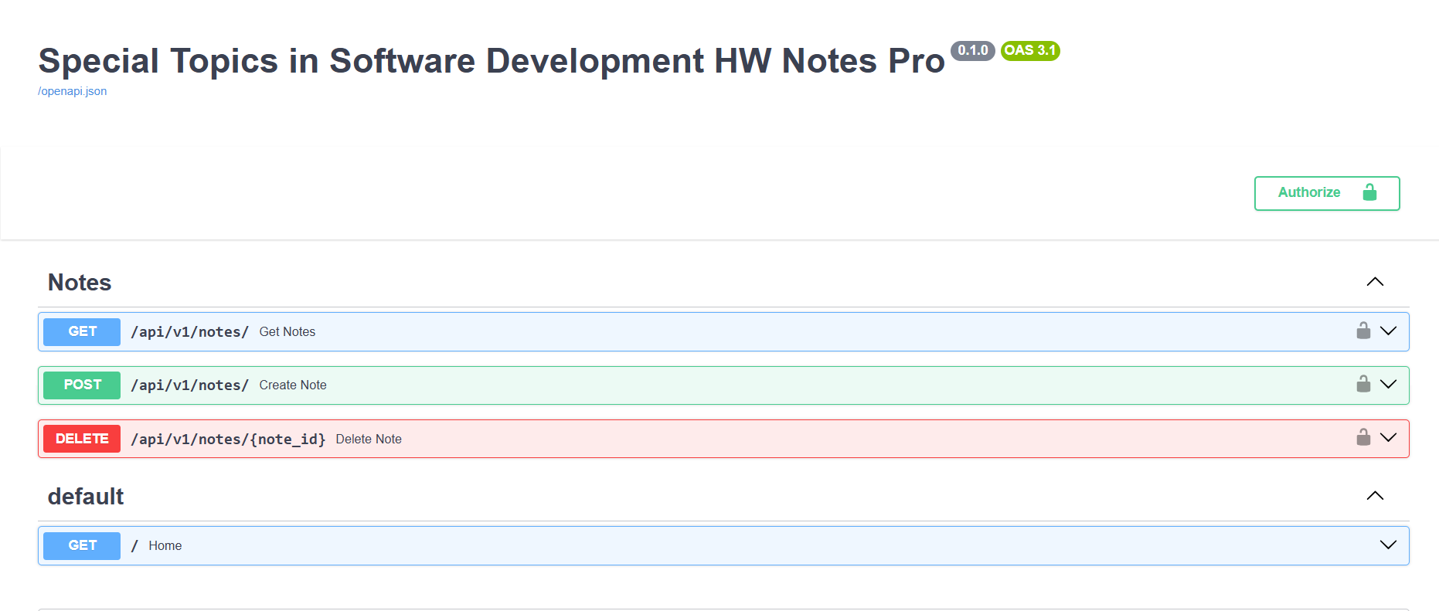

3.Core Features and Capabilities
Authentication Structure
At the moment, the system has a single Admin account to run and access everything. Every action related to notes is done through the authenticated account.his system currently works with only one form of authorized access, but it was built to scale. Therefore, if this project expands, additional access control features can be added without requiring us to start over.
Urgency Level Classification
Each note has an urgency level associated with it. This way, users can instantly see what needs to be done immediately and what can wait. This helps in organizing tasks and makes the day run smoother.
AI-Driven Smart Sorting
Smart sorting is a unique feature of the system. It uses artificial intelligence to sort the notes. Each note is ranked according to its urgency and importance. This way, the most critical note appears on top. This feature ensures one does not miss any critical task.
CRUD Operations
The system provides the ability to create, read, update, and delete. This feature is very essential and simple. One can add a note, read existing ones, update existing ones, and delete existing ones.
RESTful API Architecture
The system provides access to all its functionality through the REST API. This feature is very essential. This way, the system can easily integrate with different client applications. This feature keeps the system modular and flexible.
Database Management
The system has a database to keep the notes. SQLite is the database management system. This way, the system keeps its data well-organized.
Containerization Support
The system is containerized. This feature is very essential. This way, the system can run consistently in different environments. Docker is the containerization tool.
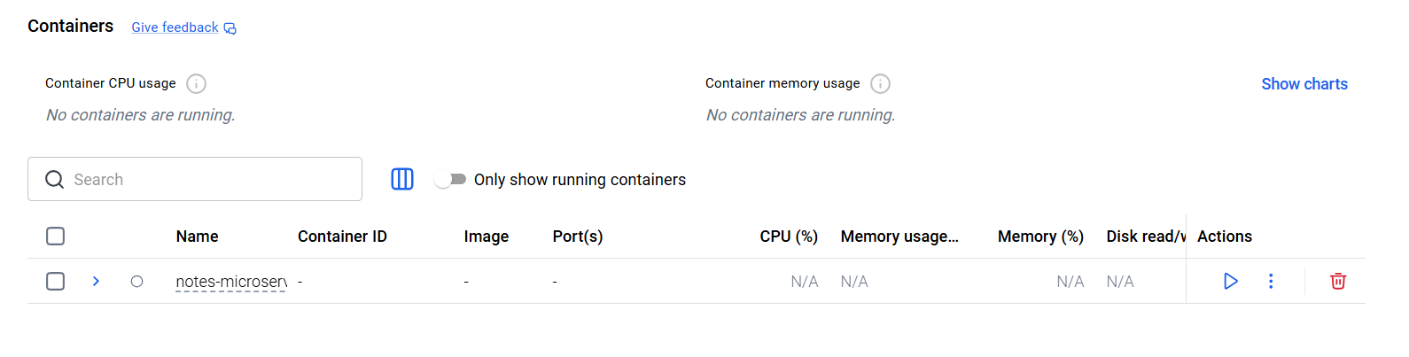4. Technical Architecture and Infrastructure
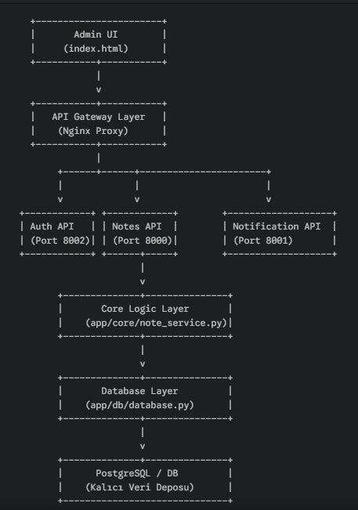
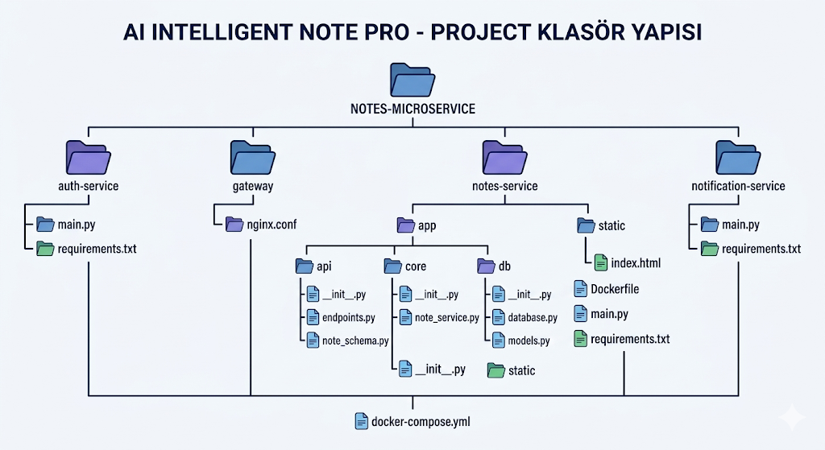

4.1 General Architecture Smart Notes is a client-server architecture:
- Front End: Customized HTML client for managing notes
- Back End: Python application with REST API endpoints
- Database: SQLite database for structured data management
- Containerization: Docker containerization for portability and consistency
Layered Architecture:
- Presentation Layer/UI: HTML is used for the user interface
- Application Layer: Python code for creating, updating, deleting notes, and setting urgency levels along with smart sorting
- Backend Layer: REST API endpoints for creating, updating, deleting notes along with data validation and structured request handling
- Database Layer: SQLite database for storing structured notes with fields for content, urgency level, and creation/update timestamps
- Infrastructure Layer: Docker container for uniform deployment on any infrastructure
4.2 Project Directory Structure
Modular directory structure with the following folders:
- frontend: HTML code and styles
- backend: Python code with API endpoints
- database: SQLite database files
- docker: Docker configuration
- scripts: Utility scripts
4.3 Data Flow How the code handles user inputs:
- Admin logs in using the admin user ID and password
- Authentication is done to ensure authorization
- Notes creation, updation, or reading is done using SQLite database
- Smart sorting is done based on the urgency level
- Everything is logged

5. Technology Stack
5.1 Frontend Technologies
- HTML/CSS – UI layout and styling
- Tailwind CSS v4 – Utility-first styling for rapid design
- Radix UI – Accessible UI components
- Sonner – Toast notification system
5.2 Backend and Database
- Python 3.11 + FastAPI – REST API backend and business logic
- SQLite – Lightweight relational database
- Docker – Containerization for portability and deployment
- Logging & Middleware – Request tracking and API key security

5.3 Code Distribution
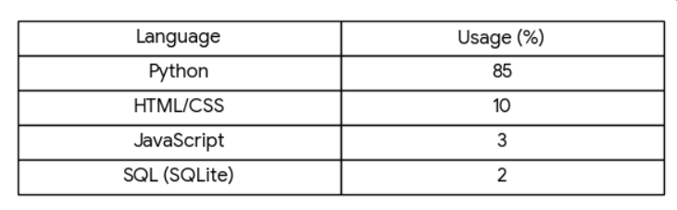

6. Security, Auditing, and Resilience
6.1 Access Control and Authorization
This approach also prefers flexibility, making it easier to transition towards more sophisticated methods like JWT or RBAC when the user count increases. Additionally, the Principle of Least Privilege ensures that the AI sorting logic only interacts with the data it needs, ensuring the user’s information remains private.

6.2 Data Integrity and Protection
To keep the code clean and secure, credentials are not hardcoded, and configurations are stored in environment variables (.env files). At execution time, FastAPI and Pydantic collaborate to validate all incoming data pieces against the defined data schemes. Using Docker for containerizing SQLite adds another security layer, protecting the data from security issues in the host OS.

6.3 Auditing and Disaster Recovery
For disaster recovery, Docker Volumes help prevent data loss when restarting or updating the application. Snapshots of the database are also performed regularly, ensuring a reliable option for restoring the application and making it running again after a failure occurs unexpectedly.
GitHub Actions is used for continuous integration.With the .github/workflows/main.yml file, every time code is pushed, the system automatically:
Installs dependencies.Checks code quality (linting).This prevents faulty code from being merged into the main project.
Cagla13/notes-microservice: Production-grade microservice with Clean Architecture, AI integration, and CI/CD. GITHUB LİNK
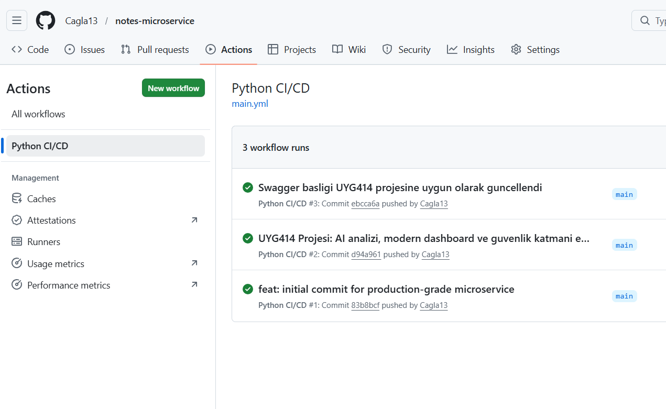

7. Role and Authorization Management Model
7.1 System Administrator (SuperAdmin)
The SuperAdmin functions as the primary architect of the system, holding the keys to the entire application environment. This role is responsible for high-level tasks like user management, permission audits, and system backups. Furthermore, the SuperAdmin has the unique authority to calibrate the AI sorting parameters and access the full dataset, making this role essential for project leads who require total oversight.
7.2 Operational Manager (Admin)
The Admin role is centered on workflow efficiency and team coordination. These users are responsible for the day-to-day organization of the platform, such as categorizing notes and validating urgency tags to keep the team's output aligned with project goals. With the ability to manage records within their specific scope, this role is tailored for project managers who need to balance resource coordination with task prioritization.
8. Note Prioritization and Sensitivity Levels
Inspired by structured information management, our application employs a tiered classification system to help users organize their data based on both urgency and sensitivity. We categorized notes into four distinct levels: L1 (General) for routine observations, L2 (Personal) for private reminders, L3 (Important) for academic or professional deadlines, and L4 (Critical) for time-sensitive tasks that require immediate attention. This hierarchy doesn't just label the notes; it feeds directly into our AI-driven sorting engine, allowing the system to intelligently surface the most vital information at the top of the user’s feed.
9. User Experience and Interface Design
Our design philosophy focused on creating a clean, distraction-free environment using Tailwind CSS v4 and Radix UI. We prioritized a "mobile-first" approach, ensuring the interface remains fluid and responsive whether accessed from a desktop or a smartphone. To enhance the daily workflow, we integrated a theme-switching system that supports both dark and light modes, alongside Sonner for real-time toast notifications. Accessibility was a non-negotiable standard for our team; therefore, the UI is fully keyboard-navigable and follows WCAG 2.1 color contrast guidelines to ensure every user, regardless of their needs, has a seamless experience.

10. Installation and Deployment Strategy
To guarantee consistency across different environments, we utilized Docker to containerize the entire stack. Our production-ready Dockerfile encapsulates the Python backend and the SQLite database, making the deployment process as simple as a single command. For local development, our 5-person team established a streamlined workflow: users simply need Python 3.11, install the required dependencies via pip, and run the FastAPI server. This dual approach—flexible for development yet robust for production—ensures that the application can be hosted on cloud platforms or local servers with minimal configuration.
11. Integration and Scalability
The Smart Notes Application is built as a lightweight microservice, leveraging the asynchronous capabilities of FastAPI to handle concurrent requests efficiently. We designed the system to be highly integrable, offering a RESTful API that allows the notes engine to communicate with external frontends or third-party tools. For long-term scalability, we implemented GitHub Actions for CI/CD, ensuring that every update is automatically tested and validated before deployment. Although we currently use SQLite for its simplicity, the architecture is decoupled enough to allow a seamless migration to a managed PostgreSQL instance if the data volume grows significantly.

12. Competitive Analysis and Differentiation
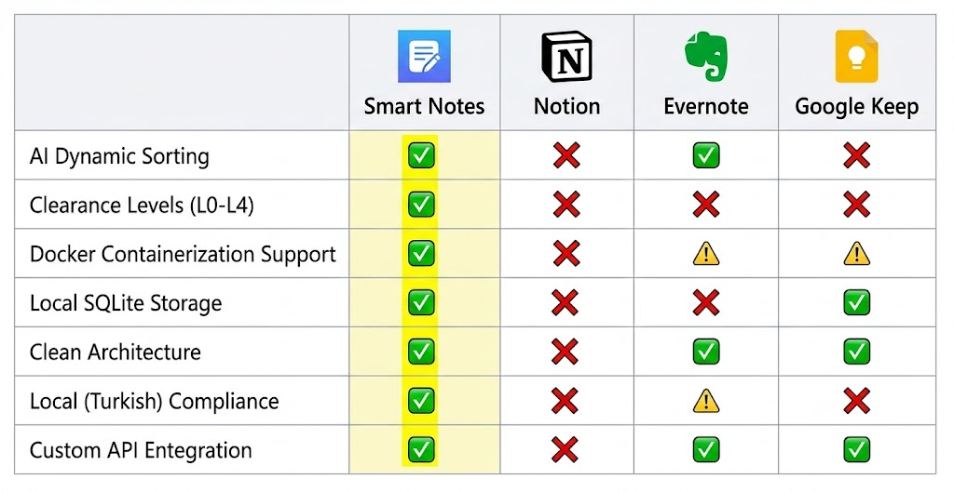

13. Licensing and Sustainability Model
13.1 Open Source Licensing
We have chosen to distribute the Smart Notes Application under the MIT License. This decision reflects our commitment to open-source principles, allowing others to freely modify, distribute, and deploy the application for both private and commercial purposes. While the core software remains open, our 5-person development team has structured the project to support future enterprise-level integrations, including dedicated support and service-level agreements (SLA) for institutional deployments.
13.2 Proposed Service Tiers
To demonstrate the scalability of our business logic, we have outlined three potential service tiers. The Academic Tier provides essential note management and AI sorting for individual students. The Professional Tier expands this by offering multi-device synchronization and deeper audit logs for power users. Finally, the Enterprise Tier is designed for small teams or departments, featuring unlimited collaborative workspaces, top-tier clearance levels (L0-L4), and high-availability deployment support.
-

14. Technical Specifications and Environment
14.1 System Requirements
On the server side, the application is optimized for Python 3.11+ environments using FastAPI. While the system can run directly on any machine with pip installed, we strongly recommend using Docker to ensure environment consistency and easy deployment. For data storage, we utilize SQLite 3, providing a lightweight yet robust relational database that requires zero external configuration. On the client side, the interface is compatible with all modern browsers (Chrome 90+, Firefox 88+, Safari 14+) and is optimized for a minimum resolution of 1024x768 to ensure the layout remains functional and clear.
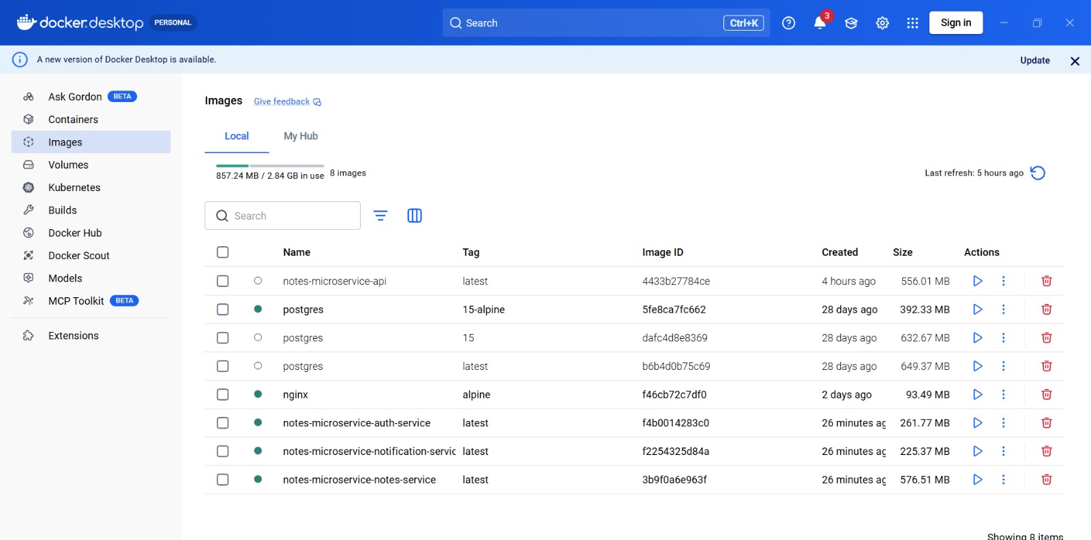
14.2 Configuration and Environment Variables
To keep our deployment secure and flexible, our team utilizes a .env file for all critical configurations. This approach allows us to separate sensitive keys from the source code. The primary variables include:
- APP_NAME: Customizes the application branding (defaulting to "Smart Notes").
- DATABASE_URL: Defines the path to the SQLite file or an external database instance.
- ADMIN_API_KEY: A secure token used to protect the management endpoints.
- DEBUG_MODE: A toggle for development logging and error tracking.
- THEME_DEFAULT: Sets the initial UI state (light or dark mode) for new users.

14.3 Email Sharing and Notification Module
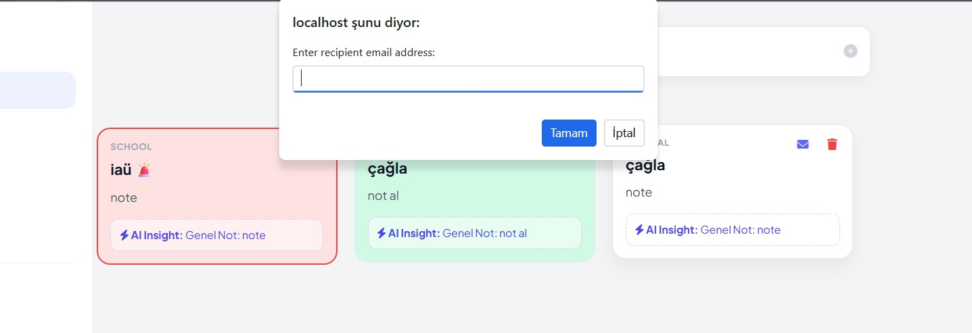

The Microservice Architecture of the project was expanded by adding an "Email Notify Module" to allow users to easily share notes, including any AI-generated insights.
A user selects to share a note and is prompted on the front-end (browser) with a simple request for the email address of the recipient. After entering the email address, instead of processing the request in a monolithic manner, the system uses an email notification service running independently in its own docker container to send the request.
The browser interface will show a success message indicating, "SUCCESS: Note has been sent to the Email Notification Service!" This decoupled approach, as well as logging on
docker containers, demonstrates our system's adherence to the Clean Architecture principles and adds to the overall observability of our containerized environment.
14.4 Authentication and User Interface
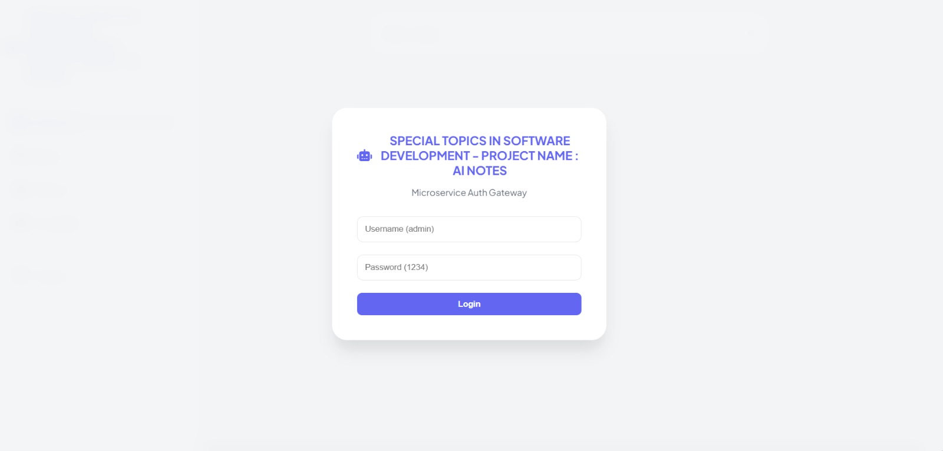
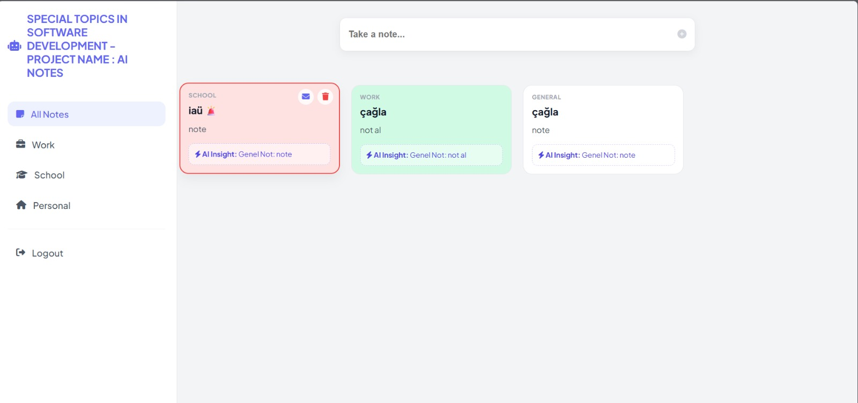

Project Description: AI-Powered Microservices Note Management System
We created a sophisticated and fully-featured NOTE MANAGEMENT SYSTEM (NMS) using a Microservice architecture that adheres to the principles of Clean Architecture. The purpose of this project was to modernize an existing notes application by converting it into a fully containerized ecosystem of connected services.

Our system is divided into a variety of independent components/services – AUTHENTICATION GATEWAY (to handle authentication), CORE NOTE SERVICE (to manage user notes), NOTIFICATION SERVICE (to send/email notifications of user action). All components are packaged within Docker containers, enabling easy and seamless scalability between all development, staging and production environments.

The BACKEND has been created using PYTHON language in VISUAL STUDIO CODE, using SQLLITE as its relational database for structured data persistence. One of the main differentiators of our system from others is that it was built on an AI engine that incorporates smart analysis into the application’s functionality. Because it provides the user with more than just a place to store notes, the SYSTEM FEATURES AN ADDITIONAL LAYER OF SMART INSIGHT (an artificial intelligence tool) THAT EVALUATES EACH NOTE ENTERED BY THE USER BASED ON ITS CONTEXT (the definition of the word context is defined in the C# section below). By determining the URGENCY of each NOTE, along with other factors, the system can provide users with prioritization lists of critical information/documents at the time of entry, resulting in the creation of a SMART SORTING system to automatically sort notes based on their importance and relevance to USERS PRIORITIES.

The USER INTERFACE was created using HTML5 and CSS3 “management dashboard.” It also provides a MINIMALISTIC AND RESPONSIVE DESIGN WITH COLOR-CODED (school/work/personal) CATEGORIZATION AND INTUITIVE USER ACTION TRIGGERS. This is an example of how to combine CI/CD readiness with Intelligent Data Processing (and how this is to be accomplished) AND HOW THIS PROJECT DEMONSTRATES A PRODUCTION-LEVEL APPROACH TO MODERN DAY SOFTWARE ENGINEERING CHALLENGES.

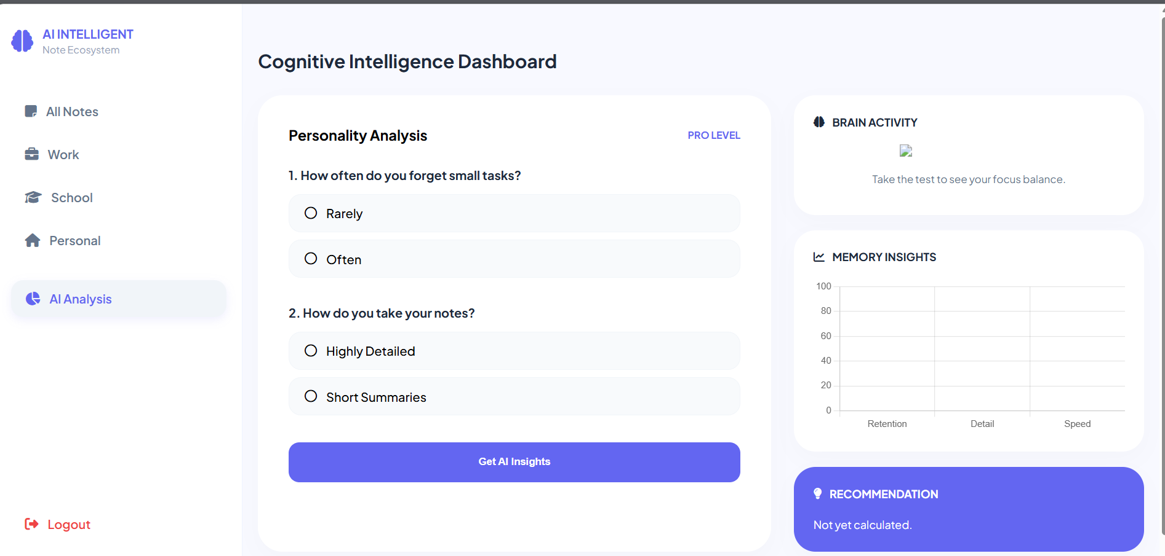
Our Cognitive Analysis and AI Integration Strategy
In the scope of our project, the developed AI layer is built upon a deterministic cognitive engine that analyzes user habits and cognitive preferences, distinguishing it from traditional note-taking applications that merely store data statically. This engine, positioned within the "Notes Service" layer of our microservices architecture, effectively transforms subjective user input into objective metrics.
Through a five-stage cognitive assessment provided via the user interface, our backend algorithms evaluate parameters such as the individual's Retention threshold, Detail orientation, and processing Speed. The Left-Right brain analysis we implemented is a specialized weighting algorithm based on the user’s decision-making mechanisms (logic vs. intuition). Based on the resulting data, we utilize CSS filters and dynamic SVG manipulations on the frontend to visualize the user’s profile across an analytical (blue spectrum) or creative (purple spectrum) continuum.
The contextual categorization framework (e.g., School, Work, Personal) organizes data into semantic clusters. Through this structure, data-driven feedback is provided via specialized icons and "AI Insight" modules tailored for each note category. Specifically, categories such as "School" demonstrate the system's capability for semantic labeling and dynamic filtering based on the user's current focus. Ultimately, this architecture offers an intelligent ecosystem that processes raw text data to cultivate user awareness regarding their own cognitive processes.
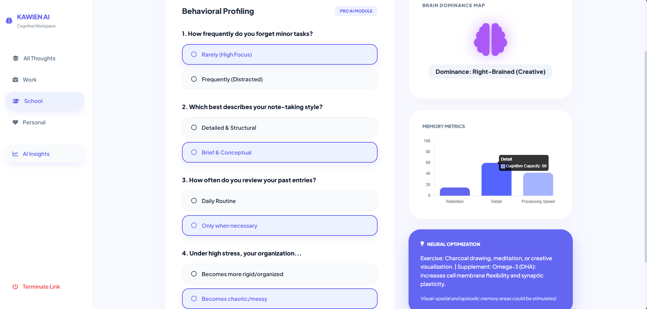

15) DOCKER DEVELOP PART
Fault Tolerance
In our system, we implemented fault tolerance mechanisms using Docker to ensure high availability.
In the docker-compose.yml file, we used the restart: always policy so that any crashed microservice is automatically restarted.
Additionally, we integrated a healthcheck mechanism to verify whether services are not only running but also functioning correctly.
Configuration we used:
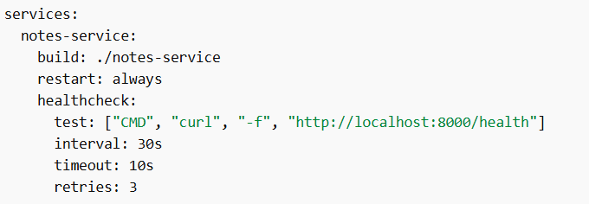

Health Checks
We created a dedicated /health endpoint for each microservice.
This allows Docker or the API Gateway to verify not only that the service is running, but also that it is healthy.
Example implementation:
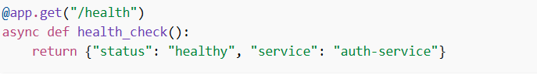
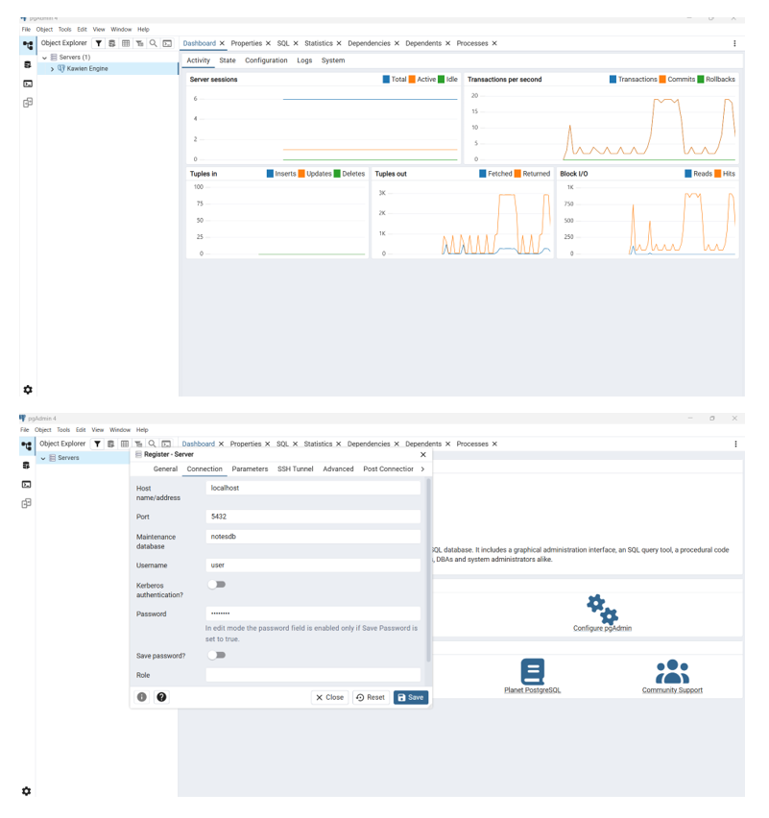

Monitoring
To monitor system performance, we used Docker’s docker stats command.
This allows us to track CPU, memory, and network usage in real time.
Using these metrics, we can easily identify performance bottlenecks in the system.
Centralized Logging
We implemented middleware in each service to log incoming requests and their processing durations.
This enables centralized tracking of system activities.
Middleware implementation:
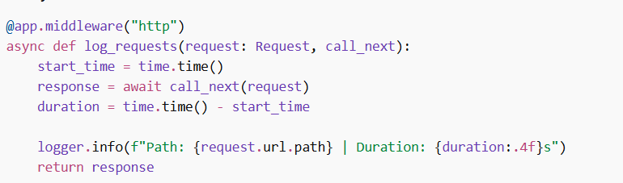Overall Reliability
In our project, we implemented:
Container-based architecture with Docker ,Service validation using health checks ,Fault tolerance with restart policies ,Performance monitoring ,Centralized logging
As a result, our system provides a production-ready microservice architecture that is self-healing, observable, and reliable.

16 . SECURITY & AI FEATURE INTEGRATION
Advanced Security
We implemented security in our system based on three main components:
- Rate Limiting:
Using Nginx, we limited incoming requests (5 requests per second per IP) to protect the system against brute-force and bot attacks.
- Secure Authentication (JWT):
We replaced basic authentication with JWT-based authorization. Users receive a temporary token instead of sending credentials on every request, increasing security.
- Secrets Management:
Sensitive data such as database URLs and API keys are stored in .env files instead of hardcoding them, ensuring security even if the codebase is exposed.
Artificial Intelligence Features
Our system goes beyond a simple notes app by integrating AI-based features:
- Smart Sorting:
Notes are automatically analyzed and categorized by importance levels (L1–L4), prioritizing urgent tasks.
- Cognitive Intelligence Dashboard:
The system evaluates user behavior (logic vs intuition) and measures cognitive metrics such as retention, detail, and speed.
- AI Insight Module:
Provides contextual suggestions based on note categories (e.g., school, work), helping users make better decisions.

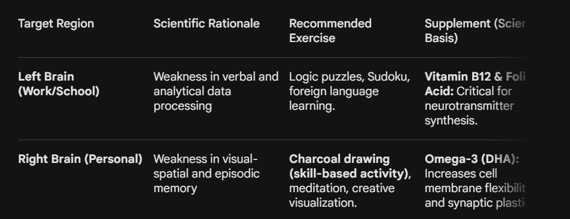

SOURCES
Mueller, P. A., & Oppenheimer, D. M. (2014). The pen is mightier than the keyboard. Psychological Science, 25(6), 1159-1168.
Tulving, E., et al. (1994). Hemispheric encoding/retrieval asymmetry in episodic memory. PNAS, 91(6), 2016-2020.
Rathod et al. (2016)
“Novel insights into the effect of vitamin B12 and omega-3 fatty acids on brain function”

B2180.060046 Çağla Beyza Kandemir Cagla13/notes-microservice: Production-grade microservice with Clean Architecture, AI integration, and CI/CD.
B2180.060064 Levent Arda Padar https://github.com/ardapadar/STISD-HW
B2180.060070 Emre Sezer
B2280.060062 Barış Utku Canbay https://github.com/bariscanb/microservice-project
B2180.060034 Sefa Cabir Kadıoğlu https://github.com/sefakadioglu/UYG-414

