**PLANING FRONTEND THE AGILE WAY**

**COURSE-END PROJECT**

**Date: Dec 16, 2023**

1. **Project Description:**

Anna runs an Architectural firm. To manage her client meetings and projects, she needs project management software which will be developed by Henna Solutions, a software company in her town. In addition, Anna needs a web app to manage her clients and client meeting schedules.

1. **Project Scope:**

` To build a responsive Single Page Application (SPA) webapp for Client Management Application to handle data of multiple clients and projects getting developed in parallel regarding projects tasks, client meetings, and client portfolio.

* For this solution: the Architectural firm that Anna is running will be called: AnnaProject
* To plan and develop and frontend for AnnaTech using Agile Methodology and Angular.
* To design the database using SQL in MySQL and with JSON files
* To use the version control system git and sync the code in GitHub.

1. **Prerequisites / Tech Stack**:

The following tools and skills are required for successful execution of this project:

Agile / Jira Software VS-Code Editor HTML / CSS JavaScript / Typescript Angular CLI MySQL / Json File Git / Github Local Json Server

1. **Project Planning and Executions – Agile and Scrum:**

* In Jira Software: create AnnaTech Project, Epic Stories, User Stories, Child Stories, Sprints, etc.
* As a <role> I want <feature > so that <goal>
* Navbar - As a Developer I want the navigation or routing functionality, so that I can gather client’s user experiences.
* Create Client - As an Admin I want to create new client in AnnaTech system, so that client can access privileged information.

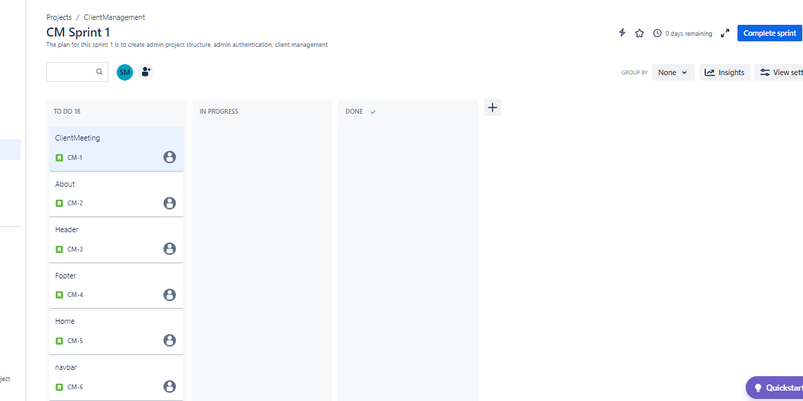

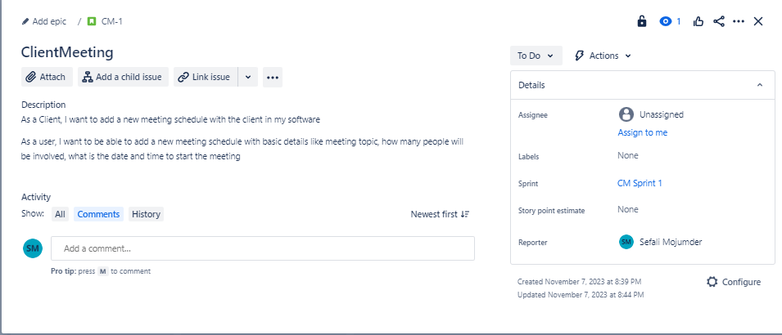

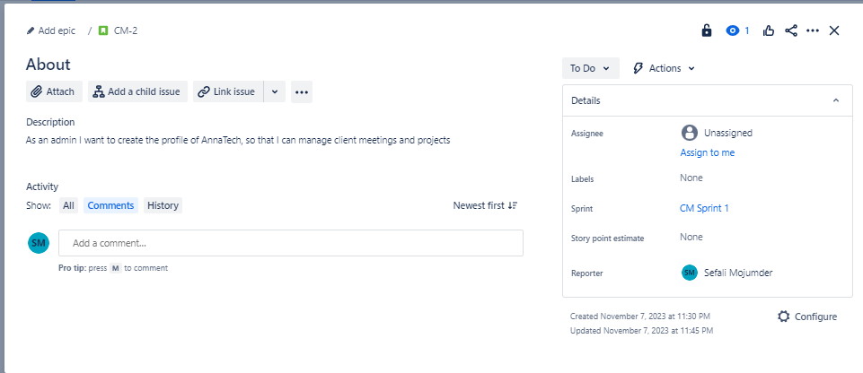

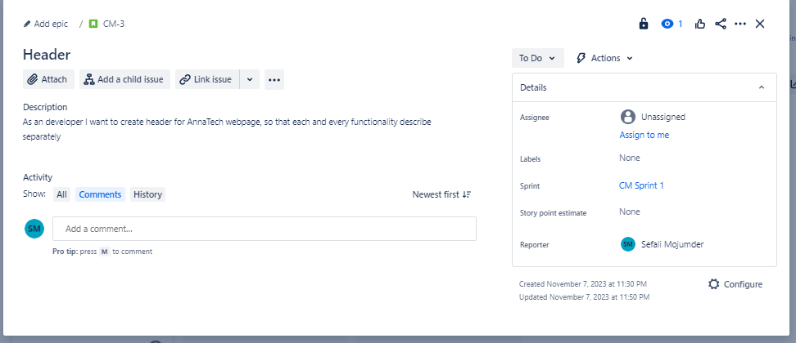

1. **Develop AnnaTech Webapp – Vs-Code and Angular:**

* Create Angular projects for Clients Webapp and Client Meetings Webapp
* Design SPA web pages using HTML, CSS, Javascript, Typescript, Bootstrap, etc. a
  + Create Header, Footer, Navbar, etc. for AnnaTech website
  + Create the Admin Home page and About Us page for AnnaTech
  + Create Admin Authentications (registration, login, etc.) for AnnaTech
  + Create web pages for Scheduling, updating and deleting Client Meetings
  + Setup App-Routing to redirect bad web address to the home page
  + Setup App-Routing to show 404 error message when page is not found
* **Develop angular Main Page**

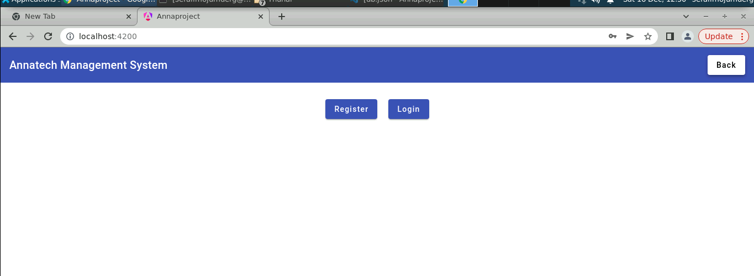

* **Develop angular component for Registration page**

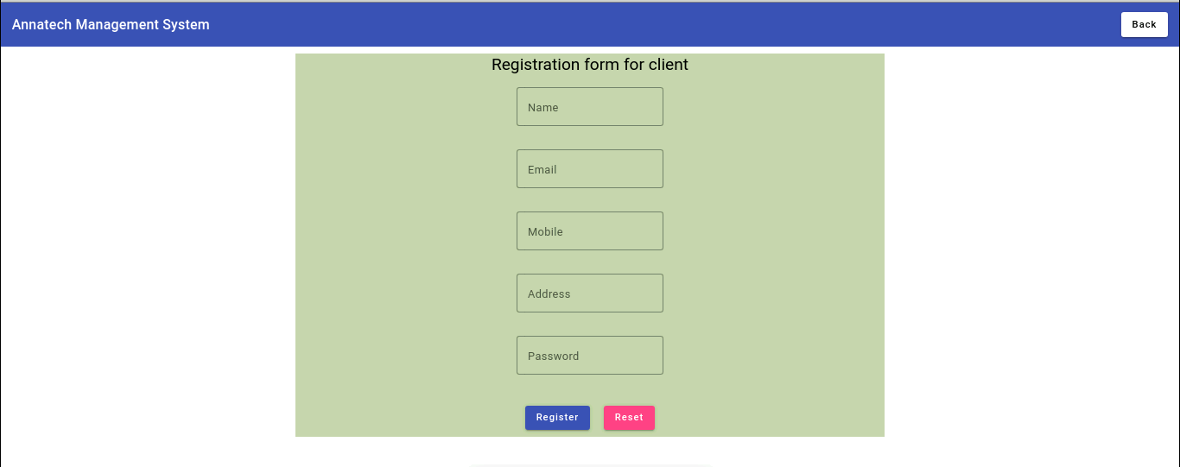

* **Develop angular component for Login page**

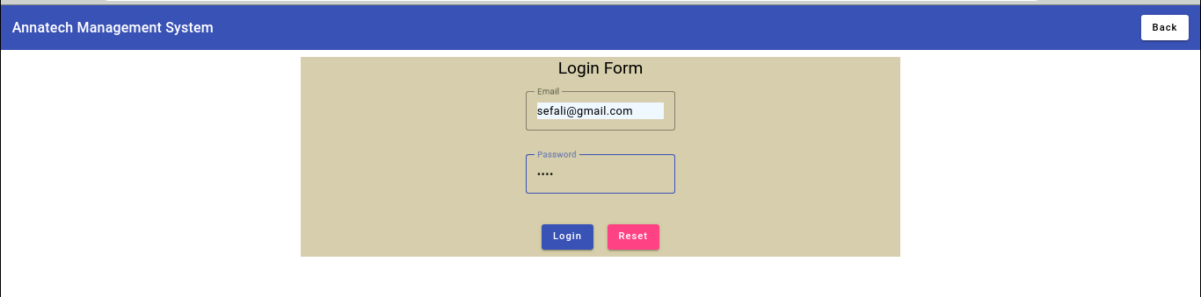

* **Develop angular component for Client Meeting Management**

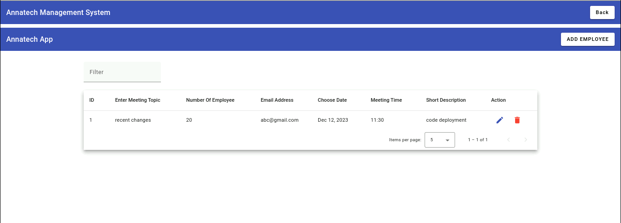

* **Add Meeting fields (date-picker, time-picker, etc.) in the Modal**

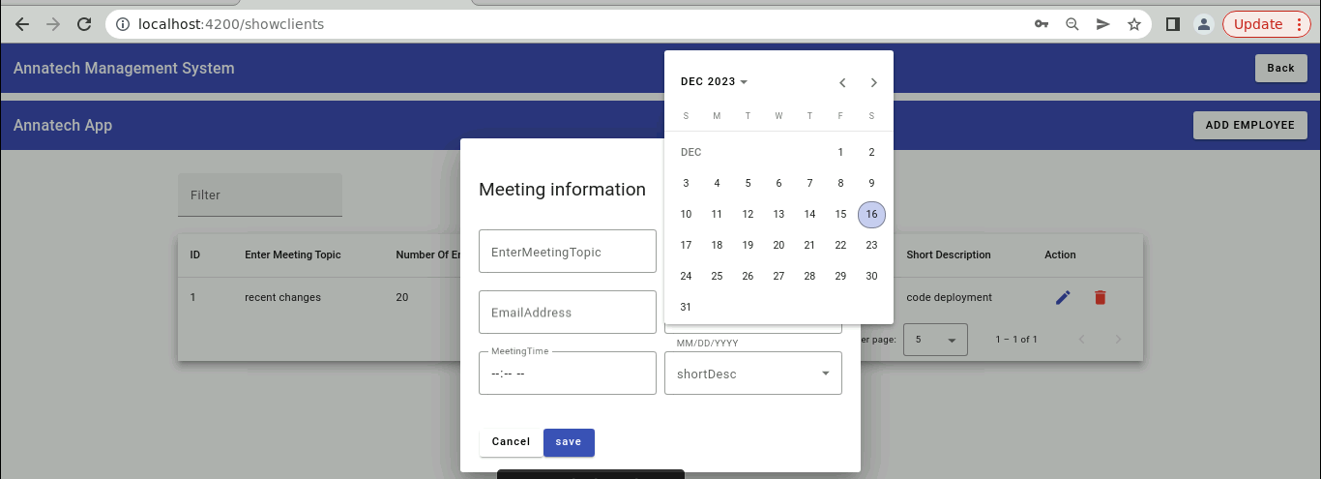

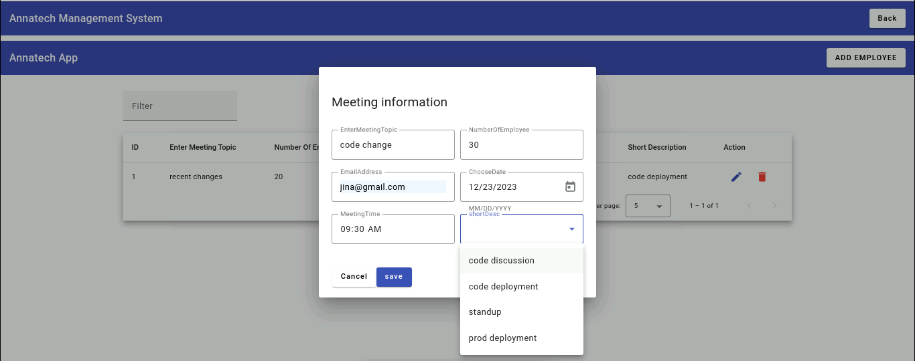

* **Use the same modal-pop with multiple buttons for:**
  + **Updating Client Meetings through meeting list interface**
  + **Deleting Client Meetings through meeting list interface**

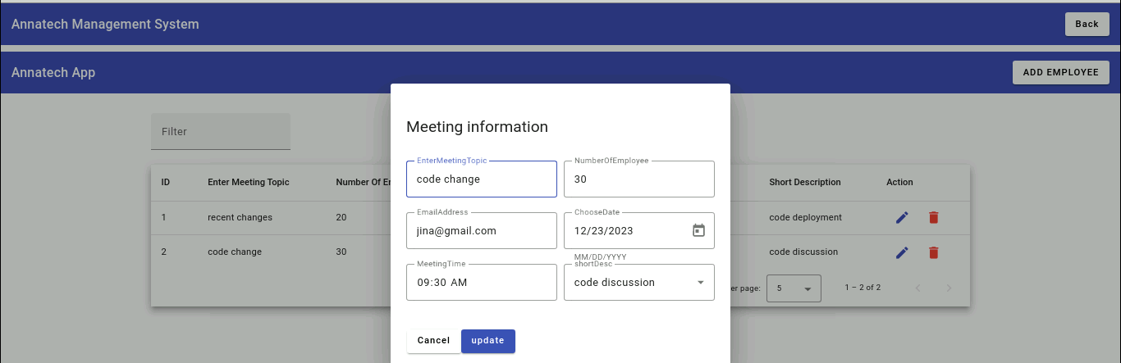

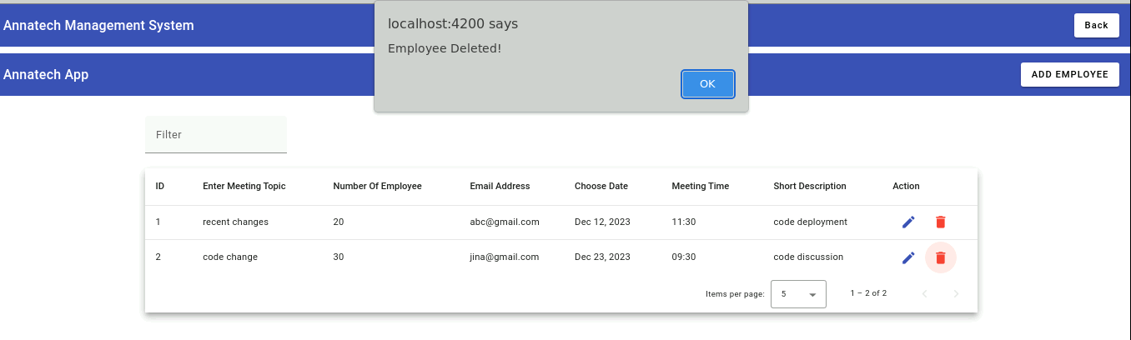

1. **Project Repositories – Git and Github:**
   1. **Setup Git and Github as repositories for AnnaTech Admin Webapp**
   2. **Sync the project codes from local Git Repo to remote Github Repo**
      1. **Initialize local Git Repo in my project directory**
      2. **Create the remote Repo in my Github account**
      3. **Commit and push my code into remote Github Repo**
   3. **Github link ==>** [**https://github.com/sefali123456/Annaproject.git**](https://github.com/sefali123456/Annaproject.git)

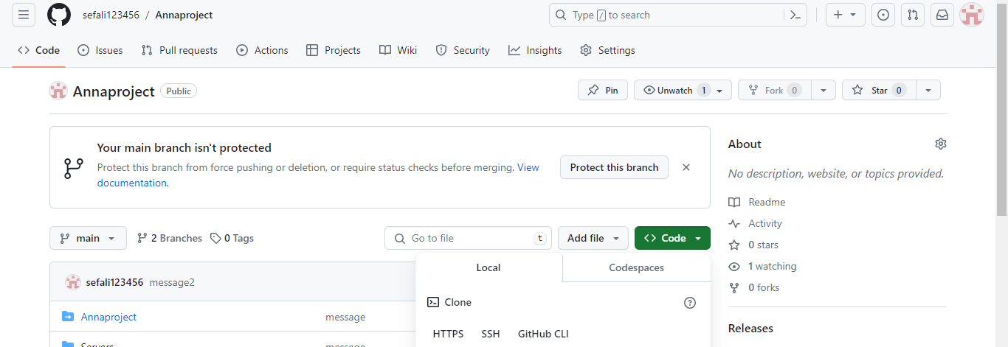

1. **Design fake Database using JSON Files:**

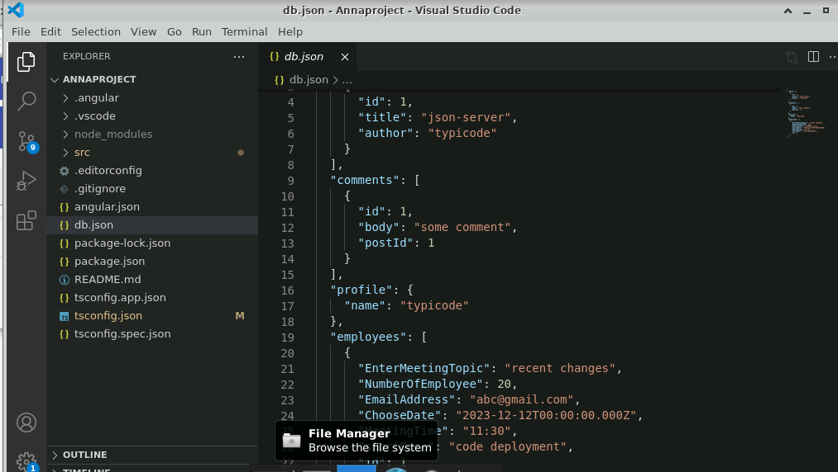

1. **Source Code Files – PDF and Github:**
   1. **File name for the source code is: Anna+project_2023**
   2. **Github link ==>** [**https://github.com/sefali123456/Annaproject.git**](https://github.com/sefali123456/Annaproject.git)
2. **Appendix – Additional Screen Shots and Info**

