**Task 1. Pulse oximeter reading (part 1)**

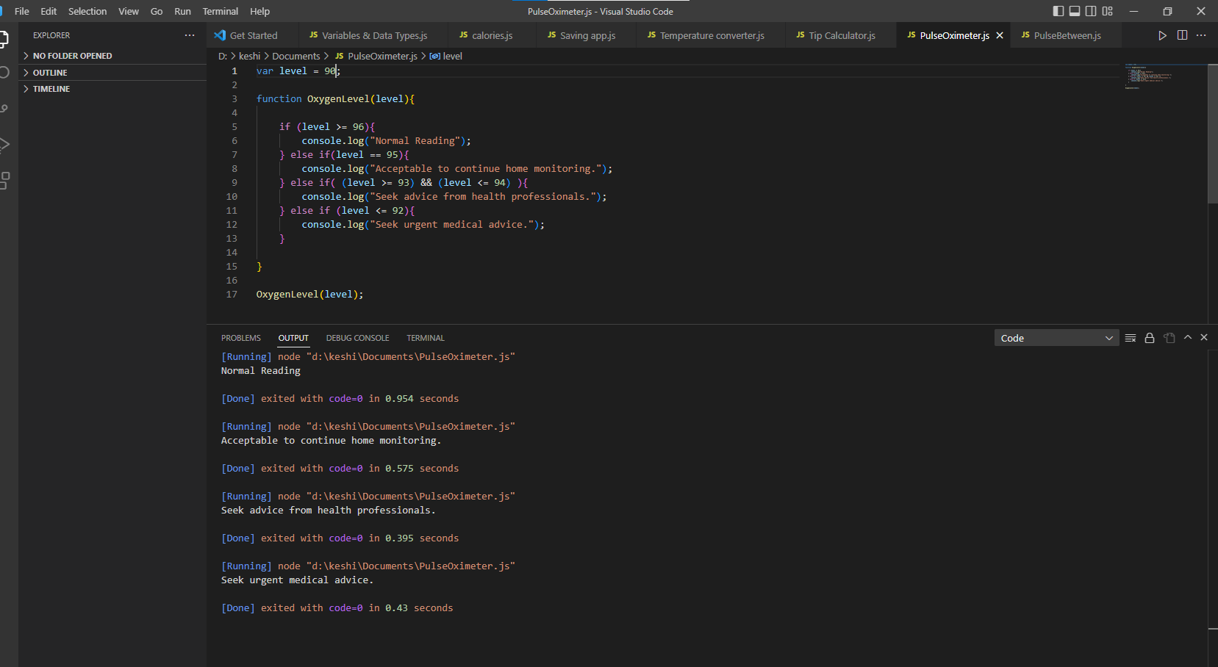

**Code**

var level = 90;

function OxygenLevel(level){

if (level >= 96){

console.log("Normal Reading");

} else if(level == 95){

console.log("Acceptable to continue home monitoring.");

} else if( (level >= 93) && (level <= 94) ){

console.log("Seek advice from health professionals.");

} else if (level <= 92){

console.log("Seek urgent medical advice.");

}

}

OxygenLevel(level);

**Task 2. Pulse oximeter reading (part 2)**

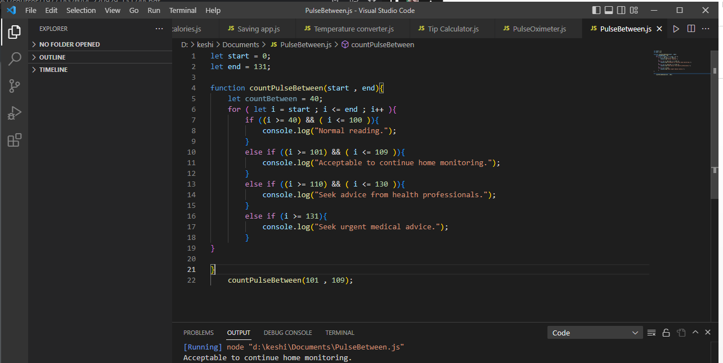

Code:

let start = 0;

let end = 131;

function countPulseBetween(start , end){

let countBetween = 40;

for ( let i = start ; i <= end ; i++ ){

if ((i >= 40) && ( i <= 100 )){

console.log("Normal reading.");

}

else if ((i >= 101) && ( i <= 109 )){

console.log("Acceptable to continue home monitoring.");

}

else if ((i >= 110) && ( i <= 130 )){

console.log("Seek advice from health professionals.");

}

else if (i >= 131){

console.log("Seek urgent medical advice.");

}

}

}

countPulseBetween(101 , 109);