**Task 1. Calorie Tracking App**

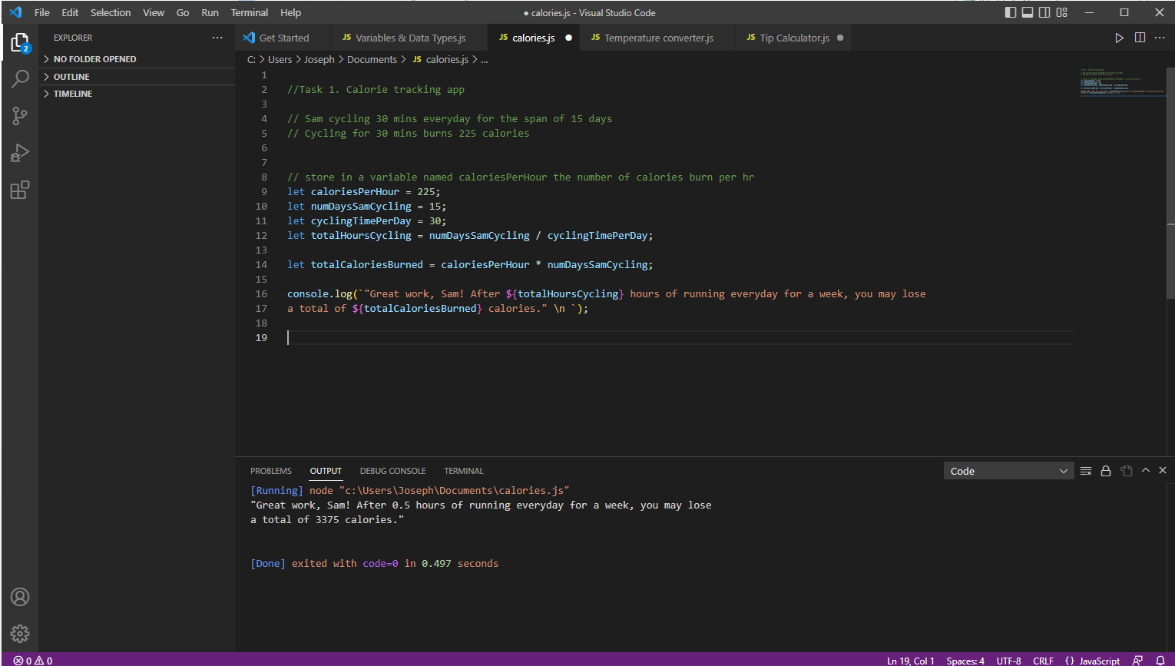

**Code:**

//Task 1. Calorie tracking app

// Sam cycling 30 mins everyday for the span of 15 days

// Cycling for 30 mins burns 225 calories

// store in a variable named caloriesPerHour the number of calories burn per hr

let caloriesPerHour = 225;

let numDaysSamCycling = 15;

let cyclingTimePerDay = 30;

let totalHoursCycling = numDaysSamCycling / cyclingTimePerDay;

let totalCaloriesBurned = caloriesPerHour * numDaysSamCycling;

console.log(`"Great work, Sam! After ${totalHoursCycling} hours of running everyday for a week, you may lose

a total of ${totalCaloriesBurned} calories." \n `);

**Task 2. Saving App**

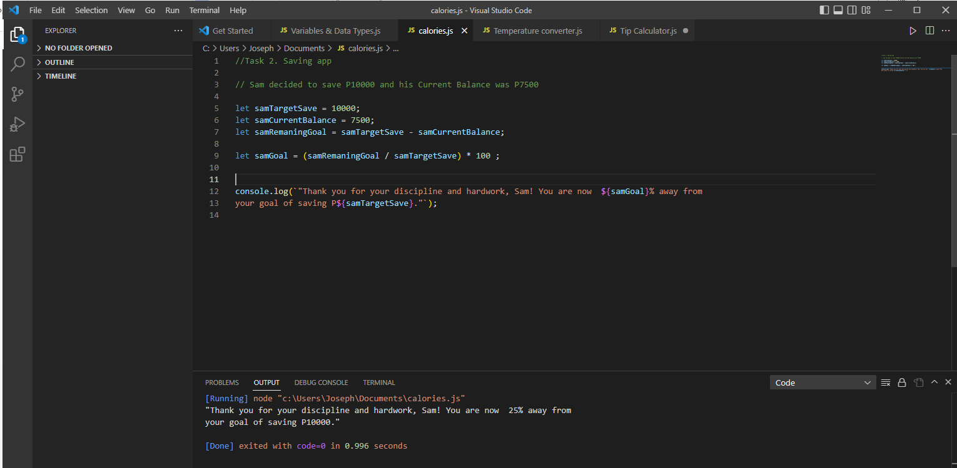

**Code:**

//Task 2. Saving app

// Sam decided to save P10000 and his Current Balance was P7500

let samTargetSave = 10000;

let samCurrentBalance = 7500;

let samRemaningGoal = samTargetSave - samCurrentBalance;

let samGoal = (samRemaningGoal / samTargetSave) * 100 ;

console.log(`"Thank you for your discipline and hardwork, Sam! You are now ${samGoal}% away from

your goal of saving P${samTargetSave}."`);