CAREMIND - ADAPTIVE MEMORY REINFORCEMENT SYSTEM FOR ELDERS AND DEMENTIA CARE
Main Project Report

Submitted by

ALEX LISON

Reg No: FIT24MCA-2011

Submitted in partial fulfillment of the requirements for the award of the degree of
Master of Computer Applications
Of
A P J Abdul Kalam Technological University


FEDERAL INSTITUTE OF SCIENCE AND TECHNOLOGY (FISAT)®

ANGAMALY-683577, ERNAKULAM(DIST)
MARCH 2026

DECLARATION

I, MR ALEX LISON hereby declare that the report of this project work, submitted to the Department of Computer Applications, Federal Institute of Science and Technology (FISAT), Angamaly in partial fulfillment of the award of the degree of Master of Computer Applications is an authentic record of my original work.

The report has not been submitted for the award of any degree of this university or any other university.

Date:

Place:

FEDERAL INSTITUTE OF SCIENCE AND TECHNOLGY
(FISAT)®

ANGAMALY, ERNAKULAM-683577

DEPARTMENT OF COMPUTER APPLICATIONS



CERTIFICATE
This is to certify that the project report titled “CAREMIND - ADAPTIVE MEMORY REINFORCEMENT SYSTEM FOR ELDERS AND DEMENTIA CARE” submitted by ALEX LISON [ Reg No: FIT24MCA-2011 ] towards partial fulfillment of the requirements for the award of the degree of Master of Computer Applications is record of bonafide work carried out by her during the year 2025.

Project Guide Head of the Department

MS. Manju Joy Dr. Shahna K U

ACKNOWLEDGEMENT

Gratitude is a feeling which is more eloquent than words, more silent than silence. To complete this project work I needed the direction, assistance and co- operation of various individuals, which is received in abundance with the grace of God.
I hereby express my deep sense of gratitude to Dr. Jacob Thomas V, Principal of FISAT for allowing me to utilize all the facilities of the college. Our sincere thanks to Dr. Shahna K U, Head of the department of MCA, FISAT, who had been a source of inspiration. During the period of my project work, I have received generous help from MS. Manju Joy my project guide, Dr. Santhosh Kottam my scrum master which I like to put on record here with deep gratitude and great pleasure.
Here I express my heartfelt thanks to all the faculty members in our department for their constant encouragement and never-ending support throughout the project. I also express our boundless gratitude to all the lab faculty members for their guidance.
Finally, I wish to express a whole hearted thanks to my parents, friends and well-wishers who extended their help in one way or other in preparation of my project. Besides all, I thank God for everything.

ALEX LISON

ABSTRACT

The CareMind – Adaptive Memory Reinforcement System for Elders and Dementia Care is a smart healthcare platform designed to help elderly individuals and dementia patients manage daily medications and routines. It addresses forgetfulness and lack of supervision through an adaptive, behavior-based reminder system.
The platform includes a patient mobile application and a caregiver web dashboard. The mobile app provides reminders, task tracking, chatbot-based assistance, and emergency location sharing. The system monitors user behavior and dynamically adjusts alert frequency using reinforcement logic to improve adherence.
The caregiver web app enables real-time monitoring of patient activity, performance tracking, and instant notifications for missed tasks, allowing timely intervention.

By integrating adaptive reminders, caregiver monitoring, and safety features, CareMind improves patient independence, enhances adherence, and reduces caregiver burden in elderly and dementia care.

Contents

- INTRODUCTION
1.1 SCOPE OF THE WORK ……………………………………….……... 2
2 PROOF OF CONCEPT
2.1 REVIEW OF LITERATURES ………………………………..……… 6
2.2 EXISTING SYSTEM ………………………………………………… 6
  - LIMITATION OF EXISTING MODELS / SYSTEMS ……….......… 6
2.4 OBJECTIVES .…..………....……………….………………………… 7
2.5 PROPOSED SYSTEM …..….…………………………….......………. 9
3 SYSTEM ANALYSIS AND DESIGN
3.1 SYSTEM ANALYSIS
3.1.1 INTRODUCTION …...………...………………………….. 11
3.1.2 METHODOLOGY …...………...…………………….……. 11
3.1.3 HARDWARE AND SOFTWARE REQUIREMENTS …... 13
3.2 SYSTEM DESIGN
3.2.1 INTRODUCTION ….……………………………………. 16
3.2.2 MODULE DESCRIPTION ……………………...………. 16
3.2.3 SYSTEM ARCHITECTURE / UML DIAGRAMS ..…….. 19
3.2.4 DATABASE / DATASETS ……………...………………. 24
3.3 ISSUES FACED AND REMEDIES TAKEN
3.3.1 ISSUES ………………………………………...………….. 33

3.3.2 REMEDIES ……………………………………….…………………. 33

4. RESULTS AND DISCUSSION
4.1 TESTING, TEST CASES AND TEST RESULTS ……………………. 34
4.2 RESULTS / PERFORMANCE EVALUATION / SCREEN SHOTS OF
IMPORTANT RESULTS ……………………………….…………….. 34
4.3 RESULTS COMPARISON ……………………...……………………. 34

5. CONCLUSION AND FUTURE SCOPE
  - CONCLUSION …………………………………………………… 37
  - FUTURE ENHANCEMENTS ………………………………….... 37
6. APPENDIX …………………………………………………………….... 39
  - SOURCE CODE ……………………………………………......… 37
  - SCREENSHOTS ……………………...………………………....... 37
  - LIST OF ABBREVIATIONS ...……….….……………..……….... 37
7. REFERENCES …………………………………………………………... 60

Chapter

INTRODUTION
The CareMind – Adaptive Memory Reinforcement System for Elders and Dementia Care represents a significant advancement in digital healthcare technology, designed to address the everyday challenges faced by elderly individuals and dementia patients. This comprehensive system combines adaptive reminder mechanisms, behavioral analysis, and real-time caregiver monitoring to create a reliable and intelligent healthcare assistance platform.
At the core of CareMind is a reinforcement-based logic engine that continuously analyzes patient behavior, task completion patterns, and adherence levels. Unlike traditional static reminder systems, CareMind dynamically adjusts alert frequency, timing, and intensity based on user performance. By identifying problematic time periods, routines, or behaviors, the system ensures more effective reminders and improved consistency in medication intake and daily activities.
The platform is built using a dual-application architecture, consisting of a mobile application for patients and a web-based dashboard for caregivers. The patient mobile app provides features such as medication and routine reminders, task tracking, chatbot-based assistance for basic medical queries, and emergency location sharing for enhanced safety. These features empower users to maintain independence while receiving continuous support.
On the other hand, the caregiver web application enables real-time monitoring of patient activities, including adherence tracking, performance analytics, and behavioral insights. Caregivers receive instant notifications when tasks are missed or delayed, allowing timely intervention and reducing the risks associated with neglect or forgetfulness. This continuous monitoring system significantly reduces caregiver burden while improving patient safety.

Additionally, CareMind maintains structured digital records of medications, routines, notifications, and adherence scores, providing a clear overview of patient health trends. The system’s intelligent alert mechanism, combined with pattern detection and adaptive reinforcement, ensures proactive healthcare management rather than reactive intervention.
By integrating adaptive reminders, caregiver monitoring, chatbot assistance, and emergency support features into a unified platform, CareMind bridges the gap between technology and healthcare support. This solution enhances patient independence, improves adherence to daily routines, and provides a scalable and practical approach to modern elderly and dementia care.
1.1 SCOPE OF THE WORK
The scope of the CareMind – Adaptive Memory Reinforcement System for Elders and Dementia Care focuses on developing an intelligent healthcare assistance platform that improves medication adherence and daily routine management for elderly individuals and dementia patients.
The system includes a patient mobile application and a caregiver web application. The mobile app allows patients to receive reminders for medicines and routines, track task completion, access chatbot-based assistance, and share their location in case of emergencies. The caregiver web platform enables remote monitoring of patient activities, visualization of adherence performance, and receiving notifications for missed or delayed tasks.
CareMind incorporates a reinforcement-based adaptive alert system that analyzes user behavior, detects patterns such as frequently missed tasks or problematic time periods, and dynamically adjusts reminder frequency and timing. The system also maintains digital records of medications, routines, notifications, and adherence scores for better tracking and analysis

Chapter 2
PROOF OF CONCEPT
The Proof of Concept (PoC) for the CareMind – Adaptive Memory Reinforcement System for Elders and Dementia Care validates the core functionality of the system in a controlled environment, demonstrating its ability to improve medication adherence and routine management through adaptive reminders and real-time caregiver monitoring. The PoC showcases key features that will be fully integrated into the final system, ensuring seamless interaction between patients and caregivers.
Key Features :
• Patient Registration and Profile Management
The PoC allows patients to register and maintain personal profiles, including basic details, emergency contacts, and assigned caregivers. It validates how patient data is structured to support personalized reminders and monitoring.
• Medication and Routine Management
The system enables scheduling of medicines and daily routines with specific timings and instructions. The PoC demonstrates how tasks are organized, displayed, and tracked for daily adherence.
• Adaptive Reminder and Reinforcement System
A reinforcement-based logic engine is implemented to monitor user behavior and task completion. The PoC validates how the system identifies missed or delayed tasks and dynamically adjusts alert frequency and timing to improve adherence.
• Patient Mobile Application Features
The mobile app provides reminders, task completion tracking, chatbot-based assistance for basic queries, and emergency location sharing. The PoC demonstrates usability and accessibility for elderly and dementia patients.

• Caregiver Dashboard and Monitoring
Caregivers can access a web-based dashboard to monitor patient activity, view adherence performance, and track completed or missed tasks. The PoC validates real-time monitoring and data visualization capabilities.
• Missed Task Notifications and Alerts
The system sends instant notifications to caregivers when tasks are missed or delayed. The PoC demonstrates how timely alerts enable quick intervention and improve patient safety.
The Proof of Concept successfully demonstrates that the CareMind system can provide an effective, scalable, and user-friendly solution for elderly and dementia care. It highlights the integration of adaptive reminders, patient support features, and caregiver monitoring, establishing a strong foundation for full-scale system development.
2.1 REVIEW OF LITERATURES
Paper 1: Evaluating the Effectiveness of Mobile Apps on Medication Adherence (JMIR 2025)
Methodology/Approach:
This study presents a systematic review and meta-analysis of 14 randomized controlled trials (RCTs) focusing on the effectiveness of mobile applications in improving medication adherence. The selected studies involved diverse patient groups with chronic conditions, and the duration of interventions ranged from 30 days to 12 months. The mobile applications analyzed in these studies primarily included features such as medication reminders, adherence tracking, logging of doses, and data sharing capabilities.
The evaluation was conducted using standardized adherence measurement scales such as the Morisky Medication Adherence Scale (MMAS-8 and MMAS-4).

A random-effects model was used to compare adherence outcomes between intervention and control groups.
Findings:
The study found that all 14 RCTs reported improvement in medication adherence when mobile applications were used. Most applications helped users by providing structured reminders and enabling them to track their medication intake. The presence of logging and notification features improved user awareness and consistency in following medication schedules.
Accuracy of Results:
The meta-analysis showed statistically significant improvements in adherence. For example, the MMAS-8 scale showed an average improvement of 0.57 (95% CI: 0.33–0.80, p < 0.001). Additionally, difference-in-differences analysis also confirmed consistent improvement across studies.
Conclusion:
The study concludes that mobile applications are effective tools for improving medication adherence. However, most applications rely on fixed-time reminders and predefined schedules, which do not adapt to user behavior. This limitation highlights the need for systems like CareMind that use adaptive reinforcement logic based on daily interaction patterns rather than static reminders.
Paper 2: Effects of a Medication Adherence App Among Chronic Illness Patients (2024)
Methodology / Approach:
This research is a randomized controlled trial (RCT) conducted on medically underserved adults with chronic illnesses. Participants were divided into two groups: one group used a medication adherence mobile application, while the control group followed standard care using printed medication instructions. The mobile application included features such as reminder alerts, medication tracking, and behavioral support mechanisms.

The study measured outcomes such as medication adherence, self-efficacy, and knowledge over a one-month period.
Findings:
The results showed that participants using the mobile application demonstrated improved adherence behavior compared to the control group. The app helped users maintain consistency in medication intake and improved their confidence in managing their treatment. However, the study also observed that knowledge improvement was not significant, indicating that reminders and behavioral support play a more important role than informational content.
Accuracy of Results:
The study reported statistically significant improvement in adherence with an effect size of Cohen’s d = -0.52 (p = 0.014). Self-efficacy also improved significantly (Cohen’s d = 0.43, p = 0.035), confirming the effectiveness of app-based interventions.
Conclusion:
The study concludes that mobile applications can improve adherence and patient confidence. However, the system still depends on fixed reminder mechanisms and does not adapt dynamically to user behavior. This supports the need for an adaptive system like CareMind, where reminder intervals are adjusted using behavior tracking and cron-based updates.
Paper 3: Health Information Technology Supporting Adherence in Memory Disorder Patients (2024)
Methodology / Approach:
This paper presents a systematic literature review following PRISMA guidelines, analyzing 15 studies related to technology-based interventions for patients with memory disorders such as dementia and Alzheimer’s disease. The study categorized technologies into different groups, including reminder systems,

educational tools, simplified treatment systems, and monitoring solutions. The quality of studies was assessed using standardized evaluation methods.
Findings:
The study found that reminder-based systems significantly improve medication adherence in patients with memory disorders. Technologies that simplify user interaction and provide consistent alerts were more effective. However, challenges such as usability, system complexity, and user interaction issues were identified as major barriers.
Accuracy of Results:
The included studies showed high reliability, with methodological quality ratings ranging from 80% to 100%. This indicates strong evidence supporting the effectiveness of technology-based adherence systems.
Conclusion:
The study concludes that technology plays a crucial role in supporting adherence among patients with cognitive impairments. However, systems must be simple, adaptive, and user-friendly. Complex systems reduce usability. This aligns with CareMind’s approach of using a simple reinforcement-based adaptive reminder system instead of complex algorithms.
Paper 4: Medication Management Strategies in Older Adults (2024)
Methodology / Approach:
This study used a qualitative interview-based approach involving 22 older adults aged 50 and above. The objective was to understand how individuals manage medications in real-life home environments. Data was collected through structured interviews and analyzed using thematic analysis to identify common behavioral patterns.

Findings:
The study revealed that most older adults develop their own medication management strategies through trial and error. Around 59% relied on personal methods, and only 14% used reminders or alarms. Forgetfulness and disruption of daily routines were identified as major causes of non-adherence.
Accuracy of Results:
The findings are based on real-world user behavior and systematic qualitative analysis, making them practically reliable and relevant.
Conclusion:
The study concludes that older adults lack structured and reliable systems for medication adherence. This highlights the importance of systems like CareMind that provide automated reminders, routine-based tracking, and adaptive alert mechanisms.
Paper 5: Reinforcement Learning to Send Reminders at Right Moments (2021)
Methodology / Approach:
This study developed a smartphone application that uses a reinforcement-based adaptive model to determine the optimal timing for sending reminders. The system continuously learns from user interactions and adjusts reminder timing based on contextual factors such as user activity and response patterns.
Findings:
The study demonstrated that sending reminders at adaptive times significantly improves user engagement and response. The system was able to identify effective moments for intervention based on user behavior.
Accuracy of Results:
The results showed that 83.3% of reminders triggered user response, and 66.7% resulted in user action within 5 hours, indicating high effectiveness.

Conclusion:
The study concludes that adaptive reminder systems are more effective than fixed-time alerts. This directly supports CareMind’s approach of using a reinforcement-based adaptive model updated through daily interactions (cron jobs), ensuring practical and scalable implementation without complex algorithms.
2.2 EXISTING SYSTEM
In the current healthcare support landscape, most individuals rely on basic reminder methods and manual tracking to manage their daily medications and routines. Existing systems are often fragmented, non-adaptive, and lack proper integration between patients and caregivers, making them ineffective for consistent adherence and monitoring.
Manual Reminder System
- Individuals depend on alarms, phone reminders, or memory-based routines to take medications
- Fixed-time reminders do not adjust based on user behavior or missed tasks
- Leads to frequent missed or delayed medication intake
Lack of Adaptive Behavior Tracking
- Existing systems do not analyze user behavior or adherence patterns
- No mechanism to identify problematic time periods or repeated missed tasks
- Reminder systems remain static and do not improve over time
Fragmented Monitoring and Communication
- Caregivers have limited or no real-time visibility into patient activities
- No centralized system to track task completion, missed alerts, or adherence performance

- Communication between patients and caregivers is mostly manual (calls/messages)
Limited Patient Support Features
- Most systems do not provide additional support such as chatbot assistance or emergency location sharing
- Users lack immediate guidance for basic queries or emergency situations
- No integration of safety features within reminder systems
Inefficient Data Management
- Medication and routine records are either not stored or stored locally without proper structure
- No centralized database to maintain history, adherence scores, or performance trends
- Difficult to analyse long-term behavior or generate insights
Absence of Intelligent Alert Systems
- Reminders are time-based only, without considering user response or history
- No escalation mechanism for missed tasks
- Caregivers are not notified automatically when critical tasks are skipped
Conclusion of Existing System
These limitations result in poor medication adherence, lack of timely intervention, and increased dependency on manual supervision. The absence of adaptive behavior tracking, real-time monitoring, and integrated support features highlights the need for an intelligent system like CareMind, which provides dynamic reminders, caregiver monitoring, and structured healthcare assistance.

2.3 LIMITATIONS OF EXISTING SYSTEMS / MODELS
Despite the availability of basic reminder applications and healthcare management tools, existing systems suffer from several limitations that reduce their effectiveness in real-world usage, especially for continuous medication and routine adherence.
Lack of Adaptive Reminder Mechanism
- Most systems use fixed-time reminders that do not adjust based on user behavior
- No capability to learn from missed or delayed tasks
- Results in ineffective alerts and reminder fatigue
No Behavior-Based Analysis
- Existing models do not track or analyze user interaction patterns
- Unable to identify frequently missed time slots or routines
- No improvement in system performance over time
Limited Caregiver Integration
- Caregivers are not actively involved in most systems
- No real-time monitoring or automatic alerts for missed tasks
- Delays in intervention during critical situations
Absence of Centralized Monitoring System
- Data is often scattered or stored locally without proper structure
- No unified platform for tracking medications, routines, and adherence history
- Difficult to generate insights or monitor long-term performance

Lack of Smart Notification System
- Notifications are uniform and non-prioritized
- No escalation mechanism for repeated missed tasks
- Systems fail to differentiate between normal and critical conditions
Insufficient User Support Features
- Most systems do not provide chatbot assistance or interactive guidance
- No emergency features like location sharing
- Limited support for real-time user needs
Low Practical Usability
- Many systems are either too simple (only alarms) or too complex (heavy ML systems)
- Lack of balance between simplicity and intelligent functionality
- Not suitable for consistent long-term usage
Conclusion
Existing systems fail to provide a dynamic, user-centered, and integrated solution for medication and routine management. The absence of adaptive logic, real-time caregiver monitoring, and intelligent notification mechanisms highlights the need for a system like CareMind, which overcomes these limitations using a reinforcement-based adaptive approach with cron-driven updates and continuous behavior tracking.

2.4 OBJECTIVES
The primary objective of the CareMind – Adaptive Memory Reinforcement System for Elders and Dementia Care is to develop an intelligent and user-friendly healthcare assistance platform that improves medication adherence and daily routine management through adaptive and behavior-based reminders.
Specific Objectives
- To design and develop a patient mobile application for managing medications and daily routines efficiently
- To implement an adaptive reminder system that adjusts alert frequency and timing based on user behavior and task completion patterns
- To develop a caregiver web application for real-time monitoring of patient activities and adherence performance
- To enable automatic notifications to caregivers when tasks are missed or delayed for timely intervention
- To maintain centralized digital records of medications, routines, alerts, and adherence history
- To integrate chatbot-based assistance for basic medical queries and user support
- To provide emergency features such as location sharing for enhanced patient safety
- To implement a reinforcement-based logic system using cron jobs that updates alert behavior based on daily interaction data
- To ensure the system is scalable, reliable, and easy to use for both patients and caregivers

2.5 PROPOSED SYSTEM
The proposed system, CareMind – Adaptive Memory Reinforcement System for Elders and Dementia Care, is an intelligent healthcare assistance platform designed to improve medication adherence and routine management through adaptive reminder mechanisms and real-time caregiver monitoring.
The system follows a dual-platform architecture, consisting of a mobile application for patients and a web-based dashboard for caregivers, ensuring seamless interaction and continuous monitoring.
Patient Mobile Application
The patient-side mobile application provides an easy-to-use interface for managing daily medications and routines. It delivers timely reminders, allows users to mark tasks as completed, and continuously tracks user interactions.
Additional features include:
- Chatbot-based assistance for basic medical queries
- Emergency location sharing for safety
- Notification system for reminders and alerts
The mobile app ensures accessibility and usability for elderly users by maintaining a simple and intuitive design.
Caregiver Web Application
The caregiver web dashboard enables real-time monitoring of patient activities. Caregivers can:
- View medication and routine schedules
- Track task completion and adherence performance
- Receive instant notifications for missed or delayed tasks

This ensures timely intervention and reduces the risk associated with non-adherence.
Adaptive Reinforcement Mechanism
The core of the proposed system is a reinforcement-based adaptive reminder system. Unlike traditional fixed reminders, the system:
- Tracks daily user interactions and task completion
- Identifies problematic time periods and missed patterns
- Dynamically adjusts alert frequency and timing
This adaptation is implemented using cron-based background processing, which updates system behavior daily based on user performance data.
Centralized Data Management
The system maintains a centralized database to store:
- Patient profiles
- Medication and routine schedules
- Task completion logs
- Notification history
- Adherence scores
This enables structured tracking, performance analysis, and long-term monitoring.
Smart Notification and Alert System
The system uses a multi-level notification mechanism:
- Patient reminders before and after scheduled tasks

- Escalated alerts for repeated missed tasks
- Automatic caregiver notifications for critical situations
This ensures continuous engagement and proactive healthcare management.
Overall System Functionality
The proposed system integrates adaptive reminders, real-time monitoring, and patient support features into a unified platform. It provides a practical and scalable solution that improves adherence, enhances patient independence, and reduces caregiver burden.

Chapter 3
SYSTEM ANALYSIS AND DESIGN
3.1 SYSTEM ANALYSIS
3.1.1 INTRODUCTION
System analysis is the process of understanding system requirements, identifying existing problems, and defining solutions. It ensures that the system meets user needs effectively.For CareMind, system analysis focuses on issues like poor medication adherence, lack of adaptive reminders, and limited caregiver monitoring. The system is designed to overcome these by providing an adaptive reminder mechanism, patient mobile app, and caregiver web dashboard.
This phase helps in defining system functionalities and ensures a reliable and scalable solution before implementation.
3.1.2 METHODOLOGY
The methodology for developing the CareMind – Adaptive Memory Reinforcement System for Elders and Dementia Care follows a structured and iterative approach to ensure a reliable, scalable, and user-friendly system.
1. Requirement Gathering and Analysis
Requirements are collected from patients and caregivers to identify key features such as adaptive reminders, task tracking, caregiver monitoring, notifications, chatbot support, and location sharing.
2. System Design
The system is designed with a dual-platform architecture consisting of a patient mobile app and a caregiver web dashboard. The design focuses on simplicity, usability, and efficient data management.

3. Development
The system is developed using:
- React Native for the mobile application
- React (Web) for caregiver dashboard
- Node.js & Express for backend
- MongoDB for data storage
Core features include reminder system, task tracking, adaptive reinforcement logic (cron-based), notifications, and monitoring system.
4. Testing
The system undergoes unit testing, integration testing, and user testing to ensure proper functionality, performance, and usability.
5. Deployment
After testing, the system is deployed with proper server setup, database configuration, and security measures, making it accessible to users.
6. Maintenance and Updates
The system is continuously monitored and updated based on user feedback, ensuring performance improvement and feature enhancement.
3.1.3 HARDWARE AND SOFTWARE REQUIREMENTS
HARDWARE REQUIREMENTS
- Processor : Intel Core i5 or equivalent (Quad-core or higher)
- RAM : 8 GB (16 GB preferred for better performance)
- Storage : 500 GB HDD or 256 GB SSD (SSD preferred for faster read/write speed)

- Network : High-speed internet connection (minimum 10 Mbps) for smooth real-time operations, such as machine monitoring and booking management
SOFTWARE REQUIREMENTS
FRONTEND TECHNOLOGIES
React (Web Application)
React is used to develop the caregiver web dashboard, providing an interactive and responsive interface for monitoring patient activities and adherence performance.
React Native (Mobile Application)
React Native is used to build the patient mobile application, enabling cross-platform support for Android and iOS with a simple and user-friendly interface.
HTML & Tailwind CSS
HTML provides the structure of web pages, while Tailwind CSS is used for styling. Tailwind is a utility-first CSS framework that enables rapid UI development with responsive design, ensuring a clean, consistent, and modern user interface across the application.
BACKEND TECHNOLOGIES
Node.js
Node.js is used as the backend runtime environment to handle server-side logic and manage asynchronous operations efficiently.
Express.js
Express.js is used to build RESTful APIs, manage routing, and handle communication between frontend and backend systems.

MongoDB
MongoDB is a NoSQL database used to store patient data, medication schedules, routines, notifications, and adherence records in a flexible and scalable format.
SYSTEM LOGIC & PROCESSING
Adaptive Reinforcement Logic (Cron-based)
The system uses a cron-based scheduling mechanism to process daily patient interactions and update reminder behavior dynamically based on adherence patterns.
AUTHENTICATION AND SECURITY
JWT (JSON Web Tokens)
JWT is used for secure authentication. After login, users receive a token that is used to access protected routes and ensure secure communication.
Bcrypt
Bcrypt is used to hash user passwords securely, protecting credentials from unauthorized access.
TOOLS
Postman
Postman is used for testing APIs, verifying backend functionality, and ensuring secure communication between system components.
NOTIFICATION SYSTEM
Push Notifications
The system uses push notifications to deliver reminders, alerts, and caregiver notifications in real time.

3.2 SYSTEM DESIGN
3.2.1 INTRODUCTION
System design is a critical phase in software development that defines the structure, components, and interactions within the system. It provides a clear blueprint of the architecture, data flow, and module integration while ensuring scalability, security, and performance.
For the CareMind – Adaptive Memory Reinforcement System for Elders and Dementia Care, the system design focuses on delivering a seamless and efficient experience for both patients and caregivers. The architecture follows a dual-platform approach, consisting of a patient mobile application and a caregiver web application, ensuring continuous interaction and monitoring.
The system is divided into key modules including user management, medication and routine management, task tracking, adaptive reminder system, notification system, caregiver monitoring, chatbot assistance, and emergency location sharing. These modules work together to provide a complete healthcare support system.
The design uses modern technologies such as React Native for the mobile application, React (with Tailwind CSS) for the web interface, Node.js and Express.js for backend services, and MongoDB for data storage. The system also incorporates a cron-based adaptive reinforcement mechanism to dynamically adjust reminders based on daily user interactions.
This structured and modular design ensures that the system is scalable, secure, easy to maintain, and suitable for real-world healthcare applications, while effective

3.2.2 MODULE DESCRIPTION
The CareMind system is divided into total of 8 modules to ensure structured functionality, security, and efficient healthcare support. Each module performs a specific role within the system.
1. Identity & Access Management Module
- Provides secure login for Admin, Caregiver, and Patient
- Implements JWT-based authentication
- Enforces role-based access control
- Supports account activation and deactivation
- Prevents unauthorized system access
2. Patient Profile & Relationship Management Module
- Maintains patient personal and medical information
- Stores emergency contact details
- Manages familiar people (relations)
- Links patients with caregivers
- Supports profile updates
3. Medication & Routine Management Module
- Enables medicine scheduling
- Supports daily routine configuration
- Defines task timing and frequency
- Controls task active/inactive status
- Records patient task completion

4. Smart Alert & Notification Module
- Sends reminders before scheduled tasks
- Generates repeated alerts for pending tasks
- Detects missed activities
- Notifies caregivers when tasks are missed
- Manages notification read and expiry status
4.1 Patient Notification Module
- Triggers patient reminders
- Sends push/in-app alerts
- Maintains notification status
4.2 Caregiver Notification Module
- Detects missed tasks
- Sends caregiver alerts
- Maintains alert history
5. Patient Task Performance Monitoring Module
- Tracks completion of medicines and routines
- Calculates delay in task completion
- Assigns performance score (0–4)
- Maintains daily activity history
- Provides data for behavior analysis

6. Adaptive Cognitive Reinforcement Module
- Analyses patient behavior patterns
- Identifies problematic times and tasks
- Calculates priority score
- Adjusts alert frequency dynamically
- Improves long-term patient performance
6.1 Pattern Analysis Module
- Analyses historical task data
- Detects problematic time slots
- Identifies frequently missed tasks
6.2 Priority Evaluation Module
- Computes weekly performance
- Calculates miss rates
- Assigns priority level
6.3 Adaptive Alert Controller Module
- Adjusts alert intervals
- Adds early reminders
- Coordinates with notification module
7. Automation & Background Processing Module
- Executes scheduled background jobs
- Performs minute-level alert scanning

- Runs daily cron-based processing
- Detects missed tasks automatically
- Cleans expired notifications
7.1 Scheduled Job Manager
- Triggers cron-based jobs
- Runs periodic system checks
- Schedules reinforcement updates
7.2 Background Alert Processor
- Scans pending tasks
- Determines alert eligibility
- Triggers notifications
8. Patient Support & Emergency Assistance Module
- Provides chatbot-based assistance
- Answers basic patient queries
- Clarifies medicines and routines
- Captures current GPS location
- Shares emergency location via WhatsApp or SMS
- Enables quick caregiver contact

3.2.3 SYSTEM ARCHITECTURE / UML Diagrams
USE CASE DIAGRAM
A Use Case Diagram is a visual representation that illustrates the interactions between external actors (such as users or other systems) and the system’s functionalities, known as use cases. It provides a high-level view of how users engage with the system to accomplish specific goals. The diagram typically includes actors, which represent entities that interact with the system, such as human users, external systems, or hardware devices. Use cases
represent the system’s services or functionalities, detailing the actions or tasks the system performs for the actors. These use cases are connected to actors through associations (lines linking actors to use cases), showing how actors interact with the system. Additionally, relationships like include (where one use case always includes the behavior of another) and extend (indicating optional or conditional behavior) help clarify the flow of actions. The system’s scope is defined by a system boundary, a rectangle that encloses the use cases and identifies which functionalities are part of the system.

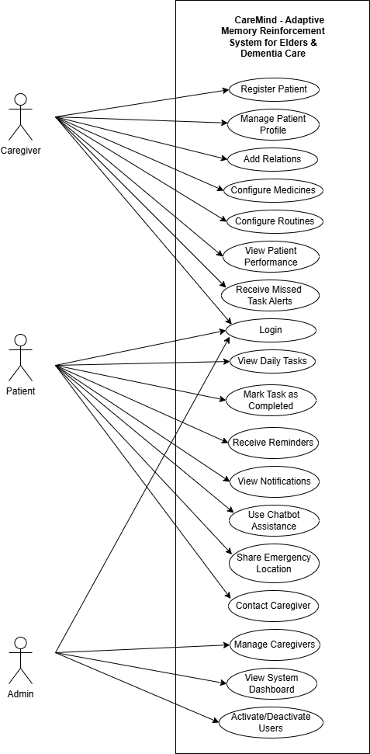

Fig: 3.2.3.1 Use Case Diagram

3.2.4 DATABASE
1. Users Collection
Field | Type | Description
_id | ObjectId | Unique identifier
role | String | User role (admin/caregiver)
name | String | User name
email | String | Login email
password | String | User password
phone | String | Contact number
gender | String | Male/Female/Others
address | Object | Address details
isActive | Boolean | Account status

Table: 3.2.4.1 Users Collection

2. Patient Collection
Field | Type | Description
_id | ObjectId | Unique identifier
name | String | Patient name
email | String | Login email
password | String | password
caregiverId | ObjectId | Linked caregiver ID
dob | Date | Date of birth
gender | String | Gender
bloodGroup | String | Blood group
address | Object | Patient address
emergencyContact | Object | Emergency contact details
imageUrl | String | Profile image
isActive | Boolean | Patient status
Table: 3.2.4.2 Patient Collection

3. Medicine Collection
Field | Type | Description
_id | ObjectId | Unique identifier
name | String | Medicine name
dosage | String | Dosage details
frequency | String | Frequency
timing | Array | Time slots
instructions | String | Special instructions
status | String | Active / Inactive
patientId | ObjectId | Linked patient ID
caregiverId | ObjectId | Linked caregiver ID
Table: 3.2.4.3 Medicine Collection

4. Routine Collection
Field | Type | Description
_id | ObjectId | Unique identifier
title | String | Routine name
type | String | Routine type
scheduledTime | String | Time of routine
frequency | String | Daily / Weekly
description | String | Routine details
status | String | Active / Inactive
patientId | ObjectId | Linked patient ID
Table: 3.2.4.4 Routine Collection

5. TaskTracking Collection
Field | Type | Description
_id | ObjectId | Unique identifier
patientId | ObjectId | Patient reference
taskId | ObjectId | Linked task ID
taskType | String | Medicine / Routine
taskName | String | Task name
scheduledDate | String | Date of task
scheduledTime | String | Time of task
status | String | Pending / Completed / Missed
completedAt | Date | Completion time
latenessMinutes | Number | Delay in minutes
score | Number | Adherence score (0–4)
Table: 3.2.4.5 TaskTracking Collection

6. PatientNotification Collection
Field | Type | Description
_id | ObjectId | Unique identifier
patientId | ObjectId | Patient reference
taskId | ObjectId | Related task ID
taskName | String | Task name
scheduledTime | String | Scheduled time
title | String | Notification title
message | String | Notification message
type | String | Reminder / Alert
sentAt | Date | Time sent
read | Boolean | Read status
Table: 3.2.4.6 Patient Notification Collection

7. CaregiverNotification Collection
Field | Type | Description
_id | ObjectId | Unique identifier
caregiverId | ObjectId | Caregiver reference
patientId | ObjectId | Patient reference
patientName | String | Patient name
taskId | ObjectId | Task reference
taskName | String | Task name
scheduledTime | String | Scheduled time
title | String | Alert title
message | String | Alert message
severity | String | Info / Warning / Urgent
read | Boolean | Read status
Table: 3.2.4.7 Caregiver Notification Collection

8. Reinforcement Collection
Field | Type | Description
_id | ObjectId | Unique identifier
patientId | ObjectId | Patient reference
dailyScores | Array | Daily adherence scores
weeklyAverage | Number | Weekly average score
medicineMissRate | Number | Medicine miss rate
routineMissRate | Number | Routine miss rate
problematicTimes | Array | Frequent missed time slots
problematicDays | Array | Problematic days
priorityLevel | String | Normal / Medium / High / Critical
alertInterval | Number | Alert interval
priorityScore | Number | Overall priority score
Table: 3.2.4.8 Reinforcement Collection

3.3 Issues faced and Remedies Taken
3.3.1 Issues
- Inconsistent user adherence due to fixed reminder systems
- Difficulty in handling real-time task tracking and status updates
- Managing timely notifications and missed task detection
- Ensuring proper synchronization between mobile app and web dashboard
- Handling data consistency and storage for multiple users
- Designing a system that is simple for elderly users but functionally efficient
- Implementing adaptive behavior without using complex machine learning models
- Managing background processes for reminders and daily updates
3.3.2 Remedies
- Implemented an adaptive reinforcement logic to adjust reminders based on user behavior
- Developed a cron-based background processing system for timely updates and missed task detection
- Designed a centralized database (MongoDB) to ensure structured and consistent data storage
- Integrated real-time notification system for both patients and caregivers
- Ensured proper API integration between mobile and web applications
- Focused on simple and user-friendly UI design for better usability
- Used a lightweight approach instead of complex ML models for practical implementation
- Implemented task tracking and scoring system to monitor adherence effectively

4. RESULTS AND DISCUSSION

4.1 Testing, Test Cases and Test Results
The CareMind system was tested using unit, integration, and user testing to ensure proper functionality, reliability, and performance across all modules.
Test Case | Description | Input | Expected Output | Pass/Fail
Login | User login with valid credentials | Email & Password | Login successful | If user dashboard loads
Add Patient | Add new patient | Patient data | Patient added | If data stored in DB
Schedule Medicine | Addmedicine schedule | Medicine details | Medicine scheduled | If schedule saved correctly
Reminder Notification | Trigger reminder | Scheduled time | Notification sent | If alert received on time
Task Completion | Mark task as completed | Task selection | Status updated | If status changes to completed
Missed Task Alert | Task not completed | No user action | Caregiver notified | If alert sent to caregiver
Adaptive Update | Update reinforcement data | Daily task data | Model updated | If alert timing changes
Chatbot Response | Ask basic query | User query | Response generated | If valid response returned
Location Sharing | Send location | Trigger emergency | Location shared | If GPS location sent
Data Storage | Store task data | Task input | Data saved | If data persists correctly
Test Cases
Table: 4.1.1 Test Cases

Test Report
The actual results were compared with the expected results for all test cases.
Test Case | Expected Result | Actual Result | Status
Login | Login successful | Login successful | Pass
Add Patient | Patient added | Patient added | Pass
Schedule Medicine | Medicine scheduled | Medicine scheduled | Pass
Reminder Notification | Notification sent | Notification sent | Pass
Task Completion | Status updated | Status updated | Pass
Missed Task Alert | Notification sent | Notification sent | Pass
Adaptive Update | Adaptive model updated | Updated correctly | Pass
Chatbot Response | Response generated | Response generated | Pass
Location Sharing | Location shared | Location shared | Pass
Data Storage | Data stored | Data stored | Pass

Table: 4.1.2 Test Results
4.2 RESULTS / PERFORMANCE EVALUATION / SCREENSHOTS
Key Results
- The system successfully delivered timely reminders for medicines and routines without delay
- The task tracking and scoring system accurately recorded completion, delay, and adherence scores
- Caregiver notifications were triggered instantly for missed or delayed tasks
- The adaptive reinforcement system dynamically adjusted alert frequency and timing based on user behavior patterns
- The system effectively identified problematic time slots and frequently missed tasks
- The cron-based background processing ensured continuous monitoring and automatic updates

- The system maintained accurate daily and weekly adherence data for each patient
- Notification escalation mechanism worked correctly for repeated missed tasks
- The system provided real-time synchronization between mobile app and caregiver dashboard
- The chatbot module responded correctly to basic user queries
- The emergency location sharing feature worked reliably during testing
- The system handled multiple users simultaneously without performance issues
- Data was stored and retrieved correctly from the MongoDB database without loss or inconsistency
Performance Evaluation
- Response Time: Fast response for user actions such as login, task updates, and data retrieval
- Notification Accuracy: High accuracy in sending reminders at correct scheduled times and intervals
- System Reliability: table performance during continuous usage and background processing
- Scalability: System handled multiple users and tasks efficiently without degradation
- Data Consistency: No data loss observed; all task and notification data were stored correctly
- Usability: Simple and intuitive interface suitable for elderly users
- Adaptability: System successfully adapted reminder frequency based on user behavior patterns
- Real-time Performance: Caregiver dashboard reflected updates in near real-time
- Security: Secure authentication and protected data access using JWT and encryption

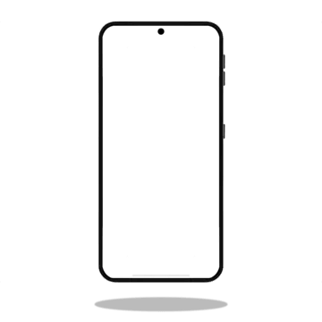
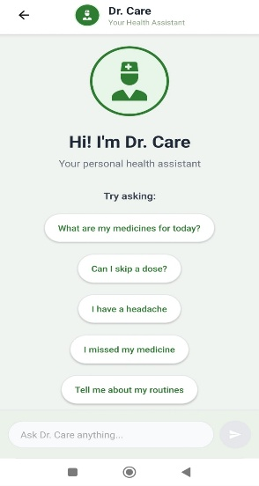
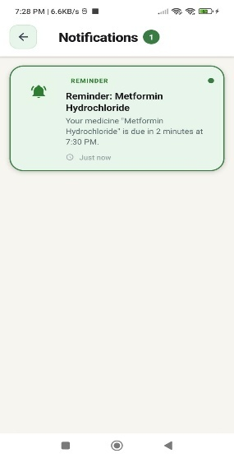


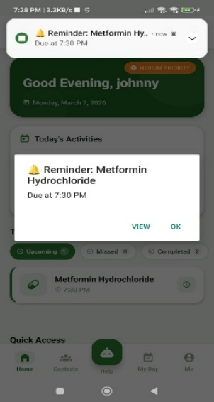
SCREENSHOTS OF IMPORTANT RESULTS

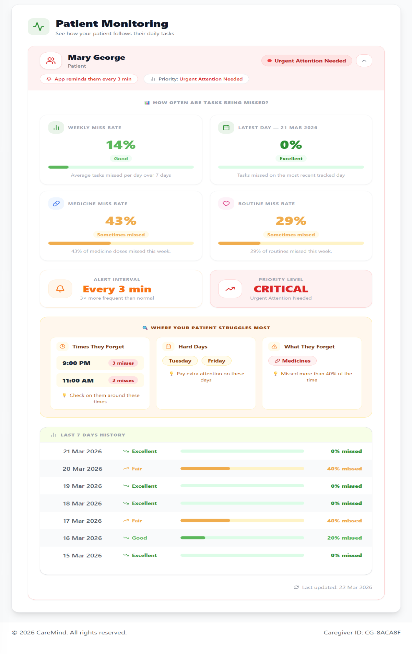
Fig: 4.2.1 Reminders Fig: 4.2.2 Notifications Fig: 4.2.3 Chat Bot

Fig: 4.2.4 Caregiver Monitoring

4.3 Results Comparison
The proposed CareMind system was compared with existing systems to evaluate improvements.
Feature | Existing Systems | CareMind System
Reminder Type | Fixed alerts | Adaptive reminders
Behavior Tracking | Not available | Available
Caregiver Monitoring | Limited | Real-time monitoring
Notifications | Basic | Smart & escalated
Data Management | Fragmented | Centralized
User Support | Minimal | Chatbot + Emergency support
Adaptability | Not available | Dynamic (cron-based)
Table: 4.3.1 Results Comparison

Chapter 5
CONCLUSION AND FUTURE SCOPE
5.1 CONCLUSION
The CareMind – Adaptive Memory Reinforcement System for Elders and Dementia Care successfully addresses the challenges of medication adherence and routine management through a simple and adaptive approach. The system integrates a patient mobile application and a caregiver web dashboard to provide continuous monitoring and support.The implementation of a reinforcement-based adaptive reminder system using cron-based updates improves adherence by adjusting alerts based on user behavior. Features such as task tracking, caregiver notifications, chatbot assistance, and emergency location sharing enhance the overall effectiveness of the system.
The results demonstrate that the proposed system is reliable, scalable, and user-friendly, making it suitable for real-world healthcare applications while reducing caregiver burden and improving patient independence.
5.2 FUTURE ENHANCEMENTS
The CareMind system can be enhanced by integrating voice-based interaction for easier accessibility and AI-based prediction models to improve behavior analysis and adherence tracking. Adding multi-language support will make the system more accessible to a wider range of users.
Future improvements can also include integration with wearable devices for real-time health monitoring and upgrading the chatbot for better assistance. Implementing a cloud-based analytics system will help in tracking patient performance and trends. Additionally, features like offline functionality, support for multiple caregivers, and improved UI/UX design can further enhance system usability and effectiveness.

Chapter 6
APPENDIX
6.1 SOURCE CODE
LoginScreen.js
import React, { useState, useEffect } from 'react';
import { View,Text,TextInput,TouchableOpacity,StatusBar,Alert,ActivityIndicator,
KeyboardAvoidingView,Platform,ScrollView,
} from 'react-native';
import MaterialCommunityIcons from 'react-native-vector-icons/MaterialCommunityIcons';
import { patientLogin, getSavedCredentials } from '../services/LoginService';
import styles from '../styles/LoginStyles';
const LoginScreen = ({ navigation }) => {
const [email, setEmail] = useState('');
const [password, setPassword] = useState('');
const [showPassword, setShowPassword] = useState(false);
const [loading, setLoading] = useState(false);
const [rememberMe, setRememberMe] = useState(false);
const [initialLoading, setInitialLoading] = useState(true);
useEffect(() => {
loadSavedCredentials();
}, []);
const loadSavedCredentials = async () => {
try {
const saved = await getSavedCredentials();
if (saved.rememberMe) {
setEmail(saved.email);

setPassword(saved.password);
setRememberMe(true);
}
} catch (error) {
console.error('Error loading saved credentials:', error);
} finally {
setInitialLoading(false);
}};
const validateInputs = () => {
if (!email.trim()) {
Alert.alert('Error', 'Please enter your email');
return false; }
if (!password.trim()) {
Alert.alert('Error', 'Please enter your password');
return false; }
const emailRegex = /^[^\s@]+@[^\s@]+\.[^\s@]+$/;
if (!emailRegex.test(email)) {
Alert.alert('Error', 'Please enter a valid email address');
return false;}
return true;
};
const handleLogin = async () => {
if (!validateInputs()) return;
setLoading(true);
try {
const result = await patientLogin(email, password, rememberMe);
if (result.success) {
navigation.reset({ index: 0,

routes: [{ name: 'Home' }],
});
} else {
Alert.alert('Login Failed', result.message);
}
} catch (error) {
Alert.alert('Error', 'An unexpected error occurred');
console.error('Login handler error:', error);
} finally {
setLoading(false);
}
};
const handleForgotPassword = () => {
Alert.alert(
'Forgot Password',
'Please contact your caregiver to reset your password.',
[{ text: 'OK' }]
);
};
return (
<KeyboardAvoidingView

style={{ flex: 1 }}
behavior={Platform.OS === 'ios' ? 'padding' : 'height'}>
<ScrollView
contentContainerStyle={{ flexGrow: 1 }}
keyboardShouldPersistTaps="handled">
<View style={styles.container}>

<StatusBar barStyle="dark-content" backgroundColor="#FFFFFF" />
<View style={styles.header}>
<View style={styles.logoBox}>
<MaterialCommunityIcons name="brain" size={40} color="#2E7D32" />
</View>
<Text style={styles.title}>
Care<Text style={styles.light}>Mind</Text>
</Text>
<Text style={styles.subtitle}>
Welcome back! Please login to continue
</Text>
</View>
<View style={styles.card}>
<Text style={styles.sectionTitle}>Patient Login</Text>
<View style={styles.labelRow}>
<MaterialCommunityIcons name="email-outline" size={18} color="#6B7280" />
<Text style={styles.labelText}>Email Address</Text>
</View>
<TextInput
placeholder="Enter your email"
placeholderTextColor="#94A3B8"
style={styles.inputBox}
value={email}
onChangeText={setEmail}
keyboardType="email-address"
autoCapitalize="none"

autoCorrect={false}
editable={!loading}
/>
<View style={styles.labelRow}>
<MaterialCommunityIcons name="lock-outline" size={18} color="#6B7280" /> <Text style={styles.labelText}>Password</Text>
</View>
<View style={styles.passwordBox}>
<TextInput
placeholder="Enter your password"
placeholderTextColor="#94A3B8"
secureTextEntry={!showPassword}
style={styles.passwordInput}
value={password}
onChangeText={setPassword}
editable={!loading}
autoCorrect={false} />
<TouchableOpacity
onPress={() => setShowPassword(!showPassword)}
disabled={loading}>
<MaterialCommunityIcons
name={showPassword ? 'eye-off-outline' : 'eye-outline'}
size={22}
color="#6B7280" />
</TouchableOpacity></View>
<View style={styles.rowContainer}>
<TouchableOpacity
style={styles.rememberMeContainer}

onPress={() => setRememberMe(!rememberMe)}
<View style={styles.checkbox}>
{rememberMe && (
<MaterialCommunityIcons name="check" size={16} color="#2E7D32" />
)}</View>
<Text style={styles.rememberMeText}>Remember me</Text>
</TouchableOpacity>
<TouchableOpacity onPress={handleForgotPassword} disabled={loading}>
<Text style={styles.forgotPasswordText}>Forgot Password?</Text>
</TouchableOpacity></View>
<TouchableOpacity
style={[styles.button, loading && styles.buttonDisabled]}
onPress={handleLogin}
disabled={loading}>
{loading ? (
<ActivityIndicator color="#FFFFFF" />
) : (
<Text style={styles.buttonText}>Sign In</Text>
)}</TouchableOpacity></View>
<Text style={styles.footer}>© 2025 CareMind. All rights reserved.</Text>
</View>
</ScrollView>
</KeyboardAvoidingView>
);
};
export default LoginScreen;

NoficationScreen.js
import React, { useState, useEffect, useCallback } from 'react';
import {
View,Text,TouchableOpacity,FlatList,SafeAreaView,StatusBar,ActivityIndicator,RefreshControl,Alert,
} from 'react-native';
import MaterialCommunityIcons from 'react-native-vector-icons/MaterialCommunityIcons';
import { getPatientNotifications, markNotificationAsRead, getTodayTasks
} from '../services/HomeService';
import styles from '../styles/NotificationStyles';
const NotificationScreen = ({ navigation }) => {
const [notifications, setNotifications] = useState([]);
const [loading, setLoading] = useState(true);
const [refreshing, setRefreshing] = useState(false);
const [navigating, setNavigating] = useState(false);
const [taskMap, setTaskMap] = useState({});
const fetchNotifications = useCallback(async () => {
try {
const response = await getPatientNotifications();
if (response.status === 'SUCCESS') {
setNotifications(response.data || []);
}
} catch (error) { console.log('Fetch error:', error) } finally {
setLoading(false);
setRefreshing(false);
}

}, []);
const buildTaskMap = useCallback(async () => {
try {
const tasksRes = await getTodayTasks();
if (tasksRes.status === 'SUCCESS' && tasksRes.data) {
const map = {};
(tasksRes.data.allTasks || []).forEach(task => {
const key = `${task.taskName}_${task.scheduledTime}`;
map[key] = task.id || task._id; // This is the task tracking ID
console.log(`Mapping ${key} -> ${map[key]}`);
});
setTaskMap(map);
}
} catch (error) { console.log('Build task map error:', error); }
}, []);
useEffect(() => {
fetchNotifications();
buildTaskMap();
const interval = setInterval(() => {
fetchNotifications();
buildTaskMap();
}, 15000);
return () => clearInterval(interval);
}, [fetchNotifications, buildTaskMap]);
const onRefresh = () => {
setRefreshing(true);
Promise.all([fetchNotifications(), buildTaskMap()]).finally(() => {
setRefreshing(false);

});
};
const handleNotificationPress = async (notification) => {
try {
setNavigating(true);
console.log('Notification pressed:', {
taskName: notification.taskName,
scheduledTime: notification.scheduledTime,
notificationTaskId: notification.taskId
});
const key = `${notification.taskName}_${notification.scheduledTime}`;
console.log('Looking for key:', key);
console.log('Available taskMap:', taskMap);
const taskTrackingId = taskMap[key];
if (!taskTrackingId) {
console.log('No matching task found for key:', key);
Alert.alert('Error',
'Could not find the corresponding task. It may have been completed or deleted.', [{ text: 'OK' }]
);
setNavigating(false);
return;
}
console.log('Found task tracking ID:', taskTrackingId);
navigation.navigate('TaskDetails', { taskId: taskTrackingId });
if (!notification.read) {
try {
await markNotificationAsRead(notification._id);

setNotifications(prev =>
prev.map(n =>
n._id === notification._id ? { ...n, read: true } : n));
} catch (markError) { console.log('Mark read error:', markError); }
}
} catch (error) { console.log('Notification press error:', error);
Alert.alert('Error', 'Failed to load task details. Please try again.',
[{ text: 'OK' }] );
} finally { setNavigating(false); }
};
const formatTime = (dateString) => {
if (!dateString) return '';
const date = new Date(dateString);
const now = new Date();
const diffMs = now - date;
const diffMins = Math.floor(diffMs / 60000);
const diffHours = Math.floor(diffMins / 60);
const diffDays = Math.floor(diffHours / 24);
if (diffMins < 1) return 'Just now';
if (diffMins < 60) return `${diffMins} min ago`;
if (diffHours < 24) return `${diffHours} hour${diffHours !== 1 ? 's' : ''} ago`;
if (diffDays < 7) return `${diffDays} day${diffDays !== 1 ? 's' : ''} ago`;
return date.toLocaleDateString('en-US', {
month: 'short',
day: 'numeric',
hour: 'numeric',
minute: 'numeric'});
};

const getIconAndColor = (type) => {
switch (type?.toLowerCase()) {
case 'reminder':
return {
icon: 'bell-ring',
color: '#2E7D32',
bg: '#E8F5E9',
label: 'REMINDER'
};
case 'alert':
return {
icon: 'alert',
color: '#F59E0B',
bg: '#FEF3C7',
label: 'ALERT'
};
case 'missed':
return {
icon: 'close-circle',
color: '#DC2626',
bg: '#FEE2E2',
label: 'MISSED'
};
default:
return {
icon: 'bell',
color: '#6B7280',
bg: '#F3F4F6',

label: 'INFO'
};
}
};
const extractMinutesLate = (message) => { if (!message) return null;
const match = message.match(/(\d+)\s*minutes?\s*late/i);
return match ? parseInt(match[1], 10) : null;
};
const renderNotification = ({ item }) => {
const { icon, color, bg, label } = getIconAndColor(item.type);
const minutesLate = extractMinutesLate(item.message);
return (
<TouchableOpacity
style={[styles.card, !item.read && styles.unreadCard]}
onPress={() => handleNotificationPress(item)} activeOpacity={0.7}
disabled={navigating}>
<View style={[styles.iconContainer, { backgroundColor: bg }]}>
<MaterialCommunityIcons name={icon} size={28} color={color} />
</View> <View style={styles.content}>
<View style={styles.headerRow}>
<Text style={[styles.typeTag,
{ color, backgroundColor: bg }]}>{label}</Text>
{!item.read && <View style={styles.unreadDot} />} </View>
<Text style={styles.title}>{item.title}</Text>
<Text style={styles.message}>{item.message}</Text>
<View style={styles.footer}>
<MaterialCommunityIcons name="clock-outline" size={14} color="#9CA3AF" />

<Text style={styles.time}>{formatTime(item.sentAt)}</Text>
{minutesLate !== null && (
<View style={[styles.timeBadge, { backgroundColor: bg }]}>
<MaterialCommunityIcons name="timer" size={14} color={color} />
<Text style={[styles.timeBadgeText, { color }]}>
{minutesLate >= 60
? `${Math.floor(minutesLate / 60)}h${minutesLate % 60 > 0 ? ` ${minutesLate % 60}m` : ''} late`
: `${minutesLate} min late`}
</Text> </View>
)} </View> </View>
</TouchableOpacity>
);
};
if (loading && !refreshing) {
return (
<View style={styles.loadingContainer}>
<ActivityIndicator size="large" color="#2E7D32" />
<Text style={styles.loadingText}>Loading notifications...</Text>
</View>
);}
const unreadCount = notifications.filter(n => !n.read).length;
return (
<SafeAreaView style={styles.safeArea}>
<StatusBar barStyle="dark-content" backgroundColor="#FFFFFF" />
<View style={styles.header}>
<TouchableOpacity onPress={() => navigation.goBack()} style={styles.backButton}>

<MaterialCommunityIcons name="arrow-left" size={24} color="#374151" />
</TouchableOpacity>
<View style={styles.headerTitleContainer}>
<Text style={styles.headerTitle}>Notifications</Text>
{unreadCount > 0 && (
<View style={styles.headerBadge}>
<Text style={styles.headerBadgeText}>{unreadCount}</Text>
</View>
)} </View>
<View style={styles.placeholder} /> </View>
{notifications.length === 0 ? (
<View style={styles.emptyContainer}>
<MaterialCommunityIcons name="bell-off" size={80} color="#D1D5DB" />
<Text style={styles.emptyTitle}>All caught up!</Text>
<Text style={styles.emptyText}>No notifications to show</Text>
</View> ) : (
<FlatList data={notifications}
keyExtractor={(item) => item._id?.toString() || Math.random().toString()}
renderItem={renderNotification}
contentContainerStyle={styles.listContent}
refreshControl={<RefreshControl refreshing={refreshing} onRefresh={onRefresh} />}
showsVerticalScrollIndicator={false} />)}
</SafeAreaView>
);
};
export default NotificationScreen;

6.2 SCREENSHOTS
Login Screen Home Screen

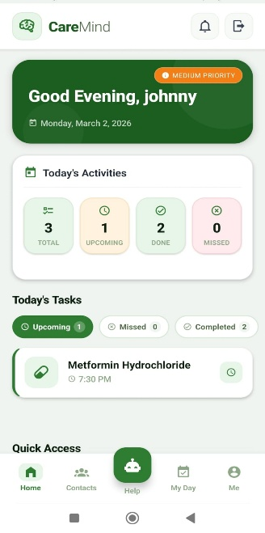

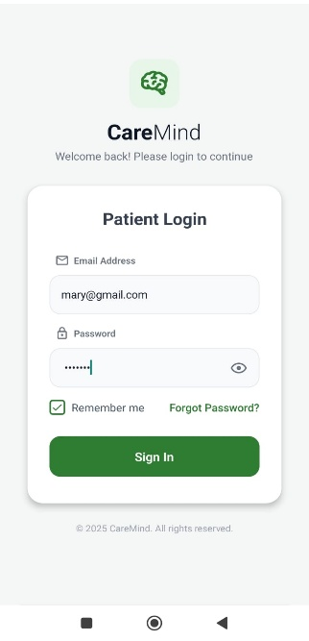

Fig: 6.2.1 Login Fig: 6.2.2 Home
Notification Screen Popup Alert

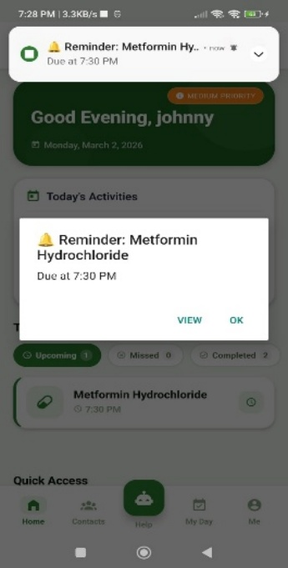

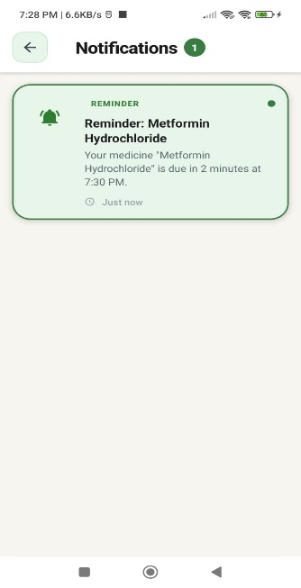

Fig: 6.2.3 Notification Fig: 6.2.4 Popup Alert


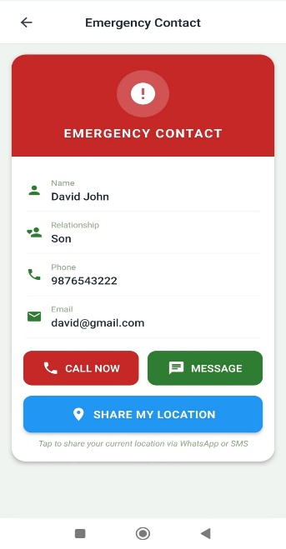
Chat Bot Screen Emergency Contact Screen

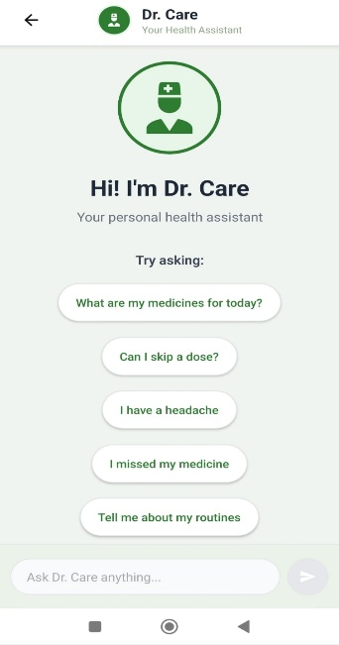

Fig: 6.2.5 Chat Bot Fig: 6.2.6 Emergency
Patient Profile Screen Caregiver Detail Screen

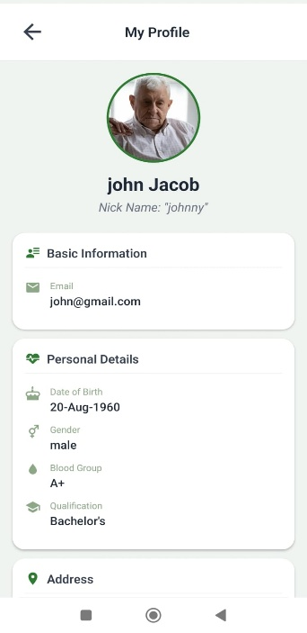

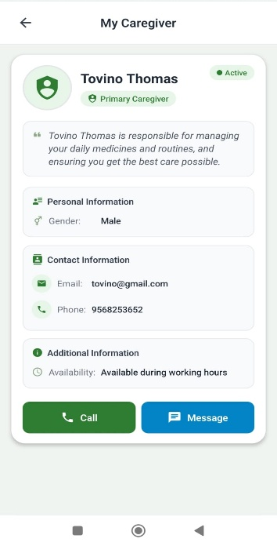

Fig: 6.2.7 Patient Profile Fig: 6.2.8 Caregiver Info

Task Detail Screen Patient Relations Screen


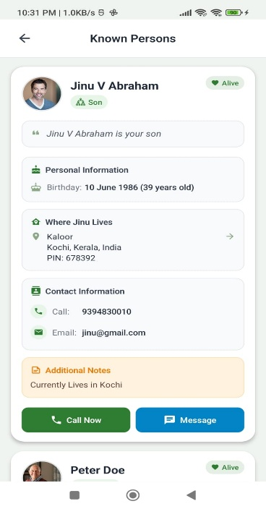

Fig: 6.2.9 Task Details Fig: 6.2.10 Relations

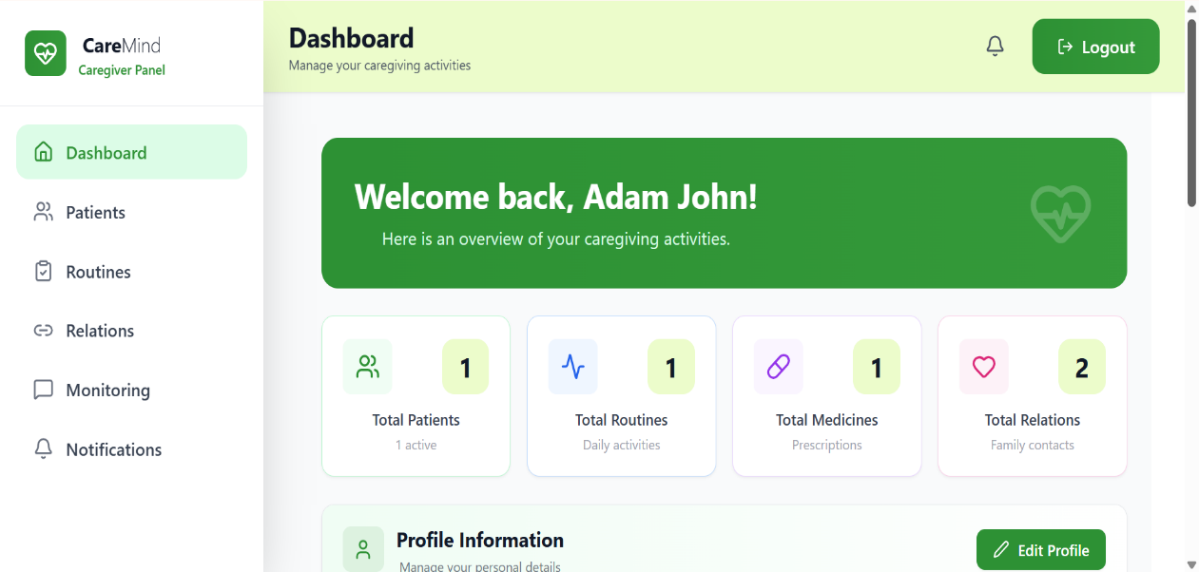
Caregiver Dashboard

Fig: 6.2.11 Caregiver Dashboard

Caregiver Add Patient
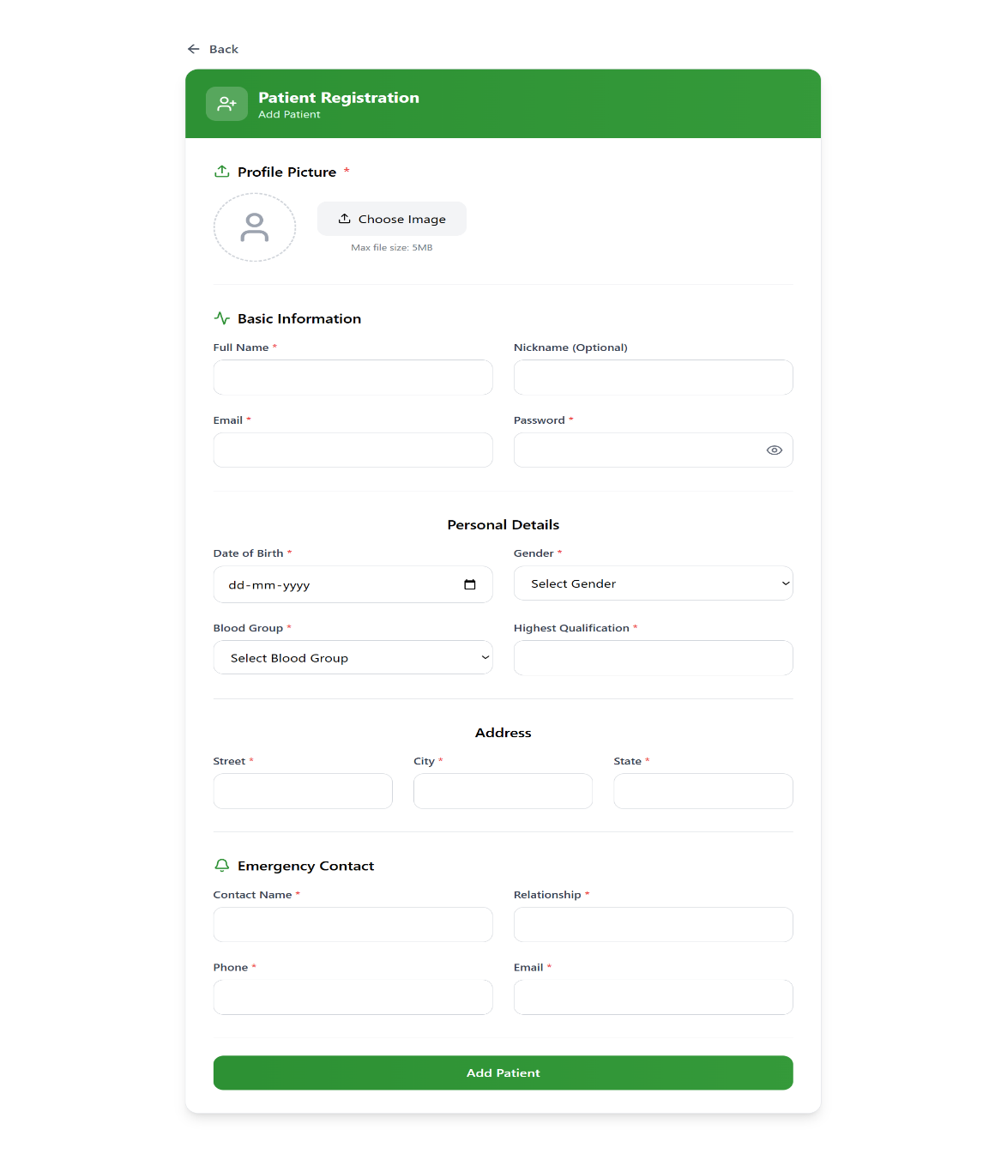

Fig: 6.2.12 Patient Registration
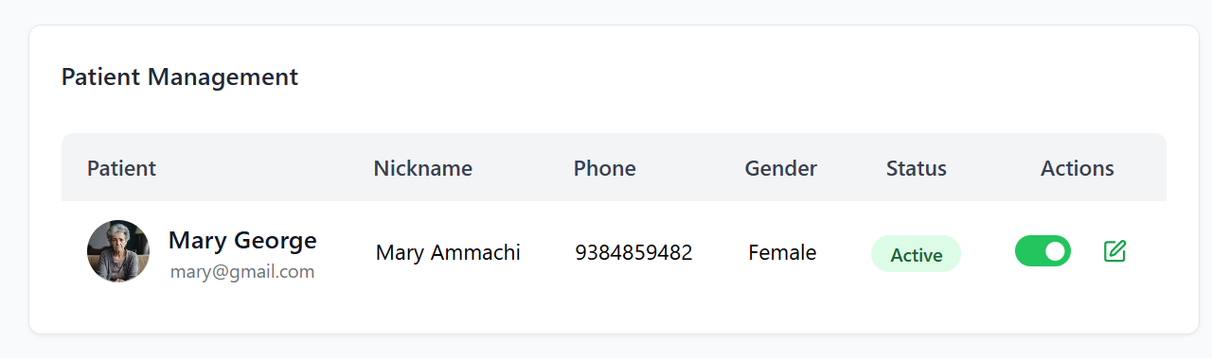
Caregiver Patient Management
Fig: 6.2.13 Patient Management

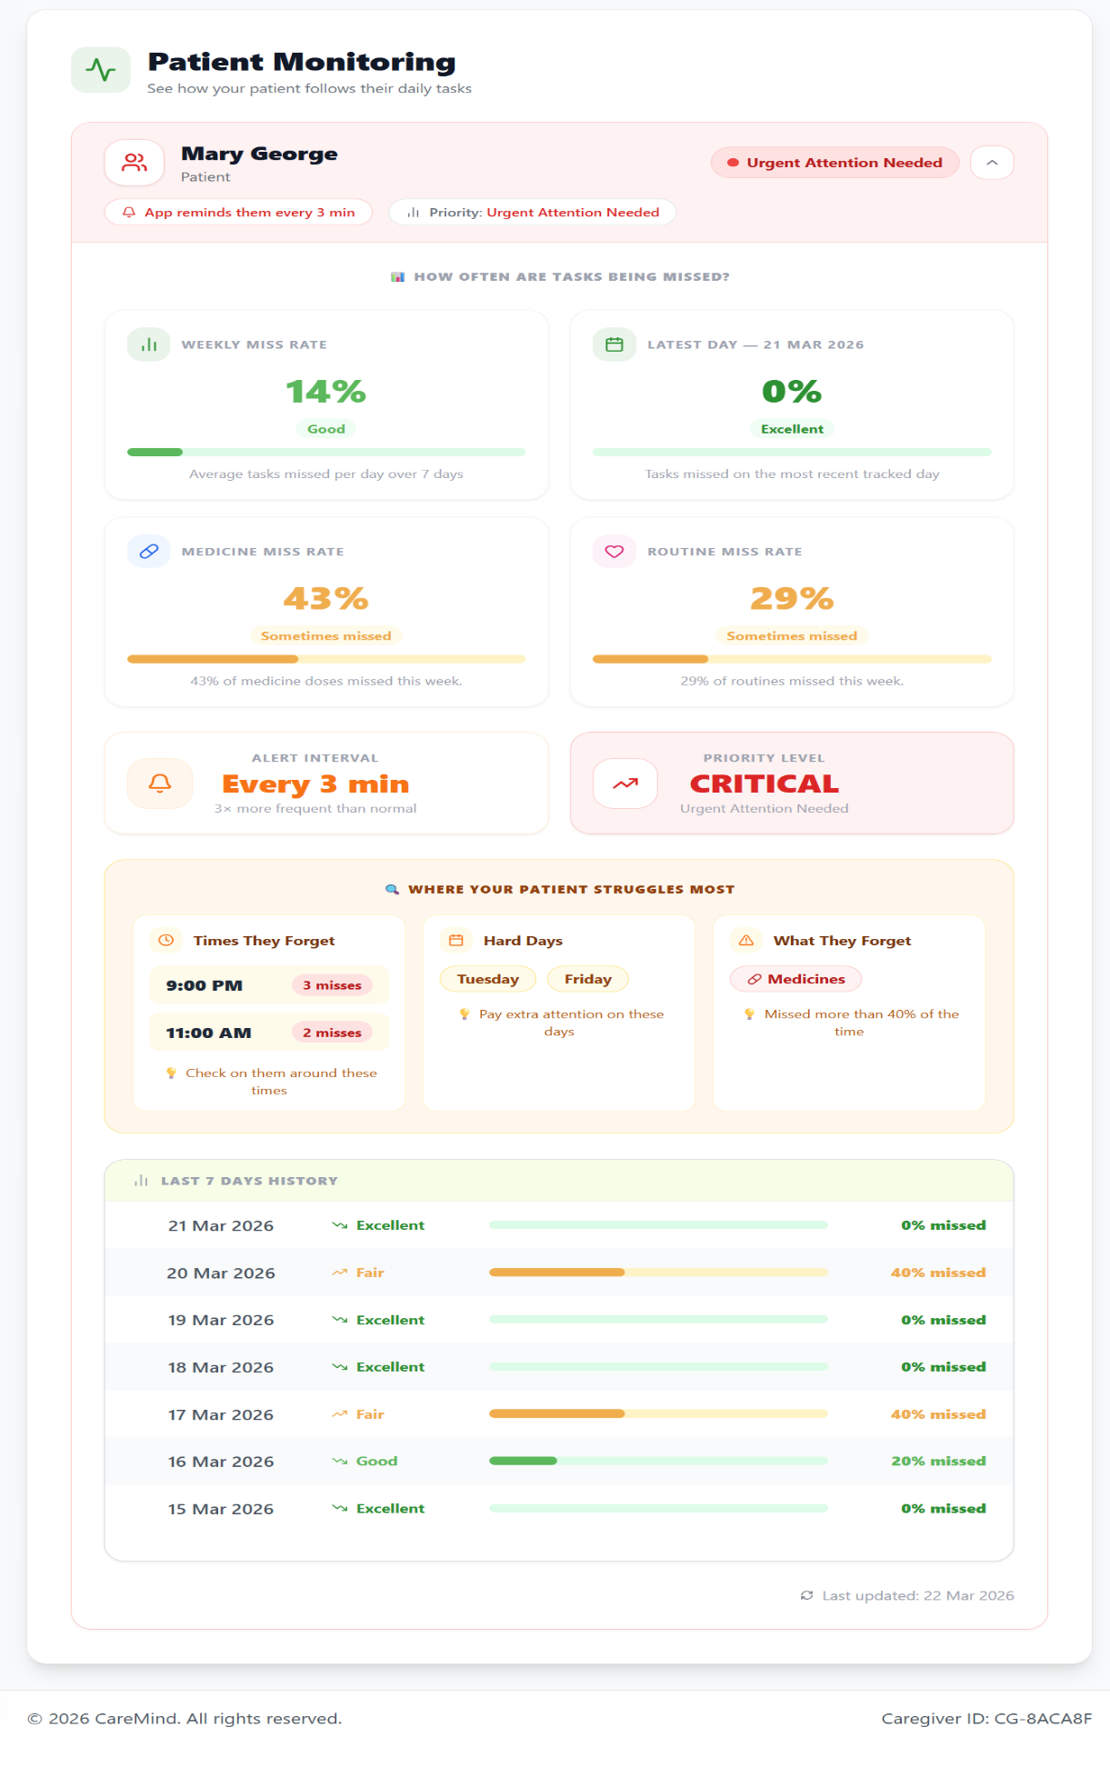
Caregiver Monitoring
Fig: 6.2.14 Patient Monitoring

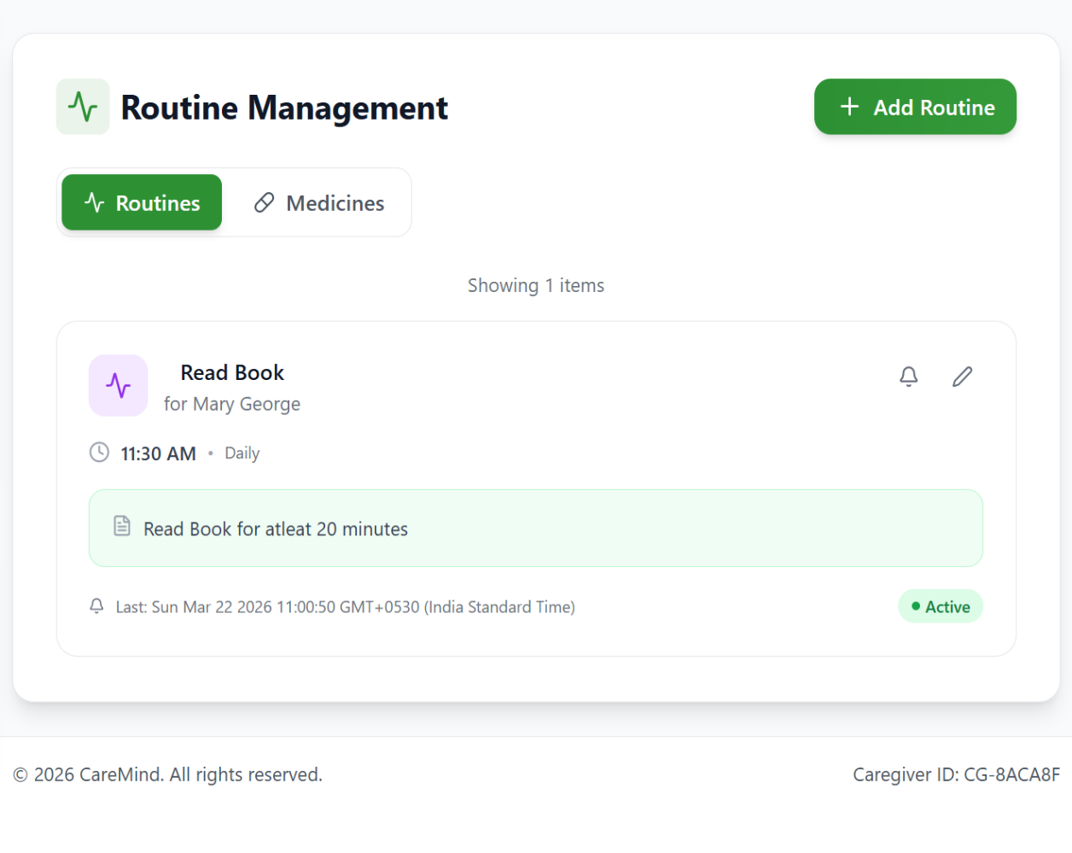
Caregiver Routine and Medicine Management
Fig: 6.2.15 Routine Management
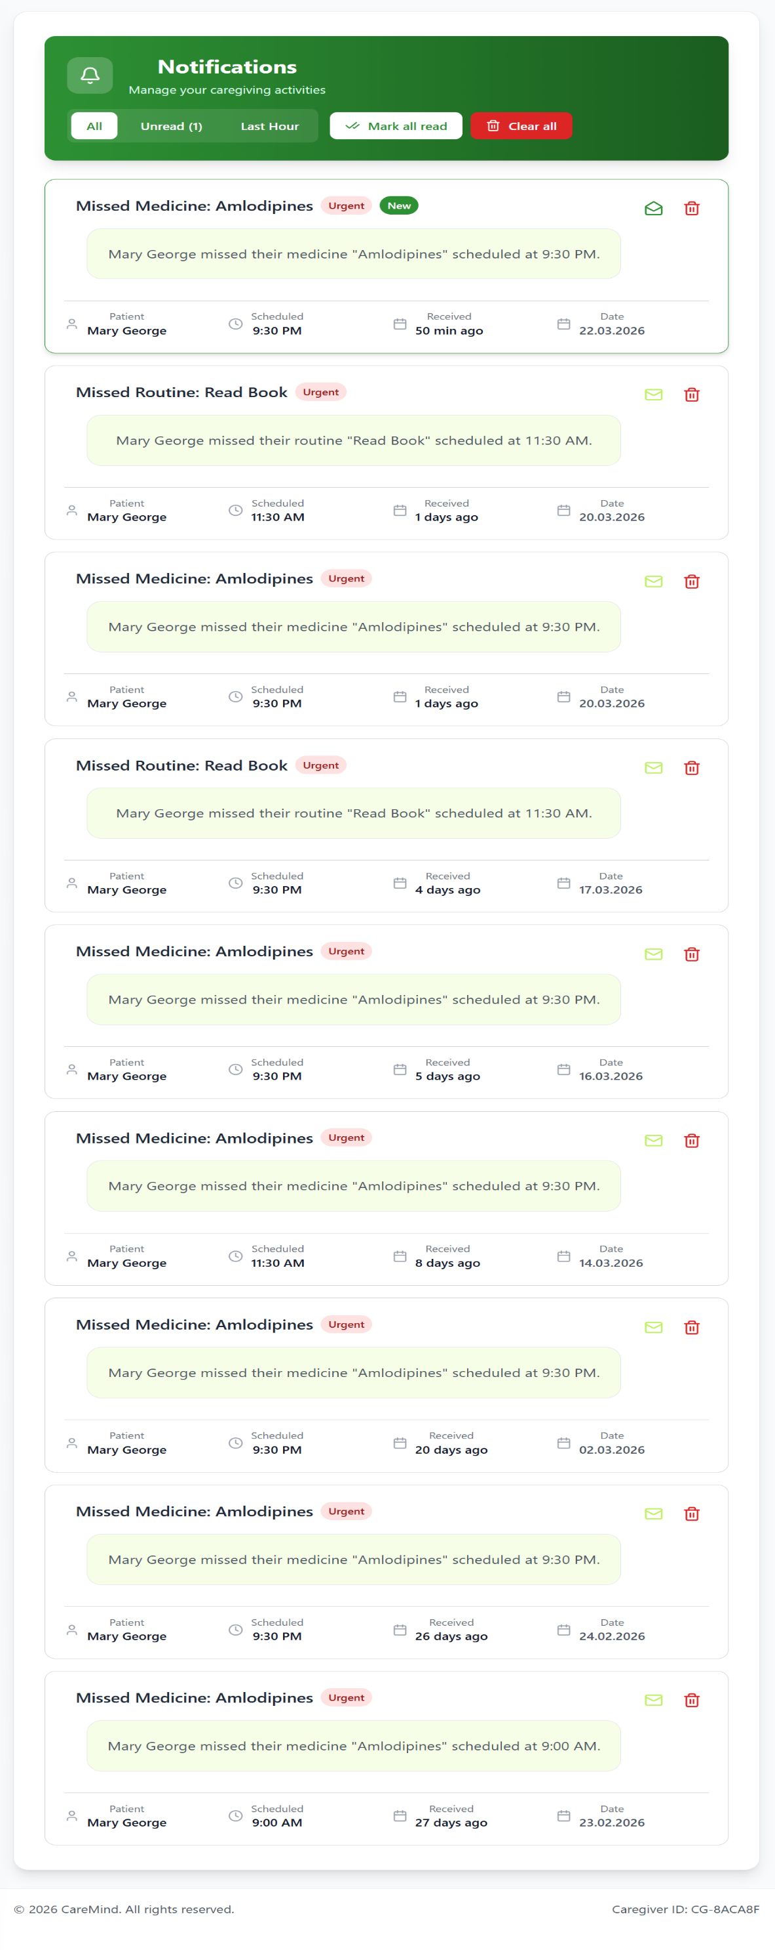
Caregiver Notifications
Fig: 6.2.16 Caregiver Notifications

6.3 LIST OF ABBREVIATIONS
Abbreviation | Full Form
JWT | JSON Web Token
API | Application Programming Interface
UI | User Interface
UX | User Experience
DB | Database
CRUD | Create, Read, Update, Delete
HTTP | HyperText Transfer Protocol
GPS | Global Positioning System
OTP | One-Time Password
URL | Uniform Resource Locator
JSON | JavaScript Object Notation
REST | Representational State Transfer

Fig: 6.3.1 List of Abbreviations

Chapter 7
REFERENCES
[1] V. Lanke et al., “Evaluating the Effectiveness of Mobile Apps on Medication Adherence for Chronic Conditions: Systematic Review and Meta-Analysis,” Journal of Medical Internet Research, vol. 27, 2025.
https://www.jmir.org/2025/1/e60822
[2] C. E. Hartch et al., “Effects of a Medication Adherence App among Medically Underserved Adults with Chronic Illness: A Randomized Controlled Trial,” Journal of Behavioral Medicine, vol. 47, pp. 389–404, 2024.
https://doi.org/10.1007/s10865-023-00446-2
[3] S. Elkefi et al., “Health Information Technology Supporting Adherence in Memory Disorder Patients: A Systematic Literature Review,” Applied Clinical Informatics, vol. 15, pp. 85–100, 2024.https://doi.org/10.1055/s-0043-1776792
[4] L. Gualtieri et al., “Medication Management Strategies to Support Medication Adherence: Interview Study With Older Adults,” Interactive Journal of Medical Research, vol. 13, 2024.https://www.i-jmr.org/2024/1/e53513
[5] S. Wang et al., “Reinforcement Learning to Send Reminders at Right Moments in Smartphone Exercise Application: A Feasibility Study,” International Journal of Environmental Research and Public Health, vol. 18, 2021.https://doi.org/10.3390/ijerph18116059
[6] M. Santo et al., “Mobile Phone Apps to Improve Medication Adherence: A Systematic Stepwise Process to Identify High-Quality Apps,” JMIR mHealth and uHealth, vol. 4, no. 4, 2023.https://mhealth.jmir.org/2016/4/e132
[7] N. Nieuwlaat et al.,“Interventions for Enhancing Medication Adherence,”
Cochrane Database of Systematic Reviews, no. 11, 2022. https://doi.org/10.1002/14651858.CD000011.pub4

[8] S. A. Kales, H. C. Gitlin, and C. G. Lyketsos,“Management of Behavioral and Psychological Symptoms of Dementia,”BMJ, vol. 350, 2022. https://www.ncbi.nlm.nih.gov/pmc/articles/PMC4707529/
[9] A. Free et al., “The Effectiveness of Mobile-Health Technologies to Improve Health Care Service Delivery Processes: A Systematic Review and Meta-Analysis,”PLoSMedicine,vol.10,no.1,2022.https://doi.org/10.1371/journal.pmed.1001363
[10] E. Thakkar et al., “Mobile Telephone Text Messaging for Medication Adherence in Chronic Disease: A Meta-analysis,” JAMA Internal Medicine, vol. 176, no. 3, pp. 340–349, 2021.https://doi.org/10.1001/jamainternmed.2015.7667
[11] R. C. Petersen et al.,“Practice Guideline Update Summary: Mild Cognitive Impairment,”Neurology,vol.90,no.3,pp.126135,2018.https://www.ncbi.nlm.nih.gov/pmc/articles/PMC5772157/

