Digital Twins in Engineering and STEM Higher Education: A Systematic Review of Architectures, Pedagogy, and the Quality of Learning Evidence

Abstract
Background: Practical laboratory training is central to engineering education yet constrained by cost, safety, access, and post-pandemic continuity. Digital twins (DTs) — virtual replicas bidirectionally coupled to physical assets — are increasingly proposed to address these limits, but the educational evidence is dispersed and uneven.
Purpose: This review characterises how DTs are designed, implemented, and evaluated in higher-education engineering and STEM settings, across four objectives: technological architecture and deployment environments (O1); pedagogy and Industry 4.0/5.0 competencies (O2); empirical learning outcomes (O3); and institutional benefits and barriers (O4).
Scope/Method: Following PRISMA 2020, five databases were searched. A terminological screen, three-agent semantic screening (with a moderator agent; inter-agent Fleiss’ κ = 0.60), and human review yielded 126 eligible records, of which 65 retrievable studies (2018–2026) formed the corpus. Extraction was theme-conditional with double verification; the methodological quality of empirical studies was scored on a 0–6 composite and sensitivity-tested. Synthesis combined descriptive profiling, aggregation by objective, and an exploratory relational analysis (attribute-association network, multiple correspondence analysis, and a capability-by-evidence gap map).
Results: The corpus demonstrates feasibility and engagement and is disciplinarily broad, with a recent shift toward bidirectional, occasionally AI-augmented twins. However, the technical maturity of the twin is decoupled from the rigour of its evaluation: architectures are described more than instrumented, pedagogy is active but seldom named, and the learning evidence is weak-dominated, with only a minority of rigorous studies reporting substantial effects.
Conclusions: Educational DTs are promising but not yet evidentially consolidated. We outline priorities for pre-registered, transfer-oriented, and well-reported research.

Keywords
digital twins; engineering education; STEM education; systematic review; evidence quality

Introduction
Laboratory and hands-on instruction occupy a privileged place in engineering education. The formation of professional competence depends on the repeated manipulation of equipment, the observation of real system behaviour under controlled perturbation, and the disciplined translation of theory into practice (Lei et al., 2022; Naukkarinen & Sainio, 2018). Yet the physical laboratory is a constrained resource. Time, space, equipment cost, maintenance, and safety place hard limits on how many students can practise, how often, and on how current the available apparatus remains relative to the industrial state of the art (Lei et al., 2022; Prichetnikov et al., 2020). The COVID-19 pandemic sharpened these long-standing constraints, forcing the rapid migration of practical courses online and exposing how poorly procedural skill formation tolerates the loss of physical access (Alkhedher et al., 2021; Haase, 2022). In response, virtual, remote and simulation-based laboratories have proliferated across engineering disciplines—from electrical measurement, transmission lines and microcontroller programming to chemical reaction engineering and control systems (Andrieu et al., 2021; Chumchuen & Akatimagool, 2023; Lei et al., 2022; Naukkarinen & Sainio, 2018; Panagiotakis et al., 2022). A recent systematic review of digital technologies for practical teaching in science, engineering and technology education concludes that these tools improve access, flexibility and engagement, yet finds limited evidence that they can fully replace hands-on laboratory and workshop experience, leaving a persistent gap between online provision and the tacit, procedural learning of the physical workshop (Maladzhi & Bello, 2025).
Among these digital approaches, the digital twin (DT) has emerged as a distinct and more demanding proposition. First articulated by Grieves in the context of product-lifecycle management (as reported in Liljaniemi & Paavilainen, 2020), a DT is a virtual representation of a physical asset maintained in correspondence with it through a data connection, such that the state of one is reflected in the other across the asset’s lifecycle (De Larmelina et al., 2026; Weichbroth et al., 2024). This definitional core is widely shared, but the term remains contested. Analysing more than 15,000 publications, Abdelrahman et al. (2025) show that no consensus definition exists and that several features often assumed to be intrinsic—real-time bidirectional data flow, simulation, and embedded artificial intelligence (AI)—are not yet mature even in industrial practice. The literature therefore distinguishes degrees of integration, from a static digital model, through a digital shadow with one-way physical-to-virtual updating, to a fully bidirectional digital twin capable of closed-loop control (Kritzinger et al., 2018, as cited in Liljaniemi & Paavilainen, 2020; Abdelrahman et al., 2025; Bokhtiar Al Zami et al., 2025). This gradation matters pedagogically, because it separates a DT from a conventional simulation or an immersive scene: what is labelled a “twin” may range from a high-fidelity but disconnected model to an instrumented, synchronised cyber-physical system (Kabir & Ray, 2025; Y. Lee et al., 2025). Establishing this maturity—rather than assuming it from the label—is consequently a prerequisite for any serious account of what educational DTs are and what they can teach.
The motivation to bring DTs into the classroom is inseparable from the competence demands of Industry 4.0 and the emerging, human-centred Industry 5.0 (Kabir & Ray, 2025; Saini & Garg, 2026). Employers and accreditation bodies increasingly expect graduates to be fluent in the industrial Internet of Things, automation and data analytics and, with the Industry 5.0 turn, in human–machine collaboration and sustainability-oriented practice (Azofeifa et al., 2025; Dautaj et al., 2026; Sell et al., 2025). Several studies document a persistent mismatch between graduate competencies and labour-market expectations (Denissova et al., 2026), while survey evidence shows that engineering faculty themselves often feel insufficiently prepared, and insufficiently equipped, to teach these technologies (Cuperman & Raveh, 2026). DTs are attractive in this context precisely because they promise to expose students to the same cyber-physical systems they will meet in industry, and to align that exposure with competence frameworks articulated for Industry 5.0 work and learning factories (Al-Jumeily et al., 2026; Niţu et al., 2026; Zare et al., 2026).
DTs rarely arrive alone. They are typically embedded within, or compared against, a broader wave of immersive and virtual technologies—virtual, augmented and mixed reality, the metaverse, and serious games—whose use in engineering and higher education has expanded rapidly and been mapped by numerous reviews (Espinoza et al., 2025; Fan & Zhang, 2025; Jin et al., 2026; Lampropoulos et al., 2025; Llanos-Ruiz et al., 2025). The evidence on these technologies is, however, mixed. Many studies report gains in motivation, engagement and the understanding of complex concepts, but controlled comparisons sometimes find no significant difference in measured learning outcomes relative to traditional methods, underscoring that pedagogical design, not technology alone, drives the effect (Giussani et al., 2025; Lainidis & Mystakidis, 2026; Yindeemak et al., 2026). Within this landscape, DT-based education has grown from early demonstrations in construction and mechanical engineering (Liljaniemi & Paavilainen, 2020; Sepasgozar, 2020; Treffinger et al., 2022) into a varied corpus spanning manufacturing, robotics, electrical and chemical engineering, aviation maintenance and even university mathematics (Bolanos et al., 2026; Hunpinyo et al., 2026; Khan et al., 2026; Kwateng & Leong, 2026; J. Y. Lee et al., 2023; Xiang et al., 2025), often coupled with project-based and experiential pedagogies and framed as preparation for Industry 4.0/5.0 practice (Álvarez Ariza & Hernández Hernández, 2026; Ruppert et al., 2023; Terkaj, Kleine, et al., 2024; Zhang et al., 2024).
This momentum has produced several reviews, but they leave important questions open. Existing syntheses tend either to survey immersive technologies broadly, with DTs as one instance among many (Jiang et al., 2026; Lampropoulos et al., 2025; Tokhayeva et al., 2026), or to concentrate on a single application niche, such as DT-coupled virtual learning environments for smart manufacturing (Kumar Karanam & Hartman, 2025). Across this body of work three gaps recur. First, the techno-pedagogical architecture of educational DTs—their deployment environment, communication protocols and synchronisation, and degree of bidirectional integration—is seldom characterised jointly with the pedagogy it is meant to serve, so that technical and instructional accounts run in parallel rather than being read together. Second, reviews rarely appraise the methodological quality of the underlying learning evidence; effectiveness claims are aggregated without weighting how rigorously each was established, even though the immersive-technology literature itself warns that headline gains often rest on small, uncontrolled designs (Fan & Zhang, 2025; Giussani et al., 2025). Third, no synthesis has examined how technical, pedagogical and evaluative choices co-vary across the field—whether, for example, the most technically capable twins are also the most rigorously evaluated, or whether ambitious competence claims are matched by demonstrated outcomes. Addressing these gaps calls for a synthesis that treats architecture, pedagogy, evidence quality and institutional context as linked dimensions rather than as separate narratives.
Accordingly, this systematic review synthesises 65 primary studies on the use of digital twins in engineering and higher education, published between 2018 and 2026. Drawing on an inductive thematic analysis organised into eight themes, the review pursues four objectives: (O1) to characterise the technological architectures and deployment environments of educational DTs, including their enabling components, synchronisation and convergence with AI; (O2) to describe the pedagogical designs adopted and the Industry 4.0/5.0 competencies they target; (O3) to appraise the empirical evidence for learning outcomes and the methodological quality on which it rests; and (O4) to assess the institutional benefits claimed for DTs and the barriers to their adoption. Beyond profiling each dimension separately, the review analyses how these dimensions co-occur and relate, so that the maturity of the technology can be read against the rigour of its evaluation and the breadth of competence claims against the weight of demonstrated learning. By coupling a structured description of what is being built with a critical appraisal of what has actually been shown, the review aims to give engineering educators, researchers and institutions an evidence-weighted map of the field and a foundation for the research agenda developed in the sections that follow.
The significance of this work for engineering education research and practice lies in its appraisal stance. Rather than cataloguing digital-twin applications, the review evaluates the quality of the evidence behind them and asks how technical and evaluative choices co-vary, exposing a structural decoupling between the maturity of the twin and the rigour of its evaluation that reframes how the field should read its own claims. For research, this specifies where confirmatory, transfer-oriented evidence is most needed; for practice, it cautions educators and institutions against inferring learning gains from technical sophistication, and argues for pairing digital twins with explicit pedagogy, aligned assessment, and instrumented cost, sustainability and accessibility claims.

Positionality Statement
The authors are engineering and education faculty at a public university, with teaching and research interests spanning electronic and control engineering, automation, and engineering education. Several of us have designed and taught laboratory courses using simulation- and technology-mediated tools, an experience that shaped this review in two ways. First, it motivated our central question — whether the technological sophistication of a digital twin is matched by evidence that it improves learning — because we have seen compelling demonstrations adopted ahead of evidence in our own teaching contexts. Second, it disposed us toward a deliberately cautious, evidence-weighted reading rather than an advocacy stance. We hold no commercial interest in any digital-twin platform, vendor, or engine. We are mindful that our location in a resource-constrained setting sharpens our attention to cost, accessibility, and equity, and may make us more sceptical of unquantified institutional-benefit claims than authors writing from better-resourced contexts. To limit the influence of these dispositions on the findings, study selection used independent screening agents with explicit inclusion/exclusion tests, and the quality appraisal followed a pre-specified rubric applied with double verification.

Methods

Protocol and reporting
This review was designed and is reported following the PRISMA 2020 statement. A pre-specified protocol (Review Protocol v2) fixed the research question, eligibility criteria, search strategy, screening procedure and analysis plan before screening began. The review was not prospectively registered; registration in PROSPERO or OSF is recommended before any update and is noted among the outstanding items below. The review question, framed with the Population–Concept–Context (PCC) scheme, asked how digital twins (DTs) are designed, implemented and evaluated in higher-education engineering and STEM settings. It was decomposed into four objectives: technological architectures and deployment environments (O1); pedagogical strategies and Industry 4.0/5.0 competencies (O2); empirical evidence of learning outcomes (O3); and institutional benefits and critical barriers (O4).

Eligibility criteria
The population and context were university-level engineering or STEM students and instructors in courses, laboratories, training or assessment; the concept was the educational implementation, deployment, evaluation or use of a DT. The construct was defined canonically and applied with a deliberately conservative severity rule to guard against semantic drift: a DT is a virtual representation of a specific physical asset, bidirectionally and continuously coupled to it, so that state changes propagate physical→virtual and virtual→physical. Standalone simulations or numerical models, virtual or remote laboratories, VR/AR/XR, the metaverse, serious games, generic CPS/IoT testbeds, digital models (no automatic data exchange) and digital shadows (one-way coupling) were treated as near-misses and qualified only when the bidirectional coupling was explicit. Studies that claimed a “digital twin” with partial or unstated synchronisation were coded uncertain rather than excluded, under an authoritative precedence rule whereby absence of confirming evidence is never grounds for exclusion.
A hard document-type gate was applied before thematic relevance: empirical journal articles, full conference papers and early-access empirical articles were eligible, whereas reviews of any kind, surveys, editorials, opinion pieces, abstracts, posters and keynote summaries were ineligible. No language restriction was imposed; the retained corpus includes English, Spanish and Russian.

Information sources and search
Five bibliographic databases were searched: Scopus, Web of Science, IEEE Xplore, EBSCO and Dimensions. The core string combined the construct with an education block — (“digital twin*” OR “educational digital twin*”) AND (“engineering education” OR “engineering training” OR “technical education” OR “STEM education”) — adapted to each database’s syntax. The choice of a compact, precision-oriented string rests on a documented sensitivity analysis of the search chain. In Scopus, the construct alone (“digital twin*”) returned 20,917 records, and lengthening the construct disjunction with “digital-twin*” or “educational digital twin*” did not enlarge this domain; conjoining the education block reduced the set to 192–193 records, whereas appending a long technology disjunction (laboratory, IoT, CPS, mechatronics, automation, telecommunications, embedded and cyber-physical systems) only narrowed recall further, to 159, without surfacing additional relevant work. Progressively trimming the education terms moved the yield monotonically between 141 (“engineering education” alone) and 193 (the full education disjunction). These runs confirmed two design decisions: the term “digital twin*” alone retrieves the same domain as longer construct disjunctions, and the education block — not a long technology disjunction — is the effective constraint. The string was therefore fixed to favour precision over an unfocused expansion of recall.
The searches returned 1,504 raw records (Scopus 772, Dimensions 409, IEEE 181, EBSCO 81, Web of Science 61). After removing 38 records lacking a title or authors, 1,466 records entered deduplication. Matching on DOI (232) and fuzzy title (47) removed 279 duplicates, yielding 1,187 unique records; a further 9 without an abstract were set aside, leaving 1,178 records for screening.

Study selection
Selection proceeded in three stages, summarised in the PRISMA 2020 flow diagram (Figure 1). First, an automated terminological screen required both a DT block and an engineering-education block to be present in the title, abstract or keywords, with a keyword-based rescue for records carrying the terms only in author or index keywords. This retained 799 records (206 by full field match and 593 by keyword rescue) and set aside 379 on terminological grounds. Second, the 799 records underwent semantic screening by three independent large language model (LLM) agents implemented with DeepSeek-V4-Flash in a non-reasoning configuration at temperature 0, so that classification was deterministic and reproducible. Each agent applied the protocol’s positive include/exclude tests and its construct-severity mapping (strict, moderate or near-miss) and returned, for every record, a decision (include, exclude or uncertain), a confidence score and the governing inclusion/exclusion criterion; split or uncertain cases were escalated to a fourth moderator agent (the same model and settings), and records that remained uncertain were never excluded on absence of evidence. Agreement among the three primary agents was substantial: they were unanimous on 466 of the 799 records (58%), the moderator resolved a further 96 split cases, and inter-agent reliability was Fleiss’ κ = 0.60 across the three categories, with pairwise Cohen’s κ between 0.56 and 0.63. This level of agreement is both expected and, for our purpose, desirable rather than a weakness: because the protocol’s conservative severity rule never excludes a record on the absence of confirming evidence, it deliberately privileges recall (exhaustiveness) over first-pass precision, which depresses nominal agreement on the borderline “uncertain” category while ensuring that no potentially eligible study is discarded prematurely. Contested records were therefore resolved by the moderator agent and by subsequent human review rather than by inter-agent majority. The agent prompts, scores and per-record outputs are provided as supplementary material and in the public repository. Third, a human review of the 247 records that the agents flagged as include (11) or uncertain (236) confirmed 126 as eligible. Full texts could be obtained for 65 of these; the remaining 61 could not be retrieved, and the synthesis proceeds on the 65 retrievable studies.
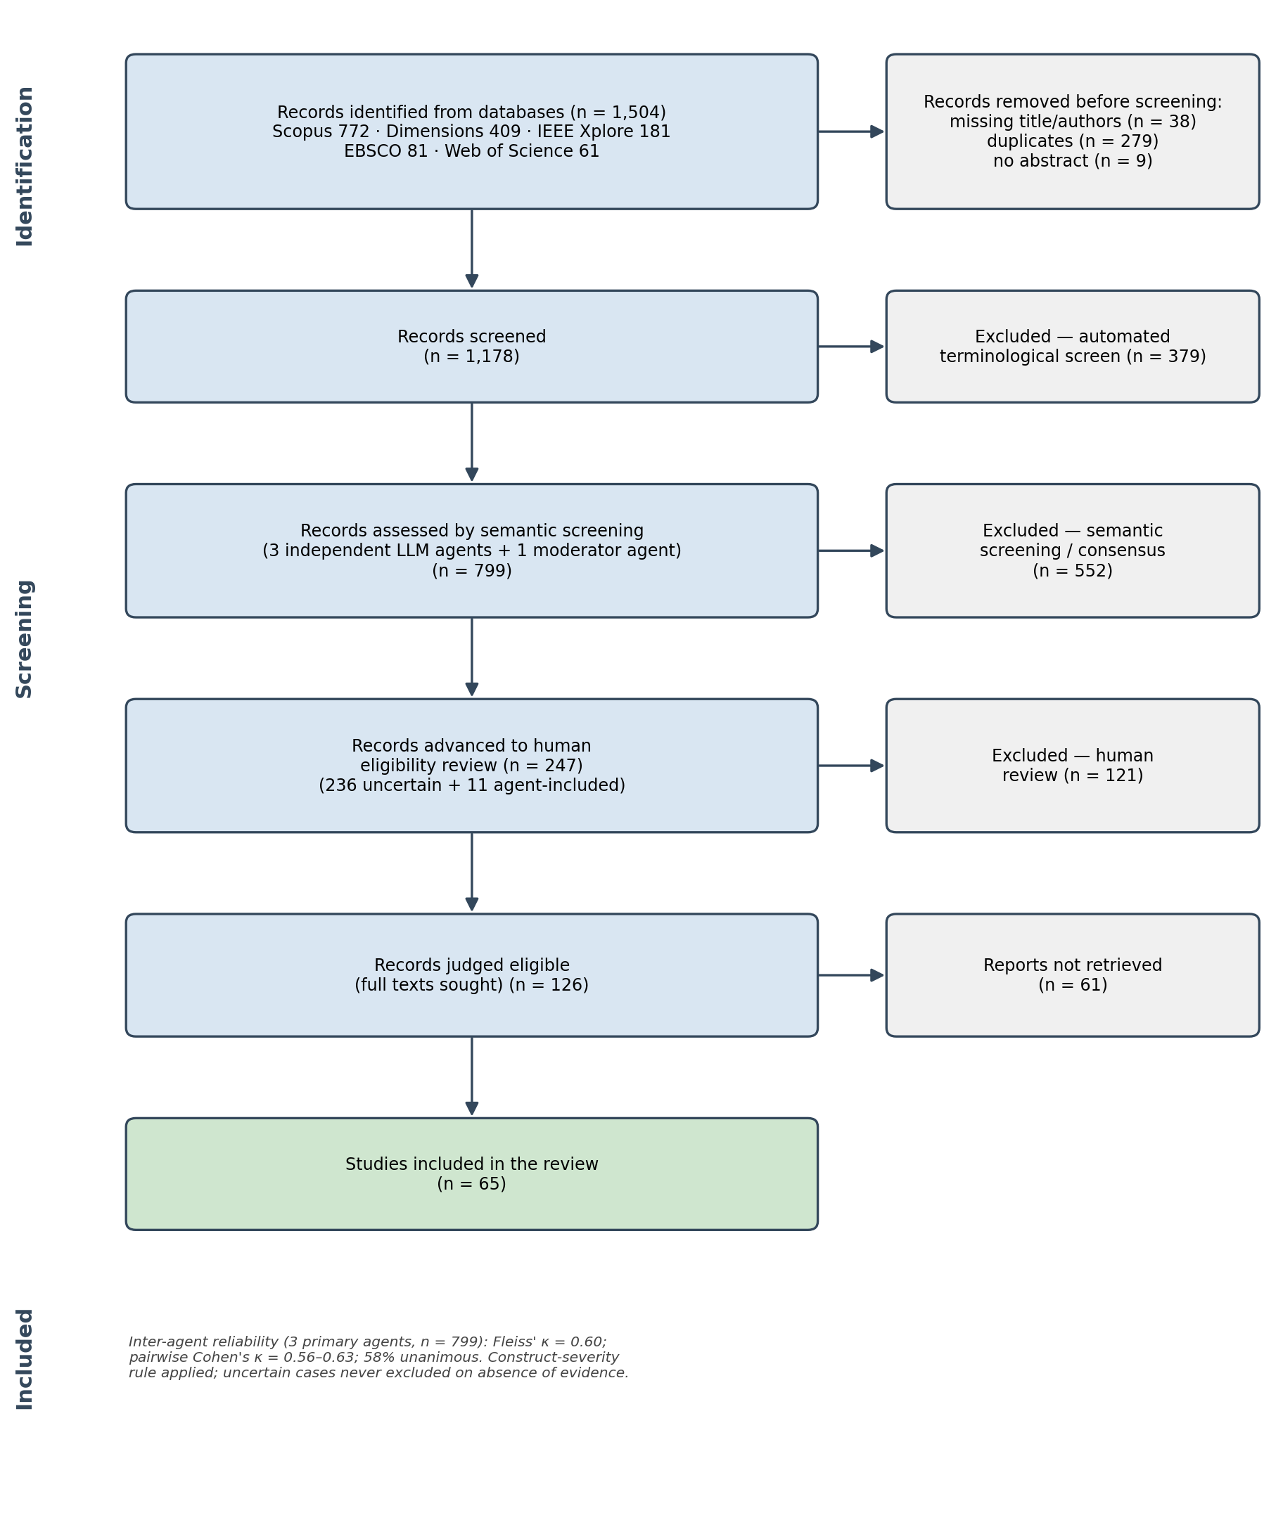
Figure 1. PRISMA 2020 flow diagram of identification, screening and inclusion. Title/abstract screening combined an automated terminological screen with semantic screening by three independent large language model (LLM) agents and a fourth moderator agent (inter-agent Fleiss’ κ = 0.60).

Data extraction
Full texts were converted from PDF with the Marker pipeline to preserve textual fidelity, and extraction followed a theme-conditional activation principle: each study activated only the extraction templates of the themes in which it had been inductively coded, with the remaining variables left as not-applicable. This reduced extraction load, kept the evidence pertinent, and allowed per-theme reporting rates to be computed. Every critical variable used a controlled vocabulary — NR (not reported), NA (not applicable) and UNCERTAIN — and double verification, recording the extracted value together with a verbatim supporting quotation and its location, so that each datum is auditable and amenable to a Cohen’s κ check.

Thematic analysis and synthesis
An inductive thematic analysis — conducted with three frontier LLMs (ChatGPT 5.5, Gemini 3.1 Pro and Claude Opus 4.7), whose independent codings were iteratively cross-fed and refined through successive rounds of author review to converge on a scheme granular enough to be exhaustive yet parsimonious enough to remain tractable — produced eight themes: practical infrastructure (T1), enabling architectures (T2), AI convergence (T3), Industry 4.0/5.0 competencies (T4), pedagogical design (T5), empirical evidence (T6), institutional value (T7) and barriers (T8). The three models’ outputs are included in the public repository. These were mapped N:M onto the four objectives through a traceability matrix (O1 = T1+T2+T3; O2 = T4+T5; O3 = T6; O4 = T7+T8), so that a single study could contribute to several themes and objectives.
The synthesis was structured and narrative, without meta-analysis — a decision justified by the methodological and outcome heterogeneity of the corpus. Because the review’s principal inferences depend on the strength of the primary evidence, the methodological quality of each empirical study was formally appraised rather than assumed. Analysis proceeded in three principal layers: per-theme descriptive profiling with explicit reporting rates (Layer 1); aggregation by objective, including a 0–6 evidence-quality composite over empirical studies built from design rigour, comparator, inferential statistics, effect size and declared validity threats (Layer 2); and theme co-occurrence and configuration analysis (Layer 3). These were complemented by an exploratory relational layer comprising an attribute-association network (φ coefficients with Fisher exact tests and non-parametric bootstrap 95% confidence intervals, B = 5,000), a multiple correspondence analysis embedding, and a capability-by-evidence gap map. The robustness of the evidence bands was tested with a threshold-sensitivity analysis and bootstrap intervals, and the full pipeline is scripted end-to-end for reproducibility.

Information that remains to be supplied
In the interest of transparency, several items should be completed before publication or any update, and they bound the conclusions that can presently be drawn. Methodologically, the protocol should be registered and its identifier reported, and the exact last-search dates stated. While the inter-agent reliability of the semantic screening is reported above, the planned human double-coding of a randomised 20% subset of the data extraction, with its Cohen’s κ, should still be completed to substantiate extraction reliability. For search completeness, the most consequential gap is full-text attrition: only 65 of 126 eligible records were retrievable, so interlibrary loan and direct author contact are recommended to recover the 61 missing reports and to assess whether their absence biases the corpus. Because recall rests on a single core string across five databases, backward and forward citation chasing (snowballing) and a grey-literature scan are advisable to test sensitivity. Finally, the conservative, strictly bidirectional construct definition, while it protects against construct inflation, may also set aside loosely reported twins; this boundary should be acknowledged when interpreting both the included set and the records deferred as uncertain.

Results
This section reports the synthesis of 65 primary studies on digital twins (DTs) in engineering education. Following the review design, the analysis proceeds in three layers — descriptive profiling per theme (Layer 1), aggregation by review objective (Layer 2), and cross-cutting co-occurrence and relational analysis (Layer 3/4) — mapped onto the four objectives O1–O4. Counts are reported over the subset of studies that activated each theme; reporting rates (the share of those studies that actually documented a given variable, as opposed to “not reported”, NR) are stated explicitly because they bound the strength of every claim that follows. All supporting tables and figures (Figures 2–11; Tables 1 and 2) are produced by a reproducible analysis pipeline.

Corpus overview
The corpus spans 2018–2026 and is recent: 39 of 65 studies (60%) were published in 2025–2026, with 26 in 2025 and 13 in 2026. Journal articles (37) and conference papers (26) are represented in comparable numbers. Studies are unevenly distributed across the eight inductive themes: pedagogy (T5, n=47) and Industry 4.0/5.0 competencies (T4, n=47) are most frequent, followed by practical infrastructure (T1, n=38), empirical evidence (T6, n=35), barriers (T8, n=28), enabling architectures (T2, n=26), institutional value (T7, n=21) and AI convergence (T3, n=11). Most studies activated three (19) or four (28) themes, indicating that individual papers typically address technology, pedagogy and outcomes jointly rather than in isolation.

O1 — Technological architectures and deployment environments (T1+T2+T3)
Deployment environment (T1). The environment type was reported in 37 of 38 studies (97%). Hybrid physical–virtual setups are the most common configuration (18), followed by immersive VR/AR/MR environments (11), remote (4) and virtual-only (3). The modelled physical system was almost always specified (95%), most often a manufacturing plant or production line, with isolated cases in metallurgy, instrumentation laboratories, HVAC and robotics. Two variables were comparatively under-reported: the access modality (37%) and the immersive hardware/software stack (55%), where Unity is the recurring engine and head-set hardware (e.g., Oculus Rift) appears only sporadically. Reported visual/ functional fidelity (58%) was qualitatively “high” in 14 studies, but fidelity was seldom quantified.
Enabling architecture (T2). Among the 26 architecture studies, physical components, virtual components and communication protocols were each documented in 88% of cases, whereas the layered architecture was described in 62%. OPC UA is the most frequently named protocol, with MQTT, TCP/IP, EtherCAT, the Asset Administration Shell (AAS) and the IEC 61131-3/61499 family also present. Mapped onto the Kritzinger et al. taxonomy (reported by 18 of 26), the studies that specify a category claim a fully bidirectional digital twin in 10 cases and a (unidirectional) digital shadow in 7, with a single static digital model. Synchronisation, where stated (20 of 26), is “real-time” (8) or “near-real-time” (8); only one study documents automatic bidirectional control. These figures should be read with caution: the taxonomy is largely self-described by authors and rarely accompanied by latency or jitter measurements, so the prevalence of “complete” twins likely reflects terminological usage more than verified closed-loop synchronisation.
AI convergence (T3). AI is the least represented dimension (11 studies). Where an AI family is named (8 of 11), it ranges across classical machine learning, deep/neural networks, generative models (LLM/GAN), explainable AI and knowledge graphs; the most common declared functions are prediction, diagnosis and predictive maintenance, with a few cases of automated student feedback and adaptive personalisation. Notably, AI performance metrics (accuracy, F1, inference latency) were reported in only 3 of 11 studies (27%), so the educational and technical performance of these AI components is largely unverified in the current corpus.
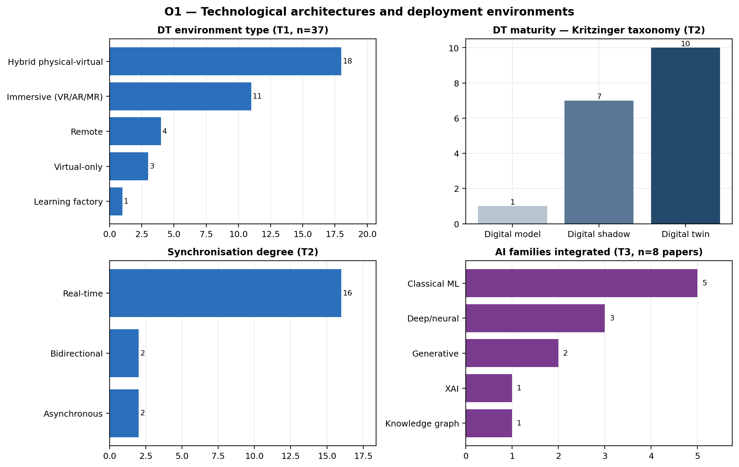
Figure 2. Technological architectures and deployment environments (Objective O1): category distributions and per-variable reporting rates for deployment environment, modelled system, enabling architecture and AI convergence. AR = augmented reality; MR = mixed reality; VR = virtual reality; AAS = Asset Administration Shell; AI = artificial intelligence; OPC UA = Open Platform Communications Unified Architecture.

O2 — Pedagogical design and competencies (T4+T5)
Disciplinary scope and competencies (T4). The engineering domain was reported in 46 of 47 studies (98%). Manufacturing (12) and automation (9) dominate, but the corpus is disciplinarily diverse, also covering mechatronics (5), chemical engineering (4), and smaller clusters in metallurgy, energy, civil/construction, robotics and cybersecurity. Targeted competencies were documented in 81% of studies and cluster around IIoT, smart manufacturing, automation, data analytics and — increasingly — human–machine collaboration framed as Industry 5.0. Two alignment variables are weak spots: explicit mapping to industrial or accreditation standards (ABET, ISA-95, RAMI 4.0, IEC) and documented industry–academia collaboration were each reported in only 21% of studies. Competencies are therefore frequently asserted as design intent rather than anchored to external frameworks or industry validation.
Instructional design (T5). The pedagogical model was reported in 43 of 47 studies (92%) and is overwhelmingly described as “active learning” (23) or “experiential learning” (14); formally named approaches such as project-based learning, learning/teaching factories, ADDIE or challenge-based learning are individually rare. Interventions are concentrated at the undergraduate level (31), and student participation is typically “active experimentation” (25) or a “full life-cycle project” (12), with student construction of the twin itself documented only once. The teacher is consistently positioned as a facilitator or supervisor (reported in 77%). A recurring reporting gap is intervention duration, stated in only 38% of studies, which limits any inference about dose or sustained effects.
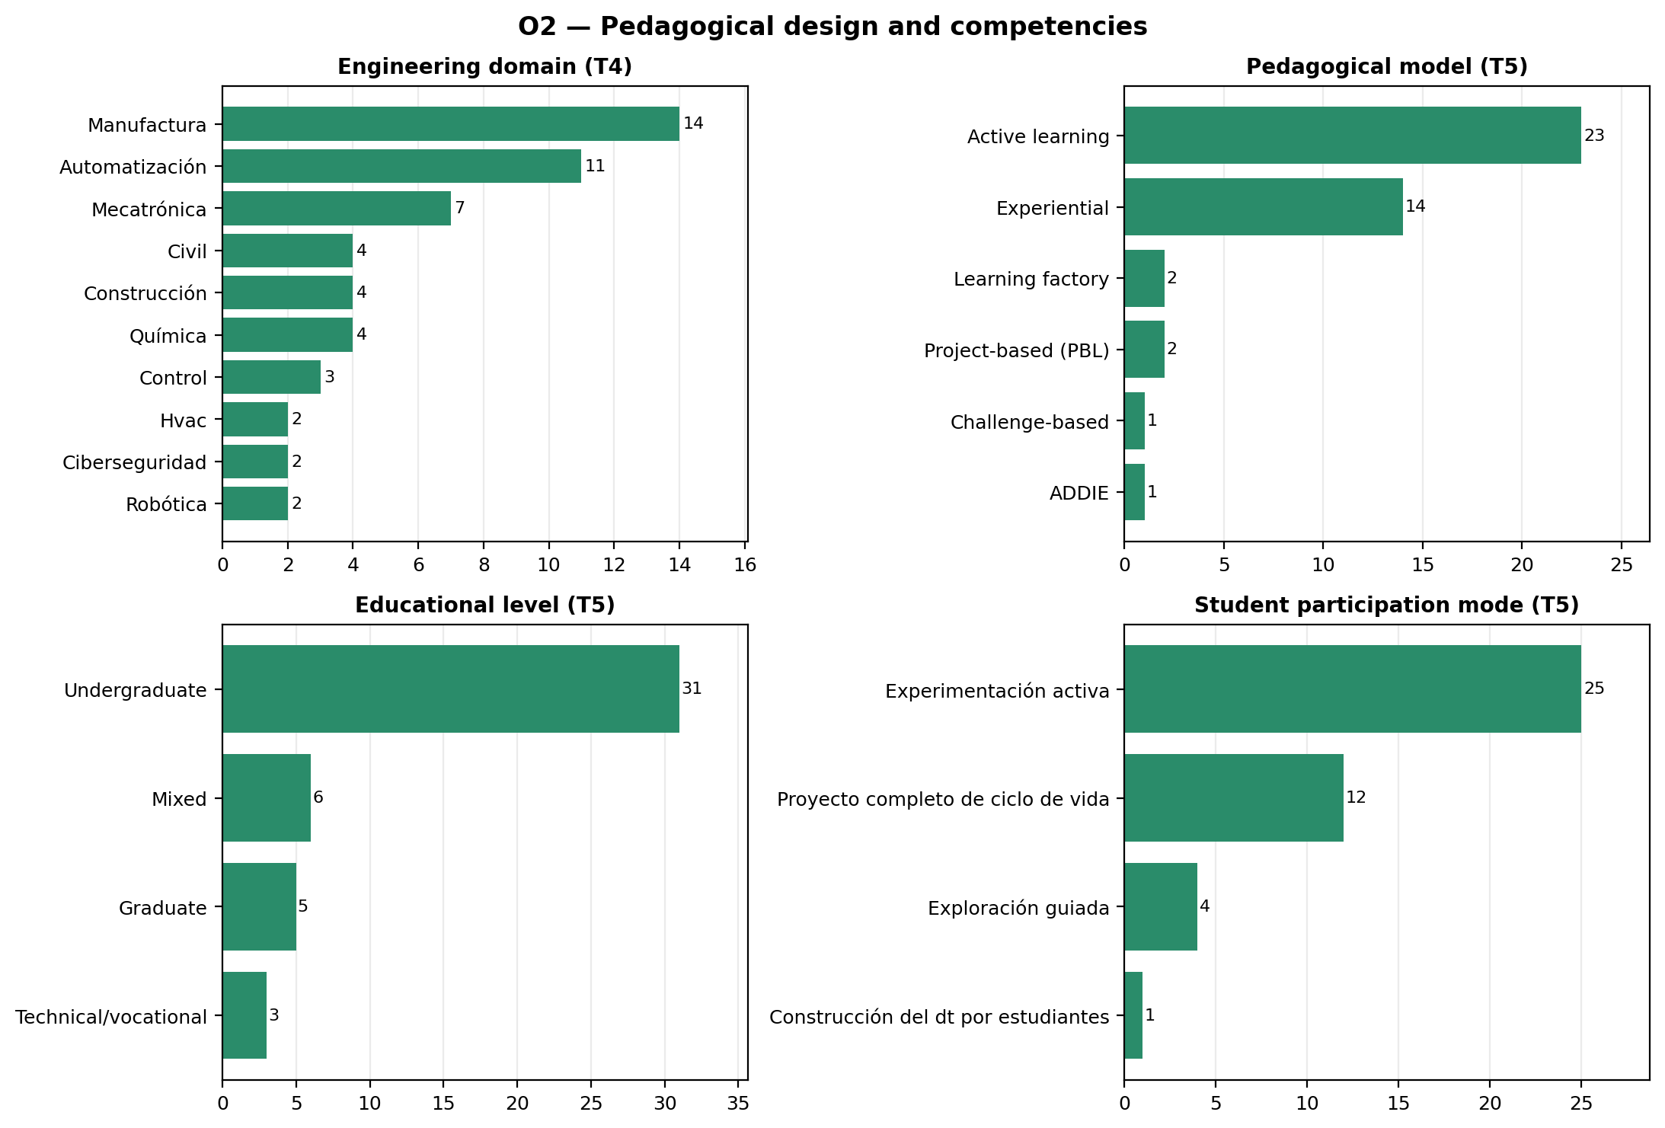
Figure 3. Pedagogical design and Industry 4.0/5.0 competencies (Objective O2): engineering domains, targeted competencies, pedagogical models and participation modes, with reporting rates. IIoT = industrial Internet of Things.

O3 — Empirical evidence of learning outcomes (T6)
Thirty-five studies activated T6. Research design was reported in 80% of them and is mixed in rigour: quasi-experiments (8) and conceptual/design-development studies (8) are equally common, alongside case studies/surveys/pilots (8), mixed-methods (3) and a single controlled experiment. A comparator was described in 83% of studies, but in 9 of these the “comparator” was in fact none, and only a minority used a traditional-class control (8) or a within-subject pre/post design (6). Across reported outcome dimensions, affective/engagement results (23; spanning motivation, technology acceptance, self-efficacy and, where NASA-TLX is used, cognitive load) and cognitive results (22) are reported more often than procedural skills (17).
The central limitation of the evidence base concerns statistical reporting. Inferential statistics with reported values appear in only 11 of 35 studies (31%), and an effect size in only 7 (20%). To make this explicit, we scored each empirical study on a 0–6 composite (design rigour, comparator, inferential statistics, effect size, and declared validity threats). The resulting distribution is weighted toward the lower end: 20 studies are weak, 10 moderate and 5 strong (median composite score = 2 of 6). This bottom-heavy profile does not depend on the chosen cut-points: under a stricter banding only 1 study is strong and under a lenient banding 12 are, yet weak-or-moderate studies remain the clear majority in every scheme (66–97%; 20 of 35 score ≤2 and are weak under all schemes).
Where strong studies exist, they report substantial effects. In a controlled quasi-experiment on a digital-twin/IoT laboratory intervention, Kwateng & Leong (2026) report a between-groups difference of t(198)=8.94, p<.001 with Cohen’s d=0.91, a pre/post mean gain of +18.5 points in the intervention group versus +4.3 in the control, and procedural improvements such as cloud-synchronisation success rising from 68% to 92%; Wang et al. (2025) report Cohen’s d=1.24 for knowledge mastery, Tarng et al. (2024) an ANCOVA group effect of η²=0.50, and Lu & Hu (2025) Cohen’s d≈1.0 in algorithm-design and debugging tasks. These cases show that rigorous evaluation of educational DTs is feasible, and the five strongest studies are not small (N=60–140). They remain the exception, however: they are mostly single-institution, non-randomised quasi-experiments with short, single-module exposures and possible novelty effects — limitations the authors themselves declare in 57% of T6 studies. Reported gains should therefore be read as promising but not yet robustly generalisable.
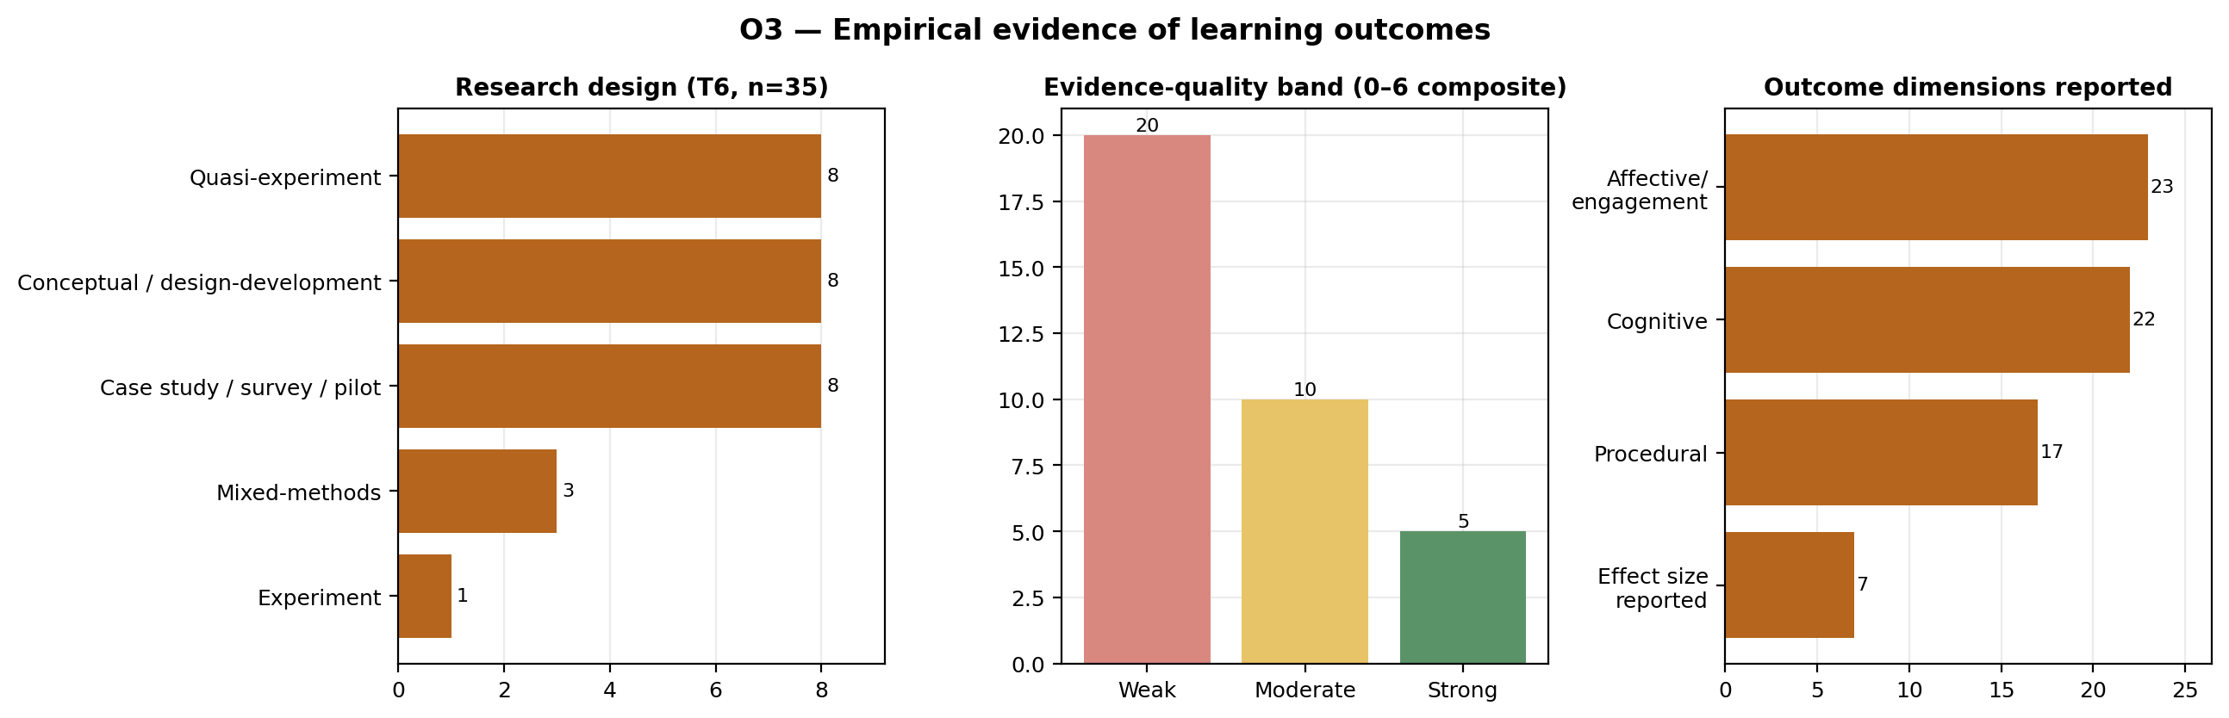
Figure 4. Empirical evidence of learning outcomes (Objective O3): research designs, comparators, reported outcome dimensions and the 0–6 evidence-quality composite. NASA-TLX = NASA Task Load Index.

O4 — Institutional benefits and critical barriers (T7+T8)
Institutional value (T7). Among the 21 studies addressing institutional value, accessibility and equity arguments are the most frequently articulated (86%), predominantly framed as geographic remote access; the geographic context of application was reported in all 21. However, the quantitative underpinnings of the institutional case are thin: implementation cost was reported in only 6 studies (29%), environmental-sustainability indicators in 3 (14%), and licensing model in 8 (38%, of which 6 open-source). The few studies that do quantify these dimensions are informative: Bonavolonta et al. (2026) provide a life-cycle assessment of an immersive electronics laboratory (≈7,000 kWh/year, ≈1.75 tCO₂/year, ≈200 kg of WEEE over seven years, and a per-student cost roughly four times lower than the traditional laboratory, with completion rising to 70% vs 56%), and Gallego & Vallverdú (2025) report a low-cost VR-teleoperated robotic arm at under €400. Post-COVID continuity, a common narrative motivation, is explicitly invoked in only 38% of these studies.
Barriers (T8). Twenty-eight studies discuss barriers, but reporting is again partial. Technical barriers are the most frequently documented (43%) — insufficient model fidelity, limited interoperability, latency/jitter, synchronisation complexity and cybersecurity — while institutional/teacher barriers (teacher training, curricular governance, resistance to change) and pedagogical/curricular barriers (the virtual-to-physical transfer gap, limited ecological validity, misalignment of competencies–activities–assessment) are each documented in roughly a quarter of studies. Scalability or transferability evidence was reported in 36%, usually as architectural argument rather than demonstrated multi-institution replication. Declared facilitating conditions (25%) converge on institutional commitment, industry partnerships, prior training and minimum infrastructure.
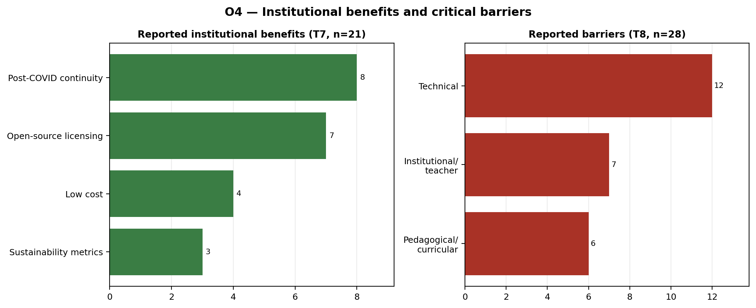
Figure 5. Institutional benefits and barriers (Objective O4): articulated benefits (accessibility, cost, sustainability, continuity) and reported barrier types (technical, institutional, pedagogical), with reporting rates. WEEE = waste electrical and electronic equipment.

Cross-cutting analysis: co-occurrence, gaps and relationships
The co-occurrence matrix (Figure 6) shows that the corpus is organised around a pedagogy–competencies–evidence core: the strongest theme pairings are T4–T5 (competencies × pedagogy, 34 studies) and T5–T6 (pedagogy × evidence, 31). AI (T3) is weakly connected to every other theme (maximum co-occurrence of 8, with T4). This structure motivates four configuration analyses that surface relationships not visible in the per-theme frequencies:
- Aspiration–evidence gap. Twenty-five studies (38%) claim Industry 4.0/5.0 competencies (T4) without activating empirical evaluation (T6), and 16 (25%) describe a pedagogical design (T5) with no empirical evidence. The competency claims of the field currently outpace its demonstrated learning outcomes.
- Optimism asymmetry. Sixteen studies (25%) report institutional benefits (T7) without discussing any barrier (T8), while 23 report barriers without claiming benefits. The presence of a substantial barriers-only group suggests the corpus is not uniformly promotional, but the benefits-without-barriers group should be read with caution.
- Immersive-without-evidence. Eight studies (12%) combine an immersive or practical environment (T1) with a pedagogical design (T5) but report no empirical outcomes (T6) — a recurring pattern of compelling demonstrations awaiting evaluation.
- Integrated maturity is rare. Only 3 studies (5%) assemble the full stack of environment + architecture + pedagogy + evidence (T1+T2+T5+T6: Sakkas et al. (2025); Tarng et al. (2024); Terkaj, Pessot, et al. (2024)), and only 1 combines a detailed architecture, AI and empirical evaluation (T2+T3+T6: Machado et al. (2025)).
The relational tables make three further associations explicit; given the small cell sizes these are descriptive, not inferential.
- Architecture maturity is decoupled from evaluation rigour. Only 4 studies both characterise the twin on the Kritzinger taxonomy (T2) and report an evaluable outcome (T6) with a quality band. In other words, the studies that describe how complete the twin is are largely not the studies that test whether it improves learning — a structural separation between the engineering and the educational evidence in the field.
- Effect-size reporting is low across all designs. The share of studies reporting an effect size is 0% for conceptual/design-development and mixed-methods studies, about 38% for case-study/survey/pilot and quasi-experimental studies, and 100% only for the single controlled experiment (Figure 7a). Even quasi-experiments report an effect size in only about a third of cases, so weak statistical reporting is pervasive rather than confined to the weakest designs.
- A shift toward fully bidirectional twins over time. Among architecture studies, “complete” digital twins are concentrated in 2024–2026 (10 of 18), whereas earlier years are dominated by digital shadows (Figure 7b). The terminological and technical ambition of the field is increasing, which makes the decoupling noted in point 1 — and the scarce reporting of AI and synchronisation metrics — the more consequential to address.
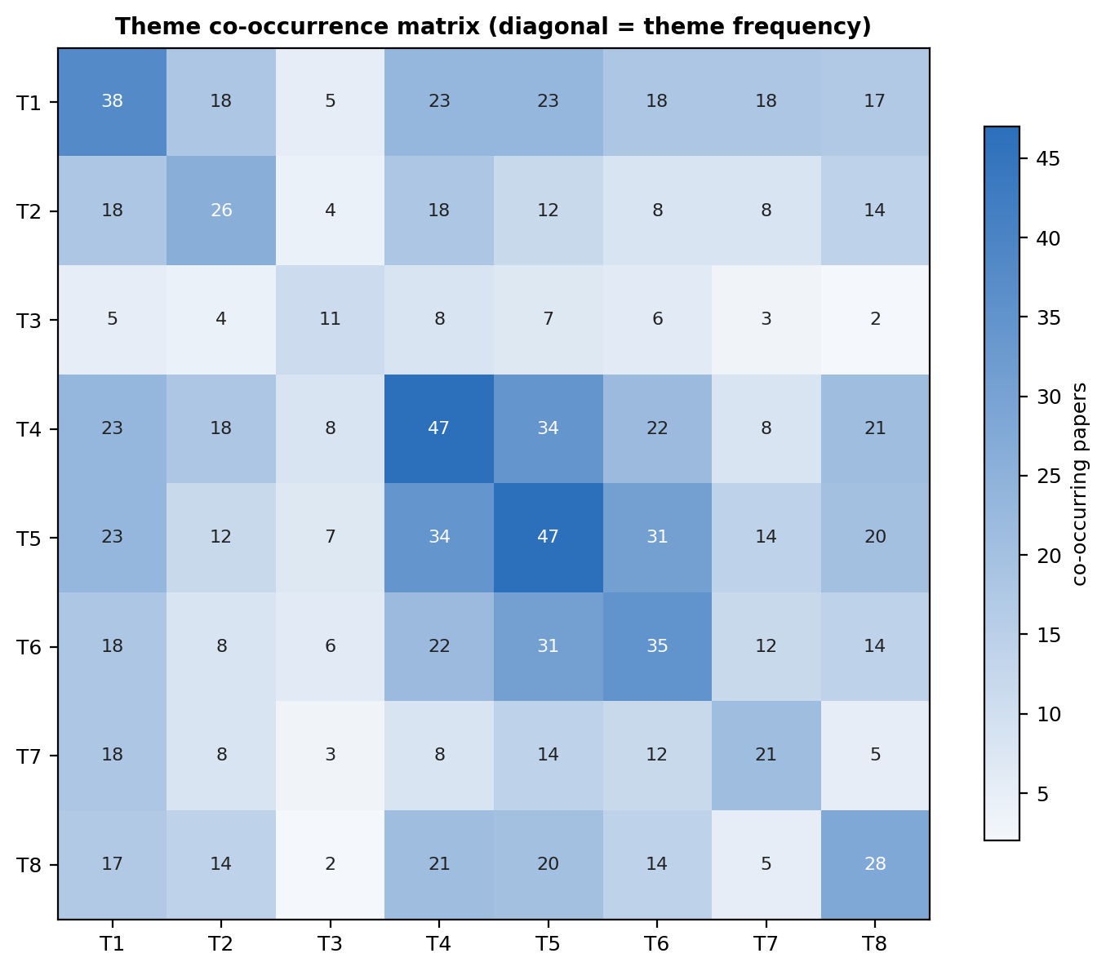
Figure 6. Theme co-occurrence matrix: number of studies jointly activating each pair of the eight inductive themes (T1–T8).
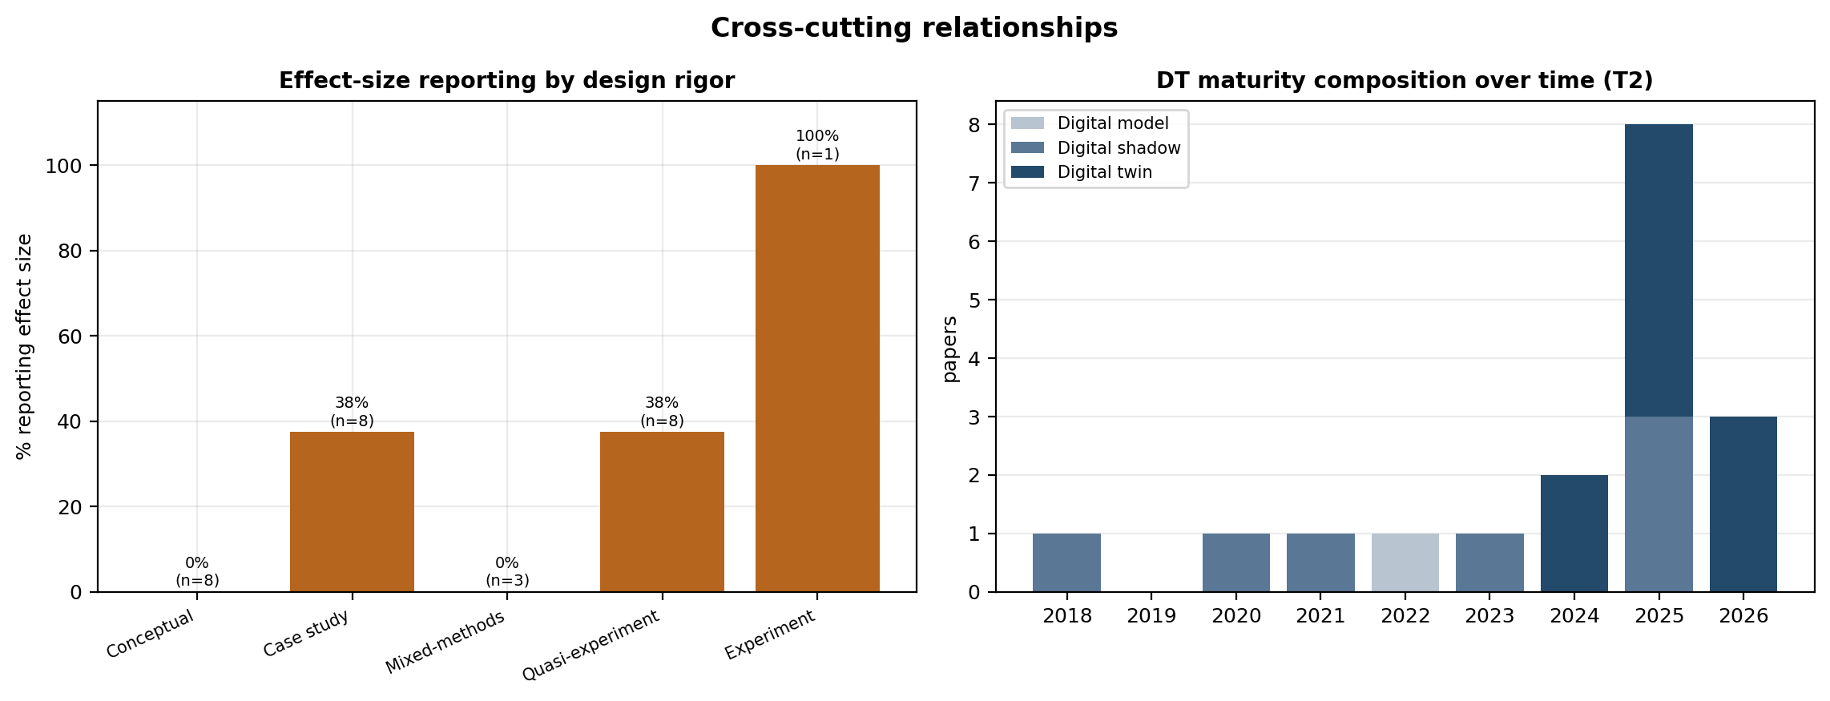
Figure 7. Relational analyses: (a) rate of effect-size reporting by research design; (b) digital-twin maturity (Kritzinger taxonomy) by publication year.

Advanced relational analysis (exploratory)
Because per-theme frequencies cannot show how technical, pedagogical and evaluative choices travel together, we examined pairwise associations between 18 binary study attributes spanning the four objectives (φ coefficient with Fisher exact tests over the 65 studies, plus non-parametric bootstrap 95% confidence intervals, B=5000). With this sample size the associations are hypothesis-generating rather than inferential; each is reported with its co-occurrence count and bootstrap CI, and we flag edges whose interval includes zero. The attribute network (Figure 8) is organised into three loosely connected communities rather than a single integrated cluster: (i) a technical-capability group in which bidirectional twins, real-time synchronisation and hybrid environments co-occur (φ=0.69, 95% CI [0.51, 0.86], between bidirectional DT and real-time sync; φ=0.40 [0.13, 0.65] between hybrid environment and bidirectional DT); (ii) an evaluation-rigour group in which rigorous design, comparator use, effect-size reporting and affective-outcome measurement co-occur (φ=0.60 [0.42, 0.77] design–comparator; φ=0.41 [0.16, 0.62] comparator–effect size); and (iii) a curricular group linking undergraduate level, active learning, industry collaboration and full life-cycle projects (φ=0.43 [0.11, 0.70] between life-cycle project and industry collaboration). One cross-objective signal is worth noting: the technical-capability and curricular communities are bridged mainly by a negative association (active-learning-labelled courses are less likely to use the most capable bidirectional twins). By contrast, the apparent link between immersive laboratories and environmental-sustainability quantification rests on only two studies and is not robust (φ=0.29, 95% CI [−0.07, 0.60], compatible with no association). Several attributes — AI augmentation, immersive environment, open-source licensing, sustainability quantification — remain isolated at the chosen threshold, indicating they do not yet co-occur systematically with rigorous evaluation. Across the six highlighted edges, five of six bootstrap CIs exclude zero, but several remain wide (e.g. life-cycle–industry [0.11, 0.70]), reinforcing that the network is best read as a map of hypotheses for confirmatory study.
The research-frontier gap map (Figure 9) plots each empirical study on technical capability (a 0–1 composite of maturity, synchronisation, AI and immersion) against evidence-quality score. Studies concentrate in the low-capability columns (18 of 35) and in the lower evidence-quality rows; the high-capability/strong-evidence corner — studies that are simultaneously technically advanced and rigorously evaluated — contains only 1 study (Tarng et al., 2024). This near-empty frontier is the central structural gap of the field and complements the qualitative decoupling reported above. The 3D evidence space (Figure 10, with an interactive version) and the MCA embedding (Figure 11) tell the same story from the multivariate side. The first MCA axis cleanly separates empirical from non-empirical/conceptual studies, recovering a valid topological structure of the field in which evaluation status is its dominant axis of organisation. As is intrinsic to the geometry of MCA, the share of inertia carried by this axis (12.3%) is modest; this is a property of the method rather than a sign of weak structure, and the separation should be read as a robust ordinal and topological pattern rather than as a proportion of variance explained.
Finally, Tables 1 and 2 make the most important contributions explicit. Table 1 lists the 15 empirical studies reaching at least a moderate evidence-quality score, with their designs, samples, comparators and reported effects — including the controlled studies of Kwateng & Leong (2026, between-group gain +18.5 vs +4.3, d=0.91), Tarng et al. (2024, ANCOVA F=71.9, p<0.001, η²=0.50), Lin et al. (2025, p. +31.2% transfer to novel problems with retention at 3 and 6 months), Lu & Hu (2025, p. d=1.06 in algorithm design) and Wang et al. (2025, p. +16.6% vs +7.5% knowledge mastery). These define the empirical frontier of the field. Table 2 lists the four studies that assemble the most complete technology–pedagogy–evidence stack (Sakkas et al., 2025; Tarng et al., 2024; Terkaj, Pessot, et al., 2024) or couple a detailed architecture with AI and evaluation (Machado et al., 2025); notably, only Tarng et al. (2024) combines a high-maturity twin with strong evidence, which is consistent with the decoupling and the empty frontier identified above.
Table 1. Empirical studies reaching at least a moderate evidence-quality score (composite ≥ 3 of 6), ordered by score. ES = effect size reported; NR = not reported. The composite sums design rigour, comparator, inferential statistics, effect size and declared validity threats.
Study | Domain | Design | N | Comparator | ES | Key reported result | Band (score)
Kwateng et al. (2026) | Manufacturing | Quasi-experiment | 140 | Control (no intervention) | Yes | Pre/post gain +18.5 vs +4.3 (control); t(198)=8.94, p<.001, d=0.91 | Strong (6)
Lin et al. (2025) | Automation | Experiment | 127 | Control group(s) | Yes | +31.2% transfer to novel problems; higher retention at 3 and 6 months | Strong (5)
Lu et al. (2025) | Programming | Quasi-experiment | 135 | Traditional class | No | Algorithm design d=1.06; debugging d=0.91 | Strong (5)
Tarng et al. (2024) | Robotics | Quasi-experiment | 75 | Traditional class | Yes | Post-test 8.71 vs 3.75; ANCOVA F=71.9, p<.001, η²=0.50 | Strong (5)
Wang et al. (2025) | Cybersecurity | Quasi-experiment | 60 | Traditional class | Yes | Knowledge mastery +16.6% vs +7.5% (control) | Strong (5)
Khan et al. (2026) | Manufacturing | Mixed-methods | 40 | Pre/post (within-subject) | No | 63% improvement in course-evaluation scores | Moderate (4)
Li (2025) | Chemical eng. | Case study / pilot | 95 | Traditional class | Yes | Knowledge-mastery gain 27.3% vs 11.5% (control) | Moderate (4)
Liljaniemi et al. (2025) | Mechatronics | Quasi-experiment | 96 | Physical laboratory | No | VR group +11.85% on component identification; parity on diagram interpretation | Moderate (4)
Ning et al. (2024) | Civil/construction | Quasi-experiment | 28 | Traditional class | No | Significantly better academic performance | Moderate (4)
Ortiz et al. (2025) | Automation | Quasi-experiment | 16 | Pre/post (within-subject) | No | Task time 18.2→12.5 min; error rate 21.6%→7.8% | Moderate (4)
Park et al. (2026) | NR | Quasi-experiment | 10 | Traditional class | No | Improved conceptual-knowledge quiz scores (pilot) | Moderate (4)
Álvarez Ariza et al. (2026) | Multi-case | Case study / pilot | 119 | Pre/post (within-subject) | Yes | 96.5–100% agreement on fundamental-knowledge development | Moderate (4)
García et al. (2026) | Digital logic | Case study / pilot | 30 | None | Yes | Task completion 100% / 93.3% / 80% / 73.3% by difficulty | Moderate (3)
Speicher et al. (2026) | Manufacturing | Case study / pilot | 6 | Traditional vs smart-mfg | No | Machining cycle time 58→28 min (>50% reduction) | Moderate (3)
de Melo Freires et al. (2025) | Postgraduate STEM | Mixed-methods | 24 | Pre/post (within-subject) | No | Share rating comprehension 4–5 rose to 90.9% (from 27.3%) | Moderate (3)
Table 2. Reference-architecture configurations: studies assembling the most complete technology–pedagogy–evidence stack (full-stack T1+T2+T5+T6) or coupling a detailed architecture with AI and empirical evaluation (T2+T3+T6). DT type follows the Kritzinger et al. taxonomy; NR = not reported.
Study | Configuration | Environment | DT type | AI | Pedagogy | System modelled | Evidence band
Sakkas et al. (2025) | Full-stack (T1+T2+T5+T6) | Virtual-only | Digital shadow | — | Active learning | Electronic circuits (Arduino, ESP32) | Weak
Tarng et al. (2024) | Full-stack (T1+T2+T5+T6) | Hybrid physical–virtual | Digital twin | — | NR | WLKATA six-axis industrial robotic arm | Strong
Terkaj, Pessot, et al. (2024) | Full-stack (T1+T2+T5+T6) | Hybrid physical–virtual | NR | — | NR | Manufacturing plant | Weak
Machado et al. (2025) | Architecture+AI+evidence (T2+T3+T6) | Remote | NR | CNN, generative AI, LLM, data-driven | NR | Manufacturing plant (CP-LAB) | Weak
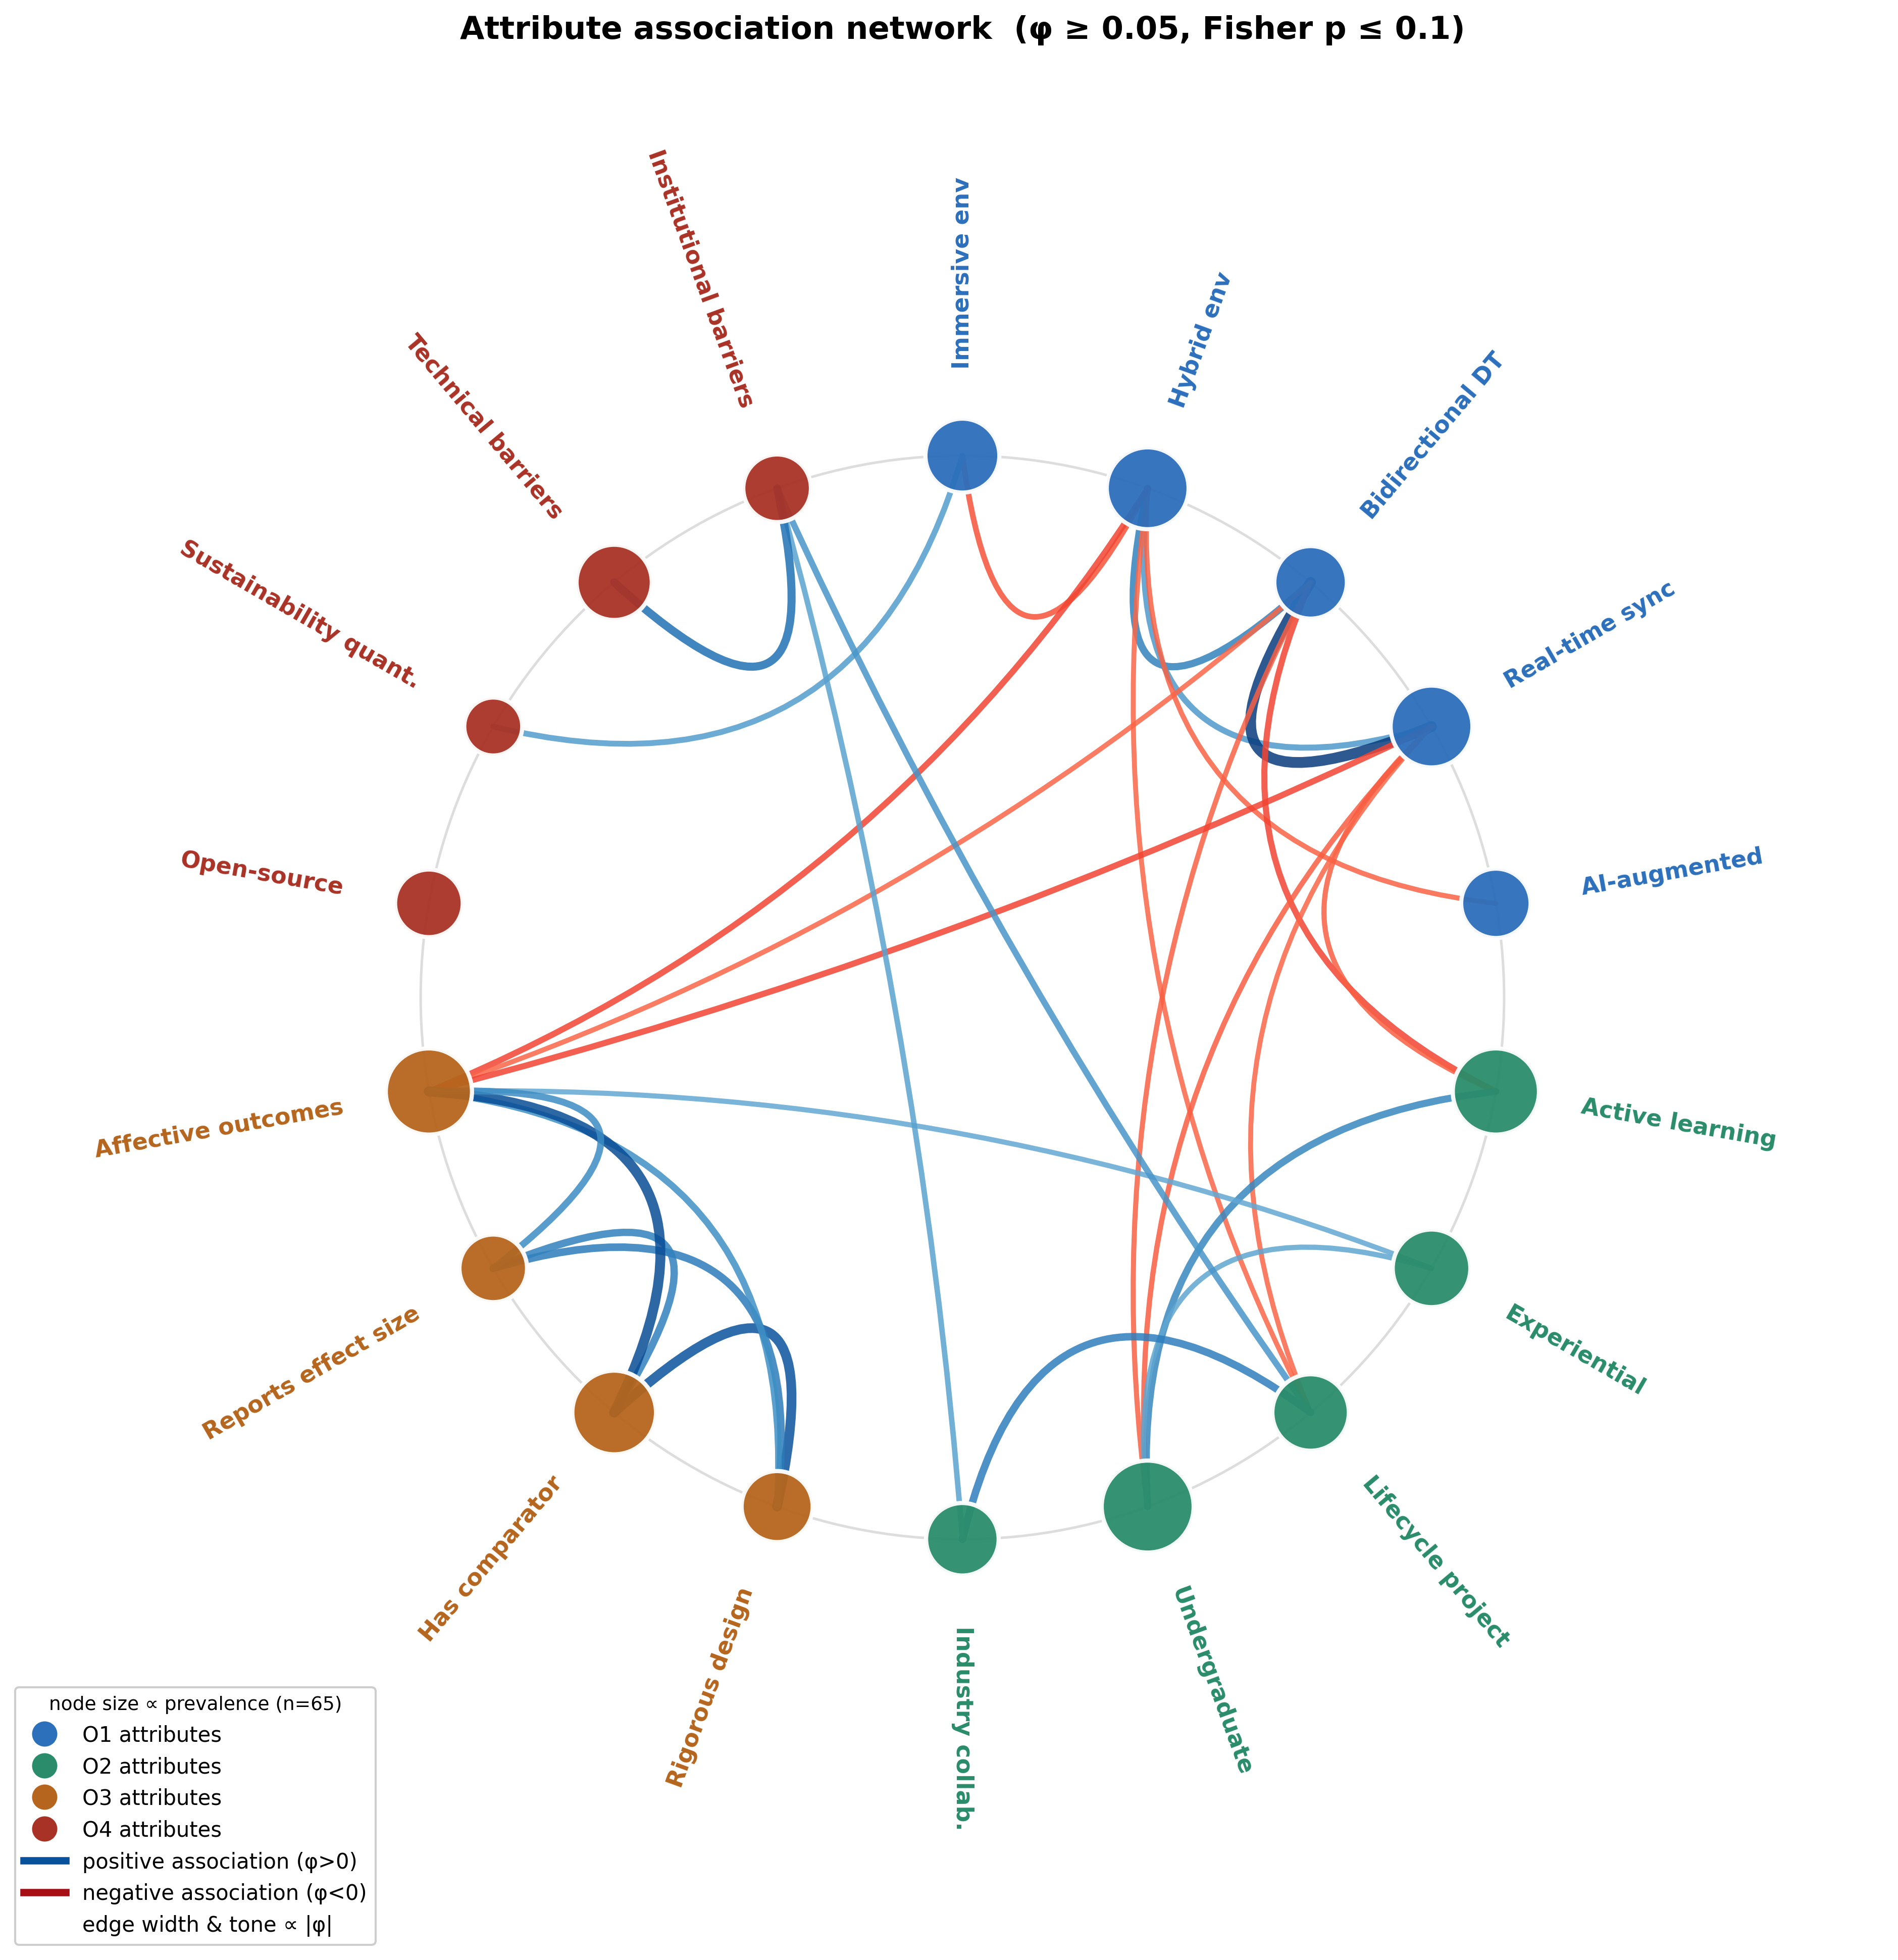
Figure 8. Attribute-association network. Nodes are binary study attributes; edges are pairwise φ associations whose bootstrap 95% confidence interval (CI) excludes zero (B = 5,000). Communities: technical capability, evaluation rigour, curricular design.
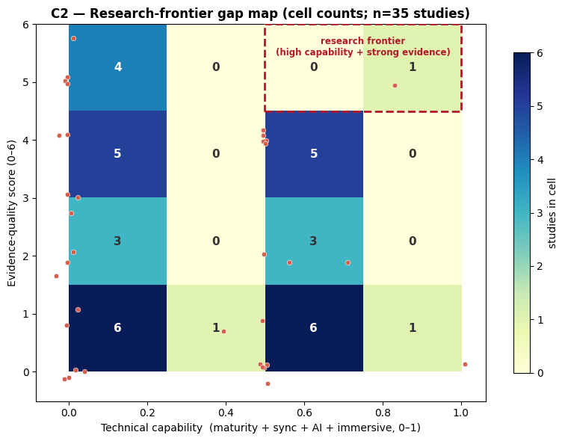
Figure 9. Capability-by-evidence gap map: each empirical study plotted by technical-capability composite (0–1: maturity, synchronisation, AI, immersion) against evidence-quality score (0–6). The high-capability, strong-evidence corner is near-empty.
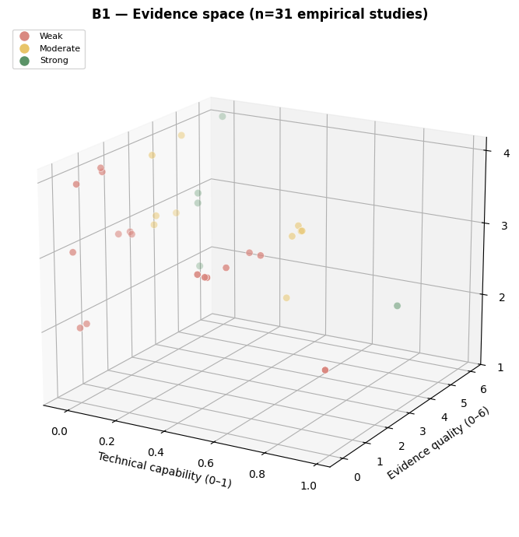
Figure 10. Three-dimensional evidence space (technical capability × evidence quality × publication year). An interactive version is provided as supplementary material.
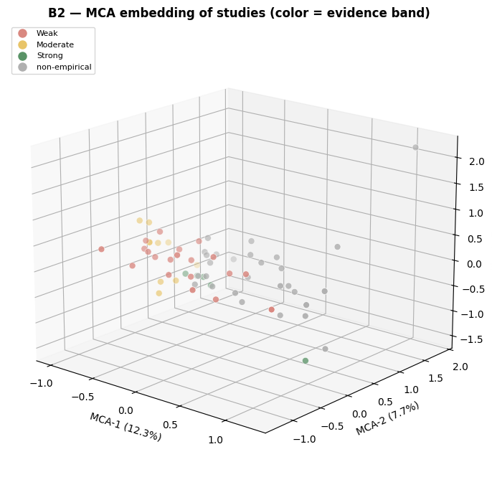
Figure 11. Multiple correspondence analysis (MCA) embedding of study attributes. The first axis (12.3% of inertia) separates empirical from non-empirical/conceptual studies.

Summary
The corpus consistently demonstrates feasibility and engagement and is disciplinarily broad, with a recent shift toward more capable, bidirectional, and occasionally AI-augmented twins. The weight of the evidence, however, rests on a minority of methodologically strong studies; competency and benefit claims frequently lack matched empirical or quantitative support; and the technical description of the twin is largely separate from the evaluation of its educational effect. These patterns directly inform the gaps and future-research agenda developed in the Discussion.

Discussion
This review set out to characterise educational digital twins (DTs) across four objectives and, crucially, to examine how their technical, pedagogical and evaluative dimensions travel together. The synthesis of 65 studies yields a consistent but sobering picture: the field reliably demonstrates feasibility and engagement, is disciplinarily broad, and is shifting toward more capable, bidirectional and occasionally AI-augmented twins, yet its evidence rests on a small minority of methodologically strong studies. Interpreting this pattern, not the headline enthusiasm, is the purpose here.
The most consequential finding is structural rather than aggregate: across the corpus, the maturity of the twin is largely decoupled from the rigour with which it is evaluated. The studies that describe how complete a twin is—its bidirectional synchronisation, its layered architecture—are seldom the studies that test whether it improves learning, and the capability-by-evidence frontier is almost empty. This decoupling mirrors a tension documented across the wider DT literature, where academic sophistication consistently outpaces validated deployment and workforce readiness (S. Chen et al., 2025). It is compounded by terminological inflation: the prevalence of self-described “complete” twins, rarely accompanied by latency or synchronisation measurements, suggests that the label is applied more loosely than the established physical-to-virtual and virtual-to-physical data-flow criteria would warrant (Thelen et al., 2022), and that the field still lacks shared criteria for evaluating what a twin actually does (Liu et al., 2025). Claims of Industry 4.0/5.0 competence and institutional benefit similarly outpace demonstrated outcomes, and the asymmetry between benefit-only and barrier-only studies counsels caution in reading the field’s optimism at face value.
Three exploratory analyses sharpen this reading. The thematic co-occurrence structure (Figure 6) shows a field organised around a pedagogy–competencies– evidence core—competencies and pedagogy co-occur in 34 studies and pedagogy and evidence in 31—while the AI dimension stays peripheral, never co-occurring with another theme in more than eight studies; the DT–AI convergence prominent in the industrial literature (S. Chen et al., 2025; Liu et al., 2025) thus remains marginal and largely unvalidated in education. The attribute-association network (Figure 8) resolves the studies into three loosely connected communities—technical capability, evaluation rigour and curricular design—bridged between the technical and curricular groups mainly by a negative association, whereby courses labelled “active learning” tend not to employ the most capable bidirectional twins. The research-frontier gap map (Figure 9) localises the decoupling: of 35 empirical studies, eighteen fall in the lowest-capability columns and only one occupies the high-capability, strong-evidence cell, while the multivariate embedding (Figure 11) recovers a valid topological structure whose dominant axis separates empirical from non-empirical work. Tellingly, effect-size reporting is flat across design types even as twin maturity rises over time (Figure 7), so weak quantification is a field-wide habit, not an artefact of the weakest designs.
These patterns demand interpretive caution. They derive from 65 studies spread across many sparsely populated cells; the association estimates carry wide bootstrap confidence intervals, several compatible with no effect—the apparent link between immersive laboratories and sustainability quantification, for instance, rests on only two studies—and the embedding accounts for only a modest share of inertia. They are therefore best read as a map of hypotheses for confirmatory study, not as established relationships. That such an exploratory layer is necessary is itself diagnostic of how little well-reported empirical work the field has produced.
These observations extend, rather than echo, prior syntheses of DTs in education. Earlier bibliometric work mapped the field’s rapid growth and flagged unresolved questions around teacher competence and governance, but did not weigh the quality of the underlying learning evidence (Chamorro-Atalaya et al., 2024); domain-specific reviews reached a “strong consensus” on DT effectiveness for training while themselves noting the fragmented, largely conceptual nature of the literature (Omrany et al., 2026); and materials-science mapping documents exponential output without appraising educational outcomes at all (Vergara et al., 2025). By coupling a structured description of architecture and pedagogy with an explicit, sensitivity-tested quality appraisal and a relational analysis, the present review adds the dimension these accounts lack: not how much is published, but how well what is claimed has been shown.
The few strong studies in our corpus report substantial gains, of the order of Cohen’s d between 0.9 and 1.2. These sit at, or above, the upper bound of meta-analytic estimates for comparable immersive interventions—knowledge- acquisition effects around a standardised mean difference of 0.33–0.48 in virtual- and augmented-reality simulation (AlMekkawi et al., 2026; Li et al., 2026), and collaborative- or mobile-VR effects near Hedges’ g 0.47–0.50 (C.-H. Chen et al., 2026; Widowati et al., 2025). This positioning warrants restraint. Such meta-analyses report high heterogeneity and inconsistent effects across domains; more pointedly, effect sizes in this literature have declined over time as designs have become more rigorous—from very large early estimates to small recent ones (Widowati et al., 2025)—a trajectory consistent with novelty effects and weak controls. Our predominantly recent, single-institution, non-randomised studies are precisely those most exposed to this inflation, reinforcing that the reported gains are promising but not yet robustly generalisable.
A second under-examined frontier concerns whether learning on a twin transfers to physical practice. The corpus rarely tests this, and the broader evidence offers little reassurance: in a review of 64 VR studies, only two examined transfer at all (Zhong et al., 2026). Transfer cannot be assumed from immersion or visual fidelity; it depends on functional rather than merely perceptual correspondence (Harris et al., 2020), and inadequate technical fidelity can even produce negative transfer (Kim & Kirollos, 2026). The corpus’s habit of asserting twin “completeness” without synchronisation or fidelity metrics is therefore not a minor reporting gap but a direct threat to the ecological-validity claims on which much of the pedagogical case rests.
Several implications follow. For curriculum design, DTs should be paired with an intentional, named pedagogy and aligned assessment rather than deployed as active-learning settings whose instructional model is left implicit. Concretely, future implementations should move beyond generic “active experimentation” and anchor their designs in explicit learning theory: constructivist and social-constructivist principles for knowledge building, Biggs’ constructive alignment to lock intended competencies, twin-based activities and assessment into a single coherent system (Biggs, 1996), and—where the goal is learner self-direction in open-ended, capability-oriented tasks—student-agency models such as heutagogy (Blaschke, 2012). The negative technical–curricular bridge in the attribute network suggests engineering ambition and pedagogical design are currently advancing on parallel tracks; naming and theorising the pedagogy is what would allow the instructional design to keep pace with the sophistication of the twin. For researchers, the priority is methodological: pre-registered comparators, reported effect sizes, and explicit measurement of retention and transfer, supported by designs—including rigorous single-case and quasi-experimental approaches—suited to authentic laboratory settings (Dayo et al., 2024), with the reporting transparency that educational-technology research is repeatedly found to lack (Demir & Uşak, 2025). For institutions, accessibility and sustainability claims need instrumentation rather than assertion, particularly where digital-divide constraints shape who benefits (Eltaiba et al., 2025). For tool builders, interoperability, synchronisation metrics and the validation of AI components remain prerequisites for credible educational deployment (S. Chen et al., 2025).
Several limitations qualify this synthesis. The corpus is recent and skewed toward manufacturing and automation and undergraduate cohorts; the relational analyses rest on small cell counts and are hypothesis-generating rather than confirmatory; and the evidence-quality composite is necessarily ad hoc, though its banding proved robust under threshold-sensitivity analysis. We deliberately refrained from meta-analysis, a decision the marked clinical and methodological heterogeneity of the broader literature retrospectively supports (Widowati et al., 2025). The agenda these gaps define is concrete: populate the empty capability-by-evidence frontier with pre-registered, multi-institution quasi-experiments on high-maturity twins; measure transfer and retention rather than immediate satisfaction; validate AI-augmented and cognitive twins against declared performance criteria; and standardise the reporting of synchronisation, cost and sustainability, so that the field’s momentum can mature into cumulative, trustworthy evidence.

Conclusions
Regarding the technological architectures and deployment environments (O1), educational digital twins are realised predominantly as hybrid physical–virtual and immersive configurations rather than as fully instrumented, closed-loop systems. The field’s technical ambition is rising—bidirectional and occasionally AI-augmented twins are increasingly described—but the terminology frequently outpaces verified synchronisation, and the convergence with artificial intelligence remains incipient and largely unvalidated. The technological maturity of the field is therefore, at present, more often asserted than demonstrated, and claims of completeness are best read as descriptive rather than evidential until synchronisation and fidelity are actually measured.
On the pedagogical and curricular dimension (O2), digital twins are consistently embedded in active, experiential and project-based designs and span a widening range of engineering disciplines, signalling genuine pedagogical intent and disciplinary breadth. Yet the instructional model is often left implicit, and the competencies attributed to Industry 4.0/5.0 are seldom anchored to recognised standards or validated with industry. The pedagogical case is thus plausible but under-specified: technical capability and intentional instructional design are advancing on parallel rather than integrated tracks.
With respect to the empirical evidence of learning outcomes (O3), the corpus establishes feasibility and positive engagement, and a minority of methodologically stronger studies report meaningful gains; these, however, sit within a heterogeneous and weakly reported base in which inferential statistics and effect sizes are the exception rather than the norm. The present evidence justifies cautious optimism about engagement and proof of concept, but does not yet support robust or generalisable claims of learning efficacy, particularly concerning skill transfer and longer-term retention.
Concerning institutional benefits and barriers (O4), accessibility, educational continuity and sustainability are argued far more often than they are quantified, while the technical, pedagogical and institutional barriers are reported unevenly. The presence of a substantial barriers-aware literature indicates that the field is not uniformly promotional; even so, the recurring assertion of benefits without a matched account of limitations counsels restraint. The institutional value proposition remains largely rhetorical pending the instrumentation of cost, environmental and equity claims.
Taken together (general objective), this review characterises a field that reliably demonstrates feasibility, engagement and disciplinary breadth, yet whose defining feature is a structural decoupling between the maturity of the twin and the rigour of its evaluation, with competence and institutional claims outpacing demonstrated outcomes. The contribution of this synthesis is not to adjudicate whether digital twins “work”, but to weight the available evidence and make this decoupling—and the near-empty frontier where technical sophistication meets strong evaluation—explicit. Digital twins in engineering education are best understood as a promising but not yet evidentially consolidated approach, whose trajectory will depend less on further technical demonstration than on the quality of the evidence brought to bear on it. In this, the review offers engineering education research a sharper criterion for judging progress—evidential quality rather than technical novelty—and offers practice a caution against equating sophistication with demonstrated learning.
Several recommendations follow. For researchers, the priority is evidential consolidation: pre-registered, multi-institution studies on higher-maturity twins, with explicit comparators, reported effect sizes, and the measurement of transfer and retention rather than immediate satisfaction; AI and synchronisation components should be validated against declared performance criteria. For educators, digital twins should be paired with an explicit pedagogical model—grounded in constructivist learning theory, constructive alignment, or learner-agency frameworks—and aligned assessment, and competencies linked to recognised standards. For institutions and tool developers, cost, sustainability, accessibility, interoperability and synchronisation should be reported with metrics rather than asserted. To support cumulative, verifiable progress, the full protocol, screening trace, extraction dataset and analysis code underlying this review are released openly (GitHub and Zenodo), so that the synthesis can be audited, reused and extended. Finally, the review itself should be strengthened before any update by registering the protocol, reporting the remaining inter-rater reliability, and recovering the full texts that could not be retrieved, so that the corpus on which these conclusions rest is as complete as the field allows.

Statement on Artificial Intelligence
In the interest of transparency, and consistent with the journal’s policy, we disclose the following uses of artificial intelligence (AI) in this work, beyond the standard copyediting tools embedded in word processors (e.g., grammar checkers).
Inductive thematic analysis. The eight inductive themes (T1–T8) were derived with three frontier LLMs — ChatGPT 5.5, Gemini 3.1 Pro, and Claude Opus 4.7 — whose independent codings were iteratively cross-fed and refined under author review. The resulting theme–objective scheme and all decisions were determined by the authors; the three models’ raw outputs are available in the public repository.
Data screening. Three independent large language model (LLM) agents — implemented with DeepSeek-V4-Flash in a non-reasoning configuration at temperature 0 to ensure deterministic, reproducible classification — performed the semantic screening of records against the protocol’s pre-specified inclusion/exclusion tests and construct-severity mapping, each returning a decision, a confidence score, and the governing criterion; a fourth agent (same model and settings) acted as moderator for split or uncertain cases. AI-assigned decisions were not treated as final: inter-agent reliability was quantified (Fleiss’ κ = 0.60), all records flagged as include or uncertain were reviewed by the authors, and the eligibility of every included study was confirmed by a human. This use is described in the Methods (Study selection).
Data processing. Full-text PDFs were converted to structured text with an automated document-parsing pipeline (Marker) to support extraction. Every extracted value was verified by a human against the source and recorded with a verbatim supporting quotation and its location (Methods, Data extraction). The analytical results — descriptive profiling, the evidence-quality composite, and the relational analyses — were produced by an author-developed, reproducible computational pipeline, not generated by AI.
Manuscript development. Generative AI tools were used to assist with drafting and language refinement of portions of the manuscript. All AI-assisted text was reviewed, edited, and verified by the authors.
AI tools were not used to generate, alter, or fabricate data; to select, invent, or format references; or to produce the study’s findings. The authors take full responsibility for the validity, accuracy, and integrity of the entire manuscript, including all claims, citations, and references.

Data and Code Availability
All materials supporting this review are openly available: the review protocol and extraction schemas, the database search exports, the full screening trace (per-record agent decisions, confidence scores, governing criteria, and final status), the extraction dataset with verbatim supporting quotations, the evidence-quality scoring, and the complete, end-to-end analysis and figure-generation code — including the theme co-occurrence, multiple correspondence analysis, and attribute-association-network pipelines. These are released in a public GitHub repository and archived on Zenodo with a citable DOI ([repository URL and Zenodo DOI to be inserted on acceptance]), under an MIT license for code and a CC BY 4.0 license for data and text. The review followed a pre-specified protocol (Review Protocol v2); the protocol will be registered (PROSPERO/OSF) before any update.

References
The reference list below includes all works cited in the text. The 65 primary studies included in the systematic review are listed in full in Appendix A.
Abdelrahman, M., Macatulad, E., Lei, B., Quintana, M., Miller, C., & Biljecki, F. (2025). What is a Digital Twin anyway? Deriving the definition for the built environment from over 15,000 scientific publications. Building and Environment, 274. https://doi.org/10.1016/j.buildenv.2025.112748
Al-Jumeily, D., Coombs, T., & Assi, S. (2026). Implementing Skills 4.0 in Higher Education: Pros and Cons. Higher Education in the Arab World: Artificial Intelligence, 115–142. https://doi.org/10.1007/978-3-031-99068-7_6
Alkhedher, M., Mohamad, O., & Alavi, M. (2021). An interactive virtual laboratory for dynamics and control systems in an undergraduate mechanical engineering curriculum - A case study. Global Journal of Engineering Education, 23(1), 55–61. https://www.scopus.com/pages/publications/85103183610?origin=resultslist
AlMekkawi, M., ElKhalil, R., Nalubega, S., Pandarakutty, S., Maalouf, I., Aldawsari, A., Bashayreh, I., & Maqbali, M. A. (2026). Effectiveness of virtual and augmented reality in undergraduate nursing education: A meta-analysis of learning outcomes. Teaching and Learning in Nursing. https://doi.org/10.1016/j.teln.2026.05.001
Álvarez Ariza, J., & Hernández Hernández, C. (2026). Investigating the Impact of Education 4.0 and Digital Learning on Students’ Learning Outcomes in Engineering: A Four-Year Multiple-Case Study. Informatics, 13(2), 18. https://doi.org/10.3390/informatics13020018
Andrieu, G., Fredon, T., Farah, S., & Aknin, N. (2021). Remote Laboratory Implementation for the Study of Transmission Lines. Proc. Int. E-Eng. Educ. Serv. Conf., e-Engineering, 107–110. https://doi.org/10.1109/e-Engineering47629.2021.9470570
Azofeifa, J. D., Gonzalez-Gomez, L. J., Rueda-Castro, V., Gómez-Puente, S. M., Noguez, J., & Caratozzolo, P. (2025). Top Occupations Based on a Strategic Taxonomy Framework of Future Skills for Workforce Development. IEEE Global Eng. Edu. Conf., EDUCON. https://doi.org/10.1109/EDUCON62633.2025.11016445
Biggs, J. (1996). Enhancing teaching through constructive alignment. Higher Education, 32(3), 347–364. https://doi.org/10.1007/BF00138871
Blaschke, L. M. (2012). Heutagogy and lifelong learning: A review of heutagogical practice and self-determined learning. The International Review of Research in Open and Distributed Learning, 13(1), 56–71. https://doi.org/10.19173/irrodl.v13i1.1076
Bokhtiar Al Zami, M., Shaon, S., Khanh Quy, V., & Nguyen, D. C. (2025). Digital Twin in Industries: A Comprehensive Survey. IEEE Access, 13, 47291–47336. https://doi.org/10.1109/ACCESS.2025.3551532
Bolanos, D., Caizaluisa, C., Zapata-Hidalgo, D., & Loza-Matovelle, D. (2026). Design and Implementation of a Digital Twin-Enhanced Collaborative Robot for Applied Robotics Education in STEM Environments. Revista Iberoamericana de Tecnologias Del Aprendizaje, 21, 194–203. https://doi.org/10.1109/RITA.2026.3675117
Bonavolonta, F., Verde, M. T., Schiano Lo Moriello, R., & Liccardo, A. (2026). Sustainability comparison between a traditional electronics measurement laboratory and an immersive metaverse laboratory: An extended life cycle assessment analysis. Acta IMEKO, 15(1), 1–nov. https://doi.org/10.21014/actaimeko.v15i1.2199
Chamorro-Atalaya, O., Flores-Velásquez, C. H., Flores-Cáceres, R., Arévalo-Tuesta, J. A., Zevallos-Castañeda, M., Tomás-Quispe, G., Aranda-Dextre, C. C., Cruz-Telada, Y., Caller-Luna, J., & Alarcón-Anco, R. (2024). Use of Digital Twin Technology in the Teaching-Learning Process, in the field of University Education: A Bibliometric Review. International Journal of Learning, Teaching and Educational Research, 23(2), 313–329. https://doi.org/10.26803/ijlter.23.2.15
Chen, C.-H., Kuo, P.-J., & Chang, S.-H. (2026). Effects of virtual reality-based collaborative learning on students’ learning achievement: A meta-analysis. Educational Research Review, 52. https://doi.org/10.1016/j.edurev.2026.100785
Chen, S., Turanoglu Bekar, E., Bokrantz, J., & Skoogh, A. (2025). AI-enhanced digital twins in maintenance: Systematic review, industrial challenges, and bridging research–practice gaps. Journal of Manufacturing Systems, 82, 678–699. https://doi.org/10.1016/j.jmsy.2025.07.006
Chumchuen, N., & Akatimagool, S. (2023). Remote Virtual Laboratory Innovation on MIAP Engineering Teaching Model for Electrical Measurement Course. In Auer M.E., Pachatz W., & Rüütmann T. (Eds.), Lect. Notes Networks Syst.: 633 LNNS (pp. 423–431). Springer Science; Business Media Deutschland GmbH. https://doi.org/10.1007/978-3-031-26876-2_40
Cuperman, D., & Raveh, I. (2026). Academic Faculty Perceptions of Incorporating Industry 4.0 Technologies in Engineering Higher Education. International Journal of Engineering Pedagogy, 16(1), 4–23. https://doi.org/10.3991/ijep.v16i1.59353
Dautaj, M., Rossi, M., & Terzi, S. (2026). The Importance of Skills for Society 5.0. In Mizuyama H., Morinaga E., Kaihara T., Nonaka T., von Cieminski G., & Romero D. (Eds.), IFIP Advances in Information and Communication Technology: 769 IFIPAICT (pp. 93–106). Springer Science; Business Media Deutschland GmbH. https://doi.org/10.1007/978-3-032-03550-9_7
Dayo, N., Said Metwaly, S., & Van Den Noortgate, W. (2024). Evaluating technology enhanced learning by using single-case experimental design: A systematic review. British Journal of Educational Technology, 55(6), 2457–2477. https://doi.org/10.1111/bjet.13468
De Larmelina, S., Da Silva, A. L., & Risso, L. A. (2026). Conceptualizing the Digital Twin: An Analysis of Definitions, Applications, Technologies, Benefits and Challenges. Journal of Advanced Manufacturing Systems, 25(2), 253–279. https://doi.org/10.1142/S0219686726500125
Demir, S., & Uşak, M. (2025). Analyzing the Implementation of PLS-SEM in Educational Technology Research: A Review of the Past 10 Years. SAGE Open, 15(2). https://doi.org/10.1177/21582440251345950
Denissova, O., Suieubayeva, S., Zakimova, А., Mashekenova, A., Thinakaran, R., & Roseley, N. R. N. (2026). Factors Determining the Development of Engineering Education in the Labor Market and the Real Sector of the Economy of the East Kazakhstan Region. AIMS Energy, 22(3), 95–110. https://doi.org/10.24191/jmeche.v22i3.5680
Eltaiba, N., Hosseini, S., & Okoye, K. (2025). Benefits and impact of technology-enhanced learning applications in higher education in Middle East and North Africa: A systematic review. Global Transitions, 7, 350–374. https://doi.org/10.1016/j.glt.2025.06.004
Espinoza, K. E., Jimbo, M. A., Romero, J. B., & Cabrera, E. A. (2025). Virtual reality evolution in Latin American higher education: A systematic review of trends, benefits, and challenges in the last decade. Formacion Universitaria, 18(6), 35–46. https://doi.org/10.4067/S0718-50062025000600035
Fan, H., & Zhang, X. (2025). Impacts of Immersive Virtual Reality Devices on Learning Outcomes across Disciplines in Higher Education: A PRISMA-Based Systematic Review. Proc. Int. Conf. Big Data Econ. Inf. Manag., BDEIM, 104–110. https://doi.org/10.1145/3724154.3724172
Gallego, J., & Vallverdú, F. (2025). Low-Cost Digital-Twin VR Teleoperation of a 3D-Printed Robotic Arm for STEM Education. 2025 11th International Conference on Virtual Reality, ICVR 2025, 351–356. https://doi.org/10.1109/icvr66534.2025.11172534
Giussani, R., Dozio, N., Becattini, N., Cascini, G., Ferrise, F., & Morosi, F. (2025). Study on the Benefits of Virtual Reality as a Support for STEM Learning. Computer Applications in Engineering Education, 33(4). https://doi.org/10.1002/cae.70065
Haase, J. (2022). Teaching Engineering Students Practical Skills By Means of Remote Laboratories. IEEE Reg. Humanit. Technol. Conf.: Sustain. Technol. Humanit., R10-HTC, 2022-September, 419–424. https://doi.org/10.1109/R10-HTC54060.2022.9929842
Harris, D. J., Bird, J. M., Smart, P. A., Wilson, M. R., & Vine, S. J. (2020). A Framework for the Testing and Validation of Simulated Environments in Experimentation and Training. Frontiers in Psychology, 11. https://doi.org/10.3389/fpsyg.2020.00605
Hunpinyo, P., Narataruksa, P., Ampaipisut, A., Nonbudsri, A., Inthapattha, C., Chokkhanapitak, C., Kanchanathanaseth, K., Sangthong, N., Petiraksakul, P., Meechai, A., Saranuttee, P., & Naknon, A. (2026). An ISA95 Aligned Pedagogical Framework for Remote Process Automation in Chemical Engineering Education. Journal of Chemical Education, 103(3), 1238–1249. https://doi.org/10.1021/acs.jchemed.5c00719
Jiang, X., Johar, M. G. M., & Tham, J. (2026). The State of Virtual Reality in Higher Education: A Bibliometric Visual Analysis Based on CiteSpace. International Journal of Pattern Recognition and Artificial Intelligence, 40(8). https://doi.org/10.1142/S0218001426560069
Jin, Y., Osman, K., & Arsad, N. M. (2026). Extended Reality (XR) and Immersive Learning: The Impact of Virtual, Augmented, and Mixed Reality on Experiential and Situated Learning in STEM Higher Education. Learning and Analytics in Intelligent Systems, 59, 259–291. https://doi.org/10.1007/978-3-032-09058-4_15
Kabir, Md. R., & Ray, S. (2025). Digital Twin Tools for Smart Manufacturing: A Paradigm Shift for Industry 4.0. IEEE Open Journal of the Industrial Electronics Society, 6, 1756–1770. https://doi.org/10.1109/OJIES.2025.3628531
Khan, M. S., Fatima, A., & Irwin, J. (2026). In Teaching Lean Manufacturing with Digital Twin: A Modern Approach to Engineering Education. Journal of Engineering Technology, 43(1), 28–38. https://doi.org/10.18260/jet.43.1.3
Kim, J. J.-J., & Kirollos, R. (2026). Effect of simulator frame rate on pilot training for high-speed fighter aircraft. Frontiers in Physiology, 17. https://doi.org/10.3389/fphys.2026.1763485
Kumar Karanam, S. A., & Hartman, N. W. (2025). A systematic review of Digital Twin (DT) and virtual learning environments (VLE) for smart manufacturing education. Manufacturing Letters, 44, 1597–1608. https://doi.org/10.1016/j.mfglet.2025.06.179
Kwateng, F., & Leong, W. Y. (2026). Enhancing engineering learning through digital twin and IoT applications: Student engagement and industry alignment in the Ghanaian context. Eurasia Journal of Mathematics, Science and Technology Education, 22(3), em2787. https://doi.org/10.29333/ejmste/17970
Lainidis, I., & Mystakidis, S. (2026). Systematic Literature of Immersive Learning Design with Virtual Reality for STEM Education in Higher Education. In Krüger J.M., Schmidt M., Mikropoulos A., Koutromanos G., Pedrosa D., Beck D., Mystakidis S., Smith-Nunes G., Peña-Rios A., & Richter J. (Eds.), Commun. Comput. Info. Sci.: 2598 CCIS (pp. 219–233). Springer Science; Business Media Deutschland GmbH. https://doi.org/10.1007/978-3-031-98080-0_14
Lampropoulos, G., Fernández-Arias, P., Bosque, A. de, & Vergara, D. (2025). Virtual Reality in Engineering Education: A Scoping Review. Education Sciences, 15(8). https://doi.org/10.3390/educsci15081027
Lee, J. Y., Pyon, C. U., & Woo, J. (2023). Digital Twin for Math Education: A Study on the Utilization of Games and Gamification for University Mathematics Education. Electronics (Switzerland), 12(15). https://doi.org/10.3390/electronics12153207
Lee, Y., Baek, M.-S., & Yoon, K. (2025). Digital Entity Management Methodology for Digital Twin Implementation: Concept, Definition, and Examples. IEEE Transactions on Broadcasting, 71(1), 19–29. https://doi.org/10.1109/TBC.2024.3517138
Lei, Z., Zhou, H., Hu, W., & Liu, G.-P. (2022). Teaching and Comprehensive Learning With Remote Laboratories and MATLAB for an Undergraduate System Identification Course. IEEE Transactions on Education, 65(3), 402–408. https://doi.org/10.1109/TE.2021.3123302
Li, X., Hu, Y., Peng, H., Luo, S., Yang, C., Luo, B., Wan, X., & Li, Y. (2026). Effects of Immersive Virtual Reality Simulation on Nursing Students’ Learning Outcomes: A Systematic Review and Meta-Analysis. Journal of Nursing Management, 2026(1). https://doi.org/10.1155/jonm/4686851
Liljaniemi, A., & Paavilainen, H. (2020). Using Digital Twin Technology in Engineering Education – Course Concept to Explore Benefits and Barriers. Open Engineering, 10(1), 377–385. https://doi.org/10.1515/eng-2020-0040
Lin, T.-C., Chiu, C.-N., Wang, P.-T., & Fang, L.-D. (2025). VisFactory: Adaptive Multimodal Digital Twin with Integrated Visual-Haptic-Auditory Analytics for Industry 4.0 Engineering Education. 1(1), 3. https://doi.org/10.3390/multimedia1010003
Liu, Y., Ji, T., Guo, X., Xu, X., & Polzer, J. (2025). Cognitive Digital Twin frameworks in manufacturing—A critical survey, evaluation criteria, and future directions. Journal of Manufacturing Systems, 83, 597–611. https://doi.org/10.1016/j.jmsy.2025.10.004
Llanos-Ruiz, D., Abella-García, V., & Ausín-Villaverde, V. (2025). Virtual Reality in Higher Education: A Systematic Review Aligned with the Sustainable Development Goals. Societies, 15(9). https://doi.org/10.3390/soc15090251
Lu, M., & Hu, Z. (2025). Digital Twin-Enhanced Programming Education: An Empirical Study on Learning Engagement and Skill Acquisition. Computers, 14(8), 322. https://doi.org/10.3390/computers14080322
Machado, G. S., Salgado, T. R. M., Ayres, F. A. C., Bessa, I. V., Medeiros, R. L. P., & Lucena, V. F. (2025). Automatic Correction System for Learning Activities in Remote-Access Laboratories in the Mechatronics Area. Applied Sciences (Switzerland), 15(5), 2574. https://doi.org/10.3390/app15052574
Maladzhi, R. W., & Bello, K. A. (2025). Digital Technologies for Practical Teaching in Science, Engineering, and Technology Education: A Systematic Review. Africa Education Review, 21(4), 205–220. https://doi.org/10.1080/18146627.2026.2619881
Naukkarinen, J., & Sainio, T. (2018). Supporting student learning of chemical reaction engineering using a socially scaffolded virtual laboratory concept. Education for Chemical Engineers, 22, 61–68. https://doi.org/10.1016/j.ece.2018.01.001
Niţu, E. L., Gavriluţă, A. C., Ionescu, N., Necşoi, M. L., & Schutz, J. (2026). Engineering for Industry 5.0: Developing Smart, Sustainable Skills in a Lean Learning Ecosystem. Sustainability (Switzerland), 18(4). https://doi.org/10.3390/su18041855
Omrany, H., Al-Obaidi, K. M., Ghaffarianhoseini, A., Chang, R.-D., Park, C., & Rahimian, F. (2026). Digital twin technology for education, training and learning in construction industry: Implications for research and practice. Engineering, Construction and Architectural Management, 33(3), 1836–1870. https://doi.org/10.1108/ECAM-10-2024-1376
Panagiotakis, S., Karampidis, K., Garefalakis, M., Tsironi-Lamari, A., Rallis, I., Kamarianakis, Z., & Papadourakis, G. (2022). Remote Arduino Labs for Teaching Microcontrollers and Internet of Things Programming. In Lopes F. & Fonseca I. (Eds.), Proc. Annu. Conf. Eur. Assoc. Educ. Electr. Inf. Eng., EAEEIE. Institute of Electrical; Electronics Engineers Inc. https://doi.org/10.1109/EAEEIE54893.2022.9820605
Prichetnikov, A. V., Tishchenko, I. A., & Fedorov, I. S. (2020). Investigation on the Application of Virtual Education for Engineering Students in the Energy Industry. Int. Multi-Conf. Ind. Eng. Modern Technol., FarEastCon. https://doi.org/10.1109/FarEastCon50210.2020.9271451
Ruppert, T., Darányi, A., Medvegy, T., Csereklei, D., & Abonyi, J. (2023). Demonstration Laboratory of Industry 4.0 Retrofitting and Operator 4.0 Solutions: Education towards Industry 5.0. Sensors, 23(1). https://doi.org/10.3390/s23010283
Saini, A., & Garg, V. (2026). Industry 5.0: Pioneering Business and Management Transformations. Emerald Group Publishing Ltd. https://doi.org/10.1108/978-1-83608-826-4
Sakkas, K., Ntagka, N. E., Spyridakis, M., Miltiadous, A., Glavas, E., Tzallas, A. T., & Giannakeas, N. (2025). Multiplayer Virtual Labs for Electronic Circuit Design: A Digital Twin-Based Learning Approach. Electronics (Switzerland), 14(16), 3163. https://doi.org/10.3390/electronics14163163
Sell, R., Czekalski, P., Tokarz, K., Kuaban, G. S., Nikitenko, A., Berkolds, K., & Lipka, L. (2025). An international hands-on IoT education platform towards Industry 5.0. Proceedings of the Estonian Academy of Sciences, 74(2), 198–204. https://doi.org/10.3176/proc.2025.2.21
Sepasgozar, S. M. E. (2020). Digital twin and web-based virtual gaming technologies for online education: A case of construction management and engineering. Applied Sciences (Switzerland), 10(13). https://doi.org/10.3390/app10134678
Tarng, W., Wu, Y.-J., Ye, L.-Y., Tang, C.-W., Lu, Y.-C., Wang, T.-L., & Li, C.-L. (2024). Application of Virtual Reality in Developing the Digital Twin for an Integrated Robot Learning System. Electronics (Switzerland), 13(14), 2848. https://doi.org/10.3390/electronics13142848
Terkaj, W., Kleine, K., & Kuts, V. (2024). Virtual labs for higher education in industrial engineering. Proceedings of the Estonian Academy of Sciences, 73(2), 142–149. https://doi.org/10.3176/proc.2024.2.07
Terkaj, W., Pessot, E., Kuts, V., Bondarenko, Y., Pizzagalli, S. L., & Kleine, K. (2024). A framework for the design and use of virtual labs in digital engineering education. AIP Conference Proceedings, 2989, 1–jun. https://doi.org/10.1063/5.0189669
Thelen, A., Zhang, X., Fink, O., Lu, Y., Ghosh, S., Youn, B. D., Todd, M. D., Mahadevan, S., Hu, C., & Hu, Z. (2022). A comprehensive review of digital twin — part 1: Modeling and twinning enabling technologies. Structural and Multidisciplinary Optimization, 65(12). https://doi.org/10.1007/s00158-022-03425-4
Tokhayeva, A., Alzhanov, A., Smakova, N., Abuov, A., & Mukhtarkyzy, K. (2026). Virtualisation in higher education from 2018 to 2025: A systematic review of modern tools, learning impact, and cost efficiency. Cogent Education, 13(1). https://doi.org/10.1080/2331186X.2026.2662138
Treffinger, P., Canz, M., & Glembin, J. (2022). Investigations on the Students’ Perception of an Online-Based Laboratory with a Digital Twin in the Main Course of Studies in Mechanical Engineering. International Journal of Online and Biomedical Engineering, 18(14), 28–41. https://doi.org/10.3991/ijoe.v18i14.35081
Vergara, D., Bosque, A. del, & Fernández-Arias, P. (2025). A Decade of Digital Twins in Materials Science and Engineering. Computers, Materials and Continua, 85(1), 41–64. https://doi.org/10.32604/cmc.2025.067881
Wang, J., Fan, P., & Zhang, H. (2025). Innovative Exploration of the “Four-Dimensional Linkage” Teaching System of Network Security Based on Interdisciplinary Research. Proceedings of 2025 International Conference on Educational Technology and Artificial Intelligence, ETAIC 2025, 128–133. https://doi.org/10.1145/3766557.3766580
Weichbroth, P., Jandy, K., & Zurada, J. (2024). Toward Sustainable Development: Exploring the Value and Benefits of Digital Twins. Telecom, 5(3), 774–791. https://doi.org/10.3390/telecom5030039
Widowati, A., Zaida Ilma, A., Wijayanti, A., & Arti, Y. (2025). Meta-Analysis of Mobile VR and Cognitive Learning Outcomes (2020–2025): A Two-Level Synthesis via JASP. Measurement. https://doi.org/10.1080/15366367.2025.2535096
Xiang, Z., Tian, C., Dai, Y., Xiang, H., Huang, L., Liu, X., & Zhang, Y. (2025). Research and Application of Digital Twin and Simulation Teaching Methodology in DVOR. IEEE Access, 13, 27487–27506. https://doi.org/10.1109/ACCESS.2025.3539709
Yindeemak, A., Pasmala, R., Chooppawa, P., Nammanee, M., Jantakoon, T., Wannapiroon, P., & Nilsook, P. (2026). Emerging Trends in Virtual Simulation for Education: A Systematic Review of Technology–Pedagogy Alignment. International Journal of Technology in Education and Science, 10(2), 417–442. https://doi.org/10.46328/ijtes.6779
Zare, L., Rauch, E., & Matt, D. T. (2026). Engineering Education 5.0: Specific Work 5.0 Competence-Based Requirements for Smart and Sustainable Operations Management. In Matt D.T., Rauch E., Dallasega P., Gualtieri L., & De Marchi M. (Eds.), Lect. Notes Networks Syst.: 1605 LNNS (pp. 99–113). Springer Science; Business Media Deutschland GmbH. https://doi.org/10.1007/978-3-032-03722-0_9
Zhang, J., Zhu, J., Tu, W., Wang, M., Yang, Y., Qian, F., & Xu, Y. (2024). The Effectiveness of a Digital Twin Learning System in Assisting Engineering Education Courses: A Case of Landscape Architecture. Applied Sciences (Switzerland), 14(15). https://doi.org/10.3390/app14156484
Zhong, Y., Guo, K., Xu, L., & Fryer, L. K. (2026). From virtual to reality: A systematic review of the impact of virtual reality on skill acquisition, retention, and transfer. Educational Research Review, 50. https://doi.org/10.1016/j.edurev.2026.100767

Appendix A. Studies Included in the Review (N = 65)
The following 65 primary studies constitute the corpus synthesised in this review. Studies discussed individually in the text are additionally listed in the References.
Álvarez Ariza, J., & Hernández Hernández, C. (2026). Investigating the Impact of Education 4.0 and Digital Learning on Students’ Learning Outcomes in Engineering: A Four-Year Multiple-Case Study. Informatics, 13(2), 18. https://doi.org/10.3390/informatics13020018
Baranov, V. N., Bezrukikh, A. I., Konstantinov, I. L., Rudnitsky, E. A., Solopeko, N. S., & Baykovskiy, Y. V. (2022). Digital Twin Application in Teaching Students Majoring in Metallurgical Engineering. Vysshee Obrazovanie v Rossii, 31(2), 135–148. https://doi.org/10.31992/0869-3617-2022-31-2-135-148
Barletta, V. S., Caivano, D., Catalano, C., Gentile, A., Posa, D. P., & Piccinno, A. (2025). Cyber Digital Twin to improve Security Education: The RedTeam Knife approach. CHItaly 2025 - Proceedings of the 16th Biannual Conference of the Italian SIGCHI Chapter, 68. https://doi.org/10.1145/3750069.3750102
Boltsi, A., Kosmanos, D., Xenakis, A., Chatzimisios, P., & Chaikalis, C. (2025). Towards a Novel Digital Twin Framework Proposal Within the Engineering Design Process for Future Engineers: An IoT Smart Building Use Case. Sensors (14248220), 25(11), 3504. https://doi.org/10.3390/s25113504
Bonavolonta, F., Verde, M. T., Schiano Lo Moriello, R., & Liccardo, A. (2026). Sustainability comparison between a traditional electronics measurement laboratory and an immersive metaverse laboratory: An extended life cycle assessment analysis. Acta IMEKO, 15(1), 1–nov. https://doi.org/10.21014/actaimeko.v15i1.2199
Chen, S., & Chen, Y. (2025). Research on the virtual simulation system of intelligent manufacturing production line teaching based on digital twin. Proceedings of 2025 International Conference on Artificial Intelligence and Smart Manufacturing, ICAISM 2025, 204–209. https://doi.org/10.1145/3756423.3756455
Cortes, D., Ramirez, J., Villagomez, L., Batres, R., Vasquez-Lopez, V., & Molina, A. (2020). Digital Pyramid: An approach to relate industrial automation and digital twin concepts. Proceedings - 2020 IEEE International Conference on Engineering, Technology and Innovation, ICE/ITMC 2020, 9198643. https://doi.org/10.1109/ice/itmc49519.2020.9198643
Cruz Salazar, L. A., Tovar, H. S., Prada Salamanca, E. A., Márquez Juárez, J. C., & Cruz, E. M. (2025). Adaptive Learning and Interoperability in I4.0: A Case Study of Agent-based Digital Twin with Asset Administration Shell. IFAC-PapersOnLine, 59, 202–207. https://doi.org/10.1016/j.ifacol.2025.12.150
Cuiffi, J. D., Wang, H., Heim, J., Anthony, B. W., Kim, S., & Kim, D. D. (2021). Factory 4.0 Toolkit for Smart Manufacturing Training. ASEE Annual Conference and Exposition, Conference Proceedings. https://www.scopus.com/pages/publications/85124517580?origin=resultslist
Eriksson, K., Alsaleh, A., Behzad Far, S., & Stjern, D. (2022). Applying Digital Twin Technology in Higher Education: An Automation Line Case Study. Advances in Transdisciplinary Engineering, 21, 461–472. https://doi.org/10.3233/atde220165
Federal University of Amazonas, D. of P. E., Melo Freires, V. de, Lucas, A., Silva, R. H. P., State University of Amazonas, D. of E. E., & Almeida, E. (2025). Development of a didactic solution for teaching concepts related to Digital Twins using Educational Robot. International Journal of Industrial Engineering and Management, 16(4), 444–458. https://doi.org/10.24867/ijiem-398
Fu, X., Wang, Y., & Fan, Y. (2025). Computer technology-enhanced digital twin-driven innovation and practice of talent training mode of new engineering experimental and training. Proceedings of The 2nd International Conference on Intelligent Education and Computer Technology, IECT 2025, 690–697. https://doi.org/10.1145/3764206.3764314
Fuertes, J. J., Prada, M. Á., Rodríguez-Ossorio, J. R., González-Herbón, R., Pérez, D., & Domínguez, M. (2021). Environment for Education on Industry 4.0. IEEE Access, 9, 144395–144405. https://doi.org/10.1109/access.2021.3120517
Gallego, J., & Vallverdú, F. (2025). Low-Cost Digital-Twin VR Teleoperation of a 3D-Printed Robotic Arm for STEM Education. 2025 11th International Conference on Virtual Reality, ICVR 2025, 351–356. https://doi.org/10.1109/icvr66534.2025.11172534
García, D. C., Correa, I. A., González, S. G., Sánchez, A. Á., & González, G. V. (2026). Digital Twin for Designing Logic Gates in Minecraft Through Automated Circuit Verification and Real-Time Simulation. Electronics (Switzerland), 15(3), 499. https://doi.org/10.3390/electronics15030499
González-Medina, J. A., González-Suárez, P., & Hernández-Castellano, P. M. (2026). Virtual Remotes Teaching Laboratories in the Progress of a Sustainable Education. In Safe and Sustainable Value Creation by Design (pp. 421–429). https://doi.org/10.1007/978-3-032-21154-5_46
Guo, M., Zhang, Z., Orduña, P., & Hussein, R. (2025). RHL-Butterfly: A Scalable IoT-Based Digital Twinning Platform for Embedded Systems and Remote Laboratories. International Journal of Online and Biomedical Engineering, 21(4), abr–28. https://doi.org/10.3991/ijoe.v21i04.54297
Häfner, P., Bergmann, V., Häfner, V., Michels, F. L., Grethler, M., & Karande, A. (2024). An Adaptive Learning Environment for Industry 4.0 Competencies Based on a Learning Factory and Its Immersive Digital Twin. International Conference on Computer Supported Education, CSEDU - Proceedings, 1, 720–731. https://doi.org/10.5220/0012757000003693
Hagedorn, L., Riedelsheimer, T., & Stark, R. (2023). PROJECT-BASED LEARNING IN ENGINEERING EDUCATION – DEVELOPING DIGITAL TWINS IN A CASE STUDY. Proceedings of the Design Society, 3, 2975–2984. https://doi.org/10.1017/pds.2023.298
Heidarinejad, M., & Srivastava, A. (2023). Implication of Developing Digital Twins to Improve Students’ Learning Experiences. ASEE Annual Conference and Exposition, Conference Proceedings. https://www.scopus.com/pages/publications/85172150147?origin=resultslist
Hu, W., Cao, Z., Messaoudi, A. E., Li, P., & Zeng, Z. (2025). A desktop learning factory for smart and resilient manufacturing based on digital twin and AI. 11th 2025 International Conference on Control, Decision and Information Technologies, CoDIT 2025, 739–744. https://doi.org/10.1109/codit66093.2025.11321707
Jiang, F., Jiang, F., Xu, Y., Zhuang, Y., Qian, J., Liu, H., Su, X., Chen, S., & Chen, X. (2026). A six-dimensional digital twin model for flexible manufacturing systems in engineering education. https://doi.org/10.1007/s44443-026-00589-7
Keaveney, S., Athanasopoulou, L., Siatras, V., Stavropoulos, P., Mourtzis, D., & Dowling, D. P. (2021). Development and Implementation of a Digital Manufacturing Demonstrator for Engineering Education. Procedia CIRP, 104, 1674–1679. https://doi.org/10.1016/j.procir.2021.11.282
Khan, M. S., Fatima, A., & Irwin, J. (2026). In Teaching Lean Manufacturing with Digital Twin: A Modern Approach to Engineering Education. Journal of Engineering Technology, 43(1), 28–38. https://doi.org/10.18260/jet.43.1.3
Kumarasinghe, E. M. H. K., Liyanawaduge, N. N., Kulatunga, A. K., Seneviratne, A. M. N. D. B., & Darmawardana, M. (2025). Transforming Computer Integrated Manufacturing Facility to Use as a Digital Twin Enabled Learning Factory. Lecture Notes in Mechanical Engineering, 881–888. https://doi.org/10.1007/978-3-031-93891-7_97
Kwateng, F., & Leong, W. Y. (2026). Enhancing engineering learning through digital twin and IoT applications: Student engagement and industry alignment in the Ghanaian context. Eurasia Journal of Mathematics, Science and Technology Education, 22(3), em2787. https://doi.org/10.29333/ejmste/17970
Li, X. (2025). Exploration of An Intelligent Teaching System for the Post-Lithium Battery Course Empowered by AI. Education Reform and Development, 7(11), 302–308. https://doi.org/10.26689/erd.v7i11.13103
Liljaniemi, A., & Paavilainen, H. (2020). Using Digital Twin Technology in Engineering Education – Course Concept to Explore Benefits and Barriers. Open Engineering, 10(1), 377–385. https://doi.org/10.1515/eng-2020-0040
Liljaniemi, A., & Paavilainen, H. (2025). Enhancing engineering education through immersive environments-a study of the Holodeck VR system in hydraulics and pneumatics. Cogent Education, 12(1), 2530900. https://doi.org/10.1080/2331186x.2025.2530900
Lin, T.-C., Chiu, C.-N., Wang, P.-T., & Fang, L.-D. (2025). VisFactory: Adaptive Multimodal Digital Twin with Integrated Visual-Haptic-Auditory Analytics for Industry 4.0 Engineering Education. 1(1), 3. https://doi.org/10.3390/multimedia1010003
Lu, M., & Hu, Z. (2025). Digital Twin-Enhanced Programming Education: An Empirical Study on Learning Engagement and Skill Acquisition. Computers, 14(8), 322. https://doi.org/10.3390/computers14080322
Machado, G. S., Salgado, T. R. M., Ayres, F. A. C., Bessa, I. V., Medeiros, R. L. P., & Lucena, V. F. (2025). Automatic Correction System for Learning Activities in Remote-Access Laboratories in the Mechatronics Area. Applied Sciences (Switzerland), 15(5), 2574. https://doi.org/10.3390/app15052574
Morris, J., & Wagner, J. R. (2023). Application of Extracurricular Course Teaching Product Lifecycle Management Concepts to Undergraduates. ASEE Annual Conference and Exposition, Conference Proceedings. https://www.scopus.com/pages/publications/85172155593?origin=resultslist
Mourtzis, D., Panopoulos, N., & Angelopoulos, J. (2022). A hybrid teaching factory model towards personalized education 4.0. International Journal of Computer Integrated Manufacturing, 36(12), 1739–1759. https://doi.org/10.1080/0951192x.2022.2145025
Nikolaev, S., Gusev, M., Padalitsa, D., Mozhenkov, E., Mishin, S., & Uzhinsky, I. (2018). Implementation of “digital twin” concept for modern project-based engineering education. IFIP Advances in Information and Communication Technology, 540, 193–203. https://doi.org/10.1007/978-3-030-01614-2_18
Ning, G., Luo, H., Yin, W., & Zhang, Y. (2024). Exploration of the Application and Practice of Digital Twin Technology in Teaching Driven by Smart City Construction. Sustainability (Switzerland), 16(23), 10312. https://doi.org/10.3390/su162310312
Norambuena, N., Ortega, J., Rivera, F. M.-L., Covarrubias, M., Rivera, J. L. V., Ramírez, E., & Ketterer, C. I. G. (2025). Integrating Digital Twins of Engineering Labs into Multi-User Virtual Reality Environments. Applied Sciences (Switzerland), 15(7), 3819. https://doi.org/10.3390/app15073819
Ortiz, J. S., Andaluz, V. H., & Carvajal, C. P. (2026). Real-Time Digital Twin Architecture for Immersive Industrial Automation Training. Sensors, 26(7), 2023. https://doi.org/10.3390/s26072023
Ortiz, J. S., Quishpe, E. K., Sailema, G. X., & Guamán, N. S. (2025). Digital Twin-Based Active Learning for Industrial Process Control and Supervision in Industry 4.0. Sensors (14248220), 25(7), 2076. https://doi.org/10.3390/s25072076
Pang, D., Cui, S., & Yang, G. (2022). Remote Laboratory as an Educational Tool in Robotics Experimental Course. International Journal of Emerging Technologies in Learning, 17(21), 230–245. https://doi.org/10.3991/ijet.v17i21.33791
Park, J., Ho, C. Y., & Li, L. K. B. (2026). AR Tunnel: An augmented-reality digital twin for immersive learning of wind tunnel laboratories. Computers and Education: X Reality, 8, 100139. https://doi.org/10.1016/j.cexr.2026.100139
Posio, J., Maljamäki, P., Haavikko, M., Tepsa, T., & Väätäjä, H. (2023). EXPERIENCES AND LEARNING OUTCOMES OF USING VIRTUAL REALITY IN BUILDING SERVICES ENGINEERING EDUCATION. SEFI 2023 - 51st Annual Conference of the European Society for Engineering Education: Engineering Education for Sustainability, Proceedings, 1098–1108. https://doi.org/10.21427/kcvd-ph95
Promyoo, R., Alai, S., & El-Mounayri, H. (2019). Innovative digital manufacturing curriculum for industry 4.0. 34, 1043–1050. https://doi.org/10.1016/j.promfg.2019.06.092
Riess, C., Walter, M. S. J., Tyroller, M., & Nierlich, R. (2023). A DIGITAL LEARNING ENVIRONMENT TWIN OF A LAB ON PROTOTYPING TO GIVE ENGINEERING STUDENTS DIGITAL ACCESS 24/7. SEFI 2023 - 51st Annual Conference of the European Society for Engineering Education: Engineering Education for Sustainability, Proceedings, 2815–2823. https://doi.org/10.21427/g96d-we79
Rigó, L., Fabianová, J., Čabaníková, L., & Palinský, J. (2026). Digital Twin of a Material Handling System Based on a Physical Construction-Kit Model for Educational Applications. Machines, 14(4), 429. https://doi.org/10.3390/machines14040429
S, H. (2026). A Study On Impact Of Remote, Twin-Based Labs On Student Performance And Engagement. 8(1). https://doi.org/10.36948/ijfmr.2026.v08i01.66381
Sakkas, K., Ntagka, N. E., Spyridakis, M., Miltiadous, A., Glavas, E., Tzallas, A. T., & Giannakeas, N. (2025). Multiplayer Virtual Labs for Electronic Circuit Design: A Digital Twin-Based Learning Approach. Electronics (Switzerland), 14(16), 3163. https://doi.org/10.3390/electronics14163163
Shehadeh, A., Alshboul, O., Abuaddous, M., Nimer, H. F., & Otoom, M. (2026). Emerging WEFE technologies in engineering education: Integration of optimization, explainable AI, digital twins, and virtual reality. Array, 30, 100756. https://doi.org/10.1016/j.array.2026.100756
Speicher, T., DeFranco, J., Stricker, C., Kumara, S., & Bilén, S. (2026). Digital twin technology for engineering education: An experiential learning case study. Industry and Higher Education. https://doi.org/10.1177/09504222261443589
Szántó, N., Monek, G. D., & Fischer, S. (2024). Development of an Immersive, Digital Twin-Supported Smart Reconfigurable Educational Platform for Manufacturing Training: A Proof of Concept. Journal of Engineering Management and Systems Engineering, 3(4), 199–209. https://doi.org/10.56578/jemse030402
Tarng, W., Wu, Y.-J., Ye, L.-Y., Tang, C.-W., Lu, Y.-C., Wang, T.-L., & Li, C.-L. (2024). Application of Virtual Reality in Developing the Digital Twin for an Integrated Robot Learning System. Electronics (Switzerland), 13(14), 2848. https://doi.org/10.3390/electronics13142848
Terkaj, W., Kleine, K., & Kuts, V. (2024). Virtual labs for higher education in industrial engineering. Proceedings of the Estonian Academy of Sciences, 73(2), 142–149. https://doi.org/10.3176/proc.2024.2.07
Terkaj, W., Pessot, E., Kuts, V., Bondarenko, Y., Pizzagalli, S. L., & Kleine, K. (2024). A framework for the design and use of virtual labs in digital engineering education. AIP Conference Proceedings, 2989, 1–jun. https://doi.org/10.1063/5.0189669
Tjahyadi, H., Prasetya, K., & Murwantara, I. M. (2023). Digital Twin Based Laboratory for Control Engineering Education. International Journal of Information and Education Technology, 13(4), 704–711. https://doi.org/10.18178/ijiet.2023.13.4.1856
Toivonen, V., Lanz, M., Nylund, H., & Nieminen, H. (2018). The FMS Training Center - A versatile learning environment for engineering education. Procedia Manufacturing, 23, 135–140. https://doi.org/10.1016/j.promfg.2018.04.006
Usman, M., Usmani, A., & Jadidi, M. (2023). Re-envisioning Field Surveying as an Immersive Gamification Experience. Interaction Design and Architecture(s), (58), 72–89. https://doi.org/10.55612/s-5002-058-003
Vásquez-López, V., García-León, A. A., & López-Suárez, Ó. (2025). Enhancing Engineering Education through Digital Twins and Interdisciplinary Collaboration. 11th International Conference on Higher Education Advances (HEAd’25), 864–871. https://doi.org/10.4995/head25.2025.20074
Veitia, M. S.-I., Cousquer, C., Garcia, R., Khaoulan, S., Hauquier, F., Gomez, C., Caqueret, V., Pommet, M., Gervais, M., Lagarde, N., Garnier, G. M., Guiga, W., Havet, J. L., Chapet, C., Habay, N., Bertrand, L., Haustant, C., Auchet, A., Roecker, B., & Texier, A. (2025). When Virtual Reality Reinvents Training: The Cnam Bet with CAP’VR. EPiC Series in Computing, 107, 384–394. https://doi.org/10.29007/jjhj
Wang, J., Fan, P., & Zhang, H. (2025). Innovative Exploration of the “Four-Dimensional Linkage” Teaching System of Network Security Based on Interdisciplinary Research. Proceedings of 2025 International Conference on Educational Technology and Artificial Intelligence, ETAIC 2025, 128–133. https://doi.org/10.1145/3766557.3766580
Wang, T., Wang, J., & Chen, J. (2025). Digital Empowerment Reform of Wind Farm Curriculum Design Based on Virtual Reality Integration. 8(3), 125–133. https://doi.org/10.23977/curtm.2025.080318
Wu, T. (2025). Teaching Reform Practices of Quality and Engineering Management in the Context of Curriculum-based Ideological and Political Education. 9(2), 39–44. https://doi.org/10.23977/aetp.2025.090207
Xinyi, Z., & Liye, L. (2025). Teaching Reform and Reflections on Industrial IoT Curriculum under the Dual Needs of Industry 4.0 and New Engineering Construction. 8(5), 129–136. https://doi.org/10.23977/curtm.2025.080518
Yin, R. (2025). Research on the Design and Development of Intelligent Manufacturing Production Platform Based on Digital Twin. Proceedings of 2025 3rd International Conference on Internet of Things and Cloud Computing Technology, IoTCCT 2025, 106–110. https://doi.org/10.1145/3776865.3776884
Zhang, M.-Q., Xu, Y., He, Y.-L., Zhang, Y., & Song, X.-L. (2025). AI-Driven Reconstruction and Optimization of Teaching Model for Fault Detection and Diagnosis in Industrial Safety Production. Proceedings of The 2nd International Conference on Intelligent Education and Computer Technology, IECT 2025, 234–239. https://doi.org/10.1145/3764206.3764241
Zhou, Z., Oveissi, F., & Langrish, T. (2024). Applications of augmented reality (AR) in chemical engineering education: Virtual laboratory work demonstration to digital twin development. Computers and Chemical Engineering, 188, N.PAG–N.PAG. https://doi.org/10.1016/j.compchemeng.2024.108784

