DEFAULTER ANALYSIS AND CLASSIFICATION FOR A MONEY LENDING COMPANY

FINAL REPORT
BDM CAPSTONE PROJECT

HARSHIL PANDEY
22F1001864


IITM ONLINE BS DEGREE PROGRAM,
INDIAN INSTITUTE OF TECHNOLOGY, MADRAS, CHENNAI
TAMIL NADU, INDIA, 600036
Contents

- Declaration Statement | 3
- Executive Summary | 4
- Proof of Originality | 4
- Metadata and Descriptive Statistics | 4
- Detailed Explanation of Analysis Process | 7
- Result and Findings | 10
- Interpretation of Results | 18
- Additional Resources | 19

Declaration Statement

I am working on a Project Titled “DEFAULTER ANALYSIS AND CLASSIFICATION FOR A MONEY LENDING COMPANY”. I extend my appreciation to Home Credit Group and Kaggle for providing the necessary resources that enabled me to conduct my project.
I hereby assert that the data presented and assessed in this project is genuine and precise to the utmost extent of my knowledge and capabilities. I affirm that all procedures employed for data analysis have been duly explained in this report. The outcomes and inferences derived from the data are an accurate depiction of the findings acquired through thorough analytical procedures.
I am dedicated to adhering to the information of academic honesty and integrity, and I am receptive to any additional examination or validation of the data contained in this project report.
I understand that the execution of this project is intended for individual completion and is not to be undertaken collectively. I thus affirm that I am not engaged in any form of collaboration with other individuals, and that all the work undertaken has been solely conducted by me. In the event that plagiarism is detected in the report at any stage of the project’s completion, I am fully aware and prepared to accept disciplinary measures imposed by the relevant authority.
I agree that all the recommendations are business-specific and limited to this project exclusively, and cannot be utilized for any other purpose with an IIT Madras tag. I understand that IIT Madras does not endorse this.


Signature
Name: Harshil Pandey

Executive Summary
The project focuses on an international non-bank financial company called Home Credit Group. It provides financial solutions like loans and EMI based payments to both individual customers and businesses which makes it a B2C as well as a B2B business.
Since the company’s main objective is to provide financial solutions to those who have no or insufficient credit histories, the major problem which the business faces is to identify potential defaulters who fail to repay the loan amount either partially or completely. On the other hand, the loan approval criteria cannot be made too strict as the company may reject loans of valuable non-defaulter customers.
The issues will be addressed by analyzing the data through different analytical procedures like data cleaning, identifying important attributes for defaulter classification and tuning a machine learning model on the data. For the customers that do have some credit history, efforts to aggregate it and include past data in the analysis will also be made. Tools like MS Excel, Python and its various libraries will extensively be used for data preprocessing, analysis and visualization.
The most important features are related to the age of the customer, data from the external sources which the company maintains, and number of ongoing previous loans. The machine learning model fails to perform up to the mark due to high class imbalance. The company needs to make its loan approval process stricter for younger customers.

Proof of Originality
The data has been collected from a Kaggle Competition called Home Credit Default Risk. The link for the competition can be accessed here: Home Credit Default Risk
The competition data was released by Home Credit Group itself on May 17, 2018.

Meta Data and Descriptive Statistics
The data of interest is mainly distributed in seven CSV (comma separated values) files. They are:
- application_train.csv: Each row in this file corresponds to one application by a customer. This file contains the attributes related to the customers and the loan, which were recorded at the time of application. ‘SK_ID_CURR’ attribute is the unique id provided to each loan, so each customer can be recognized by their respective loan id. ‘TARGET’ is the attribute that takes the value of ‘0’ or ‘1’ which represents that the customer successfully repaid the loan (‘0’) or they defaulted it (‘1’). This file contains the main data and has 3,07,511 observations with 122 attributes/features.
- bureau.csv: Each row in this file corresponds to one previous loan application a customer made which was reported to the Credit Bureau. Name of the Credit Bureau has not been revealed in the dataset, but it can be thought of as an organization that keeps track of previous customer loans. The information of the previous loans was not given by Home Credit Group but by other financial institutions. Each bureau loan is uniquely identified by the ’SK_ID_BUREAU’ attribute and each current customer can have multiple previous bureau loans. Hence this data has to be aggregated appropriately. This file has 3,05,811 observations with 17 attributes.
- bureau_balance.csv: This file contains the monthly status records of the previous loans that were reported to the Credit Bureau. Each row in this file corresponds to a monthly record of one of the previous bureau loans that were reported. This file has 2,72,99,925 observations with 3 attributes.
- previous_application.csv: Each row in this file corresponds to one previous loan application a customer made to the Home Credit Group. The difference between this data and the bureau data is that the loan applications in this file were made to the Home Credit Group directly instead of being reported to the Credit Bureau by other financial institutions. Each previous loan is uniquely identified by the ‘SK_ID_PREV’ attribute and each current customer can have multiple previous loans, so this data has to be aggregated appropriately. This file has 16,70,214 observations with 37 attributes.
- credit_card_balance.csv: This file contains the monthly records of the previous credit cards a customer had with the Home Credit Group. Data like number of credit card drawings, amount spent, etc. is recorded in this file in a monthly fashion for each credit card. This file has 38,40,312 observations with 23 attributes.
- installments_payments.csv: Each row in this file corresponds to an instalment payment made or missed by the customer for a previous Home Credit loan. This provides a kind of credit history of the customers which can be aggregated and used for identifying defaulters. This file has 1,36,05,401 observations with 8 attributes.
- POS_CASH_balance.csv: This file contains the monthly snapshots of the previous loan applications that the customers had with the Home Credit Group. This data is very similar to the data in the ‘bureau_balance.csv’ file but it describes the loans made to the Home Credit Group. This file has 1,00,01,358 observations with 8 attributes.

Since there are a lot of attributes which are distributed over so many files, it is infeasible to provide descriptions and descriptive statistics for all of them in a single report. So, the metadata of the whole dataset is provided as a CSV file called ‘HomeCredit_columns_description.csv’, the link for which can be accessed from the ‘Additional Resources’ section of the report. This file was in fact provided by Home Credit Group as part of the data on the Kaggle Competition. The descriptive statistics and all plots of the most important variables can be accessed through the links provided in ‘Additional Resources’ section as well. For some of the features the metadata and descriptive statistics are as follows:
- AMT_CREDIT: This feature is part of the data present in ‘application_train.csv’. For each loan this attribute represents the loan amount that the customer applied for. The unit of measurement is not defined in the dataset. The descriptive statistics are as follows:
Mean: 5.99*10⁵ Standard Deviation: 4.02*10⁵ Median: 5.13*10⁵
Minimum: 4.50*10⁴ Maximum: 4.05*10⁶ Null Values: 0
- DAYS_BIRTH: This feature is part of the data present in ‘application_train.csv’. For each loan this attribute represents the age of the customer in days at the time of application. The values are in negative integers. So, for example if the age is 7500 days, then it is stored as -7500 days. The descriptive statistics are as follows:
Mean: -16037 Standard Deviation: 4363.98 Median: -15750
Minimum: -25229 Maximum: -7489 Null Values: 0
- EXT_SOURCE_1: This feature is part of the data present in ‘application_train.csv’. For each loan this attribute represents the credit score of the customer. It is a normalized value between 0 and 1 and may be extremely useful in judging the repayment capability of the customer. The source of the credit score is not revealed and the values is not available for all the customers, hence giving rise to null values. The descriptive statistics are as follows:
Mean: 0.502 Standard Deviation: 0.211 Median: 0.505
Minimum: 0.014 Maximum: 0.962 Null Values: 17338
Alongside these features, all the features that represent some snapshot of time, example days or months, are recorded relative to the current application date and as negative integers just like ‘DAYS_BIRTH’ feature.

Detailed Explanation of Analysis Process
Finding out the most informative attributes out of all the given attributes will be a complex task and would involve usage of various techniques. The whole procedure can be divided into various steps. The steps with their explanation and justification are as follows:

Initial Filtering Based on Descriptive Statistics
Out of all the provided attributes not all of them will be important with respect to identifying defaulters. The first indication of such redundant features will be their descriptive statistics. Descriptive Statistics give an indication of the type and shape of the distribution of a numerical feature, for example, all the features which have extremely low standard deviation can be treated as constants and thus provide no information in the context of judging a customer’s repayment capability. Moreover, those features that have high percentage of null values (>60%) may be dropped from further analysis as they are unavailable for majority of the customers. For categorical attributes, category proportions will be useful in determining the usability of the feature. For example, if a categorical attribute takes three values but in more than 90% of the data it only takes one of the three values then that attribute can be dropped as it is constant for almost the whole data, thus providing no information. Dropping such features will allow me to focus on the more informative features and derive useful insights.

Further Analysis on the Retained Attributes and Outlier Detection
Out of the retained attributes, further filtering will be done based on visualizations. For getting an idea of the impact a numerical attribute has on the ‘TARGET’ feature, we will look at the two visualizations mentioned below:
- Kernel Density Plot: We will divide our feature into two subsets, one with those observations which have the corresponding ‘TARGET’ value as 0, i.e. customers who repaid the loan, and the other subset having observations of those customers that defaulted (‘TARGET’ value as 1). Then we will plot the kernel density graph of both these subsets. Kernel density plot is like a smoothened histogram which is more appropriate for numerical variables. If the plots for both the subsets are alike then we can conclude that the feature is not informative. This is because, if the feature and ‘TARGET’ had some relation, then the distribution along with the density plot of the two subsets of the feature would be dissimilar.
- Histogram of Default Percentage: We will bin our feature into a number of equal frequency bins, then for each bin, we will calculate the percentage of customers that defaulted. Then we will plot the histogram of bins and the corresponding default percentage. If the feature has an impact on the ‘TARGET’ value, then the default percentage should vary across different bins. If it does not show much variability, then the feature can be termed as unimportant. Instead of choosing equal width bins, equal frequency bins are chosen so that each bin has approximately the same number of observations and the default percentage does not vary by fluke (noise in the data).
The categorical attributes can be similarly analyzed, for each category of the feature we can look at the corresponding default percentage and plot it using a bar graph. If the feature impacts the ‘TARGET’ value, then the default percentage should vary across categories.
In this way, we can find the most important features with respect to defaulter detection. But the data is not always perfect, it almost always has anomalous observations also called as outliers that do not follow the general trend. It is important to identify outliers as they might hinder the resolution of the data or may even provide meaningful insights. Outliers will be identified using the technique of IQR (inter-quartile range) and box plots, which are pretty standard techniques for the task. The outliers will not be dropped and will be marked with dedicated columns for further analysis. This will allow us to extract them easily or even drop them whenever we want.

Scaling and Imputing Null Values
Different features have different scales of measurement and may be difficult to interpret together. Hence, there is a need to scale these features appropriately in order to increase their interpretability. For example, most of the features that represent time are stores as number of days, and have high absolute values. These features will be scaled down to year scale which may help us to understand the feature impact better.
Some features that may come out to be important from previous steps may have relatively high number of null values and it becomes necessary to impute them to make them more usable. Imputing these values with simple statistics like mean or median may disrupt the original distribution of the respective features just because of the sheer number of null values. Instead of using simple imputation techniques, a modified version of K-Nearest Neighbors Imputation technique will be used. In this technique, all the features will be scaled down to have mean 0 and standard deviation 1, then, null values in each record will be imputed by first calculating the nearest neighbor records based on non-null features and then averaging out that feature’s value from the nearest neighbors which has to be imputed. This will be done in a batch size of 10,000 data points iteratively. Otherwise doing it in one go would increase the time complexity of the procedure, taking very long time to produce results. In this way, the individual feature distributions would be minimally affected by imputation.

Aggregating Past Data
After dealing with the main data present in the ‘application_train.csv’ file, focus will be shifted to the data present all the other files as all of it would require some level of aggregation in order to be used. The main problem here is that most current customers have more than 1 record in these files. So, a way has to be devised in which all the data is aggregated such that each current customer has only 1 corresponding record, because only then we will be able to compare these features to the ‘TARGET’ feature. This will be done by utilizing the ‘groupby’ functionality present in the ‘pandas’ library of Python. The data will be grouped on the basis of the current loan id, i.e. ‘SK_ID_CURR’ and the aggregations such as minimum, maximum, median, count, and sum will be calculated for each numerical feature. The mean will not be calculated as it more affected by outliers than the median. For each categorical feature, count of each category value will be considered as the new aggregated features. For example, if a feature takes three values, then for a customer, the count of the three categories encountered throughout their records will be considered as three new features.
After the aggregation, the same analysis process discussed above will be followed for these features.

Quantifying Feature Importance using Machine Learning Models
All the collected and preprocessed data will be merged into a single table and will be used to train an ensemble machine learning model like RandomForrest or LightGBM which are provided in various Python packages. After training these models, a quantitative estimate of the feature importance for all features will be available to us which will be used to rank these features and find the best ones. Feature importance is calculated internally by these models and mostly a high value of this metric means that the corresponding feature considerably impacts the value of the ‘TARGET’ feature.

Results and Findings
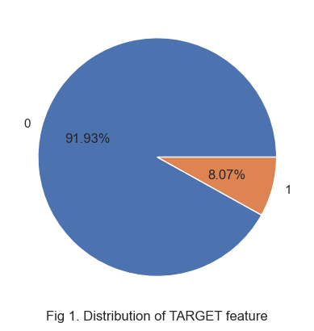
The first and foremost task is to check the distribution of the ‘TARGET’ feature itself.

Since only two categories are there, a pie chart perfectly captures the distribution of both the categories. We can clearly see that out of all the customers present 8.07% of them have defaulted. So, there is a class imbalance in our dataset and all analysis has to be in accordance to it.
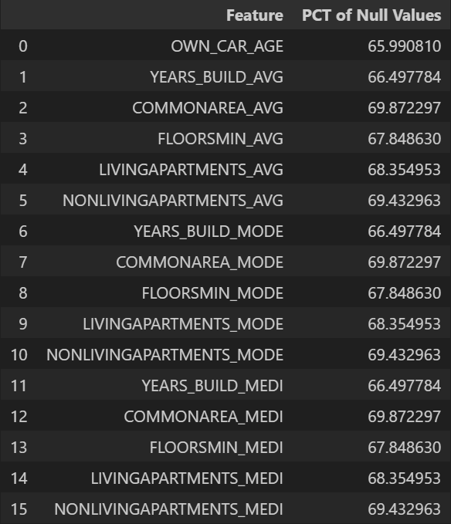
Let us look at those features that can be dropped immediately since they have high percentage of null values (>60%).

This table conveys the information in a neat manner and these features can be dropped.

Fig 2. Features with Highest Percentage of Null Values

Let us move forward with analysis of the remaining features. The first such attribute is the ‘AMT_CREDIT’ attribute which represents the amount of loan a customer received.
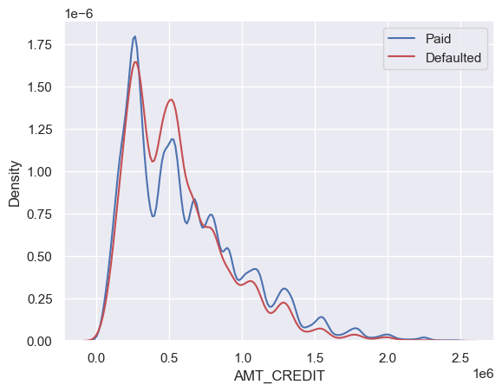

This plot clearly shows that the density of defaulter customers is more in the middle and drops as the value of the feature increase. To confirm this, we will also look at the Histogram of Default Percentage.

Fig 3. Kernel Density Plot of AMT_CREDIT feature
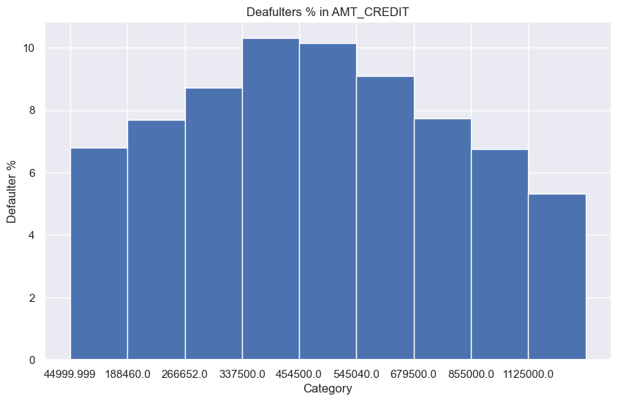
This plot also clearly confirms our speculations on the impact of AMT_CREDIT on the TARGET feature. The defaulter percentage is highest in the middle categories.

Fig 4. Histogram of Default Percentage of AMT_CREDIT

One more interesting attribute would be to look at the age of the customer and how it might impact their repayment capability. For this purpose, we will consider the ‘DAYS_BIRTH’ attribute. As mentioned above all, day related attributes are stored as negative integers, so ww will convert the features into the appropriate year scale by dividing all values by a factor of -365. Again, we look at the same two plots for this feature:
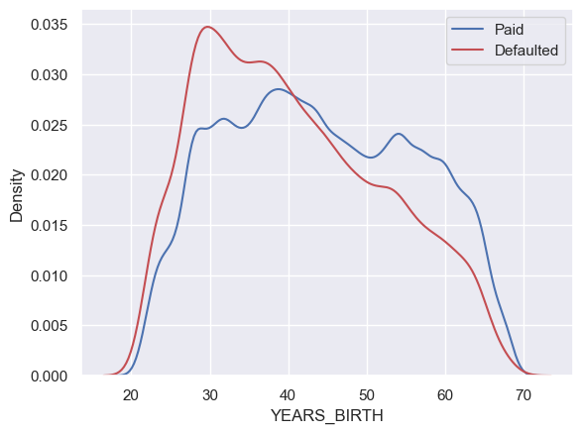
This plot beautifully captures the relationship between the age and the TARGET feature. It is evident that the density of defaulters is significantly higher among the younger generation applicants while older applicants are less likely to default.

Fig 5. KDE Plot for YEARS_BIRTH

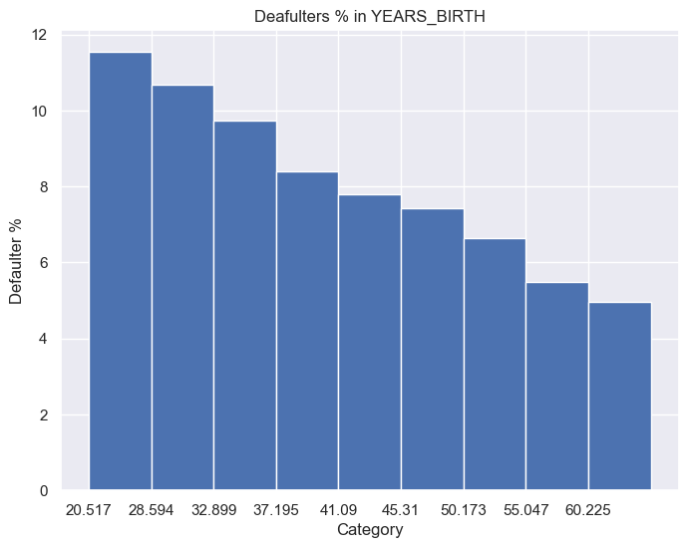
This plot shows a clear trend between age and defaulters. As the age is increasing the rate of default is monotonically decreasing.

Fig 6. Histogram of Default Percentage of YEARS_BIRTH

The dataset also involves features taken from external sources that provide the credit score of customers. If we simply look at the Histogram of the default percentage of these features, it reveals powerful trends with respect to the TARGET feature. One such feature is EXT_SOURCE_1. The plot for the same is:
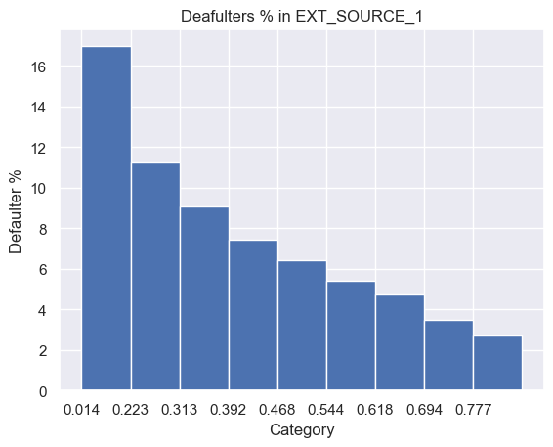
This plot shows an extremely vivid trend between the external source score and the TARGET feature. The lower the score the higher the chance of default. The customers having score below 0.223 have a huge default rate of over 16% which is double the default rate of the whole dataset. While customers with score higher than 0.777 have a default rate of below 3%.

Fig 7. Histogram of Default Percentage of EXT_SOURCE_1

Similar features are EXT_SOURCE_2 and EXT_SOURCE_3 that also produce almost the same plots. So instead of looking at those plots, let us look at the behavior of these features together. If these three features are highly correlated then they may not be useful individually as only one these features will be able explain the other two. But if these features are uncorrelated then they will be highly beneficial for classification of defaulters. To do this let us look at the correlation matrix of these features with TARGET displayed as a heatmap.
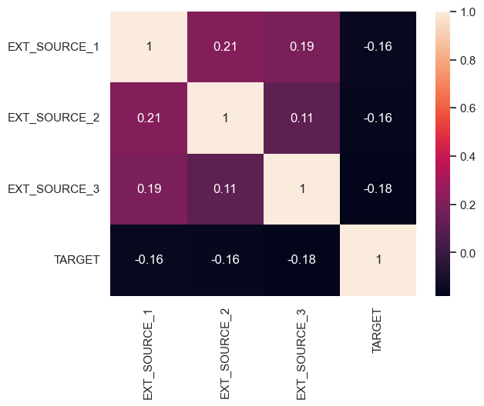
All the external sources are positively correlated but the correlation is weak. On the other hand, all external sources are negatively correlated to the TARGET feature.

Fig 8. Correlation Heatmap of External Features and TARGET

After similar analysis of all features, the most important features are: AMT_ANNUITY, AMT_CREDIT, AMT_INCOME_TOTAL, AMT_GOODS_PRICE, YEARS_BIRTH, YEARS_EMPLOYED, YEARS_ID_PUBLISH, YEARS_REGISTRATION, YEARS_LAST_PHONE_CHANGE, EXT_SOURCE_1, EXT_SOURCE_2, EXT_SOURCE_3.
The plots and analysis of all these features can be accessed from the ‘Additional Resources’ section of the report.
Let us move forward and shift our focus to aggregating the past customer data and relating it to the TARGET feature. As discussed in the ‘Detailed Explanation of Analysis Process’ section of the report, the aggregation will be done on the basis of ‘SK_ID_CURR’ which is the unique customer id. When aggregation was done on the bureau data, one of the most important features was found out to be ‘YEARS_CREDIT_median’. This value represents the median number of years a previous loan was reported to the Bureau before the current application.
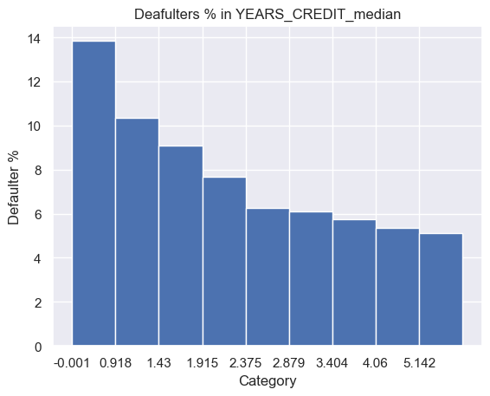

This also shows a clear trend that if the previous loan was applied recently (low value of the feature) then the customer is more likely to default.

Fig 9. Histogram of Default Percentage of ‘YEARS_CREDIT_median’

When data aggregation was done on the instalments data, one of the most important features was found out to be ‘DAYS_PAYMENT_DIFFERENCE_median’. This feature was not there in the dataset but was created by me in the aggregation procedure. This feature takes both positive and negative values, if positive, then the value represents the median number of days the customer paid their instalments after the due date. If negative, the value represents the median number of days the customer paid their instalments before the due date. The plot is as follows:
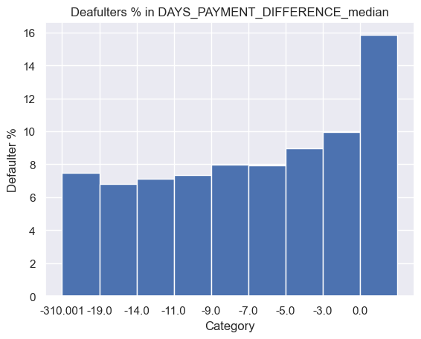
This plot shows that for all the customers with this feature value greater than 0, the default percentage is almost 16%. Other customers have a default percentage of around 8%.

Fig 10. Histogram of Default Percentage of DAYS_PAYMENT_DIFFERENCE_median

When data aggregation was done on the credit card data, one of the most important features was found out to be ‘CNT_DRAWINGS_CURRENT_max’. This feature represents the maximum amount of card drawings done by a customer in a month. The plot is as follows:
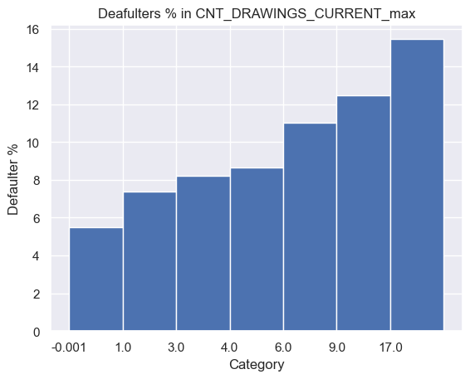
This plot shows that customers with monthly drawings greater than 17 have the most default percentage. The default rate monotonically increases as the feature value increases.

Fig 11. Histogram of Default Percentage of CNT_DRAWINGS_CURRENT_max

After finding out the most important features from each of the dataset, we move forward to quantify the feature importances using machine learning models. The models used for this purpose is LightGBM, which is a light weight Gradient Boosting Model. The whole preprocessed data was combined in a single table and divided into two subsets, training and testing. The model was trained on the training set and evaluated using the testing set. The top 20 features used for classification are as follows:

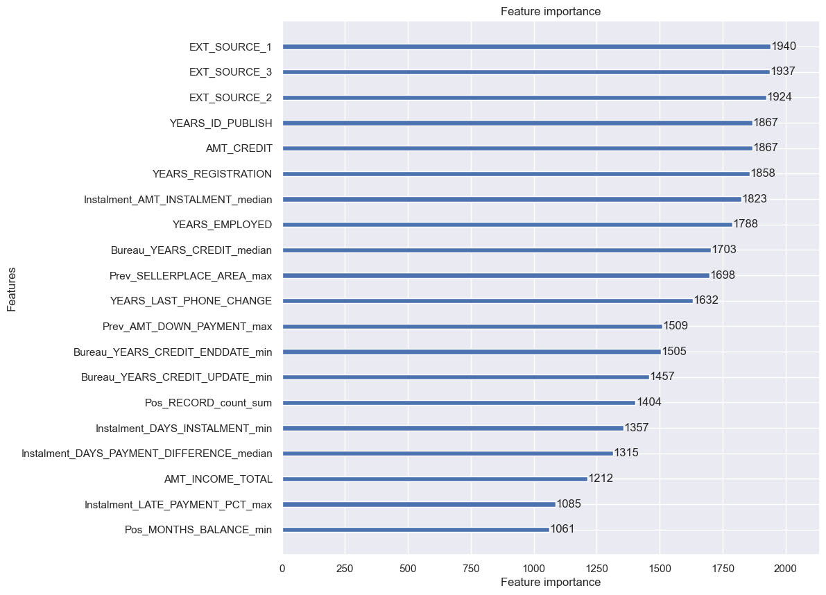
Fig 12. Features and their Feature Importances according to LightGBM

The confusion matrix for the training and test data is as follows:
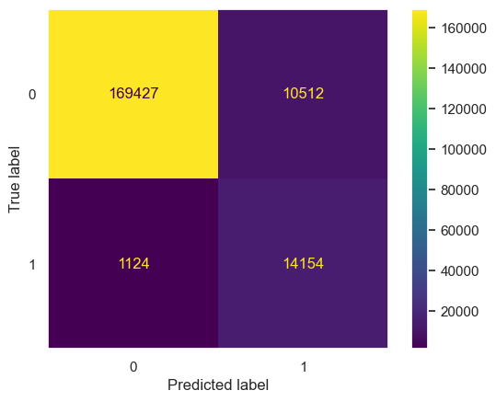
This plot shows a confusion matrix with true labels as rows and predicted labels as columns.

Fig 13. Confusion Matrix of Training Data

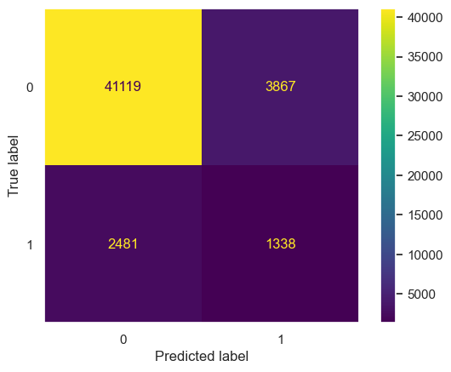
This plot shows a confusion matrix with true labels as rows and predicted labels as columns.

Fig 14. Confusion Matrix of Testing Data

Interpretations of Results
After analyzing the plots and the results, we can come to the following interpretations:
- The age of the customer plays a major role in explaining their repayment behavior. Young clients with age less than 30 years are most likely to default while older clients with age over 50 years are comparatively less likely to default.
- External sources that provide the customer score are one of the most useful features because of two reasons: They show high variability when compared to the TARGET feature, higher the score, the lower the chance of default. Secondly, they are very weakly correlated amongst themselves; this allows them to individually explain the defaulter behavior.
- When the customer has recent ongoing or completed loans, they are more likely to default than a customer who had completed loans more than 2 years ago. This can be attributed to inability to pay all the ongoing instalments at once.
- A customer that has had even a single late instalment payment in any of the loans in the past is twice more likely to default again in the current loan.
- A customer with more monthly credit card drawings (above 4) is more likely to default on a loan. Major reason can be their inability to pay back the credited amount and lack of credit management.
- A customer who has changed their mobile phone number or personal identity proof recently is more likely to default. This is derived from the ‘YEARS_LAST_PHONE_CHANGE’ and ‘YEARS_ID_PUBLISH’ features.
- The machine learning model does not perform well for testing data as more than 50% of defaulter customers are predicted as capable according to the model. This can be attributed to the fact that only 8% data was available for the defaulter class and due to class imbalance, the model is not able to perform well.
- There is a need to make a stricter loan approval process for especially those clients who do not have any history provided by external sources. This is because the industry standard for default rate is lower than 4% but Home Credit Group has a default rate of more than 8%.
- The credit cards can be given having a drawing limit on both the amount and count of drawings per month.
- The unimportant variables should continue to be recorded as the trends change over time and a feature which seems unimportant today may become important in the future. Moreover, some important features have correlations with other features, this helps in imputing the values of these important features with the help of other features.

Additional Resources
Meta Data: MetaData
Main Drive: MainDrive
All the python code can be accessed from the notebooks provided in the specific folders of the datasets. All plots can also be accessed from the same link.

