Introduction to Compressed Sensing
Compressed sensing (CS) is an emerging field of mathematics and engineering that challenges the conventional paradigms of data acquisition. Since the seminal publication(Candes, 2006), the field has developed a substantial academic literature and has provided the foundation for major innovations in medical imaging, astronomy, and digital photography. Although the field of CS is very mathematical, it can be conceptually intuitive. This tutorial provides a brief introduction to CS concepts through simple examples and interactive figures in an accompaning Jupytr notebook.

Overview
Many signals have an inherent low-dimensional structure, meaning all the information can be compressed into relatively few coefficients. As a simple example, consider the signal x(t)=Asin(ft+ϕ) which is constructed with only three pieces of information: the amplitude A, the frequency f, and the phase ϕ. Measuring this signal using conventional acquisition requires sampling the entire duration of the signal at a rate of at least 2f, which for a 10 second 30 Hz signal results in 600 samples. Why did we collect 600 samples of data when we only require 3 pieces of information? This is the fundamental question CS is asking, and in a field with large data acquisition costs we should pay close attention to the answers.
To gain some basic intution into CS, this tutorial demonstrates the compressed acquisition of the simple 1D signal:
x(t)=50sin(2πf1t+ϕ1)+100sin(2πf2t+ϕ2)

Sparsity
The first requirement for compressed sensing is the existence of a sparse signal representation. We need to know a priori that the signal we are acquiring has relatively few non-zero coefficients in some transform domain. This may seem like a heavy requirement, but fortunately the field of data compression has found sparsifying transforms for many types of general signal classes. For example, the wavelet transform sparsifies images, the Fourier transform sparsifies harmonic signals, and curvelets sparsify seismic data. In our simple example, let's assume we know the signal has harmonic content and will be sparse in the Fourier domain.

Sampling
Let's make the jump from data compression to compressed sensing, where we will try to exploit the compressibility of our signal directly during acquisition. Let's look first at the limitations of uniform sampling then move on to other sampling methods.
Uniform sampling has been the engineered data acquisition strategy for decades, where Shannon-Nyquist theory says we can uniquely represent our signal by sampling at least twice the highest frequency. Considering our test signal can be reduced to only 2 samples of information, we are grossly oversampling. Figure 3 and 4 show the result of trying to reconstruct the test signal from 5-fold undersampling below the Nyquist rate. As a result of the sub-sampling we have introduced new frequency components called aliases, and when we try to reconstruct our test signal we are incorrectly filling in the gaps betweens samples(Figure 4).
Fundamentally, aliasing occurs when multiple signals have the same value at every sample, which creates ambiguity to what the true signal is. When we violate the Nyquist rate we can no longer uniquely fill gaps between data samples. Figure 5 demonstrates aliased signals; the two signals are identical at every sample point.
The problem is that both the signal and sampling pattern are periodic, which causes them to coherently interfere with each other. If our sampling pattern was aperiod, it would be very unlikely for different signals to have the exact same value at every sample. The easiest way to break coherency is to use a random sampling pattern. Figure 6 shows that the aliased signals become distinguishable when we use a random sample pattern.
We have shown we can break aliasing patterns by random sampling, so let's return to the problem of sub-sampling our test signal. Note the differences in the Fourier spectrum (Figure 7) compared to the aliased result we saw earlier. Since we broke the coherency of our sampling pattern, aliased signals have become random noise. We didn't recover our signal (Figure 8) due to the added noise, but now that we have removed the ambiguity of aliasing we can exactly reconstruct our signal through denoising techniques such as thresholding.

Recovery
The recovery stage of CS is the most challenging, as it requires significant a priori knowledge of the signal. For our test signal, we can fully reconstruct the original signal by taking the two largest Fourier coefficients and renormalizing the signal energy. This requires prior knowledge to either the number of non-zero coefficients in our signal, or knowledge of an acceptable threshold value. In practice recovery is often posed as optimization problem where we search for the smallest number of coefficients that can fit our sampled data within a given tolerance.

Seismic Applications
This tutorial demonstrated CS concepts to a somewhat trivial acquisition of a simple signal. We showed that for CS to be successful, we need:
- A transform domain that can sparsely represent our data.
- A sampling pattern that is incoherent in the transform domain.
- A reconstruction method that promotes a priori knowledge about the signal sparsity.
All of these are active fields of research in the seismic community. Curvelets have shown promise as a potential sparse representation of seismic data, and “low-rank” methods which exploit redundant structure in the midpoint-offset domain is also gaining traction with researchers.
Applying random sampling patterns in theory is very simple, but in practice requires significant re-engineering of the way we collect data. Seismic surveys are massive and utilize large vessels, streamer arrays, and precise logistics that all have been designed to collect data on regular intervals. Although challenging, real world random acquisition is still a very tractable problem given adaquate investment.
Confidence in the reconstruction is perhaps the largest hurdle in the uptake of CS methodology, as it is difficult to put an engineering specification on prior knowledge of signal sparsity or the rank of your data matrix. The a priori assumptions required for signal recovery are dependent on the local geology and carry a high-level of uncertainty. Simulations, as well as synthetic resampling of seismic data, have shown high SNR reconstructions with as much as 10 fold sub-sampling. Although exciting, these aren't blind experiments and often use knowledge of the true signal when definining reconstruction conditions. CS has the potential to be a disruptive innovation in seismic acquisition, but it is still in its uncertain stages of early engineering.

References and further reading
Candès, Emmanuel J., Justin K. Romberg, and Terence Tao. 'Stable Signal Recovery From Incomplete And Inaccurate Measurements'. Communications on Pure and Applied Mathematics 59.8 (2006): 1207-1223. Web.

Hennenfent, Gilles, and Felix J. Herrmann. 'Simply Denoise: Wavefield Reconstruction Via Jittered Undersampling'. GEOPHYSICS 73.3 (2008): V19-V28. Web.

Mansour, Hassan et al. 'Randomized Marine Acquisition With Compressive Sampling Matrices'. Geophysical Prospecting 60.4 (2012): 648-662. Web.

Bryan, Kurt, and Tanya Leise. 'Making Do With Less: An Introduction To Compressed Sensing'. SIAM Rev. 55.3 (2013): 547-566. Web.

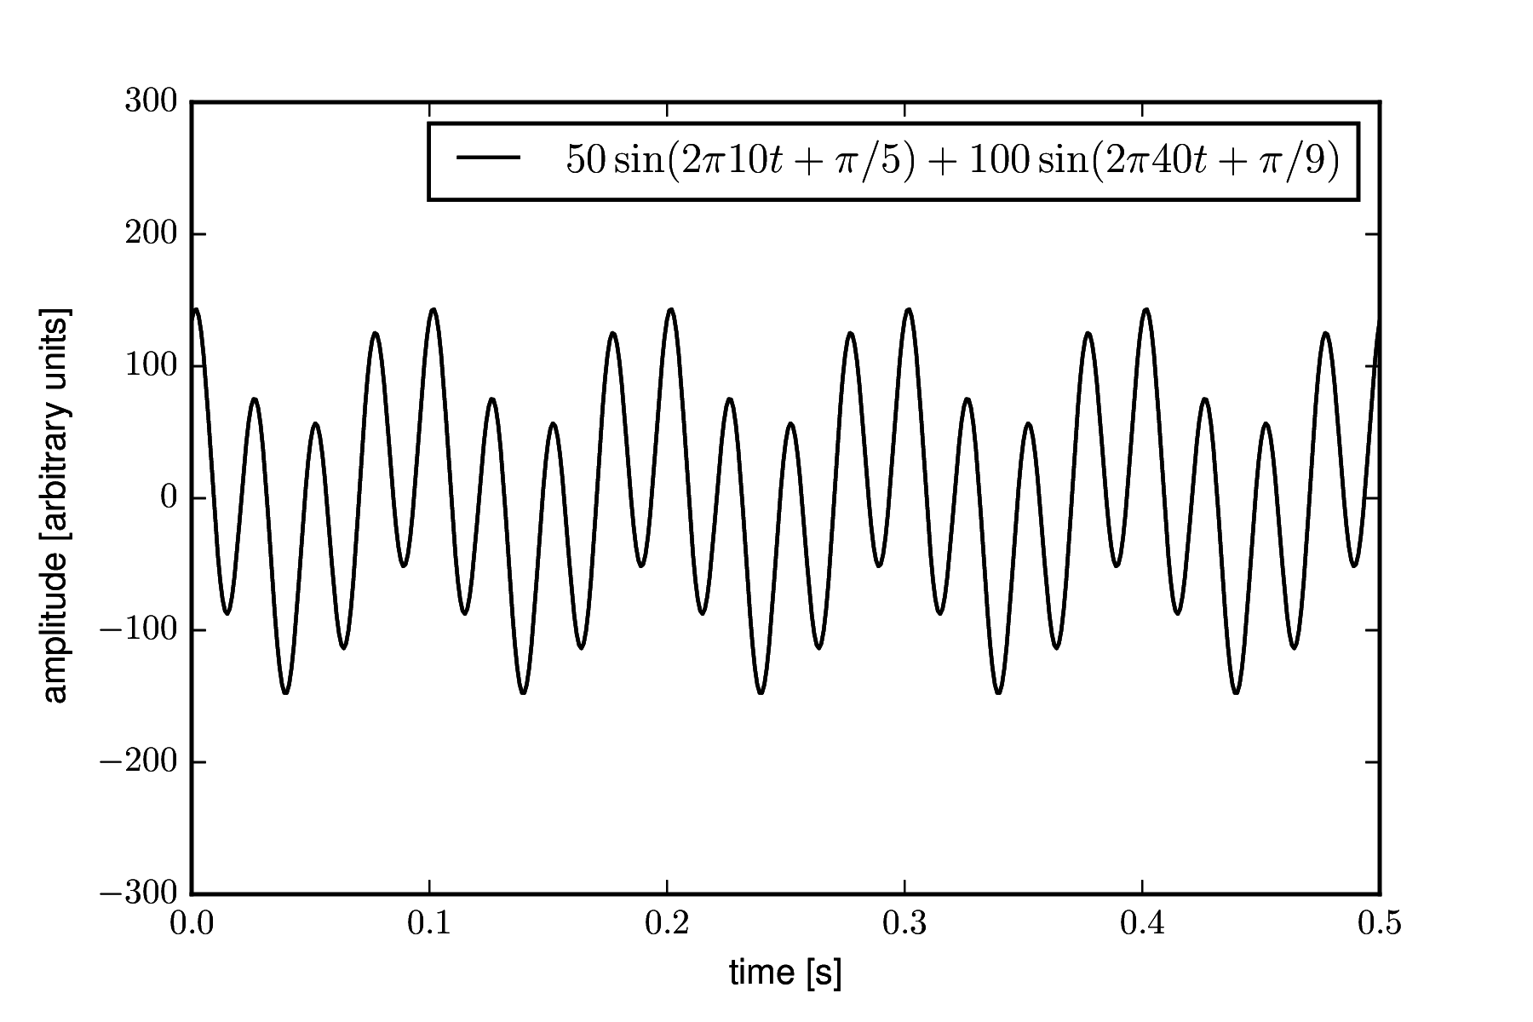Figure 1: Simple test signal timeseries.

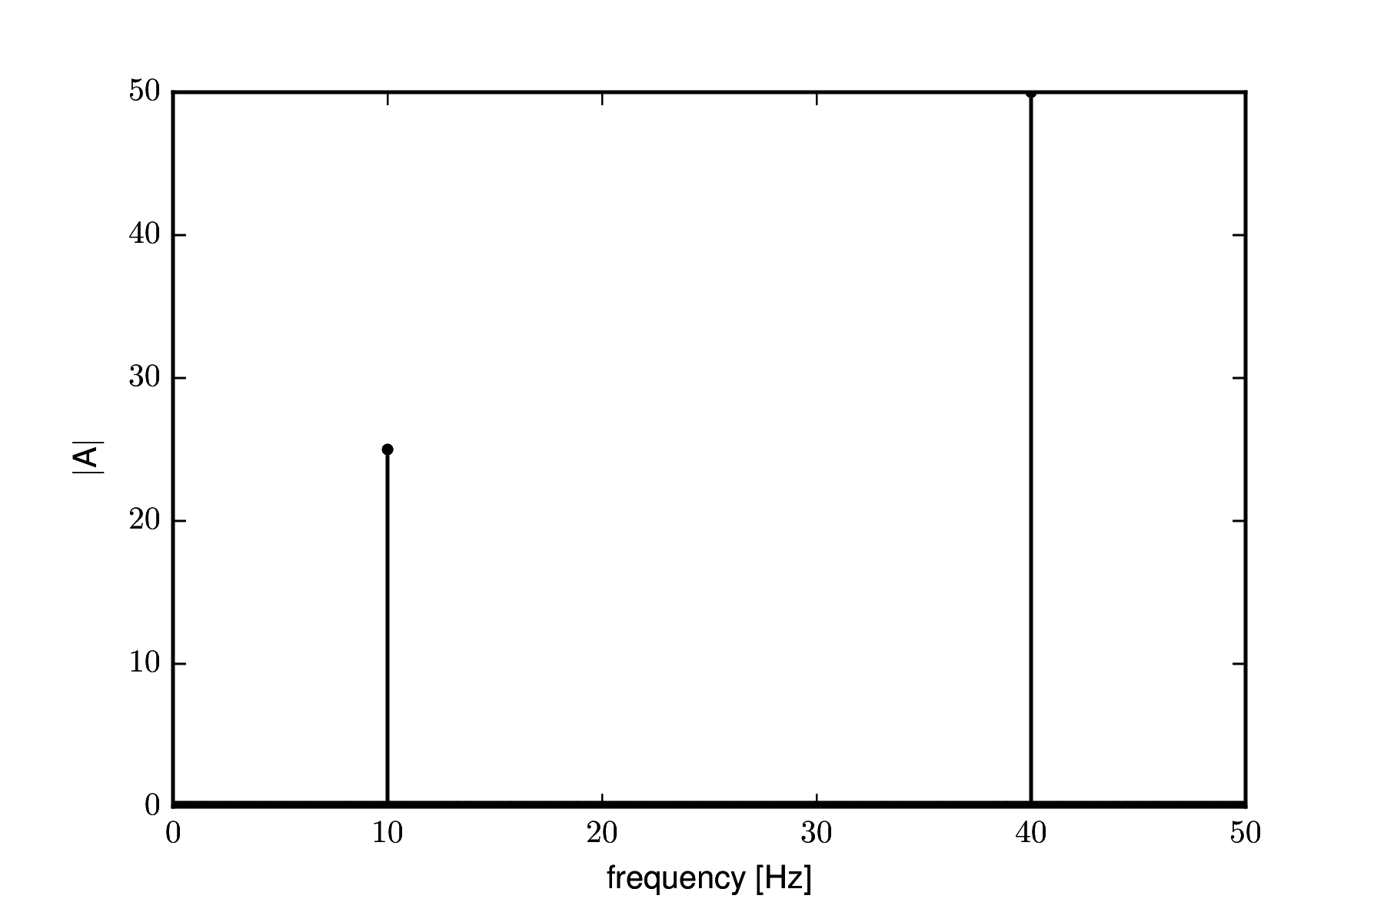Figure 2: Amplitude half-spectra of the test signal.

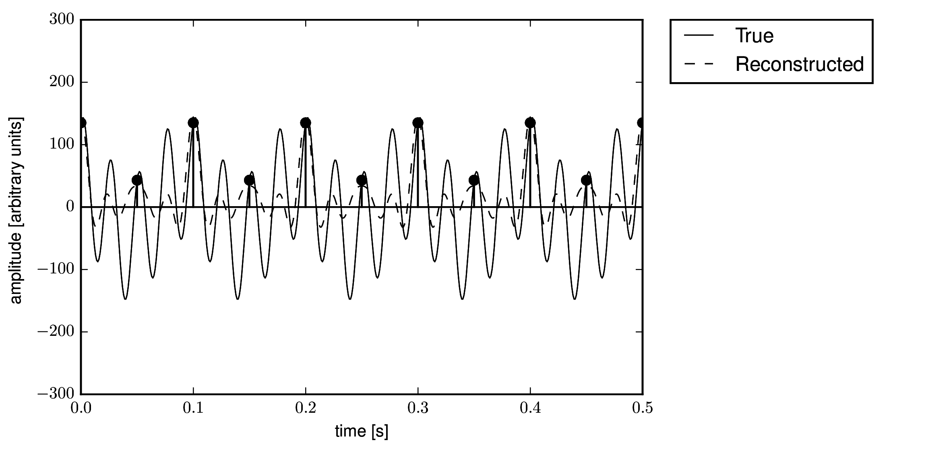Figure 3: Sampling and reconstruction of the test signal using 5-fold regular sub-sampling.

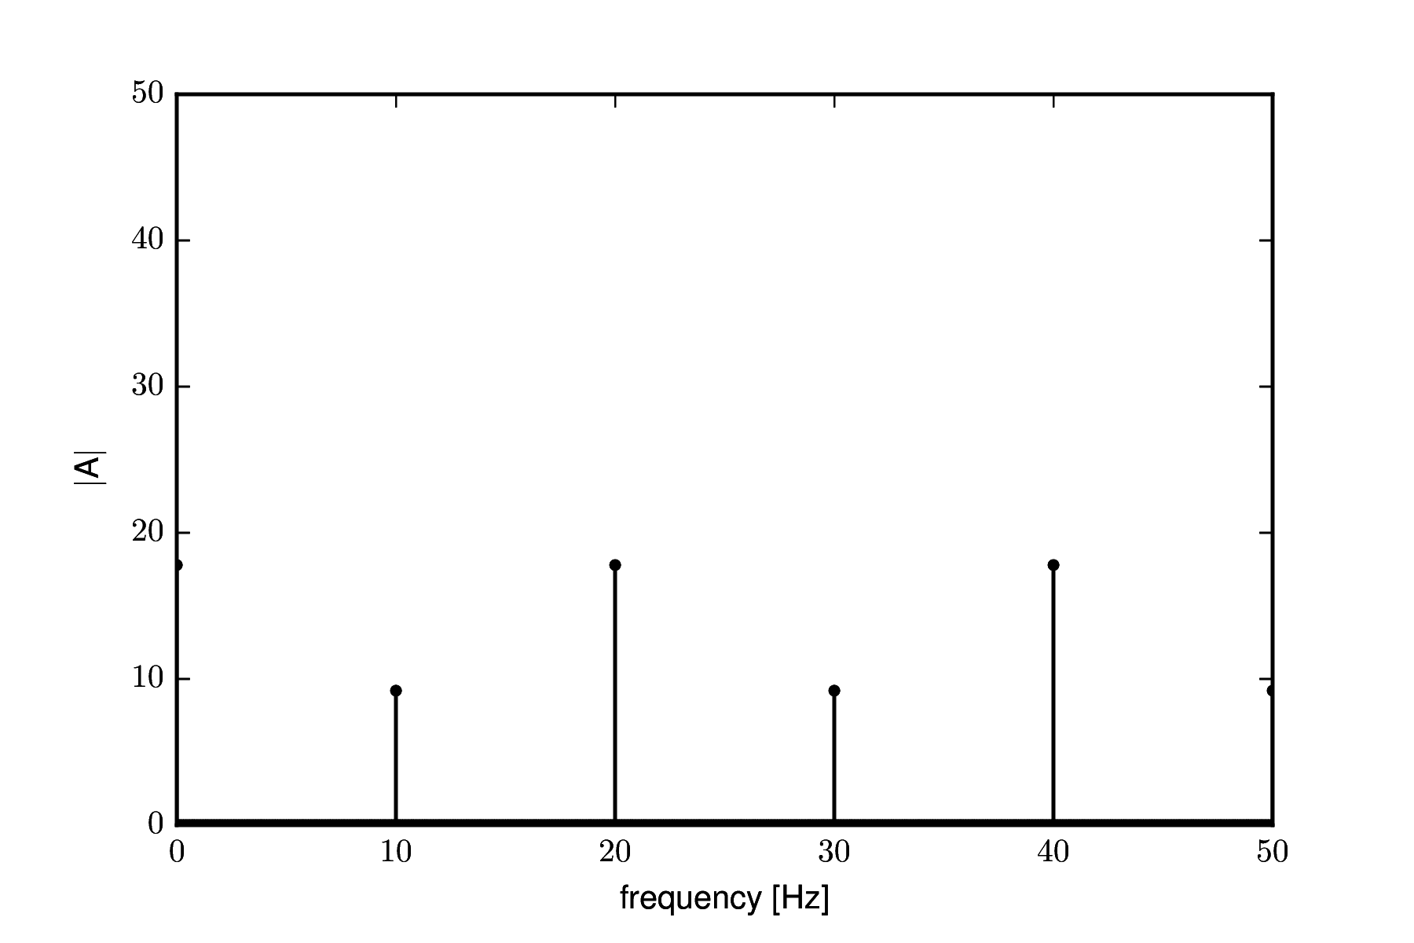Figure 4: Aliased spectrum of the 5-fold regularly sub-sampled test signal.
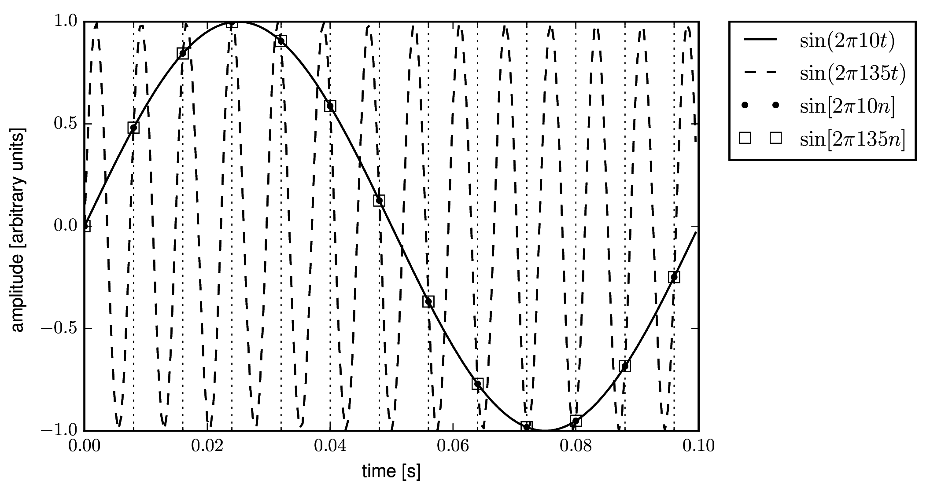Figure 5: Demonstration aliasing caused by periodic sampling.

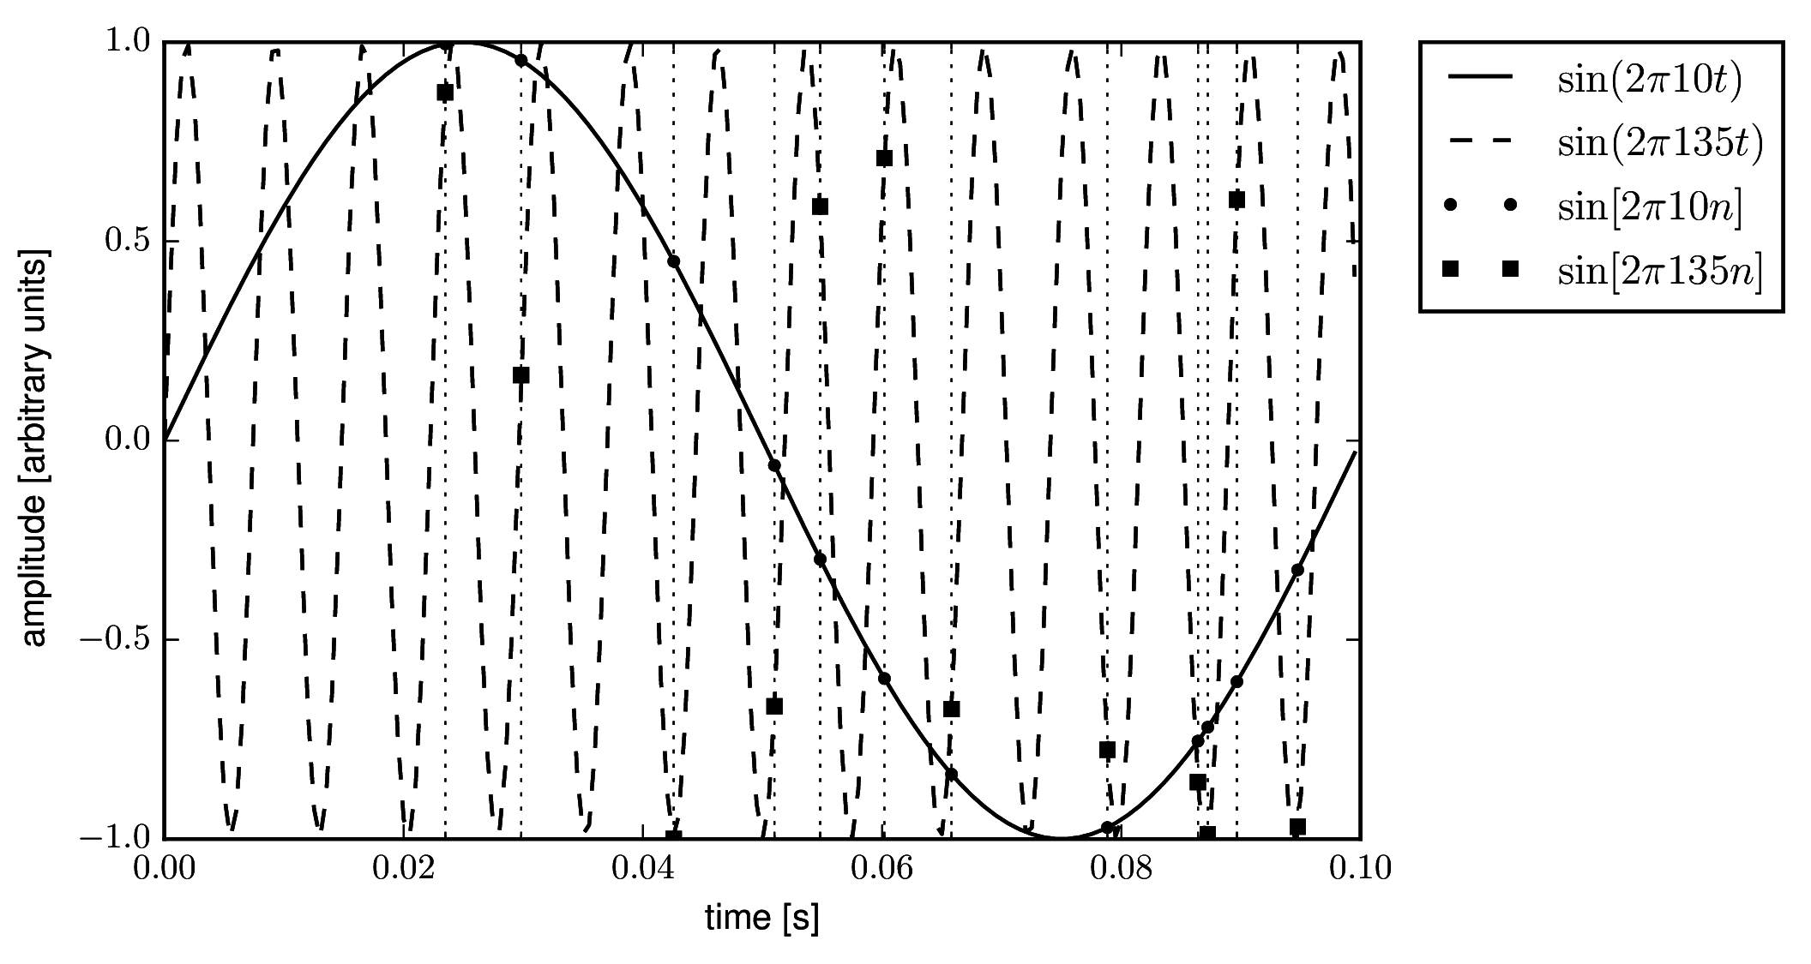Figure 6: Breaking aliased signals using a random sample pattern.
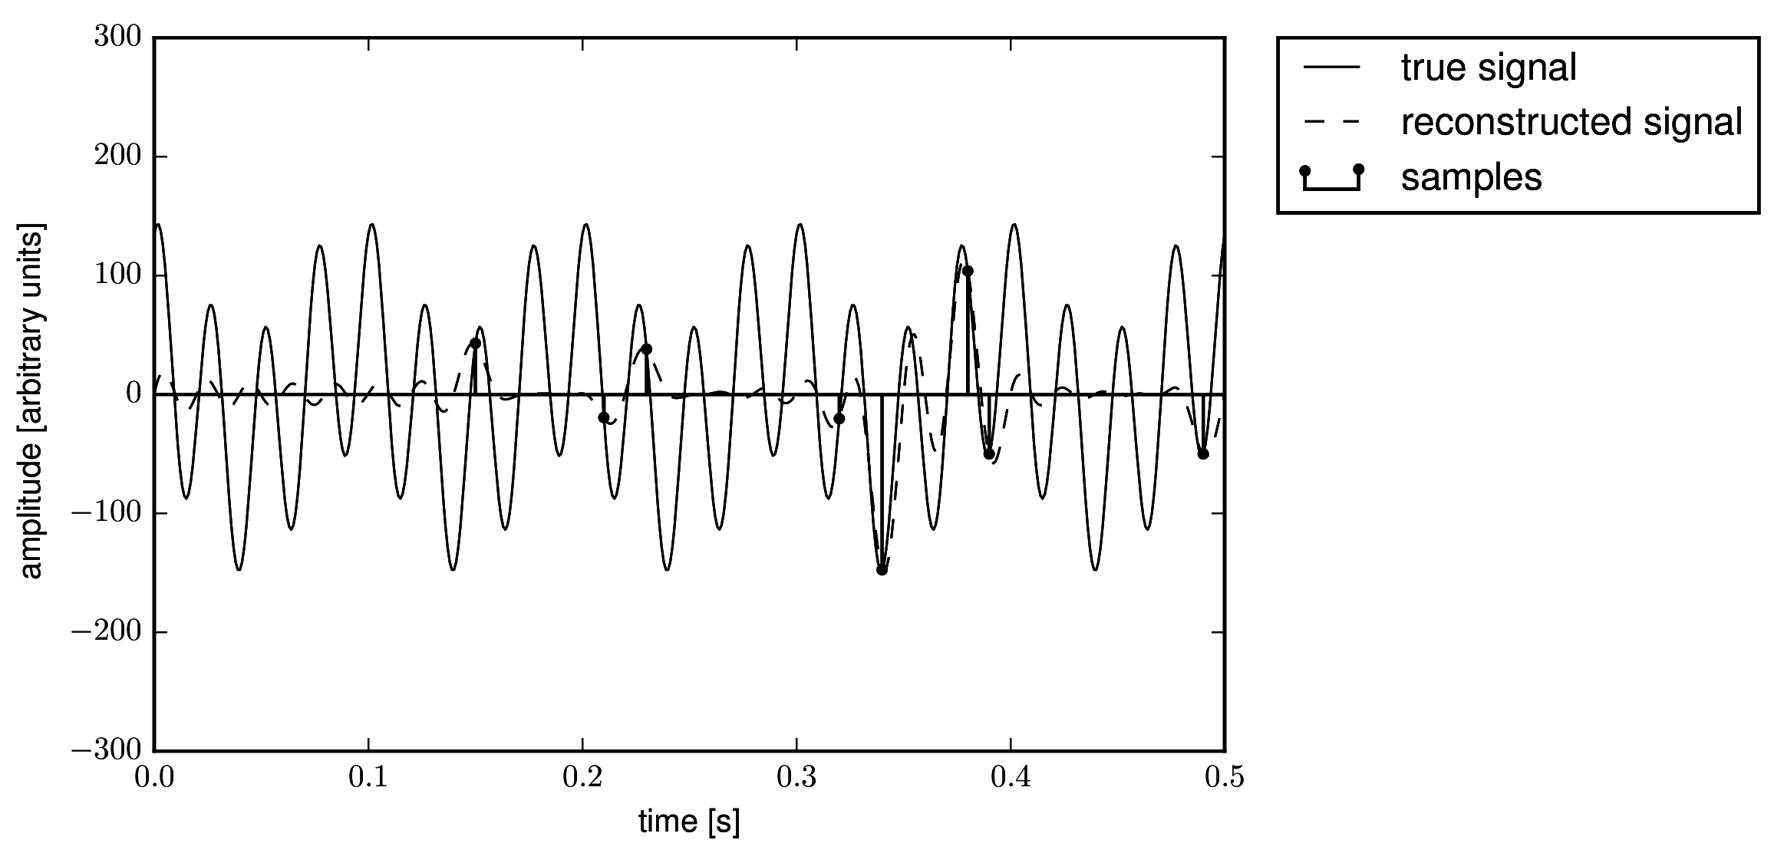Figure 7: Sampling and reconstruction using 5-fold random undersampling.
Figure 8: Random 5-fold undersampling of the test signal.
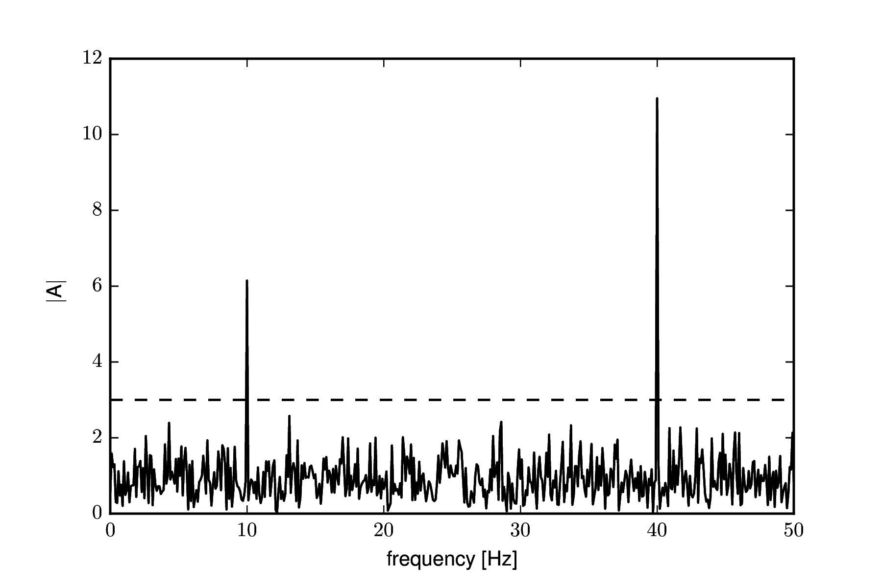Figure 8: Amplitude spectrum of 5-fold random sub-sampling of the test signal. Thresholding the spectrum allows for perfect signal reconstruction.

