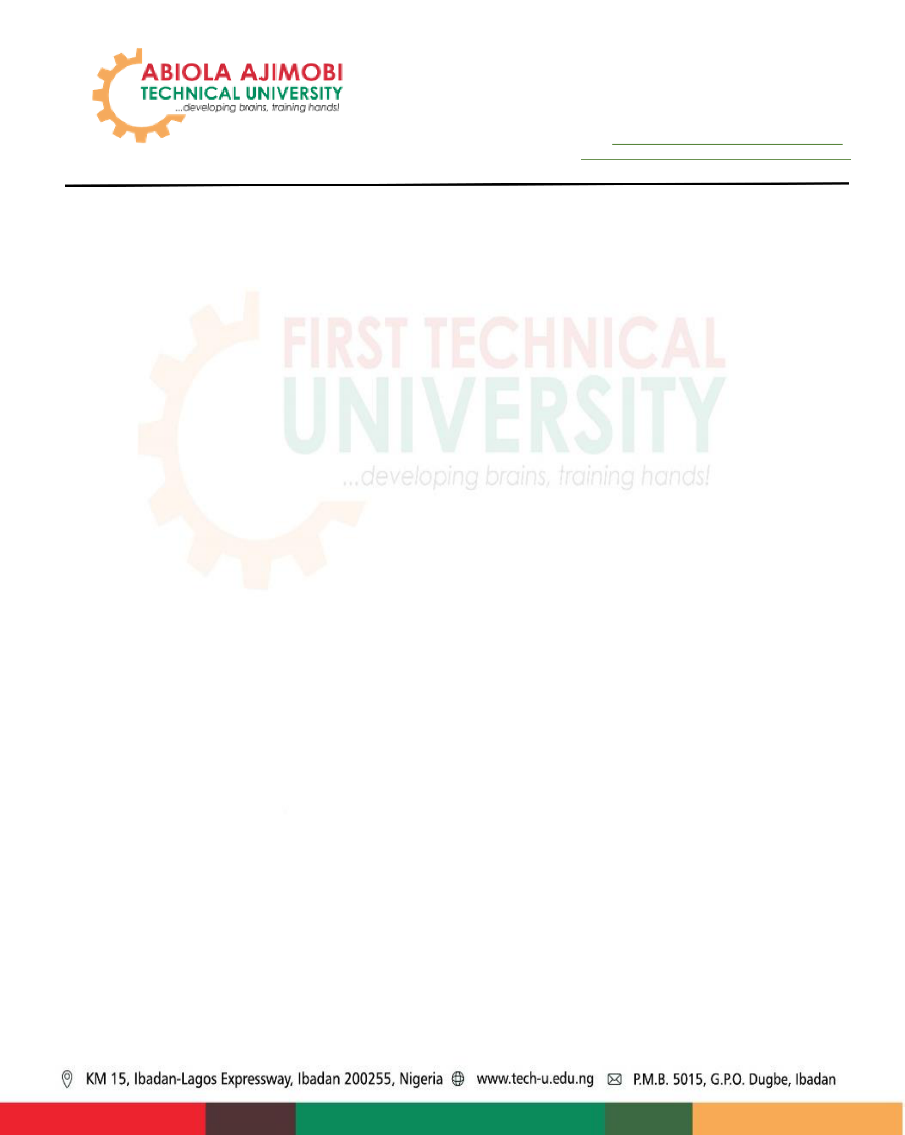
Sunday Adeola AJAGBEPhD, MNCS, MIEE, R.Engr.
Senior Lecturer
Department of Computer Engineering and Industrial & Production Engineering
Faculty of Engineering and Technology
Abiola Ajimobi Technical University, Ibadan, 200255, Ibadan
KM 15 La
Top 2% World Scientist Ranking, 2025; Ph
April 2, 2026
Tech Nation Assessment Panel
6th Floor, 180 Strand
2 Arundel Street
London, WC2R 3DA
Dear Assessment Panel,
Re: Academic Reference in Support of Mr Olusegun Odeyemi’s Global Talent Visa Application
It is with strong professional regard, academic confidence, and personal conviction that I write in support of Mr Olusegun Odeyemi’s application for the Global Talent Visa under the Digital Technology route.
I write this letter in my capacity as a senior academic, researcher, and lecturer in Computer Engineering and Intelligent Systems, with long-standing work across artificial intelligence, machine learning, cybersecurity, low-resource language technologies, and applied digital innovation. Over the years, my academic journey has allowed me to observe many promising researchers and technology practitioners, but only a smaller number produce work that moves beyond theory and becomes useful in the classroom, in research discussion, and in the formation of new thinking among students. Mr Odeyemi belongs to this latter category.
I am Dr Sunday Adeola Ajagbe, a lecturer in the Department of Computer and Industrial & Production Engineering at Abiola Ajimobi Technical University, Nigeria, and a Research Associate in the Department of Computer Science at the University of Zululand, South Africa. My work focuses on artificial intelligence, natural language processing, low-resource languages, information security, and intelligent systems. I have been involved in national and international research collaborations and have contributed to the development of AI knowledge across African and global research communities.
My professional encounter with Mr Odeyemi’s work began not merely as a reader of his publications, but as a teacher searching for materials that could help students understand the emerging relationship between artificial intelligence, system reliability, anomaly detection, compliance enforcement, and the governance of modern digital platforms. In teaching advanced technology subjects, one is often looking for work that does not simply repeat known concepts, but opens a door for deeper inquiry. Mr Odeyemi’s work provided that door.
In my CPE 604: Techniques in Machine Learning for Low-Resource Languages course, I included Mr Odeyemi’s research as part of the recommended readings for students. His works, including “Universal Deviation Principle: A Multi-Operator Framework for Anomaly Detection and Classification with Sensitivity Guarantees,” “Blind-Spot Decomposition and the Geometry of System Collapse,” and “MTTP/AMTTP: A Four-Layer Architecture for Deterministic Compliance Enforcement in Institutional DeFi,” were used to broaden students’ understanding of how machine learning and digital systems must be studied not only through the lens of model performance, but also through the deeper questions of deviation, collapse, blind spots, trust, compliance, and institutional readiness.

The reason I found his work valuable is that it helped students see the hidden architecture behind technological failure. In many classrooms, students are taught that a model either performs well or performs poorly. Mr Odeyemi’s work encourages a more mature understanding: systems fail through patterns, through blind spots, through ungoverned deviation, and through weak enforcement layers. This is a crucial lesson for students preparing to work in AI, cybersecurity, fintech, blockchain, compliance technology, and institutional digital systems.
In particular, his work on deterministic compliance enforcement in institutional DeFi was especially useful because it brought together two worlds that are often taught separately: technical architecture and regulatory accountability. Many students understand decentralised finance at the surface level, but Mr Odeyemi’s framework helped us discuss what would be required for serious institutional adoption: rules, enforcement, auditability, integration layers, and structured compliance at protocol level. This gave the class a practical lens through which to examine the future of digital finance, not as speculation, but as a governed and engineered system.
What impressed me most was the originality and seriousness of the thinking. His work is not simply a commentary on existing systems; it attempts to define frameworks through which future systems can be designed, monitored, and corrected. That is the kind of contribution that reflects exceptional promise in digital technology. It shows a mind working at the intersection of research, architecture, risk, compliance, and applied innovation.
The classroom impact was meaningful. Students were able to engage with his papers as examples of how abstract concepts can become useful frameworks. His ideas helped us discuss anomaly detection, system breakdown, digital governance, AI safety, and the importance of building technologies that can withstand pressure. Several students became more interested in how AI and machine learning principles can be applied beyond language models alone, especially in areas such as financial technology, cybersecurity, institutional infrastructure, and compliance automation.
This is important because African students and researchers need exposure to globally relevant work that still speaks to the realities of emerging markets. Mr Odeyemi’s research carries that dual relevance. It is intellectually ambitious enough to sit within global conversations on digital systems, yet practical enough to be useful in teaching students who are preparing to solve real problems in fintech, AI governance, cybersecurity, and digital infrastructure. To evidence the independent academic uptake of his work, I am able to provide supporting materials including:
➢the CPE 604 lecture handout where Mr Odeyemi’s publications are included as recommended readings;
➢the accompanying lecture slides where his work appears as part of the student reading list; ➢the TechRxiv publication page for his work on deterministic compliance enforcement in institutional DeFi;
➢any further course evidence required to confirm that his research has been used in my academic teaching.
In my professional judgment, Mr Odeyemi demonstrates the qualities expected of an individual with exceptional promise in digital technology. His work shows originality, technical depth, and a forward-looking understanding of how digital systems must be built for reliability, compliance, resilience, and institutional trust. He is contributing to an area of increasing global importance, particularly as AI, decentralised systems, fintech infrastructure, and digital governance continue to shape the future economy.
I strongly recommend Mr Olusegun Odeyemi for endorsement under the Global Talent route. I believe his continued development and engagement within the United Kingdom’s digital technology ecosystem would be of real value. He has the intellectual courage to work on difficult problems, the technical

discipline to propose structured frameworks, and the promise to contribute meaningfully to research, innovation, and responsible technology development.
Please do not hesitate to contact me should you require any further information or clarification.
Warm regards
 02/04/2026
Sunday A. Ajagbe PhD IAENG, MIEEE, MNCS, R.Engr
Senior Lecturer, Department of Computer and Industrial & Production Engineering, Abiola Ajimobi Technical University, Ibadan, Nigeria
Research Associate, Department of Computer Science, University of Zululand, South Africa
Telephone: +234 803 549 8084
Email: or
LinkedIn:

