TechNationVisa-ExceptionalPromise
Applicant: OdeyemiOlusegunIsrael
Criteria: MandatoryCriteria(InnovationandTechnicalLeadership)
MC-1:DesignandDevelopmentofAMTTP—AFour-LayerReal-Time BlockchainComplianceSystem
ExecutiveSummary:Idesignedandbuiltafour-layerreal-timecompliancesystemforblockchain transactions.TraditionalAMLtoolsactonlyaftertransactionsarecompleted,whileAMTTPassesses risk,verifiessanctions,andappliescontractdecisionsinlessthanasecond—beforeanyfundsare transferred.In its first public month, the live platform processed 920,848transactions and attracted 1,220 unique visitors at amttp.com.Every layer — consumer app, enterprise dashboard, nine-service AIbackend,andblockchaincontracts—wasbuiltbyme.
LivePublicDeploymentEvidence
4-MINUTEVIDEODEMONSTRATION
https://youtu.be/I0dXSNScR0
Publicdemo:amttp.com —Sepolia-backedenvironment —1,220uniquevisitors
—38,320requests—5Apr–5May2026
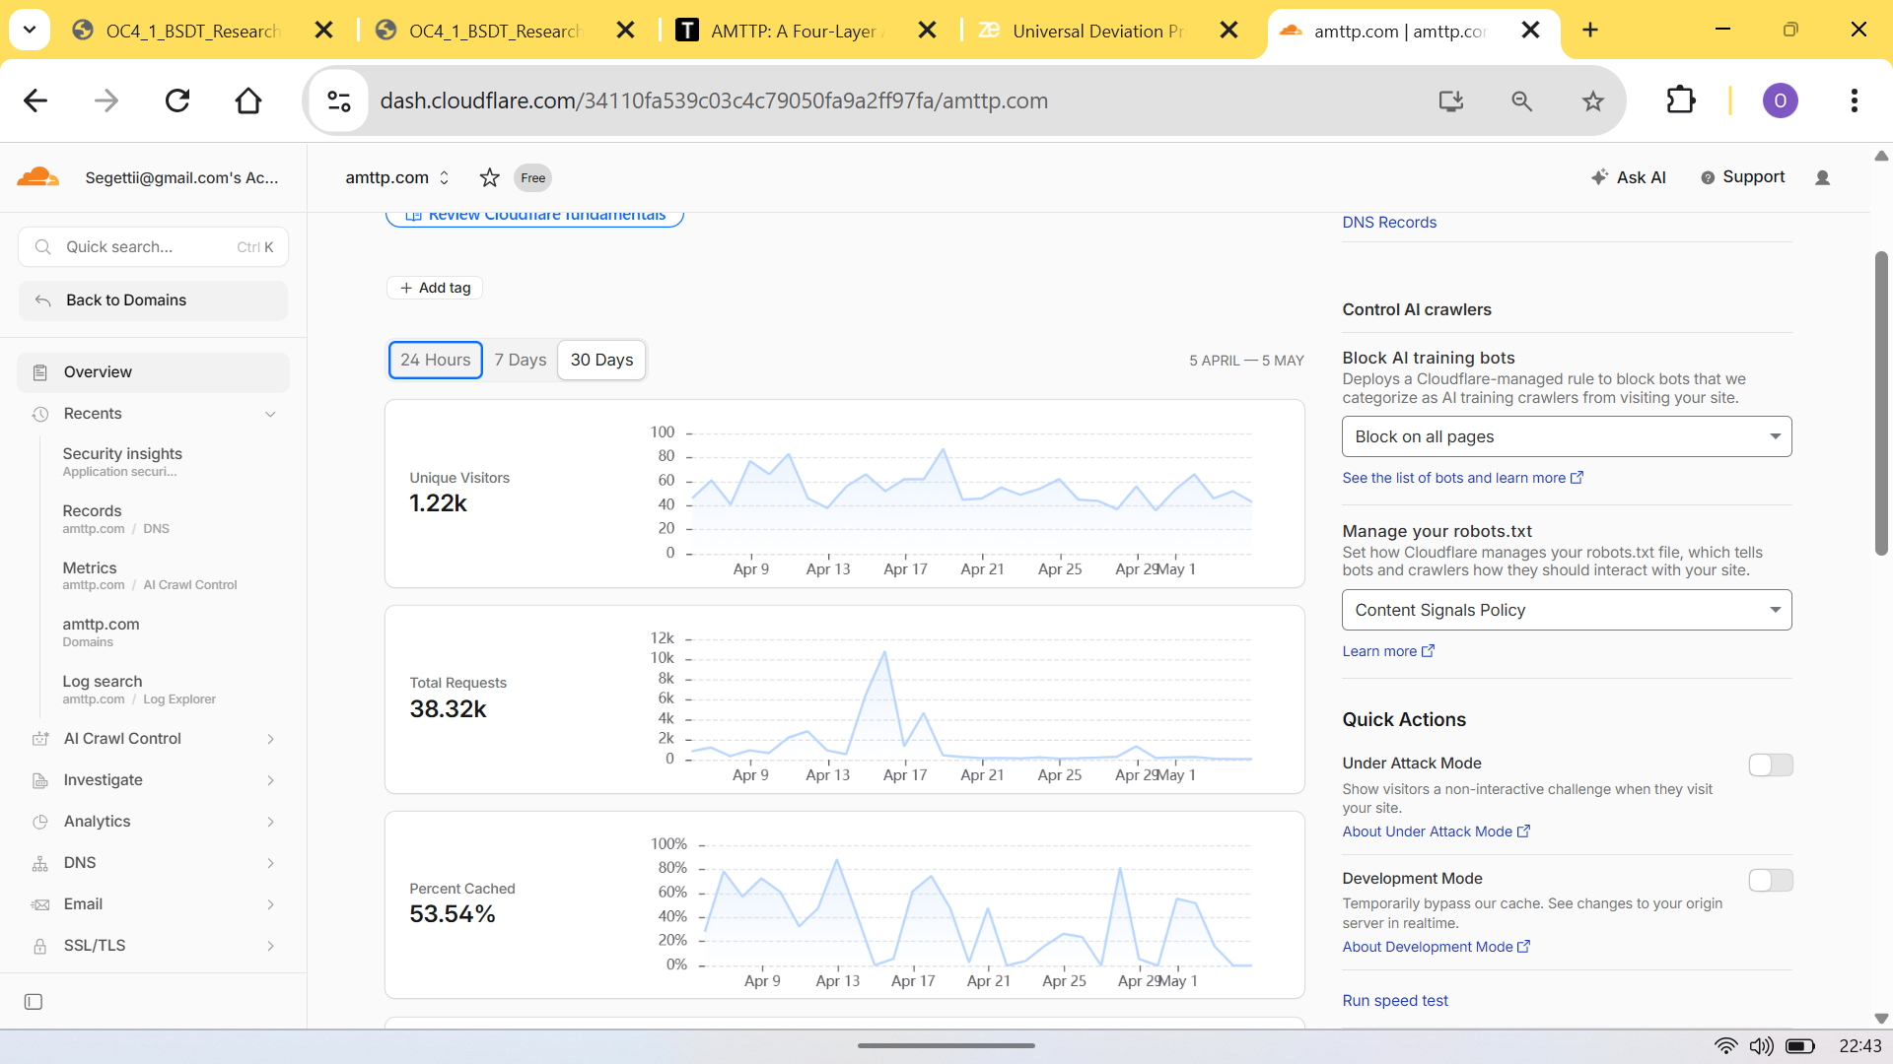
Figure1:Cloudflareanalyticsforamttp.com—1,220uniquevisitors,38,320totalrequests,53.54%cache-hit ratio(5Apr–5May2026).IndependentlyverifiableontheliveSepolia-backedenvironment.
TechnicalContributions

ˆPre-settlementenforcementatscale:920,848 transactionsprocessedonalivepublictestnet;deci-sionsissuedbeforefundsmove,notafter.
ˆDual-modelAIscoring:agradient-boostedclas-sifierandaGraphNeuralNetwork(walletrelation-ship analysis); fraud-detection accuracy (ROC-AUC) 0.9999998.
ˆ90%+costreduction:acompactmodeltrained fromalargeronerunsonstandardoffice-grade CPUs,eliminatingspecialistGPUhardware.

1

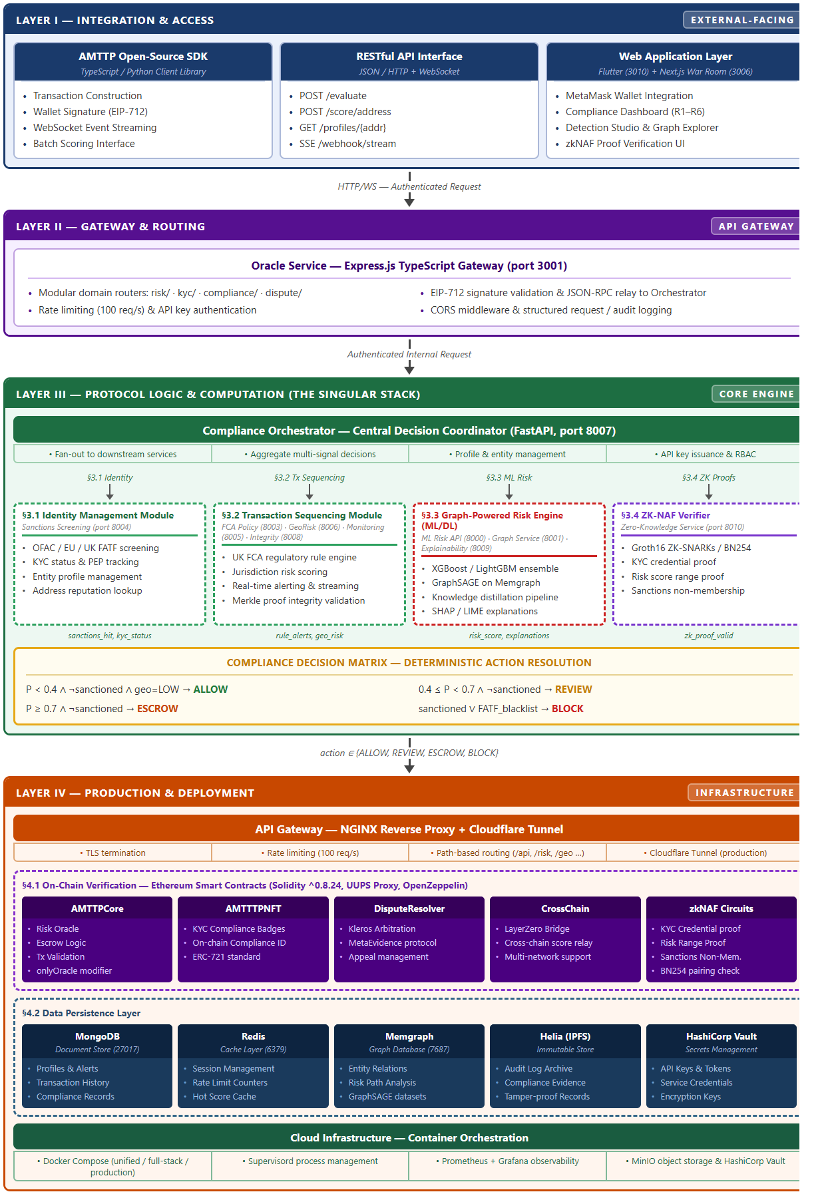
Figure2:AMTTPfour-layerarchitecture—Flutter+Next.js(UI)→ExpressGateway→PythonFastAPI orchestrator(9microservices)→38Solidityfiles(corecontracts,interfaces,andsupportingmodules),17Docker containers.Alllayerssole-authored.
2

LiveDashboardEvidence
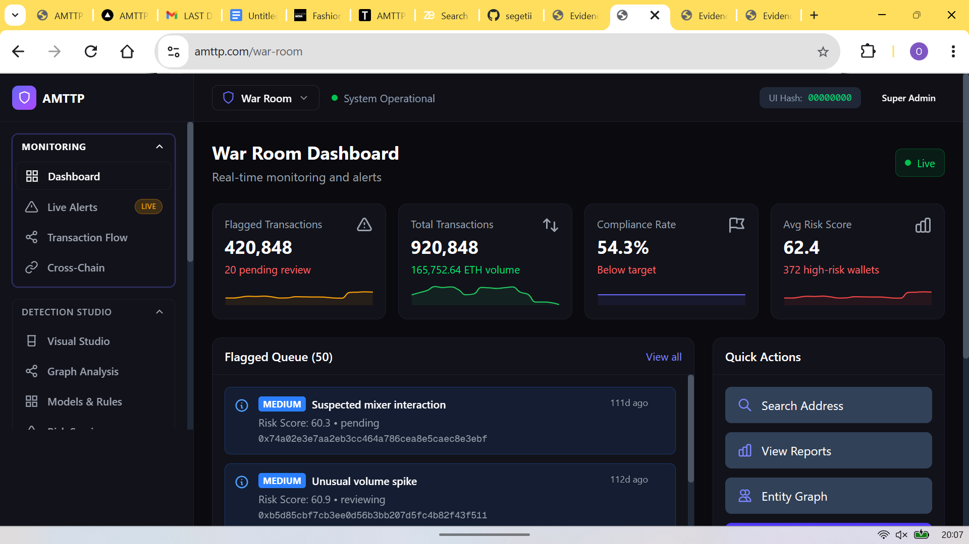
Figure3:WarRoomdashboardonthelivepublictestnet—920,848transactionsprocessed,54.3%compliance rate,averageriskscore62.4.RealwalletaddressesindependentlyverifiableonEtherscan.
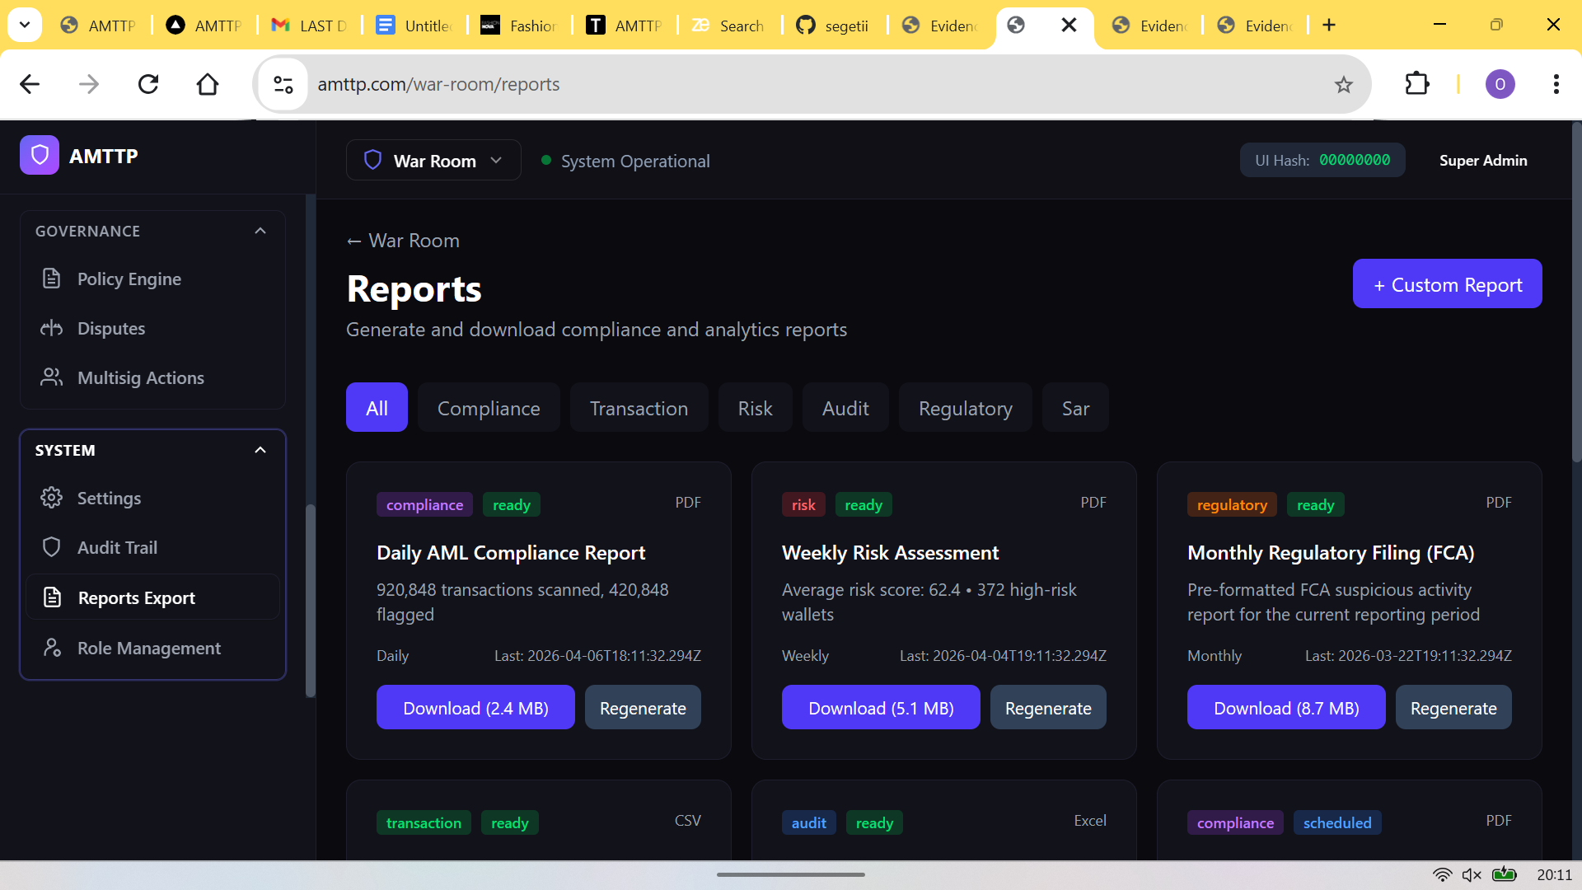
Figure4:Automatedreportgeneration—DailyAMLCompliancePDF(2.4 MB),WeeklyRiskAssessment (5.1 MB),MonthlyFCASAR(8.7 MB)—allgeneratedprogrammaticallywithoutmanualintervention.
3

