Tech Nation Visa — Global Talent (Exceptional Promise)
Criteria: Mandatory Criteria — Technical Leadership / Innovation
Applicant: Odeyemi Olusegun Israel

MC-2: Sustained Technical Contributions — GitHub Repository and Codebase Authorship
1. Executive Summary

I built the AMTTP codebase as the sole author. The public GitHub repository records 361 commits over eight months (September 2025 – April 2026) from my account, covering the full product stack: Python AI services, a TypeScript API gateway and SDKs, a Dart mobile app, Solidity smart contracts, and security/research tooling.
The repository verifies both authorship and delivery: commit history, timestamps, and per-file diffs are public at github.com/segetii/AMTTP. This evidence shows sustained development of a working product across multiple engineering domains.
2. Development Activity

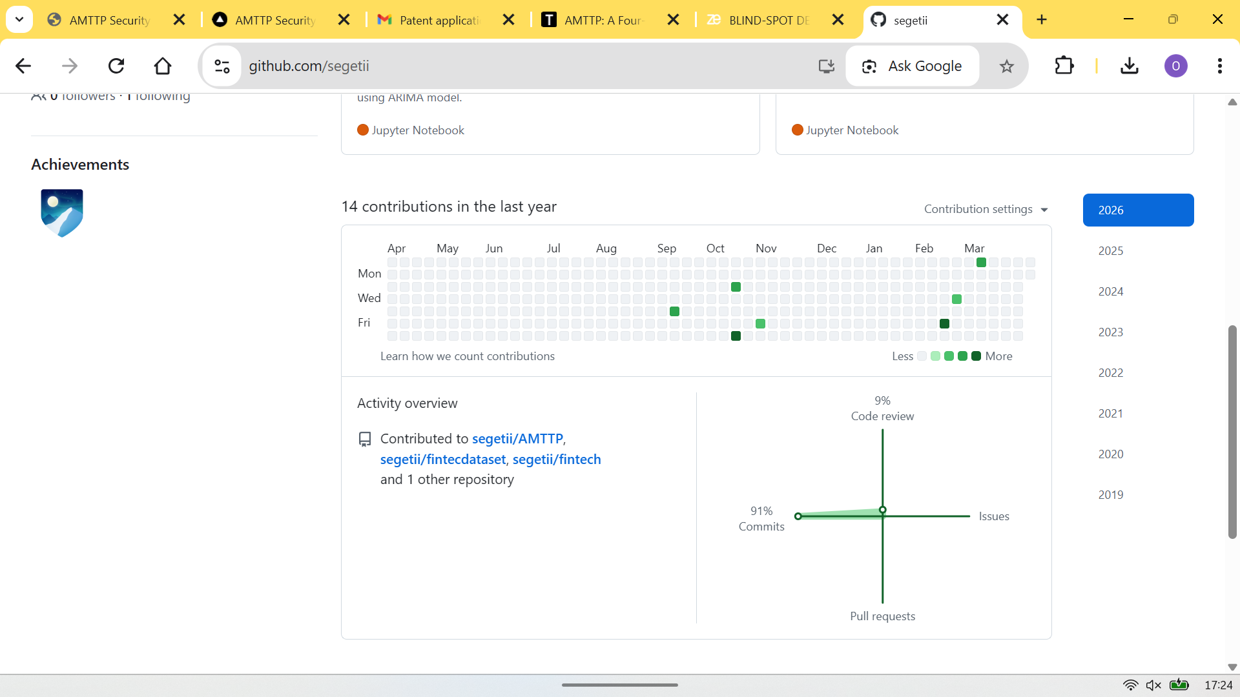
Figure 1: GitHub activity graph for github.com/segetii — sustained solo engineering across the full design-to-deployment lifecycle of AMTTP. Each square represents a day with code commits.
3. Public Verification Record

The table below summarises the public development timeline. The volume, cross-domain consistency, and language diversity confirm this is the output of a single senior engineer operating across the full technical stack.
Metric | Value
Total commits (all branches) | 361
Active development period | Sep 2025 – Apr 2026
Peak month (Mar 2026) | 191 commits
Languages | Python, TypeScript, Dart, Solidity
Repository | github.com/segetii/AMTTP

Table 1: Public repository summary showing sustained development over eight months in four production languages.
Development Activity by Month:
Month | Commits | Focus
Sep 2025 | 1 | Project inception
Oct 2025 | 22 | Smart contract architecture
Nov 2025 | — | ML model training & dataset work (Google Colab)
Dec 2025 | — | ML pipeline refinement & validation (Google Colab)
Jan 2026 | 18 | ML pipeline integration & microservices
Feb 2026 | 115 | Full-stack integration & SDKs
Mar 2026 | 191 | Security auditing & production hardening
Apr 2026 | 14 | Research papers & documentation

Table 2: Monthly cadence (Sep 2025 – Apr 2026). November and December 2025 commits do not appear in the GitHub graph because ML model training and dataset experimentation during that period were conducted in Google Colab; the resulting artefacts were integrated into the repository from January 2026 onwards.
Delivered components: live public platform at amttp.com (1,220 visitors, 38,320 requests in month 1); complete Solidity contract suite deployed and verified on Ethereum Sepolia; nine-service AI compliance backend; and two developer SDKs enabling third-party integration.
4. Repository Scope and Authorship

AMTTP/ (monorepo root)
+-- contracts/ (38 authored Solidity files) UUPS proxy, ZK-NAF, CrossChain
+-- backend/ (Oracle Gateway + 10 FastAPI microservices)
| +-- oracle-service/ Express.js TypeScript gateway (port 3001)
| +-- compliance-service/ orchestrator, sanctions, monitoring
+-- ml/ (XGBoost, LightGBM, GraphSAGE pipelines)
| +-- Automation/ risk_engine/ + ml_pipeline/ + models/
+-- frontend/
| +-- frontend/ Next.js App Router (War Room, port 3006)
| +-- amttp_app/ Flutter (6-platform consumer app, port 3010)
+-- packages/
| +-- client-sdk/ TypeScript SDK (@amttp/client-sdk)
| +-- python-sdk/ Python SDK (amttp)
+-- research/ (4 academic papers, visa docs, UDL framework)
+-- patents/ (8 patent specifications, unified filing)
+-- test/ (Hardhat + Foundry smart contract tests)
+-- audit/ (Slither + Echidna security pipeline)

Figure 2: Repository directory structure confirming sole authorship across 5 languages and 14+ independently deployable services.
Technical significance: Delivering a full-stack compliance platform across blockchain, AI, mobile, and enterprise web demonstrates end-to-end technical ownership. Every commit, timestamp, and per-file diff is permanently public at github.com/segetii/AMTTP; authorship is verifiable without relying on any claim made here.
5. Supplementary: ML Development Activity (Nov–Dec 2025)

As noted in Table 2, November and December 2025 saw no commits to the public GitHub repository because model training and dataset experimentation were conducted in Google Colab. The Google Drive listing below provides independent, Google-timestamped corroboration.
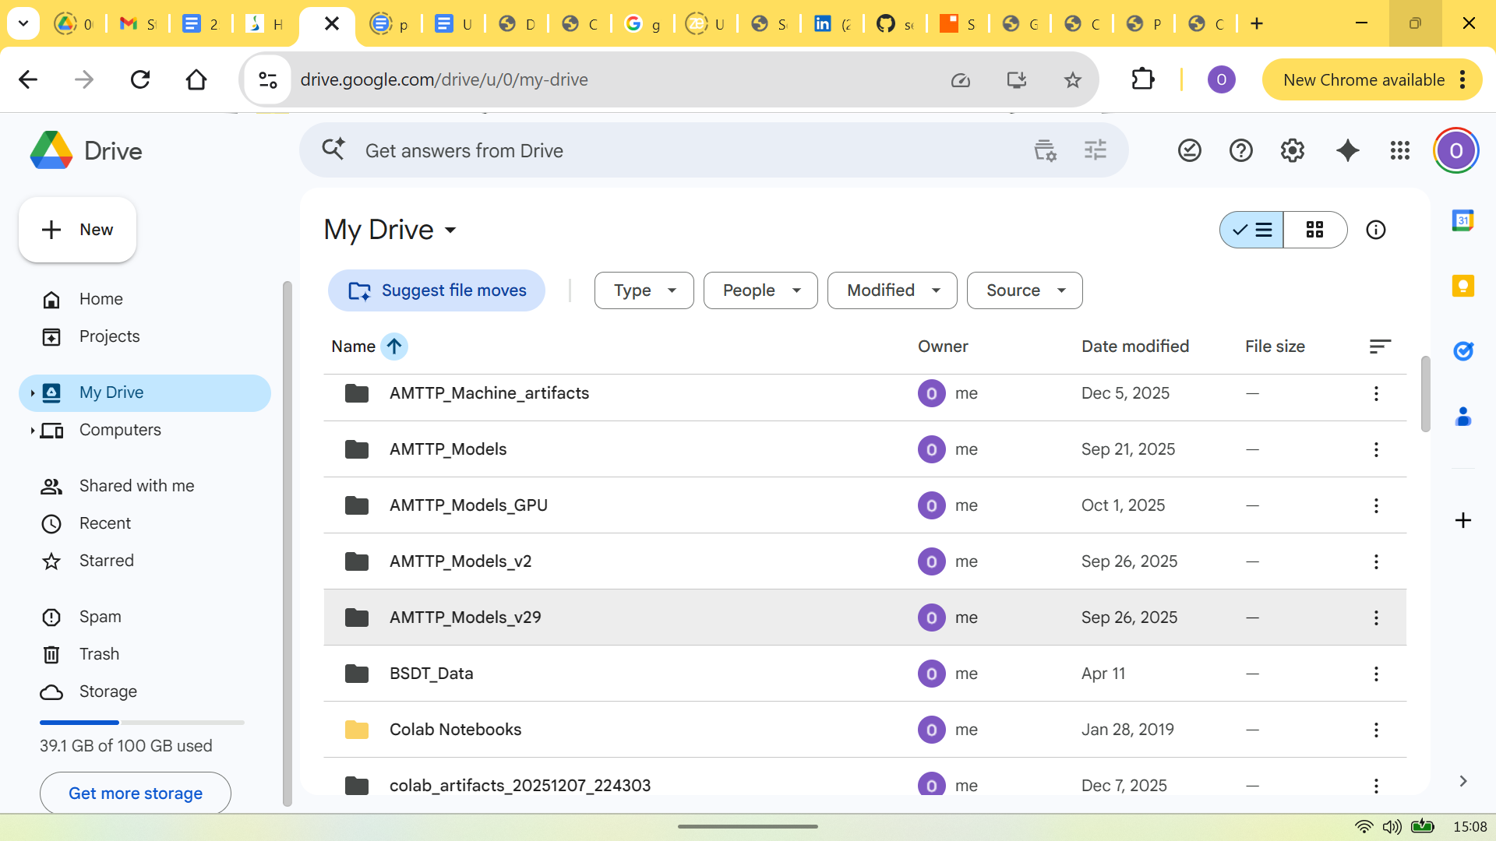
Figure 3: Google Drive listing (captured 13 May 2026) showing AMTTP ML artefact folders. Key entries: AMTTP_Machine_artifacts (Dec 5, 2025) and colab_artifacts_20251207_224303 (Dec 7, 2025) — the folder name is an auto-generated ISO timestamp (7 Dec 2025, 22:43:03 UTC) from a Colab export script. AMTTP_Models_GPU (Oct 1, 2025) and AMTTP_Models_v2/_v29 (Sep 26, 2025) show ML versioning began at project inception.
6. Technical Breadth — Cross-Domain Deliverables

The codebase spans five production programming languages used simultaneously. Each domain was designed, written, tested, and deployed by the same author, without a team.
Domain | Language | Key Deliverable | Public Verification
AI / ML | Python | 9-service FastAPI backend + distilled XGBoost/LightGBM | github.com/segetii/AMTTP/ml/
Blockchain | Solidity | 38 contracts, 10 deployed on Sepolia | sepolia.etherscan.io
API Gateway | TypeScript | Express.js Oracle Service + TypeScript SDK | github.com/segetii/AMTTP/backend/
Mobile / Web App | Dart | Flutter 6-platform consumer app (port 3010) | github.com/segetii/AMTTP/frontend/amttp_app/
Enterprise Web | TypeScript | Next.js War Room dashboard (port 3006) | github.com/segetii/AMTTP/frontend/frontend/
Python SDK | Python | amttp SDK — PyPI-ready, mirrors TS SDK | github.com/segetii/AMTTP/packages/python-sdk/
Security Tooling | YAML/Python | Slither + Echidna audit pipeline (38 contracts) | github.com/segetii/AMTTP/audit/
Smart Contract Tests | JavaScript | Hardhat + Foundry test suites (74 files compiled) | github.com/segetii/AMTTP/test/

Table 3: Public verification matrix — each domain, language, and deliverable is independently verifiable from the public repository without relying on any claim made in this document. Building across all eight rows simultaneously is the distinguishing characteristic of sole authorship.

