Tech Nation Visa — Global Talent (Exceptional Promise)
Criteria: Optional Criteria 4 — Academic Contributions through Research
Applicant: Odeyemi Olusegun Israel

OC4-2: Academic Publications & Global Research Impact
1. Executive Summary

I wrote and published four research papers without institutional affiliation, co-authors, or promotion budget on TechRxiv (the IEEE engineering preprint platform) and Zenodo (a CERN-hosted open-access research archive). In under ten weeks they recorded 365 views and 210 downloads. Three were independently selected as required reading for an accredited postgraduate course by a Top 2% World Scientist (Stanford University annual citation impact ranking), without any prior contact with me. The course evidence is documented separately in OC4-3.
2. The AMTTP Infrastructure Paper (TechRxiv)

Field | Detail
Published | 27 February 2026
Metrics | 230 Views, 153 Downloads (as of 5 May 2026)
Platform | TechRxiv — IEEE engineering preprint server
DOI | 10.36227/techrxiv.177220113.33816607/v1

The first paper, introducing the AMTTP system design to the academic community — specifically how the blockchain enforcement layer and the AI fraud-detection engine are connected. It recorded 230 views and 153 downloads in roughly ten weeks, with no institutional promotion.
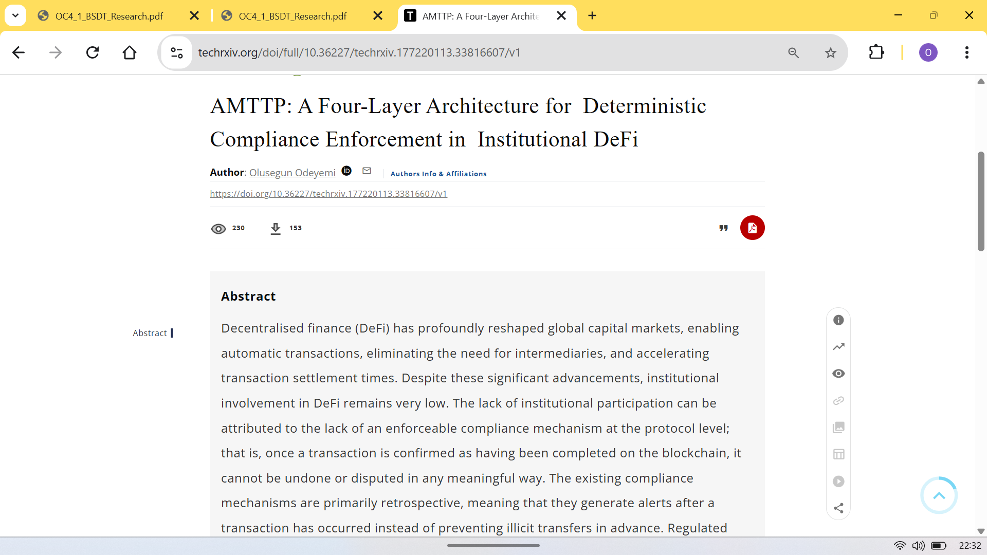
Figure 1: TechRxiv analytics — 230 views, 153 downloads; 10 weeks, no institutional promotion.
3. Blind-Spot Decomposition Theory — BSDT (Zenodo)

Field | Detail
Published | 5 March 2026
Metrics | 135 Views, 57 Downloads (as of 5 May 2026)
Platform | Zenodo — CERN-hosted open-access archive
DOI | 10.5281/zenodo.18870590

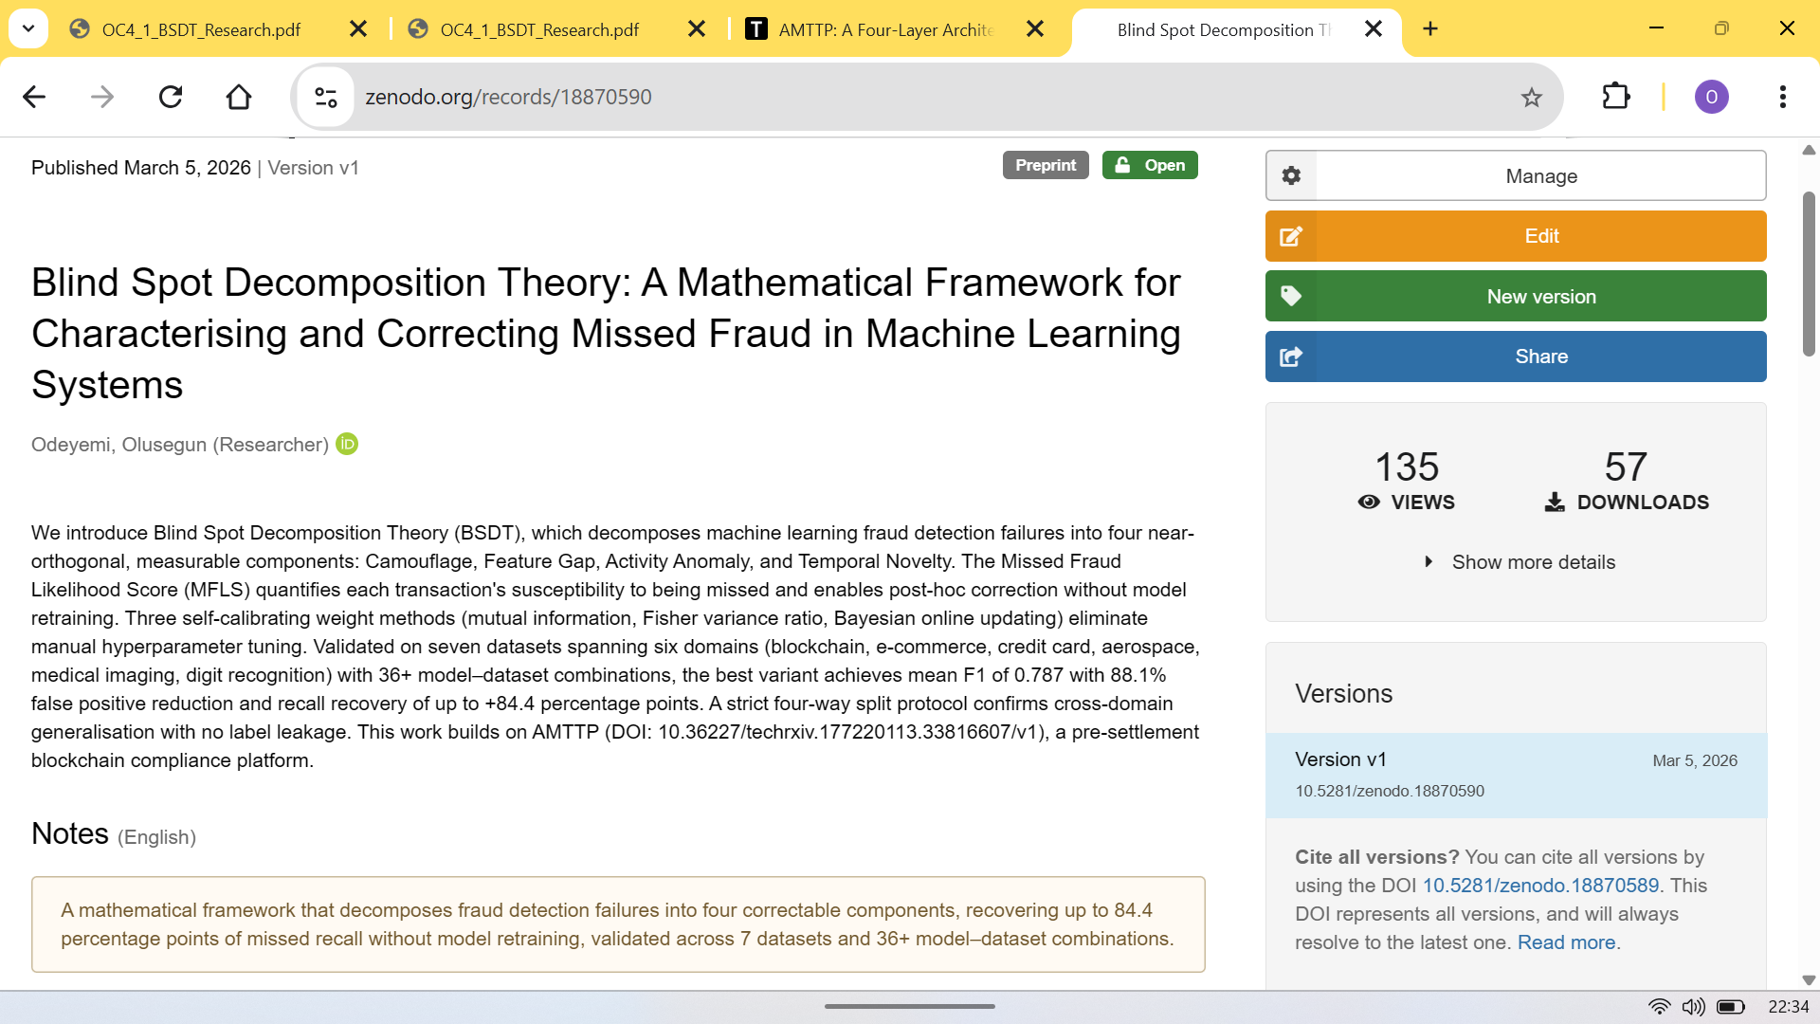
Figure 2: Zenodo analytics — 135 views, 57 downloads for the BSDT paper.
4. Blind-Spot Decomposition and the Geometry of System Collapse (Zenodo)

Field | Detail
Published | 16 March 2026
Platform | Zenodo — CERN-hosted open-access archive
DOI | 10.5281/zenodo.19038783

This paper extends BSDT using topology and control theory, testing whether the same framework detects instability beyond financial fraud. It was applied to three independent crisis datasets (2008 US banking crisis, Terra/Luna collapse, 2021 Texas power-grid failure) without retraining; quantitative results are in OC4-1. This is generalisable mathematical theory, not product-specific implementation.
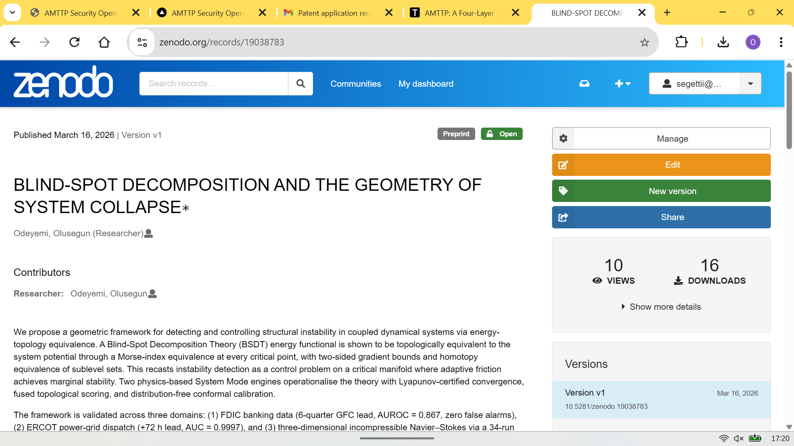
Figure 3: Zenodo — Geometry of System Collapse. Three crisis datasets, no retraining. AUROC 0.9997 on ERCOT.
5. Universal Deviation Principle (Zenodo
Field | Detail
Published | March 2026
Platform | Zenodo — CERN-hosted open-access archive
DOI | 10.5281/zenodo.19037688

A multi-operator framework for anomaly detection and classification with sensitivity guarantees. Selected as recommended reading in CPE 604 alongside the BSDT and AMTTP papers.
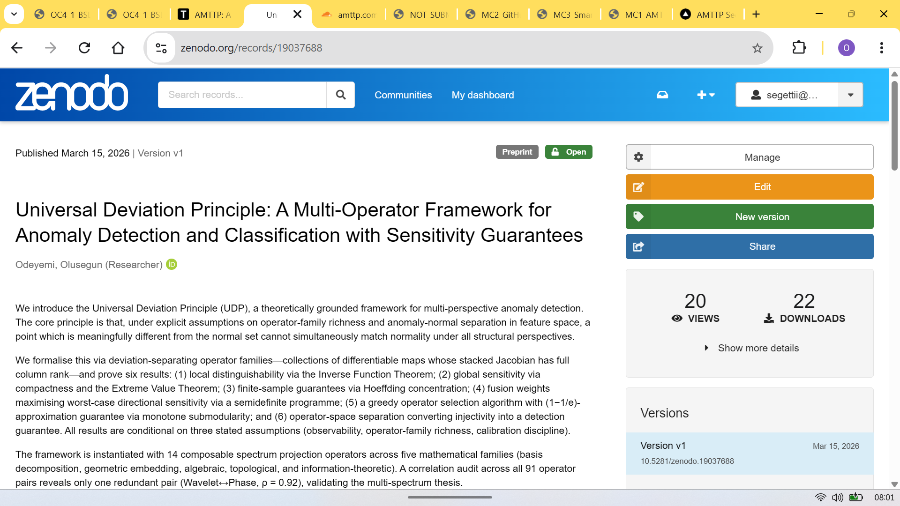
Figure 4: Zenodo record for the Universal Deviation Principle paper. DOI: 10.5281/zenodo.19037688. Published March 2026.
6. Combined Impact Summary

Four papers, three platforms, under ten weeks from first submission to academic adoption — all without institutional affiliation, co-authors, or any promotion budget.
Paper | Platform | Views | Downloads | Adopted (CPE 604)
AMTTP Infrastructure | TechRxiv | 230 | 153 | Yes
BSDT Framework | Zenodo | 135 | 57 | Yes
Geometry of System Collapse | Zenodo | — | — | Yes
Universal Deviation Principle | Zenodo | — | — | No
Total | — | 365 | 210 | 3 of 4

Table 1: Four-paper research impact. Three of four papers independently selected for CPE 604 postgraduate teaching. 365 views and 210 downloads across TechRxiv and Zenodo in under ten weeks, entirely organic.
The view and download counts are independently verifiable at the DOI pages listed above. The platform analytics are public and not controlled by the author. The academic adoption record is documented separately in OC4-3 with the signed confirmation letter and CPE 604 course slides.

