Tech Nation Visa — Global Talent (Exceptional Promise)
Criteria: Mandatory Criteria — Innovation and Technical Leadership
Applicant: Odeyemi Olusegun Israel

MC-1: Design and Development of AMTTP — A Four-Layer Real-Time Blockchain Compliance System
Executive Summary: I designed and built a four-layer real-time compliance system for blockchain transactions. Traditional AML tools act only after transactions are completed, while AMTTP assesses risk, verifies sanctions, and applies contract decisions in less than a second — before any funds are transferred. In its first public month, the live platform processed 920,848 transactions and attracted 1,220 unique visitors at amttp.com. Every layer — consumer app, enterprise dashboard, nine-service AI backend, and blockchain contracts — was built by me.
Live Public Deployment Evidence

4-MINUTE VIDEO DEMONSTRATION
https://youtu.be/I0dXSN_ScR0
Public demo: amttp.com | Sepolia-backed | 1,220 unique visitors | 38,320 requests | 5 Apr – 5 May 2026

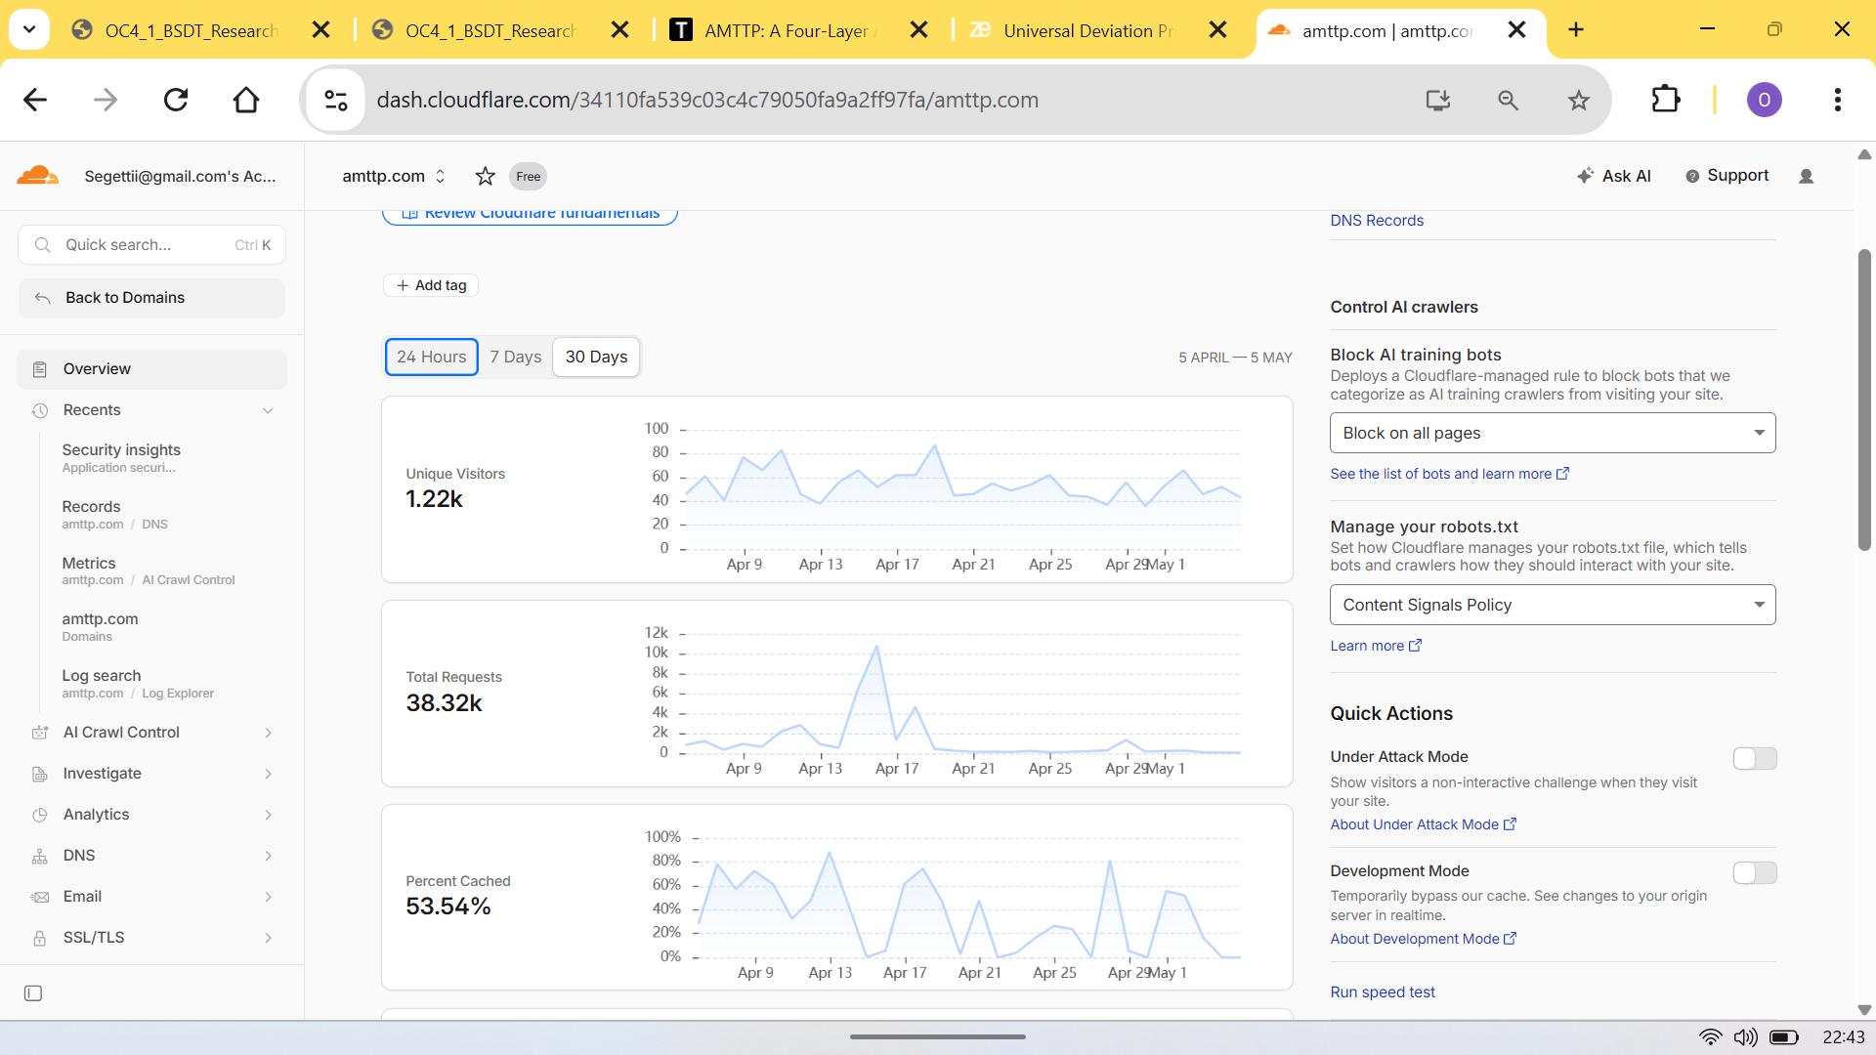
Figure 1: Cloudflare analytics — 1,220 unique visitors, 38,320 requests, 53.54% cache-hit ratio (5 Apr – 5 May 2026). Independently verifiable at amttp.com.
Technical Contributions

- Pre-settlement enforcement at scale: 920,848 transactions processed on a live testnet; decisions issued before funds move — not after.
- Dual-model AI scoring: gradient-boosted classifier + Graph Neural Network; fraud-detection ROC-AUC 0.9999998.
- 90%+ cost reduction: compact distilled model runs on standard CPUs, eliminating specialist GPU hardware.
- Privacy-preserving identity: sanctions verified on-chain without exposing personal data — GDPR-compliant on a public ledger.
- Regulatory audit trail: every compliance decision permanently recorded on-chain (FCA / MiCA requirements).
- Zero-downtime upgrades: UUPS upgradeable contract design — compliance rules change without taking the live platform offline.

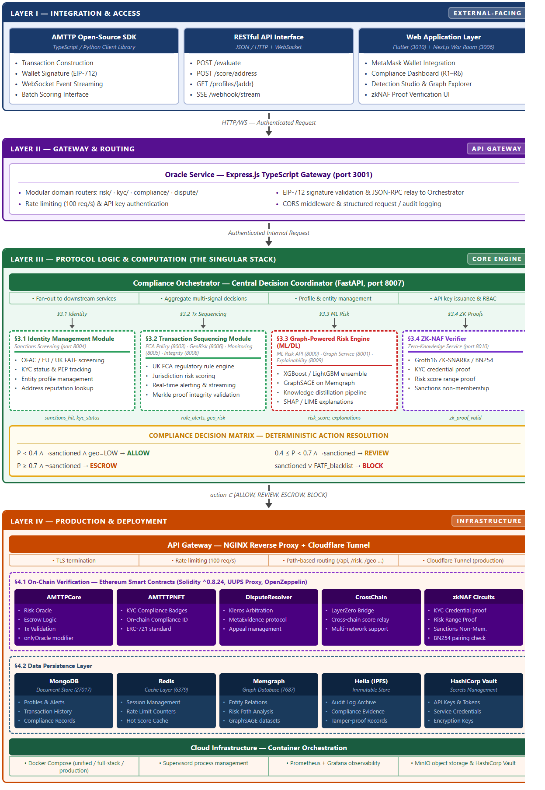
Figure 2: AMTTP four-layer architecture — Flutter + Next.js (UI) → Express Gateway → Python FastAPI orchestrator (9 microservices) → 38 Solidity files, 17 Docker containers. All layers sole-authored.

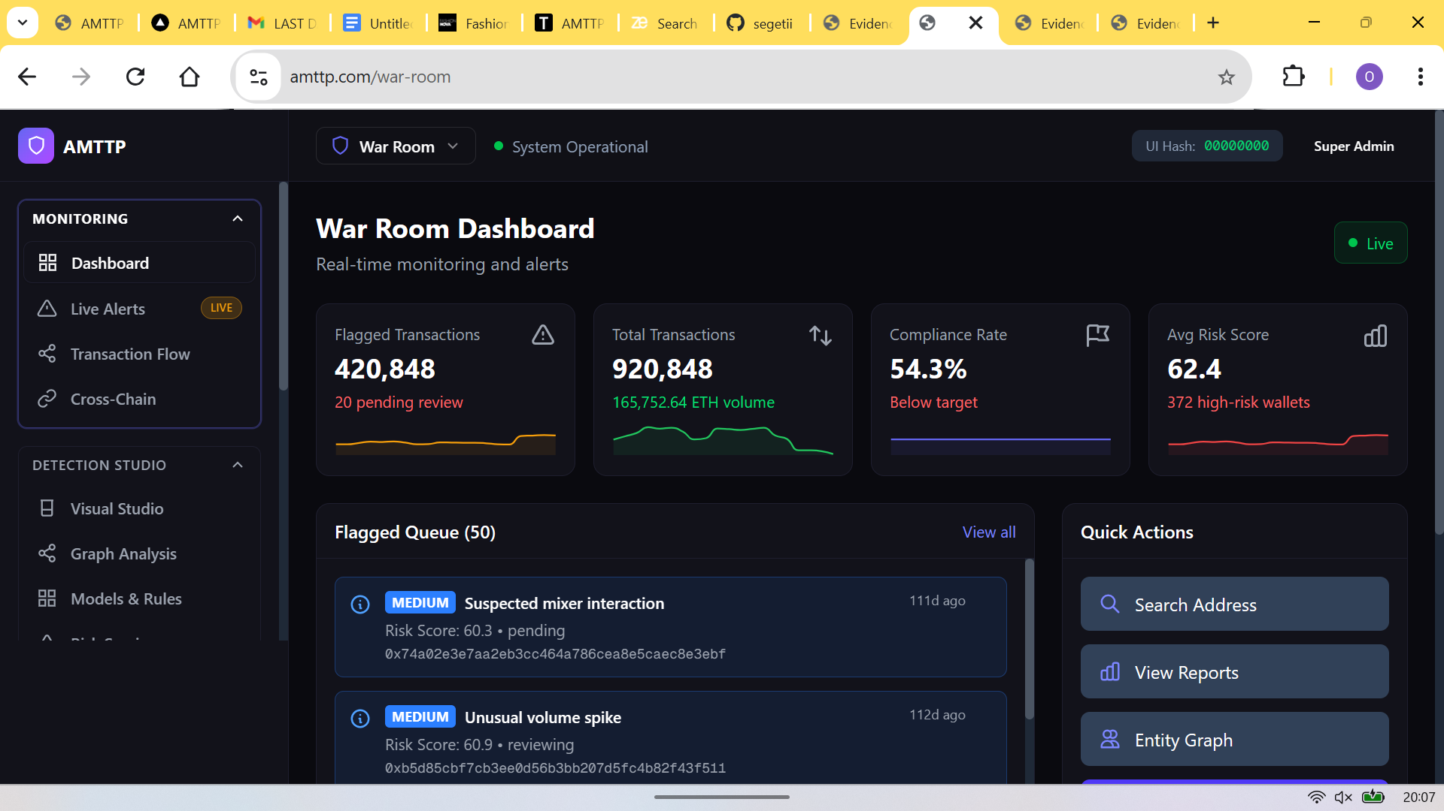
Figure 3: War Room enterprise dashboard (Next.js, port 3006) — live compliance monitoring for compliance officers. Role-based access enforced server-side.
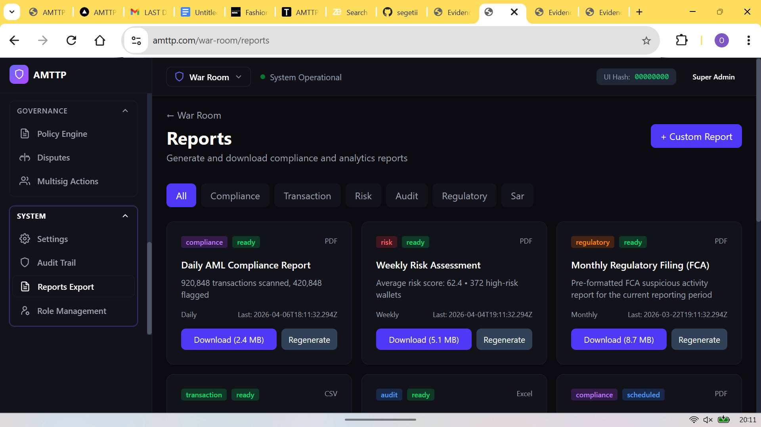
Figure 4: Automated report generation — Daily AML PDF (2.4 MB), Weekly Risk Assessment (5.1 MB), Monthly FCA SAR (8.7 MB).

