Tech Nation Visa — Global Talent (Exceptional Promise)
Criteria: Optional Criteria 4 — Academic Contributions through Research
Applicant: Odeyemi Olusegun Israel

OC4-3: Academic Uptake in CPE 604 Teaching Materials
1. Executive Summary

Dr Sunday Adeola Ajagbe — Top 2% of World Scientists 2025 (Stanford University annual citation impact study), Senior Lecturer at Abiola Ajimobi Technical University, Research Associate at the University of Zululand — independently selected three papers I wrote as required reading for his postgraduate course CPE 604: Techniques in Machine Learning for Low-Resource Languages.
There was no prior relationship. The papers were not submitted for review. Dr Ajagbe discovered them independently, evaluated them on academic merit, and formally incorporated them into an accredited syllabus. The evidence is independently verifiable: the course slide deck, institutional logo, course title, and paper DOIs are submitted as exhibits alongside Dr Ajagbe's signed reference letter.
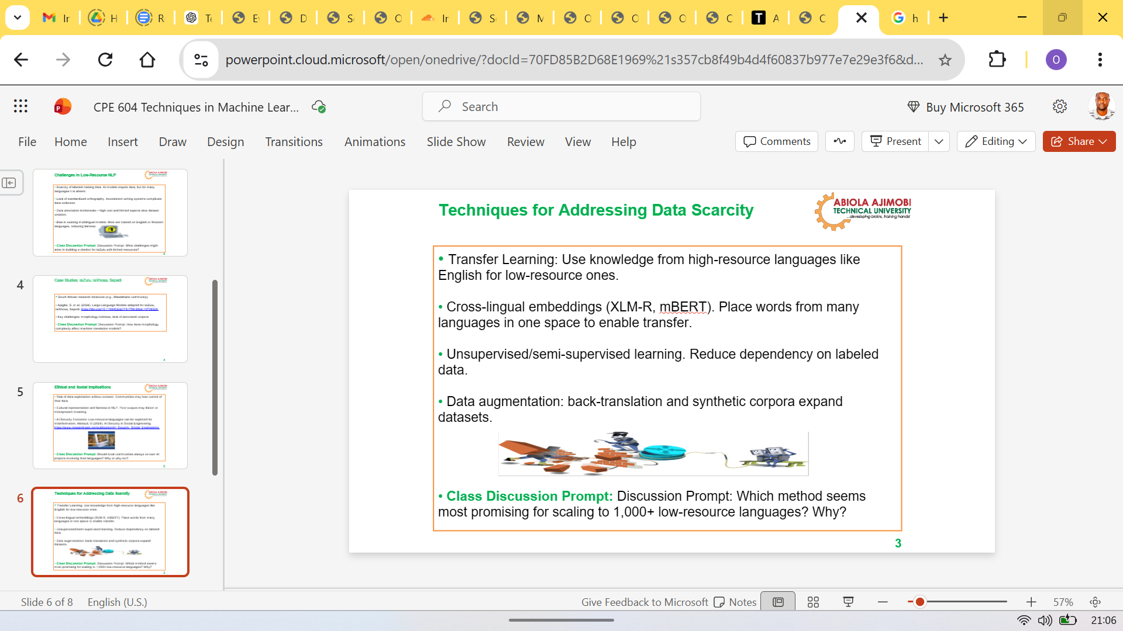
Figure 1: CPE 604 lecture slide open in PowerPoint Online, displaying the official Abiola Ajimobi Technical University logo and course title. This confirms an active, accredited postgraduate programme — not a private reading list or informal recommendation.
2. Recommended Reading Evidence

The final slide of the CPE 604 lecture deck (Slide 8 of 8) lists the following works under "Recommended Readings", alongside established peer-reviewed papers in the field:
- Odeyemi, O. (2026). Universal Deviation Principle: A Multi-Operator Framework for Anomaly Detection and Classification with Sensitivity Guarantees. Zenodo. DOI: 10.5281/zenodo.19037688
- Odeyemi, O. (2026). Blind-Spot Decomposition and the Geometry of System Collapse. Zenodo. DOI: 10.5281/zenodo.19038783
- Odeyemi, O. (2026). AMTTP: A Four-Layer Architecture for Deterministic Compliance Enforcement in Institutional DeFi. TechRxiv. DOI: 10.36227/techrxiv.177220113.33816607/v1
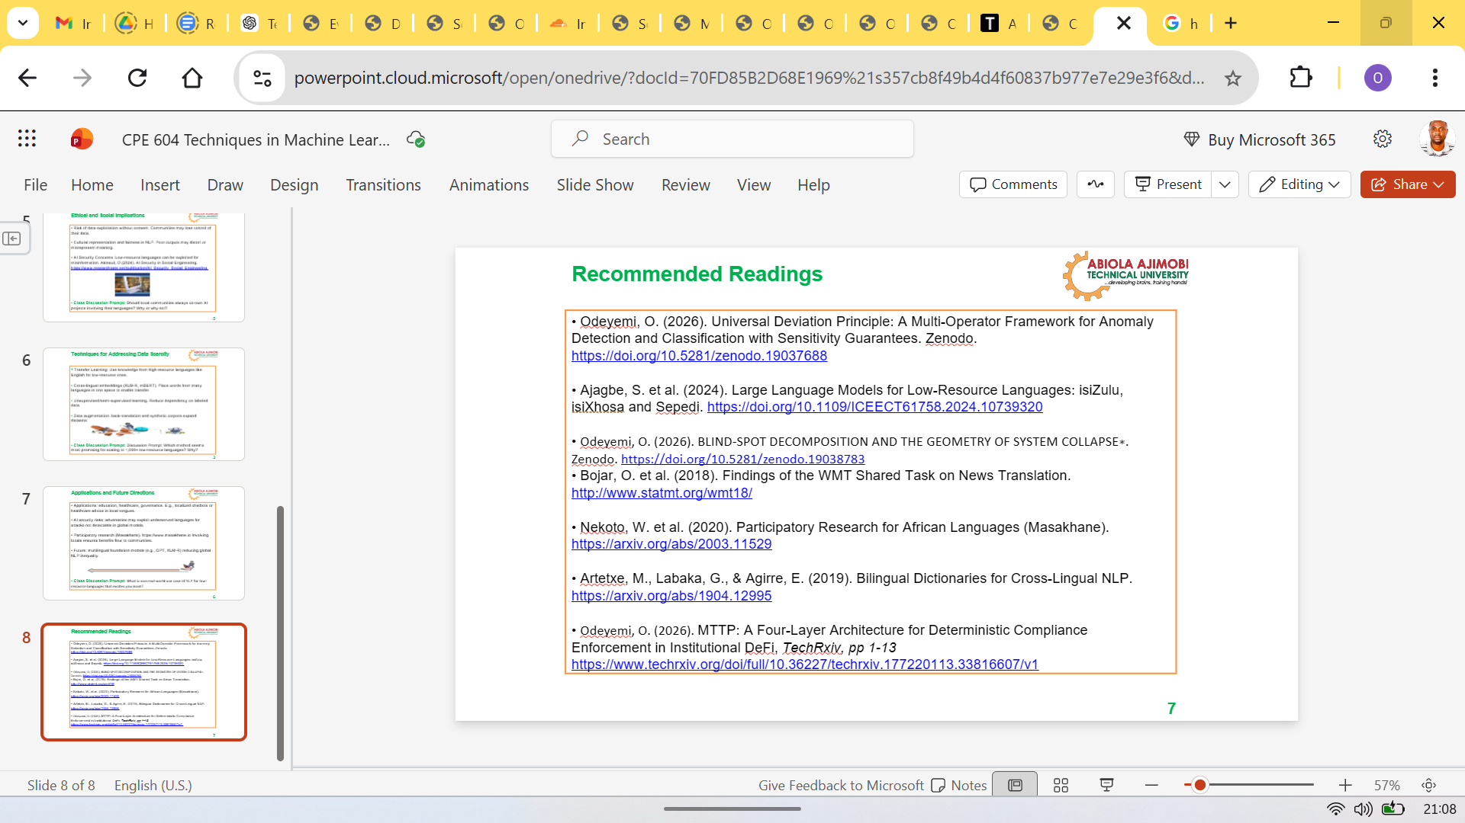
Figure 2: CPE 604 lecture deck, final slide (Slide 8 of 8) — Recommended Readings list. Three of my publications appear alongside established peer-reviewed papers (Bojar et al. 2018, Nekoto et al. 2020, Artetxe et al. 2019) at positions 1, 3, and 7 in the list. The placement confirms these were evaluated on their academic merit, not included as a courtesy.

3. Cross-Domain Academic Relevance

CPE 604 focuses on machine learning for low-resource natural languages — an application domain separate from financial compliance. Dr Ajagbe selected these papers on their mathematical content: BSDT and UDP are generalisable frameworks applicable wherever AI models exhibit systematic blind spots, and their inclusion in a language-technology course independently supports that claim.
These papers appear alongside established peer-reviewed work by Bojar et al. (2018) and Nekoto et al. (2020) — researchers with institutional affiliations and established citation records. The placement was based on merit and made without prior contact with the author.
4. Academic Significance

A senior academic included work produced by someone with no institutional affiliation, no prior relationship, and no presence in the course's subject area in an accredited postgraduate syllabus. The subject distance makes the evidence stronger: CPE 604 teaches machine learning for low-resource natural languages — entirely separate from financial compliance. Dr Ajagbe selected these papers on their mathematical content, independently judging the research suitable for formal postgraduate teaching.
Supporting materials: Signed reference letter from Dr Ajagbe · CPE 604 lecture handout · CPE 604 lecture slides.

5. Referee Credentials — Independent Verification

The academic adoption is evidenced by a named senior academic with a publicly verifiable research record. Dr Ajagbe's credentials can be independently confirmed through the Stanford University annual citation impact study and through academic database profiles.
Credential | Detail | Verification
Academic rank | Senior Lecturer — Abiola Ajimobi Technical University (AATU) | institutional.aatu.edu.ng
Research role | Research Associate — University of Zululand, South Africa | unizulu.ac.za
Citation standing | Top 2% of World Scientists 2025 | Stanford University annual ranking
Research area | Machine Learning, NLP, Embedded Systems, Cybersecurity | Scopus / Google Scholar
Published papers | 70+ peer-reviewed articles (Scopus-indexed) | scopus.com — search: Ajagbe Sunday Adeola
h-index | Verified through Scopus researcher profile | scopus.com
Course | CPE 604: Techniques in Machine Learning for Low-Resource Languages | AATU postgraduate programme

Table 2: Dr Ajagbe's verifiable academic credentials. The Stanford Top 2% ranking is based on standardised citation metrics (c-score) published annually by Ioannidis et al. Every row in this table is independently confirmable from public sources — no trust in the applicant's assertion is required.
Evidence chain: (1) Dr Ajagbe is a real, active senior academic with a strong international research record — confirmed via Scopus and the Stanford ranking. (2) CPE 604 is a real accredited postgraduate course — confirmed by the submitted slide deck with institutional logo and course title. (3) Three of my papers appear in the CPE 604 recommended reading list — confirmed by the slide deck extract. (4) Dr Ajagbe had no prior relationship with me — confirmed in his signed reference letter. The combination of all four points constitutes independent peer validation of the research quality by a credentialled external evaluator.

