Tech Nation Visa — Global Talent (Exceptional Promise)
Criteria: Optional Criteria 3 — Significant Technical and Entrepreneurial Contribution
Applicant: Odeyemi Olusegun Israel

OC3-3: Cross-Chain Interoperability & SDK Distribution
1. Executive Summary

I built: compliance enforcement across seven simultaneous blockchain networks — closing the cross-chain evasion gap where a blacklisted wallet moves freely to a different chain — and two developer SDKs that compress third-party integration from weeks of custom infrastructure work to hours, exposing nine specialist AI compliance services behind a single import.

The problem: conventional compliance tools enforce rules on one blockchain. A blacklisted wallet simply moves assets to a different network and transacts freely. I solved this by propagating risk scores and block decisions across seven networks via LayerZero — a cross-blockchain messaging protocol that transmits signed data packets between networks. A wallet blocked anywhere is blocked everywhere. EVM (Ethereum Virtual Machine) is the shared code standard across Ethereum, Polygon, Arbitrum, Optimism, Base, BSC, and Avalanche, meaning enforcement code written once applies to all of them.
Two developer SDKs — TypeScript (@amttp/client-sdk) and Python (amttp) — accompany the core system, exposing the full compliance stack behind a simple import. Neither wraps an existing library; both were written from scratch.
Cross-Chain Contract Integration (from contracts/AMTTPCrossChain.sol):
contract AMTTPCrossChain is Initializable, OwnableUpgradeable,
UUPSUpgradeable, ILayerZeroReceiver {

mapping(address => mapping(uint16 => uint256))
public crossChainRiskScores;
mapping(address => bool) public globallyBlocked;
ILayerZeroEndpoint public lzEndpoint;

function sendRiskScore(
uint16 _dstChainId, address _targetAddress,
uint256 _riskScore, bytes calldata _adapterParams
) external payable whenNotPaused nonReentrant {
require(_riskScore <= 1000, "Invalid risk score");
bytes memory payload = abi.encode(
MSG_RISK_SCORE, _targetAddress, _riskScore);
lzEndpoint.send{value: msg.value}(
_dstChainId, trustedRemotes[_dstChainId],
payload, payable(msg.sender), address(0),
_adapterParams);
}
}

Figure 1: AMTTPCrossChain.sol — upgradeable Solidity contract implementing LayerZero cross-chain message passing. A risk score or block decision on one of 7 EVM networks is encoded, signed, and broadcast to all connected chains. nonReentrant and whenNotPaused guards prevent replay and denial-of-service.
2. Developer SDK Distribution

- TypeScript SDK (@amttp/client-sdk): For web and application developers. Provides AI-powered risk scoring, blockchain enforcement integration, identity compliance checks, and support for multiple blockchain networks.
- Python SDK (amttp): For data scientists and backend engineers. Provides the same capabilities in Python — the standard language in financial analytics and data science teams.
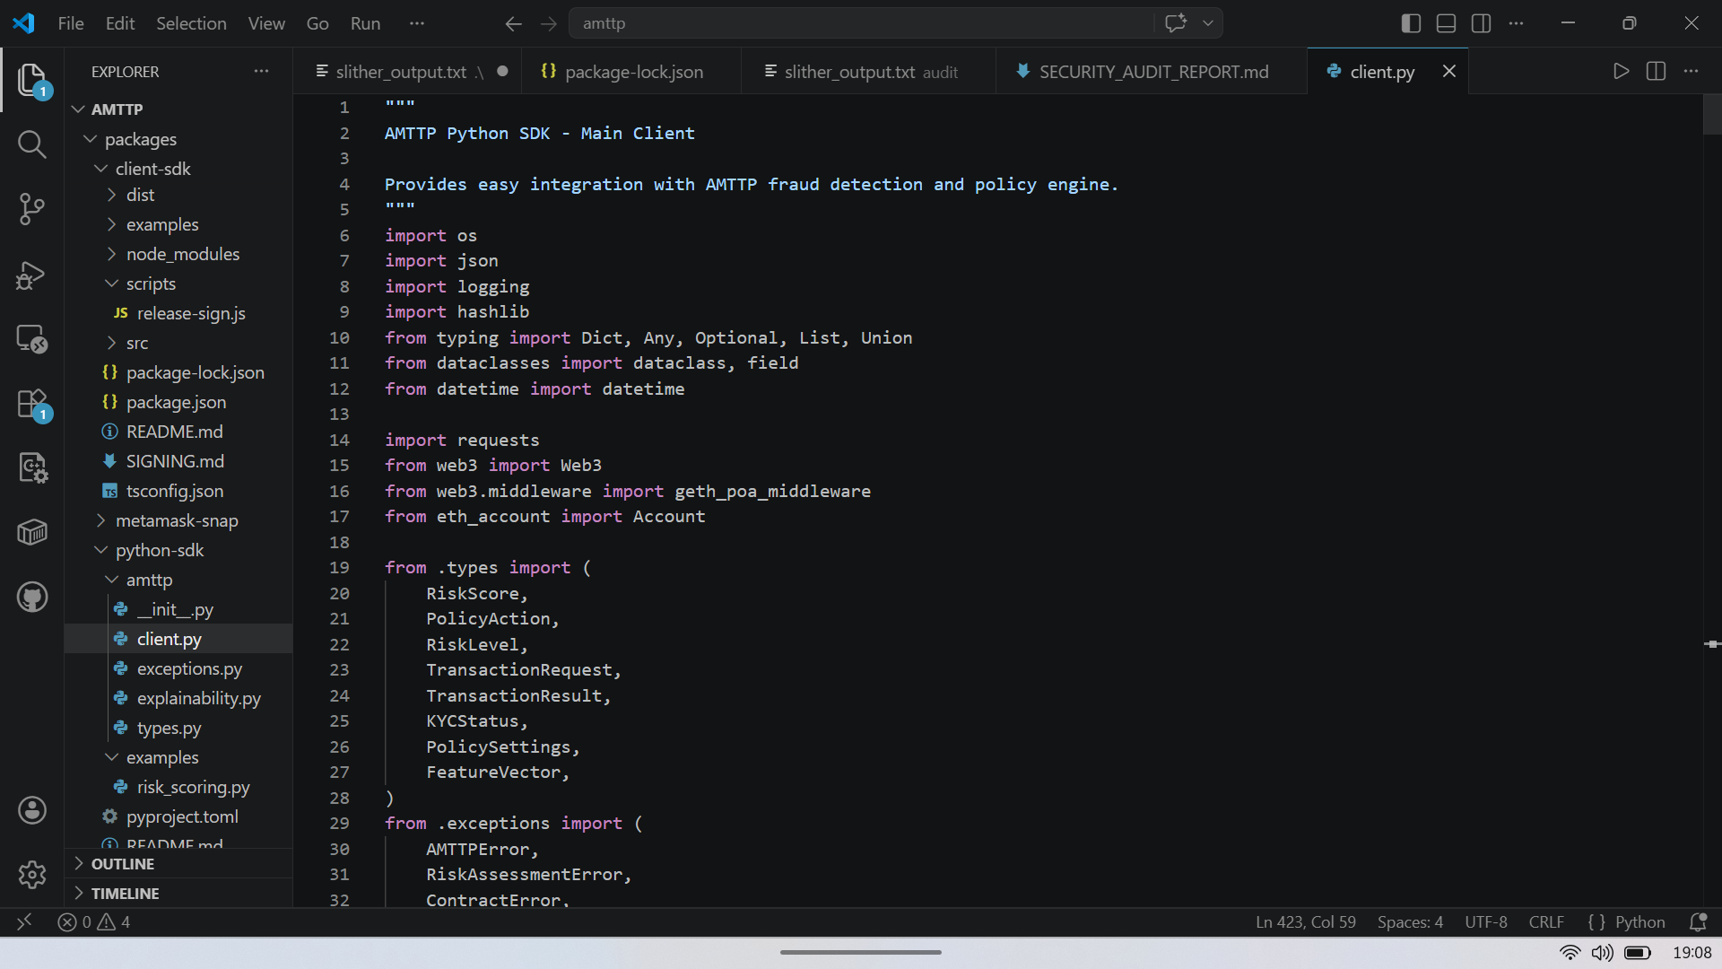
Figure 2: VS Code workspace showing both SDKs fully structured and ready for distribution. Both packages are sole-authored: no collaborative commits, no fork from an existing SDK. Each wraps the full nine-service AMTTP compliance stack behind a single import.
3. Commercial Readiness and UK Ecosystem Value

Cross-chain enforcement and distribution-ready SDKs transform AMTTP from a research system into a deployable compliance product. The architectural decision to implement enforcement at the cross-chain messaging layer — rather than as a post-settlement reporting tool — means a block decision propagates to all seven networks within the same transaction cycle. A wallet cannot evade by moving chains.
The two SDKs directly address the principal integration barrier for regulated institutions: a bank, payment processor, or fintech operating on any of the seven supported networks can integrate the full nine-service compliance stack within hours, in their preferred language, without rebuilding or understanding the underlying infrastructure. This eliminates a cost and complexity barrier that would otherwise require a dedicated blockchain engineering team.
For UK digital-finance institutions operating under FCA digital-asset rules, Travel Rule obligations, or MiCA cross-border requirements, the enforcement layer and its distribution tooling represent production-ready infrastructure they can adopt immediately. I designed, built, and sole-authored every component.

4. Pilot Deployment Agreement

A formal Pilot Evaluation Agreement has been executed with an enterprise partner, confirming independent commercial interest in evaluating AMTTP in a real business environment. This is framed as pilot-stage external validation, not a claim of paid production adoption. The agreement covers the cross-chain enforcement layer and the developer SDKs documented in this exhibit. It was signed and company-sealed by the partner after independent review — with no prior professional relationship between the parties.
The signed and sealed Schedule A/signature exhibit is reproduced below. Key terms: (a) the partner is evaluating defined AMTTP pilot components; (b) the scope includes onboarding/KYC, risk scoring, integrity checks, dispute/evidence workflow, and monitoring/reporting; (c) the agreement is non-exclusive and preserves the applicant's ability to commercialise the technology independently.

Figure 3: Signed and company-sealed Pilot Evaluation Agreement exhibit — Schedule A pilot components and signature page together. Independent commercial validation that AMTTP is being evaluated externally as deployable compliance infrastructure.

