Tech Nation Visa — Global Talent (Exceptional Promise)
Criteria: Mandatory Criteria — Innovation and Technical Leadership
Applicant: Odeyemi Olusegun Israel
MC-1: Design and Development of AMTTP — A Four-Layer Real-Time Blockchain Compliance System
Executive Summary: I designed and built a four-layer real-time blockchain compliance system. Unlike traditional AML tools that act after settlement, AMTTP assesses risk, checks sanctions, and executes contract decisions in under a second before transaction settlement. In its first public month, it processed 920,848 transactions and attracted 1,220 unique visitors on amttp.com. I built every layer: the consumer app, enterprise dashboard, nine-service AI backend, and blockchain contracts.
This demonstrates independent technical leadership, not just participation. The evidence—public deployment, third-party analytics, product screens, and a repeatable architecture—shows I personally took an original digital-technology product from design to public release.
Claim | Evidence | Independent verification
Public product exists | amttp.com live deployment | Cloudflare analytics + public URL
Public interest | 1,220 unique visitors; 38,320 requests | Cloudflare independent infrastructure analytics
Working system | 4-minute demo and product screens | YouTube demo + War Room screenshots
External validation | Signed/sealed pilot agreement | Ibironke Estate Limited (RC No. 1647148) Schedule A + signature/seal
Live Public Deployment Evidence
4-MINUTE VIDEO DEMONSTRATION
https://youtu.be/I0dXSN_ScR0
Public demo: amttp.com | Sepolia-backed | 1,220 unique visitors | 38,320 requests | 5 Apr – 5 May 2026
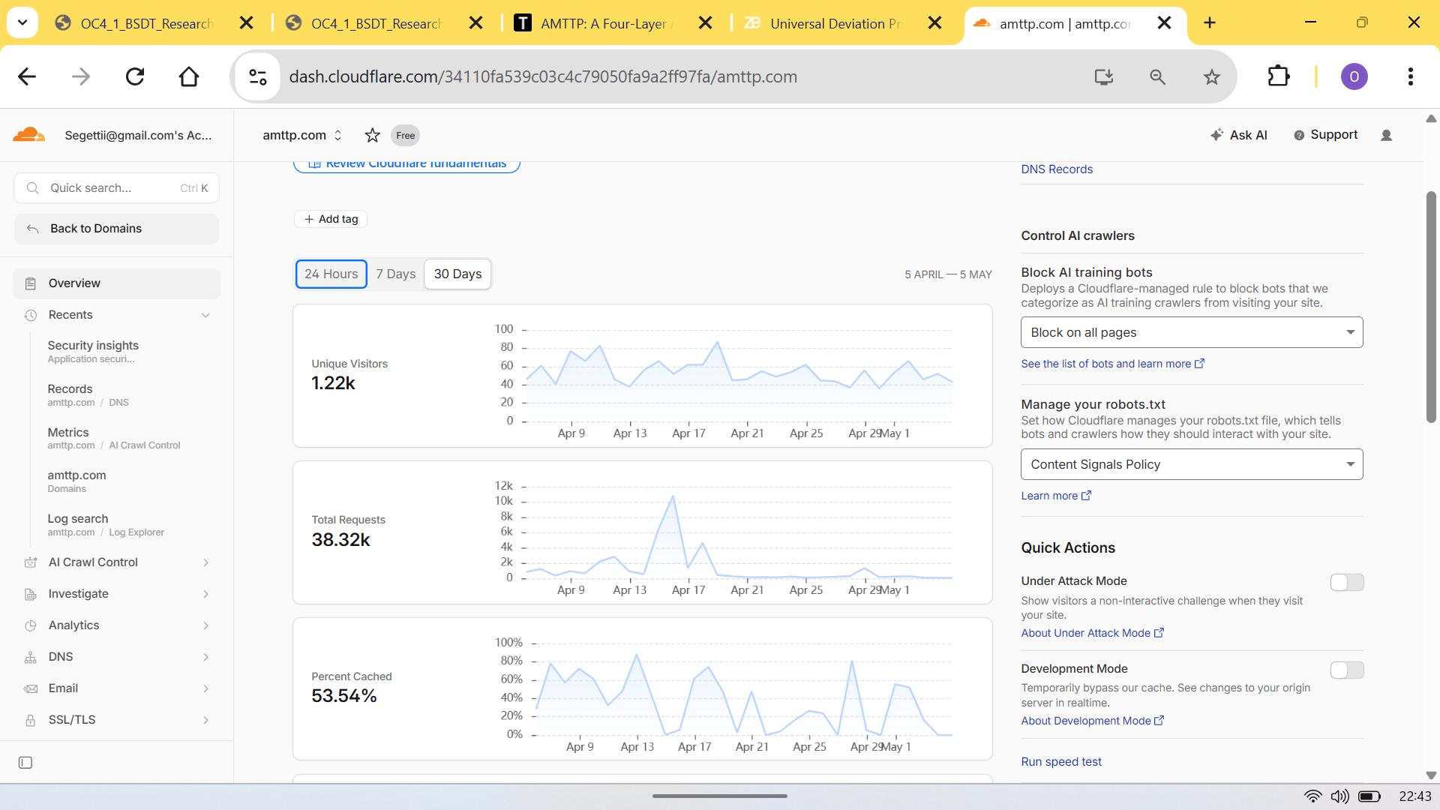
Figure 1: Cloudflare analytics — 1,220 unique visitors, 38,320 requests, 53.54% cache-hit ratio (5 Apr – 5 May 2026). Independently verifiable at amttp.com.
Technical Contributions
- Pre-settlement enforcement at scale: 920,848 transactions processed on a live testnet; decisions issued before funds move — not after.
- Dual-model AI scoring: gradient-boosted classifier + Graph Neural Network; fraud-detection ROC-AUC 0.9999998.
- 90%+ cost reduction: compact distilled model runs on standard CPUs, eliminating specialist GPU hardware.
- Privacy-preserving identity: sanctions verified on-chain without exposing personal data, designed to support GDPR-style data minimisation on public ledgers
- Regulatory audit trail: every compliance decision permanently recorded on-chain, to align with FCA / MiCA styled requirements.
- Zero-downtime upgrades: UUPS upgradeable contract design — compliance rules change without taking the live platform offline.
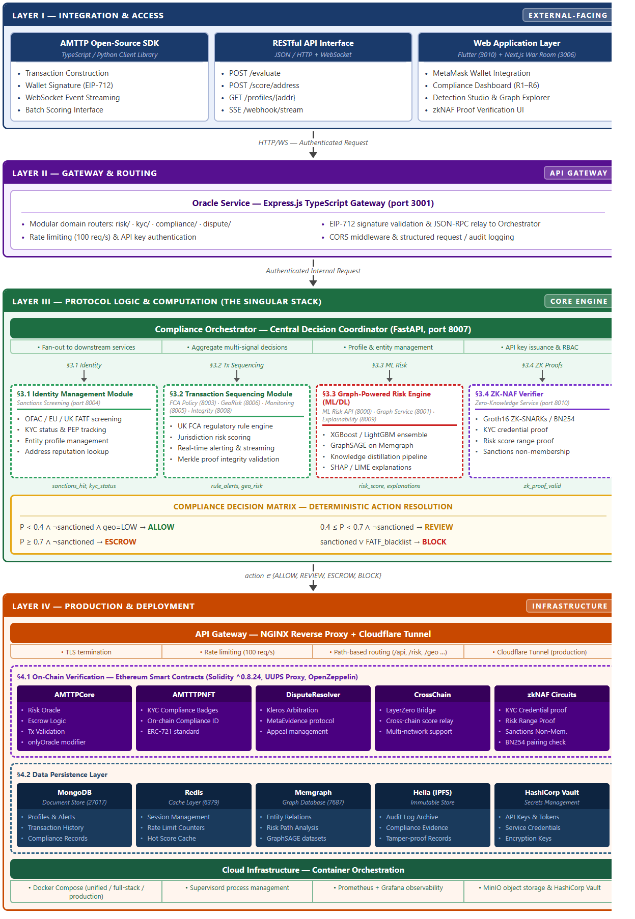
Figure 2: AMTTP four-layer architecture — Flutter + Next.js (UI) → Express Gateway → Python FastAPI orchestrator (9 microservices) → 38 Solidity files, 17 Docker containers. All layers sole-authored.
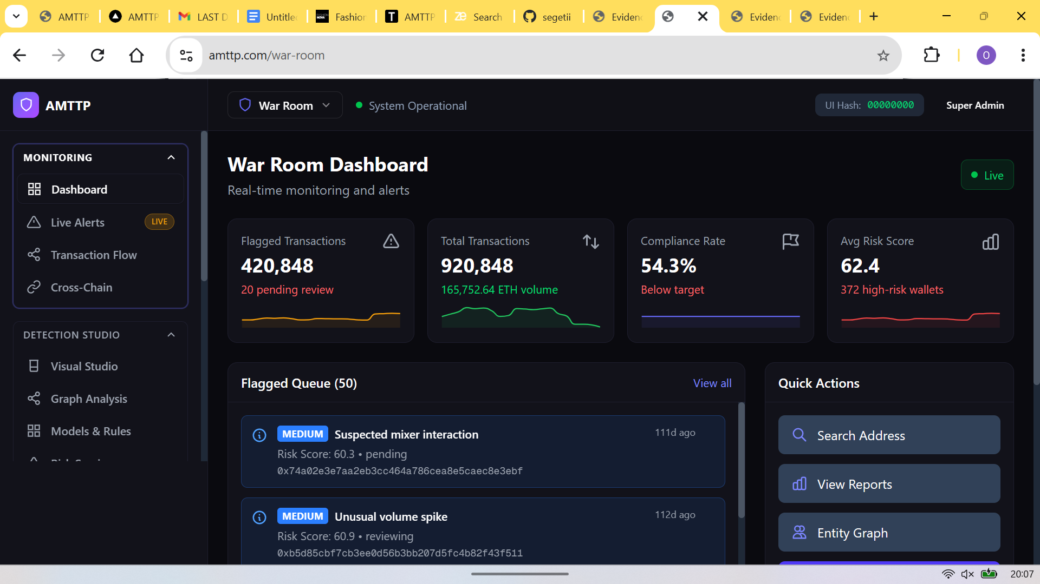
Figure 3: War Room enterprise dashboard (Next.js, port 3006) — live compliance monitoring for compliance officers. Role-based access enforced server-side.
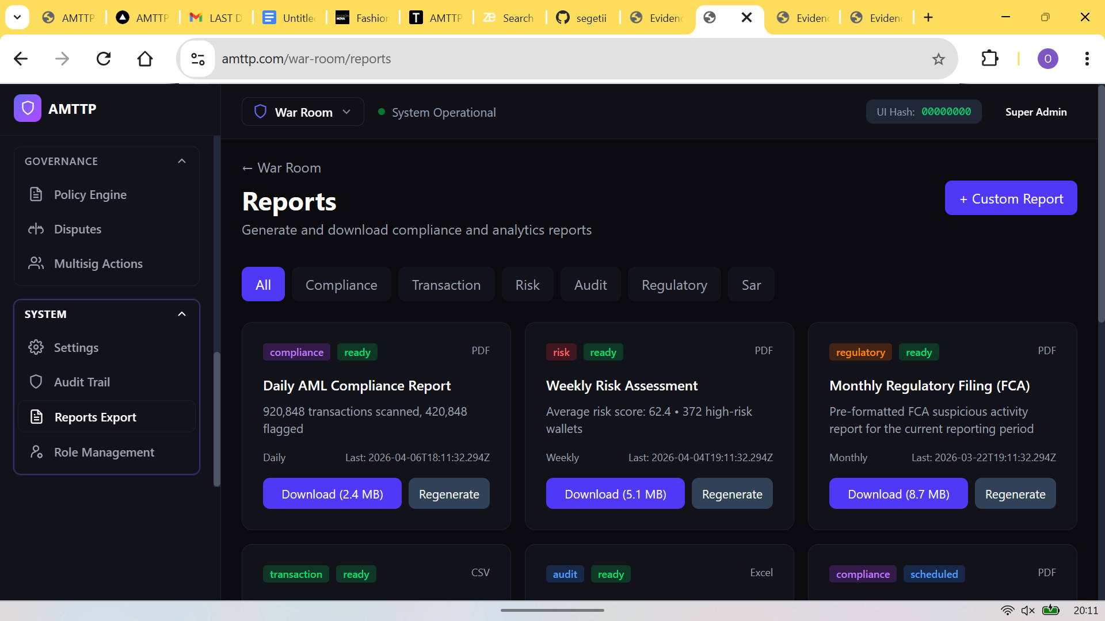
Figure 4: Automated report generation — Daily AML PDF (2.4 MB), Weekly Risk Assessment (5.1 MB), Monthly FCA SAR (8.7 MB).
External Validation: Enterprise Pilot Agreement
What this proves: External enterprise adoption under a formal legal agreement, independently verifying that AMTTP is usable by a real organisation outside the developer's own environment. Nigerian property management and real estate company signed a binding pilot evaluation agreement to test AMTTP components in its operational systems.
Signed parties: Olusegun Odeyemi (Developer) and Akintunde Ibironke, Director of Ibironke Estate Limited (RC No. 1647148). The agreement grants the company a 90-day evaluation licence, defines IP ownership (retained by Developer), sets confidentiality obligations, and includes a commercialisation pathway.
Schedule A confirms: The evaluated components — Smart Contract Gateway, ML Risk Engine, Compliance Orchestrator, War Room Dashboard, and Cross-Chain SDK — are the exact same components evidenced elsewhere in this submission. The stamped company seal (red) and both signatures are visible below.
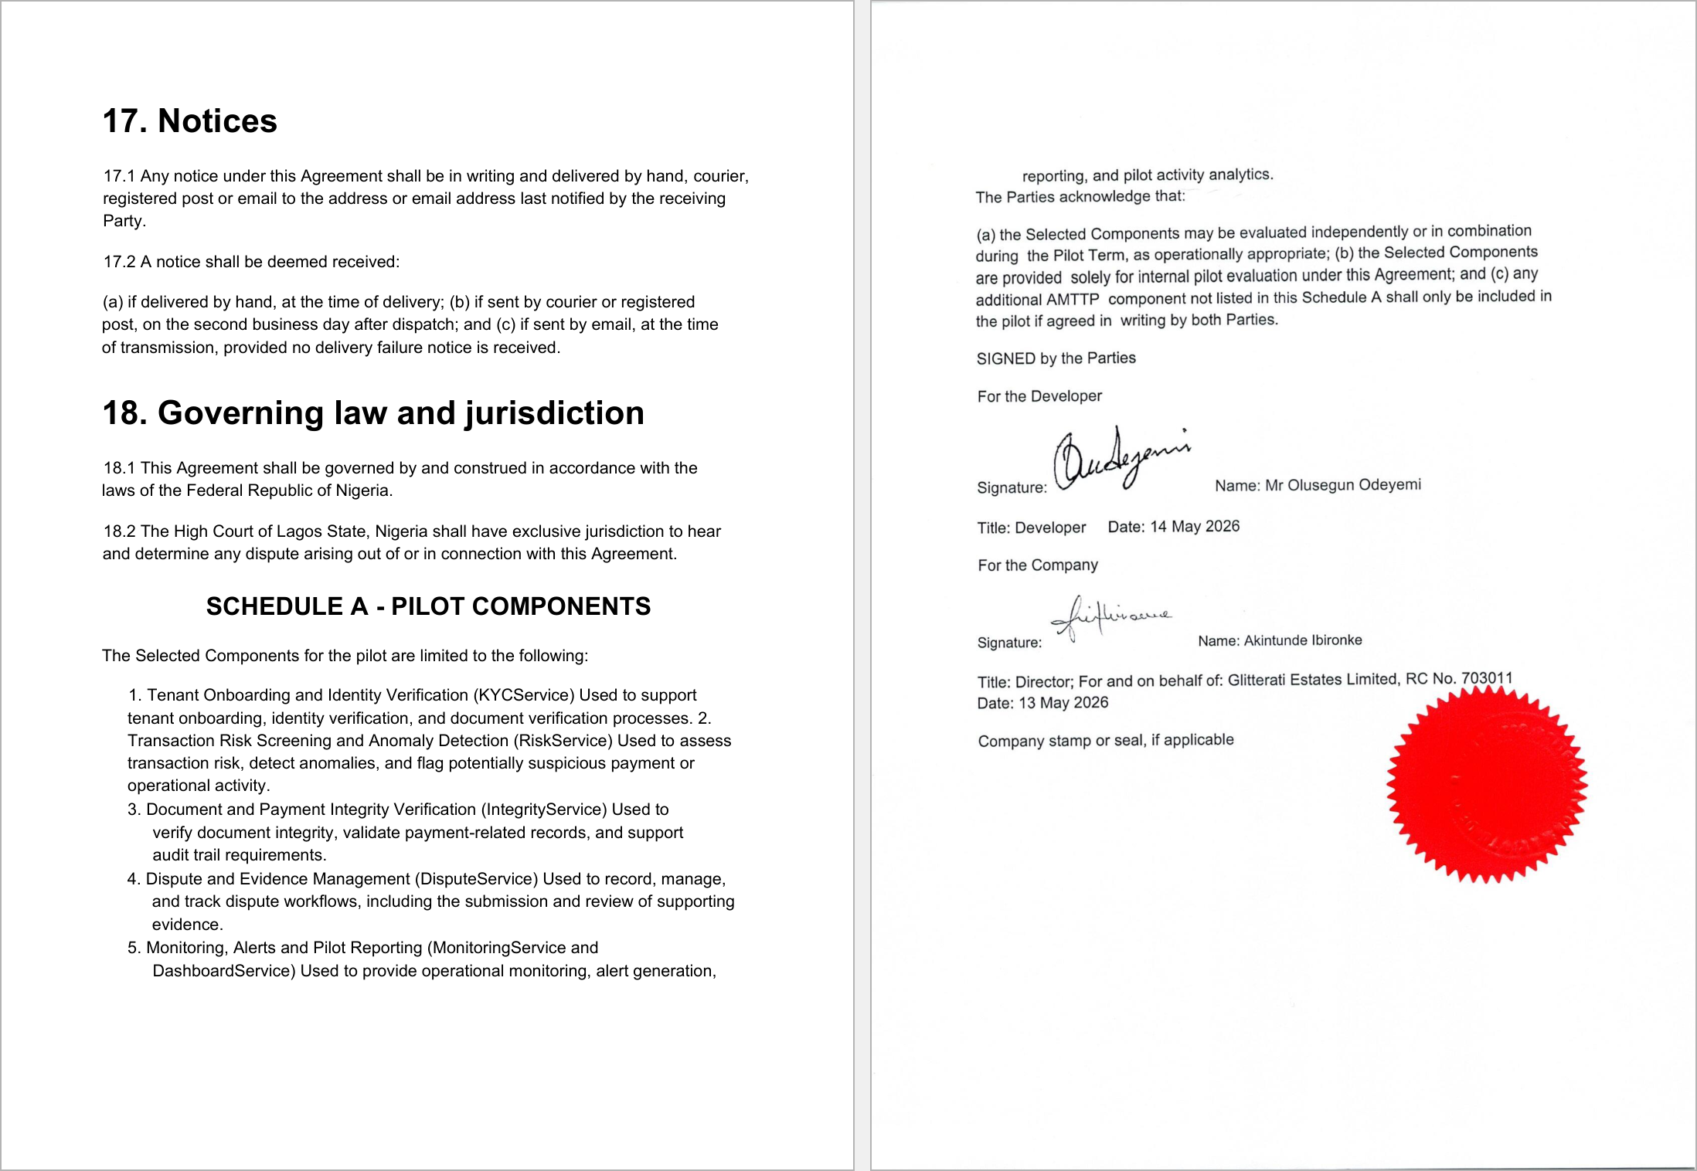
Figure 5: Pilot Evaluation Agreement — Schedule A (left) listing the evaluated AMTTP components, and the signed and company-sealed signature page (right). Signed by Developer and Akintunde Ibironke, Director, Ibironke Estate Limited. Company seal (red stamp) confirms formal corporate execution.
Anti-loophole note: This exhibit does not rely only on screenshots. It ties the product to third-party infrastructure analytics, a public URL, a video demonstration, and a signed/sealed external pilot document.

