Chapter 2: Literature Review
This chapter reviews the concepts, methods, technologies, and existing products that frame the Discord Platform. The project is not simply a chatbot connected to a Discord bot. It is a configuration-management system in which natural language captures an administrator's intent, while a declarative state model, deterministic checks, human approval, and a controlled execution engine decide what may happen to the live server. The literature is therefore drawn from four areas: Discord administration, tool-using language models, declarative configuration management, and safety patterns for long-running external operations.

2.1 Background Knowledge

2.1.1 Discord servers as configurable systems
Discord calls each server a guild. A guild contains channels, categories, roles, members, and permission settings. Roles grant guild-level capabilities to groups of members, while channel permission overwrites can allow or deny specific capabilities for a role or member in one channel. Discord represents permissions as a bitfield and evaluates them through a hierarchy of guild permissions, role positions, and channel-specific overwrites [1], [2]. Consequently, apparently simple requests such as "make a private staff section" involve several dependent decisions:
- a staff role must exist;
- the category and its child channels must exist in the intended order;
- the default role must be denied access;
- the staff role must be allowed access; and
- the bot's own role must be high enough to create or modify the target resources.
This dependency structure is important because a server configuration cannot be treated as a list of unrelated API calls. Creating a channel before its new parent category, or assigning a role before that role exists, would fail. Permission changes can also have a wider effect than their small representation suggests. A system that automates Discord administration must therefore understand resource relationships, ordering, and the bot's authorization boundary.
Discord applications normally use two complementary interfaces. The Gateway is a persistent WebSocket connection through which Discord sends events such as channel, role, and member changes [3]. The REST API is used for explicit reads and mutations. Both surfaces are authenticated and subject to Discord's permission and rate-limit rules [1], [4]. This creates a common systems trade-off: cached Gateway state is efficient for interactive planning, but a fresh REST read is more appropriate when correctness at an execution boundary matters.
The human and bot identities are also distinct. OAuth2 authenticates the administrator and exposes the guilds that the user can access, whereas a bot token identifies the application account that performs Discord operations [1]. A safe management platform must check both sides: the human must be authorized to manage the selected guild, and the bot must have sufficient Discord permissions and role position to carry out the approved change.

2.1.2 Natural-language intent and structured action
A natural-language interface lowers the knowledge required to describe a server configuration. The administrator can express an outcome such as "create a support area for verified members" without naming REST endpoints, permission bits, or role IDs. However, free-form text is not a safe execution format. It can be ambiguous, incomplete, or internally inconsistent, and a generative model may produce different outputs for similar prompts.
Research on language-model agents provides a useful separation between reasoning about a task and acting through a constrained interface. ReAct interleaves reasoning with task-specific actions so that a model can update a plan using observations from its environment [5]. Toolformer similarly studies models that decide which external API to call, when to call it, and which arguments to provide [6]. These works motivate tool use, but tool use alone does not guarantee safe administration. A model-selected function call remains probabilistic output. The receiving system must still validate its name and arguments, control its effects, and decide whether it is permitted to run.
For this project, the LLM is best understood as an intent interpreter and plan author, not as the final authority. Its output is restricted to a fixed registry of typed operations. During planning, those operations modify an imagined server state rather than Discord itself. This preserves the accessibility of natural language while moving authority into deterministic software and an explicit human approval step.

2.1.3 Declarative configuration and desired state
Declarative systems describe what state should exist, rather than prescribing every command needed to reach it. Kubernetes controllers, for example, observe current state and repeatedly move managed resources toward desired state [7]. Terraform applies a related plan-first workflow: it compares configuration with current infrastructure, presents an execution plan, and applies the reviewed changes later [8]. Both examples show why current state, desired state, and the difference between them should be separate concepts.
The same model is valuable for Discord administration:
- read the current guild state;
- fork it into an editable desired state;
- change the desired state without mutating Discord;
- compute the required create, update, move, and delete operations;
- show those operations to the administrator; and
- apply only the approved plan.
Unlike Kubernetes, the project is not a continuously authoritative controller that silently reconciles every difference. Discord administrators may intentionally change a server outside the platform. The selected approach is therefore human-triggered convergence: drift is detected and reported, but a new or repaired plan must still be reviewed and approved. This retains the benefits of desired-state modelling without taking control away from the guild's administrators.

2.2 Related Technologies and Methodologies

2.2.1 Schema-constrained tool calling
Tool calling provides a bridge between language and application logic. Each tool has a name, description, and parameter schema. The model selects a tool and supplies arguments; application code validates and handles the call. The important security property is that the model does not receive a general-purpose Discord client. It can express only the operations exposed by the tool registry.
The methodology has three boundaries:
- syntactic boundary: tool arguments must satisfy a schema;
- semantic boundary: the requested mutation must be valid for the current desired state; and
- authority boundary: planning a tool must not execute it against Discord.
This project goes beyond the typical reason-act loop described by ReAct [5]. Most structural tools are deferred: their planning function updates desired state, while their execution function remains unreachable until the plan has been generated, validated, and approved. The special interaction tool can pause planning to ask the administrator a question, but it has no Discord side effect. This distinction prevents conversational uncertainty from becoming an immediate live mutation.

2.2.2 Plan, preview, approve, and apply
Terraform's saved-plan workflow illustrates an important control: the reviewed plan can become the specific artifact later applied, rather than merely an informal preview [8]. The Discord Platform adopts the same principle as a methodology, although its state model and operations are specific to Discord.
The separation provides several benefits:
- the administrator can inspect additions, edits, moves, and deletions before execution;
- the same desired state can be revised manually or through another LLM turn;
- deterministic validation can examine the complete plan rather than isolated commands;
- dependencies can be ordered before any mutation begins; and
- the system can record exactly which contract the administrator approved.
Preview is therefore more than a user-interface convenience. It is part of the safety boundary. The Discord-like visual representation helps the administrator interpret the proposed outcome, while the explicit step list preserves technical detail for validation and execution.

2.2.3 Human-in-the-loop AI and layered assurance
The NIST Generative AI Profile recommends documenting how model output is used and overseen, combining human oversight with automated evaluation, and maintaining governance throughout the AI system lifecycle [9]. These recommendations are particularly relevant when model output may cause external side effects.
No single control is sufficient for this project. Human approval can catch intent errors but may miss a dangling symbol or Discord constraint. Deterministic validation can prove structural invariants but cannot reliably interpret every natural-language server policy. An LLM policy check can interpret flexible rules but should not be trusted as the only guard. The selected assurance model therefore layers:
- schema validation at the API and tool boundaries;
- state-store invariants during planning;
- a deterministic diff and dependency graph;
- structural and permission validation before execution;
- an LLM-assisted check against guild-specific written rules;
- a human review and approval gate; and
- stale-state and authorization checks at execution time.
The ordering of the policy check is an implementation limitation discussed in Chapter 4. The current system performs the guild-rule LLM check at execution rather than making rules part of the initial planning prompt. The literature supports layered assurance, but it does not imply that two probabilistic model calls constitute deterministic proof. The hard-coded checks and approval gate remain necessary.

2.2.4 Compensating recovery for external side effects
A Discord execution is a long-running sequence of remote operations, not one database transaction. Once Discord has accepted a channel deletion or role change, a PostgreSQL rollback cannot undo it. The Saga pattern addresses a similar problem by decomposing a long-lived transaction into smaller transactions with compensating actions when later work fails [10].
This project uses the same broad recovery idea but avoids claiming full transactional rollback. It captures the guild's structural state before execution and, after a failure or rollback request, computes another diff that attempts to converge the live guild toward that snapshot. This can recreate channels, roles, overwrites, and member-role assignments, but it cannot restore data that Discord no longer retains, such as messages in a deleted channel or the original IDs of recreated resources. A request already dispatched through Discord.js may also settle after the engine stops waiting. Best-effort structural convergence is therefore a more accurate term than atomic rollback.

2.2.5 Server-Sent Events for progress reporting
Planning and execution both produce ordered, server-to-browser progress updates. The browser sends commands through ordinary HTTP requests, while the server sends turn, step, completion, failure, and rollback events in one direction. Server-Sent Events (SSE) fit this communication shape: the HTML standard defines the EventSource interface for a server to push events to a web page over an HTTP event stream [11].
WebSockets would support full-duplex communication, but the project does not require arbitrary messages in both directions over the same connection. Keeping commands as authenticated REST requests and progress as SSE reduces protocol and state-management complexity. The trade-off is that reconnect behavior and missed terminal events must be handled deliberately by the client and server.

2.3 Related Work and Existing Systems

2.3.1 Native Discord administration and Server Templates
Discord's native interface is the baseline solution. Administrators can create and edit channels, roles, categories, and permission overwrites directly. It offers maximum control and immediate feedback, but a complex setup requires many separate screens and a detailed understanding of Discord's permission model.
Discord Server Templates reduce repeated setup. A template can clone categories, channels, roles, and permissions, and Discord provides a preview before creating a server [12]. However, the native workflow creates a new guild from the template. It is not a general plan-and-diff mechanism for modifying an existing guild. Templates also require manual synchronization when the source changes, and Discord documents that some community channel types are not transferred [12]. Native templates therefore solve repeatable initial structure more directly than iterative management of a live server.

2.3.2 Xenon
Xenon is a mature Discord backup, cloning, and template product. Its public documentation describes loading a template or backup onto an existing guild, including channels, categories, roles, and permissions [13]. Its backup system can store channels, roles, and server settings by default, with additional message and member data available in paid tiers [14].
Xenon's strength is recoverability and replication. It can copy structure across guilds and offers scheduled backups. Its documentation also warns administrators to back up first and review permissions after loading a template because a load may overwrite settings [13]. The default backup load replaces channels and roles, although options can narrow that behavior [14]. This workflow is template- or snapshot-driven rather than a conversational translation of a new intent into a minimal desired-state diff.

2.3.3 AI-assisted Discord builders
AI-assisted server builders now overlap directly with this project's natural-language goal. BuildMyDiscord publicly describes a "describe, review, deploy" flow in which generated channels, roles, and permissions are editable before initial deployment [15]. It also provides a tool-using AI editor for live servers and requires confirmation for destructive operations. Its broader scope includes an integrated management bot with moderation, onboarding, tickets, and other community features [15].
AiGuild provides another in-Discord approach. Its Discord App Directory listing describes a prompt-based /setup command that generates a server, together with commands for onboarding and voice statistics [16]. The public listing focuses on generation through slash commands and does not document a desired-state history, deterministic whole-plan validation, stale-state rejection, failure compensation, or drift workflow.
The existence of these systems changes the project's novelty claim. Natural-language Discord generation is not unique. The meaningful distinction is the control model: this project applies the plan-first workflow to both initial and ongoing structural changes, keeps planning side-effect free, exposes the evolving desired state, validates the complete diff, rejects stale assumptions, and treats recovery and external drift as first-class concerns.

2.3.4 Comparative analysis
The following comparison is limited to capabilities documented by each product's cited public materials as accessed on July 29, 2026. "Not documented" does not prove that a private or newer version lacks the capability; it means the capability cannot be credited from the reviewed source.
System | Primary interaction | Existing-guild changes | Review before mutation | Documented recovery model | Relationship to this project
Discord native settings | Manual graphical settings | Yes, one setting at a time | The edited form is visible, but there is no whole-change plan | Manual correction | Baseline control and familiarity; high effort for coordinated changes
Discord Server Templates | Template link and preview | No; creates a new guild | Yes, template preview | No rollback workflow documented | Strong for repeatable initial structures, not live-guild reconciliation [12]
Xenon | Slash commands, backups, and templates | Yes | Documentation recommends post-load review rather than a full minimal-diff contract | Snapshot/backup loading | Stronger backup and content-preservation scope; less focused on conversational intent [13], [14]
BuildMyDiscord | Natural-language builder and live AI editor | Yes | Initial generated structure is reviewable; destructive live edits require confirmation | Comparable automatic failure rollback is not documented on the reviewed page | Closest functional competitor; broader management-bot scope, different execution controls [15]
AiGuild | Prompt through Discord slash commands | Generates/configures a guild | Not documented in the public listing | Not documented in the public listing | Lightweight in-Discord generation; less publicly documented planning and recovery detail [16]
Discord Platform (this project) | Natural-language Studio plus manual desired-state editing | Yes | Full desired-state and diff review before every structural execution | Before-snapshot, automatic best-effort compensation, and requested rollback | Narrower than all-in-one management bots; deeper emphasis on plan integrity, validation, stale state, and drift
The comparison shows that the project should not be evaluated as a replacement for every Discord administration product. It does not attempt Xenon's message-level archival, BuildMyDiscord's general management-bot feature set, or the simplicity of a one-click native template. It explores how AI-authored structural changes can be made inspectable and controllable on an existing guild.

2.4 Selected Technologies and Methodologies

2.4.1 Selection criteria
Technology selection followed the project's main constraints rather than choosing the largest framework in each category. The system needed:
- one strongly typed language across browser, API, planning, and shared domain logic;
- direct access to Discord's Gateway and REST behavior;
- relational persistence for users, guild ownership, conversations, plans, and snapshots;
- flexible storage for versioned desired-state and plan documents;
- streaming support for long-running work;
- runtime validation for untrusted API and model output; and
- a deployment model that can run on one commodity host during development and evaluation.

2.4.2 Application technology stack
Layer | Selected technology | Rationale and trade-off
Language and workspace | TypeScript and pnpm workspaces | TypeScript provides static checking before execution [17], which is valuable when the same domain contracts cross the web, server, database, and tool layers. pnpm workspaces link local packages into one repository [18]. The trade-off is a compile-time type system that still requires runtime validation at external boundaries.
Web interface | React, React Router, Vite, Tailwind CSS, and Zustand | React's component model suits the Studio's independent chat, preview, tab, modal, and sidebar states [19]. Vite provides a fast development server and optimized production build [20]. Tailwind keeps styling colocated through utility classes [21], while Zustand provides a small hook-based store with selector subscriptions [22]. This stack is productive for a SPA but places accessibility, loading-state, and client-state discipline on the application.
HTTP API | Hono on Node.js | Hono uses standard Request and Response primitives and supports Node through an adapter [23]. Its small routing and middleware surface matches a monolithic API without requiring a larger service framework. The trade-off is that architectural boundaries must be maintained by project structure rather than framework modules.
Discord integration | Discord.js v14 | Discord.js provides object-oriented access to the Discord API [24], including Gateway caches and REST-backed guild operations. It avoids reimplementing authentication, event handling, resource managers, and permission constants. The application still must handle Discord-specific hierarchy, propagation delay, and non-cancellable in-flight calls.
Persistence | PostgreSQL and Drizzle ORM | PostgreSQL supports relational constraints and transactions together with jsonb, whose binary representation is efficient to process and can be indexed [25]. This fits normalized ownership/status data plus versioned plan documents. Drizzle keeps schemas and SQL-like queries in TypeScript [26]. JSONB flexibility is useful, but plan content is less directly queryable than a fully normalized step schema.
Authentication | Better Auth with Discord OAuth2 | Better Auth is a framework-agnostic TypeScript authentication system with social sign-on and session management [27]. Discord OAuth2 avoids a separate password store and provides the identity needed for guild authorization. Authentication alone is insufficient; every guild route must still check the user's current Manage Server permission.
LLM access | Raw fetch to an OpenAI-compatible endpoint | OpenRouter exposes an OpenAI-compatible chat-completions API and a broad model catalogue [28]. Using raw HTTP rather than a provider SDK keeps the endpoint, key, and model configurable and reduces coupling. The trade-off is that streaming parsing, errors, aborts, and tool-call accumulation are application responsibilities.
Runtime schemas | Zod | Zod combines runtime validation with inferred TypeScript types [29]. The same tool schema can validate model arguments and be converted for the LLM's tool definition. It adds a schema layer, but prevents compile-time types from being mistaken for runtime checks.
Live progress | Server-Sent Events | SSE is a web standard for one-way server push [11], which matches planning and execution logs. It is simpler than a bidirectional socket for this flow, but reconnect and event-lifecycle handling remain explicit concerns.
Testing | Vitest | Vitest uses Vite's transform and configuration pipeline [30], giving the TypeScript monorepo a consistent unit-test environment. Discord and database boundaries still require mocks or integration infrastructure; framework convenience does not remove that cost.
This stack also supports a simple monorepo boundary: packages/shared owns the declarative model, tool contracts, and validation utilities; packages/db owns persistence; apps/server owns the API, planner, execution engine, and Discord bot; and apps/web owns the Studio. A microservice split was not selected because the current scale does not justify distributed transactions, service discovery, or multiple deployment units. The modular monolith preserves process-local coordination for planning sessions, guild locks, event buses, and the bot cache.

2.4.3 Selected control methodology
The selected methodology can be summarized as conversational intent, declarative state, and controlled execution:
- Natural language captures intent. It is the primary authoring interface, not the executable artifact.
- Typed tools constrain model output. Unknown operations and malformed arguments are rejected.
- Planning modifies desired state only. The LLM has no Discord execution context.
- A deterministic diff generates the plan. Ordered steps, dependencies, and symbolic IDs are derived from current and desired state.
- Preview and iteration precede approval. The administrator can revise, manually edit, or revert without touching Discord.
- Validation is layered. Structural checks, Discord permission rules, a guild-policy check, authorization, and stale-state checks cover different failure classes.
- Approval binds execution to a reviewed artifact. Execution does not reinterpret the original prompt.
- Recovery is compensating, not atomic. Snapshots support best-effort convergence after failure or a later rollback request.
- Drift is reported, not silently overwritten. External changes cause the administrator to refresh or explicitly repair the plan.
This methodology is intentionally more conservative than a live AI editor that executes ordinary changes as soon as they are requested. It adds review latency and implementation complexity, but it also creates a traceable boundary between probabilistic interpretation and privileged action. That boundary directly supports the safety, reliability, and maintainability requirements defined in Chapter 3 and the architecture detailed in Chapter 4.

2.5 Project Scope Compared with Similar Systems
The project covers the lifecycle from a natural-language request to a controlled structural change on an existing Discord guild:
- conversational planning and clarification;
- desired-state preview and current-versus-desired differences;
- revision, manual editing, templates, and iteration history;
- deterministic structural validation and LLM-assisted guild-rule checking;
- explicit approval, stale-state rejection, and per-guild execution locking;
- ordered Discord execution with progress events and transient retries;
- automatic and requested best-effort structural rollback; and
- detection of external drift.
The following areas are deliberately outside the project scope:
- message, attachment, ban, and nickname archival comparable to a dedicated backup service;
- general moderation, ticketing, leveling, welcome, music, or engagement-bot features;
- subscription, billing, and enterprise organization management;
- a public marketplace for globally shared templates;
- replacement of Discord's native client or permission model; and
- a continuously autonomous controller that changes a guild without renewed human approval.
This boundary positions the project between native manual administration and direct AI automation. Compared with native settings, it reduces the effort of coordinating many related changes. Compared with native templates, it works with evolving existing guilds rather than only creating a new one. Compared with Xenon, it gives up deep archival scope in favor of intent-based minimal changes. Compared with current AI builders, it treats the desired state, complete diff, validation result, approval, stale-state check, and recovery attempt as explicit parts of every structural change.
The project's contribution is therefore not a claim that AI can generate Discord channels and roles; existing products already demonstrate that capability. Its contribution is an applied architecture for placing a declarative, reviewable, and recoverable control plane between an LLM's interpretation and a privileged Discord bot.

Chapter 3: Requirement Analysis
Requirement analysis describes the external behavior of the system — what the system does as observed from the outside, by its users and by the external systems it depends on. It does not describe how the system is built internally; that is the subject of Chapter 4 (System Design).
The primary user of the system is the Administrator: a person who is signed in through Discord and holds the Manage Server permission on the Discord server (called a guild) they want to configure. The system also interacts with two external systems: the Discord API (through a bot) and an LLM provider (an OpenAI-compatible chat-completions endpoint used for planning and policy checks).

3.1 Functional Requirements
Functional requirements state what the system shall let its users do, phrased as behavior observable from outside the system. Each requirement is given an identifier (FR-x) so that later chapters — in particular the use case specifications (Section 3.4) and the test cases (Chapter 6) — can refer to it directly.

3.1.1 Authentication and Access Control
ID | Requirement | Description
FR-1 | Sign in with Discord | The system shall let a user sign in using their Discord account (OAuth2). No separate account or password is created.
FR-2 | List manageable servers | After signing in, the system shall show the user only the Discord servers on which they hold the Manage Server permission.
FR-3 | Require an operable bot | The system shall allow configuration only when the platform's bot is a member of the server and holds Administrator. For a plan that edits, moves, or deletes an existing role, or assigns or removes a member role, the bot's highest role shall also be above every role targeted by that plan; otherwise execution shall be blocked with guidance to reposition the bot. Channel- and category-only plans do not require the bot to occupy the server's highest role.
FR-4 | Reject unauthorized actions | The system shall reject any planning or execution request for a server the user is not authorized to manage, before any AI or Discord action runs.

3.1.2 Planning from Natural Language
ID | Requirement | Description
FR-5 | Submit a request in natural language | The administrator shall be able to describe a desired server change in plain English (for example, "make a Support section with three text channels and a Helper role").
FR-6 | Generate a structured plan | The system shall turn the request into a structured, previewable plan of changes (channels, categories, roles, permissions, member roles) without touching the live server.
FR-7 | Ask clarifying questions | When the request is ambiguous, the system shall be able to pause and ask the administrator a clarifying question, then continue once answered.
FR-8 | Stream planning progress live | The system shall show the planning progress in real time as the plan is being built, including the actions being added to the plan.
FR-27 | Cancel planning in progress | The administrator shall be able to cancel a plan that is still being generated, stopping the LLM before it completes.

3.1.3 Preview and Iteration
ID | Requirement | Description
FR-9 | Preview the desired state | The system shall present the planned result in a Discord-like preview (channels, categories, roles, members) so the administrator can see the outcome before anything is applied.
FR-10 | Show the difference from the current server | The preview shall indicate what is added, changed, or removed relative to the server's current state.
FR-11 | Revise the plan | The administrator shall be able to send a follow-up instruction to refine the current plan.
FR-12 | Revert to an earlier version of the plan | The system shall keep the history of plan iterations and let the administrator restore any earlier iteration.
FR-13 | Manually edit the desired state | The administrator shall be able to make manual edits to the planned result in addition to natural-language instructions.
FR-14 | Use templates as ideas | The administrator shall be able to attach a saved template to the conversation so the planner can incorporate it into the plan.

3.1.4 Validation and Approval
ID | Requirement | Description
FR-15 | Validate structural safety | Before execution, the system shall check the plan for structural problems (for example, referencing a role the bot cannot manage, or two channels with the same name) and block execution if any are found.
FR-16 | Validate against server rules | The system shall check the plan against the server's own written rules (a policy check) and surface any violations as blockers or warnings.
FR-17 | Approve a plan | The administrator shall be able to approve a reviewed plan, which locks it as the contract to be executed.

3.1.5 Execution
ID | Requirement | Description
FR-18 | Execute an approved plan | The administrator shall be able to execute an approved plan, applying the changes to the live Discord server through the bot.
FR-19 | Stream execution progress live | During execution, the system shall show a live log of each step as it starts, completes, or fails.
FR-20 | Roll back automatically on failure | If a step fails during execution, the system shall automatically attempt to converge the server's structure — channels, categories, roles, permission overwrites, and member-role assignments — toward its pre-execution snapshot. The system shall report the rollback outcome and any residual divergence. Data Discord does not preserve across deletion (message history in removed channels, original resource IDs) cannot be restored, and an in-flight Discord request cannot be cancelled after dispatch.
FR-21 | Reject stale-state approval and execution | The system shall refuse to approve or execute a plan if the server has changed since the plan was created, to avoid acting on an out-of-date view.
FR-28 | Abort execution in progress | The administrator shall be able to abort an execution while it is running. The system shall stop scheduling new steps, stop waiting for the current step, and attempt structural rollback. Because Discord.js does not expose cancellation for an already-dispatched request, that request may still settle later; the system shall report the rollback outcome rather than claim unconditional restoration.

3.1.6 Post-Execution and Monitoring
ID | Requirement | Description
FR-22 | Roll back a completed plan | The administrator shall be able to request reversal of a previously completed plan. The system shall diff current state against the retained before-snapshot, attempt structural convergence, and report whether the rollback completed or left residual differences.
FR-23 | View plan history | The system shall show a history of past plans and their outcomes for the server.
FR-24 | Detect and notify of drift | The system shall detect when the server is changed outside the platform (for example, edited directly in Discord) and notify the administrator, offering to refresh the plan's view of the server.

3.1.7 Rules and Template Management
ID | Requirement | Description
FR-25 | Manage server rules | The administrator shall be able to create, edit, and delete the server's written rules that the policy check (FR-16) enforces.
FR-26 | Manage templates | The administrator shall be able to create, edit, and delete reusable configuration templates for a server.

3.2 Non-Functional Requirements
Safety is the defining quality of this system: it makes changes to live Discord servers on the user's behalf, so it must never act carelessly.
Each requirement below has an acceptance criterion. A criterion marked assessment target is a proposed evaluation threshold rather than a claim that the current implementation has already passed that evaluation.

3.2.1 Safety and Reliability
ID | Requirement | Description | Acceptance criterion
NFR-1 | Approval-gated execution | The system shall never apply any change to a live server without explicit human approval of the specific plan. Planning and preview shall have no side effects on Discord. | Planning, preview, revision, manual-edit, and revert tests record zero Discord mutation calls; an execution request without an approved plan is rejected.
NFR-2 | Structural rollback on failure | If any execution step fails, the system shall initiate structural rollback by diffing current state against the before-snapshot. It shall verify and report the resulting state. Rollback is best-effort convergence of channels, categories, roles, overwrites, and member roles; it cannot recover discarded data or cancel an already-dispatched Discord request. | Injecting a failure after at least one mutation causes a rollback attempt, a post-rollback state comparison, and a user-visible result identifying success or residual divergence.
NFR-3 | Single execution per server | The system shall ensure that at most one plan executes against a given server at any time, preventing concurrent conflicting changes. | Two simultaneous execution requests for one guild result in at most one executing plan; the other is rejected as busy. Locks older than 30 minutes or without a heartbeat for 5 minutes are eligible for recovery.
NFR-4 | Stale-state protection | The system shall detect when its view of a server is out of date and refuse to approve or execute a plan built on that stale view. | Change the guild after a plan fork and before approval or execution; the request is rejected with a stale-state response and no Discord mutation occurs.
NFR-5 | Recoverability | The system shall retain before/after snapshots of executed plans so that structural reversal can be attempted after the fact, subject to the limits in NFR-2 and the snapshot-retention period. | A completed execution creates before/after snapshots usable by rollback; snapshots remain available for 30 days and are removed by the daily cleanup job after expiry.
NFR-6 | Fault tolerance on transient errors | The system shall retry transient failures (rate limits, temporary network or server errors) with backoff before treating a step as failed. | A transient failure receives the initial attempt plus at most three retries with increasing backoff; a non-transient failure is not retried as transient.

3.2.2 Performance and Responsiveness
ID | Requirement | Description | Acceptance criterion
NFR-7 | Real-time feedback | Planning and execution progress shall be streamed to the user as it happens, rather than appearing only after the operation completes. | A representative planning run emits progress before its terminal event, and an execution emits start and completion/failure events for each attempted step before the final result.
NFR-8 | Low-latency reads during planning | The system shall read a server's current state from an in-memory cache during planning, avoiding per-request calls to Discord and staying within Discord's rate limits. | A planning request uses the cached projection without a Discord state-fetch call. Assessment target: cached state and preview reads complete at p95 ≤ 1 second under 20 concurrent local requests.
NFR-9 | Bounded long-running operations | Long operations (LLM planning, execution) shall be bounded by two deadlines: a per-step deadline after which the engine stops waiting for a hung action, and an overall execution deadline after which it stops scheduling work, attempts rollback, and releases its lock. These deadlines bound the engine's wait; they cannot cancel a Discord request already in flight. | A hung step stops blocking the engine after 30 seconds; an execution reaches its overall 5-minute deadline, stops scheduling new work, attempts rollback, and releases the lock. The dispatched Discord request may still settle later.

3.2.3 Security and Privacy
ID | Requirement | Description | Acceptance criterion
NFR-10 | Delegated authentication | The system shall authenticate users through Discord OAuth2 and shall not store user passwords. | The sign-in flow redirects to Discord OAuth2, and the application exposes no local-password form or password-authentication API.
NFR-11 | Multi-tenant isolation | The system shall isolate each server's data and shall restrict every operation to users authorized for that specific server. | A signed-in user without Manage Server for a guild receives an authorization error before the request reads guild data, calls the LLM, or calls Discord; cross-guild records are not returned.
NFR-12 | Least-privilege secret handling | Sensitive credentials (the bot token, OAuth secrets, session keys) shall be provided through environment configuration and never exposed to the client or logged in cleartext. | A scan of server responses, the built client, and representative logs finds no configured credential values; credentials are read only by server-side configuration.
NFR-13 | Auditability | The system shall keep a persistent record of conversations, approved plans, and executed changes for later review. | After planning and execution, the database contains the conversation, plan owner, plan data, status, results, and execution timestamps. The current design does not claim a separate executor identity.

3.2.4 Usability
ID | Requirement | Description | Acceptance criterion
NFR-14 | Familiar preview | The preview shall resemble the Discord interface so that administrators can interpret the planned outcome without learning a new visual language. | Assessment target: at least 80% of five representative Discord administrators correctly identify planned additions, changes, and removals in a representative preview without assistance.
NFR-15 | Natural-language interaction | The primary means of describing changes shall be plain English, requiring no knowledge of the underlying tools or data model. | Assessment target: at least 80% of five representative Discord administrators complete three representative configuration tasks using plain-English requests without naming tools or internal fields.
NFR-16 | Reversible exploration | The user shall be able to explore, revise, and revert plans freely, because none of these actions affect the live server until execution. | Revision, manual-edit, template-attach, and iteration-revert tests update desired-state history while recording zero live Discord mutations before execution.
NFR-17 | Actionable failure reporting | When an execution step fails, the system shall present a human-readable diagnosis and suggested remedy (for example, a missing-permission or deleted-resource explanation) rather than a raw error code. | For representative permission, stale-state, conflict, timeout, and Discord API failures, the UI/API result includes a plain-language cause and next action, not only a numeric or provider error code.

3.2.5 Maintainability and Architecture
ID | Requirement | Description | Acceptance criterion
NFR-18 | Declarative, plan-first design | The system shall represent every intended change as declarative state that is diffed against reality, rather than executing imperative commands directly. | Every live mutation in an execution trace is attributable to an ordered stored plan step produced from a desired-state diff; a request cannot dispatch an unplanned mutation.
NFR-19 | Constrained AI surface | The AI planner shall be able to affect the system only through a fixed, validated set of tools, and shall never reach Discord directly. | An unregistered or malformed model tool call is rejected before dispatch, and the LLM integration has no direct Discord client or execution-context access.
NFR-20 | Type safety and validation | Inputs crossing system boundaries (tool parameters, API requests) shall be schema-validated. | Representative malformed API bodies and tool arguments receive validation errors before planning or execution side effects; valid boundary values are accepted.

3.2.6 Compatibility and Portability
ID | Requirement | Description | Acceptance criterion
NFR-21 | Discord API compliance | The system shall interact with Discord only through supported bot APIs and shall respect Discord's rate limits and permission model. | Integration or contract tests show mutations use the bot API, reject operations disallowed by Discord permissions or hierarchy, and classify rate-limit/transient responses for bounded retry.
NFR-22 | Provider-agnostic LLM integration | The system shall integrate with the LLM through a standard OpenAI-compatible interface, so the underlying model or provider can be changed via configuration. | The same planning flow succeeds against two OpenAI-compatible endpoint configurations without code changes; endpoint, API key, and model are supplied through server configuration.
NFR-23 | Self-hostable deployment | The system shall be deployable on commodity hardware (a single host with a local database), without dependence on managed or serverless-only services. | A clean deployment using one application host and local PostgreSQL starts, migrates, and serves the web/API without a managed or serverless platform; Discord and the configured LLM remain documented external dependencies.

3.3 Use Case Diagrams
The system has one primary actor and three supporting actors. The use cases are divided into three diagrams so that each workflow remains readable.
Actor | Type | Role in the system
Administrator | Primary (human) | A signed-in Discord user holding Manage Server on the target guild. Initiates every user-facing workflow.
Discord API | Supporting (external) | Provides OAuth login, guild and permission data, and applies live changes through the bot. It is also the source of external drift.
LLM Provider | Supporting (external) | Produces and revises plans, checks plans against server rules at execution, and assists with template merge and stale-plan repair.
Scheduler | Supporting (time-triggered) | Periodically initiates drift detection. It represents the passage of time rather than a human user.
An «include» relationship denotes behavior that always runs as part of a use case. An «extend» relationship denotes conditional or optional behavior. The diagrams intentionally omit detailed exception paths; those are specified in Section 3.4.

3.3.1 Access and planning
This diagram covers entry to the platform and all actions that change only the planned desired state. None of these actions mutates the live Discord server.
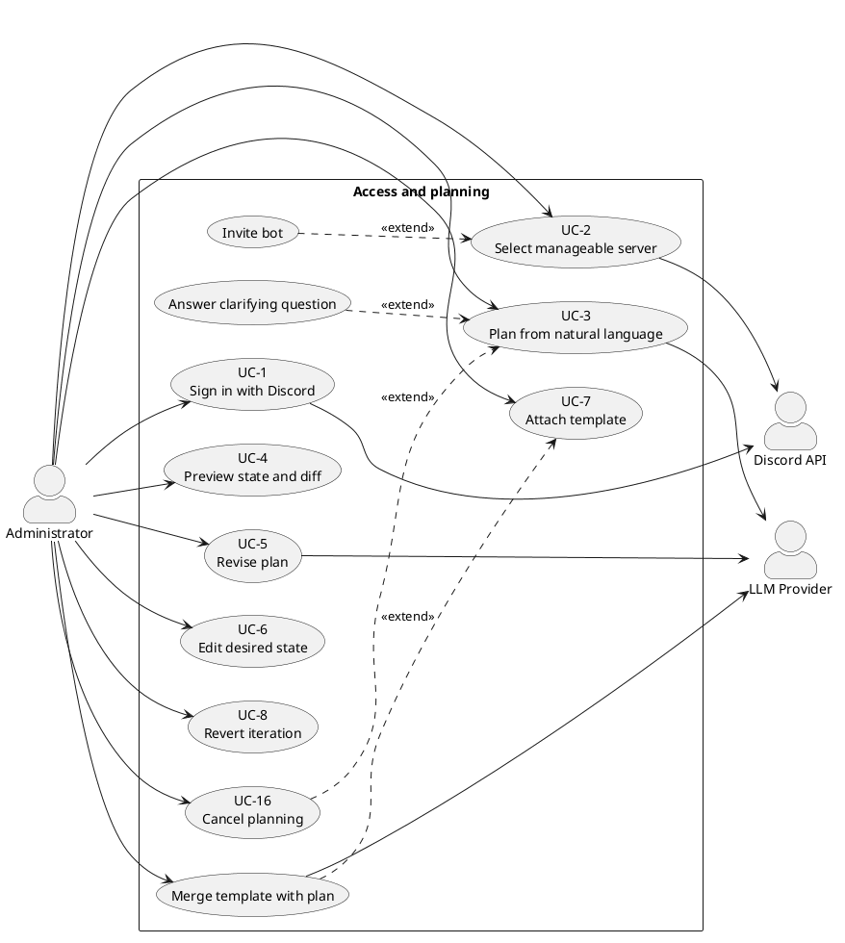

3.3.2 Approval and execution
Approval records the reviewed desired state as the contract to execute; it does not run validation or contact the LLM. At execution start, the system performs a fresh conflict check, Stage 1 deterministic validation, and the Stage 2 LLM policy check against the stored server rules. The ordinary planning prompt does not currently receive those rules.
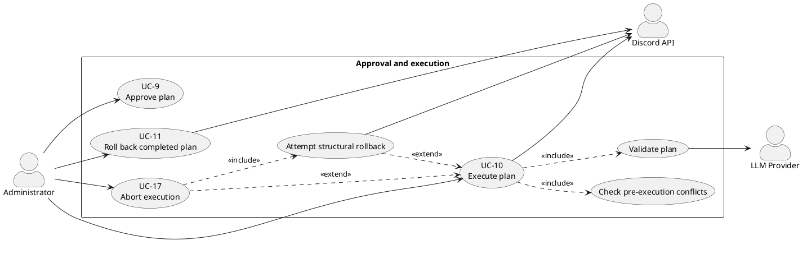

3.3.3 Monitoring and management
The Scheduler detects external changes in the background. Detection and review are separated because the system records and reports drift, then waits for the administrator rather than refreshing or repairing a plan automatically.
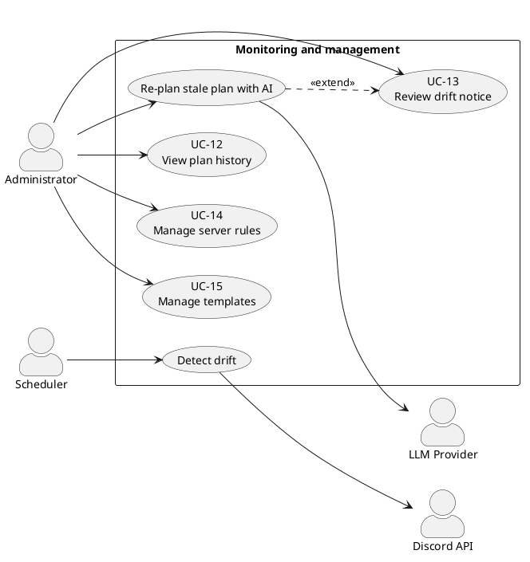
If drift affects an approved plan, Re-plan stale plan with AI can fork from current state while retaining the previous conversation and desired state as repair context. If no approved plan exists, the safe alternative is a new conversation from current state. Dismissing the visible notice does not remove the server-side hash check or make a stale plan executable.

3.4 Use Case Specifications
The diagram in Section 3.3 shows which use cases exist; this section specifies how all seventeen behave. Every use case records its actors, linked requirements, precondition, trigger, main success flow, alternative and exception flows, and postcondition. The grouping below reflects workflow only; it does not imply that one group is less important or less fully specified. These are normative requirements. Chapter 6 evaluates whether the final implementation fully, partially, or does not yet realise each one.

3.4.1 Core use cases
UC-3 — Plan from natural language
Field | Detail
Realises | FR-5, FR-6, FR-7, FR-8, FR-27
Primary actor | Administrator
Secondary actors | LLM Provider
Precondition | Administrator is signed in, has selected a server they can manage, and the bot is operable on that server (FR-3).
Trigger | Administrator submits a natural-language request describing a change.
Main flow | 1. System records the current server state as the plan's comparison baseline. 2. System opens a planning conversation. 3. The planner turns the request into a structured desired state without touching Discord. 4. System streams each planning action to the administrator as it is added. 5. On completion, System stores the result as a new plan iteration and makes it available for preview.
Alternate flows | A1 — Clarification (FR-7): if the request is ambiguous, the planner emits a clarifying question, the conversation enters waiting_for_user, and planning resumes once the administrator answers (see UC "Answer clarifying question"). A2 — Cancel (FR-27): the administrator cancels an in-progress plan; System stops the planner and marks the conversation cancelled.
Exception flows | E1 — Cache not ready: if the bot has not finished building its cache, the fork hash cannot be computed and System returns a retry-later error without creating a conversation. E2 — Clarification timeout: if the administrator does not answer within the ask-user window, the session is cancelled and the conversation marked expired.
Postcondition | A previewable desired state exists as a plan iteration; the live server is unchanged (NFR-1).
UC-9 — Approve plan
Field | Detail
Realises | FR-17, FR-21 (approval half)
Primary actor | Administrator
Secondary actors | —
Precondition | A conversation exists with a completed planning session and at least one plan iteration; the administrator has reviewed the preview and diff (UC-4).
Trigger | Administrator approves the reviewed plan.
Main flow | 1. System re-checks that the administrator may manage the server. 2. System confirms that the plan's comparison baseline still matches the live server and that no other plan is executing against it. 3. System records the latest reviewed desired state as the approved plan of record. 4. System closes the planning session.
Alternate flows | —
Exception flows | E1 — Stale view (FR-21): if the server changed since planning, System refuses approval and directs the administrator to start a new conversation. E2 — Server busy: if another plan holds the guild lock, System refuses approval. E3 — Session not completed: if planning is still running, System refuses approval.
Postcondition | A plan exists as the contract to execute; approval performs no validation and no live change. Validation is deferred to execution start (UC-10).
UC-10 — Execute plan
Field | Detail
Realises | FR-15, FR-16, FR-18, FR-19, FR-20, FR-21 (execution half), FR-28
Primary actor | Administrator
Secondary actors | Discord API, LLM Provider (Stage 2 policy validation)
Precondition | An approved plan exists; the bot is operable on the server; the administrator may manage the server.
Trigger | Administrator executes the approved plan.
Main flow | 1. System verifies that the plan may execute and its comparison baseline still matches the server. 2. System compares the approved desired state with current state to produce ordered changes. 3. System checks those changes for current-state conflicts — «include» Check pre-execution conflicts. 4. System runs Stage 1 deterministic validation and Stage 2 policy validation against stored server rules — «include» Validate plan — and reports any warnings. 5. System reserves the guild so no second execution can run concurrently. 6. System records a before-snapshot, applies each change through the bot, and streams start/completion/failure progress, with bounded retries for transient failures. 7. On success, System records an after-snapshot and reports completion.
Alternate flows | A1 — Abort (FR-28): the administrator aborts mid-execution; System stops scheduling new steps and stops waiting for the current request, attempts rollback, and reports the outcome. The underlying Discord request may still settle because it cannot be cancelled after dispatch.
Exception flows | E1 — Stale view (FR-21): server changed since planning → refuse with a 409. E2 — Conflict check fails: a current-state assumption fails → refuse with the list of conflicts; plan stays draft. E3 — Validation fails (FR-15, FR-16): blockers found → refuse with blockers and warnings; plan stays draft. E4 — Server busy: lock held by another plan → refuse. E5 — Step failure (FR-20): a step fails after retries → System attempts convergence to the before-snapshot and records the execution and rollback outcome. E6 — Overall timeout (NFR-9): execution exceeds the overall deadline → stop waiting, attempt rollback, and release the lock.
Postcondition | On success, the live server matches the approved desired state and before/after snapshots are retained (NFR-5). On failure or abort, structural rollback is attempted and its outcome is reported; exact restoration is not guaranteed when Discord has discarded data, a rollback operation fails, or an already-dispatched request settles late.
UC-11 — Roll back a completed plan
Field | Detail
Realises | FR-22, NFR-5
Primary actor | Administrator
Secondary actors | Discord API
Precondition | A plan is in the completed state and its before-snapshot is retained; the bot is operable; the administrator may manage the server.
Trigger | Administrator requests an undo of a completed plan.
Main flow | 1. System loads the plan's before-snapshot. 2. System compares current server state with that snapshot to compute reversing changes. 3. If nothing differs, System reports that rollback is already satisfied. 4. Otherwise System reserves the guild for exclusive execution and applies the reversing changes through the bot. 5. System records and reports the outcome.
Alternate flows | —
Exception flows | E1 — Not completed: the plan is not in the completed state → refuse. E2 — Snapshot missing: the before-snapshot cannot be found → refuse. E3 — Server busy: lock held by another plan → refuse.
Postcondition | If rollback succeeds, the server structure matches the plan's pre-execution snapshot within the limits of FR-20. If it fails, the plan remains failed and the error identifies that recovery was incomplete.
Note on rollback (E5 in UC-10 and UC-11): rollback is not a naive replay of the applied steps in reverse. In both cases System diffs the current live state against the target (pre-execution) state and executes that diff, so the server attempts to converge to the target structure even if some steps only partly applied. Discord.js cannot cancel an operation already sent to Discord, so a timed-out or aborted request may finish after the engine has stopped waiting. Rollback is therefore a best-effort structural recovery mechanism, not a transactional guarantee, and it cannot restore data Discord discards on deletion.

3.4.2 Plan iteration and management use cases
UC-5 — Revise plan
Field | Detail
Realises | FR-11
Primary actor | Administrator
Secondary actors | LLM Provider
Precondition | An active, non-stale conversation has a completed turn and is not currently planning.
Trigger | Administrator submits a follow-up instruction about the current plan.
Main flow | 1. System verifies the administrator and conversation. 2. System sends the follow-up instruction with the existing conversation and desired state to the planner. 3. The planner updates the structured desired state. 4. System streams progress. 5. System stores the result as a new plan iteration.
Alternate flows | A1 — Clarification: the planner pauses for an answer before completing the revision. A2 — Cancel: the administrator invokes UC-16 and System restores the pre-turn desired state.
Exception flows | E1 — Turn already in progress: refuse the overlapping revision. E2 — Stale conversation: refuse and require drift recovery. E3 — Provider failure: report the failure and preserve the last completed iteration.
Postcondition | A new revision exists or the previous completed iteration remains current; the live server is unchanged.
UC-6 — Edit desired state
Field | Detail
Realises | FR-13
Primary actor | Administrator
Secondary actors | —
Precondition | An active, non-stale conversation has a desired state and is not in a planning turn.
Trigger | Administrator saves a structured manual change in the desired-state editor.
Main flow | 1. System verifies access and checks that the conversation is editable. 2. Administrator adds, edits, moves, or removes a supported planned resource. 3. System validates the submitted structure. 4. System applies the change to desired state. 5. System records a new manual-edit iteration and refreshes the preview and diff.
Alternate flows | A1 — Cancel edit: discard the unsaved UI change and retain the current iteration. A2 — Multiple edits: repeat steps 2–5 for additional resources.
Exception flows | E1 — Planning in progress: refuse the edit. E2 — Stale conversation: refuse the edit. E3 — Invalid structure: show validation details and leave the stored iteration unchanged.
Postcondition | The validated manual edit is the latest plan iteration, or no stored state changes after cancellation/failure; Discord remains unchanged.
UC-13 — Review drift notice
Field | Detail
Realises | FR-24, FR-21
Primary actor | Administrator
Secondary actors | Scheduler, Discord API, LLM Provider (only when AI repair is selected)
Precondition | Scheduled drift detection has found a difference between the live guild and the recorded view and has notified the administrator.
Trigger | Administrator opens or acts on the drift notification.
Main flow | 1. System shows that the guild changed externally and keeps stale approval/execution blocked. 2. Administrator reviews the notice. 3. Administrator chooses a recovery action. 4. System either starts repair from current state, starts a fresh conversation, or dismisses only the visible notice. 5. Any repaired result returns to preview and review.
Alternate flows | A1 — Approved stale plan: invoke Re-plan stale plan with AI, preserving previous intent as repair context. A2 — Unapproved conversation: start a new conversation from current state. A3 — Dismiss: hide the notice while server-side stale-state protection remains.
Exception flows | E1 — Fresh state unavailable: report that recovery cannot start and keep the plan blocked. E2 — AI repair fails: preserve the old plan as stale and offer retry or a fresh conversation.
Postcondition | A repaired plan is ready for review, a fresh conversation exists, or the stale plan remains blocked; no automatic live-server change occurs.
UC-14 — Manage server rules
Field | Detail
Realises | FR-25
Primary actor | Administrator
Secondary actors | —
Precondition | Administrator is signed in and may manage the selected server.
Trigger | Administrator opens server rules and chooses to create, edit, or delete a rule.
Main flow | 1. System lists the server's rules. 2. Administrator enters or changes rule text. 3. System validates and saves the change. 4. System displays the updated rule set. 5. At a later execution, Stage 2 loads the stored rules for the policy check; ordinary planning does not automatically receive them.
Alternate flows | A1 — Delete: request removal, confirm it, and remove the rule. A2 — Cancel: discard unsaved text.
Exception flows | E1 — Unauthorized guild: refuse the request. E2 — Invalid or missing rule: show validation/not-found feedback and preserve existing rules.
Postcondition | The persisted rule set reflects the successful change and applies to subsequent execution-stage policy checks.
UC-15 — Manage templates
Field | Detail
Realises | FR-26
Primary actor | Administrator
Secondary actors | LLM Provider (only when merge is selected)
Precondition | Administrator is signed in and may manage the selected server.
Trigger | Administrator opens template management and chooses to create, edit, delete, or merge a template.
Main flow | 1. System lists templates scoped to the server. 2. Administrator creates or selects a template. 3. Administrator edits its metadata and structure. 4. System validates and saves it. 5. System displays the updated template. 6. The template can later be attached through UC-7.
Alternate flows | A1 — Delete: confirm and remove the selected template. A2 — Merge: choose a template, start an AI-assisted planning turn, and return the merged desired state for review. A3 — Cancel: discard unsaved edits.
Exception flows | E1 — Unauthorized guild: refuse the request. E2 — Invalid structure or missing template: show feedback and preserve stored templates. E3 — Merge provider failure: report the failure without changing the live server.
Postcondition | The template set reflects successful CRUD changes, or a merged plan iteration is ready for review; the live server remains unchanged.

3.4.3 Access, review, history, and interruption use cases
UC-1 — Sign in with Discord
Field | Detail
Realises | FR-1
Primary actor | Administrator
Secondary actors | Discord API
Precondition | Administrator has a Discord account and can reach the platform.
Trigger | Administrator selects Sign in with Discord.
Main flow | 1. System redirects the browser to Discord OAuth2. 2. Administrator authenticates with Discord and authorizes the requested scopes. 3. Discord returns the browser to the platform. 4. System establishes a session and opens the server-selection view.
Alternate flows | A1 — Existing session: System recognizes the valid session and skips re-authentication. A2 — Cancel consent: Administrator returns unauthenticated.
Exception flows | E1 — OAuth denial or callback failure: show a sign-in error and do not create a session. E2 — Discord unavailable: report that authentication is temporarily unavailable.
Postcondition | Administrator has an authenticated platform session, or remains signed out; the platform never collects a local password.
UC-2 — Select manageable server
Field | Detail
Realises | FR-2, FR-3, FR-4
Primary actor | Administrator
Secondary actors | Discord API
Precondition | Administrator is signed in.
Trigger | Administrator opens the server picker or selects a server.
Main flow | 1. System obtains the administrator's Discord guild permissions. 2. System lists only guilds where the administrator holds Manage Server. 3. Administrator selects a guild. 4. System verifies that the bot is present and holds Administrator. 5. System opens the guild workspace.
Alternate flows | A1 — Bot absent: offer the Discord bot invitation flow, then re-check membership. A2 — Bot lacks _Administrator: explain the required permission. A3 — Role operation planned later: execution additionally checks the bot above each targeted role.
Exception flows | E1 — Permission changed: if Manage Server was removed, reject access and refresh the list. E2 — Guild cache not ready: show retry-later feedback without starting planning.
Postcondition | A manageable, operable guild is selected, or the administrator receives the action required before configuration can continue.
UC-4 — Preview state and diff
Field | Detail
Realises | FR-9, FR-10
Primary actor | Administrator
Secondary actors | —
Precondition | A plan iteration and a current guild-state projection are available.
Trigger | Administrator opens the desired-state preview or a planning turn completes.
Main flow | 1. System loads the current desired state and current guild projection. 2. System presents categories, channels, roles, permissions, and member roles in a Discord-like view. 3. System marks additions, changes, and removals. 4. Administrator inspects the affected resources before deciding to revise, approve, or leave the plan.
Alternate flows | A1 — Inspect detail: open a channel, role, member, or permission detail view. A2 — No differences: state that the desired state already matches the current projection.
Exception flows | E1 — Current projection unavailable: report that comparison cannot be completed and disable approval until current state is available. E2 — Stale plan: show drift status and keep approval blocked.
Postcondition | Administrator can identify the planned outcome and its differences; viewing the preview does not modify Discord.
UC-7 — Attach template
Field | Detail
Realises | FR-14
Primary actor | Administrator
Secondary actors | LLM Provider (only for merge)
Precondition | An active, non-stale conversation and at least one accessible template exist.
Trigger | Administrator selects a template for the conversation.
Main flow | 1. System lists templates scoped to the selected guild. 2. Administrator chooses a template. 3. System attaches it to the conversation and makes its metadata/structure available as planning context. 4. The attached template is shown in the conversation. 5. A subsequent planning or merge turn can incorporate it into desired state.
Alternate flows | A1 — Merge now: begin an AI-assisted merge and return the merged iteration for review. A2 — Detach: remove the template from future planning context without changing completed iterations.
Exception flows | E1 — Template missing or belongs to another guild: refuse the attachment. E2 — Planning turn in progress: defer/refuse a context change until the turn is safe. E3 — Merge failure: keep the prior desired state and report the provider error.
Postcondition | The template is attached for future planning, a merged iteration exists, or prior state is preserved; Discord remains unchanged.
UC-8 — Revert iteration
Field | Detail
Realises | FR-12
Primary actor | Administrator
Secondary actors | —
Precondition | An active, non-stale conversation has at least two iterations and is not in a planning turn.
Trigger | Administrator selects an earlier iteration and requests reversion.
Main flow | 1. System displays the iteration timeline. 2. Administrator selects an earlier version. 3. System loads its desired-state snapshot. 4. System restores that state as the current desired state. 5. System records the reversion as a new iteration and refreshes the preview.
Alternate flows | A1 — Inspect only: view an iteration without reverting. A2 — Cancel: close history and keep the current iteration.
Exception flows | E1 — Planning in progress: refuse reversion until the turn finishes or is cancelled. E2 — Stale conversation: require drift recovery. E3 — Iteration missing: report that it can no longer be loaded.
Postcondition | The selected snapshot becomes the latest desired state through a new iteration, or current state remains unchanged; Discord is untouched.
UC-12 — View plan history
Field | Detail
Realises | FR-23
Primary actor | Administrator
Secondary actors | —
Precondition | Administrator is signed in and has selected a guild they may manage.
Trigger | Administrator opens plan history.
Main flow | 1. System verifies guild access. 2. System retrieves plans belonging to the selected guild. 3. System lists each plan with status, owner, creation/execution time, and outcome. 4. Administrator selects a plan. 5. System displays its approved changes and recorded result.
Alternate flows | A1 — No history: display an empty state and a route to start planning. A2 — Filter: narrow the list by status or date when supported.
Exception flows | E1 — Unauthorized guild: refuse the request and return no records. E2 — History unavailable: show a retryable loading error.
Postcondition | Administrator has reviewed stored plan history without altering a plan or the live guild.
UC-16 — Cancel planning
Field | Detail
Realises | FR-27
Primary actor | Administrator
Secondary actors | LLM Provider
Precondition | A planning or revision turn is in progress.
Trigger | Administrator selects Cancel planning.
Main flow | 1. System verifies access and finds the active planning session. 2. System aborts the outstanding LLM request. 3. System stops processing further model tool calls. 4. System restores the pre-turn desired-state snapshot when available. 5. System marks the conversation cancelled and reports cancellation.
Alternate flows | A1 — Turn already completed: keep the completed iteration and report that no active turn remains to cancel.
Exception flows | E1 — Session not found: return a not-running response without changing stored desired state. E2 — Cancellation request interrupted: the user may retry; no Discord mutation can have occurred because planning is side-effect free.
Postcondition | The active planning turn no longer produces plan changes; the live server remains unchanged.
UC-17 — Abort execution
Field | Detail
Realises | FR-28, FR-20
Primary actor | Administrator
Secondary actors | Discord API
Precondition | An approved plan is currently executing.
Trigger | Administrator selects Abort execution.
Main flow | 1. System verifies the administrator and plan. 2. System signals the active execution to abort. 3. System stops scheduling new steps and stops waiting for the in-flight step. 4. System attempts to converge guild structure toward the before-snapshot. 5. System records and reports the execution and rollback outcome.
Alternate flows | A1 — Abort between steps: no further step is dispatched before rollback begins. A2 — In-flight request settles later: drift detection or subsequent review exposes any resulting divergence.
Exception flows | E1 — Plan no longer executing: report that it cannot be aborted. E2 — Rollback operation fails: record and report residual divergence. E3 — Already-dispatched Discord request: it cannot be cancelled and may complete after the engine stops waiting.
Postcondition | Execution is no longer actively scheduling work and a rollback outcome is recorded; exact pre-execution restoration is not guaranteed.

3.5 Business Rules and Constraints
The functional and non-functional requirements say what the system does and how well. This section states the rules the system must uphold regardless of implementation, the constraints imposed on it from outside, and the concrete numeric limits it is currently configured with.

3.5.1 Business rules
Business rules are domain invariants: they would remain true even if the system were rewritten in a different language or framework. They state the required behavior; the Testing and Evaluation chapter assesses whether each rule is fully, partially, or not yet enforced by the final implementation.
ID | Rule | Rationale | Enforced via / traces to
BR-1 | No change is applied to a live server without explicit human approval of the specific plan. | The platform mutates real servers on the user's behalf; unattended change is unacceptable. | NFR-1, FR-17
BR-2 | At most one plan may execute against a given server at any time. | Concurrent executions would race on the same channels, roles, and overwrites. | NFR-3; per-server execution lock
BR-3 | A plan built on a stale view of the server must not be approved or executed. | Acting on an out-of-date view could destroy or duplicate resources the user never saw. | FR-21, NFR-4; conversation fork hash compared to live state
BR-4 | A server may be configured only when the bot is present and holds Administrator. For role edits, moves, deletions, or member-role assignment, the bot must also be above every role targeted by the plan. | Discord role hierarchy limits role operations, but does not require a globally highest bot role for channel- or category-only work. | FR-3; targeted pre-execution hierarchy validation
BR-5 | The AI planner may affect the system only through the fixed, validated tool set; it never reaches Discord directly. | Constrains the AI's blast radius and makes every AI action previewable and validatable. | NFR-19; tool registry
BR-6 | Every intended change is expressed as declarative desired state diffed against reality, never as blind imperative commands. | Enables preview, validation, and convergent rollback. | NFR-18; diff engine
BR-7 | Planning and preview have no side effects on the live server. | Users must be free to explore and revise without consequence. | NFR-1, NFR-16
BR-8 | Only users holding Manage Server on a target server may plan or execute against it, and each server's data is isolated. | Multi-tenant safety and least privilege. | FR-2, FR-4, NFR-11
BR-9 | Failed or aborted executions trigger an automatic best-effort attempt to converge the server's structure toward its pre-execution snapshot, and the outcome is reported. | Partial changes should be recovered where Discord permits, without presenting rollback as an infallible transaction. | FR-20, FR-28, NFR-2

3.5.2 Constraints
Constraints are limits the system does not get to choose; they come from the platforms and protocols it depends on.
ID | Constraint | Consequence for the system
C-1 | Discord enforces API rate limits. | State is read from an in-memory cache during planning; transient rate-limit errors are retried with backoff (NFR-8, NFR-6).
C-2 | Discord's role hierarchy governs what the bot may modify. | The bot must sit above every role it manages (BR-4); a plan cannot manage roles above the bot.
C-3 | Discord permanently discards some data on deletion — message history in removed channels, and the original numeric IDs of deleted resources — and Discord.js exposes no cancellation hook for an already-dispatched operation. | Rollback can only attempt structural convergence; it cannot recover discarded data or guarantee that a late in-flight operation will not create new drift (FR-20, FR-28, NFR-2, NFR-5).
C-4 | Authentication is delegated to Discord OAuth2. | The system stores no passwords and cannot authenticate users Discord does not (NFR-10).
C-5 | AI planning requires an external, OpenAI-compatible LLM endpoint. | The planner depends on a configured provider; the interface is provider-agnostic so the model can be swapped (NFR-22).
C-6 | The system targets self-hosted deployment on a single host with a local database. | No dependence on managed or serverless-only services (NFR-23).

3.5.3 Configured limits
The following numeric values are current configuration, not domain rules: they are tuned for a responsive single-host deployment and can be changed without altering the system's behaviour in principle. They are listed here so the requirements above are not misread as mandating specific durations.
Limit | Value | Purpose
Clarification response window | 2 minutes | If the administrator does not answer a clarifying question in time, the planning session expires (UC-3, E2).
Per-step execution deadline | 30 seconds | The engine stops waiting for a step and retries it rather than stalling the whole execution; the underlying Discord request cannot be cancelled (NFR-9).
Overall execution deadline | 5 minutes | A stuck execution stops scheduling work, attempts rollback, and releases its lock (NFR-9).
Retries per step | 3 (4 total attempts) | A transient failure can be retried three times after the initial attempt, with backoff between attempts (NFR-6).
Drift detection interval | 60 seconds | How often the Scheduler polls for external changes (UC "Detect drift", FR-24).
Execution lock TTL / heartbeat-stale threshold | 30 minutes / 5 minutes | A crashed executor's lock is eventually reclaimed so a server is not locked forever (NFR-3).
Execution snapshot retention | 30 days | Before/after execution snapshots remain available for rollback until their expiry time (NFR-5).
Snapshot cleanup interval | Daily | Old before/after snapshots are pruned on a daily sweep.

3.6 Legal, Social, Ethical and Professional Issues
A system that authenticates real people and reshapes live community spaces on their behalf raises concerns beyond its functional behaviour. This section examines those concerns under four headings, and for each it distinguishes what the current design already addresses from the risks that remain open. The professional analysis is framed against the British Computer Society (BCS) Code of Conduct, the relevant professional standard for this work.

3.6.1 Legal issues
Data protection (UK GDPR / GDPR). The system processes personal data about two groups. For signed-in administrators it stores a name, email address, avatar, Discord identity, session IP address and user-agent. It also reads the usernames, Discord IDs, and role assignments of ordinary guild members so the planner can reason about member-role changes. Some of that guild structure is sent to the configured LLM provider in the system prompt and can be persisted inside conversation messages and desired-state iterations. The second group may never use this platform directly and should not be treated as if accepting the administrator-facing service automatically covers their data.
The relevant principles include lawfulness, fairness and transparency, data minimisation, purpose limitation, storage limitation, integrity and confidentiality, and accountability. Contractual necessity may support the processing needed to provide the service to the signed-in administrator, but a controller would need to identify and document an appropriate lawful basis for processing other members' data rather than assume the same basis applies.
Addressed: authentication is delegated to Discord OAuth2, so no passwords are stored (NFR-10); operations and persisted resources are scoped to an authorised guild (NFR-11); and conversations, plans, plan ownership, status transitions, and execution timestamps provide a partial technical audit trail (NFR-13).
Open risks: there is no automated data-retention or erasure mechanism. Conversation content and plan history accumulate without a purge policy (only execution snapshots are pruned, on a daily sweep), which sits awkwardly with the storage-limitation principle and a data subject's right to erasure. A production deployment would need a documented retention schedule, deletion and export paths, and a privacy notice that explains administrator and guild-member data flows.
The external LLM provider is a further processing recipient. A production operator would need to establish the controller/processor relationship, review the provider's retention and model-training terms, execute an appropriate data processing agreement, and assess any international transfer mechanism. The current application makes the endpoint configurable but does not itself prove that a selected provider satisfies those obligations. Data minimisation should also be revisited: member identifiers and usernames should be omitted or pseudonymised when the requested plan does not require member-level reasoning.
Credential handling. The system holds OAuth access and refresh tokens and the bot token — credentials that, if leaked, grant real control over user accounts and servers.
Addressed: secrets are supplied through environment configuration and are never exposed to the client or logged in cleartext (NFR-12).
Open risks: OAuth access and refresh tokens are persisted in the database as plaintext columns (a Better Auth default), rather than encrypted at rest. On a self-hosted single-host deployment (C-6) a database compromise would expose them. Encryption at rest, or delegating token custody entirely, would reduce this exposure.
Third-party terms. As a Discord bot and API consumer, the system is bound by Discord's Developer Terms of Service and API terms, including rate limits and acceptable-use rules; violations can result in the bot being banned. The design respects the API's rate limits and permission model (NFR-21, C-1, C-2), but ongoing compliance is an operational responsibility, not a one-off guarantee.

3.6.2 Social issues
Power asymmetry over a shared space. A Discord server is a shared social environment, but only administrators use this platform. A single administrator can restructure channels, roles, and members that many other people inhabit, and those members have no visibility into, or say over, the AI-generated plan. The tool amplifies an administrator's reach — a sentence of natural language can become dozens of structural changes — which concentrates power and raises the cost of a careless or ill-intentioned instruction.
Addressed: the system limits who can act to holders of Manage Server (BR-8), so it does not widen the circle of people who can reshape a server beyond those Discord already trusts. It also makes changes deliberate rather than accidental: nothing is applied without an explicit, reviewed approval (BR-1).
Open risks: the platform does nothing to inform or involve the wider membership of a server whose structure is about to change; that remains a matter of the administrator's own judgement and the server's social norms. The tool could also encourage over-frequent restructuring simply because it is cheap.
Deskilling and over-reliance. Because the system turns intent into action without the user needing to understand Discord's underlying model (NFR-15), administrators may lean on it in place of learning the platform, and may approve plans they do not fully understand. The Discord-like preview and explicit diff (FR-9, FR-10, NFR-14) are the main mitigation — they aim to make the outcome legible before approval — but they mitigate rather than remove the risk that a user rubber-stamps a plan.
Accessibility. As a web application the Studio interface should meet accessibility expectations so administrators with disabilities can review plans on equal terms. The requirements touch this only indirectly through the familiar-preview goal (NFR-14); full conformance would require dedicated evaluation and is not yet claimed.

3.6.3 Ethical issues
AI acting on real infrastructure. The central ethical tension is that a language model — which can misread intent or hallucinate — proposes changes to a live server that real communities depend on. The system's whole architecture is a response to this: the AI can act only through a fixed, validated tool set and never touches Discord directly (BR-5); every intended change is expressed as declarative state and shown as a preview and diff before anything happens (BR-6, FR-9, FR-10); and no change is applied without an explicit human approval (BR-1). The human-in-the-loop approval gate is the core ethical safeguard: a person, not the model, authorises every live change.
Informed consent and transparency. The preview and diff turn approval into informed consent — the administrator approves the shown outcome, not merely their original sentence. When the system detects that the server has drifted, it notifies and waits rather than silently reconciling (UC-13), keeping the human in control.
Open risks: informed consent is only as strong as the reviewer's attention. A plausible but subtly wrong plan can still be approved; structural validation (FR-15) and the policy check against server rules (FR-16) catch certain classes of error, but neither can stop a technically valid plan that is simply not what the user meant.
Accountability when things go wrong. If an execution causes harm, responsibility is genuinely distributed across the administrator who approved it, the platform that generated it, and the model provider. The design supports investigation by retaining the plan owner/approver, conversation, plan content, statuses, results, and execution timestamps (NFR-13). It does not currently record a separate executedBy identity when another authorised administrator starts execution, so it cannot always attribute approval and execution to two distinct people. Failed executions trigger automatic structural rollback (BR-9, FR-20), but that recovery is best effort.
Open risks: rollback can attempt to restore structure, not data Discord discards on deletion (C-3). A plan that successfully but wrongly deletes a channel full of history causes irreversible loss even though the system did exactly what it was told. An aborted or timed-out Discord request may also finish after the engine stops waiting because Discord.js provides no cancellation hook for the in-flight operation. These residual risks mean the design can narrow harm through preview, approval, validation, and recovery, but cannot promise transaction-like reversal.

3.6.4 Professional issues
The work is assessed here against the four principles of the BCS Code of Conduct: the public interest, professional competence and integrity, duty to relevant authority, and duty to the profession.
Public interest. The principle requires having due regard for the privacy, security, and wellbeing of others. The design serves this through multi-tenant isolation and least-privilege secret handling (NFR-11, NFR-12) and through the safety-first stance that protects the servers of people who never touch the tool. Open gap: the outstanding data-protection issues in Section 3.6.1 — no retention or erasure policy, OAuth tokens stored in plaintext — would need to be resolved before a deployment could claim to fully discharge this duty, and are recorded honestly here rather than presented as solved.
Professional competence and integrity. The plan-first, declarative architecture (BR-6, NFR-18), the constrained AI surface (BR-5), schema validation at system boundaries (NFR-20), and the layered safety mechanisms (approval, validation, rollback, locking) reflect deliberate engineering for a high-risk domain rather than expedient shortcuts. Integrity is also served by stating the system's limits plainly — the irreversible-deletion risk, the pragmatically chosen (not empirically derived) timeout values, the reliance on reviewer attention — instead of overstating the guarantees.
Duty to relevant authority. The system respects the authority of the platform it operates on: it works only through Discord's supported bot APIs and honours its rate limits and permission hierarchy (NFR-21, C-1, C-2) rather than circumventing them, and it authenticates through Discord's own OAuth rather than creating a parallel credential store (NFR-10).
Duty to the profession. Deploying AI that acts on live systems is an area where careless work reflects on the field. Building in preview, explicit approval, reversible exploration, and automatic rollback — and documenting the residual risks — models a responsible way to put an LLM in control of real infrastructure, in contrast to systems that let a model act unchecked.
In summary, the design already addresses the core professional obligations around competence, platform authority, and safe AI deployment, while the main open gaps are the data-protection concerns of Section 3.6.1. Recording those gaps rather than concealing them is itself part of acting professionally.

4. System Design
Chapter 3 described the system from the outside: what an administrator can do and the qualities the system must have. This chapter turns inward and describes how the system is built and behaves to meet those requirements. It proceeds from the high-level architecture — the overall shape and the major components — down to the detailed design of individual parts: the data model, the key algorithms, the API surface, the user interface, and the security design.
Unless explicitly identified as a target or open gap, statements in this chapter describe the current implementation. Chapter 3 remains the normative statement of required external behavior; Chapter 6 will assess which requirements the final build fully or partially satisfies.

4.1 System Architecture

4.1.1 The driving idea
Every significant structural choice in this system follows from one problem: a large language model, which can misread intent or fabricate output, must be allowed to reshape a live Discord server that real communities depend on. The architecture's job is to make that safe. Its answer is indirection — a series of deliberate gaps between the model's intent and irreversible reality, so that nothing the AI produces reaches Discord without first being made declarative, previewable, validatable, and recoverable where Discord permits.
Four architectural commitments realise this, and each traces directly to a requirement from Chapter 3:
- Plan-first and declarative (BR-6, NFR-18). The system never issues blind imperative commands. It represents the intended outcome as desired state, diffs that against the server's actual state, and applies only the computed difference. The diff is the unit of change, which is what makes preview and convergent rollback possible.
- The AI is boxed in (BR-5, NFR-19). The planner can only emit calls to a fixed registry of validated tools; it has no path to Discord.js. This bounds what the AI can express and guarantees every AI action is inspectable.
- An abstraction seam decouples execution logic from Discord (NFR-18). The execution engine and executable tool functions depend on an ExecuteContext interface rather than Discord.js. The bot supplies the concrete Discord.js implementation. Planning and diffing remain separately testable through domain types and desired state; validation is not entirely behind this seam because it reads stored rules and bot role-position information.
- Human approval gates every live change (BR-1, NFR-1). Planning and preview have no side effects; only an explicit, reviewed approval moves a plan toward execution, and failures trigger an automatic structural recovery attempt.
The remainder of this section presents the architecture at three levels of zoom — system context, containers, and the plan-first data flow — and then records the three architectural decisions that most shape the system.

4.1.2 System context
At the widest zoom, the platform is a single system used by one human actor and one time-based actor, and it depends on two external services. The administrator drives every workflow from the browser; the scheduler is an internal clock that periodically triggers drift detection. Discord is both the system of record it reads from and the system it applies changes to, and the LLM provider turns natural language into structured plans.
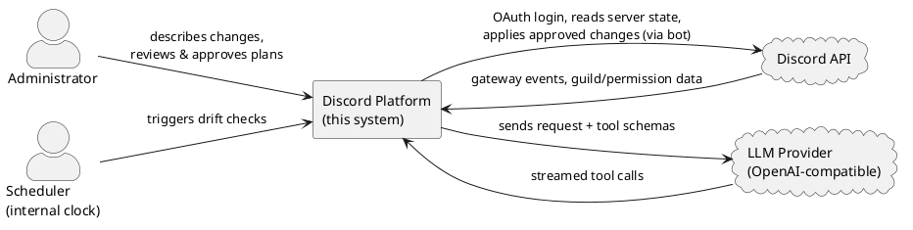
The system boundary is meaningful: the administrator never talks to Discord or the LLM directly, and the AI never talks to Discord. All three external relationships pass through the platform, which is where every safety control lives.

4.1.3 Containers
Zooming in, the system is organised as a pnpm monorepo with two runnable applications and two shared packages.
- Web app (apps/web) — a Vite + React single-page application. It hosts the Studio, where the administrator describes changes, watches the Discord-like preview update live, and approves plans. State is held in Zustand; styling is Tailwind. It talks to the server over a REST API and receives live updates over Server-Sent Events (SSE).
- Server (apps/server) — a single Node.js process that runs both the Hono HTTP API and the Discord.js bot. This co-location is deliberate (Section 4.1.5): the API reads the server's current structure from the bot's in-memory cache with no extra Discord calls. The server also owns the planning engine, diff engine, execution engine, validation, locking, and drift detection.
- Shared package (packages/shared) — the pure domain core: the tool registry, the desired-state model and store, the diff-relevant types, permission constants, and the ExecuteContext interface. It depends on neither Discord.js nor the database, so it is portable and directly testable.
- Database package (packages/db) — the Drizzle ORM schema, migrations, and client. PostgreSQL persists conversations, plan iterations, plans, snapshots, rules, templates, and drift events.
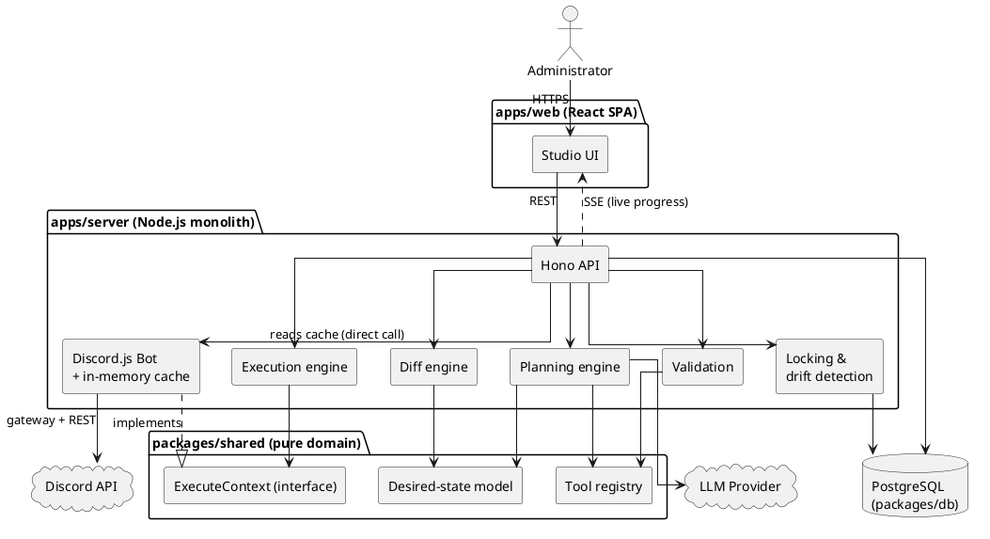
Two edges in this diagram carry the architecture's central ideas. First, Exec --> ECtx and Bot ..|> ECtx: the execution engine depends only on the ExecuteContext interface, and the bot is the concrete implementation that fulfils it against Discord.js. This isolates step dispatch and makes the execution engine testable with a plain mock context, although validation still reads Discord-derived role positions through the bot permission helpers. Second, API --> Bot : reads cache: the API reads live server structure by a direct in-process call into the bot's cache, not over the network — the reason the two run as one process.

4.1.4 The plan-first data flow
The defining behaviour of the system is the pipeline a request travels along, from natural language to applied change. It has a strict property: side effects on Discord occur only in the final stage, and only after a human approval. Every earlier stage operates on in-memory or persisted state, never on the live server.
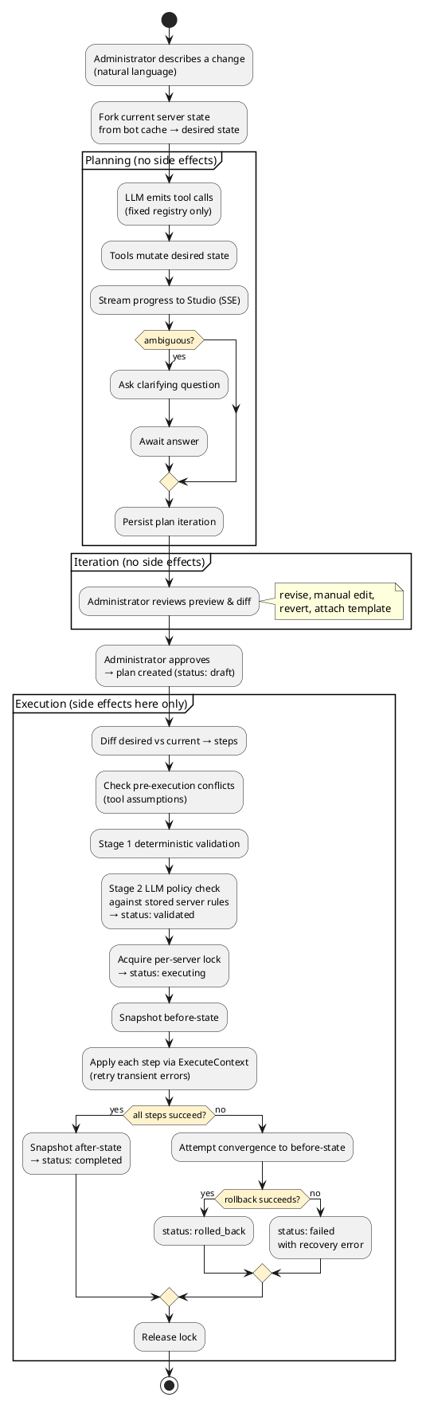
Three aspects of this flow are worth drawing out, because they are where the architecture earns its safety properties:
- The desired state is checked again against current cached reality. A fork hash of the bot-maintained server-state projection is taken when planning begins; at approval and execution the system rebuilds that projection from the current custom cache and compares its hash. Execution also re-diffs the desired state against that projection. This is not a synchronous Discord REST fetch, but it is refreshed through gateway lifecycle events and protected by the separate drift detector. If the hash changed, approval or execution is refused and an unexecuted plan can enter the confirmed AI re-plan flow (FR-21).
- Validation runs at execution start, not at approval. Approval only records the reviewed desired state as the contract to execute; the pre-execution conflict check, Stage 1 deterministic checks, and Stage 2 LLM policy check run at the start of execution. Stage 2 loads the stored server rules and a summary of the computed steps; those rules are not currently injected into the ordinary planning prompt. This ordering matters because a check at approval could pass and then execute minutes later against changed state. A current limitation is that Stage 2 returns no policy issues when the provider is unavailable or its response cannot be parsed, so provider failure is fail-open rather than fail-closed; Chapter 6 must treat FR-16 as partial until that behavior is changed or explicitly accepted.
- Rollback is convergent, not a reverse replay. On failure the system does not undo steps one by one. It diffs the current live state against the before-snapshot and executes that diff, attempting to converge the server back to its starting structure even if steps only partly applied. This is best-effort recovery rather than a transaction. Discord discards message history and original IDs on deletion, rollback steps can themselves fail, and Discord.js cannot cancel a request already dispatched; a timed-out or aborted request may therefore settle after the engine has begun recovery (C-3, FR-20, FR-28).

4.1.5 Key architectural decisions
Three decisions shape the system more than any other and are recorded here with their rationale and trade-offs.
Monolithic backend (API and bot in one process). The Hono API and the Discord.js bot run in a single Node.js process and communicate by direct function calls rather than a message broker. The driving reason is the cache: the bot maintains an in-memory view of every guild's structure via the Discord gateway, and planning needs to read that structure constantly. Co-location lets the API read it as a plain in-process call, avoiding per-request Discord calls (and their rate-limit cost, C-1) and keeping planning reads low-latency (NFR-8). A second reason is that the bot needs a persistent gateway WebSocket, which rules out serverless hosting, and LLM planning can take tens of seconds, which rules out short serverless timeouts. The trade-off is horizontal scalability: the two cannot be scaled independently. This is acceptable for the target self-hosted, single-host deployment (C-6, NFR-23); a future split into separate processes with a shared cache over Redis or PostgreSQL notification remains possible without changing the domain logic.
Server-Sent Events over polling or WebSockets. Planning and execution progress are pushed to the Studio over SSE (for example, GET /api/plan/:id/stream). The communication is one-way (server → client) and append-only — a live log of steps — which is exactly SSE's shape, so the bidirectional complexity of WebSockets is unnecessary. Browser EventSource attempts reconnection automatically. The server does not currently replay events missed during a disconnect, so reconnection restores the stream but not necessarily the complete log. SSE also carries only server-to-client traffic; client actions (approve, revise, abort) use ordinary REST calls, which fits since those are discrete commands rather than a stream.
The constrained AI surface as a design element. Although described above as a safety commitment, the tool registry is also a concrete architectural component worth naming here: it is a fixed list of tool definitions in packages/shared, each pairing a JSON-schema parameter definition (for the LLM) with a pure plan function that mutates desired state and an optional getAssumptions function used by the pre-execution conflict check. The planner can do nothing the registry does not define, and because the tools live in the pure domain package, they can be validated and tested without the LLM or a live Discord connection. Current automated coverage is partial rather than complete; the final coverage and requirement evidence belong in Chapter 6.

4.2 Component and Service Design
Section 4.1 described the containers and the pipeline that runs through them. This section zooms one level further in, to the individual components inside the server that do the work, and specifies each one's responsibility, its inputs and outputs, and the design choices that shape it. The components are grouped by the stage of the pipeline they serve: the domain core they all build on, then planning, then diff, then validation, then execution, and finally the cross-cutting infrastructure (locking, drift detection, event buses) that the others rely on.
The unifying design rule across all of them is the one established in Section 4.1.1: side effects on Discord are confined to the execution stage, and everything before it manipulates in-memory or persisted state. That rule is why most of these components can be pure functions or depend only on an interface, and why the codebase can test roughly two thirds of the server logic with a plain mock object rather than a live Discord connection.

4.2.1 The domain core (packages/shared)
Every other component builds on a small, dependency-free domain package. It imports neither Discord.js nor the database, which is what makes it portable and directly unit-testable, and it is the single place where the shape of a plan is defined.
- Domain types (types.ts). The vocabulary the whole system speaks: ServerState (the current structure of a guild), DesiredState (the planned structure), PlanStep (one ordered, executable change), and the supporting Role, ChannelBase, PermissionOverwrite, MemberRole, and Tombstone types. Because these types are shared, the planner, diff engine, validation, and execution engine all agree on what a plan is without importing each other.
- The desired-state model and store (state/). DesiredState is the central data structure of the system: the declarative description of what the server should look like after execution. It is not a plain snapshot — it carries active items (things that should exist), tombstones (things explicitly deleted during planning), and a symbol counter for naming not-yet-created resources. Every mutation flows through DesiredStateStore, which is the single choke point that validates a change before it is applied (no duplicate names, referenced roles exist, and so on) and generates symbols for new resources. No planning tool touches DesiredState directly; they all call the store. fork.ts builds a store from a captured ServerState, which is how planning begins from the server's real structure.
- The tool registry (tools/). The fixed catalogue of seventeen tools the planner may call, described as an architectural element in Section 4.1.5. Each tool pairs a Zod parameter schema (converted to a JSON schema for the LLM) with a pure plan() function that mutates desired state through the store, an optional execute() function that applies the change through the ExecuteContext interface, and an optional getAssumptions() function that declares the pre-execution conditions the change relies on (for example, "parent category still exists", "no name conflict"). Two tools are marked planning_only and are never dispatched during execution. ask_user is handled specially by the planning loop, which pauses until the administrator answers. batch_set_overwrite applies several overwrite changes to desired state in one call; the diff later emits individual set_overwrite steps.
- The ExecuteContext interface (execute-context.ts). The seam between execution logic and Discord. Tool execute() functions and the execution engine depend on this interface, never on Discord.js. The concrete implementation lives in the bot (Section 4.2.6). This is the single decision that makes the execution engine testable with a mock context.
- Server-state hashing (hash-server-state.ts). A stable stringify plus SHA-256 that reduces a ServerState to a forkStateHash. This hash is the mechanism behind stale-state protection (NFR-4): planning records the hash of the state it forked from, and approval and execution recompute it to detect whether the server changed underneath the plan.
- Constants (constants.ts). Discord permission metadata and permission-name/bitfield conversion helpers, the channel-type mapping, and the plan-status, step-status, and snapshot-type enumerations.

4.2.2 The planning engine
The planning engine turns natural language into a DesiredState. Its job is to drive a constrained conversation with the LLM, dispatch the tool calls the LLM emits, and stream progress — all without touching Discord.
- Planning session (planning-session.ts). The core state machine. It is not a simple loop: it can pause on an ask_user call, hold its state in server memory, and resume when the administrator answers. On each turn it builds the system prompt (which encodes the four-phase planning model — roles, then layout, then access control, then members — and restricts which tools are legal in each phase), sends the conversation plus the tool schemas to the LLM, and dispatches each returned tool call through the registry into the store. Validation happens at dispatch: Zod checks the parameter shape, then the store checks state-level constraints, and only then is desired state mutated. A turn cap (maxTurns = 20) prevents a runaway loop; on exhaustion the session force-completes with an explanatory summary.
- Session manager (session-manager.ts). An in-memory registry of active PlanningSession objects keyed by conversation, plus the timeouts that expire an ask_user pause that is never answered. Sessions live in memory deliberately (Section 4.4): a server restart loses in-flight planning state, and the administrator starts a fresh conversation from current state.
- LLM transport (llm-request.ts, stream-parser.ts). A thin layer over a raw streaming fetch to an OpenAI-compatible chat-completions endpoint, configured entirely by LLM_BASE_URL / LLM_API_KEY / LLM_MODEL. The stream parser accumulates tool-call deltas across SSE chunks and separates the model's thinking text from its answer text. Keeping the transport this thin is what satisfies provider-agnostic integration (NFR-22): swapping models is a configuration change, not a code change.
The engine emits its progress at tool-call granularity, not token by token: a tool call is dispatched the moment it is fully accumulated, and a tool_called / tool_result pair is streamed to the Studio so the preview re-renders live. The administrator sees the level that matters — which tools ran and what they did — rather than a stream of raw tokens.

4.2.3 The diff engine
The diff engine (diff-engine.ts) is the component that makes the system declarative. It is a pure function, (ServerState, DesiredState) → PlanStep[], and it makes no decisions of its own: no heuristics, no rename detection, no scoring. It reads explicit state — active items, tombstones, symbols — and emits the corresponding Discord steps. This "dumb and deterministic" stance is a deliberate design choice, argued at length in the design docs: any cleverness here (for instance, guessing that a delete-plus-create was "really" a rename) would be brittle and would take a judgement call away from the human reviewer, who is far better placed to make it.
It runs in three phases:
- Generate raw steps. For each active item: if it carries a real Discord ID it is existing (emit an edit_* step if it differs, skip if identical, flag a conflict if it has vanished from the server); if it carries a symbol it is new (emit a create_* step). Overwrites and member roles are diffed symmetrically — anything present in the server but absent from desired state becomes a removal — because, unlike channels and roles, they gain nothing from a tombstone audit trail. Each tombstone becomes a delete_* step.
- Topological sort. Steps are ordered by TOOL_ORDER (categories before the channels that live in them, roles before the members assigned to them, creation before the overwrites that reference the created items, deletions last) and by an explicit dependency graph over symbols. A post-sort pass resolves any symbol-like reference that actually points at a pre-existing resource back to its real Discord ID.
- Optimise. Merge multiple edits to the same Discord ID into one step, then drop no-op steps (an edit whose field set turned out empty).
The output is an ordered PlanStep[] plus a symbol table recording which step defines each symbol — the input the execution engine resolves against.

4.2.4 The validation subsystem
Validation (validation.ts) runs at the start of execution, not at approval (Section 4.1.4). It is the one part of the pre-execution path that is not fully behind the ExecuteContext seam, because it reads stored server rules and the bot's role position. It is organised as two stages.
Stage 1 — deterministic checks (no LLM). Five groups run in order and are pure functions over the plan steps and desired state, so they are fast and fully unit-testable:
- A. Permissions and hierarchy — permission names are valid; the bot holds ADMINISTRATOR (hard block); and no step edits, moves, deletes, or assigns a role positioned above the bot's highest role (the hierarchy invariant behind FR-3).
- B. Dependencies — every symbolic reference resolves to a defined symbol of the right type, and the dependency graph is a sortable DAG with no cycles or dangling indices.
- C. Resource constraints — no duplicate names among created items, no duplicate member-role operations, category child counts within Discord's limit of 50, and channel-type constraints (a topic only on text/announcement, a bitrate only on voice/stage).
- D. Safety guards — block granting ADMINISTRATOR to a plan-created role unless explicitly requested; warn when the plan may exceed the execution time budget; warn when two unsynced channels in a category carry identical overwrites that could be consolidated up to the category.
- E. Plan integrity — the plan has at least one step and a legal status.
The design docs record several checks that were deliberately left out — per-action permission checks (redundant under ADMINISTRATOR), "won't delete important channels" guards (they contradict the present-don't-judge philosophy), and a planData schema check (the data is produced internally by the diff engine, never parsed from untrusted input). These omissions are design decisions, not gaps, and Chapter 6 treats them as such.
Stage 2 — server-rule policy check (validateWithLLM). Per-guild natural-language rules are checked by a second LLM pass that reads the rules plus a summary of the computed steps and returns block/warning issues. It no-ops when no rules exist or no LLM key is configured.
Known divergence, carried from Chapter 3 (FR-16). Two things about Stage 2 do not yet match the intended design and are recorded here so the design and the code do not silently disagree. First, the intended design folds rules into the planning prompt so the LLM is compliant by construction; today the ordinary planning prompt does not receive the rules and enforcement happens only at execution. Whether to also keep the execution-time check as a backstop is an open decision. Second, the check is currently fail-open: when the provider is unavailable or its response cannot be parsed, Stage 2 returns no issues rather than blocking. Chapter 6 must therefore treat FR-16 as partially satisfied until this is changed or explicitly accepted.
A related pre-execution step, the conflict check, runs each step's getAssumptions() against fresh state before Stage 1. When it fails, execution is blocked outright — there is no force-apply — and the administrator can invoke the confirmed AI re-plan flow (POST /plans/:planId/replan), which re-forks from current state and asks the planner to adapt the plan, preserving the conversation and prior intent.

4.2.5 The execution engine
The execution engine (execution-engine.ts) is the only server component that causes side effects on Discord, and it is the component where the recoverability requirements (NFR-2, NFR-6, NFR-9) are realised. It receives an ordered PlanStep[], a symbol table, and an ExecuteContext, and applies the steps.
- Symbol resolution. Before each step, symbols in its parameters are replaced with the real Discord IDs recorded as earlier steps completed ($cat_0 → the ID Discord returned when the category was created). Tools only ever receive resolved IDs; resolution is an engine-level concern, not a tool concern.
- Retry with backoff (NFR-6). Each step is attempted up to MAX_RETRIES = 3 additional times on a transient error (network/5xx/timeout), with exponential backoff (1 s → 2 s → 4 s) and ±25% jitter. Discord.js handles 429 rate-limit backoff itself. Known permanent errors (403/404/400) are diagnosed through a hardcoded fix map and fail the step; unknown errors fail the step too — the engine never asks the LLM to diagnose an execution error.
- Two deadlines (NFR-9). A per-step deadline (DEFAULT_STEP_TIMEOUT_MS = 30 s) stops the loop from blocking forever on one hung Discord call, and an overall execution deadline (EXECUTION_TIMEOUT_MS = 5 min, enforced in the plans route via an AbortController) stops the engine scheduling new work. Both bound the engine's wait; neither can cancel a Discord request already in flight, so a timed-out request may still settle later — a limit stated plainly in Chapter 3 and honoured in the reporting.
- Convergent rollback (NFR-2). On any permanent step failure, abort, or overall timeout, rollbackFull() does not replay steps in reverse. It reads fresh Discord state, forks the before-snapshot into a DesiredState, runs the diff engine to compute the reverse delta, and executes that as an ordinary plan. This converges the server toward its starting structure even if steps only partly applied, and handles external changes since execution uniformly. It is best-effort structural recovery, not a transaction: Discord discards message history and original IDs on deletion, and a rollback step can itself fail. The engine reports the outcome — success or residual divergence — rather than claiming unconditional restoration.

4.2.6 The bot and its cache
The Discord.js bot (bot/) is the system's window onto Discord, and it plays two distinct roles.
- Live state cache (bot/cache.ts, bot/index.ts). The bot maintains an in-memory projection of every guild's structure, kept current by gateway lifecycle events (ChannelCreate/Update/Delete, GuildRoleCreate/…, GuildMemberAdd/…, GuildCreate/Delete). Because the API runs in the same process (Section 4.1.5), planning reads this projection as a direct in-process call, with no Discord round-trip and no rate-limit cost — the mechanism behind low-latency planning reads (NFR-8).
- ExecuteContext implementation (bot/execute-context.ts). The concrete fulfilment of the domain interface: every Discord.js call the execution engine needs, and nothing more. It is stateless and throws on failure, leaving retry, rollback, and tracking to the engine above it.
- Permissions and formatting (bot/permissions.ts, bot/formatter.ts). Reads the bot's own ADMINISTRATOR status and role position (used by validation), and renders the cached ServerState into the compact structured text the planner receives upfront.

4.2.7 Cross-cutting infrastructure
Three smaller services support the pipeline without belonging to any single stage.
- Locking (locking.ts). Enforces single execution per server (NFR-3) through a lock held in the guilds row (currentPlanId plus acquire / heartbeat / release timestamps). acquireGuildLock is a conditional update that succeeds only when no lock is held, so two concurrent executions cannot both win. Stale locks are recoverable: a background job (startPeriodicLockCleanup, every 5 minutes, also run at boot) clears any lock older than a 30-minute TTL or without a heartbeat for 5 minutes, which is how a crashed execution frees its guild.
- Drift detection (drift-detector.ts). A scheduled poll (every 60 s) compares live Discord state against the cache; when they differ it persists a driftEvents row and pushes an event to any subscribed Studio client over SSE. Detection and remedy are deliberately separated: the system reports drift and then waits for the administrator (FR-24), rather than refreshing a plan automatically. The server-side stale hash check remains in force regardless of whether the visible notice is dismissed.
- Event buses (event-bus.ts, planning-event-bus.ts) and snapshot cleanup (snapshot-cleanup.ts). Two small pub/sub buses decouple the engines from the SSE endpoints — one per plan for execution events, one per conversation for planning events — so a component emits progress without knowing who is listening. A daily cleanup job deletes snapshots past their 30-day retention (NFR-5) and orphaned plan iterations.

4.3 Database Design
The system persists to a single PostgreSQL database, defined as a Drizzle ORM schema in packages/db/src/schema.ts. The schema serves two purposes that shape its design: it is the durable audit record required by NFR-13 (conversations, plans, and executed outcomes survive restarts and are available for review), and it is the recovery store required by NFR-5 (before/after snapshots retained so a completed plan can be reversed). Ephemeral planning state — the in-flight LLM loop, the live DesiredState being mutated within a turn — is held in server memory, not the database (Section 4.4); what reaches the database is the committed record of a plan iteration, not the working state.
A convention runs through the schema. Every table carries id, createdAt, and updatedAt; column names are snake_case in SQL and camelCase in TypeScript; resource-scoped tables carry a guildId that both links to the owning guild and serves as the isolation boundary enforced above the database (NFR-11); and larger structured payloads — desired state, plan steps, snapshot contents — are stored as jsonb rather than being decomposed into relational columns, because they are read and written as whole documents by the domain code and are never queried field-by-field in SQL.

4.3.1 Entity–relationship overview
The tables fall into three groups: the authentication tables managed by Better Auth (users, sessions, accounts, verifications), the guild-scoped configuration and audit tables (guilds, conversations, plan_iterations, plans, snapshots, rules, templates, drift_events), and no others. The diagram below shows the guild-scoped core and its links to the user and guild anchors; the Better Auth session/account/verification tables are omitted for readability, as they hang off users in the conventional way.
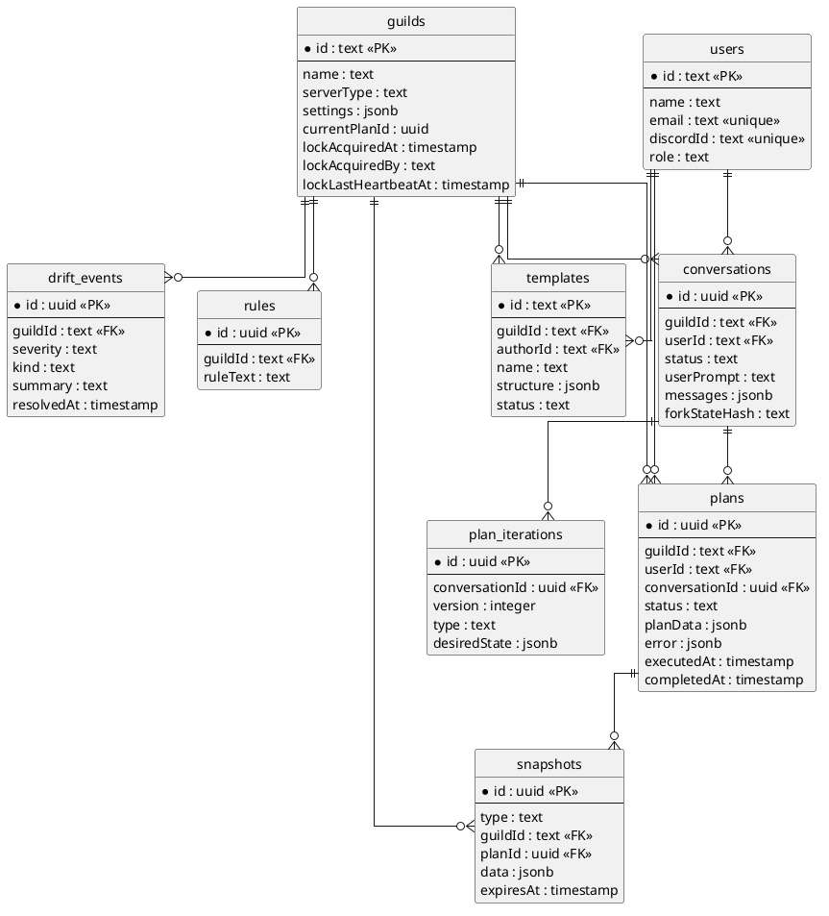
Two relationships in this diagram carry the plan-first model. A conversation owns an ordered series of plan iterations (version unique per conversation), each holding one DesiredState document and tagged by how it was produced — llm_generated, manual_edit, or revert. This is the iteration history that powers preview, revert (FR-12), and manual editing (FR-13). A plan is the contract created at approval; it links back to the conversation that produced it and forward to the snapshots taken around its execution, so the executed outcome is always traceable to the reviewed intent (NFR-13).

4.3.2 Key tables
The tables below carry the system's core behaviour; the Better Auth tables are standard and are not detailed here.
- guilds. The anchor for a Discord server and, notably, the home of the execution lock (Section 4.2.7). Rather than a separate lock table, the lock is four columns on the guild row — currentPlanId, lockAcquiredAt, lockAcquiredBy, lockLastHeartbeatAt — so that "acquire the lock" is a single conditional UPDATE … WHERE current_plan_id IS NULL that PostgreSQL serialises for us (NFR-3). settings and serverType are per-guild configuration; subscriptionTier exists but is currently unused.
- conversations. The top-level planning unit and the LLM audit log. It stores the originating userPrompt, the full messages array as jsonb, a status (active, waiting_for_user, cancelled, expired, …), and the forkStateHash — the SHA-256 of the server state the conversation forked from, which is the value stale-state protection (NFR-4) compares against.
- plan_iterations. One row per saved desired-state version within a conversation. desiredState is the full jsonb document; version is unique per conversation (a uniqueIndex enforces it); type records provenance. These rows survive server restarts, which is what lets a user reopen a conversation and revert to an earlier iteration even after the in-memory session is gone.
- plans. The approved contract and its execution record. planData holds the ordered steps as jsonb; status moves through the lifecycle (draft → validated → executing → completed / rolled_back / failed); executedAt and completedAt timestamp the run; and error captures a structured failure for actionable reporting (NFR-17). Indexed by guildId and userId for history queries (FR-23).
- snapshots. Server-state captures for rollback (NFR-5). type distinguishes the before- and after-execution snapshots; data is the full ServerState as jsonb; planId links the snapshot to its plan; and expiresAt drives the 30-day retention cleanup. Indexed by (guildId, type), by planId, and by expiresAt so the cleanup job can scan efficiently.
- rules. Per-guild natural-language policy strings (ruleText) consumed by the Stage 2 policy check (FR-16, FR-25). Deliberately unstructured free text — which is why enforcing them requires an LLM rather than a deterministic check.
- templates. Reusable configuration templates scoped to a guild (structure as jsonb, plus name, description, category, tags, status). Attachable to a conversation and mergeable into a plan (FR-14, FR-26).
- drift_events. The persisted output of the drift detector: severity, kind, summary, details, and a resolvedAt that distinguishes open from resolved drift. Indexed by (guildId, createdAt) for history and by (guildId, resolvedAt) for the unresolved-drift lookup that gates the Studio indicator (FR-24).

4.3.3 Design choices worth noting
Two choices are worth calling out because they trade query flexibility for a simpler, document-oriented model that matches how the domain code uses the data.
First, planData, desiredState, and snapshot data are opaque jsonb documents. The domain code reads and writes them whole (plan.planData as unknown as PlanData), so decomposing them into relational tables would buy nothing and cost a great deal of mapping. The accepted trade-off is that these columns are not queryable from SQL — a known limitation logged as a Phase-2 item (making planData queryable) rather than a defect.
Second, the four Better Auth tables are owned by the auth library, not by application code. They follow Better Auth's expected shape (a password column exists on accounts, for instance, even though the system uses Discord OAuth exclusively and never populates it). The application reads them but does not manage their schema, and the rare raw-SQL access the codebase needs targets these tables specifically. This is why the security design (Section 4.6) can state that no local password is ever stored despite the column existing.

4.4 API and Data Flow Design
Section 4.1.4 described the plan-first pipeline at the level of stages and safety properties. This section makes that pipeline concrete: the shape of the HTTP API the Studio calls, the conventions every endpoint shares, and the request/response sequences of the two flows that carry the most weight — starting a planning conversation and executing an approved plan. Where 4.1.4 answered what happens and why it is safe, this section answers how a client drives it.

4.4.1 API design and shared conventions
The backend exposes a single HTTP API mounted under /api, composed in hono/app.ts from seven route modules plus a small set of top-level endpoints. The API is resource-oriented and mostly nested under a guild (/api/guilds/:guildId/...), because almost every operation is scoped to one Discord server. It is not a strict REST/CRUD API: several endpoints are commands (/plans/:planId/execute, /conversations/:convId/approve) rather than resource mutations, which matches a domain where the interesting operations are verbs — plan, approve, execute, roll back — not row edits.
Every request passes through a fixed middleware chain before reaching a handler, and the order matters:
- CORS — credentialed CORS is scoped to the configured web origin (WEB_APP_URL, default http://localhost:5173), because the browser sends the session cookie cross-origin.
- Rate limit — a sliding-window limiter caps traffic at 100 requests per minute (hono/middleware/rate-limit.ts), applied to all of /api/* (NFR-9).
- Bot-ready gate — every /api/* handler awaits the botReady promise before running. This is a deliberate correctness guard, not just startup hygiene: a request served before the guild cache is populated would fork a plan from an empty state and silently corrupt the planning contract. Blocking until the cache is warm makes that class of bug impossible.
- Authentication — authMiddleware resolves the Better Auth session from the cookie and attaches the user to the Hono context; requireUser throws a 401 if absent. The SSE stream endpoints remain inside this bot-ready and authentication chain, then run an additional resource lookup and guild authorization before subscribing. Only the Better Auth handler itself sits outside the protected api composition so that a session can be created.
On top of that chain, individual handlers apply two more checks that recur across the whole API and are worth naming once here rather than repeating per endpoint:
- Guild authorization. Guild-scoped handlers call userHasManageGuild(userId, guildId) and return 403 if the caller lacks the Discord Manage Server permission on that guild. Authentication proves who you are; this proves you may act on this server (FR-2). It is detailed in Section 4.6.
- Guild operability. Command handlers that touch a guild call checkGuildOperable / checkGuildAccess, which confirm the bot is actually in the guild and its cache entry exists. A missing guild returns 404, while a bot that is present but lacks ADMINISTRATOR returns 403; transient failures while resolving a user's Discord membership are converted to 503 by the global error handler. This separates "you are not allowed" from "the system cannot act right now", so the Studio can retry an availability failure without treating it as a permission failure.
Request bodies and query strings are validated at the boundary with Zod via Hono's zValidator, so a malformed request is rejected with a 400 before any handler logic runs and every handler can treat its input as well-typed. Response conventions are uniform: JSON throughout, resource creation returns 201, and errors return a JSON object with an error string (plus, for the execution pipeline, structured conflicts / blockers / warnings arrays so the Studio can render actionable messages rather than a bare string). A single app.onError handler centralises the failure contract — it maps HTTPException to its status, converts an internal DiscordApiError into a 503 ("Discord API is temporarily unavailable"), and collapses everything else to a 500 so an unexpected throw never leaks an internal error shape to the client.
The client side mirrors these conventions in one place. The web app routes every call through an apiFetch wrapper (apps/web/src/lib/api.ts) that attaches credentials, sets the JSON content type, and treats a 401 as a global signal to clear auth state and redirect to /login. Because that behaviour lives in the wrapper, no individual component has to handle session expiry.
The table below summarises the surface. HTTP verbs are grouped per resource; the two stream endpoints are Server-Sent Event streams rather than ordinary responses, covered in 4.4.4.
Resource / endpoint | Methods | Purpose
/api/health | GET | Liveness — DB reachable, bot connected (unauthenticated)
/api/auth/* | GET, POST | Better Auth handler (Discord OAuth2 sign-in/callback/session)
/api/me | GET | Current authenticated user
/api/bot | GET /status, GET /invite | Bot connection status; OAuth invite URL
/api/guilds | GET (list), GET /:id, PATCH /:id | Guilds the user manages; server type & settings
/api/guilds/:g/rules | GET, POST, PUT /:id, DELETE /:id | Server policy rules (Stage 2 input)
/api/guilds/:g/state etc. | GET /state, /channels, /roles | Read the cached current server state
/api/guilds/:g/plans | GET, GET /:id, POST | List / read / create a plan
/api/guilds/:g/plans/:id/* | POST execute, abort, rollback, replan | Execution lifecycle commands
/api/guilds/:g/conversations | GET, GET /:id, POST | List / read / start a planning conversation
/api/guilds/:g/conversations/:id/* | POST approve, revise, cancel, ask-user, revert/:v, edit-state, template attach/detach | Planning-loop commands
/api/guilds/:g/templates | GET, GET /:id, POST, PUT, DELETE, POST /:id/merge | Template CRUD + LLM merge
/api/plan/:id/stream | GET (SSE) | Live execution progress
/api/conversations/:id/stream | GET (SSE) | Live planning progress

4.4.2 Flow: starting a planning conversation
The most characteristic request in the system is POST /api/guilds/:guildId/conversations — the client sends a natural-language prompt and the server begins an LLM planning session. What makes it architecturally interesting is that the HTTP response does not carry the plan. The request returns almost immediately with a conversation record, and the actual planning work streams over a separate SSE channel. The POST is a kick-off; the /conversations/:id/stream endpoint is where the result arrives.
The handler (conversations.ts) runs the following sequence:
- Validate the body (userPrompt) with Zod, then authorise the caller against the guild.
- Fork the current state. It builds a ServerState from the bot cache and computes a forkStateHash (SHA-256) over it. This hash is persisted on the conversation row and is the anchor for every later stale-state check — it records exactly which version of reality the plan was formed against. If the cache is not yet populated, hashing fails and the handler returns 503 with a retry message rather than forking from nothing.
- Persist the conversation (status: "planning", empty message log, the fork hash) and return it to the client.
- Start the planning session as an in-process background task. A PlanningSession is created with an emit callback wired to the conversation event bus; the session runs the LLM tool-calling loop independently of the HTTP request that started it.
From that point the client opens GET /api/conversations/:id/stream and receives the planning progress live: streamed reasoning, each tool call and its effect on the desired state, and finally either a completed event or an ask_user event. The emit callback also drives the conversation's persisted status as a side effect — waiting_for_user when the LLM asks a clarifying question, completed when it finishes, expired on error or timeout — so the database always reflects the live session even though the work is detached from any single request.
Two details in this flow are load-bearing. First, ask_user is not a dead end: when the LLM needs clarification it emits the question over SSE and arms a two-minute timeout; the client answers with POST /conversations/:id/ask-user, which resumes the same in-memory session. If the timeout fires first, the session is cancelled and the conversation is marked expired. Second, the forkStateHash captured here is what later lets execution detect that the world moved: the same hash is recomputed at execution time and compared, which is the mechanism behind the 409 described next.

4.4.3 Flow: executing an approved plan
POST /api/guilds/:guildId/plans/:planId/execute is the only endpoint that mutates Discord, and it is where the safety machinery of Section 4.1.4 becomes a concrete, ordered gauntlet of checks. Each check maps to a specific HTTP status so the Studio can distinguish "the plan is stale" from "the plan is invalid" from "someone else is executing." The handler runs them in this order, returning at the first failure:
- Operability + authorization — checkGuildOperable (404/403) and userHasManageGuild (403), as for every command.
- Load and state-check the plan — the plan must exist for this guild (404) and be in draft or approved status (400); a plan mid-execution or already completed cannot be re-run.
- Stale-state detection (409). If the plan is tied to a conversation, the server rebuilds ServerState from the current cache, recomputes its hash, and compares it to the conversation's forkStateHash. A mismatch means the server changed since planning began, so execution is refused with 409 and canAIRepair: true — the signal the Studio uses to offer the confirmed AI re-plan flow (FR-21) rather than a dead error.
- Re-diff (409). The desired state is diffed against current reality. If the diff reports conflicts — for example the plan edits a channel that no longer exists — it returns 409 with the conflict messages.
- Pre-execution assumption checks (409). Each step's tool assumptions (parent exists, no name collision, bot hierarchy) are evaluated against the current state; any failure returns 409 with the specific messages.
- Stage 1 deterministic validation (400). validatePlan runs the hard-coded check groups; blockers return 400 with structured blockers/warnings arrays. On success the plan advances to status: "validated".
- Lock acquisition (423). acquireGuildLock takes the per-guild execution lock via a conditional UPDATE. If another plan holds it, the endpoint returns 423 Locked — the status that names exactly this condition — and the guild serialises rather than executing two plans concurrently.
Only after all seven gates pass does the handler snapshot the before-state, apply each step through a DiscordExecuteContext, and stream progress over the plan event bus. Two timers bound the work: a per-step deadline inside the execution engine and a five-minute overall AbortSignal.timeout that aborts the run mid-step. A heartbeat interval refreshes the lock so a long-but-healthy execution is not reclaimed by the stale-lock sweeper.
The terminal outcomes are deliberately explicit. On success the plan is marked completed, an after-snapshot is stored, and the JSON response reports { success, steps, error }. On failure the handler updates the plan to failed and — if a before-snapshot was captured and the bot is still connected — attempts the convergent rollback described in 4.1.4, streaming rollback_started and per -step rollback events. If the bot disconnected mid-execution it skips rollback because it cannot safely compute the reverse diff without a live cache. The current catch path records the plan as failed and returns 500; the log makes the skipped rollback explicit so the partial mutation can be investigated rather than pretending that recovery succeeded. A finally block always clears the abort controller, stops the heartbeat, and releases the lock, so no failure path can strand the guild in a locked state. As a final consistency step, sibling conversations whose forkStateHash no longer matches the new reality are marked stale and their in-memory sessions cancelled — the same drift the drift detector would otherwise catch, applied immediately at the moment the server changed.

4.4.4 Server-Sent Events for live progress
Both long-running flows report progress over SSE rather than in the HTTP response, because both are one-way, append-only logs — precisely SSE's shape, as argued in 4.1.5. The two stream endpoints (/api/plan/:id/stream, /api/conversations/:id/stream) share a structure: they authorise the caller against the resource's guild, emit an initial streaming_ready status, then subscribe to the relevant in-process event bus (event-bus for execution, planning-event-bus for planning) and forward each event to the client as a typed SSE message. A 30-second heartbeat keeps the connection alive through proxies, and an onAbort handler unsubscribes when the client disconnects so the bus does not leak subscribers.
This is the read side of an asymmetric design: the server pushes progress over SSE, but every client action — approve, revise, execute, abort — is an ordinary authenticated REST call. Those are discrete commands, not a stream, so forcing them through a bidirectional socket would add complexity for no benefit. The Studio therefore holds one EventSource open per active resource and issues normal POSTs alongside it; browser EventSource reconnects automatically on drop, though (as noted in 4.1.5) the server does not replay events missed during the gap.

4.4.5 Asynchronous commands as a cross-cutting pattern
The two flows above share one shape worth stating as a design principle, because it recurs across the API: a command that triggers long work returns quickly with a handle, and the work reports separately over SSE. Starting a conversation returns the conversation row while the LLM keeps planning; approving returns a plan handle, and the subsequent execution reports its progress over the plan stream. This keeps request handlers short and within normal HTTP timeouts even though the underlying operations — LLM loops of tens of seconds, executions of up to five minutes — run far longer than any single response should. It is the API-level expression of the same separation the whole architecture rests on: the request records intent, and the actual effects unfold, observably, behind it.

4.5 User Interface Design
The user interface is designed around the platform's central safety rule: an administrator should be able to describe, inspect, revise, and understand a server change before authorising it. The primary workspace is therefore not a conventional settings dashboard. It is a chat-native Studio that places the natural-language conversation beside a persistent, Discord-like representation of both the current and desired server states. This arrangement keeps the request, the planner's progress, the proposed result, and the approval controls within one visual context (FR-5–FR-13, FR-17, NFR-14–NFR-16).
The diagrams in this section are deliberately low-fidelity. The sitemap records navigation and route ownership, while the wireframes record information hierarchy, major controls, and the relationship between panes. They are design artifacts rather than evidence of the rendered application. Screenshots of the implemented interface are consequently reserved for Chapter 5, where they can be presented alongside the implementation they evidence.

4.5.1 Information architecture and sitemap
The application has a shallow information architecture. Discord OAuth sign-in is the only public workflow; after authentication, the Studio is the hub from which an administrator chooses a guild, opens a conversation, previews a plan, manages rules, or enters the template library. Keeping these tasks under one authenticated shell avoids the split mental model of a separate "AI chat" and "server dashboard." The template library and editor remain separate routes because their wider forms and editable structure benefit from the full content width, but both return directly to the selected guild's Studio.
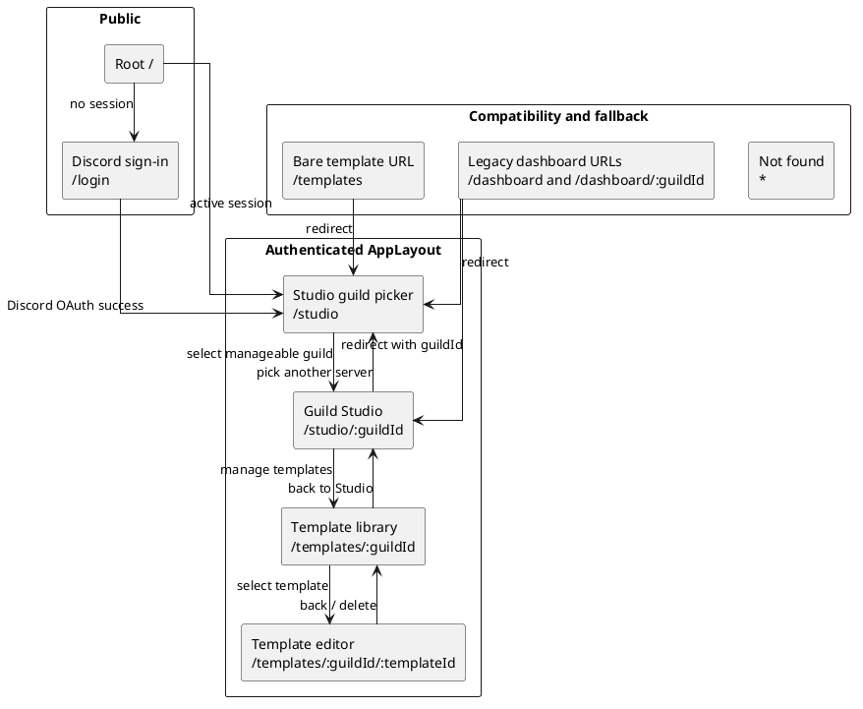
The route guard in App.tsx encloses every Studio and template route in AppLayout. If no authenticated session exists, navigation to any protected route is replaced with /login; an authenticated user who visits /login is sent to /studio. The layout contributes the global header — product identity, the Studio navigation item, signed-in user identity, and sign-out — while the selected route supplies the workspace beneath it.
The main routes have the following interface responsibilities:
Route | Primary interface responsibility
/login | Begin Discord OAuth2 sign-in; no local-password form is presented.
/studio | List guilds available to the signed-in administrator and provide the bot-invite empty state when no guild is ready.
/studio/:guildId | Host conversation history, natural-language planning, desired-state review, execution progress, drift feedback, templates, and rules for one guild.
/templates/:guildId | Search and browse the selected guild's saved template library.
/templates/:guildId/:templateId | Edit template metadata and structure, fork a copy, or delete the template.
The old Dashboard is intentionally absent from the active sitemap. Existing /dashboard links are compatibility redirects to the Studio, and the retained Dashboard.tsx and Setup.tsx source files are not routed. This consolidation matches the product's dominant workflow: choose a server, describe a target, and review the resulting state in one place.
The first wireframe shows the authenticated entry state. At this point the conversation and preview columns are not yet meaningful, so StudioShell collapses their optional slots and gives the guild chooser the working area.
┌──────────────────────────────────────────────────────────────────────────────┐
│ Discord Platform Studio [User] Sign out │
├──────────────────────────────────────────────────────────────────────────────┤
│ Studio │
├──────────────────────────────────────────────────────────────────────────────┤
│ │
│ Select a guild to plan against │
│ │
│ ┌──────────────────────────┐ ┌──────────────────────────┐ │
│ │ Community Server │ │ Support Server │ │
│ │ 428 members│ │ 91 members │ │
│ └──────────────────────────┘ └──────────────────────────┘ │
│ │
│ Empty alternative: │
│ "No guilds ready yet" + explanation + [Invite the bot] │
│ │
└──────────────────────────────────────────────────────────────────────────────┘
Only guilds returned by the authorised guild-list endpoint are offered. If the list is empty, the page explains that the bot must be invited with Administrator permission and provides the generated Discord OAuth invite link. This makes the missing precondition actionable instead of presenting an empty selector (FR-2, FR-3).

4.5.2 Studio shell and visual hierarchy
After a guild is selected, the Studio becomes a three-column desktop workspace under two headers. The global AppHeader preserves application identity and session controls. Directly below it, StudioHeader identifies the active guild and provides a "Pick a server" route back to the guild chooser. The working surface then divides into a 256-pixel conversation sidebar, a flexible central conversation, and a 480-pixel preview panel. The fixed side columns make the history and structural preview stable while the centre absorbs changes in viewport width.
Each column has one primary responsibility:
- Conversation history (left). ConversationSidebar starts with New Chat, then groups persisted conversations into Today, Yesterday, and Earlier. Each row uses the initiating prompt as its recognisable label, includes its current status, and loads the selected conversation into the centre pane. The sidebar can collapse its contents to icon-only controls, reducing visual distraction while retaining the column's allocated width.
- Intent and decisions (centre). ChatArea is the workflow surface. It begins with curated request suggestions and a free-form prompt, then renders the user's request, planning events, clarification controls, the completed desired state, and execution results as a chronological conversation. The controls that change lifecycle state — revise, edit, approve, save as a template, rollback, and start over — appear next to the result they affect.
- Current and desired structure (right). RightPanel behaves like an editor tab strip. Server and Desired are persistent tabs; the latter displays an empty instruction until a conversation produces desired state. The + menu opens closable Roles, Members, Templates, and Settings tabs. Selecting a channel in the Server tab opens a closable channel-detail tab with its type-specific settings and permission overwrites.
The following wireframe captures the full Studio in its plan-review state. It shows the most information-dense state because it contains all three objects the administrator must compare before approval: the original intent, the generated proposal, and the current/desired server representation.
┌────────────────────────────────────────────────────────────────────────────────────────────────────┐
│ Discord Platform Studio [Administrator] Sign out │
├────────────────────────────────────────────────────────────────────────────────────────────────────┤
│ ← Pick a server / Community Server Templates Settings │
├──────────────────┬───────────────────────────────────────────────┬─────────────────────────────────┤
│ CONVERSATIONS │ CHAT │ [Server] [Desired] [+] │
│ │ │ │
│ [ + New Chat ] │ ┌──────────────┐ │ Community Server v3 │
│ │ │ User request │ │ │
│ Today │ └──────────────┘ │ CATEGORIES (2) │
│ ● Staff layout │ │ Staff modified │
│ ○ Support roles │ ┌───────────────────────────────────────────┐ │ │
│ │ │ Planned │ │ CHANNELS (8) │
│ Yesterday │ │ ▸ planning actions │ │ # staff-chat new │
│ ○ Gaming setup │ └───────────────────────────────────────────┘ │ # announcements │
│ │ │ │
│ Earlier │ ┌───────────────────────────────────────────┐ │ ROLES (5) │
│ ○ Welcome flow │ │ Plan ready │ │ Moderator modified │
│ │ │ Summary │ │ │
│ │ │ Categories / Channels / Roles / Members │ │ WILL BE REMOVED (1) │
│ │ │ [Edit] [Approve] [Save as template] │ │ # old-staff removed│
│ │ │ [Cancel] │ │ │
│ │ └───────────────────────────────────────────┘ │ │
│ │ │ │
│ │ [Revise this plan…________________] [Revise] │ │
└──────────────────┴───────────────────────────────────────────────┴─────────────────────────────────┘
The layout deliberately duplicates the desired-state representation in two places. The completed assistant bubble keeps the proposal and its decision buttons together in the conversational record, while the Desired tab gives the same structure a persistent inspection surface independent of chat scrolling. Both use DesiredStateView, so categories, channels, roles, members, removal sections, and diff badges have identical semantics in either location.
The visual language is Discord-inspired rather than a pixel-for-pixel Discord copy. Categories and channels follow Discord's familiar hierarchy; roles and member assignments are shown as structured lists; dark shell surfaces, subdued borders, and the Discord-like accent support recognition without implying that the preview is the live Discord client. The right panel remains explicitly labelled Server or Desired, which is essential: visual similarity must not blur the distinction between reality and a proposal (NFR-14, NFR-18).

4.5.3 Conversation lifecycle and interaction states
The central pane is governed by a small, explicit UI state model. The useConversation hook owns the active identifiers, phase, planning and execution event logs, desired and current states, iteration list, errors, and in-flight guard. ChatArea renders one set of controls for each phase, so the administrator is led through the workflow rather than being presented with all possible commands at once.
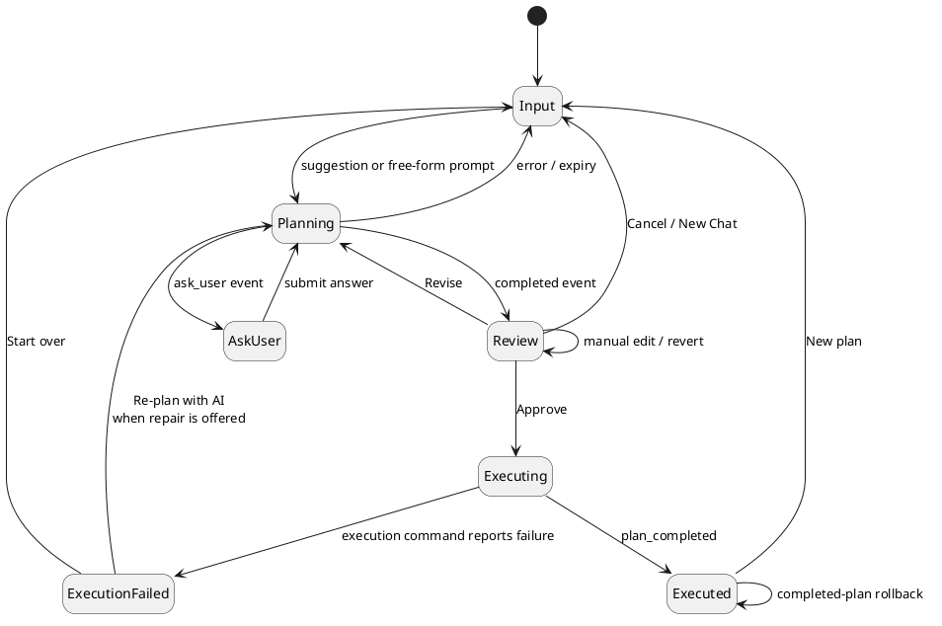
The visible treatment of each phase is as follows:
UI phase | Visible design and available action
input | WelcomeScreen offers five representative configuration prompts and a free-form textarea. Either path creates a conversation.
planning | The user prompt remains visible and an assistant bubble is labelled Planning…. A collapsed log grows as turn_started, tool_called, and tool_result events arrive, exposing progress without overwhelming the primary conversation.
ask_user | A Waiting for you planning state is followed by the planner's question. The control supports single- or multi-select options and a custom answer when allowed; submission returns to planning.
completed / review | A Plan ready bubble presents the summary, desired-state preview, iteration-history entry point, and Edit, Approve, Save as template, and Cancel actions. A separate Revise input remains docked below the conversation.
executing | An Executing… bubble appends step-start, completion, retry, failure, and rollback events as they stream from the plan endpoint. Actions that could submit a duplicate lifecycle command are guarded while a request is in flight.
executed | The bubble becomes Execution complete and offers Rollback or New plan.
execute_failed | A human-readable error is presented with Start over. When the API marks a stale/conflicted plan as AI-repairable, Re-plan with AI starts the confirmed repair flow and returns the conversation to planning.
This state-specific design supports progressive disclosure. A new user only needs to understand the prompt box; planning exposes the tool log only on demand; review reveals decision controls after a concrete state exists; and rollback appears only after execution. The workflow therefore preserves the power required by experienced administrators without making the underlying tool registry or plan-step schema part of the normal interaction (NFR-15).
The interface also treats long work as observable rather than blocking. The initial conversation POST returns before the plan exists, and the planning bubble is populated from /api/conversations/:id/stream. Approval opens /api/plan/:id/stream before issuing execution, so step events can appear while the execution request remains in progress. The user receives one continuous narrative even though commands and progress use the asymmetric REST/SSE design described in Section 4.4.

4.5.4 Desired-state preview, revision, and history
The desired-state preview is the principal safety surface because approval is a decision about the proposed end state, not about the wording of the original prompt. DesiredStateView decomposes the DesiredState document into five readable groups: categories, channels, roles, member-role assignments, and tombstones. When the current server state is available, a pure client-side diff labels resources as new, modified, or removed. Resources present in Discord but absent from the target are collected under Will be removed, while prior planning deletions retained as tombstones appear under Already removed. This makes destructive consequences visible instead of forcing the user to infer them from an instruction log (FR-9, FR-10).
Review supports three complementary forms of iteration:
- Natural-language revision. The docked Revise field sends a follow-up instruction to the same conversation. The centre pane returns to planning, streams the new work, and eventually displays a new desired-state iteration (FR-11).
- Manual editing. Edit changes DesiredStateView from read-only rows to a working copy. The user can add, modify, or remove categories, channels, and roles through inline controls. Save sends the edited state to the conversation's edit-state command and appends a manual_edit iteration; Cancel discards the working copy (FR-13).
- Version restore. The History control opens IterationHistoryModal, which sorts versions newest-first and identifies each as LLM-generated, manual edit, or revert. Selecting a version opens a read-only preview; Revert makes that state current by appending a new revert iteration rather than deleting later history (FR-12, NFR-16).
This append-only presentation is significant. A revision does not silently replace the reviewed result, and a revert does not erase the route taken to the current state. The UI reflects the persistence model from Section 4.3: each version remains independently inspectable, while one latest iteration supplies the active desired state.
The Approve button is intentionally located after the preview rather than in a global toolbar. It is disabled when a planning or command request is already in flight and when the client has received a drift event for the selected guild. A drift toast explains that Discord changed externally and offers Re-fork, which resets the conversation so a new plan can begin from current reality. The server repeats the stale-state comparison on approval and execution, so this UI gate is immediate guidance rather than the only protection (FR-21, FR-24, NFR-4).

4.5.5 Templates, rules, and contextual inspection
Secondary workflows are kept close to the Studio without competing with the conversation. The right panel's + menu is the local navigation mechanism: each selected tool opens as a closable tab while Server and Desired remain pinned. This creates a workbench model in which an administrator can inspect a role list, a member's role assignments, a template, or a channel's permission overwrites and then return to the plan without losing conversation state.
Templates have three deliberately different entry points:
- Templates tab. A compact per-guild browser supports text search, displays channel and role counts, and starts a server-side LLM merge into a fresh planning conversation. Its Manage → link opens the full library.
- Conversation template panel. Once a conversation exists, a toolbar button opens TemplatePanel above the chat. Templates can be attached to or detached from the conversation context, allowing the planner to treat them as design ideas rather than commands that immediately mutate the desired state (FR-14).
- Standalone library and editor. The library route supports broader browsing. Selecting an item opens the editor, where metadata and structure can be changed, the template can be forked, or it can be deleted (FR-26).
The third wireframe shows the standalone template-management path. It is a conventional document editor rather than a three-column Studio because the user is editing one reusable artifact, not comparing a live server, a conversation, and a proposal.
┌──────────────────────────────────────────────────────────────────────────────┐
│ Discord Platform Studio [User] Sign out │
├──────────────────────────────────────────────────────────────────────────────┤
│ ← Back Edit template [Fork] [Delete] [Save] │
│ v3 · id: staff-layout │
│ │
│ Name [ Staff layout__________________________________________ ] │
│ Description [ Private staff area with moderator roles______________ ] │
│ Category [ community____________________________________________ ] │
│ Tags [ staff, moderation____________________________________ ] │
│ │
│ STRUCTURE [Edit structure] │
│ ┌──────────────────────────────────────────────────────────────────────────┐ │
│ │ Categories (1) Staff │ │
│ │ Channels (2) #staff-chat #staff-voice │ │
│ │ Roles (1) Moderator │ │
│ │ Members (0) │ │
│ └──────────────────────────────────────────────────────────────────────────┘ │
└──────────────────────────────────────────────────────────────────────────────┘
The editor reuses the same DesiredStateView and useDesiredStateEdit logic as conversation editing. This is a deliberate consistency choice: a channel or role has the same presentation and edit behavior whether it belongs to an active plan or a reusable template. Metadata is saved separately from the structure, and Fork creates a new per-guild copy before navigating to the new editor.
Server rules are managed in SettingsTab, not on a separate Dashboard. The tab lists the guild's free-text rules and supports add, inline edit, and delete. These rules become input to the Stage 2 policy validation described in Section 4.2.4 (FR-25). Keeping rule management beside the Desired preview makes the relationship visible: rules describe the local policy against which proposed states are checked, while the plan remains the object being reviewed.
The remaining contextual tabs are read-oriented. Roles and Members provide server-wide summaries, while clicking a channel in the Server view opens a detail tab showing its category, type-dependent settings, tags where relevant, and permission-overwrite table. These views reduce the need to leave the Studio for Discord merely to verify the context of a proposed change.

4.5.6 Client state, feedback, and error presentation
The component design separates durable server data from transient presentation state. useConversation owns the active workflow and all API/SSE coordination; useDesiredStateEdit owns an isolated working copy during manual edits; and the Zustand useStudioStore owns workspace concerns that need to cross components, principally the right-panel tabs and the per-guild stale flag. Authentication is held separately in useAuthStore. This prevents an open tab or partially typed edit from being mistaken for persisted plan state.
Feedback is placed at the scope of the action that produced it:
- planning and execution progress appears chronologically inside the chat;
- loading and empty states appear within the panel or page waiting for data;
- template, rule, and conversation errors appear beside their corresponding controls;
- drift is guild-wide and therefore appears as a top-right alert toast;
- potentially destructive template and rule deletion requires confirmation;
- in-flight guards and disabled buttons prevent duplicate submissions.
The interface uses familiar text labels alongside icons for consequential actions such as Approve, Delete, Rollback, and Save. The tab strip exposes tablist, tab, selection, and close labels; modal history identifies itself as a dialog; the drift notification uses alert semantics; and icon-only close controls carry accessible labels. These measures do not constitute a full accessibility evaluation — that belongs in Chapter 6 — but they make the intended interaction semantics explicit in the component design.
Errors are translated into workflow choices where the server provides enough information. A stale or conflicted execution can expose Re-plan with AI; other execution failures expose Start over; a missing channel opened in a detail tab explains that it may have been removed; and an unavailable guild list presents the bot-invite route. Raw streamed events are retained for diagnostic visibility, but the primary bubble label and error message remain human-readable (NFR-17).

4.5.7 Scope and current interface constraints
The implemented interface is intentionally desktop-first. The global header, guild cards, and standalone template pages include responsive Tailwind variants, but the full Studio keeps fixed 256-pixel and 480-pixel side columns and does not yet replace them with mobile drawers. The conversation sidebar can reduce its contents to icon-only controls, but it does not currently release its allocated width; the right tab strip scrolls when many tabs are open. A complete small-screen Studio remains future refinement rather than an implemented claim.
The active navigation is also intentionally narrow. Full administration, subscription and billing, detailed audit-log browsing, and user management are outside the locked project scope. The retired Dashboard and Setup pages remain on disk only as stashed code. Plan and conversation evidence is surfaced through the conversation list, iteration history, and execution bubbles rather than a separate analytics dashboard. This is not yet a dedicated persisted plan-and-outcome history view of the kind required by FR-23; the API can list plans, but the active web routes do not expose that list.
Three smaller navigation and command gaps remain in the current Studio. The Cancel control that calls the conversation-cancellation command is rendered in the Plan ready bubble, not while the planning phase is visibly in progress, so the web interface does not yet expose the in-progress cancellation promised by FR-27 at the point it is needed. Similarly, the plans API supports aborting an execution, but ChatArea does not present an Abort action during the executing phase (FR-28). Finally, the contextual header's Settings shortcut currently targets the legacy /dashboard/:guildId redirect; the working route to SettingsTab is the right panel's + menu. These are interface wiring gaps, not claims that the corresponding server commands or safety checks are absent, and they should be closed or assessed explicitly in Chapters 5 and 6.
Finally, the design keeps browser controls advisory and the API authoritative. The interface disables actions when it knows a request is unsafe or stale, but it never assumes that disabled buttons are a security boundary. Guild authorization, plan status, validation, stale-state comparison, and execution locking are repeated on the server as detailed in Section 4.6. This preserves the key relationship between the UI and the plan-first architecture: the Studio helps the administrator make an informed decision, while the backend determines whether that decision can be applied safely.

4.6 Security and Safety Design
Security in this platform is a chain of independent gates rather than a single login check. The browser is an untrusted client; the Hono API is the policy boundary; PostgreSQL stores the user's plans and conversations; Discord is the external system of record; and the LLM provider is an untrusted transformation service. A request must first identify a user, then prove that the user may act on the selected guild, then prove that the bot can operate that guild, and, for a live change, pass the plan-integrity and concurrency checks described in Sections 4.1 and 4.4. This layering is important because a valid web session does not by itself grant authority over any Discord server.

4.6.1 Identity, sessions, and the authentication boundary
Identity is delegated to Discord OAuth2 through Better Auth. The server does not implement a password flow: the accounts table has a library-compatible password column, but the application never populates or reads it for login. Better Auth persists users, sessions, accounts, and verification records in the four library-owned tables described in Section 4.3.2. The application configures an HTTP-only session cookie and enables Better Auth's short-lived cookie cache; the browser-side apiFetch wrapper sends that cookie with every request and turns a 401 response into a single logout-and-redirect action.
The protected API is composed under /api and applies authMiddleware before dispatching route modules. The middleware asks Better Auth for the session from the request headers, stores the authenticated user and session in Hono's context, and returns a uniform JSON 401 when no session is present. Handlers call requireUser at their boundary as a second, typed assertion. The health endpoint and Better Auth's own /api/auth/* handler are intentionally outside the protected route composition: health is a liveness probe, while the auth handler must be reachable before a session exists. The bot status and invite endpoints are mounted under the protected API and therefore still require a session.
Environment validation is part of the boot boundary. The server refuses to start without DATABASE_URL, a 32-character BETTER_AUTH_SECRET, valid auth and web URLs, and (in production) the Discord bot and OAuth credentials. This prevents a partially configured process from accepting requests with an unknown session or Discord identity configuration. The Better Auth user record also contains role and subscriptionTier fields, but neither participates in authorization; they are currently informational and the platform has no local RBAC or subscription gates.

4.6.2 Guild authorization and tenant isolation
Authorization is derived from Discord, not from an application-admin table. For a requested (userId, guildId) pair, userHasManageGuild first resolves the user's linked Discord account, confirms that the bot is ready and has the guild in its cache, and fetches the member from Discord. The request is allowed when that member is the guild owner or has the Discord MANAGE_GUILD permission. A positive or negative result is cached for 60 seconds to avoid a Discord member fetch on every API call; the cache can be invalidated per user when membership changes. If Discord cannot answer the membership request, the helper throws DiscordApiError, which the global Hono handler exposes as a 503 instead of incorrectly converting an outage into a 403 denial.
Every state, rules, plan, conversation, and drift route repeats this check. Template mutations and template merges do as well, while the current template browsing handlers allow any authenticated session to request the selected guild's templates and global templates. Resource-oriented routes that enforce guild access add an ownership check after loading the row: the plan or conversation must belong to the guildId in the URL, otherwise the handler returns 404. The two top-level execution and planning SSE routes do the same lookup before subscribing to an event bus. Consequently, possession of an ID from another guild does not expose its plan data or live events.
That template-browsing exception is narrower than the execution boundary but is still a tenant-isolation consideration: the current GET list/detail handlers do not call userHasManageGuild, so a caller with a valid application session who knows another guild's identifier can request that guild's stored templates. Template writes remain protected by guild access and, for updates and deletes, by the template author's user ID. If templates become private tenant data, their read handlers need the same guild authorization check as the other guild-scoped resources.
The second recurring authorization layer is bot operability. botReady blocks API composition until the first Discord gateway cache rebuild completes. checkGuildOperable then requires both a cache entry (the bot is in the guild) and the bot's ADMINISTRATOR permission. A missing cache entry is 404; missing ADMINISTRATOR is 403 with a remediation message. The same gate is used before planning, state reads, rule changes, plan execution, and rollback, so an authenticated manager cannot turn a disconnected or unsafe bot into a partial mutation tool.

4.6.3 Bot privileges and the Discord trust boundary
The bot is deliberately installed with Discord's ADMINISTRATOR permission (the invite route generates permission bitfield 8). This is a broad gateway privilege, but it establishes a safety invariant: channel overwrites cannot lock the bot out, including an @everyone VIEW_CHANNEL denial. The cache rebuild and guild-join handlers log guilds where the invariant is absent, and the operability gate blocks their API operations. Execution re-checks operability and validation immediately before mutation using the bot's current Discord.js cache; fresh direct Discord reads are reserved for the after-snapshot and rollback paths.
Role hierarchy is checked at execution validation time. Group A reads the bot's highest role position and blocks edits, moves, or deletions of roles above it; member-role additions and removals receive the same block. Group D separately blocks a newly created role that grants ADMINISTRATOR. Permission names are parsed against the shared Discord permission registry, so an unknown permission cannot enter a set_overwrite step. These are deterministic checks and do not depend on an LLM's interpretation.
The implementation currently enforces hierarchy when a plan is validated, rather than maintaining a separate startup "bot is highest role" flag. That is strong enough to stop the execution path, but it is a narrower implementation than the aspirational startup requirement in docs/design/security.md; the distinction is recorded here rather than presenting the design target as an already deployed gate.

4.6.4 Plan isolation, validation, and human approval
The LLM has no Discord client or database mutation capability. It can only produce calls described by the fixed tool registry, and planning tools mutate a DesiredState fork in memory. The only execution-capable tool calls are turned into diff steps and dispatched later by an explicit execute command. This keeps prompt injection or malformed model output inside a typed, inspectable data structure until a human has reviewed the preview and approved the plan.
At the execution boundary, Zod validates request bodies before route logic. The diff engine rejects missing resources and emits an ordered step list; assumption checks then re-check parent existence, name collisions, and other tool-specific preconditions against the current cache. Stage 1 deterministic validation checks permissions, symbol dependencies and cycles, resource limits and type constraints, safety guards, overwrite-consolidation warnings, and plan integrity. Block-level issues fail closed with 400 and structured blocker and warning arrays. Stage 2 optionally sends a compact plan summary and the guild's rule text to the configured OpenRouter-compatible provider. It is fail-open by design when no API key or rules exist, or when the provider fails or returns an unusable response; runtime diagnosis is never delegated back to the model. This is a known safety limitation: the deterministic backstop is mandatory, while natural-language policy enforcement is best effort.
The current implementation also keeps guild rules out of the planning system prompt. They influence the execution-time Stage 2 check only, so an administrator may see a plan that has not been policy-screened until approval time. This is the documented design divergence and should be read alongside the fail-open behavior rather than mistaken for an earlier authorization gate.

4.6.5 Stale state, concurrency, and recovery
The main time-of-check/time-of-use risk is addressed by anchoring a conversation to the SHA-256 forkStateHash of the cache state it planned from. Execution recomputes the hash and returns 409 when the guild changed. It then rebuilds the diff and evaluates every step's assumptions again, so a plan cannot rely solely on an old preview. After an execution, sibling conversations whose hash no longer matches are marked stale and their in-memory planning sessions are cancelled.
Execution is serialised per guild by an atomic conditional update on the guild row. The lock records plan, owner, acquisition time, and heartbeat time; a 60-second heartbeat keeps healthy five-minute executions alive. A 30-minute TTL and five-minute periodic cleanup recover locks from crashes or dead processes, while the finally block releases the lock on every normal or error path. The plan-level AbortController stops work after five minutes, and each step has its own deadline and bounded retry policy. Permanent failure, timeout, or user abort triggers a diff-based rollback against the before-snapshot when the bot is still connected. Rollback is structural and best effort: Discord message history and some member-side effects cannot be reconstructed from a server snapshot. If the bot disconnects, rollback is skipped and the route reports a failure for manual review rather than issuing unauditable compensating calls.

4.6.6 Transport controls, persistence, and remaining limits
Credentialed CORS is restricted to WEB_APP_URL; the rate limiter applies a sliding 100-request-per-minute window to /api/*. It keys the window by the connection's source IP and only trusts x-forwarded-for when TRUST_PROXY=1, which prevents an arbitrary client header from selecting a different bucket. The limiter is process-local, so deployments with multiple server instances would need a shared store to obtain a global limit.
The application route layer does not add a separate CSRF-token middleware for cookie-authenticated commands. Its browser-facing protection is the origin-restricted credentialed CORS policy and Better Auth's cookie/session behavior; production deployment should keep those origins and cookie settings aligned rather than treating CORS as a substitute for an independent CSRF control.
SSE connections authenticate and authorize before subscribing, emit a ready event, and unregister on client abort. Heartbeats keep intermediaries from closing idle streams, but events are held only in the in-process event bus and are not replayed after a reconnect. The client must therefore reload the resource over REST if it misses a progress event.
Conversations, prompts, LLM messages, desired states, plans, rules, and snapshots are persisted as PostgreSQL rows, several as jsonb documents. The application does not add field-level encryption or a detailed audit-log table; database, cookie, secret, and LLM-provider protection remain deployment responsibilities. Detailed audit logging, application-level RBAC, and subscription/tier enforcement are explicitly outside the current scope. These limits do not remove the plan-first safety gates, but they bound what can be claimed about forensic traceability and multi-instance security in the current build.

